Photographing absence in deathscapes
Terence Heng
Department of Sociology, Social Policy and Criminology
University of Liverpool
t.heng@liverpool.ac.uk
Keywords: absence–presence, Bukit Brown Cemetery, deathscapes, photography, Singapore, visual methods
Abstract How do visual methods, particularly the practice of photography, help us to visu- alise and understand absence in deathscapes? In this paper I will argue that pho- tographs, with their ability to freeze moments, are able to capture what I term points of praxis – moments in which practices by individuals inscribe meaning onto deathscapes, and in that intense and captured presence, evoke the feeling of absent individuals. Such points of praxis can exist in two ways – the praxis of the body and the praxis of objects – both of which I will illuminate with the use of visual ethnographic methods. To support my argument, I present work taken from a three‐year visual ethnographic study of Bukit Brown Cemetery, specifically drawing on the social and cultural documentation of the Hungry Ghost Festival.
Cite as
Heng T. Photographing absence in deathscapes. Area. 2018;00:1–10. https://doi.org/10.1111/area.1251 4

INTRODUCTION
The study of deathscapes and deathspaces is not a new phenomenon in Geography but at the same time has not garnered the same attention as other social and cultural spaces. Madrell and Sidaway define deathscapes as “both the places associ- ated with death and for the dead” (Maddrell & Sidaway, 2010, p. 4), while Teather explains deathscapes as “the material expression in the landscape of practices relating to death” (2001, p. 185). Deathscapes can be both formal and informal (Young & Light, 2013), and include not just cemeteries and columbaria, but also special spaces set aside for the dead, like altars at home, war memorials or tribute spots for road‐accident victims. As many scholars have noted (Hockey et al.,2010; Kong, 1999; Maddrell & Sidaway, 2010), deathscapes are also often contested spaces – socially, culturally and politically. It is often through these contestations that deathscapes are socially and culturally constructed through rituals, artefacts and systems of beliefs (Francaviglia, 1971; Kong, 1999) (see Figure 1).
In this paper I will explore how photography can better visualise the intangible elements, or what Shields called the “attitudes and habitual practices” (1999, p. 154) of places associated with death. I will do this by applying the concept of “absence–presence,” which Maddrell uses to understand the ways in which the absence and continued presence of dead individuals are felt, experienced and materialised (especially on landscapes) by their bereaved loved ones. As Maddrell notes,
absence is not merely a ‘presence’ in and of itself, but rather the absent is evoked, made present, in and through enfolded blendings of the visual, material, haptic, aural, olfactory, emotional‐affective and spiritual planes, prompting memories and invoking a literal sense of continued ‘presence,’ despite bodily and cognitive absence. (2013, p. 503)
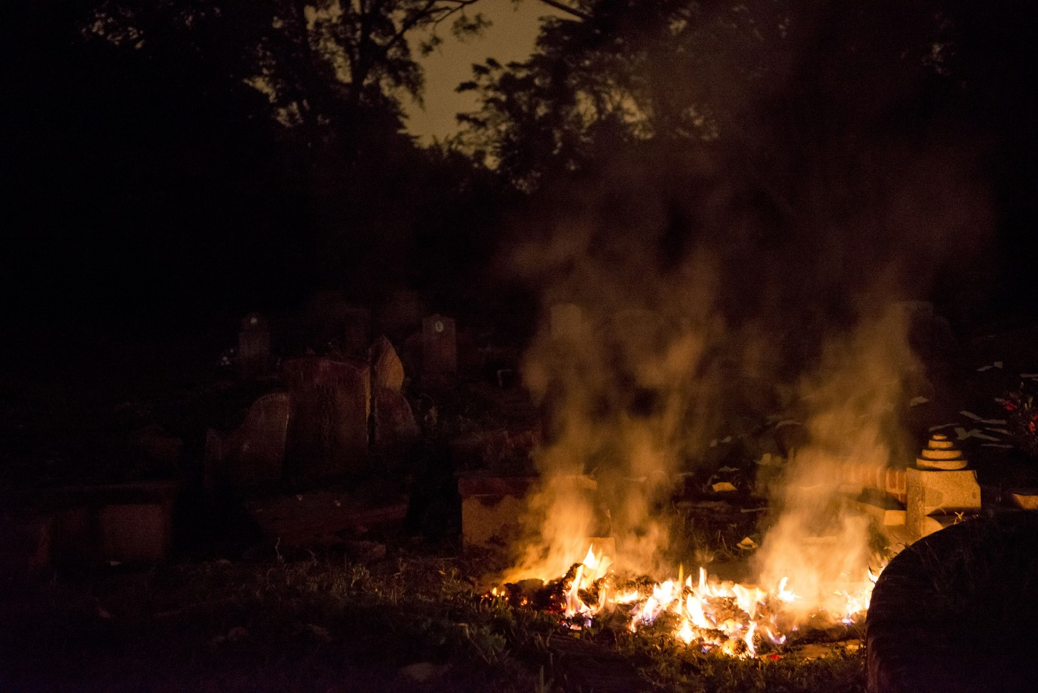
FIGURE 1 Burning effigies of money for dead ancestors in Bukit Brown Cemetery – a praxis of objects‐in‐motion in deathscapes.
In tandem with absence–presence, Maddrell also discusses the concept of continuing bonds – ongoing feelings of relation- ships and connections between the living and the dead, proposing that such a “sense of relationship” (2013, p. 508) transcends class, kin, religion and gender. Attitudes towards the dead are not of closed finality, but an ongoing process. These attitudes are expressed in death and mnemonic rituals and objects which do not end the relationship with the dead, but instead bring them into a quotidian fold (citing Wojtkowiak & Venbrux, 2010).
Maddrell (2013) explains that continuing bonds, which perform the presence of absent individuals, can be further observed through communication and care (and the continuity of care). Individuals maintain an ongoing relationship with the dead by expressing a sense of their loved ones’ presence (see Hunniford, 2008), but also by directly addressing the dead through letters, prayers (to and for the dead) and via intermediaries like mediums. Indeed, others like Bartolini et al. (2018) have examined the role that mediums play in Spiritualist churches in the United Kingdom, acting as gatekeepers to the dead but maintaining ordinary, everyday conversations. In terms of care and the continuity of care, Maddrell illustrates her argument with images and case studies from memorial benches and other objects meant to evoke and perpetuate the memory of, and relationship with, a loved one where “the location, inscriptions and practices around benches represent a range of relationships and beliefs, including those that signify and materialise the continuing attachment of the bereaved to the deceased” (Maddrell, 2013, p. 514).
Whether it is through objects or other actions, the performative practices of the bereaved can give us insights into the way meaning is inscribed onto deathscapes. Methodologically, Geography scholars often choose a combination of qualita- tive methods to record and analyse these phenomena. Descriptive textual accounts of deathscapes and the actions in death- scapes are frequent (as seen in Maddrell's (2013) and Bartolini et al.'s (2018) studies, and also with Hunter (2016) and Teather (1998)), along with the use of visual methods (particularly photography) to visualise observations. However, many of these images are static photographs devoid of the individuals who inhabit and shape said places. At the same time, they show the traces of practice, but not the practice itself. In this paper, I argue visual methods and photography in particular possess affordances that allow us to better capture the intangible emotional‐affective aspects of absence and presence in deathscapes by depicting moments of presence through what I call “points of praxis.” But in order to explain how these processes work, two things must first be discussed – how photography currently and potentially works in visualising deathscapes, and the particularities of the event (and place) I will be using to support my argument. I will deal with each of these in turn.
PHOTOGRAPHY AND DEATHSCAPES
Photography has long been used to frame, document and expose the social and cultural dimensions of space, place and landscapes. As Ballerini, quoting Schwartz and Ryan (2003), notes, photography is “a chain of practices and processes by which geographical information is gathered” in a framework of a geographical imagination, where the latter is “a mecha- nism by which people come to know the world and situate themselves in space and time” (2004, p. 300). Visual methods in a broader sense feature heavily in geographical research, and photography has been favoured in a variety of topics by scholars, including understanding the topographies of the global sex trade (Biemann, 2002), as a method in geographical fieldwork education (Sidaway, 2002), and tourism and leisure studies (Burns et al., 1989; Jenkins, 2003). In the study of deathscapes, photography is used, but not consistently. For example, one important text on deathscapes by Hockey et al. (2010) features just 15 photographs over 234 pages, where the photographs tend towards being mechanical reproductions of something the author/s has/have witnessed or observed. In a chapter on roadside memorials by MacConville and McQuillan (2010), the authors make use of two photographs, primarily as evidence that such memorials exist and are still remembered. One image of a roadside cross for a child (MacConville & McQuillan, 2010, p. 198) is important and poign- ant in its portrayal, but does little else than stand as a memorial of the memorial. In the same book, Davies's (2010) excel- lent chapter on spirit geographies does not make use of images at all, despite having discussions on religious architecture and cemeteries – sites where visuality and materiality would appear to be important.
This lack of images or illustrative use of images is a pity, because photography has the potential to interrogate the emo- tional/sensorial aspects of place (Rose, 2012). That said, some photographs (more so than others) of deathscapes have shown to be able to do this kind of work. Foote and Grider's (2010, p. 198) paper on US College memorial sites exhibits a photograph that piques the viewer's curiosity and, in the context of individuals gathering at a memorial marking a tragedy, suggests and evokes from the viewer a sympathetic reading of the space that is photographed. The image is unlike others we see in the deathscapes literature – shot from a distance, with the subjects’ backs to the camera, the photograph combines the form and structure of the memorial with evocative contrasting lights and shadows and ambiguous body language. The photograph thus works to create new understandings of this deathspace. Likewise, as Rose (2008) argues, there are other ways of using photographs in Geography beyond their illustrative capacity. Citing Goin's (2002) use of photographs, Rose notes that Goin argues for the representational and emotional quality of his photographs by using an expressive kind of text that Rose calls “lyrical.” When paired with the photographs, this works as a way of immersing the reader in the sensations of the place being photographed.
But such photographs are less common than we might expect in the deathscapes literature. More often deathscape pho- tographs work well enough to depict and illustrate, and at times evoke feelings of absence through visual depictions of pre- sent objects and elements on the landscape (see Teather, 1998, p. 192; Maddrell, 2013, p. 516), but I propose that such photographs could do much more by exposing the practices that make up deathscapes. There are multiple ways in which this can be done, and through the rest of the paper I will explore one option, which is to document practices as they hap- pen, and compose and produce images of these practices that are immersive and lyrical. In this way, the photograph
becomes a material artefact that records and re‐performs the practice to the reader. Thus, instead of photographs showing simply traces of absence, they can actively evoke absence by showing practices of presence. To demonstrate this, I will be using photographs created during a three‐year visual ethnographic exploration of a Chinese cemetery in Singapore during the Hungry Ghost Festival, where I documented Chinese religious rituals. In the next section I will outline and map this particular deathscape, as well as my methodology.
CHINESE RELIGION, SPIRITS, THE HUNGRY GHOST FESTIVAL AND BUKIT BROWN CEMETERY
It is difficult to give a thorough and exhaustive explanation of Chinese religion and its myriad regional nuances in a single section. Indeed, the term itself is problematic because it suggests a monolithic system of beliefs particular to an ethno‐racial group (we do not, for example, group all forms of Christianity into one category and call it Caucasian religion!). However, for the purpose of this paper, and because it is a common term in scholarly work, I will as others (DeBernardi, 2006) do, define Chinese religion as sets of beliefs syncretised from Taoist, Buddhist and Chinese folk religion systems, lacking in canonical tradition (Wee, 1976). Adherents commonly refer to their practice as bai shen, or the worship of spirits (what Elliott (1955) calls shenism), where such spirits are drawn from a pantheon of ascended ancestors as well as Taoist and Buddhist lore.
In Geography, scholars have often situated the study of Chinese religion in theories of sacred space (Kong, 1993; 1999; Heng, 2016; Tong & Kong, 2000). For example, Tong & Kong's, 2000 study of Chinese religion practitioners in social housing in Singapore revealed how individuals adapted feng shui beliefs to accommodate modernist ideologies concretised in the templated design of their flats and policies surrounding use of said flat. In my own research I have examined the role of spirit mediums in the construction of unofficial sacred spaces in their own home, arguing that the body of the medium becomes the locus around which sacred space exists and continues to exist so long as the medium is possessed by the spirit of a deity (Heng, 2016).
The presence of spirits and the spiritual realm are part of the quotidian fabric for adherents of Chinese religion. The ven- eration of ancestors is a significant and often mandatory practice, for reasons of Confucian filial piety and also as a form of risk/profit management (Teather, 1998). Making sufficient and pleasing offerings to one's ancestors not only promises wealth and blessings for the living, but also staves off misfortune from angry and unappeased spirits (Teather, 2001). As such, the living are in constant engagement with spirits, peaking at certain times of the year, especially during the seventh month of the Chinese lunar calendar. Known as the Hungry Ghost Festival, this is a period of time where adherents believe that the spirits of the dead are released from the netherworld to roam the earth and interact with the physical and living world (Teiser, 1996). Absent souls are suddenly again present in the physical world. Such spirits may be the souls of loved ones, but might also be those of strangers. Regardless, they must be fed and appeased through offerings of food, drink, entertainment and money. Streets and neighbourhoods are transformed into temporary deathscapes, with roadside altars and offerings springing up to cater to the dead (Chan, 2018; Heng, 2014, 2015). More fervent adherents would also take this time to visit cemeteries to make offerings to graves, both known and unknown, believing that the cemetery is a crucial gateway between the living and the dead (Teather, 2001).
Much of my research into the Hungry Ghost Festival has been focused on a particular deathscape in Singapore: Bukit Brown Cemetery, or Bukit Brown for short, the first Chinese municipal cemetery in Singapore. From its inception in 1922 to a place of renewed interest starting in 2011, Bukit Brown exists as multiple forms of spaces – ritual, local, global, urban planning and policy relevance (Chong & Chua, 2014). It is a classic deathscape – not only is it a site of remembrance, marked with tombs, shrines and altars, it is also a site of political, cultural and social contestatations between the state and civil society, the former arguing for redevelopment and the latter fighting to save it for heritage purposes. Since its closure to new burials in 1973, the cemetery has also changed dramatically. In contrast to other, well‐maintained and landscaped cemeteries in Singapore, Bukit Brown has no public street lighting, and is covered in dense secondary rainforest. Such physical features have meant that many graves now lie forgotten by both state and descendant, and might explain why the cemetery attracts many adherents to make offerings to what they deem to be lost souls – dead individuals who have no family to “care” for them.
I have chosen to focus my analysis on photographs taken and observations made during the Hungry Ghost Festival in Bukit Brown. This period is an opportunity for social groups to conduct rituals for the benefit of both the dead and the liv- ing. The cemetery becomes alive, though still hidden in darkness, with the sights and sounds of ritual, artefacts and tran- sient aesthetic markers (Chong & Chua, 2014; Heng, 2015). The photographs I am using in this paper were chosen for their ability to capture moments of practice, or their ability to evoke what I or others had felt in Bukit Brown.
METHODOLOGY AND ETHICS
Visual ethnographic methods, in this case photography and observation (see DeWalt & DeWalt, 2011; Harper, 2012; Heng, 2017; Pink, 2007), lay at the heart of my approach to Bukit Brown as well as in other research projects, where I have ter- med it “visually‐focussed participant observation” (Heng, 2016, p. 221). Here, I spent three years observing and interacting with adherents, photographing their rituals in real‐time and building a visual library of this deathscape. Unlike other projects, I took the role of a complete observer (Junker, 1960), choosing not to become an insider, but maintaining a role as a researcher/photographer in the field. In total, I took more than 60,000 photographs and 50 video clips of rituals, individuals and the cemetery's landscape. The types of photographs I recorded ranged from descriptive and illustrative to textural and atmospheric. At times I followed Collier and Collier's (1999) advice to create cultural inventories of what I observed, but at other times I tried to capture the emotive aspects (Edwards, 1997; Rose, 2012) of the landscape in more abstract images.The photographs used in this paper sit somewhere in‐between these two extremes – they should be read as texts (Knowles & Sweetman, 2004) – documents that show and depict, but at the same time that have the potential to be interpreted and re‐interpreted by the reader.
In order to freeze moments, as I am arguing for in this paper, it follows that the researcher must be in the field at the point of time deathscapes are being assembled. And despite the fact that many deathscapes and deathspaces are public, the acts involved in assembling them can be very personal and intimate. Being a photographer allowed me to establish a signif- icant level of rapport with individuals performing rituals in Bukit Brown, especially since the presence of a professional camera meant that they saw me as an opportunity to document something that was important to them, and much less so an invasion of their privacy. In terms of ethics, I and other researchers present gained fully informed consent from participants before we began documenting. In the cases of encountering public rituals, we would first introduce ourselves and explain our work, along with the completing the necessary forms. No observations were made or photographs taken until consent was given. Occasionally there would be certain restrictions on what could or could not be photographed, and in this case we ensured that our cameras were positioned at angles so that these restricted items/actions could not accidentally fall into the view of the camera. Where possible, the documentation team would also try to give adherents copies of photograph/ videos taken, if they asked for them.
VISUALISING ABSENCE THROUGH FREEZING “ POINTS OF PRAXIS ”
In this section I will argue that photographs are best used to capture moments of practice, or what I call “points of praxis” in deathscapes, thereby visualising the agencies of individuals as they perform absence through their presence. I will show that such encapsulation is afforded by particular mechanical technologies and practices in the photograph, in this case, the juxtaposition of visual elements and shutter speeds that create a “visual static‐ness.” A photograph has the ability to freeze and static‐ise moments. Wells, citing Metz (1985), argues that “(t)he qualities that make a photograph work as a fetish – its immobility and silence, its ability to freeze a past moment – are deathly qualities” (2015, p. 225). Notable photographs in history have also been known for capturing a particular moment – especially those by Henri Cartier‐Bresson and Robert Capa. Cartier‐Bresson (1952) notes that the freezing of a particular moment when elements come together is significant, hence the title of his book The Decisive Moment. It is this decisive moment where we can capture the practices of individuals as they inscribe meaning onto the landscape.
Points of praxis of the body – Setting‐up offerings
When adherents visit Bukit Brown, they often stop short of going deep into the cemetery, where a lack of lighting and under‐maintained roads can make travelling by vehicle difficult. Many choose to make their offerings at a concrete platform about 150 metres from the gates. The platform is almost like a stage (with steps) for performative rituals, where individuals may position themselves for the greatest possible interaction with the dead. During the Hungry Ghost Festival in 2012, I met one large group of friends who had come to make offerings in Bukit Brown and were happy to give us permission to document them. They began by setting up at the base of the concrete platform – laying out offerings and other artefacts, and also proceeded to illuminate most of the graves overlooking the platform by placing candles in front of the tombstones. This created puddles of warm candlelight that dotted the slope, but also pools of darkness in between – without any form of street lighting, Bukit Brown is pitch black, except for any moonlight that can penetrate the canopy.
Figure 2 shows an example of how these “set‐up” rituals are able to reveal the praxis of the body – the presence of movements and positions of individuals that evoke absence. The effect of a transient body in the foreground was achieved in‐camera (i.e., no post‐processing editing at work). On the hill, Lim (M, Chinese, 20s) rose to make his way gingerly to another grave. I was squatting near the pair, shooting with a very slow shutter speed so as to allow enough ambient light in to illuminate the landscape of graves without using any artificial light. The exposure time was nearly a second – meaning that any movement would cause the subject to blur (also known as motion blur). The blur, combined with the stillness of Ang (M, Chinese, 50s), the graves and the trees in the background, provides a menagerie of bodies in motion and iner- tia. Assembled together, we have an image that not only depicts the layout of graves, but also the mnemonic and honorary rites that make the cemetery in real‐time. We are treated to a precarious and shaky, almost ghost‐like movement that echoes the absent but still present bodies buried underneath.
Figure 3 brings us to the base of the concrete platform, to a spot at which many groups burn kim zua for the cemetery spirits, evidenced by the pile of accumulated ashes left behind. We see the interplay of previous practices (ash) and current ones – Tin (M, age and ethnicity unknown), a monk practicing Tibetan Buddhism, was (according to our informants) flown in from abroad to conduct these rites. Tin engaged in the setting‐up by setting alight an amalgamated and syncretised series of ritual objects – cereal, honey, butter, incense, paper effigies of clothes, and Thai Buddhist paper amulets – for the benefit of present spirits.
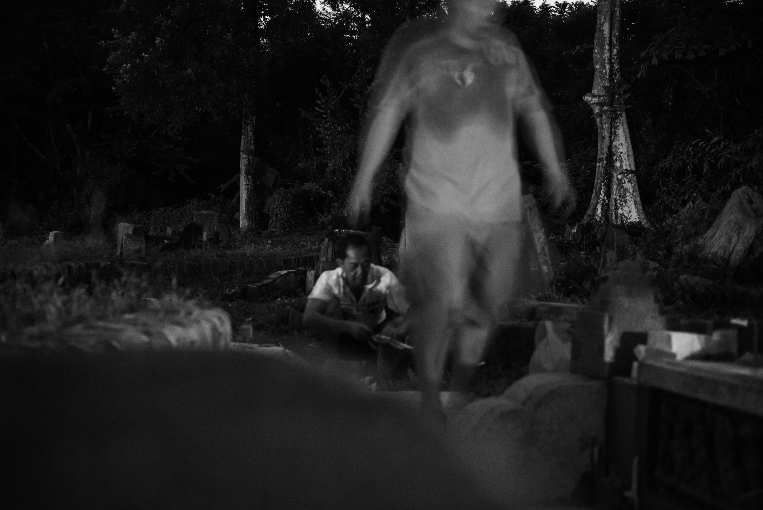
FIGURE 2 Praxis of the body, semi‐frozen in the dark.
Figure 3 freezes a particular point in the ritual set‐up where Tin is juxtaposed against Simon (M, Chinese, 30s) in the background. While the ritual space is still a significant subject in the photograph, the two individuals add an additional layer of meaning and imagination to the scene. They are not just juxtaposed by position but also by clothing – one sacred and the other everyday. I chose this particular photograph from a series of 20 others of the same scene. Some of these images showed only Tin, others precluded the ritual space in favour of the participants. Figure 3 worked for me because of the balance of space and bodies, frozen in a particular moment of the ritual, creating a point of praxis that is part sacred place‐making, part acknowledgement of history and part evocation of absent ancestors.
Points of praxis with objects – Burning offerings
Like bodies, objects can also be seen to have agency, being part of the assemblage of landscapes, and in this case death- scapes. Returning again to Maddrell's study of memorialscapes, her photographs convincingly demonstrate the importance of objects as markers and performers of continuing bonds between the living and the dead. And like other scholars, pho- tographs of deathscapes overwhelmingly show the material (but not human) remnants of ritual, activity and connection. Such placed‐ness has its own pathos – it carried the weight of grief and memory in the static deployment of objects. But at the same time I argue that, where possible, photographs can go further to capture such objects as they are employed and deployed.
Figure 4 shows one such deployment. In this scene, the adherents have built a circular structure using blocks of kim zua. Within the structure other paper effigies of mundane objects needed by spirits to lead everyday lives – clothes and toi- letries especially – are thrown into the mix while Tin chants in the background. The entire structure is then set alight, so that the effigies are hierophanised into actual objects in the spiritual realm. In doing this, adherents are not simply making symbolic gestures for the dead – they are actively providing sustenance and support with tangible‐intangible goods, items that only take on real form when destroyed.
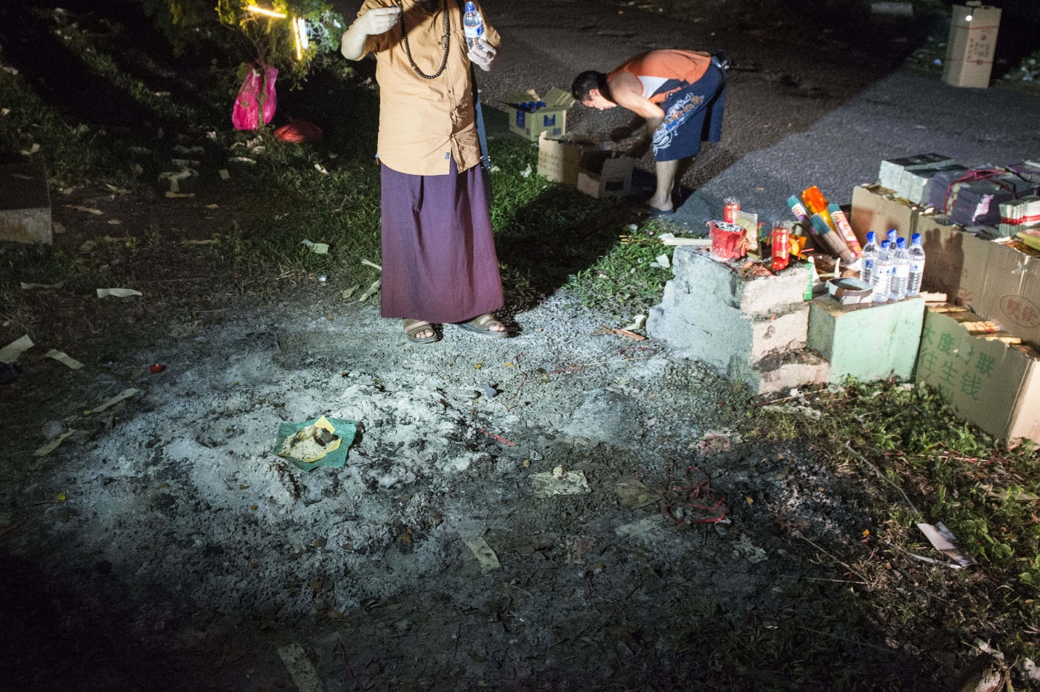
FIGURE 3 Juxtaposing bodies.
As the flames reach their peak, the adherents also start throwing bai ku qian (white warehouse money) upwards. These small slips of paper often have silver leaf imprinted onto them, symbolising silver currency, and are meant as payment to any spirits in the area for the living's safe passage. These effigies are not meant to be burnt, but are instead scattered throughout the area, temporarily marking the area as a site of ritual and remembrance. In this case, the vortex created by the flames carries the bai ku qian far into the air, further than anyone can throw. The scene is not just performative, it is spectacular – a fitting climax that often punctuates such rituals.
Figure 4 (as well as Figure 1 at the start of this paper) shows not just the praxis of adherents as they witness the work they have done, but also the praxis of objects as they fly, dance and disintegrate. The photograph works to express absence through the presence of objects‐in‐motion because readers are no longer asked to imagine how they exuded presence when they were placed, but are instead witness to the actual act of emplacement, the instance of inscription on the landscape. By freezing the act of dispersal and burning, the photograph now accentuates and intensifies the presence of these objects, allowing us to see and experience the assemblage of this deathscape in progress. The absences of dead individuals, previ- ously made evident by their static graves, are now performed in concert with the mundane objects being hierophanised for them.
CONCLUSION: THE AESTHETICS OF DEATHSCAPE PHOTOGRAPHS
In a paper on using photographs as illustrations in geographical fieldwork, Rose argues that photos can do something that written text cannot … (they) have the unique ability to be strange and surprising. Illustrative photographs, instead of just supporting a written argument, can enliven it, intensify it, or maybe disturb and haunt it – perhaps even answer back. (Rose, 2008, p. 155)
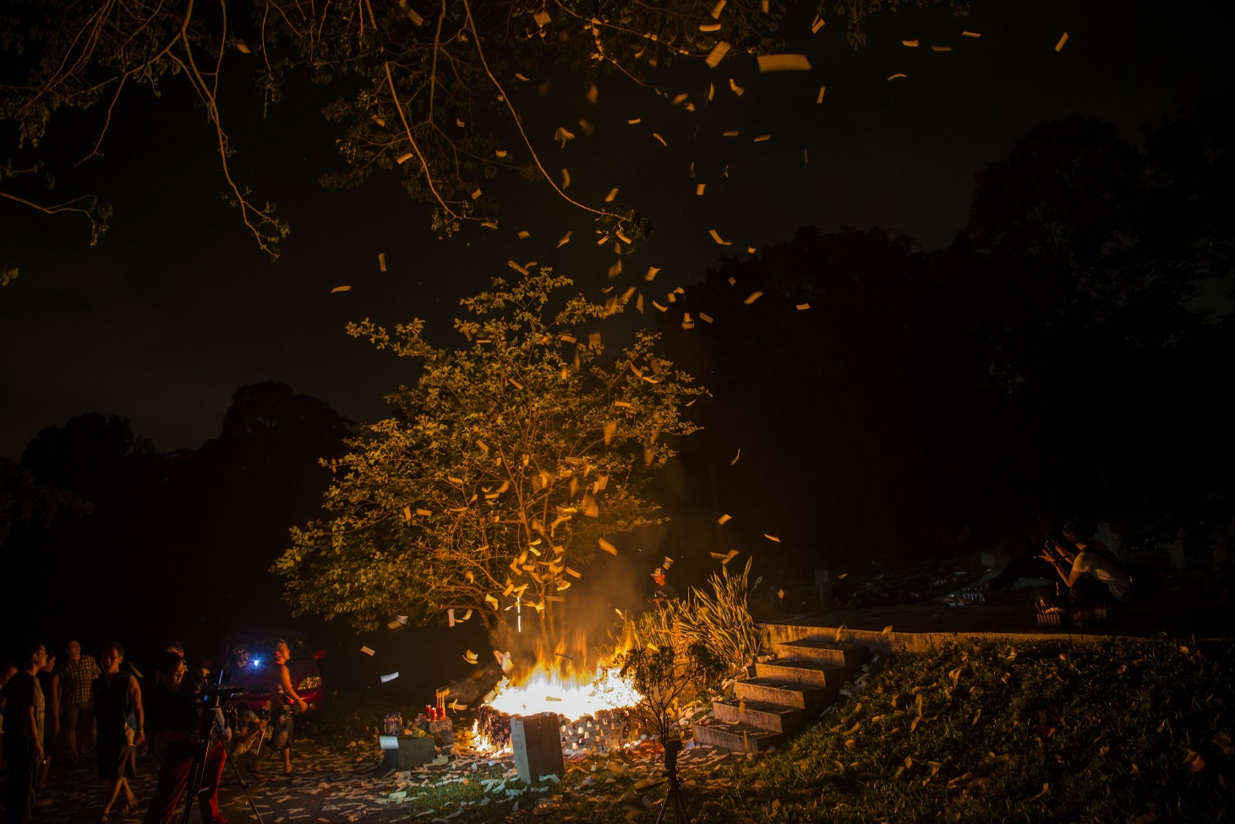
FIGURE 4 The instance of inscription: Seeing deathscapes assemble in real time.
So it is not new that photographs have the ability to influence and challenge. But what this paper can contribute is illumi- nating some of the ways in which we can better visualise the absence–presence dynamic through photographing and freez- ing points of praxis. These points, when captured, allow us to witness the intense presence of individuals’ practices, accentuating absence and the continuing bonds that living and dead share. Not all photographs are capable of doing this – we need to create, find, select and contextualise photographs that are more likely to afford us the opportunity to discover that agency necessary to visualise points of praxis. Two arguments are useful in extending this point. The first is by Pauwels, who writes about the need for style and aesthetics in photographs created for the social sciences, arguing that “visual scholars should no longer disregard or neglect the vital importance of style and form (the ‘how’) in conveying any content (the ‘what’)” (2012, p. 250).
Pauwels frames the “style and form” of a photograph in terms of what he calls “functional aesthetics” – in other words, aesthetics that “result in better, richer forms of scholarly communication that will help data transfer and argumentation” (2012, p. 251). In functional aesthetics we do not only see the photograph as either a record of our observations (the mechanical representation argument) or as text to be read (the semiotics or constructivist argument), but also as an opportu- nity for an emotional, sensorial engagement with the researcher's field. In other words, we cannot be satisfied by a pho- tograph as an agent (Larsen, 2008) that assembles deathspaces through the mundane framing of the subject or landscape, but as an agent that does this in a creative, expressive and aesthetic manner, where such aesthetics are central to our under- standing of the assembled intangibilities of the place.
The second point follows on from the first and, although there is not enough space here to deal with the issue in its entirety, it is certainly worth considering for future research and analysis. If a photograph's functional aesthetics are to con- vey content in an exciting and evocative form, and for the purposes of this study, to convey the intangibilities of death- spaces by visualising the sensorial aspect of Bukit Brown Cemetery, then the photograph can potentially take on a more sensorial role (Pink, 2009) than primarily informative or illustrative. This kind of photograph eschews content and by itself may then be seen as too abstract to be understood. However, when contextualised within a series of other more descriptive photographs, i.e., becomes part of a visual assemblage of the place, its agency becomes a specific part of Barthes's (1981) framework of studium – to evoke. In this way, the photograph achieves a combination of Nakamura's (2013) two strands of sensory ethnography – the aesthetic‐sensual and the multisensory‐experiential. For this kind of photograph to work, it cannot be overly descriptive. Its agency lies in mystery and possibilities, its abstractness and texture.

ACKNOWLEDGEMENTS
The author would like to thank the editors of the special section and reviewers for their comments, which have made this a much more focused paper. The author would also like to thank the Bukit Brown Documentation Project team, particularly Yew-Foong, Pik Ching and David. Finally, thanks must also go to the informants, who so gamely agreed to be photo- graphed and observed.
REFERENCES
Ballerini, J. (2004). Photography and geography. History of Photography, 28, 299–300. https://doi.org/10.1080/03087298.2004.10441327
Barthes, R. (1981). Camera lucida. New York, NY: Hill and Wang.
Bartolini, N., MacKian, S., & Pile, S. (2018). Talking with the dead: Spirit mediumship, affect and embodiment in Stoke‐on‐Trent. Transactions of the Institute of British Geographers, 43, 170–183. https://doi.org/10.1111/tran.12207
Biemann, U. (2002). Remotely sensed: A topography of the global sex trade. Feminist Review, 70, 75–88.
Burns, A. L., Mitchell, G., & Obradovich, S. (1989). Of sex roles and strollers: Female and male attention to toddlers at the zoo. Sex Roles, 20,309–315. https://doi.org/10.1007/BF00287727
Cartier-Bresson, H. (1952). The decisive moment: Photography by Henri Cartier-Bresson. New York, NY: Simon and Schuster.
Chan, S. C. (2018). Heritagizing the Chaozhou hungry ghosts festival in Hong Kong. In C. Maags, & M. Svensson (Eds.), Chinese heritage in the making (pp. 146–167). Amsterdam, The Netherlands: Amsterdam University Press.
Chong, T., & Chua, A. L. (2014). The multiple spaces of Bukit Brown. In W. S. W. Lim (Ed.), Public space in urban Asia (pp. 26–55). Singapore: World Scientific Publishing.
Collier, J., & Collier, M. (1999). Visual anthropology: Photography as a research method (revised and expanded edition). Albuquerque, NM: University of New Mexico Press.
Davies, D. J. (2010). Geographies of the spirit world. In J. L. Hockey, C. Komaromy, & K. Woodthorpe (Eds.), The matter of death: Space, place and materiality (pp. 208–222). London, UK: Palgrave Macmillan.
DeBernardi, J. (2006). The way that lives in the heart: Chinese popular religion and spirit mediums in Penang, Malaysia. Stanford, CA: Stanford University Press.
DeWalt, K. M., & DeWalt, B. R. (2011). Participant observation: A guide for fieldworkers. Oxford, UK: AltaMira Press.
Edwards, E. (1997). Beyond the boundary: A consideration of the expressive in photography and anthropology. In M. Banks, & H. Morphy (Eds.), Rethinking visual anthropology (pp. 53–80). New Haven, CT and London, UK: Yale University Press.
Foote, K., & Grider, S. (2010). Memorialisation of US college and university tragedies: Spaces of mourning and remembrance. In A. Maddrell, & J. Sidaway (Eds.), Deathscapes: Spaces for death, dying, mourning and remembrance (pp. 181–106). Farnham, UK: Ashgate.
Francaviglia, R. V. (1971). The cemetery as an evolving cultural landscape. Annals of the Association of American Geographers, 61, 501–509.https://doi.org/10.1111/j.1467-8306.1971.tb00802.x
Goin, P. (2002). Where the pavement ends. Geographical Review, 92, 545–554. https://doi.org/10.1111/j.1931-0846.2002.tb00012.x
Harper, D. A. (2012). Visual sociology. New York, NY: Routledge.
Heng, T. (2014). Hungry ghosts in urban spaces: A visual study of aesthetic markers and material anchoring. Visual Communication, 13, 147–162. https://doi.org/10.1177/1470357213496520
Heng, T. (2015). An appropriation of ashes: Transient aesthetic markers and spiritual place‐making as performances of alternative ethnic identi- ties. The Sociological Review, 63, 57–78. https://doi.org/10.1111/1467-954X.12235
Heng, T. (2016). Making “unofficial” sacred space: Spirit mediums and house temples in Singapore. Geographical Review, 106, 215–234. https://doi.org/10.1111/j.1931-0846.2015.12156.x
Heng, T. (2017). Visual methods in the field: Photography for the social sciences. London, UK: Routledge.
Hockey, J. L., Komaromy, C., & Woodthorpe, K. (2010). The matter of death: Space, place and materiality. London, UK: Palgrave Macmillan. Hunniford, G. (2008). Always with you. London, UK: Hodder & Stoughton.
Hunter, A. (2016). Deathscapes in diaspora: Contesting space and negotiating home in contexts of post‐migration diversity. Social & Cultural Geography, 17, 247–261. https://doi.org/10.1080/14649365.2015.1059472
Jenkins, O. (2003). Photography and travel brochures: The circle of representation. Tourism Geographies, 5, 305–328. https://doi.org/10.1080/14616680309715
Junker, B. (1960). Field Work. Chicago, IL: University of Chicago Press.
Knowles, C., & Sweetman, P. (2004). Picturing the social landscape: Visual methods and the sociological imagination. London, UK: Routledge. Kong, L. (1993). Ideological hegemony and the political symbolism of religious buildings in Singapore. Environment and Planning D: Society and Space, 11, 23–45. https://doi.org/10.1068/d110023
Kong, L. (1999). Cemeteries and Columbaria, memorials and mausoleums: Narrative and interpretation in the study of deathscapes in geography. Australian Geographical Studies, 37, 1–10. https://doi.org/10.1111/1467-8470.00061
Larsen, J. (2008). Practices and flows of digital photography: An ethnographic framework. Mobilities, 3, 141–160. https://doi.org/10.1080/17450100701797398
MacConville, U., & McQuillan, R. (2010). Potent reminders: An examination of responses to roadside memorials in Ireland. In J. Hockey, C.
Komaromy, & K. Woodthrope (Eds.), The matter of death: Space, place and materiality (pp. 195–207). Basingstoke, UK: Palgrave.
Maddrell, A. (2013). Living with the deceased: Absence, presence and absence‐presence. Cultural Geographies, 20, 501–522. https://doi.org/10.1177/1474474013482806
Maddrell, A., & Sidaway, J. D. (2010). Deathscapes: Spaces for death, dying, mourning and remembrance. Farnham, UK: Ashgate. Metz, C. (1985). Photography and fetish. October, 34, 81–90. https://doi.org/10.2307/778490
Nakamura, K. (2013). Making sense of sensory ethnography: The sensual and the multisensory. American Anthropologist, 115, 132–135.https://doi.org/10.1111/j.1548-1433.2012.01544.x
Pauwels, L. (2012). Contemplating the state of visual research: An assessment of obstacles and opportunities. In S. Pink (Ed.), Advances in visual methodology (pp. 248–264). London, UK: Sage.
Pink, S. (2007). Doing visual ethnography: Images, media and representation in research (3rd ed.). London, UK: Sage. Pink, S. (2009). Doing sensory ethnography. London, UK: Sage.
Rose, G. (2008). Using photographs as illustrations in human geography. Journal of Geography in Higher Education, 32, 151–160. https://doi.org/10.1080/03098260601082230
Rose, G. (2012). Visual methodologies: An introduction to the interpretation of visual materials (3rd ed.). London, UK: Sage.
Sidaway, J. D. (2002). Photography as geographical fieldwork. Journal of Geography in Higher Education, 26, 95–103. https://doi.org/10.1080/03098260120110395
Schwartz, J. M., & Ryan, J. R. (2003). Picturing place: Photography and the geographical imagination. London, UK: I.B. Tauris.
Teather, E. K. (1998). Themes from complex landscapes: Chinese cemeteries and columbaria in Urban Hong Kong. Australian Geographical Studies, 36, 21–36. https://doi.org/10.1111/1467-8470.00037
Teather, E. K. (2001). The case of the disorderly graves: Contemporary deathscapes in Guangzhou. Social & Cultural Geography, 2, 185–202. https://doi.org/10.1080/14649360120047805
Teiser, S. (1996). The ghost festival in medieval China. New Jersey, NJ: Princeton University Press.
Tong, C. K., & Kong, L. (2000). Religion and modernity: Ritual transformations and the reconstruction of space and time. Social & Cultural Geography, 1, 29–44. https://doi.org/10.1080/14649369950133476
Wee, V. (1976). Buddhism in Singapore. In R. Hassan (Ed.), Singapore: Society in transition (pp. 155–188). Kuala Lumpur, Malaysia: Oxford University Press.
Wells, L. (2015). Photography: A critical introduction. London, UK: Routledge.
Wojtkowiak, J., & Venbrux, E. (2010). Private spaces for the dead: Remembrance and continuing relationships at home memorials in the Nether- lands. In A. Maddrell, & J. D. Sidaway (Eds.), Deathscapes: Spaces for death, dying, mourning and remembrance (pp. 207–221). Farnham, UK: Ashgate.
Young, C., & Light, D. (2013). Corpses, dead body politics and agency in human geography: Following the corpse of Dr Petru Groza. Transac- tions of the Institute of British Geographers, 38, 135–148. https://doi.org/10.1111/j.1475-5661.2012.00502.x

