**Initial reduction of therapy prior to complete treatment discontinuation in chronic myeloid leukaemia: Final results of the British DESTINY Study.**

Richard E Clark, Fotios Polydoros, Jane F Apperley, Dragana Milojkovic, Katherine Rothwell, Christopher Pocock, Jennifer Byrne, Hugues de Lavallade, Wendy Osborne, Lisa Robinson, Stephen G O’Brien, Lucy Read, Letizia Foroni, Mhairi Copland.

Department of Haematology, Royal Liverpool University Hospital, Liverpool, UK (Prof R E Clark MD); Liverpool Cancer Trials Unit, University of Liverpool, Liverpool, UK (F Polydoros MSc, L Read BA); Department of Haematology, Hammersmith Hospital, London, UK (Prof J F Apperley MD, D Milojkovic PhD, Prof L Foroni PhD); Department of Haematology, St James University Hospital, Leeds, UK (K Rothwell PhD); Department of Haematology, East Kent Hospitals, Canterbury, UK (C Pocock PhD); Department of Haematology, City Hospital, Nottingham, UK (J Byrne PhD); Department of Haematology, King’s College Hospital, London, UK (H de Lavallade MD); Department of Haematology, Freeman Hospital, Newcastle-on-Tyne, UK (W Osborne MBBS, Prof S G O’Brien); Department of Haematology, Wye Vale NHS Trust, Hereford, UK (L Robinson MBBS); Paul O’Gorman Leukaemia Research Centre, University of Glasgow, Glasgow, UK (Prof M Copland).

**Corresponding Author:** Prof. Richard E. Clark,

Department of Haematology,

Royal Liverpool University Hospital,

Prescot Street,

Liverpool L7 8XP

United Kingdom

Email: [clarkre@liverpool.ac.uk](mailto:clarkre@liverpool.ac.uk).

Telephone: +44 (0)151-706-4344

FAX: +44 (0)151-706-5810

**Running title:** Initial TKI reduction prior to complete discontinuation in CML (63 characters)

**Word counts:** abstract 298, text 4296.

2 Tables (plus 3 supplementary in WebAppendix), 4 Figures (plus 2 supplementary in Web Appendix), 21 references.

ABSTRACT

BACKGROUND. All studies of treatment free remission (TFR) in chronic myeloid leukaemia have discontinued treatment abruptly, and have focussed on stable MR4 (BCR-ABL/ABL ratio <0.01%). Information is lacking on more gradual treatment withdrawal and whether TFR is feasible for less deep though stable remission.

METHODS. The De-Escalation and Stopping Treatment with Imatinib, Nilotinib or sprYcel (DESTINY) study (NCT 01804985) recruited 174 adult first chronic phase patients, with all (≥3) BCR-ABL qPCR transcript levels < 0.1% (major molecular response; MMR) in the 12 months before entry. If all were also <0.01%, the patient was assigned to an ‘MR4 group’ (as in other studies); patients with result(s) between 0.1% and 0.01% were allocated to a novel ‘MMR group’. Treatment was de-escalated to half the standard dose for 12 months, then stopped for a further 24 months, with frequent PCR monitoring. Recurrence was defined as the first of 2 consecutive samples >0.1%; this required treatment recommencement at full dose.

FINDINGS. Treatment at entry was imatinib (148), nilotinib (16) or dasatinib (10), for a median of 6.9 years. Recurrence free survival after 36 months on study (the primary endpoint), was 72% (95% CI: 64-80%) in MR4 patients, and 36% (95% CI 25-53%) in the MMR group. Treatment duration predicted recurrence (p=0.021), but age, gender or performance status did not. Patient diaries revealed improvement of common treatment related symptoms both on initial de-escalation and again on stopping. No disease progression was seen; two deaths occurred due to unrelated causes. All recurrences regained MMR within 5 months of treatment resumption.

INTERPRETATION. Initial de-escalation may improve the success of TFR, though the mechanism of its benefit is not yet clear. Both de-escalation and stopping treatment improve symptoms. The findings also suggest that TFR merits further study in stable MMR patients.

FUNDING. Newcastle University and Bloodwise.

INTRODUCTION

Thanks to tyrosine kinase inhibitors (TKIs), the life expectancy of the vast majority of patients who are newly diagnosed with chronic myeloid leukaemia is now comparable to healthy age-matched individuals1. This dramatic improvement in outlook is mainly due to the efficacy of TKI therapy, aided by highly efficient molecular monitoring which can detect *BCR-ABL1* transcripts at very low levels. This has led to increasing focus on the side effects of therapy2 and on whether after a few years of TKI therapy it may be possible to stop treatment.

Begun in 2006, the STIM study of stopping imatinib in 100 French patients in deep remission established that treatment free remissions (TFRs) are possible for some patients3. Several subsequent TFR studies (reviewed in 4 and 5) have used the loss of major molecular response (MMR, defined as a *BCR-ABL1* to *ABL1* transcript ratio of <0.1%) as the definition of molecular recurrence. The largest of these is the EUROSKI trial, which recently reported a molecular recurrence-free survival (RFS) of 61% at 6 months and 50% at 24 months after treatment cessation6 in 755 evaluable patients. This study also found that longer treatment duration and longer deep molecular response durations were associated with increased probability of maintenance of MMR 6 months after treatment cessation.

The vast majority of TFR studies so far have abruptly stopped TKI therapy in patients consistently in MR4 (*BCR-ABL1* to *ABL1* transcript ratio of < 0.01%). It is possible that some patients who would have experienced molecular recurrence with this approach might maintain MMR on lower than standard TKI doses, relieving ongoing TKI-related side effects. Reduction of therapy in 19 patients in established deep remissions appears safe7, and recent mathematical modelling data suggest that this may not lead to a reduction of long-term treatment efficacy for most patients8. In addition, apart from anecdotal reports9,10 and a study of 12 patients11 TFR has not been formally studied in patients achieving enduring MMR but not necessarily MR4. The present study was designed to examine these TFR questions. Entry was permitted for patients with stable MMR over the previous 12 months, and patients were stratified into either an MR4 (or deeper) group as in many other studies, or a novel MMR group not previously studied. The trial design comprised initial de-escalation to half the standard TKI dose for 12 months, followed by complete cessation.

Interim results of the de-escalation phase of this De-Escalation and Stopping Treatment with Imatinib, Nilotinib or sprYcel (DESTINY) study have been published12. We now present the final results of the study after the subsequent 24 months of treatment cessation.

METHODS

Study design and participants

The trial was part of the UK National Cancer Research Institute portfolio, and was registered at <https://clinicaltrials.gov/> as NCT 01804985. It was sponsored jointly by the University of Liverpool and the Royal Liverpool and Broadgreen University Hospitals Trust, and was approved by the North West - Liverpool East Committee of the UK National Research Ethics Service. Trial entry required fulfilment of all the following: aged ≥18; in first chronic phase with a known *BCR-ABL1* transcript (any transcript type was permitted); ≥3 years of therapy with either imatinib, nilotinib or dasatinib; no change in TKI unless for intolerance (once only); ≥3 PCR measurements over the preceding 12 months, each with ≥10,000 *ABL1* control transcripts AND *BCR-ABL/ABL1* ratio of ≤ 0.1%. If all PCR measurements during this pre-trial observation period were ≤ 0.01% (i.e. in MR4 throughout), the patient was assigned to an ‘MR4 group’; if some or all were > 0.01% but ≤ 0.1%, the patient was assigned to an ‘MMR group’. Prior interferon-α therapy was permitted if discontinued ≥12 months before entry. Recipients of ponatinib or bosutinib or of doses higher than imatinib 400mg daily, nilotinib 400mg twice daily or dasatinib 100mg daily (unless within a trial comparing front-line standard and higher doses) were all excluded.

Procedures

The treatment strategy was identical for both groups, and comprised 2 sequential phases; an initial 12 months of de-escalation to half the standard TKI dose at the time of trial design, followed by 24 months of treatment cessation. The dose during de-escalation comprised continuing the same TKI at imatinib 200mg daily, nilotinib 200mg twice daily, or dasatinib 50mg daily. Patients already on reduced doses of TKI because of intolerance of the standard dose were eligible as long as their dose was at least the de-escalation dose. Molecular monitoring was carried out centrally at Imperial College Molecular Pathology at Hammersmith Hospital, London, monthly for the first 2 years and alternate months thereafter. PCR results for the 172 patients with e13a2 and/or e14a2 transcripts were expressed using International Scale (IS) standardisation (the remaining 2 patients had the e19a2 transcript).

Outcomes

The primary end-point for both the MR4 and the MMR groups was the proportion of patients who can first de-escalate their treatment (to half the standard dose of their TKI) for 12 months, and then stop treatment completely for a further 2 years, without losing MMR. This was estimated separately for the MR4 and MMR groups. Molecular recurrence, defined as loss of MMR, was timed as the first of two consecutive results > 0.1%. Such patients were required to resume their entry TKI at the full standard dose, and were followed monthly until the PCR was ≤ 0.1%IS, at which point they were taken off trial.

Secondary endpoints comprised the following, all of which are summarised in Supplementary Table 2 in the WebAppendix: overall survival (OS, the time from commencing de-escalation to death from any cause); progression-free survival (PFS, the time from commencing de-escalation to the earlier of date of progression to advanced phase or death from any cause); event-free survival (EFS, the time from commencing de-escalation to the date of confirmed loss of MMR, progression to advanced phase or death from any cause); the proportion of patients who lose MMR on de-escalation/stopping and regain MMR on resumption of their TKI, and their time to MMR recovery (TTR, defined as the time from the date of confirmed loss of MMR to the date of MMR recovery); the proportion of patients who successfully de-escalate treatment but then lose MMR on complete TKI cessation; the proportion of patients in confirmed MR4.5 (BCR-ABL ≤ 0.0032% IS with at least 31,623 ABL1 control transcripts) prior to being enrolled in the study. The following secondary endpoints have already been reported: Health Economic Assessment12, Quality of Life12 and laboratory studies to identify subsets of patients who are more likely to relapse on de-escalation / cessation18.

Patients were asked to keep a diary throughout their follow-up, recording any new symptoms and the evolution of already reported ones, and to grade these according to the standard National Cancer Institute Common Toxicity Criteria. The diaries were semistructured, specifically asking about the symptoms presented in the WebAppendix). FACT-BRM and EQ-5D Quality of Life data at trial entry were already comparable to a healthy control population as previously reported12, suggesting that these instruments are too insensitive for well controlled chronic myeloid leukaemia.

Statistical analysis

The sample size was calculated assuming a worst-case scenario (proportion of relapsing patients = 0.5; group allocation of 1:3 in either direction; 17% dropouts ), and estimated that 168 patients would provide 90% confidence intervals (CI) with maximum width of 0.16 and 0.28 for the “larger” and “smaller” group respectively.

Although no formal stopping rules were defined, three pre-planned Interim Analyses were performed and reviewed by an Independent Safety Data Monitoring Committee, to allow early termination of either group if an unacceptable RFS was observed.

All statistical analyses were performed on an intention-to-treat basis using R (version 3.3.1). No adjustment for multiple testing or missing data was incorporated. Continuous variables were summarised using median and inter quartile range (IQR) values, whereas frequencies, proportions and polar charts were used for categorical variables. The RFS was estimated using the Kaplan Meier method and reported with 95% CI. For the estimation of time to MMR recovery, cumulative incidence analysis adjusting for the competing risk of death/progression to advanced phase was used. Univariate and multivariate Cox regression analysis were used to explore the effect of various trial entry characteristics on RFS.

Role of the funding source

The sponsor and the funding sources had no role in study design, or collection, analysis, or interpretation of the data or in the writing of this manuscript. Authors REC (corresponding author), FP and LR had full access to all of the data, and LF had access to the molecular data. Authors REC and FP had the final responsibility to submit for publication.

RESULTS

The trial recruited at 20 British centres listed on page 1 of the WebAppendix, between 16th December 2013 and 6th May 2015. A total of 335 patients were screened, but 161 did not enter the trial. These comprised 67 patients who declined due to concern over additional visits (19) or bone marrow aspiration (requested at entry and recurrence for laboratory research studies (4)), apprehension about stopping treatment (7), or no information available (37), and 94 who were ineligible (didn’t meet all the inclusion criteria (29), exceeded ≥1 exclusion criterion (40), or study closed to recruitment before the patient was registered (25)).

Clinical details of the 174 entrants have been previously published12 and are summarised here as Supplementary Table 1 on page 2 of the WebAppendix for completeness. At entry, 148 patients were receiving imatinib, 16 nilotinib and 10 dasatinib, for a median duration of 6.9 years (IQR 4.8 – 10.2 years). The CONSORT diagram in Figure 1 gives their flow through the trial; the MR4 and MMR groups comprised 125 and 49 patients respectively. All but 2 entrants had either an e13a2 or an e14a2 *BCR-ABL1* transcript; the remaining 2 had an e19a2. Three (2%) MR4 and 9 (18%) MMR patients relapsed during the de-escalation phase, as previously reported12, and 4 and 1 patients respectively from these groups withdrew consent before completion of de-escalation from concern regarding stopping treatment; thus 118 MR4 and 39 MMR patients entered the treatment cessation phase.

Molecular recurrence

Figure 2 gives the RFS for each group. In the MR4 group, 84 of the original 125 entrants reached the 36 month trial completion point, giving a 3-year RFS of 72% (95% CI 64-80%). Recurrence was seen in 34 patients, and 7 discontinued for other reasons (5 withdrew consent, 1 pregnancy, 1 protocol violation). In the MMR group, 16 of the 49 entrants completed the study, giving a 3-year RFS of 36% (95% CI 25-53%) with 30 molecular recurrences and 3 consent withdrawals. The RFS is significantly worse in the MMR group than in the MR4 group (log rank statistic 27.11; p < 0.001). Outcomes of the secondary endpoints are given in Supplementary Table 2 on page 3 of the Appendix.

In exploratory analysis, of the 4 scoring systems using diagnostic data to predict long term outcome in chronic myeloid leukaemia 13-16, Supplementary Table 3 on page 4 of the Appendix summarises the comparison of high vs low/intermediate scores for the 74 patients with available data. No significant association was seen between any of these scores and the RFS, nor if high/intermediate scores were compared with low scores. Similarly, no significant association was seen when the MMR or MR4 groups were considered in isolation (data not shown).

Allocation to the MMR group

*Per protocol*, patients were allocated to the MMR or MR4 group according to the pattern of PCR results in the pre-entry 12 month observation period. A sensitivity analysis was carried out to see how this differed from merely allocating patients to MR4 or MMR groups by their single centralised molecular result at trial entry. Of the 125 patients that were classified as MR4 based on local results, 124 (99%) were ‘confirmed’ as MR4 by the centralised molecular assessment. However, this single entry result would have allocated 38 of the 49 MMR patients to the MR4 group, and 15 of these (39%) completed the study without recurrence. Of the 11 MMR patients who would remain in an MMR group if categorised on a single entry molecular assessment, 3 completed the study without recurrence (RFS 31%), all of whom achieved MR4 during the de-escalation phase. These RFS results for these different subpopulations within the protocol-defined MMR group therefore appear similar, and consistent with the overall results for the MMR group, though this clearly requires further study.

Molecular recurrence in patients in MR4.5 on study entry

Figure 3 shows the RFS stratified according to whether in MR4.5 (defined at *BCR-ABL1:ABL1* ≤ 0.0032%IS) or not at trial entry. In the MR4 group, for patients with at least 31623 control transcripts, being in MR4.5 at study entry confers no advantage (p=0.99). In the MMR group (where a patient can also be in MR4.5 at trial entry, since the assignment to trial group was determined by the previous 12 months local PCR results, whereas the assessment of molecular status was by central molecular analysis at trial entry), being in MR4.5 also confers no advantage (p=0.47), though the numbers at risk of recurrence become very low beyond ~18 months.

Molecular recurrence in patients on less than standard TKI doses on entry

Twenty-six patients entered the trial on TKI doses lower than standard. These comprised imatinib at an average once daily dose of 300mg (13), 200mg (3), 350 or 250 mg (1 each), nilotinib at twice daily doses of 300mg (4), 225 or 200mg (1 each), or dasatinib at a once daily dose of 80 or 50mg (1 each); their distribution by group and individual outcome has been previously reported (Table 4 of reference 12). The exclusion of these 26 “less than standard dose” entrants does not affect the RFS at 36 months: in the MR4 group this becomes 68% (from 72%) and in the MMR group 37% (from 36%).

Predictive factors for molecular recurrence

The results of Cox regression analysis of the association between various trial entry characteristics and the RFS are shown in Table 1. It was not feasible to include Time in MR4, since this is only applicable for the MR4 patients, in whom there are few recurrence events. Furthermore, both Time in MR4 and Time in MMR were incomplete, since complete molecular data from original diagnosis were unavailable for 80 patients, and were invariably locally derived and not to IS. Conversely, Time on TKI was easily retrieved from the treatment history.

In univariate analysis, no relationship was seen with the length of time in MMR before trial entry, but there was a significant association between trial group and recurrence, as expected from Figure 2. Being in MR4.5 at trial entry was also strongly correlated with continued molecular remission, since most MR4.5 patients were in the MR4 group. There was also a trend for fewer recurrences in patients with longer treatment durations; although the proportion of recurrences in the shortest two quartiles (3-5 and 5-7 years on TKI) is comparable (46% and 55% respectively), this drops to 28% and 24% for the longest two quartiles (7-10 and 10-14 years on TKI respectively). However, this distribution differs for the two trial groups, in that the proportion of recurrences falls below 50% beyond 7 years of TKI therapy in the MR4 group, but not until after 9 years of therapy in the MMR group (data not shown), suggesting that MMR patients may need around 2 extra years of TKI therapy to achieve similar RFS to MR4 patients.

In multivariate analysis, the only significant factors predictive of recurrence were the trial group and the duration of TKI treatment. Using the backward elimination method with a p value = 0.1 as threshold, the selected final model was:

ln (λ(t)/ λ0(t)) = -1.309 x [Molecular Group = MR4] – 0.083 x Time on TKI (in years)

where being in the MR4 group = 1 and the expression ln (λt/ λ0(t)) represents the log hazard ratio that the Cox Proportional Hazards model is estimating. This model estimates a non-linear average decrease in the proportion of recurrences of ~8% per additional year on TKI in the trial overall (reflected by the hazard ratio of 0.92 in Table 1), but again this differs according to trial group with an average 4% decreased recurrence rate/year for the MR4 group and 11% for the MMR group.

Recovery from molecular recurrence

Patients with recurrences were required to resume the full dose of their entry TKI, and all complied with this. Figure 4 gives the recovery from molecular recurrence classified according to our protocol definition. Of the 64 recurrences across the trial, 58 returned to MMR within 5 months of TKI resumption, with no significant difference (p=0.59) between the MR4 and MMR arms. Six patients (3 in each trial group) opted to either delay TKI resumption or to resume at less than full dose. This protocol violation precluded formal central molecular monitoring; however local PCR data in all 6 cases documented their return to MMR within 5 months.

Adverse events

During follow-up, two patients died due to worsening of pre-existing chronic obstructive pulmonary disease or peripheral arterial occlusive disease (both patients had only ever received imatinib). No patient underwent disease progression. One patient lost haematological response at the time of recurrence, this was rapidly regained on TKI resumption.

A total of 27 serious adverse events in 17 patients were reported, as given in Table 2. These include 4 myocardial infarctions and 1 episode of complete atrioventricular block, and 7 infections. All were declared as unrelated to the trial or the underlying disease. Non-serious adverse events were not recorded in this trial.

Using data from patient diaries, Supplementary Figure 1 on page 5 of the WebAppendix gives the frequency of individual TKI associated side effects over time. In each group, all improve especially in the first 3 months after both de-escalation and also stopping, though not thereafter.

During the first 12 months of the stopping phase, 56 (40%) of 141 assessible patients reported musculoskeletal symptoms comprising arthralgia (38), either generalised (21) or of specific joints or combinations thereof (17), myalgia (10), either generalised (6) or at various sites (1) or as muscle cramps (3) or both (5) or bone pain (3). The trial was however not designed to collect detailed information on the duration,or treatment of these symptoms.

DISCUSSION

There has been considerable interest in TFR in chronic myeloid leukaemia in the recent past4,5, with most studies typically showing RFS (defined as loss of MMR) of 50-60% in first chronic phase patients on TKI for some years and in stable MR4. Here we extend knowledge about TFR in two important ways.

Firstly, in patients in stable MR4, prefacing treatment cessation by a year of de-escalation produces an excellent subsequent 2 year RFS of 72%, which has only been equaled by a small study of interferon maintenance on imatinib withdrawal17. Though not a randomised comparison with abrupt cessation, the present result appears superior to all other TFR studies of TKI treatment withdrawal in chronic myeloid leukaemia, notably the recently published large EUROSKI study, which reported a 2-year RFS of 50% 6. Our entry criteria for MR4 patients were deliberately almost identical to EUROSKI, differing only in that we did not mandate an e13a2 or e14a2 transcript (2 patients expressed an e19a2 transcript, one of whom had a recurrence) or inclusion of diagnostic components of the Sokal score. Other TFR studies have used a single PCR value > 0.1% to define molecular recurrence, whereas here recurrence is defined as the first of 2 consecutive values > 0.1%. Altering our recurrence definition to a single result > 0.1% brings forward the timing of recurrence in 8 cases (5 MR4, 3 MMR) but has a negligible effect on the RFS (68% (from 72%) in the MR4 group and 30% (from 36%) in the MMR group).

The median durations of therapy in the present MR4 group and the comparable EUROSKI study patients differ by a year (6.5 vs. 7.5 years respectively), though the initial year of de-escalation in DESTINY may somewhat mitigate this difference. However, the mean benefit of additional treatment on RFS for the MR4 group is 4% per additional year, which as stated is comparable to the 3% observed in the EUROSKI study. It is therefore likely that the year of de-escalation has some bearing on the present excellent result for the MR4 group. Possible mechanisms might include altering the quiescent proportion of leukaemic stem cells (LSC) at a time when TKI is still present, or altering competition for the haematopoietic niche in favour of normal haematopoietic stem cells, but investigation of this is difficult as by definition there are very few LSC available for study. Alternatively, TKI de-escalation may modify anti-leukaemic immune responses. We have recently shown that changes in CD4+ regulatory T cells, CD56dim and CD56bright NK cell subsets occur during TKI de-escalation; indeed no further changes are seen on stopping for any subset; furthermore a rise in the effector memory CD8+ subset predicts molecular recurrence18. Treatment discontinuationis more successful in patients with higher NK cell levels 19,20, and less successful with higher CD86+ plasmacytoid dendritic cells21. Overall, current data are compatible with the view that the effect of TKIs on immune cell subset numbers and function may be greater in patients who will relapse after treatment discontinuation. The relative contribution of LSC activation and the immune system clearly requires further study, and it will also be interesting to look at whether longer periods of de-escalation can mitigate the sharp fall in RFS after subsequent cessation.

Secondly, we have included patients in stable MMR but not MR4 in a formal TFR study. Their RFS over the entire 36 months of study is 36%. This is a potentially practice-changing result since hitherto TFR attempts in MMR-only patients have been discouraged 5, though we stress that further studies are required in this patient group. Their heterogeneous PCR patterns during the pre-trial entry observational year range from those with all but one PCR result in MR4 to those with several results close to 0.1%. These extremes have similar RFS to the whole MMR group, though a larger sample size is required to determine whether particular PCR patterns affect the success of TFR.

Multivariate analysis revealed that the length of time on TKI (though not time in MMR) is associated with an improved RFS. We could not examine the effect of time in MR4 on recurrence, since our MR4 group had rather few recurrence events. The mean improvement in 2 year RFS of 8% per additional year of TKI is not linear with gradations in TKI duration, and the mean 4% improvement in RFS per additional treatment year for the MR4 group is comparable to the 3% seen in the EUROSKI study of similar patients 6. The greater benefit of additional treatment years for the MMR group, together with the tantalising finding that the RFS in MMR patients may be similar to MR4 patients after ~2 additional treatment years, require confirmation in further studies.

Our study has some limitations. Firstly, the local molecular assessments in the 12 month observation period prior to trial entry (i.e. during 2012-14) were not to IS. This arises because IS was not in universal use in the UK health service until ~2016, though this was similar to many other European countries and it is therefore possible that other contemporary and earlier studies may also be guilty of this problem. Furthermore, local and centralised results are at different time points, and characterising patients by serial pre-trial data may not be the same as defining at a single baseline molecular test. Although we show that these two alternatives do not make a difference for the MR4 group, in our novel MMR group 38 of the 49 patients would have been classified as in MR4 by their centralised baseline result, yet have an RFS that is clearly inferior to patients defined as MR4 by serial pre-trial molecular data. This suggests that a single PCR result **at** trial entry may be less powerful in predicting recurrence than the PCR trend **before** trial entry as used here. This will be an important area to consider in future studies, especially for MMR patients.

A further limitation is that follow up was curtailed at 36 months. Sites were encouraged to report patient outcome beyond this time, but this was not mandatory. Although Figure 2 shows that the number of recurrences in the final year of follow-up is low, in line with other studies, longer follow-up would be helpful, especially for the novel MMR group. We have previously shown that on de-escalation, the incidence of common TKI-associated symptoms typically improves 12, and now show that there is further improvement on subsequently discontinuing TKI in both trial groups. These data are derived from patients’ own diaries and are therefore not subject to possible bias by trialists as can occur with traditionally reported adverse events. It is not possible to examine whether symptom improvement is related to RFS, because recurrences are almost all in the first few months of stopping and these patients will therefore not have data on symptom changes, a problem known as immortal time bias.

In summary, we present data that initial de-escalation may improve the proportion of patients in stable MR4 who can successfully undergo a TFR attempt, though the mechanism of its benefit is not yet clear. In this regard it would be of considerable interest to carry out a meta-analysis of the present MR4 patients and those in EUROSKI. Different de-escalation strategies, both more gradual and more rapid, will be of considerable interest. We also use the same strategy in patients not in stable MR4, here labelled MMR, who have rarely been included in TFR studies to date. Approximately one-third of such patients remain in TFR 2 years after TKI cessation, but caution is urged in stopping treatment in MMR patients outside a clinical trial, as further TFR data are urgently required for this group.

AUTHOR CONTRIBUTIONS

The study was conceived by REC, SOB, JFA, LF and MC together with the late John Goldman and Tessa Holyoake. REC was the Chief Investigator of the trial and wrote the manuscript. FP was the trial statistician. LF together with JFA oversaw the centralised PCR testing. REC, JFA, DM, KR, CP, JB, HdL, WO, LRobinson and MC all recruited patients and also contributed to the trial management groups together with SOB. LRead was the trial co-ordinator. All authors commented on and approved the final manuscript.

DECLARATION of CONFLICT of INTERESTS

The following authors have declared relevant research support and/or honoraria from the following:

REC reports grants from Bloodwise (formerly Leukaemia & Lymphoma Research), grants from Newcastle University, during the conduct of the study; grants and personal fees from Pfizer, grants and personal fees from Novartis, grants and personal fees from Bristol Myers Squibb (BMS), personal fees from Ariad/Incyte, outside the submitted work; FP reports personal fees from Novartis Pharma AG, outside the submitted work; JFA reports personal fees from BMS, grants and personal fees from Incyte/Ariad, grants and personal fees from Novartis, grants and personal fees from Pfizer, outside the submitted work; DM reports personal fees from BMS, Novartis, Incyte and Pfizer, during the conduct of the study; KR reports personal fees from Novartis, outside the submitted work; JB reports personal fees from Novartis, personal fees from Pfizer, outside the submitted work; HdL reports grants and personal fees from BMS, grants and personal fees from Incyte, personal fees from Novartis, outside the submitted work; WO reports personal fees from Pfizer, non-financial support from Novartis, during the conduct of the study; personal fees and non-financial support from Roche, personal fees and non-financial support from Takeda, personal fees from Servier and Gilead and Merck-Sharp-Dohme, outside the submitted work; SO’B reports grants from BMS, outside the submitted work; and chairmanship of the UK National Institute of Clinical Excellence (NICE) Technology Appraisal Committee C; MC reports grants and personal fees from BMS, personal fees from Pfizer, grants, personal fees and non-financial support from Incyte, personal fees from Novartis, outside the submitted work. The other authors declared no conflicts of interest.

ACKNOWLEDGEMENTS

The UK charity Bloodwise (grant number 13020) supported the trial and Newcastle University Clinical Trials Unit assisted with arrangements for trial funding. JFA is a NIHR Senior Investigator and together with DM and LF, acknowledges the support of the Imperial College NIHR Biomedical Research Centre. The authors are indebted to Tony Coffey of Liverpool Clinical Trials Unit (LCTU) for early help in setting up the trial, Mrs. Susan Cain for logistic support, and Dr Richard Jackson (LCTU) for help in finalising the statistics and the Figures for publication. Finally we thank the patients and staff who have enthusiastically supported the trial.

REFERENCES

1. Bower H, Björkholm M, Dickman PW, Höglund M, Lambert PC, Andersson TM. Life expectancy of patients with chronic myeloid leukemia approaches the life expectancy of the general population. J Clin Oncol. 2016; 34: 2851-2857.

2. Steegmann J-L, Baccarani M, Breccia M, et al. European LeukaemiaNet recommendations for the management and avoidance of adverse events of treatment in chronic myeloid leukemia. Leukemia 2016; 30: 1648-1671.

3. Etienne G, Guilhot J, Réa D, et al. Long-term follow-up of the French Stop Imatinib (STIM1) study in patients with chronic myeloid leukemia. Journal of Clinical Oncology 2017; 35: 298-305.

4. Saussele S, Richter J, Hochhaus A, Mahon FX. The concept of treatment-free remission in chronic myeloid leukemia. Leukemia 2016; 30: 1638-1647.

5. Hughes TP, Ross DM. Moving treatment-free remission into mainstream clinical practice in CML. Blood 2016; 128: 17-23.

6. Saussele S, Richter J, Guilhot J, et al. Discontinuation of tyrosine kinase inhibitor therapy in chronic myeloid leukaemia (EURO-SKI): a prespecified interim analysis of a prospective, multicentre, non-randomised, trial. Lancet Oncol. 2018; 19: 747-757.

7. Faber E, Divoká M, Skoumalová I, et al. A lower dosage of imatinib is sufficient to maintain undetectable disease in patients with chronic myeloid leukemia with long-term low-grade toxicity of the treatment. Leuk Lymphoma. 2016; 57: 370-375.

8. Fassoni AC, Baldow C, Roeder I, Glauche I. Reduced tyrosine kinase inhibitor dose is predicted to be as effective as standard dose in chronic myeloid leukemia: a simulation study based on phase III trial data. Haematologica 2018; 103: 1825-1834.

9. Goh HG, Kim YJ, Kim DW, et al. Previous best responses can be re-achieved by resumption after imatinib discontinuation in patients with chronic myeloid leukemia: implication for intermittent imatinib therapy. Leuk Lymphoma. 2009; 50: 944-51.

10. Benjamini O, Kantarjian H, Rios MB, et al. Patient-driven discontinuation of tyrosine kinase inhibitors: single institution experience. Leuk Lymphoma. 2014; 55: 2879-2886.

11. Koskenvesa P1, Kreutzman A, Rohon P, et al. Imatinib and pegylated IFN-α2b discontinuation in first-line chronic myeloid leukemia patients following a major molecular response. Eur J Haematol. 2014; 92: 413-420.

12. Clark RE, Polydoros F, Apperley JF, et al. De-escalation of tyrosine kinase inhibitor dose in patients with chronic myeloid leukaemia patients with stable major molecular response (DESTINY): an interim analysis of a non-randomised phase 2 trial. Lancet Haematology 2017; 4: e310-e316.

13. Sokal JE, Cox EB, Baccarani M, et al. Prognostic discrimination in "good-risk" chronic granulocytic leukemia. Blood 1984; 63: 789-799.

14. Hasford J, Pfirrmann M, Hehlmann R, et al. A new prognostic score for survival of patients with chronic myeloid leukemia treated with interferon alfa. Writing Committee for the Collaborative CML Prognostic Factors Project Group. J Natl Cancer Inst. 1998; 90: 850-858.

15. Hasford J, Baccarani M, Hoffmann V, et al. Predicting complete cytogenetic response and subsequent progression-free survival in 2060 patients with CML on imatinib treatment: the EUTOS score. Blood 2011; 118: 686-692.

16. Pfirrmann M, Baccarani M, Saussele S, et al. Prognosis of long-term survival considering disease-specific death in patients with chronic myeloid leukemia. Leukemia 2016; 30: 48-56.

17. Burchert A, Saussele S, Eigendorff E, et al. Interferon alpha 2 maintenance therapy may enable high rates of treatment discontinuation in chronic myeloid leukemia. Leukemia 2015; 29: 1331-1335.

18. Austin GM, Knight K, Bell J, et al. The effect on lymphocyte subsets of decreasing/stopping tyrosine kinase inhibitor therapy in chronic myeloid leukaemia: data from the DESTINY trial. British Journal of Haematology 2018; Nov 8. doi: 10.1111/bjh.15629. [Epub ahead of print].

19. Ilander M, Olsson-Strömberg U, Schlums H, et al. Increased proportion of mature NK cells is associated with successful imatinib discontinuation in chronic myeloid leukemia. Leukemia 2017; 31: 1108-1116.

20. Réa D, Henry G, Khaznadar Z, et al. Natural killer-cell counts are associated with molecular relapse-free survival after imatinib discontinuation in chronic myeloid leukemia: the IMMUNOSTIM study. Haematologica 2017; 102: 1368-1377.

21. Schütz C, Inselmann S, Saussele S, et al. Expression of the CTLA-4 ligand CD86 on plasmacytoid dendritic cells (pDC) predicts risk of disease recurrence after treatment discontinuation in CML. Leukemia 2017; 31: 829-836, with erratum at Leukemia 2018; 32: 1054.

LEGENDS to TABLES and FIGURES

Table 1. Univariate and multivariable analysis of various parameters’ association with molecular recurrence. Where relevant, the hazard ratio refers to the probability of recurrence for the named parameter relative to the alternative (e.g. MR4 vs. MMR; male vs. female; imatinib vs. other entry drugs). CI = confidence interval.

Table 2. Serious adverse events (SAE).

Figure 1. CONSORT diagram for the trial.

Figure 2: Molecular recurrence-free survival (RFS) for each trial group. CI = confidence intervals.

Figure 3: Molecular recurrence stratified according to whether in MR4.5 at trial entry. Dotted lines = in MR4.5; solid lines = not in MR4.5. Red lines = MR4 group patients; blue lines = MMR group.

Figure 4: Recovery from molecular recurrence *per protocol*.

Table 1.

|  |  |  |  |
| --- | --- | --- | --- |
| *Univariate* |  |  |  |
| **CHARACTERISTIC** | **HAZARD RATIO** | **95% CI** | **p-value** |
|  |  |  |  |
| **Molecular group MR4** | **0.29** | **0.18-0.48** | **<0.001** |
|  |  |  |  |
| Age | 0.99 | 0.97-1.01 | 0.19 |
|  |  |  |  |
| Gender Male | 0.70 | 0.43-1.14 | 0.15 |
|  |  |  |  |
| Medication imatinib | 1.60 | 0.73-3.52 | 0.23 |
|  |  |  |  |
| ECOG score | 0.83 | 0.37-1.83 | 0.64 |
|  |  |  |  |
| Time on TKI | 0.94 | 0.87-0.99 | 0.082 |
|  |  |  |  |
| Time in MMR | 0.92 | 0.83-1.03 | 0.13 |
|  |  |  |  |
| **MR4.5 at entry** | **0.43** | **0.26-0.72** | **0.001** |
|  |  |  |  |
|  |  |  |  |
| *Multivariable* |  |  |  |
| **CHARACTERISTIC** | **HAZARD RATIO** | **95% CI** | **p-value** |
|  |  |  |  |
| **Molecular group MR4** | **0.27** | **0.16-0.44** | **<0.001** |
|  |  |  |  |
| **Time on TKI** | **0.92** | **0.86-0.99** | **0.021** |

**Table 2.**

|  |  |  |  |  |  |  |  |  |
| --- | --- | --- | --- | --- | --- | --- | --- | --- |
|  | | | **Severity: No. of SAEs (No. of patients)** | | | | | |
| **CTCAE Category (No. of SAEs)** | **CTCAE short name (No. of SAEs)** | **Group** | **1** | **2** | **3** | **4** | **5** |
| Cardiac disorders (7) | Myocardial infarction (4),  Atrioventricular block complete (1),  Chest pain – cardiac (1), Syncope (1) | MMR | - | - | - | - | - |
| MR4 | - | 3 (2) | 4 (4) | - | - |
| Eye disorders (1) | Other (1) | MMR | - | - | 1 (1) | - | - |
| MR4 | - | - | - | - | - |
| Gastrointestinal disorders (1) | Abdominal pain (1) | MMR | - | - | - | - | - |
| MR4 | - | - | - | 1 (1) | - |
| General disorders and administration site  conditions (1) | Pain (1) | MMR | - | - | - | - | - |
| MR4 | - | - | 1 (1) | - | - |
| Hepatobiliary disorders (1) | Gallbladder pain (1),  Other (1) | MMR | - | - | - | - | - |
| MR4 | - | - | 2 (1) | - | - |
| Immune system disorders (1) | Allergic reaction (1) | MMR | - | - | - | - | - |
| MR4 | - | 1 (1) | - | - | - |
| Infections and infestations (7) | Sepsis (3), Urinary tract infection (2),  Skin Infection (1), Vaginal infection (1) | MMR | - | - | 1 (1) | - | - |
| MR4 | - | 3 (2) | 3 (3) | - | - |
| Injury, poisoning, procedural  Complications (2) | Other (2) | MMR | - | - | - | - | - |
| MR4 | - | - | 2 (1) | - | - |
| Musculoskeletal and connective  tissue disorders (2) | Bone pain (1),  Other (1) | MMR | - | - | - | - | - |
| MR4 | - | - | 2 (2) | - | - |
| Nervous system disorders (1) | Headache (1) | MMR | - | - | - | - | - |
| MR4 | 1 (1) | - | - | - | - |
| Renal and urinary disorders (1) | Urinary retention (1) | MMR | - | - | - | - | - |
| MR4 | - | 1 (1) | - | - | - |
| Vascular disorders (1) | Other (1) | MMR | - | - | 1 (1) | - | - |
| MR4 | - | - | - | - | - |
| Total | | MMR | - | - | 3 (3) | - | - |
| MR4 | 1 (1) | 8 (6) | 14 (12) | 1 (1) | - |

Figure 1. CONSORT diagram

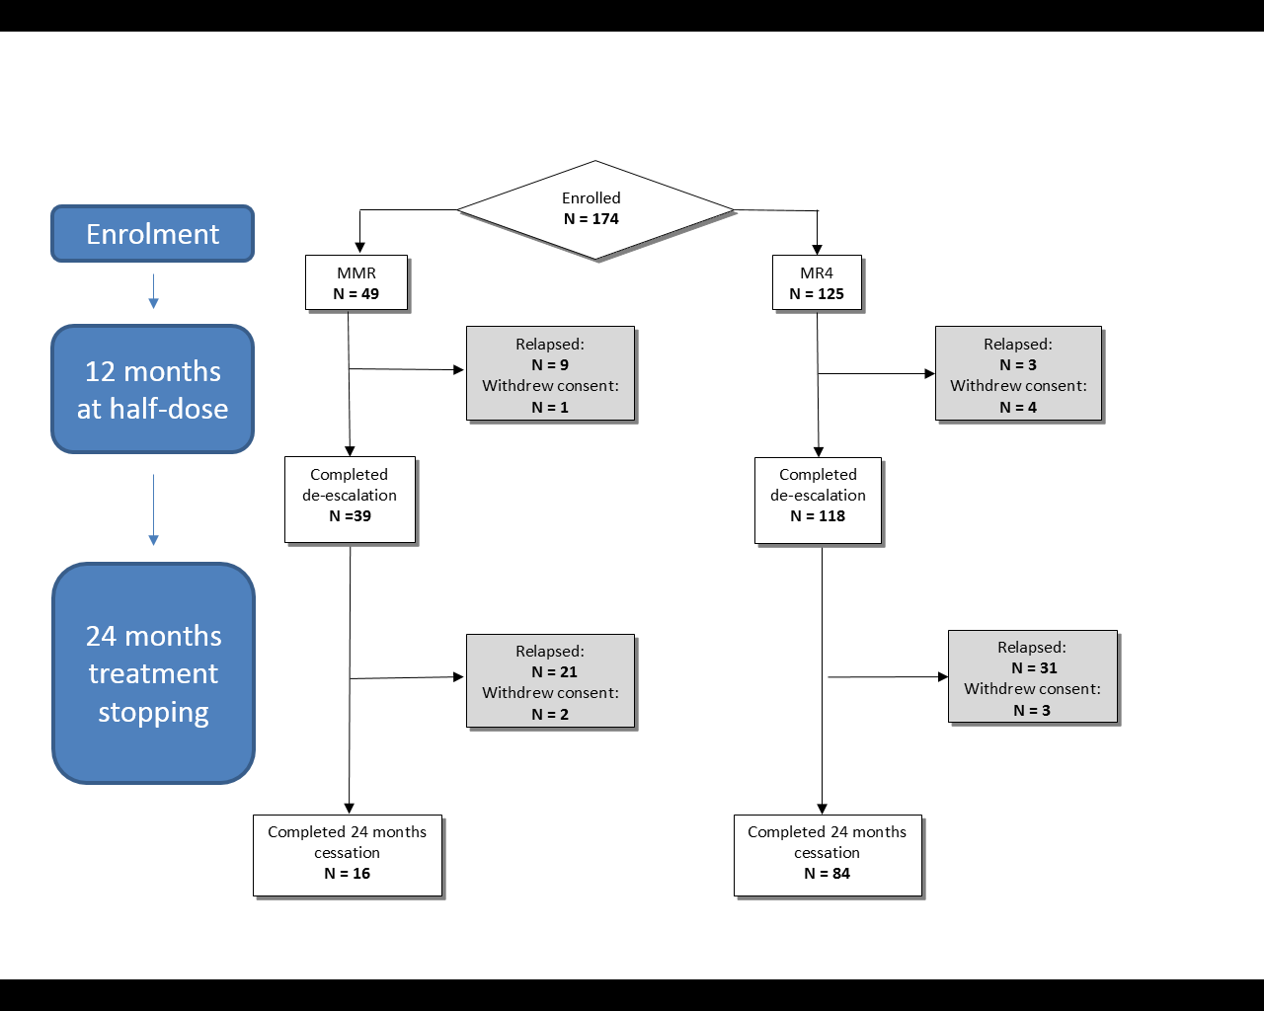

Figure 2.

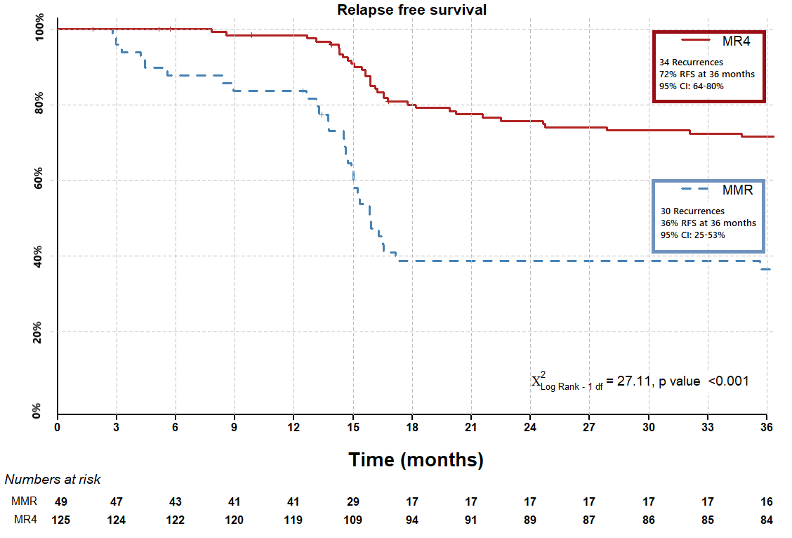

Figure 3.

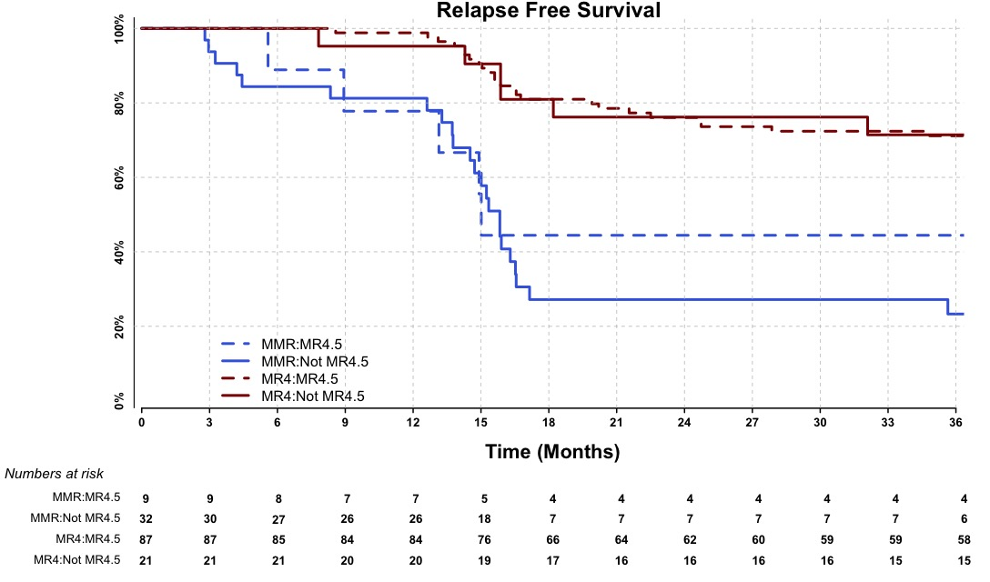

Figure 4.

