List of participating sites, with their principal investigators and numbers of patients recruited.

Royal Liverpool University Hospital (Professor Richard E Clark) 39
Hammersmith Hospital, London (Professor Jane F Apperley) 22
Beatson Institute for Cancer Research, Glasgow (Professor Mhairi Copland) 15
East Kent Hospitals, Canterbury (Dr Christopher Pocock) 12
St James University Hospital, Leeds (Dr Katherine Rothwell) 12
Nottingham City Hospital (Dr Jennifer Byrne) 10
King’s College Hospital, London (Dr Hugues de Lavallade) 8
Hereford County Hospital (Dr Lisa Robinson) 7
Freeman Hospital, Newcastle-upon-Tyne (Dr Wendy Osborne) 7
Birmingham Heartlands Hospital (Dr Joanne Ewing) , 6
Royal Devon & Exeter Hospital, Exeter (Dr Jason Coppell) 5
Salisbury District Hospital (Dr Jonathan Cullis) 5
Colchester General Hospital (Dr Gavin Campbell) 5
North Bristol (Southmead) Hospital (Dr Alistair Whiteway) 4
Queen Elizabeth Hospital, Birmingham (Dr Manoj Raghavan) 4
University Hospital of Wales, Cardiff (Dr Andrew Goringe) 4
Churchill Hospital, Oxford (Professor Adam Mead) 3
Aberdeen Royal Infirmary (Dr Dominic Culligan) 3
Manchester Royal Infirmary (Dr Fiona Dignan) 2
Addenbrookes Hospital, Cambridge (Dr Brian Huntly) 1

TOTAL 174.
Supplementary Table 1. Demographic and clinical details of the recruited patients.
IQR = interquartile range. Other abbreviations are as defined in the text.

Patient characteristics at trial entry | MR4 | MMR | Overall
 | n = 125 | n = 49 | n = 174
Demographic characteristics
Age (years); median | 61 | 57 | 59
IQR | 51-68 | 45-66 | 50-68
Gender; male [n (%)] | 73 (58%) | 25 (51%) | 98 (56%)
Physical findings
0 - Fully Active | 113 (90%) | 42 (86%) | 155 (89%)
1 - Work Able | 10 (8%) | 7 (14%) | 17 (9%)
2 - Not Work Able | 1 (1%) | - | 1 (1%)
3 - Limited Self Care | 1 (1%) | - | 1 (1%)
4 - Completely Disabled | - | - | -
Clinical characteristics
BCR-ABL1 % at trial entry: median | 0.001 | 0.0047 | 0.001
IQR | 0.0003- 0.002 | 0.002- 0.009 | 0.0006- 0.003
Treatment history
Duration of TKI (years): median | 6.5 | 7.7 | 6.9
IQR | 4.8- 10.2 | 5.1- 10.7 | 4.8- 10.2
Missing | - | 1 | 1
Medication
Imatinib n (%) | 105 (84%) | 43 (88%) | 148 (85%)
Nilotinib n (%) | 14 (11%) | 2 (4%) | 16 (9%)
Dasatinib n (%) | 6 (5%) | 4 (8%) | 10 (6%)

Supplementary Table 2. Endpoint outcomes. Figures in parentheses are 95% confidence limits. Results are at 36 months. The following secondary endpoints have already been reported, as detailed in the Outcomes section in the main text: Health Economic Assessment, Quality of Life and laboratory studies to identify subsets of patients who are more likely to relapse on de-escalation / cessation.

Endpoint | Definition | Group | Result | Further details
Primary:
Molecular recurrence-free survival (RFS) | Time from commencing de-escalation to the date of confirmed loss of MMR (two consecutive BCR-ABL >0.1% IS) | MR4 | 72% (64-80%) | Main Figure 2 and Results section
 |  | MMR | 36% (25-53% | Main Figure 2 and Results section
Secondary:
Overall survival | Event = death from any cause | MR4 | 98% (96-100%) | Supplementary Figure 2
 |  | MMR | 100% | Supplementary Figure 2
Progression-free survival | Event = progression to advanced phase; death from any cause. | MR4 | 98% (96-100%) | Supplementary Figure 2
 |  | MMR | 100% | Supplementary Figure 2
Event-free survival | Event = molecular recurrence, progression to advanced phase; death from any cause. | MR4 | 70% (62-79%) | Supplementary Figure 2
 |  | MMR | 36% (25-53%) | Supplementary Figure 2
In patients who lose MMR, the proportion who regain MMR on TKI resumption. | Time to MMR recovery (TTR) = the time from the date of confirmed loss of MMR to the date of MMR recovery). | MR4 and MMR | 100% of those assessable in each group | Main Figure 4 and Results section.  TTR is shown in Main Figure 4.
In patients who successfully de-escalate, the proportion who lose MMR on TKI cessation |  | MR4 | 27% (proportion successfully de-escalating = 98%) | Main Figure 2 and Results section
 |  | MMR | 56% (proportion successfully de-escalating = 81%) | Main Figure 2 and Results section
The proportion of MR4.5 patients at entry | Note; some patients were not assessable for this endpoint as there were insufficient (< 31,623) control transcripts. | MR4 | 87/108 (81%) | Main Figure 3 and Results section
 |  | MMR | 9/41 (22%) | Main Figure 3 and Results section

Supplementary Table 3. Molecular recurrence according to diagnostic prognostic score (citations to each in the text). Data were available for 74 patients. Four scoring systems are presented as mentioned in the text; in each case the recurrence rate in the high scoring group is compared to that in the low (and intermediate where relevant) scoring group. CI = confidence intervals.

CHARACTERISTIC | HAZARD RATIO | 95% CI | p-value
Sokal: High | 1.03 | 0.24 – 4.39 | 0.97
EURO (Hasford) : High | 0.94 | 0.13 – 6.96 | 0.95
EUTOS: High | 0.98 | 0.45 – 2.11 | 0.95
ELTS: High | 1.07 | 0.44 – 3.31 | 0.87

Supplementary Figure 1. Radial plot of TKI related symptoms over time. The number of patients reporting individual side effects (lethargy, diarrhoea, rash, nausea, periorbital oedema, hair thinning) is shown according to time from trial entry, for the MMR group (left) and MR4 group (right).

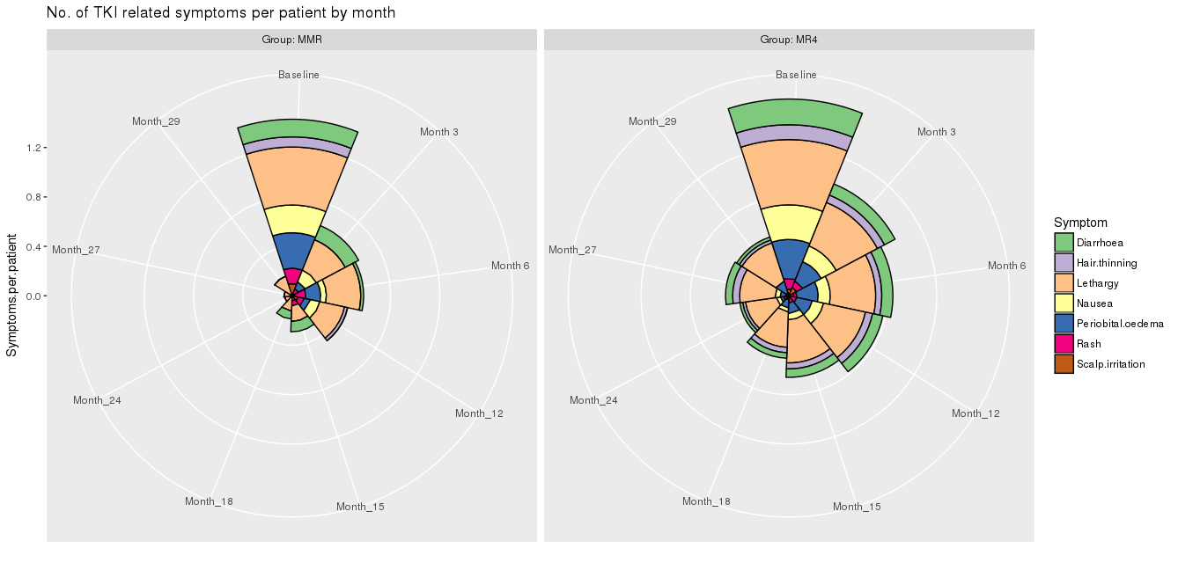

Supplementary Figure 2. Overall survival (OS), Progression free survival (PFS) and Event free survival (EFS).

