Abstract

A thymoma was an incidental finding in a seven year old, female neutered, crossbred dog referred for further investigation of an acute hepatopathy. Excision of the thymoma was performed via median sternotomy and 12 weeks later the dog presented with severe neutropenia. The bone marrow was hypercellular and following exclusion of other causes, a diagnosis of paraneoplastic immune-mediated neutropenia was made. The neutrophil count increased to normal within seven days of treatment with prednisolone, which was subsequently tapered. A caudal mediastinal mass was documented on thoracic radiographs 17 months following initial thymoma excision and pleural and mediastinal metastases were evident on computed tomography. Cytology of the largest mass was consistent with carcinoma. Following the prescription of toceranib phosphate, there was stable disease on computed tomography at six weeks and six months. At 12 months there was severe locoregional disease progression and the dog died eight days thereafter. Post-mortem examination showed diffuse metastatic carcinoma of the caudal mediastinum, parietal pleura and diaphragm and histopathology and immunohistochemistry was most consistent with thymic carcinoma.

Introduction

A thymoma is a neoplasm of the thymic epithelium accompanied by varying degrees of lymphocyte infiltration. Whilst uncommon in dogs, it is one of the most common tumours to occur in the cranial mediastinum¹. Thymomas usually occur in older (median age 9.4 – 11 years^{1,2,3}), medium to large breed dogs and Labrador retrievers, golden retrievers and German shepherd dogs may be over represented^{1,4,5}. Thymic carcinoma is rare and there is limited veterinary literature on the biological behaviour of this neoplasm. In human medicine six histological subtypes of thymoma, from benign to malignant, referred to as thymic epithelial tumours have been described⁶. Thymic carcinoma is considered within this spectrum but is a clinically distinct entity with different biology including higher stage, lower resectability, lower overall and progression-free survival, more distant metastases and earlier relapses⁷.

Paraneoplastic syndromes are common in dogs with thymoma, occurring in up to 67% of cases⁴. Paraneoplastic syndromes described in dogs include myasthenia gravis, occurring in up to 40% of cases^{1,2,3}, polymyositis⁸, hypercalcaemia, anaemia, lymphocytosis⁹, exfoliative dermatitis, erythema multiforme, and myocarditis causing third-degree atrioventricular block². Paraneoplastic syndromes can occur at presentation, later in the disease course or following tumour excision^{2, 10}. Paraneoplastic syndromes are common too in human medicine and include myasthenia gravis, hypogammaglobulinaemia, pemphigus, pure red cell aplasia, aplastic anaemia, agranulocytosis¹¹, haemolytic anaemia, pernicious anaemia, paroxysmal nocturnal haemoglobinuria and factor XI deficiency¹². Agranulocytosis associated with thymoma is rare with fewer than 20 cases described in the human literature to-date^{11, 12, 13}. Granulocytopenia associated with thymoma was described in a domestic shorthaired cat¹⁴. To the authors’ knowledge, granulocytopenia associated with thymoma was not previously described in a dog, and herein we present the first reported case, including complete follow-up. In addition this dog later developed metastatic thymic carcinoma and we describe the first case in the veterinary literature in which a tyrosine kinase inhibitor was used for treatment of a thymic epithelial tumour.

This case highlights three rare features of thymoma in a dog, two of which were previously undescribed: development of immune-mediated neutropenia following thymoma excision, locoregional recurrence of a more aggressive variant (thymic carcinoma) and prolonged response to toceranib phosphate.

Case report

A seven year old, female neutered, German Shepherd/Siberian Husky cross weighing 34.6kg presented for further investigation following the diagnosis of an acute hepatopathy. Haematology at the time showed a normal neutrophil count. Serum biochemistry showed mild hypocholesterolaemia 2.8mmol/L (Ref. 3.2-6.0) and a mild-moderate increase in ALT 274 IU/L (Ref. 7-50). Thoracic radiographs showed a large (10cm x 10cm), well-marginated, multilobulated and homogeneous soft tissue opacity mass in the right cranial thorax causing mild dorsal displacement of the cardiac silhouette and trachea. Cytology yielded a mixed population of lymphoid cells, frequent mast cells and moderate numbers of epithelial cells displaying mild atypia, consistent with thymoma (Figures 1 and 2). The liver was normal on ultrasound and there were no abnormalities of significance on cytology of the liver. There was no evidence of gross metastatic disease on computed tomography (CT [Figure 3]) and paraneoplastic disease was excluded based on haematology, serum biochemistry and normal acetylcholine receptor antibodies. Excision of the thymoma was performed on day 7 via median sternotomy and histopathology and immunohistochemistry were consistent with thymoma (figure 4 and 5). No evidence of infiltration by neoplastic cells was seen in the local lymph nodes submitted with the thymoma. On haematology 18 days post-operatively there was moderate thrombocytosis 721x10³/µL (Ref. 150-500) and the neutrophil count was normal. Serum biochemistry was within normal limits.

The initial post-operative period was uneventful then on day 28 the owner described lethargy and mild exercise intolerance. Haematology showed a mild slightly regenerative anaemia, HCT 0.33L/L (Ref. 0.35-0.55), RBC 5.10x10¹²/L (Ref. 5.4-8.0), Hgb 12.1g/dL (Ref. 12-18), absolute reticulocyte count 82x10⁹/L; mild neutropenia 2.4x10⁹/L (Ref. 3-12), and borderline thrombocytopenia 149x10⁹/L (Ref. 150-400). Serum biochemistry showed a mild decrease in urea 3.3mmol/L (Ref. 3.5-6.0) and moderate hypocholesterolaemia 2.2mmol/L (Ref. 3.2-6.5). Folate, cobalamin, basal cortisol, total thyroxine and thyroid stimulating hormone were within normal limits. Post-operative paraneoplastic myasthenia gravis was excluded based on normal acetylcholine receptor antibodies. Paracetamol/codeine was prescribed for suspected pain at the sternotomy site and re-assessment was performed on day 35. On haematology there was a stable, mild regenerative anaemia, HCT 0.33L/L (Ref. 0.35-0.55), RBC 5.06x10¹²/L (Ref. 5.4-8.0), Hgb 11.7g/dL (Ref. 12-18), absolute reticulocyte count 101x10⁹/L and progressing mild neutropenia 2.0x10⁹/L (Ref. 3-12). Thoracic radiographs showed no evidence of sternal osteomyelitis as the cause of the suspected sternal pain and progressing neutropenia. Continued post-operative pain was suspected and robenacoxib was prescribed in addition to paracetamol/codeine. There was a significant increase in stamina with the prescription and robenacoxib and the dog no longer lagged behind during exercise. Follow-up haematology on day 56 was within normal limits and the neutrophil count was low-normal 3x10⁹/L (Ref. 3-12).

One month later, on day 84, the dog presented for recurrent mild exercise intolerance (following withdrawal of robenacoxib and paracetamol/codeine) and acute onset lethargy and hyporexia. Physical examination was normal. Haematology showed severe neutropenia 0.36x10⁹/L (Ref. 3-12) and all other parameters were within normal limits. On serum biochemistry there was a mild decrease in urea 3.2mmol/L (Ref. 3.5-6.0) and mild hypocholesterolaemia 2.9mmol/L (Ref. 3.2-6.5). Thoracic radiographs were normal and there was no recurrence of the previous thymoma. On abdominal ultrasound there was a single small hypoechoic hepatic nodule (cytology showed lymphocytic and histiocytic infiltrates), generalised splenomegaly (cytology showed extra medullary haematopoiesis and possible lymphoid hyperplasia) and a small pancreatic cyst. Polymerase chain reaction for antigen receptor rearrangement (PARR) was performed on the liver and splenic aspirates to exclude lymphoma and both were negative. Urinalysis was normal and urine culture was sterile. There was no evidence of a septic or inflammatory focus causing the severe neutropenia and bone marrow aspiration and biopsy were performed. PCR on the bone marrow for Anaplasma spp., Ehrlichia spp. and Parvovirus were negative. On cytology and histopathology of the bone marrow there was a moderate increase in overall cellularity with slight predominance of mature neutrophils. The severe neutropenia in the presence of hypercellular bone marrow and the absence of a septic or inflammatory focus was consistent with peripheral destruction of the neutrophils and a diagnosis of immune-mediated neutropenia. An immunosuppressive dose of prednisolone (40mg/m²/24hr) was prescribed for treatment.

On day 91 the neutrophil count was normal, 9.7x10⁹/L (Ref. 3-12). Mild mature neutrophilia 15x10⁹/L (Ref. 3-12) was documented on day 105 and the dose of prednisolone was tapered by 20%. Re-assessment was performed every 21-28 days and the dose of prednisolone was gradually tapered on each occasion based on a continued normal neutrophil count. The total duration of treatment was seven months and during this period there were moderate adverse effects of glucocorticoid therapy including polyphagia, muscle atrophy, a decrease in tendon strength on the left pelvic limb, vacuolar hepatopathy, portal vein thrombosis and recurrent lower urinary tract infection.

Considering the thymoma was an incidental finding and no clinical signs were described at the time of initial referral re-staging with thoracic radiographs and abdominal ultrasound was recommended every six-twelve months. On re-staging on day 180 there was no evidence of local recurrence or gross metastatic disease. However on day 510, there was a large (8cm x 8cm x 10cm), well defined soft tissue mass in the right mid-thorax suggestive of locoregional recurrence. CT was performed for further clarification and to establish if surgical excision would be possible. CT showed a small amount of pleural fluid in the dependent side of the thorax, symmetrically distributed in both hemithoraces. There were multiple pleural masses in both hemithoraces. These masses had a broad based appearance towards the periphery of the lung field and were of soft tissue attenuation. A large mass (9-10cm diameter) with irregular margins was confirmed in the caudoventral part of the right hemithorax appearing to arise from the mediastinum. There were multiple solid nodules of variable size in the ventral parts of the cranial and caudal mediastinum (figure 6). All the masses had a similar degree of contrast enhancement. There was a small amount of fluid in the mediastinum. Ultrasound guided percutaneous biopsy of the large mediastinal mass was declined by the owner due to the requirement for general anaesthesia and fine needle aspiration was performed. Cytology was consistent with a carcinoma of uncertain origin and no similarities to the previous cytology and histopathology of the earlier diagnosed thymoma were found (Figure 7). A diagnosis of metastatic mediastinal/pleural carcinoma of uncertain origin was made and based on the described use of tyrosine kinase inhibitors for treatment of various solid tumours, including apocrine gland anal sac adenocarcinoma, metastatic osteosarcoma, head and neck carcinoma and nasal carcinoma^{15, 16} and the authors’ clinical experience using tyrosine kinase inhibitors in metastatic carcinoma, toceranib phosphate (2.8mg/kg PO 3x weekly) was prescribed. Haematology, serum biochemistry and urinalysis were obtained as a baseline prior to starting therapy and these investigations were repeated at regular intervals for therapeutic monitoring according to the data sheet.

The neutrophil count at the time of diagnosis of metastatic mediastinal/pleural carcinoma of uncertain origin was 2.7x10⁹/L (Ref. 3-12) and there was a gradual decreasing trend to a nadir of 1.3x10⁹/L (Ref. 3-12) on day 538, four weeks following the prescription of toceranib phosphate. Neutropenia is an uncommon consequence of treatment with a tyrosine kinase inhibitor^{17, 18} and considering the dog’s history and the low neutrophil count prior to treatment, a suspected diagnosis of relapsed immune-mediated neutropenia was made. Prednisolone (40mg/m²/24hr) was again prescribed and the neutrophil count increased to normal, 4.2x10⁹/L (Ref. 3-12) by day 552. As in the past, the dose of prednisolone was tapered gradually based on a continued normal neutrophil count. The total duration of treatment was seven months.

Re-staging with CT was performed on days 552, 690 and 941, (six weeks, six months and twelve months following the prescription of toceranib phosphate). On the first occasion there was evidence of a partial response to treatment with <50% reduction in size of the largest mediastinal mass and a decrease in the number of pleural nodules. On the second occasion there was a continued response to treatment and the largest mediastinal mass was no longer present as a defined mass, leaving an ill-defined and irregular region of soft tissue attenuation. The majority of the pleural masses were decreased in size and number, and two were marginally increased in size. On the third occasion there was significant disease progression with a large increase in the size and number of pleural masses and a small pleural effusion. The neutrophil count was normal at this time, 4.9x10⁹/L (Ref. 3-12). Toceranib phosphate was withdrawn and meloxicam was prescribed for palliative treatment.

Eight days following documentation of progressive disease and withdrawal of toceranib phosphate, the owner described the dog as unsettled and pacing. The dog died at home a short time later, 949 days following the initial incidental diagnosis of thymoma. Post-mortem examination was performed. The thoracic cavity contained 2.8L of serosanguineous fluid, the majority of which was within the right side. Within the caudal thoracic cavity, compressing and partly displacing the lungs cranially, there was a very large, irregularly shaped neoplastic mass (figure 8). This mass exhibited a multinodular surface, each nodule approximately 1cm in diameter, and the bulk of the neoplastic mass probably represented a coalescence of smaller nodules. There was one significantly large mass present in the right caudal aspect of approximately 5cm diameter. There were several large (approximately 2cm diameter) nodular masses visible within the larger mass. There were a large number of randomly scattered, multifocal small neoplastic nodules throughout the parietal pleura, more numerous on the right side. Arising from the right parietal pleura at the level of the 5th – 7th ribs was a focal larger mass, approximately 5cm diameter (figure 9). On the thoracic epimysial surface of the diaphragm there were several similar tumours, including a single larger tumour of approximately 5cm diameter. Histopathology and immunohistochemistry were consistent with a poorly differentiated carcinoma with occasional squamous differentiation (figure 10 and 11). The neoplastic cells mostly presented as a pleomorphic population of polygonal cells with few features to indicate a tissue of origin. The appearance of these cells differed from the epithelial cells of the original thymoma. Assuming thymus to be the origin of the neoplasm, thymic carcinoma would be appropriate, although there were no features of the tumour to specifically suggest thymus as the origin. With the previous diagnosis of thymoma, the subsequent development of a mediastinal neoplasm may represent locoregional recurrence of that lesion, albeit the new tumour was centred on the caudal mediastinum rather than the cranial mediastinum, as is typical. It is plausible that intra-mediastinal invasion during the surgery 30 months earlier left potentially malignant neoplastic stem cells within the caudal mediastinum, which underwent further malignant transformation over time.

Discussion

This case highlights three rare features of thymoma in a dog, two of which were previously undescribed. First, the dog developed immune-mediated neutropenia, considered paraneoplastic, following thymoma excision. To the authors’ knowledge this is the first report of paraneoplastic immune-mediated neutropenia occurring in a dog in association with thymoma. Granulocytopenia associated with thymoma was described in a five-year-old, female neutered domestic shorthaired cat¹⁴ and agranulocytosis associated with thymoma is rarely described in the human literature^{11, 12,13}. Immune-mediated neutropenia, primary or secondary, is considered rare in dogs, with only a single case in a series of 261 dogs with neutropenia at a referral institute¹⁹. Response to immunosuppressive therapy is often used to confirm the diagnosis in dogs, whilst documentation of anti-neutrophil antibodies is preferred to confirm the diagnosis in human medicine. Anti-neutrophil antibodies were documented in human patients with thymoma and granulocytopenia^{20, 21}, although this is an inconsistent finding¹¹, possibly due to specific toxicity to the myelomonocytic precursor cells in the bone marrow. Anti-neutrophil antibodies have been documented in dogs with immune-mediated neutropenia^{22, 23} and they could not be used to distinguish primary from secondary disease. Measurement of anti-neutrophil antibodies was not available in this case and the complete response to immunosuppressive therapy was used to support the immune-mediated origin. Thymoma and thymic carcinoma arise from thymic epithelial cells and can cause immune dysregulation, which is thought to cause the immune-mediated paraneoplastic syndromes. It has been postulated that there is failure of thymus-dependent immunologic surveillance with aberrant positive selection of potentially auto-reactive T-cells and failure to export regulatory T-cells²⁴. There is no evidence to suggest a relationship between the histologic features of a thymic epithelial tumour and the development of a paraneoplastic syndrome²⁵. There was a complete response to immunosuppressive therapy in this case, supporting an immune-mediated origin of the neutropenia. A similar response to immunosuppression with prednisolone and ciclosporin was documented in the earlier reported cat and there was no clinical evidence of relapse in the eight month period following thymoma excision, although haematology was not performed beyond 27 days post-operatively¹⁴. In human medicine the response to treatment is variable, dependent on whether the agranulocytosis presents with complete myeloid aplasia (typically fatal outcome) or promyelocyte arrest (chance of recovery with treatment). The bone marrow cytology and rapid response to prednisolone in this case was similar to cases described in a recent study of canine primary immune-mediated neutropenia²⁶. Immune-mediated neutropenia can be idiopathic (primary) or secondary to infection, drugs or neoplasia. The condition was considered secondary in this case with the history of thymoma excision and the propensity for paraneoplastic syndromes with this neoplasm, even following excision. Drug-induced neutropenia could not be completely excluded, given the recent surgery and prescribed analgesia, although this was considered less likely as no ‘high risk’ drugs for immune-dysfunction were used (e.g. carprofen, trimethoprim).

The second unusual feature in this case was the development of a suspected thymic carcinoma following thymoma excision. To the authors’ knowledge this was described in only one other dog in the veterinary literature. Alwen et al²⁷ described an 11-year-old male neutered vizla which developed intra-thoracic and portal site metastasis with paraneoplastic hypercalcaemia following video-assisted thoracoscopic surgery to excise a thymoma six months earlier. The initial thymoma was morphologically distinct from the metastatic lesions on histopathology and with an overall lack of lymphoid components in the latter, a diagnosis of thymic carcinoma with carcinomatosis was made. The gross appearance at necropsy and the histopathology of the metastatic lesions in the vizla²⁷ was comparable to our case. In both cases neoplastic transformation is plausible and the development of malignancy could follow deposition of potentially malignant neoplastic stem cells during surgery. Thymic carcinoma is part of a spectrum of thymic epithelial tumours in human medicine and it is reasonable to suggest the development of thymic carcinoma in this and the earlier case was consistent with locoregional progression. In the largest review of thymoma in dogs¹, locoregional progression occurred in 17% of the cases treated surgically, at a median of 362 days (range 32 - 2,170) following surgery. This frequency of recurrence, accompanied with the wide time frame over which it can occur and the potential for a more aggressive histopathological variant would support a recommendation of regular follow-up and re-staging following thymoma excision. This recommendation is further supported by the high incidence of concurrent non-thymic neoplasia in people and dogs with thymic epithelial tumours¹.

The third feature in this case was the prolonged response of the suspected thymic carcinoma to toceranib phosphate. Surgical excision is the treatment of choice for thymoma and the effects of chemotherapy for treatment of thymoma in dogs has not been well evaluated in the veterinary literature. Treatment is most often applied in the neoadjunctive setting to decrease the gross disease burden preceding surgery or where the tumour is non-resectable or recurrent. Platinum compounds, anthracyclines, cyclophosphamide and vincristine are the chemotherapeutic agents most commonly employed and the response rates are variable to poor^{1,3}. In human medicine platinum-based chemotherapy is the standard of care for metastatic, inoperable and/or recurrent disease²⁸. Response rates differ with histopathology and if there is a poor response to treatment or disease progression alternative therapy is sort. Although rare in thymic carcinoma, the presence of c-KIT mutations have been well-demonstrated in the human literature and c-KIT-mutated cases have a significant clinical response to various tyrosine kinase inhibitors²⁹. The use of the tyrosine kinase inhibitors imatinib, sorafenib and sunitinib in thymic epithelial tumours as 2nd, 3rd, 4th or greater line treatment was recently described in the human literature²⁹⁻ ³³. A disease control rate of 63% (86% for thymoma and 55% for thymic carcinoma) was reported in one study³³. In another study²⁹, sorafenib activity appeared to be independent from the c-KIT and PDGFR-alpha mutational status suggesting an anti-angiogenetic mechanism of action. The authors of the latter study concluded following disease progression on sorafenib, sequential treatment with a different tyrosine kinase inhibitor could be considered. To the authors’ knowledge there is no previous veterinary literature describing the use of a tyrosine kinase inhibitor for treatment of a thymic epithelial tumour. London et al¹⁵ described a clinical benefit of toceranib phosphate in 74% of 85 dogs with apocrine gland anal sac adenocarcinoma, metastatic osteosarcoma, head and neck carcinoma or nasal carcinoma and based on this, and the evidence from the human literature, toceranib phosphate was prescribed in this case. Treatment was well tolerated with only a short pause in treatment and a mild dose reduction (to 2.6mg/kg PO 3x weekly) required due to gastrointestinal toxicity 10 days following the initial prescription. The response to treatment was prolonged and would suggest toceranib phosphate could be used for treatment of thymic carcinoma, or potentially thymoma, in dogs where surgical excision is not plausible. Tyrosine kinase inhibitors are not first line treatment in human medicine and should not be considered routine first line treatment in veterinary medicine. It was the unknown origin of the second tumour and presence of metastatic disease in this case that prompted the use of toceranib phosphate as a first line treatment.

This case highlights the importance of evaluating dogs for the presence of paraneoplastic syndromes associated with thymoma pre and post-treatment and to exclude thymoma as a potential cause when an immune-mediated disease is diagnosed. In addition it highlights the value of longer term follow-up and re-staging following excision of a thymoma, especially where the tumour was an incidental finding. Tyrosine kinase inhibitors are increasingly used in human medicine for ≥2nd line treatment of metastatic, inoperable and/or recurrent thymic epithelial tumours and could be a realistic option for treatment of metastatic, inoperable and/or recurrent thymic epithelial tumours in dogs.

References

- Robat CS, Cesario L, Gaeta R, Miller M, Schrempp D, Chun R. Clinical features, treatment options, and outcome in dogs with thymoma: 116 cases (1999-2010). Journal of the American Veterinary Medical Association 2013; 243 (10); 1448-1454
- Atwater SW, Powers BE, Park RD, Straw RC, Ogilvie GK, Withrow SJ. Thymoma in dogs: 23 cases (1980-1991). Journal of the American Veterinary Medical Association 1994; 205 (7): 1007-1013
- Zitz JC, Birchard SJ, Couto GC, Samii VF, Weisbrode SE. Results of excision of thymoma in cats and dogs: 20 cases (1984-2005). Journal of the American Veterinary Medical Association 2008; 232 (8): 1186-1192
- Aronsohn MG, Schunk KL, Carpenter JL, King NW. Clinical and pathologic features of thymoma in 15 dogs. Journal of the American Veterinary Medical Association 1984; 184 (11): 1355-1362
- Day MJ. Review of thymic pathology in 30 cats and 36 dogs. Journal of Small Animal Practice 1997; 38: 393-403
- Burgess KE, DeRegis CJ, Brown FS, Keating JH. Histologic and immunohistochemical characterization of thymic epithelial tumours in the dog. Veterinary and Comparative Oncology 2013; 14 (2): 113-121
- Huang J, Rizk NP, Travis WD, Riley GJ, Park BJ, Bains MS, Dycoco J, Flores RM, Downey RJ, Rusch VW. Comparison of Patterns of Relapse in Thymic Carcinoma and Thymoma. Journal of Thoracic and Cardiovascular Surgery 2009; 138, 1: 26-31
- Darke PGG, McCullagh KG, Geldart PH. Mysasthenia gravis, thymoma and myositis in a dog. Veterinary Record 1975; 97: 392-394
- Batlivala TP, Bacon NJ, Avery AC, Barabas K, Gunn-Christie RG, Conway J, Avery PR. Paraneoplastic T cell lymphocytosis associated with thymoma in a dog. Journal of Small Animal Practice 2010; 51: 491-494
- Singh A, Boston SE, Poma R. Thymoma-associated exfoliative dermatitis with post-thymectomy myasthenia gravis in a cat. Canadian Veterinary Journal 2010; 51: 757-760
- Alvares CL, Svasti-Salee D, Rowley M, Gordon-Smith EC, Marsh JCW. Remission induced by Campath-1H for thymoma-associated agranulocytosis. Annals of Hematology 2004; 83:398-400
- Jethava Y, Alamelu J, Rangarajan S, Lang-Lazdunski L, van der Walt J, Fields P. Acquired Agranulocytosis and Factor XI Deficiency in Association with Thymoma. Journal of Clinical Oncology 2011; 29 (20): 604-606
- Yip D, Rasko JEJ, Lee C, Kronenberg H, O’Neill B. Thymoma and agranulocytosis: two case reports and literature review. British Journal of Haematology 1996; 95: 52-56
- Fidel J, Pargass IS, Dark MJ, Holmes SP. Granulocytopenia Associated With Thymoma in a Domestic Shorthaired Cat. Journal of the American Animal Hospital Association 2008; 44: 210-217
- London C, Mathie T, Stingle N, Clifford C, Haney S, Klein MK, Beaver L, Vickery K, Vail DM, Hershey B, Ettinger S, Vaughan A, Alvarez, Hillamn L, Kiselow M, Thamm D, Higginbotham ML, Gauthier Mm Krick E, Phillips B, LaDue T, Jones P, Bryan J, Gill V, Novasad A, Fulton L, Carreras J, McNeill C, Henry C, Gillings S. Preliminary evidence for biologic activity for toceranib phosphate (Palladia®) in solid tumours. Veterinary and Comparative Oncology 2011; 10: 194-205
- Bernabe LF, Portela R, Nguyen S, Kisseberth WC, Pennell M, Yancey MF, London CA. Evaluation of the adverse event profile and pharmacodynamics of toceranib phosphate administered to dogs with solid tumors at doses below the maximum tolerated dose. BMC Veterinary Research 2013; 9: 190
- London CA, Hannah AL, Zadovoskaya R, Chien MB, Kollias-Baker C, Rosenberg M, Downing S, Post G, Boucher J, Shenoy N, Mendel DB, McMahon G, Cherrington JM. Phase I Dose-Escalating Study of SU11654, a Small Molecule Receptor Tyrosine Kinase Inhibitor, in Dogs with Spontaneous Malignancies. Clinical Cancer Research 2003; 9 (7): 2755-2768
- London CA, Malpas PB, Wood-Follis SL, Boucher JF, Rusk AW, Rosenberg MP, Henry CJ, Mitchener KL, Klein MK, Hintermeister JG, Bergman PJ, Couto GC, Mauldin GN, Michels GM. Multi-center, Placebo-controlled, Double-blind, Randomized Study of Oral Toceranib Phosphate (SU11654), a Receptor Tyrosine Kinase Inhibitor, for the Treatment of Dogs with Recurrent (Either Local or Distant) Mast Cell Tumor Following Surgical Excision. Clinical Cancer Research 2009; 15 (11); 3856-3865
- Brown MR, Rogers KS. Neutropenia in Dogs and Cats: A Retrospective Study of 261 Cases. Journal of the American Animal Hospital Association 2001; 37: 131-139
- Postiglione K, Ferris R, Jaffe JP, Stroncek D. Immune mediated agranulocytosis and anemia associated with thymoma. American Journal of Hematology 1995; 49 (4): 336-340
- Kobayashi M, Hasegawa T, Iwabuchi S, Fukushima M, Koie H, Kannari K. The effect of thymectomy on myasthenia gravis, thrombocytopenia and granulocytopenia associated with thymoma: report of a case. Surgery Today 1995; 25 (12): 1061-1065
- Weiss DJ. Evaluation of antineutrophil IgG antibodies in persistently neutropenic dogs. Journal of Veterinary Internal Medicine 2007; 21: 440-444
- Weiss DJ. An indirect flow cytometric test for detection of anti-neutrophil antibodies in dogs. American Journal of Veterinary Research 2007; 68: 464-467
- Skeie GO, Romi F. Paraneoplastic myasthenia gravis: immunological and clinical aspects. European Journal of Neurology 2008; 15: 1029-1033
- Aronsohn M. Canine Thymoma. Veterinary Clinics of North America 1985; 15 (4): 755-767
- Devine L, Armstrong PJ, Whittemore JC, Sharkey L, Bailiff N, Huang A, Rishniw M. Presumed primary immune-mediated neutropenia in 35 dogs: a retrospective study. Journal of Small Animal Practice 2017; 58: 307-313
- Alwen SGJ, Culp WTN, Szivek A, Mayhew PD, Eckstrand CD. Portal site metastasis after thoracoscopic resection of a cranial mediastinal mass in a dog. Journal of the American Veterinary Medical Association 2015; 247 (7): 793-800
- Girard N, Ruffini E, Marx A, Faivre-Finn C, Peters S. Thymic Epithelial Tumours: ESMO Clinical Practice Guidelines. Annals of Oncology 2015; 26 (5): v40-v55
- Pagano M, Sierra NM, Panebianco M, Rossi G, Gnoni R, Bisagni G, Boni C. Sorafenib efficiency in thymic carcinomas seems not to require c-KIT or PDGFR-alpha mutations. Anticancer Research 2014; 34 (9): 5105-5110
- Strobel P, Hartmann M, Jakob A, Mikesch K, Brink I, Dirnhofer S, Marx A. Thymic carcinoma with overexpression of mutated KIT and the response to imatinib. New England Journal of Medicine 2004; 350: 2625-2626
- Neuhaus T, Luyken J. Long lasting efficacy of sorafenib in a heavily pretreated patient with thymic carcinoma. Targeted Oncology 2012; 7 (4): 247-251
- Ströbel P, Bargou R, Wolff A, Spitzer D, Manegold C, Dimitrakopoulou-Strauss A, Strauss L, Sauer C, Mayer F, Hohenberger P, Marx A. Sunitinib in metastatic thymic carcinomas: Laboratory findings and initial clinical experience. British Journal of Cancer 2010; 103 (2): 196-200
- Remon J, Girard N, Mazieres J, Dansin E, Pichon E, Grellier L, Dubos C, Lindsay C, Besse B. Sunitinib in patients with advanced thymic malignancies: Cohort from the French RYTHMIC network. Lung Cancer 2016; 97: 99-104

Figures

- Fine needle aspirate cytology of the thymoma showing mixed lymphocytes and a cluster of epithelial cells (delineated by black arrows) 20x magnification, Wright-Giemsa 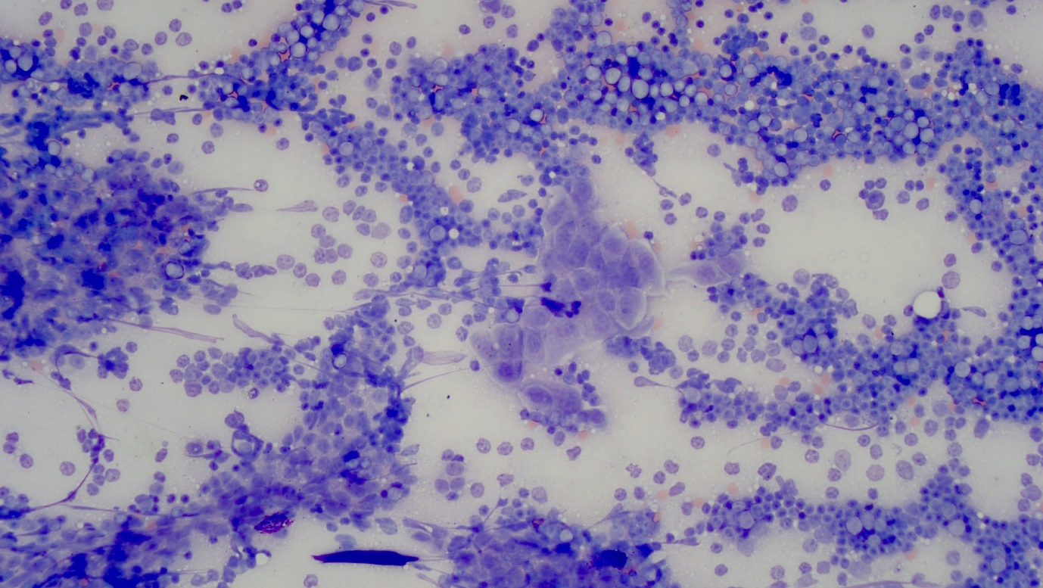
- Fine needle aspirate cytology of the thymoma showing mixed lymphocytes and mast cells (black arrows) 20x magnification, Wright-Giemsa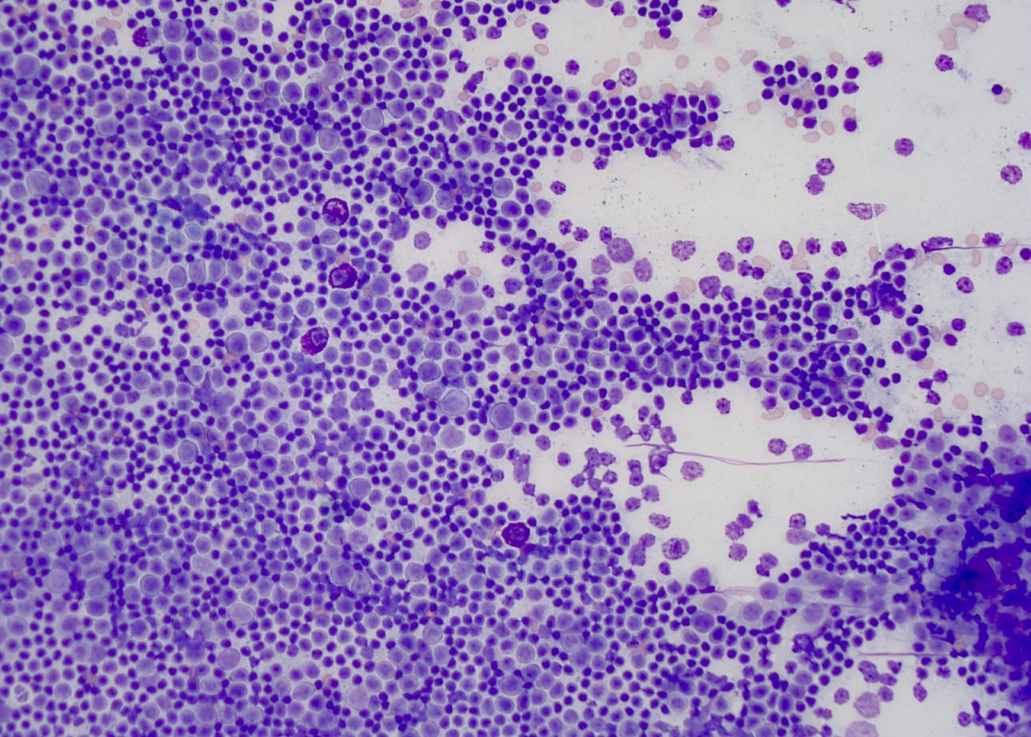
- CT (dorsal) of the thorax with a large, predominantly right-sided cranial mediastinal mass (black arrow)
- Histopathology (H&E staining) of the thymoma 20x. There is a relatively distinct pale focus (delineated by the arrows) which contains many infiltrates of neoplastic cells. In other areas there are dense associated infiltrates of small lymphocytes, with the neoplastic cells indistinct in the background in these areas 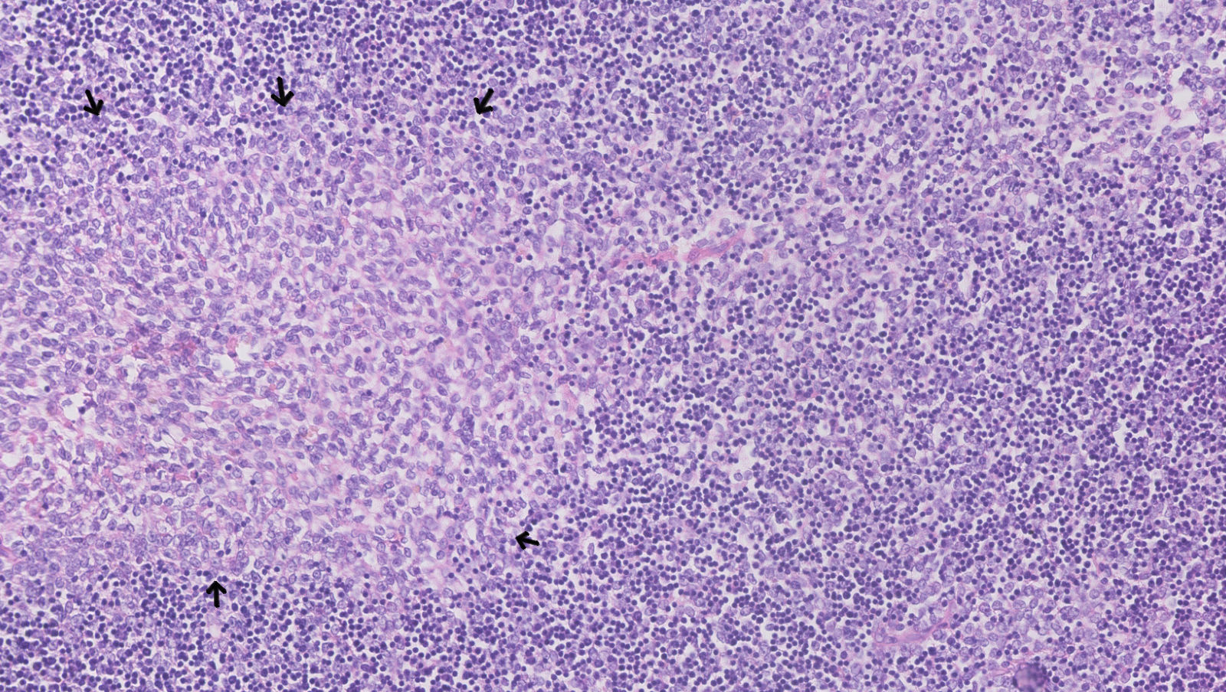
- Cytokeratin immunohistochemistry of the thymoma 40x. Variably distinct aggregates of neoplastic cells (black arrows) are highlighted by cytoplasmic (brown) labelling for Cytokeratin, consistent with thymic epithelium. The associated small lymphocytes (white arrows) in the infiltrates are negative 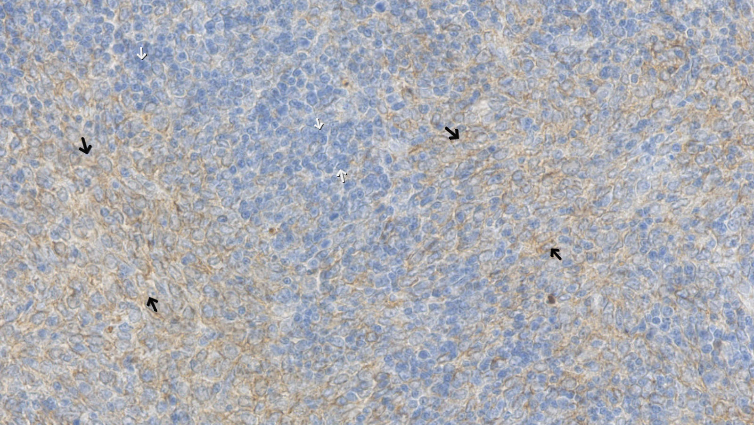
- CT (dorsal) of the thorax with a large right sided caudal mediastinal mass (bold arrow), and multiple cranial and caudal mediastinal metastases (dotted arrows)
- Fine needle aspirate cytology of the caudal mediastinal mass showing high numbers of neoplastic cells arranged in small to large, cohesive clusters or found as naked nuclei; 20x magnification, Wright Giemsa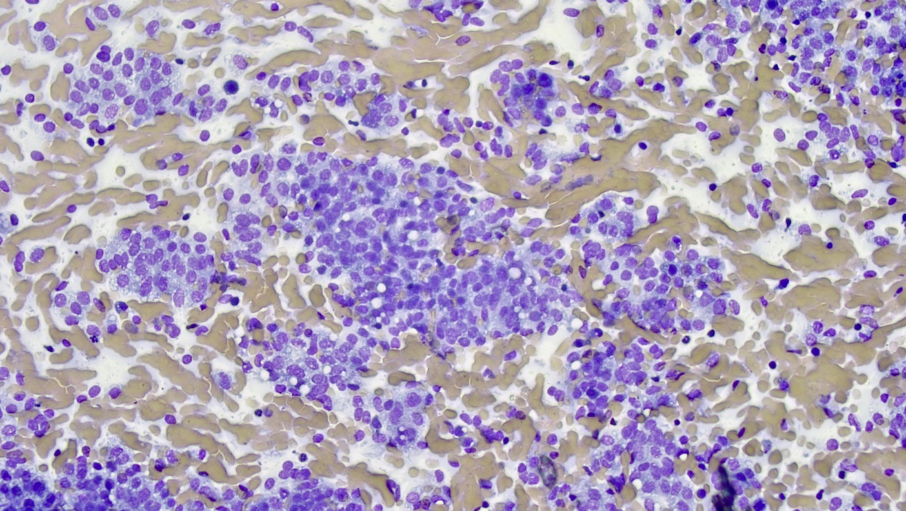
- Gross pathology of the lungs with a very large, irregularly shaped, multinodular neoplastic mass adhered caudally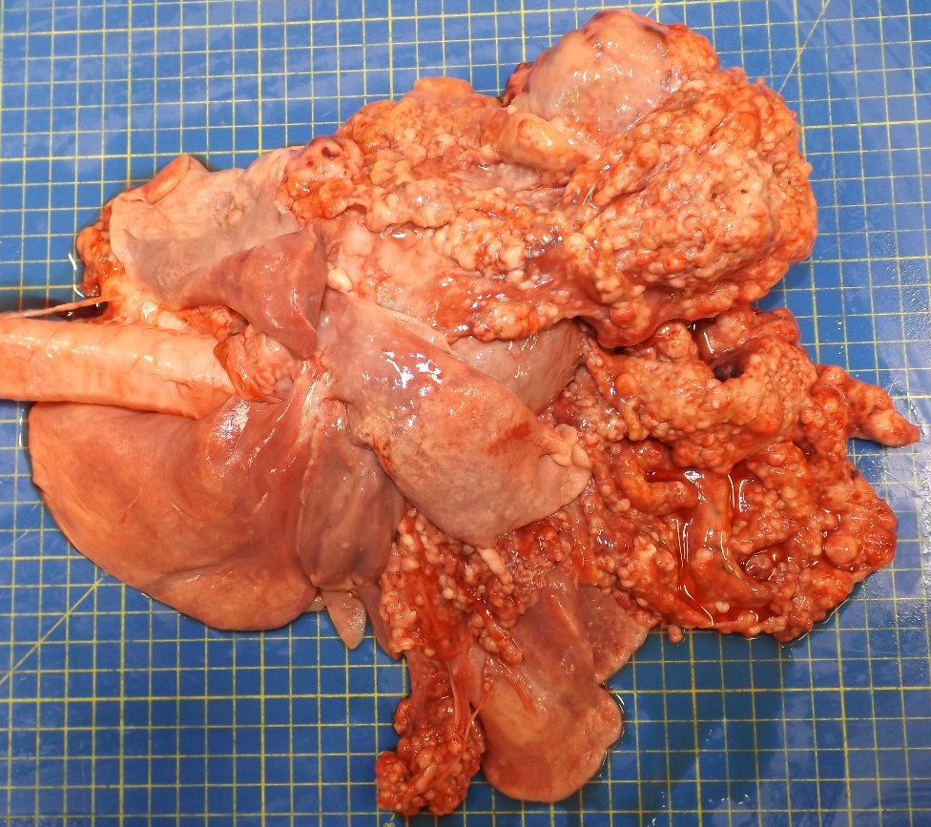
- Gross pathology of the thoracic cavity with multiple pleural and diaphragmatic nodules and a large focal mass arising from the right parietal pleura at the level of the 5th – 7th ribs and the thoracic epimysial surface of the diaphragm
- Histopathology (H&E staining) of the caudal mediastinal carcinoma 20x. The mass was poorly demarcated, unencapsulated, densely cellular and highly infiltrative. The neoplastic cells were arranged predominantly in a densely cellular sheet, with some separation variably into broad trabeculae or smaller packets separated by fine fibrous stroma septa. Neoplastic cells were a moderate pleomorphic population of large polygonal cells exhibiting mild to moderate anisocytosis. 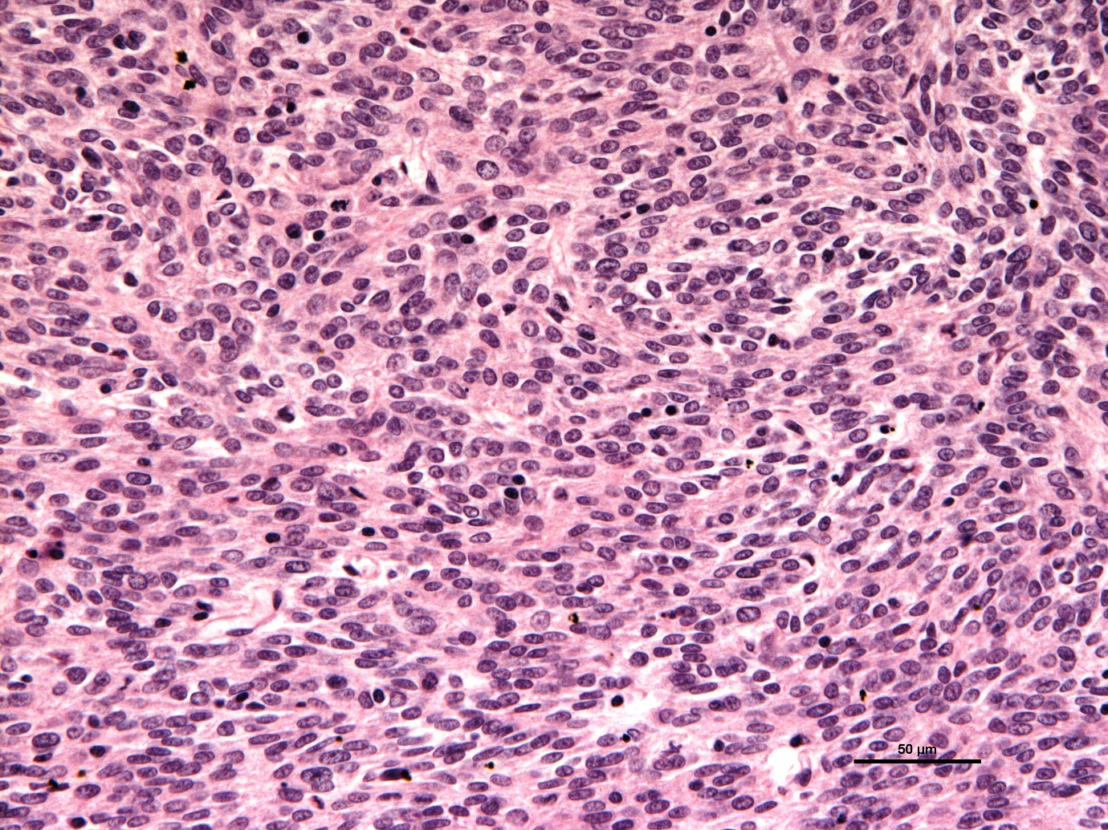
- Pancytokeratin immunohistochemistry of the caudal mediastinal carcinoma 40x. The neoplastic cells were diffusely pancytokeratin positive consistent with epithelial origin. The neoplastic cells were negative for Iba-1 (for histiocytic origin), Vimentin (for mesenchymal origin), Synaptophysin (for neuroendocrine origin) and c-KIT.