Supplemental Figures and Figure Legends
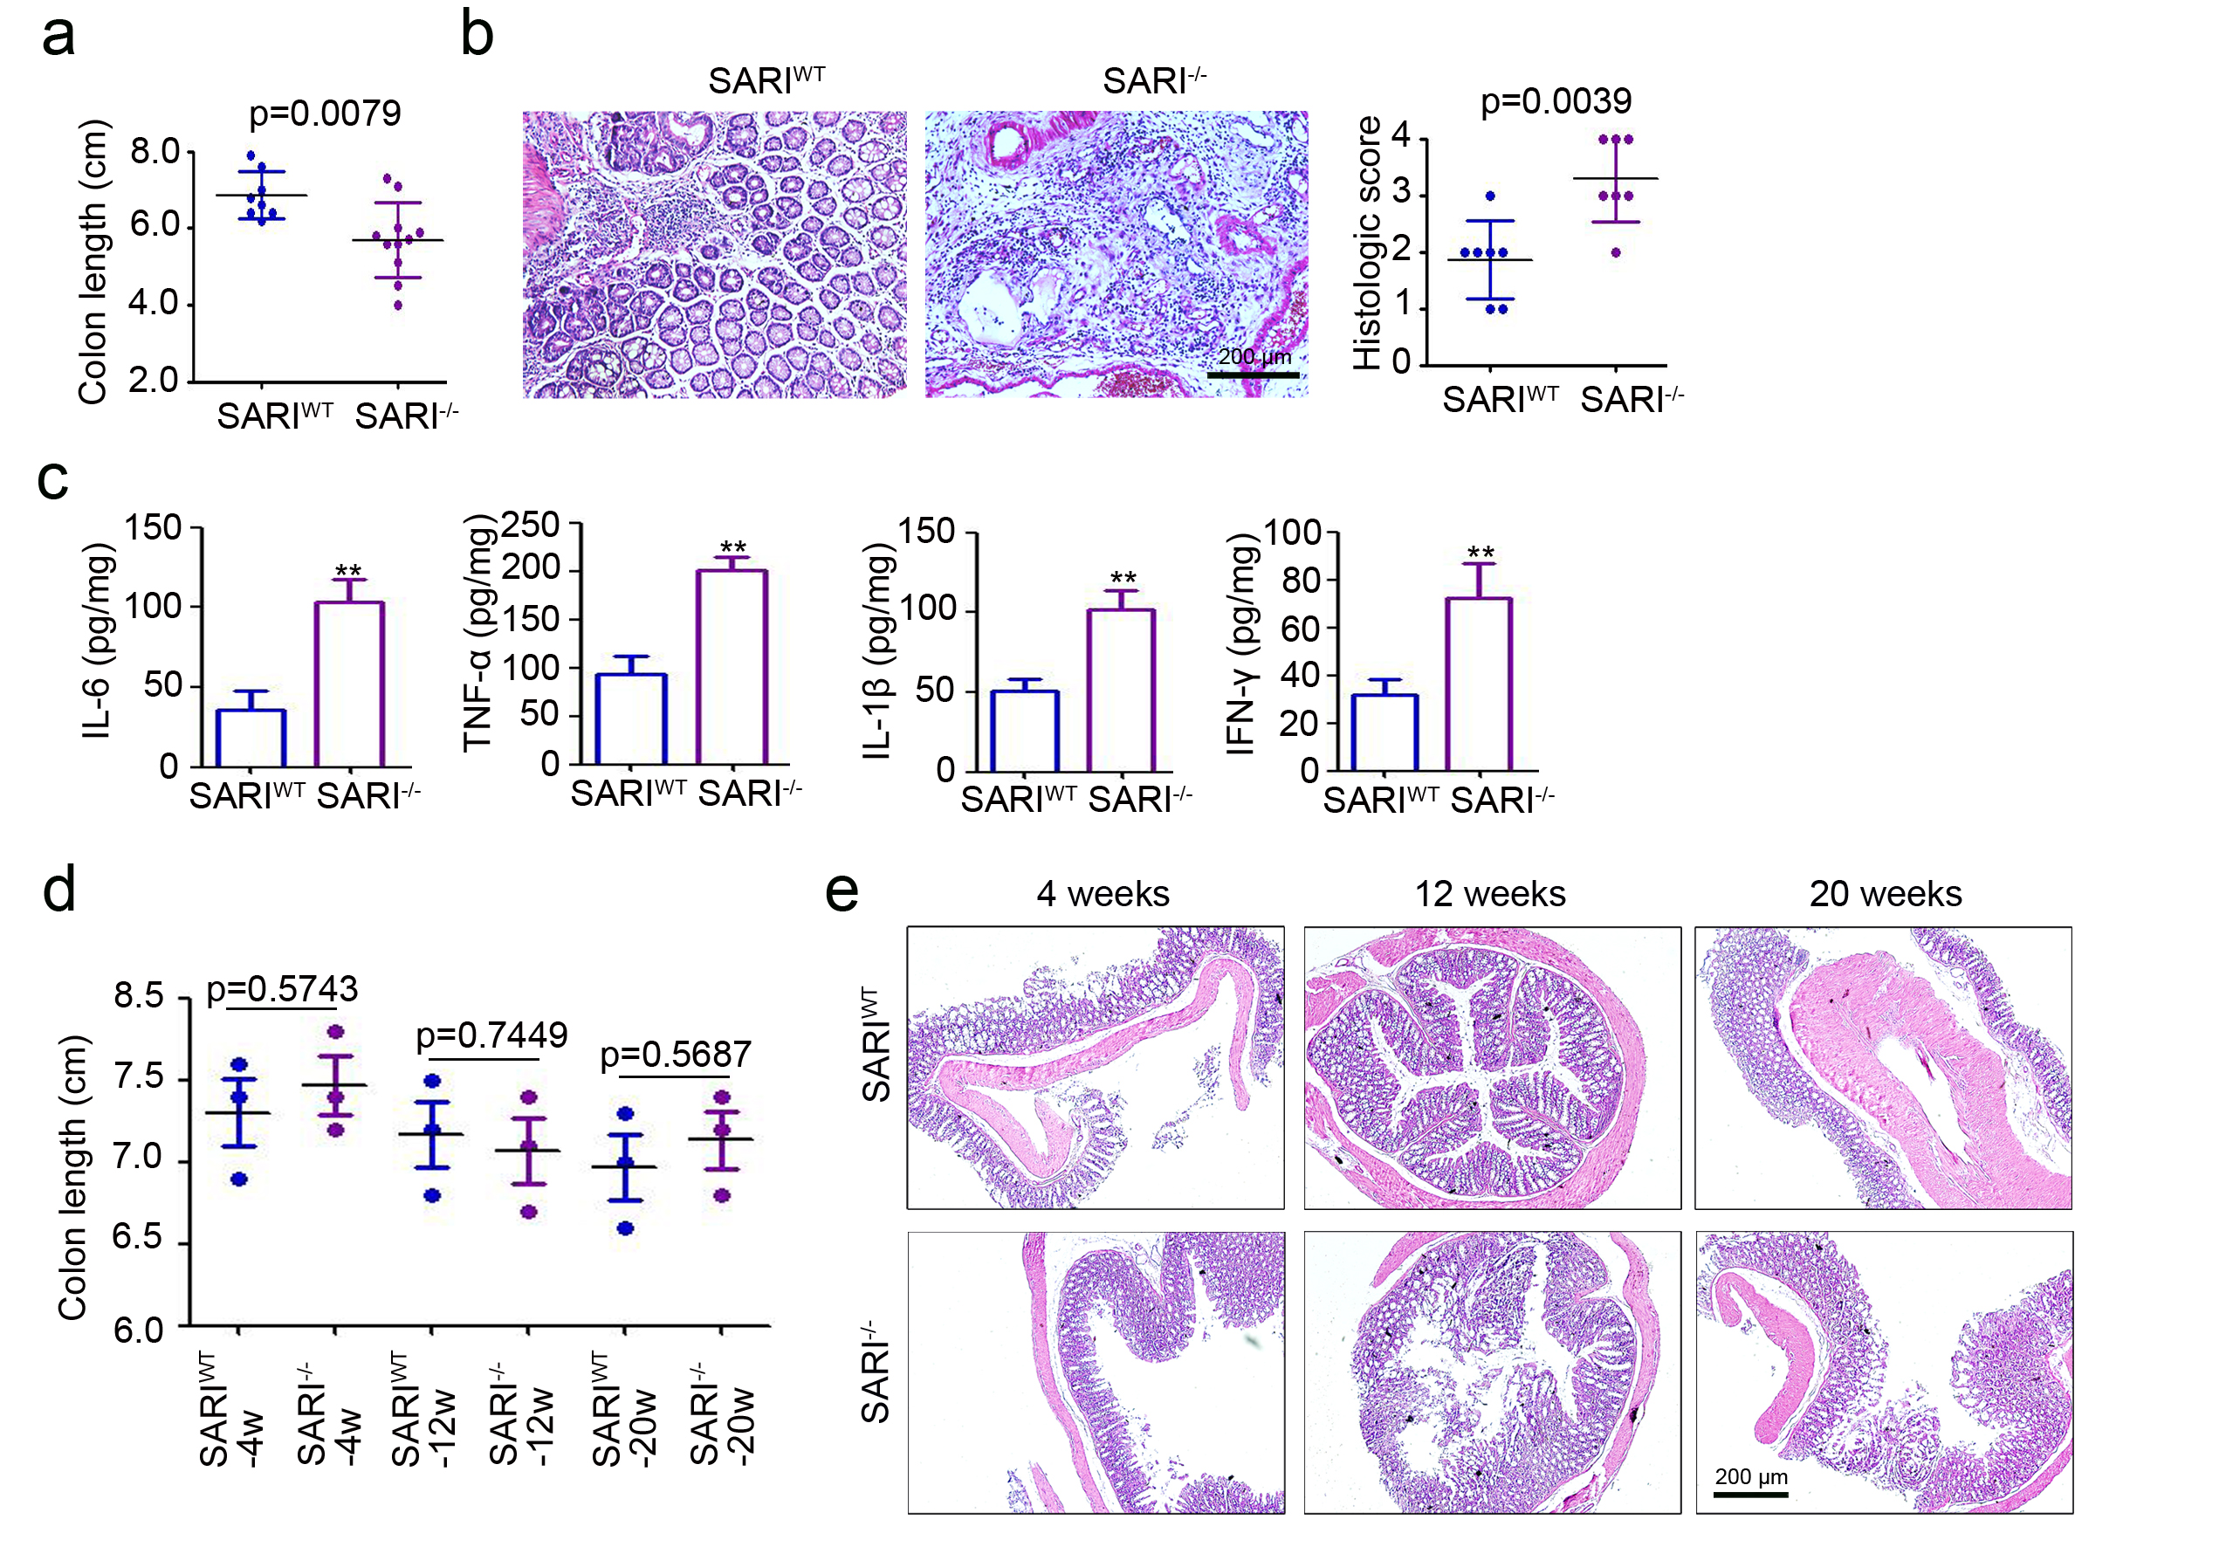
Supplemental Figure 1 Colon length (a) and H&E images (b) of colon cross-section at the end of three cycles of 2% DSS administration and the quantitation of histological inflammation (b). (n = 7). (c) Cytokine expression in whole colons from SARI^{WT} and SARI^{-/-} mice after receiving three cycles of 2% DSS administration was determined by ELISA. (n = 4, **, p < 0.01). (d) Colon length of SARI^{WT} and SARI^{-/-} mice at 4, 12 and 20 weeks old (n = 3). (e) H&E images of colon cross-section of SARI^{WT} and SARI^{-/-} mice at 4, 12 and 20 weeks old.

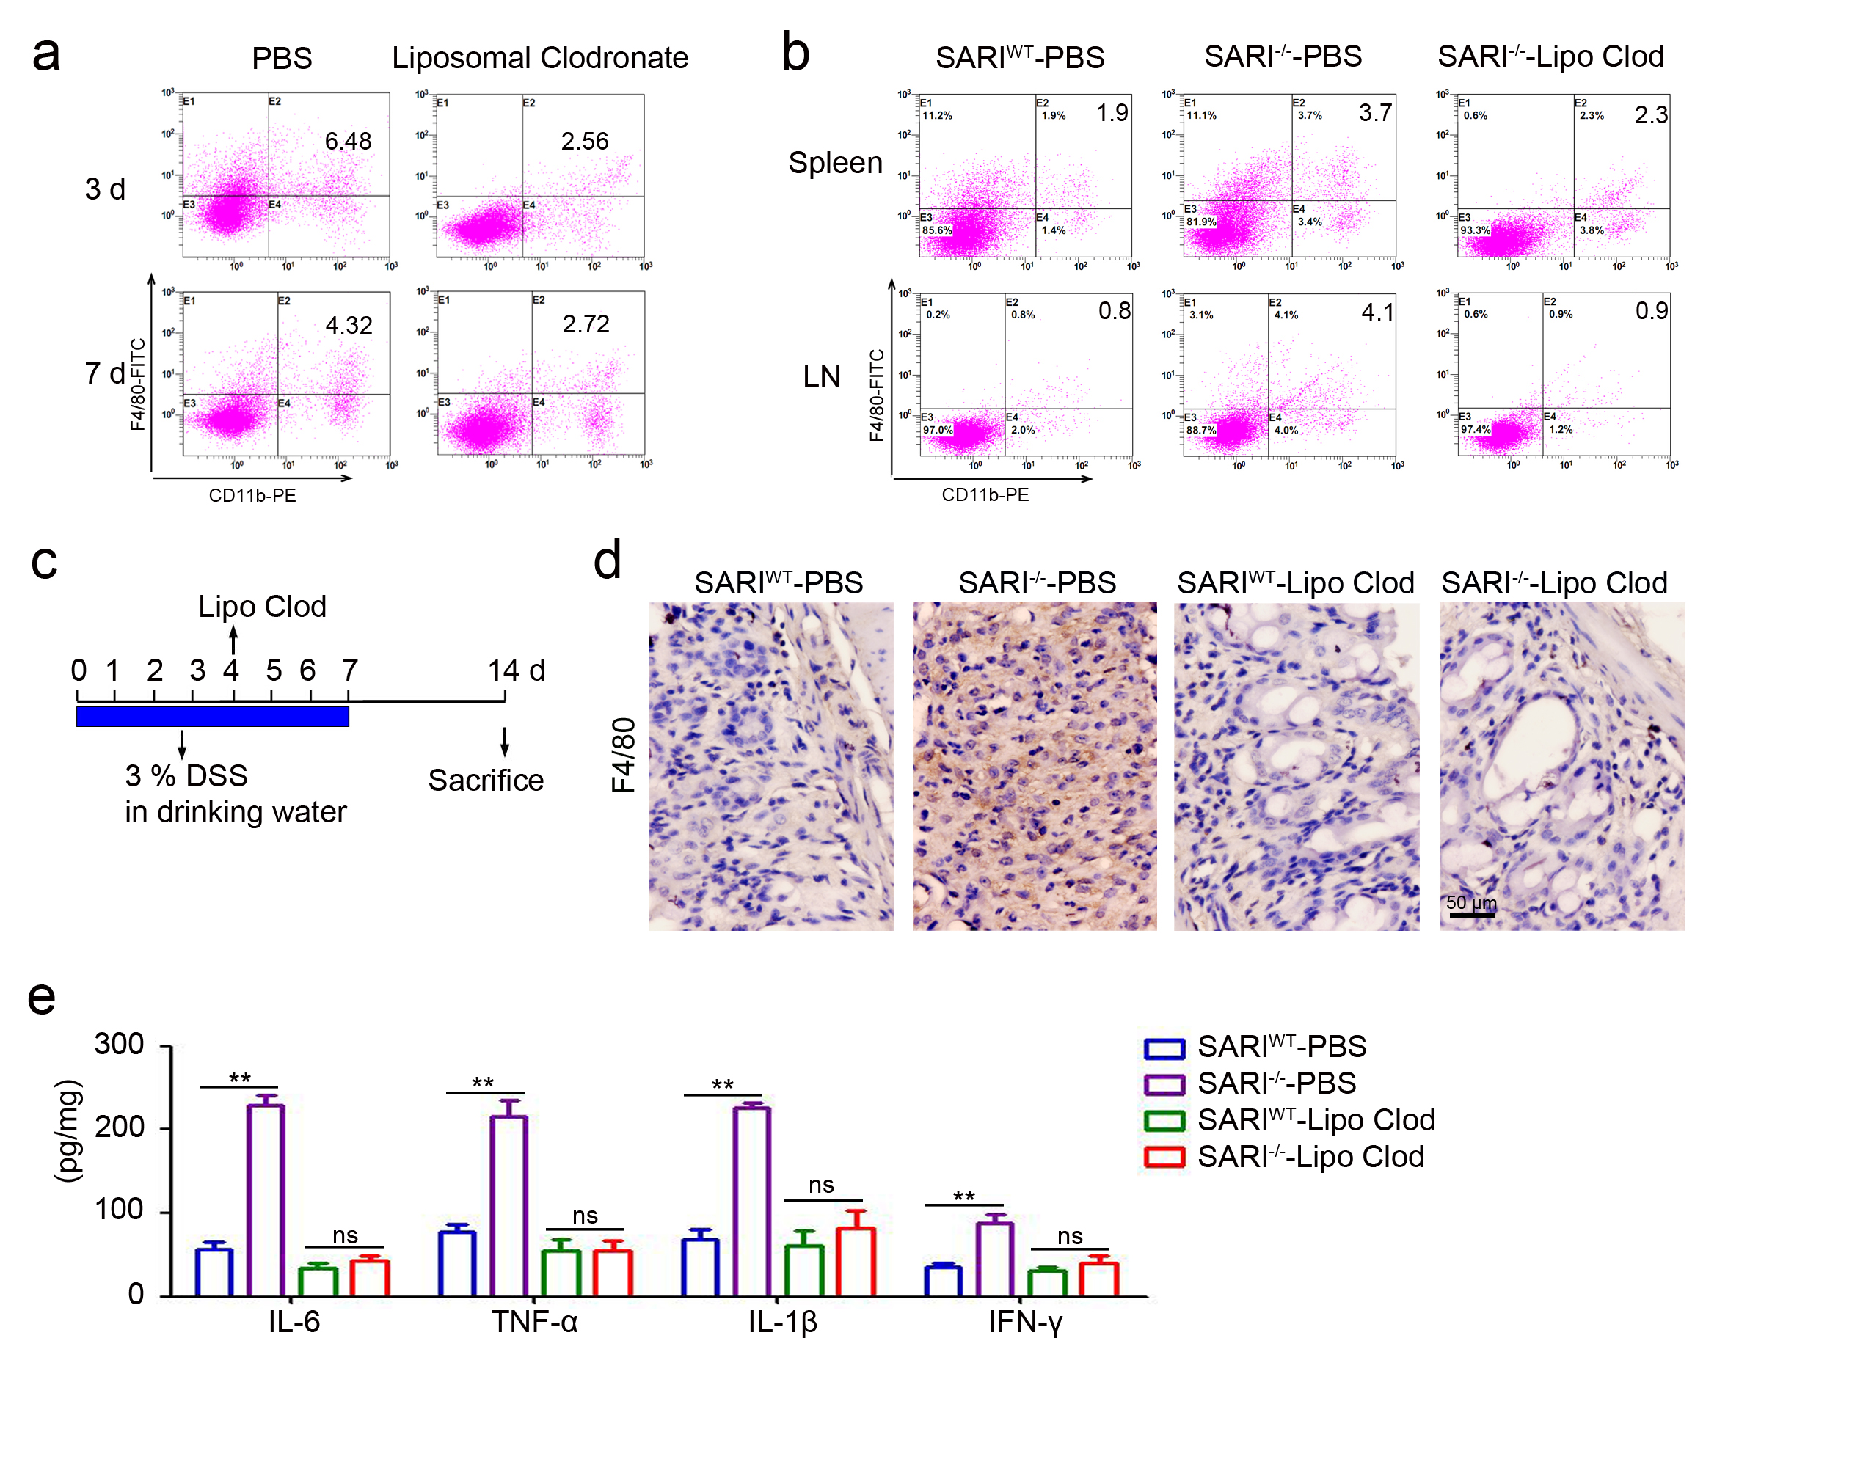
Supplemental Figure 2 (a) Flow cytometry analysis of macrophages infiltration in colonic tissues at 3 days and 7 days post Liposomal Clodronate injection. (b) Flow cytometry analysis of macrophages located at spleen and lymph node at 3 days and 7 days post Liposomal Clodronate injection. (c) Schematic diagram of the Liposomal Clodronate treatment in acute colitis mice. A single injection of Liposomal Clodronate was performed at four days post 3% DSS administration and the mice were sacrificed at 14 days post 3% DSS administration. (d) Representative images of F4/80 staining of colon tissues from Liposomal Clodronate-treated mice. The percent of F4/80 positive cells were analyzed. (e) Cytokines expression in whole colons from mice were determined by ELISA. (n=4, **, p<0.01).

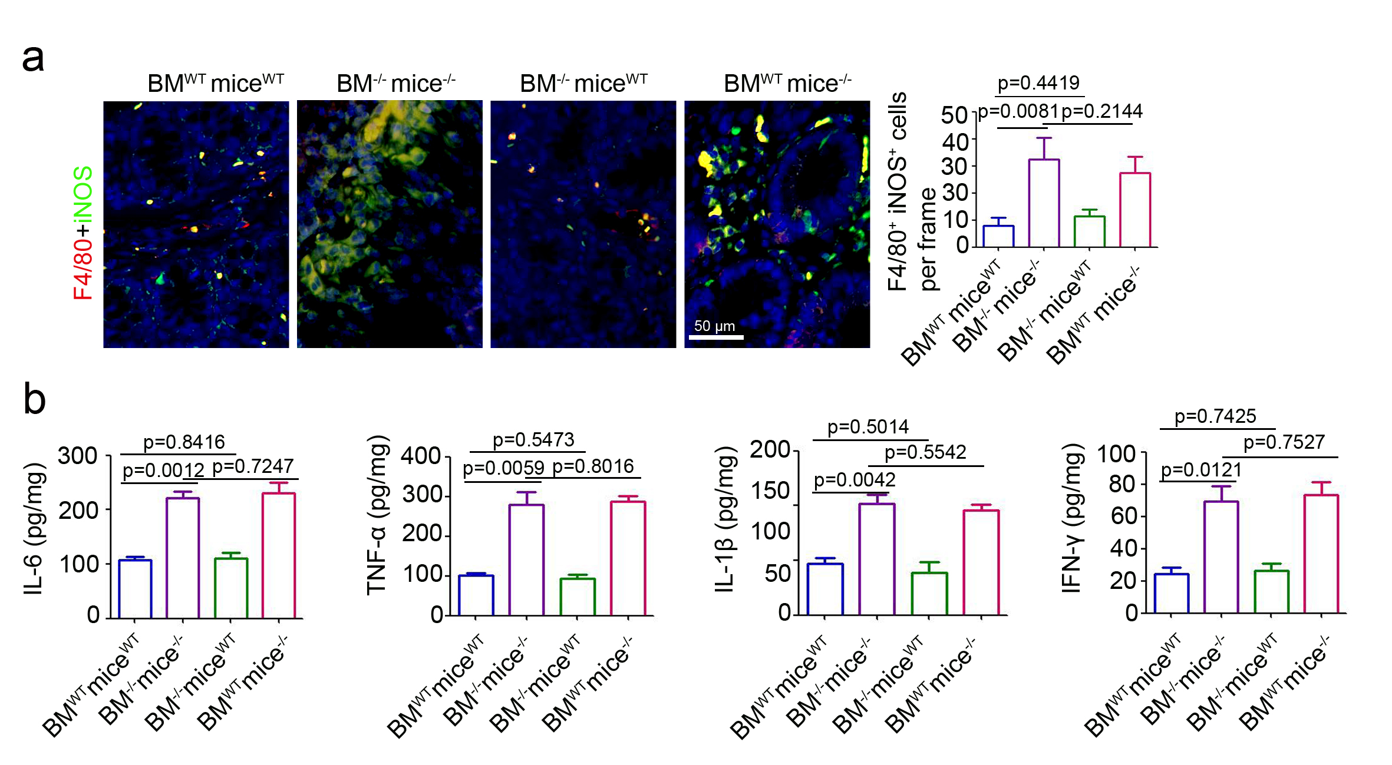
Supplemental Figure 3 (a) Representative images of F4/80 (red) and iNOS (green) staining of colon tissues. The cell nucleic were stained with DAPI (blue). Scale bar = 100 μm, **, p<0.01. (b) Cytokines expression in whole colons from bone marrow chimeras mice (n=4).

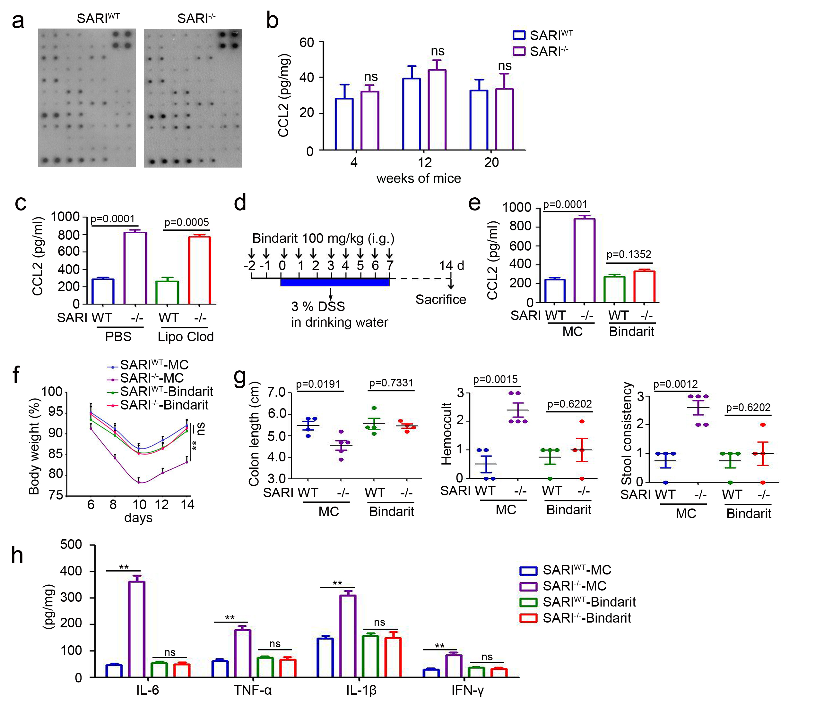
Supplemental Figure 4 (a) Mice cytokine array analysis of the colonic proteins of SARI^{WT} mice and SARI^{-/-} mice. (b) ELISA analysis of CCL2 expression in SARI^{WT} mice and SARI^{-/-} mice at the age of 4, 12 and 20 weeks old. (c) CCL2 expression in whole colons from SARI^{WT}-PBS, SARI^{-/-}-PBS, SARI^{WT}-Lipo clod and SARI^{-/-}-Lipo clod mice at the end of 3% DSS treatment (n = 3). (d) Schematic diagram of the CCL2 inhibitor Bindarit treatment in acute colitis mice. Bindarit (100 mg/kg, dissolved in methyl cellulose) was intragastrically (i.g.) injected at 2 days before 3% DSS treatment and last for 10 days in total. (e) CCL2 expression in whole colons from SARI^{WT}-MC (methyl cellulose), SARI^{-/-}-MC, SARI^{WT}-Bindarit and SARI^{-/-}-Bindarit mice at the end of 3% DSS treatment (n = 3). (f) Weight change analysis (% of the original weight) of SARI^{WT}-MC (methyl cellulose), SARI^{-/-}-MC, SARI^{WT}-Bindarit and SARI^{-/-}-Bindarit mice (n ≥ 4, **, p < 0.01). (g) Colon length, hemoccult and stool consistency of mice (SARI^{WT}-MC (methyl cellulose), SARI^{-/-}-MC, SARI^{WT}-Bindarit and SARI^{-/-}-Bindarit) at the end of 3% DSS treatment (n ≥ 4). (h) Cytokines expression in whole colons from SARI^{WT} mice and SARI^{-/-} mice with or without Bindarit treatment (n = 4).

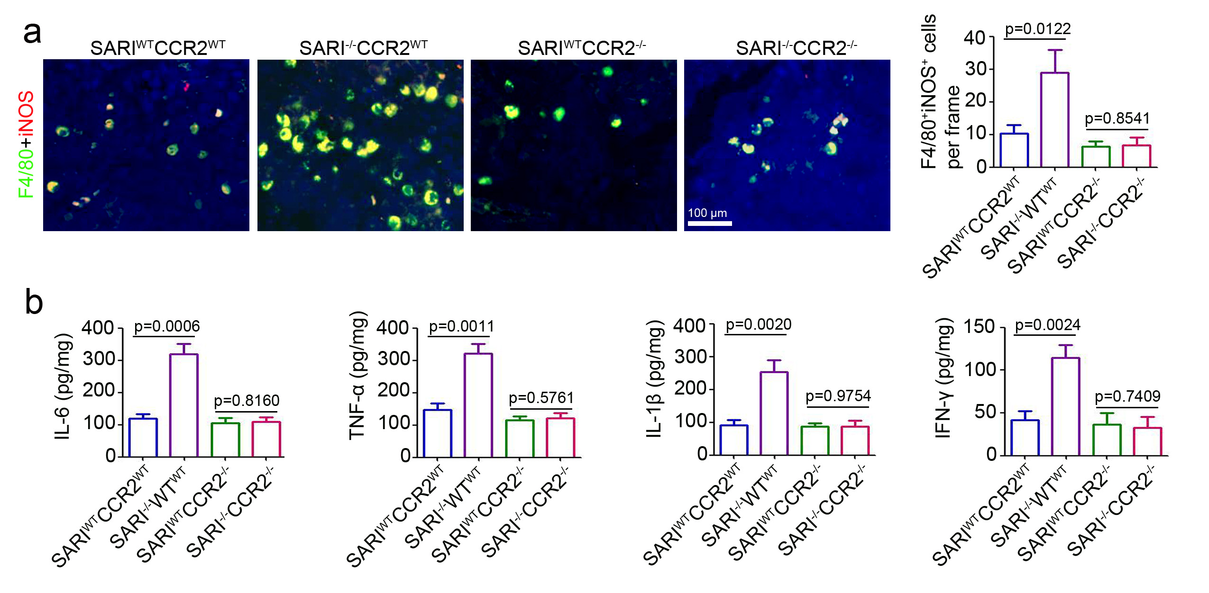
Supplemental Figure 5 (a) Representative images of F4/80 (green) and iNOS (red) staining of colonic tissues from SARI^{WT}CCR2^{WT}, SARI^{-/-}CCR2^{WT}, SARI^{WT}CCR2^{-/-}, SARI^{-/-}CCR2^{-/-} mice receiving 3% DSS treatment. The cell nuclei were stained with DAPI (blue). The number of F4/80 and iNOS positive cells in per frame were counted and analyzed (n = 6). (b) Cytokine expression in whole colons from SARI^{WT}CCR2^{WT}, SARI^{-/-}CCR2^{WT}, SARI^{WT}CCR2^{-/-}, SARI^{-/-}CCR2^{-/-} mice receiving 3% DSS treatment for 14 d.

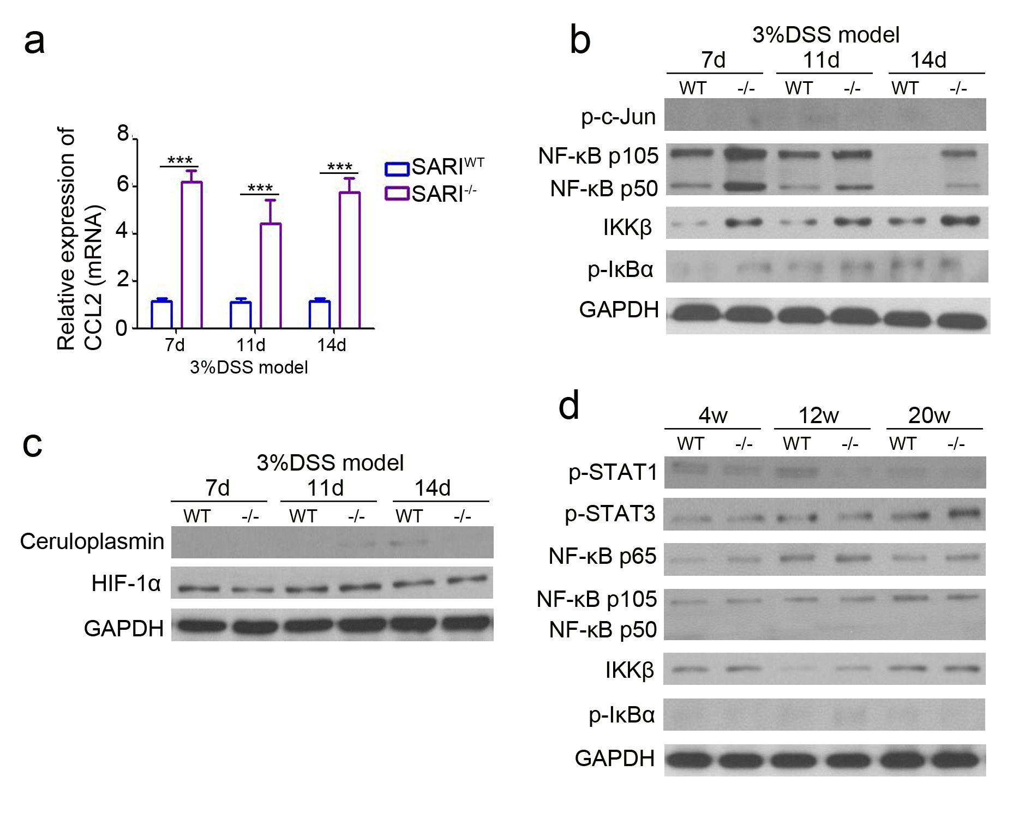
Supplemental Figure 6 (a) Real-time PCR analysis of CCL2 expression in whole colonic tissues from colitis SARI^{WT} and SARI^{-/-} mice (n=4, ***, p<0.0001). (b) Immunoblots of p-c-Jun, NF-κB p105, NF-κB p50, IKKβ, p-IκBα protein expression in whole colonic tissues from SARI^{WT} and SARI^{-/-} mice receiving 3% DSS treatment for 7, 11 and 14 days. GAPDH was used as loading control. (c) Immunoblots of HIF-1α and ceruloplasmin protein expression in whole colonic tissues from SARI^{WT} and SARI^{-/-} mice receiving 3% DSS treatment for 7, 11 and 14 days. GAPDH was used as loading control. (d) Immunoblots of p-STAT1, p-STAT3, NF-κB P65, NF-κB p105, NF-κB p50, IKKβ, p-IκBα protein expression in whole colonic tissues from SARI^{WT} and SARI^{-/-} mice at the age of 4, 12 and 20 weeks old. GAPDH was used as a loading control.

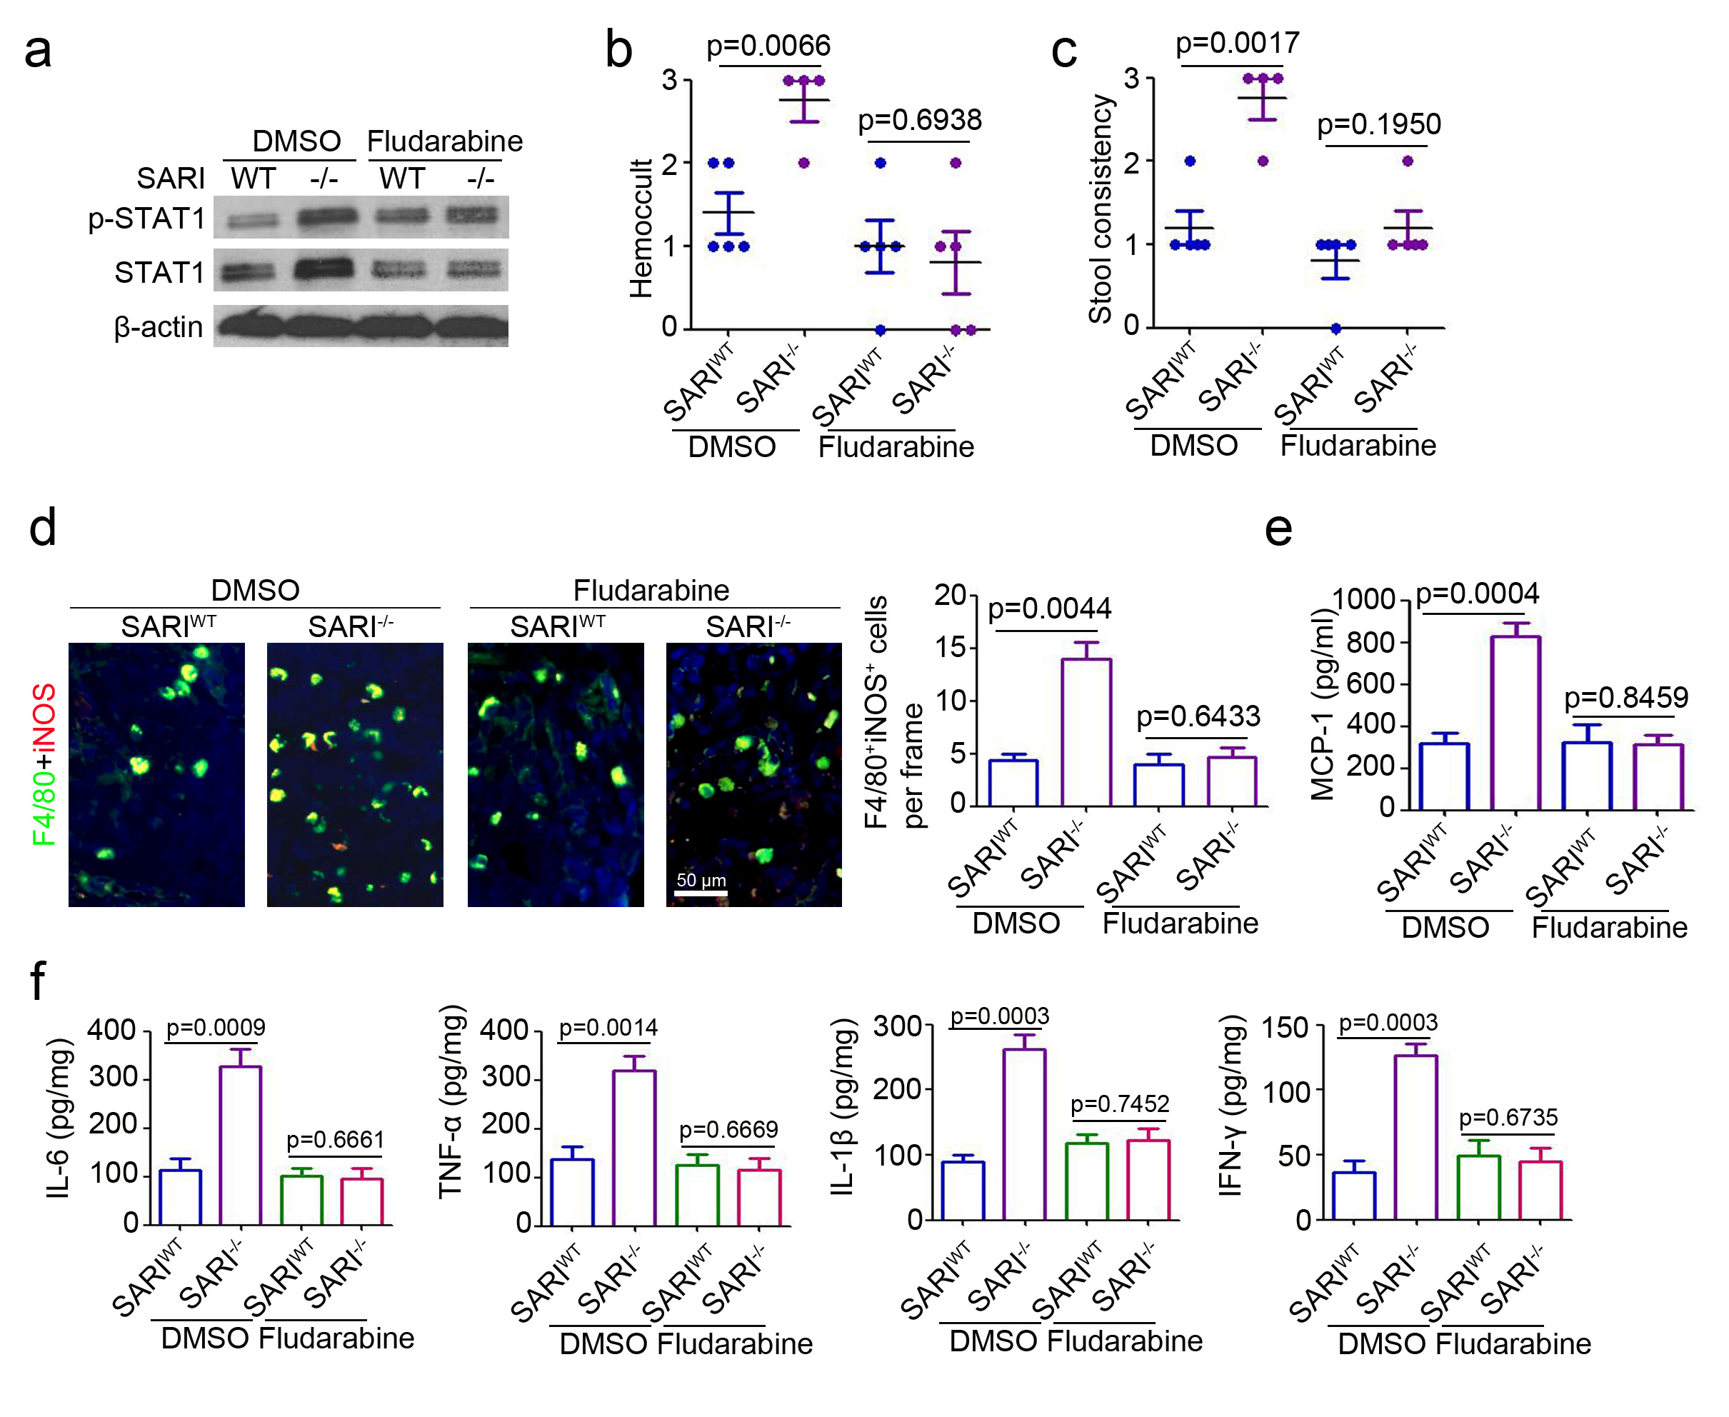
Supplemental Figure 7 (a) Schematic diagram of the STAT1 inhibitor Fludarabine treatment in acute colitis mice. Fludarabine (20 mg/kg) was intraperitoneally (i.p.) injected at 2 days before 3% DSS treatment and last for 10 days in total. Hemoccult (b) and stool consistency (c) of SARI^{WT}-DMSO, SARI^{WT}-Fludarabine, SARI^{-/-}-DMSO and SARI^{-/-}-Fludarabine mice receiving 3% DSS treatment. (n ≥ 4, **, p<0.01; ns, no significant difference). (d) Representative images of F4/80 (green) and iNOS (red) staining of colonic tissues from SARI^{WT}-DMSO, SARI^{WT}-Fludarabine, SARI^{-/-}-DMSO and SARI^{-/-}-Fludarabine mice receiving 3% DSS treatment. The cell nuclei were stained with DAPI (blue). The number of F4/80 and iNOS positive cells in per frame were counted and analyzed (n = 6). (e) ELISA analysis of CCL2 expression in whole colonic tissues from SARI^{WT}-DMSO, SARI^{WT}-Fludarabine, SARI^{-/-}-DMSO and SARI^{-/-}-Fludarabine mice receiving 3% DSS treatment (n = 3). (f) Cytokines expression in whole colonic tissues from SARI^{WT}-DMSO, SARI^{WT}-Fludarabine, SARI^{-/-}-DMSO and SARI^{-/-}-Fludarabine mice receiving 3% DSS treatment (n = 3).

