The Aerodynamic Effect Of An Oblique Wind On Helicopter Recovery To The Queen Elizabeth Class Aircraft Carrier
Neale A Watson, Michael F Kelly, Ieuan Owen, Mark D White
School of Engineering
University of Liverpool
Liverpool, UK

ABSTRACT
This paper describes an investigation into the air flow over the flight deck of HMS Queen Elizabeth, the UK’s new aircraft carrier, and how it could affect helicopter recovery. The twin islands on the starboard side of the ship mean that there will be turbulent air flow over the flight deck for starboard winds. The unsteady air flow over the ship was created using time-accurate Computational Fluid Dynamics for a 25kts wind coming from 25° off the starboard, i.e. a Green 25 wind over deck. As well as using the CFD results to show the expected mean velocity field and turbulence intensity over the flight deck, the time-varying velocity components have also been used to assess how the unsteady air flow will affect a helicopter by integrating the velocity components of the ship’s airwake with a flight dynamics model of a helicopter configured to represent a SH-60B Seahawk. The application of the helicopter flight dynamics model has been implemented in two different ways: first where the flight model is held stationary in the airwake to evaluate the unsteady aerodynamic loads imposed on the helicopter, and second where the airwake and the flight model are integrated into a piloted full-motion flight simulator to assess pilot workload during a series of deck landings. The results show how the turbulent air flow over the landing spots correlates with the predicted unsteady loads on the helicopter, and with the workload ratings awarded by a test pilot in the simulator.

Introduction
HMS Queen Elizabeth, the first of the United Kingdom’s two new Queen Elizabeth Class (QEC) aircraft carriers, was commissioned in December 2017 and has already
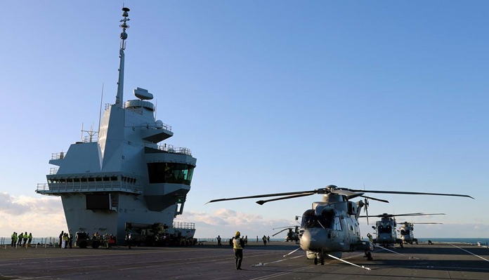

Figure 1. Merlin helicopters on deck of HMS Queen Elizabeth © Crown copyright (Ref. 1)
successfully conducted sea-trials, rotary-wing flight testing and First of Class Flight Trials (FOCFTs) with the Lockheed Martin F-35B Lightning II Short Take-Off and Vertical Landing (STOVL) stealth fighter jet. As well as the STOVL variant of the fixed-wing F-35, the ship will also operate with a range of rotary-wing assets including Merlin, shown on deck in Fig. 1, Wildcat, Chinook and Apache helicopters.
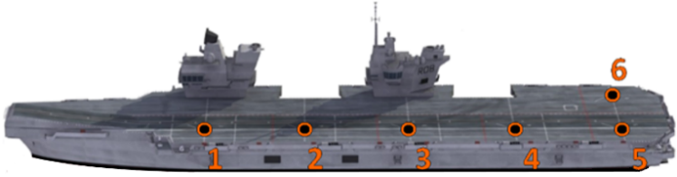
Figure 2. Queen Elizabeth class aircraft carrier with Vertical Landing spots identified
As can be seen in Fig. 2, the QEC superstructure is characterized by its two islands and a ‘ski-jump’ ramp to assist the launch of the fixed-wing F-35B. Figure 2 also shows the six landing spots designated for Vertical Landing recovery for both the F-35B and rotorcraft, with spot 6 being designated solely for rotorcraft operations.
Research at the University of Liverpool (UoL) has been focused on understanding the air flow environment around ships and how it affects the flying qualities of the ship’s aircraft and pilot workload through the use of modelling and simulation (e.g. Refs. 2, 3). Of particular interest, and the subject of this paper, is how the two islands on the starboard side of the QEC affect the air flow over the flight deck when the wind comes obliquely from starboard, creating a turbulent air flow over the flight deck, and how it will impact a helicopter during a deck landing.
This paper will, therefore, describe a study into the effect of airwake turbulence on a helicopter being recovered to the ship when the relative wind is from 25° off the starboard side, i.e. a Green 25 Wind Over Deck (WOD). The unsteady airflow over the ship was modelled using Computational Fluid Dynamics (CFD). How the unsteady flow field in the vicinity of the landing spots will impact the helicopter was investigated by integrating the unsteady velocities in the ship’s airwake with a flight dynamics model of a helicopter configured to represent a SH-60B Seahawk. The application of the helicopter flight dynamics model has been implemented in two different ways: first where the flight model is held stationary in the airwake to evaluate the unsteady aerodynamic loads imposed on the helicopter, and second where the airwake and the flight model are integrated into a piloted flight simulator to assess pilot workload during a series of deck landings.

THE SHIP AIRWAKE
The unsteady air flow over the 280m long ship, (the ship ‘airwake’), is computed using time-accurate CFD, i.e. it is necessary to compute the velocity components as they change with time. Within the flight simulation, the time varying velocities are then integrated with the helicopter flight model to create the unsteady loads on the aircraft which the pilot will experience. While the CFD technique reported previously has been used by the authors on a number of ship configurations, e.g. Ref. 4, the size of the carrier and the need to maintain the turbulence in the airwake over the flight deck and 400m astern of the ship along the fixed-wing approach path, placed greater demands on the CFD analysis in terms of computational time and memory. Only a brief description of the CFD process and its experimental validation is included here, but a more detailed description can be found in Ref. 5.
The CFD method adopted was Delayed Detached Eddy Simulation (DDES), a time-accurate CFD approach suitable for unsteady flow dominated by both quasi-periodic large-scale structures and chaotic small-scale turbulent features typical of bluff body geometries (Ref. 6). DDES combines both Large Eddy Simulation (LES), which resolves large scale structures away from the surface of the ship, and Unsteady Reynolds-averaged Navier-Stokes (URANS) to resolve the flow close to the surface (Ref. 7); it was employed with an SST k-ω based turbulence model and third-order accuracy. This hybrid method of turbulence modelling is well suited to ship-airwake simulations as the computational time needed is reduced in comparison with “pure” LES, and the turbulent features in the region of interest over the flight deck are explicitly resolved. DDES also produces less dissipation of turbulent kinetic energy in the flow shed from the bluff superstructure when compared with a “pure” URANS approach. To maintain simulation fidelity and reduce artificial dissipation the flow must be explicitly resolved in the area of interest using LES, requiring a sufficiently dense mesh over the flight deck. To resolve the turbulence for both rotary-wing and fixed-wing flight simulation, in which the flow over the deck and astern of the ship was accounted for, required a mesh size of 100 million cells. At the CFD inlet boundary condition a steady atmospheric boundary layer (ABL) was applied to represent the flow over the sea surface (Refs. 4, 8). Once the CFD solution had settled, the three-dimensional velocity components were sampled for 30 seconds which were then looped to create a continuously unsteady flow field in the flight simulation environment.
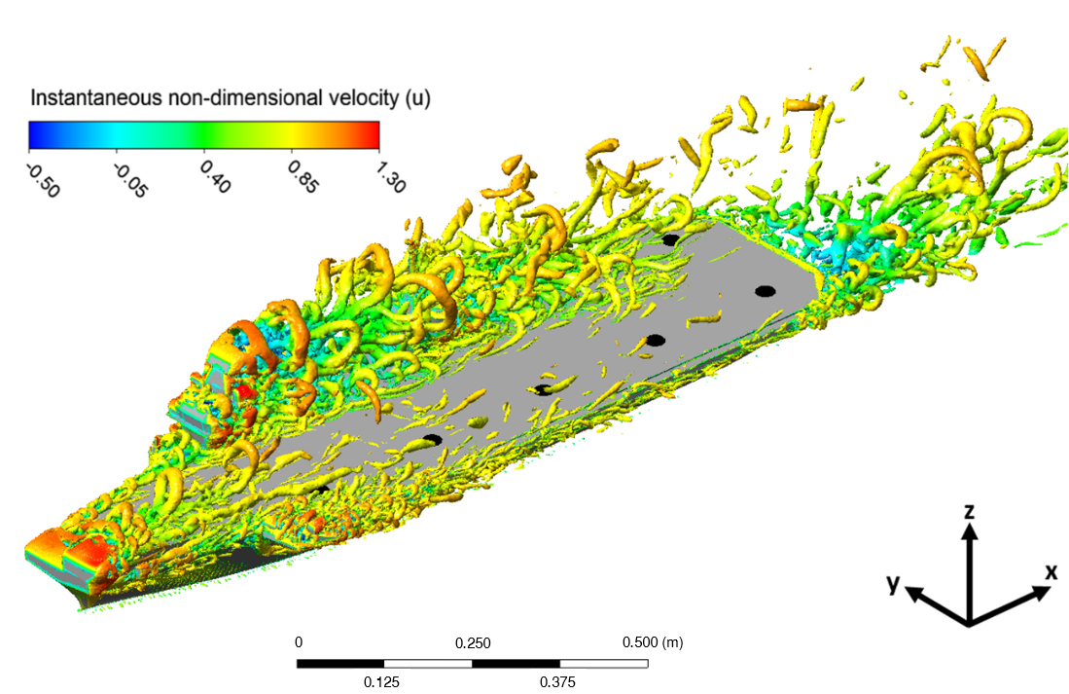
Figure 3. Headwind flow over QEC model presented as instantaneous iso-surfaces of Q-criterion coloured by u-velocity
Figure 3 shows the vortical structures in the CFD-generated airwake for a headwind, using the Q-criterion vortex identification method, as iso-surfaces coloured by instantaneous streamwise u-velocity. Also shown in Fig. 3 are the five landing spots along the port side of the ship and spot 6 behind the aft island (shown as black dots on the deck). It can be seen that in the headwind, landing spots 1 to 5, along the deck, are in mainly undisturbed air flow. Figures 4 to 6, on the other hand, show the turbulent wakes from the islands in the Green 25 WOD. In Fig. 4 the airwake in a Green 25 wind is illustrated in terms of turbulence intensities in vertical planes. In this study the turbulence intensity is the root mean square (RMS) of fluctuating velocity normalized by the freestream velocity (i.e. not the local mean velocity). Each plane in Figs. 4(a-e) is aligned with the 25° wind direction and passes through landing spots 1 to 5. The CFD images also show the location of the SH-60B helicopter main rotor for a hover position above landing spots 1 to 5. The rotor height above the deck is 10m, approximately the height the pilot holds the aircraft above the landing spot before descending to the deck to land.
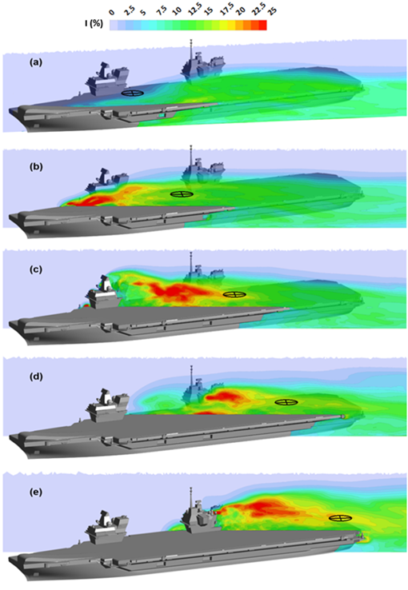
Figure 4. Ship airwake visualised as contours of mean tubulence intensity in streamwise vertical planes through landing spots 1 to 5
Figure 4(a) shows a low turbulence intensity at the rotor hover position over spot 1, but in Figs. 4(b-d) the turbulence generated by the islands can be seen to encroach on the areas over landing spots 2 to 5.
Figure 5 shows the total non-dimensional velocity averaged over the 30 second sampling period in a horizontal plane at the 10m hover height; streamlines in the horizontal plane are also included showing the direction of the flow. It can be seen that the flow velocity at spot 1 is largely unaffected by the ship’s superstructure while spots 2 to 5 are within the wake of the two islands and show a large reduction and variability in velocity compared with the freestream flow.
Figure 6 shows the turbulence intensity in the 10m horizontal plane. Again, spots 2 to 5 are in turbulent air flow; the turbulence varies between spots, and across the rotor disc, but are generally in the region of 15 to 20%. The two islands, and the gap between them, affect the air speed and turbulence over each landing spot, both of which will affect the aerodynamic loads on the helicopter, and hence the pilot workload; these two aspects were investigated separately. The unsteady loads imparted on a stationary helicopter have been assessed using a software analysis tool, known as the Virtual AirDyn (VAD), which integrates the airwake velocity components with a helicopter flight dynamics model (Ref. 9). The effect of the unsteady air flow on pilot workload has been assessed using a motion-base piloted flight simulator, the HELIFLIGHT-R (Ref. 10). Both of these simulation techniques integrate the unsteady velocity components of the airwake with a flight dynamics model of a helicopter.
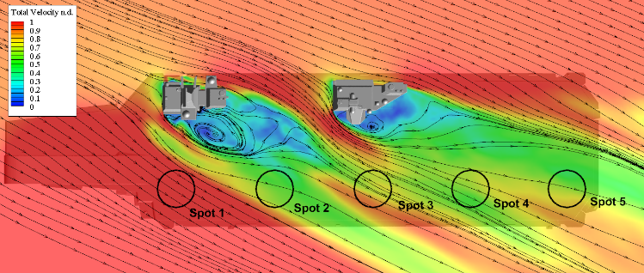
Figure 5. Mean total non-dimensional velocity in a horizontal plane at 10m hover height
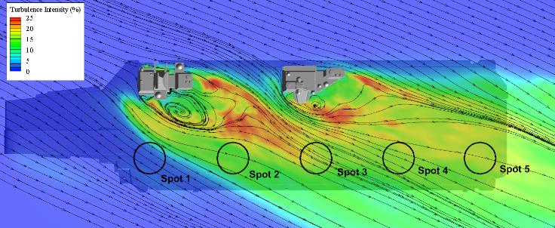
Figure 6. Mean turbulence intensity in a horizontal plane at 10m hover height
The helicopter flight model is from the air-vehicle library within Advanced Rotorcraft Technology’s FLIGHTLAB software (Ref. 11). This generic rotorcraft flight dynamics model was configured to be representative of the Sikorsky SH-60B Seahawk and was chosen for these exploratory simulation trials due to its strong validation (Ref. 12) and extensive use during previous research at UoL (e.g. Ref. 2). The FLIGHTLAB model of the SH-60B is comprised of the following major subsystem components: (1) blade-element main-rotor model including look-up tables of non-linear lift, drag and pitching moment coefficients stored as functions of incidence and Mach number; (2) Bailey disk tail-rotor model; (3) Peters-He finite-state dynamic inflow model; (4) separate look-up tables for the fuselage, vertical tail and stabilator aerodynamic loads stored as nonlinear functions of incidence and sideslip; (5) turbo-shaft engine model with a rotor-speed governor; (6) primary mechanical flight control system and Stability Augmentation System (SAS) models including sensor and actuator dynamics; and (7) landing gear model to provide deck reaction cues on touchdown.

AIRWAKE INTEGRATION
For the helicopter model to be subjected to the effect of the ship’s airwake in both the Virtual AirDyn and the piloted flight simulator, the 30 seconds of unsteady airwake velocities generated by CFD are imposed on the aircraft flight dynamics model at various locations on the rotor blades and airframe within FLIGHTLAB. Figure 7 shows a schematic of how the raw data produced in CFD is processed to enable the unsteady components of velocity in the ship’s airwake to be applied to the flight dynamics model of the aircraft. The raw CFD output contains data for every cell throughout the computed domain; as most of this data is unnecessary for flight simulation, the unstructured velocities are interpolated onto a uniform grid of 1m spacing in the region of interest. The bottom left of Fig. 7 shows the boundaries of the structured domain extending from the flight deck to astern of the ship and off the port side, areas in which both fixed-wing and rotary-wing aircraft operate.
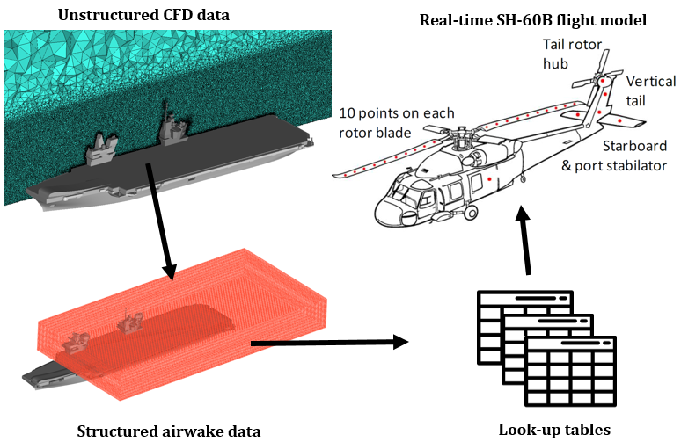
Figure 7. Integration of CFD airwake with helicopter flight dynamics model
To reduce the overall storage and allow real-time playback of the data, the CFD solution computed at 100Hz was down-sampled to 25Hz. The structured data is then converted into a series of look-up tables from which the unsteady velocity components can be applied to the flight dynamics model in real-time via Aerodynamic Computation Points (ACPs). The majority of ACPs, indicated as red dots in the top right of Fig. 7, are located on the main rotor with ten ACPs distributed along each blade; the remaining points are positioned at the aircraft’s center of gravity, the vertical tail, the tail rotor hub and the starboard and port stabilizers.
Figure 8 shows an example of the down-sampled u and v velocity components at points 10m above spots 1 and 2. Off-line comparison of the data in Fig. 8 with the original 100 Hz data showed insignificant differences. It can also be seen in the figure that the velocity components at spot 1, which is not within the wake of the islands, show a higher mean and much lower fluctuations in both velocity components compared with spot 2, consistent with the data shown in Figs. 4 to 6.
Figure 8. Airwake velocity components at points 10m above spots 1 and 2

THE VIRTUAL AIRDYN
While the CFD results can give information on the unsteady air flow and steep velocity gradients in which the helicopter will operate, it is more important to understand how this will affect the helicopter.
The VAD is a software analysis tool developed at the UoL to measure the impact of an unsteady airwake on a helicopter by integrating the unsteady velocity components with a helicopter flight dynamics model (Ref. 9). During piloted real-time simulations, the time-varying velocities in the airwake will produce unsteady forces and moments through the helicopter’s flight dynamics model that will cause the aircraft to deviate from the trim condition, requiring the pilot to compensate for these disturbances through movement of the helicopter’s controls. The helicopter model in the VAD is first trimmed in the prevailing freestream condition and then placed at a selected point in the airwake and fixed in that position. Since the helicopter is held at a fixed location, when the unsteady airwake velocities are applied it will experience time-varying non-zero forces and moments. These forces and moments are recorded by the VAD over a 30 second period and provide a quantitative measure of the relative impact on the helicopter from the ship’s airwake. Previous research at UoL has employed the VAD for investigating the effect of a ship’s superstructure design on helicopter handling qualities and pilot workload and for evaluating and comparing different ship designs (Ref. 9).
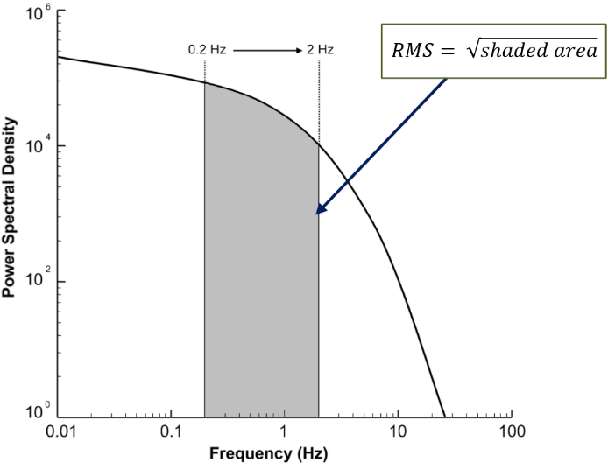
Figure 9. Method for calculating RMS forces and moments acting on helicopter flight dynamics model
The helicopter model in the VAD was placed over landing spots 1 to 5 for 30 seconds and the forces and moments acting on the aircraft were recorded. The resulting unsteady loads are created over a wide range of frequencies; however, it is known that loads in the range 0.2 to 2Hz are the main contributors to pilot workload (Ref. 13). This range is known as the pilot closed-loop response frequency range; at disturbance frequencies within this range the pilot will respond to (compensate) with stick/pedal inputs. At frequencies much below this range disturbances will be ‘quasi-steady’ and manifest themselves as a drift which needs to be trimmed out before resulting in large displacements. Frequencies above 2Hz are experienced as vibrations through the airframe that will mainly impact ride quality.
At each hover position, the root mean square (RMS) value in the three unsteady forces and moments are computed over the pilot’s closed-loop response frequency range of 0.2 to 2 Hz by calculating the Power Spectral Density (PSD) plot of each time history and calculating the square root of the integral between the upper and lower bounds; this process is illustrated schematically in Fig. 9.
An example of the unsteady thrust force (Fz) computed at the helicopter’s centre-of-gravity during hover at spots 1 and 2 in a 25kt Green 25 WOD condition is shown in Fig. 10. The time-history of spot 2 in the upper graph shows a larger deviation from the mean thrust in comparison with spot 1 over the 30 second time period; this is reflected in the PSD plot at the bottom of Fig. 10 which shows that spot 2 has a higher power compared with spot 1 throughout the frequency range. The two dashed red lines in Fig. 10 show the pilot’s closed-loop response frequency range between 0.2 and 2 Hz, used as boundaries to calculate the area beneath each curve giving an RMS value at spots 1 and 2 of 3.1kN and 9.1kN respectively. The higher RMS loads over spot 2 is consistent with the higher turbulence in the CFD results discussed earlier.
Figure 10. Unsteady thrust computed by Virtual AirDyn at spots 1 and 2 in 25kts Green 25 WOD
Figure 11 shows the RMS value for each force and moment calculated over the pilot’s closed-loop response frequency range at spots 1 to 5 in a 25kts Green 25 WOD condition using the VAD. The RMS forces show a larger variation in the thrust force compared with the drag and side forces; this is to be expected since the production of thrust to counteract the weight of the aircraft is sensitive to any change in air velocity across the rotor disc. The forces required to counteract the drag and side force are relatively small and less sensitive to fluctuations in wind speed. Figure 11 shows an increasing level of RMS value in the thrust and drag forces from spots 1-4 with a drop in the RMS at spot 5. A larger variation in moment is shown for yaw in Fig. 11 than in roll or pitch; this is in part due to the reliance on the tail rotor to produce thrust in the horizontal plane to counteract the torque produced by the main rotor. As with RMS values for forces, the variations in moments for spot 1 is consistently the lowest; corresponding to the low level of air turbulence seen earlier.

Figure 11. Virtual AirDyn RMS forces and moments acting on aircraft fixed in hover at 25kts Green 25 WOD

FLIGHT SIMULATION
The VAD results shown above enable the integrated effects of the unsteady airwake on the whole aircraft to be quantified at the different landing spots. While unsteady loads in the different axes will vary with wind speed and direction, and location over the deck, to determine pilot workload requires a pilot-in-the-loop to evaluate how the loads combine. UoL has been at the forefront of research using high-fidelity ship-helicopter dynamic-interface simulation to predict ‘virtual’ Ship Helicopter Operating Limits (SHOL), e.g. Refs. 2 and 14, using the HELIFLIGHT-R reconfigurable generic flight simulator shown in Fig. 12 (Ref. 10). The HELIFLIGHT-R simulator consists of a twin-seat cockpit, with a third seat at the rear for an instructor or simulator operator, housed inside a 12ft diameter visual display dome, mounted on a hexapod motion platform, comprising six electric actuators, each with a 24 inch stroke.
Figure 12 shows the interior of the cockpit, including the primary cockpit instruments displayed on two wide-screen flat-panel displays. The main outside-world scene displayed on the inside of the dome is projected using three DLP projectors, each with a resolution of 2,560 × 1,600 pixels. The image from each projector is geometry-corrected and edge-blended to present a single continuous image to the pilot. The projectors are equipped with wide-angle lenses and provide a horizontal field-of-view of 230° (±115°) and a vertical field-of-view of 70° (+30°/-40°). HELIFLIGHT-R also provides the capability to configure the force-feel characteristics of both the pilot and co-pilot’s cyclic, collective and pedal controls through a four-axis electronic control loading system, allowing a wide range of aircraft types to be simulated. Throughout the cockpit, audio cues are communicated to the pilot by a loudspeaker system.
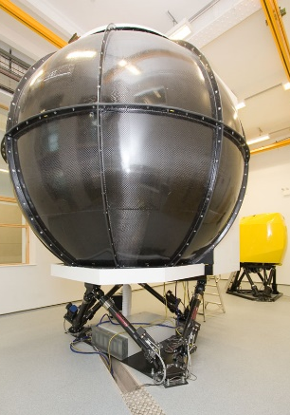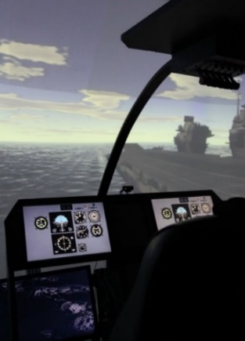
Figure 12. HELIFLIGHT-R full-motion flight simulator with QEC visual scene
The same generic rotorcraft flight dynamics model used in the VAD experiment was integrated with HELIFLIGHT-R using the Advanced Rotorcraft Technology’s FLIGHTLAB software (Ref. 11). A visual model of the ship was integrated into the simulator run-time environment; the view from the cockpit can be seen in the right of Fig. 12. Real-time data monitoring and recording is available in FLIGHTLAB which, along with in-cockpit video and audio recordings, are used for post-trial analysis.

Piloted Flight Simulation Trial
Once the QEC simulation environment had been successfully implemented, a series of flight trials were conducted, with an experienced former Royal Navy test pilot, to investigate pilot workload during recovery to the ship in a Green 25 WOD. Three wind speeds of 25kts, 35kts, and 45kts were tested and, for each wind speed, the pilot was instructed to land at spots 1 to 5 using a port-side forward-facing recovery as shown in Fig. 13. Each landing evolution was divided into three contiguous Mission Task Elements (MTEs). The landing was initiated with the helicopter off the port side of the ship, facing forward and moving at the same speed as the ship; MTE 1 comprised the lateral translation from off the port side to over the landing spot; MTE 2 was a 30 second hover; MTE 3 was the descent and touch-down. The pilot was asked to provide a quantified rating of perceived workload for each of the three MTEs using the Bedford Workload Ratings scale shown in the Appendix (Ref. 15), and to provide a rating for the difficulty of the overall landing task using the Deck Interface Pilot Effort Scale (DIPES), also shown in the Appendix (Ref. 16).
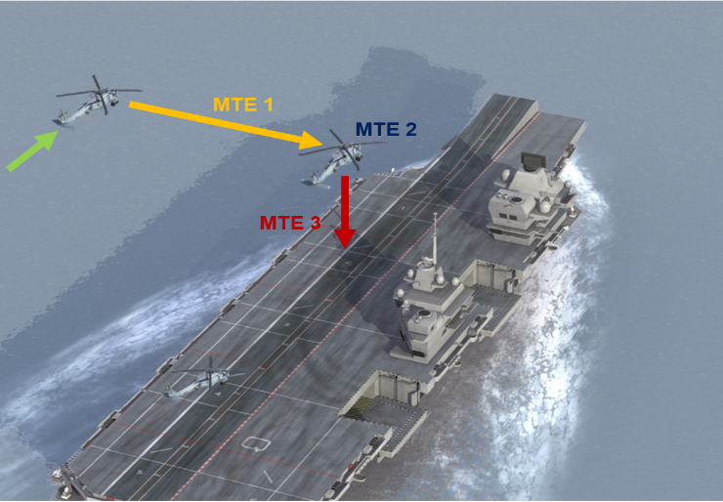
Figure 13. Port side helicopter recovery to QEC
The Bedford Workload Ratings scale is used to determine the pilot’s perceived workload, defined as the integrated physical and mental effort generated by the perceived demands of a specified piloting task. A questionnaire study, carried out by Roscoe and Ellis during development of the Bedford scale, found that pilots naturally think in terms of spare capacity when considering workload (Ref. 15). In the Bedford scale spare capacity is defined as the pilot’s ability to perform secondary tasks, such as maintaining mission awareness, monitoring aircraft systems or listening to radio communications, the primary task being to fly the aircraft through a particular manoeuvre or mission. The higher the workload generated by the primary task, the less spare capacity there is for attention to these secondary tasks and the higher the rating on the scale shown in the Appendix. A rating of 1-3 indicates that workload was satisfactory without reduction during the task. Ratings of 4-6 are awarded where although the workload was tolerable for the task the workload was unsatisfactory leaving little spare capacity for the pilot to conduct additional tasks. A workload rating of 7-9 shows that the pilot was able to complete the task but had little or no spare capacity for additional tasks. The highest rating of 10 is reserved for situations where the pilot is unable to apply sufficient effort and the task is abandoned.
The DIPES is used to assess the amount of effort needed to complete the overall landing task. Unlike the Bedford Workload Ratings scale the DIPES also accounts for aircraft physical control margins and identifies environmental factors such as deck motion and turbulence; identifying conditions where, although pilot workload may be low, control limits are reached. This makes the DIPES well suited for qualification testing to determine limiting conditions for ship-aircraft combinations. DIPES is widely used by NATO member countries during First of Class Flight Trials. As tests are carried out by pilots with extensive experience in ship-borne helicopter operations to establish optimal and safe operations, ratings given should account for the capabilities and skill of the ‘average’ fleet pilot.
The DIPES shown in the Appendix can be used to give a rating of 1-5 for each landing. Ratings of 1-3 covers the range from slight to highest tolerable effort required for aircraft recovery, while still remaining within acceptable operating limits for an average fleet pilot. A rating of 4 indicates that the task requires an excessive amount of effort making it unacceptable for fleet pilots, who would not be able to consistently repeat the task. A DIPES rating of 5 indicates extreme pilot compensation is required to complete the task even under controlled test conditions with fully proficient crews. A list of suffixes are also provided with the DIPES which allows the pilot to specify the cause(s) of increased workload (e.g. ‘T’ for turbulence).
During the simulated flight trials the pilot awarded workload ratings for each MTE from the Bedford scale, along with a DIPES rating for the total recovery task to the ship at landing spots 1 to 5 in Green 25 WOD at 25kts, 35kts and 45kts. For brevity, only the results from the Bedford Workload Ratings scale for the hover task will be reported, along with the DIPES ratings.

Flight Trial Results
Figure 14 shows the workload ratings given by the test pilot for the hover task, i.e. MTE 2, at spots 1 to 5 in a 25kts, 35kts and 45kts Green 25 WOD condition. The dashed red lines show the limit in the Bedford Workload Ratings scale at which the level of spare capacity the pilot has for additional tasks is tolerable. As the wind speed is increased, the workload ratings given for the hover task at each spot also increases; for each wind speed the general trend is that workload increases from spot 1 to 4 and then either falls or remains constant for spot 5. This trend is consistent with the VAD results in Fig. 11 where the RMS of the helicopter thrust load increases along the deck, peaking at spot 4, while at the same time pitch and yaw moments are consistently higher over spots 2 to 5 compared with spot 1. In a 25kts Green 25 WOD the hover task is within tolerable limits of workload for all spots. In a 35kts wind the workload ratings for spots 1 and 2 are considered acceptable, while for spots 3 to 5 the workload is unsatisfactory. As the wind speed is increased to 45kts, the workload for all spots, with the exception of spot 1, has become intolerable according to the Bedford Workload Ratings scale.
Figure 15 shows the DIPES rating given by the test pilot for the complete landing task at spots 1 to 5 in a 25kts, 35kts and 45kts Green 25 WOD condition; the dashed red line corresponds with a DIPES rating of 3, which is the limit at which the level of effort during the task is acceptable. As a 5 point scale, the DIPES is coarser than the 10 point Bedford scale, it is also a measure of the difficulty of the overall landing task, not of discrete elements within it. Figure 15 shows that the difficulty of the landing task increases significantly with wind speed. For the 25kts wind the pilot is not significantly challenged and awarded a rating of 1 for all spots. For the more challenging 35kts and 45kts winds the trend of the reported DIPES rating for landings at the different spots is similar to that of the Bedford ratings awarded for the hover task, i.e. workload increases from spot 1 to 4 and then either falls or remains the constant for spot 5. This trend is again consistent with the VAD results in Fig. 11. In the 35kts wind, the landing to spot 4 was deemed too difficult for a fleet pilot to achieve consistently as was spot 3 in a 45kts wind, while landings to spots 4 and 5 were deemed outside of safe operating limits.
Figure 14. Bedford workload ratings for hover task over each landing spot
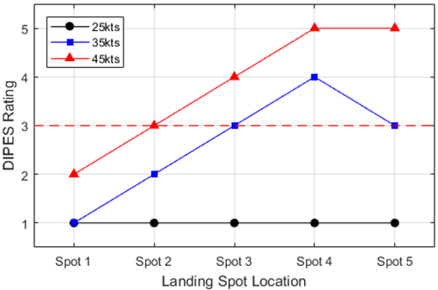
Figure 15. DIPES ratings for complete landing task
Relatively high pilot workload in a Green wind at 45kts for a carrier with a starboard superstructure is not an altogether surprising result. The workload ratings presented here are, of course, purely derived from simulation and, in addition, a simulation which makes use of a generic helicopter model, generic cockpit and limited visual and motion cues. Therefore, these results must not be taken as a replacement for real-world at-sea testing. Nevertheless, the study has identified areas where increased workload might be expected and, as such, the recommendations from these simulations would be that when conducting real-world flight testing such conditions should be explored in a suitably progressive manner using an experienced and fully proficient test crew. If, once such testing has been completed, the flight test results concurred with the simulation then the appropriate boundaries would be drawn on the released-to-service envelopes so that fleet pilots are not exposed to high levels of workload.

cONCLUSIONS
This paper has described an investigation of an oblique unsteady airwake over the landing deck of the Queen Elizabeth class aircraft carrier, and how it could affect helicopter recovery. CFD was used to simulate the unsteady air flow over the ship in a wind approaching from 25° off the starboard which, due to the twin island superstructure, creates turbulent flow over much of the deck. Thirty seconds of unsteady CFD has been used to calculate the mean and turbulent velocities above the vertical landing spots used by both rotary- and fixed-wing aircraft. The effect of time-varying air flow on the unsteady loads on a helicopter was assessed, using a technique known as the Virtual AirDyn, to quantify the unsteady forces and moments acting on the aircraft in the hover. How the unsteady air flow would affect the handling qualities of the helicopter and pilot workload during a deck landing to each spot was assessed through a series of simulated flight trials conducted in a full-motion flight simulator configured to represent a SH-60B Seahawk helicopter.
The main conclusions can be listed as follows:
- Winds approaching the Queen Elizabeth class aircraft carriers from the starboard side will create turbulent air flow over the flight deck in the wake of the twin-island superstructure.
- In a Green 25 wind the unsteady loads imparted on a helicopter will progressively increase along the deck from spot 1 to spots 4 and 5.
- Green 25 winds up to 25kts presented little difficulty to the pilot when hovering above spots 1 to 5.
- Green 25 winds up to 25kts presented little difficulty to the pilot when conducting a port-side landing to spots 1 to 5.
- In a 35kts wind the workload of the pilot whilst maintaining a hover over the landing spot increased progressively from spot 1 to 4, before decreasing for spot 5. For spots 2 to 5 the workload was considered excessive.
- In a 35kts wind the workload for the overall port side landing measured on the DIPES scale increased steadily along the deck from spot 1 to 4, then decreased slightly for spot 5. In this simulation the landing to spot 4 was deemed too difficult to achieve consistently for a fleet pilot.
- In a 45kts wind the workload of the pilot to maintain a hover over the landing spot increased steadily along the deck for spots 1 to 5, and was excessive for each spot.
- In a 45kts wind the workload for the overall port side landing measured on the DIPES scale increased steadily along the deck from spot 1 to spots 4 and 5. In this simulation the landing to spot 3 was deemed too difficult to achieve consistently for a fleet pilot, while landing to spots 4 and 5 were deemed dangerous and beyond safe limits.

- The unsteady helicopter loads obtained by the Virtual AirDyn were consistent with the workload reported by the test pilot.
- The overall synthetic environment, including the integration of CFD airwakes into a real-time piloted simulation using a generic rotorcraft model, was considered by the pilot to be a realistic representation of the at-sea flying experience. This is an encouraging result, which has implications for the potential role of flight simulation in supporting future at-sea testing of maritime rotorcraft and for enhancing pilot training devices.
Author contact: Neale Watson nawatson@liv.ac.uk

Acknowledgments
The Authors acknowledge the financial support from the Engineering and Physical Sciences Research Council through Industrial CASE Awards jointly funded with BAE Systems, and the ongoing support of ANSYS UK Ltd. They would also like to thank Wajih Memon from the Flight Science and Technology research group at the University of Liverpool and the flight test pilot Andy Berryman for their guidance and expertise.

REFERENCES
- Royal Navy Imagery Database, accessed March 2018, https://www.royalnavy.mod.uk/useful-resources-and-information/rn-image-archive
- Owen, I., White, M. D., Padfield, G. D. and Hodge S. J., “A virtual engineering approach to the ship-helicopter dynamic interface – a decade of modelling and simulation research at the University of Liverpool”, Aeronautical Journal, Vol. 121, Issue 1246, December 2017, 1833-1857.
- Kelly, M. F., Watson, N. A., Hodge, S. J., White, M. D. and Owen, I. “The Role of Modelling and Simulation in the Preparations for Flight Trials Aboard the Queen Elizabeth Class Aircraft Carriers”, 14th International Naval Engineering Conference, Glasgow 2018
- Forrest, J. S and Owen, I., “An Investigation of Ship Airwakes Using Detached-Eddy Simulation”, Computers & Fluids, 2010, 39 (4), 656–673.
- Watson, N. A., Kelly, M. F., Owen, I., Hodge, S. J. and White, M. D. “Computational and experimental modelling study of the unsteady airflow over the aircraft carrier HMS Queen Elizabeth”, Ocean Engineering, Vol. 172, 2019, 562-574.
- Spalart, P. R., Deck, S., Shur, M. L., Squires, K. D., Strelets, M. Kh. & Travin, A. “A New Version of Detached-Eddy Simulation, Resistant to Ambiguous Grid Densities”. Theoretical and Computational Fluid Dynamics, 2006, Vol. 20, Iss 3, 181-195.
- Spalart, P. R., “Comments on the feasibility of LES for wing and on a hybrid RANS/LES approach”. 1st ASOSR CONFERENCE on DNS/LES. Arlington, TX, August 1997.
- Garratt, R. “The atmospheric boundary layer”. Cambridge Atmospheric and Space Science Series, Cambridge University Press, 1992.
- Kääriä, C. H., Forrest, J. S. & Owen, I., “The Virtual AirDyn: a simulation technique for evaluating the aerodynamic impact of ship superstructures on helicopter operations,” Aeronautical Journal, 2013, 117 (1198), 1233-1248.
- White, M. D., Perfect, P., Padfield, G. D., Gubbels, A. W. and Berryman, A. C., “Acceptance testing and commissioning of a flight simulator for rotorcraft simulation fidelity research”, Proceedings of the Institution of Mechanical Engineers, Part G: Journal of Aerospace Engineering, Volume 227 Issue 4, April 2013, 663 – 686.
- DuVal, R. W. and He, C., “Validation of the FLIGHTLAB virtual engineering toolset”, Aeronautical Journal -New Series 122(125), March 2018, 1-37.
- Howlett, J. J., “UH-60A Black Hawk Engineering Simulation Program: Volume I – Mathematical Model”, NASA-CR-166309, December 1981.
- McRuer,, D. T., Interdisciplinary interactions and dynamic systems integration, Int. J. Control, 1994, 59, (1), pp 3-12.
- Hodge, S. J., Forrest, J. S., Padfield, G. D., & Owen, I.., “Simulating the environment at the helicopter-ship dynamic interface: research, development and application,” Aeronautical Journal. 1:116 (1185):1155. November 2012.
- Roscoe, A. and Ellis, G. “A subjective rating scale for assessing pilot workload in flight. A decade or practical use”. RAE report TR90019, Royal Aircraft Establishment, Farnborough, UK, 1990.
- Carico, G. D., Fang, R., Finch, R. S., Geyer, W. P., Krijns, Jr., Cdr. (Ret.) H. W., and Long, K., “Helicopter/Ship Qualification Testing”, Research and Technology Organisation, North Atlantic Treaty Organisation, BP 25, F-92201 Neuilly-sur-Seine Cedex, France, February 2003.

APPENDIX – Workload Rating Scales
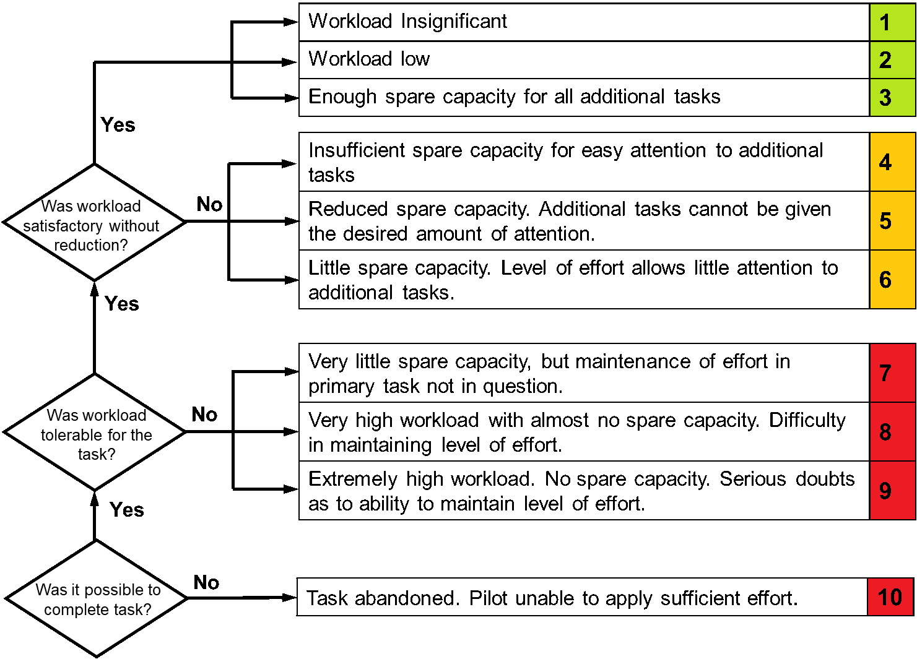
Bedford Workload Ratings scale (Ref. 15)

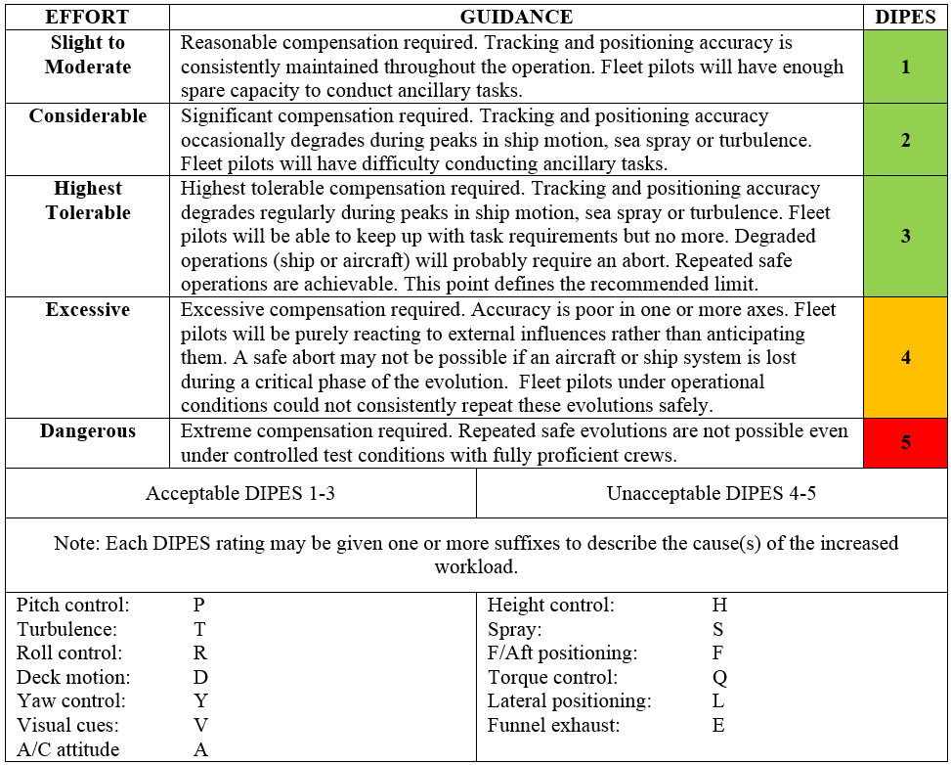
Deck Interface Pilot Effort Scale (DIPES) (Ref. 16)

