Experimental Validation of the Unsteady CFD-generated Airwake of the HMS Queen Elizabeth Aircraft Carrier

Neale A. Watson, Mark D. White and Ieuan Owen
University of Liverpool, Liverpool, United Kingdom
This paper describes an experimental study in which a 1:200 scale model of the Queen Elizabeth Class aircraft carrier was submerged in a water channel, and Acoustic Doppler Velocimetry was used to measure the unsteady flow over the ship’s superstructure. The study was conducted to provide experimental data to compare with a CFD prediction of the air flow over the full-scale, 280m long, ship. The paper describes the experimental technique and discusses the scaling issues between a 1:200 small-scale model in a water channel and the full-scale ship. The CFD was carried out using Delayed Detached Eddy Simulation to provide 30 seconds of the unsteady flow over and astern of the ship. The same CFD methodology was also applied to the small-scale experiment to provide further information on the scaling issues. While the detail of the CFD is not the main subject of the paper, a brief description is given, and comparisons are made between the experimental measurements and the CFD solutions.

Introduction
HMS Queen Elizabeth, the United Kingdom’s flagship, and the first of two new Queen Elizabeth Class (QEC) aircraft carriers, has successfully conducted sea-trials, rotary-wing flight testing and, most recently, completed the second phase of First of Class Flight Trials (FOCFTs) with the Lockheed Martin F-35B Lightning II Short Take-Off and Vertical Landing (STOVL) stealth fighter jet. The QEC will operate both the fixed wing STOVL variant of the F-35 [1] and a range of rotary-wing assets including Merlin, Wildcat, Chinook and Apache helicopters. As can be seen in Fig. 1, the QEC superstructure is characterized by its twin island superstructure and a ‘ski-jump’ ramp to assist the launch of the F-35B. The motivation for the work reported in this paper was to gain an understanding of the air flow over and around the aircraft carrier, commonly known as the ship’s airwake, and to produce a set of CFD-generated airwakes to be used in piloted flight simulation trials of aircraft launch and recovery. The airwake is created by a combination of the ship’s forward speed and the prevailing wind and is of interest because areas of unsteady turbulent air flow which can form over the flight deck will impact the aircraft operating to the ship, and can affect pilot workload.

The recent success of the QEC FOCFTs, completed on schedule, was the accumulation of over a decade of planning and preparation; as part of that preparation the University of Liverpool (UoL) has been working in collaboration with BAE Systems to support their development of high-fidelity piloted flight simulation facilities at BAE Systems Warton. A description of this collaboration and the fixed-wing F35B/QEC integration simulator is given in [3]. Simulation research has also been conducted at UoL, focused on shipboard helicopters, using modelling and simulation to better understand the airflow environment around ships and how it affects the flying qualities of the helicopter and pilot workload [4, 5, 6]. The majority of this work has related to single-spot ships such as frigates and destroyers and has included the use of time-accurate CFD to compute the unsteady velocity components in the area around the ship in which the aircraft will fly. The airwakes have been integrated into UoL’s motion-base flight simulator, HELIFLIGHT-R [7], in which test pilots conduct simulated deck landings [5]. The collaboration with BAE Systems has involved creating airwakes of comparable fidelity to those produced previously for single spot ships; however, for the much larger multi-spot aircraft carrier it was considered necessary to obtain new experimental data against which to compare the CFD airwake results. This paper will present the experimental setup and flow measurement technique used to compare mean and turbulent velocity data against a CFD solution of the QEC in a headwind. A brief description of the CFD method is also given but a more comprehensive account can be found in [8].

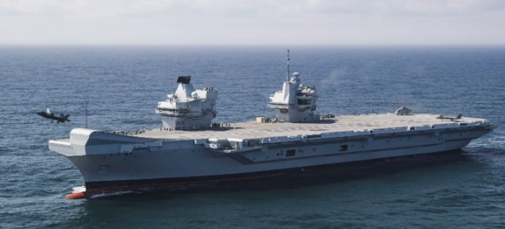

Fig. 1 HMS Queen Elizabeth during F-35B First of Class Flight Trials, October 2018 [2] (© Crown copyright).

Experimental Study
To assess the accuracy of the CFD method used for creating the ship’s airwake for integration into the piloted flight simulation, experimental measurements of mean velocity and turbulence in selected locations over a physical scale model of the ship were compared with the CFD-generated solution. This section describes the manufacture of a physical model of the QEC used for experimentation and the method used to measure the flow over the model, which was immersed in a water channel.
Detailed digital drawings were used to produce the QEC geometry for both the CFD computations and the manufacture of a 1:200 scale model. The 1.4m long ship model was manufactured from Acrylonitrile Butadiene Styrene (ABS) using 3-D printing techniques to create a model with sufficient stiffness and rigidity to withstand the oncoming flow when submerged in the water channel. The slender mast located on the aft island was produced using Direct Metal Laser Sintering with cobalt-chrome to achieve the required stiffness. Due to the size of the model, the ship was manufactured as six separate sections: three for the hull which were interlocked together, one for each island and a section for the ski-jump. Rasterization, an effect inherent to the additive layering process, was present on each 3-D printed component, particularly the curving ski-jump, and required additional finishing to obtain a smooth surface. All the manufacturing was carried out at BAE Systems’ Additive Layer Manufacturing centre. The assembled model is shown in Fig. 2.

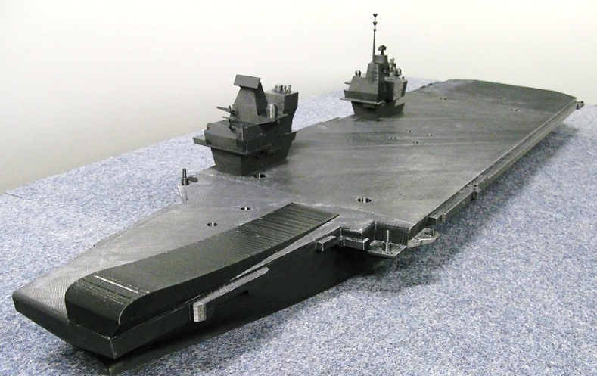

Fig. 2 Assembled 1:200 scale 3-D printed model of HMS Queen Elizabeth.

To reduce the overall manufacturing time, cost and weight, the ship’s hull was designed to be hollow, which also allowed five suction cups, connected to a vacuum pump, to be attached inside the hull to secure the model to the floor of the water channel. Figure 3 shows the underside of the ship CAD model with the suction cups coloured blue.

Fig. 3 Underside of the QEC model showing the vacuum pump attachment system.

Experimental measurements were carried out in a 90,000 litre recirculating water channel, shown schematically in Fig. 4. The model was submerged in the 3.7m long, 1.4m wide working section of the channel and secured by the suction cups to the adjustable floor in a water depth of 0.85m. With the QEC model aligned with the flow direction, the working section blockage was approximately 3.2%. The water channel is capable of speeds up to a maximum of 6m/s but was set at 1m/s for all measurements in the experiment to minimize disturbance across the generally smooth water surface of the working section. A uniform velocity profile is generated at the section entry with a contraction upstream of the working section as shown in Fig. 4; a water jet injection system located at the end of the contraction adds flow to the free surface to maintain a uniform inlet profile at the surface [9]. For the model-scale CFD, the ship airwake was therefore computed with a uniform inlet velocity profile to match the experimental conditions.

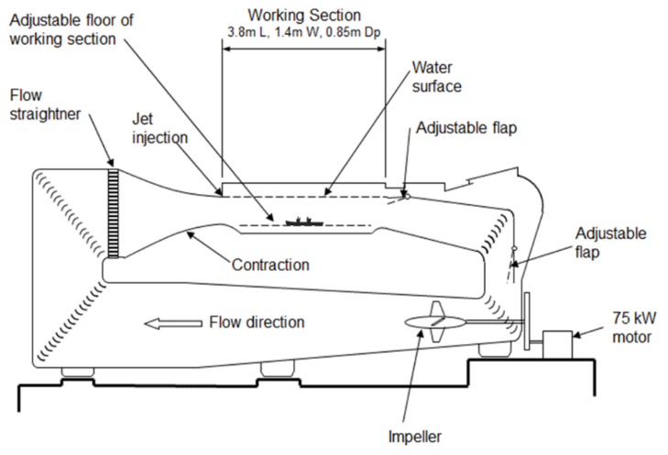
Fig. 4 Schematic of water channel showing the QEC model submerged in the working section.

Velocity measurements in the flow were taken using a Nortek Vectrino+ ADV probe, which uses small variations in the acoustic signal frequency arising from the Doppler effect to measure the velocity in three components [10]. Two ADV probes were used in this study and are shown in Fig. 5. One probe is oriented such that it faces downward in the flow, and the second faces sideward; each has an acoustic signal transmitter and four receivers which measure the velocity of particles within a sample volume located 50mm from the transmitter, thereby minimizing any interference with the flow. The size of the cylindrical sampling volume in which velocities are measured may be adjusted according to the experimental conditions. For each measurement in this study the sampling volume was set at a diameter of 6mm and a length of 7mm, with the mid-point located 50mm from the acoustic transmitter, as shown in Fig. 5.

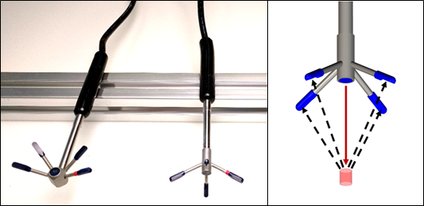

Fig. 5 Nortek Vectrino+ ADV sideward- and downwards-looking probes and schematic showing measurement volume relative to the probe transmitter and receivers.

The reason two probes were used is that while an ADV is able to measure accurately the mean velocities in three components, it is only able to obtain reliable turbulent statistics in one direction: the one aligned with the acoustic transmitter, as shown on the right of Fig. 5. The velocity signal measured using the ADV probes contains a level of noise due to a combination of Doppler noise, signal aliasing, and velocity shear across the sampling volume [11]. As Doppler noise is characterised as unbiased white noise, each of the mean three-component velocities are left unaffected and have been shown to be within 1% of validation data in a range of laboratory and field conditions [12-14]. Post-processing of the ADV output signal, necessary to remove erroneous data that affects turbulent statistics [15, 16], was accomplished using an adaption of the “spike detection” filter in Ref. [17], first proposed in Ref. [16]. Although the turbulent statistics may be measured in the velocity component aligned with the probe, a rise in Doppler noise is present in the two velocity components normal to the transmitter, preventing reliable measurement. Both probes were therefore able to measure the three-component mean velocities, but turbulent statistics were only measured in the vertical (w) and lateral (v) components. When the sideward probe was pointed into the flow, to possibly measure the streamwise (u) turbulent fluctuations, the probe interfered with the flow and gave an inaccurate measurement of mean velocity. To achieve positional accuracy and repeatability for each chosen sample point, a three-dimensional electronic-programmable traverse system was designed, manufactured and integrated with the water channel. The positional accuracy of the traverse was 0.1mm. Using the in-built distance tool of the ADV probe, the sample volume could be positioned within 1mm in the x, y and z direction producing a total approximate positional accuracy of 1.1mm, which was checked at regular intervals.

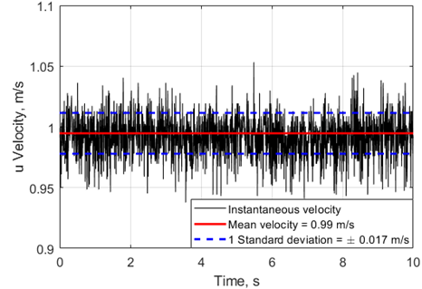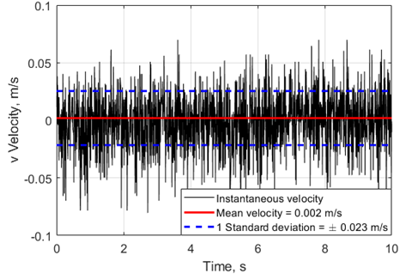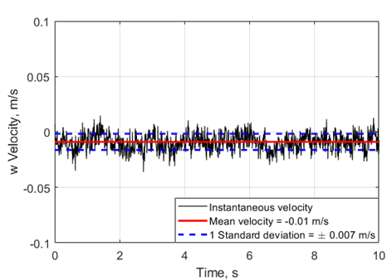

Fig. 6 Free-stream time histories of velocity components measured by downward-facing ADV probe.
At each sample point, the velocity components were measured over a period of 60 seconds at a sample rate of 200Hz giving a total of 12,000 individual samples per velocity time history, a much larger sample size than is required to achieve minimum errors on first and second-order statistical moments of the velocity components [18]. Before conducting the experiment, both probes were placed in the open channel to measure the water velocity at the same position and to compare the mean and turbulent statistics of the undisturbed freestream flow. Figure 6 shows the three components of velocity of the downward-facing probe; only 10 seconds of data are shown, but the means and standard deviations were calculated for the entire 60 seconds of data. It can be seen that the freestream u component is within 1% the value that was set for the freestream flow, consistent with the probe manufacturer’s specification. The mean v and w velocity components are essentially zero and are within the specified accuracy of 1% of the freestream velocity. As can be seen, the signal is noisy in the u and v components, and significantly less so in the w component, which is aligned with the acoustic transmitter. Figure 7 shows the corresponding data for the sideward-facing probe, the mean u, v and w velocities are again within 1% of the expected values, and the v velocity component, which is aligned with the transmitter, has much lower noise that the other two components.

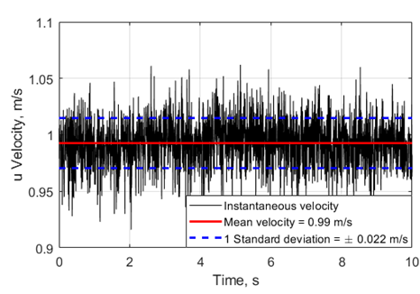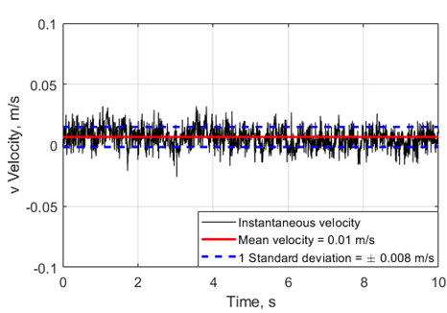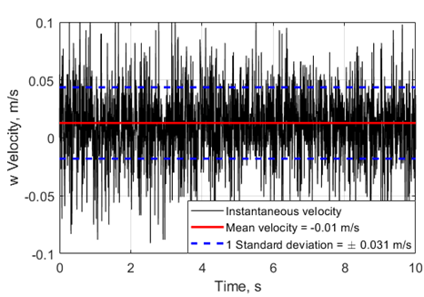

Fig. 7 Free-stream time histories of velocity components measured by sideward-facing ADV probe.

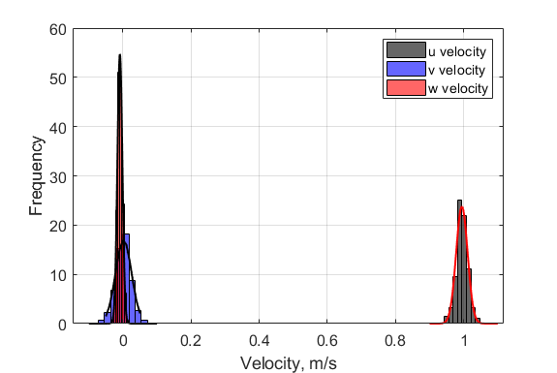

(a)
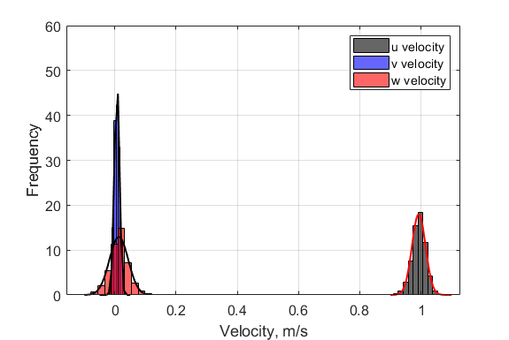

(b)

Fig. 8 Histograms of velocity components measured by (a) downward and (b) sideward-facing probes.

Figure 8 shows the histograms of the velocity components for each probe orientation; a low spread of values is seen in the w and v components of velocity of the downward and sideward-facing probes respectively, corresponding with the alignment of the transmitter. The velocity components normal to the transmitter direction have a wider spread of data that fit well to the overlaid normal distribution shown in Fig 8. Both probes gave a turbulence intensity of about 1% in the correctly aligned lateral and vertical components, indicating that the inlet turbulence was isotropic, as expected.
The two ADV probes were then used to measure velocity profiles at various locations over the ship, and astern along the approach path. The total number of measurements taken with the ship orientated into the flow (i.e. generating a headwind) was approximately 1,500. Figure 9 shows the downward facing probe positioned in the water channel to measure a sample point between the two islands of the submerged aircraft carrier model.

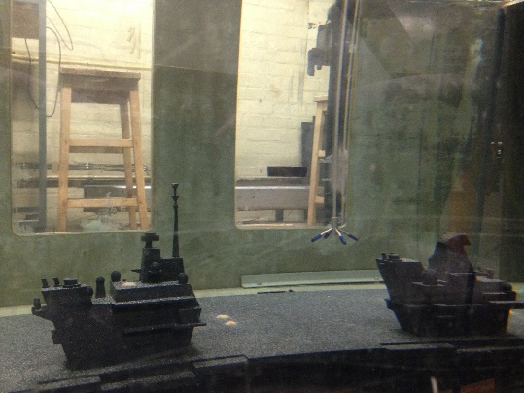

Fig. 9 ADV flow measurement of a sample point in the wake of the submerged QEC model.

Ship airwake CFD method
Full-scale QEC airwakes, for numerous wind angles, have been produced by the UoL as part of a collaboration with BAE Systems, who have developed a high-fidelity synthetic environment for conducting piloted simulations of the F-35B and QEC flight trials to prepare crews for the FOCFT [3]. By integrating the time-varying velocity components of the ship’s airwake into a real-time piloted flight simulation environment, the effect of the airwake on pilot workload and handling qualities can be studied [19]. Previous research at the UoL on the effect of the at-sea environment on helicopter-ship flight operations has been focused on smaller ships, such as UK Type 23/26/45 frigates and destroyers, and Wave Class tankers [4, 5, 20]. The airwake for each of these smaller ships was computed using a validated time-accurate CFD method [4]; however, as the QEC represents a significant increase in size, a new challenge was presented to adequately resolve the flow over a large domain with a much greater demand on the CFD analysis in terms of computational time and memory [8]. It was because of this new challenge, of computing a complex airwake at such a large scale, that it was deemed necessary to provide a new experimental dataset for comparison. The comparison was conducted in two stages: first comparing the experimental data with a CFD solution for the flow in the water channel, and second to use the same CFD method applied to the full-scale.
Figure 10 shows a computed airwake for the model-scale QEC aircraft carrier aligned with the flow, i.e. in a headwind. The unsteady flow shedding from the two islands and the ramp is illustrated by surfaces of instantaneous Q-criterion, which is a vortex identification method. The flight deck is marked by a number of black spots along the portside of the deck indicating the position of the vertical landing spots for both the fixed- and rotary-wing aircraft; the landing spot to the rear of the aft island is exclusively used by rotary-wing aircraft.
The time-accurate CFD method, which was applied to the model- and full-scale ships, was Delayed Detached Eddy Simulation (DDES). DDES is a hybrid method which resolves the flow near the surface using Unsteady Reynolds-averaged Navier-Stokes (URANS), while Large Eddy Simulation (LES), is used to resolve large scale structures away from the surface [21]; it is suitable for unsteady flow dominated by both quasi-periodic large-scale structures and chaotic small-scale turbulent features typical of the flow around bluff body geometries [22]. The SST k-ω based turbulence model with third-order accuracy was employed in the ANSYS FLUENT solver. By explicitly resolving the turbulent features over the flight deck using LES, in combination with URANS to compute the flow near the surface, the computation time is greatly reduced in comparison with a “pure” LES solution; this allows large domains such as the QEC to be computed in a reasonable time period. DDES is also superior to the “pure” URANS approach because of much reduced artificial dissipation of turbulent kinetic energy production in the flow shed from the bluff body superstructure.

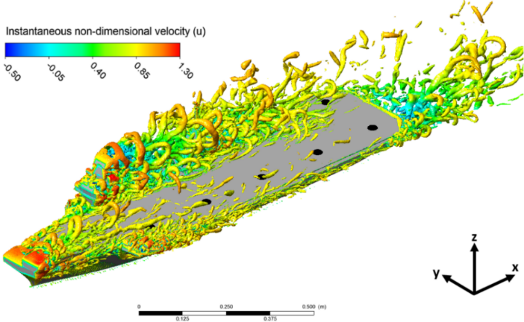

Fig. 10 Computed air flow over the small-scale model of HMS Queen Elizabeth in a headwind presented as instantaneous iso-surfaces of Q-criterion coloured by u-velocity.

For the full-scale solution, the flow over the sea surface was modelled as a steady atmospheric boundary layer (ABL) applied at the inlet [4, 23]. For the solution of the model ship in the water channel, the simulation was configured to model the experiment, particularly the geometry of the water channel, the uniform inlet velocity profile, and the working fluid was selected to be water. There were therefore two significant differences between the two CFD solutions: the flow Reynolds number and the inlet velocity profile. In both solutions, the unsteady CFD was allowed to settle before the three-dimensional mean and unsteady velocity components were sampled for 30 seconds. The grid spacing for the full- and small-scale were kept in proportion, and in both cases the solutions contained about 100 million cells. The areas of interest were not just the flow over the ship, but also for 400m astern to include the fixed-wing approach path.

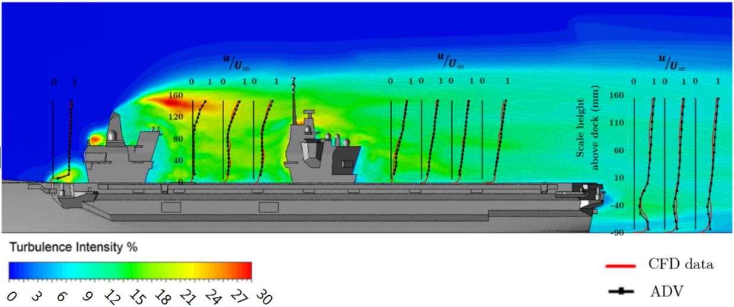
Fig. 11 Comparison of experimental and CFD u-velocity components in a plane through the centre of the island

Comparison of experimental data with CFD

From a practical flight operations perspective, it is the airflow along the landing deck and over the designated landing spots that are the most interesting; however, from an aerodynamic perspective, the more interesting areas are those where the flow is most disturbed by the ship’s superstructure, such as around the islands, over the bow and astern of the ship. Figure 11 shows a sample of the results in which the measured values of the streamwise u-velocity components are compared with the computed values of the CFD solution for the small-scale experiment. The results are in a vertical plane through the centre of the islands and are superimposed onto contours of turbulence intensity in the same plane. The turbulence intensity in this
paper is defined as the Root Mean Square (RMS) of the turbulent velocity fluctuations divided by the freestream flow velocity, i.e. not the local velocity. For example, the turbulence intensity presented as contours in Fig. 11 is calculated by Eqn. 1, where $u^{'}$, $v^{'}$, $w^{'}$ are the fluctuations in the three velocity components u, v, w.

 | $$Ti= \frac{\sqrt{\frac{1}{3}\left({u^{'}}^{2}+{v^{'}}^{2}+{w^{'}}^{2}\right)}}{U_{∞}}$$ | (1)

As can be seen, the experimental and computational results compare very well. Directly behind the forward island in Fig. 11 the u-velocity reduces close to zero in both the CFD solution and the ADV measurements; this agreement is also present behind the aft island and to the rear of the ship. The highest levels of turbulence intensity can be seen at the rear of the forward island.
Figure 12 shows another comparison of the ADV measurements of the u-velocity component with the small-scale CFD solution, but this time astern of the ship in a plane through the ship’s centreline. Again, good agreement can be seen between the CFD solution and experimental measurements. A reverse flow region is apparent, similar to the flow over a backward facing step, as well as an area of higher turbulence between the recirculation zone and the flow off the deck, indicating the presence of a shear layer.

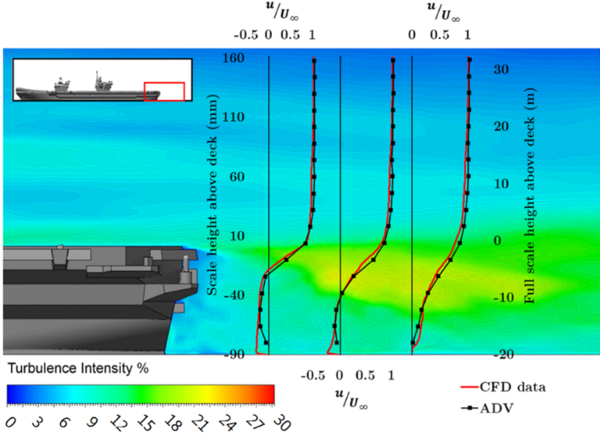
Fig. 12 Comparison of experiment and CFD mean u-velocity component on ship centreline astern of the ship.

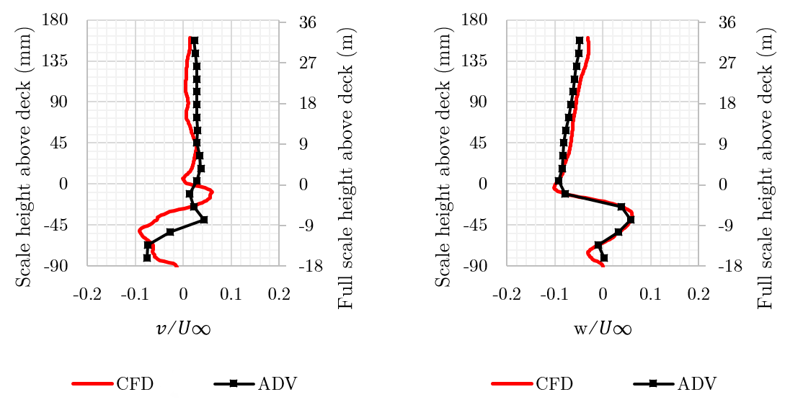
Fig. 13 Comparison of experimental and CFD mean v- and w-velocity components on centreline astern of the ship.

The lateral and vertical velocity components along the vertical line closest to the ship in Fig. 12 are shown in greater detail in Fig. 13. The measurements were taken along the centreline of the ship and, since the ship is not symmetrical, the wake astern of the ship is also asymmetrical as can be seen in the lateral velocity component which would otherwise be close to zero. Also shown is Fig. 13 is the positive (upward) vertical velocity present along the line below the deck edge, while above the deck the vertical velocity is negative; the velocity distribution is due to the recirculation zone immediately aft of the ship. Given that the lateral and vertical velocities are small and sensitive to the positional accuracy of the ADV probe, Fig 13 represents good agreement between the ADV measured data and the CFD model of the water channel. Figure 14 shows the turbulence intensities corresponding to the mean velocities in Fig. 13. The peak in the turbulence coincides with the shear layer indicated in Fig. 12; again, the agreement between experiment and CFD is reasonably good.

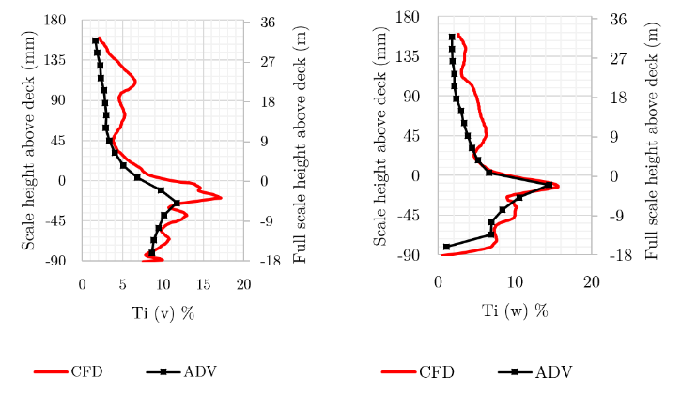

Fig. 14 Comparison of experimental and CFD turbulence intensities in v- and w-velocity components on centreline astern of the ship.

Another area of aerodynamic interest is at the bow of the ship. Figure 15 shows the comparison between the CFD and the experiment for the flow over the ski jump. The ADV probe was unable to measure data any closer to the ski jump surface than that presented in Fig. 15 without interference from the ship’s surface; nevertheless, the agreement is still good. An area of recirculation, or separation bubble, can be seen Fig. 15 behind the tip of the ramp. It is at the bow, when the flow first encounters the ship, that the differences in the full- and small-scale can be expected and this will be discussed later when considering the full-scale CFD results.

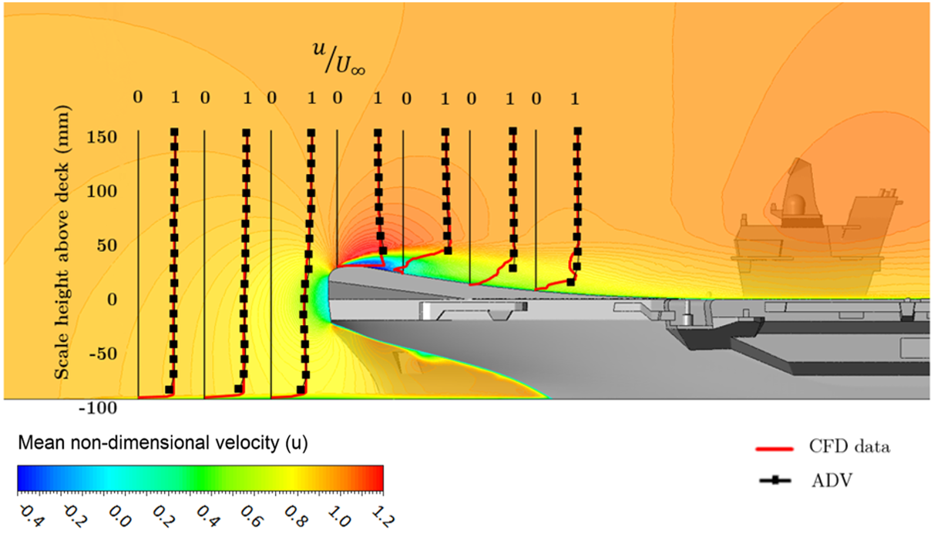

Fig. 15 Comparison of experimental and CFD u-velocity over the ski-jump.

The flow along the fixed-wing approach path is another area of interest. Unlike conventional carrier-borne fixed wing aircraft, the F-35B can employ vectored thrust from its STOVL propulsion system and approach the ship at a lower speed to execute a vertical landing on one of the designated landing spots. The Shipborne Rolling Vertical Landing (SRVL) is an alternative recovery technique that has been developed specifically for the F-35B for landing to the QEC carrier, although vertical landing remains the primary method of recovery [24]. The SRVL uses forward speed to maintain lift from the wings which augments the propulsion system, allowing the aircraft to recover to the ship at higher gross weights. Further details of the SRVL manoeuvre are beyond the scope of this paper and further details can be found in [24], but for now it is sufficient to state that the SRVL involves the aircraft approaching along a 7˚ glideslope over the stern of the ship. A comparison of the experimental CFD and measured mean vertical (w) velocity along the SRVL approach is given in Fig. 16; each point along the SRVL is in good agreement and shows the negative vertical velocity close to the rear of the ship known as the “burble” [25].

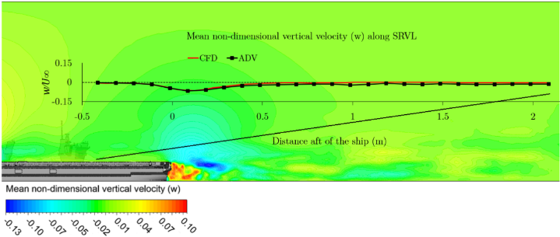

Fig. 16 Comparison of experiment and CFD mean w-velocity along the SRVL approach path.

One limitation of CFD methods is their ability to capture the turbulence in the wake far downstream of a bluff body. DDES is suited to this type of simulation as it produces a much lower level of artificial dissipation of turbulent kinetic energy. Figure 17 shows the comparison of experimental and CFD turbulence intensities in the lateral, v, and vertical, w, velocity components along the SRVL approach path. The agreement is reasonable, and the experimental values fall away towards the freestream value of approximately 1% after one ship length astern. It can be seen that despite the efforts taken to prevent turbulence dissipation, the computed turbulence does fall towards zero downstream of the ship.

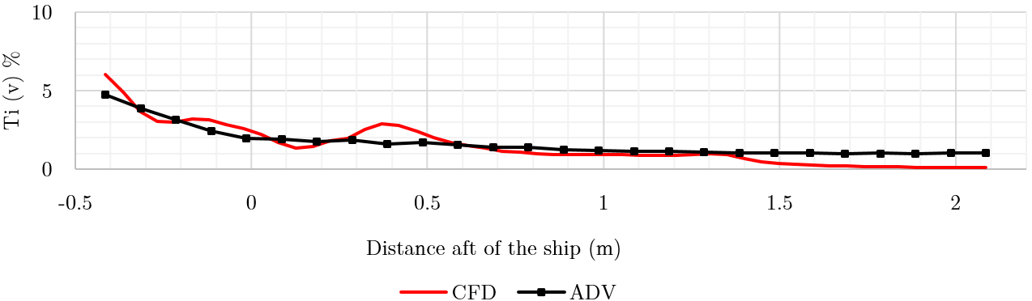
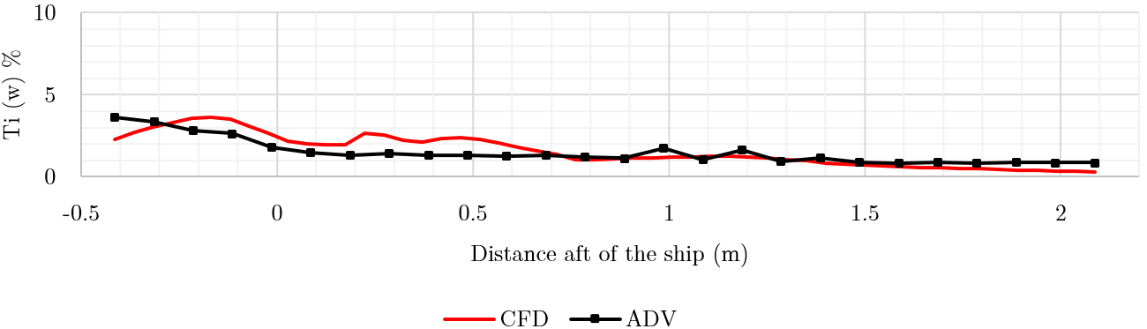
Fig. 17 Comparison of experimental and CFD turbulence intensities in v- and w-velocity components along the SRVL approach path.

Overall, therefore, the agreement between the ADV measurements and the CFD of the experimental flow field was very good. It is not unusual to use small scale, usually wind tunnel, experiments to investigate the flow field over much larger objects and so it was of interest in this study to assess how well the experiment represented the full-scale CFD. Figure 18 shows a comparison of the CFD results for both the small- and full-scale; it can be seen that the results are very similar, despite the different inlet flow conditions and Reynolds numbers.

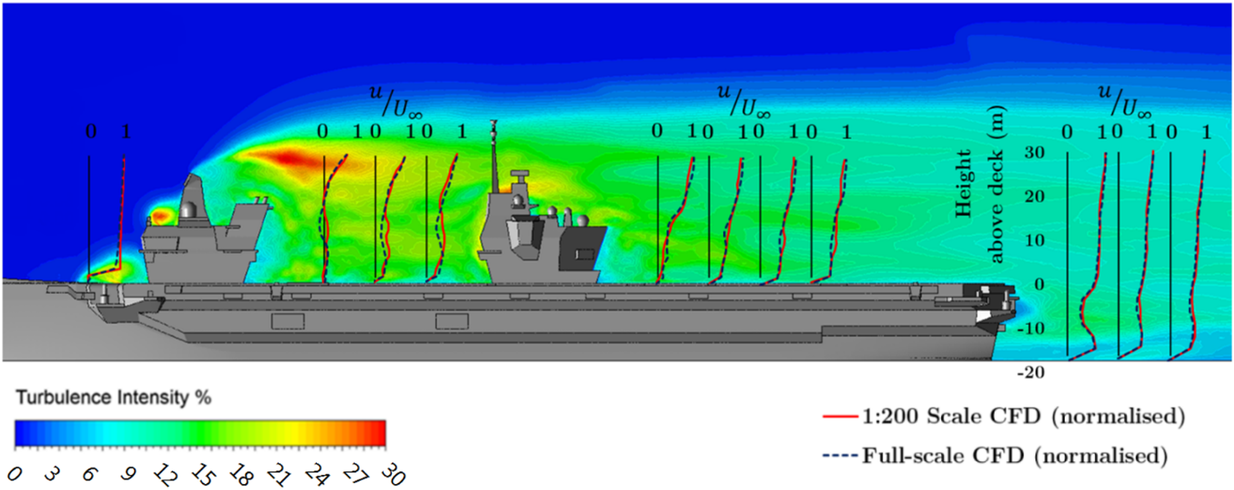

Fig. 18 Comparison of small-scale and full-scale CFD results in u-velocity component.

In experimental bluff body aerodynamics, especially where the body has sharp edges, it is common practice to assume that the flow characteristics are independent of Reynolds number; this is because the flow separates cleanly from sharp edges, unlike, for example, the separation from the curved surface of an aerofoil. Although for surface-mounted cubes it is claimed that Reynolds number independence is seen for flows with values greater than 2-3×10⁴, this can be affected by the nature of the incoming flow [26], and it can be higher for rectangular blocks which are long in the direction of flow [27], or for rectangular blocks with rounded edges [28]. The Reynolds number of the experiment, based on the height of the QEC to the deck, is approximately 1×10⁵, while for the full-scale with a relative headwind of 10m/s (~20 knots) the Reynolds number is approximately 1.3×10⁷. Notwithstanding the various caveats for the Reynolds number values above for which independence and dynamic similarity can be assumed, the small-scale experiment has produced a flow field that represents the full-scale flow very well, as seen in Fig. 18.
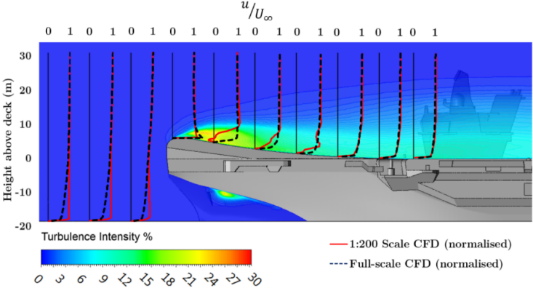

Fig. 19 Comparison of full-scale and small-scale CFD results in u-velocity component over the ski-jump.

At the bow of the ship, however, the top of the ski-jump, and the deck alongside the ski-jump, has a radius as a precaution to prevent flow separation. Figure 19 shows a comparison of the full- and small-scale CFD in this area and it is apparent that the higher Reynolds number full-scale flow does not separate from the curved surface, while at small-scale, both in CFD and experiment, it does separate and forms a recirculation bubble. The ABL inlet profile applied to the full-scale CFD can be seen in Fig. 19 where the velocity profile ahead of the ship is not uniform. Notwithstanding the differences at the bow, by the time the two flows have reached the end of the ski-jump ramp they are indistinguishable and, as was seen in Fig. 18, the flow over the ship is very similar, showing that the small-scale experiment is capable of providing a good representation of the flow over the full-scale ship.

Conclusions
This paper has described a comparison of the unsteady velocities present in the airwake over a model of HMS Queen Elizabeth, generated using CFD, with experimental measurements taken over a 1:200 scale model submerged in a water channel. The flow over the ship in the water channel was measured at various locations using two differently orientated ADV probes to capture both the three mean components of velocity and the lateral and vertical turbulent statistics. Time-accurate CFD was used to simulate the flow over the model ship in the water channel, which included a uniform velocity profile inlet condition. The same CFD method was used to simulate the airwake of the ship at full-scale with the application of a steady atmospheric boundary layer as an inlet condition. Both CFD solutions utilized the same technique, solver and turbulence model to produce time-accurate data.

The main conclusions can be listed as follows:

- This study has shown that a water channel is an effective alternative to a wind tunnel and that an Acoustic Doppler Velocimeter, not normally used for detailed studies such as reported here, is an effective instrument, notwithstanding that it only provides reliable turbulence measurements in one direction.
- Measurements of mean and turbulent velocities over and astern of the model ship showed generally good agreement with CFD. DDES has been shown to be suitable for resolving the unsteady flow over the ship, particularly in areas of separation and turbulent wakes.
- The CFD results for the full-scale ship also showed generally good agreement with both the experiment and the small-scale CFD. However, differences were seen in the flow over the rounded bow where the high Reynolds number flow in the full-scale did not experience flow separation, unlike at the small-scale, low Reynolds number flow, which did. However, by the time the flow had reached the end of the ski-jump ramp, and further downstream, the agreement between the small- and full-scale flows was good. This suggests that the experiment was capable of producing reliable full-scale airwake data.
- The good agreement between the measured and computed velocities along the SRVL approach path, astern of the ship, shows that DDES is capable of maintaining the turbulent kinetic energy in the extended wake of a bluff body, although the turbulence does eventually dissipate.

Acknowledgements
The Authors acknowledge the financial support from the Engineering and Physical Sciences Research Council through an Industrial CASE Award jointly funded with BAE Systems, and the ongoing support of ANSYS UK Ltd.

References
- Bevilaqua, P. M., “Inventing the F-35 Joint Strike Fighter,” 47th AIAA Aerospace Sciences Meeting Including the New Horizons Forum and Aerospace Exposition, Orlando, Florida. AIAA 2009-1650, January 2009.
doi: 10.2514/6.2009-1650
- Royal Navy Imagery Database, accessed March 2018 https://www.royalnavy.mod.uk/useful-resources-and-information/rn-image-archive
- Kelly, M. F., Watson, N. A., Hodge, S. J., White, M. D. and Owen, I., “The Role of Modelling and Simulation in the Preparations for Flight Trials Aboard the Queen Elizabeth Class Aircraft Carriers,” Proc. 14th International Engineering Conference, Glasgow, 2-4 Oct. 2018.
doi: 10.24868/issn.2515-818X.2018.037
- Forrest, J. S., and Owen, I., “Investigation of Ship Airwakes using Detached-Eddy Simulation,” Computers & Fluids, Vol. 39, No. 4, April 2010, 656-673.
doi: 10.1016/j.compfluid.2009.11.002
- Hodge, S. J., Forrest, J. S., Padfield, G. D., and Owen, I., “Simulating the environment at the aircraft-ship dynamic interface: research, development, & application,” The Aeronautical Journal, Vol. 116, issue 1158, November 2012, 1155-1184.
doi: 10.1017/S0001924000007545
- Owen, I., White, M. D., Padfield, G. D. and Hodge S. J., “A virtual engineering approach to the ship-helicopter dynamic interface – a decade of modelling and simulation research at the University of Liverpool,” The Aeronautical Journal, Vol. 121, Issue 1246, December 2017, 1833-1857.
doi: 10.1017/aer.2017.102
- White, M. D., Perfect, P., Padfield, G. D., Gubbels, A. W. and Berryman, A. C., “Acceptance testing and commissioning of a flight simulator for rotorcraft simulation fidelity research,” Proceedings of the Institution of Mechanical Engineers, Part G: Journal of Aerospace Engineering, Volume 227 Issue 4, pp. 663 – 686, April 2013.
doi: 10.1177/0954410012439816
- Watson, N. A., Kelly, M. F., Owen, I., Hodge, S. J. and White, M. D., “Computational and experimental modelling study of the unsteady airflow over the aircraft carrier HMS Queen Elizabeth,” Ocean Engineering, Vol. 172, 2019, 562-574.
doi: 10.1016/j.oceaneng.2018.12.024
- Millward, A., Nicholson, K., and Preston, J. H., “The use of jet injection to produce uniform velocity in a high speed water channel,” Journal of Ship Research, Vol. 24, No. 2, September 1980, 128-134.
- Kraus, N. C., Lohrmann, A., and Cabrera, R., “New Acoustic Meter for Measuring 3d Laboratory Flows”. Journal of Hydraulic Engineering, Vol. 120, No. 3, March 1994, 406-412.
doi: 10.1061/(ASCE)0733-9429(1994)120:3(406)
- Lane, S. N., Biron, P. M., Bradbrook, K. F., Butler, J. B., et al., “Three-dimensional measurements of river channel topography and flow processes using acoustic Doppler velocimetry,” Earth Surface Processes & Landforms, Vol. 23, issue 13, December 1998, 1247-1267.
doi: 10.1002/(SICI)1096-9837(199812)23:13<1247::AID-ESP930>3.0.CO;2-D
- Voulgaris, G., and Trowbridge, J. H., “Evaluation of the Acoustic Doppler Velocimeter (ADV) for Turbulence Measurements,” Journal of Atmospheric and Oceanic Technology, Vol. 15 No. 1, February 1998, 272-289.
doi: 10.1175/1520-0426(1998)015<0272:EOTADV>2.0.CO;2
- Lohrmann, A., Cabrera, R., and Kraus, N., “Acoustic-Doppler Velocimeter (ADV) for Laboratory Use,” Fundamentals and Advancements in Hydraulic Measurements and Experimentation, American Society of Civil Engineers, Buffalo, New York, August 1994.
- Lopez, F., and Garcia, M. H., “Mean flow and turbulence structure of open-channel flow through nonemergent vegetation,” Journal of Hydraulic Engineering, Vol. 127, No. (5), May 2001, 392–402.
doi: 10.1061/(ASCE)0733-9429(2001)127:5(392)
- Chanson, H., Trevethan, M. & Aoki, S., “Acoustic Doppler velocimetry (ADV) in small estuary: Field experience and signal post-processing,” Flow Measurement and Instrumentation, Volume 19, 2008, pp. 307-313.
- Goring, D. G. & Nikora, V. I., “Despiking Acoustic Doppler Velocimeter Data,” Journal of Hydraulic Engineering, 128(1), 2002, p. 117–126.
- Wahl, T. L., “Discussion of ‘Despiking acoustic Doppler Velocimeter data’ by Derek G. Goring and Vladimir I. Nikora,” Journal of Hydraulic Engineering, 129(6), 2003, p. 484–488.
- Chanson, H., Trevethan, M., and Koch, C., “Discussion of ‘Turbulence Measurements with Acoustic Doppler Velocimeters” by Carlos M. García, Mariano I. Cantero, Yarko Niño, and Marcelo H. García,” Journal of Hydraulic Engineering, Vol. 133, No. 11, November 2007, 1283-1286.
doi: 10.1061/(ASCE)0733-9429(2007)133:11(1283)
- Watson, N. A., Kelly, M. F., Owen, I., Hodge, S. J. and White, M. D., “The Aerodynamic Effect Of An Oblique Wind On Helicopter Recovery To The Queen Elizabeth Class Aircraft Carrier,” Presented at the Vertical Flight Society’s 75th Annual Forum & Technology Display, Philadelphia, PA, USA, May 13-16, 2019.
- Mateer, R., Scott, S. A., Owen, I., White, M. D., “Superstructure Aerodynamics of the Type 26 Global Combat Ship,” International Naval Engineering Conference, Glasgow, UK, 2018.
doi: 10.24868/issn.2515-818X.2018.038
- Spalart, P. R., Deck, S., Shur, M. L., Squires, K. D., Strelets, M. Kh., and Travin, A., “A new version of detached-eddy simulation, resistant to ambiguous grid densities,” Theoretical and Computational Fluid Dynamics, Vol. 20, No. 181, July 2006, 181-195.
doi: 10.1007/s00162-006-0015-0
- Spalart, P. R., “Detached-Eddy Simulation,” Annual Review of Fluid Mechanics, Vol 41, pp. 181-202, 2009.
doi: 10.1146/annurev.fluid.010908.165130
- Garratt, R., The atmospheric boundary layer, Cambridge Atmospheric and Space Science Series, Cambridge University Press, April 1994.
- Cook, R., Atkinson, D., Milla, R., Revill, N., Wilson, P., 2010 “Development of the Shipborne Rolling Vertical Landing (SRVL) Manoeuvre for the F-35B Aircraft,” International Powered Lift Conference, October 5-7, 2010.
- Polsky, S., Naylor, S., “CVN Airwake Modeling and Integration: Initial Steps in the Creation and Implementation of a Virtual Burble for F-18 Carrier Landing Simulations,” AIAA Modeling and Simulation Technologies Conference and Exhibit, 2012.
doi: 10.2514/6.2005-6298
- Lim, H. C., Castro, I. and Hoxey, R. P. “Bluff bodies in deep turbulent boundary layers: Reynolds-number issues,” J. Fluid Mech., Vol. 571, 2007, 97-118.
doi: 10.1017/S0022112006003223.
- Engineering Sciences Data Unit, “Fluid forces, pressure and moments on rectangular blocks,” ESDU Data Item 71016, 1978.
- Cooper, K. R., “The Effect of Front-Edge Rounding and Rear-Edge Shaping on the Aerodynamic Drag of Bluff Vehicles in Ground Proximity,” SAE Technical Paper 850288, February 1985.
doi: 10.4271/850288

PhD Student, Flight Science & Technology, School of Engineering
Senior Lecturer, Flight Science & Technology, School of Engineering,
Emeritus Professor, Flight Science & Technology, School of Engineering

