In-MOFs based on amide functionalised flexible linkers
J. Haddad, G. F. S. Whitehead, A. P. Katsoulidis, M. J. Rosseinsky
Department of Chemistry, University of Liverpool, Crown Street, Liverpool L69 7ZD

Abstract
Two new amide functionalised metal-organic frameworks, In(OH)CSA and In(OH)PDG, were synthesized using two flexible linkers, N-(4-Carboxyphenyl)succinamic acid (CSA) and N,N’-(1,4-Phenylenedicarbonyl) diglycine (PDG), respectively. Both structures consist of corner-sharing {InO₄(OH)₂} octahedra in the form of trans indium hydroxide chains, which are interconnected by the dicarboxylate linkers to form stacked 2-dimensional layers. The different symmetries and configurations of the flexible and rigid features on the linkers results in different supramolecular interactions dominating between linkers, resulting in different shaped pores and functional group orientation. In(OH)CSA lacks hydrogen bonding between linkers, which results in close packing between the layers and very small solvent accessible pores running perpendicular to the plane of the layers. In(OH)PDG exhibits strong intra- and interlayer hydrogen bonding, which prevents the layers from close packing and results in larger cylindrical pores running parallel to the indium hydroxide chains, producing a total accessible volume of 25 % of the unit cell volume.
Introduction
Metal-organic frameworks have attracted enormous scientific interest because their crystalline nature is combined with high porosities, well defined surface functionalities and tunable pore sizes.¹ These properties make MOFs promising candidates for many technological applications such as gas storage and separation, catalysis, sensing, data storage and drug delivery.² The structures of MOFs are composed of metal nodes and organic linkers, assembled through highly directional coordination bonds to form infinite frameworks encompassing a broad range of topologies. The design and synthesis of targeted MOFs is relatively straightforward when rigid molecules are used as linkers,³ but it becomes much more challenging in the case of flexible linkers. Flexible linkers are defined as molecules that have at least one sp³ atom in the backbone⁴ and their conformational mobility confers structural diversity to MOFs and responsivity to external stimuli.
Group 13 metals, Al, Ga and In have been widely used in the synthesis of MOFs producing a series of isostructural compounds with carboxylate linkers.⁵ The most well-known compound, MIL-53, consists of trans chains of corner sharing {MO₄(OH)₂}, which are connected by terephthalate linkers.⁶⁻⁸ Al MOFs are well known for their excellent thermal and chemical stability however they rarely form large single crystals suitable for single crystal X-ray diffraction. On the other hand, the In-O bond is weaker than Al-O bond and allows the reversible metal-linker reaction to correct the crystal structure and form large single crystals.
There are few cases where flexible linkers have been employed in MOF synthesis with group 13 metals and these are clustered in two groups: aliphatic linkers and “V-shaped” linkers, where a non-linear flexible joint links two phenyl groups, for example 4,4’-oxybis(benzoic acid). Adipic acid and 1,4-cyclohexanedicarboxylic acid are aliphatic linkers that form porous structures with Al and their conformations change between empty and solvated phases.^{9,10} “V-shaped” linkers have been shown to form 2D and 3D MOFs with {AlO₄(OH)₂} and {InO₄(OH)₂} chains.¹¹⁻¹³
Herein, we report two new structures of 2D MOFs formed with In and two highly flexible linkers; N-(4-Carboxyphenyl)succinamic acid, herein CSA, and N,N’-(1,4-Phenylenedicarbonyl) diglycine, herein PDG, to produce In(OH)CSA, and In(OH)PDG. Both linkers have two sp³ carbons and they have been designed to bring different arrangement of rigid and flexible features on their backbone (Figure 1). PDG is a symmetrical molecule with a phenyl ring at the centre linked to two para amide groups that in turn are linked to carboxylates through sp³ carbons. CSA is an asymmetric molecule having one carboxylate group directly attached on the phenyl ring and the other on a chain composed from an amide group and two sp³ carbons. These differences in their molecular structure are reflected in the crystal structures of the obtained MOFs, in particular the dominating supramolecular interactions within the structures and in the size and directionality of any solvent accessible voids. Both structures consist of layers stacked in AAA fashion, however the differences in intermolecular interactions define the interlayer spacing, which is absent in In(OH)CSA and exists as 1D channels in In(OH)PDG. Bulk materials of In(OH)CSA and In(OH)PDG as well as their Al analogues have been prepared and characterised.
Experimental
Materials. Al(NO₃)₃•9H₂O was purchased from Sigma Aldrich at 97% purity, N-(4-carboxyphenyl) succinamic acid (CSA), In(NO₃)₃•xH₂O and InCl₃ were purchased from Alfa Aesar in 99.99%. 99% and 98% purity respectively. N,N’-(1,4-Phenylenedicarbonyl) diglycine (PDG) was purchased from Manchester Organics in 95% purity. DMF was purchased from Fischer. All reagents were used without any further purification.
Synthesis of In(OH)CSA crystals. A 0.5 M aqueous stock solution of In(NO₃)₃•xH₂O was made up. CSA ( 237.2 mg, 1 mmol) was weighed into a 40 mL Teflon capped glass vial, to this, In(NO₃)₃ solution (2 mL, 1 mmol), DMF (2 mL) and H₂O (1 mL) were added. The reaction mixture was heated to 100 °C at a rate of 2.5 °C per minute, and left for 12 hours before being cooled to room temperature at 0.2 °C per minute. The formula of the crystal was determined from SCXRD to be In(OH)CSA•H₂O. For the synthesis of bulk In(OH)CSA material limited quantities of In(NO₃)₃ solution (1.20 mL, 0.6 mmol) were used compared to the single crystal synthesis. The resultant white powder was filtered and washed with DMF (4 x 20 mL), THF (3 x 20 mL) and ethanol (3 x 20 mL) and left to pump dry. The dry yield was 157 mg of white powder, of which 98 mg was activated at 155 °C under vacuum (10⁻² mbar) overnight to remove guest solvent molecules, giving a final yield of 90 mg.
Synthesis of In(OH)PDG crystals. PDG (140 mg, 0.5 mmol) was weighed out into a 40 mL Teflon capped glass vial, to this, In(NO₃)₃•xH₂O (390 mg, 1 mmol), DMF (2 mL) and H₂O (3 mL) were added. The reaction mixture was heated to 100 °C at a rate of 2.5 °C per minute, and left for 12 hours before being cooled to room temperature at 0.2 °C per minute. The formula of the crystal was determined from SCXRD to be In(OH)PDG. For the synthesis of bulk In(OH)PDG material an excess amount of PDG (280 mg, 1 mmol) was used. The resultant white powder was filtered and washed with DMF (4 x 20 mL), THF (3 x 20mL) and ethanol (3 x 20mL) and left to pump dry, this yielded 166 mg of a white powder. 116 mg of the material was activated at 155 °C under vacuum (10⁻² mbar) overnight to remove guest solvent molecules, leaving a final yield of 104 mg.
Synthesis of Al(OH)CSA and Al(OH)PDG bulk materials
A 1M aqueous stock solution of Al(NO₃)₃.9H₂O was made up. CSA (237.21 mg, 1 mmol) was weighed out into a 40 mL Teflon capped glass vial, to this, Al(NO₃)₃ solution (0.60 mL, 0.6 mmol), DMF (2 mL) and H₂O (2.40 mL) were added. The reaction mixture was heated to 100 °C at a rate of 2.5 °C per minute, and left for 12 hours before being cooled to room temperature at 0.2 °C per minute. The resultant white powder was filtered and washed with DMF (4 x 20 mL), THF (3 x 20mL) and ethanol (3 x 20mL) and left to pump dry, this yielded 122 mg of a white powder. 104 mg of the material was activated at 155 °C under vacuum (10⁻² mbar) overnight to remove guest solvent molecules, leaving a final yield of 95 mg.
PDG (280 mg, 1 mmol) was weighed out into a 40 mL Teflon capped glass vial, to this, Al(NO₃)₃•9H₂O ( 188 mg, 0.5 mmol), DMF (2 mL) and H₂O (3 mL) were added. The reaction mixture was heated to 100 °C at a rate of 2.5 °C per minute, and left for 12 hours before being cooled to room temperature at 0.2 °C per minute. The resultant white powder was filtered and washed with DMF (4 x 20 mL), THF (3 x 20 mL) and ethanol (3 x 20 mL) and left to pump dry, this yielded 187 mg of a white powder. 98 mg of the material was activated at 155 °C under vacuum (10⁻² mbar) overnight to remove guest solvent molecules, leaving a final yield of 72 mg.
Characterisation. Single crystal X-ray diffraction data for each structure was collected on a Rigaku MicroMax™-007 HF with a molybdenum rotating anode microfocus source and a Saturn 724+ detector. Data integration and reduction was performed by the CrysAlisPro system software. The structure was solved and refined using SHELX-2013 and Olex2 package. Powder X-ray diffraction data was collected at room temperature on a Bruker D8 Advance diffractometer using Cu Kα radiation. The samples (as- made and activated) were loaded into 0.7 mm borosilicate capillaries. TGA was measured using a TA Instruments Q-500 thermogravimetric analyser. The sample was heated to 650 °C under a flow of air (50 mL / min), using a heat rate of 10 °C / min.

Results and Discussion

The In(OH)CSA structure consists of corner-sharing {InO₄(OH)₂} octahedra in the form of trans indium hydroxide chains bridged by the dicarboxylate CSA linker. (Figure 2). The trans indium hydroxide chains are a typical inorganic building unit observed in many Al, Ga and In MOFs. The structure adopts the space group monoclinic P2₁/c, with the indium hydroxide chains running parallel to the crystallographic 2₁ operation lying within the ac plane, separated by 12.1030(9) Å perpendicular to the ab plane, with each In-OH-In pair additionally bridged by two μ-2 carboxylates from two CSA; one aliphatic linked and one phenyl linked. The second carboxylates for both these CSAs then bridge to a single In-OH-In pair in a neighbouring indium hydroxide chain, related by a c-glide operation and shifted by 2.0684(17) Å along the b-axis, completing the 2D sheet structure. The flexibility of the CSA molecule allows for two, rather than one, CSAs to bridge between two indium hydroxide chains, with the aliphatic group adopting an L-shaped conformation to enable this (Figure 2). These 2D-sheets stack along the crystallographic a-axis with no strong non-covalent interaction between the sheets (only Van der Waals interactions). The structure contains small solvent accessible voids, which run perpendicular to the plane of the 2D sheets and contain solvent water molecules that hydrogen bond between the amide groups of neighbouring CSA parallel to the indium hydroxide chains. The flexibility of the linker is highlighted by the fact that the phenyl and amide groups are disordered over two sites within the crystal in a 62:38 split in occupancies, with an associated disordered solvent water molecule for each conformation within the solvent accessible voids of the structure. The total solvent accessible volume of In(OH)CSA is 12.5 % and 18.2 % of the unit cell volume respectively for the two conformations, giving an average of 14.67 %. The In-O distances range from 2.079(3) Å to 2.167(11) Å and they are in good agreement with other In MOFs.

In(OH)PDG also consists of corner-sharing {InO₄(OH)₂} octahedra in the form of trans indium hydroxide chains, only this time bridged by the dicarboxylate PDG linker. However, the structures and the dominating intermolecular forces are quite different. The structure is triclinic, with the trans indium hydroxide chains lying in the crystallographic ac plane, running parallel to the crystallographic a-axis within the ac plane and displaced by 11.8645(8) Å along c, with each In-OH-In pair additionally bridged by two μ-2 carboxylates from two PDG. The second carboxylates of both these PDG then bridge an In-OH-In pair in a neighbouring trans indium hydroxide chain, 6.2567(13) Å along the a-axis. In order to achieve this, the linker adopts a Z-like conformation when viewed along the b-axis and gives the appearance that the trans indium hydroxide chains are slipped relative to each other, shown in Figure 2b. This completes the 2D-sheet structure. These 2D-sheets are stacked along the crystallographic b-axis completing the 3D-structure. The bridging PDG pairs within the 2D-sheets exhibit strong intermolecular interactions, with hydrogen bonding between each pair of amide groups with a D…A distance of 2.9048(2) Å. The amide groups within each PDG are almost co-planar (with a mean plane RMSD of 0.054 Å) and lie parallel to the crystallographic b-axis, with the phenyl group twisted away from the amide-amide plane by 33.2(3)° to enable the hydrogen bonding to occur. This same interaction occurs with the amide groups in neighbouring layers (D…A distance of 2.8051(2) Å), which in combination with the intra-layer interaction forms a strong hydrogen bonded network parallel to the crystallographic b-axis. (Figure 3a). The stacking of layers creates solvent accessible voids within the structure running parallel to the crystallographic a-axis, hence parallel to the trans indium hydroxide chains, with maximum penetrating sphere radius of 2.0 Å. In(OH)PDG is more porous than In(OH)CSA having total accessible volume 25 % of the unit cell volume.

Considering that these structures have similar connectivity, the differences in pore size, shape and orientation arise from the adopted conformations of these flexible linkers, the dominating supramolecular interactions and the symmetry of the molecules. CSA adopts an L-shape conformation because it is asymmetric, and comprised of a rigid part, defined by the phenyl and amide groups, and a flexible tail of two sp³ carbons. This aliphatic tail is twisted, with a torsion angle of C-C bond of 69.4(16)° in order to link to the neighbouring inorganic unit. There is only one amide per CSA, and the amides of neighbouring CSAs are not adjacent in the structure, meaning intermolecular hydrogen bonding between linkers is not possible. This results in the dominating supramolecular interactions between linkers both within and between layers being Van der Waals interactions. Instead, the amide groups are free to hydrogen bond to solvent water molecules, with the phenyl groups and aliphatic chains packing as closely as possible. In the dominant conformation, there is also evidence for weak π-π interaction between the phenyl rings of neighbouring CSAs within, but not between, layers, with a phenyl plane-plane distance of 3.834(3) Å and a parallel displacement of 1.369(7) Å.

Conversely, PDG adopts a Z shape conformation and exhibits strong hydrogen bonding interactions between the amides of neighbouring symmetrical rigid cores. The two flexible one sp³ carbon tails at each end twist, the torsions of N-C bonds equal to 58.3(9)° and -120.1(9)°, to allow both the bridging of two PDG between the same In-OH-In pairs of neighbouring chains, whilst also granting the conformational freedom for the amides of neighbouring rigid cores to orientate to maximise hydrogen bonding. The symmetrical nature of the rigid core results in the amides of neighbouring PDG approaching closely, allowing hydrogen bonding between neighbouring PDG to occur and become the dominating supramolecular interaction which prevents the layers from close packing. This results in larger cylindrical solvent accessible voids between the layers running parallel to the trans indium hydroxide chains.

Bulk materials of Al(OH)CSA and In(OH)CSA were produced at yields of 65 % and their structures and compositions were characterised with PXRD and elemental analysis respectively. Phase purity of In(OH)CSA is confirmed by the PXRD pattern (Figure 4) where all the peaks matched with the simulated pattern of In(OH)CSA•H₂O single crystal. PXRD pattern Al(OH)CSA•H₂O has been indexed to a unit cell very similar to that of In(OH)CSA•H₂O (Table S3) which suggests that the Al compound adopts a similar structure to the In one. Elemental analysis were performed on desolvated Al(OH)CSA•H₂O and In(OH)CSA•H₂O samples to avoid any interference from potentially adsorbed DMF on C and N contents. The results (Table S4) show the expected composition according the proposed formulas for both compounds and prove that no hydrolysis products of CSA participate in the formation of these frameworks.

In(OH)PDG and Al(OH)PDG bulk products were prepared with yields of 72 % and 82 % respectively. PXRD pattern of In(OH)PDG (Figure 5) presents no extra peaks compared to the simulated pattern of the single crystal and has been indexed to a similar unit cell (Table S5). On the other hand Al(OH)PDG cannot be indexed to the same unit cell with the In analogue and its structure remains unclear. Elemental analysis results on the desolvated samples corresponds to proposed formulas and indicates that PDG linker form these compounds without being hydrolysed.

Conclusions
We report the discovery two new In-MOFs with amide flexible linkers. Both compounds present the typical indium hydroxide building unit, the same connectivity and layered type structure. The differences in the molecular structures of the two linkers are reflected in the symmetry of the molecules, the dominating supramolecular interactions that occur and the resultant shape of layers and their packing.
In In(OH)CSA, the structure is dominated by Van der Waals supramolecular interactions, with the layers close packing effectively and the linker adopting an L-shaped conformation in order to bridge neighbouring indium hydroxide chains. This drive towards close packing can be attributed to the lack of hydrogen bonding between amide groups of neighbouring linkers, which in turn can be attributed to the asymmetry of the linker and the resultant large lateral spacing between the amide of neighbouring linkers being too great for hydrogen bonding to occur. This is instead directed towards solvent water within the solvent accessible voids that are orientated perpendicular to the plane of the 2D layers.
Conversely, in In(OH)PDG the structure is dominated by hydrogen bonding between neighbouring linkers, enabled both by the high symmetry of the rigid component of the linker and the flexibility of both ends of the linker. The linker adopts a Z-shaped conformation in order to bridge between neighbouring indium hydroxide chains, driven by the need to maximise hydrogen bonding between the amides of neighbouring linkers. The dominating hydrogen bonding supramolecular interactions prevent the layers from close packing, resulting in a more porous structure than the similar CSA-based structure and larger solvent accessible voids that are orientated between the layers, parallel to the trans indium hydroxide chains.

Acknowledgement
This project has received funding from the European Research Council (ERC) under the European Union's Horizon 2020 research and innovation programme (grant agreement n° 692685). We thank the UK EPSRC for a studentship for JH.

Electronic supplementary information (ESI) available: Elemental analysis results, thermogravimetric analysis, crystallographic data and structure refinement summary for CCDC 1534623 and 1534624

Figure 1 The flexible molecules CSA and PDG have two sp³ carbons each. CSA has rigid core, consisted of phenyl ring and an amide bond, that has directly attached the carboxylate group on the one end and through a flexible tail on the other. PDG is asymmetric molecule with a core consisted of a phenyl ring and two amide bonds, which are connected to carboxylate groups through sp³ carbons.

(a)
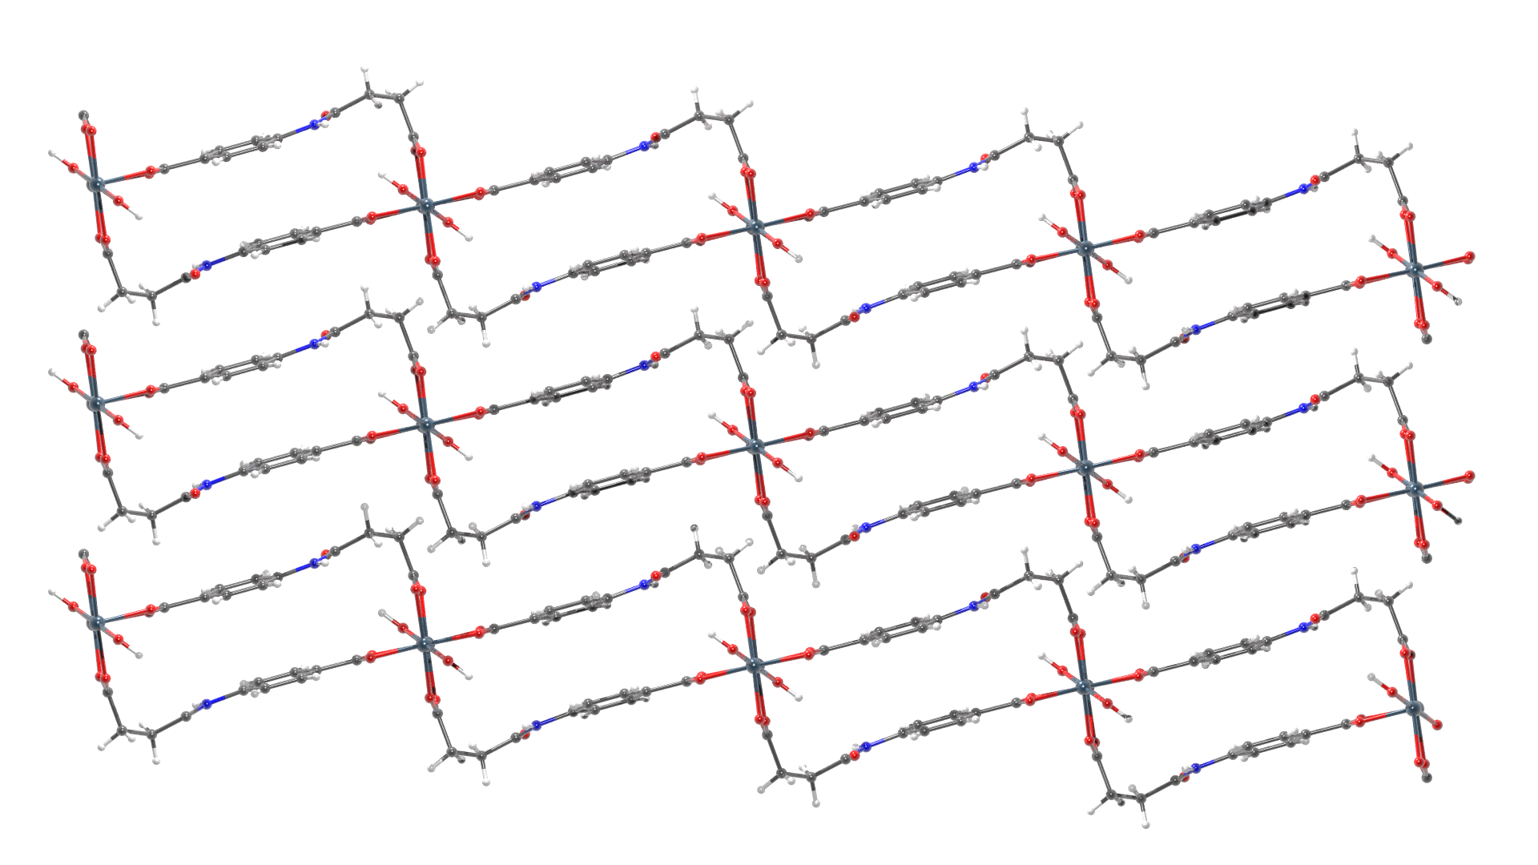
(b)
(c)

Figure 2 Structure of In(OH)CSA. (a) The inorganic building unit, chains of trans corner-sharing {InO₄(OH)₂} octahedra. (Right) The rectangular shaped motif formed by the L shape conformation of CSA linker, showing both conformations of the CSA linker. (Bottom) 2D layers of In(OH)CSA stacked in AAA fashion, showing only the most common conformation.

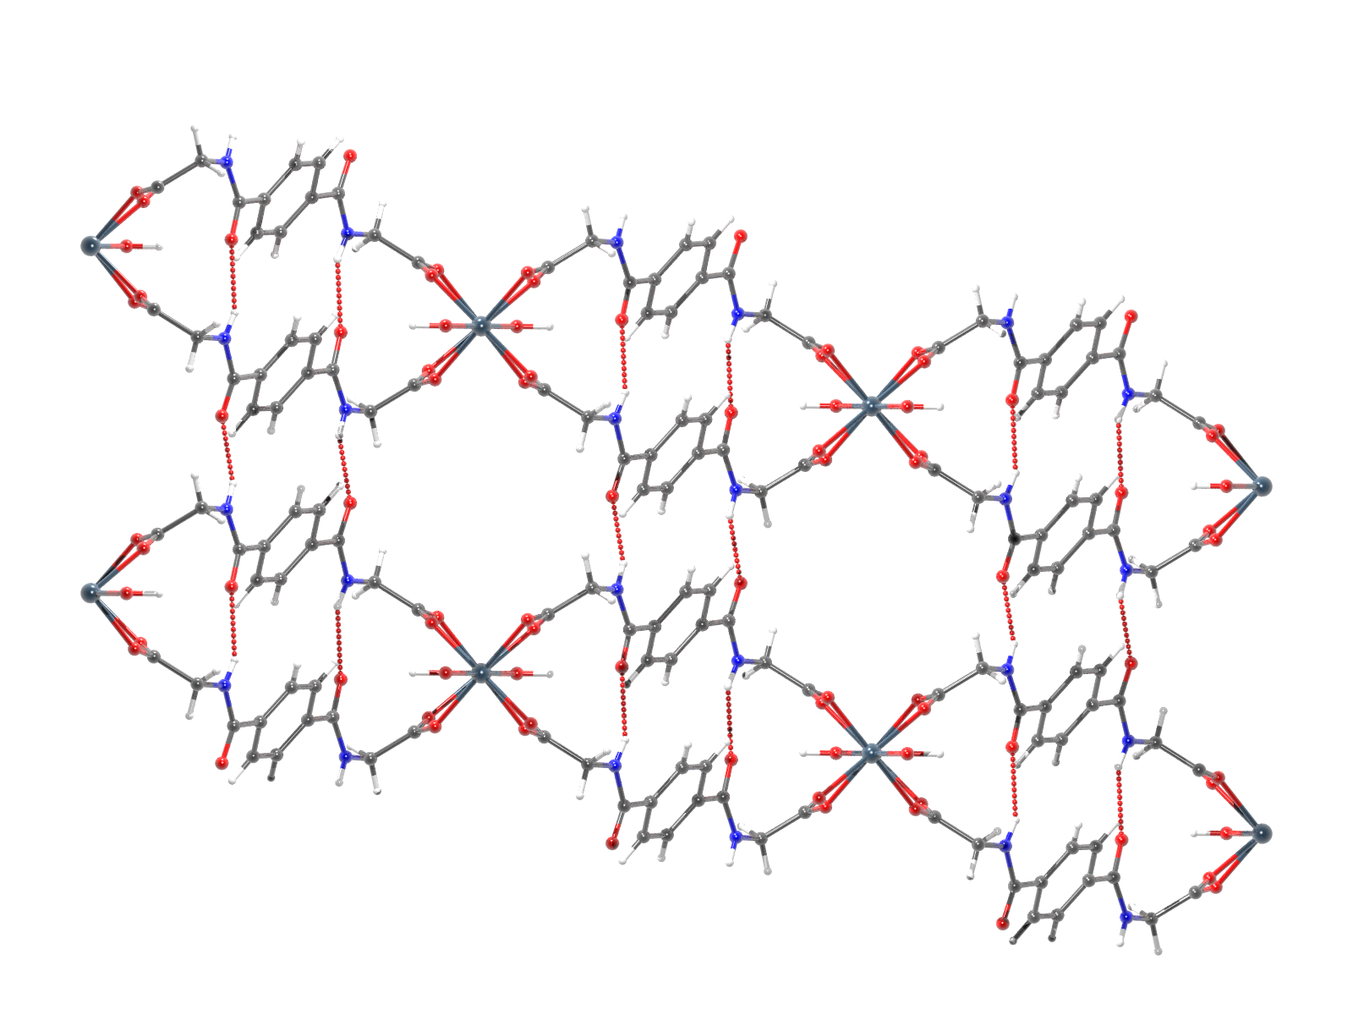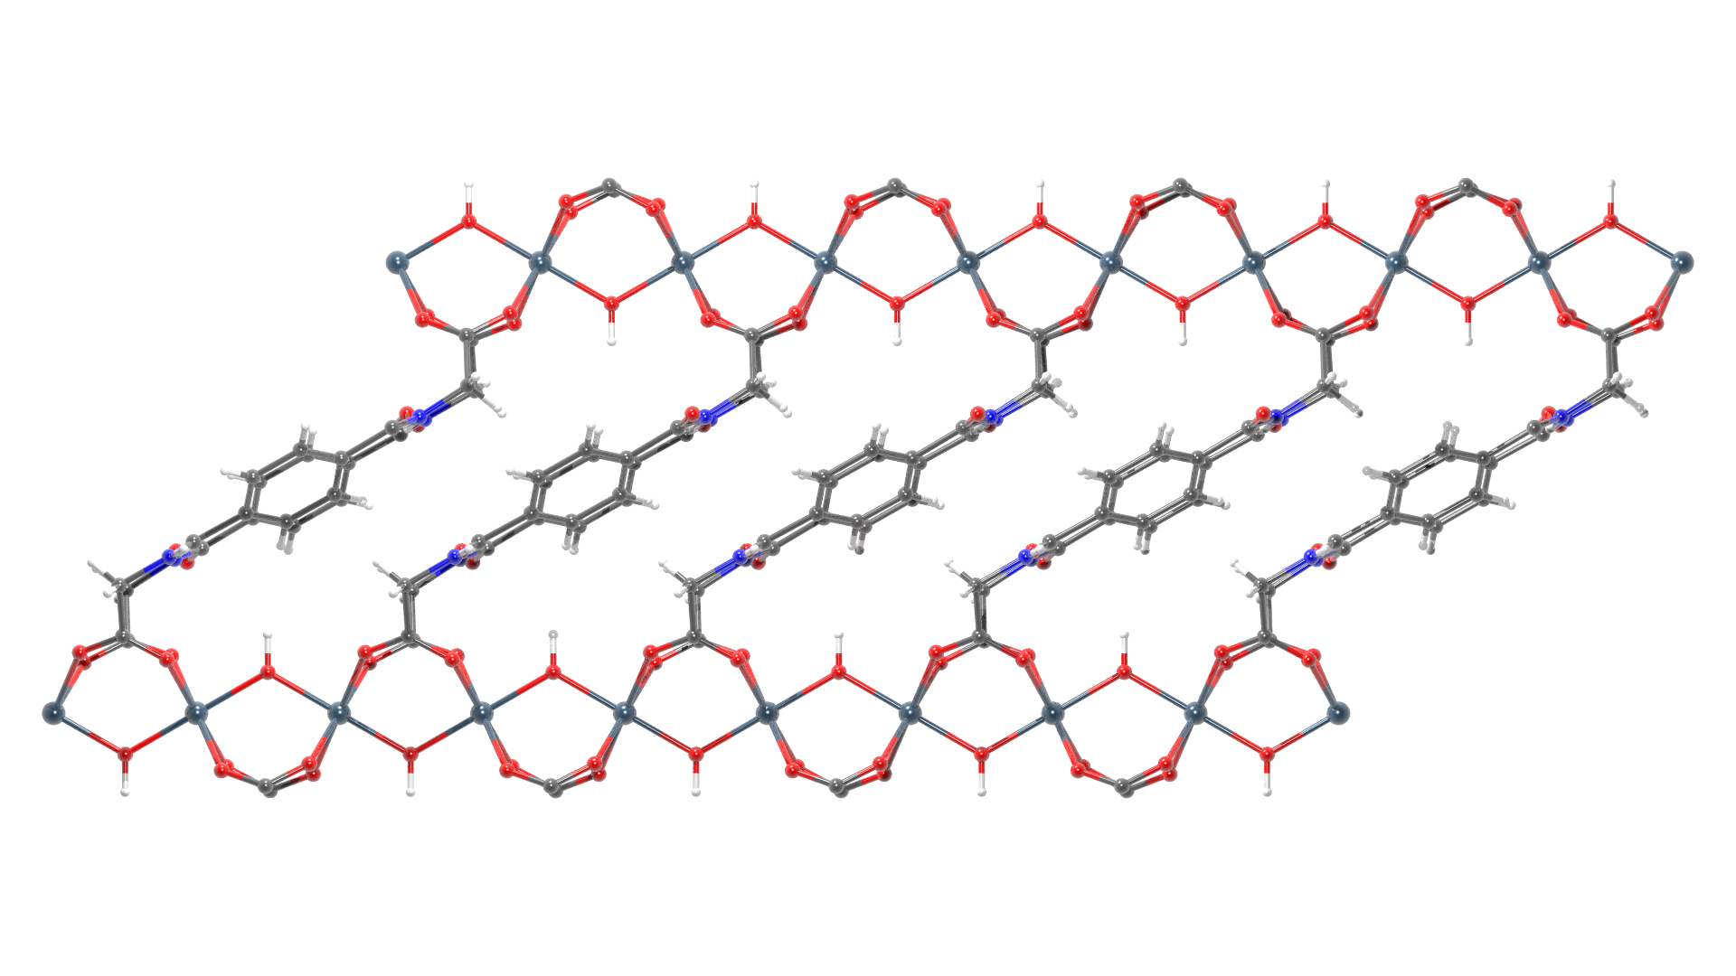
(a)
(b)
(c)
Figure 3 In(OH)PDG structure. (a) The stacked layers of In(OH)PDG are connected with H-bonds and they form 1D pores which are accessible by sphere diameter of 4.0 Å. (b) The PDG linker adopts a Z shaped conformation because of the sp³ carbons at both ends of the rigid core. (c) The indium hydroxide chains are slipped to relative each other because of the Z shaped conformation of the PDG linker

Figure 4 XRD patterns of bulk In(OH)CSA and Al(OH)CSA compared with the simulated pattern of single crystal In(OH)CSA.

Figure 5 XRD patterns of bulk In(OH)PDG and Al(OH)PDG compared with the simulated pattern of single crystal In(OH)PDG.

REFERENCES

1 Furukawa, H., Cordova, K. E., O’Keeffe, M. & Yaghi, O. M. The Chemistry and Applications of Metal-Organic Frameworks. Science 341, doi:10.1126/science.1230444 (2013).
2 Cui, Y. et al. Metal–Organic Frameworks as Platforms for Functional Materials. Accounts of Chemical Research 49, 483-493, doi:10.1021/acs.accounts.5b00530 (2016).
3 Howarth, A. J. et al. Chemical, thermal and mechanical stabilities of metal–organic frameworks. Nature Reviews Materials 1, 15018, doi:10.1038/natrevmats.2015.18 (2016).
4 Lin, Z.-J., Lu, J., Hong, M. & Cao, R. Metal-organic frameworks based on flexible ligands (FL-MOFs): structures and applications. Chemical Society Reviews 43, 5867-5895, doi:10.1039/C3CS60483G (2014).
5 Schilling, L.-H., Reinsch, H. & Stock, N. in The Chemistry of Metal–Organic Frameworks 105-135 (Wiley-VCH Verlag GmbH & Co. KGaA, 2016).
6 Loiseau, T. et al. A Rationale for the Large Breathing of the Porous Aluminum Terephthalate (MIL-53) Upon Hydration. Chemistry – A European Journal 10, 1373-1382, doi:10.1002/chem.200305413 (2004).
7 Volkringer, C. et al. XRD and IR structural investigations of a particular breathing effect in the MOF-type gallium terephthalate MIL-53(Ga). Dalton Transactions, 2241-2249, doi:10.1039/B817563B (2009).
8 Anokhina, E. V., Vougo-Zanda, M., Wang, X. & Jacobson, A. J. In(OH)BDC·0.75BDCH2 (BDC = Benzenedicarboxylate), a Hybrid Inorganic−Organic Vernier Structure. Journal of the American Chemical Society 127, 15000-15001, doi:10.1021/ja055757a (2005).
9 Reinsch, H. et al. Structure and properties of Al-MIL-53-ADP, a breathing MOF based on the aliphatic linker molecule adipic acid. Dalton Transactions 45, 4179-4186, doi:10.1039/C5DT03510D (2016).
10 Niekiel, F. et al. Conformation-Controlled Sorption Properties and Breathing of the Aliphatic Al-MOF [Al(OH)(CDC)]. Inorganic Chemistry 53, 4610-4620, doi:10.1021/ic500288w (2014).
11 Reimer, N., Reinsch, H., Inge, A. K. & Stock, N. New Al-MOFs Based on Sulfonyldibenzoate Ions: A Rare Example of Intralayer Porosity. Inorganic Chemistry 54, 492-501, doi:10.1021/ic502242j (2015).
12 Gándara, F. et al. An Indium Layered MOF as Recyclable Lewis Acid Catalyst. Chemistry of Materials 20, 72-76, doi:10.1021/cm071079a (2008).
13 Aguirre-Díaz, L. M. et al. Tunable Catalytic Activity of Solid Solution Metal–Organic Frameworks in One-Pot Multicomponent Reactions. Journal of the American Chemical Society 137, 6132-6135, doi:10.1021/jacs.5b02313 (2015).

