A multi-column plate adapter provides an economical and versatile high-throughput protein purification system

Matthew J. Domingueza, Benjamin J. Lantza, Rebecca J. Rhodea, Zoey L. Sharpa, Krysten C. Finneya, Valeria Jaramillo Martineza, Elliott J. Stollara,b

a Physical Sciences Department, Eastern New Mexico University, Portales, NM, USA

b Current address**:**School of Life Sciences, University of Liverpool, Liverpool, United Kingdom

Keywords: Protein purification, High-throughput, SH3 domain

# **Abstract**

Protein purification is essential in the study of protein structure and function, and the development of novel therapeutics. Many studies require purifying multiple proteins at once, increasing the demand for improved purification methods. We hypothesized that multiple chromatography columns could be interfaced with a multi-well collection plate for rapid and convenient protein purification without the need of expensive instrumentation. As such, we developed a multi-column plate adapter (MCPA), which provides an economical yet versatile and time efficient, high-throughput protein purification system. ­The MCPA system simultaneously purified milligrams of different proteins under gravity or under vacuum for faster purification. The MCPA handles up to twenty-four 12 mL columns and multiple MCPA’s in sequence allow milligram-scale purification of 96 different samples with relative ease. We also used the MCPA system for large scale affinity purification of four proteins, providing sufficient yields and purity for protein crystallization and biophysical characterization. The MCPA system is ideal for optimizing resin type and volume or any other purification parameter by customizing individual columns during the same purification. The high-throughput and versatile nature of this system should prove to be useful in obtaining adequate amounts of protein for subsequent analyses in any laboratory setting.

# **Introduction**

Protein purification is an ever-important method for both academia and industry, [1, 2] as protein-ligand structural analysis is central to biochemistry and the drug discovery process [3, 4]. Production of relevant target proteins can become a bottleneck as the main biophysical techniques used to investigate structure, x-ray crystallography and nuclear magnetic resonance (NMR) spectroscopy, require milligrams of high purity protein [5-7]. The advancements of cryo-electron microscopy (cryo-EM) can allow for structural determination with relatively less protein, [8, 9] but the basic need to quickly and effectively purify protein remains. Recombinant protein purification with affinity chromatography, specifically immobilized metal affinity chromatography (IMAC), is one of the most efficient techniques to achieve high purity and yields [10, 11]. The versatile and widespread use of IMAC has led to the development of high-throughput technologies to rapidly purify many samples [2, 12]. Most high-throughput protein purification (HTPP) IMAC methods involve automated systems with costly instruments and commercial kits [4].

The range of automated systems vary from general liquid handling to low-end (semi-automated) and high-end (fully automated) systems [13]. For instance, we previously developed a semi-automated method with the use of a QIACube to purify 12 small scale samples in parallel [14]. However, it has been suggested that the purification bottleneck problem may be alleviated with fast protein liquid chromatography (FPLC) automation advancements [12]. One example in this direction is the fully automated platform purification system called Protein Maker from Protein BioSolutions. Inc [15, 16]. The Protein Maker system can purify up to 24 samples in parallel with great success, but it is still not widely used [12]. These technological advances, useful as they may be, require expensive machines and additional upkeep that might not be viable for small laboratories.

Significantly cheaper purification alternatives involve the use of common laboratory equipment (centrifuge or vacuum). A centrifuge or vacuum with a manifold speed up purification, compared to a gravity method, and is more economical than purchasing an automated system. Current technologies utilizing this equipment are plate-based with the primary focus on his-tag HTPP. Life science companies offer their own variations for plate-based purification [13]. For example, GE Healthcare life sciences sells pre-packaged 96 well filter plates with specific resin in their MultiTrap products line for IMAC purification, while Sigma Aldrich has a similar product line with their HIS-Select® Plates. Currently, these pre-packaged 96 well filter plates offer small scale high-throughput purification in the microgram yield range [17], with additional applications for screening/buffer optimization and desalting/buffer exchange. QIAGEN offers a vacuum-based protein purification system, the QIAvac 24 Plus; however, it relies on small spin columns and is not practical for collecting flow through or washes, as the column liquids collect together. These alternatives are much more affordable than automated purification machines; yet, producing milligram amounts of protein is not feasible with the small-scale purification format.

Despite the recent technological advances in automation and HTPP, simple gravity affinity chromatography is still the most cost-efficient purification method [11]. However, under gravity, it is inconvenient to use multiple columns at the same time as it is hard to set up and many individual collection vessels must be used simultaneously, which is prone to error. Thus, we hypothesized a multi-column plate adapter (MCPA) could interface multiple affinity chromatography columns to 96 well and 48 well collection plates for convenient parallel protein purification. In this study, the development of this multi-column plate adapter (MCPA) and its use in parallel affinity column chromatography purification is described for his-tagged yeast SH3 domains and Ark1 peptide-domain hybrid mutants of the SH3 domain from the yeast protein Abp1p (AbpSH3) [18]. The MCPA purification system conveniently purified milligram protein yields without the need for expensive instrumentation.

# **Materials and methods**

## *Multi-column plate adapter (MCPA) assembly*

The MCPA system, with columns, was made from the following components. Plates from Agilent Technologies; 96 well long drip plate (200919-100), 96 well plate seal/mat, pierceable, (201158-100), 2 mL/well collection plate (201240-100), 5 mL/well collection plate (201238-100), reservoir collection plate (201244-100). Male luer plugs (EW-45503-70) from Cole-Parmer. Poly-Prep® 12 mL chromatography columns (7311550) from Bio-Rad. The Repeater® Plus (02226020) with 5 mL and 50 mL syringes from Eppendorf. The vacuum manifold starter kit package from Sigma-Aldrich (PlatePrep 96 well Vacuum Manifold Starter kit 575650-U SUPELCO).The VACUSAFE (158 320) vacuum from INTEGRA. The Vacusafe has a vacuum range from -300 mBar to 600 mBar, and a 4 L waste collection bottle/trap. His60 Ni Superflow Resin (635660) from Takara Bio (previously Clontech).

Long drip filter plates are the main body of the MCPA and come supplied with 0.25 µm filters, which were removed, as the chromatography columns themselves have filters and allows the MCPA to be reused by simple cleaning. Next, the 96 well plate seal/mat is securely placed on the top of the plate to allow holes to be punctured with Poly-Prep® 12 mL chromatography columns in the appropriate spots (Fig 1). The 96 well plate seal/mat are easily pierceable with Poly-Prep® 12 mL chromatography columns, by firmly pushing a column into the sealing mat. Air from a syringe can be pushed through the holes to confirm they are open and ready. Holes were made evenly in a row with an open row between each set of 6 punctures. Furthermore, holes are staggered between each column for an optimum fit. Fig 1 shows a sealing mat with 24 holes. If less than 24 columns are used at once, the extra holes are closed with male luer plugs to keep a vacuum seal, although the vacuum is still sufficient with some open holes. Moreover, if smaller columns are used up to 96 holes may be required. MCPA sealing mats are also re-usable. A box of long drip plates and sealing mats makes several units at a low cost of $45 per unit. This is the minimum cost for the purification system without a vacuum manifold.

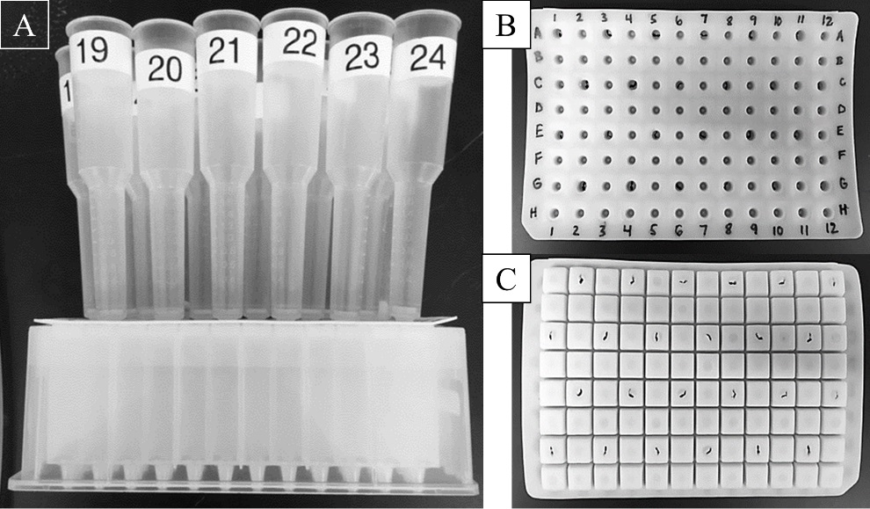

**Fig 1.** The multi column plate adapter (MCPA) with columns. A. Front view of MCPA (long drip filter plate with sealing mat) with 24 columns attached. The MCPA guides samples from each column into a 96, 48 well or open collection plate. B & C. Top and bottom view of sealing mat respectively. 6 evenly spaced holes are made per row over alternating lines.

## *Proteins*

Construct design for AbpSH3 and AbpSH3-Ark1 hybrid and variants were previously described [14, 19]. SH3 domain and hybrid constructs were expressed from an ampicillin resistant pJexpress414 (DNA 2.0) plasmid to include an N-terminal Histidine-tag (his-tag) or from a pET21d (+) (Novagen) plasmid to include a C-terminal his-tag. Supplemental Table 1 contains additional information regarding individual samples.

## *Protein overexpression*

AbpSH3 domain, AbpSH3-Ark1, and variants of these proteins were overexpressed using T7-based plasmids with an auto-induction protocol [20]. Cells were transformed using lab made Mix & Go (Zymo Research) BL21 Gold (DE3) cells (Agilent Technologies) and plated on LB-agar plates supplemented with 100 µg/ mL ampicillin. One colony was used to inoculate 4 mL of luria broth (LB) medium with 100 µg/mL carbenicillin and was left to shake overnight at 250 rpm and 37 °C for 12 – 16 hours. The LB starter culture was transferred, in a 1:50 ratio (2 mL), to a 500 mL flask containing 100 mL of sterile auto-induction media with 100 µg/mL ampicillin and was left to shake at 250 rpm and 37 °C for 6 hours. The cells were harvested in 50 mL fractions by centrifugation at 4600 rpm for 20 minutes until all culture was pelleted. The pellets were frozen at -20 °C until lysis and purification.

## *Purification buffer compositions*

Buffer compositions for denaturing and native purifications can be seen in Table 1. Buffers were previously described [14].

|  |  |  |
| --- | --- | --- |
|  | **Denaturing buffers compositions** | **Native buffers compositions** |
| **Lysis buffer** | 100 mM NaH2PO4, 10 mM Tris, 6 M GuHCl, 10 mM imidazole, pH 8.0 | 20 mM Tris, 300 mM NaCl, 0.5 mM CaCl2, 2.5 mM MgSO4, 10 mM imidazole, pH 8.0 |
| **Wash buffer** | 100 mM NaH2PO4, 10 mM Tris, 6 M GuHCl, 20 mM imidazole, pH 8.0 | 20 mM Tris, 300 mM NaCl, 20 mM imidazole, pH 8.0 |
| **Elution buffer** | 100 mM NaH2PO4, 10 mM Tris, 6 M GuHCl, 20 mM acetic acid, pH 3.0 | 20 mM Tris, 300 mM NaCl, 250 mM imidazole, pH 8.0 |

Table 1: Composition of buffers for denaturing and native purifications (all chemicals purchased from VWR).

## *Denaturing cell lysis*

Overexpression of 100 mL culture yielded a pellet of approximately 2 grams wet weight. 5 mL of cold denaturing lysis buffer per gram of pellet was used to resuspend to homogeneity with a vortex. Each lysate was left rocking for 30 minutes at 4 °C and then spun at 4500 rpm for about 30 minutes. The lysate supernatant was then decanted and frozen at -80 °C. Prior to purification, the samples were thawed and centrifuged at 12,000 rpm for 20 minutes to further separate the lysate. Denaturing cell lysis was slightly modified from our previous study[14].

## *Native cell lysis*

Overexpression of 100 mL culture yielded a pellet of approximately 2 grams wet weight. 5 mL of cold native lysis buffer per gram of pellet was used to resuspend to homogeneity by gently pipetting with a 3 mL disposable transfer pipette and gentle vortexing. Then solid lysozyme was added to 0.4 mg/mL and 100 X protease inhibitor, 10 mg/mL DNase, and Triton X-100 were added to make a 1 in 100 stock dilution. Each lysate was left rocking for 30 minutes at 4 °C followed by 3 cycles of freeze/thaw at -80 °C for 30 minutes per step, and then spun at 4500 rpm for about 30 minutes. The lysate supernatant was then decanted and frozen at -80 °C. Prior to purification, the samples were thawed and centrifuged at 12,000 rpm for 20 minutes to further separate the lysate. Native cell lysis was slightly modified from our previous study[14].

## *Gravity or vacuum purification*

Each clear lysate was loaded into a column pre-equilibrated with denaturing lysis buffer and containing the appropriate Nickel (Ni) resin (0.6 mL resin for 100 mL auto-induction culture). The columns were washed 5 times using a repeater pipette to give a total wash buffer volume that is 50 times the resin volume (the volume of beads in the column). Elutions, 6 total, were collected at a volume of one resin volume per elution. Elutions were quantitated using absorbance measurements at 280 nm and elution fractions with sufficient protein (OD280 > 1) were dialyzed in 10 mM Tris, 100 mM NaCl, pH 8.0. In the case of denaturing purification, dialysis was used to refold samples from guanidine hydrochloride [21]. Samples were analyzed on Any kD Mini-PROTEAN TGX gels (456-9036) from Bio-Rad.

## *Circular dichroism spectroscopy*

Temperature melts were performed using a Chirascan™-plus CD spectrometer with 250 µL sample (20-30 µM). AbpSH3 was subjected to a steady temperature increase with a range starting and ending at approximately 10 °C and 90 °C respectively while Triple, AbpSH3-Ark1 hybrid and Triple-Ark1 hybrid were heated between 30 °C and 102 °C. Temperature increased 2 °C every minute and measurements were obtained at 1.5 points/second for wavelengths ranging from 200 nm to 260 nm. Temperature was monitored using a sample probe. Additionally, a pre-melt and post-melt CD spectra including fluorescence and absorbance was taken to verify the spectra remained unchanged and thus demonstrate the reversibility of any temperature dependent structural changes that occurred during the melt process. Temperature melt analysis with the Global 3™ Analysis Software from Applied Photophysics yielded melting temperatures (Tm). The pre-melt spectra were used for secondary structure comparisons using a secondary structure prediction tool, β-structure selection (BeStSel) [22]. Near UV spectra were measured at room temperature (25 ºC) with 250 µL sample (100-500 µM). Measurements were obtained at 4 points/second for wavelengths between 250 nm – 350 nm. All spectra were blank corrected with buffer (10 mM Tris, 100 mM NaCl, pH 8.0). Data was collected in millidegrees (mdeg) and were converted to degrees and mean residue ellipticity for comparisons (Equation 1 and 2).

Equation 1: $Mean residue molar concentration= \left(\# of residues\right)×(molar concentration)$

Equation 2: $Mean residue ellipticity= \frac{100*(ellipticity in deg )}{\left(Mean residue molar concentration\right)×\left(pathlength in cm\right)}$

# **Results/Discussion**

## *Development of multi-column plate adapter (MCPA) and purification method*

The objective of this study was to develop a versatile HTPP system in a plate format for easy collection of samples and to be compatible with medium to large scale purification. To potentially solve this problem and test our hypothesis, we created a MCPA, to interface chromatography columns to multi-well collection plates (Fig 1). The central component of the MCPA is the long drip filter plate, which is currently sold for the intention of filtering buffers or small volume samples in a convenient 96 well format. However, the low volume of the wells (2 mL) make it ineffective for plate-based protein purifications at the milligram scale as the volume of the resin, lysate, or washes are limited. Instead, we removed the plate filters and turned the long drip filter plate into an adapter that interfaces individual columns to collection plates. To “seal” the top of the plate (after removal of filters) we used a 96 well plate seal/mat and punctured 24 evenly spaced holes (Fig 1), to allow up to 24 chromatography columns to be used in parallel. In the case where less than 24 columns are used, the additional holes can be closed using male luer plugs or blocked empty columns to maintain a complete seal when using a vacuum (the vacuum is still sufficient with some open holes). With the chromatography columns attached to the MCPA via a sealing mat, up to 5 times more lysate per column can be loaded than a single well of the long drip filter plate alone and from 1 to 24 columns can be selected quickly and easily. The estimated cost for one MCPA is $45 and all parts of the MCPA can be cleaned and re-used for future purifications.

Conveniently, protein purification with a MCPA can be done with gravity or with a vacuum manifold for a faster purification. The use of a vacuum manifold is optional but convenient and could be suitable for small life science laboratories as they cost less than $1000. For vacuum-based purifications, the assembled vacuum manifold with MCPA (Fig 2) was used with an Integra Vacusafe although any vacuum source is compatible as long as a trap is installed.

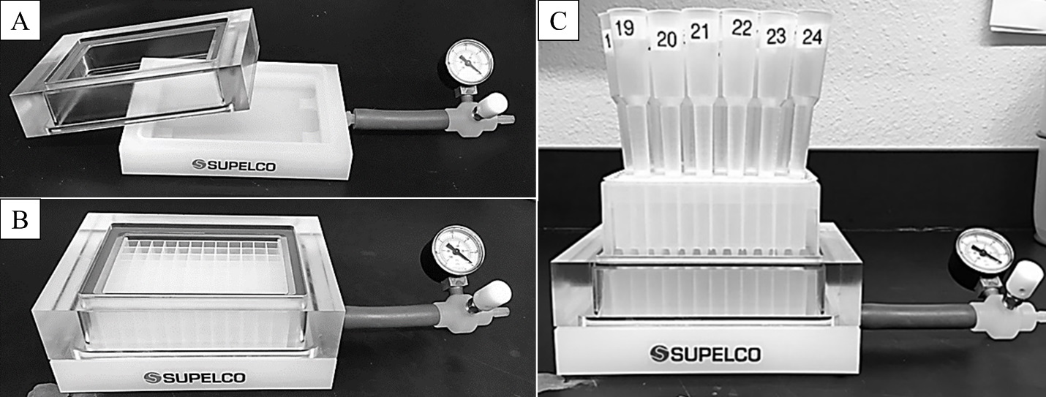

**Fig 2.** MCPA protein purification system with vacuum manifold. A. Top piece and bottom pieces of vacuum manifold with pressure gauge and bleed valve attached. B. Vacuum manifold assembled with a 96 x 2 mL well collection plate in the vacuum manifold. C. Fully assembled system with MCPA on top of the vacuum manifold with 24 columns attached to the MCPA.

A protocol for the MCPA protein purification method with Ni resin under vacuum is found below. This protocol can also be followed without a vacuum manifold using gravity where the MCPA is directly stacked on top of a collection plate.

1. *Determine the number of columns and the resin type/volume*
2. Determine how many columns are needed as well as the desired resin type and volume based on the expression volume or the wet mass of bacterial cells that have overexpressed protein. We typically use up to twenty-four 12 mL columns containing 0.1 mL to 0.6 mL resin for auto-induction cultures between 20 mL and 100 mL respectively.
3. Insert the desired number of columns (with resin) into a pre-assembled MCPA (Fig 3). The columns should fit snugly in the holes of the sealing mat that have been punctured (Fig 1).
4. If less than 24 columns are used, empty holes should be closed with male luer plugs (or an empty, closed column) to maintain the vacuum seal. Fig 3 provides a schematic for assembly of MCPA.
5. Make sure resin is properly regenerated. For Ni resin, a bold blue color should be present. If resin does not appear bold blue or column is running slowly, proceed to Step 6: *Regenerate Ni resin and columns*.

C:\Users\biochem01\Dropbox\1 Matt\Writing & Reviews\Vacuum Purification Paper\Figures\Tiff images\Figure 3.tif

**Fig 3**: Schematic assembly of the MCPA purification system. The sealing mat with punctured holes attaches to the long drip plate (with filters removed) and columns are attached to the top of the sealing mat and the MCPA sits on top of a collection plate. This can be used with a vacuum manifold for faster purifications.

1. *Equilibrate columns*
2. Put an open collection plate into the vacuum manifold to collect buffer waste from equilibration and place MCPA with attached columns. Add three times the resin volume of appropriate lysis buffer to each column thus equilibrating the resin. Use an Eppendorf Repeater Plus with a 50 mL syringe to efficiently load the buffer into the columns.
3. Turn the vacuum on to increase the flow of buffer through the column. Once all buffer has passed through, turn off the vacuum and change/empty the waste collection plate. Ni resin can tolerate brief “drying”, if the vacuum is still applied after buffer has passed through the column.
4. If any columns are running significantly slower, detach column and check air can be pushed through the MCPA using a large syringe. If this is unblocked, use a different column with a fresh filter.
5. *Load lysates*
6. Lysates should be a clear, light yellow color. If lysates are cloudy (which may happen after thawing), centrifuge samples at maximum speed (ideally > 18,000 g) for at least 20 minutes and decant the clear supernatant into another tube. If a sonicator is available/amenable to lyse the cells, it will help degrade the nucleic acid and further improve the quality of the lysate. Native lysates are much less viscous than denaturing lysates.
7. Lysate flow through can be collected into a 48 x (5 mL/well) plate; however, if the total lysate volume exceeds 4 mL per column, multiple plates must be used to avoid sample spill over. As such, the lysate will have to be loaded in 4 mL increments. Alternatively, if flow through will not be collected and saved, an open bottom collection plate can be used instead of a well plate, allowing up to 300 mL volume.
8. Load lysates using disposable transfer (Pasteur) pipettes, while exercising caution as to not mix samples. Once loaded, it is recommended to mix the lysate and Ni resin with the pipette to encourage binding.
9. Once columns are loaded, it is recommended to wait a 1-3 minutes and mix a few times before turning on the vacuum, again to encourage binding, before the lysate flows through. If multiple loads are needed, ensure the collection plate will not over flow and repeat steps 3b-d.
10. If a column is “blocked” it is recommended to pour the lysate/resin mixture into a new column with a fresh filter. Excess lysis buffer may be needed to transfer the entire mixture. A blocked column is easily spotted as it will take much longer for the lysate to flow through than neighboring columns.
11. Turn off vacuum when lysate has gone through all columns.
12. *Wash columns*
13. To remove as many protein contaminants as possible and take advantage of fast liquid transfer rates under vacuum, columns should be washed with 50 resin volumes of wash buffer. Split this step into 5 separate washes of 10 resin volumes each (e.g. 0.6 mL resin volume = 6 mL per wash). For first wash, load wash buffer into all columns using an Eppendorf Repeater Plus with a 50 mL syringe and turn on vacuum.
14. Turn off vacuum once wash buffer has flowed through all columns. Repeat these steps for the remaining 4 washes. Also, to avoid overflow, it is important to periodically empty the waste plate.
15. *Elute from columns*
16. In total, 6 elutions are recommended to remove all protein bound to the resin, therefore, carefully label six 96 x (2 mL/well) collections plates.
17. For each plate, elute protein-bound resin with one resin volume of elution buffer using an Eppendorf Repeater Plus with a 10 mL syringe.
18. To avoid protein foaming during this step, the vacuum should be used on its lowest setting or collect under gravity.
19. Check to make sure wells that surround elution containing wells are still empty to ensure all elutions were collected in the intended well.
20. *Regenerate Ni resin and columns*
21. Regenerate Ni resin by switching to an open collection plate and adding two resin volumes of 100 mM EDTA, followed by two resin volumes of 0.5 M NaOH.
22. Add four resin volumes of 100 mM Ni sulfate, followed by two resin volumes of water.
23. Dispose of waste in a dedicated container as Ni should not be poured down the sink.
24. Regeneration can be done at the beginning or end of a purification depending on user preference.
25. Cap both ends of columns and store them in 20 % ethanol in a rack at 4 °C for future use. Alternatively, instead of removing the columns from the MCPA, an intact sealing mat can be used to seal the bottom as an alternative method of storage.
26. Some columns will eventually have their filters blocked and will run too slowly, these columns should be replaced, or filters cleaned. As such, it is recommended to periodically test filters by removing resin and filling the column with water to see if it flows through quickly. Filters can be cleaned by leaving a closed column filled with denaturing elution buffer and shaking overnight.

## *Vacuum vs. Gravity purification*

A direct comparison using the MCPA system with Ni resin in 12 mL columns under vacuum and gravity was performed to determine if there was a difference in protein purity and yield. We used 100 mL auto-induction cultures expressing 24 different AbpSH3-Ark1 hybrid mutant proteins, which contain AbpSH3 connected to its binding peptide via a flexible linker. The 10 mL of lysate for each protein was split into two parts, one for each purification method using 0.3 mL of Ni resin for each. The vacuum purification had a total purification time of 46 minutes, whereas the gravity purification was nearly 3 times as long (Fig 4A). The lysate loading step had the biggest difference in time with the two methods. This is likely due to the relatively viscous lysates which flow through the column much faster with assistance from vacuum. The purity of representative samples from each purification type is seen in Fig 4B. Both purification methods yielded similar amounts of highly pure protein (Supplemental Table 2) with only a slight contaminant around 25 kDa which we believe to be a common co-purified *E.coli* protein YodA [23]. The MCPA with vacuum manifold for shorter purification times has been used in our lab to purify hundreds of proteins usually with a resin volume of 0.6 mL. The average purification time of 24 columns with 0.6 mL of resin is about 75 minutes, which is nearly twice as fast as using the gravity method with 0.3 mL of resin (Fig 4A). Native lysates prepared from sonication are even quicker to flow through the resin, which would further reduce the purification time. Also, the speed/pressure of the vacuum does not compromise the integrity of the resin as we have purified with the same resin > 10 times and maintained similar yields. Furthermore, we found a resin volume ranging from 0.1 mL to 0.6 mL to be optimal. If less than 0.1 mL of resin is used, the user risks the resin not completely covering the bottom of the column. This would allow sample to flow through the column without ever having a chance to bind and lowering yields. The ability for the researcher to change the resin volume range and the use of the MCPA system with or without a vacuum are just two instances of the systems versatility.

C:\Users\biochem01\Dropbox\1 Matt\Writing & Reviews\Vacuum Purification Paper\Figures\Tiff images\Figure 4.tif

**Fig 4.** Optimization of MCPA affinity purification. A. Comparison of vacuum and gravity purification times for 0.3 mL and 0.6 mL resin volumes using 24 columns. For 0.3 mL, the vacuum purification time was only 45 minutes compared to the gravity purification of around 2 hours. B. SDS-PAGE analysis comparing a purification under vacuum and gravity. For vacuum (V) and gravity (G), the second elution (E2) for each protein (labeled 1 to 7) was refolded by dialysis into 10 mM tris 100 mM NaCl pH 8.0 before running on the gel.

## *MCPA system versatility*

As seen in the previous section, the simplest and highest sample throughput configuration would be 1 column/protein for 24 different samples (1 x 24) at our maximum recommended resin volume of 0.6 mL. This column configuration (1 x 24) has been used in our lab with hundreds of proteins ranging in size from ~7 kDa to ~28 kDa, using both denaturing and native purification methods. As an additional example of a 1 x 24 column configuration, with the recommended resin maximum volume, various yeast AbpSH3 mutants (Supplemental Table 1) were purified under denaturing conditions (Fig 5A). The samples appear to be mostly pure with a common contaminant present at ~25 kDa believed to be YodA previously seen in Fig 4B, which is known to be washed away with high imidazole concentrations (≥ 80 mM) [23]. Interestingly, under native purification conditions, we were able to remove the ~25 kDa contaminant when purifying various members of the yeast SH3 domain family (Fig 5B). Further analysis of native lysates (data not shown) indicates the ~25 kDa contaminant is insoluble in most cases and is separated into the pellet, indicating how the MCPA system, even on the same plate, could be used for optimizing purifications by comparing native vs. denaturing method.

C:\Users\biochem01\Dropbox\1 Matt\Writing & Reviews\Vacuum Purification Paper\Figures\Tiff images\Figure 5.tif

**Fig 5.** A. Denaturing purification of various AbpSH3 mutants. The 14 purified AbpSH3 mutants shows a slight contaminant around 25 kDa but appear to be mostly pure. B. Native purification of 11 different yeast SH3 domains. The ~25 kDa contaminant appears to be removed with our native conditions.

Once a purification is optimized at a smaller scale, the MCPA system can easily be scaled for larger purifications. This is done by using fewer different proteins per MCPA purification and splitting the lysate between multiple columns. For example, 12 columns/protein for 2 different proteins (12 x 2) or 6 columns/protein for 4 different proteins (6 x 4) all purified in parallel. To test the large-scale purification capabilities of the MCPA system, four separate purifications were performed. Each sample was grown in a culture volume of 1.8 L, lysed in a volume of approximately 90 mL of denaturing lysis buffer, and purified one at a time using 18, 12 mL columns (alternatively, fewer Econo-Pac® 30 mL columns can be used). The lysate was divided evenly among the 18 columns containing 0.6 mL Ni resin to maintain the ratio of 0.6 mL resin to 100 mL auto-induction culture. One AbpSH3 domain mutant (Triple) and three variations of the AbpSH3-Ark1 hybrid were purified. Triple is AbpSH3 with three stabilizing mutations [E(7)L, V(21)K, N(23)G] in the domain, Triple hybrid (T-Hybrid) has a long linker (17 amino acids) between the domain and Ark1 peptide. HML is the AbpSH3-Ark1 hybrid with a medium linker (10 amino acids). HSL is the hybrid with a short linker (6 amino acids) [19, 24]. Each of the four purifications yielded highly pure protein with the same contaminant seen previously (Fig 6A). Open-bottom collection plates were conveniently used during the elution step for simultaneous collection of elutions from all columns for a given protein. This eliminates the need to combine elutions from a multi-well plate. Similarly, 4 column or 2 column reservoir plates can be used when using different configurations such as 6 x 4 or 12 x 2 respectively. Sample yields varied between 22 to 44 mg per 1 L expression (Fig 6B). The high yields from the large scale and the common 1 x 24 configuration have provided adequate protein for biophysical analysis. The MCPA versatility, due to the various configurations, allow it to fit the researcher’s specific purification needs without purchasing additional supplies and allow for predictable scale up.

C:\Users\biochem01\Dropbox\1 Matt\Writing & Reviews\Vacuum Purification Paper\Figures\Tiff images\Figure 6.tif

**Fig 6.** Large-scale MCPA purification of 4 his-tagged proteins.A.Each of the four purifications from 1.8 L of auto-induction culture appears to yield highly pure protein with only slight contamination around 25 kDa. Shown are the first 3 elutions from each purification (E1 to E3). B. Table of yields. All samples gave high yields. Triple was the highest yielding sample with 86 mg from 1.8 L culture.

## *Biophysical analysis*

The MCPA system is a simple and cost-effective, purification system capable of purifying sufficient protein for biophysical analysis. Various biophysical techniques including x-ray crystallography, NMR spectroscopy, circular dichroism (CD) spectroscopy, isothermal titration calorimetry (ITC), and small angle x-ray scattering (SAXS) have been used with MCPA purified protein. For example, the one-step large scale purification of Triple, seen in the previous section, allowed for crystallization screens, the best of which came from 20% 1000 PEG, 200 mM LiSO4, 100 mM citrate/phosphate pH 4.0 (Supplemental Fig 1). These crystals diffract to 2.1 Å resolution and will assist in elucidation of this hyperstable three-point mutant [19]. Additionally, the common 1 x 24 configuration also yielded sufficient protein for biophysical analysis and in this study, CD spectroscopy is used on AbpSH3 and variants as an example.

CD spectroscopy is a common biophysical technique used to monitor secondary and tertiary structure in a protein’s native state [25, 26]. Near UV CD spectroscopy for tertiary analysis requires higher concentrations of protein than far UV, but the MCPA system purified sufficient protein for both types of CD spectroscopy using a 1 x 24 configuration. Moreover, CD spectroscopy can also be used to monitor the unfolding and folding of proteins by thermal denaturation [27]. A representative temperature melt of AbpSH3 (Fig 7A) shows high data quality across multiple wavelengths from 205 – 260 nm. Previous structural studies have found AbpSH3 domain to have a typical SH3 domain fold, consisting of a compact β-barrel with 5 antiparallel β-strands and an RT-loop between strands 1 and 2 [28, 29]. However, there have been no secondary or tertiary structural investigation into the AbpSH3 stabilized mutant, Triple. Far UV (200 – 260 nm) spectra shows similar line shapes for AbpSH3 and Triple, although Triple has higher peak maxima of the two major peaks around 215 nm and 235 nm (Fig 7B), which appears to correspond to an increase in antiparallel β-sheet content based on secondary structure analysis using BeStSel [22]. Furthermore, thermal denaturation shows Triple has an ~30 °C increase in Tm (Fig 7C). This increase is expected; however we believe our values to be more accurate than a previous study [19] as a cuvette probe was used throughout the experiment to monitor the exact temperature of the proteins in solution. Near UV spectra also show a similar shape between the two domains, but there is once again an increase in peak maxima for Triple (Fig 7D). Triple’s increase in maxima for both near and far UV coupled with enhanced β-sheet content and Tm indicates a tighter, better folded domain, a correlation that has been seen previously with other thermostable variants [30].

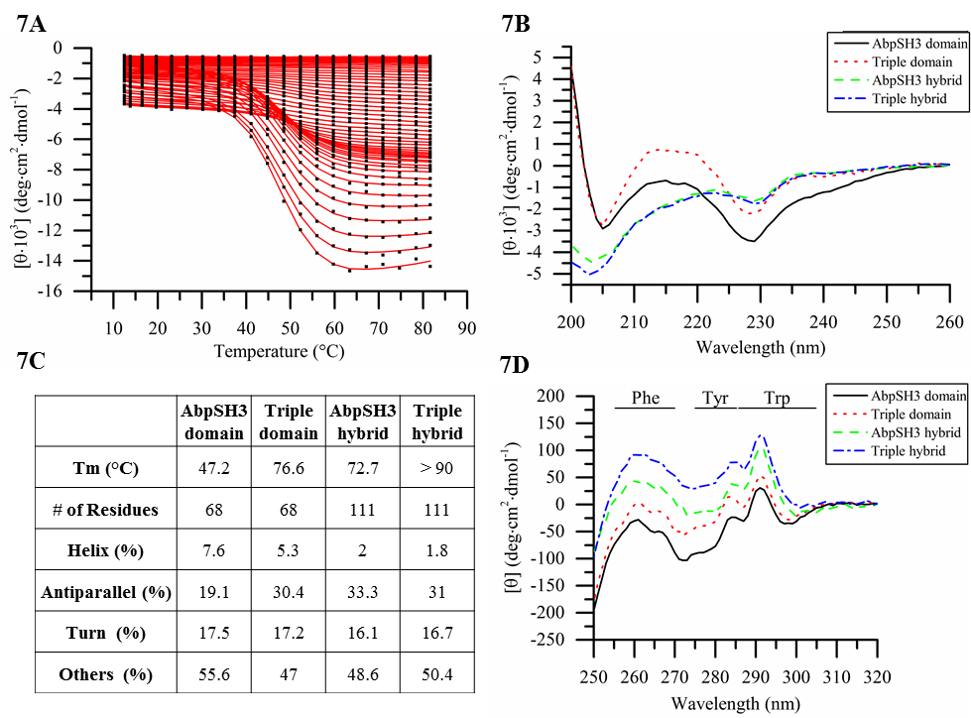

**Fig 7:** CD spectroscopy analysis. A. Representative temperature melt of AbpSH3. Wavelengths 205- 260 nm were measured between 10 – 80 degrees. Raw data is represented by the black points and the red line is the fitted curve (each curve is data at a different wavelength, with 205 nm showing the greatest signal change). B. Far UV spectra (200 nm – 260 nm). AbpSH3 and Triple have a similar shape, although Triple has higher peak maxima. AbpSH3 hybrid and Triple hybrid have nearly identical far UV spectra with only a slight difference between 200 nm – 205 nm. C. Tm with secondary structure estimates based on BeStSel analysis [22], it was not possible to accurately measure Triple hybrid’s Tm as it was higher than the limit of detection. D. Near UV spectra (220 nm – 330 nm).

AbpSH3-Ark1 hybrid and Triple-Ark1 hybrid were also compared against their respective domains. Both hybrid versions had an increase in Tm compared to their respective domains, due to binding of the attached Ark1 peptide. Far UV spectra of both hybrids (Fig 7B) are nearly identical with only a slight difference between 200 nm – 205 nm, indicting the Ark1 peptide binds to Triple in a similar fashion as it does to AbpSH3. The Ark1 peptide in the hybrids does not have any additional Phe, Tyr, and Trp, which allows tertiary structure comparisons between the peptide bound and unbound domains. Near UV line shapes are similar for all hybrids and domains indicating the same overall fold within the domain. However, there are differences between peak maximum where T-hybrid > Triple and AbpSH3 hybrid > AbpSH3. This correlates with relative thermal stabilities, likely due to an increased population of a well packed fold that has environments for Phe, Tyr, and Trp with strong near UV signals as would be expected for a domain that is stabilized in the bound state [26, 31].

CD spectroscopy is a powerful biophysical technique which can require extensive amounts of protein for near UV analysis. The MCPA system has the capability to purify large amounts of protein for biophysical analysis as demonstrated with CD spectroscopy. Implementation of the MCPA system in our lab has produced a boom of purified protein for a variety of biophysical techniques which will be demonstrated in subsequent papers.

# **Conclusion**

The MCPA system uses a simple adapter to convert individual columns into a plate-based format for protein purification. Additionally, the MCPA system allows for individualized parallel purifications, thus increasing throughput while still allowing for modularity, which is different from current plate-based purification kits. For example, smaller scale purification (microgram yields) with 96 well filter plates from GE Healthcare life sciences, or Sigma, are sold pre-packaged with specific resin. Although convenient, one pre-packaged plate does not offer much, if any, scale-up or modularity for optimization of resin types/volumes. Our system can easily be adapted to other types of IMAC with various metals such as cobalt or copper for his-tag purifications. Furthermore, a single MCPA is capable of purification with other affinity resins, as well as resins for ion exchange, or hydrophobic interaction chromatography and could easily be adapted to immunoaffinity chromatography (IAC) for antibody purification [7, 32, 33]. The versatile nature of the MCPA even permits the user to purify with different methods simultaneously on the same plate. For example, with the (1 x 24) configuration, each individual column can purify the same his-tagged sample using different conditions to investigate resin type (e.g. nickel vs. cobalt), buffer system (e.g. native vs. denaturing), wash buffer imidazole concentration (e.g. 10 mM vs. 20 mM) and lysate load volume (e.g. from 100 mL vs 200 mL auto-induction culture).

The purification method described here has been optimized to be < 2 hours for 24 sample purifications on a single plate. This method could easily be scaled up to purify > 96 samples efficiently, as multiple purifications can be done simultaneously using multiple MCPA systems under gravity or vacuum manifolds. Table 2 shows possible purification configurations for the domains in this study with expected yields for columns with 0.3 mL and 0.6 mL of resin. The wet cell mass of the cultures for 24 purifications were approximately 1 and 2 grams, and this generally yielded about 1.5 and 3 mg of protein. Alternatively, one MCPA can process up to 48 grams of wet cell mass for a single protein by evenly splitting up the lysate between 24 columns. The protein yields will naturally vary for different systems than those described here and for lower expressing proteins, the yields may only be sufficient for small-scale optimizations. However, this modularity and predictability between small-scale and large-scale purification capability is highly advantageous as switching between the two requires very little effort and it does not require the purchase of separate kits, chromatography columns, or instruments.

|  |  |  |  |  |  |  |
| --- | --- | --- | --- | --- | --- | --- |
| **Scale (number of columns per sample)** | **Culture volume (mL)** | **Wet cell mass (g)** | **Lysate volume (mL)** | **Resin volume per column (mL)** | **Total resin Volume (mL)** | **Expected yield (mg)** |
| 1 | 50 | 1 | 5 | 0.3 | 0.3 | ~1.5 |
| 1 | 100 | 2 | 10 | 0.6 | 0.6 | ~3 |
| 24 | 2400 | 48 | 240 | 0.6 | 14.4 | ~72 |

**Table 2**. Purification configurations. The expected wet cell mass is about 1 gram from 50 mL of overexpressed auto-induction culture volume. Lysis buffer is added in a ratio of 1-gram wet cell mass to 5 mL buffer and resin volume per column is 0.3 mL resin for 5 mL of lysate. The total resin volume can be increased up to 14.4 mL to purify a starting wet cell mass of 48 grams. Expected yields are based on purification of over-expressed yeast SH3 domains (Supplemental Table 1).

Protein purification will continue to be a key component in development of new therapeutics [34, 35]. Biophysical techniques in drug discovery still require milligram yields of pure protein, creating the need to improve expression and purification time and cost [1, 6, 36, 37]. Automated purification systems are a tremendous advancement, improving efficiency and providing consistent yields and purity. However, the initial cost of automated purification systems can still be too expensive for small research laboratories. Additionally, automated purification systems can require extensive training and constant maintenance to keep the machine functional, especially when using corrosive buffers containing denaturants [38]. Therefore, the simple, easy to use, MCPA system is a good alternative. The MCPA system is significantly cheaper than an automated system and has produced protein with high purity and yields for biophysical analyses. Furthermore, the MCPA purification system can rival the speed of automated systems by including a vacuum manifold. Automated purification systems are likely the future of protein purification, but until the cost of these machines are affordable to all laboratories, small innovations with conventional laboratory supplies such as the MCPA system will continue to be useful to the expanding field of protein purification.

# **Contributions**

EJS conceived the idea for this research. EJS and MJD developed the MCPA. MJD, BJL, RJR, KCF, ZLS, and VJM collected final data. MJD and EJS analyzed the data and wrote the paper.

# **Acknowledgements**

Regis Blake and Amanda Logsdon for initial pilot project. Thomas Germain for assistance with CD temperature melts. Faraz Harsini and Bryan Sutton (Texas Tech University Health Sciences Center) for assistance with crystallization. Research reported in this publication was supported by an Institutional Development Award (IDeA) from the National Institute of General Medical Sciences of the National Institutes of Health under grant number P20GM103451, internal research grants from Eastern New Mexico University and a US Department of Education HSI-STEM grant.

# **References**

[1] M. Saraswat, L. Musante, A. Ravida, B. Shortt, B. Byrne, H. Holthofer, Preparative purification of recombinant proteins: current status and future trends. Biomed Res Int 2013 (2013) 312709.

[2] H. Block, B. Maertens, A. Spriestersbach, N. Brinker, J. Kubicek, R. Fabis, J. Labahn, F. Schäfer, Chapter 27 Immobilized-Metal Affinity Chromatography (IMAC), Guide to Protein Purification, 2nd Edition, 2009, pp. 439-473.

[3] P. Stromberg, J. Rotticci-Mulder, R. Bjornestedt, S.R. Schmidt, Preparative parallel protein purification (P4). J Chromatogr B Analyt Technol Biomed Life Sci 818 (2005) 11-18.

[4] A.C. Anderson, The Process of Structure-Based Drug Design. Chemistry & Biology 10 (2003) 787-797.

[5] Y. Kim, G. Babnigg, R. Jedrzejczak, W.H. Eschenfeldt, H. Li, N. Maltseva, C. Hatzos-Skintges, M. Gu, M. Makowska-Grzyska, R. Wu, H. An, G. Chhor, A. Joachimiak, High-throughput protein purification and quality assessment for crystallization. Methods 55 (2011) 12-28.

[6] J.P. Renaud, C.W. Chung, U.H. Danielson, U. Egner, M. Hennig, R.E. Hubbard, H. Nar, Biophysics in drug discovery: impact, challenges and opportunities. Nat Rev Drug Discov 15 (2016) 679-698.

[7] C. Zhang, A.M. Long, B. Swalm, K. Charest, Y. Wang, J. Hu, C. Schulz, W. Goetzinger, B.E. Hall, Development of an automated mid-scale parallel protein purification system for antibody purification and affinity chromatography. Protein Expr Purif 128 (2016) 29-35.

[8] K. Murata, M. Wolf, Cryo-electron microscopy for structural analysis of dynamic biological macromolecules. Biochim Biophys Acta 1862 (2018) 324-334.

[9] X.C. Bai, G. McMullan, S.H. Scheres, How cryo-EM is revolutionizing structural biology. Trends Biochem Sci 40 (2015) 49-57.

[10] A.S. Pina, C.R. Lowe, A.C. Roque, Challenges and opportunities in the purification of recombinant tagged proteins. Biotechnol Adv 32 (2014) 366-381.

[11] V. Gaberc-Porekar, V. Menart, Perspectives of immobilized-metal affinity chromatography. J Biochem Biophys Methods 49 (2001) 335-360.

[12] J. Konczal, C.H. Gray, Streamlining workflow and automation to accelerate laboratory scale protein production. Protein Expr Purif (2017).

[13] J. Koehn, I. Hunt, High-Throughput Protein Production (HTPP): a review of enabling technologies to expedite protein production. Methods Mol Biol 498 (2009) 1-18.

[14] J. McGraw, V.K. Tatipelli, O. Feyijinmi, M.C. Traore, P. Eangoor, S. Lane, E.J. Stollar, A semi-automated method for purification of milligram quantities of proteins on the QIAcube. Protein Expr Purif 96 (2014) 48-53.

[15] E.R. Smith, D.W. Begley, V. Anderson, A.C. Raymond, T.E. Haffner, J.I. Robinson, T.E. Edwards, N. Duncan, C.J. Gerdts, M.B. Mixon, P. Nollert, B.L. Staker, L.J. Stewart, The Protein Maker: an automated system for high-throughput parallel purification. Acta Crystallogr Sect F Struct Biol Cryst Commun 67 (2011) 1015-1021.

[16] G. Helie, M. Parat, F. Masse, C.J. Gerdts, T.P. Loisel, A. Matte, Application of the Protein Maker as a platform purification system for therapeutic antibody research and development. Comput Struct Biotechnol J 14 (2016) 238-244.

[17] E. Cummins, D.P. Luxenberg, F. McAleese, A. Widom, B.J. Fennell, A. Darmanin-Sheehan, M.J. Whitters, L. Bloom, D. Gill, O. Cunningham, A simple high-throughput purification method for hit identification in protein screening. J Immunol Methods 339 (2008) 38-46.

[18] T. Brown, N. Brown, E.J. Stollar, Most yeast SH3 domains bind peptide targets with high intrinsic specificity. PLoS One 13 (2018) e0193128.

[19] A. Rath, A.R. Davidson, The design of a hyperstable mutant of the Abp1p SH3 domain by sequence alignment analysis. Protein science : a publication of the Protein Society 9 (2000) 2457-2469.

[20] W.F. Studier, Protein production by auto-induction in high-density shaking cultures. Protein Expression and Purification 41 (2005) 207-234.

[21] K.L. Maxwell, D. Bona, C. Liu, C.H. Arrowsmith, A.M. Edwards, Refolding out of guanidine hydrochloride is an effective approach for high-throughput structural studies of small proteins. Protein Sci 12 (2003) 2073-2080.

[22] A. Micsonai, F. Wien, L. Kernya, Y.H. Lee, Y. Goto, M. Refregiers, J. Kardos, Accurate secondary structure prediction and fold recognition for circular dichroism spectroscopy. Proc Natl Acad Sci U S A 112 (2015) E3095-3103.

[23] V.M. Bolanos-Garcia, O.R. Davies, Structural analysis and classification of native proteins from E. coli commonly co-purified by immobilised metal affinity chromatography. Biochim Biophys Acta 1760 (2006) 1304-1313.

[24] Q. Wang, N. Waterhouse, O. Feyijinmi, M.J. Dominguez, L.M. Martinez, Z. Sharp, R. Service, J.R. Bothe, E.J. Stollar, Development and Application of a High Throughput Protein Unfolding Kinetic Assay. PloS one 11 (2016).

[25] B. Ranjbar, P. Gill, Circular dichroism techniques: biomolecular and nanostructural analyses- a review. Chem Biol Drug Des 74 (2009) 101-120.

[26] S.M. Kelly, T.J. Jess, N.C. Price, How to study proteins by circular dichroism. Biochim Biophys Acta 1751 (2005) 119-139.

[27] N.J. Greenfield, Using circular dichroism collected as a function of temperature to determine the thermodynamics of protein unfolding and binding interactions. Nat Protoc 1 (2006) 2527-2535.

[28] E.J. Stollar, B. Garcia, P.A. Chong, A. Rath, H. Lin, J.D. Forman-Kay, A.R. Davidson, Structural, functional, and bioinformatic studies demonstrate the crucial role of an extended peptide binding site for the SH3 domain of yeast Abp1p. J Biol Chem 284 (2009) 26918-26927.

[29] B. Fazi, M.J. Cope, A. Douangamath, S. Ferracuti, K. Schirwitz, A. Zucconi, D.G. Drubin, M. Wilmanns, G. Cesareni, L. Castagnoli, Unusual binding properties of the SH3 domain of the yeast actin-binding protein Abp1: structural and functional analysis. The Journal of biological chemistry 277 (2002) 5290-5298.

[30] E. Querol, J.A. Perez-Pons, A. Mozo-Villarias, Analysis of protein conformational characteristics related to thermostability. Protein Eng 9 (1996) 265-271.

[31] E.J. Stollar, H. Lin, A.R. Davidson, J.D. Forman-Kay, Differential Dynamic Engagement within 24 SH3 Domain: Peptide Complexes Revealed by Co-Linear Chemical Shift Perturbation Analysis. PLoS ONE 7 (2012).

[32] S. Arora, V. Saxena, B.V. Ayyar, Affinity chromatography: A versatile technique for antibody purification. Methods 116 (2017) 84-94.

[33] B.V. Ayyar, S. Arora, C. Murphy, R. O'Kennedy, Affinity chromatography as a tool for antibody purification. Methods 56 (2012) 116-129.

[34] D.S. Hage, J.A. Anguizola, C. Bi, R. Li, R. Matsuda, E. Papastavros, E. Pfaunmiller, J. Vargas, X. Zheng, Pharmaceutical and biomedical applications of affinity chromatography: recent trends and developments. J Pharm Biomed Anal 69 (2012) 93-105.

[35] M.W. Nowicki, E.A. Blackburn, I.W. McNae, M.A. Wear, A Streamlined, Automated Protocol for the Production of Milligram Quantities of Untagged Recombinant Rat Lactate Dehydrogenase A Using AKTAxpressTM. PLoS One 10 (2015) e0146164.

[36] H. Jubb, A.P. Higueruelo, A. Winter, T.L. Blundell, Structural biology and drug discovery for protein-protein interactions. Trends Pharmacol Sci 33 (2012) 241-248.

[37] S.C. Almo, S.J. Garforth, B.S. Hillerich, J.D. Love, R.D. Seidel, S.K. Burley, Protein production from the structural genomics perspective: achievements and future needs. Curr Opin Struct Biol 23 (2013) 335-344.

[38] M. May, Automated Sample Prep. Science 351 (2016) 300-302.

**Supplemental material:**

|  |  |  |  |  |  |  |  |  |  |  |
| --- | --- | --- | --- | --- | --- | --- | --- | --- | --- | --- |
| **Sample Identification** | **Protein Name** | **Plasmid type** | **Residues for SH3 domain** | **Uniprot # for SH3 domain** | **Linker** | **Peptide Name** | **Residues for peptide** | **Uniprot # for peptide** | **Total size (kDa)** | **Additional information** |
| Abp1 (EJS67) | Actin-binding protein | pET21d (+) | 535–592 | P15891 | - | - | - | - | 7.93 |  |
| Abp1 mutants | Actin-binding protein | pET21d (+) | 535–592 | P15891 | - | - | - | - | >7.93 | Various mutations at N-terminus |
| Triple (Abp1) (EJS73) | Actin-binding protein | pET21d (+) | 535–592 | P15891 | - | - | - | - | 7.88 | Mutations at: E(7)L, V(21)K, N(23)G |
| T-HLL (Abp1-Ark1) (EJS164) | Actin-binding protein | pJexpress414 | 534–592 | P15891 | GSGSENLYF QGGSYAMG | Ark1p | KKTKPPVPPKPSHLKGT | C7GWN7 | 12.37 | Mutations at: E(7)L, V(21)K, N(23)G |
| HLL (Abp1-Ark1) (OF38) | Actin-binding protein | pJexpress414 | 534–592 | P15891 | GSGSENLYF QGGSYAMG | Ark1p | KKTKPPVPPKPSHLKGT | C7GWN7 | 12.41 | - |
| HML (Abp1-Ark1) (EJS163) | Actin-binding protein | pJexpress414 | 534–592 | P15891 | GSGSGSGSGS | Ark1p | KKTKPPVPPKPSHLKGT | C7GWN7 | 11.42 | - |
| HSL (Abp1-Ark1) (OF37) | Actin-binding protein | pJexpress414 | 534–592 | P15891 | GSYAMG | Ark1p | KKTKPPVPPKPSHLKGT | C7GWN7 | 11.27 | - |
| Abp1-Ark1 mutants | Actin-binding protein | pJexpress414 | 534–592 | P15891 | GSGSENLYF QGGSYAMG | Ark1p | KKTKPPVPPKPSHLKGT | C7GWN7 | > 12.40 | Various mutations at C-terminus |
| Lsb1 (EJS48) | LAS seventeen-binding protein 1 | pJexpress414 | 48 – 122 | P53281 | - | - | - | - | 10.45 | - |
| Lsb2 (Cab12) | [PSI+] inducibility protein 3 | pET21d (+) | 54 – 113 | Q06449 | - | - | - | - | 7.88 | - |
| Lsb3 (OF77) | LAS seventeen-binding protein 3 | pJexpress414 | 400 – 459 | P43603 | - | - | - | - | 11.87 | - |
| Lsb4 (Cab22) | Protein YSC84 | pET21d (+) | 410 – 468 | P32793 | - | - | - | - | 7.47 | - |
| Myo3 (EJS223) | Myosin-3 | pJexpress414 | 1121 – 1182 | P36006 | - | - | - | - | 9.01 | - |
| Myo5 (EJS46) | Myosin-5 | pJexpress414 | 1072 – 1158 | Q04439 | - | - | - | - | 11.51 | - |
| Nbp2 (EJS251) | NAP1-binding protein 2 | pJexpress414 | 110 – 170 | Q12163 | - | - | - | - | 9.07 | - |
| Pex13 (Cab15) | Peroxisomal membrane protein PAS20 | pET21d (+) | 302 – 374 | P80667 | - | - | - | - | 9.82 | - |
| Rvs167 (Cab19) | Reduced viability upon starvation protein 167 | pET21d (+) | 423 – 482 | P39743 | - | - | - | - | 7.86 | - |
| Sho1 (EJS225) | High osmolarity signaling protein SHO1 | pJexpress414 | 296 – 361 | P40073 | - | - | - | - | 9.64 | - |
| Sla1_c (EJS116) | Sla1p | pET21d (+) | 354 – 405 | C7GM55 | - | - | - | - | 8.39 | - |

**Supplemental Table 1:** Construct information. All samples are yeast SH3 domain or SH3 domain-peptide hybrids. Peptide residues highlighted in red, PV, indicate point mutations. Constructs were expressed in ampicillin resistant plasmids using either a pET21d (+) (Novagen) to include a C-terminal his-tag or pJexpress414 (DNA 2.0) to include an N-terminal histag.

|  |  |  |  |  |
| --- | --- | --- | --- | --- |
| **Sample #** | **Molecular Weight (g/mol)** | **Mass concentration (mg/mL)** | **Vacuum Protein yield (mg)** | **Gravity Protein yield (mg)** |
| 1 | 12921 | 4.84 | 1.94 | 1.31 |
| 2 | 12475 | 0.51 | 0.20 | 1.25 |
| 3 | 12987 | 2.62 | 1.05 | 1.71 |
| 4 | 12887 | 1.20 | 0.48 | 1.46 |
| 5 | 12885 | 3.96 | 1.58 | 1.61 |
| 6 | 12856 | 2.22 | 0.89 | 0.58 |
| 7 | 12498 | 5.33 | 2.13 | 1.66 |
| 8 | 12411 | 2.40 | 0.96 | 1.17 |
| 9 | 12985 | 4.18 | 1.67 | 1.54 |
| 10 | 12411 | 2.32 | 0.93 | 1.20 |
| 11 | 12911 | 3.28 | 1.31 | 1.58 |
| 12 | 12971 | 3.22 | 1.29 | 1.22 |
| 13 | 12931 | 2.24 | 0.90 | 1.23 |
| 14 | 12996 | 2.67 | 1.07 | 1.40 |
| 18 | 12865 | 1.62 | 0.65 | 1.03 |
| 19 | 13037 | 2.74 | 1.10 | 0.94 |
| 20 | 12411 | 2.91 | 1.16 | 0.77 |
| 21 | 13037 | 3.97 | 1.59 | 0.61 |
| 22 | 12661 | 5.06 | 2.02 | 1.25 |
| 23 | 12411 | 4.52 | 1.81 | 1.01 |
| 24 | 12799 | 4.88 | 1.95 | 0.84 |
| Average yield | | | 1.27 | 1.21 |

**Supplemental Table 2:** Table of yields from vacuum vs. gravity purification for 24 samples.

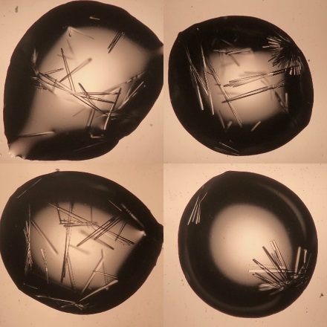

**Supplemental Fig 1:**Protein crystallization drops of Triple at 22.5 mg/mL. Protein sample buffer contains 10 mM Tris 1.5 M NaCl pH 8.0 and protein crystal buffer contains 20% 1000 PEG, 200 mM LiSO4, 100 mM citrate/phosphate pH 4.0. These crystals diffract to 2.1 Å resolution.