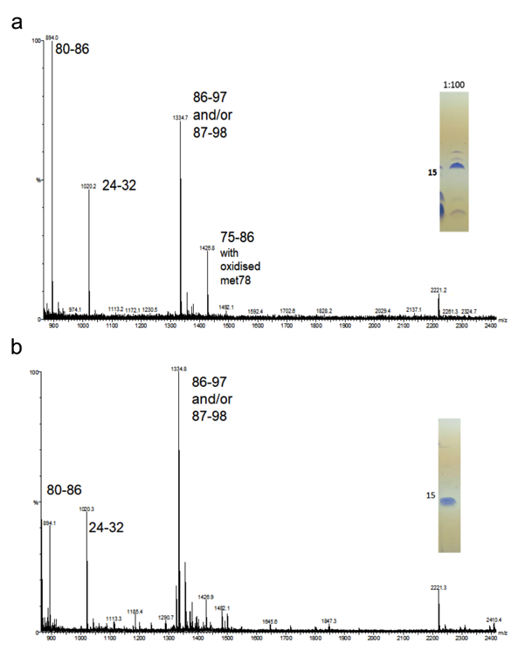
Supplementary Materials
Figure S1. Mass-spectrometry analysis of JEV capsid protein. MS analysis of digested (a) and purified capsid (b). SDS-PAGE gels of the samples used for MS analysis are shown. Residue numbers are indicated next to the peaks.

Figure S2. Hydrogen bonds at the JEV capsid dimer interface. Hydrogen bonds at the α1-α1’, α2-α2’, and α3-α3’ are shown with dashed lines in figure (a), (b), and (c), respectively. One monomer is in orange. Another is in green.

Figure S3. DENV capsid α1-α3 bundle. Residues invlove in side chain packing of DENV (PDB: 1R6R) capsid α1-α3 bundle are labeled. Each monomer coloured by the 1-4 α helices in orange, green, purple, and yellow, respectively.

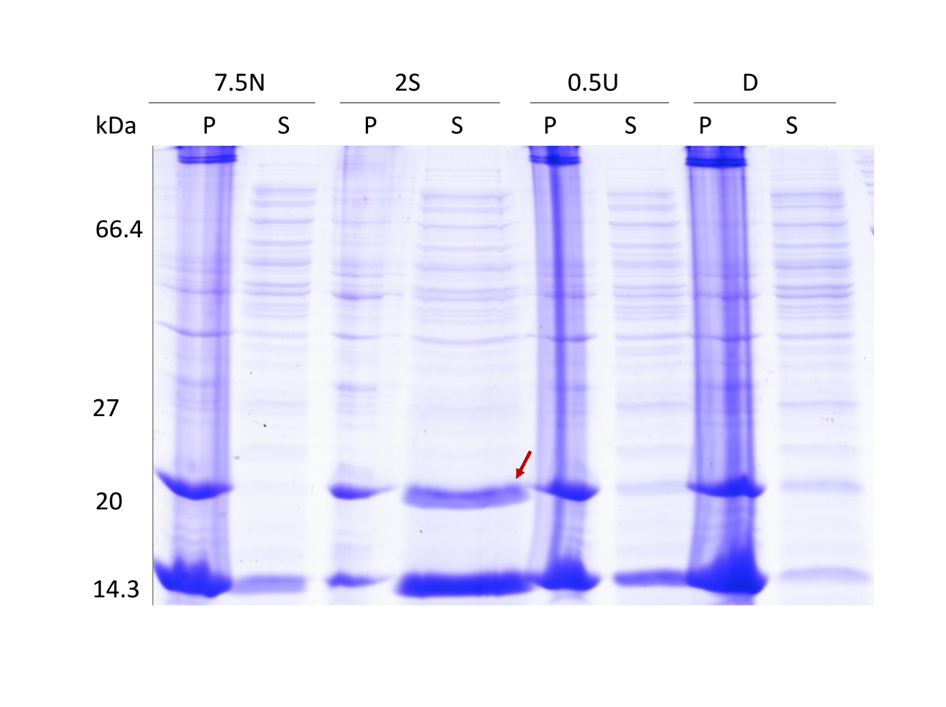Figure S4. JEV capsid protein lysis buffer screening. Lysis buffer screening demonstrated that capsid protein is soluble in 2 M salt buffer indicating by red arrow and partially soluble in buffer containing urea and detergent. Pellet fractions and suspension fractions were labelled P and S, respectively. Four lysis buffers were the buffer added with the following additives: no additive (7.5N), 2 M NaCl (2S), 0.5 M urea (0.5U), and 0.2% Triton X 100 (D).
Table S1. Data collection and refinement statistics.
 | JEV Capsid
Data Collection
Space group | P212121
Cell dimensions
a, b, c (Å) | 46.31, 49.78, 68.25
α,β,γ(°) | 90, 90, 90
Resolution (Å) | 38.32-1.98(2.03-1.98)*
R_{merge}  R_{pim} | 0.058(0.862)  0.044(0.686)
I / σI  CC half | 12.1(1.4)  0.999(0.551)
Completeness (%)  Redundancy | 99.6(99)  4.5(4.3)
Refinement
Resolution (Å) | 38.32-1.98
No. reflections | 10871
R_{work} / R_{free} | 0.188/0.237
No. atoms  Protein  Water  Ethylene glycol  Citrate ion  B-factors  Protein  Water  Ethylene glycol  2-propanol  Citrate ion | 1229  1144  56  16  13  42.77  53.26  52.91  -  66.22
R.m.s. deviations
Bond lengths (Å) | 0.014
Bond angles (°) | 1.428

Table S2. Hydrogen bonds between JEV capsid dimer interfacing residues and the distance.
Number | Structure 1 | Distance (Å)¹ | Structure 2
1 | Lys 31 [NZ] | 2.64 | Asp 39 [OD1]²
2 | Arg 45 [NE] | 3.11 | Phe 56 [O]
3 | Arg 45 [NH2] | 3.13 | Phe 56 [O]
4 | Arg 98 [NH2] | 3.36 | Trp 69 [O]
5 | Arg 98 [NH1} | 2.94 | Val 72 [O]
6 | Lys 85 [NZ] | 3.87 | Lys 85 [O]
7 | Lys 55 [NZ} | 3.03 | Glu 87 [O}
8 | Lys 74 [NZ] | 2.77 | Arg 98 [O]
9 | Asp 39 [OD1] | 2.69 | Lys 31 [NZ]
10 | Phe 56 [O] | 3.16 | Arg 45 [NH2]
11 | Phe 56 [O] | 3.07 | Arg 45 [NE]
12 | Glu 87 [O] | 3.00 | Lys 55 [NZ]
13 | Arg 98 [O] | 2.98 | Lys 74 [NZ]
¹ Assembly analysis in the program PISA [50].

Table S3. Salt bridges between JEV capsid dimer interfacing residues.
Number | Structure 1 | Distance (Å)¹ | Structure 2
1 | Lys 31 [NZ] | 2.64 | Asp 39 [OD1]
2 | Lys 74 [NZ] | 2.77 | Arg 98 [O]
3 | Asp 39 [OD1] | 2.69 | Lys 31 [NZ]
4 | Arg 98 [O] | 2.98 | Lys 74 [NZ]
¹ Assembly analysis in the program PISA.
Table 4. JEV capsid dimer interfacing residues reported with accessible (ASA) and buried surface area (BSA), solvation energy effect (ΔG) and conservation score.
(The values are reported from one monomer)
Number | Residue | ASA (Å²) | BSA (Å²) | ΔG (kcal/mol) | Conservation¹
1 | Leu27 | 83.65 | 21.41 | 0.34 | 1
2 | Val30 | 117.35 | 93.60 | 1.5 | 2*
3 | Lys31 | 144.46 | 90.81 | 0.19 | 8
4 | Val33 | 69.18 | 18.08 | 0.29 | 3*
5 | Val34 | 64.36 | 56.65 | 0.91 | 6*
6 | Met35 | 100.45 | 54.43 | 1.29 | 1
7 | Leu37 | 10.72 | 9.71 | 0.16 | 5*
8 | Leu38 | 49.69 | 37.96 | 0.59 | 3*
9 | Asp39 | 74.39 | 20.45 | -0.36 | 2*
10 | Arg45 | 84.22 | 18.52 | -0.08 | 6*
11 | Phe46 | 93.98 | 43.04 | 0.67 | 2*
12 | Ala49 | 41.95 | 41.95 | 0.56 | 7
13 | Leu50 | 24.80 | 24.80 | 0.38 | 2*
14 | Ile51 | 19.52 | 7.19 | 0.12 | 5*
15 | Thr52 | 28.95 | 28.56 | 0.17 | 5*
16 | Phe53 | 92.37 | 91.73 | 1.47 | 7*
17 | Phe54 | 22.78 | 16.86 | 0.27 | 5*
18 | Lys55 | 164.75 | 92.62 | -1.11 | 7*
19 | Phe56 | 146.69 | 144.04 | 1.49 | 6*
20 | Thr57 | 60.84 | 42.49 | 0.44 | 6*
21 | Leu59 | 102.50 | 49.22 | 0.79 | 7*
22 | Ala60 | 89.25 | 18.81 | -0.10 | 5*
23 | Thr62 | 52.30 | 27.04 | 0.43 | 8
24 | Trp69 | 87.57 | 51.05 | 0.60 | 8
25 | Lys70 | 155.76 | 6.41 | 0.02
26 | Lys72 | 25.04 | 11.51 | -0.11
27 | Lys74 | 158.12 | 83.67 | -0.29 | 6*
28 | Ala77 | 16.40 | 16.40 | 0.26 | 9
29 | Met78 | 106.53 | 38.83 | 0.97 | 7*
30 | Leu81 | 56.97 | 56.80 | 0.77 | 8
31 | Thr82 | 69.35 | 21.75 | 0.35 | 2*
32 | Phe84 | 36.14 | 36.14 | 0.51 | 7*
33 | Lys85 | 156.49 | 85.08 | -0.30 | 7
34 | Glu87 | 97.01 | 47.74 | 0.13 | 6*
35 | Leu88 | 79.21 | 79.04 | 1.24 | 7
36 | Gly89 | 30.81 | 14.57 | 0.21 | 5*
37 | Thr90 | 93.35 | 9.88 | 0.16 | 4*
38 | Leu91 | 108.63 | 90.54 | 1.44 | 7
39 | Ile92 | 91.95 | 74.87 | 1.19 | 6*
40 | Val95 | 102.29 | 87.78 | 1.23 | 4*
41 | Asn96 | 114.80 | 45.24 | -0.49 | 8
42 | Lys97 | 165.54 | 0.48 | 0.01 | 3*
43 | Arg98 | 130.94 | 29.07 | 0.03 | 9
¹ Amino acid conservation scores are given by Consurf. [51] (9 = conserved and 1 = variable) The following UniProtKB were submitted for conservation score calculation: W0LHC1, A0A1B2CW17, A0A0A7AAT7, W0LLY6, Q32ZE1, P12823, P14335, Q89277, P07720, and P27395.
- Below the confidence cut-off [51].
References

50. Krissinel, E.; Henrick, K. Inference of macromolecular assemblies from crystalline state. J. Mol. Biol. 2007, 372, 774–797. doi:10.1016/j.jmb.2007.05.022.
51. Landau, M.; Mayrose, I.; Rosenberg, Y.; Glaser, F.; Martz, E.; Pupko, T.; Ben-Tal, N. ConSurf 2005: the projection of evolutionary conservation scores of residues on protein structures. Nucleic Acids Res. 2005, 33, W299-302. doi:10.1093/nar/gki370.

