High electrochemical seawater desalination performance  
enabled by an iodide redox electrolyte  
paired with a sodium superionic conductor

J. Lee,a,b,c P. Srimuk,a,b R. L. Zornitta,a,d  
M. Aslan,a B. L. Mehdi,c and V. Pressera,b,*

a INM - Leibniz Institute for New Materials, Campus D2 2, 66123 Saarbrücken, Germany

b Department of Materials Science and Enginering, Saarland University, Campus D2 2, 66123 Saarbrücken, Germany

c University of Liverpool, School of Engineering, 514 Brodie Hall, L69 3GQ, Liverpool, United Kingdom

d Department of Chemical Engineering, Federal University of São Carlos, 13565-905 São Carlos, Brazil

* Corresponding author’s eMail: [volker.presser@leibniz-inm.de](mailto:volker.presser@leibniz-inm.de)

**Keywords**:

NASICON; redox electrolyte; sodium selectivity; superionic conductor; water desalination

**Abstract**

In recent years, a wealth of new desalination technologies based on reversible electrochemical redox reactions has emerged. Among them, the use of redox-active electrolytes is highly attractive due to the high production rate and energy efficiency. Yet, these technologies suffer from the imperfect permselectivity of polymer membranes. Our present work demonstrates the promising desalination performance of a sodium superionic conductor (NASICON) for selective removal of sodium against iodide in a half-cell configuration consisting of an activated carbon electrode in aqueous 600 mM NaI solution. For feedwater with aqueous 600 mM NaCl, the desalination cell exhibited a stable performance over a month with more than 400 operation cycles with the aid of high sodium permselectivity of the NASICON membrane against iodide (99.9-100 %). The cell exhibited a maximum sodium removal capacity of 69±4 mg/g (equivalent to the NaCl salt uptake capacity of 87±4 mg/g) with a charge efficiency of 81±3 %.

# Introduction

Ion-separation technologies are crucial for freshwater production in agriculture and domestic uses, and also for industrial processes for chemical production or recovery.1-3 Using thermal, electrochemical, chemical, or physical processes, the general purpose is to separate particular ions from the feed solution. In recent decades, a wealth of new ion-separation technologies based on reversible electrochemical reactions have emerged as energy efficient alternatives; for examples, capacitive deionization and battery desalination.4-6 In general, the ion-separation with reversible electrochemical reactions requires a flow of a feed solution and a reversible electrochemical reaction as a driving force. The reaction occurs in an electrochemical cell consisting of electrodes, membranes, and a solution flow channel, while the ion-separation mechanism depends on the type of reactions and membrane configurations. Employing ion electrosorption via electrical double-layer formation, capacitive deionization requires less energy than that of the conventional reverse osmosis process for brackish water deionization.4, 7-9 Furthermore, as the invested energy can be partially recovered during the reversible reaction half cycle, the efficiency of the overall process can be further enhanced by being integrated as a part of the energy storage system.10-13

A major drawback of conventional capacitive deionization is its limited application to brackish water concentration.4, 7 When exceeding a concentration of 50-100 mM NaCl, the permselectivity of ion removal drops significantly through notorious co-ion repulsion.6, 14-15 For highly concentrated solutions, the process of ion electrosorption can conveniently be replaced by redox-processes.16-18 In comparison to non-chemical EDL formation of the carbon-based capacitive deionization technologies, high permselective ion removal can be enabled by introducing reversible chemical reactions such as insertion/intercalation,19-22 conversion,23-24 and surface redox reactions.25-26 While the majority of the work regarding the ion separation with reversible redox reactions has been studied with aqueous NaCl solutions, particularly for water desalination, selective separation of other ions has also been demonstrated. For instance, recent studies show a highly selective separation of particular ions such as chromium, arsenic oxyanion, ammonium, magnesium, and cesium in aqueous solutions;20, 25 and carboxylates, sulfonates, and phosphonates in organic solutions.26

For the design of effective electrochemical cells, ion-selective membranes have also played important roles in manipulating the direction of ion migration and permselective ion removal.17, 27-28 Ion-selective membranes have been broadly introduced as an engineering tool to provide various desalination modes such as semi-continuous process,29-30 rocking-chair batteries,17, 31 and inversed hybrid capacitive deionization.10, 32 In contrast, the membrane permselectivity has been less investigated for ion separation processes. One possible reason is that the governing ion separation mechanism is not determined by redox reactions at the electrode/electrolyte interface but by the permselective feature of the membrane. The latter feature, however, can enable a unique application by introducing redox active electrolytes. These redox electrolytes contain redox couples whose oxidation state change in the liquid phase through the electron transfer process at the electrode/electrolyte interface.33-35 By applying redox electrolytes with potassium ferricyanide and zinc chloride, Desai et al. (Ref. 36) demonstrated a new concept of flow battery desalination, and Hou et al. (Ref. 37) presented a similar concept with sodium iodide and vanadium chloride. The major benefit of flow battery systems is the continuous desalination enabled by liquid phase redox electrolytes being circulated between two coupled cells: one cell for desalination, and the other cell for regeneration. The high charge storage capacity of redox electrolytes38-42 further provides access to a high salt uptake capacity above 50 mg/g (i.e., 50 mg NaCl salt is removed per 1 g of the electrode material).37

The operational mode of redox aided electrochemical desalination with NaI differs from conventional capacitive deionization (**Fig. 1**). In the latter case, desalination is accomplished by most of the invested charge being used for counter-ion adsorption with a minority of the charge being consumed for co-ion desorption.43 Counter-ions are ions with the opposite charge sign compared to the electrode’s polarity. Intrinsically, capacitive deionization is limited to low molar concentration regimes, such as brackish water, because of the favorable dominance of counter-ion adsorption over co-ion desorption.44 Thereby, a decreased ion concentration is registered in the effluent stream leaving the desalination cell upon charging, while the concentration is increased during discharging (**Fig. 1A**). Peruse of a cation exchange membrane placed between the flow channel and the compartment hosting a carbon electrode immersed in aqueous NaI solution, we prevent iodide loss into the effluent stream.10 When this side of the desalination cell is positively polarized, in addition to the electro-adsorption of iodide, we also encounter reversible iodide oxidation via **Equation (1)**:

 Equation (1)

Per the increased positive charge, the cell will eject sodium ions across the ion exchange membrane into the effluent stream to preserve electroneutrality of the electrolyte (**Fig. 1B**). During reduction of the cell, the NaI-containing compartment will accommodate an increased number of sodium ions, thereby leading to desalination of the feedwater stream. The counter-electrode will follow suit and accomplish the up-take of an increased number of chlorine ions to ensure charge-neutrality of the global electrolyte. Consequently, redox aided electrochemical desalination with NaI accomplishes desalination during reduction.

In the case of ion separation processes with redox electrolytes, the key functional requirement is the permselectivity against the redox ions, which prevents the diffusion of redox ions to the water channel. Despite the importance of the latter aspect concerning environmental and health issues, the possibility of cross-contamination has been often ignored.32, 45 As we demonstrated in our recent study with a redox electrolyte containing sodium iodide, small but continuous leaching of iodide into the water channel occurred at a rate of 0.4-1.0 µg/(cm2·min) normalized to the area of the membrane.10 Hence, the contamination of redox ions is considered as the major concern since the permselectivity of commercially available ion-selective membranes is around 80-95 %.46

Considering the limited permselectivity of polymer-based ion-selective membranes, it is highly attractive to use ceramic superionic conductors (SICON) when employing redox electrolytes. Due to high ionic conductivity even in a solid-state, SICONs have been broadly investigated for electrochemical energy storage and conversion systems like batteries and fuel cells.47 Compared to other solid materials, SICONs provide several orders of magnitude higher ionic conductivity.48 The high ionic conductivity is based on the classical diffusion through ion-hopping where ions transition from one lattice site to another through interconnected diffusion pathway in the crystal structure.48 Through this mechanism, the SICON-based crystalline membranes provide high permselectivity for particular ions such as sodium (NASICON) and lithium (LISICON). To the best of our knowledge, only one case has been reported for the use of NASICON membrane for battery desalination where organic solvent needed to be separated from the water stream (**Fig. 2A**).49 The ion-selective feature of the crystalline SICON membranes (**Fig. 2B**), that is, employing the permselectivity of the ceramic material to selectively allow the passage of one specific ion while blocking transport of another, has not been established so far.

Here, we report the sodium permselectivity of a ceramic NASICON membrane against iodide for ion separation applications with a redox electrolyte. As a proof-of-concept that a certain type of cations can be permselectively removed against a certain type of anions, we chose sodium as the targeting ion and anion as the undesired ion for selective removal concerning the growing importance of sodium ion removal and the promising performance of iodide-containing redox electrolytes. By investigating sodium removal performance of an activated carbon electrode in NaI aqueous solution, we demonstrate a high sodium permselectivity of the NASICON by tracking the iodide concentration in the solution through chemical analysis. Our work also illustrates the beneficially high desalination performance of the aqueous NaI system for deionization of aqueous 600 mM NaCl (i.e., seawater salinity).

# Experimental

# Materials

We have synthesized a ceramic NASICON membrane by solid-state reaction process using Na2CO3 (Alfa Aesar, 100% purity), ZrO2 (TOSOH, particle size 40 nm), SiO2 (AEROSIL OX50, particle size < 50 nm), and NH4H2PO4 (Alfa Aesar, 98% purity) precursor with a stoichiometric ratio of 3.3/2/2/1 for Na/Zr/Si/P. This ratio has been reported for producing better ion-conductive NASICON materials than the generally known chemical composition of Na3Zr2Si2PO12.50 By following a similar method as described in Ref. 50, the starting materials for 100 g batch were first mixed with zirconia balls (10 mm diameter) in a polyethylene terephthalate container by a tumbler for 1 h. The mixing continued for another 24 h after the addition of 150 mL ethanol without zirconia balls. The resulting homogeneous ethanolic slurry was dried while stirring at 75 °C. The dried powder was placed in an alumina crucible and calcinated in an air atmosphere at 600 °C for 4 h and subsequently treated at 1150 °C for 4 h. The resulting powder was then reground by dry tumbling with zirconia balls (10 mm diameter) for 1 h and heat treated for a second time at 1100 °C for 4 h in air atmosphere followed by regrinding with zirconia balls (10 mm diameter) in tumbler mixer for 1 h. The calcined powder was cold-isostatically pressed at 398 MPa in a cylindrical rubber mold to obtain a green body. This green body with a relative density of around 60% was sintered at 1100 °C for 10 h in the air leading to a sample with a relative density of about 75%.

From the sintered body, thin slides of 500±50 µm thickness were cut by a high precision diamond saw. These thin disks were vacuum infiltrated with epoxy resin to close the open pore channels. After hardening the epoxy resin, the epoxy layer covering the surface was removed by sandpaper. For thin membranes with a thickness of 300±30 µm, the epoxy filled NASICON disc was further polished by sandpaper.

For the free-standing and polymer-binder consolidated carbon film electrodes, type YP-80F activated carbon powder (Kuraray) was mixed with polytetrafluoroethylene (PTFE, Sigma-Aldrich) and ethanol, rolled to 200±20 µm thickness, and dried in a vacuum oven (120 °C, 203 Pa) for 48 h while controlling the mass ratio of carbon to PTFE to be 95:5.51 More information on this type of carbon and the electrode fabrication can be found in Ref. 52. In short: YP-80F is a mostly microporous carbon with few-micrometer-sized particles with a specific surface area determined by quenched-solid density functional theory of 1786 m2/g and an average pore size of 1.3 nm. In the presence of 5 mass% PTFE, the surface area is reduced to 1599 m2/g while the average pore size remains to be 1.3 nm.53

Aqueous sodium iodide (NaI) solutions were prepared with NaI (99.999 % purity, Sigma Aldrich) in deionized water (Milli-Q). NaI was stored and weighted in an inert-gas-filled glove box. Aqueous sodium chloride solution was prepared with NaCl (≥99.5 % purity, Sigma Aldrich) in deionized water.

# Material characterization

The morphology of the NASICON samples was investigated by a JEOL JSM 7001F field emission scanning microscope (FE-SEM) at an acceleration voltage of 10 kV.

X-ray diffraction (XRD) experiments were conducted using a D8 Advance (Bruker AXS) diffractometer with a copper X-ray source (Cu-Kα, 40 kV, 40 mA) and a nickel filter. The system was calibrated with LaB6 (purity 99 %, Sigma Aldrich). All measurements were measured between 10-80°2θ in a step size of 0.02° and a measurement time of 1 s per step. Rietveld refinement was carried out using Bruker AXS software TOPAS 5.

# Electrochemical characterization

We used custom-built electrochemical cells with a polyether ether ketone body and titanium pistons in combination with a VMP300 potentiostat/galvanostat (Bio‐Logic) in a full-cell configuration with activated carbon electrodes; the scheme of the cell design can be found elsewhere.35, 39 The activated carbon electrodes (200±20 µm thickness, 12 mm diameter) were used as both positive and negative electrodes with equal mass. Before cell assembly, the electrodes were soaked in the electrolyte and degassed by applying a vacuum for 5 min. The electrodes were placed between graphite current collectors, and the NASICON membrane in the middle separating the electrodes with a complete sealing with two silicon gasket layers. The electrolyte was dropped onto the gasket channel during assembly, and the cell was sealed directly afterward.

The specific capacity of a single electrode (*Q* in mAh/g) was obtained from the charge accumulated (mAh) by the discharging current (*I*) measured by galvanostatic cycling with potential limitation through **Equation (2)**:

 Equation (2)

where *t2-t1* is the time required for the cell discharging, and *ms* (in g) is the active mass (excluding the mass of the binder material) of a single electrode.

The specific current (A/g) was obtained by normalizing the applied current by the active mass of a single electrode (i.e., without the mass of binder).

The specific capacitance of a single electrode (*C*sp in F/g) was calculated based on the capacitive slope (*dQ*/*dV*) of the galvanostatic discharge profile through **Equation (3)**:

 Equation (3)

where Δ*V* is the cell voltage excluding the iR drop measured during discharging, and factor 7.2 was applied to convert the unit from mAh to C (Coulomb) unit and to represent the capacitance of a single electrode.54

The specific capacitance of a single electrode (*C*sp in F/g) was also converted from the current response ($I$, in mA) measured by cyclic voltammetry through **Equation (4)**:

 Equation (4)

Where *v* is the scan rate (mV/s), and factor 2 was applied to represent the capacitance of a single electrode.54

# Desalination performance

The desalination performance for NASICON membranes was characterized by using a custom-built cell (*Supporting Information*, **Fig. S1**). The silicone (600 µm thickness) gaskets provided tight sealing of the activated carbon working electrode (200±20 µm thickness, 26 mm diameter) with the thin NASICON membrane (300±30 µm thickness, 35 mm diameter) and of the activated carbon counter electrode (550±20 µm thickness, 30 mm diameter) with an anion exchange membrane (FAS-PET-130, FuMA-Tech, 130 µm thickness, 35 mm diameter). The latter membrane was applied to exclude the influence of the activated carbon counter electrode regarding ineffective ion perm-selectivity.32, 55 In general, the ion exchange membranes are not necessary even for highly concentrated solutions (>100 mM) when redox reactions are introduced to counter electrodes for the electrochemical operation.22, 56 The membranes were separated by a middle water flow channel (3 mm thick) filled with glass fiber separators (Millipore, 8 stacks of 380 µm). As current collectors, a pair of graphite plates (thickness of 10 mm) were applied; one of them provided a small opening channel of 4 mm diameter for insertion of an Ag/AgCl reference electrode at the counter electrode. The cell was characterized by galvanostatic cycling with potential limitation while the potential of the activated carbon working electrode was controlled by the reference electrode.

An aqueous solution was prepared by dissolving NaCl (≥99.5 % purity, Sigma Aldrich) at 600 mM in deionized water (Milli-Q). For desalination cycling, a flow-by mode with a semi-single pass flow operation was applied with a 10 L reservoir while the stream of water was continuously circulated at a flow rate of 5 mL/min with a peristaltic pump.27, 57-58 The combination of a comparably small mass of the electrodes and a large volume of aqueous NaCl reservoir ensures that the concentration change of the feedwater stream was negligible during desalination operation. To deplete dissolved oxygen, the NaCl reservoir was continuously purged with nitrogen gas. The conductivity of the treated water stream was measured close to the cell with a Metrohm PT1000 conductometric cell. The pH value of the outflow was measured by WTW SensoLyt 900P sensor probe after the solution stream passed through the conductivity meter. Then, the solution was circulated back to the solution reservoir.

The desalination capacity (equivalent NaCl desalination capacity, in mg/g) of the working electrode was calculated by **Equation (5)**:

 Equation (5)

where *cn* (in M) is the measured molar concentration at time *tn* (in s), *c0* is the initial concentration, *ν* is the volumetric flow rate (in L/s), *MNaCl* is the molecular mass of NaCl (58.440 g/mol), *tn-tn-1* is the time interval for conductivity measurement, and *ms* (in g) is the mass of the working electrode. The factor of 2 comes from the fact that the desalination capacity of the cell contains the contributions of two electrodes. The desalination is normalized by the mass of the working electrode.45 The Na+ uptake capacity (NUC) was calculated by applying the molecular weight of sodium *MNa* instead of *MNaCl* without introducing the factor 2.

The concentration of NaCl is calculated by the relation of concentration and conductivity (*Supporting Information*, **Fig. S2**) via **Equation (6)**:

 Equation (6)

where *σn* is the corrected conductivity (µS/cm) at time *tn* via **Equation (7)**:

 Equation (7)

where *σm* is the measured conductivity (µS/cm) and *σw* is the conductivity of water calculated by using **Equation (8)**:

 Equation (8)

where *kB* is Boltzmann constant (1.38·10-23 m2kg/s2K), *NA* is Avogadro constant (6.02·10‑23 mol-1), is the diffusion coefficient of hydronium ion (9.3·10-9 m2/s), and is the diffusion coefficient of a hydroxyl ion (5.3·10-9 m2/s).

The charge efficiency, as defined in Ref. 58, was calculated by **Equation (9)**:

 Equation (9)

where *F* is the Faraday constant, and 3600 is multiplied to *Q* for the unit conversion from mAh to Coulomb.

Before and during the desalination operation, water samples were collected from the water reservoir to quantify the iodide concentration and characterized by inductively coupled plasma optical emission spectrometry (ICP-OES; Jobin Yvon Horiba Ultima 2). The integral intensity at 182.976 nm was used for the calculation of the iodide concentration.

# Results and discussion

# Material characterization

As can be seen from SEM images, the ceramic matrix of the NASICON membrane is composed of sub-micrometer particles (inset **Fig. 3A**). With a theoretical density of about 75%, the sintered material contains still a significant pore volume; however, epoxy infiltration effectively sealed these macropores which was confirmed by water uptake of epoxy treated membrane slides to be <1 mass%. X-ray diffraction analysis of the initial ceramic membranes (i.e., prior to electrochemical application) shows that the material predominately consists of Na3Zr2Si2PO12-like NASICON (powder diffraction file, PDF 84-1184) with secondary phases of baddeleyite ZrO2 (PDF 89-9066) and parakeldyshite Na2ZrSi2O7 (PDF 73-2309). Rietveld analysis of the X-ray diffraction data shows an initial composition of 89 mass% of NASICON, 8 mass% of parakeldyshite, and 3 mass% of baddeleyite. This phase composition and the unit cell parameters remain virtually unchanged after soaking the ceramic membranes in either aqueous 1 M NaCl or 1 M NaI (*Supporting Information*, **Table S1**).

# Electrochemical performance

We will first demonstrate the charge/discharge behavior of activated carbon electrodes operated in 1 M NaCl when using our ceramic NASICON membranes as a separator. **Fig. 4A** depicts cyclic voltammograms obtained at 1 mV/s for the thin and thick membranes in 1 M NaCl aqueous solution. The rectangular electrochemical signature in both cases aligns with the capacitive behavior of an ion electrosorption process. Previous works have shown in conventional setups with porous separators for the same type of activated carbon a specific capacitance of 100-120 F/g depending on the applied cell voltage range and the electrolytes.35, 45, 52, 59-60 Regardless of the thickness, we observe a capacitive response of around 100 F/g in the potential regime corresponding with a cell voltage of 1 V. At the vertex potential, we see a more pronounced resistive knee for the thick NASICON membrane per the longer diffusional pathlength. Apart from this small difference, we see no significant influence of the membrane thickness on the charge storage capacity.

The influence of thickness on the ion diffusion was further studied with galvanostatic charge/discharge data at different rates (**Fig. 4B-C**, and *Supporting Information*, **Fig. S3**). At a low specific current of 20 mA/g, a nearly ideal capacitive behavior with a specific capacitance of 110 F/g is seen for both membranes; the slope (*d*V/*d*Q) in the graph is inversely proportional to the capacitance value. In the case of a thin membrane, the specific capacitance (F/g) was well retained (93 %) as the applied specific current was increased to 400 mA/g whereas the specific capacity (mAh/g) was significantly reduced by 57 % (*Supporting Information*, **Fig. S3A**). This reduction is most probably caused by the increased Ohmic resistance as evidenced by a linear increase of iR drop as a function of specific current (**Fig. 4C**) and the high retention of specific capacitance (*Supporting Information,* **Fig. S3A**). The latter implies that the formation of electric double-layer is less limited by concentration polarization but mostly by Ohmic resistance.10 In the case of the thick membrane, the specific capacitance decreases significantly as the applied specific current increases. This large reduction implies that the formation of electric double-layer can be possibly limited by concentration polarization. The results from the galvanostatic analysis indicate that the thin NASICON is much more beneficial as compared to the thick membrane due to lower Ohmic resistance and less diffusion-limited feature. Thereby, the ion transport properties of the ceramic membrane limit the overall performance of the electrochemical cell.

We further characterized the cells with electrochemical impedance spectroscopy. The Nyquist plots in **Fig. 4D** represents the impedance of the cells with the NASICON membranes measured at a cell voltage of 0 V with the amplitude of 5 mV from 1 MHz to 5 mHz. For both cells, we observe a large semi-circle at a high-frequency regime as followed by a small semi-circle and a long tail at a low-frequency regime. These data can be further analyzed by use of a parallel RC circuit via **Equation (10)**.61

 Equation (10)

where *Ci* is the capacitance (F) of the circuit element *i*, *fmax* is the frequency of maximum loss in Hz, and *Ri* is the resistant element *i*.

From the semicircle at the high frequency for the cell with the thin NASICON membrane, we can estimate the resistance of 35-40 Ω which leads to the capacitance value with the magnitude of 10-9. This magnitude implies that the semicircle at the high frequency can be assigned to grain boundary resistance of the thin NASICON membrane.61 As often reported, the contribution of the grain resistance is not resolved at room temperature due to very low capacitance values in the magnitude of 10-12; instead, one single depressed semicircle can be observed.50, 62-63 For that reason, the high-frequency intercept of the grain boundary semi-circle at 21-23 Ω can represent the grain resistance of the thin NASICON membrane;62-64 here, we ignored a negligible bulk solution resistance according to our previous work.35 The semi-circle at the low frequency implies an electrode/membrane interface resistance (11-13 Ω) based on the capacitance value in the magnitude of 10-5. As we observed no sign of charge transfer reaction from the Nyquist plots for the tested activated carbon electrode, the contribution of the redox reactions by carbon functional groups to this interface resistance can be excluded. The possible origin can be charge transfer reactions at the membrane interface facing the electrode 61 or diffusion of sodium and chloride ions through micro- and mesopores of the NASICON membrane.65 Despite the possibility of the micro- and mesopores through insufficient sintering reaction, the latter contribution is ruled out as our NASICON membranes were prepared by epoxy infiltration. At a very low-frequency regime (<10 Hz), a short linear line with an angle close to 45° can be observed as followed by a steep increase with an angle of almost 90° (**Fig. 4D**, *inset*). The former regime can be assigned to be equivalent distributed resistance which arises due to frequency dependent electric double-layer formation in porous carbons similar to Warburg diffusion behavior of a flat electrode.33, 66-67 The 90 ° features an ideal capacitive behavior which, in our case, was enabled by the electric double-layer formation in carbon pores.68

For the thick NASICON membrane, a similar Nyquist plot (**Fig. 4D**) is obtained in comparison to that of the thin membrane. By assigning the semi-circle at the high frequency as grain boundary resistance, the thick NASICON has a 1.7-times higher grain boundary resistance (66-72 Ω) and a 1.8 times higher grain resistance (38-40 Ω) as compared to the thin membrane. Since these factors of 1.7 and 1.8 correspond to the thickness ratio of both membranes, the high resistance values of the thick membrane are believed to be caused mainly by the extended diffusion length. In contrast, the electrode/membrane interface resistance, as evaluated by the semi-circle at the low frequency, of the thick membrane is obtained in the range of 11-14 Ω which is the similar value to that of the thin membrane. These similar values of the membranes further support that the semi-circle at the low frequency is rather governed by the interfacial area than by the thickness of the membrane. At a very low-frequency regime (<10 Hz), a 45° regime (**Fig. 4D**) can also be observed for the thick membrane whereas largely deviated behavior can be seen at further lower frequencies as compared to the thin membrane. Instead of 90°, the thick membrane exhibits a much lower angle in the range of 68-79°. This deviation expresses a non-ideal capacitive behavior of the system which is undesired for ideal energy storage applications.68

# Desalination performance

The previous electrochemical analysis has shown the promising performance of activated carbon electrodes separated by ceramic NASICON membranes; the reduced performance at higher rates of the thick membrane motivated us to explore only the desalination performance of a cell employing the thin membrane. The limited charge storage capacity of the ion electrosorption process can be overcome by replacing the electrochemically inert chlorine anion with iodide.10 Our previous work has shown that this approach enables fast and energy-efficient desalination of seawater, but there remained the issue of iodide contamination when we used a polymer-based ion exchange membrane.10 Our present work now shows the beneficial use of a ceramic NASICON membrane to effectively negate iodide ions access to the effluent stream of desalinated water.

A scheme of our electrochemical desalination cell is found in *Supporting Information*, **Fig. S1**. Using activated carbon for both electrodes, the setup employed two side channels separated from the feedwater stream by two types of ion-exchange membranes: one polymer-based anion exchange membrane and ceramic NASICON. The latter shielded the activated carbon electrode immersed in 600 mM NaI from the aqueous 600 mM NaCl feedwater; the polymer-based anion exchange membrane was placed in front of the counter-electrode side-channel also containing 600 mM NaCl and was employed to suppress ineffective chloride separation during the process.

As a specific current of 100 mA/g was applied to the activated carbon working electrode (**Fig. 5A**), the effluent stream salt concentration increases and stabilizes at 600.4 mM NaCl. The increasing concentration during the oxidation process results from sodium ions migrating from the electrode compartment to the feedwater channel (**Fig. 1-2**). If it were not for the sodium selective feature, we would expect a decreasing concentration since anions would migrate from the feedwater to the electrode compartment to compensate for the increasing positive charges at the electrode compartment. The number of sodium ions released to the feedwater during oxidation was calculated to be 49.0 mg/g. During reduction, an opposite process occurs; sodium ions are migrating from the feedwater to the electrode compartment as evidenced by a decreasing concentration (**Fig. 5A**). The amount of sodium ions removed from the feedwater during reduction is calculated to be 49.6 mg/g. As a representative value for sodium removal capacity, the values obtained during the oxidation and the reduction were averaged. In this way, the sodium uptake capacity of 49.3 mg/g (equivalent to the NaCl desalination capacity of 62.6 mg/g) is obtained for the first cycle.

Along with sodium uptake capacity, desalination rate is an important desalination performance to address the amount of salt removed per given time in mg/(g·min) unit. To investigate the salt uptake rate of the system, we varied the specific current by setting an oxidation capacity limit of 69.2 mAh/g (*Supporting Information*, **Fig. S4**). The latter is the specific capacity obtained at the lowest specific current in the potential range of 0.02-0.40 V vs. Ag/AgCl. The potential profiles obtained at the various specific currents in the range from 100-1000 mA/g (*Supporting Information*, **Fig. S4**) exhibit a similar shape with a clear plateau indicating the redox activities of iodide. As evidenced by almost equal discharging and charging capacity throughout the applied current range, the system showed high Coulombic efficiency values of around 99 % indicating no significant influence of water splitting neither by hydrogen nor oxygen evolution. Hence, by limiting the same oxidation capacity, we were able to obtain concentration profiles (**Fig. 5B**) solely by iodide redox activities without water splitting reactions for analysis of the desalination rate. The increasing peak concentration with increasing applied current (**Fig. 5B**) shows the ability to control the peak concentration not only by the number of cell stacks or electrode area but also by varying specific current.

By integrating the concentration profiles and normalizing to the reduction time applied for the desalination process, the desalination rates were obtained (**Fig. 5C**). While a proportional relationship between the desalination rate and the applied specific current can be seen in a low current range, there is a significant deviation from the trend at the high specific current of 1 A/g. The origin of this deviation can be explained by low charge efficiency during the desalination process (**Fig. 5D**). In the current range of 100-500 mA/g, the charge efficiency values are all at 78±4 %. This value aligns with our previous work, where an ion exchange membrane aided reversible electrochemical desalination system, yielded charge efficiency below 80 % for the feedwater concentration higher than 100 mM NaCl.10 At a high current of 1 A/g, charge efficiency values were found to be low at around 43 % indicating the effective ion separation at the current setup is limited for high current applications.

A low charge efficiency may result from the possible leakage of iodide from the side-channel into the effluent stream. Therefore, we have investigated the desalination performance of the cell with the NASICON membrane over 420 cycles for about a month (**Fig. 6**) by tracking the iodide concentration of the water reservoir through inductively coupled plasma optical emission spectrometry (ICP-OES). For the first 300 cycles, the system showed a stable desalination performance and no sign of iodide diffusion through the NASICON membrane. For all measurements, the iodide concentration during desalination operation never exceeded the initial trace amount of iodide with about 1 mg/L (i.e., 7.9 µmol/L). After 300 initial cycles, we extended the upper potential limit from 0.40 V vs. Ag/AgCl to 0.48 V vs. Ag/AgCl as it can be beneficial for high sodium uptake capacity. For about 80 further cycles, a stable sodium uptake capacity of 68.6±3.7 mg/g (equivalent to the desalination capacity of 87.2±3.7 mg/g) with a charge efficiency value of 81.3±3.4 % while no sign of iodide contamination was observed. Considering the detection limit of the ICP-OES analysis of 139.24 µg/L, these data document an iodide loss at a maximum of 1.46 ng/(cm2·min) as normalized to the active membrane area. This value is a negligibly small amount as compared to the iodide cross-over rate of 0.72 µg/(cm2·min) at 5 mL/min obtained from our previous work with commercially available polymer-based ion exchange membranes. Based on the average sodium flux of 1.95 µg/(cm2·min) during the entire test period, a sodium permselectivity against iodide of 99.9 % can be expected.

To complement the performance stability data, we have also analyzed the ceramic NASICON membranes after electrochemical testing and desalination operation (see *Section 3.3*). The X-ray diffractograms (*Supporting Information*, **Fig. S5**) show the continued dominance of NASICON without significant crystallographic changes (*Supporting Information*, **Table S1**). A slight decrease of the unit cell volume from an initial value of 1087.6 Å3 to 1084.2 Å3 after electrochemical testing or 1086.4 Å3 after desalination operation would be consistent with a small change of the amount of sodium within the crystal structure, as shown by previous work.50

# Conclusions

We synthesized a NASICON ceramic membrane by solid-state reaction process and epoxy infiltration. The initial pore volume within the ceramic material was easily filled with an epoxy resin to allow permselective sodium transfer across the membrane. We established that NASICON membranes could be applied to electrochemical cells based on electric double-layer formation. In 1 M NaCl aqueous solution, electric double-layer capacitors with the NASICON membranes with the thickness around 300 µm exhibit moderate power handling performance whereas the thick membranes showed diffusion-limited and non-ideal capacitive characteristics. In the desalination cell configuration with redox active 600 mM NaI solution, we observed no sign of iodide cross-over through the thin NASICON membrane. Based on the detection limit of the iodide by ICP-OES analysis, we conclude that the thin NASICON membrane has sodium permselectivity of 99.9-100 % against iodide. The desalination cell with the NASICON membrane exhibited attractive desalination performance such as maximum desalination capacity of 87.2 mg/g with a charge efficiency of 81.3 % for 600 mM NaCl feedwater and long-term stability over 400 cycles. These data proved the concept that the application of superionic conductors as permselective membranes can be advantageous for ion-separation applications.

# Acknowledgments

RLZ acknowledges his fellowship supported by the São Paulo Research Foundation (FAPESP, processes 2015/26593-3 and 2016/24684-4). The authors thank Eduard Arzt for his continuing support. The authors are grateful to (in alphabetical order) Thiago Martins Amaral, Öznil Budak, Andrea Jung, Anna Schreiber, Aura Tolosa, and Yuan Zhang (all at INM) for their technical assistance and helpful discussions.

# Conflict of interest

The authors state no conflict of interest

# Supporting information

Scheme of the setup of the electrochemical desalination cell, calibration curve of the conductivity probe, supporting electrochemical data in aqueous 1 M NaCl, post-mortem X-ray diffraction analysis, tabulated values from Rietveld refinement.

# References

(1) Zhou, D.; Zhu, L.; Fu, Y.; Zhu, M.; Xue, L. Development of lower cost seawater desalination processes using nanofiltration technologies - A review. *Desalination* **2015,** *376*, 109-116.

(2) Ordonez, J.; Gago, E. J.; Girard, A. Processes and technologies for the recycling and recovery of spent lithium-ion batteries. *Renewable Sustainable Energy Rev.* **2016,** *60*, 195-205.

(3) Scarazzato, T.; Panossian, Z.; Tenório, J. A. S.; Pérez-Herranz, V.; Espinosa, D. C. R. A review of cleaner production in electroplating industries using electrodialysis. *J. Cleaner Prod.* **2017,** *168*, 1590-1602.

(4) Porada, S.; Zhao, R.; van der Wal, A.; Presser, V.; Biesheuvel, P. M. Review on the science and technology of water desalination by capacitive deionization. *Prog. Mater. Sci.* **2013,** *58* (8), 1388-1442.

(5) Singh, K.; Porada, S.; de Gier, H. D.; Biesheuvel, P. M.; de Smet, L. C. P. M. Timeline on the application of intercalation materials in capacitive deionization. *Desalination* **2019,** *455*, 115-134.

(6) Suss, M. E.; Presser, V. Water desalination with energy storage electrode materials. *Joule* **2018,** *2* (1), 10-15.

(7) Suss, M. E.; Porada, S.; Sun, X.; Biesheuvel, P. M.; Yoon, J.; Presser, V. Water desalination via capacitive deionization: what is it and what can we expect from it? *Energy Environ. Sci.* **2015,** *8* (8), 2296-2319.

(8) Zhang, C.; He, D.; Ma, J.; Tang, W.; Waite, T. D. Faradaic reactions in capacitive deionization (CDI) - problems and possibilities: A review. *Water Res.* **2018,** *128* (Supplement C), 314-330.

(9) Liu, Y.; Nie, C.; Liu, X.; Xu, X.; Sun, Z.; Pan, L. Review on carbon-based composite materials for capacitive deionization. *RSC Adv.* **2015,** *5* (20), 15205-15225.

(10) Lee, J.; Srimuk, P.; Carpier, S.; Choi, J.; Zornitta, R. L.; Kim, C.; Aslan, M.; Presser, V. Confined redox reactions of iodide in carbon nanopores for fast and energy-efficient desalination of brackish water and seawater. *ChemSusChem* **2018,** *11* (19), 3460-3472.

(11) Kang, J.; Kim, T.; Shin, H.; Lee, J.; Ha, J.-I.; Yoon, J. Direct energy recovery system for membrane capacitive deionization. *Desalination* **2016,** *398*, 144-150.

(12) Andres, G. L.; Yoshihara, Y. A capacitive deionization system with high energy recovery and effective re-use. *Energy* **2016,** *103*, 605-617.

(13) Dlugolecki, P.; van der Wal, A. Energy recovery in membrane capacitive deionization. *Energy Environ. Sci.* **2013,** *47* (9), 4904-4910.

(14) Burt, R.; Birkett, G.; Zhao, X. S. A review of molecular modelling of electric double layer capacitors. *Phys. Chem. Chem. Phys.* **2014,** *16* (14), 6519-6538.

(15) Prehal, C.; Weingarth, D.; Perre, E.; Lechner, R. T.; Amenitsch, H.; Paris, O.; Presser, V. Tracking the structural arrangement of ions in carbon supercapacitor nanopores using in situ small-angle X-ray scattering. *Energy Environ. Sci.* **2015,** *8* (6), 1725-1735.

(16) Pasta, M.; Wessells, C. D.; Cui, Y.; La Mantia, F. A desalination battery. *Nano Lett.* **2012,** *12* (2), 839-843.

(17) Smith, K. C.; Dmello, R. Na-ion desalination (NID) enabled by na-blocking membranes and symmetric na-intercalation: porous-electrode modeling. *J. Electrochem. Soc.* **2016,** *163* (3), A530-A539.

(18) Porada, S.; Shrivastava, A.; Bukowska, P.; Biesheuvel, P. M.; Smith, K. C. Nickel hexacyanoferrate electrodes for continuous cation intercalation desalination of brackish water. *Electrochim. Acta* **2017,** *255*, 369-378.

(19) Lee, J.; Yu, S.-H.; Kim, C.; Sung, Y.-E.; Yoon, J. Highly selective lithium recovery from brine using a λ-MnO2-Ag battery. *Phys. Chem. Chem. Phys.* **2013,** *15* (20), 7690-7695.

(20) Srimuk, P.; Lee, J.; Fleischmann, S.; Aslan, M.; Kim, C.; Presser, V. Potential-dependent, switchable ion selectivity in aqueous media using titanium disulfide. *ChemSusChem* **2018,** *11* (13), 2091-2100.

(21) Kim, S.; Lee, J.; Kim, C.; Yoon, J. Na2FeP2O7 as a novel material for hybrid capacitive deionization. *Electrochim. Acta* **2016,** *203*, 265-271.

(22) Srimuk, P.; Halim, J.; Lee, J.; Tao, Q.; Rosen, J.; Presser, V. Two-dimensional molybdenum carbide (MXene) with divacancy ordering for brackish and seawater desalination via cation and anion intercalation. *ACS Sustainable Chem. Eng.* **2018,** *6* (3), 3739-3747.

(23) Nam, D.-H.; Choi, K.-S. Bismuth as a new chloride-storage electrode enabling the construction of a practical high capacity desalination battery. *J. Am. Chem. Soc.* **2017,** *139* (32), 11055-11063.

(24) Yoon, H.; Lee, J.; Kim, S.; Yoon, J. Hybrid capacitive deionization with Ag coated carbon composite electrode. *Desalination* **2017,** *422*, 42-48.

(25) Su, X.; Kushima, A.; Halliday, C.; Zhou, J.; Li, J.; Hatton, T. A. Electrochemically-mediated selective capture of heavy metal chromium and arsenic oxyanions from water. *Nat. Commun.* **2018,** *9* (1), 4701.

(26) Su, X.; Kulik, H. J.; Jamison, T. F.; Hatton, T. A. Anion-selective redox electrodes: electrochemically mediated separation with heterogeneous organometallic interfaces. *Adv. Funct. Mater.* **2016,** *26* (20), 3394-3404.

(27) Biesheuvel, P. M.; van der Wal, A. Membrane capacitive deionization. *J. Membr. Sci.* **2010,** *346* (2), 256-262.

(28) Tang, W.; Liang, J.; He, D.; Gong, J.; Tang, L.; Liu, Z.; Wang, D.; Zeng, G. Various cell architectures of capacitive deionization: Recent advances and future trends. *Water Res.* **2019,** *150*, 225-251.

(29) Kim, C.; Srimuk, P.; Lee, J.; Aslan, M.; Presser, V. Semi-continuous capacitive deionization using multi-channel flow stream and ion exchange membranes. *Desalination* **2018,** *425* (Supplement C), 104-110.

(30) Kim, C.; Lee, J.; Srimuk, P.; Aslan, M.; Presser, V. Concentration-gradient multichannel flow-stream membrane capacitive deionization cell for high desalination capacity of carbon electrodes. *ChemSusChem* **2017,** *10* (24), 4914-4920.

(31) Lee, J.; Kim, S.; Yoon, J. Rocking chair desalination battery based on prussian blue electrodes. *ACS Omega* **2017,** *2* (4), 1653-1659.

(32) Lee, J.; Srimuk, P.; Zwingelstein, R.; Zornitta, R. L.; Choi, J.; Kim, C.; Presser, V. Sodium ion removal by hydrated vanadyl phosphate for electrochemical water desalination. *J. Mater. Chem. A* **2019,** *7* (8), 4175-4184.

(33) Lee, J.; Srimuk, P.; Fleischmann, S.; Su, X.; Hatton, T. A.; Presser, V. Redox-electrolytes for non-flow electrochemical energy storage: a critical review and best practice. *Prog. Mater. Sci.* **2019,** *101*, 46-89.

(34) Lee, J.; Tolosa, A.; Krüner, B.; Jäckel, N.; Fleischmann, S.; Zeiger, M.; Kim, D.; Presser, V. Asymmetric tin-vanadium redox electrolyte for hybrid energy storage with nanoporous carbon electrodes. *Sustainable Energy Fuels* **2017,** *1* (2), 299-307.

(35) Lee, J.; Choudhury, S.; Weingarth, D.; Kim, D.; Presser, V. High performance hybrid energy storage with potassium ferricyanide redox electrolyte. *ACS Appl. Mater. Interfaces* **2016,** *8* (36), 23676-87.

(36) Desai, D.; Beh, E. S.; Sahu, S.; Vedharathinam, V.; van Overmeere, Q.; de Lannoy, C. F.; Jose, A. P.; Völkel, A. R.; Rivest, J. B. Electrochemical Desalination of Seawater and Hypersaline Brines with Coupled Electricity Storage. *ACS Energy Lett.* **2018,** *3* (2), 375-379.

(37) Hou, X.; Liang, Q.; Hu, X.; Zhou, Y.; Ru, Q.; Chen, F.; Hu, S. Coupling desalination and energy storage with redox flow electrodes. *Nanoscale* **2018,** *10* (26), 12308-12314.

(38) Lee, W.; Yamauchi, S.; Tamura, S.; Imanaka, N. Divalent Ni2+ cation conduction in NASICON-type solid. *Mater. Lett.* **2019,** *234*, 261-263.

(39) Krüner, B.; Lee, J.; Jäckel, N.; Tolosa, A.; Presser, V. Sub-micrometer novolac-derived carbon beads for high performance supercapacitors and redox electrolyte energy storage. *ACS Appl. Mater. Interfaces* **2016,** *8* (14), 9104-9115.

(40) Lee, J.; Krüner, B.; Tolosa, A.; Sathyamoorthi, S.; Kim, D.; Choudhury, S.; Seo, K.-H.; Presser, V. Tin/vanadium redox electrolyte for battery-like energy storage capacity combined with supercapacitor-like power handling. *Energy Environ. Sci.* **2016,** *9* (11), 3392-3398.

(41) Lee, J.; Srimuk, P.; Fleischmann, S.; Ridder, A.; Zeiger, M.; Presser, V. Nanoconfinement of redox reactions enables rapid zinc iodide energy storage with high efficiency. *J. Mater. Chem. A* **2017,** *5* (24), 12520-12527.

(42) Su, X.; Hatton, T. A. Redox-electrodes for selective electrochemical separations. *Adv. Colloid Interface Sci.* **2017,** *244*, 6-20.

(43) Johnson, A. M.; Newman, J. Desalting by Means of Porous Carbon Electrodes. *J. Electrochem. Soc.* **1971,** *118* (3), 510-517.

(44) Biesheuvel, P. M.; Porada, S.; Levi, M.; Bazant, M. Z. Attractive forces in microporous carbon electrodes for capacitive deionization. *J. Solid State Electrochem.* **2014,** *18* (5), 1365-1376.

(45) Lee, J.; Srimuk, P.; Aristizabal, K.; Kim, C.; Choudhury, S.; Nah, Y. C.; Mücklich, F.; Presser, V. Pseudocapacitive desalination of brackish water and seawater with vanadium-pentoxide-decorated multiwalled carbon nanotubes. *ChemSusChem* **2017,** *10* (18), 3611-3623.

(46) Güler, E.; Elizen, R.; Vermaas, D. A.; Saakes, M.; Nijmeijer, K. Performance-determining membrane properties in reverse electrodialysis. *J. Membr. Sci.* **2013,** *446*, 266-276.

(47) Richards, W. D.; Tsujimura, T.; Miara, L. J.; Wang, Y.; Kim, J. C.; Ong, S. P.; Uechi, I.; Suzuki, N.; Ceder, G. Design and synthesis of the superionic conductor Na10SnP2S12. *Nat. Commun.* **2016,** *7*, 11009.

(48) He, X.; Zhu, Y.; Mo, Y. Origin of fast ion diffusion in super-ionic conductors. *Nat. Commun.* **2017,** *8*, 15893.

(49) Zhang, Y.; Senthilkumar, S. T.; Park, J.; Park, J.; Kim, Y. A new rechargeable seawater desalination battery system. *Batteries & Supercaps* **2018,** *1* (1), 6-10.

(50) Park, H.; Jung, K.; Nezafati, M.; Kim, C.-S.; Kang, B. Sodium ion diffusion in Nasicon (Na3Zr2Si2PO12) solid electrolytes: Effects of excess sodium. *ACS Appl. Mater. Interfaces* **2016,** *8* (41), 27814-27824.

(51) Lee, J.; Jäckel, N.; Kim, D.; Widmaier, M.; Sathyamoorthi, S.; Srimuk, P.; Kim, C.; Fleischmann, S.; Zeiger, M.; Presser, V. Porous carbon as a quasi-reference electrode in aqueous electrolytes. *Electrochim. Acta* **2016,** *222*, 1800-1805.

(52) Aslan, M.; Zeiger, M.; Jäckel, N.; Grobelsek, I.; Weingarth, D.; Presser, V. Improved capacitive deionization performance of mixed hydrophobic/hydrophilic activated carbon electrodes. *J. Phys.: Condens. Matter* **2016,** *28* (11), 114003.

(53) Jäckel, N.; Rodner, M.; Schreiber, A.; Jeongwook, J.; Zeiger, M.; Aslan, M.; Weingarth, D.; Presser, V. Anomalous or regular capacitance? The influence of pore size dispersity on double-layer formation. *J. Power Sources* **2016,** *326*, 660-671.

(54) Beguin, F.; Presser, V.; Balducci, A.; Frackowiak, E. Carbons and electrolytes for advanced supercapacitors. *Adv. Mater.* **2014,** *26* (14), 2219-2251.

(55) Huang, Y.; Chen, F.; Guo, L.; Yang, H. Y. Ultrahigh performance of a novel electrochemical deionization system based on a NaTi2(PO4)3/rGO nanocomposite. *J. Mater. Chem. A* **2017,** *5* (34), 18157-18165.

(56) Chen, F.; Huang, Y.; Kong, D.; Ding, M.; Huang, S.; Yang, H. Y. NaTi2(PO4)3-Ag electrodes based desalination battery and energy recovery. *FlatChem* **2018,** *8*, 9-16.

(57) Porada, S.; Weinstein, L.; Dash, R.; van der Wal, A.; Bryjak, M.; Gogotsi, Y.; Biesheuvel, P. M. Water desalination using capacitive deionization with microporous carbon electrodes. *ACS Appl. Mater. Interfaces* **2012,** *4* (3), 1194-1199.

(58) Zhao, R.; Biesheuvel, P. M.; Miedema, H.; Bruning, H.; van der Wal, A. Charge efficiency: a functional tool to probe the double-layer structure inside of porous electrodes and application in the modeling of capacitive deionization. *J. Phys. Chem. Lett.* **2009,** *1* (1), 205-210.

(59) Srimuk, P.; Kaasik, F.; Krüner, B.; Tolosa, A.; Fleischmann, S.; Jäckel, N.; Tekeli, M. C.; Aslan, M.; Suss, M. E.; Presser, V. MXene as a novel intercalation-type pseudocapacitive cathode and anode for capacitive deionization. *J. Mater. Chem. A* **2016,** *4* (47), 18265-18271.

(60) Aslan, M.; Weingarth, D.; Herbeck-Engel, P.; Grobelsek, I.; Presser, V. Polyvinylpyrrolidone/polyvinyl butyral composite as a stable binder for castable supercapacitor electrodes in aqueous electrolytes. *J. Power Sources* **2015,** *279* (0), 323-333.

(61) Irvine, J. T. S.; Sinclair, D. C.; West, A. R. Electroceramics: Characterization by impedance spectroscopy. *Adv. Mater.* **1990,** *2* (3), 132-138.

(62) Khakpour, Z. Influence of M: Ce4+, Gd3+ and Yb3+ substituted Na3+xZr2-xMxSi2PO12 solid NASICON electrolytes on sintering, microstructure and conductivity. *Electrochim. Acta* **2016,** *196*, 337-347.

(63) Kumar, S.; Balaya, P. Improved ionic conductivity in NASICON-type Sr2+ doped LiZr2(PO4)3. *Solid State Ionics* **2016,** *296*, 1-6.

(64) Jolley, A. G.; Cohn, G.; Hitz, G. T.; Wachsman, E. D. Improving the ionic conductivity of NASICON through aliovalent cation substitution of Na3Zr2Si2PO12. *Ionics* **2015,** *21* (11), 3031-3038.

(65) Sagane, F.; Abe, T.; Ogumi, Z. Sodium-ion transfer at the interface between ceramic and organic electrolytes. *J. Power Sources* **2010,** *195* (21), 7466-7470.

(66) De Levie, R. On porous electrodes in electrolyte solutions: I. Capacitance effects. *Electrochim. Acta* **1963,** *8* (10), 751-780.

(67) Black, J.; Andreas, H. A. Effects of charge redistribution on self-discharge of electrochemical capacitors. *Electrochim. Acta* **2009,** *54* (13), 3568-3574.

(68) Kötz, R.; Carlen, M. Principles and applications of electrochemical capacitors. *Electrochim. Acta* **2000,** *45* (15–16), 2483-2498.

# Figures



**Figure 1**: Schematic illustration of the desalination/salination processes at one electrode (nanoporous carbon) during (A) capacitive deionization and (B) NaI-aided electrochemical desalination. In each case, a schematic representation of the potential development and concentration change of the effluent stream are included.



**Figure 2**: Schematic illustration of the possible applications of superionic conductors for ion separation processes: (A) solvent separation and (B) selective ion removal

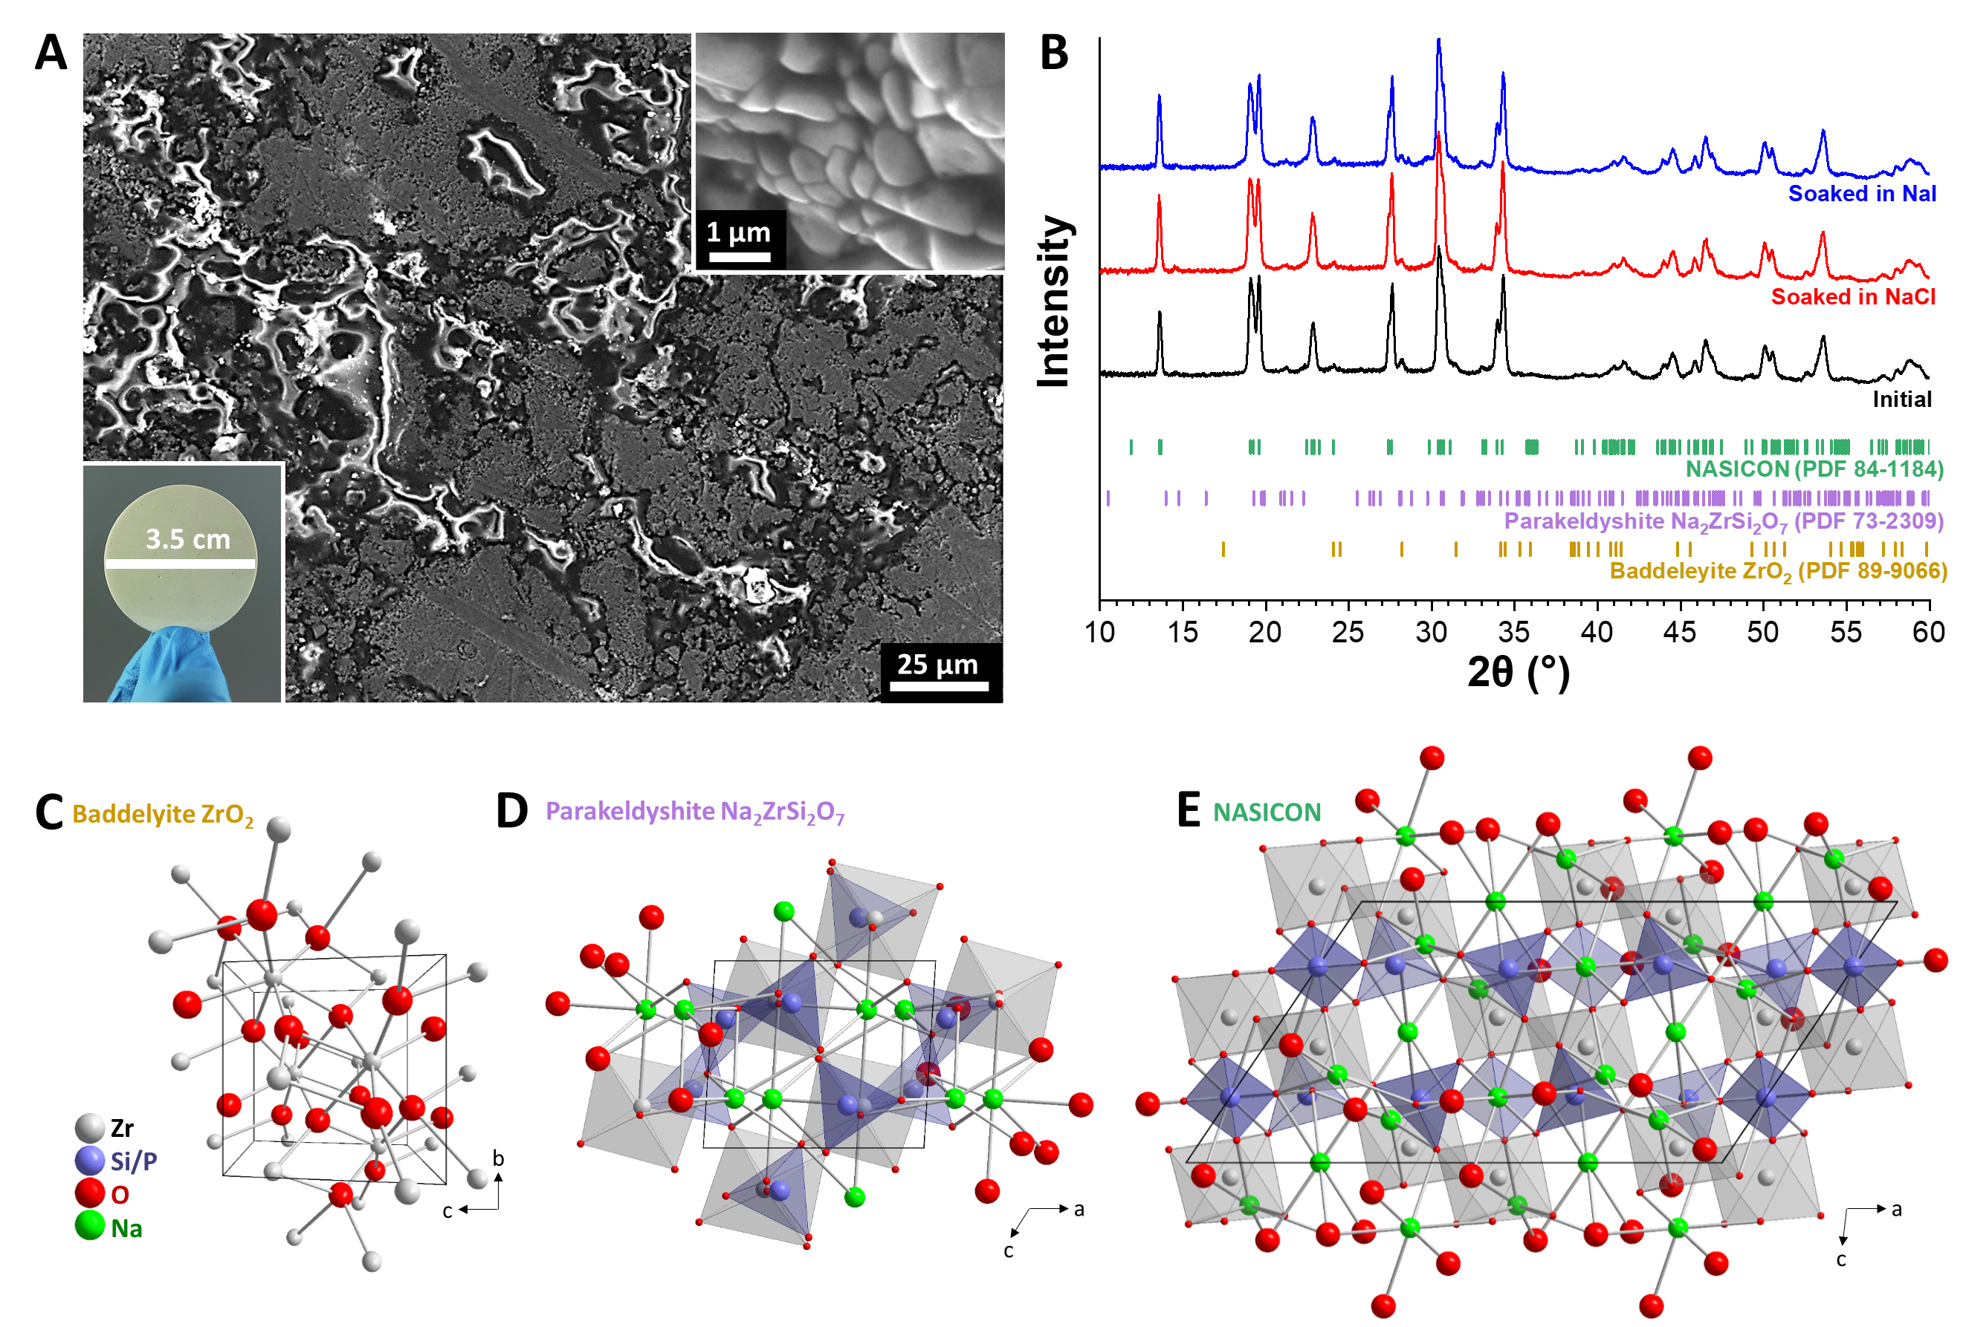

**Figure 3**: (A) Scanning electron micrograph of the initial NASICON membrane after infiltrating the open pores of the ceramic with an epoxy resin. The grey areas are NASICON, the dark areas are pores which host epoxy resin (bright). Per cutting and polishing, some of the epoxy was lost and the pore space seems only partially filled. The bottom-left inset depicts a photograph of the ceramic membrane held by hand and the top-right inset shows a high-resolution scanning electron micrograph of the NASICON microstructure. (B) X-ray diffractograms of the ceramic NASICON membranes prior to use (i.e., after synthesis) and after soaking in either aqueous NaCl or aqueous NaI. (C-E) Crystal structures of ZrO2, Na2Si2O7, and NASICON as used for the Rietveld refinement.

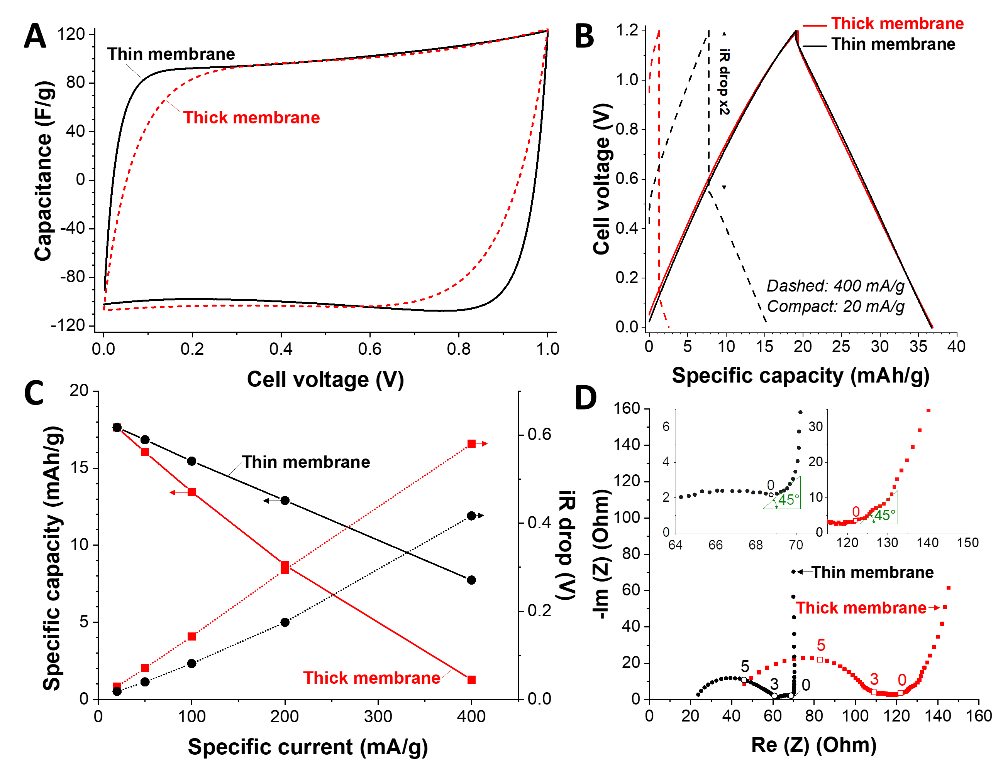

**Figure 4**: Electrochemical performance of activated carbon electrodes in a full-cell with the thin and thick NASICON membranes in 1 M NaCl aqueous solution: (A) cyclic voltammograms recorded at 1 mV/s, (B) galvanostatic profiles at 400 mA/g (solid lines) and 20 mA/g (dashed lines), (C) galvanostatic rate handling performance, and (D) Nyquist plot. The applied frequency (Hz) in the Nyquist plot is described by the magnitude; for instance, 0 and 3 represent 100 Hz and 103 Hz, respectively. The two insets are enlarged areas for thin membranes (black, left) and thick membranes (red, right).

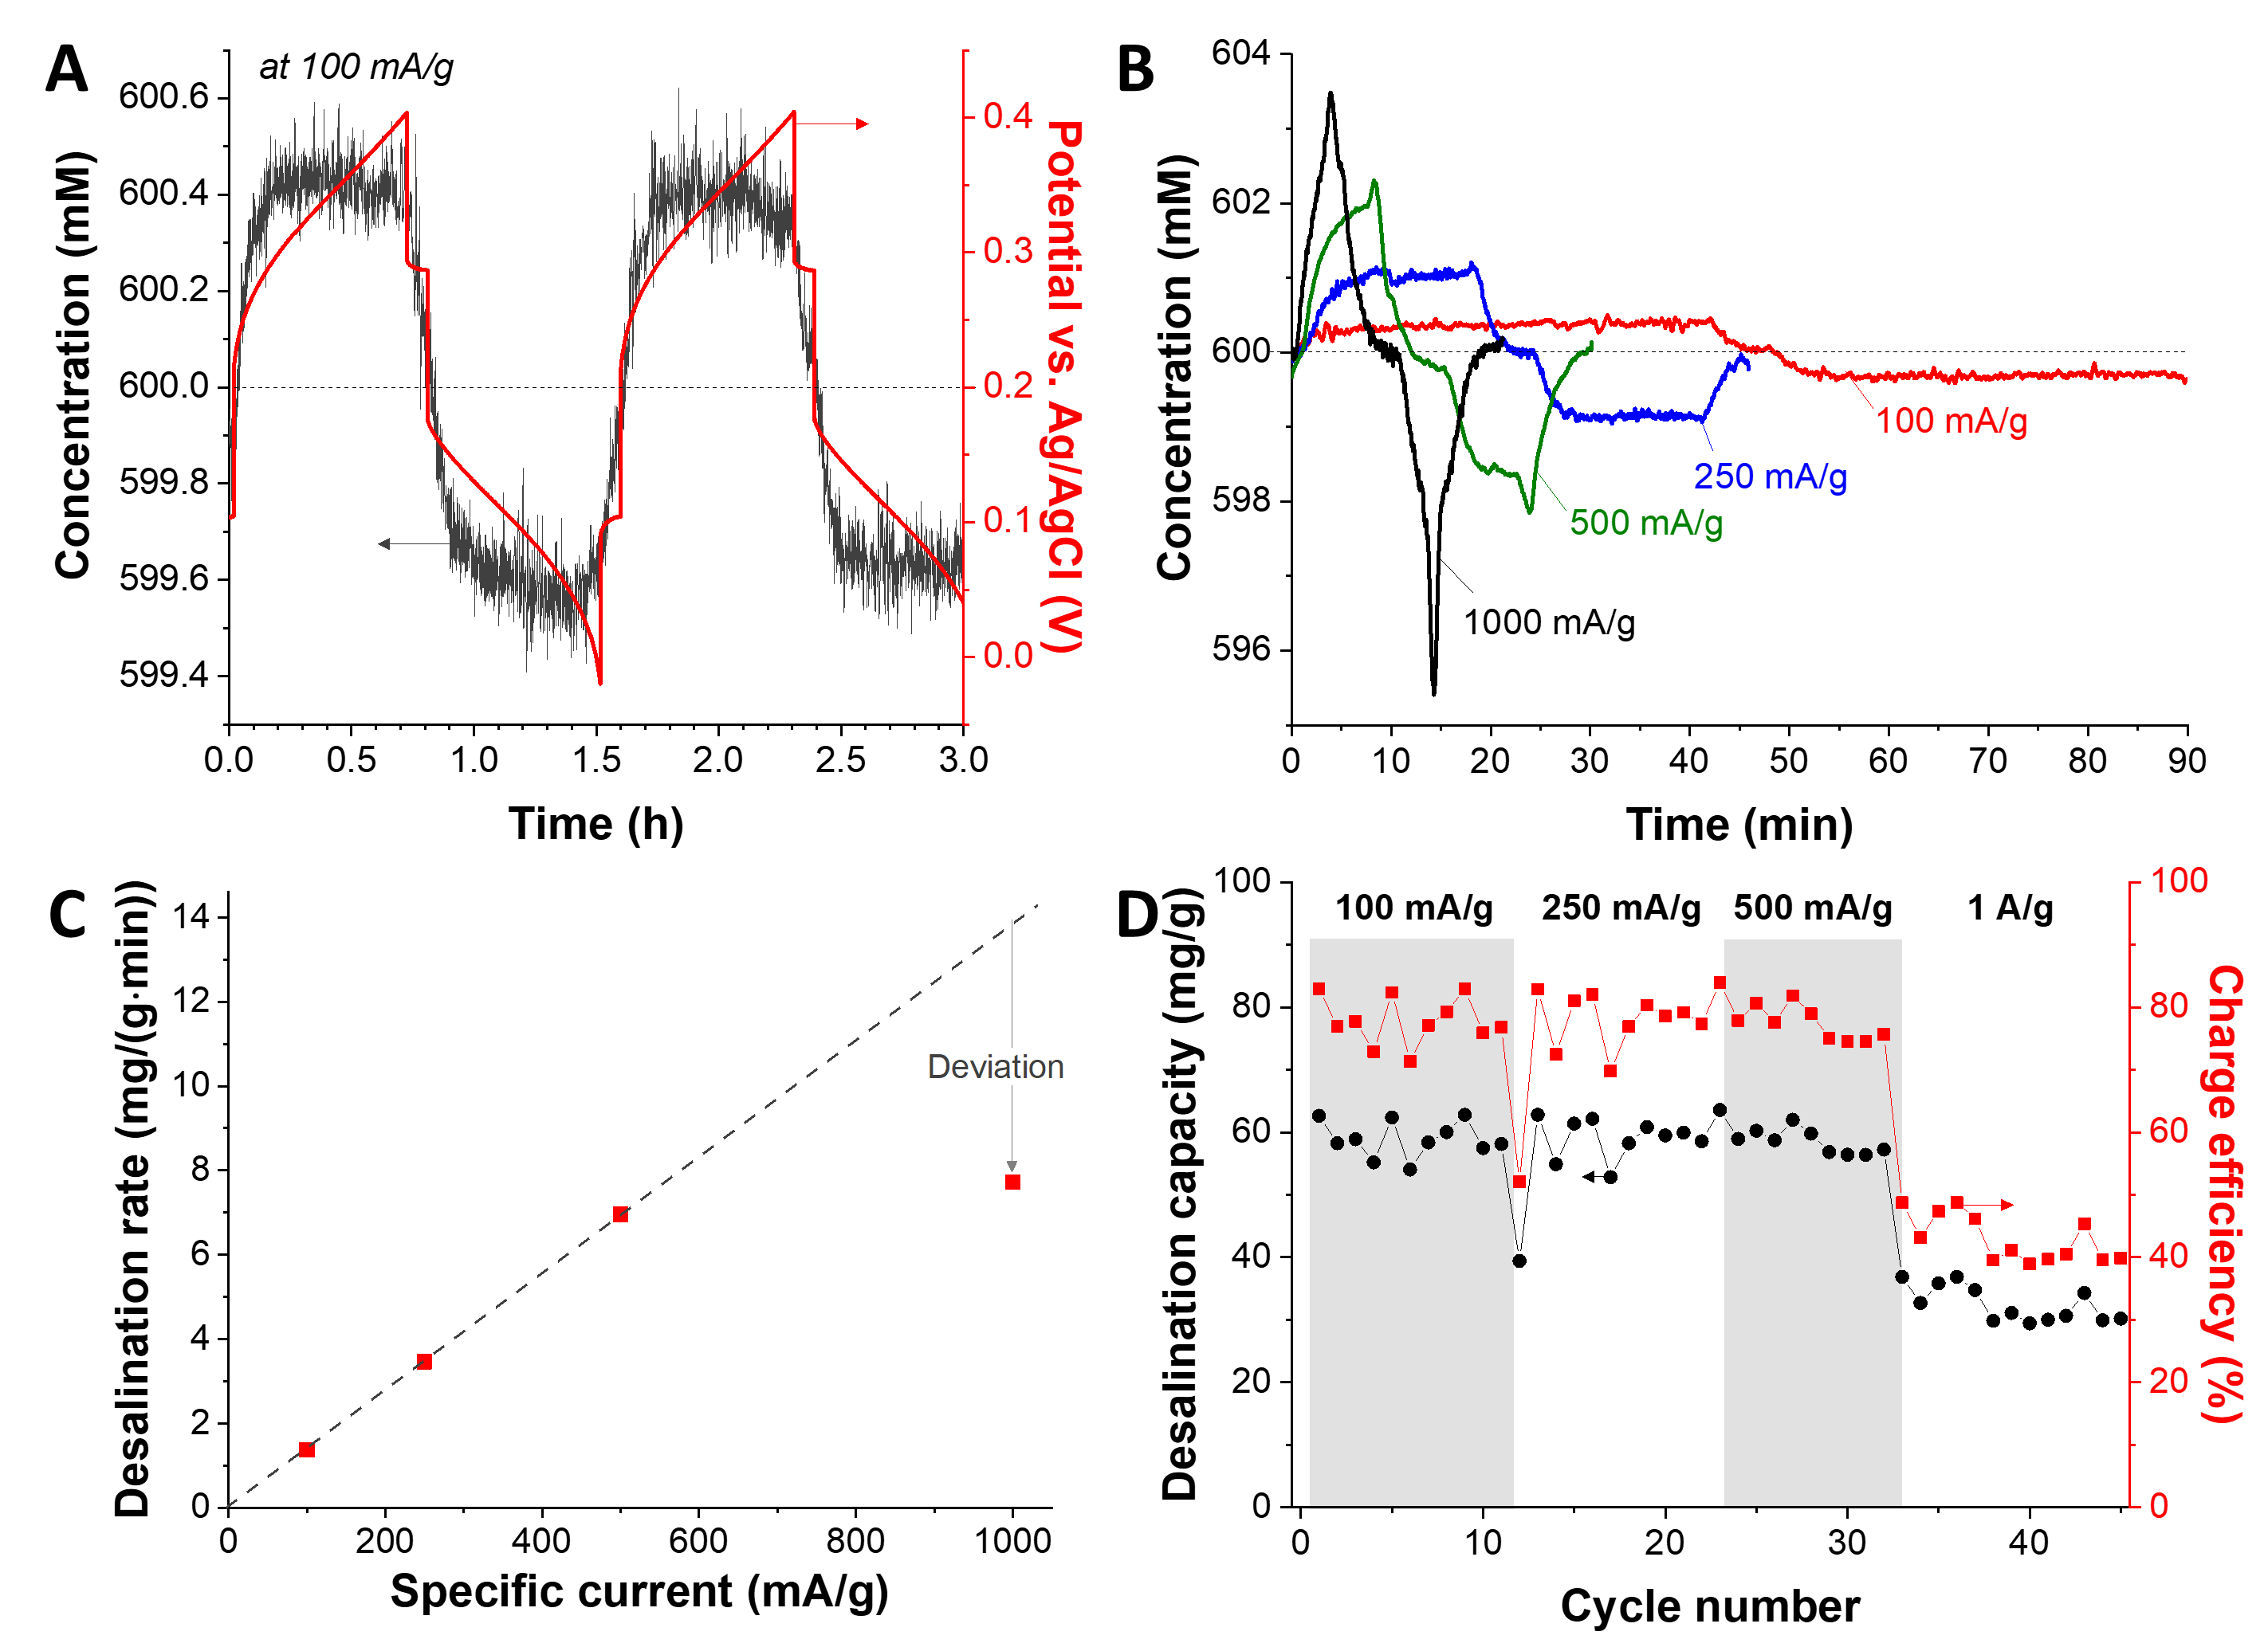

**Figure 5**: Desalination performance of an activated carbon electrode with the thin NASICON membrane in 600 M NaI aqueous solution for 600 mM NaCl feedwater in the specific current range of 100-1000 mA/g: (A) concentration and potential profiles at 100 mA/g; (B) concentration profiles; (C) desalination rate; (D) desalination capacity and charge efficiency at different specific currents.

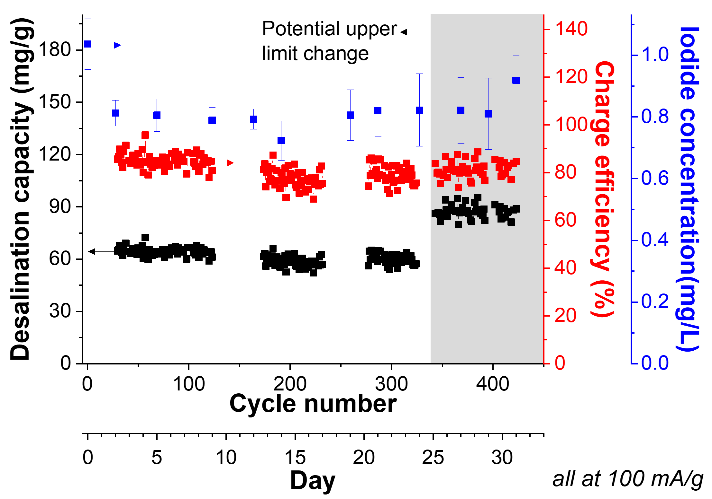

**Figure 5**: Long-term desalination performance of an activated carbon electrode with the thin NASICON membrane in 600 mM NaI aqueous solution for 600 mM NaCl feedwater at 100 mA/g. Iodide concentration of the NaCl solution was tracked by ICP-OES analysis.

# TOC

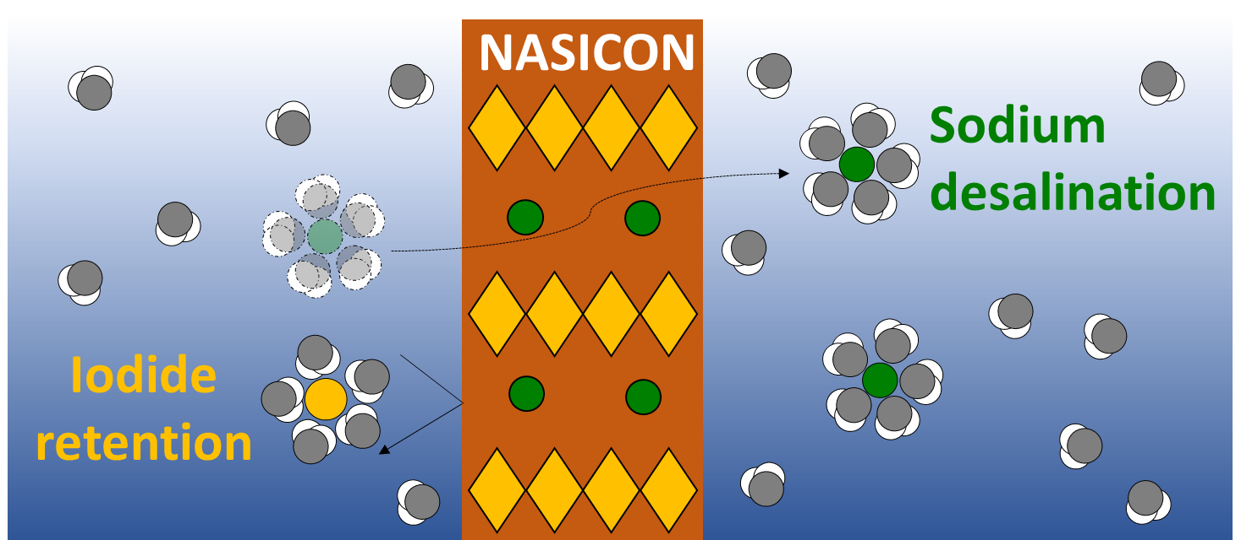

Ceramic sodium superionic conductor (NASICON) is an effective membrane material for electrochemical desalination, especially when capitalizing when using redox-active electrolytes.