Supplementary material

Fig. S1. Screening of convalescent blood donors for anti-HEV IgG and HEV-Ag neutralising antibodies.
b)
a)
a)
Donor | No. of days since HEV RNA positive sample | Quantification of anti-HEV IgG (WHO units/ml) | % HEV-Ag neutralisation of diluted sampleª
A | 85 | 13.9 | 80.84
B | 64 | 10.3 | 82.38
C | 94 | 10.5 | 101.0
D | 84 | 30.7 | 94.66
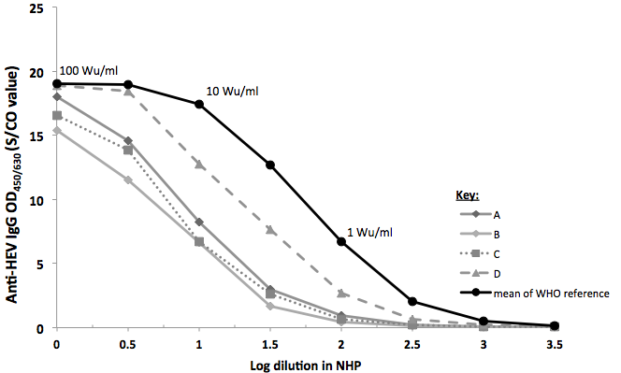

Legend to Fig. S1. (a) Plasma samples from the four blood donors (A-D) were tested in a dilution series in parallel with the WHO reference standard (NIBSC code: 95/584) for anti-HEV IgG (Fortress Diagnostics, Antrim, Northern Ireland, UK). The raw optical density (OD) values of the WHO standard were used to generate a smoothed sigmoid curve and patient samples were ascribed a WHO unitage (WHO units/ml, Wu/ml) based on the OD values compared to the linear section of the sigmoid curve (not shown). (b) Plasma samples were also tested for the presence of antibodies capable of binding HEV-Ag and preventing reactivity in the ELISA, termed HEV-Ag neutralisation using a previously published method [1].
ªPrior to testing, samples were assigned an anti-HEV IgG WHO value as described and subsequently diluted in normal human plasma (NHP) to have an equivalent level of anti-HEV IgG (2-5 WHO units/ml). HEV-Ag neutralising activity was then measured by incubating 50μl of diluted supernatant fluid from tissue culture expressing ORF2 HEV-Ag (day 45 post-inoculation of HepG2/C3a cell line with G3 HEV-containing faecal sample) with 50μl of donor sample (or NHP control) for one hour at room temperature. Residual HEV-Ag reactivity was measured using the aforementioned ELISA. HEV-Ag neutralising activity was determined as a percentage of reduction in reactivity in the HEV-Ag assay when the tissue culture supernatant was incubated with the test sample in comparison to incubation with a non-neutralising control (NHP):
% neutralisation = 100 – (ODcultured antigen + test sample* – OD_{NHP}) x 100
(OD_{cultured antigen + NHP} – OD_{NHP})
OD = optical density at 450/630nm wavelength
NHP = normal human plasma (negative for HEV IgG)
* = donor sample

Table S1. Protocol for administration and monitoring of convalescent plasma therapy for HEV.

Time | Infusion | Procedures
Day 0 |  | Admit patient to liver unit. Height and Weight the patient. Confirm consent.  Bloods: FBC, Group & save, U&E, LFTs, HEV RNA, Anti-HEV IgG and HEV-Ag.
Day 1- baseline | 1 | Bloods: HEV RNA, Anti-HEV IgG and HEV-Ag.  Observations: temperature, pulse, respiratory rate, blood pressure and oxygen saturations. Symptom enquiry. 1 hourly observations for 6 hours then 4 hourly.  Infuse 1 x 560ml of CP over 1 hour.
Day 1- 1 & 4 hours post 1st infusion |  | Bloods: HEV RNA, Anti-HEV IgG and HEV-Ag.
Day 1 – baseline  (after 12 hours) | 2 | Observations: as before pre and post infusion, then 4 to 6 hourly.  Bloods: FBC, U&Es, LFTs, HEV RNA, Anti-HEV IgG and HEV-Ag.  Infuse 1 x 560ml of CP over 1 hour.
Day 1- 1 & 4 hours post 2nd infusion |  | Bloods: HEV RNA, Anti-HEV IgG and HEV-Ag.
Day 2 – baseline  (after 18 hours) | 3 | Observations: as before pre and post infusion, then 4 to 6 hourly.  Bloods: FBC, U&Es, LFTs, HEV RNA, Anti-HEV IgG and HEV-Ag.  Infuse 1 x 560ml of CP over 1 hour.
Day 2- 1, 4 & 6 hours post 3rd infusion |  | Bloods: HEV RNA, Anti-HEV IgG and HEV-Ag.  Prior to discharge full systems review by doctor.
Day 5 |  | Bloods: FBC, U&Es, LFTs, HEV RNA, Anti-HEV IgG and HEV-Ag.
Day 7 |  | Bloods: FBC, U&Es, LFTs, HEV RNA, Anti-HEV IgG and HEV-Ag.
Day 14 |  | Bloods: FBC, U&Es, LFTs, HEV RNA, Anti-HEV IgG and HEV-Ag.
Day 21 |  | Bloods: FBC, U&Es, LFTs, HEV RNA, Anti-HEV IgG and HEV-Ag.

Abbreviations: CP, convalescent plasma; FBC, full blood count; HEV, hepatitis E virus; HEV-Ag, hepatitis E virus Antigen; LFTs, liver function tests; U&Es, Urea and electrolytes.

Table S2. Anti-HEV IgG levels in convalescent plasma donations.

Infusion No. | Donor | Anti-HEV IgG (WHO units/ml)
1a | C | 21.6
1b | C | 22.7
2a | D | 44.8ª
2b | D | 44.8ª
3a | D | 52.9
3b | D | 44.8

ªSame donation episode
Abbreviations: WHO, world health organisation.

Supplementary data 1: Illumina whole genome sequencing and Bioinformatics

Illumina whole genome sequencing
Illumina whole genome next generation sequencing (NGS) for HEV was undertaken at the MRC-University of Glasgow Centre for Virus Research (CVR) using an HEV target-enrichment protocol. RNA was extracted on the NucliSENS easyMAG platform (BioMérieux, Basingstoke, UK; generic 2.0.1 protocol) from 200μl of plasma and eluted into 40μl of buffer. NGS libraries were assembled using the KAPA stranded RNA-seq kit (Kappa, UK). Libraries were quality checked and quantified by the 2200 Tapestation (Agilent, Santa Clara, USA) and Qubit™ 3.0 fluorometer (Invitrogen), prior to target enrichment. A custom set of NimbleGen SeqCap EZ HEV probes (Roche) were used for target enrichment by hybridization for 48 hours. After 14 rounds of PCR the resultant pools were sequenced using the NextSeq™ sequencing system (Illumina).
Bioinformatics for Illumina whole genome sequencing
FASTQ files generated from short-read Illumina sequencing underwent quality control screening (Trim Galore version 0.4.0, Cutadapt version 1.16, Phred score cut-off 30 using ASCII+33 quality encoding). Trimmed files were subsequently used to generate SAM files by reference mapping against the proposed HEV reference sequences using Tanoti and consensus sequences produced (http://bioinformatics.cvr.ac.uk/tanoti.php). Sequences were aligned using MAFFT sequence alignment program (https://mafft.cbrc.jp/alignment/software/). Aligned consensus sequences were viewed in BioEdit (Version 7.2.5) and the GLUE system, loaded with the HEV-GLUE project (http://hev.glue.cvr.ac.uk), was used to analyse SAM files for amino acid polymorphisms at specific loci identified by BioEdit analysis [2]. Amino acid variations were only called at loci when the depth of reads exceeded 10 and frequencies only recorded when in excess of 5% of the viral population using samReporter [3].

[1] Ankcorn MJ, Ijaz S, Haywood B, Neuberger J, Elsharkawy AM, Maggs J, et al. Confirmation of specificity of reactivity in a solid phase ELISA for the detection of hepatitis E viral antigen improves utility of the assay. Journal of Virological Methods 2018;252:42-48.
[2] Singer JB, Thomson EC, McLauchlan J, Hughes J, Gifford RJ. GLUE: a flexible software system for virus sequence data. BMC Bioinformatics 2018;19:532.
[3] Singer JB, Thomson EC, Hughes J, Aranday-Cortes E, McLauchlan J, da Silva Filipe A, et al. Interpreting Viral Deep Sequencing Data with GLUE. Viruses 2019;11.

