Original Article
Corresponding Author:
Nicholas Webb, Liverpool School of Architecture, Leverhulme Building, Abercromby Square, University of Liverpool, Liverpool L69 7ZN, UK
Email: njwebb@liverpool.ac.uk

Digitally aided analysis of medieval vaults in an English cathedral, using generative design tools

Nicholas Webb
(School of Architecture,) University of Liverpool, UK

Alexandrina Buchanan
(Department of History,) University of Liverpool, UK

Abstract
Medieval masons relied on a ruler and compass to generate designs of increasing complexity in both two and three dimensions. They understood that arcs and lines could be used for proportioning, working with halves, thirds, fifths and so on, rather than specific dimensions. Geometric rules enabled them to create vaulted bays, high up in church and cathedral interiors. In recent years, the influence of digital generative design tools can be seen in our built environment. We will explore generative design to reverse engineer and better understand the design and computational processes that the medieval masons might have employed at our case study site of Exeter cathedral, England. Our focus is on a run of bays along the nave, which at first appear consistent in their design, yet in reality are subtly different. We will investigate the capacity for changes in the generative process whilst preserving the overall medieval design concept.

Keywords
Reverse engineering, generative design, algorithms aided design, laser scanning, Exeter cathedral, medieval design, pre-digital computing.

1. Introduction
Designing medieval vaults is intriguing as a straight edge and compass were used to create many different patterns and proportions. We have elsewhere argued, and surviving drawings suggest, that two-dimensional designs were achieved by dividing the plan of the bay with lines and arcs. This process was repeated to varying levels of complexity to achieve desired patterns. Individual vault ribs were created in three dimensions by projecting arcs from the two-dimensional plan, formed by a series of fixed parameters usually based on the existing architecture. The medieval two- and three-dimensional process therefore relied on rule-based geometry, which has become increasingly prevalent in contemporary architectural design practice using generative design software, for example Grasshopper 3D. Rule-based or parametric architecture enables every element of a design to be connected, achieving a ‘self-referential condition where you can make changes, preserving the whole concept’[1]. The aim of this research is to investigate how generative digital design tools can assist in reverse engineering the medieval design process of creating a gothic vaulted ceiling, and whether such tools can reveal new information about these structures.

The nave vaults at Exeter cathedral in south-west England form the case study for this investigation and represent one of the longest runs of a seemingly single vault design in the world, when including the choir (Figure 1). Previous scholarship has noted that there are minor differences in vault design along the cathedral’s length. In order to explore these differences, we create a wireframe generative model of the vaults in Grasshopper and compare this to the built geometry of each bay, which we document with digital laser scanning. Using the digital survey, we can identify design differences between bays in the nave in greater detail than previous scholarship has achieved by eye and investigate which of the parameters require amendment in the Grasshopper model to simulate the design of each individual bay accurately. In this way, our aim is to mimic the design process of the medieval masons at Exeter with rule-based geometry, where subtle changes are required to create a buildable yet seemingly consistent pattern.

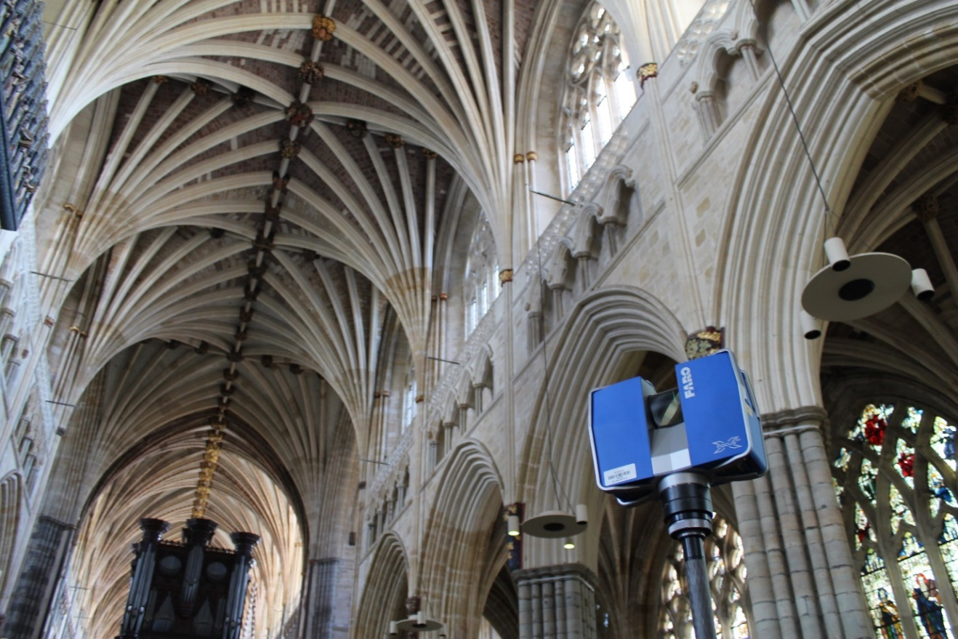
Figure 1. The nave vaults at Exeter cathedral, which continue through the choir.

2. Background
Although generative design may be seen as a modern phenomenon, it has been used throughout history, for example in Islamic patterns [2], Renaissance design treatise [3] as well as Gothic architecture. Although it is generally accepted that medieval architecture relied on geometry at the design stage, there has been much debate, summarised by Bork, over whether and how such geometrical processes can be recovered [4]. As Bork highlights, digital analysis has enabled scholars to achieve a level of precision in analysis impossible when working from analogue plans. Yeomans is cautious about the extent that scholars propose geometry as tools for setting out the general scheme of medieval architecture, yet he is more convinced by the geometrical processes proposed for setting out buildings [5]. Most study has focused on the original intended design, but as churches and cathedrals were often constructed over several centuries, their designs inevitably evolved over time. Masons also needed to amend designs to enable for adjustments to parameters like individual bay sizes and elevational design, something rarely acknowledged in existing literature. We will first give an overview of previous related scholarship into digital generative design in the context of built heritage, followed by an outline of medieval design processes and our case study vaults at Exeter cathedral.

2.1. Digital generative design tools in a built heritage context
Since tools including Grasshopper and Generative Components were released in the early 2000s, there have been a small yet growing number of built heritage projects using generative design as a research tool. In Poland, researchers used parametric methods to create digital reconstructions of medieval huts, as evidence suggested that they were based on a series of underlying rules [6]. Because many structures required modelling, generative design methods enabled individual huts to be modelled much faster based on these rules, which reduced modelling periods and left more time for scholarly debate with project partners, as changes could be made quickly and accurately within the software. This is an essential reason why we chose to investigate generative design in the context of medieval vaults, as traditional digital modelling is much slower than modelling parametrically, therefore generative design software increases our time spent on interrogating the medieval design process. Chevrier et al also state that parametric modelling of built heritage results in more efficient modelling times, particularly when looking to future related projects which can make use of the same generative models [7]. This is also true of our project, where we aim to reuse the Grasshopper model at other sites, as well as sharing it with project partners researching vaulted ceilings internationally. In terms of methodological comparison, Coutinho et al used laser scanning to document a work of architecture followed by interrogation of the digital data with generative design tools [3]. They laser scanned a Doric column base of the São Vicente de Fora church in Portugal that resulted in a highly accurate point cloud and mesh model, which could then be reverse engineered using shape grammars to automate the process. Consequently, by programming software to consider these shape grammars, a better understanding of the design parameters of Leon Alberti (author of an important treatise on Renaissance architecture) and their influence on the church was achieved. Our research similarly acknowledges the importance of the modelling process: medieval design, particularly the underlying generative geometry, is better understood through the osmosis of reverse engineering.

Reviewing literature specifically linked to Gothic architecture, the work of Havemann and Fellner in the early 2000s forms an important precedent [8]. Here, generative design enabled investigation of Gothic window tracery, which uses the same system of simple geometric patterns to create complex designs as the vaults that we are studying. With a window featuring two lancets and a circular light they demonstrated how the width and height of the opening could be adjusted using parametric modelling, whilst retaining the underlying geometric features of it. They also highlighted that the Gothic pointed arch has an advantage over the semi-circular arch as it is easier to amend window widths whilst reaching the same height, as arc radii can be adjusted where necessary to meet the apexes. The same rule applies to Gothic vaulted ceilings, which we will describe in the next section. Takayama aimed to build on the work of Havemann and Fellner by introducing more complex motifs to the generative design of Gothic window tracery, demonstrating how software had advanced over a ten-year period [9]. He noted that the research has limitations, as it does not account for three-dimensional forms. Therefore, the major difference between these previous two studies of digital generative design tools applied to Gothic architecture is that window tracery is two-dimensional as designs were applied to a planar surface, whereas vaulted ceilings were designed within a three-dimensional volume, which adds an additional and necessary layer of complexity to our investigation.

2.2. Medieval vault design
Although poor rates of survival mean that our knowledge of Gothic architectural drawing is inevitably limited, surviving archives suggest that although drawing became a normal part of the designer’s role, scaled representations were rarely made. Surviving evidence tells us that large-scale building elements, for example vaulted ceilings, were drawn directly on the ground for 1:1 translation into built form [10]. Bork argued that Gothic drawing practices arose around 1200 as certain designs became too complex to construct directly in stone and the technique of drawing to a reduced scale offered a means of evolving and mediating designs and working through their constructional implications [4]. Binski references Villard de Honnecourt’s famous thirteenth-century portfolio when discussing medieval generative design, and how ideas were first ‘drawn in’ using geometrical figures, then ‘drawn out’ or traced to create specific designs [11]. Medieval drawing tools included the straight edge and dividers to form lines and arcs [12]. In terms of vault design, these drawing and generative design tools could be used to create a desired two-dimensional pattern, ranging from a simple quadripartite design to complex ribbed tierceron (or intermediate ribs), lierne (short ribs connecting major ribs) and fan vaults (Figure 2). Next, ribs were projected upwards as arcs, which were usually defined by fixed points from the existing architecture for example column capitals and window apexes, as well as the two-dimensional plan itself. Crucial to this process was the ability of straight edge and dividers to proportion the geometry, creating patterns in plan and elevation. It is in this design stage that we begin to comprehend the significance of generative design to the medieval masons.

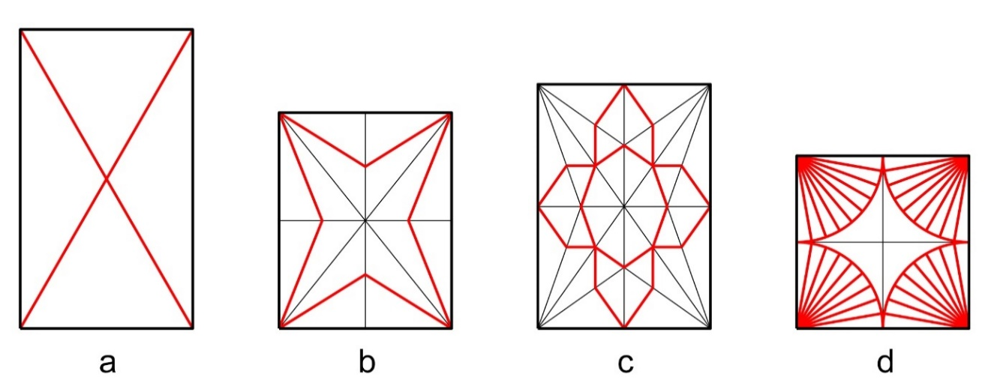
Figure 2. Ribbed vaults of increasing complexity from quadripartite (a), tierceron (b), lierne (c) and fan (d). The bay sizes also demonstrate possible medieval ratios for example 1:√3 (a), 4:5 (b), 1:√2 (c) and 1:1 (d).

In many cases, the two-dimensional plan defining the bay boundaries was designed to specific proportions including root ratios, particularly the ‘medieval’ golden section of 1:√2, as well as a modular ratio system of 1:2, 2:3, 3:4 and so on [13,14]. As such, if the width of a bay is known we can determine its length when a specified ratio is used (Figure 2). Across many of our case study sites in England, we have proposed that an ancient geometric dividing device now known as the ‘starcut’ diagram seems to have been used to aid the two-dimensional vault design [15,16,17]. Once the bay size is determined, the starcut diagram is added by creating four chevrons: each connecting one corner of the bay to the opposite midpoint and back to the adjacent corner. The crossing points of these chevrons enables bays to be divided into halves, thirds, fourths, fifths, sevenths, elevenths and further still, and can be used for any rectangular bay regardless of size. Thus, the design concept of a vault bay is preserved if the shape of the bay is changed, hence, the device’s rule-based geometry (Figure 3).

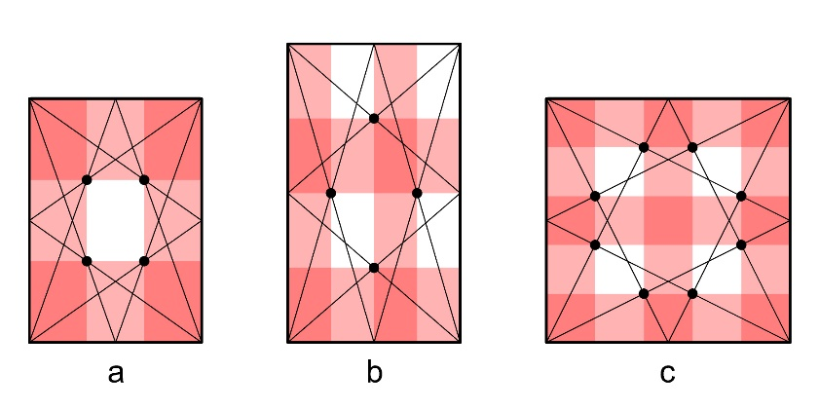
Figure 3. Illustrations of the starcut diagram applied to different bays. Regardless of size, it enables divisions for example thirds (a), quarters (b) and fifths (c).
As with the two-dimensional plan, the medieval masons employed rule-based geometry to elevate their designs into three dimensions. For all ribs (except liernes), their springing point is known as it was defined by the plan and, in most cases, they spring from the corners of the bay. Throughout the Gothic period, three-dimensional rib design was generally formed of a single arc and was fixed by its apex height, its radius and its centre point in relation to the impost level. The impost was usually level with the upper surface of the existing column capitals from which individual ribs spring, the springing usually being formed by a single block of stone known as the ‘tas-de-charge’. If two of these three fixed elements are known, the third is computable using geometrical processes. For example, if the known elements for a vault are each arc’s apex height and that their centres are on the impost level, the missing radii are calculated using the ‘chord’ method (Figure 4). Here, a straight line is drawn between the known springing point and apex height, followed by a perpendicular line from the centre of the chord towards the known impost level. Where the perpendicular line crosses the known impost level gives the centre of the arc which is then used to draw the missing radius. Using this method, if the apex height is amended, an updated radius can also be generated as shown in Figure 4(c).

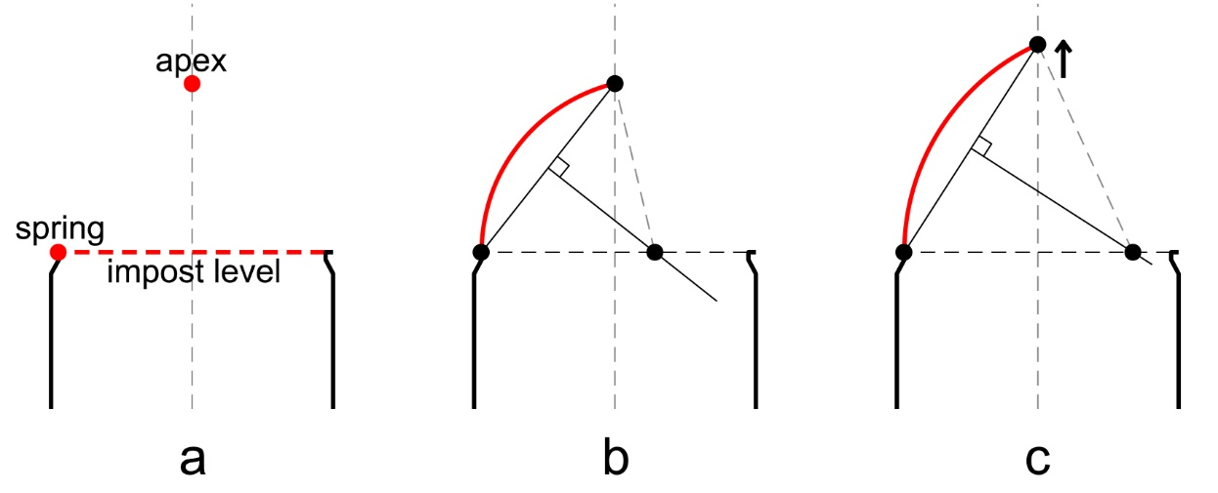
Figure 4. If the springing point, apex height and arc centre in relation to the impost level are known (a), the chord method enables the missing radius to be calculated (b). Using this method, if the apex is raised the radius also changes (c).

A wide variety of rule-based designs can be created using these processes and once complete, they were transferred to physical form first by building timber formwork known as centering, then by building each vault rib directly on the centering, followed by infilling the webbing in between. The intrados lines, forming the inner edge of the stone voussoirs that sit directly on the timber centring during construction, are crucial to our research as a set of wireframe arcs can be traced along these lines then interrogated.

2.3. Exeter cathedral
The run of tierceron-vaulted bays along the nave and choir at Exeter creates a dramatic avenue of branching, palm-like conoids, their aesthetic impact deriving largely from their apparent consistency (Figure 1). In addition to the large number of vaults in sequence, they are also of note due to the number of tiercerons employed: three sets longitudinally and one set transversely. The vaults were built over a period of around fifty years from the late thirteenth century to the mid fourteenth century [18]. This timeframe gives one reason why design changes in the vaulting occurred, as it involved many teams of masons, who may have held differing views on the design and construction process. The chronology of the cathedral was first established by Lethaby, evidenced by original fabric account rolls that recorded all expenses relating to the building [19]. The current accepted chronology suggests there was a break in construction between bays eight and nine in the Eastern arm, forming the choir and presbytery respectively [20]. Next, the crossing, transepts and first bay of the nave were constructed (bays 12-13), followed by a remodelling of the West front (beyond bay 19). Finally, the remaining nave bays were built, which form the focus of this investigation (bays 14-18). Published fabric rolls [18], timber dating in the roof [21] as well as archaeological recording and analysis [22,23] all support this dating (Figure 5). Harvey attempted to assign individual architects to the design of Exeter [24], suggesting that the Lady Chapel and presbytery were by Master Roger (1299-1310), the crossing and first bay of the nave were by William Luve (1310-16), the choir fittings, nave elevation and cloister north walk by Thomas of Witney (1316-42), the west front screen by William Joy (1329-46) and initially attributed the nave vault to Richard Farleigh (1333-63). Harvey later amended his view and instead assigned both the crossing and the nave to Thomas of Witney [25], an attribution supported by Morris [26]. Having identified Witney as possessing a ‘highly individual style’, Harvey argued the curvatures of the nave vault ribs were indicative of Witney’s originality and genius [27].

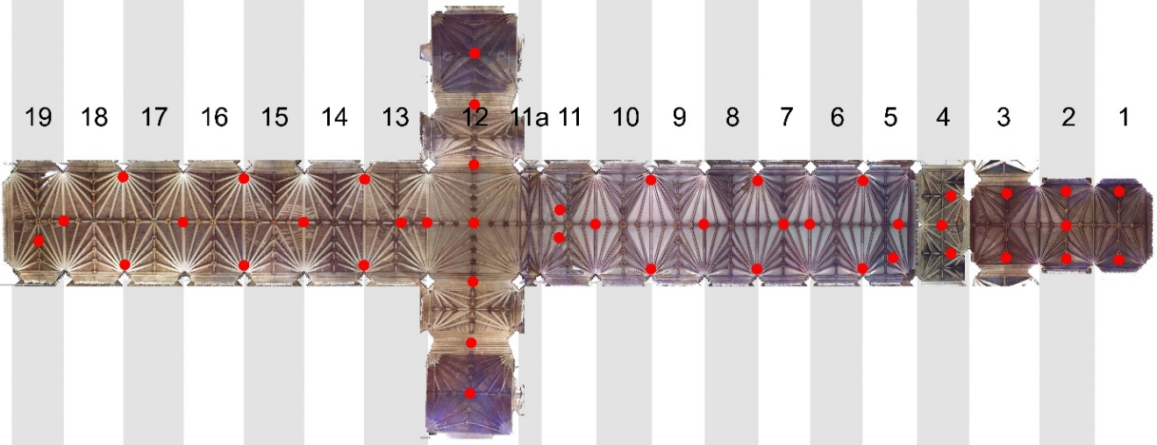
Figure 5. Orthophoto plan of the Exeter cathedral high vaults along the nave, choir and Lady Chapel, as well as the transept arms. Individual bays are numbered for reference and individual scan locations shown in red.

3. Reverse engineering process
To gain enhanced understanding of the vaults using rule-based geometry in Grasshopper, we first had to survey them digitally, followed by processing which produced key information of two-dimensional floor plans, individual rib radii, apex heights and arc centre distances from the impost level. Next, we could reverse-engineer the design process in two dimensions, and then increase the complexity of the experiment by investigating the vaults in three dimensions.

3.1. Data capture
At Exeter as well as other sites of investigation, digital laser scanning was the primary method of capturing the medieval vault geometry due to its speed and accuracy, a process we have previously discussed in detail [28]. Similar methods are employed by researchers on parallel projects for instance those in Catalonia digitally surveying and analysing complex masonry vaults [29]. We used a Faro Focus laser scanner, with a resolution of one point every 3 millimetres at a 10-metre distance, scanning in colour from the cathedral floor. To ensure good coverage along the length of the nave and choir and to make sure we captured all detail of the palm-like conoids, we used a consistent scanning pattern alternating between two scans positioning the scanner underneath the arcade column at either side of the bay, and one scan taken centrally between bays in the next (Figure 5). Once data was captured, raw scans were imported to Faro Scene, the scanner’s proprietary software, and combined into a single homogenised point cloud model. This was then exported to Rhinoceros 3D as a mesh model for further exploration. Here we traced the intrados lines of each vault rib, which are crucial in understanding the geometry of the vaults. Next, we created a plan view of each 3D wireframe model, to form the basis of the reverse engineering process in two dimensions. We then added best-fit curves running through the traced arcs in order to extract geometric data for three-dimensional reverse engineering. In some cases at Exeter, prominently in the choir bays, we found vault ribs comprised of more than one arc, which had been previously suggested by Harvey (though in different bays from those identified by our research) and Wilson [30,31].

Using the best-fit arcs based on the traced survey data, we were able to identify each arc’s radius, centre distance from the impost level and apex height. These three figures, in addition to the arc’s springing point identified in plan, allowed averages and trends to be established across all case study bays using data tables. This gave us vital information for reverse engineering of the vault design in three dimensions, for example, the diagonal ribs in the nave bays 14-18 have an average radius of 6.98 metres, their average arc centre point is 0.13 metres below the impost level and their average apex height is 6.75 metres above the springing point (Figure 6). This information formed the starting points in creating Grasshopper versions of the vaults.

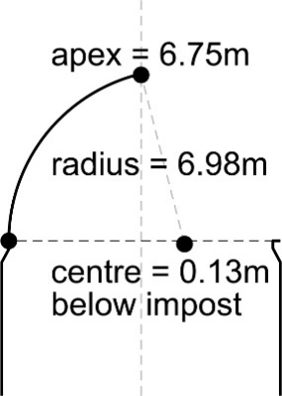
Figure 6. Elevational diagram showing average data for diagonal ribs in nave bays 14-18.

3.2. Generative modelling in two dimensions
The first stage of the experimental process was to establish a two-dimensional bay design with adjustable proportions to enable subsequent comparison with the actual bays surveyed at Exeter. As previously noted, it was common in medieval vaults to proportion bays using geometric ratios, however, some vault bays do not appear to adhere to any proportional system, including those investigated at Exeter. As an initial exercise in Grasshopper focussing on the Exeter vaults, number sliders were used to create a rectangular bay of any longitudinal width or transverse length, with wall faces defining the length and the intrados of transverse arches defining the width. A series of panels were also added allowing the bay dimensions to be changed to specific proportions for future investigations using the same methodology at sites where we have identified them. A stream filter panel in Grasshopper allowed the toggling between these three proportioning systems, so they could be changed when required to observe and analyse their output as a three-dimensional design (Figure 7).

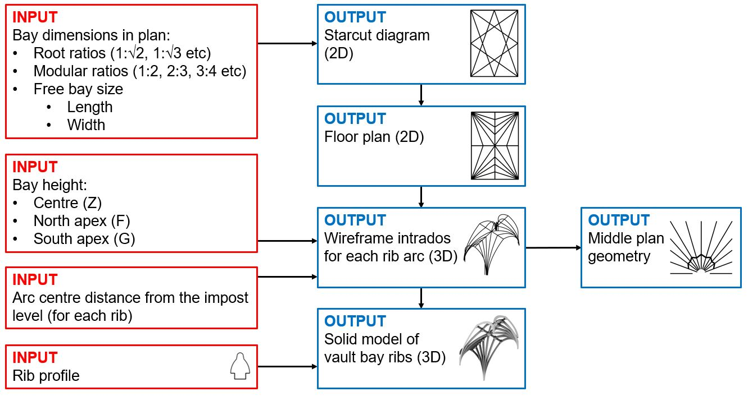
Figure 7. Grasshopper script diagram showing the different inputs and their associated outputs in Rhinoceros.

With adjustable bay sizes established, we next drew the starcut diagram, as we had already postulated that this was often used by medieval designers to divide vault bays accurately and therefore could be used as a template for creating complex designs for those at Exeter. For each of the four sides creating the rectangular bay, their two end points were joined to the midpoint of the line on the opposite side, creating four chevrons which cross many times to give multiple bay divisions (Figure 3). Panels were then added in Grasshopper to identify these crossing points and assist with the bay design. Although it would have been more straightforward to add panels in Grasshopper, which directly divided the longitudinal and transverse bay distances, the process of drawing the starcut diagram was mimicked digitally to visually demonstrate what we have proposed to be the medieval design process (Figure 7). From this, the two-dimensional floor plan in the nave and most of the choir at Exeter could be drawn easily, as it is first based on divisions of thirds, followed by divisions of ninths to create the longitudinal tiercerons using a subsidiary starcut diagram. Diagonal ribs were added by joining corner points, and ridge ribs added by joining opposite midpoints. Here we again see the relationship between medieval vault design and a generative design process, as design is based on divisions and the joining of existing points, rather than specific dimensions. Examples of the two-dimensional design of the nave and choir at Exeter are shown in Figure 8, demonstrating how this can be amended to different bay sizes in Grasshopper to create unlimited design iterations. Crucial to this process is the ability to maintain the geometric principles in each case, for example, regardless of the bay’s proportions in the Exeter vaults, the longitudinal tiercerons all remain at one-ninth intervals across the bay and similarly, the transverse tiercerons remain at one-quarter intervals along the bay.

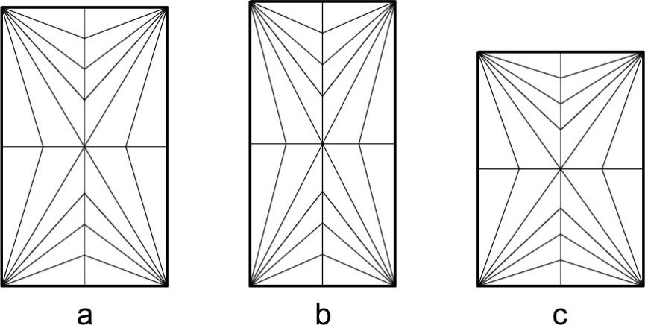
Figure 8. The two-dimensional floor plan is consistent in its proportional design even though it changes size between the nave (a) and bays 5-9 in the choir (b). Adjusting the bay size further (c) maintains the same design concept.

3.3. Generative modelling in three dimensions
For the three-dimensional investigation, we focussed on a run of five vault bays in the nave (14-18), which appeared to be the most consistent based on the laser scan data and were seemingly simpler as they only contain one-centred arcs. For this article, we have excluded vaults with two-centred arcs as found in bay 13 of the nave as well as most bays in the choir. This is because those bays do not add to the overall Grasshopper methodology described here and are therefore outside the scope of the article. At a later stage of the project, we will apply this method to the bays with two-centred arcs at Exeter, as well as our other case study sites. The annotated two-dimensional bay plan for Exeter shown in Figure 9 should be used to identify the individual ribs discussed in the following sections and, where appropriate, details of a quarter of the bay are discussed rather than the entire bay for simplicity. The transverse ridge rib, shown in section, is also labelled in Figure 10.
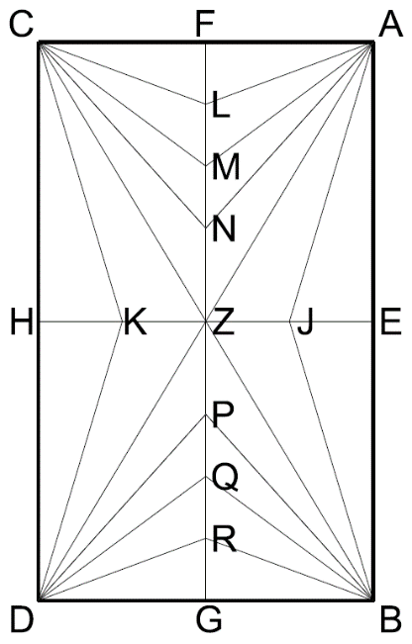
Figure 9. Two-dimensional floor plan for the high vaults at Exeter cathedral.

To create the design of each rib in three dimensions, fixed elements were found, these being the rib apexes, the distance of each arc’s centre point from the impost level, as well as the springing points (Figure 4). If these are known, processes of geometry are used to create the arcs as described previously. The springing point was easily found, as defined by the two-dimensional plan at approximately 0.25 metres radially from each corner of the bay. This offsetting from the corner is accounted for by the dimensions of the tas-de-charge. The apex heights were found to be based on the existing architecture, notably windows in elevation (F and G) as well as the height of the longitudinal ridge rib (EJZKH) continuing horizontally from the previously built bays to the east. For bays 14-18, these longitudinal ridge rib apexes (EJZKH) were an average of 6.75 metres above the impost level, giving a fixed height for the transverse ribs (e.g. AE) and diagonal ribs (e.g. AZ) to reach, as well as the transverse tiercerons (e.g. AJ). The transverse ridge rib (FLMNZPQRG), which forms the apex for the longitudinal wall ribs (e.g. AF) and three sets of longitudinal tiercerons (e.g. AL, AM, AN), change height as the apex of the existing windows in elevation vary in height along the nave (e.g. F). Figure 10 shows three orthographic point clouds taken from the laser scan survey that demonstrate how the transverse ridge ribs (FLMNZPQRG) change shape along the nave. Each must meet the longitudinal ridge rib (EJZKH) at the common centre of each bay (Z) which thus represents a fixed series of points as it relies on this existing geometry of the longitudinal ridge, being a constant along the entire length of the cathedral’s vaults.

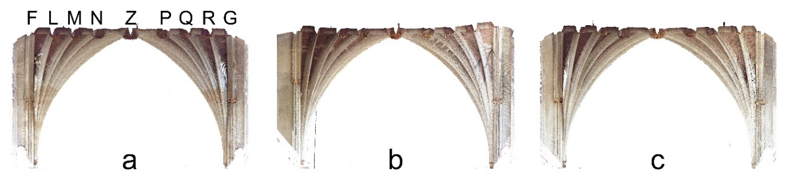
Figure 10. Orthographic point cloud sections through the transverse ridge rib of bay 14 (a), 15 (b) and 16 (c) demonstrating the differing geometry, either flat or slightly curved.
The final fixed element for nave vaults 14-18 was each arc’s centre point in relation to the impost level. For the purpose of our initial investigation in three dimensions, each arc’s centre point was placed exactly on the impost level. This decision was taken as the average distance of all rib centre distances to the impost was just 0.06 metres below it, and therefore close enough to assume that the medieval masons were working using this as a fixed point. There were of course deviances from this average, the highest being 0.45 metres above the impost for longitudinal tierceron CL in bay 14 and the lowest being 0.61 metres below the impost for longitudinal tierceron BR, also in bay 14. There is no universally agreed understanding of tolerances in vault rib geometries and no standardisation is likely, as it is dependent on the accuracy of construction, which varies between sites; however, our assumption was based on previous investigations of vaults with smaller bay sizes where we attempted to establish tolerances [32]. Even though we initially assumed that vault bays 14-18 of the nave at Exeter had their arc centres on the impost level, if necessary, these could still be adjusted in Grasshopper to assist with later analysis.

Once each arc’s apex, springing point and centre point in relation to the impost level were known, we could determine the missing radius using the ‘chord’ method already described (Figure 4). This process was repeated to finalise the geometry of each rib in the bay and modelled in Grasshopper. The model allowed all the bay variables to be changed: their width and length, apex heights and arc centre distance from the impost level, whilst maintaining the original design intention of the medieval masons (Figure 7).

4. Comparing the original tracings with the generative models
The Grasshopper model, with its changeable parameters, was next overlaid with the original traced geometry of each bay, then amended using the variables listed above with the aim of understanding the changes that the masons made between bays and thus enhancing our knowledge of the medieval design process. Investigations were based on the run of bays in the nave (14-18) and complexity was increased as different questions regarding the design process arose.

4.1. Varying ridge rib heights
Beginning with the original intrados tracings in bay 14, the proportions of the bay in the Grasshopper model were adjusted to match it. We excluded transverse arch AEB from the process, as it has a different curvature because it forms the western edge of bay 13, which is the end of a previous construction campaign. On changing the number sliders for the transverse and longitudinal bay dimensions to 10.33 by 6.14 metres, the two-dimensional design adjusted automatically. In this way, we could visualise the vector direction of each rib as well as their springing point. Next, the height of the longitudinal ridge rib (EJZKH) from the impost level was amended to 6.75 metres using number sliders, as well as the apex heights above the windows of the existing walls (F and G), forming the start and end point of the transverse ridge rib (FLMNZPQRG), which in this case was horizontal. As we assumed from the data that each rib had its arc centre on the impost, we therefore had enough information to visualise the whole design for bay 14, which closely matched intrados lines as traced from the survey data (Figure 11). There were some notable differences between the models, particularly longitudinal tierceron BR as noted already, which had a much larger radius (11.01 metres in the surveyed tracing compared with 9.02 metres in the Grasshopper model) and lower centre point (0.61 metres below the impost in the surveyed tracing and on the impost in the Grasshopper model) than equivalent ribs. This could be due to human error in the design or construction process as well as settlement over time, although we found no deviation from the vertical in the side walls, suggesting that any settlement would be minor. Additional variations could be accounted for as follows: firstly, during the digital surveying process where ribs are traced by hand, a margin of error is possibly introduced, as well as minor errors occurring during the medieval design and construction process itself as already highlighted. Secondly and more significantly, the medieval masons may have made slight adjustments to ribs to account for fixed elements changing, for example the apex heights, as well as potentially modifying the design of the ribs as they diverge from the tas-de-charge stone, particularly as the bay design changes between 13 and 14. We will investigate changes made to apex heights using the Grasshopper model in the next section.

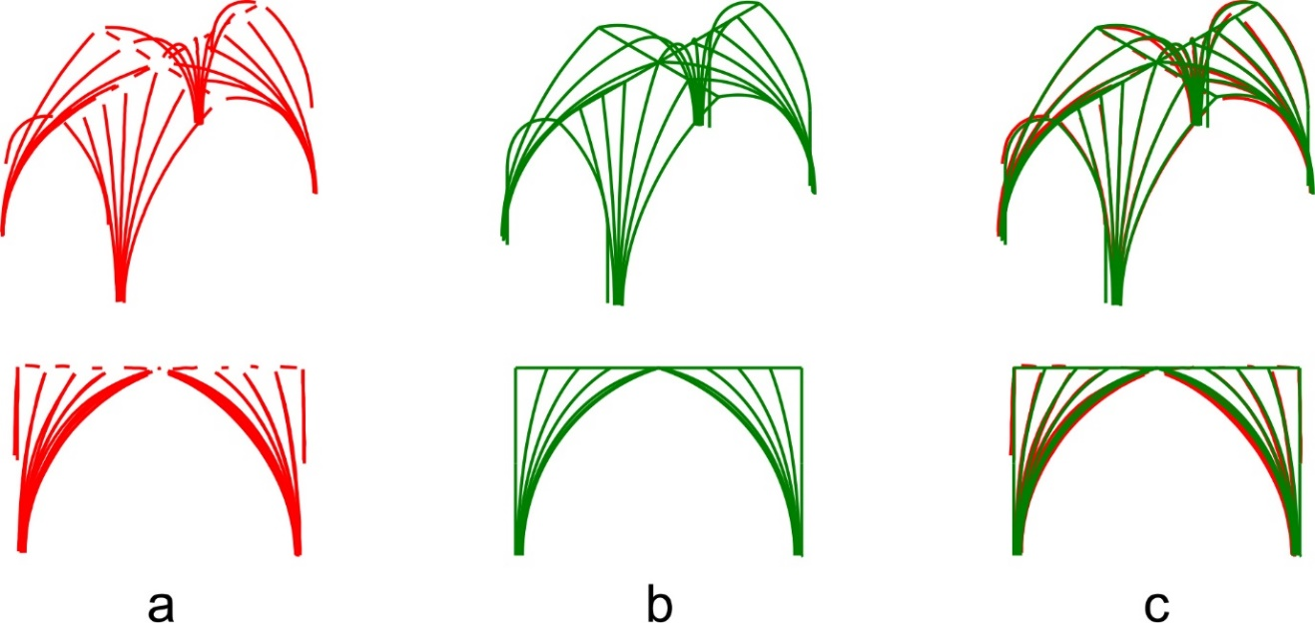
Figure 11. Bay 14 showing the surveyed traced intrados lines (a), the Grasshopper model (b) and an overlay of both (c).

Moving from bay 14 to bay 15, survey data showed that the apex height of the longitudinal wall arch to the north (F) increased in height slightly by 0.16 metres and the longitudinal wall arch to the south (G) increased significantly by 0.35 metres. This was based on the increased heights of the clerestory windows by whose dimensions their height is determined (Figure 10). Therefore, we raised these apex heights using the appropriate number sliders in Grasshopper and consequently amended the transverse ridge rib design to align with the tracings of bay 15 (Figure 12) using the same generative rules as bay 14. With Grasshopper, we could mimic these design ‘tweaks’ in the medieval vaults. First we compared the geometry for bay 15, with its higher apexes, in comparison with the hypothesised geometry produced using Grasshopper. An example of how the vaults used generative design can be seen in longitudinal tiercerons AL, CL, BR and DR of bay 15. To the north (AL and CL), these are constrained by the slightly raised window apex (F) and to the south (BR and DR) these are constrained by the significantly raised window apex (G). When comparing the geometry of the Grasshopper model with the original traced survey data, they align closely: longitudinal tiercerons AL and CL in the north have a smaller radius than BR and DR in the south, which are larger as they must reach a greater apex height (Figure 12). The other longitudinal tierceron sets show similar changes. This suggests that the Grasshopper model was successfully hypothesising the design changes between bays. We also tested the Grasshopper model against the traced bays of 16-18, providing similar results.
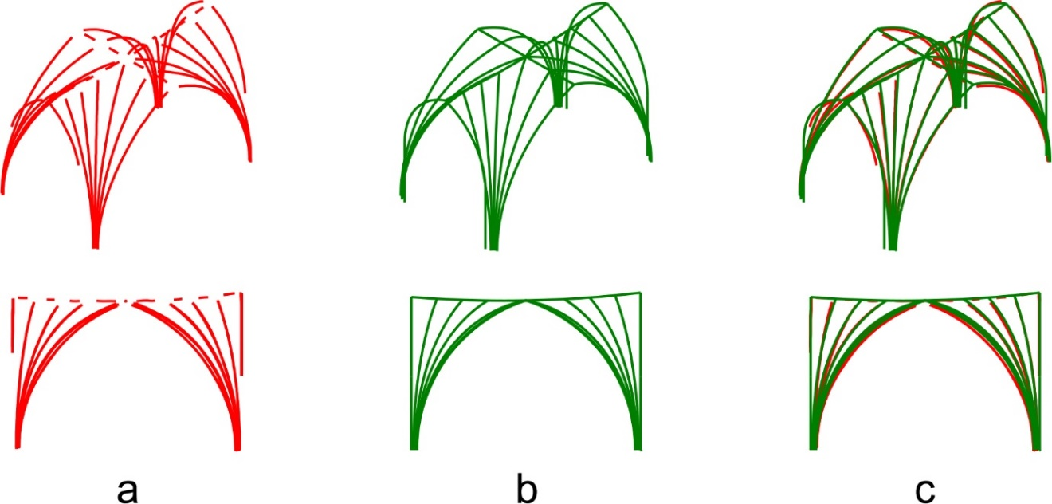
Figure 12. Bay 15 showing the surveyed traced intrados lines (a), the Grasshopper model (b) and an overlay of both (c).

4.2. The middle plan
Besides the varying transverse ridge rib apex heights, there was another notable design change in bays 14-18 of the nave. This related to what Professor Robert Willis, a Victorian scholar who investigated vault design, termed the ‘middle plan’ [33]. This is horizontal section taken at approximately half the height of the arcs (Figure 13). Willis noted that arc centres for ribs were not necessarily on the impost level, and one method of visualising and testing this was using the middle plan. He also stated that a pre-defined middle plan could be used to modify the form of the vaults; however, he suggested that this was not necessarily a method that the medieval masons would have employed.

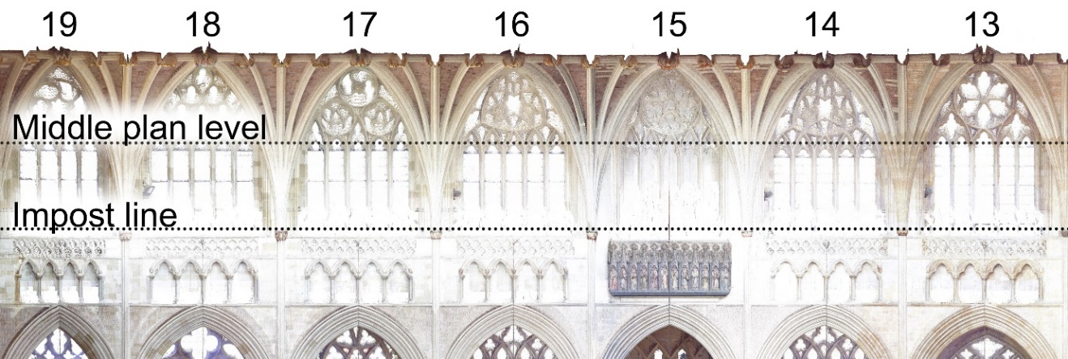
Figure 13. Section line taken through an orthographic long section of the nave vaults at the point of the middle plan.
It was plausible to create a Grasshopper model of the vaults that closely aligned with the traced intrados lines where all ribs have their arc centres on the impost, as demonstrated in the previous section. However, taking middle plans through the survey tracings of nave bays 14-18 and comparing these with versions created through the Grasshopper model revealed significant differences, which suggests that the slight variations in arc centre distances from the impost level which were previously thought to be insignificant, were in fact meaningful. Figure 14(a) shows the surveyed middle plans of bays 14-18 had a distinct ‘zig-zag’ or fluted appearance and bay 13 had a smoother radial appearance. The hypothesised Grasshopper versions of bay 14-18 in Figure 14(b) had a smoother radial appearance closer to the survey tracing of bay 13, and therefore do not accurately replicate the tracings of the surveyed vaults of 14-18.

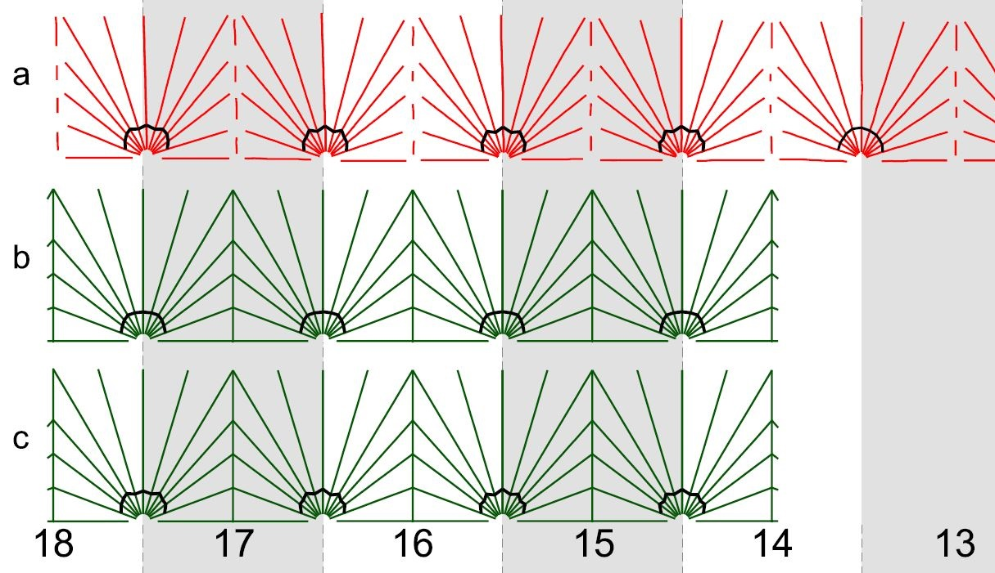
Figure 14. Middle plans taken through nave bays 14-18, comparing the original survey tracings, including bay 13 (a), the Grasshopper model with arc centres on the impost level (b) and the Grasshopper model with alternating arc centres above and below the impost level (c).

To increase the accuracy of the Grasshopper hypothesis, rather than assuming each rib’s arc centres were on the impost, we used the survey data to apply the actual distances from the impost, however insignificant they may have seemed. Working radially from longitudinal tierceron AL around to the transverse rib AE, the average arc centre distances from the impost began above, then below, then above, then below and so on. This replicated the geometric principles of the middle plan from the rib survey tracings, with the above/below sequence resulting in a forwards/backwards fluted appearance. The average arc centre distances from the impost for each rib type were applied to the Grasshopper model for the individual bays, which resulted in a much closer alignment as shown in Figure 14(c) when compared to the surveyed middle plan of Figure 14(a) as well as a closer alignment to the surveyed traced intrados lines themselves. This suggests that the fluted appearance of the middle plan was intentional. At this point we moved from wireframe to solid modelling to visualise and understand these patterns better.

4.3. From wireframe to solid modelling
Visually, wireframe modelling had limitations, as the subtle changes discussed in the previous section were difficult to comprehend, except for the middle plan. Therefore, solid modelling was employed to enhance our visual understanding of the ribs. Again, Grasshopper was used as the parameters could quickly be amended to analyse the different scenarios of ribs with their arc centres on the impost level compared to those that alternate in an above/below pattern. First, the profiles of the ribs were traced using the point cloud and mesh model survey data. This was finalised as a two-dimensional curve in Rhinoceros, then extruded along the various wireframe rib arcs in the Grasshopper hypothesis. Using this method, we could again make adjustments in Grasshopper and quickly visualise how changing the parameters affected the model for bay 15 (Figure 15).

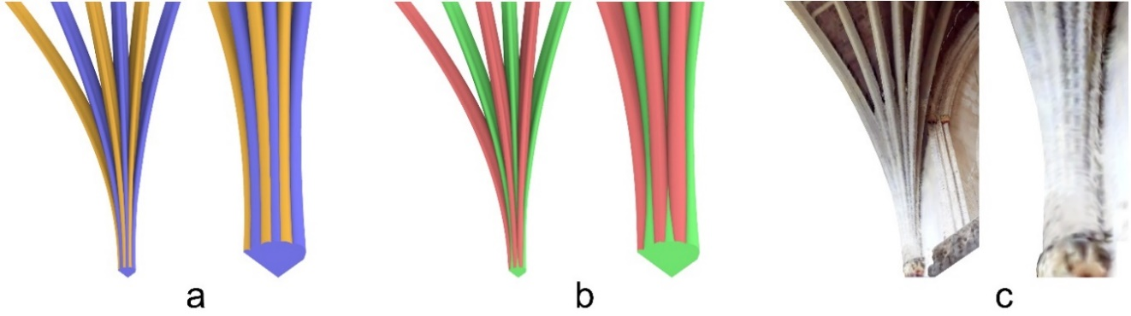
Figure 15. Solid modelling to visualise the difference between a tas-de-charge stone for bay 15 with arc centres on the impost level (a), in an above/below pattern (b) compared to the original surveyed mesh model (c).

Alternating colours are used between ribs to highlight them. Figure 15(a) shows ribs all with their arc centres on the impost, which created a regular conoid with all ribs sharing a similar prominence at tas-de-charge level before breaking individually. Figure 15(b) shows a set of ribs that are adjusted with their arc centre’s in an above/below pattern. This pushed forward certain ribs (red) and pushes back alternates (green) giving greater prominence to those in red. We have already established that this matched the geometry of the surveyed vaults in the previous sections, but in Figure 15(c) as well as Figure 1 we can see that it is also matched in three dimensions. This experimentation, first in wireframe and finally in solid modelling, strongly suggested that the medieval masons initially designed each rib to have its arc’s centre on the impost level and then made small adjustments to give greater prominence to certain ribs. This was achieved by moving the arc centres slightly above (transverse ribs, diagonal ribs and the second set of longitudinal tiercerons) or slightly below the impost level (transverse tiercerons and the first and third set of longitudinal tiercerons).

5. Reflections and conclusions
This article has highlighted the use of pre-digital computational methods in the designing of medieval vaults and investigated these using modern digital techniques. We have shown that specific digital software enabling generative design, Grasshopper 3D, aids our understanding of these processes, particularly in establishing geometric rules, mimicking medieval design methods as well as increasing modelling speeds which consequently gives more time and focus on analysis. Creating modern designs with vaulted structures using generative design software is not new, however, its application to reverse engineer medieval designs is still overlooked and we have begun addressing this issue in our methods presented in this article (Figure 16). Digital generative design methods were especially useful in understanding the medieval design process, as each decision to create the digital model had to be taken in the context of considering how each vault rib was designed in terms of geometry, and how these related to other vault ribs in the bay as well as adjacent bays and the existing built architecture of the cathedral.

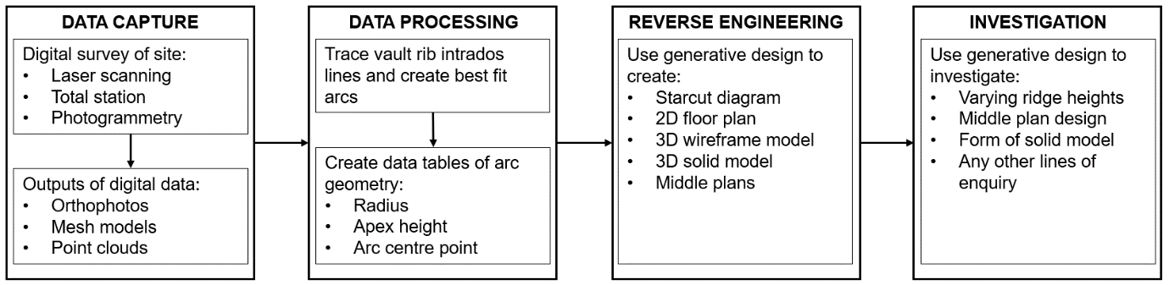
Figure 16. Method diagram outlining the process of researching the design of medieval vaults using digital scanning and generative design software.

At Exeter, digital tools assisted in gaining greater awareness of how the masons amended their designs, notably how a medieval cathedral could include many detailed changes, such as shifts in bay dimensions and window heights, to which subsequent designers had to respond in order to retain a level of consistency throughout. We were also able to explore and uncover very precise and subtle design decisions, notably the raising and lowering of arc centre points in relation to the impost level in Exeter nave bays 14-18 causing a ‘fluted’ middle plan and visually giving greater prominence to alternate ribs. These subtle changes have not previously been acknowledged; therefore, this article should advance the awareness and significance of minor changes in the medieval design and construction process that are very difficult to measure and understand using traditional non-digital methods. This finding would have been hard to investigate using traditional digital methods, whereas arc centres in relation to the impost level could quickly and easily be amended using the Grasshopper model, and therefore the effects of this were also easily explored.

Our research has also assisted in analysing construction breaks in the cathedral, significantly to this article the break between bays 13 and 14. Harvey attributed the nave vaults 14-18 as well as the crossing and nave bay 13 to Thomas of Witney. Yet our digital survey and analysis indicates a clear change in design between these two sets, as shown by the fluted middle plan and one centred arcs in nave bays 14-18 compared to a smoothly curved middle plan and inclusion of two-centred arcs in bay 13 of the nave. This complicates Harvey’s assessment: the changes could indicate the involvement of a different designer – either that the designs for the crossing and eastern bay of the nave predate Witney as he had originally argued, or that bays 14-18 should be attributed otherwise (perhaps to William Joy, who probably succeeded, and may have collaborated with, Witney at Wells), that Witney himself modified his designs, or that a foreman or site architect was responsible for projecting the two-dimensional plans into three dimensions but was left to his or their own devices in terms of how to do this. Further comparative research is required before we can evaluate the likelihood of any of these possibilities.

Our next steps are to investigate more complex vault forms using the same methodology, particularly those with arcs of two-centres as found at Exeter in nave bay 13 as well as many bays in the choir. We will also refine the Grasshopper model, for example by adding dialog boxes to the interface for faster input of data from the original surveyed bays. Consequently, we aim to share the model with our research partners working internationally in Germany, Spain and Central America, enabling them to interrogate vaults using the same methods, thus adding to their findings. The raw digital data for Exeter cathedral, as well as our other sites of investigation, will form part of an open access repository stored with the Archaeology Data Service. This will include point clouds, mesh models, traced intrados lines as well as data tables to act as a resource for fellow researchers as well as custodians of our case study sites and the wider public.

Finally, Willis stated that his research into medieval design processes should allow new vaults to be built using the original medieval design methods of the masons [33]. We too, digitally at least, can now use equivalent methods to create new bays of the Exeter model of any design within the established medieval parameters, enabling future research into their aesthetic, constructive and structural properties (Figure 17).
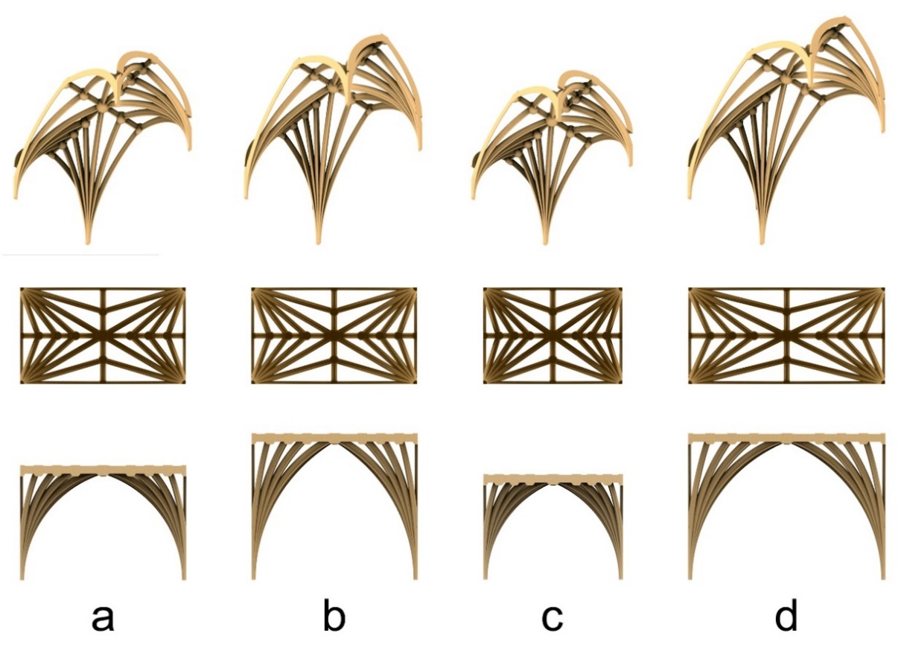
Figure 17. Using the Grasshopper model we can use the established medieval parameters to design a vaulted bay of any dimensions, for example bay 14 at Exeter cathedral as built (a), with increased apex heights (b), with a 1:√2 bay volume (c) and a 1:2 bay plan with increased apex heights (d).
Acknowledgements
We would like to thank John Allan, Cathedral Archaeologist of Exeter Cathedral and the Dean and Chapter for facilitating access, and J. R. Peterson for his technical support.

Funding
We would like to thank the University of Liverpool for financing our fieldwork at Exeter cathedral through the Interdisciplinary Network Fund.

References
[1] Wirz F. Foreword. In: Parametric architecture with Grasshopper : primer (A Tedeschi.), Brienza, Italy: Le Penseur, 2011, pp. 7-8.

[2] Abdelsalam M. The Use of Smart Geometry in Islamic Patterns - Case Study: Mamluk Mosques. In: CAAD, Innovation, Practice, 6th International Conference Proceedings of the Arab Society for Computer Aided Architectural Design, 21-23 February 2012.

[3] Coutinho F, Mateus, L, Duarte J, Ferreira V, Kruger, M. From Point Cloud to Shape Grammar to Grammatical Transformations. In: Computation and Performance – Proceedings of the 31st eCAADe Conference – Volume 2, (eds R Stouffs and S Sariyildiz), 18-20 September 2013.

[4] Bork R. The Geometry of Creation: Architectural Drawing and the Dynamics of Gothic Design. 1st ed. Abingdon, Oxfordshire: Routledge; 2011, p1.

[5] Yeomans D. The Geometry of a Piece of String. Architectural History 2011; 54: pp. 23-47.

[6] Kowal S, Koszewski K, Slyk J, Wrona S. Parametric Methods in Reconstruction of the Medieval Proto-Town in Pultusk, Poland. Real Time, In: Proceedings of the 33rd eCAADe Conference - Volume 1 (eds B Martens, G Wurzer, T Grasl, W Lorenz and R Schaffranek), 16-18 September 2015

[7] Chevrier C, Charbonneau N, Grussenmeyer P, Perrin J. Parametric Documenting of Built Heritage: 3D Virtual Reconstruction of Architectural Details. International Journal of Architectural Computing 2010;8(2): pp. 135-150.

[8] Havemann S, Fellner D. Generative parametric design of Gothic window tracery. In: The 5th International Symposium on Virtual Reality, Archaeology and Cultural Heritage (eds K Cain, Y Chrysanthou, F Niccolucci, N Silberman), 7-9 June 2004.

[9] Takayama J. Computer-generated Gothic Tracery with a Motif-oriented Approach. Consilience and Innovation in Design; 26th-30th August 2013.

[10] Ackerman JS. Origins, imitation, conventions : representation in the visual arts. Cambridge, Mass.; London : MIT Press; 2002.

[11] Binski P. Notes on artistic invention in Gothic Europe. Intellectual History Review 2014;24(3): pp. 287-300.

[12] Shelby L. Medieval Masons' Tools. II. Compass and Square. Technology and Culture 1965;6(2): pp. 236-248.

[13] Hiscock N. The wise master builder: platonic geometry in plans of medieval abbeys and cathedrals. London : Routledge, Taylor & Francis Group, 2018.

[14] Palacios Gonzalo JC. La Cantería Medieval. La construcción de la boveda gotica española. 1st ed.: Munillaleria; 2009;

[15] Stewart M. Patterns of Eternity: Sacred Geometry and the Starcut Diagram. 1st ed. Edinburgh: Floris Books; 2009.

[16] Mitchell J, Brown A. How the World is Made: The Story of Creation According to Sacred Geometry. 1st ed. London: Thames & Hudson Ltd; 2009.

[17] Buchanan A, Webb N. Creativity in Three Dimensions: An Investigation of the Presbytery Aisles of Wells Cathedral. British Art Studies 2017(6).

[18] Erskine M. The accounts of the fabric of Exeter Cathedral, 1279-1353. : Publications of the Devon & Cornwall Record Society; 1981-83.

[19] Lethaby WR. How Exeter Cathedral was Built. Architectural Review 1903;13:109-130.

[20] Prideaux EK, Holt Shafto GR. Bosses & Corbels of Exeter Cathedral. 1st ed. Exeter and London: James G. Common and Chatto & Windus; 1910.

[21] Mills C. Dendrochronology in Exeter and its Application. University of Sheffield; 1988.

[22] Brown S, Matthews A. Exeter Cathedral Roof: An Archaeological Survey of the North Side from the East End to the Crossing, 1999.

[23] Brown S, Matthews A. Exeter Cathedral High Roof: An Archaeological Survey of the North Side from the Crossing to the West End of the Nave, 2003.

[24] Harvey JH. The English Cathedrals. London: Batsford; 1963.

[25] Harvey JH. English mediaeval architects: a biographical dictionary down to 1550. 1st ed. London: Batsford; 1954.

[26] Morris RK, Thomas of Witney at Exeter, Winchester and Wells. In: Medieval Art and Architecture at Exeter Cathedral: Leeds: Maney; 1985.

[27] Harvey JH. English mediaeval architects: a biographical dictionary down to 1550. 2nd ed. London: Batsford; 1987.

[28] Webb N, Buchanan A. Tracing the past: A digital analysis of Wells cathedral choir aisle vaults. Digital Applications in Archaeology and Cultural Heritage 2017;4:19-27.

[29] Costa-Jover A, Lluis i Ginovart J, Coll-Pla S, López Piquer M. Using the terrestrial laser scanner and simple methodologies for geometrically assessing complex masonry vaults. Journal of Cultural Heritage 2019; In press.

[30] Harvey JH. The mediaeval architect. London : Wayland; 1972.

[31] Wilson C. The origins of the Perpendicular Style and its Development to circa 1360. 1980.

[32] Webb N, Buchanan A. Tracing the Past: Establishing Tolerances when Investigating Medieval Vault Rib Geometries using Digital Tools. In: Envisioning Architecture: Space/Time/Meaning Vol. 1. Glasgow School of Art; 8 September, 2017, pp. 30-37.

[33] Willis R. On the Construction of the Vaults of the Middle Ages. Transactions of the Royal Institute of British Architects 1842;1(2):1-69, p12-13.

