Author accepted manuscript

Title Page

Corneal Confocal Microscopy Detects Small-Fibre Neuropathy in Burning Mouth Syndrome: a cross-sectional study

Dr Francis O’Neill PhD, MBChB, FDS RCPS^{1,2}, Dr Andrew Marshall MBChB, BSc, FRCP ^{3, 4}, Dr Maryam Ferdousi BSc, MSc, PhD³, Professor Rayaz A Malik PhD, MSc, MBChB, FRCP ^{3, 5}

¹ The Pain Research Institute, University of Liverpool, Clinical Sciences Centre, Lower Lane, Liverpool, L9 7AL United Kingdom
² School of Dentistry, Institute of Clinical Sciences, University of Liverpool L3 5PS United Kingdom
³ Faculty of Biology, Medicine and Health, University of Manchester, Manchester, United Kingdom
⁴ Department of Clinical Neurophysiology, Salford Royal NHS Foundation Trust, Salford M6 8HD United Kingdom
⁵ Weill Cornell Medicine, Doha, Qatar

Key words: corneal confocal microscopy burning mouth syndrome

Abbreviations: CCM = corneal confocal microscopy, BMS = burning mouth syndrome, LC = Langerhans cell, SD = standard deviation, CI = confidence interval,

Financial support: This study was supported through a J.E.McAllister/Emile de Trey Research Endowment Fund administered by the University of Liverpool Dental School awarded to FON.

Acknowledgements: The authors thank Mitra Tavakoli for acquiring some of the CCM images, and Dr Meena Rudrulingham for referral of a proportion of patients.

Conflicts of Interest Disclosures: The authors have no conflicts of interest to declare.

Total pages: 15
Word Count:
Abstract: 260
Manuscript: 1569
Figures: 2
Tables: 1

Corresponding author:

Francis O’Neill, PhD, MBChB, FDS(OS)RCPS, FHEA
The Pain Research Institute,
Clinical Sciences Centre,
Lower Lane,
Liverpool L9 7AL
United Kingdom
Email: foneill@liverpool.ac.uk
Tel: +44 (0)1517065245
Fax: +44(0) 1517065807

Abstract

Aims To assess the utility of corneal confocal microscopy in identifying small fibre damage in patients with burning mouth syndrome (BMS).
Methods A prospective cross-sectional cohort study conducted at two UK dental hospitals between 2014 and 2017. 17 consecutive patients aged between 18 to 85 years with idiopathic BMS (15F/2M) and 14 healthy age matched control subjects (7F/7M) were enrolled in this study. Corneal subbasal nerve plexus measures and Langerhans cell density were quantified in images acquired with a laser scanning in-vivo corneal confocal microscope. Main outcome measures were corneal nerve fibre density, nerve branch density, nerve fibre length and Langerhans cell density.
Results Of the 17 patients with BMS 15 (88%) were female with a mean (standard deviation) age of 61.7 (6.5) years. Of the healthy controls, 7 (50%) were female with a mean (standard deviation) age of 59.3 (8.68) years. Corneal nerve fibre density (no./mm²) (BMS: 29.27±6.22 vs. Controls: 36.19±5.9; median difference, 6.71; 95% CI [1.56 to 11.56]; P= .007) and corneal nerve fibre length (mm/mm²) (BMS: 21.06±4.77 vs. Controls: 25.39±3.91; median difference, 4.5; 95% CI [1.22 to 6.81]; P= .007) were significantly lower and Langerhans cell density (no./mm²) (BMS: 74.04±83.37 vs. Controls: 29.17±45.14; median difference, -21.27; 95% CI [-65.35to -2.91]; P= .02) was significantly higher in patients with BMS compared to controls.
Conclusions This study, using a rapid non-invasive ophthalmic imaging technique, provides further evidence for small fibre damage in BMS and has potential utility to monitor disease progression or response. Furthermore, it shows a hitherto undocumented increased immune cell density in this group of patients.

Introduction
Idiopathic burning mouth syndrome (BMS) is a debilitating painful condition of the oral cavity, characterised by a burning sensation of the tongue, palate or buccal mucosa ¹ and has a major impact on quality of life ^{2,3}. It affects between 0.7% to 3.7% of the general population ^{4,5}.
For the diagnosis of BMS, systemic causes such as Sjogren’s syndrome should be excluded and the oral mucosa should be normal to inspection ⁶. The underlying etiology of BMS is complex and poorly understood⁷ with abnormalities extending from the altered expression of vanilloid and cannabinoid receptors on the epithelium ⁸, to peripheral nerve ⁹ and central functional and structural alterations in the hippocampus and prefrontal cortex ¹⁰. Altered immune and endocrine function has also been implicated in the aetiology of BMS ^{11,12}.
The management of BMS is very difficult in relation to accurate diagnosis, especially as it is often misdiagnosed as Sjogren’s syndrome¹³. A wide array of sub-optimally effective therapies have been used and include antidepressants, alpha-lipoic acid, anti-inflammatory agents and non-pharmacological therapies ¹⁴⁻¹⁶. The complex etiology of BMS and the existence of specific subtypes with differing contributions of peripheral and central neuropathic pain may explain the limited therapeutic response ^{14,17}.
The role of small fibre pathology was explored in an early tongue biopsy study which revealed a significant decrease in epithelial nerve density and active axonal degeneration in the sub-papillary nerve plexus, in patients with BMS ¹⁸. In a more recent study there was a loss of epidermal nerve fibres, but no difference in subepithelial nerve fibre density ⁹. In a further study, there was an overall loss of epidermal nerve fibres, but with an increase in TRPV1 and NGF expressing pain nerve fibres ¹⁹. Furthermore, in a recent study mechanical sensitivity thresholds were preserved indicating preferential small fibre involvement in BMS ²⁰.
A tongue biopsy may be useful in identifying small fibre damage and to explore the underlying etiology of BMS, however, its invasive nature limits its usefulness. We have pioneered the technique of corneal confocal microscopy (CCM) for rapid non-invasive imaging of the corneal sub-basal plexus, which are sensory nerves derived from the trigeminal nerve ²¹. We have shown that CCM is a reproducible and repeatable technique ²² for identifying small fibre damage in diabetic neuropathy ²³⁻²⁵ and a range of other peripheral neuropathies ²⁶⁻²⁹. We have also shown increased Langerhans cell density in diabetic neuropathy ³⁰, chronic inflammatory demyelinating polyneuropathy ²⁶ and multiple sclerosis ³¹ in relation to corneal nerve loss. We have also recently shown corneal nerve fibre loss in patients with multiple sclerosis ³¹ and Parkinson’s disease ³².
The aim of this study was to investigate if CCM can detect an abnormality in corneal small nerve fibres and Langerhans cell density in patients with BMS compared to age matched controls.

Methods
Study subjects
This was a prospective cross-sectional cohort study conducted at two tertiary referral dental hospitals in the United Kingdom June between 2014 and 2017.
17 consecutive patients with burning mouth syndrome who were able to attend for further investigations were studied and compared to 14 age-matched healthy control subjects selected from hospital and university staff without any cause of neuropathy. The study was approved by the NHS Health Research Authority, National Research Ethics Service reference 14/NW/0004 and written informed consent was obtained from all participants. This research adhered to the tenets of the Declaration of Helsinki.
Eligibility
Patients with a definite clinical history of primary burning mouth syndrome for at least six months, aged between 18 to 85 years were invited for the study. The diagnostic criteria were based on the International Classification of Headache Disorders (ICHD-3 beta) defined as “an intraoral burning or dysaesthetic sensation, recurring daily for more than two hours per day over more than three months, without clinically evident causative lesions.” The diagnosis of BMS included a clinical investigation of the oral cavity in order to exclude local causes and laboratory analysis to eliminate any systemic cause of burning or sore mouth¹³. Exclusion: Subjects with a known history of corneal abnormality, trauma or surgery, wearing contact lenses, any other cause of neuropathy and burning mouth symptoms attributed to any other underlying cause such as candidiasis, trauma and thermal or chemical burns were excluded from the study.

Corneal Confocal Microscopy
All participants underwent corneal confocal microscopy using a Heidelberg Retinal Tomograph III with Rostock Cornea Module (HRT III RCM) (Heidelberg Engineering GmbH, Heidelberg, Germany). The examination took 5-10 minutes per patients and was performed by highly experienced optometrists. 6 images (3 per eye) from the central corneal sub basal nerve plexus were selected following our previously published protocol ²².
Image analysis
An experienced examiner (MF) analysed all the images manually using CCMetrics (MA Dabbah; Imaging Science and Biomedical Engineering, University of Manchester, Manchester, UK), while being masked from the diagnosis. The measurements that were performed comprised: Corneal nerve fibre density (CNFD) indicating the number of major nerves/mm² of corneal tissue; Corneal nerve fibre length (CNFL) indicating the length of nerves/mm² of corneal tissue; Corneal nerve branch density (CNBD) indicating the number of nerve branches/mm² of corneal tissue; Corneal nerve fibre tortuosity (CNFT) indicating the degree of non-linearity of the nerve fibres were quantified. Langerhans cells (LC) were identified from their size and morphology as highly bright dendritic structures and the density (no./mm²) was derived by counting the total number of LC’s in the area of the cornea using the NBD feature of the CCMetrics software ²⁶.
Statistical analysis
IBM SPSS v22 (Chicago, IL, USA) for Windows and Stata V 15 (Texas, USA) were used to compute the results. Analysis included descriptive and frequency statistics and all data are presented as mean ± standard deviation (SD). All data were tested for normality using the Shapiro-Wilk test and Q-Q plots. Two independent sample t-tests (for parametric variables) and Mann-Whitney U test (for non-parametric variables) were used to compare means between the two groups. Where appropriate, confidence intervals (CI) were expressed.

Sample size
Based on previously published results in patients with Charcot Marie Tooth (27) we estimated a minimum of 12 patients and 12 controls were required to detect a difference in CCM parameters with a significance level of 0.05 and power of 0.80, based on a two-tailed independent sample T-test per group.
Results
Demographics
17 patients with BMS (15 Females/2 Males) were compared with 14 healthy age matched control subjects (7 Females, 7 Males). There was no difference in age between patients with BMS and controls (BMS: 61.7±6.5 vs Controls: 59.3±8.7; mean difference, -2.45; 95% CI [-8.46 to 3.55]; P=0.4).
Corneal nerve fibres
Corneal nerve fibre density (no. /mm²) (BMS: 29.27±6.22 vs. Controls: 36.19±5.9; median difference, 6.71; 95% CI [1.56to 11.56]; P= .007) and corneal nerve fibre length (mm/mm²) (BMS: 21.06±4.77 vs. Controls: 25.39±3.91; median difference, 4.52; 95% CI [1.22 to 6.81]; P= .007) were significantly lower in patients with BMS compared to controls. There was no difference in corneal nerve branch density (no./mm²) (BMS: 74.83±27.43 vs. Controls: 76.48±23, median difference, 2.86; 95%CI [-19.27 to 21.66]; P= .7) and corneal nerve fibre tortuosity (TC) (BMS: 14.42±2.95 vs. Controls: 16.41±2.7; mean difference, 2.42; 95%CI [-0.24 to 4.58]; P= .06) between patients with BMS and controls (Table 1 and Figures 1 and 2).
Langerhans cell density
Cell density was significantly increased in patients with BMS compared to controls (no. /mm²) (BMS: 74.04±83.37 vs. Controls: 29.17±45.14; median difference, -21.27; 95% CI [-65.35to -2.91]; P= .02) (Table 1, Figures 1-2).

Discussion

Corneal confocal microscopy has identified corneal small fibre damage in patients with burning mouth syndrome. This confirms the presence of a small fibre neuropathy in patients with BMS, that could previously only be shown through a reduction in epidermal nerve fibre density in tongue biopsies^{9,18,19}.
The key advantage with CCM is that it is a rapid non-invasive imaging method that accurately and reproducibly ^{25,33} quantifies small fibre damage in a range of peripheral neuropathies ^{25,34,35}. Indeed, we have previously shown that CCM has comparable diagnostic utility to intra-epithelial nerve fibre density in skin biopsies for patients with diabetic neuropathy ^{33,35}.
We have also shown that CCM can predict the development of clinical neuropathy ^{36,37} and can detect early nerve fibre repair after therapeutic intervention ^{34,38}. It is hoped, therefore, that CCM may be able to detect response of small nerve fibres to treatment in BMS patients also. As CCM allows the detection of small fibre damage in BMS patients, it may help to identify BMS patients with a greater abnormality in peripheral rather than central pain pathways ^{14,39}.
Furthermore, we also show a significant increase in corneal Langerhans cell density in BMS patients, suggestive of immune alterations in BMS. Two previous studies have suggested immune alterations in patients with BMS with a reduction in CD8 cells and altered CD4/CD8 ratios ^{12,40}. Whilst, Langerhans cell density has not been assessed directly in biopsies from BMS patients, TRPV1 receptors are expressed on LC’s, and TRPV1 immunoreactivity has been shown to be increased in tongue biopsies from patients with BMS ¹⁹. In relation to a mechanistic link with nerve degeneration, increased Langerhans cell density has been associated with a reduced density of intra-epidermal nerve fibres in patients with painful diabetic neuropathy⁴¹.
Corneal confocal microscopy is a fast, non-invasive imaging method to quantify small nerve fibre damage in patients with BMS. Further studies utilising CCM are needed to investigate if it has utility in differentiating disease subtypes or to monitor progression or response to treatment.

Author Contributions: Study concept and design: O’Neill, Marshall, Malik. Acquisition, analysis, or interpretation of data: All authors. Drafting of the manuscript: O’Neill. Critical revision of the manuscript for important intellectual content: All authors. Statistical analysis: Ferdousi. Administrative, technical, or material support: O’Neill, Marshall, Malik. Study supervision: O’Neill, Marshall, Ferdousi, Malik.

REFERENCES

1. Acharya S, Carlen A, Wenneberg B, Jontell M, Hagglin C. Clinical characterization of women with burning mouth syndrome in a case-control study. Clin Oral Investig. 2018;76(4):279-286.
2. Adamo D, Sardella A, Varoni E, et al. The association between burning mouth syndrome and sleep disturbance: A case-control multicentre study. 2018;24(4):638-649.
3. Ardore M, Spadari F, Bombeccari G, et al. The relationship between the clinical features of idiopathic burning mouth syndrome and self-perceived quality of life. Oral Dis. 2016;58(4):475-481.
4. Bergdahl M, Bergdahl J. Burning mouth syndrome: prevalence and associated factors. J Oral Pathol Med. 1999;28(8):350-354.
5. Coculescu EC, Tovaru S, Coculescu BI. Epidemiological and etiological aspects of burning mouth syndrome. J Med Life. 2014;7(3):305-309.
6. Chimenos-Kustner E, de Luca-Monasterios F, Schemel-Suarez M, Rodriguez de Rivera-Campillo ME, Perez-Perez AM, Lopez-Lopez J. Burning mouth syndrome and associated factors: A case-control retrospective study. Med Clin (Barc). 2017;148(4):153-157.
7. Nasri-Heir C, Shigdar D, Alnaas D, Korczeniewska OA, Eliav R, Heir GM. Primary burning mouth syndrome: Literature review and preliminary findings suggesting possible association with pain modulation. Quintessence international (Berlin, Germany : 1985). 2017:49-60.
8. Borsani E, Majorana A, Cocchi MA, et al. Epithelial expression of vanilloid and cannabinoid receptors: a potential role in burning mouth syndrome pathogenesis. Histol Histopathol. 2014;29(4):523-533.
9. Puhakka A, Forssell H, Soinila S, et al. Peripheral nervous system involvement in primary burning mouth syndrome--results of a pilot study. Oral Dis. 2016;22(4):338-344.
10. Khan SA, Keaser ML, Meiller TF, Seminowicz DA. Altered structure and function in the hippocampus and medial prefrontal cortex in patients with burning mouth syndrome. Pain. 2014;155(8):1472-1480.
11. Feller L, Fourie J, Bouckaert M, Khammissa RAG. Burning Mouth Syndrome: Aetiopathogenesis and Principles of Management. 2017;2017:1926269.
12. Koike K, Shinozaki T, Hara K, et al. Immune and endocrine function in patients with burning mouth syndrome. Clin J Pain. 2014;30(2):168-173.
13. Aljanobi H, Sabharwal A, Krishnakumar B, Kramer JM. Is it Sjogren's syndrome or burning mouth syndrome? Distinct pathoses with similar oral symptoms. Oral surgery, oral medicine, oral pathology and oral radiology. 2017;123(4):482-495.
14. de Souza IF, Marmora BC, Rados PV, Visioli F. Treatment modalities for burning mouth syndrome: a systematic review. 2018;22(5):1893-1905.
15. Varoni EM, Lo Faro AF, Lodi G, Carrassi A, Iriti M, Sardella A. Melatonin Treatment in Patients with Burning Mouth Syndrome: A Triple-Blind, Placebo-Controlled, Crossover Randomized Clinical Trial. J Oral Facial Pain Headache. 2018;32(2):178-188.
16. Zoric B, Jankovic L, Kuzmanovic Pficer J, Zidverc-Trajkovic J, Mijajlovic M, Stanimirovic D. The efficacy of fluoxetine in BMS-A cross-over study. Gerodontology. 2018;35(2):123-128.
17. Azzi L, Croveri F, Pasina L, et al. A burning therapy for burning mouth syndrome: preliminary results with the administration of topical capsaicin. J Biol Regul Homeost Agents. 2017;31(2 Suppl 1):89-95.
18. Lauria G, Majorana A, Borgna M, et al. Trigeminal small-fiber sensory neuropathy causes burning mouth syndrome. Pain. 2005;115(3):332-337.
19. Yilmaz Z, Renton T, Yiangou Y, et al. Burning mouth syndrome as a trigeminal small fibre neuropathy: Increased heat and capsaicin receptor TRPV1 in nerve fibres correlates with pain score. J Clin Neurosci. 2007;14(9):864-871.
20. Honda M, Iida T, Kamiyama H, et al. Mechanical sensitivity and psychological factors in patients with burning mouth syndrome. Clin Oral Investig. 2018.
21. Muller LJ, Vrensen GF, Pels L, Cardozo BN, Willekens B. Architecture of human corneal nerves. Invest Ophthalmol Vis Sci. 1997;38(5):985-994.
22. Kalteniece A, Ferdousi M. Corneal confocal microscopy is a rapid reproducible ophthalmic technique for quantifying corneal nerve abnormalities. 2017;12(8):e0183040.
23. Petropoulos IN, Alam U, Fadavi H, et al. Corneal nerve loss detected with corneal confocal microscopy is symmetrical and related to the severity of diabetic polyneuropathy. Diabetes Care. 2013;36(11):3646-3651.
24. Malik RA, Kallinikos P, Abbott CA, et al. Corneal confocal microscopy: a non-invasive surrogate of nerve fibre damage and repair in diabetic patients. Diabetologia. 2003;46(5):683-688.
25. Kalteniece A, Ferdousi M, Petropoulos I, et al. Greater corneal nerve loss at the inferior whorl is related to the presence of diabetic neuropathy and painful diabetic neuropathy. PLoS One. 2018;8(1):3283.
26. Stettner M, Hinrichs L, Guthoff R, et al. Corneal confocal microscopy in chronic inflammatory demyelinating polyneuropathy. Ann Clin Transl Neurol. 2016;3(2):88-100.
27. Tavakoli M, Marshall A, Banka S, et al. Corneal confocal microscopy detects small-fiber neuropathy in Charcot-Marie-Tooth disease type 1A patients. Muscle Nerve. 2012;46(5):698-704.
28. Tavakoli M, Marshall A, Pitceathly R, et al. Corneal confocal microscopy: a novel means to detect nerve fibre damage in idiopathic small fibre neuropathy. Exp Neurol. 2010;223(1):245-250.
29. Tavakoli M, Marshall A, Thompson L, et al. Corneal confocal microscopy: a novel noninvasive means to diagnose neuropathy in patients with Fabry disease. Muscle Nerve. 2009;40(6):976-984.
30. Tavakoli M, Boulton AJ, Efron N, Malik RA. Increased Langerhan cell density and corneal nerve damage in diabetic patients: role of immune mechanisms in human diabetic neuropathy. Cont Lens Anterior Eye. 2011;34(1):7-11.
31. Bitirgen G, Akpinar Z, Malik RA, Ozkagnici A. Use of Corneal Confocal Microscopy to Detect Corneal Nerve Loss and Increased Dendritic Cells in Patients With Multiple Sclerosis. JAMA Ophthalmol. 2017;135(7):777-782.
32. Kass-Iliyya L, Javed S, Gosal D, et al. Small fiber neuropathy in Parkinson's disease: A clinical, pathological and corneal confocal microscopy study. Parkinsonism Relat Disord. 2015;21(12):1454-1460.
33. Alam U, Jeziorska M, Petropoulos IN, et al. Diagnostic utility of corneal confocal microscopy and intra-epidermal nerve fibre density in diabetic neuropathy. PLoS One. 2017;12(7):e0180175.
34. Brines M, Culver DA, Ferdousi M, Tannemaat MR, van Velzen M. Corneal nerve fiber size adds utility to the diagnosis and assessment of therapeutic response in patients with small fiber neuropathy. 2018;8(1):4734.
35. Chen X, Graham J, Dabbah MA, et al. Small nerve fiber quantification in the diagnosis of diabetic sensorimotor polyneuropathy: comparing corneal confocal microscopy with intraepidermal nerve fiber density. Diabetes Care. 2015;38(6):1138-1144.
36. Pritchard N, Edwards K, Russell AW, Perkins BA, Malik RA, Efron N. Corneal confocal microscopy predicts 4-year incident peripheral neuropathy in type 1 diabetes. Diabetes Care. 2015;38(4):671-675.
37. Edwards K, Pritchard N, Dehghani C, et al. Corneal confocal microscopy best identifies the development and progression of neuropathy in patients with type 1 diabetes. J Diabetes Complications. 2017;31(8):1325-1327.
38. Tavakoli M, Mitu-Pretorian M, Petropoulos IN, et al. Corneal confocal microscopy detects early nerve regeneration in diabetic neuropathy after simultaneous pancreas and kidney transplantation. Diabetes. 2013;62(1):254-260.
39. Jaaskelainen SK. Is burning mouth syndrome a neuropathic pain condition? Pain. 2018;159(3):610-613.
40. Ballyram R, Lemmer J, Srinivasan M, Kodumudi KN, Zunt SL. Soluble CD14 and toll-like receptor-2 are potential salivary biomarkers for oral lichen planus and burning mouth syndrome. Pain Res Manag. 2008;126(1):31-37.
41. Casanova-Molla J, Morales M, Planas-Rigol E, et al. Epidermal Langerhans cells in small fiber neuropathies. Pain. 2012;153(5):982-989.

Tables and Figures

Table 1. Corneal Confocal Microscopy measurements in BMS patients and controls.
 | BMS (n=17) | Controls (n=14) | P value
Age (years) | 61.76±6.5 | 59.3±8.68 | 0.4
CNFD (no./mm²) | 29.27±6.22 | 36.19±5.9 | 0.007
CNBD (no./mm²) | 74.83±27.43 | 76.48±23.15 | 0.7
CNFL (mm/mm²) | 21.06±4.77 | 25.39±3.91 | 0.007
CNFT (TC) | 14.42±2.95 | 16.41±2.79 | 0.06
LC’s density (no./mm²) | 74.04±83.37 | 29.17±45.14 | 0.02

Abbreviations: CNFD = corneal nerve fibre density, CNBD = corneal nerve fibre branch density, CNFL = corneal nerve fibre length, CNFT = corneal nerve fibre tortuosity, LC’s = Langerhans cells. All data presented as Mean±SD.

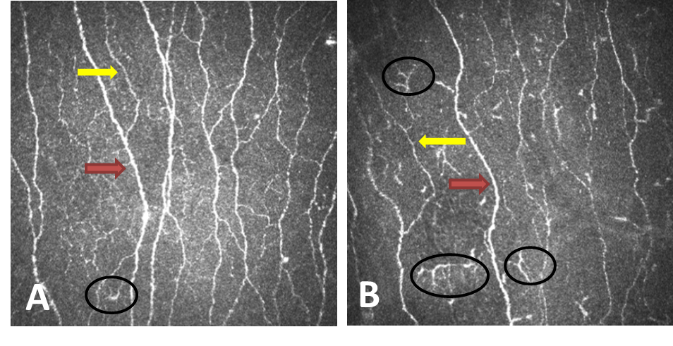
Figure 1. CCM images of the central sub-basal nerve plexus from a healthy control subject (A) and a patient with BMS (B). Red arrows indicate main nerves, yellow arrows indicate branches and circles indicate Langerhans cells.

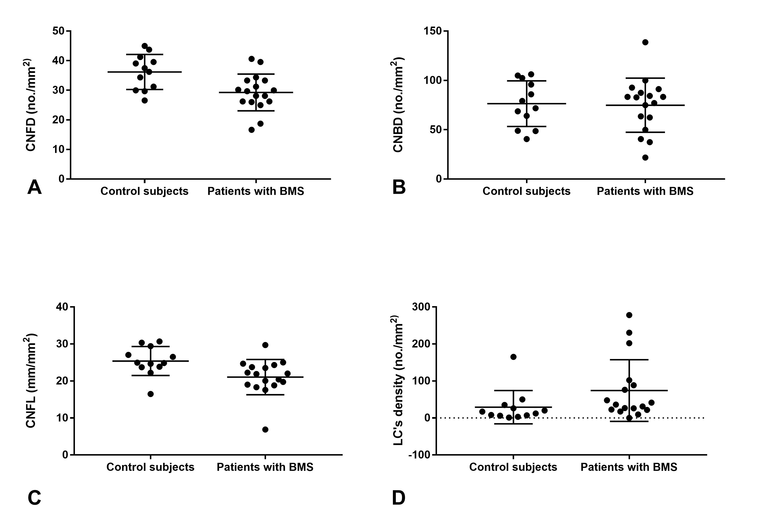
Figure 2. Corneal nerve fibre density (CNFD) (A), Corneal nerve branch density (CNBD) (B), Corneal nerve fibre length (CNFL) (C) and Langerhans cell (LC’s) density (D) in control subjects and patients with BMS. Bars indicate mean and one standard deviation.

