Precarious Spaces: Visualising Unofficial Sacredness
Terence Heng, University of Liverpool
VISUAL ETHNOGRAPHY Vol. 8, No. 1, 2019, ISSN 2281-1605. DOI: 10.12835/ve2019.1-0122
Introduction
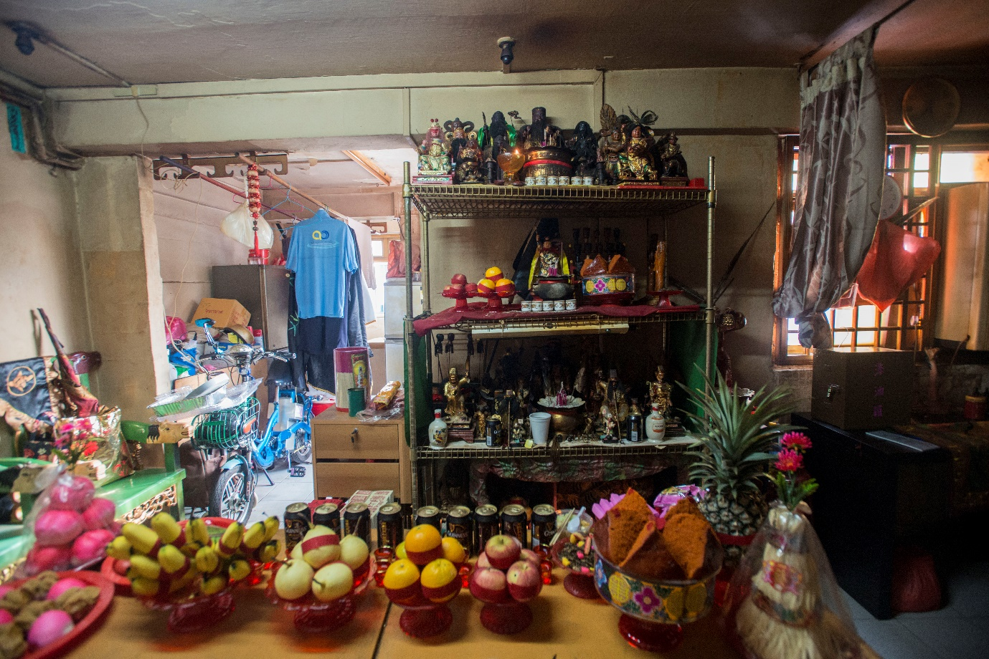
Figure 1: Hao’s 1-Room Flat and the Altar of Five Treasures
I visited the Altar of Five Treasures in mid 2017, during the seasonal Hungry Ghost Festival. My contact, Mrs Sim, had arranged for me to visit, observe and document this spirit altar’s celebrations and walkabout. Located in the West of Singapore, the Altar of Five Treasures was housed in a 1-room, or studio flat – a form of state-subsidised housing that tends to leased, rather than sold to its occupants, who typically comprise individuals positioned low on the economic spectrum. As I gingerly stepped over the threshold, I was struck by the degree of sacred clutter appropriating mundane living spaces. The altar housing kim sin (statues of deities) was not a typical rosewood multi-tier affair, instead industrial shelves stood as proxy. In Figure 1, a thin curtain is all that separates the altar from a mattress, desk and television.
The occupant, Hao, is a cleaner by day and a tang-ki by night. Many tang-ki in Singapore also lead their own sin tua (spirit altar), a collective of 5-10 individuals who see the tang-ki as the cornerstone of their spiritual and religious life. As such, Tang-ki are spiritual leaders in Chinese Religion who enter into deep trances in the belief that their souls are replaced by deities, and in effect become a deity (Heng 2016) for taumaturgical purposes (DeBernardi 2012). Chinese Religion is a scholarly term used to denote the collective and myriad forms of religious practices originating from China. Although the term is not used by adherents, it is a common keyword amongst anthropologists and other social researchers (see DeBernardi 2012). In my own fieldwork site, Singapore, adherents refer to themselves as Taoists, reflecting the Zhengyi sect of Taoism (Adler 2007, Tan 2018), which combines Taoist principles with folk religion beliefs. Taoism and its various sects was the predominant religion amongst ethnic Chinese individuals in the 1960s (see Clammer 1983, 1991 and Chong and Hui 2013) but has since receded in favour of other faiths as well as rising secularism. However, this does not mean that the faith is gone, as can be seen from the elaborate rituals still carried out by adherents such as Hao.
This visual essay seeks to examine the everyday negotiations that individuals like Hao and others make in order to practice their faith whilst limited by regulations set by the state. It is not in the purview of this essay to deal with the details and nuances of such negotiations, which I have analysed in other articles (Heng 2015, 2016). However, I will briefly summarise the current relationship between religion, space and the state so as to better contextualise my photographs. As others (Kong 1993, Woods 2018) have noted, physical space is highly regulated and planned by the state in Singapore, which through the use of a master plan has demarcated and denoted specific spaces for specific uses (commercial, residential, religious, etc). With religious space, organisations often have to bid through an auction process in order to acquire new parcels of land on which to build their structures. Each parcel of land is not just demarcated for religious purposes, but also for particular religions. Hence, religious groups would compete amongst themselves, and not other religions, for state-sanctioned, or “official” sacred space (Kong 1993).
Whilst regulating space is nothing new in urban planning, the degree to which the state exercises control over such purposes is significant, especially for the nature of groups like sin tua. As DeBernardi (2012) notes of tang-ki and sin tua, their organisational structures are often entrepreneurial – single individuals or pairs leading smaller, informal set-ups of a core group of members (7-10) as opposed to more formal and defined structures such as temples (more on this later). These groups often do not have the financial resources to compete in auction bids for land, and when they do, often create joint bids to form a ‘combined temple’ of three separate altars in one building.
Other sin tua make use of whatever space that they can, which is often either their own homes, or a unit in an industrial estate. When activities or rituals call for more individuals than their ‘regular’ spaces will handle, groups will temporarily appropriate space in ebbs and flows. Both regular and temporal appropriation carry risks. Residential spaces, especially state-subsidised housing (known colloquially as Housing Development Board or HDB flats) have multiple caveats for ownership and use. Old laws from the 1960s still apply as to how such spaces are used – and in this case commercial and religious activities are at best restricted and in some cases prohibited. Public spaces are similarly regulated, with processions, festivals and celebrations all requiring prior approval from relevant authorities.
There is thus no guarantee that tang-ki and their followers will always have permission to do what they want to do. Interviews with my informants have revealed how some tang-ki have had their HDB flats confiscated by the state because of complaints from neighbours over noise levels. Most take extra care not to create a disturbance, but the risk is always there. Similarly, risks abound in other spaces, whether environmental (as their processions on busy roads are largely informal), regulatory (permission from authorities in one year does not guarantee permission in the next) or even spiritual (the presence of ghosts or evil spirits are always around, meaning to do harm).
The photographs in this essay thus seek to visualise this precarity - whether that manifests itself in the environment, in relation to the state, through the social networks generated and disrupted, or with perceptions of the spiritual realm – that individuals encounter as they try to form and shape their own sacred spaces. Kong (1993) has noted that these are “unofficial” sacred spaces – those that are political in that they resist state classification, but such transience and lack of political recognition also comes with inherent instability (see Woods 2013). I have created these photographs over a period of 6 years, starting with a visual ethnography of cemeteries (Heng and Hui 2015), then moving on to the unofficial sacred spaces manifested in homes, offices, factory units, public areas, parks and along the street (Heng 2014, 2015, 2016). As I have discussed elsewhere (Heng 2016), my photographs are realist in style but attempt to provide additional ethnographic layers to observations made, while at the same time democratising the field for readers. Such democratisation occurs through weaving a narrative of (sometimes non-chronological) events that leaves open different pathways of interpretation. Doing this allows for a crafting of a visual essay through themes, rather than just ‘what there is to visualise’.

Spirituality and Industry
Prior to modernisation efforts in the 1960s and 70s, many practitioners of Chinese religion operated from three-storey shophouses, with Amoy Street in the Central Business District being a distinct concentration.
The Land Planning Act of 1960 forbade the use of industrial spaces for religious purposes until 2012, but this did not stop groups of individuals from appropriating such spaces. This vignette deals with the leftover spatial arrangements of hiddenness and unofficial sacredness.

Figure 2: In a flatted-factory unit, sacredness is demarcated between public-facing and private-worship through storage cabinets. Gods remain hidden from public view, and known only to devotees.

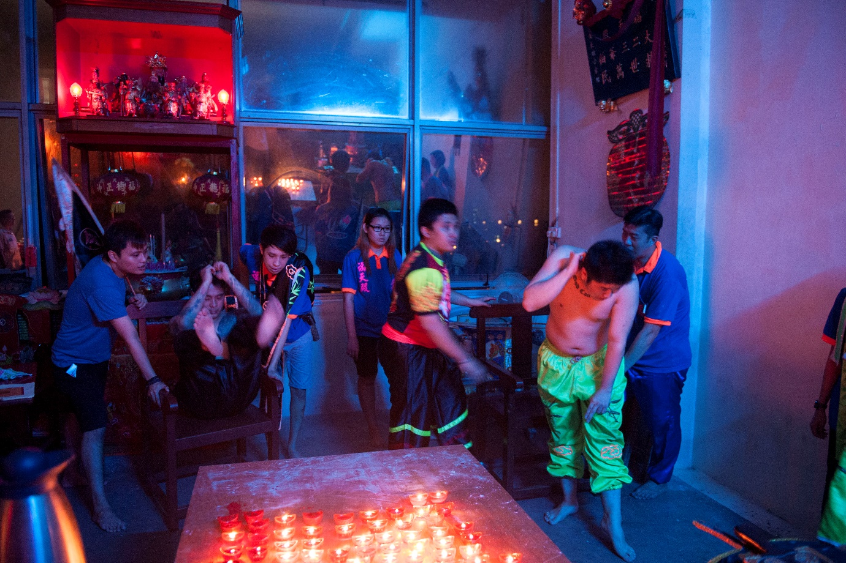
Figure 3: In previous work (Heng 2016), I have noted how unofficial sacred spaces can work with Chinese Religion practitioners because when in a trance, the tang-ki’s body acts as an anchor to temporal sacred space. In becoming a deity, the tang-ki also becomes the locus around which sacred space revolves.

Figure 4: Sa Ya Pek, or Third Uncle, appears from behind the wall to greet devotees as part of the Sin Tua’s Hungry Ghost Festival celebrations. An enforcer of the underworld, Sa Ya Pek is said to have been deified for his filial devotion to his mother, for whom he cried himself to death for.

Spirits at Home
The home is a paradoxical place of precarity for Tang-ki – whilst many own their flats, they must also abide by the rules set out by the state, but conversely are compelled to serve and shelter their Gods, installing large altars in the living room (see also Kong and Tong 2006). As shown in Hao’s flat in Figure 1, such devotion often leads to the objects themselves appropriating more mundane living space.
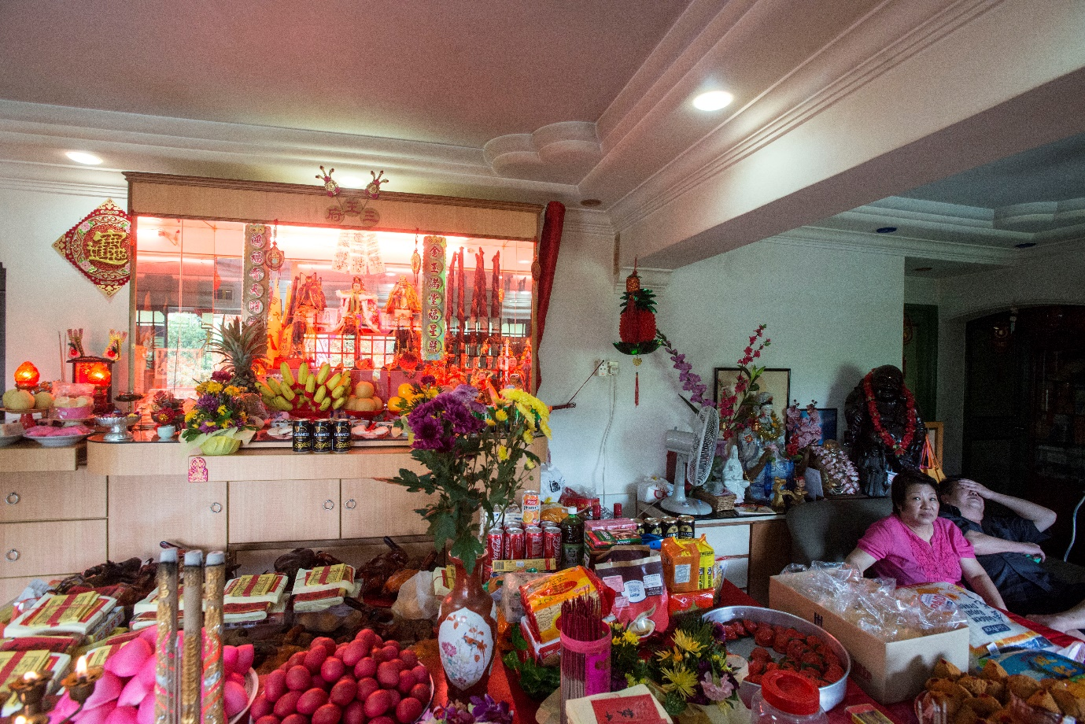
Figure 5: Many Tang-ki operate from their homes, and echo of the old spirit altars in shophouses. The next three photographs shows a “pop-up” Sin Tua – one that only appears once a year for the extended family. Jeffrey inherited the mantle from his late mother, whose vestments still hang in the family home.

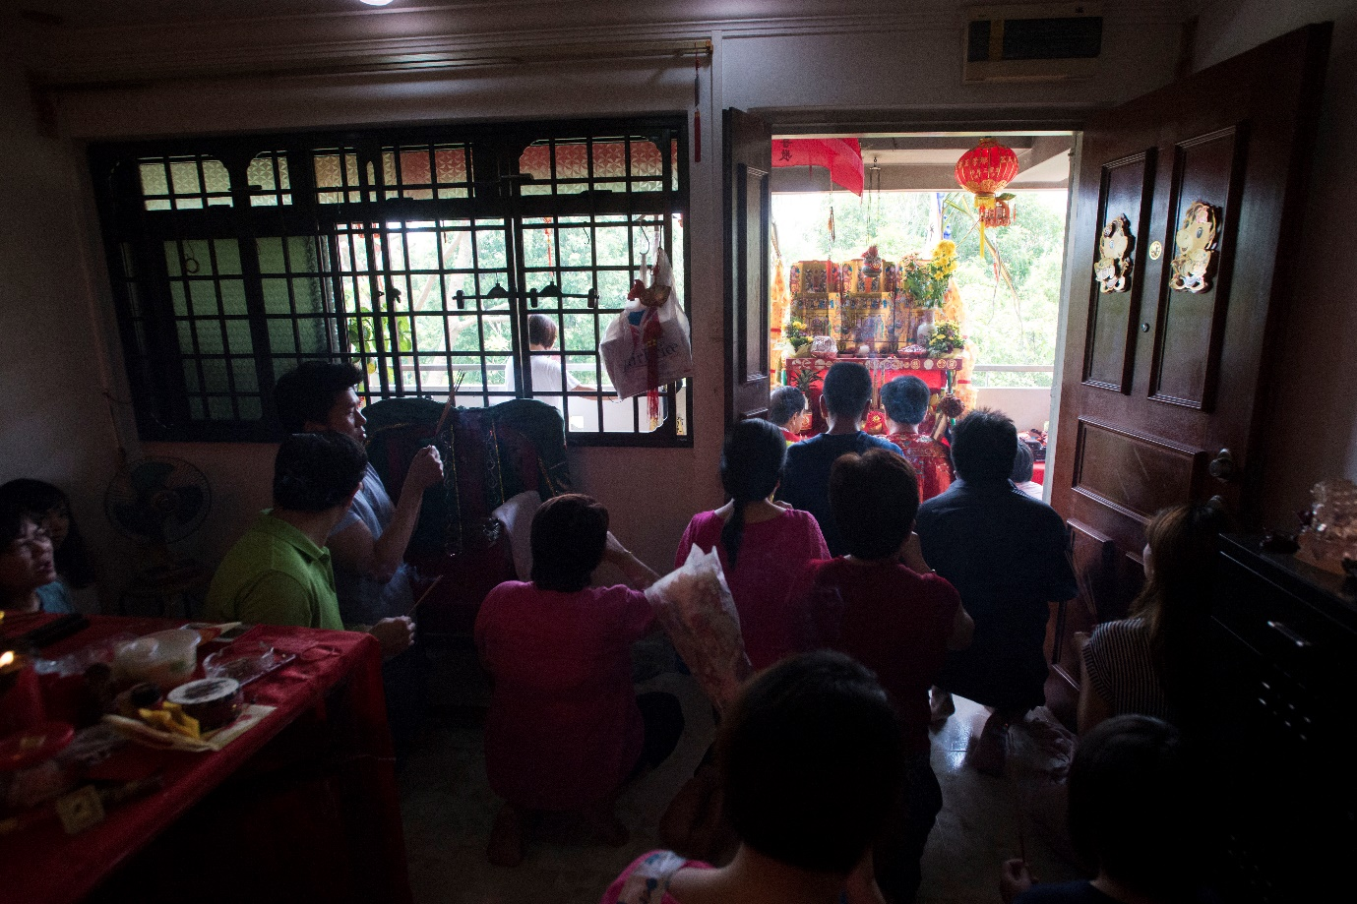
Figure 6: The extended family pay respects to the Jade Emperor, whose altar is temporarily located in the common corridor of these Housing Development Board (HDB) flats.

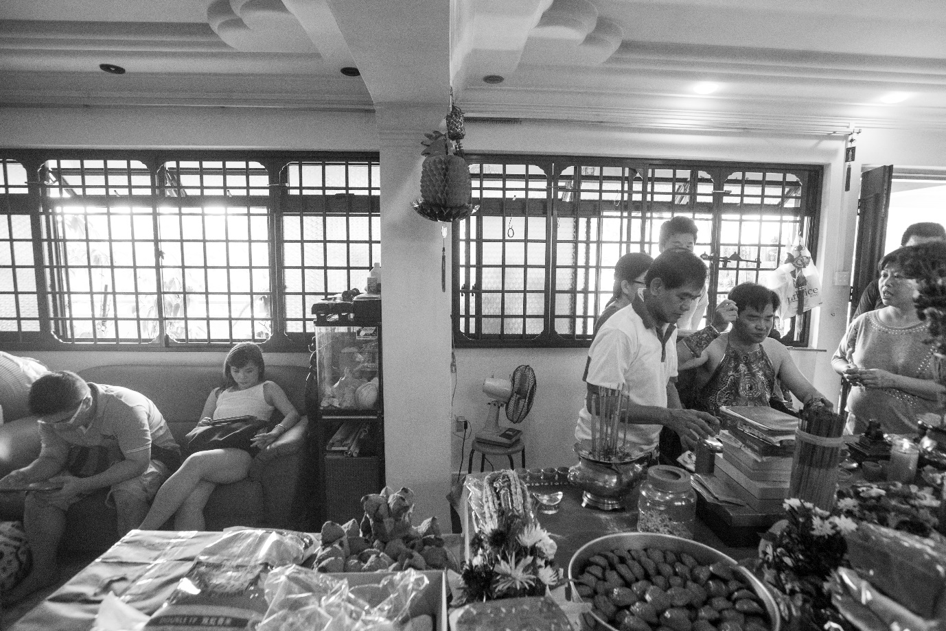
Figure 7: Like many Tang-ki, Jeffrey had little say in serving his Gods. Once chosen, many mediums say they are compelled to serve by setting up a spirit altar, sometimes after many years of resistance and failed secular ventures. Permitted or otherwise in social housing, their Gods require a home.

Spiritual Risks
Chinese Religion devotees do not simply deal with risk in the physical and legal world, but also with the spiritual realm. To exist in this world is to exist in a fluid space between physical and spiritual – man, God and ghost. There are always spirits around, some benign, others meaning to do one harm. Chinese Religion rituals are thus not just about piety or prosperity, but also about gaining protection and appeasing the unseen.

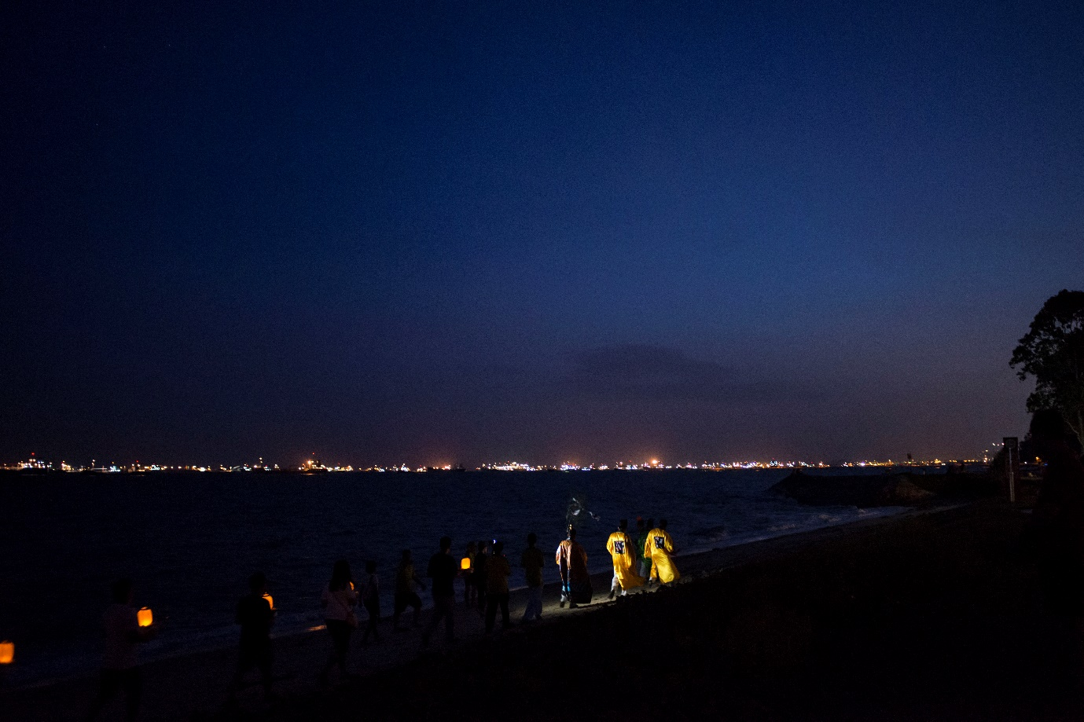
Figure 8: Taoist priests on East Coast Parkway beach summon souls lost at sea to preach to during the Hungry Ghost Festival.

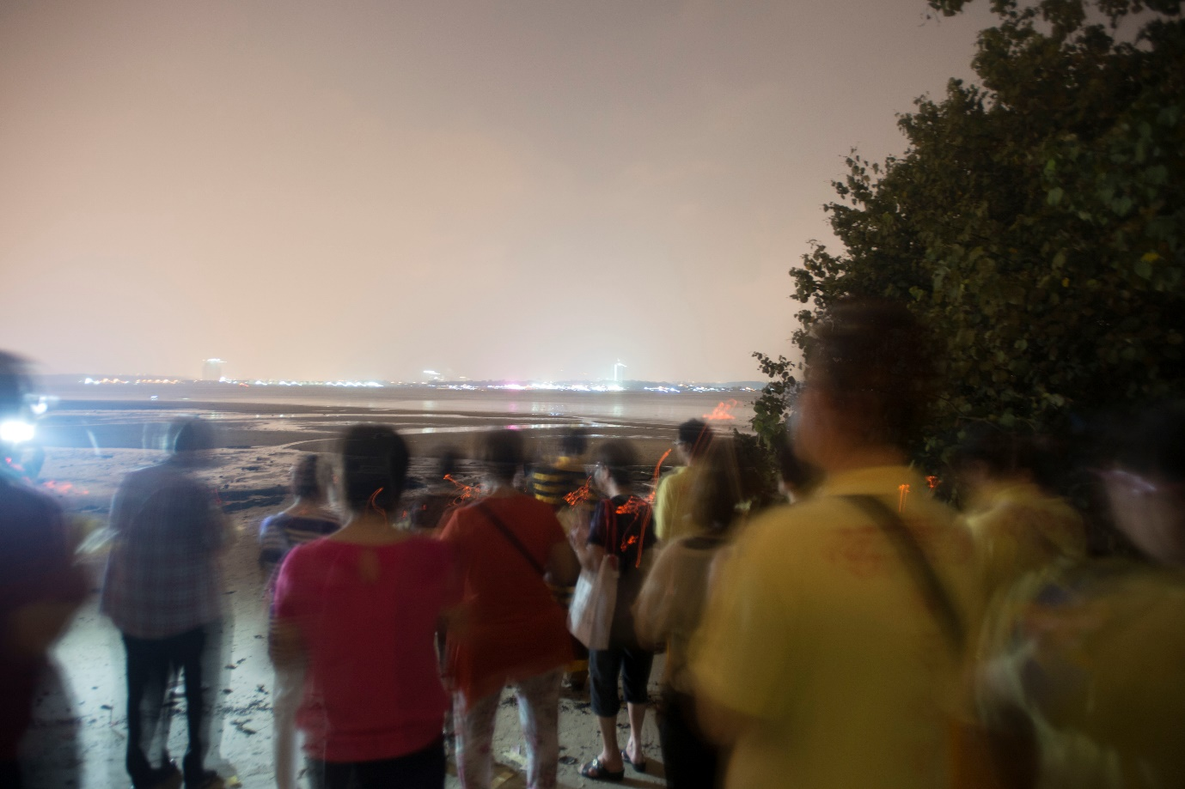
Figure 9: Devotees on a pitch-black beach prepare to walk towards the sea to invite souls in, also during the Hungry Ghost Festival. Without their Tang-ki as Di Ya Pek (or Second Uncle, another netherworld deity), the beach is dangerous, rife with spirits meaning to do one harm.

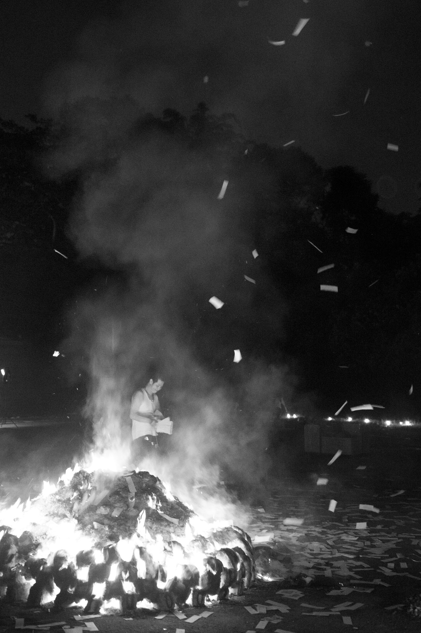
Figure 10: Individuals performing spiritual charity for souls in Bukit Brown Cemetery. Despite the cemetery being seen as a spiritually unclean area, it is also a site for reverence and filial piety. Individuals and groups see it as their duty to engage in this kind of spiritual risk by visiting such sites to make offerings.
References
CHONG, Terence - HUI, Yew-Foong
2013. Different Under God: A Survey of Church-going Protestants, Singapore: Institute of South-East Asian Studies.
CLAMMER, John
1991. The Sociology of Singapore Religion: Studies in Christianity and chinese Religion, Singapore: Chopmen.
CLAMMER, John (ed.)
1983. Studies in Chinese Folk Religion in Singapore and Malaysia, Singapore: Contributions to Southeast Asian Ethnography.
DEBERNARDI, Jean Elizabeth
2012. The Way that Lives in the Heart: Chinese Popular Religion and Spirit Mediums in Penang, Malaysia Singapore: NUS Press.
HENG, Terence
2014. Hungry ghosts in urban spaces: A visual study of aesthetic markers and material anchoring, in: Visual Communication 13(2):147–162.
HENG, Terence
2015. An appropriation of ashes: transient aesthetic markers and spiritual place-making as performances of alternative ethnic identities, in: The Sociological Review 63 (1):57–78.
HENG, Terence
2016. Making Unofficial Sacred Space: Spirit Mediums and House Temples in Singapore, in: Geographical Review 106(2):215–234.
HENG, Terence - HUI, Yew-Foong
2015. Diaspora after Death: A Visual Essay of Bukit Brown Cemetery in Singapore, in: ISA E-Symposium 5(3)
KONG, Lily
1993. Ideological hegemony and the political symbolism of religious buildings in Singapore, in: Environment and Planning D: Society and Space 11(3):23–45.
TAN, Chee Beng
2018 Chinese Religion in Malaysia, Leiden: Brill.
WOODS, Orlando
2013. Converting houses into churches: the mobility, fission, and sacred networks of evangelical house churches in Sri Lanka, in: Environment and Planning D: Society and Space 31(6):1062–1075.
WOODS, Orlando
2018. Religious urbanism in Singapore: Competition, commercialism and compromise in the search for space, in: Social Compass

