Automatic Shading Detection System for
Photovoltaic Strings

Jieming Ma
Dept. of Computer Science and Software Engineering, Xi’an Jiaotong-Liverpool University, Suzhou, China
Sch. of Elec and info. Engineering, Suzhou University of Science and Technology, Suzhou, China
jieming.ma@xjtlu.edu.cn
Ziqiang Bi, Ka Lok Man, Yong Yue
Dept. of Computer Science and Software Engineering,
Xi’an Jiaotong-Liverpool University, Suzhou, China
{ziqiang.bi, ka.man, yong.yue}@xjtlu.edu.cn

Jeremy S. Smith
Dept. of Electrical Engineering and Electronics
University of Liverpool
Liverpool, UK
J.S.Smith@liverpool.ac.uk

Abstract— Partial shading is one of the main factors that affect the output power of series-parallel photovoltaic (PV) strings. However, physical irradiance measurement instruments (e.g. pyranometers and pyrheliometers) are seldom used in commercial PV systems due to their high cost. This paper proposes an automatic shading detection system for estimating the shading rate by using voltage sensors. The main features of the proposed method are the utilization of a reduced number of sensors, a simple switching control strategy and the high detection rate. The feasibility and effectiveness of the proposed shading detecting system is validated through experiments.
Keywords--Partial shading scenarios; shading detection; photovoltaic systems.

Introduction
Even in near-ideal solar locations, partial shade from passing clouds, neighboring buildings, trees or dust is inevitable in photovoltaic (PV) strings. Early studies have shown that partial shade can dramatically cut an entire solar string’s output [1]. Bypass diodes serve as a protection mechanism that allows the PV module to continue producing power in partial shading scenarios (PSS) [2]. Experiments demonstrate that the power-voltage (P-V) characteristic curves of PV strings obtain multiple peaks in PSS. Therefore, knowing the PSS information is of significance for maximum power point tracking (MPPT) control and system maintenance.
Zheng et al. [3] demonstrated that the number of local power points depends on the bypass diode configurations and string topology in PSS. The occurrence of partial shade is usually identified by a sudden significant change in output power. However, it is hard to distinguish the PSS from the rapidly changing atmospheric conditions. Jieming et al. [4] proposed a partial shading detection method in accordance with the relations between module voltage and string voltage, but the system cost is high. Silvestre et al. [5] proposed reference thresholds for detecting PSS based on the errors between simulated and measured capture losses. Although many shading detection methods have been proposed in recent years, few of them can estimate the shading rate [6] of the partially shaded PV systems. In this paper, an automatic shading detection system has been proposed to estimate the shading rate of PV strings. The main features of the detection system are not only the high detection rate, but also the utilization of the reduced number of sensors and the simple control strategy.
This research is supported by the National Natural Science Foundation of China (Grant No. 61702353), the Natural Science Foundation of Jiangsu Province (Grant No. BK20160355), the Science and Technology Project of Ministry of Housing and Urban-Rural Development (Grant No. 2016-K1-019), the Suzhou Science and Technology Project (SYG201603), XJTLU Research Development Funds (RDF-14-02-32 & -17-02-04) and XJTLU Key Program Special Fund (Grant No. KSF-P-02).

Shading Detection System

Voltage measurement system
The sub-string voltage – string voltage (V_{ss}-V_{s}) curves of a PV string with a shaded module are shown in Fig. 1. The bypass diode allows current to pass around M2. The number of unshaded modules would be equal to V_{s}/V_{ss1}, where V_{ss1} is the module voltage of the unshaded M1. In other words, the shading rate χ (the proportion of shaded modules in the PV string), can be estimated as soon as one unshaded module voltage is measured. Thus, the proposed shading detection system estimates the shading rate by measuring the module voltages.
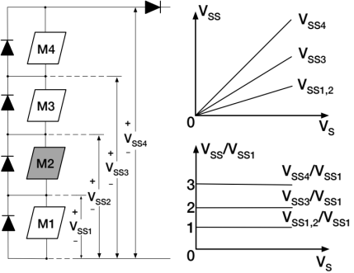
Fig. 1. The V_{ss}-V_{s} characteristics of a PV string in PSS.

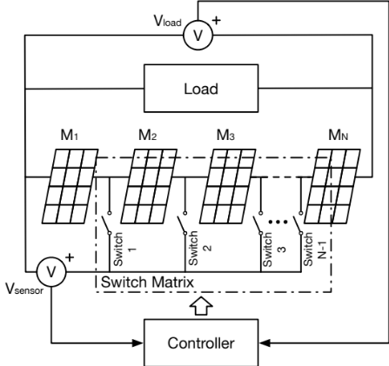
Fig. 2. Block diagram for the proposed shading detection system.
Fig. 2 shows the block diagram of the proposed shading rate detection system for a PV string with (N+1) modules. Only two voltage sensors are utilized in the voltage measurement system. One is used to measure the load voltage V_{load} and the other one is used to measure the module voltage V_{sensor}. A switch matrix is applied to select the measured sub-string.

Switching control strategy
A module is considered as the shaded module if the measured sub voltage is less than threshold voltage V_{threshold} (V_{threshold} = 1V in this paper). A switching control strategy is designed to measure the voltage of the first insolated module as shown in Algorithm 1. The situation that all the modules in the string are shaded is not included as it is trivial for this research. Let i be the switch index (1 ≤ i ≤ N). If a shaded module is detected, switch i will be opened and switch i+1 will be closed. As soon as the system gets the voltage of an insolated module V_{sensor}, the number of the insolated PV modules N_{insolated} can be expressed as:
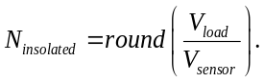 (1)
The shading rate χ can be calculated by the following equation:
(2)
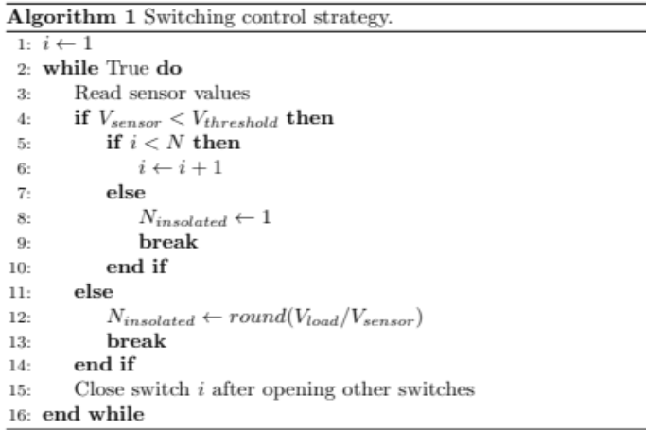

Experimental Results and Discussions
The overview of the experimental setup is shown in Fig. 3. The experimental detection system consists of four 10W PV modules, a DC electronic load (ITECH IT8512A+), an oscilloscope (GWINSTEK GDS-2202A), a voltage sensor module, a relay module and a central controller (UDOO NEO FULL). Experiments were conducted to evaluate the feasibility of the proposed method. The insolated PV modules received about 600 W/m² and shaded modules received 55 W^{/m2}.
Fig. 4 shows the time-sequence results in a rapid changing PSS. The values of V_{sensor} and V_{load} are respectively shown by yellow and cyan lines on the oscilloscope. The bottom red wave is the calculated N_{insolated}. Four different PSS were manually set in the experiment. In T1, all modules were insolated and N_{insolated} = 4. In T2, T4 and T6, it is observed that N_{insolated} was correctly estimated. Due to the sampling interval, the right switches cannot be closed in T3 and T5, which leads to wrong estimates. As soon as controller finishes sampling, the N_{insolated} can be predicted. Besides the above 4 PSS, 10 more possible PSS were set to verify the correctness of the proposed method. No error was found in the experiments.
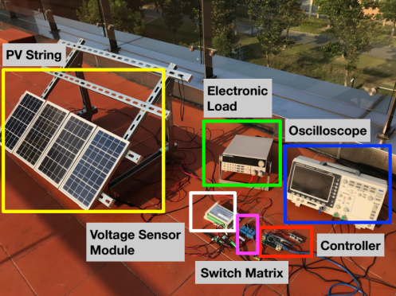
Fig. 3. Experimental setup of the validation system.
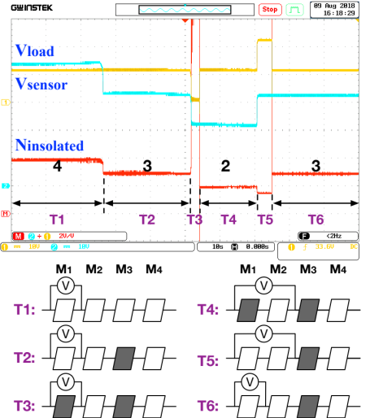
Fig. 4. Experimental results.

Conclusions
This paper has presented a novel automatic shading detection system for PV strings. The shading is detected by using a voltage measurement system with the proposed switching control strategy. Experimental results have shown that the system has the ability to estimate the shading rate effectively.

References
- H. Heydari-doostabad, R. Keypour, M.R. Khalghani and M.H. Khooban. “A new approach in MPPT for photovoltaic array based on extremum seeking control under uniform and non-uniform irradiances.” Solar Energy, 94, pp. 28-36, 2013.
- J. Storey, P. R. Wilson and D. Bagnall, “The Optimized-String Dynamic Photovoltaic Array,” in IEEE Transactions on Power Electronics, vol. 29, no. 4, pp. 1768-1776, 2014.
- H. Zheng, S. Li, R. Challoo, and J. Proano, “Shading and bypass diode impacts to energy extraction of pv arrays under different converter configurations,” Renewable Energy, vol. 68, no. 7, pp. 58–66, 2014.
- J. Ma, T. Zhang, Y. Shi, X. Li and H. Wen, “Shading pattern detection using electrical characteristics of photovoltaic strings,” IEEE International Conference on Power Electronics, Drives and Energy Systems (PEDES) , Conference Proceedings, 2016, pp. 1-4.
- S. Silvestre, A. Chouder, and E. Karatepe, “Automatic fault detection in grid connected pv systems,” Solar Energy, vol. 94, no. 4, pp. 119–127, 2013
- J. Ma, X. Pan, K. L. Man, X. Li, H. Wen and T. O. Ting, “Detection and Assessment of Partial Shading Scenarios on Photovoltaic Strings,” in IEEE Transactions on Industry Applications. Eearly Acces, doi: 10.1109/TIA.2018.284

