An advantage for smooth compared to angular contours in the speed of processing shape

Marco Bertamini1,2  Letizia Palumbo3 Christoph Redies4

*1 Department of Psychological Sciences, University of Liverpool*

*2 Department of General Psychology, University of Padova*

*3 Department of Psychology, Liverpool Hope University*

*4 Institute of Anatomy, Jena University Hospital, Friedrich Schiller University of Jena*

Correspondence:

Marco Bertamini

Department of Psychological Sciences, University of Liverpool

Eleanor Rathbone Building

Bedford Street South

L69 7ZA, Liverpool, UK

[m.bertamini@liverpool.a.cuk](mailto:m.bertamini@liverpool.a.cuk)

**Abstract**

Curvature along a contour is important for shape perception, and a special role may be played by points of maxima (extrema) along the contour. Angles are discontinuities in curvature, a special case at one extreme of the curvature continuum. We report four studies using abstract shapes and comparing polygons (curvature discontinuities at the vertices) and a smoothed version of polygons (no vertices). Polygons are simpler and are defined by a small set of vertices, while smoothed shapes have a continuous curvature change along the contour. Angles have also been discussed as an early signal of threat and danger and, on that basis, one may predict faster responses to polygons. However, curved shapes are more typical of the natural environment in which the visual system has evolved. For a detection task we found faster responses to smooth shapes, not mediated by complexity (Exp 1). We then tested three orthogonal shape tasks: comparison between shapes (detection of repetition) (Exp 2a), comparison after a rotation (Exp 2b), and detection of bilateral symmetry (Exp 3). In all tasks responses for smoothed stimuli were faster; there was also an interaction with type of response: trials with smooth shapes were faster when a positive response was produced. Overall, there was evidence that smooth shapes with continuous change in curvature along the contour are processed more efficiently, and they tend to be classified as targets. We discuss this in relation to shape analysis and to the preference for smoothed over angular shapes.

Keywords: perception, visual preference, curvature, complexity

Word count (excluding abstract and references): 8061

Public significance statement: The study demonstrates that shapes with smooth curvature are processed more quickly and efficiently compared to shapes with sharp angles. This perceptual factor may clarify the link between perception and preference because smooth shapes are known to be preferred.

In his seminal article, Attneave (1954) noted that, along contours, points of maximal curvature carry the greatest information. He designed a now famous example using an image of a cat, reproduced in Figure 1. He selected 38 points of maximal curvature from the boundary contour of the image of a sleeping cat, and connected them with lines. For most people the cat is still easy to recognise. In a second demonstration Attneave asked people to mark salient points along the contour of a random shape. Here too the points selected were close to the locations of maximal curvature. These locations with peaks of curvature (curvature extrema) are the sharp turns along the contour. The idea is that they allow the extraction of an economical description of objects.

The importance of curvature extrema has been studied and confirmed by empirical studies. De Winter & Wagemans (2008) found that participants were most likely to pick up local curvature maxima when asked to mark salient points along the contour line of 2D shapes (see also Norman, Phillips, & Ross, 2001). An explicit representation of curvature has also been implemented within formal models of vision (Asada & Brady, 1984). In general, a role for curvature extrema is acknowledged in theories of shape representation (Cohen & Singh, 2007; De Winter & Wagemans, 2006, 2008; Feldman, & Singh, 2005, Hoffman & Richards, 1984; Hoffman & Singh, 1997; Leyton, 1989). There is also evidence that attention is allocated preferentially to regions near corners (Bertamini, Helmy, & Bates, 2013; Cole, Skarratt, & Gellatly, 2007) perhaps due to the fact that these are more informative locations. Many studies have also highlighted how positive and negative extrema (convexities and concavities) carry information about solid shape (Bertamini & Wagemans, 2013; Hoffman & Richards, 1984; Koenderink, 1984).

Separately from the literature on curvature extrema, there is evidence from experimental aesthetics that smooth curvature along contours or surfaces is preferred to angular contours (Bar & Neta, 2006; Bertamini, Palumbo, Gheorghes, & Galatsidas, 2016; Silvia & Barona, 2009). We review this literature next and then consider a possible link with perception. To fill a gap in the empirical studies, we conducted four experiments to compare angular and smooth versions of abstract shapes on three different perceptual tasks. By angular 2D shapes we mean irregular polygons. These have sharp angles that are easy to see and locate. By smooth 2D shapes we mean similar polygons (generated by the same algorithm) that have been converted into shapes with a continuously changing curvature along the contour. We carefully controlled that the same series of convexities and concavities were present in both sets. To anticipate the results, despite the fact that angular shapes are simpler, we found an advantage in processing smooth shapes on perceptual tasks, and we speculate that this may be a contributing factor to their preference.

Preference for smooth curvature

Shapes with smooth curvature along their contours are preferred to shapes with more angular contours, as observed by both artists and psychologists (for the historical background see Bertamini & Palumbo, 2015, and Gómez-Puerto, Munar & Nadal, 2016). This phenomenon is true for both familiar objects and abstract shapes (Bar & Neta, 2006; Bertamini et al., 2016; Silvia & Barona, 2009), it has been confirmed in different cultures (Gómez-Puerto et al., 2017) in children (Jadva, Hines & Golombok, 2010) and in other species such as great apes (Munar, Gómez-Puerto, Call & Nadal, 2015), and it has been measured also using implicit tasks of preference or approach (Palumbo, Ruta, & Bertamini, 2015; Palumbo & Bertamini, 2016).

The relationship between perception, including attention allocation, and preference is fascinating but complex. If corners are important for shape analysis and attract attention, and if one assumes that stimuli that are salient for perception are also liked more, one could formulate the prediction of a preference for angularity. The same conclusion may be based on a differential in processing speed, which may affect preference through a process of fluency (Reber, Winkielman, & Schwartz, 1998). However, this is the opposite of what the empirical studies have consistently found: smooth shapes are preferred to angular shapes. Bar and Neta (2007) have suggested that this is due to the role of angles in threat detection. Supporting this hypothesis, they found that the amygdala, a structure involved in fear processing, is significantly more active for angular objects compared to similar but less angular objects. Recently, Grebenkina, Brachmann, Bertamini, Kaduhm, and Redies, (2018) found that edge-orientation entropy predicts aesthetic ratings. This factor shares a large portion of predicted variance with the preference for curved over angular stimuli.

The difference in preference between angular and smooth shapes was the original motivation for the current set of studies. Given that the preference for smooth curvature is a robust effect, we need to know more about how shapes with smooth curvature along their contours are perceived.

Reasons to expect faster responses to angular or to smooth shapes

We set out to explore the difference between shapes with angular and smooth contours for different perceptual tasks. A case can be made to expect faster responses to shapes with angular contours, but an alternative case can be made to expect faster responses to shapes with smooth contours.

One hypothesis is that angular shapes, because of their relative simplicity, because of the salience of angles (Cole, Skarratt, & Gellatly, 2007; Bertamini, Helmy, & Bates, 2013), or because of the threat association (Bar & Neta, 2006; Larson, Aronoff, Sarinopoulos & Zhu, 2009; Larson, Aronoff, & Stearns, 2007), will generally lead to faster responses. The opposite is also possible. Small changes in orientation may facilitate contour integration (Field, Hayes, & Hess, 1993; Bex, Simmers & Dakin, 2001). A smooth contour is a contour in which at any point change of orientation is small, compared to the abrupt change for an angular shape, therefore contour integration is more efficient for smooth contours. Neurophysiological evidence supports a role for curvature in how shape is encoded in early visual areas, and in particular in V4 (Pasupathy & Connor, 2002), and explicit coding of local curvature is implied by the presence of curvature after-effects (Suzuki & Cavanagh,1998; Gheorghiu & Kingdom, 2007; 2008).

These two hypotheses are extreme scenarios. It is important to compare different tasks because advantages and disadvantages may vary depending on the task, for example contour integration may only be relevant when global shape has to be extracted and analysed. Finally, for tasks in which there is a correct and an incorrect answer there can also be differences in criterion, with observers more willing to provide a positive response to some shapes than others. For example, Brodeur, Chauret, Dion-Lessard, and Lepage (2011) have reported that in a memory task there is a bias to classify symmetrical shapes as familiar. This was not a difference in sensitivity but in response bias.

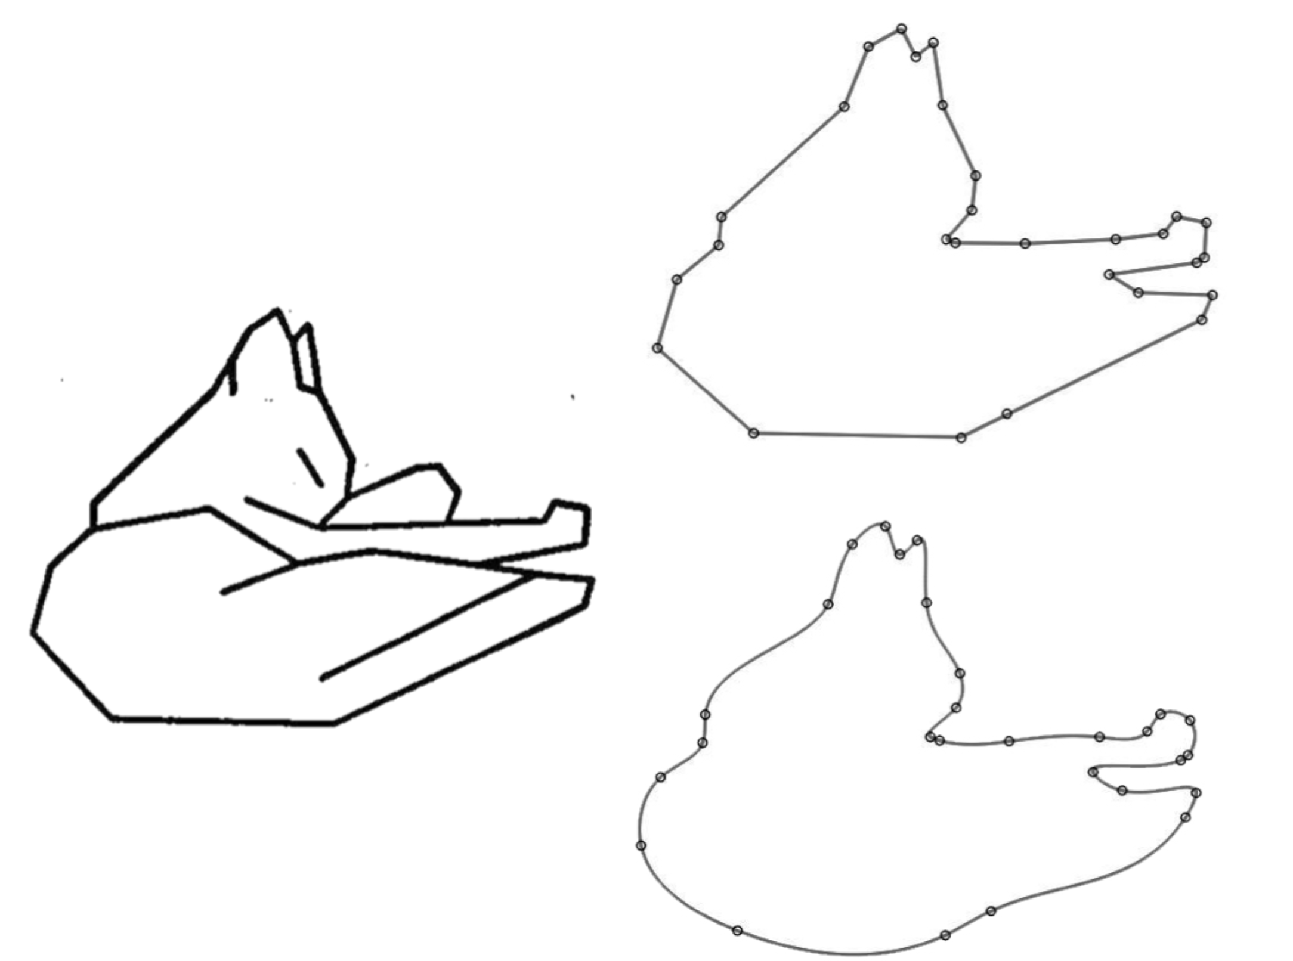

*Figure 1.*The image on the left shows a reproduction of the original demonstration by Atteneave (1954) with 38 vertices. The original photograph of a cat is not available. The polygon (top right) is based on 28 vertices around the outside of the image, and the last image is a version of the same shape with smooth contours. Without information inside the shape it is hard to recognise the cat, but angular and smooth versions have similar overall information.

Summary of experiments

In Experiment 1 we used a simple task in which observers had to respond to the shapes on the basis of whether they belong to one or the other of the two categories. In this task observers had to press a key as soon as a stimulus appeared on screen when it was angular (in one set of trials) or when it was curved (in a different set of trials). This can therefore be described as a variation on the inhibition control procedure (Logan & Cowan, 1984). We used abstract shapes that were either angular (polygons) or curved (smoothed version of polygons) and varied in complexity. The aim was to test whether angular shapes produce faster responses than smoothly curved shapes.

For Experiment 2 we wanted a task in which the whole shape had to be processed. We presented two shapes side by side and the task was to judge whether they were the same. They could be either both angular or both curved (never a mix of the two). The aim was to test processing of global shape while the angularity of the stimuli was not task relevant. In Experiment 2a the shapes were presented side by side, in Experiment 2b the task was harder because one shape was rotated by 180 degrees.

The aim for Experiment 3 was to test the role of shape in a symmetry detection task. As in Experiment 2 the task required processing of the whole shape. The comparison in this case was between two contours, which could match (bilateral symmetry) or be different and unrelated (asymmetrical). The information about whether the contours were angular or smoothly curved was not relevant for the task.

For both Experiment 2 and 3 the study was designed to record and analyse speed of responses and errors. In a separate analysis we measured sensitivity and response bias using a signal detection approach. However, the task was easy because we wanted to minimise errors, and therefore we are aware that given the focus on response time we are likely to see a ceiling effect in terms of correct responses.

To estimate the expected effect size we looked at a study in which the observer was presented with simple polygons, and the task was to discriminate between two different shapes (Bertamini & Farrant, 2006). The dependent variable was response time and the average effect size over the three experiments was 0.28 (partial 𝜂*2* ) and therefore 0.62 (Cohen f). We used G*Power (Version 3.1.9; Faul, Erdfelder, Buchner, & Lang, 2009) and entered this effect size, an alpha of 0.05 and a power of 0.95. For a main effect in an ANOVA with repeated measures the necessary sample size was 11. We decided on a more conservative sample size of 26 and made also an explicit decision that this sample size would be kept the same across all our experiments.

Experiment 1: Detection response time

There were two parts in this experiment. During the first part the observer produced a response (pressing the space bar) when an angular shape was shown on the screen and waited without responding when a smooth shape was shown on the screen. In another set of trials, the observer produced a response when a smooth shape was shown, and waited without responding when an angular shape was shown. If no response was produced the shape disappeared after 4 seconds. Every participant performed both type of tasks in a balanced design. The aim was to see whether observers are faster to produce a response to one or the other of the two types of shapes. The positive response to a specific type of stimulus was inspired in part by the existing techniques using response inhibition (e.g. go no-go task, Nosek & Banaji, 2001).

The stimuli were always unfamiliar abstract shapes, and no shape was ever repeated twice within a task. The colour of the shape was lighter than the background or darker than the background (with equal probability). Therefore, in one case the onset of the stimulus coincided with an increase in luminance and in the second case it coincided with a decrease in luminance.

To vary the complexity of the shapes we varied the number of vertices. The polygon could have 10, 20 or 30 vertices. In addition, we controlled number of convexities and concavities, as this is likely to affect perceived part structure (Bertamini & Wagemans, 2013). Concavities could be 30%, 40% or 50% of the total number of vertices. Therefore for 10 vertices concavities were 3, 4 or 5, for 20 vertices they were 6, 8 or 10, and for 30 vertices they were 9, 12 or 15.

Method

*Participants*. Twenty-six participants took part (mean age: 24; 2 left handed; 14 females). All participants had normal or corrected to normal vision. They provided a written consent for taking part and received course credits. The experiment was approved by the Ethics Committee of the University of Liverpool and was conducted in accordance with the Declaration of Helsinki (2008).

*Stimuli and apparatus*. Stimuli were created using python and Psychopy (Peirce, 2007). The shapes were generated by sampling locations along a circle, and connecting these locations to create a polygon. When sampling a location for a vertex, the radius (i.e. distance from the centre) was not kept constant. Instead, it varied randomly between 110 and 210 pixels. Therefore, the polygon was irregular. The locations (sides of the polygon) were either 10, 20, or 30. Concave vertices were 30%, 40% or 50% of the total number of vertices. The way that convex and concave vertices formed a sequence was not constrained, and therefore more than one convex or more than one concave vertex could follow each other creating more complex convexities or concavities. Alternating convex and concave vertices would have created highly regular star patterns.

To create smooth stimuli, we started with a polygon and generated a smoothed version by fitting a curve through the vertices using a cubic spline (see Bertamini et al. 2016 for a similar approach). The smoothed contour did pass through all the vertices of the original polygon. The difference between the curved and angular stimuli can be seen in Figure 2. Note that these are some examples because in every trial we used a different set of vertices and therefore no shape was repeated twice during one session (i.e. one task). In other words, there were 252 different shapes. Approximate size (max diameter) was 8 cm. The stimuli are available from: https://osf.io/4278q/

The background was a uniform grey (approximate luminance 59 cd/m2). The colour of the shape could be either lighter than the background (68 cd/m2) or darker than the background (53 cd/m2). This factor is called Colour and it implies that the onset could be an increase or a decrease of luminance.

Participants sat at approximately 60 cm of distance from the screen. Stimuli were presented on a 1280 × 1024 pixels Apple StudioDisplay 21" Cathode Ray Tube (CRT) monitor at 60 Hz.

**

*Figure 2.*Experiment 1: Examples of angular stimuli (left) and smooth contour stimuli (right). Stimuli could be darker than the background (top) or lighter (bottom). The three rows show the three levels of number of vertices: 10, 20 or 30. The three columns show the three levels of percentage of concave vertices.

*Experimental Design and Procedure*. A 2 × 2 × 3 × 2 × 2 design was employed. The within-subjects factors were Task (angular, curved); Shape (angular, curved); Colour (light, dark); Complexity (10, 20, 30) and Concavity (30%, 40%, 50%). The only between-subjects factor was the order of the tasks, whether they responded to angular first or to curved first. The experiment lasted approximately 40 minutes.

The experiment began with the instructions followed by the practice session (18 trials). Each trial started with a fixation cross at the centre of a grey background. This fixation lasted randomly between 500 and 1500 ms. After that the shape appeared and remained on screen until response. The response was entered with the space bar on a computer keyboard. Responses had to be entered within 4000 ms of stimulus onset, otherwise the trial would end, and the program would move on to the next trial. In total there were 504 experimental trials, divided in two sessions with 252 trials for each of the two tasks.

Analysis

A mixed ANOVA was performed with Shape (angular, curved), Colour (light, dark), Complexity (10, 20, 30) and Concavity (30%, 40%, 50%) as within-subjects factors and Order (angular first, curved first) as between-subjects factor.

The dependent variable was the response time. We inspected the distribution, which was limited at one end by the 4000 ms maximum time for a response. In terms of wrong responses, there are two possible errors. First, participants press the space bar when they should not do so. Second, participants do not press the space bar when they should (and therefore time reached 4000 ms). Errors were rare, and all errors (2.5% of trials in total) were removed. The analysis was carried out on the trials on which subjects were required to produce a response. In addition, responses below 250 ms were removed because they were likely to be anticipation errors. They were extremely rare (0.05% of trials). Over all the remaining trials the mean response time was 692 ms and the standard deviation was 363 ms.

Results and discussion

The response time results are illustrated in Figure 3. The ANOVA confirmed a main effect of Shape (F(1,24)=5.08, p=0.034, partial 𝜂*2* =0.17) with faster responses to smooth shapes. A main effect of Complexity (F(2,48)=23.89, p<0.001, partial 𝜂*2* =0.50) with responses becoming slower as Complexity increased. A main effect of Colour (F(1,24)=4.37, p=0.047, partial 𝜂*2* =0.15) with responses faster when the shapes were lighter than the background. A main effect of Concavity (F(2,48)=5.87, p=0.005, partial 𝜂*2* =0.20), due to slower responses for the stimuli with 50% concave vertices.

In terms of interactions, there was an interaction between Colour and Order (F(1,24)=4.98, p=0.035, partial 𝜂*2* =0.17) and a three way interaction between Colour, Order and Complexity (F(2,48)=3.71, p=0.032, partial 𝜂*2* =0.13). It seems that there were faster responses to light stimuli when they were responded to first.

There were also some interactions involving Shape: and interaction between Shape, Complexity and Concavity (F(4,96)=5.47, p<0.001, partial 𝜂*2* =0.19) and between Shape, Complexity, Concavity and Colour (F(4,96)=4.09, p=0.004, partial 𝜂*2* =0.15). Interpreting these effects required post-hoc analyses. Because of its importance for our hypothesis we conducted three separate tests of the effect of Shape and Complexity at each of the three levels of Concavity. We wanted to see if the effect of these two key factors would be present in each subset of data. These were three repeated measures ANOVA and we adjusted the alpha levels (from 0.05 to 0.008).

For 30% concave vertices we confirmed the same effects of Shape and Complexity as in the main analysis. There was an effect of Shape (F(1,25)=20.51, p<0.001, partial 𝜂*2* =0.45) with faster responses to smooth shapes, an effect of Complexity (F(2,50)=15.17, p<0.001, partial 𝜂*2* =0.38) with responses becoming slower as complexity increased, and an interaction (F(2,50)=6.65, p<0.003, partial 𝜂*2* =0.21): for angular stimuli the slope was steeper as Complexity increased.

For 40% concave vertices there was an effect of Shape (F(1,25)=8.72, p<0.007, partial 𝜂*2* =0.26) with faster responses to smooth shapes, and an effect of Complexity (F(2,50)=21.57, p<0.001, partial 𝜂*2* =0.46) with responses becoming slower as Complexity increased. By contrast, for 50% concave vertices there was only a significant effect of Complexity (F(2,50)=14.01, p<0.001, partial 𝜂*2* =0.36) with responses becoming slower as Complexity increased.

These analyses show that constraining the amount of concavities can affect the comparison between angular and smooth stimuli. To understand this effect, it is useful to look at the stimuli in Figure 2: with many alternating convex and concave vertices the smooth stimuli become very angular. Indeed, paradoxically, when a concave vertex is between two convex vertices and the distances are small the curve has to turn very sharply to reach the vertex, creating a very pointy feature, one that may be sharper than when the vertices are connected by straight lines. In other words, some of the 50% concave stimuli may have been too complex and therefore degenerate to the point that angular and smooth versions would be hard to discriminate.

The method used to produce smooth contours starting from polygons implies that for smooth contours the length of the contours will be slightly longer, and the area slightly greater. On average the length was 1261 and the area 78057 for angular stimuli, and 1320 and 78802 for smooth stimuli. These are pixels and squared pixels values. As a percentage the smooth shapes were 4.4% longer and 0.9% larger than the angular shapes. To check the relationship between these parameters and response time we looked at Pearson correlations over all trials. There was a correlation, as expected, between length and area (𝜌=0.468, p<0.001) but no correlation between length and response time (𝜌=0.006, p=0.503) and between area and response time (𝜌=0.001, p=0.952).

Difference in contour length and complexity are not likely to explain the faster response to smooth shapes based on other considerations as well. A much larger difference in contour length was present as a function of number of vertices. On average the length was 1102, 1266, and 1511 for 10, 20 and 30 vertices respectively. This difference produced slower responses to the stimuli with longer perimeter, the opposite pattern compared to the faster responses to smooth contours. We referred to the factor number of vertices as complexity. There is an interesting pattern with slower responses to more complex stimuli (in terms of contour length and number of vertices) but faster responses to more complex stimuli (in terms of smooth change of orientation of the contour).1

Observers responded faster when they had to produce a response to smooth shapes. There were other factors such as Complexity and Colour that influenced response time, however the effect of Shape did not interact with any other factor. The overall difference was of 50 ms in favour of the smooth contours. Speed of responses did not correlate with length of the contour; it did increase with complexity as defined by number of vertices, while it decreased with smoothness. This apparent paradox may be understood in terms of the task. With an increase in number of vertices angular and smooth stimuli become more similar because smooth stimuli become more and more pointy. Therefore, the discrimination task was harder and response time longer. Importantly, this phenomenon can explain the effect of number of vertices, but it cannot explain why responses were faster to smooth stimuli.

**

*Figure 3.* Results of Experiment 1. Mean response time as a function of Shape, Colour, Complexity (number of vertices) and Concavity (percentage of concave vertices). Error bars are ± 1 SEM.

Post-hoc analysis of image complexity

We have stated that smooth stimuli are more complex. Therefore, we decided to add an analysis of image complexity. We calculated two additional measures of objective image complexity for all stimuli. The first measure (here termed Gradient) is based on luminance gradient images that are used to calculate Histograms of Oriented Gradients (HOGs; Dalal & Triggs, 2005). The gradients are calculated using the Matlab function *gradient*. The mean of all gradient strengths in the gradient image is used as a measure of the objective complexity of each image. Low values indicate small changes in luminance gradients, and high mean values large changes. For a detailed explanation of how this measure is calculated, see Braun et al. (2013, Appendix). The second measure is Edge density and represents the sum of all Gabor filter responses in an image, using a bank of 24 oriented Gabor filters, as described in more detail in Redies et al. (2017). The higher the Edge density, the more complex is the image.

The graphs in Figure 4 show mean values for the two objective complexity measures as a function of two different factors of Experiment 1 (number of vertices and shape), and the scatterplots show how complexity relates to reaction time. The total number of trials was 13104 but because each observer only responded to one category at a time we have response time for half of these total (6552).

It is clear that both measures of complexity strongly depend on the number of vertices. In addition, independent of number of vertices, Figure 4 also shows that smooth stimuli were more complex than angular stimuli. The two scatterplots show that response time increases with objective complexity. This result is not surprising, as we had already seen that response time increases with number of vertices.

Next, we used a regression model to test the contribution of Shape (angular versus smooth) and objective complexity. As Gradient and Edge density were highly correlated for our stimuli (𝜌=0.99) we selected only one of them (Gradient) for the regression. Gradient was centered by subtraction of the mean. We used linear mixed-effects models (lme4 package; Bates, Mächler, Bolker, & Walker, 2015) in R version 3.3.3. The model included Shape and Gradient as factorial fixed effects. Participants were a random factor and in addition we included Number of vertices as a second random factor. This is because the shapes with 10, 20 and 30 vertices are different types of objects and response time varies with this factor. However, we are interested in evaluating the role of shape and complexity and we are not interested at this stage in the role of number of vertices. The effects of the fixed predictors were tested via likelihood-ratio (𝜒2) comparisons through the sequential decomposition of the model.

There was a significant negative effect of Shape (𝛽 = -0.02, 𝜒2(1) = 79.24, p < .001), but no significant effect of Gradient (𝛽 = 0.59, 𝜒2(1) = 3.10, p=0.08) and no interaction (𝛽 = 0.28, 𝜒2(1) = 1.34, p=0.25). This mixed-effects model accounted for 0.9% of the variance without the random effect structure and 32.6% when it was included (𝑅2m= 0.009, 𝑅2c = 0.326). This analysis confirms that the role of Shape is a strong predictor of response time, even in comparison to objective measures of complexity.



*Figure 4.* Average Gradient and Edge density as a function of Shape and Number of vertices. Scatterplots with regression slopes showing the increase in response time (sec) as a function of Gradient and Edge density.

Experiment 2a: Shape difference task

In Experiment 1 local information about straight lines or curvature were sufficient to perform the task. For example, people could look at one edge of the shape and judge whether it was a straight line or not. A straight line has always the same type of curvature (zero curvature) while a curved contour can vary greatly in terms of curvature. In Experiment 2 we wanted a task in which observers had to process the shapes and respond to a global shape property. We used a task in which two angular or two smooth shapes were presented side by side and observers judged whether the two were identical or not. Therefore, local information is not sufficient, two shapes may have local similarities but are the same only if they match in every aspect of the contour. Straight edges for example would be present in both shapes for the angular condition. Note also that unlike Experiment 1 the type of shape (angular or smooth) was irrelevant to the task.

Method

*Participants*. Twenty-six participants took part in Experiment 2 (mean age: 23; 1 left handed; 12 females). All participants had normal or corrected to normal vision and provided a written consent for taking part. The experiment was approved by the Ethics Committee of the University of Liverpool and was conducted in accordance with the Declaration of Helsinki (2008).

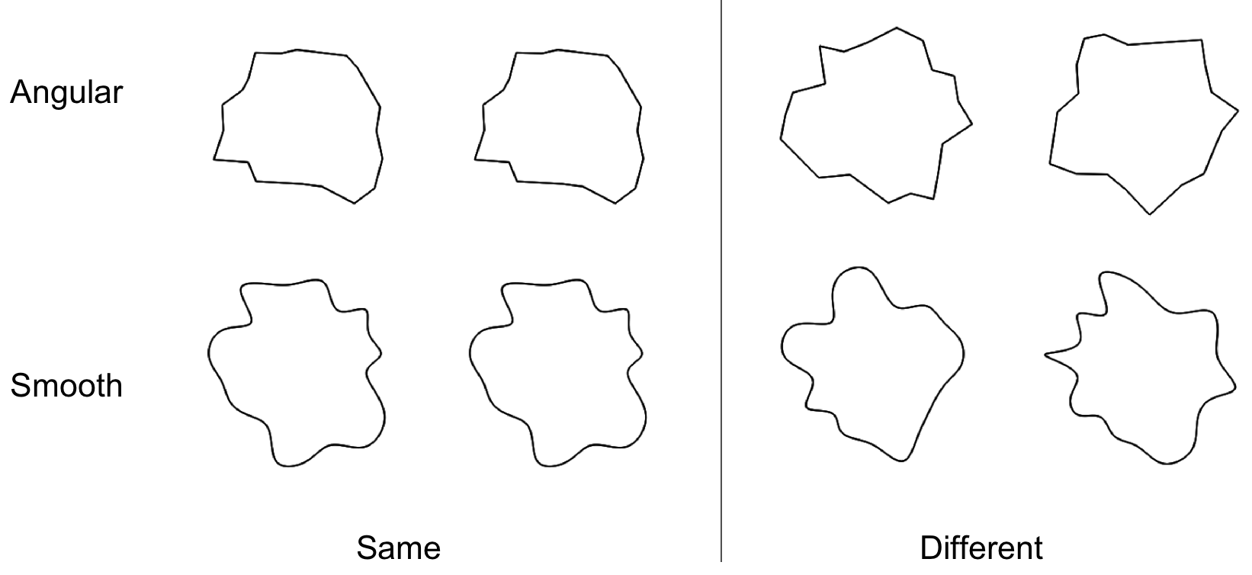

*Figure 5.*Experiment 2a: Examples of angular and smooth stimuli. The first panel shows examples in which the pair of shapes matches ("same") and the second panel shows examples in which the pair did not match ("different").

*Stimuli and apparatus*. The stimuli were generated using a procedure similar to that in Experiment 1, and the apparatus was the same. The underlying circle for the generation of the polygon was smaller (the radius varied between 75 and 125 pixels). Unlike Experiment 1 the stimuli were not filled, and the number of vertices was always 22. They were shown as black contours on a white background. These stimuli are different from Experiment 1 because we wanted to maximise the contrast for the contour information. Angular and smooth shapes are therefore easy to discriminate but this was not the task in Experiment 2.

On each trial there was a pair of shapes presented, one to the left and one to the right of fixation. The distance between the centres was 320 pixels. Examples of stimuli are shown in Figure 5. Stimuli are available for download from: https://osf.io/4278q/

*Experimental Design and Procedure*. A 2 × 2 × 2 design was employed. The within-subjects factors were Shape (angular, curved) and Congruency (same, different). The between-subjects factor was the hand mapping: half of the participants used the right hand to respond "same" and the left hand to respond "different" and the other half of the participants did the reverse. No pair of stimuli was ever presented twice. The experiment lasted approximately 30 minutes.

The experiment began with the instructions followed by the practice session (6 trials). Each trial started with a fixation cross at the centre of a white background. This fixation lasted randomly between 600 and 1600 ms. After that the pair of shapes appeared and remained on screen until response. In total there were 180 experimental trials. Other aspects of the procedure were the same as in Experiment 1.

Analysis

A mixed ANOVA was performed with Shape (angular, curved) and Congruency (same, different) as within-subjects factors and Key mapping (mapping of right and left hands to the same/different responses) as between-subjects factor.

The dependent variable was the response time. Only correct responses were analysed in the ANOVA. Errors were 4% of the total. In addition, responses above 4381 ms were removed (2 standard deviations above the mean, 1.8% of the trials). After this process the average response time was 1388 ms and the standard deviation was 760 ms. In addition to the analysis on response time we also used a signal detection theory approach and compared d' and c' measures for sensitivity and bias (Macmillan & Creelman, 2004).

Results and discussion

The results are illustrated in Figure 6. The effect of Shape in the ANOVA was marginal (F(1,24)=3.93, p<0.059, partial 𝜂2=0.14). There was an interaction between Shape and Congruency (F(1,24)=5.58, p<0.027, partial 𝜂2=0.19). Finally, there was a three-way interaction between Shape and Congruency and Key mapping (F(1,24)=6.12, p<0.021, partial 𝜂2=0.20). The pattern for response time can be compared with the pattern for errors in Figure 6. Error rate was low, and there is no evidence of a speed-accuracy trade off.

The d' values were 3.84 for angular shapes and 2.88 for smooth shapes. The c' was used as a measure of bias and the values were 0.015 for angular shapes and -0.004 for smooth shapes. Positive values indicate a bias to respond different and negative values a bias to respond same. A t-test analysis did not confirm any significant difference between the two shapes in terms of sensitivity (t(25)=-0.70, p=0.490) or bias (t(25)=1.11, p=0.278). This analysis found mean differences that were consistent with the analysis of response time, but it was not conclusive as level of performance was high and therefore d' values suffered from a ceiling effect.

Let us compare the results of Experiment 2a with those of Experiment 1. Responses to shapes with smooth contours were only slightly faster than responses to angular contours (by 26 ms). We have to consider this together with the interaction between Shape and Congruency. A tendency to respond faster when producing a "same" rather than a "different" response was associated with the smooth contours. This can be seen as consistent with the results from Experiment 1, because in that study participants had to produce a positive response (i.e. produce a key press) to either of the two shapes, and they were faster for the smooth contours. It may be easier to produce a positive response to smooth contours, and a negative response to angular contours, in agreement with the results from the measure of approach/avoidance (Palumbo et al., 2015).

The three-way interaction complicates the pattern. Perhaps not surprisingly there was a tendency to respond more quickly if the "same" response is associated with the right hand (by 211 ms), although Key mapping, a between-subjects variable, was not significant as a main effect. But this role of key mapping manifested itself in terms of making the other differences less pronounced for the group of participants who responded "same" using their right hand.



*Figure 6.* Results of Experiment 2a. On the left performance is plotted as a function of Shape (above: response time; below: errors). On the right the graph shows the three-way interaction between Shape, Congruency, and Key Mapping. Mapping right means the response "same" was given with the right hand. Mapping left means the response "same" was given with the left hand. Error bars are ± 1 SEM.

Experiment 2b: Shape difference task

We conducted a second version of the shape matching experiment. There were two main modifications. The main change was about orientation: when a pair of identical shapes was presented, one was always rotated 180 deg compared to the other. We reasoned that this forced the observer to a more global processing of the shape, perhaps by means of a mental rotation, and a comparison of the structural description of the whole object. We also predicted that the task would be harder and response time longer.

The second change was about the match of the stimuli in terms of perimeter length. In Experiment 1 and 2a we used stimuli with similar area and perimeter, but because of how smooth shapes were generated, they had a slightly longer perimeter compared to angular stimuli. In Experiment 2b we decided to match perimeter length precisely. Therefore, we prepared stimuli so that each angular shape had a corresponding smooth shape with the same total perimeter. In all other respects Experiment 2b was the same as Experiment 2a.

Method

*Participants*. Twenty-six participants took part in Experiment 2b (mean age: 28; 1 left handed; 19 females). All participants had normal or corrected to normal vision and provided a written consent for taking part. The experiment was approved by the Ethics Committee of the University of Liverpool and was conducted in accordance with the Declaration of Helsinki (2008).

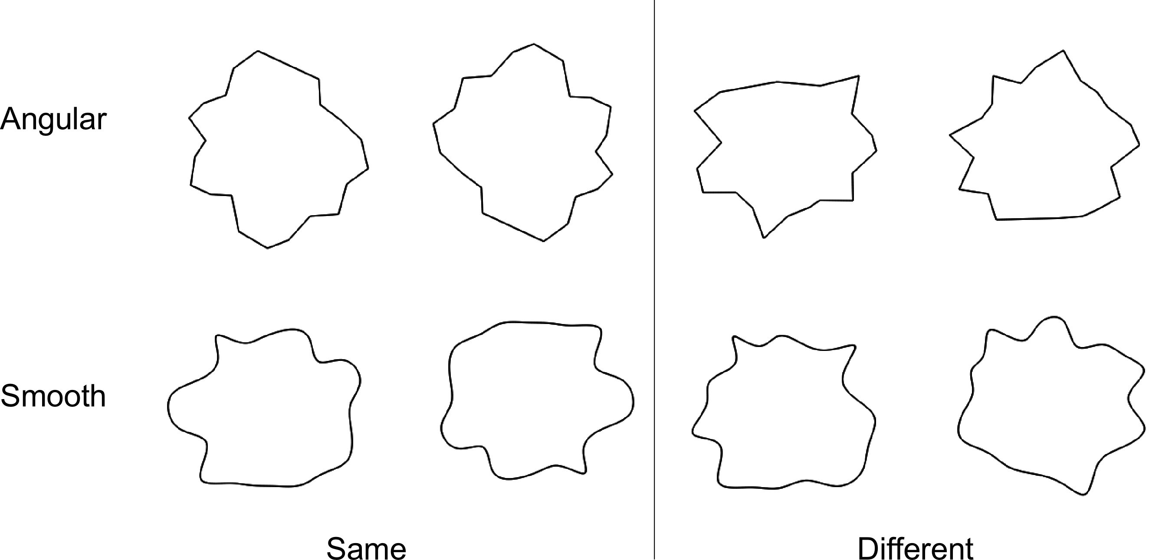

*Figure 7.*Experiment 2b: Examples of angular and smooth stimuli. The first panel shows examples in which the pair of shapes matches ("same") and the second panel shows examples in which the pair did not match ("different"). Note the difference in orientation (180 deg) in the matching pair. Perimeter length was matched so each smooth subset had a matched angular subset. In these examples the perimeter is 742 pixels. In the experiment values ranged between 647 and 814 pixels.

*Stimuli and apparatus*. The stimuli were generated using a procedure similar to that in Experiment 2a, and the apparatus was the same. On each trial there was a pair of shapes presented, one to the left and one to the right of fixation. For each pair of angular shapes in one trial, the total length of the perimeter was matched to a pair of smooth shapes in another trial. On average total perimeter was 742 pixels (for angular and for smooth shapes, and also for same and for different trials). The distance between the centres was 320 pixels. Examples of stimuli are shown in Figure 6. Stimuli are available for download from: https://osf.io/4278q/

*Experimental Design and Procedure*. A 2 × 2 × 2 design was employed. The within-subjects factors were Shape (angular, curved) and Congruency (same, different). The between-subjects factor was the hand mapping: half of the participants used the right hand to respond "same" and the left hand to respond "different" and the other half of the participants did the reverse. No pair of stimuli was ever presented twice. The experiment lasted approximately 30 minutes. The procedure was the same as in Experiment 2a.



*Figure 8.* Results of Experiment 2b. On the left performance is plotted as a function of Shape (above: response time; below: errors). On the right the graph shows the three-way interaction between Shape, Congruency, and Key mapping. Error bars are ± 1 SEM.

Analysis

A mixed ANOVA was performed with Shape (angular, curved) and Congruency (same, different) as within-subjects factors and Key mapping (mapping of right and left hands to the same/different responses) as between-subjects factor.

The dependent variable was the response time. Only correct responses were analysed in the ANOVA. Errors were 10.4% of the total. In addition, responses above 5382 ms were removed (2 standard deviations above the mean, 4% of the trials). After this process the average response time was 1999 ms and the standard deviation was 1013 ms. In addition to the analysis on response time we also used a signal detection theory approach and compared d' and c' measures for sensitivity and bias.

Results and discussion

The results are illustrated in Figure 8. There was a significant effect of Shape (F(1,24)= 48.38, p<0.001, partial 𝜂2=0.67). There was an effect of Congruency (F(1,24)=9.51, p=0.005, partial 𝜂2=0.28). Finally, there was a two-way interaction between Shape and Key mapping (F(1,24)=6.21, p=0.020, partial 𝜂2=0.21). The pattern for response time can be compared with the pattern for errors in Figure 8. Error rate was higher than in Experiment 2a, but there is no evidence of a speed-accuracy trade off.

The d' values were 2.67 for angular shapes and 2.85 for smooth shapes. The c' was used as a measure of bias and the values were 0.001 for angular shapes and 0.020 for smooth shapes. Positive values indicate a bias to respond different and negative values a bias to respond same. A t-test analysis did not confirm a significant difference between the two shapes in terms of sensitivity (t(25)=-1.66, p=0.109) or bias (t(25)=-0.70, p=0.490). As for Experiment 2a there was some limitations due to ceiling effects, but not to the same extent.

The results of Experiment 2b were in the same direction but more clear-cut than those from Experiment 2a. The task was much harder, and observers were forced to perform a more global analysis of the shape because the "same" pair was presented with different orientations. Responses to shapes with smooth contours were faster than responses to angular contours (by 235 ms). Moreover, the tendency to respond faster when producing a "same" rather than a "different" response in the case of smooth contours was not significant (i.e. no significant interaction between shape and congruency).

Experiment 3: Symmetry

In Experiments 2a and 2b we used a task in which two shapes had to be compared. This can be thought of as a detection of a translated or rotated shape. In Experiment 3 we used a pair of contours and asked observers to compare them and to detect bilateral symmetry. The task therefore is similar to that of Experiment 2 in that the global shape is relevant. Also, again consistent with Experiment 2, the distinction between smooth and angular was not relevant for the task. Experiment 3 is, however, different in what type of correspondence the observer had to detect. Contours could be matched under a reflection, and were therefore symmetrical, or they could be unrelated. In addition, the contours were closed to form a single object in one condition, or they were part of two separate objects in another condition. This factor has been found to affect detection of symmetry in previous studies (Baylis & Driver, 1995; Bertamini, Friedenberg & Kubovy 1997; Corballis & Roldan, 1974).

Method

*Participants*. Twenty-six participants took part in Experiment 3 (mean age: 29.4; 1 left handed; 14 females). All participants had normal or corrected to normal vision and provided a written consent for taking part. The experiment was approved by the Ethics Committee of the University of Liverpool and was conducted in accordance with the Declaration of Helsinki (2008).

*Stimuli and apparatus*. The stimuli were generated using a procedure similar to that of Experiment 1. Instead of closed shapes we generated pairs of vertical contours with 10 vertices. They were shown as black contours on a white background. There was always a context of additional straight lines. One context joined the two contours so as to form a single vertically oriented object. We call this the One-object condition. The other context joined the contours to form two closed shapes with an empty space in between the contours. We call this the Two-objects condition. Examples of stimuli are shown in Figure 7. Stimuli are available for download from: https://osf.io/4278q/

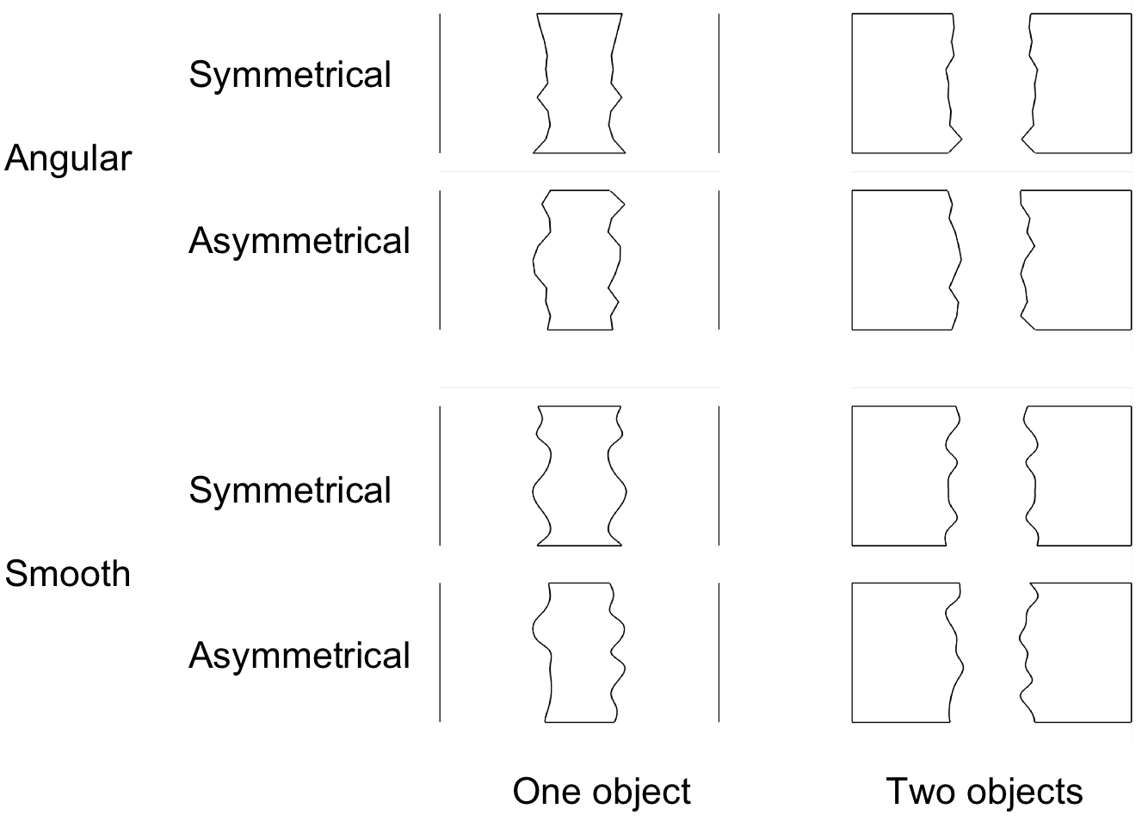

*Figure 9.* Experiment 3: Examples of the stimuli. On the top angular stimuli and on the bottom smooth stimuli. The set of four stimuli on the left show the One-object condition, and the four stimuli on the right show the Two-objects condition.

*Experimental Design and Procedure*. A 2 × 2 × 2 design was employed. The within-subjects factors were Shape (angular, curved), Closure (one object, two objects) and Symmetry (symmetric, asymmetric). The between-subjects factor was the Key mapping: half of the participants used the right hand to respond "symmetrical" and the left hand to respond "asymmetrical" and the other half of the participants did the reverse. The experiment lasted approximately 30 minutes.

The experiment began with the instructions followed by the practice session (8 trials). Each trial started with a fixation cross. This fixation lasted randomly between 500 and 1500 ms. After that the stimulus appeared and remained on screen until response. In total there were 176 experimental trials. Other aspects of the procedure were the same as in Experiment 1.

Analysis

A mixed ANOVA was performed with Shape (angular, curved), Closure (one object, two objects) and Symmetry (symmetric, asymmetric) as within-subjects factors and Key mapping (mapping of right and left hands to the responses) as between-subjects factor.

The dependent variable was the response time. Only correct responses were analysed in the ANOVA. Errors were 4.7% of the total. Responses above 2306 ms were removed (2 standard deviations above the mean, 3.5% of the trials). After this process the average was 839 ms and the standard deviation was 347 ms. In addition to the analysis on response time we also used a signal detection theory approach and compared d' and c' measures for sensitivity and bias.

**

*Figure 10.* Results of Experiment 3. On the left performance is plotted as a function of Shape (above: response time; below: errors). On the right the graph shows the two-way interaction between Shape and Symmetry. Error bars are ± 1 SEM.

Results and discussion

The mean response times are illustrated in Figure 10. The ANOVA confirmed a significant main effect of Shape (F(1,24)=12.74, p=0.002, partial 𝜂*2*=0.35; responses were faster to smooth contours) and a significant effect of Closure (F(1,24)=12.58, p=0.002, partial 𝜂*2*=0.34; responses were faster for one object). There was an interaction between Shape and Symmetry (F(1,24)=6.05, p=0.02, partial 𝜂*2*=0.20) and an interaction between Shape, Symmetry and Key mapping (F(1,24)=8.22, p=0.008, partial 𝜂*2*=0.25). We did not find the expected interaction between Symmetry and Closure (F(1,24)=1.60, p=0.218), although in terms of mean response time the difference is in the predicted direction (a relative advantage for symmetry within a single object).

The pattern of results is shown in Figure 10. In relative terms people are fast when they make positive responses ("same" or "symmetry") to the smooth shapes, and negative responses ("different" or "asymmetrical") to the angular shapes. The pattern for response time can be compared with the pattern for errors. The error rate was low, and there is no evidence of a speed-accuracy trade off.

The d' values were 3.39 for angular shapes and 3.50 for smooth shapes. The c' was used as a measure of bias and the values were 0.034 for angular shapes and 0.002 for smooth shapes. Negative values indicate a bias to respond "symmetry" and positive values a bias to respond "asymmetry". A t-test analysis did not confirm a significant difference between the two types in terms of sensitivity (t(25)=-1.91, p=0.067). There was, however, a difference for the bias (t(25)=2.12, p=0.044). As for Experiment 2, this analysis suffered the limitation of high performance and a ceiling effect, but it does support the conclusion that for smooth shapes there was more of a bias to produce a positive response (in this case for "symmetry") than for angular shapes.

General discussion

We have compared abstract shapes with sharp angles (irregular polygons) and similar shapes with smooth contours. In the first study we tested a speeded response to the onset of the stimulus from a specific category (angular or smooth). Observers could produce the response quickly (overall average response time was 692 ms). Responses to shapes with smooth contours were faster compared to angular shapes (by 50 ms).

In the second study two shapes had to be compared to decide whether they were identical or different. The shapes were outlines and each pair had either both angular or both smooth contours. The task was harder and required an analysis of the whole shape, in particular in Experiment 2b where shapes were both translated and rotated (average response time was 1388 ms in Experiment 2a and 1999 in Experiment 2b). The task in Experiment 2a was easy and probably led to ceiling effects. Moreover, as the match was direct (side by side), it did not force a global processing of the shapes as much as Experiment 2b. In Experiment 2a there was only a trend for participants to be faster when responding to shapes with smooth contours. There was also an interaction between the match between the shapes and the type of shape. Specifically, participants were relatively faster to respond "same" for smooth contours and to respond "different" for angular contours. The advantage for smooth shapes, on the other hand, was clear in Experiment 2b: responses to smooth shapes were faster by 235 ms.

In the final experiment (Experiment 3) observers had to report whether a pair of contours were bilaterally symmetrical or not. This task was slower than the task of Experiment 1 but faster than the task of Experiments 2a and 2b (average response time was 933 ms). Again, responses were faster for smooth contours than to angular contours (by 30 ms). There was also a bias to respond "symmetry" which was stronger for smooth shapes as compared to angular shapes. Note that in Experiments 2a, 2b and 3 the difference in shape (angular or smooth) was completely task irrelevant. Observers were making a judgment about an orthogonal dimension.

How can we explain faster responses to smooth contours, consistently across three different tasks? Given the way the stimuli were generated, the two conditions (angular or smooth) were comparable in terms of overall size (with a slightly larger area for smooth shapes) and in terms of number of convexities and concavities. Differences in perimeter length were small, and in Experiment 2b the stimuli were prepared so as to match perimeter length exactly (using pairs of smooth and angular stimuli matched on this variable). When we varied the number of vertices in Experiment 1, shapes with more vertices (which also appear more angular) were responded to more slowly. It is important to note that the smooth shapes are objectively more complex, in particular in terms of edge orientation along the contour. In a delayed matching task with abstract shapes Kayaert and Wagemans (2009) found that responses were slower and less accurate when complexity increased. However, smooth contours are not judged to be more complex. On the contrary they are subjectively judged as less complex (Bertamini et al., 2016, Experiment 1). This may be because a smooth contour is seen as a single line, by contrast a polygon is segmented in a number of individual lines and therefore perhaps individual parts.

We have argued that angular shapes, and polygons in particular, are simpler than our smoothed polygons. There are many ways to operationalize complexity, and there is a large literature on complexity including the analysis of statistical image properties. The concept of complexity is related to other aspects like fractal dimension and symmetry (Graham & Redies, 2010). The objective complexity of the smooth stimuli was documented for the stimuli in Experiment 1 in an additional post-hoc analysis. This was based on the computation of two objective measures of complexity, called Complexity and Edge density. The type of shape was the best predictor of response time also in the context of complexity as a second predictor.

The results show faster responses to smooth shapes. This finding is interesting, not related to objective complexity, and likely related to the subjective simplicity of these shapes and to the fact that people have a preference for smooth shapes. Previous findings in the literature were mixed, and they come from studies that did not set out to test directly the question of speed of processing as a function of contour type. In Bar and Neta (2006) participants were asked to give a fast preference response (like/dislike) after a brief presentation of the images (84 ms). There was a difference in preference but no significant difference in response times. For real objects and for meaningless patterns the difference between smooth and angular conditions was very small (5 ms and 1 ms respectively). In Experiment 4 in Bertamini et al. (2016) there was an overall effect of shape on response time, but modulated by type of response. There was no difference between angular and smooth shapes for approach responses, and slower responses to smooth shapes for avoidance responses. In other words, there was a difficulty to produce a negative (avoidance) response to smooth stimuli. Nevertheless, this difference raises questions about how to compare different tasks, and in some conditions responses may be slower to smooth stimuli. Note that the approach/avoidance task required an explicit evaluation of contour type: observers had to first decide whether the shape was smooth or angular and then produce different responses. Therefore, this evidence supports our choice of using tasks in which shape was not task-relevant. Next, we provide some context and speculation about the origin of this advantage.

In the introduction we mentioned that the principles of grouping introduced by Gestalt psychologists (for a review, see Wagemans et al., 2013) include proximity and good continuation. Contour integration can be studied by manipulating local orientation of a set of elements. When these elements are aligned along a smooth path (collinearity) sensitivity in a contour detection task increases (Field, Hayes, & Hess, 1993). The stimuli typically used in these studies have become known as snakes (similar local orientation) and ladders (orthogonal local orientation) (Bex, Simmers & Dakin, 2001). Our stimuli are fundamentally different, but it is relevant to note that snakes are related to smooth contours, in that along the contour changes in orientation are always small. If it is easier to integrate contours of this type this advantage may also lead to faster responses, and to a perception of these shapes as less complex. However, angular shapes have good continuity for most of their length. The discontinuity is localised at the vertices. If these local discontinuities are the key difference, then any prediction based on contour integration should be mainly a function of number of vertices. Our experiments did not test this factor directly. When number of vertices was manipulated (Experiment 1) there was no overall interaction between type of shape and number of vertices. Moreover, for preference tasks, number of vertices does not seem to be important. For example, smooth curves (parabola) are preferred to straight lines with or without vertices (Bertamini et al., 2016, Experiment 3). A similar argument can be made about the hypothesis that segmentation of the shape into separate lines is an important factor. If it is true that polygons are perceived as composite objects this could explain the fact that they are judged as more complex, and perhaps that responses are slower. This hypothesis predicts a difference in behaviour as a factor of number of vertices on all tasks.

With respect to the importance of curvature in perception, it is worth noting that curvature plays an important role in how shape is encoded in the brain (Pasupathy & Connor, 2002), and contour information, in particular convexities and concavities, affect perceived part structure (Bertamini & Wagemans, 2013; Hoffman & Richards, 1984). In terms of experimental evidence, differences in contour curvature affect visual search efficiency (Hulleman, te Winkel, & Boselie, 2000; Kristjánsson & Tse, 2001) shape matching (Bertamini, 2008; Garrigan & Kellman, 2011), shape after-effects (Hancock & Peirce, 2008; Gheorghiu & Kingdom, 2008), target detection (Barenholtz & Feldman, 2003) and perceived part structure (Barenholtz, Cohen, Feldman, & Singh, 2003; Bertamini & Croucher, 2003). There are also well-known illusions in which straight lines are perceived as curved (Oppel, 1855; Hering, 1861) or curved lines are perceived as straight (Bertamini & Kitaoka, 2018; Takahashi, 2017).

A more fundamental point has to do with the visual environment. Polygons are simple in terms of geometry and in terms of how they can be drawn on paper or by computers, however they are very artificial and unnatural. If contours are projected outlines of surface occlusion and in particular surface self-occlusion, then smooth contours are more common and natural (for smooth surfaces) (Hoffman & Richards, 1984; Koenderink, 1984; Koenderink, 1990). By analysing images of the natural environment in terms of local edge orientations Sigman, Cecchi, Gilbert and Magnasco (2001) found long-range correlations. There was a pattern of cocircularity for orientation and this pattern extended over the entire visual field. A follow-up analysis by Chow, Jin, and Treves (2002) came to a slightly different conclusion: the data may simply "indicate that there are many closed smooth contours in natural visual scenes". The important point is that, as Sigman et al. suggest, properties of the visual system that integrate edge information match regularities in the environment.

The relative advantage of the visual system to process smooth contours may therefore be seen as a result of the statistics of the natural environment in which the system has evolved. Future work needs to focus on natural statistics. In turn this analysis may also shed light over the robust preference that human observers display for smooth contours.

Acknowledgements

This work was supported in part by the Economic and Social Research Council (ESRC, Ref. ES/K000187/1).

Footnotes

1. We also repeated the ANOVA on response time adding perimeter as covariate. The main results did not change, in particular the main effect of shape (confirming faster responses to smooth shapes).

References

Asada, H. & Brady, M. (1984). *The curvature primal sketch*. MIT AI memo.

Attneave, F. (1954). Some informational aspects of visual perception. *Psychological Review*, *61(3)*, 183-193.

Bar, M., & Neta, M. (2006). Humans prefer curved visual objects. *Psychological Science, 17(8),* 645–648. https://doi.org/10/b62dqj

Bar, M., & Neta, M. (2007). Visual elements of subjective preference modulate amygdala activation. *Neuropsychologia, 45(10)*, 2191–2200. https://doi.org/10/ddsf8f

Barenholtz, E., & Feldman, J. (2003). Visual comparisons within and between object parts: evidence for a single-part superiority effect. *Vision Research, 43*, 1655–1666. https://doi.org/10/bqqgm5

Barenholtz, E., Cohen, E. H., Feldman, J., & Singh, M. (2003). Detection of change in shape: an advantage for concavities. *Cognition, 89(1)*, 1–9. https://doi.org/10/bkfc9c

Bates, D., Mächler, M., Bolker, B., & Walker, S. (2015). Fitting linear mixed-effects models using lme4. *Journal of Statistical Software, 67(1)*, 1-48.

Baylis, G. C., & Driver, J. (1995). Obligatory edge assignment in vision: the role of figure and part segmentation in symmetry detection. *Journal of Experimental Psychology: Human Perception and Performance, 21(6)*, 1323–1342. https://doi.org/10/cj6h23

Bertamini, M. (2008). Detection of convexity and concavity in context. *Journal of Experimental Psychology. Human Perception and Performance, 34(4)*, 775–789. https://doi.org/10.1037/0096-1523.34.4.775

Bertamini, M. & Palumbo, L. (2015). The aesthetics of curvature in historical context. In *Art and its role in the history of the Balkans (between durability and transientisms)*. Published by Faculty of Philosophy, Kosovska Mitrovica, University of Pristina.

Bertamini, M., & Croucher, C. J. (2003). The shape of holes. *Cognition, 87(1)*, 33–54. https://doi.org/10/d562b7

Bertamini, M., & Farrant, T. (2006). The perceived structural shape of thin (wire-like) objects is different from that of silhouettes. *Perception, 35(12)*, 1679–1692. https://doi.org/10/csd7k6

Bertamini, M., & Kitaoka, A. (2018). Blindness to curvature and blindness to illusory curvature. *i-Perception, 9(3)*, 204166951877698. https://doi.org/10/gfr94k

Bertamini, M., & Wagemans, J. (2013). Processing convexity and concavity along a 2-D contour: figure-ground, structural shape, and attention. *Psychonomic Bulletin & Review, 20(2)*, 191–207. https://doi.org/10/f4qn6v

Bertamini, M., Friedenberg J., & Kubovy M. (1997). Detection of symmetry and perceptual organization: How a lock-and-key process works. *Acta Psychologica, 95,* 119-140.

Bertamini, M., Helmy, M., & Bates, D. (2013). The visual system prioritizes locations near corners of surfaces (not just locations near a corner). *Attention, Perception & Psychophysics, 75(8)*, 1748–1760. https://doi.org/10/f5mk6g

Bertamini, M., Palumbo, L., Gheorghes, T. N., & Galatsidas, M. (2016). Do observers like curvature or do they dislike angularity? *British Journal of Psychology, 107(1)*, 154–178. https://doi.org/10/gd84vw

Bex, P. J., Simmers, A. J., & Dakin, S. C. (2001). Snakes and ladders: the role of temporal modulation in visual contour integration. *Vision Research, 41(27)*, 3775–3782. https://doi.org/10/fh6g5b

Braun, J., Amirshahi, S. A., Denzler, J., & Redies, C. (2013). Statistical image properties of print advertisements, visual artworks and images of architecture. *Frontiers in Psychology, 4*, 808. http://dx.doi.org/10.3389/fpsyg.2013.00808.

Brodeur, M. B., Chauret, M., Dion-Lessard, G., & Lepage, M. (2011). Symmetry brings an impression of familiarity but does not improve recognition memory. *Acta Psychologica, 137(3)*, 359-370. doi:10.1016/j.actpsy.2011.04.005

Chow, C. C., Jin, D. Z., & Treves, A. (2002). Is the world full of circles? *Journal of Vision, 2(8),* 4-4

Cohen, E. H., & Singh, M. (2007). Geometric determinants of shape segmentation: Tests using segment identification. *Vision Research*, *47*, 2825–2840.

Cole, G. G., Skarratt, P. A., & Gellatly, A. R. H. (2007). Object and spatial representations in the corner enhancement effect. *Perception & Psychophysics*, *69*, 400-412.

Corballis, M., & Roldan, C. (1974). On the perception of symmetrical and repeated patterns. *Perception & Psychophysics, 16(1)*, 136-142.

Dalal, N., & Triggs, B. (2005). Histograms of oriented gradients for human detection. *International Conference on Computer Vision & Pattern Recognition, 2*, 886–893.

De Winter, J., & Wagemans, J. (2006). Segmentation of object outlines into parts. A large-scale integrative study. *Cognition*, *25*, 275-325,

De Winter, J., & Wagemans, J. (2008). Perceptual saliency of points along the contour of everyday objects: A large-scale study. *Perception & Psychophysics*, *70*(1), 50-64.

Faul, F., Erdfelder, E., Buchner, A., & Lang, A. (2009). Statistical power analyses using G*Power 3.1: Tests for correlation and regression analyses. *Behavior Research Methods, 41*, 1149–1160. doi:10 .3758/brm.41.4.1149

Feldman, J., & Singh, M. (2005). Information along contours and object boundaries. *Psychological Review*, *112(1),* 243–252.

Field, D. J., Hayes, A., & Hess, R. F. (1993). Contour integration by the human visual system: Evidence for a local “association field”. *Vision Research*, *33*(2), 173–193.

Garrigan, P., & Kellman, P. J. (2011). The role of constant curvature in 2-D contour shape representations. *Perception, 40(11)*, 1290–1308. https://doi.org/10/fxmgbf

Gheorghiu, E., & Kingdom, F. A. (2007). The spatial feature underlying the shape-frequency and shape-amplitude after-effects. *Vision Research, 47(6)*, 834-844.

Gheorghiu, E., & Kingdom, F. A. A. (2008). Spatial properties of curvature-encoding mechanisms re- vealed through the shape-frequency and shape- amplitude after-effects. *Vision Research, 48,* 1107– 1124, doi:10.1016/j.visres.2008.02.002.

Gómez-Puerto, G., Munar, E., & Nadal, M. (2016). Preference for curvature: A historical and conceptual framework. *Frontiers in Human Neuroscience, 9*, 712.

Gómez-Puerto, G., Rosselló, J., Corradi, G., Acedo-Carmona, C., Munar, E., & Nadal, M. (2017). Preference for curved contours across cultures. *Psychology of Aesthetics, Creativity, and the Arts*, *12(4),* 432-439. doi:10.1037/aca0000135

Graham, D., & Redies, C. (2010). Statistical regularities in art: relations with visual coding and perception. *Vision Research, 50*, 1503–1509. doi: 10.1016/j.visres.2010.05.002

Grebenkina, M., Brachmann, A., Bertamini, M., Kaduhm, A., & Redies, C. (2018). Edge-orientation entropy predicts preference for diverse types of man-made images. *Frontiers in Neuroscience, 12*, 678.

Hancock, S., & Peirce, J. W. (2008). Selective mechanisms for simple contours revealed by compound adaptation. *Journal of Vision, 8(7)*, 11, 1–10, doi:10.1167/8.7.11.

Hering, E. (1861). *Beiträge zur Physiologie. I. Zur Lehre vom Ortssinne der Netzhaut* [Contributions to physiology. I. The doctrine of the locality of the retina]. Engelmann, Leipzig

Hoffman, D. D. & Richards, W. (1984). Parts of recognition. *Cognition, 18*, 65-96.

Hoffman, D. D., & Singh, M. (1997). Salience of visual parts. *Cognition*, *63*, 29–78.

Hulleman, J., te Winkel, W., & Boselie, F. (2000). Concavities as basic features in visual search: Evidence from search asymmetries. *Perception & Psychophysics, 62(1)*, 162–174. https://doi.org/10/b5k9j5

Jadva, V., Hines, M., & Golombok, S. (2010). Infants’ preferences for toys, colors, and shapes: Sex differences and similarities. *Archives of Sexual Behavior*, *39*, 1261-1273.

Koenderink, J. (1984). What does the occluding contour tell us about solid shape? *Perception, 13,* 321-330.

Koenderink, J. (1990). *Solid shape*. MIT Press.

Kristjánsson, Á., & Tse, P. U. (2001). Curvature discontinuities are cues for rapid shape analysis. *Perception & Psychophysics, 63(3)*, 390-403. https://doi.org/10/b8xb3q

Larson, C. L., Aronoff, J., Sarinopoulos, I. C., & Zhu, D. C. (2009). Recognizing threat: A simple geometric shape activates neural circuitry for threat detection. *Journal of Cognitive Neuroscience, 21(8)*, 1523-1535.

Larson, C.L., Aronoff, J., & Stearns, J. (2007). The shape of threat: Simple geometric forms evoke rapid and sustained capture of attention. *Emotion*, *7*, 526- 534.

Leyton, M. (1989). Inferring causal history from shape. *Cognitive Science*, *13*, 357–387.

Logan, G. D., & Cowan, W. B. (1984). On the ability to inhibit thought and action: A theory of an act of control. *Psychological Review, 91*, 295–327.

Macmillan, N. A., & Creelman, C. D. (2004). *Detection theory: A user's guide*. Psychology Press.

Makovac, E., & Gerbino, W. (2010). Sound-shape congruency affects the multisensory response enhancement. *Visual Cognition, 18*, 133-137.

Munar, E., Gómez-Puerto, G., Call, J., & Nadal, M. (2015). Common visual preference for curved contours in humans and great apes. *Plos One, 10(11)*, e0141106. https://doi.org/10/gfs3wt

Norman, J. F., Phillips, F., & Ross, H. E. (2001). Information concentration along the boundary contours of naturally shaped solid objects. *Perception*, *30*, 1285–1294.

Nosek, B. A. & Banaji, M. R. (2001). The Go/No-go association task. *Social Cognition, 19,* 625-665.

Oppel, J. J. (1855). Über geometrisch-optische Täuschungen [About geometrical-optical illusions]. *Jahresbericht des physikalischen Vereins zu Frankfurt am Main,* 37–47.

Palumbo L. & Bertamini, M. (2016). The curvature effect: a comparison between preference tasks. *Empirical Studies of the Arts, 34*, 35-52.

Palumbo, L., Ruta, N., & Bertamini, M. (2015). Comparing angular and curved shapes in terms of implicit associations and approach/avoidance responses. *PLoS One, 10(10)*, e0140043. https://doi.org/10/gd84v6

Pasupathy, A., & Connor, C. E. (2002). Population coding of shape in area V4. *Nature Neuroscience, 5,* 1332–1338. https://doi.org/10/gfrjgz

Peirce, J. W. (2007). PsychoPy: Psychophysics software in Python. *Journal of Neuroscience Methods*, *162(1)*, 8-13.

Redies, C., Brachmann, A., & Wagemans, J. (2017). High entropy of edge orientations characterizes visual artworks from diverse cultural backgrounds. *Vision Research, 133,* 130--144.

Sigman, M., Cecchi, G. A., Gilbert, C. D., & Magnasco, M. O. (2001). On a common circle: natural scenes and Gestalt rules. *Proceedings of the National Academy of Sciences USA, 98(4),* 1935-1940.

Silvia, P. J., & Barona, C. M. (2009). Do people prefer curved objects? Angularity, expertise, and aesthetic preference. *Empirical Studies of the Arts*, *27*(1), 25-42.

Suzuki, S., & Cavanagh, P. (1998). A shape-contrast effect for briefly presented stimuli. *Journal of Experimental Psychology: Human Perception and Performance, 24(5)*, 1315-1341.

Takahashi, K. (2017). Curvature blindness illusion. *i-Perception, 8(6)*, 204166951774217. https://doi.org/10/gcm3tb

Wagemans, J., Elder, J. H., Kubovy, M., Palmer, S. E., Peterson, M. A., Singh, M., & von der Heydt, R. (2013). A century of Gestalt psychology in visual perception: I. Perceptual grouping and figure-ground organization. *Psychological Bulletin, 138(6)*, 1172–1217. https://doi.org/10/f4cms8