Figure 1: PRISMA flow diagram.
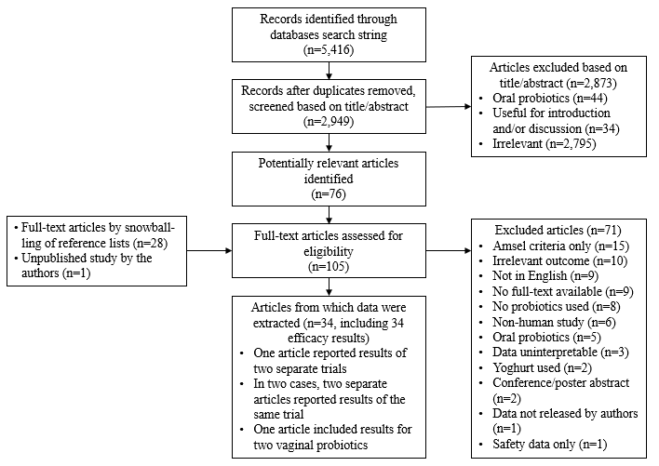

Figure 2: Risk of bias assessments.
A. | B.
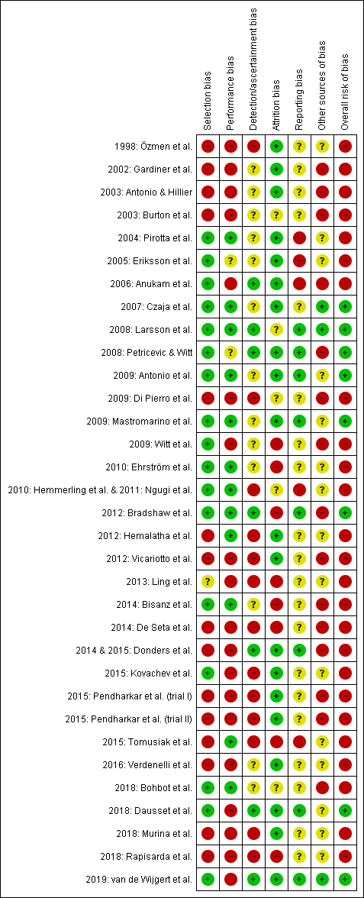 | 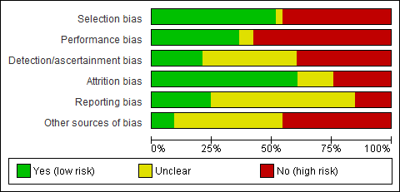
‘Other sources of bias’ included whether confounders were considered (in the eligibility criteria or statistical analyses), intent-to-treat results were reported, and statistical testing was appropriate. A Authors’ judgements about each potential bias for each study, ordered by publication year. Studies with high overall risk of bias (seventh column) are indicated with a minus symbol and studies with medium overall risk of bias with a plus symbol. No studies were judged to have a low overall risk of bias. B Summary of each bias across all 34 studies.

