Comparative analysis of the Lang Stereopad in a non-clinic population
Fiona J Rowe, PhD, Lauren R Hepworth, PhD, Claire Howard, MMedSci, Chung Shen Chean, MBChB, Meera Mistry, MBChB MRes

Department of Health Services Research, University of Liverpool, Liverpool L69 3GL

Address for correspondence:
Prof Fiona Rowe
Department of Health Services Research,
Waterhouse Building Block B,
University of Liverpool,
1-3 Brownlow Street,
Liverpool L69 3GL
T: 0151 7944956
E: rowef@liverpool.ac.uk

Category: Original article
Running title: Lang Stereopad comparisons
Word count: 2801
Number of tables: 1
Number of figures: 4

Conflict of interest: The authors do not have any commercial or proprietary interest in the Lang Stereopad. Lang-Stereotest AG provided the loan of the Lang Stereopad prototype for the conduct of this research study; the company had no role in the design or conduct of this research.

Author contribution: FR provided oversight for the study and led the writing of the paper. FR, LH, CH, CSC, MM contributed to data collection, reviewing the draft paper and approving the final version.

Abstract
Aim: New methods of measurement require testing to evaluate test validity. This study compares stereoacuity results of the Lang Stereopad to other common clinical stereoacuity assessments in a normal vision population.
Methods: A prospective cross-sectional study was conducted comparing the Lang Stereopad stereoacuity results to results from the Lang II, Frisby and TNO stereo tests. Mean stereoacuity values and their correlation with inter-ocular visual acuity difference were compared for each stereo test.
Results: 98 subjects (mean age of 33.5 years, SD 14.1; 39 males and 59 females) with normal parameters of visual function underwent multiple stereotest assessments. Median stereoacuity values were the lowest (i.e. more detailed stereoacuity) when using the Frisby stereotest (median 40”; 20-170” [minimum-maximum]) and TNO stereotest (median 60”; 15-480”). In comparison, medians were about double at 100” (50-800”) for the Lang Stereopad and greater at 200” (200-200”) for the Lang II stereotest. There was no correlation for each stereotest with interocular visual acuity differences.
Conclusions: The Lang Stereopad test is easy to administer and it has certain advantages such as no requirement for additional test glasses. It is a useful assessment to add to the clinical armamentarium for binocular assessment of stereopsis. The Lang Stereopad does not agree well with other stereo tests such as the TNO and Frisby but provides a greater stereoacuity test range than the Lang II. The Lang Stereopad now requires testing in a clinical population in which stereoacuity is a pre-requisite part of the assessment.

Keywords: Lang Stereopad, Lang II, TNO, Frisby, Stereoacuity, Diagnostic accuracy

Introduction
An important aspect of visual function is the ability to appreciate depth (stereopsis/stereoacuity). Depth may be perceived in two forms: binocular disparity (stereopsis) and monocular depth clues in the absence of binocular single vision¹. Stereopsis is the perception of the relative depth of objects on the basis of binocular disparity, which reflects the slight difference in images presented to each eye.
Stereoacuity is the angular measurement of the minimal resolvable binocular disparity which is necessary for the appreciation of stereopsis. The ability to demonstrate stereopsis indicates the presence of retinal correspondence, the normal average level of stereopsis varies dependent on the test being used but typically the threshold stereoacuity ranges from 30-60 seconds of arc in the presence of normal equal visual acuity in each eye¹. The level of stereoacuity decreases with reduction in visual acuity² and there is an age-related deterioration in stereoacuity with a linear correlation between age and stereopsis threshold³.
There are a variety of currently available methods used to test stereopsis. These include the Frisby™, FD2™ (Frisby Stereotests, UK), TNO™ (Haag Streit UK), Randot™ (Precision Vision, USA), Preschool Randot™ test (Stereo Optical, USA), Titmus™ (Precision Vision, USA), synoptophore stereo slides (Haag Streit UK) and Lang™ I and II stereotests (Lang Stereotest AG, Switzerland). All of these are in frequent use in eye clinics, in particular the Frisby, Lang and TNO stereotests.
The Lang stereotests are based on the use of random dot stereograms and cylindrical grating placement (panography) spaced at 24 cylinders per centimeter. Beneath each cylinder, there are two strips of an image, one seen by the right eye and the other seen by the left eye. The two images are fused and the disparity produces stereopsis⁴. The first Lang stereotest consists of three images - cat, car and a star, and the second Lang stereotest consists of four images - the star is a control image and can be seen in the absence of stereopsis, the car, elephant and moon are seen in the presence of stereopsis up to 200 seconds of arc.
The TNO stereotest is based on the use of random dot stereograms. Computer generated random dots are printed as red and green analyphs. Red and green glasses are worn which are complementary colours to the red and green random dots used. It consists of three gross stereoplates, a suppression plate and three graded plates with segmented circle shapes which give a result of 480 to 15 seconds of arc⁵. This is often considered the most accurate test for stereopsis as there are no monocular clues.
The Frisby Near stereotest uses random shapes with displacement and consists of three plastics plates of different thicknesses: 6mm, 3mm and 1mm. On each plate, there are four squares produced by random shapes printed on one side. On the other side corresponding to one of the squares, a disparity is created by printing a circle with random shapes. This gives a real-depth 3D appearance. The test can be held at a range of distances, the disparity is affected by the thickness of the plate and the distance at which the plate is held from the patient, for example when held at 40cms, stereopsis of 340, 170 and 85 seconds of arc can be achieved with the 6, 3 and 1mm plates respectively. The Frisby stereotest is very useful for assessing stereopsis in very young children and patients with easily dissociative strabismus.
Recently a new test has been developed – the Lang Stereopad™ (Lang-Stereotest AG, Switzerland). This test consists of a lenticular surface and random dot patterns, and has a larger range of disparities, from 50” up to 800” (50”, 100”, 200”, 400”, 600” 800”). Each stereo image is shown on a different square shape test card, and these test cards may be placed freely and independently from each other on both sides of the magnetic test plate. Assessment of stereopsis can be tailored to individual clinical requirements. Up to six different test cards may be presented on one side of the test plate. All test cards have 2D-hidden figures; 3D-recognition of the figures is the only criterion for passing the test.
As the Lang Stereopad test is a new test of stereopsis, it requires validation against other standard tests of stereopsis for widespread mainstream clinical use. The aim of this study is to compare the effectiveness of the Lang Stereopad test in detecting and measuring stereopsis in a population with normal visual parameters. In this study it was directly compared to the Frisby test, TNO test and Lang II test to determine ease of assessment, speed of assessment and accuracy of results.

Methods and materials
A cross-section comparative study was undertaken in which subjects with normal corrected binocular near visual acuity and binocular single vision (confirmed by positive Lang II stereotest) underwent stereopsis assessments with Frisby, TNO, Lang II and Lang Stereopad tests. This study had institutional ethical approval and was conducted according to the Tenets of Helsinki.
Subjects
Subjects were recruited from university and hospital staff. Inclusion criteria were adults aged 18 years or older, sufficient cognitive ability to understand and follow instructions when performing the tests, willingness to undertake testing on each stereotest on the same day, near visual acuity of better than 0.2 logMAR (binocular); 0.3 logMAR (uniocular), full ocular motility and absence of manifest strabismus. Subjects eligible for inclusion, and providing consent, underwent assessment following full explanation of the purpose of the tests and procedures.
The study protocol consisted of stereotest assessment with the Lang Stereopad, Lang II, Frisby and TNO stereotests on the same day. The order of testing was randomised as to which of the four assessment types was used first in order to take fatigue effect in to consideration. A short break of 5-10 minutes was allowed between testing. Randomisation was undertaken using a computer generated table. Test-retest was conducted for one-third of subjects. The subjects did not undergo a practice of any tests prior to the study.
Assessment
Subjects underwent assessments of their near visual acuity (high-contrast SKILL card) and binocular single vision to ensure eligibility of inclusion to the study. Following consent and recruitment to the study, each subject underwent four separate tests of stereopsis. All tests were administered as per the manufacturers’ instructions. A tape measure was used to determine and maintain correct test distance for each stereotest.
Lang II
The test was held at 40cms from the subject. Each subject should see the star and was asked what other shapes could be seen. There were two options for responses; 1) The subject could see shapes but not determine what they were – the shape value was recorded as detected; 2) The subject could see shapes and state what they were – the shape value was recorded as recognised. Measured stereoacuity values were 600 seconds of arc (”), 400” and 200” (table 1).
Frisby
The test was initially held at 30cms from the subject. The thickest plate was displayed first and subsequently working through to the thinnest plate if the subject was able to point to where the circle was on each plate. If the circle was seen on the thinnest plate, the plate was moved to 40cms from the subject, the plate was rotated to move the circle and the subject asked to detect the circle again. If seen, the plate was moved to 50cms and repeated, and so on until threshold was reached. When recording, for example if the thinnest plate circle was seen at the 80cm test distance, the value was recorded as 20”. If not, the value was taken as when the circle was last detected. Measured stereoacuity values ranged from 340” to 20”.
TNO
The test plate was held at 40 cms from the subject. Plates V to VII were used to measure stereoacuity. Each plate had four circles with a segment missing. The subject was asked if they could see the top two circles and, if seen, was asked where the segment was missing (top, bottom, their right or their left). This was repeated for the bottom two circles. Each plate was presented until the circles could not be seen or segments were not seen in the correct position. The value was recorded as the last set of circles detected correctly. Measured stereoacuity values ranged from 480” to 15”.
Lang Stereopad
The plate was presented centred to the visual axis, at 40cm from subject. The subject was asked to observe the test cards. The subject was shown and asked to respond to two or three stereo cards which could be reversed, rotated or replaced with new cards, across a range of disparities (Figure 1).
Sample size
We sought to include a minimum sample size of 100 subjects. This sample size is typically used for diagnostic accuracy studies⁶.

Table 1 Available stereoacuity scores for each stereotest
 | Lang Stereopad | TNO | Lang II | Frisby
Range of stereoacuity scores  (” seconds of arc) | 800 – 50 | 480 – 15 | 600 – 200 | 600 – 20
Available stereoacuity scores  (” seconds of arc) | 800, 600, 400, 200, 50 | 480, 240, 120, 60, 30, 15 | 600, 400, 200 | 600, 340, 300, 215, 170, 150, 110, 85, 75, 55, 40, 30, 20

Data collection and analysis
All results were recorded in numerical format and were collected using data recording sheets. Direct comparisons were made for each stereotest using the statistical package SPSS version 24 (IBM SPSS Statistics, USA) and Prism 7 software (Graphpad, USA). Descriptive statistics were provided with means (and standard deviations) and medians (with ranges). Comparison of stereoacuity results between stereotests was analysed using non-parametric (Wilcoxon) tests. Comparison of stereoacuity test-retest results within stereotests was analysed using non-parametric (Wilcoxon) tests. Bland-Altman plots were used to assess the extent of agreement between stereotests for the mean stereoacuity results. Stereoacuity results in seconds of arc were converted with log¹⁰ transformation for this analysis.

Results
One hundred and five subjects were recruited to this study. Seven subjects were excluded with visual acuity in one eye of 0.5 logMAR. Mean age was 33.5 years (SD 14.0, figure 2) for 39 males and 59 females. Mean visual acuity for right and left eyes respectively was 0.14 (SD 0.09) and 0.12 (SD 0.08) logMAR with a mean interocular difference of 0.03 (SD 0.05). Binocular visual acuities were all better than or equivalent to 0.2logMAR.
All subjects provided measurable results on all tests. The testing distances for the Lang Stereopad, Lang II and TNO were consistently at 40cms as per their instruction manuals. The testing distance for the Frisby changed from 30 to 80cms dependent on the stereoacuity ability of the participant. The lowest (i.e. best) stereoacuity values were obtained using the Frisby stereotest at distances up to 80cms (median 40”, minimum-maximum range 20” - 170”; mean 55.71” (SD 37.8”)) with the highest values being obtained using the Lang II test at a distance of 40cms (median 200”,no range). The median and mean values for the Lang Stereopad were 100” (range 50” – 800”) and 162.2” (SD 173.1”) respectively. In comparison to the other stereotests, the Lang Stereopad provided better stereoacuity values than the Lang II test (p=0.009) whilst stereoacuity values obtained by TNO (median 60”, range 15 – 480”) and Frisby stereotests were significantly better than the Lang Stereopad (p=0.0001).

Mean and median values for each stereotest are outlined in table 2.

Bland-Altman plots of differences versus averages of stereocuity log arc sec values show wide confidence intervals across the stereotest comparisons to the Lang Stereopad (Figure 3). The 95% tolerance limits of agreement, defined as 1.96 SD above and below the mean difference, are -0.469 and 0.858 log seconds of arc for the Lang Stereopad versus TNO test, -0.324 and 1.067 for the Lang Stereopad versus Frisby test, and -0.493 and 0.848 for the TNO versus Frisby test. The 95% tolerance limits of agreement are wide, reflecting the variation between the two test values.Comparisons are not reported for the Lang II stereotest because of the ceiling effect; with most subjects achieving 200”.
Test-retest results were obtained for 36 of the 98 subjects. There were no significant differences for retest stereoacuity values for any stereotest (table 2).

Table 2 Stereotest comparisons
 |  |  |  |  |  | (Retest matched pairs comparisons)
 | Lang stereopad | TNO | Lang II | Frisby |  | Lang stereopad | TNO | Lang II | Frisby
Mean (SD) | 162.24(173.06) | 103.93 (109.71) | 200 (0) | 55.71 (37.79) |  | 145.31 (165.76) | 90.94 (98.62) | 200 (0.00) | 60.47 (44.09)
Median  (Min, Max) | 100  (50, 800) | 60  (15, 480) | 200  (200, 200) | 40  (20, 170) |  | 100  (50, 800) | 60  (30, 480) | 0  (200, 200) | 40  (40,170)
Units: seconds of arc (”) |  | Stereopad vs TNO,  P<0.0001 | Stereopad vs Lang II, p=0.009 | Stereopad vs Frisby, p<0.0001 |  | p=0.425 | p=0.429 | X | p=0.865
TNO vs Frisby
p<0.0001
 |  | Wilcoxon test |  |  |  | Wilcoxon test

Discussion
Median reported stereoacuity thresholds in the literature in young adult populations with normal visual parameters are typically 20” with the test used at distances of up to 80cms^{1,7}. At a testing distance of 40cms, mean stereoacuity of 143” was reported by Simons using the Frisby test⁸. Our mean Frisby results were 55.71” measured at 80cms. Stereoacuity values using the TNO test range from a median of 60” to a mean of 83.2” ^{1,9}. In comparison, our mean TNO stereoacuity value was 103.93”. These differences likely represent the different populations, age ranges and inclusion criteria across these studies.
In this study, we primarily sought to compare the results of the Lang Stereopad to commonly used stereotests in our current clinical practice – Frisby, Lang II and TNO stereotests. Results of the Lang Stereopad were similar to those obtained with the Lang II stereotest but with higher values (less detailed stereoacuity) than results obtained with the TNO and Frisby stereotests. The Frisby stereotest obtained the lowest (i.e. best) stereoacuity results. Test-retest was undertaken for a third of our subjects and showed no significant difference in results across all tests during repeated assessment. We expected poorest stereoacuity values from the Lang II card given the nature of the test as a screening assessment with a ceiling effect of 200”. Our results with Lang II agreed with the other stereotest results to the extent possible in that subjects who scored their best of 200” on Lang II also scored 200” or better on other stereotests. The Lang Stereopad, Frisby and TNO stereotests allow assessment of stereoacuity to disparities of 50”, 20” and 15” respectively at test distances of 40, 80 and 40 cms respectively. They use different stimuli and tasks in their measurement of stereoacuity. Our results show comparable stereoacuity measurements obtained with the Frisby and TNO stereotests but poorer stereoacuity obtained with the Lang Stereopad with measurements about double those obtained with the Frisby or TNO stereotests.
The Lang Stereopad is a recently released new test of stereoacuity which can be used for rapid screening as well as threshold measurement of stereoacuity and can be used with a preferential looking technique with disparities ranging from 800” to 50”. The stereo cards consist of a lenticular surface and random dot patterns, similar to the Lang I and II stereotests, and are placed interchangeably on a small magnetic board. Additional glasses are not required for testing, such as with other sterotests such as TNO, Titmus and Randot. This is an advantage of the Lang Stereopad, Lang II and Frisby stereotest. A common issue with stereoacuity tests is that monocular cues may arise when stereo tests are administered incorrectly. Further, lateral movements of the subject’s head can elicit the presence of an object but does not allow discrimination of 3D aspects. Such issues apply also to the new Lang Stereopad test.
A limitation of this study is that we did not formally record the time taken to complete each individual stereotest. Thus we cannot provide accurate test times for each stereotest. In practice, however, the Lang Stereopad was noted to take longer to administer than the Lang II, with similar test durations to the Frisby and TNO stereotests. A further limitation of this study is that most of our subjects were in the 25-30 years old age range. Thus, we could not accurately plot effect of increasing age on the level of stereoacuity. Test-retest could only be performed on a third of subjects because of time constraints for the subjects. When using the Lang Stereopad, we followed manufacturer instructions, which included presentations of two or three cards at a time. Using two cards can increase the chance of a lucky guess so future studies should consider optimum number of cards for presentation during testing.

Conclusion
In conclusion, we report the stereoacuity results of the new Lang Stereopad in an adult population with normal ocular parameters. The test is easy to administer and it has certain advantages such as no requirement for additional test glasses. It may be a useful assessment to add to the clinical armamentarium for binocular assessment of stereopsis where an assessment is preferred without the need for additional glasses. However, the Lang Stereopad does not agree well with other stereo tests such as the TNO and Frisby and thus warrants further research to explore the extent of these differences. The Lang Stereopad now requires testing in a clinical population in which stereoacuity is a pre-requisite part of the assessment, e.g. strabismus and amblyopia.

References
1. Piano MEF, Tidbury LP, O'Connor A. Normative values for near and distance clinical tests of stereoacuity. Strabismus. 2016;24(4):169-172.
2. Oguz H, Oguz V. The effects of experimentally induced anisometropia on stereopsis. J Pediatr Ophthalmol Strabismus. 2000;37:214-218.
3. Zaroff CM, Knutelska M, Frumkes TE. Variation in stereoacuity: normative description, fixation disparity and the roles of aging and gender. Invest Ophthalmol Vis Sci. 2003;44:891-900.
4. Lang J. A new stereotest. J Pediatr Ophthalmol Strabismus. 1983;20:72-74.
5. Okuda F, Apt L, Wanter B. Evaluation of the TNO random-dot stereogram test. American Orthoptic Journal. 1977;27:124-130.
6. Bland JM, Altman DG. Statistical methods for assessing agreement between two methods of clinical measurement. Lancet. 1986;327(8476):307-310.
7. Bohr I, Read JCA. Stereoacuity with Frisby and revised FD2 stereo test. PLoS One. 2013;8(12).
8. Simons K. Stereoacuity norms in young children. Archives of Ophthalmology. 1981;99(3):439-445.
9. Momeni-Moghaddam H, Kundart J, Ehsani M, Gholami K. Stereopsis with TNO and Titmus tests in symptomatic and asymptomatic university students. Journal of Behavioral Optometry. 2012;23(2):35-39.

Figure 1
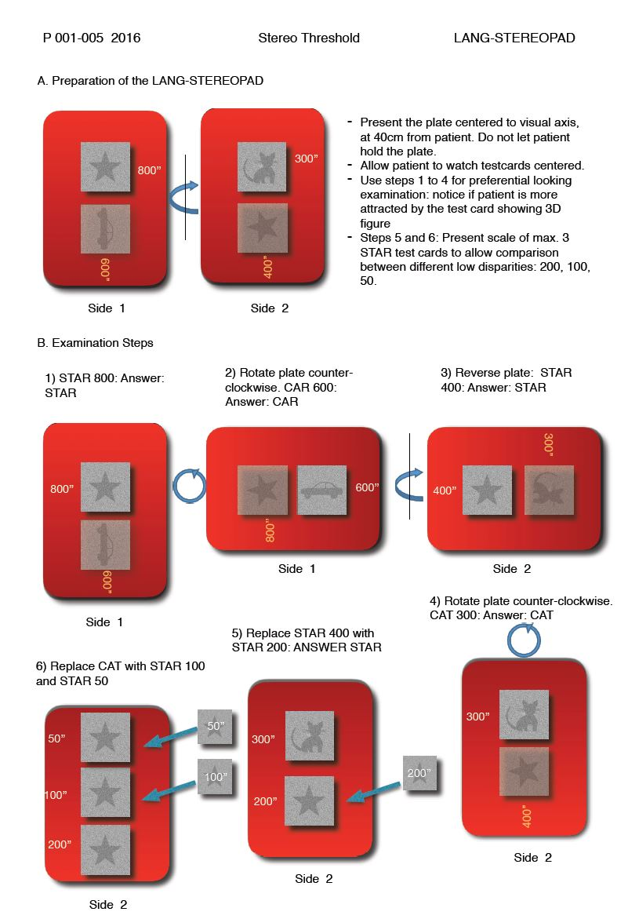

Figure 2 Age range
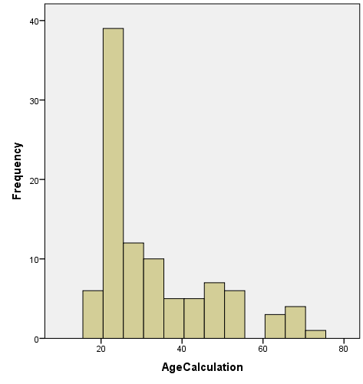

Figure 3
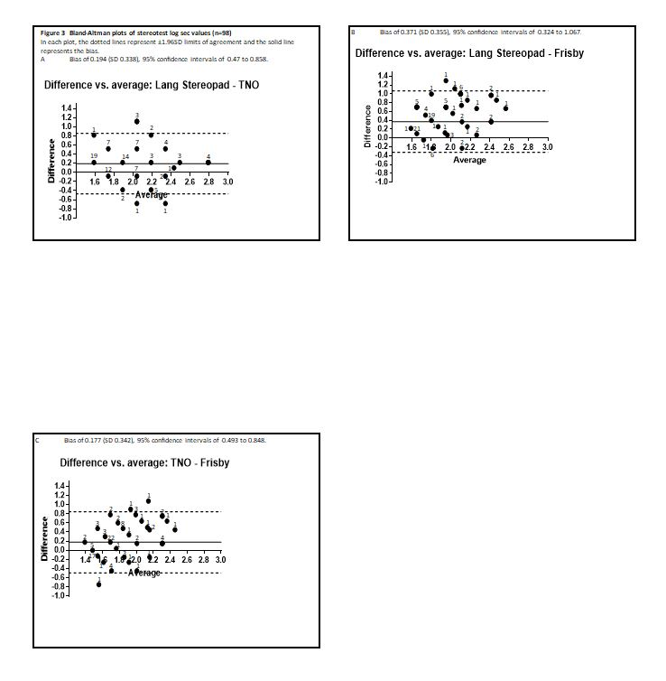

Figure 4
