**Dynamic reliability evaluation of vehicle-track coupled systems considering the randomness of suspension and wheel-rail parameters**

Yahui Zhanga*, Wei Wanga, Huajiang Ouyanga,b

*a State Key Laboratory of Structural Analysis for Industrial Equipment, Department of Engineering Mechanics, International Center for Computational Mechanics, Dalian University of Technology, Dalian 116023, PR China;*

*b School of Engineering, University of Liverpool, The Quadrangle, Liverpool L69 3GH, UK*

Corresponding author:

Dr. Y. H. Zhang

State Key Laboratory of Structural Analysis for Industrial Equipment, Department of Engineering Mechanics, Dalian University of Technology, Dalian 116023, PR China

Email: zhangyh@dlut.edu.cn

Tel: +86 411 84706337

Fax: +86 411 84708393

# Abstract

The ride quality and running safety of high-speed trains are directly influenced by uncertainties of some key parameters, such as the damping and stiffness coefficients of suspension systems, wheel-rail coefficient of friction and wheel-rail profiles. Dynamic reliability problems of vehicle-track coupled systems under the influence of the above random parameters are studied in this paper. An efficient numerical method is presented by combining a prediction-based iterative solution technique with Subset Simulation (SS) method. The solution efficiency of deterministic responses is improved by means of efficient prediction of wheel-rail forces, and the number of deterministic solutions required is reduced by expressing a small failure probability as a product of large conditional probabilities. The accuracy and the efficiency of the present method are verified by comparing with the direct Monte Carlo simulation (DMCS). The failure probability distribution (FPD) curves of the lateral ride index on straight track and the derailment coefficient during curve negotiation are obtained and the reliability sensitivity analyses are also carried out. The main conclusions are given as follows: the reliability of the system is higher when the randomness of the parameters with greater sensitivity is not considered; the increase of the damping of anti-yaw damper or the wheel-rail coefficient of friction will improve the ride quality on straight track, but will lower the running safety when negotiating a curved track.

**Keywords**

Vehicle-track coupled systems; Dynamic reliability; Subset simulation; Random parameters; Reliability sensitivity

**Notation**

|  |  |
| --- | --- |
| $M_{v}$, $K_{v}$, $C_{v}$ | Mass, stiffness and damping matrices of the vehicle |
| $X_{v}$, ${\dot{X}}_{v}$, ${\ddot{X}}_{v}$ | Displacement, velocity and acceleration vectors of the vehicle |
| $$F_{vt}$$ | Load vector acting on the vehicle |
| $$F_{vt}^{s}$$ | Load vector acting on the vehicle running on straight track |
| $$F_{c}^{s}$$ | Sub-load vector acting on car body on straight track |
| $$F_{t_{i}}^{s}(i=1\sim 2)$$ | Sub-load vector acting on frames 1~2 on straight track |
| $$F_{w_{i}}^{s}(i=1\sim 4)$$ | Sub-load vector acting on wheelsets 1~4 on straight track |
| $$F_{vt}^{c}$$ | Load vector acting on vehicle caused by geometry parameters of curved track |
| $$F_{c}^{c}$$ | Sub-load vector acting on the car body caused by geometry parameters of curved track |
| $$F_{t_{i}}^{c}(i=1\sim 2)$$ | Sub-load vector acting on frames 1~2 caused by geometry parameters of curved track |
| $$F_{w_{i}}^{c}(i=1\sim 4)$$ | Sub-load vector acting on wheelsets 1~4 caused by geometry parameters of curved track |
| $M_{t}$, $K_{t}$, $C_{t}$ | Mass, stiffness and damping matrices of the track |
| $X_{t}$, ${\dot{X}}_{t}$, ${\ddot{X}}_{t}$ | Displacement, velocity and acceleration vectors of the track |
| $$F_{tv}$$ | Load vector acting on the track |
| $F_{r}^{L}$, $F_{r}^{R}$, $F_{s}$ | Sub-load vectors acting on the left rail, right rail and sleeper |
| $$a_{n}^{ }$$ | Prediction coefficient vector |
| $${\overline{F}}_{n}^{ }$$ | Past forces vector |
| $$C$$ | Covariance matrix |
| $$\tilde{C}$$ | Approximated covariance matrix by KL expansion |
| $Λ$, $Φ$ | Eigenvalue and eigenvectors matrices |
| $x$, $y$, $z$ | Longitudinal, Lateral, vertical components along absolute coordinate system |
| $$α=L, R$$ | Left and right side of the vehicle or track |
| $F_{ix}^{α}$, $F_{iy}^{α}$, $F_{iz}^{α}$ | Longitudinal, lateral and vertical forces acting on the $ith$ wheelset |
| $$r_{w_{i}}^{α}$$ | Instant rolling radius of the wheels of the $ith$ wheelset |
| $$d_{0}$$ | Half of the lateral distance between wheel-rail nominal contact points |
| $$m_{0}$$ | Vehicle mass |
| $$ψ_{w_{i}}$$ | Yaw angle of the $ith$ wheelset |
| $$g$$ | Gravity acceleration |
| $$V$$ | Running speed |
| $$m_{c}$$ | Car body mass |
| $$r_{0}$$ | Wheel nominal radius |
| $$h_{tw}$$ | Height of frame’s centre of gravity (COG) above wheelset’s COG |
| $$h_{bt}$$ | Height of secondary suspension centre above frame’s COG |
| $$h_{cb}$$ | Height of car body’s COG above secondary suspension centre |
| $$R_{c}$$ | Curvature radius of the track at the location of car body’s COG |
| $I_{cx}$, $I_{cz}$ | Roll and yaw moments of inertia of car body |
| $I_{tx}$, $I_{tz}$ | Roll and yaw moments of inertia of frame |
| $$R_{ti}$$ | Curvature radius of the track at the location of the $i$ th frame’s COG |
| $ϕ_{sec}$, ${\ddot{ϕ}}_{sec}$ | Superelevation angle and its second derivative at the location of car body’s COG |
| $ϕ_{seti}$, ${\ddot{ϕ}}_{seti}$ | Superelevation angle and its second derivative at the location of the $i$ th frame’s COG |
| $$m_{w}$$ | Wheelset mass |
| $I_{wx}$, $I_{w_{y}}$, $I_{w_{z}}$ | Roll, pitch and yaw moment of inertia of wheelset |
| $ϕ_{sewi}$, ${\dot{ϕ}}_{sewi}$, ${\ddot{ϕ}}_{sewi}$ | Superelevation angle and its first derivative, second derivative at the location of the $i$ th wheelset’s COG |
| $$R_{wi}$$ | Curvature radius of the track at the location of the $i$ th wheelset’s COG |
| $${\dot{β}}_{wi}$$ | Angular velocity of the $i$ th wheelset in pitch direction |
| $k_{px}$, $k_{py}$, $k_{pz}$ | Longitudinal, lateral, vertical stiffness of primary suspension |
| $c_{px}$, $c_{py}$, $c_{pz}$ | Longitudinal, lateral, vertical damping coefficients of primary suspension |
| $k_{sx}$, $k_{sy}$, $k_{sz}$ | Longitudinal, lateral, vertical stiffness of secondary suspension |
| $c_{sx}$, $c_{sy}$, $c_{sz}$ | Longitudinal, lateral, vertical damping coefficients of secondary suspension |
| $$d_{w}$$ | Half of the lateral distance between primary suspensions |
| $$d_{s}$$ | Half of the lateral distance between secondary suspensions |
| $$l_{t}$$ | Half of wheelbase |
| $$l_{c}$$ | Half of the distance between bogie centres |
| $Y_{k}$, $Z_{k}$, $Φ_{k}$ | $kth$ mode shape functions of rail’s lateral, vertical bending and torsion |
| $$N_{w}$$ | Number of wheelsets |
| $$x_{w_{i}}$$ | Longitudinal coordinate of the $ith$ wheelset |
| $$K$$ | Number of modes considered for the rail beam |
| $$M_{w_{i}}^{α}$$ | Equivalent moment acting on rails from the $ith$ wheelset |
| $$P$$ | Prediction order |
| $$a_{n-ϑ}^{ }$$ | Prediction coefficient |
| $$f_{wr}$$ | Wheel-rail coefficient of friction |
| $λ_{n}$, $ϕ_{n}$ | Eigenvalues and normalized eigenvectors of covariance matrix |
| $$C_{0}$$ | Variance of the random field of wheel or rail profiles |
| $x_{i}$, $x_{j}$ | Coordinates of two discrete points of wheel or rail profiles |
| $$l$$ | Correlation length |
| $$e_{r}$$ | Relative error |
| $$b$$ | Limit value |
| $$m$$ | Number of levels of SS |
| $$N$$ | Number of samples at each level of SS |
| $$P_{F}$$ | Failure probability |
| $$P_{j}$$ | Conditional failure probability |
| $$p_{0}$$ | Level probability |
| $$N_{T}$$ | Total number of samples |
| $$W$$ | Ride index | |
| $$f$$ | Vibration frequency in Hz | |
| $$∆t$$ | Time step | |
| $$S$$ | Travel distance | |
| $$η$$ | Distribution parameter, such as mean value or variance | |
| $$\overline{η}$$ | Value of distribution parameter where partial derivative is evaluated | |
| $$e_{η}$$ | Normalized sensitivity | |

**1. Introduction**

With the expansion of operating areas and the accumulation of operating mileage, some key parameters of high-speed trains, such as the damping and stiffness coefficients of suspension systems, wheel-rail coefficient of friction, wheel-rail profiles, are bound to change due to wear and aging. Even for newly manufactured trains, these parameters of the vehicles of the same type will be different due to manufacturing errors and other reasons.1 Ride quality and running safety of trains are directly influenced by uncertainties of the above random parameters. Passenger discomfort or vehicle derailment will occur under adverse combinations of parameters. Therefore, in order to evaluate the dynamic performance of vehicle-track coupled systems comprehensively, the influence of random parameters should be considered with a probabilistic method.

In recent years, the dynamic performance evaluations of vehicle-track coupled systems under the influence of random parameters have been a big concern to many researchers. Funfschilling et al.2 proposed a method of introducing parameter uncertainties and obtained the probability density functions (PDFs) of car body acceleration and wheel derailment coefficient, considering the uncertainties of the stiffness and damping coefficients of suspension systems. Kassa and Nielsen3 established a stochastic vehicle-turnout interaction model, obtained realizations of wheel and turnout profiles with the Karhunen-Loève expansion technique and studied the effects of random parameters, such as the wheel-rail coefficient of friction, wheel and turnout profiles, on the statistical characteristics of wheel-rail forces. Mazzolaand and Bruni4 obtained the PDF of a vehicle’s critical speed by combining the direct Monte Carlo Simulation (DMCS) with the design of experiments theory, considering the uncertainties of the stiffness and damping of anti-yaw damper. Oscarsson5,6 established moving vehicle-track coupled models and investigated the influence of randomness of selected track parameters on wheel-rail forces. Suarez et al.7-9 performed sensitivity analyses to assess the influence of the suspension parameters, inertial properties and wheel-rail rolling features on the vehicle’s dynamic behaviour by modifying input parameters one at a time. Luo et al.10 predicted the evolution of wheel profiles and related vehicle’s dynamic performance by considering the uncertainties of track geometries, track irregularities and wheel-rail coefficient of friction.

All the above studies were mainly dedicated to obtaining the probability distributions of response indicators, few investigations were made on the dynamic reliability analysis of vehicle-track coupled systems. This is because of the existence of nonlinear wheel-rail relations. As a result, some conventional methods, such as the first order reliability method (FORM)11 or the second order reliability method (SORM)12, cannot be used to determine the failure probability of vehicle-track coupled systems. The DMCS method has high accuracy and computational stability in the estimation of failure probability, but the number of samples required is huge and thus results in a high computational cost. Cho et al.13 developed a linear weighted response surface method to determine the reliability of a vehicle-bridge coupled system, but lots of samples were still needed. Wetzel and Proppe14,15 combined constrained simulation technique with line sampling method to compute the overturning probability of railway vehicles under the action of random wind load, but line sampling method is efficient only when the appropriate important direction could be found.16

In order to determine the failure probability of vehicle-track coupled systems efficiently, a solution method is presented by combining Subset Simulation (SS)17,18, which has been widely used in the study of structural reliability problems in many engineering fields19-21, with the prediction-based iterative solution technique proposed by the authors.22 The structure of this paper is as follows. In section 2, the equations of motion of the vehicle and track subsystems are established separately and a wheel-rail interaction model in which nonlinear contact geometry relation can be considered is given. The methods of obtaining the realizations of random parameters, such as the damping and stiffness coefficients of suspension systems, wheel-rail coefficient of friction, wheel-rail profiles, are given in section 3 and the reliability solution method based on SS is presented in brief in section 4. In section 5, the failure probabilities of the lateral ride index on tangent track and the wheel derailment coefficient during curve negotiation are determined respectively, and the influence trends of random parameters on the dynamic reliability are analysed.

**2. Deterministic dynamic models**

The vehicle and track structures are considered as two subsystems. The equations of motion of these two subsystems are established separately and coupled by a wheel-rail spatial interaction model, in which detailed wheel-rail contact geometry relations and nonlinear wheel-rail forces could be considered.

## *2.1 Dynamic model of vehicle subsystem*

The vehicle is modelled as a multi-rigid body system with 35 degrees-of-freedom (DOFs) based on the structural characteristics of CRH2 EMU, as shown in Figure 1. Each rigid body is assigned five DOFs, which are the lateral and vertical displacements, the rolling, pitching and yawing rotations. The primary and secondary suspension systems are both approximated by parallel spring-viscous damper elements.

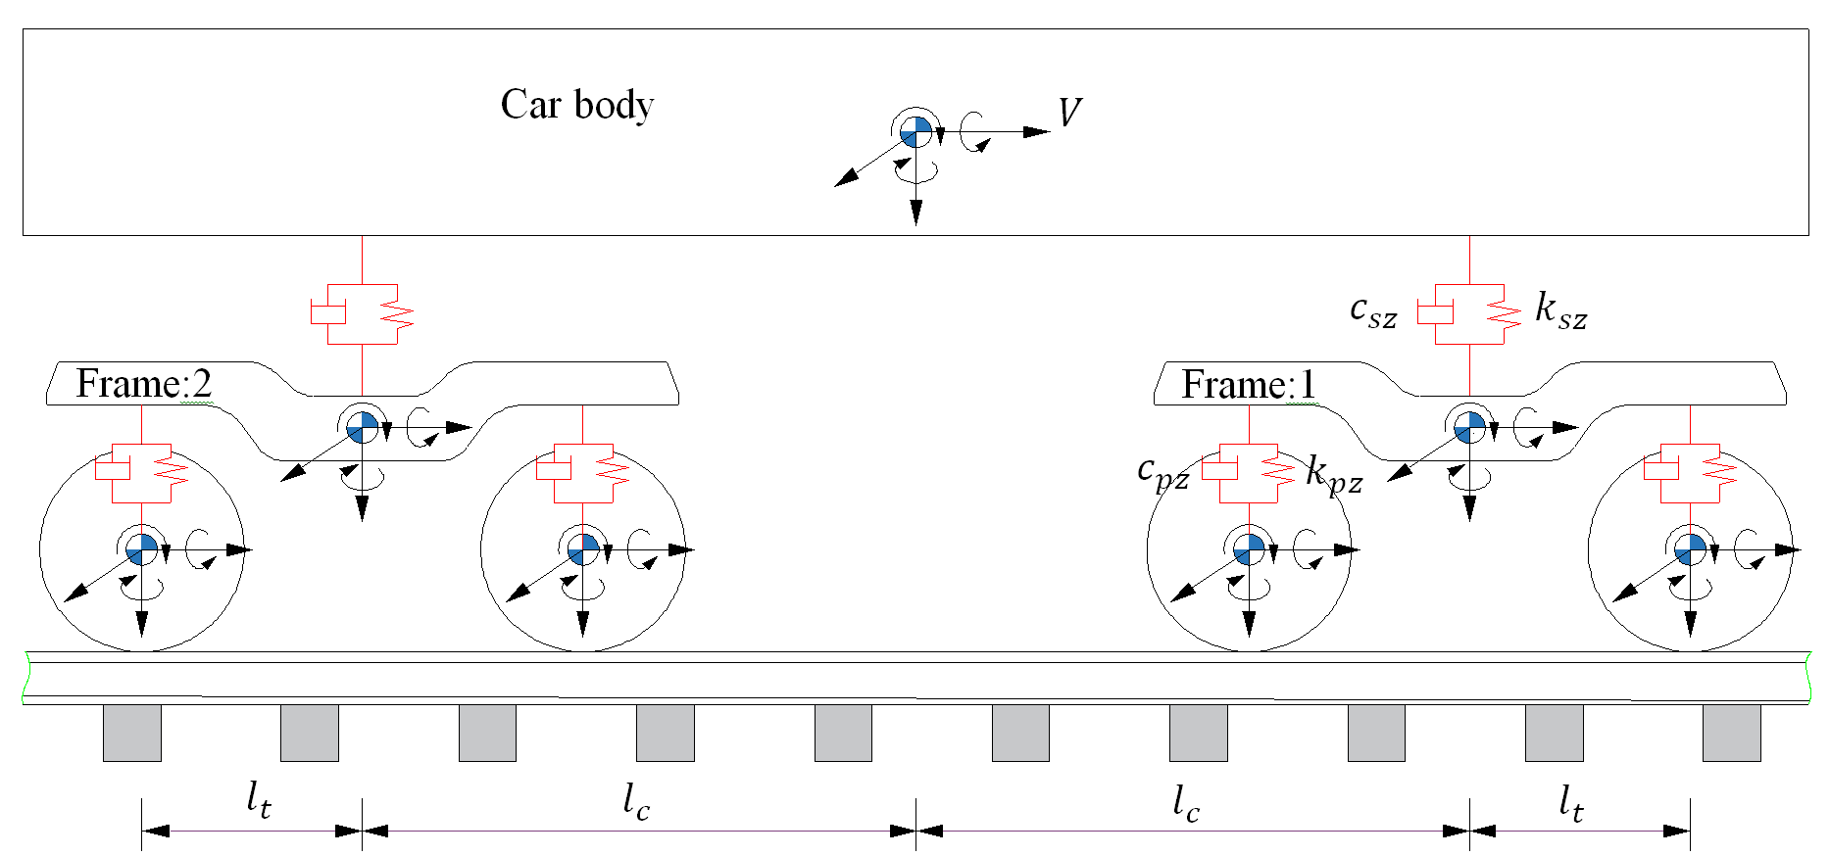

(a) Side view

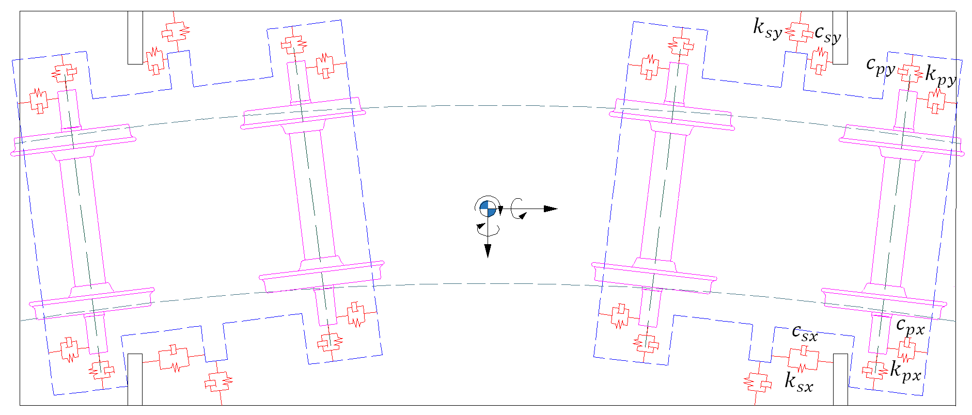

(b) Top view

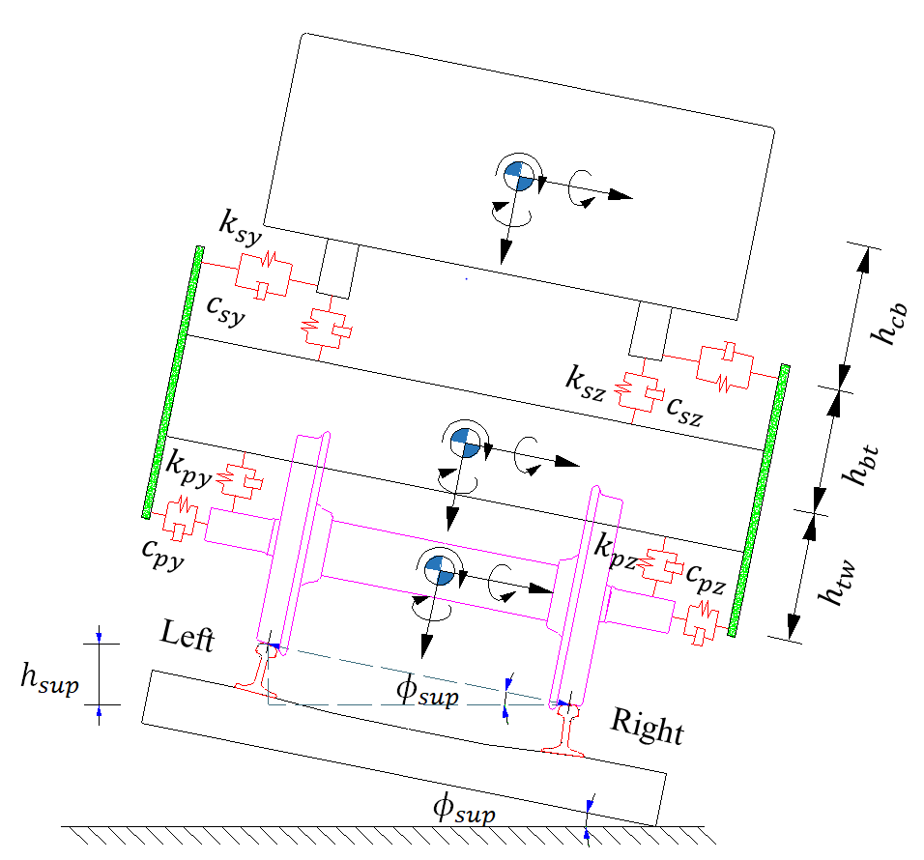

(c) Front view

**Figure 1.** Railway vehicle dynamic model

For the vehicle subsystem, the deterministic equation of motion can be expressed as

|  |  |  |
| --- | --- | --- |
|  | $$M_{v}{\ddot{X}}_{v}+C_{v}{\dot{X}}_{v}+K_{v}X_{v}=F_{vt}$$ | (1) |

where $X_{v}$**, ${\dot{X}}_{v}$** and ${\ddot{X}}_{v}$ are the displacement vector, velocity vector and acceleration vector of the vehicle subsystem, respectively; $M_{v}$, $C_{v}$, $K_{v}$ are the matrices of mass, damping and stiffness of the vehicle subsystem, respectively; the external load vector acting on the vehicle $F_{vt}$ consists of two parts

|  |  |  |
| --- | --- | --- |
|  | $$F_{vt}=F_{vt}^{s}+F_{vt}^{c}$$ | (2) |

where $F_{vt}^{s}$ is the load vector on a straight track; $F_{vt}^{c}$ is the additional load vector caused by the geometry parameters of a curved track; superscripts“*s*” and “*c*” denote the straight track and curved track respectively.

The expression of $F_{vt}^{s}$ can be given as follows

|  |  |  |
| --- | --- | --- |
|  | $$F_{vt}^{s}={\{F_{c}^{s,T},F_{t_{1}}^{s,T},F_{t_{2}}^{s,T},F_{w_{1}}^{s,T},F_{w_{2}}^{s,T},F_{w_{3}}^{s,T},F_{w_{4}}^{s,T}\}}^{T}$$ | (3) |

where subscript “ $c$” denote the car body; subscripts “ $t_{1}$” , “ $t_{2}$” denote frames 1~2 respectively; subscripts “ $w_{i}(i=1\sim 4)$” denote wheelsets 1~4; $F_{c}^{s}$, $F_{t_{i}}^{s}(i=1\sim 2)$ and $F_{w_{i}}^{s}(i=1\sim 4)$ are the sub-load vectors on straight track acting on the car body, frames 1~2 and the wheelsets 1~4 respectively.

|  |  |  |
| --- | --- | --- |
|  | $$F_{c}^{s}= F_{t_{1}}^{s}=F_{t_{2}}^{s}=0$$ | (4) |

|  |  |  |
| --- | --- | --- |
|  |  | (5) |

where subscript $x$ denotes the longitudinal component along the absolute coordinate system, and subscripts $y$ and $z$ denote the lateral and vertical components, respectively; superscript $L$ denotes the left side of the vehicle and superscript $R$ denotes the right side; $F_{ix}^{α}$, $F_{iy}^{α}$ and $F_{iz}^{α}$ are the longitudinal, lateral and vertical forces acting on the wheels; $r_{w_{i}}^{α}$ is the instantaneous rolling radius; $d_{0}$ is half of the lateral distance between the left and right nominal contact positions; $m_{0}$ denotes a quarter of the vehicle's weight; $ψ_{w_{i}}$ is the yaw angle of the $i$ th wheelset; $g$ is the acceleration of gravity.

The load vector $F_{vt}^{c}$ equals zero if the vehicle is running on a straight track, and the expression of $F_{vt}^{c}$ can be written as follows when negotiating a curved track.

|  |  |  |
| --- | --- | --- |
|  | $$F_{vt}^{c}={\{F_{c}^{c,T},F_{t_{1}}^{c,T},F_{t_{2}}^{c,T},F_{w_{1}}^{c,T},F_{w_{2}}^{c,T},F_{w_{3}}^{c,T},F_{w_{4}}^{c,T}\}}^{T}$$ | (6) |

where $F_{c}^{c}$, $F_{t_{i}}^{c}(i=1\sim 2)$ and $F_{w_{i}}^{c}(i=1\sim 4)$ are the sub-load vectors on curved track

|  |  |
| --- | --- |
| $$F_{c}^{c}=\left\{\begin{aligned}M_{c}\left(gϕ_{sec}-\frac{V^{2}}{R_{c}}-\left(r_{0}+h_{tw}+h_{bt}+h_{cb}\right){\ddot{ϕ}}_{sec}\right)+2l_{c}^{2}\left(\frac{k_{sy}}{R_{c}}+c_{sy}\frac{d}{dt}\left(\frac{1}{R_{c}}\right)\right) \\ M_{c}\left(d_{0}{\ddot{ϕ}}_{sec}+\frac{V^{2}ϕ_{sec}}{R_{c}}\right) \\ -I_{cx}{\ddot{ϕ}}_{sec}-2l_{c}^{2}h_{cb}\left(\frac{k_{sy}}{R_{c}}+c_{sy}\frac{d}{dt}\left(\frac{1}{R_{c}}\right)\right) \\ 0 \\ -I_{cz}V\frac{d}{dt}\left(1/R_{c}\right)\end{aligned}\right\}$$ | (7) |

|  |  |
| --- | --- |
|  | |
|  | (8) |

|  |  |
| --- | --- |
|  | |
|  | (9) |

where $V$ is the running speed; $m_{c}$ is the mass of car body; $r_{0}$ is the wheel’s nominal rolling radius; $h_{tw}$ is the height of the frame’s centre of gravity (COG) above the wheelset’s COG; $h_{bt}$ is the height of the secondary suspension centre above the frame’s COG; $h_{cb}$ is the height of car body’s COG above secondary suspension centre; $ϕ_{sec}$, ${\ddot{ϕ}}_{sec}$ and $R_{c}$ are the superelevation angle, second derivative of the superelevation angle with respect to time $t$ and radius of curvature of the track at the location of car body’s COG, respectively; $I_{cx}$ and $I_{cz}$ are the roll and yaw moments of inertia of the car body, respectively; $m_{t}$ is the frame mass; $I_{tx}$ and $I_{tz}$ are the roll and yaw moments of inertia of the frame, respectively; $ϕ_{seti}$, ${\ddot{ϕ}}_{seti}$ and $R_{ti}$ are the superelevation angle, second derivative of the superelevation angle with respect to time $t$ and radius of curvature of the track at the location of the $i$ th frame’s COG, respectively; $m_{w}$ is the wheelset mass; $I_{wx}$, $I_{w_{y}}$ and $I_{wz}$ are the roll, pitch and yaw moments of inertia of the wheelset; $ϕ_{sewi}$, ${\dot{ϕ}}_{sewi}$, ${\ddot{ϕ}}_{sewi}$ and $R_{wi}$ are the superelevation angle, first derivative, second derivative of the superelevation angle with respect to time $t$ and radius of curvature of the track at the location of the $i$ th wheelset’s COG, respectively; ${\dot{β}}_{wi}$ is the angular velocity of the $i$ th wheelset in pitch direction; $d_{w}$ is half of the lateral distance between primary suspension systems; $d_{s}$ is half of the lateral distance between secondary suspension systems; $l_{t}$ and $l_{c}$ are half of the wheelbase and the distance between bogie centres, respectively; $k_{px}$, $c_{px}$, $k_{py}$ and $c_{py}$ are the stiffness and damping coefficients of the primary suspension systems in longitudinal and lateral directions, respectively; $k_{sx}$ and $k_{sy}$ are the longitudinal and lateral stiffness coefficients of the secondary suspension systems, respectively; $c_{sx}$ is the damping coefficient of the anti-yaw damper; $c_{sy}$ is the lateral damping coefficient of the secondary suspension systems.

## *2.2 Dynamic model of track subsystem*

The dynamic model of the track subsystem consists of two parallel rails and a series of sleepers. Each rail is modelled by a simply supported Euler-Bernoulli beam of finite length and each sleeper is represented by a rigid body with three DOFs which are the lateral, vertical displacements and rolling rotations. All the connected components are modelled as linear spring-viscous damper parallel elements, as shown in Figure 2.

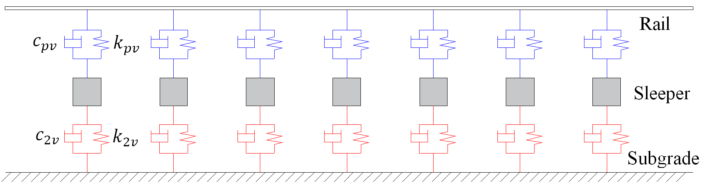

(a) Side view

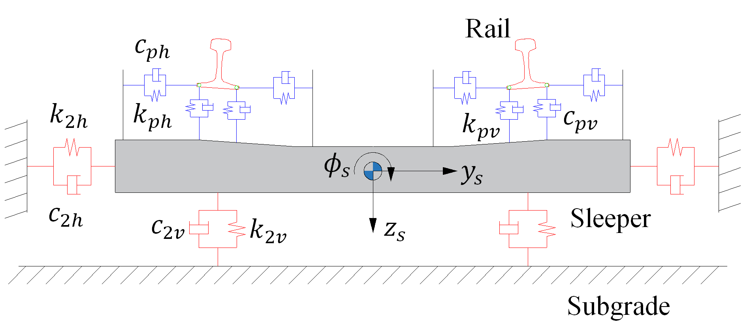

(b) Front view

**Figure 2.** Sketches of two-layer track dynamic model

For the track subsystem, the deterministic equations of motion can be written as

|  |  |  |
| --- | --- | --- |
|  | $$M_{t}{\ddot{X}}_{t}+C_{t}{\dot{X}}_{t}+K_{t}X_{t}=F_{tv}$$ | (10) |

where $X_{t}$, ${\dot{X}}_{t}$ and ${\ddot{X}}_{t}$ are the displacement vector, velocity vector and acceleration vector of the track subsystem, respectively; $M_{t}$, $C_{t}$ and $K_{t}$ are the matrices of mass, damping and stiffness of the track subsystem, respectively; The load vector acting on the track $F_{tv}$ can be expressed as

|  |  |  |
| --- | --- | --- |
|  | $$F_{tv}={\{{\left(F_{r}^{L}\right)}^{T},{\left(F_{r}^{R}\right)}^{T},F_{s}^{T}\}}^{T}$$ | (11) |

where

|  |  |
| --- | --- |
| $$\left\{\begin{aligned}F_{r}^{L}=\left\{-\sum_{i=1}^{N_{w}}{F_{iy}^{L}}Y_{1}\left(x_{w_{i}}\right),…,-\sum_{i=1}^{N_{w}}{F_{iy}^{L}}Y_{K}\left(x_{w_{i}}\right),-\sum_{i=1}^{N_{w}}{F_{iz}^{L}}Z_{1}\left(x_{w_{i}}\right),…,\right. \\ -\sum_{i=1}^{N_{w}}{F_{iz}^{L}}Z_{K}\left(x_{w_{i}}\right), {\left.\sum_{i=1}^{N_{w}}{M_{w_{i}}^{L}}Φ_{1}\left(x_{w_{i}}\right), …, \sum_{i=1}^{N_{w}}{M_{w_{i}}^{L}}Φ_{K}\left(x_{w_{i}}\right)\right\}}^{T} \\ F_{r}^{R}=\left\{-\sum_{i=1}^{N_{w}}{F_{iy}^{R}}Y_{1}\left(x_{w_{i}}\right),…,-\sum_{i=1}^{N_{w}}{F_{iy}^{R}}Y_{K}\right.\left(x_{w_{i}}\right),-\sum_{i=1}^{N_{w}}{F_{iz}^{R}}Z_{1}\left(x_{w_{i}}\right),…, \\ -\sum_{i=1}^{N_{w}}{F_{iz}^{R}}Z_{K}\left(x_{w_{i}}\right),\sum_{i=1}^{N_{w}}{M_{w_{i}}^{R}Φ_{1}\left(x_{w_{i}}\right)}{\left., …,\sum_{i=1}^{N_{w}}{M_{w_{i}}^{R}Φ_{K}\left(x_{w_{i}}\right)}\right\}}^{T} \\ F_{s}=0 \end{aligned}\right.$$ | (12) |

where $Y_{k}(x)$, $Z_{k}\left(x\right)$ and $Φ_{k}\left(x\right) (k=1\sim K)$ are the $kth$ mode functions of the lateral, vertical bending and torsion of the rail; $K$ is the truncated modal orders; $M_{w_{i}}^{α},(α=L,R)$ is the moment acting on the rails from the wheels; $x_{w_{i}}$ is the longitudinal position of the $i$ th wheelset; $N_{w}$ is the number of wheelsets.

## *2.3 Wheel-rail spatial interaction model*

The wheel-rail spatial interaction model is the essential component that couples the vehicle and track subsystems. The original profiles of the wheel and rail are LMA and CHN60, respectively. The wheel-rail contact geometry model presented by Chen and Zhai23 is used to determine the contact geometry relations between wheels and rails. The solution process of wheel-rail contact geometry relations is outlined below and detailed descriptions are given in Ref.23. Firstly, responses of the vehicle and track subsystems are solved at each time step. Next, a series of contact point coordinates on wheel profile in the absolute coordinate system, named ‘trace curve’, are obtained by the trace curve method24. Then, the rail profile discretized in the rail coordinate system is transformed into the absolute coordinate system, considering the effects of track irregularities. Finally, vertical minimum distances between the trace curve and the rail profile are calculated by interpolation, and the coordinates of contact points and wheel-rail contact geometry parameters can be obtained.

According to the wheel-rail contact geometry model, the contact point distributions between LMA wheel and CHN60 rail profiles are given in Figure 3, without lateral displacement and yaw angle of the wheelset.

F:\Paper3\WRrelation\左侧轮轨接触New.emf F:\Paper3\WRrelation\右侧轮轨接触new.emf

(a) Left side (b) Right side

**Figure 3.** Contact point distributions between LMA wheel and CHN60 rail profiles

After obtaining the geometry parameters, wheel-rail normal forces are calculated based on nonlinear Hertzian contact theory. Meanwhile, wheel-rail creep forces are solved with Kalker’s simplified theory implemented as FASTSIM25, considering the effects of geometry parameters of curved track and the rate of change of track irregularities on wheel-rail creepage.

## *2.4 Solution of deterministic dynamic responses*

The deterministic dynamic responses of vehicle-track coupled systems are solved by the prediction-based iteration method proposed by the authors22. The key is that the initial values of the wheel-rail forces at time $t_{n}$ are predicted by the Weighted Least-Squares Error (WLSE) predictor instead of taking the last converged values at time $t_{n-1}$ as in the conventional iteration method. Other steps are the same as in the conventional iteration method.

Taking the wheel-rail lateral force $F_{iy}^{ }$ as an example, the predicted force ${\hat{F}}_{iy,n}^{ }$ at time $t_{n}$ can be expressed as26

|  |  |  |
| --- | --- | --- |
|  |  | (13) |

where ${\overline{F}}_{n}^{ }={\{F_{iy,n-1}^{ }, F_{iy,n-2}^{ },…, F_{iy,n-P}^{ }\}}^{T}$ is the force vector consisting of $P$ number of forces before time $t_{n}$, $a_{n}^{ }={\{a_{n-1}^{ }, a_{n-2}^{ },…, a_{n-P}^{ }\}}^{T}$ is the column vector of the prediction coefficient; $a_{n-ϑ}^{ }$ is the prediction coefficient and $P$ is the prediction order.

According to the WLSE method26, the weighted sum of the error, which is defined as the difference between the predicted value ${\hat{F}}_{iy,n}^{ }$ and the actual value $F_{iy,n}^{ }$, will be minimized for a given set of weight coefficients. The prediction coefficients should be changed adaptively to meet the minimum WLSE criterion as

|  |  |  |
| --- | --- | --- |
|  | $$β(a)=\frac{1}{2}\sum_{k=1}^{n}{0.99{[{\hat{F}}_{iy,k}^{ }-F_{iy,k}^{ }]}^{2}}=\frac{1}{2}\sum_{k=1}^{n}{0.99{[{(a_{k}^{ })}^{T}{\overline{F}}_{iy,k}^{ }-F_{iy,k}^{ }]}^{2}}$$ | (14) |

where ${a^{ }=\{a_{n}^{ },…,a_{2}^{ }, a_{1}^{ }\}}^{T}$; ${\overline{F}}_{iy,k}^{ }={\{F_{iy,k-1}^{ }, F_{iy,k-2}^{ },…, F_{iy,k-P}^{ }\}}^{T}$ is the $P$ number of past forces before time $t_{k}$; $a_{k}^{ }={\{a_{k-1}^{ }, a_{k-2}^{ },…, a_{k-P}^{ }\}}^{T}$ is the vector of prediction coefficients. Detailed process of WLSE method is given in Ref.22

The predictability of WLSE method has been verified by comparing the predicted values and the final converged values of wheel-rail forces under different types of track irregularities.22 In addition, the efficiency and accuracy of the prediction-based iteration method have been verified by comparison with the conventional iteration method and NUCARS software.22

**3. Realizations of random parameters**

It is necessary to obtain the realizations of random parameters since SS simulation technique is used to calculate the failure probability of vehicle-track coupled systems. According to the characteristics of vehicle suspension systems, a total of 11 parameters are considered as random variables: longitudinal, lateral and vertical stiffness ($k_{px}$, $k_{py}$, $k_{pz}$) and vertical damping ($c_{pz}$) of primary suspension; longitudinal, lateral and vertical stiffness ($k_{sx}$, $k_{sy}$, $k_{sz}$) and longitudinal and vertical damping ($c_{sx}$, $c_{sz}$) of secondary suspension; damping of anti-yaw damper $c_{sy}$ and wheel-rail coefficient of friction $f_{wr}$. Random variables are all assumed to follow the one-sided Gaussian distribution.1,10 Taking into account that the parameters must be positive, sampling is based on the acceptance-rejection criterion: the samples are generated first according to the assumed PDF, and then only positive samples are selected. The coefficients of variation (COV) are all taken as 0.2 and the nominal values are given in Table 1.

**Table 1.** Nominal values of random variables

|  |  |  |  |  |  |  |
| --- | --- | --- | --- | --- | --- | --- |
| Parameter | $$k_{px}$$ | $$k_{py}$$ | $$k_{pz}$$ | $$k_{sx}$$ | $$k_{sy}$$ | $$k_{sz}$$ |
| Value | 13700 | 5490 | 1244 | 159.7 | 159.7 | 990.8 |
| Unit | $$kN/m$$ | $$kN/m$$ | $$kN/m$$ | $$kN/m$$ | $$kN/m$$ | $$kN/m$$ |
| Parameter | $$c_{pz}$$ | $$c_{sx}$$ | $$c_{sy}$$ | $$c_{sz}$$ | $$f_{wr}$$ |  |
| Value | 19.6 | 245 | 58.8 | 9.8 | 0.35 |  |
| Unit | $$kN∙s/m$$ | $$kN∙s/m$$ | $$kN∙s/m$$ | $$kN∙s/m$$ |  |  |

The wheel-rail profiles consist of a series of discrete points. The deviations in the vertical coordinates of the discrete points from the nominal ones are considered as random fields and should be described by random field theory. Here, samples of the wheel and rail profiles are generated according to the Karhunen-Loève (KL) expansion method. A detailed description of the KL method can be found in Ref.27. Based on the spectral expansion theory, the KL expansion of a discrete random field $H(x,θ)$ can be represented by

|  |  |
| --- | --- |
| $$H\left(x,θ\right)=μ_{H}\left(x\right)+\sum_{n=1}^{∞}{\sqrt{λ_{n}}}ϕ_{n}\left(x\right)ξ_{n}\left(θ\right)≈μ_{H}(x)+\sum_{n=1}^{M}{\sqrt{λ_{n}}}ϕ_{n}(x)ξ_{n}(θ)$$ | (15) |

where $μ_{H}(x)$ is the mean value of random field; $x$ is the position vector of spatial point coordinates; $M$ is the number of kept terms in series expansions; $ξ_{n}(θ)$ is a set of mutually uncorrelated random variables with zero mean and unit variance; $λ_{n}$ and $ϕ_{n}$ are the eigenvalues and normalized eigenvectors of the covariance matrix $C$ of random field.

|  |  |  |
| --- | --- | --- |
|  | $$C=ΦΛΦ^{T}$$ | (16) |

where the diagonal elements of diagonal matrix $Λ$ are the eigenvalues of the covariance matrix; the columns of $Φ$ are the associated eigenvectors $ϕ_{n}$; the eigenvalues are ordered in descending order $λ_{1}>λ_{2}>…>λ_{M}$, and the eigenvectors are adjusted accordingly.

Due to the lack of measured data of wheel-rail profiles, Gaussian covariance kernel $C$ is chosen to represent the random fields of wheel-rail profiles3.

|  |  |  |
| --- | --- | --- |
|  |  | (17) |

where $C_{0}$ is the variance of random field; $x_{i}$ and $x_{j}$ are the coordinates of two discrete points; $l$ is the correlation length.

The accuracy of the KL expansion can be measured by relative error $e_{r}$

|  |  |  |
| --- | --- | --- |
|  | $$e_{r}=1-\tilde{C}/C$$ | (18) |

where ${\tilde{C}}_{ij}=\sum_{n=1}^{M}{\sqrt{λ_{n}}}ϕ_{n}(i)ϕ_{n}^{T}(j)$ are the elements of an approximated covariance matrix $\tilde{C}$ by KL expansion.

The variances of the random fields of wheel and rail profiles are both taken as 0.1. The cumulative contributions of the first three largest eigenvalues both reach 99.99%, as shown in Figure 4.

F:\Paper3\KLwheel\特征值累积贡献New.emf F:\Paper3\KLrail\特征值累积贡献.emf

(a) Wheel (b) Rail

**Figure 4.** Cumulative contribution of the largest eigenvalues

The relative error surfaces, as given in Figure 5, show that high accuracy can be achieved with only a few terms by KL expansion, and the number of uncorrelated random variables that describe the random fields has been significantly reduced. Samples of wheel-rail profiles generated by KL expansion are given in Figure 6.

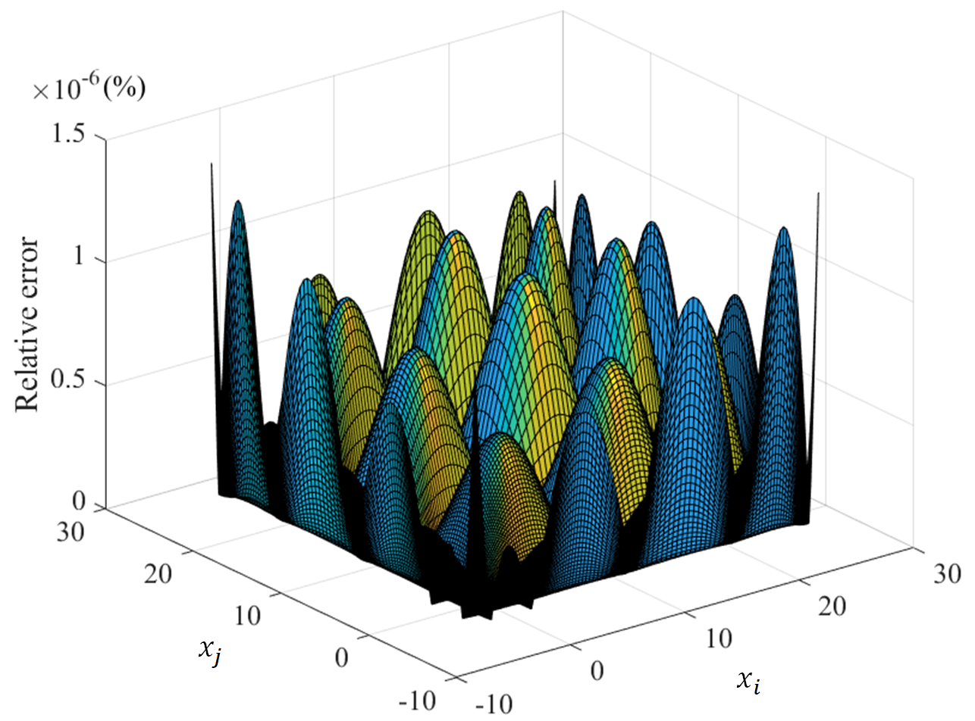 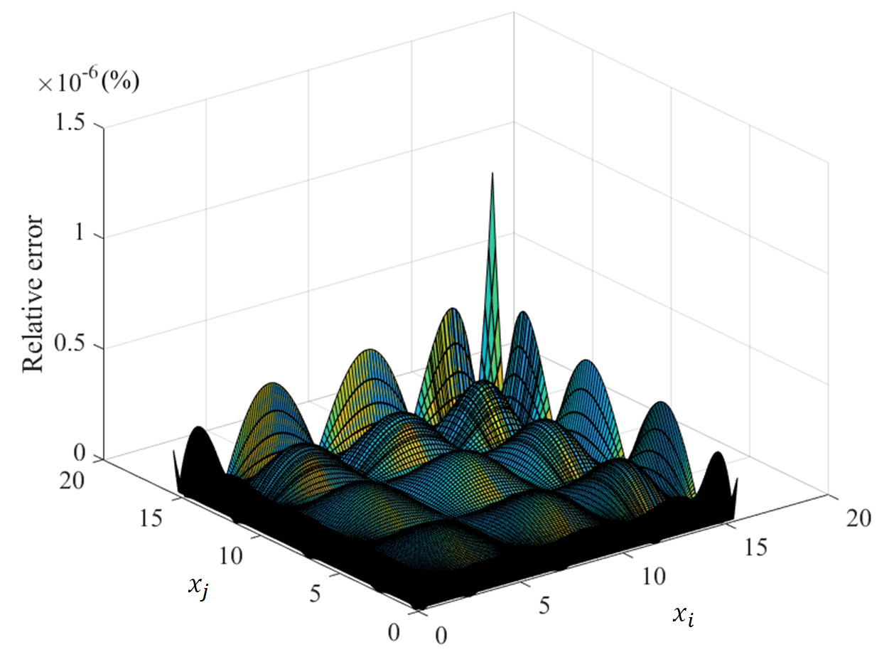

(a) Wheel (b) Rail

**Figure 5.** Relative error between approximated and exact covariance kernel

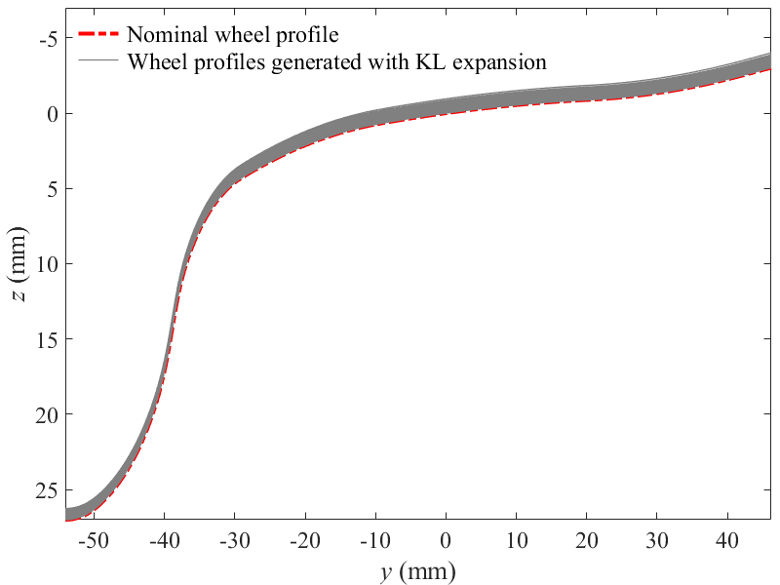 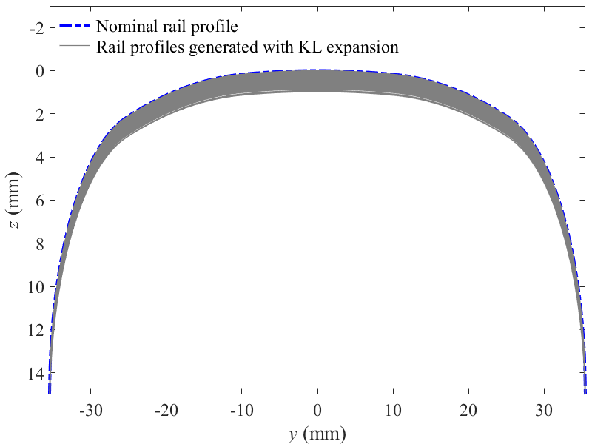

(a) Wheel (b) Rail

**Figure 6.** Random samples generated using 3-term KL expansion method

**4. Reliability solution method based on subset simulation**

The failure event of vehicle-track coupled systems can be represented as the exceedance of any specific response $g\left(t,θ\right)$ (such as the derailment coefficient, ride index, etc.) above the threshold value $b$ within a specified time interval, that is

|  |  |  |
| --- | --- | --- |
|  |  | (19) |

where $n_{r}$ is the dimension of $g\left(t,θ\right)$; $T$ is the vehicle running time; $θ$ is the random vector with PDF $q\left(θ\right)$.

The basic idea of SS is as follows: introduce a set of ascending intermediate limit values $0<b_{1}<b_{2}<⋯<b_{m}=b$ and obtain a set of nested failure events $F_{1}⊃F_{2}⊃⋯⊃F_{m}=F$, in which $m$ is the number of levels of SS. Due to the nesting characteristics of intermediate failure events, the failure probability $P_{F}$ can be expressed as the product of $P\left(F_{1}\right)$ and a set of conditional failure probabilities.

|  |  |  |
| --- | --- | --- |
|  |  | (20) |

where $P_{1}=P\left(F_{1}\right)$, $P_{j}=P\left(F_{j} | F_{j-1}\right),\left(j=2,⋯,m\right)$.

$P_{1}$ can be estimated readily by DMCS

|  |  |  |
| --- | --- | --- |
|  | $$P_{1}=\frac{1}{N}\sum_{h=1}^{N}{I_{F_{1}}\left(θ_{h}^{\left(1\right)}\right)}$$ | (21) |

where $θ_{h}^{\left(1\right)}\left(h=1,2,⋯,N\right)$ are the samples generated according to PDF $q\left(θ\right)$, $N$ is the number of samples at each level.

Samples that satisfy the given conditional PDF $q\left(θ | F_{j}\right)={q\left(θ\right)I_{F_{j}}\left(θ\right)}/{P\left(F_{j}\right)}$ are obtained with the Modified Metropolis Algorithm (MMA)17 in SS, and the conditional failure probability $P_{j}$ can be calculated by

|  |  |  |
| --- | --- | --- |
|  | $$P_{j}=\frac{1}{N}\sum_{h=1}^{N}{I_{F_{j}}\left(θ_{h}^{\left(j\right)}\right)}$$ | (22) |

where $θ_{h}^{\left(j\right)}\left(h=1,2,⋯,N\right)$ are conditional samples generated according to $q\left(θ | F_{j}\right)$.

By substituting Equations (21) and (22) into Equation (20), the failure probability $P_{F}$ can be expressed as follows

|  |  |  |
| --- | --- | --- |
|  | $$P_{F}=p_{0}^{m-1}\frac{1}{N}\sum_{h=1}^{N}{I_{F_{m}}\left(θ_{h}^{\left(m\right)}\right)}$$ | (23) |

The main procedure of SS is as follows:

Step 1: Input parameters: the number of samples at each level $N$ and the level probability $p_{0}$ (recommended value of is 0.117).

Step 2: Set $i=0$ and generate $N$ samples $θ_{h}^{\left(i\right)}(h=1,2,⋯,N)$ according to the original PDF $q\left(θ\right)$. The superscript ‘0’ here denotes the samples generated by DMCS, corresponding to the conditional level 1 of SS.

Step 3: Calculate responses $\tilde{g}\left(θ_{h}^{\left(i\right)}\right)=\max\left(\left|g\left(t,θ_{h}^{\left(i\right)}\right)\right|\right)(h=1,2,⋯,N)$ of samples $θ_{h}^{\left(i\right)}$ and count the number of response values exceeding the limit value $b$. For vehicle-track coupled systems, the response indicators (such as the car body acceleration, ride index, wheel derailment coefficient, etc.) are calculated and the number of failure samples $n_{F}^{(i)}$ is counted.

Step 4: Check whether the condition $n_{F}^{(i)}/N≥p_{0}$ is satisfied. If satisfied, go to Step 7 to output the results and stop calculation. Otherwise, set $i=i+1$ and go to Step 5 for the next loop.

Step 5: Rearrange $\tilde{g}\left(θ_{h}^{\left(i-1\right)}\right)$ in descending order and let $G_{1}^{(i-1)},…, G_{N}^{(i-1)}$ be the rearranged responses values. Define the intermediate threshold value by Equation (24), then $P_{i}=p_{0}$ can be automatically satisfied. Renumber $θ_{h}^{\left(i-1\right)}$ at the same time and let $X_{1}^{(i-1)},…, X_{N}^{(i-1)}$ be the rearranged samples.

|  |  |  |
| --- | --- | --- |
|  | $$b_{i}=\frac{1}{2}(G_{Np_{0}}^{\left(i-1\right)}+G_{Np_{0}+1}^{(i-1)})$$ | (24) |

Step 6: Generate $N(1-p_{0})$ additional conditional samples using $X_{k}^{(i-1)}$ ($k=1,2,…,Np_{0}$) as seed samples with MMA algorithm, so that a total of $N$ samples $θ_{h}^{\left(i\right)}$ satisfying the conditional PDF $q\left(∙ | F_{i}\right)$ can be obtained. Then go to Step 3 to calculate the corresponding response values of samples $θ_{h}^{\left(i\right)}$.

Step 7: Output results: the total number of levels $m,(=i+1)$; the total number of samples $N_{T},(=N+N\left(1-p_{0}\right)\left(m-1\right))$; failure probability $P_{F},(=p_{0}^{m-1}n_{F}^{(m-1)}/N)$.

**5. Numerical examples**

The failure probabilities of the lateral ride index on tangent track and the wheel derailment coefficient during curve negotiation are calculated respectively, considering the randomness of suspension parameters, wheel-rail profiles and wheel-rail coefficient of friction. The randomness of track irregularities is not considered and the measured track irregularities of Beijing-Tianjin intercity line are adopted. The accuracy and the efficiency of the present method are verified by comparing with DMCS. The FPD curves under different combinations of random parameters are compared and the reliability sensitivity analyses are also carried out to identify the critical parameters.

## *5.1 Failure analysis of ride quality on straight track*

The ride quality of a vehicle can be measured by the lateral ride index. The smaller this value, the better the ride quality. The limit value is 3.0.28 The lateral ride index can be calculated as follows28

|  |  |  |
| --- | --- | --- |
|  |  | (25) |

where $W_{i}=7.08×\sqrt[10]{a^{3}F(f)/f}$ is the ride index for each individual frequency; $f$ is the vibration frequency in $Hz$; $F(f)$ is the frequency weighting factor, as defined in Table 2; $a$ is the car body acceleration in $g$.

**Table 2.** Frequency weighting factor for lateral vibration

|  |  |  |  |
| --- | --- | --- | --- |
| $$f$$ | $$0.5\sim 5.4Hz$$ | $$5.4\sim 26Hz$$ | $$>26Hz$$ |
| $$F\left(f\right)$$ | $$0.8f^{2}$$ | $$650/f^{2}$$ | $$1$$ |

The measurement locations of the car body accelerations are illustrated in Figure 7. The maximum value of the lateral ride indexes calculated at the front and rear measurement locations is selected. The running speed $V$ is 200 $km/h$ and the travel distance $S$ is 600 $m$. A time step $∆t$ of ${10}^{-4}s$ is selected. The number of samples at each level $N$ is 500 and the level probability $p_{0}$ takes 0.1.

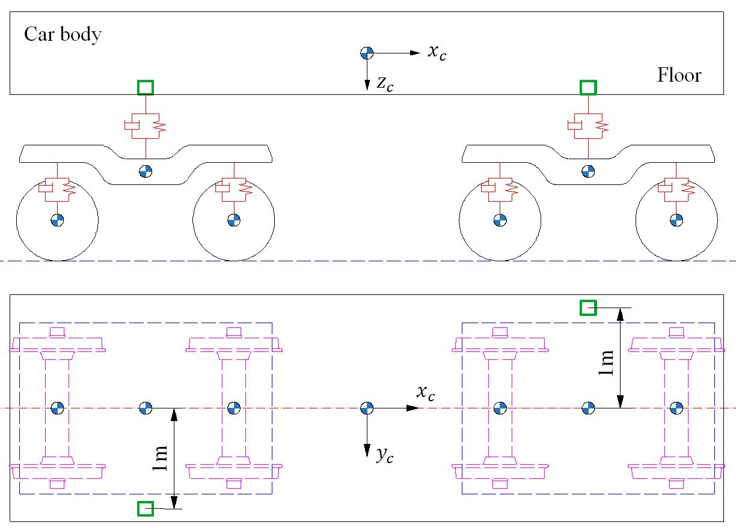

**Figure 7.** Sketch of acceleration measurement location of the car body

The FPD curves of the lateral ride index estimated by DMCS and the present method are given in Figure 8. After the calculations of 2300 samples, the failure probability can be obtained by the present method. Meanwhile, the FPD curves of DMCS with 2300 and 10000 samples are also given as references.

E:\Paper3计算结果\直线轨道平稳性指标失效概率曲线.emf

**Figure 8.** Comparison of FPD curves of lateral ride index

As can be seen from Figure 8, the results obtained by the present method agree well with the DMCS with 10000 samples, except when the failure probability is less than ${1.23×10}^{-4}$. This is mainly due to the uncertainty of DMCS, which cannot converge to the failure probability values below ${1.23×10}^{-4}$ with 10000 samples. For the DMCS with the same number of samples as the present method (2300 samples), the failure probability can only converge to a range of values larger than $3.1×{10}^{-3}$. It should be noted that the failure probability of the lateral ride index estimated with the present method is $8.21×{10}^{-5}$, while $1.218×{10}^{5}$ samples are needed for DMCS to achieve the same accuracy.

The FPD curves under different combinations of random parameters are also compared in Figure 8. For simplicity, only four curves are given, which deviate most from the FPD curve that considers all the above random parameters. From Figure 8, we know that the reliability of ride quality without considering the randomness of wheel-rail profiles is the highest, followed by ignoring the randomness of $c_{sx}$, $f_{wr}$ and $k_{sy}$. The first four parameters which have the greatest influence on ride quality on straight track are the wheel-rail profiles, $c_{sx}$, $f_{wr}$ and $k_{sy}$, respectively.

## *5.2 Sensitivity analysis of ride quality on straight track*

Reliability sensitivity is defined as the partial derivative of the failure probability with respect to the distribution parameters (the mean value or the standard deviation) of random variables. Through a reliability sensitivity analysis, the critical parameter which has a great influence on the failure probability of the system can be identified. The reliability sensitivity based on SS can be calculated as follows

|  |  |  |
| --- | --- | --- |
|  |  | (26) |

where $η$ is the distribution parameter, such as the mean value or variance; $\overline{η}$ is the value of the distribution parameter where the partial derivative is evaluated; $θ_{h}$ is the distribution parameter vector. In order to compare the effects of the distribution parameters of different dimensions, the sensitivity is normalized as follows

|  |  |  |
| --- | --- | --- |
|  | $$e_{η}=\frac{∂P_{F}}{∂η}\frac{\overline{η}}{P_{F}}$$ | (27) |

Since the reliability sensitivity method based on SS can only be used for random parameters, the sensitivities of wheel-rail profiles modelled as random fields are not calculated in this paper. The sign of a normalized sensitivity estimator indicates the influence trend of the mean value of random parameters on the system reliability: the positive sign indicates that the increase of the mean values will decrease the system reliability, while the minus sign indicates that the system reliability increases with the increase of the mean values of random parameters. The normalized sensitivities of the failure probability of lateral ride index are given in Figure 9.

E:\Paper3计算结果\灵敏度计算\均值横向平稳性指标.emf

**Figure 9.** Normalized sensitivities of the failure probability of lateral ride index

From Figure 9, we know that the first three key parameters affecting the lateral ride quality are $c_{sx}$, $f_{wr}$ and $k_{sy}$. Combining with the FPD curves given in Figure 8, the system reliability is higher when the randomness of the parameter with a greater sensitivity is not considered. According to the sensitivity sign, the increase of $c_{sx}$ or $f_{wr}$ will increase the vehicle’s critical speed, thus improve the lateral ride quality; the reduction of $k_{sy}$ will lower the yawing frequency of the car body and increase the modal damping ratio, which is beneficial for improving the lateral ride quality.

In addition, parameter sensitivities can also be reflected by the variation of the conditional PDF $q\left(θ_{l} | F\right)$ at each level.29 Based on Bayes’ theorem, $P\left(F | θ_{l}\right)$ can be expressed as

|  |  |  |
| --- | --- | --- |
|  |  | (28) |

where $N_{θ}$ is the dimension of the random vector $θ$. The greater the difference between conditional PDF $q\left(θ_{l} | F\right)$ and unconditional PDF $q\left(θ_{l}\right)$, the more sensitive the system reliability is to $θ_{l}$.

The variations of conditional PDFs of $c_{sx}$, $f_{wr}$ and $k_{sy}$ at each level are shown in Figure 10. As can be seen from Figure 10, the conditional PDFs all have larger values at some locations. This is because that some samples generated by Markov chain Monte Carlo (MCMC) are not adopted and replaced by seed samples, resulting in repeated samples. In addition, the difference between the conditional PDF and the unconditional PDF of $c_{sx}$ is the greatest, followed by those of $f_{wr}$ and $k_{sy}$. The mean value of $k_{sy}$ which has a positive sensitivity has a tendency to move to the right of the horizontal coordinate axis, while $c_{sx}$ and $f_{wr}$ which have negative sensitivities move to the left. These are consistent with the sensitivity values calculated by Equation (26).

E:\Paper3计算结果\灵敏度计算\直线csx.emf

(a)

E:\Paper3计算结果\灵敏度计算\直线fric.emf

(b)

E:\Paper3计算结果\灵敏度计算\直线ksy.emf

(c)

**Figure 10.** Conditional PDFs of $c_{sx}$, $f_{wr}$ and $k_{sy}$ at each level on straight track (blue histograms denote conditional PDFs and red solid lines denote unconditional PDFs)

## *5.3 Failure analysis of running safety on curved track*

The effects of the geometry parameters of curved track on the vehicle’s running safety are more and more noticeable, due to the change of track superelevation. The running safety can be measured by the wheel derailment coefficient, which is defined as the ratio of the lateral force to the vertical force between the wheel and the rail at the same position. The larger the value, the worse the running safety performance of the vehicle is. The wheel derailment coefficient should not exceed 0.8.28 The geometry parameters of the curved track are set as follows: the curve radius is $600m$, the length of the circular curve is $100m$, the length of the transition curve is $60m$, the superelevation is $0.075m$ and the total length of the curved track is $300m$. The running speed $V=80km/h$ and a time step $∆t$ of ${10}^{-4}s$ is selected.

The FPD curves of the wheel derailment coefficient estimated by DMCS and the present method are given in Figure 11. The number of samples at each level $N$ is 500 and the level probability $p_{0}$ takes 0.1. The failure probability value can be obtained after 5 levels of calculations by the present method and the number of corresponding samples $N_{T}$ is 2300. The FPD curves of DMCS with 2300 and 10000 samples are given as references.

E:\Paper3计算结果\曲线轨道脱轨系数失效概率曲线.emf

**Figure 11.** Comparison of FPD curves of wheel derailment coefficient

As can be seen from Figure 11, the results of the present method agree well with the DMCS with 10000 samples except when the failure probability is less than ${3.8×10}^{-5}$. This is mainly due to the uncertainty of DMCS, which cannot converge to the failure probability values below ${3.8×10}^{-5}$ with 10000 samples. For the DMCS with 2300 samples, the value of failure probability can only converge to a range of values larger than $1.2×{10}^{-3}$. It should be noted that the failure probability of the wheel derailment coefficient estimated by the present method is $2.85×{10}^{-5}$, while $3.5×{10}^{5}$ samples are needed for DMCS to achieve the same accuracy.

The FPD curves of the wheel derailment coefficient under different combinations of random parameters are given in Figure 11. It can be seen from Figure 11 that the running safety reliability of the vehicle without considering the randomness of wheel-rail profiles is the highest, followed by ignoring the randomness of $c_{sx}$、 $k_{px}$ and $f_{wr}$. These results show that the four factors which have the greatest influence on the running safety of the vehicle during curve negotiation are the wheel-rail profiles, $c_{sx}$、 $k_{px}$ and $f_{wr}$, respectively.

## *5.4 Sensitivity analysis of running safety on curved track*

The normalized sensitivities of the wheel derailment coefficient to the mean values of random parameters are shown in Figure 12. The variations of conditional PDFs of $c_{sx}$, $k_{px}$ and $f_{wr}$ at each level are given in Figure 13.

E:\Paper3计算结果\灵敏度计算\均值车轮脱轨系数.emf

**Figure 12.** Normalized sensitivities of the failure probability of derailment coefficient

E:\Paper3计算结果\灵敏度计算\曲线csx.emf

(a)

E:\Paper3计算结果\灵敏度计算\曲线kpx.emf

(b)

E:\Paper3计算结果\灵敏度计算\曲线fric.emf

(c) .

**Figure 13.** Conditional PDFs of $c_{sx}$, $k_{px}$ and $f_{wr}$ at each level on curved track (blue histograms denote conditional PDFs and red solid lines denote unconditional PDFs)

It can be seen from Figures 12 and 13 that $c_{sx}$, $k_{px}$ and $f_{wr}$ are the key parameters affecting the running safety performance of the vehicle during curve negotiation. Combining with the FPD curves given in Figure 11, the following conclusions can be obtained: the system reliability is higher when the randomness of the parameter with greater sensitivity is not considered. According to the sensitivity sign, the reduction of $c_{sx}$, $k_{px}$ and $f_{wr}$ will lower the attack angles of wheelsets and hence reduce the wheel derailment coefficient, which is beneficial for improving the curve negotiation performance of the vehicle.

**6. Conclusions**

In this paper, an efficient method for dynamic reliability analysis of vehicle-track coupled systems under the influence of random parameters is presented by combining a prediction-based iterative solution technique with Subset Simulation method. The computational efficiency of this method for analysing the system reliability is enhanced by improving the efficiency of single dynamic response solutions and reducing the number of reliability solutions. The actual wheel-rail profiles, nonlinear wheel-rail contact geometry relation and wheel-rail creep forces have been taken into account in the wheel-rail interaction model. The samples of random variables, such as the suspension parameters, wheel-rail coefficient of friction, are generated based on the assumed PDFs, while the samples of wheel-rail profiles are obtained by the Karhunen-Loève (KL) expansion method, which reduces the number of random variables needed to describe the random fields.

In the numerical examples, the failure probabilities of the lateral ride index on tangent track and the wheel derailment coefficient on curved track are calculated, respectively. The accuracy and efficiency of the present method for the dynamic reliability assessment of vehicle-track coupled systems are verified by comparing with the DMCS method. Meanwhile, the FPD curves under different combinations of random parameters are compared and sensitivity analyses are carried out. The following conclusions can be drawn: the system reliability is higher when the randomness of the parameters with greater sensitivity is not considered; the damping of anti-yaw damper $c_{sx}$, wheel-rail coefficient of friction $f_{wr}$ and lateral stiffness of secondary suspension $k_{sy}$ are the key parameters affecting the ride quality of the vehicle running on tangent track and the increase of $c_{sx}$ or $f_{wr}$ or the decrease of $k_{sy}$ will improve the lateral ride quality; The damping of anti-yaw damper $c_{sx}$, longitudinal stiffness of primary suspension $k_{px}$ and wheel-rail coefficient of friction $f_{wr}$ are the key parameters affecting the running safety of the vehicle during curve negotiation and the reduction of $c_{sx}$, $k_{px}$ or $f_{wr}$ will improve the curve negotiation performance of the vehicle.

# Acknowledgments

The authors are grateful for the support under grants from the National Natural Science Foundation of China (11672060 and 11672052).

# References

1. Funfschilling C, Perrin G, Sebes M, et al. Probabilistic simulation for the certification of railway vehicles. *Proc Inst Mech Eng Part F: J Rail and Rapid Transit* 2015; 229(6): 770-781.
2. Funfschilling C, Perrin G and Kraft S. Propagation of variability in railway dynamic simulations: application to virtual homologation. *Veh Syst Dyn* 2012; 50(Suppl): 245-261.
3. Kassa E and Nielsen JCO. Stochastic analysis of dynamic interaction between train and railway turnout. *Veh Syst Dyn* 2008; 46(5): 429-449.
4. Mazzola L and Bruni S. Effect of suspension parameter uncertainty on the dynamic behavior of railway vehicles. *Appl Mech Mater* 2012; 104: 177-185.
5. Oscarsson J. Dynamic train-track interaction: variability attributable to scatter in the track properties. *Veh Syst Dyn* 2002; 37(1): 59-79.
6. Oscarsson J. Simulation of train-track interaction with stochastic track properties. *Veh Syst Dyn* 2002; 37(6): 449-469.
7. Suarez B, Felez J, Maroto J, et al. Sensitivity analysis to assess the influence of the inertial properties of railway vehicle bodies on the vehicle’s dynamic behaviour. *Veh Syst Dyn* 2013; 51(2): 251-279.
8. Suarez B, Mera JM, Martinez ML, et al. Assessment of the influence of the elastic properties of rail vehicle suspensions on safety, ride quality and track fatigue. *Veh Syst Dyn* 2013; 51(2): 280-300.
9. Suarez B, Felez J, Lozano JA, et al. Influence of the track quality and of the properties of the wheel-rail rolling contact on vehicle dynamics. *Veh Syst Dyn* 2013; 51(2): 301-320.
10. Luo R, Shi HL, Teng WX, et al. Prediction of wheel profile wear and vehicle dynamics evolution considering stochastic parameters for high-speed train. *Wear* 2017; 392-393: 126-138.
11. Hohenbichler M and Rackwitz R. First-order concepts in system reliability. *Struct Saf* 1982; 1(3): 177-188.
12. Der Kiureghian A, Lin HZ and Hwang SJ. Second-order reliability approximations. *J Eng Mech* 1987; 113(8): 1208-1225.
13. Cho T, Song MK and Lee DH. Reliability analysis for the uncertainties in vehicle and high-speed railway bridge system based on an improved response surface method for nonlinear limit states. *Nonlinear Dyn* 2010; 59(1-2): 1-17.
14. Wetzel C and Proppe C. On reliability and sensitivity methods for vehicle systems under stochastic crosswind loads. *Veh Syst Dyn* 2010; 48(1): 79-95.
15. Proppe C and Wetzel C. A probabilistic approach for assessing the crosswind stability of ground vehicles. *Veh Syst Dyn* 2010; 48(Suppl): 411-428.
16. Schuëller GI, Pradlwarter HJ and Koutsourelakis PS. A critical appraisal of reliability estimation procedures for high dimensions. *Probab Eng Mech* 2004; 19(4): 463-474.
17. Au SK and Beck JL. Estimation of small failure probabilities in high dimensions by subset simulation. *Probab Eng Mech* 2001; 16(4): 263-277.
18. Au SK, Ching J and Beck JL. Application of subset simulation methods to reliability benchmark problems. *Struct Saf* 2007; 29(3): 183-193.
19. Tee KF, Khan LR and Li HS. Application of subset simulation in reliability estimation of underground pipelines. *Reliab Eng Syst Saf* 2014; 130: 125-131.
20. Au SK and Beck JL. Subset simulation and its application to probabilistic seismic performance assessment. *J Eng Mech* 2003; 129(8): 901-917.
21. Wetzel C and Proppe C. Stochastic modeling in multibody dynamics: aerodynamic loads on ground vehicles. *J Comput Nonlinear Dyn* 2010; 5(3): 031009-031009-9.
22. Wang W, Zhang YH and Ouyang HJ. An iterative method for solving the dynamic response of railway vehicle-track coupled systems based on prediction of wheel-rail forces. *Eng Struct* 2017; 151: 297-311.
23. Zhai WM. *Vehicles-Track Coupled Dynamics*. 4th ed. Beijing: Science Press, 2015. (in Chinese)
24. Li ZL. *Wheel-rail rolling contact and its application to wear simulation*. PhD thesis, Delft University of Technology, 2002.
25. Kalker J. A fast algorithm for the simplified theory of rolling contact. *Veh Syst Dyn* 1982; 11(1): 1-13.
26. Monzingo RA and Miller TW. *Introduction to Adaptive Arrays*. New York: John Wiley & Sons, 1980.
27. Ghanem RG and Spanos PD. *Stochastic Finite Elements: A Spectral Approach*. New York: Dover publication, 2003.
28. Ministry of Railways of the People's Republic of China. No. 28 of railway transport [2008] Testing of High-speed Electric Multiple Unit on Completion of Construction. Beijing: Ministry of Railways of the People's Republic of China;2008.(in Chinese)
29. Jensen HA, Mayorga F and Valdebenito MA. Reliability sensitivity estimation of nonlinear structural systems under stochastic excitation: A simulation-based approach. *Comput Methods Appl Mech Eng* 2015; 289: 1-23.