Received 00th January 20xx,
- Key Laboratory of Radiopharmaceuticals Ministry of Education, College of Chemistry, Beijing Normal University, Beijing 100875, P.R. China. email: qzyang@bnu.edu.cn
- Key Laboratory of Photochemical Conversion and Optoelectronic Materials, Technical Institute of Physics and Chemistry, Chinese Academy of Sciences, Beijing 100190, P. R. China.
- Department of Chemistry, University of Liverpool, Donnan Lab, G31, Crown St., Liverpool, L697ZD GB, UK. email: r.boulatov@liverpool.ac.uk
- These authors contributed equally to this work.
Electronic Supplementary Information (ESI) available. See DOI: 10.1039/x0xx00000x
Accepted 00th January 20xx
DOI: 10.1039/x0xx00000x

Ratiometric O₂ Sensing Based on Selective Self-Sensitized Photooxidation of Donor-Acceptor Fluorophores
Jian-Xin Wang^{a,d}, Li-Ya Niu^{a,d}, Peng-Zhong Chenª, Yu-Zhe Chen^{b}, Qing-Zheng Yang*ª, and Roman Boulatov*^{c}
We report a series of organic fluorophores that undergo selective self-sensitized photooxidation upon light irradiation in air accompanied by a change of fluorescence from yellow to blue on the seconds timescale. The distinct emission changes allow the ratiometric quantitation of O₂ concentration.
The last decade has witnessed considerable progress in designing molecular fluorophores for highly selective spatially-resolved ratiometric quantitation of diverse small-molecule analytes (e.g., H₂S, H₂O₂, NO, CO, HOCl) in complex environments, including living cells.¹⁻⁹ These methods, whose impressive specificities derive primarily from the selectivities of a chemical reaction between the fluorophore and the analyte, have enabled some of the more exciting and far reaching biochemical studies. A notable exception to this encouraging trend is detection of oxygen.^{10, 11} Despite the importance of knowing O₂ levels in chemistry, biology, food science and chemical process engineering, the existing methods of estimating the concentration of dissolved O₂ remain physical rather than chemical in origin. Optical methods rely primarily on quenching of luminescence of complexes of Ru, Ir, Pd or Pt, which in addition to O₂ is affected by several other molecules, reducing the utility of such a method for O₂ sensing in complex environments.¹⁰⁻¹⁶ Additionally, the necessary ratiometric measurements with these complexes require combining them with fluorophores with O₂-insentive emission, at considerable synthetic costs.¹⁴⁻¹⁶
Here we describe a series of simple easily accessible molecular fluorophores (1-4, Scheme 1) suitable for ratiometric O₂ detection in complex environments. Each donor/acceptor fluorophore contains an electron-deficient difluoroboron β-diketonate moiety linked to an electron-rich olefin. Upon light irradiation, the molecule sensitizes ³O₂ to ¹O₂ that reacts with the olefin C=C bond to yield first a dioxetane, followed by its spontaneous dissociation into acetophenone and/or indanone derivatives. The distinct emission properties of the olefin reactant and the ketone product allow the ratiometric quantitation of O₂ concentration. In contrast, all previously reported examples of photooxidation of organic fluorophores generated either non-emissive products and proceeded with insufficient selectivity to be useful for O₂ quantitation.
Fig. 1 Self-sensitizing (1-4) and non-sensitizing (5) fluorophores and the underlying photooxidation reaction.
Ratiometric O₂ sensing by photooxidation requires a fluorophore that undergoes efficient singlet-to-triplet intersystem crossing (ISC) upon photon absorption. Heavy-atom (e.g., I) substituents accelerate ISC,¹⁷⁻¹⁹ but such dyes are often toxic and unsuitable for biological applications. Heavy-atom substitution may be avoided with donor-acceptor (DA) fluorophores²⁰⁻²³ whose HOMOs and LUMOs are spatially separated. Such separation promotes triplet state generation, although the mechanism is debated.²⁴⁻²⁶ Previously reported DA fluorophores manifest thermally activated delayed fluorescence,^{14,16,17,19} and room temperature phosphorescence,^{27, 28} and were suggested to have potential for photodynamic therapy and O₂ detection in vitro by emission quenching,^{20, 29} analogous to that of the heavy-atom complexes mentioned above.
We achieved the necessary HOMO/LUMO separation by connecting electron-deficient difluoroboron β-diketonate to a meta position of an electron-rich stilbene to preclude conjugation of the two moieties. Fluorophores 1-4 and non-sensitizing control 5 in which the two moieties are conjugated (Fig. 1) were synthesized in the overall yield of 42% - 60% by Claisen condensation of an aromatic ketone and an olefin to afford β-diketones, followed by the complexation of BF₃. They were characterized by ¹H and ¹³C NMR spectroscopy and high-resolution mass spectroscopy (HRMS) (for details, see Supplementary Information).
E-1 absorbs at 300 - 500 nm with the maximum at 380 nm (Fig. 2a and Table S1) and emits at 470 - 750 nm, with the maximum at 560 nm and fluorescence quantum yield of 32% (Fig. 2b). The absorption and emission spectra of a deoxygenated solution of E-1 change slightly immediately upon the start of irradiation at 365 nm, as a photostationary state of the E and Z isomers of 1 is quickly reached, and remain unchanged over continued irradiation for 5 min (Fig. S1). In contrast, irradiation of an aerated toluene solution of E-1 at the same concentration and photon flux caused a decrease in the intensity of the emission peak at 560 nm and a growth of a new emission peak at 430 nm (Fig. 2b). Correspondingly, the emission color changed from yellow to deep blue (Fig. 2b inset). Similar spectral changes were observed for compounds 2–4, which have only one difluoroboron β-diketonate moiety per photooxidazible olefin C=C bond of different degrees of substitution. Emission bands of 2-4 are centered at 580, 524 and 500 nm, respectively. Upon irradiation in the presence of O₂, this long-wavelength emission decreased, and blue fluorescence at ~430 nm emerged (Fig. S2-S4). The observed changes require both O₂ and irradiation: the emission spectra were unchanged in the dark under air or upon irradiation of an anaerobic solution. The meta position of the difluoroboron β-diketonate moiety relative to the stilbene C=C bond is critical for achieving self-sensitization: 5, which is analogous to 4 except for the para position of difluoroboron β-diketonate, does not change upon irradiation (Fig. S5).
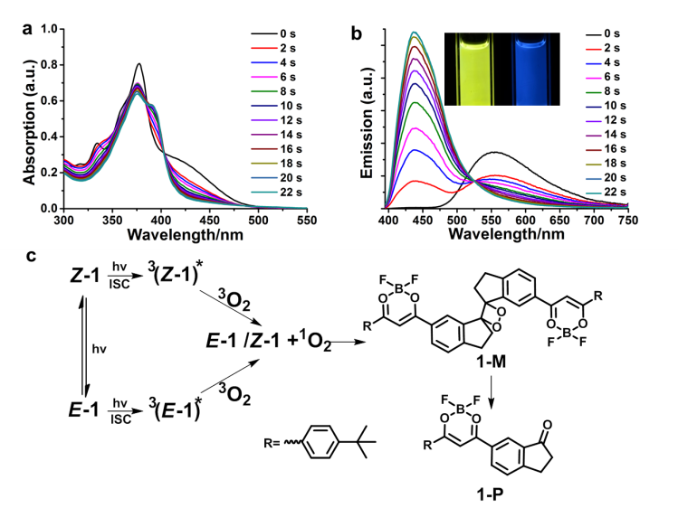
Fig. 2 Time-dependent (a) absorption and (b) emission spectra of E-1 in an air-saturated toluene 20 μM solution upon irradiation with 365 nm light. Inset: fluorescence images of the same solution before (left) and after (right) irradiation. (c) Plausible mechanism of self-sensitized photooxidation on example of E-1.
We chose compound E-1 to confirm the probable molecular origin of the observed spectral changes (Fig. 2c). First, we confirmed the generation of singlet oxygen by electron spin resonance (ESR) spectroscopy with 2,2,6,6-tetramethylpiperidine (TEMP) as an ¹O₂ scavenger. Irradiating a mixed aerated solution of E-1 and TEMP with a 365 nm LED lamp at 0.3 mW cm⁻² produced a characteristic ESR signal of TEMPO, which is a known product of reaction of TEMP with ¹O₂.^{30, 31} The signal intensity increased with the radiation time (Fig. 3a). No detectable ESR signal was observed by replacing E-1 in the above experiment with 5 (Fig. 3b), which does not self-sensitize, indicating that the generation of ¹O₂ is necessary for the observed spectral changes.
Second, HRMS of irradiated aerobic sample of E-1 revealed the molecular peak at m/z 782.3457 (Fig. S7), which we ascribed to a dioxetane intermediate, 1-M (m/z calculated for [1-M +NH₄⁺] is 782.3453), in addition to peaks at 750.3535, corresponding to 1, and at 400.1885 corresponding to the product of thermal dissociation of 1-M, 1-P. Chromatographic analysis of this solution yielded 1-P as the only new species, consistent with high lability of alkyl dioxetanes.^{32, 33} We synthesized 1-P independently and confirmed that its HRMS, ¹H and ¹³C NMR, absorption and emission spectra were identical to 1-P isolated from the irradiated sample of E-1 (Fig. S8).
Third, spectral changes in the first few seconds of irradiation reflect a rapidly established photostationary state of the E and Z isomers,³⁴⁻³⁸ which explains why the spectra before irradiation do not pass through the isosbestic points formed by all the subsequent spectra. We synthetized the Z isomer of 1, Z-1, and confirmed that while it is a weaker fluorophore than E-1, its irradiation in aerobic solution generates the same sequence of absorption and emission spectra as does irradiation of originally pure-E solution (Fig. S9).
The data above clearly establishes that the spectral changes in aerobic irradiated solutions of 1 result from the generation of ¹O₂. Such self-sensitization is typically associated with efficient singlet-to-triplet ISC in an electronically excited chromophore. The absence of heavy elements in 1 suggests that this ISC may result from a very small singlet-to-triplet energy gap, ΔE_{S1–T1} (ΔEst), which is confirmed by the nearly identical fluorescence and phosphorescence spectra of E-1 (Fig. 3c). The small ΔEst is often observed in DA fluorophores with spatially separated HOMOs and LUMOs and our calculations at the B3LYP/6-31G(d) level of the DFT revealed such separated MOs in 1-4 (Fig. S10). In contrast, 5, whose dioxaborinine group is bound at the para position of the stilbene moiety, does not self-sensitize, has substantially co-localized frontier orbitals and manifests a phosphorescence spectrum that is red-shifted relative to the fluorescent emission by >50 nm (Fig. 3d). The optimized geometries reproduced the small twist between the stiff-stilbene and the dioxaborinine ring in 2 observed in its single-crystal XRD structure (Fig. S12).
The data above suggest that spectral changes in aerobic solutions of 1-4 under light irradiation probably start with the initially populated S₁ state undergoing ISC to a nearly-isoenergetic T₁ state (Fig. 2c). In the presence of O₂, a fraction of this T₁ state relaxes by triplet-to-triplet energy transfer to regenerate the dye in the S_{o} state and ¹O₂. The latter adds to the C=C bond of 1-4 to yield dioxetane (e.g., 1-M), whose subsequent thermally-activated dissociation creates the observed new fluorophore, e.g., 1-P.
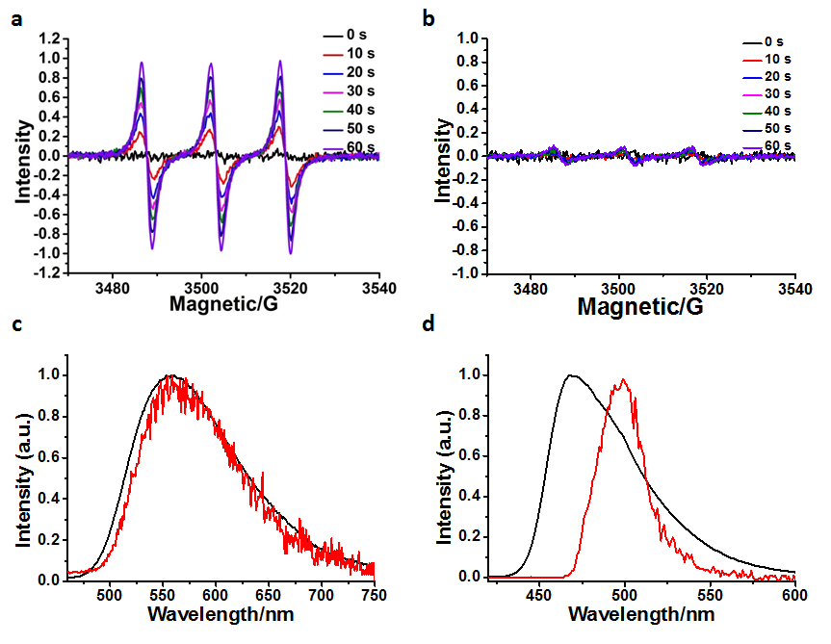
Fig. 3 ESR spectra of an air-saturated toluene solution of (a) E-1 (1 × 10⁻⁴ M) and (b) 5 (1 × 10⁻⁴ M) with TEMP (2 × 10⁻⁴ M) after increasingly long irradiation by a 365 nm LED lamp at room temperature. Fluorescence (at room temperature, black line) and phosphorescence spectra (at 77 K, after a 0.1 ms delay, red line) of (c) self-sensitizing E-1 and (d) non-self-sensitizing 5 in toluene solution at 20 μM. The spectral intensities were normalized to 1 to facilitate comparisons.
This mechanism means that the rate of the spectral changes is sensitive to the O₂ concentration, i.e., it enables ratiometric detection of O₂ with fluorophores 1-4. This conclusion was confirmed by measuring emission of E-1 in a 20 μM toluene solution under 365 nm irradiation at different oxygen partial pressures (Fig. 4). At all irradiation times the ratio of the emission intensities at 430 nm (oxygenated product) and 560 nm (initial dye) was proportional to the initial oxygen partial pressure.
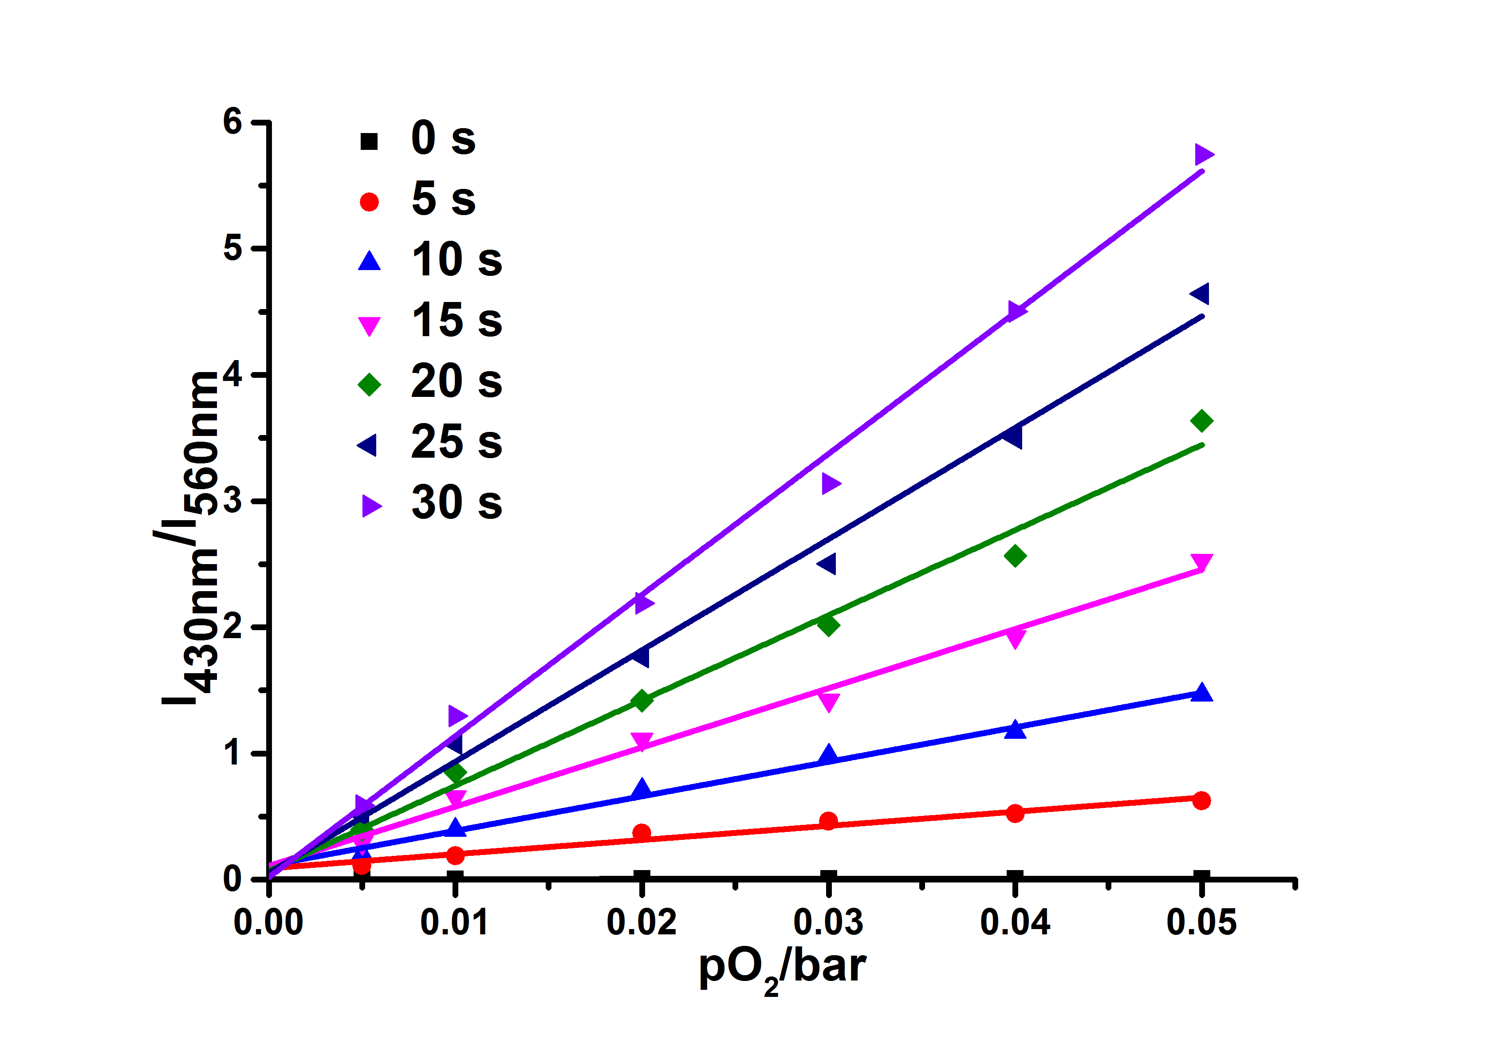
Fig. 4 The ratio of the emission intensities at 430 nm and 560 nm (I₄₃₀/I₅₆₀) of a 20 μM - toluene solution of E-1 containing different concentrations of O₂ as a function of irradiation time. Longer irradiations and higher O₂ concentrations result in larger conversions of the original dye (emitting at 560 nm) to the oxygenated product, which emits at 430 nm. Lines are least-squares fits of the experimental data demonstrating linear response at a range of irradiation times.
Fig. 5 Chemical structure of 6.
To establish the suitability of the introduced molecular design for ratiometric O₂ measurements in living cells we synthesized a water-soluble derivative 6 (Fig. 5). Fig. 6a shows confocal laser scanning microscopy images of HeLa cells incubated with 6 under ambient condition for 15 min, followed by washes to removing extracellular 6. The cells were clearly visible in the red channel (emission at 570-620 nm), but barely detectable in the blue channel (emission at 425-475 nm). Under anaerobic conditions, irradiation with 365 nm light for ~1 min produced no detectable changes in either channel. Irradiation under aerobic conditions decreased fluorescence intensity in the red channel and increased in the blue channel, with the ratio of the red-to-blue channel intensities decreasing from ~40 to ~10. These results support our view that derivatives of fluorophores 1-4 are potentially useful for quantifying oxygen in living cells.
Measurements of oxygen levels are important not only in physiology and pathology, but also in numerous applications in food sciences and chemical process control. To illustrate the utility of our fluorophores in these contexts, we doped E-1 in a hydrogel, which produced bright orange fluorescence under 365 nm irradiation. Irradiation of the same material for 5 min through a mask of a smiley face transferred this image to the hydrogel by photooxidizing the exposed areas only, engendering them with blue fluorescence (Fig. 6b).
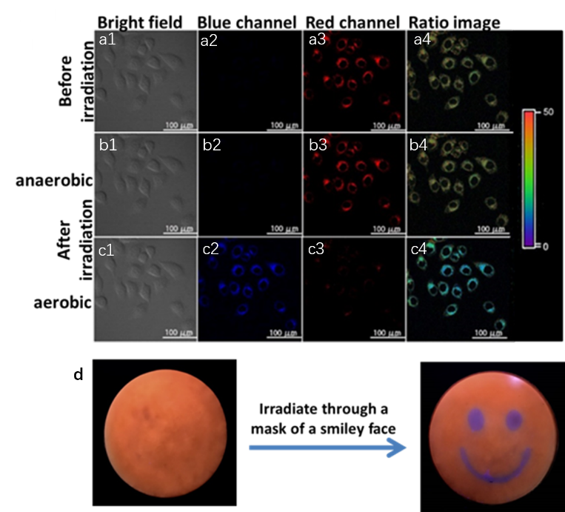
Fig. 6 (a-c) Confocal fluorescence and bright-field images of HeLa cells loaded with 6 (1 μM) before (a1-a4) and after irradiation under anaerobic (b1-b4) and ambient oxygen levels (c1-c4): Bright-field images (a1-c1); blue channel (425-475 nm) emission after excitation at 409 nm (a2-c2); red channel (570-620 nm) emission after excitation at 409 nm (a3-c3); the the red/blue channel ratio images (a4-c4). (d) Fluorescence images of polyvinyl alcohol hydrogel doped with E-1 before and after irradiation at 365 nm through a mask of a smiley face in air.
In conclusion, we reported a series of fluorophores whose emission spectra shift hypsochromically by >150 nm on irradiation in aerobic solutions as a result of selective self-sensitized photooxidation. The fluorophores contain an electron-rich aromatic olefin, such as stilbene, substituted at a meta position with a difluoroboron β-diketonate moiety. Photooxidation converts the olefin to a ketone through a labile dioxetane intermediate. These self-sensitizing fluorophores manifest nearly overlapping phosphorescence and fluorescence emissions, suggesting a small singlet-triplet gap, and according to DFT calculations have negligible spatial overlap of the frontier orbitals. Moving the dioxaborinine moiety to the para position of stilbene eliminates self-sensitization, red-shifts the phosphorescence emission compared to the fluorescence one and creates spatially overlapping frontier MOs. The self-sensitizing fluorophores enable quantitation of intracellular O₂ concentration by ratiometric fluorescence measurements. We suggest that the general molecular architecture described here and the selective self-sensitized photooxidation that it engenders forms the basis for potential applications in oxygen sensing, photocaged drug delivery system and smart materials.
This work was financially supported by National Natural Science Foundation of China (21525206, 21561130149) to QZY and by EPSRC Early Career Fellowship (EP/L000075/1) to RB.
Conflicts of interest
There are no conflicts to declare
Notes and references
1. J. Chan, S. C. Dodani and C. J. Chang, Nat. Chem., 2012, 4, 973-984.
2. Y. Yang, Q. Zhao, W. Feng and F. Li, Chem. Rev., 2013, 113, 192-270.
3. V. S. Lin, W. Chen, M. Xian and C. J. Chang, Chem. Soc. Rev., 2015, 44, 4596-4618.
4. X. Chen, F. Wang, J. Y. Hyun, T. Wei, J. Qiang, X. Ren, I. Shin and J. Yoon, Chem. Soc. Rev., 2016, 45, 2976-3016.
5. Y. Nosaka and A. Y. Nosaka, Chem. Rev., 2017, 117, 11302-11336.
6. X. Zhang, W. Zhao, B. Li, W. Li, C. Zhang, X. Hou, J. Jiang and Y. Dong, Chem. Sci., 2018, 9, 8207-8212.
7. K. Liu, X. Kong, Y. Ma and W. Lin, Nat. Protoc., 2018, 13, 1020-1033.
8. C. J. Reinhardt, E. Y. Zhou, M. D. Jorgensen, G. Partipilo and J. Chan, J. Am. Chem. Soc., 2018, 140, 1011-1018.
9. T. I. Kim, B. Hwang, B. Lee, J. Bae and Y. Kim, J. Am. Chem. Soc., 2018, 140, 11771-11776.
10. X. D. Wang and O. S. Wolfbeis, Chem. Soc. Rev., 2014, 43, 3666-3761.
11. D. B. Papkovsky and R. I. Dmitriev, Chem. Soc. Rev., 2013, 42, 8700-8732.
12. S. M. B. Andreas Fercher, Alexander V. Zhdanov, Ingo Klimant, and Dmitri B. Papkovsky, ACS. Nano., 2011, 5, 5499-5508.
13. T. T. Raymond P. Brinas, Robin M. Hochstrasser, and Sergei A. Vinogradov, J. Am. Chem. Soc., 2005, 127, 11851-11862
14. C. Wu, B. Bull, K. Christensen and J. McNeill, Angew. Chem. Int. Ed., 2009, 48, 2741-2745.
15. T. Yoshihara, Y. Yamaguchi, M. Hosaka, T. Takeuchi and S. Tobita, Angew. Chem. Int. Ed., 2012, 51, 4148-4151.
16. R. Xu, Y. Wang, X. Duan, K. Lu, D. Micheroni, A. Hu and W. Lin, J. Am. Chem. Soc., 2016, 138, 2158-2161.
17. M. Li, S. Long, Y. Kang, L. Guo, J. Wang, J. Fan, J. Du and X. Peng, J. Am. Chem. Soc., 2018, 140, 15820-15826.
18. D. Li, F. Lu, J. Wang, W. Hu, X. M. Cao, X. Ma and H. Tian, J. Am. Chem. Soc., 2018, 140, 1916-1923.
19. N. J. Turro, K.-C. Liu, M.-F. Chow and P. Lee, Photochem. Photobiol., 1978, 27, 523-529.
20. Z. Yang, Z. Mao, Z. Xie, Y. Zhang, S. Liu, J. Zhao, J. Xu, Z. Chi and M. P. Aldred, Chem. Soc. Rev., 2017, 46, 915-1016.
21. B. Gu, W. Wu, G. Xu, G. Feng, F. Yin, P. H. J. Chong, J. Qu, K. T. Yong and B. Liu, Adv. Mater., 2017, 29, 1701076.
22. X. Xiong, F. Song, J. Wang, Y. Zhang, Y. Xue, L. Sun, N. Jiang, P. Gao, L. Tian and X. Peng, J. Am. Chem. Soc., 2014, 136, 9590-9597.
23. H. Uoyama, K. Goushi, K. Shizu, H. Nomura and C. Adachi, Nature., 2012, 492, 234-238.
24. M. A. Filatov, S. Karuthedath, P. M. Polestshuk, H. Savoie, K. J. Flanagan, C. Sy, E. Sitte, M. Telitchko, F. Laquai, R. W. Boyle and M. O. Senge, J. Am. Chem. Soc., 2017, 139, 6282-6285.
25. M. K. Etherington, J. Gibson, H. F. Higginbotham, T. J. Penfold and A. P. Monkman, Nat. Commun., 2016, 7, 13680.
26. H. Kang, Y. Si, Y. Liu, X. Zhang, W. Zhang, Y. Zhao, B. Yang, Y. Liu and Z. Liu, J. Phys. Chem. A., 2018, 122, 5574-5579.
27. H. Ma, Q. Peng, Z. An, W. Huang and Z. Shuai, J. Am. Chem. Soc., 2019, 141, 1010-1015.
28. S. Cai, H. Shi, D. Tian, H. Ma, Z. Cheng, Q. Wu, M. Gu, L. Huang, Z. An, Q. Peng and W. Huang, Adv. Funct. Mater., 2018, 28, 1705045.
29. J. Zhang, W. Chen, R. Chen, X. K. Liu, Y. Xiong, S. V. Kershaw, A. L. Rogach, C. Adachi, X. Zhang and C. S. Lee, Chem. Commun., 2016, 52, 11744-11747.
30. J. Ge, M. Lan, B. Zhou, W. Liu, L. Guo, H. Wang, Q. Jia, G. Niu, X. Huang, H. Zhou, X. Meng, P. Wang, C. S. Lee, W. Zhang and X. Han, Nat. Commun., 2014, 5, 4596.
31. K. Liu, Y. Liu, Y. Yao, H. Yuan, S. Wang, Z. Wang and X. Zhang, Angew. Chem. Int. Ed., 2013, 52, 8285-8289.
32. W. Adam, Chichester: John Wiley Sons Ltd, 1992, 221-254.
33. W. Adam and A. V. Trofimov, Chichester: John Wiley Sons Ltd, 2006, 2, 1171-1209.
34. Z. Huang and R. Boulatov, Chem. Soc. Rev., 2011, 40, 2359-2384.
35. S. Akbulatov, Y. Tian, Z. Huang, T. J. Kucharski, Q.-Z. Yang and R. Boulatov, Science., 2017, 357, 299-303.
36. J. F. Xu, Y. Z. Chen, D. Wu, L. Z. Wu, C. H. Tung and Q. Z. Yang, Angew. Chem. Int. Ed., 2013, 52, 9738-9742.
37. Q. Z. Yang, Z. Huang, T. J. Kucharski, D. Khvostichenko, J. Chen and R. Boulatov, Nat. Nanotechnol., 2009, 4, 302-306.
38. Z. Huang, Q.-Z. Yang, D. Khvostichenko, T. J. Kucharski, J. Chen and R. Boulatov, J. Am. Chem. Soc., 2009, 131, 1407-1409.

