Dynamic behaviour of a bolted joint subjected to torsional excitation
Jianhua Liu^{1,} *, Huajiang Ouyang², Zhiqiang Feng³, Zhenbing Cai¹,
Jiliang Mo¹, Jinfang Peng⁴, Minhao Zhu¹
1. Tribology Research Institute, Southwest Jiaotong University, Chengdu 610031, China
2. School of Engineering, University of Liverpool, Liverpool L69 3GH, UK
3. LMEE, Univ Evry, Université Paris-Saclay, 91020, Evry, France
4. Traction Power State Key Laboratory, Southwest Jiaotong University, Chengdu 610031, China

Abstract
This paper presents results of experimental and theoretical studies on the dynamics of a bolted joint under torsional excitation. Hysteresis curves of the resultant torque versus the applied angle of twist are obtained from the experimental results. These experiments have shown relative slippages between the clamped parts and between the contact threads. Based on the experimental results, the coefficients of friction between the contact surfaces are obtained using a theoretical method. An effective modelling method is presented to exactly construct helical thread profiles. Using the finite element model thus obtained, the hysteresis curves are reproduced from the finite element analysis. Finally the hysteresis curves are recreated by a modified Jenkins element model which agrees with the detailed finite element model.

Keywords: Bolted joint; Torsional displacement; Hysteresis curve; Jenkins element

1. Introduction
Many engineering components and structures are built up by simpler components through joints. The dynamics of these assembled structures is closely related to the damping of bolted joints. Beards ^{[1]} reported that the damping of bolted joints made the largest contribution to the total damping in assembled structures. Some researchers ^{[2-6]} reported that the dissipated energy in mechanical joints depended on the clamping pressure: the slip is small between the two bolted members under high pressure, while it is relatively large because of the small friction under low pressure; there are maximum dissipated energy between the two limits. Krzyzanowski et al. ^{[7]} studied the static and vibration energy dissipation in flange bolted joints. The relationship between system damping and the bolt preload was studied both experimentally and numerically ^{[8, 9]}. Iwan ^{[10]} and Gaul et al. ^{[11]} established a model with clear physical meanings for a bolted joint using Jenkins elements in parallel. In addition, viscous damping and equivalent stiffness for a bolted joint are obtained using the harmonic balance method. The dynamics of a bolted joint subjected to torsional dynamic loading were investigated by Oldfield et al. ^{[12]} and Ouyang et al. ^{[13]}. The hysteresis curves of the applied torque versus the relative angular displacement of the joint were reproduced by two typical theoretical models in their studies. Kukreti et al. ^{[14]}, Qin et al. ^{[15]} and Deng et al. ^{[16]} analysed hysteretic responses of connections using a finite element program, and the results were compared with experimental data. Morteza et al. ^{[17]} and Jalali ^{[18]} presented a thin layer interface model with virtual elasto-plastic material behaviour, and identified the parameters of the model using experimentally measured data. The dynamic behaviour of bolted joints was investigated using the model obtained.
The finite element method has been used to investigate the mechanical properties of bolted joints. For complex bolted connections, quite often the threads of bolts and nuts were not modelled, then both the bolt and the nut were tied together ^{[19, 20]}. For simpler structures, the effect of the helix angle of threads of a bolted joint was neglected in most studies. Zhao ^{[21]} used axisymmetric models to investigate the stress concentration factors at the thread roots. Based on the model of only one half of a bolted joint, Jiang et al. ^{[22]} explored the mechanisms for the self-loosening of a bolted joint excited by harmonic shear loading. Liu et al. ^{[23]} studied the dynamic response of a bolted joint under dynamic shear displacement. Recently, some researchers investigated the behaviour of a bolted joint using helical thread models. Due to the complexity of thread profile and the limitation of finite element software, tetrahedral elements were used in these finite element models ^{[24, 25]}. In addition, external threads and bolt shank were both modelled with hexahedral elements, and then the bolt model was created through tying the bolt shank with the internal faces of the external threads. The nut model was similarly created in the same manner ^{[26-28]}.
The finite element models using the above mentioned methods could not exactly simulate the mechanical characteristics of bolted joints. In their very recent studies of bolted joints, some researchers ^{[29-31]} presented an effective modelling method to construct helical thread geometry using HyperWorks and ANSYS. For different thread sizes of bolts, the bolted joints need to be remodelled and the efficiency is low. There are three conventional methods to apply a bolt preload: a temperature increase is applied to one of the clamped members ^{[22, 32]}; a preload is applied over the bolt cross-section ^{[12, 33-35]}; an initial interference between the bolt head and the upper surface of the clamped member is defined to simulate the application of the preload ^{[36, 37]}. However, the previous three methods cannot simulate the friction torque applied to the bolt during the tightening process.
It is noted that it takes a long time to obtain a hysteresis curve of the resultant torque versus the applied angle of twist using the finite element method. This suggests that a simplified mathematical model of a bolted joint should be useful. Jenkins element model ^{[10, 11]}, Valanis model ^{[38]} and Bouc-Wen model ^{[39-40]} are used to study the mechanical behaviour of bolted joints. A Jenkins element is a spring and a damper connected in series, and it can simulate the sticking and slipping condition of a bolted joint. Gaul et. al ^{[11]} used some Jenkins elements in parallel, and the partial slip condition of a bolted joint was simulated when some of Jenkins elements were slipping and the others were sticking. Because Jenkins element model provides very similar dynamic behaviour and dissipated energy, it is widely used to simulate the mechanical behaviour of a bolted joint.
In this paper, experiments are firstly conducted for studying the dynamics of a bolted joint subjected to torsional excitation (Fig. 1). The hysteresis curves of the bolted joint are produced from the time-domain test data, and the loosening behaviour of bolted joints is analysed. The coefficients of friction between the contact threads and between the top holder and the bolt head (denoted as μ_{t-t} and μ_{h-b} respectively), which are required for the subsequent finite element analysis, are obtained by combining them with a theoretical method. Subsequently, a parametric finite element method is presented using MATLAB and ABAQUS, which can exactly and efficiently build up the bolt/nut model. The way of constructing realistic thread profiles in an finite element model is original. A theoretical method is used to validate the effectiveness of the finite element model. The contact stress on the surfaces of the washer and the threads is analysed, and the coefficient of friction between the top holder and the washer (denoted as μ_{h-w}) is obtained by combining with experimental results. Based on the established three-dimensional finite element model, the hysteresis response is studied by comparison with the experimental results.
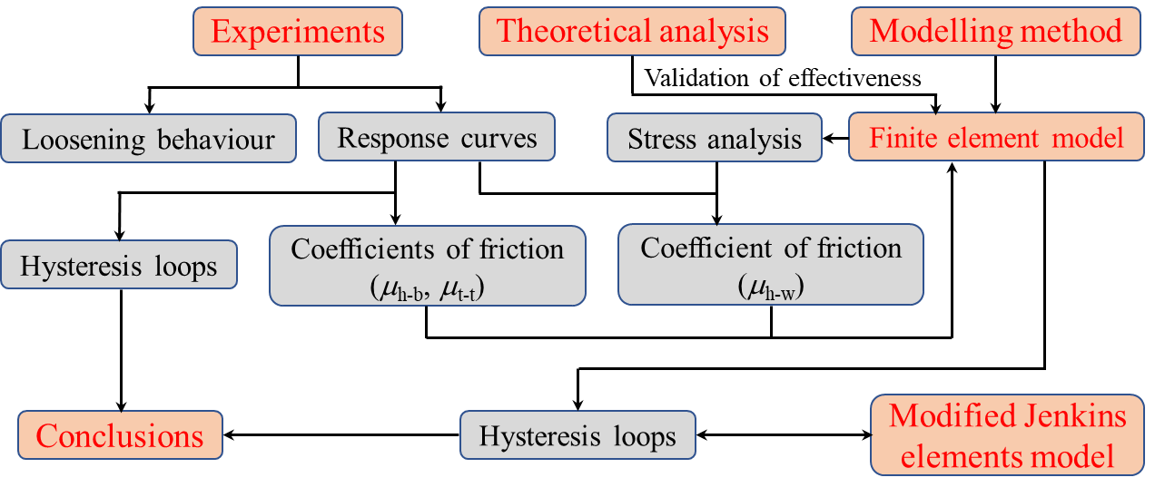
Fig. 1 Research approach
It has been found that the breakaway torque required to loosen a bolted joint is smaller than the tightening torque ^{[24, 41]}. Consequently, it can be concluded that the original Jenkins element model could not reproduce the hysteresis response of bolted joints. So this model is modified to reproduce the hysteresis curves in this paper. The third order modified Jenkins element model is found to agree well with the results predicted from the finite element model.

2. Experimental tests

2.1 Experimental method
Fig. 2 shows the testing equipment used in the experiments. The testing holders made of stainless steel have a high fatigue strength. The bolts and square nuts under tests are made of ASTM 304 stainless steel with yield strength of about 450 MPa. The resultant torque and the applied angle of twist are measured by two sensors in the testing machine (Walter + Bai LFV 100-T500-HH). The sensors are part of the machine and they do not a brand or name of their own. The capacities of the two sensors are 500 Nm and 50 degree respectively, and their accuracy is within half a percent. A load cell (WTP 218-50, capacity 50 kN for M12 bolt), with accuracy of within one percent, is used to monitor the change of the clamping force in real-time. A thin copper washer is placed in between the two holders to reduce the surface damage of the holders. The thickness and the external diameter of the copper washer used in the experiments are 3 mm and 34 mm respectively. In order to hinder a large relative slip occurring between the upper/lower contact surfaces, a circular indentation (Fig. 2(c)) used to locate the copper washer is made on the bottom holder. The depth and the diameter of the indentation are 1 mm and 34.5 mm respectively. In addition, a glue (Loctite 262) is applied on the lower contact surface of the washer. Therefore, the copper washer is almost in the center of the groove during the tests. The test procedure is as follows: (1) fix the bottom holder on the test bench, then assemble the two holders, the load cell and the thin washer using a bolt and a square nut; (2) apply a certain tightening torque to the bolt head to achieve a set preload to the bolted joint, then tighten the eight fixing bolts located on both sides of the bottom holder to fix the square nut; (3) apply a harmonic torsional displacement to the top holder (hereinafter referred to as vibration test).
For the bolt made of stainless steel, the recommended preload corresponds to a value from fifty to sixty percent of the nominal yield strength of the bolt ^{[38]}. The valid cross section, defined as A_{s}, is 84.3 mm² for the M12 bolt. Consequently, the preload range for the M12 bolt made of stainless steel (ASTM, 304) is between 19.0 kN and 22.8 kN. 21 kN is selected in the experiments. In addition, four amplitude levels of the harmonic angular displacement are used. They are 1 deg, 2 deg, 2.5 deg and 3 deg. Before the tests, all bolts and nuts are cleaned using an ultrasonic cleaner. The test conducted is repeated three separate times for each experimental condition at a frequency of 1 Hz in air at room temperature. The total run-out number of harmonic torsional displacement cycles is 2000.
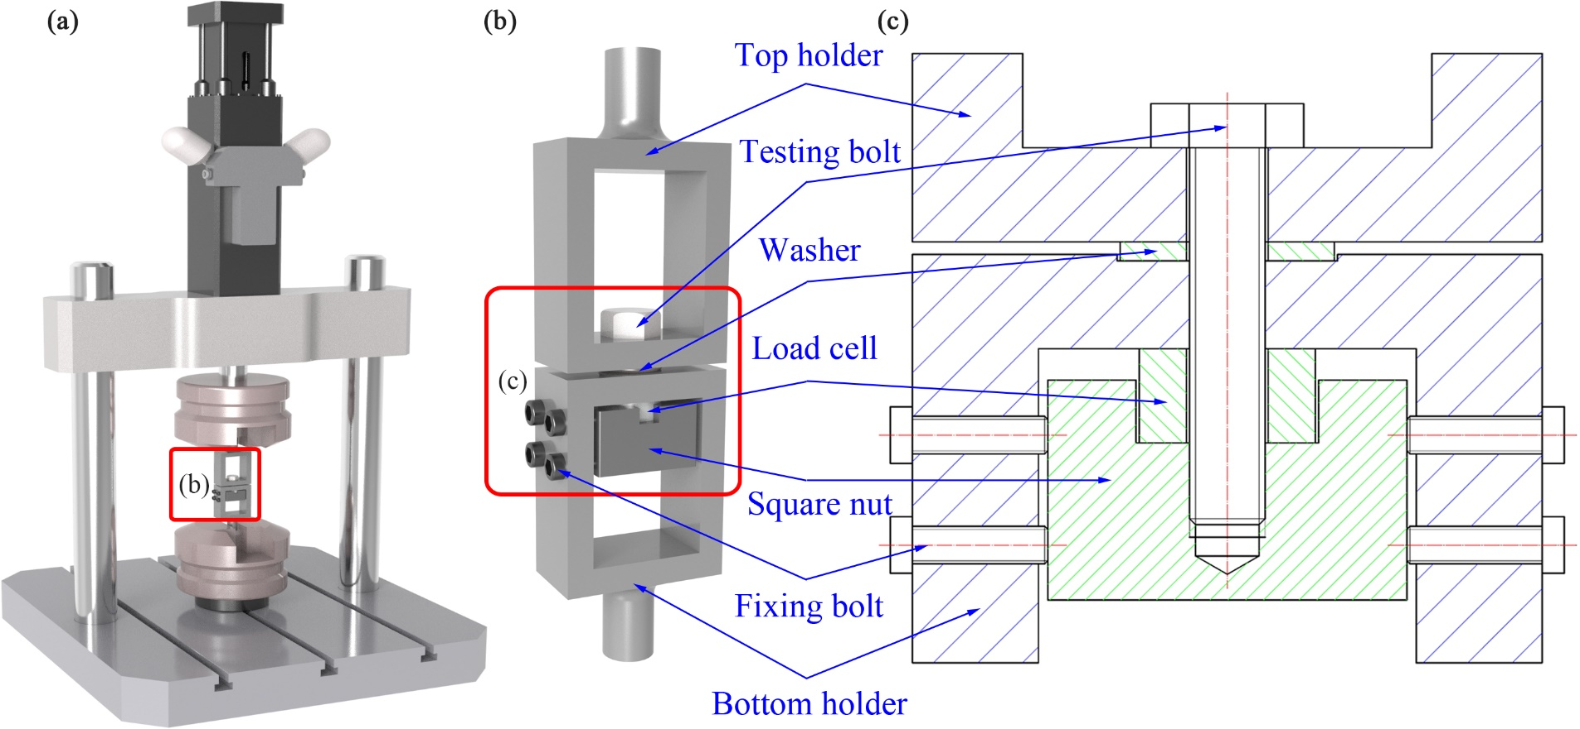
Fig. 2 Testing equipment: (a) Experimental device; (b) Testing bolted joint; (c) Broken-out section

2.2 Experimental results
In order to obtain the resultant torques when relative slippage occurs between the top holder and the washer and between the contact threads, an angular displacement around the bolt axis is applied to the top holder before and after the torsional excitation respectively, and the speed is 0.1 degree per second. The curves of the resultant torque with the applied angular displacement are shown in Fig. 3. Because of the high surface roughness of the top holder, the coefficient of friction between the bolt head and the top holder is large, which prevents the relative slippage from occurring between those two contact surfaces during the tests. With the increase of angular displacement, the contact between the top holder and the washer firstly goes into the gross slip status, and the resultant torque for this to happen is 38.42 Nm. As the angular displacement continues to increase, when the resultant torque reaches 76.36 Nm before the vibration test, the contact between threads is under the gross slip status. The contact threads are damaged in the vibration tests, which causes the coefficient of friction between the contact threads to become larger. When relative slippage between the contact threads occurs, the resultant torque reaches 100.68 Nm after the vibration test.
The analytical relation between the total tightening torque T_{bt} and the clamping force P₀ is well-known and given in Eq. (1) ^{[42]}.
(1)
where α is half of the thread profile angle, β is the helix angle of threads, d₂ and d_{w} are the pitch diameter of thread and the equivalent diameter of bearing surface respectively, μ_{t-t} and μ_{h-b} are the coefficients of friction between the contact threads and between the top holder and the bolt head respectively.
Fig. 3 Variation of the resultant torque with the applied angular displacement
Considering that the value of the helix angle of threads, denoted by β, is 0.0436 rad, Eq. (1) can be simplified to:
(2)
where T_{p} is the torque due to thread pitch, T_{t-t} and T_{h-b} are the torques due to friction between the contact threads and between the top holder and the bolt head, and P is the thread pitch.
Additionally, the analytical relation between the total loosening torque T_{bl} and preload P₀ is given as ^{[24, 38]}:
(3)
From the equation of static equilibrium,
(4)
where T_{ht} is the resultant torque when the contact between threads is in the gross slip status, and T_{h-w} is the frictional torque between the top holder and the washer.
Taking the values of the parameters showed in Tab. 1 into Eqs. (2), (3) and (4), the coefficients of friction are determined as:
(5)
Fig. 4 shows the curves of the resultant torque versus the applied angle of twist for varying loading cycles. It can be found from Fig. 4(a) that the shape of the hysteresis curves looks like a parallelogram when the angular amplitude, denoted as Δδ, is 1 deg. The response curves between two adjacent loading reversals can be divided into two stages: Stage I: gross slip has not occurred between the top holder and the washer, and the resultant torque increases rapidly with the increase of the applied angle of twist. If the gradient of the curves is denoted as k_{a}, the torsional stiffness of the testing equipment (showed in Fig. 2) is 180k_{a}/π, and it remains constant during the tests. In addition, the resultant torques are almost equal for varying loadings cycle when gross slip occurs between the top holder and the washer. This suggests that the coefficient of friction between the top holder and the washer also remains constant during the tests. Stage II: relative slippage occurs between the top holder and the washer, the resultant torque increases slowly with the increase of the applied angle of twist. Similarly, if the gradient of and the curves is denoted as k_{b}, the torsional stiffness of the bolt is 180k_{b}/π, and it increases slightly with the loading cycles. This suggests that the bolt is made of cyclic hardening material.
Table 1. Clamping force, resultant torque, frictional torque and bolt dimensional details
Description | Before the vibration test | After the vibration test
Resultant torque, T_{ht} (shown in Fig. 3) | 74.66 Nm | 97.56 Nm
Clamping force, F_{c} | 21 kN | 19.5 kN
Tightening torque, T_{bt} | 132 Nm
Frictional torque, T_{h-w} | 38.42 Nm
Pitch diameter of thread, d₂ | 10.863 mm
Thread pitch, P | 1.75 mm
Half of thread profile angle, α | 30°
Equivalent diameter of bearing surface, d_{w} | 15.63 mm
As shown in Fig. 4(b), when the applied angle of twist reaches 1.4 deg from -2 deg, the contact between threads goes into the gross slip status in the 10th loading cycle, and the resultant torque does not increase monotonically with the increasing applied angle of twist. Due to the thread damage, the coefficient of friction between threads increases with the increase of the loading cycle, and the applied angle of twist increases when the contact between threads goes into the gross slip status. After 100 loading cycles, the contact between threads is always in the sticking status, and the response curve looks like a parallelogram. Similar conclusions can be drawn from Fig. 4(c): relative slippage occurs between threads at the beginning of experiments because of the low friction coefficient, while the contact between threads is always sticking after 500 loading cycles.
The results shown in Fig. 4(d) clearly indicate that gross slip occurs between threads during the first 2000 loading cycles, and the applied angle of twist increases with the loading cycle when relative slippage occurs between the contact threads. T_{hr} is used to denote the resultant torque immediately prior to loading reversal, T_{hh} is used to denote the resultant torque when relative slippage occurs between the top holder and the washer, and T_{D} is used to denote the restoring torque produced by torsional deformation of the bolt when the contact threads are in the gross slip condition. From the equation of static equilibrium,
(6)
The restoring torque T_{D} can be given by
(7)
As discussed previously, when relative slippage occurs between the contact threads, the coefficient of friction between threads increases with the increase of the loading cycle, and then thread friction torque T_{t-t} increases, which causes the absolute values of the restoring torque T_{D} and the resultant torque T_{hr} to increase (Fig. 4(d)).
In addition, Eq. (6) can be written as
(8)
According to the results shown in Fig. 4, the frictional torque between the top holder and the washer, denoted as T_{h-w}, is 38.5±3.5 Nm, which is in agreement with the result shown in Fig. 3.
Fig. 4 Hysteresis curves for varying loading cycles:
(a) Δδ=1 deg; (b) Δδ=2 deg; (c) Δδ=2.5 deg; (d) Δδ=3 deg
Fig. 5 shows the variations of dissipated energy with the loading cycle for different angular amplitudes. When the angular amplitude is 1 deg, the contact threads is always in the sticking condition in the experiments, the dissipated energy is mainly caused by the frictional work between the top holder and the washer, and it increases slightly with the increasing loading cycle because of the increasing torsional stiffness of the bolt. For the cases with angular amplitudes of 2 deg and 2.5 deg, due to the decreasing slip amplitude between threads, the dissipated energy initially decreases with the increasing loading cycle, and then remains approximately constant after the contact threads go into the sticking condition. In addition, the dissipated friction energy between the top holder and the washer makes the largest contribution to the total dissipated energy. For the case with an angular amplitude of 3 deg, the dissipated energy decreases with the increase of the loading cycle during the first 2000 loading cycles. Fig. 6 shows the loss of clamping force after 2000 loading cycles. Under high angular amplitude, the clamping force drops quickly.
Fig. 5 Variation of dissipated energy with loading cycles for different angular amplitudes | Fig. 6 Percentage of the clamping force loss to preload for different angular amplitudes

3. Numerical analysis

3.1 Mathematical expressions of thread profile
Fig. 7 shows the profile of the external thread of a bolt. It can be divided into three parts: A-B (thread root), B-C (thread flank), and C-D (thread crest). The cross-section of the external thread perpendicular to the bolt axis can be obtained by projecting the three parts into the plane as shown in Fig. 7(b).
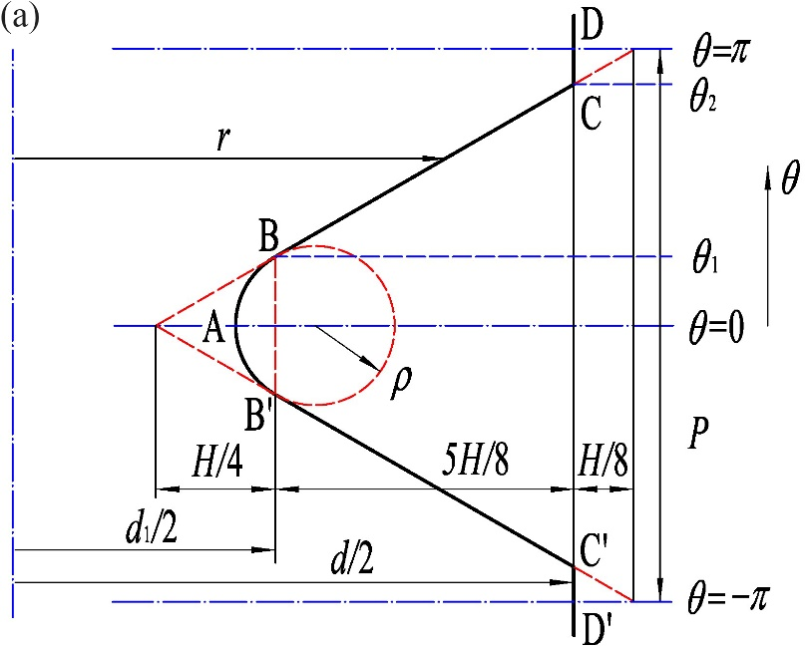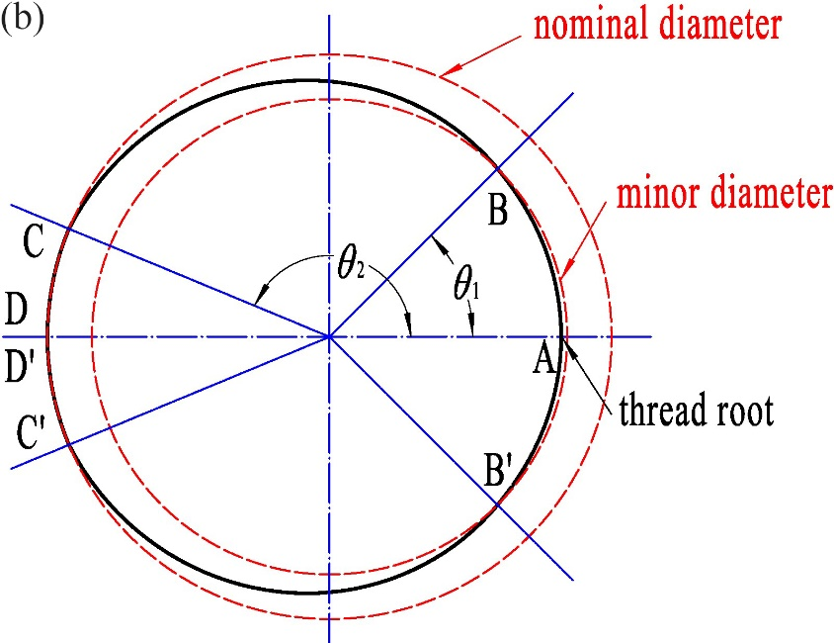
Fig. 7 Profile of the external thread of the bolt: (a) Axial-section of external thread along the bolt axis; (b) Cross-section of external thread perpendicular to the bolt axis
The profile of external thread can be expressed by ^{[29]}:
(9)
Here, d is the nominal diameter, ρ_{e} is the root radius of the external thread, and
; ; ; (10)
Similarly, the profile of internal thread can be expressed by:
(11)
Here, ρ_{i} is the root radius of the external thread, and
; ; (12)

3.2 Finite element model
The profile of an external thread is constructed through Eqs. (9) and (10). As shown in Fig. 8, a circle with radius R is created. The ring is divided into a segments along the circumferential direction, and b segments along the radial direction.
The distance between a node, denoted by N(i, j), and the bolt axis is defined by:
(13)
where i=1, 2, …, a, and j=1,2, …, b+1.
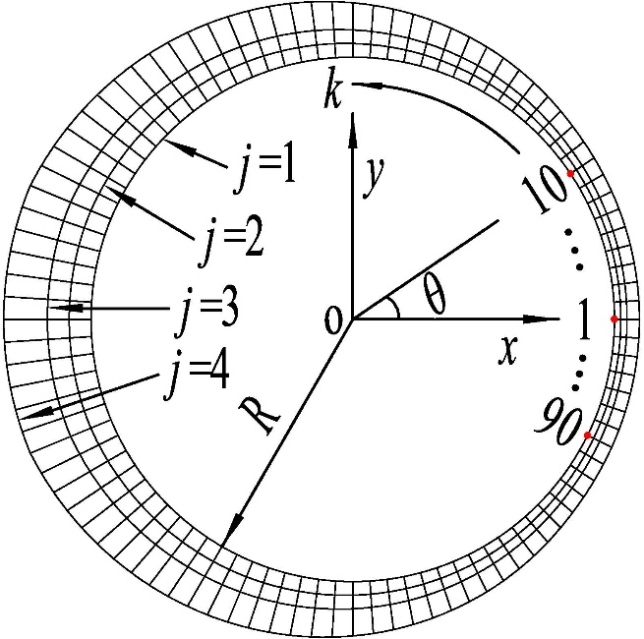
Fig. 8 Basic mesh model (a=96; b=4)
If there are s threads for a bolt, it is divided into s×c thin slices. This means that each pitch of the external thread is divided into c layers. Rotating the basic model anticlockwise by an amount of 2π(k-1)/c, and the rotated model is placed at the position of z=P(k-1)/c. Here, k=1, 2, …, s×c+1. Therefore, coordinates of the nth node, denoted by N(i, j, k), can be expressed by:
(14)
In addition, the relationship among n, i, j and k is as follows:
(15)
Above all, the serial numbers and the coordinates of all nodes can be obtained. Connecting the corresponding nodes of two adjacent meshes placed at z=Pi/c and P(i+1)/c, then a three-dimensional model with the thickness of P/c is obtained. The mth element is shown in Fig. 9. If node A is the nth node, the serial numbers of the eight nodes of the mth element are obtained, as listed in Table 2.
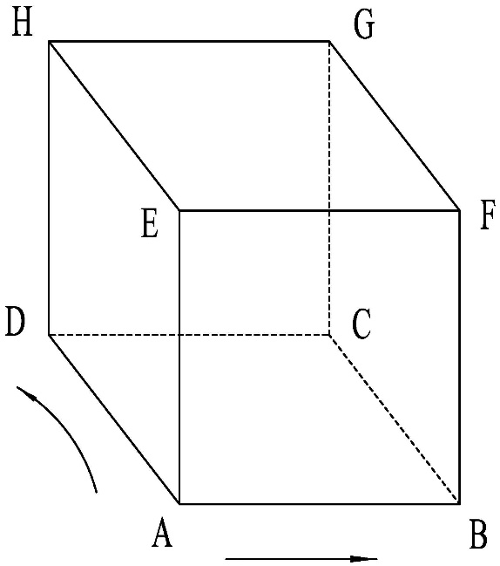
Fig. 9 The mth element (A to B: radial direction; A to D: circumferential direction)
Table 2. Serial numbers of the eight nodes of the mth element for threads
i  Node | 1, 2, …, a/c-1 | a/c | a/c+1, a/c+2, …, a-1 | a
A | n | n | n | n
B | n+a | n+a | n+a | n+a
C | n+a+1 | n+a+1 | n+a+1 | n+1
D | n+1 | n+1 | n+1 | n-a+1
E | n+a×(b+2)-a/c | n+a×(b+2)-a/c | n+a×(b+1)-a/c | n+a×(b+1)-a/c
F | n+a×(b+3)-a/c | n+a×(b+3)-a/c | n+a×(b+2)-a/c | n+a×(b+2)-a/c
G | n+a×(b+3)-a/c+1 | n+a×(b+2)-a/c+1 | n+a×(b+2)-a/c+1 | n+a×(b+2)-a/c+1
H | n+a×(b+2)-a/c+1 | n+a×(b+1)-a/c+1 | n+a×(b+1)-a/c+1 | n+a×(b+1)-a/c+1
In addition, the relationship among m, i, j and k is as follows:
(16)
The serial numbers of the eight nodes of any element can be obtained. Additionally, the serial numbers of all elements can be computed through Eq. (16). With input of these data into ABAQUS, and a three-dimensional model for external threads of the bolt is obtained (Fig. 10(a)).
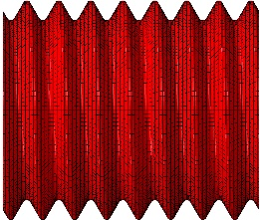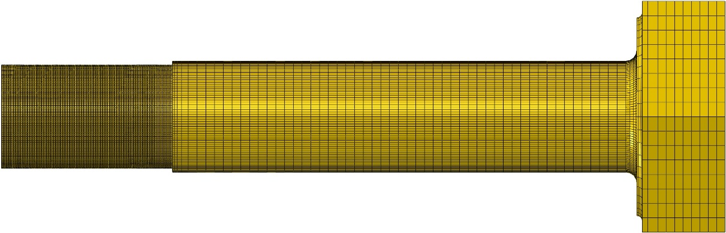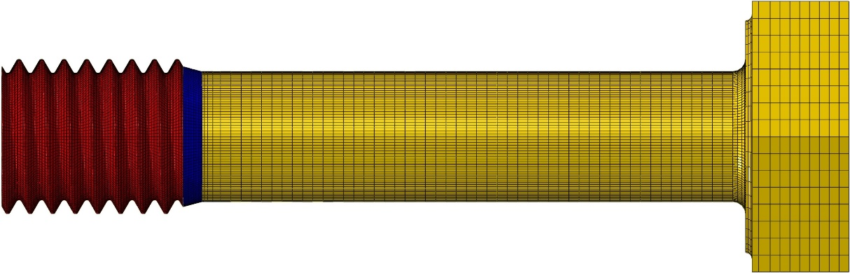
(a)
(c)
(b)
(d)
Fig. 10 Modelling process for the bolt: (a) External thread model; (b) Transition region model; (c) Bolt shank model; (d) Whole model for the bolt
The transition region between the end of the threads and the bolt shank is divided into d thin slices along the bolt’s axial direction, and function (k=1, 2, …, d+1) is defined by:
(17)
where D is the nominal diameter.
Replacing r in Eq. (13) with , the distance, denoted by , between any node and the bolt axis can be obtained. Consequently, coordinates of the nth node, denoted by N(i, j, k), can be expressed by:
(18)
where Q is the length of the transition region.
Additionally, the serial numbers of all nodes can be obtained through Eq. (15). Similarly, the serial numbers of the eight nodes of the mth element are obtained, as listed in Table 3.
In addition, the serial number of the element can be obtained through Eq. (16). With input of these data into ABAQUS, a three-dimensional model for the transition region is obtained (Fig. 10(b)).
The bolt shank model is created using ABAQUS (Fig. 10(c)), and it is merged with the thread model and the transition model, then the bolt model is built up (Fig. 10(d)). Similarly, the model for the plate with a threaded hole is created in the same manner.
Table 3. Serial numbers of the eight nodes of the mth element for the transition region
i  Node | 1, 2, …, a-1 | a
A | n | n
B | n+a | n+a
C | n+a+1 | n+1
D | n+1 | n-a+1
E | n+a×(b+1) | n+a×(b+1)
F | n+a×(b+2) | n+a×(b+2)
G | n+a×(b+2)+1 | n+a×(b+1)+1
H | n+a×(b+1)+1 | n+a×b+1
Fig. 11 shows the three-dimensional model used in this study. Full thread bolts are used in the experiments, and the minor diameter of threads is 10.106 mm. In order to save calculation time, eight threads are built up for the bolt and the nut in the finite element model. Additionally, the bolt shank with a diameter of 10.106 mm in this model is created to have the same torsional stiffness with the bolts used in the experiments. (Fig. 10(c)). For the copper used as the washer, the modulus of elasticity is 110 GPa. For the other materials, the modulus of elasticity is 200 GPa. Poisson’s ratio is 0.3 for all materials. Tetrahedral elements (C3D4R) are used in the transition region between the cylindrical part and each of the two rectangular fixtures, while eight-node linear reduced-integration hexahedral elements (C3D8R) are used in the other regions to improve the accuracy of the calculation. There are 820192 nodes and 664615 elements in this model.
Fig. 11 Finite element model: (a) Finite element mesh; (b) Contact regions on the threads
Five contact pairs are defined in this finite element model. They are the contact between the bolt head and the top holder, the contact between the top holder and the washer, the contact between the bottom holder and the load cell, the contact between the load cell and the square nut, and the contact between the threads. For the contact between the threads, an exponential pressure-overclosure relationship is selected for the normal behaviour and the penalty method with friction is used for the tangential behaviour. For the other contact pairs, the penalty methods with hard contact and friction are respectively used for the normal and tangential behaviour. Considering that relative rotation occurs between the top holder and the washer and between the contact threads in the experiments, mechanical contact is defined for the interfaces for the two contact pairs in the finite element model. In order to improve the efficiency of computation, the small sliding formulation is selected for the other contact pairs. According to the previous experimental results, the coefficient of friction between threads is taken to be 0.32 (simulating the dynamic behavior of the bolted joint at the beginning of the tests) and 0.53 (simulating the dynamic behavior of the bolted joint at the end of the tests) respectively. The coefficient of friction between the bolt head and the top holder is taken as 0.5, the coefficient of friction between the top holder and the washer is initially taken as zero, and for the other contact interfaces it is 0.15. The boundary conditions and loading process are as follows:
- The initial step: The end of the bottom holder is fixed. The top holder is not allowed to twist in the y direction. Eight fixing bolts are used to prevent the square nut rotating in the experiments. Therefore, the surfaces of the nut near the bottom holder are fixed in this step. Considering that a glue is applied on the lower contact surfaces of the washer, relative slip between the washer and the bottom holder is not likely to occur. In order to improve calculation efficiency, the lower surface of the washer is tied with the bottom holder.
- The first step: A small tightening angle is applied to the bolt head to create the contacts steadily.
- The second step: The angular displacement is changed to 0.38 rad to obtain a preload of 21 kN.
- The next eight steps: The constraints of the top holder are released, and a harmonic torsional displacement is applied to the top holder in the y direction. In view of the long computation time, two loading cycles are applied for each loading case. The loading process is shown in Fig. 12.
Fig. 12 Loading process: Δδ=2 deg

3.3 Finite element results
Fig. 13 gives the relationship between clamping force and tightening/loosening torque. For a preload of 21 kN, it is found that the tightening and loosening torques from the theoretical method are -132.7 Nm and 119.0 Nm respectively, and those from the finite element method are -133.2 Nm and 120.0 Nm. This indicates that the finite element results are slightly larger than the theoretical results, and the finite element method is feasible.
Fig. 13 Relationship between clamp force and tightening/loosening torque
Fig. 14 shows the contact stress distribution on the washer when the preload is 21 kN. A path is defined in the radial direction, and point o is on the bolt axis. It is found that stress concentration occurs at the contact edge. Consequently, the distribution of the contact stress along the previous defined path is respectively fitted by dividing it into three distinct parts shown in Fig. 14(b). The mathematical expression of the fitted curves are denoted as f_{i}(x).
The frictional torque T_{f-w} between the top holder and the washer can be written as:
(19)
where x is the distance from the bolt axis, μ_{h-w} is the coefficient of friction between the top holder and the washer, a_{i} and b_{i} are the lower and upper limits of the integral.
Taking the values of the above parameters into Eq. (19), and the coefficient of friction μ_{h-w} can be obtained:
In the subsequent numerical analysis, the coefficient of friction is 0.16 between the top holder and the washer.
Fig. 15 shows the contact pressure (denoted as CPRESS) and the frictional shear stress components in the two orthogonal local tangent directions (denoted as CSHEAR 1 and CSHEAR 2 respectively), acting on the thread surfaces of the bolt. It can be found that the difference of contact pressure is not obvious under different coefficients of friction between the threads, while the frictional shear stress components are large under high coefficient of friction. When the coefficient of friction between the threads is 0.53, relative slippage between the first contact threads is not likely to occur at t₁, t₃ and t₅. T Therefore, there is no trend of relative slippage between the subsequent contact threads, and the frictional shear stress components on the surfaces of the subsequent threads are close to zero.
o
x
Path
(a)
Fig. 14 Distribution of the contact stress on washer surface:
(a) Contact stress contour; (b) Distribution of the contact stress along Path
time |  | t₁ | t₂ | t₃ | t₄ | t₅
(a) | μ_{t-t}=0.32 | 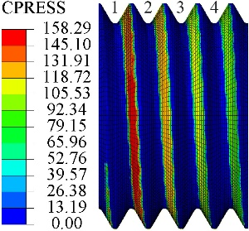 | 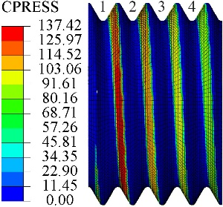 | 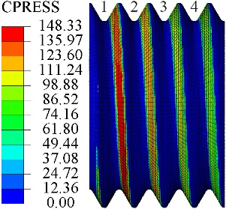 | 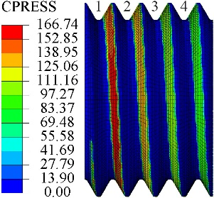 | 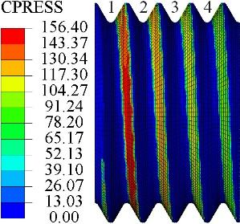
 | μ_{t-t}=0.53 | 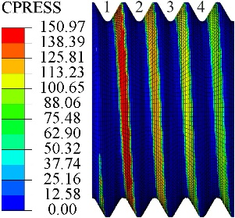 | 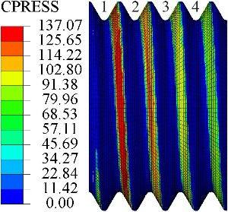 | 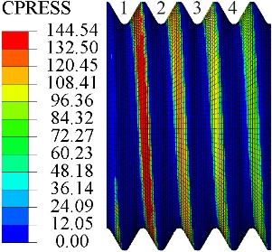 | 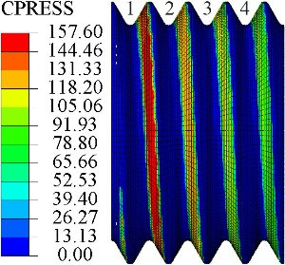 | 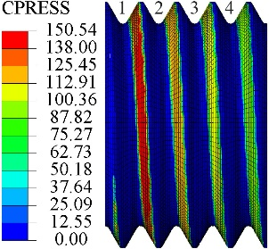
(b) | μ_{t-t}=0.32 | 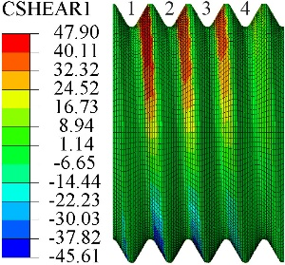 | 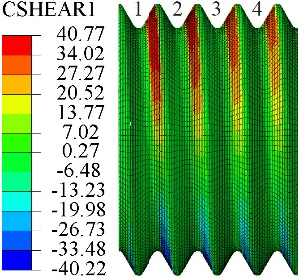 | 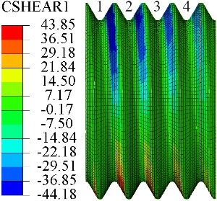 | 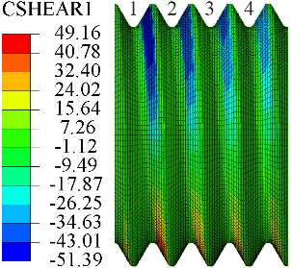 | 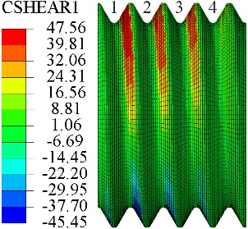
 | μ_{t-t}=0.53 | 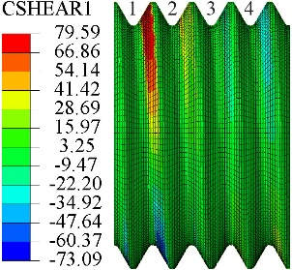 | 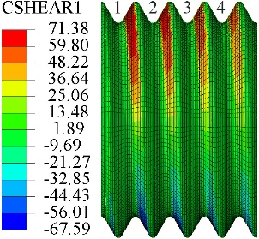 | 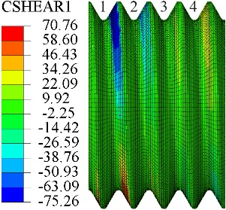 | 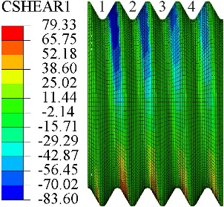 | 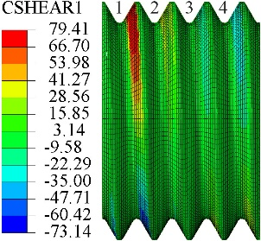
(c) | μ_{t-t}=0.32 | 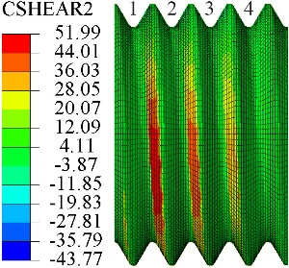 | 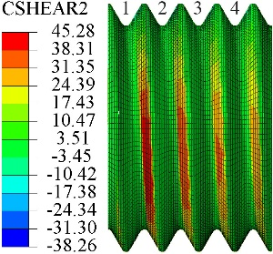 | 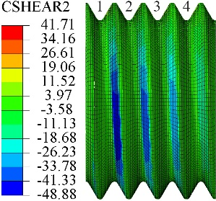 | 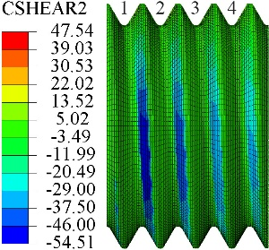 | 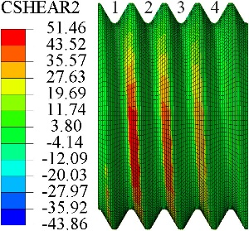
 | μ_{t-t}=0.53 | 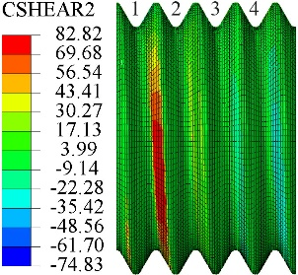 | 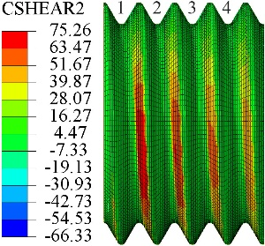 | 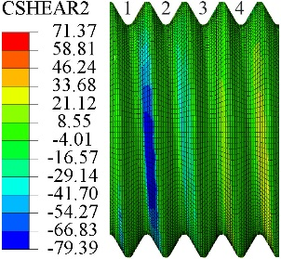 | 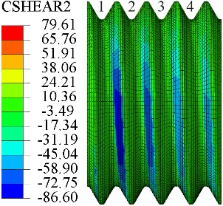 | 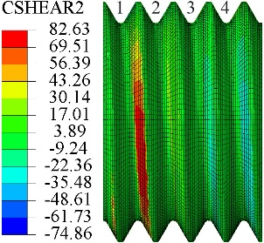
Fig. 15 Stress distribution on the thread surfaces of the bolt:
(a) CPRESS; (b) CSHEAR 1; (c) CSHEAR 2
A bolted joint displays a hysteresis curve for the resultant torque versus the applied angle of twist. The hysteresis curves from only the sixth to the tenth step are discussed in this section. As shown in Fig. 16, the hysteresis curves at the beginning of the experiment are produced from the test data and the finite element results respectively. During the tightening/loosening process, relative slippage occurs between the top holder and the washer, and then it occurs between the contact threads. When the angular displacement of the top holder is close to -2.5 deg, the resultant torque increases slightly. This is because the clamping force increases when relative slippage occurs between the contact threads. Similarly, when the angular displacement of the top holder is close to 2.5 deg, the contact between the threads begins to go into the gross slip condition, the resultant torque decreases slightly because of the decreasing clamping force. The hysteresis curve generated from the numerical method is in good agreement with that produced from the experimental results.
Fig. 16 hysteresis curves at the beginning of the experiment: Δδ=2.5 deg
The moment when relative slip occurs between the top holder and the washer is denoted by t_{i}, and it is denoted by t_{ii} when relative slip occurs between the contact threads. The torsional stiffness of the bolts is equal to the slope of the torque-angle of twist curve from t_{i} to t_{ii}. It can be found from Fig. 16 that the torsional stiffness of the bolt obtained from the numerical results is slightly larger than that obtained from the experimental results. This is because the material of the bolt and the nut in this finite element model is considered to be only elastic, while the roots of threads have stress concentration and undergo plastic deformation in the experiments. In addition, it is found from the experimental results that the value of the torque drops quickly when relative slip occurs between the contact threads, while this is not found from the numerical results. This is because the numerical results are calculated with the quasi-static method, and the coefficient of kinetic friction is assumed to be equal to the coefficient of static friction.
Fig. 17 shows the hysteresis curves in the 2000th loading cycle for varying angular amplitudes. When the angular amplitude is less than or equal to 2.5 deg, relative slippage does not occur between the contact threads, and the hysteresis curves look like a parallelogram. As shown in Fig. 17(d), when the angular displacement of the top holder is close to 3 deg, relative slippage occurs between the contact threads, and the resultant torque obtained from the experiment drops quickly with the increase of the angular displacement. This is because the coefficient of static friction is larger than the coefficient of kinetic friction, which causes the static friction torque between the contact threads to be greater than the kinetic friction torque. It is important to note that the coefficient of kinetic friction is assumed to be equal to the coefficient of static friction in the finite element model, so the resultant torque decreases slightly because of the decreasing clamping force when the contact between threads goes into the gross slip condition.
Fig. 17 hysteresis curves in the 2000th loading cycle for varying angular amplitudes:
(a) Δδ=1 deg; (b) Δδ=2 deg; (c) Δδ=2.5 deg; (d) Δδ=3 deg
Fig. 18 Dissipated energy in the 2000th loading cycle: (a) Dissipated energy for varying angular amplitudes; (b) Dissipated energy for varying torsional torque amplitudes
The dissipated energy in the 2000th cycle for varying angular amplitudes is shown in Fig. 18 (a). Generally, fair agreement is achieved between the hysteresis curves produced by experimental and numerical methods. It is well understood that the dissipated energy vs the amplitude of the applied external torque follows a power-law relationship with an exponent which is obtained between 2 and 3. It can be found from the experimental and numerical results that the exponents are 2.605 and 2.4625 respectively (Fig. 18(b)).

4. Jenkins element model
A Jenkins element consists of a linear spring and a Coulomb element. The joint simulated by a single Jenkins element only has two physical states: sticking and total slipping. So it is not appropriate to simulate the contact status of a bolted joint using a single Jenkins element. Gaul et al. ^{[11]} simulated micro-slip of a joint using several Jenkins elements. As shown in Fig. 19, the model is in the partial slip status when some of Jenkins elements are slipping and others are sticking.
The resultant torque is given as follows ^{[11]}:
(20)
where
(21)
and C_{i} is the threshold torque, k_{i} is the spring constant, θ is the angular displacement of the Jenkins elements, and θ_{rev} is the angular displacement when the angular velocity reverses its direction. Function is defined as
(22)
Fig. 19 Jenkins element model
The values of k₀, k_{i}, and C_{i} can be determined through curve-fitting to the hysteresis loops of finite element results. According to Eq. (21), the relationship between T_{h}(θ) and T_{h}(-θ) is as follows:
(23)
As known from Eqs. (2) and (3), the tightening torque is not equal to the loosening torque. Function is defined by:
(24)
The modified resultant torque is given through taking Eq. (24) into Eq. (21), and it is as follows:
(25)
The hysteresis curve of the loosening process produced by the finite element results is divided into n+1 (n=0, 1, 2) sections to identify the values of k₀, k_{i}, and C_{i} (i=0, 1, …, n). Fig. 20 shows the hysteresis curves produced by using the modified Jenkins element model. It can be seen that the hysteresis curves from the detailed finite element model can now be reproduced quite well by using the third order modified Jenkins element model.
Fig. 20 Hysteresis curves generated using modified Jenkins element model
The amounts of energy dissipated in the 2000th loading cycle are listed in Tab. 4. It is found from Figs. 16 and 17 that the absolute value of the tightening torque is larger than that of the loosening torque under the same applied angle of twist, while it is found from Eq. (20) that they are equal. Consequently, the absolute value of the tightening torque obtained from 3 non-modified Jenkins elements is smaller than that obtained from the finite element results under the same applied angle of twist, and the energy dissipation using 3 non-modified Jenkins elements is much smaller than that using the finite element model.
Table. 4 Comparison of energy dissipation in the 2000th loading cycle (J)
Finite elements results | Number of modified Jenkins elements |  |  | 3 non-modified Jenkins elements
 | 1 | 2 | 3
8.78 | 7.71 | 8.52 | 8.67 | 7.29

Additionally, it is found from Eq. (25) that the absolute value of the tightening torque is P•F_{c}/π larger than that of the loosening torque under the same applied angle of twist, which agrees well with the experimental and numerical results. Consequently, the energy dissipation using 3 modified Jenkins elements is found to be in good agreement with that from the finite element method.

5. Conclusions
In this paper, the dynamics of a bolted joint under torsional excitation is studied both experimentally and numerically. The conclusions can be summarized as follows:
- The angular amplitude is a major factor affecting the shape of the hysteresis curves. Under small angular amplitude, relative slippage does not occur between the contact threads, and the hysteresis curve of the resultant torque versus the applied angle of twist presents like a parallelogram. Under high angular amplitude, relative slippage between the contact threads occurs at the beginning of the tests, and the hysteresis curve presents like a parallel hexagon. With the increase of the loading cycle, the coefficient of friction between the threads increases because of the thread damage, and the shape of the hysteresis curve transforms to a parallelogram. When the angular amplitude is high enough, relative slippage between the contact threads occurs in any loading cycle, then the hysteresis curve always presents like a parallel hexagon. In addition, a larger angular amplitude will result in a higher self-loosening.
- A parametric finite element meshing method, which can exactly build up the bolt/nut model, is proposed using MATLAB and ABAQUS. The relationship between clamping force and tightening/loosening torque is studied by using the finite element method and is found to be in good agreement with that from the theoretical method. Additionally, the hysteresis curve produced from the finite element results agrees with that from the experimental results.
- The hysteresis curves of the bolted joint can be well reproduced by using a third order modified Jenkins element model, and good agreement was achieved for the energy dissipation from the finite element model and the third order modified Jenkins element model.

Acknowledgements

The authors gratefully acknowledge the financial support provided by Sichuan science and technology program (No. 2019YFG0290) and National Natural Science Foundation of China (No. 51705434).

References

1. C.F. Beards. Damping in structural joints. The Shock and Vibration Digest, 1992. 24: p. 3-7.
2. B.R. Hanks, D.G. Stephens. Mechanisms and scaling of damping in a practical structural joint. Shock and Vibration Bulletin, 1967. 36: p. 1-8.
3. C.B. Brown. Factors affecting the damping in a lap joint. American Society of Civil Engineers, Journal of Structures Division, 1968. 96: p. 1197-1217.
4. E.E. Ungar. The status of engineering knowledge concerning the damping of built-up structures. Journal of Sound and Vibration, 1973. 26: p. 141-154.
5. F.C. Nelson, D.F. Sullivan. Damping in joints of built-up structures. Environmental Technology 76, 22nd Annual Meeting, Institute of Environmental Science, 1976.
6. R.A. Ibrahim, C.L. Pettit. Uncertainties and dynamic problems of bolted joints and other fasteners. Journal of Sound and Vibration, 2005. 279(3-5): p. 857-936.
7. J. Krzyzanowski, W. Skoczynski, K. Augul. Mechanism of vibration energy dissipation in flange bolted joints. Proceedings of the 23rd International Seminar on Modal Analysis, 1999. 2: p. 1071-6.
8. Y.S. Shin, J.C. Iverson, K.S. Kim. Experimental studies on damping characteristics of bolted joints for plates and shells. American Society of Mechanical Engineers, Journal of Pressure Vessel Technology, 1991. 113: p. 402-408.
9. S. Song, C. Park, K.P. Moran, S. Lee. Contact area of bolted joint interface: analytical, finite element modelling and experimental study. ASME Winter Annual Meeting EEP, 1992. 3: p. 73-81.
10. W.D. Iwan. A distributed-element model for hysteresis. Journal of Applied Mechanics, 1966. 33(4): p. 893-900.
11. L. Gaul, R. Nitsche. The role of friction in mechanical joints. Applied Mechanics Review, 2001. 54: p. 93-106.
12. M.J. Oldfield, H. Ouyang, J.E. Mottershead. Simplified models of bolted joints under harmonic loading. Computers & Structures, 2005. 84(1-2): p. 25-33.
13. H. Ouyang, M.J. Oldfield, J.E. Mottershead. Experimental and theoretical studies of a bolted joint excited by a torsional dynamic load. International Journal of Mechanical Sciences, 2006. 48(12): p. 1447-1455.
14. A.R. Kukreti, P. Biswas. Finite element analysis to predict the cyclic. Computers & Structures, 1997. 65(1): p. 127-147.
15. Z. Qin, D. Cui, S. Yan, F. Chu. Hysteresis modelling of clamp band joint with macro-slip. Mechanical Systems and Signal Processing, 2016. 66-67: p. 89-110.
16. C. Deng, O.S. Bursi, R. Zandonini. A hysteretic connection element and its applications. Computers & Structures, 2000. 78: p. 93-110.
17. I. Morteza, A. Hamid. Identification of nonlinear bolted lap joint models. Computers & Structures, 2012. 96-97: p. 1-8.
18. H. Jalali, H. Ahmadian, J.E. Mottershead. Identification of nonlinear bolted lap-joint parameters by force-state mapping. International Journal of Solids and Structures, 2007. 44(25-26): p. 8087-8105.
19. E.L. Salih, L. Gardner, D.A. Nethercot. Numerical study of stainless steel gusset plate connections. Engineering Structures, 2013. 49: p. 448-464.
20. Y. Liu, C. Málaga-Chuquitaype, A.Y. Elghazouli. Behaviour of beam-to-tubular column angle connections under shear loads. Engineering Structures, 2012. 42: p. 434-456.
21. H. Zhao. Stress concentration factors within bolt–nut connectors under elasto-plastic deformation. International Journal of Fatigue, 1998. 20(9): p. 651-659.
22. Y. Jiang, M. Zhang, C.H. Lee. A study of early stage self-loosening of bolted joints. Journal of Mechanical Design, 2003. 125(3): p. 518.
23. J. Liu, H. Ouyang, L. Ma, C. Zhang, M. Zhu. Numerical and theoretical studies of bolted joints under harmonic shear displacement. Latin American Journal of Solids and Structures, 2015. 12(1): p. 115-132.
24. T. Yokoyama, M. Olsson, S. Izumi, S. Sakai. Investigation into the self-loosening behaviour of bolted joint subjected to rotational loading. Engineering Failure Analysis, 2012. 23: p. 35-43.
25. S. Izumi, T. Yokoyama, A. Iwasaki, S. Sakai. Three-dimensional finite element analysis of tightening and loosening mechanism of threaded fastener. Engineering Failure Analysis, 2005. 12(4): p. 604-615.
26. M. Ishimura, T. Sawa, A. Karami, T. Nagao. Bolt-nut loosening in bolted flange connections under repeated bending moments. ASME 2010 Pressure Vessels and Piping Conference, Bellevue, Washington, USA, 2010.
27. J. Liu, H. Ouyang, J. Peng, C. Zhang, P. Zhou, L. Ma, M. Zhu. Experimental and numerical studies of bolted joints subjected to axial excitation. Wear, 2016. 346–347: p. 66-77.
28. G. Dinger, C. Friedrich. Avoiding self-loosening failure of bolted joints with numerical assessment of local contact state. Engineering Failure Analysis, 2011. 18(8): p. 2188-2200.
29. T. Fukuoka, M. Nomura. Proposition of helical thread modelling with accurate geometry and finite element analysis. Journal of Pressure Vessel Technology, 2008. 130(1): p. 011204.
30. R.M. Rafatpanah. Finite element analysis of a three-dimensional threaded structural fastener. [D]. Rensselaer Polytechnic Institute, Hartford, USA, 2013.
31. G. Yang, J. Hong, L. Zhu, B. Li, M. Xiong. Three-dimensional finite element analysis of the mechanical properties of helical thread connection. Chinese Journal of Mechanical Engineering, 2013. 26(3): p. 564-572.
32. M. Zhang, Y. Jiang, C.H. Lee. Finite element modelling of self-loosening of bolted joints. Journal of Mechanical Design, 2007. 129(2): p. 218.
33. S.A. Nassar, X. Yang, S.V.T. Gandham, Z. Wu. Nonlinear deformation behaviour of clamped bolted joints under a separating service load. Journal of Pressure Vessel Technology, 2011. 133(2): p. 021001.
34. J. Abad, F.J. Medel, J.M. Franco. Determination of Valanis model parameters in a bolted lap joint: Experimental and numerical analyses of frictional dissipation. International Journal of Mechanical Sciences, 2014. 89: p. 289-298.
35. Y. Karim, C. Blanzé. Vibration reduction of a structure by design and control of a bolted joint. Computers & Structures, 2014. 138: p. 73-85.
36. Y. Shi, Y. Zhou. ABAQUS finite element analysis of detailed examples. 1st ed. China machine press, Beijing, 2006.
37. N.G. Pai, D.P. Hess. Three-dimensional finite element analysis of threaded fastener loosening due to dynamic shear load. Engineering Failure Analysis, 2002. 9: p. 383-402.
38. K.C. Valanis. Fundamental consequences of a new intrinsic time measure: Plasticity as a limit of the endochronic theory [J]. Archiwum Mechaniki Stossowanej, 1980, 32(2): 171―191.
39. R. Bouc. Forced vibration of mechanical system with hysteresis [C]. Proceedings of the Fourth Conference on Nonlinear Oscillations, Prague, Czechoslovakia, 1967.
40. Y.K. Wen. Method of random vibration of hysteretic systems [J]. Journal of the Engineering Mechanics Division, ASCE, 1976, 102(2): 249―263.
41. Y. Fujioka, T. Sakai. Rotating loosening mechanism of a nut connecting a rotary disk under rotating-bending force. Journal of Mechanical Design, 2005. 127(6): p. 1191.
42 D. Cheng. Handbook of mechanical design, 5th ed. Chemical Industry Press, Beijing, 2012.

*Corresponding author. Tel: +86 028 87601282; fax: +86 028 87600723 E-mail address: jianhua-liu@swjtu.edu.cn

