The Anisotropic Responses of a Flexible Metal-Organic Framework Constructed from Asymmetric Flexible Linkers and Heptanuclear Zinc Carboxylate Secondary Building Units
Elliot J. Carrington, Rémi Pétuya, Rebecca K. Hylton, Yong Yan, Dmytro Antypov, George R. Darling, Matthew S. Dyer, Neil G. Berry, Alexandros P. Katsoulidis, and Matthew J. Rosseinsky*
Department of Chemistry, University of Liverpool, Liverpool L69 7ZD, United Kingdom
ABSTRACT
A new porous and flexible metal-organic framework (MOF) has been synthesised from the flexible asymmetric linker N-(4-Carboxyphenyl)succinamate (CSA) and heptanuclear zinc oxo-clusters of formula [Zn₇O₂(Carboxylate)₁₀DMF₂] involving two coordinated terminal DMF ligands. The structural response of this MOF to the removal or exchange of its guest molecules has been probed using a combination of experimental and computational approaches. The topology of the material, involving double linker connections in the a and b directions and single linker connections along the c axis, is shown to be key in the material’s anisotropic response. The a and b directions remain locked during guest removal, while the c axis linker undergoes large changes significantly reducing the material’s void space. The changes to the c axis linker involve a combination of a hinge motion on the linker’s rigid side and conformational rearrangements on its flexible end, which were probed in detail during this process despite the presence of crystallographic disorder along this axis which prevented accurate characterisation by experimental methods alone. While inactive during guest removal, the flexible ends of the a and b axis linkers are observed to play a prominent role during DMF to DMSO solvent exchange, facilitating the exchange reaction arising in the cluster.

Introduction
Flexible metal-organic frameworks (MOFs)^{1–5} are a relatively rare but interesting subset of extended framework materials^{6,7} which can undergo structural changes in the presence of external stimuli.⁸ Their potential to provide a highly adaptable pore environment, which changes its size and shape to suit the requirements of specific chemistry, makes them particularly attractive as the next generation of materials targeted at difficult separation, catalysis, adsorption or multifunctional applications (e.g., ferroelectric and non-linear optical properties).^{1,9,10} Recently, several attractive features for the development of future porous materials, in particular anisotropy and asymmetry, have been identified by Kitagawa.¹¹ However, in order to develop these new materials, we first need to improve our understanding of how their flexible responses arise.¹² This requires in-depth structural characterisation of the MOFs before and after their stimulus-driven transitions, which is often hindered by their inherent porosity, structural disorder, or lack of crystallinity, making structural solution by traditional direct methods particularly challenging. To overcome these issues, it is possible to combine experimental and computational methods. For example, in the case of MIL-88¹³ and its isoreticular compounds,^{14,15} which display a large “swelling motion” enabled via a hinge motion, the relatively low quality of the diffraction patterns prevented the characterization of the framework's dynamics via crystallographic methods alone. Therefore, a combination of simulations (force field constrained optimizations) and powder diffraction refinements were employed to obtain a qualitative structural picture of the dynamical response.^{13–15}
In this paper we present a combined computational and crystallographic study reporting the behaviour of the new framework ZnCSA, where CSA (Figure 1(a)) is the asymmetric flexible linker N-(4-Carboxyphenyl)succinamate. CSA was selected because it combines flexible and rigid characteristics, as it can be considered to have one rigid end, consisting of an aromatic ring, and one flexible end, built from amide and aliphatic functionalities. The inherent flexibility involves sp³ carbons and rotatable bonds, which have previously been shown to produce flexible responses in a range of MOFs.^{16–18} Although reported as an organic linker in several extended framework materials, the potential of CSA for introducing flexible responses associated with the distinct ends of the linker has not yet been explored.^{19,20} The secondary building unit (SBU) in ZnCSA is an heptanuclear zinc cluster with two coordinated terminal DMF ligands of formula [Zn₇O₂(Carboxylate)₁₀DMF₂]. While MOFs built from the same SBU, but incorporating rigid bidentate carboxylate based organic linkers, have previously been reported with the same overall topology,^{21–23} the incorporation of the flexible CSA linkers enables ZnCSA to display new dynamical behaviours. The three-dimensional connectivity of ZnCSA could be determined by crystallographic methods, enabling us to describe the connections between the inorganic cluster and organic linker components, however, a subset of the CSA linkers displayed crystallographic disorder of the linker orientation, and therefore the relative binding of the rigid and flexible ends, making the exact linker environment hard to accurately characterise. In addition, ZnCSA loses single crystal crystallinity upon complete removal of its guest species. These obstacles required additional information beyond crystallography to develop an understanding of the flexible response mechanism of the material. Periodic density functional theory (DFT) calculations were therefore used in conjunction with crystallographic data to guide our understanding of the system. These methods revealed that the topology plays a crucial role in the behaviour of the framework, with the framework displaying an anisotropic response depending on the environments of the individual linkers. Post-synthetic single crystal coordinated solvent exchange (SCCSE)²⁴ of the DMF ligands to DMSO was also performed, resulting in a new material that displayed a significantly different predicted response during its guest removal. While postsynthetic modification in general has shown great potential in the functionalization of MOFs, most examples involve ligand^{25–27} or cation exchange ^{28–30} and such SCCSE are relatively rarely reported.^{31–33} These exchanges, however, offer a distinct route to control MOF behaviour, including the modulation of MOFs luminescence properties, ^{34,35} and the tuning of the flexible responses in rigid linker MOFs.³⁶ Work by Manos et al.²⁴ has also shown the potential for conducting SCCSE on a flexible material, reporting a wide range of solvent exchanges that result in changes to the overall framework size. Distinctively from these previous SCCSE examples, the mechanism for the exchange reaction at the SBU of ZnCSA appears to be directly linked to the flexibility of the CSA linker. These important structural rearrangements, occurring in the previously locked double linker connections, lead to a significantly different predicted response during guest removal.

Experimental
General
All reagents were purchased from Sigma Aldrich Ltd and were used as received without further purification.
Synthesis
ZnCSA.DMF. A 0.2M solution of Zn(NO₃)₂.6H₂O in N,N’-Dimethylformamide (DMF) (375 μl, 0.075 mmols) was added to a (10 ml) screw capped Pyrex vial containing N-(4-Carboxyphenyl)succinamic acid (CSA-H₂) (6.9 mg, 0.03 mmols). An additional volume of DMF (3.33 ml) was then added to the mixture and the vial was then capped and placed in an oven. The temperature inside the oven was raised slowly to 100 °C (1 ºC/min) and the reaction was left to proceed for 24hrs before cooling back to room temperature at a ramp rate of 0.1 °C/min. The reaction afforded a white crystalline precipitate which was washed and stored in fresh DMF.
ZnCSA.DMSO. Crystals of ZnCSA.DMF (20 mg) were transferred from DMF into a vial containing dimethylsulphoxide (DMSO) (1ml). The crystals were left to sit in the vial for 5 days, with the solvent being exchanged twice daily.
Thermogravimetric analysis
Thermogravimetric analysis was carried out on a TA 500 instrument in a temperature range of 25 °C to 600 °C with a scan rate of 3 °C / min and air flow rate of 60 ml / min.

X-ray Crystallography
Single crystal X-ray diffraction data were collected for ZnCSA.DMF using a Rigaku MicroMax-007 HF X-ray generator with a Mo-Kα rotating anode microfocus source and a Saturn 724+ CCD detector. Crystals were transferred from DMF into Fomblin oil and then mounted onto the diffractometer using a MiteGen MicroMount. The sample temperature was maintained at 100K using a 5ml/min N₂ flow from an Oxford Cryosystems Cyrostream Plus device. Intensity data were indexed, integrated and corrected for absorption using CrysAlisPro software.³⁷ Single Crystal X-ray diffraction data for ZnCSA.DMSO meanwhile were collected using synchrotron radiation at beamline I19, Diamond Light Source.³⁸ Intensity data, also collected at 100K, were indexed, integrated and corrected for absorption using Xia2.^{39,40} All structures were initially solved by direct methods in the conventional setting of the unit cell.⁴¹ The atomic positions were analysed and compared to the other structures collected for the material. Lattice transformations were then applied using the program WinGX to ensure the structures were consistently described throughout the manuscript.⁴² Details can be found in Supporting Information S2. The crystal structures in the new unit cell were refined by full-matrix least squares using SHELXL accessed via the program Olex2.^{43,44} Due to porous and flexible nature of the material, high resolution data could not always be obtained. Non-hydrogen atoms were therefore only refined anisotropically if there was sufficient data to parameter ratio available. Hydrogen atoms were placed in idealized positions and refined using a riding model with isotropic thermal parameters dependant on the connected atom. In the crystal structures, one of the organic linkers is situated on an inversion centre and is therefore highly disordered. Restrained isotropic thermal parameters combined with idealised distance restraints were used to ensure a chemically sensible model for this linker. The routine SQUEEZE from the program PLATON was used to account for the scattering contribution of disordered solvent molecules contained within the large accessible void space of the framework.⁴⁵ Full details of the crystals, data collections and refinement parameters are given in Supporting Information S1. Powder X-ray diffraction data were collected on a Bruker D8 advance diffractometer in transmission geometry using monochromated Cu-Kα radiation and 0.7 mm borosilicate capillary tubes. Due to the sensitivity of the material to loss of solvent, data for ZnCSA.DMF was initially collected while the sample was immersed in DMF within a sealed 0.7 mm borosilicate capillary tube. Crystal structures were visualised and images produced using a combination of Mercury 4.0 (CCDC)⁴⁶ and VESTA 3⁴⁷.
Computational Methods
DFT calculations were performed using the VASP⁴⁸ code. Input geometries were generated from experimental structures in which all atomic positions except for the disordered linker along the c axis had been determined. To account for the experimental random coordination of the c axis linker 2×2×1 periodic supercells were built alternating the binding through the rigid and flexible ends of the linkers in the c axis direction. Each supercell contained 20 CSA linkers, 28 zinc cations, 8 cation-bridging oxygens and 8 DMF or DMSO molecules coordinated to the SBU, a total of 652 or 628 ions for ZnCSA.DMF and ZnCSA.DMSO respectively. The experimental structures (1, 2, 3) were initially optimized with the unit cell parameters fixed (ISIF = 2) at the measured values, yielding structures C1_{opt} , C2_{opt} and C3_{opt} in the respective cases of DMF, partially removed DMF, and DMSO. The flexible behaviour of the desolvated materials was then computationally addressed via geometry optimizations by allowing both ion positions and unit cell parameters (volume and shape, ISIF = 3) to relax, thus producing the structures C1_{relax} and C3_{relax}. All calculations were conducted with their coordinated guest molecules, but not any guest molecules contained within the pore due to computational cost. Allowing both the unit cell parameters and ion positions to relax therefore probes the structural effect of removal of the solvent from the pores of the material. The ion-electron interaction was described with the Projector Augmented-Wave (PAW) method.⁴⁹ To account for van der Waals dispersion forces, the non-local correlation functional method was used⁵⁰ with optB86b-vdW exchange functional.⁵¹ An energy cut-off of 520 eV was employed for the plane-wave expansion, as well as a k-point mesh of 1×1×2 to sample the Brillouin zone in the reciprocal space. For all calculations, the “Normal” precision setting with convergence criteria of 1×10⁻⁶ eV for the electronic energy convergence and 1×10⁻⁵ eV for the ionic convergence were used.
Results
The MOF ZnCSA.DMF was synthesised using solvothermal methods from Zn(NO₃)₂.6H₂O, CSA-H₂ (Figure 1a) and DMF. This afforded plate-shaped single crystals of formula [Zn₇O₂(CSA)₅DMF₂].14DMF which were analysed by X-ray diffraction at 100K. The crystal structure of ZnCSA.DMF (1) revealed that the material crystallises in the triclinic space group $P\overline{1}$ (No. 2) with unit cell dimensions a = 15.7350(7) Å, b = 17.4602(8) Å, c = 19.3022(9) Å, α = 95.955(4)°, β = 109.926(4)°, γ = 105.846(4)°, V = 4681.2(4) Å³. The framework is constructed from a heptanuclear secondary building unit of formula [Zn₇O₂(Carboxylate)₁₀DMF₂]. The cluster contains seven zinc atoms bridged by 10 bidentate carboxylate groups (8 μ₂ connections & 2 μ₃ connections), two μ₄-O atoms and two terminal DMF ligands (see Figure 1b). The carboxylate groups belong to 10 different CSA linkers, bound through a mixture of rigid and flexible ends, which connect to 6 other clusters to give a non-interpenetrated fqr net.^{52,53} The metal clusters are located at the vertices of the crystallographic unit cell with the linker connections running along the crystallographic axes, four corresponding to the crystallographic a axis, four to the b axis and two to the c axis. Within the cluster there are one octahedral, two square pyramidal and four tetrahedral Zn environments. The octahedral Zn is located at the centre of the cluster and is apically coordinated to the two μ₄-O²⁻ anions and equatorially coordinated to four different carboxylate groups. This Zn is then connected through the two μ₄-O²⁻ anions to two equivalent trinuclear units, each centred around one of the O²⁻ anions and consisting of one square pyramidal Zn (with the coordinated DMF ligand) and two tetrahedral Zn atoms. The overall cluster could also be considered as two symmetry related Zn₄O tetrahedra which share the central octahedral Zn as a common vertex. This metal cluster unit has been previously reported in molecular complexes (although often with different terminal ligands),^{54–62} one-dimensional coordination polymers,^{61,63–66} and three-dimensional metal-organic frameworks.^{21–23} In ZnCSA, the carboxylates located around the centre of the cluster, coordinated to the central octahedral Zn, are all connections made through the flexible ends of the asymmetric CSA linker, and correspond to two a axis linkers and two b axis linkers. The carboxylate groups on outer parts of the cluster meanwhile are connections to the rigid ends of the remaining two a and two b axis linkers, displayed in green and purple in Figure 1b respectively, or connections to the two c axis linkers, displayed in orange.

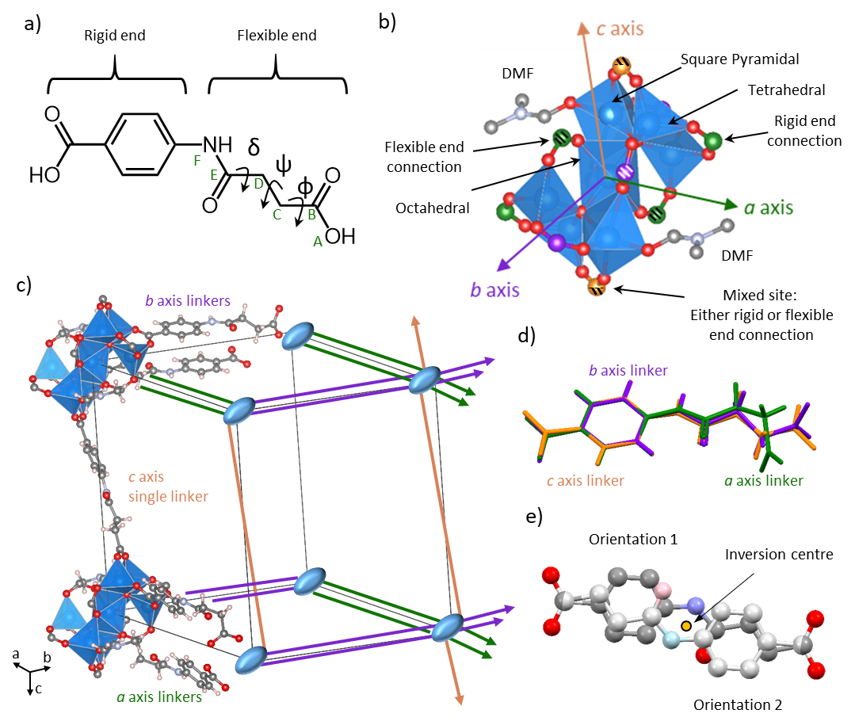
Figure 1. a) The CSA linker with distinct rigid and flexible ends. For the single c axis linker, these ends of the molecule are disordered such that it coordinates randomly via either end. Atoms labelled from A to F are involved in the definition of torsion angles φ (O_{carbox}^{(A)}-C_{carbox}^{(B)} -C_{sp3}^{(C)}-C_{sp3}^{(D)}), ψ (C_{carbox}^{(B)}-C_{sp3}^{(C)}-C_{sp3}^{(D)}-C_{amide}^{(E)}) and δ (C_{sp3}^{(C)}-C_{sp3}^{(D)}-C_{amide}^{(E)}-N_{amide}^{(F)}). Note that values of these torsions are tabulated in Supporting Information S7 for the structures discussed in the text. b) Secondary building unit of ZnCSA.DMF (1) showing the seven Zn atoms, ten carboxylate connections and two terminal DMF ligands. Carboxylate carbons coloured green are connections running along the a axis, coloured purple are connections running along the b axis, and coloured orange are connections running along the c axis. Striped coloured connections are connections through the flexible end of the linker, solid colours are connections through the rigid end, and half striped connections correspond to 50/50 distribution through the flexible and rigid ends of the linkers. The carboxylates showing mixed connections correspond to the single c axis linkers. Note that two b axis connections are hidden behind the cluster. c) Schematic showing the linker connections between the metal clusters situated at the corners of each crystallographic unit cell. Blue ellipses represent the metal clusters, double green lines represent CSA linker connections along the a axis, double purple lines represent CSA linker connections along the b axis and single orange lines represent CSA linker connections along the c axis. Disorder has also been removed from the c axis linker for clarity and coordinated DMF molecules are present on the complete clusters, although their orientations make them hard to distinguish from the Zn polyhedra. d) Overlay of the 3 different linker conformations present in 1, coloured based on the axis it defines. e) The two half-occupancy inversion symmetry-related orientations of the single c axis linker modelled crystallographically. Hydrogen atoms have been removed for clarity.

The four a and four b axis CSA linkers can be divided into pairs, each corresponding to double linker connections between two different clusters. Each pair of asymmetric linkers is oriented anti-parallel to each other (i.e., the rigid ends of each linker pointing in opposite directions and crystallographically ordered) above and below the crystallographic axis, related by inversion symmetry. The c axis, meanwhile, only shows one linker connection on either side of the cluster, running directly along its axis. This is a key component of the structure and from here will be referred to as the single c axis linker. As with the a and b axes linkers, the single c axis linker binds through both its rigid and flexible ends, however, it is crystallographically disordered around the inversion centre due to a random distribution of the two possible orientations within the whole structure. The crystallographic model of these two orientations, which required a number of bond distance restraints, is shown in Figure 1e. The three linkers modelled in the asymmetric unit, two full occupancy corresponding to the a and b axes likers, and one half occupancy corresponding to disordered c axis linker, were all observed to adopt different conformations from each other based on rotations around the torsional angles of the flexible end of the CSA linker. The rigid ends of the three linkers, however, remained the same. This can be seen visually in Figure 1d, displaying an overlay of the three crystallographically modelled conformations. The torsional angles involved, displayed in Figure 1a, can be defined as φ (O_{carbox}^{(A)}-C_{carbox}^{(B)} –C_{sp3}^{(C)}-C_{sp3}^{(D)}), ψ (C_{carbox}^{(B)}-C_{sp3}^{(C)}-C_{sp3}^{(D)}-C_{amide}€) and δ (C_{sp3}^{(C)}-C_{sp3}^{(D)}-C_{amide}€-N_{amide}^{(F)}). In particular the a axis linkers are highly bent, with a ψ value of 60°, while the b and c axis linkers are almost planar with ψ values of -176° and 163° respectively. The values of these torsions in all structures discussed are tabulated in Supporting Information S7. Overall, the framework affords a large (2032 Å³) 3-dimensional pore structure with absolute window apertures of 12.7 × 12.6 Å, 12.3 × 9.0 Å and 4.5 × 4.3 Å. The pore limiting diameter, defined as the smallest opening along the pore, calculated with the Zeo++ software package⁶⁷ is 9.7 Å. The solvent accessible void (measured with 1.2 Å probe radius) accounts for 43.4% of the unit cell volume. Based on thermogravimetric analysis, there are 14 guest DMF molecules contained within the pore, in addition to those coordinated to the cluster (see Supplementary Information S3), which corresponds well to the crystallographic data suggesting 13.6 guest DMF molecules. This value was obtained from a combination of the 1 guest site in the pore which could be resolved in the asymmetric unit, giving a refined formula of [Zn₇O₂(CSA)₅DMF₂].1.79(1) DMF, and the residual electron density calculated by the routine SQUEEZE. As a comparison, the absolute pore volume could accommodate 15.8 DMFs, assuming a packing density identical to liquid DMF. A schematic of ZnCSA, designed to emphasise the relationship of the structure to its crystallographic unit cell, is given in Figure 1c and coloured based on the connections along the different axes. More detailed views of the structure along with its Connolly surface can be found in Figure 2. The bulk phase purity of the material was confirmed by PXRD at room temperature measured while the material was immersed in DMF. The diffraction pattern was indexed to a unit cell of dimensions a = 15.877 (1) Å, b = 17.500(1) Å, c = 19.842(2) Å , α = 97.702(5)°, β = 103.279(4)°, γ = 104.588(4)°, V = 5083.8(6) Å³, which is a 9% anisotropic expansion compared to the single crystal data collected at 100K, with the majority difference being in the β angle.
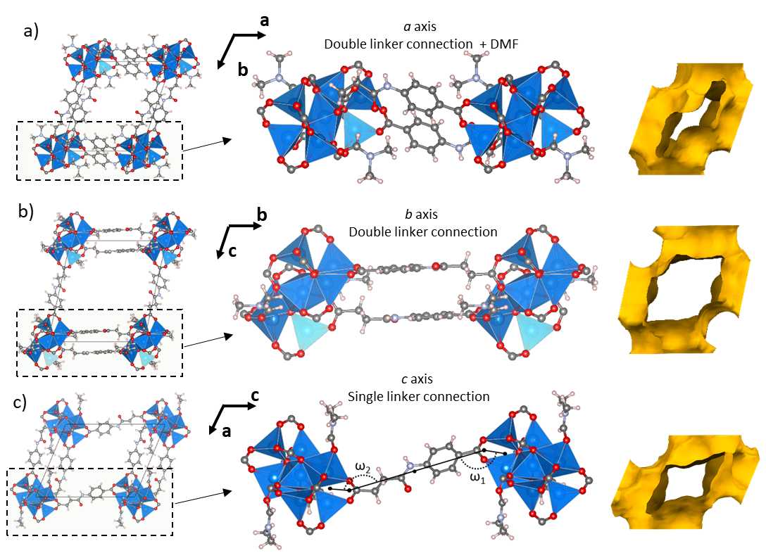
Figure 2. a) View of the channel running along the c axis in ZnCSA.DMF (left), the double linker connection running along the a axis (centre) and the Connolly surface (calculated using a 1.2 Å probe radius) (right). b) View of the channel running along the a axis (left), the double linker connection running along the b axis (centre) and the Connolly surface (calculated using a 1.2 Å probe radius) (right). c) View of the channel running along b axis (left), the single linker connection running along the c axis (centre) and the Connolly surface (calculated using a 1.2 Å probe radius) (right). Angles ω₁ and ω₂ are shown here, but are given in more detail in Figure 4b. Note that disorder has been removed from the single c axis linker for clarity.
A PXRD pattern of ZnCSA.DMF was also collected once the material was filtered, dried and heated at 120 ºC for 30 mins. TGA data (collected before and after heating) suggests that this temperature should be sufficient to remove the majority of the contained guests for the material (10 out of 14 guests) (see Figure 3a), and therefore probes the behaviour of the framework during removal of the DMF molecules in the pore but not from the SBU. The large difference observed in the two obtained PXRD patterns (see Figure 3) indicates clear changes to the unit cell parameters, and therefore the MOF crystal structure, during the desolvation process. Unfortunately, due to limitations in the data quality and the triclinic nature of the material, this new pattern could not be indexed. However, the general shift to larger 2θ values is suggestive of a reduction in d-spacing and therefore a reduction in overall unit cell volume. Heating to higher temperatures to completely remove the guests (beyond point B in Figure 3a) resulted in a loss of crystallinity. This fully activated the material also displayed a negligible volumetric uptake of nitrogen (Supporting Information S6).
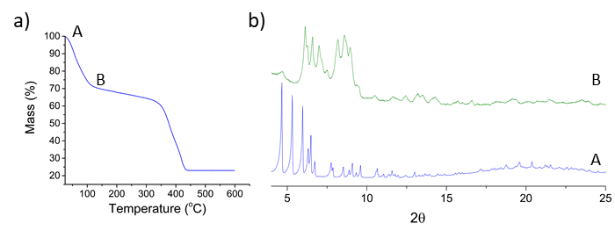
Figure 3. a) Thermogravimetric analysis of ZnCSA.DMF (1) ramping at 3 ºC/min. b) PXRD patterns of ZnCSA.DMF while immersed in DMF (Blue) and after drying and heating at 120ºC to remove some of its guests (Green). The labels A and B in the figure are to show the position of the obtained PXRD patterns in the solvent loss process. A corresponds to the as-synthesised material 1, while B is a partially desolvated material, but is significantly more desolvated than the partially-desolvated single crystal structure 2.
To gain further structural insight into the framework changes during guest removal, a single crystal structure was obtained after the material was left to dry in air for 1hr, affording the partially desolvated material 2. The level of desolvation of this crystal, however, is unknown because the significantly reduced data quality from undergoing the phase transition makes analysis of the residual electron density unreliable. 2 showed an identical building unit (metal-oxo cluster and bound DMF molecules), connectivity and topology to 1, but displayed noticeable differences in the relative angles between the different metal cluster connections, resulting in changes to the unit cell a = 15.644(1) Å, b = 17.386(1) Å, c = 18.668(3) Å, α = 97.05(1)°, β = 115.49 (1)°, γ = 105.851(7)°, V = 4236.8(9) Å³ (a 9.5% volume reduction). In particular, the single c axis linker changes significantly, which is directly reflected in the change of β from 1 (Δβ = 5.5°). This resulted in a reduced volume for the unit cell and therefore a reduction in void space from 43.4% to 38.3%. The presence of crystallographic disorder on the single c axis linker, requiring a number of bond distance restraints to model, means information on the changes to this part of the material could not be accurately interpreted from the refinement. To approach this problem and provide a chemically sensible model for the disordered components of the two structures we employed computational methods, optimising non-disordered versions of crystal structures 1 and 2 using Density Functional Theory (DFT) within a fixed 2×2×1 supercell, C1_{opt} and C2 _{opt} respectively (where C stands for computational and 1 and 2 stand for the crystal structure used as input geometry). Although computationally expensive, this choice of supercell dimensions (double the experimental cell along a and b axes) allows us to model the crystallographic disorder in an alternating manner, such that for any given SBU the binding of the single c axis linker (e.g., through its rigid end) is different to its four neighbouring SBU’s (e.g., through its flexible end) in the ab plane. It is worth mentioning that computational structures were always modelled with uncoordinated solvent molecules removed (the terminal DMF coordinated to the SBU are preserved), therefore fixed unit cell (to the experimental parameter values) geometry optimizations (the subscript “opt” refers to optimized) were intended to represent the solvated crystal, but the solvent was not actually modelled using the experimentally determined compositions due to computational cost. The overall validity of the modelling method was assessed by directly overlaying 1 and C1_{opt} (using the central atoms of four different metal SBUs) and comparing the positions of the computationally optimised atoms with the non-disordered atomic sites observed experimentally (i.e., the framework without the single c axis linker). As 1 displayed significantly higher resolution experimental data than 2, it was deemed most reliable for this analysis. Figure 4a shows the extracted sections of the overlay for all the ordered and crystallographically unique components of the structure, including the SBU, one of the two symmetry related linkers lying along the a axis and one of the two symmetry related linkers lying along the b axis. A good agreement between the experimental and computational models was observed, with the positions of all the calculated atoms, represented using a green stick model, lying within the anisotropic thermal displacement ellipsoids determined experimentally. Small root-mean-square displacement (RMSD) values (see Figure 4a) of the individual section overlays further support the computational-experimental agreement on the non-disordered parts of the structure. While the disordered components of the structure could not be directly compared in a similar way, the crystallographic model of the disordered single c axis linker, and the calculated linker environment after inversion symmetry has been applied post calculation, is shown overlaid in Figure 4b which suggests no major differences. Accordingly, the computational models were deemed suitable to provide reliable information and could be used to study the changing single c axis linkers in the structure.

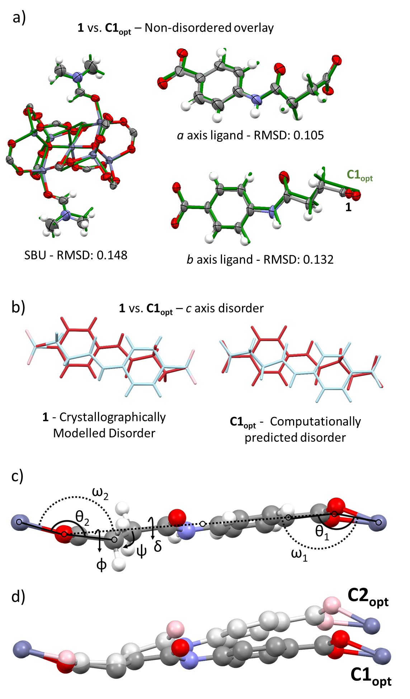
Figure 4. a) Extracted sections of the overlay of the experimentally determined structure 1, shown using ellipsoids drawn at 50% probability, and the DFT optimized structure C1_{opt}, represented with a green stick model. Root mean square displacements (RMSD) are given below each section. b) Left: The two half occupancy inversion symmetry related orientations of the single c axis linker modelled crystallographically in 1. Right: Two orientations of the single c axis linker in C1_{opt} obtained by artificially introducing inversion symmetry into the non-disordered model post calculation. c) Environment of the single c axis linker in C1_{opt} showing the defined coordination angles θ₁, θ₂ and torsional angles φ, ψ, δ. d) Overlay of computationally optimised single c axis linkers in C1_{opt} (Dark colours) & the partially desolvated C2_{opt} (Light colours). The linkers are overlaid using the two carboxylate oxygens, and the two Zn atoms which they coordinate to, of the flexible end of the linker. Hydrogen atoms have been removed for clarity.
To understand the starting point for this change, the environment of the asymmetric linker in the computed ordered structure of C1_{opt} should be described initially. Significantly, this single c axis linker, shown in Figure 4c, is predicted to lie slightly out of the plane of the connection between its two SBUs. This distortion can be quantified by the two angles ω₁ and ω₂, one measured on either side of the linker, using the centroid of the two Zn atoms from the connecting SBU, the centroid of the two coordinating carboxylate oxygens and the centre of the linker. These angles are almost identical, with ω₁ = 154° at the rigid end and ω₂ = 153° at the flexible end of the linker. At the rigid end, ω₁ can be seen to primarily arise from the direct coordination angle of the carboxylate group (θ₁) at 158°, defined in Figure 4c using the centroid of the two Zn atoms, the centroid of the two carboxylate oxygens, and the first carbon after the carboxylate group. Meanwhile, at the flexible end, ω₂ cannot be described solely by the much wider θ₂ at 170°, defined in Figure 4c consistently with θ₁. The same ω (bend out of plane) is instead achieved through additional conformational adjustments driven by rotations of three torsional angles associated with the linker’s sp³ carbons. These angles (φ, ψ & δ) become -158°, 163° and 152° respectively.
Comparing C1_{opt} and C2 _{opt}, to understand the structural transformation upon guest removal, the major change arises due to a shift in the degree that the c axis linker lies out of the plane of the connection of the SBUs, with ω₁ and ω₂ both changing to become 144°. At the rigid end of the linker this occurs only through decreasing θ₁ to 149°, while at the flexible end of the linker θ₂ decreases to 162°, combined with further torsional adjustments to ψ and δ, which change to 158° and 149° respectively. φ meanwhile is predicted to remain almost the same at -157° (torsions values tabulated in Supporting Information S7). The resulting effect is shown in Figure 4d, which shows an overlay of the predicted c axis linker in C1_{opt} and C2_{opt}. While these angles cannot be directly compared to experimental results, as the modelling of disorder makes exact torsional measurements on the individual components unreliable, an average value for the bend of the linker out of plane at both ends can be obtained. This shows very similar overall response to that predicted by calculation, with the averaged ω changing from 156° to 146°, in very good agreement with the predicted 154° to 144° change. Therefore, although guest species adsorbed within the pores are not explicitly modelled in the calculations, fixing the unit cell to its experimental parameters allows us to reliably reproduce the change in the c axis linker responsible for material flexible response.
Further treatment of single crystals, including heating at 120 ºC to mimic the preparation conditions of the sample from which the powder diffraction pattern was collected, resulted in the complete loss of single crystal crystallinity. Therefore, to try to predict the structural behaviour of the MOF during full solvent removal, our DFT calculations were extended by optimising the empty structure while allowing the dimensions of the 2×2×1 supercell to vary. This “full structural relaxation”, C1_{relax} (“relax” stands for relaxed), in which both the ions and unit cell parameters are allowed to relax, aims to predict the energy minimum of the solvent free framework. This is particularly relevant because the lattice parameters could not be determined from the PXRD, and therefore even the size of the repeating unit is completely unknown. The optimisation, which gave similar relaxed geometries for both 1 and 2, suggests the material undergoes a drastic change to its unit cell, equivalent to a = 15.30 Å, b = 17.19 Å, c = 15.15 Å, α = 96.8°, β = 138.43°, γ = 109.58°, V = 2010.4 Å³ (C1_{relax}) when related back to a 1x1x1 cell. This new cell is roughly 40% the size of 1 and, similar to the differences between C1_{opt} and C2_{opt} - a result which are have been experimentally validated, the change between C1_{opt} and C1_{relax} is primarily driven by movement of the single c axis linker, producing large differences in c axis length and β angle. While this cell does not directly index the powder pattern obtained after heating at 120 °C, the d-spacings of the first two predicted peaks (14.1Å & 13.1Å) are similar to those observed experimentally (14.4Å & 13.4Å), therefore suggesting that it may provide a reasonable approximation to the largest changes in the structure. A comparison of the experimental powder pattern after heating at 120 °C and the predicted powder pattern of C1_{relax} is shown in Supporting Figure S5. The changes to the structure between C1_{opt} and C1_{relax} occur broadly through the same mechanism observed in the optimised single crystal structures (C1_{opt} and C2_{opt}) i.e., changes in the conformation and binding of the c axis linker, but to a larger extent. ω₁ reduces to 109°, driven primarily by a reduction in θ₁ to 126°, but now also involves a bending out of plane of the aromatic ring. ω₂ meanwhile reduces to 114°, θ₂ changing to 143°, and the torsional angles φ, ψ and δ becoming -115°, 164° and 168° (torsion values tabulated in Supporting Information S7). Compared to the change between C1_{opt} and C2_{opt}, C1_{relax} shows a much more significant response in the torsion φ during the optimisation, accounting for the largest change in the flexible end of the linker. The overall mechanism, shown in Figure 5, causes a large reduction in the accessible void space to 5.9% and in the pore limiting diameter to 3.7 Å. C1_{relax} displays a complete removal of the channels running along the a and b axes resulting from the single c axis linker folding back to lie almost in plane with the a axis linkers (see Figure 5d). This anisotropic single axis response observed in ZnCSA during the “structural relaxation” is closely related to the MOF’s topology. The presence of the double linker connections along the a and b axes prevents any significant changes along these directions, thus effectively providing two-dimensional rigid platforms. The single CSA linker connections between these platforms, however, grants the necessary freedom to respond along the c axis, with changes occurring at both its rigid end (change in coordination angle θ₁ in a hinge motion) and at its flexible end (conformational adjustments of the torsional angles φ, ψ and δ).
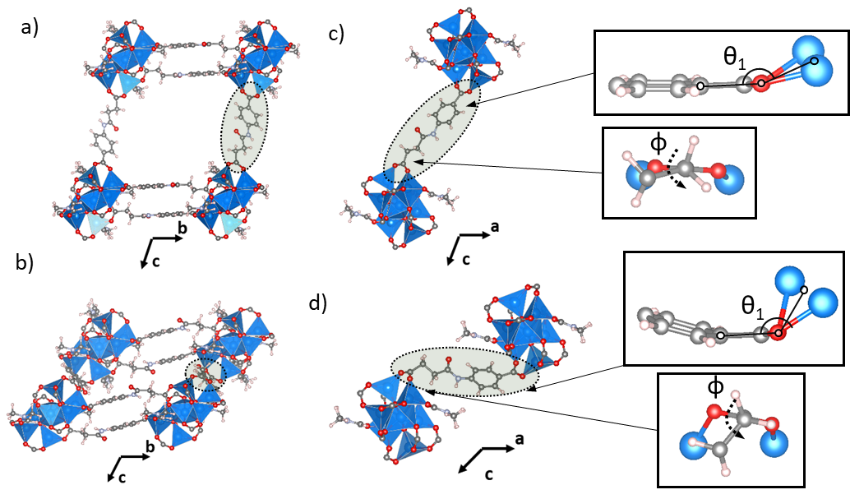
Figure 5. a) Computed optimized structure with fixed experimentally determined cell parameters, C1_{opt}, viewed down the a axis. b) Computed relaxed structure after full relaxation of both positions and cell parameters, C1_{relax}, viewed down the a axis. c) 2 SBUs of C1_{opt} connected via the single c axis linker connection. φ and θ₁ are shown in expanded sections. d) 2 SBUs of C1_{relax} connected via the single c axis linker connection. φ and θ₁ are shown in expanded sections to illustrate the conformational rearrangements and the coordination change observed at the flexible and at the rigid ends of the linker respectively.
The behaviour of ZnCSA was further explored through exchange of the DMF solvent in ZnCSA.DMF (1) with DMSO giving ZnCSA.DMSO (3), formula [Zn₇O₂(CSA)₅DMSO₂].18DMSO. The crystal structure was obtained by X-ray diffraction at 100K and transformed from its standard setting to ensure consistency in the structural description. 3 shows a drastic change in the unit cell dimensions, a = 17.605(4) Å, b = 17.548(4) Å, c = 20.650(6) Å, α = 110.09(2)°, β = 79.19(2)°, γ = 87.58(2)°, V = 5845(3) Å³, but displayed the same overall topology as 1. The pore contains 18 guest DMSO molecules based on thermogravimetric analysis, however, the crystallographic data suggests a slightly higher value of 22.5 guest DMSO molecules. Similar to ZnCSA.DMF this was calculated using a combination of the two guest sites crystallographically resolved in the asymmetric unit, giving a refined composition of [Zn₇O₂(CSA)₅DMSO₂].2.64(3)DMSO, and the residual electron density calculated by the routine SQUEEZE. This value is reasonably close to upper limit of 27.7 molecules, based on the absolute pore volume (3150 Å³) and a packing density identical to liquid DMSO. The changes in structure from 1 to 3 arise primarily due to the exchange of the two coordinated DMF molecules in the SBU for two DMSO molecules. This process involves a significant rearrangement of the metal cluster; two of the tetrahedral Zn atoms (symmetry equivalents) become octahedral, coordinating to the incoming DMSO molecules and the flexible end of a b axis CSA linker, while the two square pyramidal Zn atoms (coordinated to the outgoing DMFs) becomes tetrahedral, losing their DMF and swapping a connection to the flexible end of a b axis linker for a flexible end of an a axis linker. This change is coupled to conformational adjustments in the flexible ends of the connected a and b axes linkers, which display rotations around the torsions φ, ψ and δ (values tabulated in Supporting Information S7). In the a axis linkers these can be seen to change as follows: φ -151° to 107°, ψ 60° to -177° and δ 173° to 170°. The b axis linker, meanwhile, shows the changes φ -116° to -73°, ψ -176° to -174° and δ -150° to 167°. In addition, the bend out of plane of the c axis linker is also observed to show a response, with the averaged experimental value changing from 156° to 193°, essentially switching from bending in one direction to bending in the other (see Fig 6b). A possible mechanism, depicted in Figure 6a, starts with the binding of the new DMSO molecule to a tetrahedral Zn site without any coordinated solvent (Zn2). This causes a coordinated carboxylate from an a axis linker to rotate, transferring an oxygen (O1) from bonding to Zn2 to bonding to Zn1, the site coordinated to DMF. There is also a shift of a second carboxylate (b axis linker) changing an oxygen (O3) from bonding to Zn1 to bonding to Zn2’ (the symmetry equivalent to Zn2). Finally, the mechanism results in the departure of the original DMF molecule. The carboxylates involved in the cluster reorganisation are the central a and b axes linkers connected through the flexible end of the CSA linker, these are ordered and could be accurately characterised by crystallographic techniques, thus enabling the analysis of the coordination change without relying on computational structures. It is worth mentioning that any conformational changes in these linkers during DMF removal were not observed to significantly affect the stability of the a and b directions, thus retaining the pore aperture along the c axis. It should also be noted that the mechanism is mimicked on the opposing side of the SBU with the symmetry generated atoms Zn1’, O1’, O3’ and Zn2’. The large rearrangement of the a axis linker results in a new much straighter linker conformation, which, combined with the changes to the c axis linker, gives a significant increase in unit cell volume (20% in comparison to 1), and in the void space of the channel running along the crystallographic b axis (see Figure 6c-d). The solvent accessible void increases to 53.9% and the pore limiting diameter (now running along the b axis) increases to 11.3 Å. Exchanges with other solvents, MeOH and THF, also showed evidence of structural rearrangements by PXRD (Supporting Figure S7). However, unlike exchange with DMSO, the material didn’t retain its single crystal crystallinity.
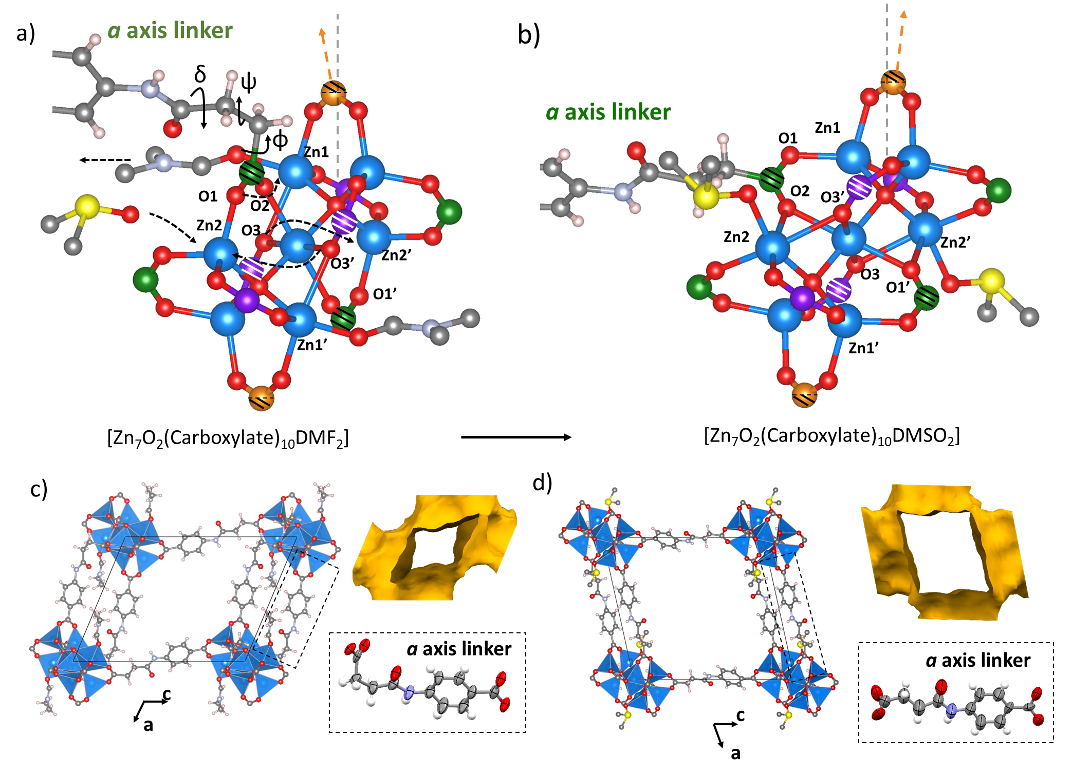
Figure 6. a) SBU and one linker (situated along the crystallographic a axis) of 1. A proposed mechanism for DMSO exchange to structure 3 is shown. Analogous to Figure 1 carboxylate carbons coloured green are connections running along the a axis, coloured purple are connections running along the b axis, and coloured orange are connections running along the c axis. Striped coloured connections are connections through the flexible end of the linker, solid colours are connections through the rigid end and half striped connections correspond to 50/50 distribution through the flexible and rigid ends of the linkers. b) SBU and one linker (situated along the crystallographic a axis) of 3. c) View along the b axis of 1, Connolly surface for this orientation (calculated using a 1.2 Å probe radius) and crystallographically modelled a axis linker showing a bent conformation (ψ = 60°). d) View along the b axis of 3, Connolly surface for this orientation (calculated using a 1.2 Å probe radius) and crystallographically modelled a axis linker showing a straight conformation (ψ = -177°).
In an attempt to experimentally study the behavior of ZnCSA.DMSO during removal of the DMSO contained within the pores, but not coordinated to the SBU, a sample was heated in analogous manner to ZnCSA.DMF. The TGA of ZnCSA.DMSO (Supporting Figure S2) showed that the majority of the solvent is removed at 175 ºC (higher than the DMF analogue), however, heating at a conservative 150 ºC was observed to result in a loss of crystallinity, with the powder pattern (Supporting Figure S8) losing all diffraction peaks except for the strongest peak in the pattern. This remaining peak also showed a reduction in intensity and a significant broadening. It should be noted that in both ZnCSA.DMF and ZnCSA.DMSO the TGA data suggest that the coordinated solvent is not lost until higher temperatures, roughly 350 ºC. The full structural relaxation was therefore instead investigated via DFT optimization, an attempt to predict the behavior, yielding an equilibrium structure (C3_{relax}) of unit cell parameters equivalent to a = 16.37 Å, b = 17.34 Å, c = 16.60 Å, α = 140.49°, β = 61.60°, γ = 86.61°, V = 1702.3 Å³. The extent of the overall change, upon removal of only the uncoordinated guests, is predicted to be even larger than for ZnCSA.DMF, the cell of C3_{relax} being only 30% of the size of 3. The overall mechanism leads to a large reduction in the accessible void space, now only 2% for C3_{relax}, and in the pore limiting diameter to 1.2 Å, such that any remaining void space can essentially be considered as pockets rather channels. Since the MOF topology is preserved during the solvent exchange process, in particular the single and double CSA linker connections, the structural change in ZnCSA.DMSO occurs via qualitatively the same mechanism as in ZnCSA.DMF. Major changes involve out of plane distortions of the single c axis linker through adjustment of the coordination angles θ₁ & θ₂ and the torsional angles φ, ψ & δ. However, in ZnCSA.DMSO this bending of the linker occurs in the opposite direction, relative to its SBU, to that predicted for ZnCSA.DMF (shown in Figure 7). This is related to the change in bending direction of the linker that occurs during the solvent exchange process and means the linker folds over the SBU’s coordinated solvent, which resides on opposite sides in the two materials. The folding in ZnCSA.DMF is also mainly along the crystallographic a axis, while the folding in ZnCSA.DMSO is in-between the a and b axes, resulting in C3_{relax} showing a collapse into the centre of the ab plane. This behavior is evidenced from the unit cell changes where ZnCSA.DMF (1 to C1_{relax}) shows major changes to the β angle (suggesting a mechanism mainly involving the a and c directions), while ZnCSA.DMSO (3 to C3_{relax}) shows a large increase of α (similar to β in ZnCSA.DMF) coupled with a decrease of β (a summary table of unit cell parameters is available in Supporting Information S9). This difference is responsible for the predicted larger reduction in void space, since the collapse of the DMSO structure into the centre of the ab plane eliminates the channel running along the original c axis (Figure 7h) that is still present in ZnCSA.DMF (1_{relax}) (Figure 7d). Quantified changes to the single c axis linker, measured between C3_{opt} (the optimized structure with fixed experimentally determined cell parameters) and C3_{relax}, can be found in Supporting Information S8 where they are compared to changes between C1_{opt} and C1_{relax.}
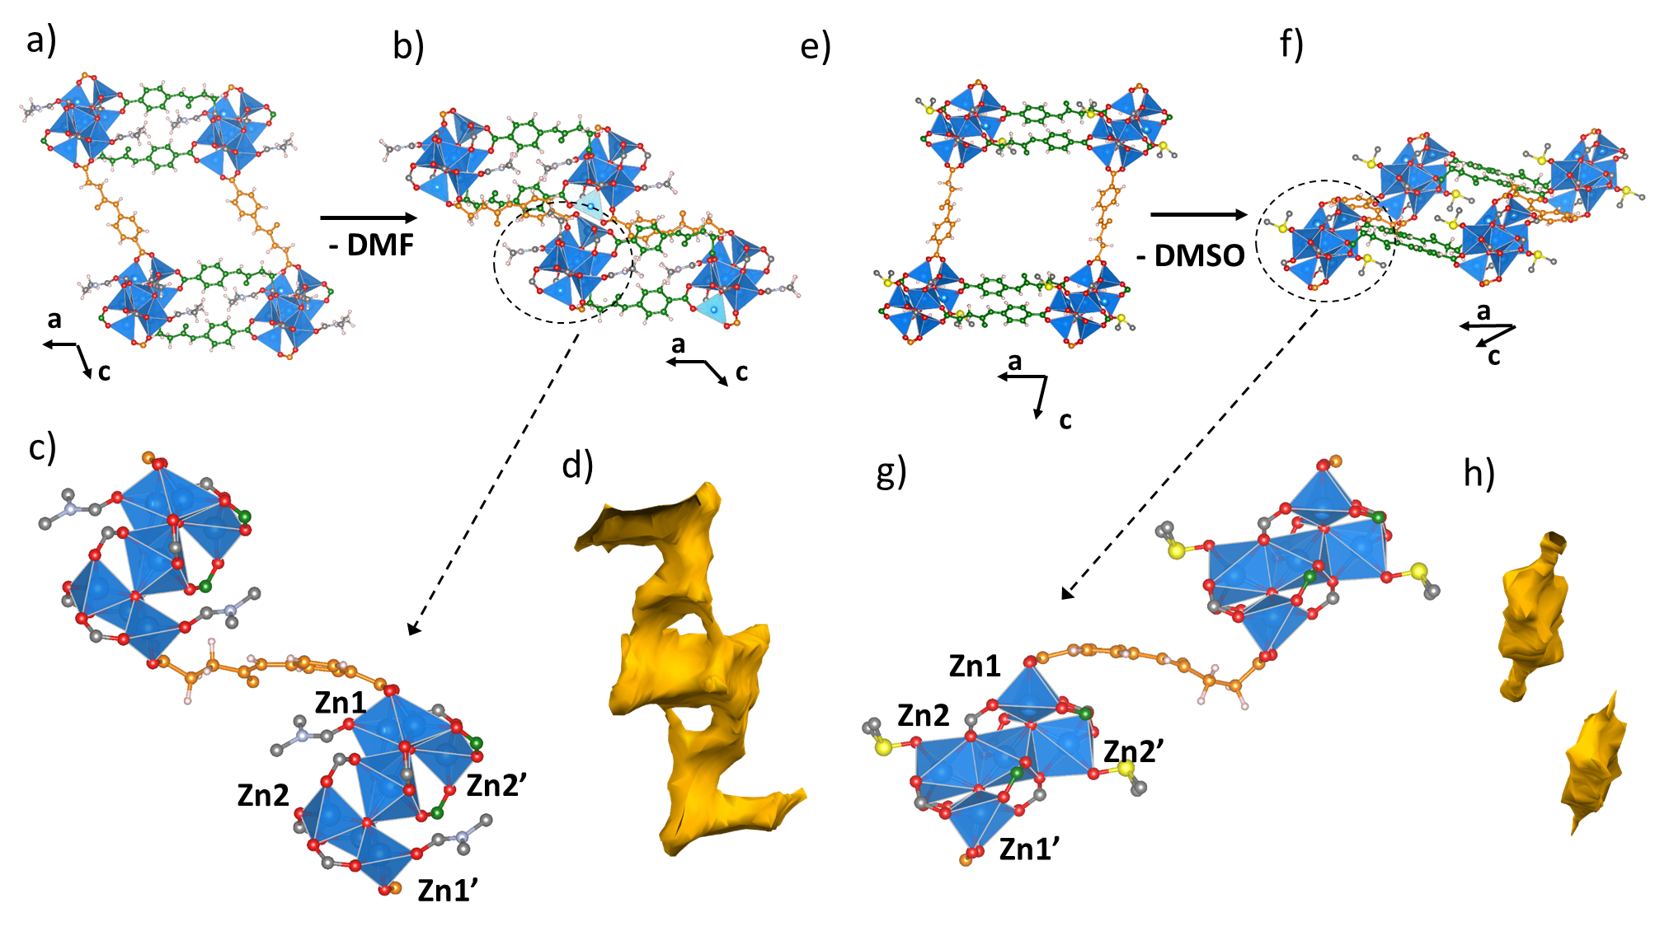

Figure 7. a) View along the b axis of ZnCSA.DMF (1). CSA linkers coloured green are connections running along the a axis and CSA linkers coloured orange are connections running along the c axis. b) View along the b axis of C1_{relax}, the predicted DMF structure after guest removal, using the same colour scheme. c) Two SBUs in C1_{relax} connected by a single c axis linker. d) Connolly surface of C1_{relax} (calculated using a 1.2 Å probe radius) showing the 1D channel remaining after structure collapse. The channel runs in the direction of the c axis defined for the original structure 1. e) View along the b axis of ZnCSA.DMSO (3). CSA linkers coloured green are connections running along the a axis and CSA linkers coloured orange are connections running along the c axis. f) View along the b axis of C3_{relax}, the predicted DMSO structure after guest removal, using the same colour scheme. g) Two SBUs in C3_{relax} connected by a single c axis linker. h) Connolly surface of C3_{relax} (calculated using a 1.2 Å probe radius) showing the removal of all channels.
Discussion
The diffraction data collected for ZnCSA reveals that the material exhibits a significant degree of flexibility. This behaviour can be divided into two separate responses: A large contraction of the void space during removal of its contained guests, and a structural rearrangement caused by the SCCSE of DMF to DMSO. The structural change during guest removal is most obviously seen in the PXRD pattern collected after heating, where the general shift of the Bragg reflections to higher 2θ values is suggestive of a significant reduction in the unit cell dimensions. Indications of the mechanism behind this contraction emerge from the analysis of the single crystal-derived structures of 1 & 2, which show a small scale (Δ9.5 % in volume) structural transformation after partial loss of the contained guests. The transformation is largely related to the single c axis linker, with the double linker connections lying along the a and b axes being observed to show very little motion. However, the exact role of the c axis linker in the transformation of 1 to 2 could not be accurately interpreted from crystallographic refinements alone. Unlike the double linker connections along the a and b axes, which are highly ordered throughout the structure sitting antiparallel and related by inversion symmetry, the single c axis linkers coordinate to their SBUs in one of two possible orientations of their rigid and flexible ends. These orientations are randomly distributed throughout the structure and therefore result in high levels of crystallographic disorder, requiring idealised bond distance restraints to generate as a refineable model, which should not be over-interpreted. The interplay between disorder and flexibility, here a consequence of the material topology, is highly intriguing and has been discussed before by Bennet et al.,⁶⁸ particularly on the dynamical disorder of UiO-abdc, an analogue of UiO-67 made of azobenzene-4,4ʹ-dicarboxylate linkers.⁶⁹
Periodic DFT calculations, benchmarked by comparing the output to the experimentally determined non-disordered a and b axes linkers, were therefore employed to gain insights into the environment of the changing single c axis linkers. These calculations predict that the transition is a result of a joint mechanism, where the rigid end of the organic linker undergoes changes in carboxylate coordination angle, while the flexible aliphatic end shows similar coordination changes combined with conformational adjustments around its sp³ carbons. The coordination angle changes predicted are commonly observed in flexible MOFs built from rigid linkers, particularly wine-rack style materials, e.g., MIL-53⁷⁰ or DMOF⁷¹, and are often referred to as a knee cap or hinge motion.^{72,73} Similarly, conformational changes around sp³ carbons are often the key mechanism to many flexible motions reported in frameworks built from solely aliphatic or peptide-based linkers.^{16–18} The two types of flexibility appear to lead to very similar distortion to the linker. This is evidenced by the 10º change in ω at both the rigid and flexible ends of the linker, which closely matches the averaged distortion modelled crystallographically. The random distribution of the orientation of this single c axis linker is likely the cause for the similarity, requiring symmetrical responses in order to maintain the more rigid 2D network constructed from the double linker connections along the a and b axes. Importantly, the change to the average bend of the single c axis linker out of the plane of the two SBUs it connects during the transformation of 1 to 2 is reliably captured by the differences between the computationally optimised structures C1_{opt} and C2_{opt}. Therefore, by extending our calculations further we have also probed the behaviour under full removal of the solvent, predicting extended changes on the same joint mechanism, Δω≈ 50º, resulting in a significantly contracted form with a considerably reduced void space, as suggested by PXRD. The extent of the knee cap motion observed in these calculations is comparable with other highly flexible systems. The coordination angle at the rigid end (θ₁) is observed to change by 32°, which compares to the 31° response seen in MIL-88-B.^{15,73,74} Meanwhile, the torsional changes at the flexible end of the linker observed in ZnCSA are in the range of 100º – 120º, similar to the rotations observed in peptide-based MOFs displaying structural transformations that are entirely attributed to conformational freedom.^{16–18} The CSA linker’s flexibility, expressed through torsional changes, appears to be highly important to the mechanism because the same flexible behaviour was not observed in MOF-123, a framework displaying the same SBU and topology but with a symmetric rigid linker capable of just the knee cap motion. Instead, MOF-123 displays a completely different behaviour involving a transition from its non-interpenetrated structure to a two-fold interpenetrated structure (MOF-246) upon heating. This occurs at high temperatures (270 °C) capable of removing the coordinated DMF molecules in addition to the guest DMF molecules in the pores, which is outside the scope of the current study on ZnCSA.²² Furthermore, the previously reported indium-based CSA MOF,¹⁹ displaying a 2D sheet structure built from similar inversion related anti-parallel double linker connections, also does not show the hinge motion observed in ZnCSA. This illustrates the intimate relationship between the linker flexibility and the 3D topology of the MOF, i.e., the presence of both single connections and a flexible linker, in forming this dynamical responsive structure.
The overall response of ZnCSA during removal of its guest species therefore arises from the combined effects of the inherent nature of the CSA linker, which is both asymmetric and flexible, and the topology of the MOF. The double connection of anti-parallel oriented asymmetric linkers, i.e., rigid and flexible ends pointing in opposite directions, provides structural stability, impeding distortions in the a and b directions, while the randomly oriented single c axis linker remains free and therefore governs the flexible response. The mechanism would be classified as “2D rigid breathing” according to the review by Murdock et al..⁷⁵ MOFs displaying this mode tend to consist of rigid 2D sheets made flexible by additional linkers running in the flexible direction.^{72,76–82} However, unlike these materials, ZnCSA is built only using one type of linker and the rigidity in the ab plane is caused by the framework’s topology.
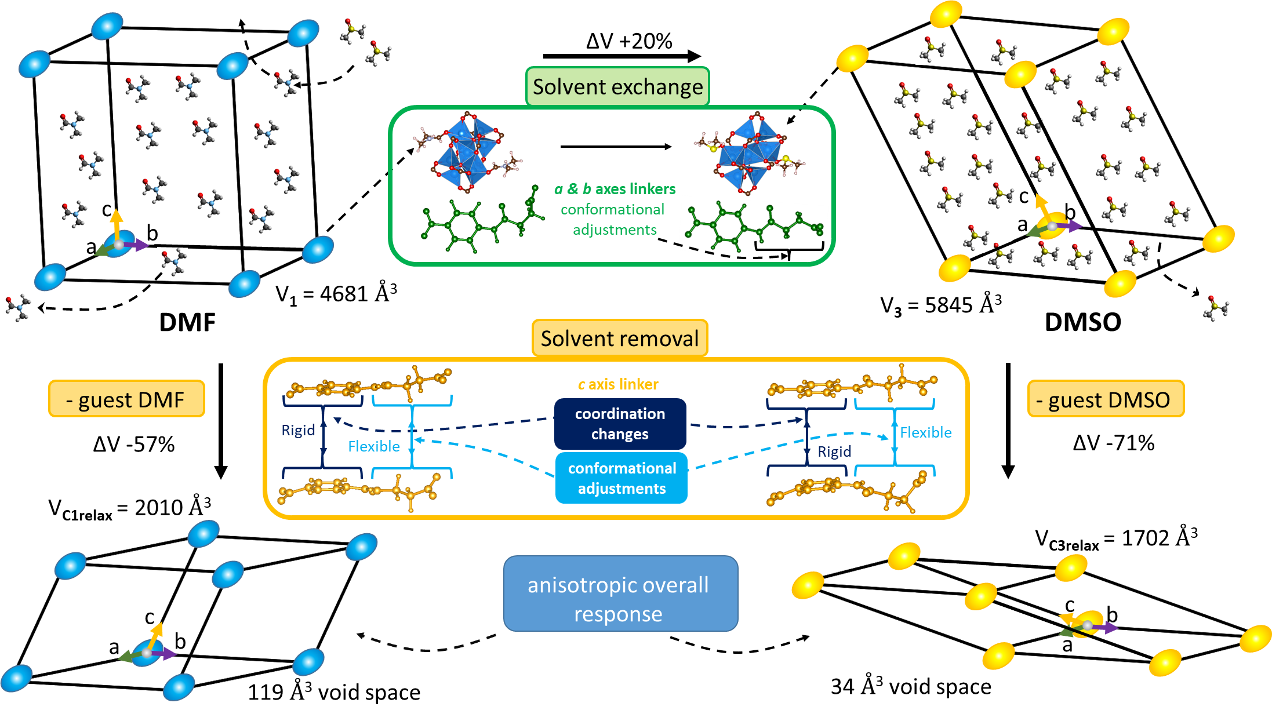
Figure 8. Overview of the responses of ZnCSA. The behaviour during DMF to DMSO single crystal coordinated solvent exchange is shown in green. The behaviour during uncoordinated guest (DMF or DMSO) removal is shown in yellow.
The framework also shows an interesting structural rearrangement during exchange of its DMF guest species for DMSO. This occurs because exchanging with DMSO not only replaces the solvent located in the pores, but also the terminal DMF ligands bound to the SBU. This appears to involve a complicated mechanism where DMSO molecules coordinate to completely different Zn atoms than the original DMF, triggering a rearrangement of the cluster involving changes in the coordination geometry of four out of seven Zn cations, and the reorganisation of four carboxylate groups. As these carboxylate groups belong to the highly ordered a and b axes linkers we are able to observe these changes crystallographically. The changing carboxylates are all connected to the flexible end of the linker, suggesting that the solvent exchange can be directly linked to the linker’s inherent flexibility. The process results in changes to the pore size and shape, but conserves the topology of the MOF, maintaining the single and double linker connections. Similar single crystal coordinated solvent exchanges (SCCSE) have been applied to a small number of rigid linkers MOFs,^{31–36} but SCCSE on MOFs capable of flexible responses has to our knowledge only been reported once by Manos et al.²⁴ This work describes the structural response of a MOF built from a “semirigid” tricarboxylic linker, one consisting of rigid components connected though a “semirigid” imine (CH=N) linkage which displays limited conformational freedom, during a wide range of topotactic solvent exchanges. However, this framework does not display the large flexibility observed for ZnCSA during removal of its guests, and the flexible response of the framework does not show the cluster rearrangements seen in ZnCSA, which are enabled through the flexibility of the linker.
In order to study the effect this structural rearrangement might then have on the removal of solvent, we returned to using periodic DFT calculations. While ZnCSA.DMSO showed a qualitatively similar response in the absolute changes of the single c axis linker response, the direction of distortion changed significantly. This is thought to originate from the previous reorganisation of the SBU from 1 to 3 upon DMSO coordination, and the resulting overall structural changes of the MOF. Consequently, a much more compact structure with a reduced void space is predicted in comparison to the predicted empty structure derived from ZnCSA.DMF. The tuning of MOF dynamical response by SBU functionalization has been reported for a rigid linker MOF, by Bon et al. for the MOF [Zn₃(bpydc)₂(HCOO₂)] (JLU-Liu₄), which exhibits a defined gate pressure response.³⁶ These workers conducted a systematic substitution of the monocarboxylates in the SBU via solvent exchange, replacing formic acid by acetic acid, benzoic acid or cinnamic acid and, due to steric effect of the monocarboxylates, the resulting isostructural materials displayed different dynamics during the wine-rack closing. However, this example is for a rigid linker MOF which, unlike ZnCSA, does not adapt its structure to accommodate the new SBU species. In ZnCSA, the torsions of the flexible ends of the a and b axes linkers actively respond to facilitate the coordinated solvent exchange reaction occurring at the cluster. DMF and DMSO are also comparable in size, whereas the size of the SBU terminal ligand was the major factor in the control exhibited by Bon et al.³⁶ The predicted changes in response of ZnCSA.DMSO compared to ZnCSA.DMF therefore illustrates the control possibilities provided by fine tuning of the SBU functionalization in flexible linker MOFs.
ZnCSA demonstrates the attractive potential of flexible asymmetric linkers, composed of rigid and flexible ends, to control the guest response of MOFs, relying on the delicate balance between topology and flexibility. Further exploration of such linkers, for example with the extensive Zn-carboxylate cluster chemistry^{83–85} as exemplified by the prototypical MOF-5,⁸⁶ provides interesting new directions in the design of future flexible MOFs.
Conclusions
We report the synthesis and characterisation of a new highly porous flexible MOF constructed from heptanuclear zinc carboxylate secondary building units and flexible asymmetric CSA linkers. Using a combination of crystallographic and computational approaches we are able to explore the dynamic response of this material during guest removal, which is driven by the changes in the disordered single linker connection along the c axis, while the double antiparallel linker connections along the a and b axes remain locked. The response of the CSA linker reflects its asymmetric nature: its rigid end experiences only a hinge motion, while its flexible end shows a combination of a hinge motion and conformational adjustments around its sp³ carbons. The overall anisotropic nature can also be related to the three-dimensional lattice topology within which it is embedded – the same linker in a two-dimensional structure with only one unique linker position does not respond in the same way. Further structural rearrangements of the material are also induced through DMF to DMSO solvent exchange, replacing the two terminal solvent molecules coordinated to the SBU based on a significant rearrangement of the cluster. This occurs through large conformational adjustments to the a and b axes CSA linkers, connected to the cluster through their flexible ends, resulting in coordination changes to the individual Zn atoms. The reorganisation significantly affects the size and shape of the solvent accessible volume of the material and is predicted to lead to a different structural response during guest removal, which highlights the potential of controlling the dynamic responses of flexible linker MOFs through SBU functionalization.

ASSOCIATED CONTENT
Supporting Information. SCXRD information. Lattice transformation used for ZnCSA.DMF (2) and ZnCSA.DMSO (3). Thermogravimetric analysis. PXRD fitting and comparison. Infrared spectroscopy. Volumetric nitrogen adsorption. Summary table of torsion angle changes. Summary table of changes between ZnCSA.DMF (1) and ZnCSA.DMSO (3). Summary table of experimental and computational structures unit cell parameters.
The following files are available free of charge:
Zip archive containing the computational structures in cif format.
AUTHOR INFORMATION
Corresponding Author
*Email: m.j.rosseinsky@liv.ac.uk (M. J. R.)
Author Contributions
The manuscript was written through contributions of all authors. All authors have given approval to the final version of the manuscript.
Notes
The authors declare no competing financial interest.
ACKNOWLEDGMENTS
This project has received funding from the European Research Council (ERC) under the European Union’s Horizon 2020 research and innovation programme (grant agreement number 692685). We acknowledge the HEC Materials Chemistry Consortium funded by EPSRC (EP/L000202, EP/R029431) for provision of computer time on the ARCHER UK National Supercomputing Service, and on the UK Materials and Molecular Modelling Hub, MMM Hub, which is partially funded by EPSRC (EP/P020194). We thank the Diamond Light Source for provision of beamtime on the I11 and I19 beamlines.
ABBREVIATIONS
CSA, N-(4-Carboxyphenyl)succinamate; DFT, density functional theory; DMF, dimethylformamide; DMSO, dimethylsulphoxide. MOF, metal-organic framework; PXRD, powder X-ray diffraction; SBU, secondary building unit.
REFERENCES
(1) Chang, Z.; Yang, D. H.; Xu, J.; Hu, T. L.; Bu, X. H. Flexible Metal-Organic Frameworks: Recent Advances and Potential Applications. Adv. Mater. 2015, 27 (36), 5432–5441.
(2) Sarkisov, L.; Martin, R. L.; Haranczyk, M.; Smit, B. On the Flexibility of Metal-Organic Frameworks. J. Am. Chem. Soc. 2014, 136 (6), 2228–2231.
(3) Schneemann, A.; Bon, V.; Schwedler, I.; Senkovska, I.; Kaskel, S.; Fischer, R. A. Flexible Metal–organic Frameworks. Chem. Soc. Rev. 2014, 43 (16), 6062–6096.
(4) Lin, Z.-J.; Lü, J.; Hong, M.; Cao, R. Metal–Organic Frameworks Based on Flexible Ligands (FL-MOFs): Structures and Applications. Chem. Soc. Rev. 2014, 43 (16), 5867–5895.
(5) Horike, S.; Shimomura, S.; Kitagawa, S. Soft Porous Crystals. Nat. Chem. 2009, 1 (9), 695–704.
(6) Furukawa, H.; Cordova, K. E.; O’Keeffe, M.; Yaghi, O. M. The Chemistry and Applications of Metal-Organic Frameworks. Science. 2013, 341, 1230444.
(7) Zhou, H.-C. “Joe”; Kitagawa, S. Metal–Organic Frameworks (MOFs). Chem. Soc. Rev. 2014, 43 (16), 5415–5418.
(8) Coudert, F.-X. Responsive Metal–Organic Frameworks and Framework Materials: Under Pressure, Taking the Heat, In the Spotlight, With Friends. Chem. Mater. 2015, 27 (6), 1905-1916
(9) Karmakar, A.; Samanta, P.; Desai, A. V; Ghosh, S. K. Guest-Responsive Metal–Organic Frameworks as Scaffolds for Separation and Sensing Applications. Acc. Chem. Res. 2017, 50 (10), 2457–2469.
(10) Guo, Z.; Cao, R.; Wang, X.; Li, H.; Yuan, W.; Wang, G.; Wu, H.; Li, J. A Multifunctional 3D Ferroelectric and NLO-Active Porous Metal-Organic Framework. J. Am. Chem. Soc. 2009, 131 (20), 6894–6895.
(11) Kitagawa, S. Future Porous Materials. Acc. Chem. Res. 2017, 50 (3), 514–516.
(12) Vanduyfhuys, L.; Rogge, S. M. J.; Wieme, J.; Vandenbrande, S.; Maurin, G.; Waroquier, M.; Van Speybroeck, V. Thermodynamic Insight into Stimuli-Responsive Behaviour of Soft Porous Crystals. Nat. Commun. 2018, 9, 204.
(13) Mellot-Draznieks, C.; Serre, C.; Surblé, S.; Audebrand, N.; Férey, G. Very Large Swelling in Hybrid Frameworks: A Combined Computational and Powder Diffraction Study. J. Am. Chem. Soc. 2005, 127 (46), 16273–16278.
(14) Lin, X.; Wang, S.; Hou, Y.; Ding, Z.; Dai, W.; Tu, W.; Hu, Z.; Xu, R. MOF-Derived Hierarchical Hollow Spheres Composed of Carbon-Confined Ni Nanoparticles for Efficient CO₂ Methanation . Catal. Sci. Technol. 2019, 9 (3), 731–738.
(15) Surblé, S.; Serre, C.; Mellot-Draznieks, C.; Millange, F.; Férey, G. A New Isoreticular Class of Metal-Organic-Frameworks with the MIL-88 Topology. Chem. Commun. 2006, No. 3, 284–286.
(16) Katsoulidis, A. P.; Park, K. S.; Antypov, D.; Martí-Gastaldo, C.; Miller, G. J.; Warren, J. E.; Robertson, C. M.; Blanc, F.; Darling, G. R.; Berry, N. G.; et al. Guest-Adaptable and Water-Stable Peptide-Based Porous Materials by Imidazolate Side Chain Control. Angew. Chemie Int. Ed. 2014, 53 (1), 193–198.
(17) Martí-Gastaldo, C.; Antypov, D.; Warren, J. E.; Briggs, M. E.; Chater, P. A.; Wiper, P. V.; Miller, G. J.; Khimyak, Y. Z.; Darling, G. R.; Berry, N. G.; et al. Side-Chain Control of Porosity Closure in Single- and Multiple-Peptide-Based Porous Materials by Cooperative Folding. Nat. Chem. 2014, 6 (4), 343–351.
(18) Katsoulidis, A. P.; Antypov, D.; Whitehead, G. F. S.; Carrington, E. J.; Adams, D. J.; Berry, N. G.; Darling, G. R.; Dyer, M. S.; Rosseinsky, M. J. Chemical Control of Structure and Guest Uptake by a Conformationally Mobile Porous Material. Nature 2019, 565 (7738), 213–217.
(19) Haddad, J.; Whitehead, G. F. S.; Katsoulidis, A. P.; Rosseinsky, M. J. In-MOFs Based on Amide Functionalised Flexible Linkers. Faraday Discuss. 2017, 201, 327–335.
(20) Li, Qian-hai, Jiang, Shun-feng, C. P. Synthesis and Crystal Structure of Copper(II) Complex Constructed by Flexible Dicarboxylate Ligands. J. Synth. Cryst. 2016, No. 7, 1875.
(21) Fang, Q. R.; Zhu, G. S.; Xue, M.; Zhang, Q. L.; Sun, J. Y.; Guo, X. D.; Qiu, S. L.; Xu, S. T.; Wang, P.; Wang, D. J.; et al. Microporous Metal-Organic Framework Constructed from Heptanuclear Zinc Carboxylate Secondary Building Units. Chem. - A Eur. J. 2006, 12 (14), 3754–3758.
(22) Choi, S. B.; Furukawa, H.; Nam, H. J.; Jung, D.; Jhon, Y. H.; Walton, A.; Book, D.; O’Keeffe, M.; Yaghi, O. M.; Kim, J. Reversible Interpenetration in a Metal-Organic Framework Triggered by Ligand Removal and Addition. Angew. Chemie Int. Ed. 2012, 51 (35), 8791–8795.
(23) Iremonger, S. S.; Vaidhyanathan, R.; Mah, R. K.; Shimizu, G. K. H. Zn₇O₂(RCOO)₁₀ Clusters and Nitro Aromatic Linkers in a Porous Metal–Organic Framework. Inorg. Chem. 2013, 52 (8), 4124–4126.
(24) Manos, M. J.; Kyprianidou, E. J.; Papaefstathiou, G. S.; Tasiopoulos, A. J. Insertion of Functional Groups into a Nd³⁺ Metal–Organic Framework via Single-Crystal-to-Single-Crystal Coordinating Solvent Exchange. Inorg. Chem. 2012, 51 (11), 6308–6314.
(25) Tanabe, K. K.; Cohen, S. M. Postsynthetic Modification of Metal–Organic Frameworks—a Progress Report. Chem. Soc. Rev. 2011, 40 (2), 498–519.
(26) Cohen, S. M. Postsynthetic Methods for the Functionalization of Metal-Organic Frameworks. Chem. Rev. 2012, 112 (2), 970–1000.
(27) Cohen, S. M. The Postsynthetic Renaissance in Porous Solids. J. Am. Chem. Soc. 2017, 139 (8), 2855–2863.
(28) Brozek, C. K.; Dincǎ, M. Cation Exchange at the Secondary Building Units of Metal-Organic Frameworks. Chem. Soc. Rev. 2014, 43 (16), 5456–5467.
(29) Lin, Z. J.; Liu, T. F.; Huang, Y. B.; Jian Lü; Cao, R. A Guest-Dependent Approach to Retain Permanent Pores in Flexible Metal-Organic Frameworks by Cation Exchange. Chem. - A Eur. J. 2012, 18 (25), 7896–7902.
(30) Liu, T. F.; Lü, J.; Tian, C.; Cao, M.; Lin, Z.; Cao, R. Porous Anionic, Cationic, and Neutral Metal-Carboxylate Frameworks Constructed from Flexible Tetrapodal Ligands: Syntheses, Structures, Ion-Exchanges, and Magnetic Properties. Inorg. Chem. 2011, 50 (6), 2264–2271.
(31) Deria, P.; Bury, W.; Hod, I.; Kung, C.-W.; Karagiaridi, O.; Hupp, J. T.; Farha, O. K. MOF Functionalization via Solvent-Assisted Ligand Incorporation: Phosphonates vs Carboxylates. Inorg. Chem. 2015, 54 (5), 2185–2192.
(32) Moushi, E. E.; Kourtellaris, A.; Spanopoulos, I.; Manos, M. J.; Papaefstathiou, G. S.; Trikalitis, P. N.; Tasiopoulos, A. J. A Microporous Co²⁺ Metal Organic Framework with Single-Crystal to Single-Crystal Transformation Properties and High CO₂ Uptake. Cryst. Growth Des. 2015, 15 (1), 185–193.
(33) Zhang, W.-Q.; Zhang, W.-Y.; Wang, R.-D.; Ren, C.-Y.; Li, Q.-Q.; Fan, Y.-P.; Liu, B.; Liu, P.; Wang, Y.-Y. Effect of Coordinated Solvent Molecules on Metal Coordination Sphere and Solvent-Induced Transformations. Cryst. Growth Des. 2017, 17 (2), 517–526.
(34) Kyprianidou, E. J.; Lazarides, T.; Kaziannis, S.; Kosmidis, C.; Itskos, G.; Manos, M. J.; Tasiopoulos, A. J. Single Crystal Coordinating Solvent Exchange as a General Method for the Enhancement of the Photoluminescence Properties of Lanthanide MOFs. J. Mater. Chem. A 2014, 2 (15), 5258.
(35) Lan, Y.-Q.; Jiang, H.-L.; Li, S.-L.; Xu, Q. Solvent-Induced Controllable Synthesis, Single-Crystal to Single-Crystal Transformation and Encapsulation of Alq3 for Modulated Luminescence in (4,8)-Connected Metal–Organic Frameworks. Inorg. Chem. 2012, 51 (14), 7484–7491.
(36) Bon, V.; Kavoosi, N.; Senkovska, I.; Müller, P.; Schaber, J.; Wallacher, D.; Többens, D. M.; Mueller, U.; Kaskel, S. Tuning the Flexibility in MOFs by SBU Functionalization. Dalt. Trans. 2016, 45 (10), 4407–4415.
(37) Crys Alis Pro. Oxford Diffraction.
(38) Nowell, H.; Barnett, S. A.; Christensen, K. E.; Teat, S. J.; Allan, D. R. I19, the Small-Molecule Single-Crystal Diffraction Beamline at Diamond Light Source. J. Synchrotron Radiat. 2012, 19 (3), 435–441.
(39) Winter, G. Xia2 : An Expert System for Macromolecular Crystallography Data Reduction. J. Appl. Crystallogr. 2010, 43 (1), 186–190.
(40) Blessing, R. H. An Empirical Correction for Absorption Anisotropy. Acta Crystallogr. Sect. A Found. Crystallogr. 1995, 51 (1), 33–38.
(41) Sheldrick, G. M. SHELXT – Integrated Space-Group and Crystal-Structure Determination. Acta Crystallogr. Sect. A Found. Adv. 2015, 71 (1), 3–8.
(42) Farrugia, L. J. WinGX and ORTEP for Windows : An Update. J. Appl. Crystallogr. 2012, 45 (4), 849–854.
(43) Sheldrick, G. M. Crystal Structure Refinement with SHELXL. Acta Crystallogr. Sect. C Struct. Chem. 2015, 71 (1), 3–8.
(44) Dolomanov, O. V.; Bourhis, L. J.; Gildea, R. J.; Howard, J. A. K.; Puschmann, H. OLEX2 : A Complete Structure Solution, Refinement and Analysis Program. J. Appl. Crystallogr. 2009, 42 (2), 339–341.
(45) Spek, A. L. PLATON SQUEEZE: A Tool for the Calculation of the Disordered Solvent Contribution to the Calculated Structure Factors. Acta Crystallogr. Sect. C Struct. Chem. 2015, 71 (1), 9–18.
(46) Macrae, C. F.; Edgington, P. R.; McCabe, P.; Pidcock, E.; Shields, G. P.; Taylor, R.; Towler, M.; van de Streek, J. Mercury : Visualization and Analysis of Crystal Structures. J. Appl. Crystallogr. 2006, 39 (3), 453–457.
(47) Momma, K.; Izumi, F. VESTA 3 for Three-Dimensional Visualization of Crystal, Volumetric and Morphology Data. J. Appl. Crystallogr. 2011, 44 (6), 1272–1276.
(48) Kresse, G.; Hafner, J. Ab Initio Molecular Dynamics for Liquid Metals. Phys. Rev. B 1993, 47, 558.
(49) Blöchl, P. E. Projector Augmented-Wave Method. Phys. Rev. B 1994, 50, 17953.
(50) Dion, M.; Rydberg, H.; Schröder, E.; Langreth, D. C.; Lundqvist, B. I. Van Der Waals Density Functional for General Geometries. Phys. Rev. Lett. 2004, 92 (24), 246401.
(51) Klimeš, J.; Bowler, D. R.; Michaelides, A. Chemical Accuracy for the van Der Waals Density Functional. J. Phys. Condens. Matter 2010, 22 (2), 022201.
(52) Alexandrov, E. V; Blatov, V. A.; Kochetkov, A. V; Proserpio, D. M. Underlying Nets in Three-Periodic Coordination Polymers: Topology, Taxonomy and Prediction from a Computer-Aided Analysis of the Cambridge Structural Database. CrystEngComm 2011, 13 (12), 3947.
(53) O’Keeffe, M.; Yaghi, O. M. Deconstructing the Crystal Structures of Metal-Organic Frameworks and Related Materials into Their Underlying Nets. Chem. Rev. 2012, 112 (2), 675–702.
(54) Hussain, M.; Tahir, M. N.; Mansoor, M. A.; Arifin, Z.; Mazhar, M. Heptanuclear Zinc Cluster for Growth of Zincite and Manganese-Doped Zincite Thin Films for Sensor Applications. Monatshefte für Chemie - Chem. Mon. 2013, 144 (3), 285–294.
(55) Darensbourg, D. J.; Wildeson, J. R.; Yarbrough, J. C. Solid-State Structures of Zinc(II) Benzoate Complexes. Catalyst Precursors for the Coupling of Carbon Dioxide and Epoxides. Inorg. Chem. 2002, 41 (4), 973–980.
(56) Lalioti, N.; Perlepes, S. P.; Manessi-Zoupa, E.; Raptopoulou, C. P.; Terzis, A.; Aliev, A. E.; Gerothanassis, I. P. Rare M₇O₂ Double Tetrahedral Core in Molecular Species: Preparation, Structure and Properties of [Zn₇O₂(O₂CMe)₁₀(1-Meim)₂] (1-Meim = 1-Methylimidazole). Chem. Commun. 1998, 2 (15), 1513–1514.
(57) Anan’ev, I. V.; Perova, E. V.; Nefedov, S. E. Pyrazolate-Bridged Binuclear Zinc Complexes Zn₂(μ-Dmpz)₂(Hdmpz)₂(OOCR)₂ (R = Me, Ph; Hdmpz = 3,5-Dimethylpyrazole). Russ. J. Inorg. Chem. 2010, 55 (1), 40–52.
(58) Waheed, A.; Jones, R. A.; McCarty, J.; Yang, X. Synthesis and Structure of Zn 7 (µ 4 -O) 2 (OAc) 10 (Pz) 2 (OAc = Acetate; Pz = Pyrazine). Dalt. Trans. 2004, 7 (22), 3840–3841.
(59) Dittrich, D.; Tewes, H.; Wölper, C.; Bläser, D.; Schulz, S.; Roll, J. Preparation, Catalytical Activity and Crystal Structure of a Heptanuclear Zinc Acetate Cluster. Transit. Met. Chem. 2017, 42 (3), 237–241.
(60) Attanasio, D.; Dessy, G.; Fares, V. Crystal and Molecular Structure of Deca-µ-Acetato-Dioxobis(Pyridine)-Heptazinc(II) and the Electron Paramagnetic Resonance Spectrum of Its Copper-Doped Crystals. J. Chem. Soc., Dalt. Trans. 1979, 84 (1), 28–32.
(61) Reger, D. L.; Debreczeni, A.; Pascui, A. E.; Smith, M. D. Heptanuclear Zinc Carboxylate Complex: New Supramolecular Building Unit and Unique Supramolecular Architecture. Polyhedron 2013, 52, 1317–1322.
(62) Feazell, R. P.; Carson, C. E.; Klausmeyer, K. K. Synthesis of a Funtionalized Monomer of the Rare M₇O₂¹⁰⁺ Double Tetrahedron Zn Cluster: [Zn₇O₂(O₂C₂H₃)₁₀(3-{CH₂OH}C₅H₄N)₂]. Inorg. Chem. Commun. 2007, 10 (8), 873–875.
(63) Constable, E. C.; Housecroft, C. E.; Schönle, J.; Vujovic, S.; Zampese, J. A. Coordination Polymers with 4′-(4-(Anthracen-9-Yl)Phenyl)- and 4′-(4-(Naphthalen-1-Yl)Phenyl)-4,2′:6′,4″-Terpyridines: Mono-, Di- and Heptazinc(II) Nodes. Polyhedron 2013, 62, 260–267.
(64) Suen, M.-C.; Chan, Z.-K.; Chen, J.-D.; Wang, J.-C.; Hung, C.-H. Syntheses and Structures of Three New Coordination Polymers Generated from the Flexible 1,3-Bis(4-Pyridyl)Propane Ligand and Zinc Salts. Polyhedron 2006, 25 (11), 2325–2332.
(65) Granifo, J.; Garland, M. T.; Baggio, R. The Effect in the Assembly and Node Nuclearity of the Long and Rigid Character of Bis-Pyridyl exo-Bidentate Spacers When React with Zinc Acetate: Crystal Structures of the High Nuclearity Coordination Polymers [Zn₇(μ₄-O)₂(OAc)₁₀(3pdb)]_{n} (3pdb = 1,4-bis(3-pyridyl)-2,3-diaza-1,3-butadiene) and [Zn₇(μ₄-O)₂(OAc)₁₀(4pdb)]_{n} (4pdb = 1,4-bis(4-pyridyl)-2,3-diaza-1,3-butadiene). Polyhedron 2006, 25 (11), 2277–2283.
(66) Ng, M. T.; Deivaraj, T. C.; J. Vittal, J. Self Assembly of Heptanuclear Zinc(II) Clusters Linked by Angular Spacer Ligands. Inorganica Chim. Acta 2003, 348, 173–178.
(67) Willems, T. F.; Rycroft, C. H.; Kazi, M.; Meza, J. C.; Haranczyk, M. Algorithms and Tools for High-Throughput Geometry-Based Analysis of Crystalline Porous Materials. Microporous Mesoporous Mater. 2011, 149 (1), 134–141.
(68) Bennett, T. D.; Cheetham, A. K.; Fuchs, A. H.; Coudert, F.-X. Interplay between Defects, Disorder and Flexibility in Metal-Organic Frameworks. Nat. Chem. 2016, 9 (1), 11–16.
(69) Hobday, C. L.; Marshall, R. J.; Murphie, C. F.; Sotelo, J.; Richards, T.; Allan, D. R.; Düren, T.; Coudert, F.-X.; Forgan, R. S.; Morrison, C. A.; et al. A Computational and Experimental Approach Linking Disorder, High-Pressure Behavior, and Mechanical Properties in UiO Frameworks. Angew. Chemie Int. Ed. 2016, 55 (7), 2401–2405.
(70) Serre, C.; Bourrelly, S.; Vimont, A.; Ramsahye, N. A.; Maurin, G.; Llewellyn, P. L.; Daturi, M.; Filinchuk, Y.; Leynaud, O.; Barnes, P.; et al. An Explanation for the Very Large Breathing Effect of a Metal–Organic Framework during CO₂ Adsorption. Adv. Mater. 2007, 19 (17), 2246–2251.
(71) Dybtsev, D. N.; Chun, H.; Kim, K. Rigid and Flexible: A Highly Porous Metal-Organic Framework with Unusual Guest-Dependent Dynamic Behavior. Angew. Chem. Int. Ed. Engl. 2004, 43 (38), 5033–5036.
(72) Férey, G.; Serre, C. Large Breathing Effects in Three-Dimensional Porous Hybrid Matter: Facts, Analyses, Rules and Consequences. Chem. Soc. Rev. 2009, 38 (5), 1380–1399.
(73) Carrington, E. J.; McAnally, C. A.; Fletcher, A. J.; Thompson, S. P.; Warren, M.; Brammer, L. Solvent-Switchable Continuous-Breathing Behaviour in a Diamondoid Metal–organic Framework and Its Influence on CO₂ versus CH₄ Selectivity. Nat. Chem. 2017, 9 (9), 882–889.
(74) Horcajada, P.; Salles, F.; Wuttke, S.; Devic, T.; Heurtaux, D.; Maurin, G.; Vimont, A.; Daturi, M.; David, O.; Magnier, E.; et al. How Linker’s Modification Controls Swelling Properties of Highly Flexible Iron(III) Dicarboxylates MIL-88. J. Am. Chem. Soc. 2011, 133 (44), 17839–17847.
(75) Murdock, C. R.; Hughes, B. C.; Lu, Z.; Jenkins, D. M. Approaches for Synthesizing Breathing MOFs by Exploiting Dimensional Rigidity. Coord. Chem. Rev. 2014, 258–259 (1), 119–136.
(76) Colodrero, R. M. P.; Olivera-Pastor, P.; Losilla, E. R.; Aranda, M. a. G.; Leon-Reina, L.; Papadaki, M.; McKinlay, A. C.; Morris, R. E.; Demadis, K. D.; Cabeza, A. Multifunctional Lanthanum Tetraphosphonates: Flexible, Ultramicroporous and Proton-Conducting Hybrid Frameworks. Dalt. Trans. 2012, 41 (14), 4045.
(77) Li, X.-L.; Liu, G.-Z.; Xin, L.-Y.; Wang, L.-Y. A Novel Metal–organic Framework Displaying Reversibly Shrinking and Expanding Pore Modulation. CrystEngComm 2012, 14 (18), 5757.
(78) Husain, A.; Ellwart, M.; Bourne, S. a.; Öhrström, L.; Oliver, C. L. Single-Crystal-to-Single-Crystal Transformation of a Novel 2-Fold Interpenetrated Cadmium-Organic Framework with Trimesate and 1,2-Bis(4-Pyridyl)Ethane into the Thermally Desolvated Form Which Exhibits Liquid and Gas Sorption Properties. Cryst. Growth Des. 2013, 13 (4), 1526–1534.
(79) Park, I.-H.; Lee, S. S.; Vittal, J. J. Guest-Triggered Supramolecular Isomerism in a Pillared-Layer Structure with Unusual Isomers of Paddle-Wheel Secondary Building Units by Reversible Single-Crystal-to-Single-Crystal Transformation. Chem. - A Eur. J. 2013, 19 (8), 2695–2702.
(80) Zeng, M.-H.; Hu, S.; Chen, Q.; Xie, G.; Shuai, Q.; Gao, S.-L.; Tang, L.-Y. Apical Ligand Substitution, Shape Recognition, Vapor-Adsorption Phenomenon, and Microcalorimetry for a Pillared Bilayer Porous Framework That Shrinks or Expands in Crystal-to-Crystal Manners upon Change in the Cobalt(II) Coordination Environment. Inorg. Chem. 2009, 48 (15), 7070–7079.
(81) Seo, J.; Matsuda, R.; Sakamoto, H.; Bonneau, C.; Kitagawa, S. A Pillared-Layer Coordination Polymer with a Rotatable Pillar Acting as a Molecular Gate for Guest Molecules. J. Am. Chem. Soc. 2009, 131 (35), 12792–12800.
(82) Alberti, G.; Murcia-Mascarós, S.; Vivani, R. Pillared Derivatives of γ-Zirconium Phosphate Containing Nonrigid Alkyl Chain Pillars. J. Am. Chem. Soc. 1998, 120 (36), 9291–9295.
(83) Kim, J.; Chen, B.; Reineke, T. M.; Li, H.; Eddaoudi, M.; Moler, D. B.; O’Keeffe, M.; Yaghi, O. M. Assembly of Metal−Organic Frameworks from Large Organic and Inorganic Secondary Building Units: New Examples and Simplifying Principles for Complex Structures ▵. J. Am. Chem. Soc. 2001, 123 (34), 8239–8247.
(84) Eddaoudi, M.; Moler, D. B.; Li, H.; Chen, B.; Reineke, T. M.; O’Keeffe, M.; Yaghi, O. M. Modular Chemistry: Secondary Building Units as a Basis for the Design of Highly Porous and Robust Metal−Organic Carboxylate Frameworks. Acc. Chem. Res. 2001, 34 (4), 319–330.
(85) Eddaoudi, M.; Kim, J.; Rosi, N.; Vodak, D.; Wachter, J.; Keeffe, M. O.; Yaghi, O. M.; Kimrn, J.; Yaghil, O. M. Systematic Design of Pore Size and Functionality in Isoreticular MOFs and Their Application in Methane Storage. Science. 2002, 295 (5554), 469–472.
(86) Li, H.; Yaghi, O. M.; O’Keeffe, M.; Eddaoudi, M. Design and Synthesis of an Exceptionally Stable and Highly Porous Metal-Organic Framework. Nature 1999, 402, 276–279.

TOC Graphic
