Carbon spheres as lubricant additives for improving tribological performance of polyetheretherketone
Chengwei Wu ¹, Chengxiong Wei ¹, Xin Jin ¹, Riaz Akhtar ², Wei Zhang ^{1,}∗
¹ State Key Laboratory of Structural Analysis for Industrial Equipment, Department of Engineering Mechanics, Dalian University of Technology, Dalian 116024, China.
² Department of Mechanical, Materials and Aerospace Engineering, School of Engineering, University of Liverpool, Brownlow Hill, L69 3GH, UK.

E-mails and ORCIDs:
Chengwei Wu
ORCID: 0000-0003-1284-9442
E-mail: cwwu@dlut.edu.cn
Chengxiong Wei
ORCID: 0000-0002-5722-1950
E-mail: weicx@mail.dlut.edu.cn
Xin Jin
ORCID: 0000-0002-3672-6853
E-mail: jinxin1011@mail.dlut.edu.cn
Riaz Akhtar
ORCID: 0000-0002-7963-6874
E-mail: r.akhtar@liverpool.ac.uk
Wei Zhang
ORCID: 0000-0002-8475-3143
E-mail: wei.zhang@dlut.edu.cn

Abstract
Polyetheretherketone (PEEK) has been increasingly used as sliding components in engineering. With the attempt to enhance the tribological performance of PEEK under oil lubrication, in the present work, carbon spheres were prepared and then added to lubricating oil as additives. Strikingly, compared with neat oil lubrication, the tribological tests manifest a notable reduction of coefficient of friction (23.5-33.2%) and wear rate (24.1%) under hybrid oil lubrication. Raman spectra, Fourier-transform infrared spectra, and electron dispersive X-ray analyses indicate the presence of functional groups on carbon spheres, enabling the good interactions between carbon spheres and lubricating oil. The uniform mixture of carbon spheres and lubricating oil can fill in the gap of the surface irregularities and form a protective boundary film. Additionally, the carbon spheres can result in rolling movement to promote the lubricating performance, evidenced by scanning electron microscopy. This study proposes a simple and practicable approach to improve the tribological performance of PEEK.
Keywords: Polymer; PEEK; Lubricant additive; Carbon sphere; Tribology

1. Introduction
Owing to their excellent properties such as corrosion resistance, self-lubrication, and high strength, polymers are widely used, particularly in harsh environments [1-3]. Polyetheretherketone (PEEK), one of the high-performance thermoplastic polymers, can be easily prepared into various shapes and dimensions by hot pressing and injection molding. It is also well known that the superior tribological performance of PEEK and its composites has been a continuous research focus. At present, numerous researches have been conducted to investigate the tribological behaviors of PEEK and its composites under dry friction or under external lubrication [4-9].
In automotive, aerospace, and machinery industries, PEEK and its composites have been increasingly utilized in gears, bearings, and seals, wherein friction and wear often play a leading role in energy loss and failure for these components [10-13]. Applying lubricants to the sliding surfaces is an effective approach to decrease the friction and wear. And the most commonly used lubricant is the liquid lubricant in mechanical parts, which cannot only reduce friction and wear but also dissipate the excessive heat energy [14]. Therefore, PEEK and its composites have caught more people's attention on their tribological behaviors under liquid lubrication. Yamamoto et al. [15] investigated the tribological performance of PEEK under water lubrication and found the coefficient of friction was about 0.1 and the specific wear rate equaled to 6.0×10⁻⁵ mm³ N⁻¹m⁻¹. Loy et al. [16] reported that the application of perfluoropolyether and multiply-alkylated cyclopentane oil could improve the wear durability of PEEK, but the coefficient of friction was still about 0.1. Zhang et al. [9] studied the behavior of pure PEEK under diesel lubrication and showed that the coefficient of friction was greater than 0.1, even though the flow rate of diesel was set to a high level. Apparently, although great achievements have been made, there are the potential and an urgent need to improve the tribological performance of PEEK under liquid lubrication.
With the attempt to improve the anti-friction and wear-resistance performance of PEEK, in this study, the tribological performance of PEEK was evaluated under the lubrication of the hybrid of commonly used engine oil and the bespoke synthesized carbon spheres. Strikingly, in contrast to the neat oil lubrication, 0.5 w.t. % (based on oil) carbon spheres could further reduce the coefficient of friction and wear rate by 23.5-33.2% and 24.1%, respectively. It was expected that this study could propose a simple and practicable approach to further improve the tribological performance of PEEK.

2. Experimental section
2.1 Materials
Carbon spheres were synthesized by using the hydrothermal carbonization method. D-glucose (analytical reagent, supplied by Tianjin Kemiou Chemical Reagent Co., Ltd.) was used as precursor. 200 mL glucose solution (0.5 mol L⁻¹) was added into the autoclave equipped with a magnetic stirrer. The autoclave was sealed and heated to 170°C. After 6 h, the autoclave was cooled to ambient temperature naturally and the resultant precipitates were washed with deionized water and ethanol in sequence until the filtrate became colorless. Then, the solid products were dried at 60°C in vacuum for 24 h. The obtained products were sealed and preserved for subsequent experiments.
PEEK (product model: 550G, supplied by Jilin Zhongyan High Performance Plastic Co., Ltd.) was shaped into disks with a diameter of 41 mm and a thickness of 3 mm by injection molding technique at a melt temperature of 380°C and an injection pressure of 81 MPa. After injection molding, the surfaces of disk specimens were polished using a P1000 sandpaper.

2.2 Materials characterization
The morphologies of the carbon spheres were analyzed by scanning electron microscopy (SEM, Quanta 200, FEI, America) and transmission electron microscopy (TEM, Tecnai F30, FEI, America). The elemental compositions of the carbon spheres were determined by electron dispersive X-ray (EDX) technique in the field-emission scanning electron microscope (FE-SEM, NOVA NanoSEM 450, FEI, America) mode. The phase structures of the carbon spheres were investigated by X-ray diffraction spectrum (XRD, Empyrean, PANalytical, Netherlands) at 40 kV and 30 mA using Cu-Kα radiation with a scanning speed of 4° min⁻¹, and Raman spectrum (DXR Microscope, Thermo Fisher, America) with a 532 nm incident laser. The functional groups of the carbon spheres were identified by Fourier-transform infrared spectrum (FTIR, Nicolet 6700, Thermo Fisher, America). The dynamic viscosity of the oil was measured on a rheometer (MCR 302, Anton Paar, Austria) with a scanning speed of 5°C min⁻¹ and a shear rate of 10 s⁻¹. The thermal properties of PEEK specimens were characterized on a differential scanning calorimetry (DSC 3, Mettler Toledo, Switzerland) with a scanning speed of 10°C min⁻¹. The surface topography of PEEK was measured by SEM and optical surface profiler (NV5000 5022S, ZYGO, America).
2.3 Friction and wear tests
Carbon sphere powders were added into Castrol 5W-40 engine oil with 0.5 w.t. % concentration (weight percent, based on the mass of oil). Then, the hybrid oil was mechanically stirred and ultrasonicated for 10 min to maintain the stability of the system. Friction and wear tests were performed on a ring-on-disk apparatus at ambient temperature and a relative humidity of 36%. The friction pairs of test apparatus included an upper ring block and a lower disk. The upper ring block manufactured with tungsten steel rotated on the lower stationary PEEK disk. The friction contact area between the upper ring block and the lower disk was an annular area with an outer diameter of 25.6 mm and an inner diameter of 20 mm. Before each test, 2 mL hybrid lubricating oil was applied evenly to the friction surface of PEEK specimen. During the tests, the temperature variations of PEEK specimens were recorded by an infrared thermometer.
In order to mimic the extreme mechanical application conditions of PEEK, the tribological tests were conducted under a load of 1500 N (equal to 1.87 MPa) and a sliding speed 150 rpm for 15 min. A loaded cell sensor could dynamically record the friction force into a computer. The coefficient of friction was obtained when the friction force were divided by the normal load. After friction test, the wear surface was thoroughly cleaned in degreaser and ethanol. The weight loss of PEEK specimen was measured by an analytical balance (precision: 0.01 mg). The wear rate of PEEK specimen was calculated according to Equation (1).

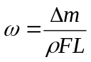 (1)

where, 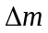 is the weight loss (g),  is the density of PEEK specimen (g mm⁻³), L is the sliding distance (m), and F is the normal load (N). The density of PEEK measured on a densimeter is about 1.29×10⁻³ g mm⁻³.

3. Results and discussion
3.1 Preparation and characterization of carbon spheres
Scanning electron microscopy (SEM) image and the size histogram of the carbon spheres are shown in Fig. 1, where it can be found that the formed carbon spheres possess spherical morphology with narrow polydispersity (Fig. 1a). 100 carbon spheres were selected randomly to estimate the size distribution and the results show that the carbon spheres have the diameter of 219±30.2 nm (Fig. 1b).

Fig. 1 (a) SEM image and (b) the size histogram of the carbon spheres.

In order to observe the microstructure, the carbon spheres were further investigated by transmission electron microscopy (TEM), as shown in Fig. 2. TEM images confirm that the carbon spheres are well separated and possess a regular spherical morphology (Fig. 2a-c). Selected area electron diffraction (SAED) patterns and high-resolution images show that the formed carbon spheres are amorphous (Fig. 2d).

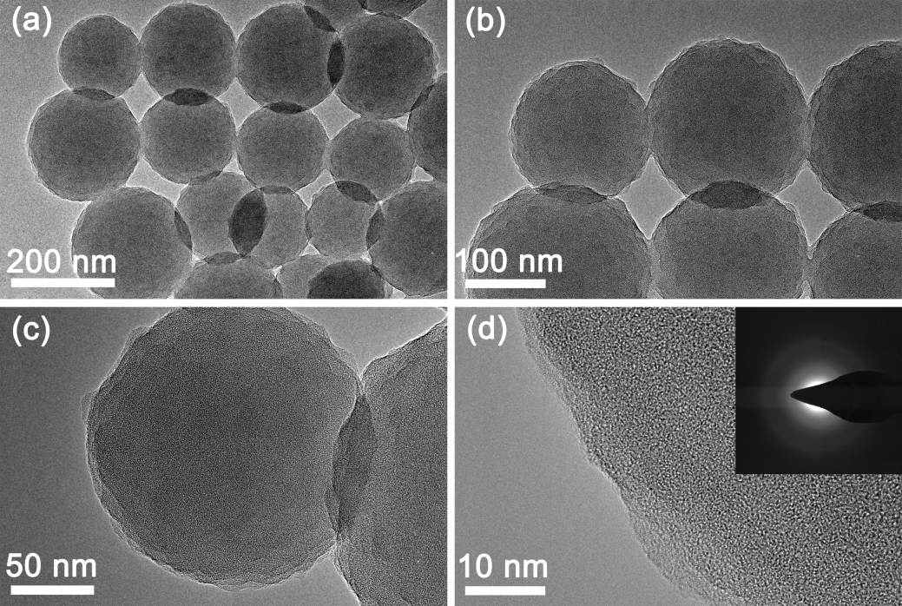
Fig. 2 TEM images of the carbon spheres and electron dispersive X-ray pattern (inset to d).

The X-ray diffraction (XRD) spectrum and Raman spectrum of the carbon spheres are shown in Fig. 3. In XRD profile, a broad peak arising from the (002) reflection of graphitic plane at 21° can be observed, see Fig. 3a. This indicates that the formed carbon spheres possess a low degree of graphitization and an amorphous carbon phase [17]. The Raman spectrum was used to further analyze the microstructure of the carbon spheres. As exhibited in Fig. 3b, the range in 800-2000 cm⁻¹ of the spectrum is typical of the carbonized materials [18]. The spectrum contains the D band and G band at around 1386 cm⁻¹ and 1589 cm⁻¹, respectively. The D band at around 1386 cm⁻¹ corresponds to the disordered carbon structure and suggests the ring-breathing vibrations in benzene or condensed benzene rings [19]. The G band at around 1589 cm⁻¹ results from the graphitic layers (sp² bonded carbon atoms) of the carbon spheres [20]. The relative intensity ratio of I_{D}/I_{G} (about 0.67) indicates a low graphitic degree and an amorphous carbon structure of the obtained carbon spheres [21]. These results agree well with the microstructure of the carbon spheres observed by the high-resolution image of TEM.

Fig. 3 (a) XRD spectrum and (b) Raman spectrum of the carbon spheres.

3.2 Friction and wear properties
Previous documents indicate that the viscosity of engine oil play an important role in the lubrication of mechanical systems [22]. Both the structure and concentration of lubricant additives have an effect on the rheological performance of engine oil. Therefore, it is necessary to investigate the effect of the addition of carbon spheres on the viscosity of lubricating oil. The viscosity properties of hybrid oil with 0.5 w.t. % carbon spheres and neat oil are depicted in Fig. 4. With the increase of temperature from 10 to 65°C, the viscosity of hybrid oil decreases from 332 to 29 cP, and the viscosity of neat oil decreases from 340 to 29 cP. This means that the addition of 0.5 w.t. % carbon spheres has marginal influence on the viscosity. Moreover, it implies that the carbon spheres have a good dispersity in the lubricating oil. This is beneficial for the reduction of friction and wear of the friction system.

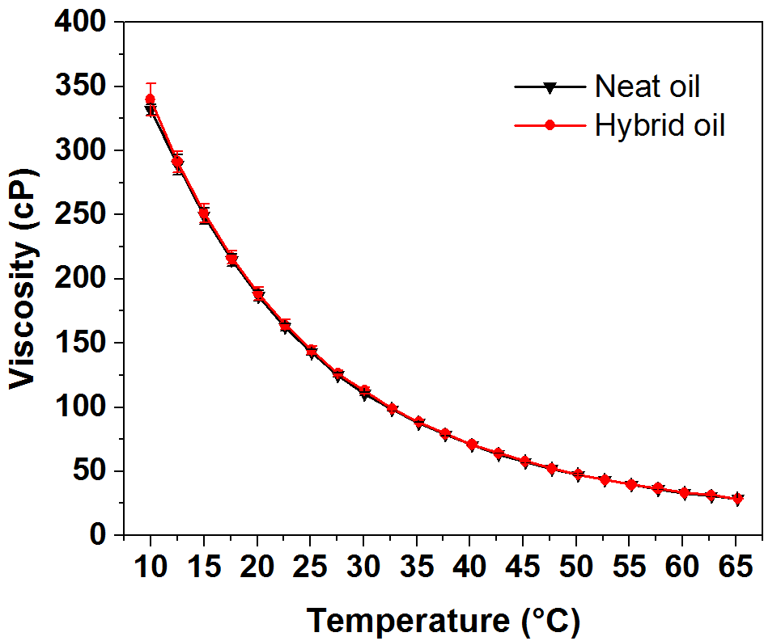
Fig. 4 Viscosity curves of neat oil and hybrid oil.

To examine the effect of the chemical functional groups on the stability of the system, the carbon spheres and the lubricating oil were characterized by Fourier-transform infrared (FTIR) spectrum (Fig. 5a). The spectrum of the carbon spheres demonstrates several characteristic absorption bands. The bands at 3418 and 1043 cm⁻¹ can be attributed to O-H (hydroxyl or carbonyl groups) and C-OH (hydroxyl, ester, or ether) stretching, respectively [23,24]. The two peaks at 2972 and 2925 cm⁻¹ can be attributed to the C-H stretching vibration [25]. The peak at 1703 cm⁻¹ can be attributed to the C=O stretching vibration from the carboxylic groups (-COOH). The peaks at around 1619 and 1297 cm⁻¹ are identified as the aromatic C=C and C-C, respectively [26,27]. The bands at around 880-585 cm⁻¹ are assigned to the aromatic C-H out-of-plane bending vibrations [28]. The results indicate that there are abundant functional groups on the surface of the carbon spheres. To analyze the elemental compositions of the carbon spheres, the EDX spectrum was recorded, see Fig. 5b, where it can be found that the weight and atomic ratio of C and O was found to be 64.37:35.63 and 70.07:19.35, respectively. The elemental analysis results are consistent with FTIR analyses and demonstrate that the C and O are the primary elements of the carbon spheres.
For the spectrum of the lubricating oil, the peaks at 2955, 2923 and 2853 cm⁻¹ can be attributed to the C-H stretching vibrations. The peak at 1706 cm⁻¹ can be ascribed to the C=O stretching vibration. The bands at 1463 and 1377 cm⁻¹ are C-H stretching and bending vibrations. The bands at 1076 and 1196 cm⁻¹ are attributed to the P=O stretching vibration [24,29]. The functional groups like C=O and P=O could enhance the interactions between carbon spheres and lubricating oil. The lubricating oil may penetrate into carbon spheres, promoting the stability of the mixture system. As shown in Fig. 5c, the mixture system can remain stable more than 168 h without obvious precipitates. The optical micrograph reflects a uniform dispersion of carbon spheres in lubricating oil, see Fig. 5d. These results demonstrate that the carbon spheres possess the good stability and dispersibility in lubricating oil.
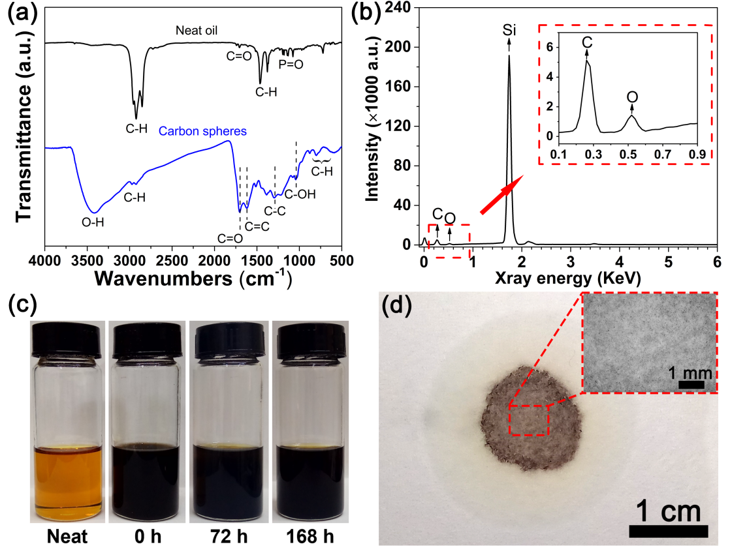
Fig. 5 (a) FTIR spectra of neat oil and carbon spheres. (b) EDX spectrum of the carbon spheres, with the Si signal originating from the sample carrier silicon. (c) The stability of the mixture of carbon spheres and lubricating oil over time. (d) The dispersibility of carbon spheres in lubricating oil and the optical micrograph (inset to d) after a drop of the mixture dried on a filter paper.

Fig. 6a depicts the variations of coefficient of friction versus test time. It can be seen that the addition of carbon spheres can significantly lower the coefficient of friction. Also, during the friction test, the coefficient of friction decreases rapidly in the initial stage, and then increases over wear time for both oil and hybrid oil. This can be explained by the fact that the friction surfaces get in contact with each other unsteadily at the beginning and the system undergoes a running-in period, and then the wear will take place and the coefficient of friction increases to resist sliding and dissipate energy over time. Compared with neat oil lubrication, the coefficient of friction for the oil with the particle additive decreases by 23.5-33.2%. The wear rates under neat and hybrid oil lubrication are shown in Fig. 6b. The reduction of wear rate for the hybrid oil lubrication is about 24.2% under the friction test investigated. According to the above results, it is apparent that the carbon spheres as lubricating oil additives can improve the tribological performance of PEEK.

Fig. 6 (a) Coefficient of friction under the neat and hybrid oil lubrication. (b) Wear rate of PEEK disk. Error bar represents ± SD (standard deviation) for 4 repetitions.

The tribological behavior of PEEK is often correlated with temperature [7,30]. As such, the temperature variation during friction test was recorded every 60 s. As shown in Fig. 7a, the temperature increases with test time under both neat and hybrid oil lubrication. The normalized temperature curves indicate that that the temperature-induced difference between neat and hybrid oil lubrication is insignificant in the friction test. In addition, a typical differential scanning calorimeter (DSC) curve of PEEK was recorded. As shown in Fig. 7b, the glass transition temperature and melting point temperature of PEEK specimen are recorded, being 148.8 and 340.2°C, respectively. The temperature of PEEK in friction test is much lower than the glass transition temperature of PEEK (148.8°C). Based on the above analysis, it can be deduced that PEEK can maintain its mechanical properties during the whole test and it is unlikely that the temperature rise plays a crucial role in anti-friction and wear-resistance performance of PEEK under oil-lubricated condition.

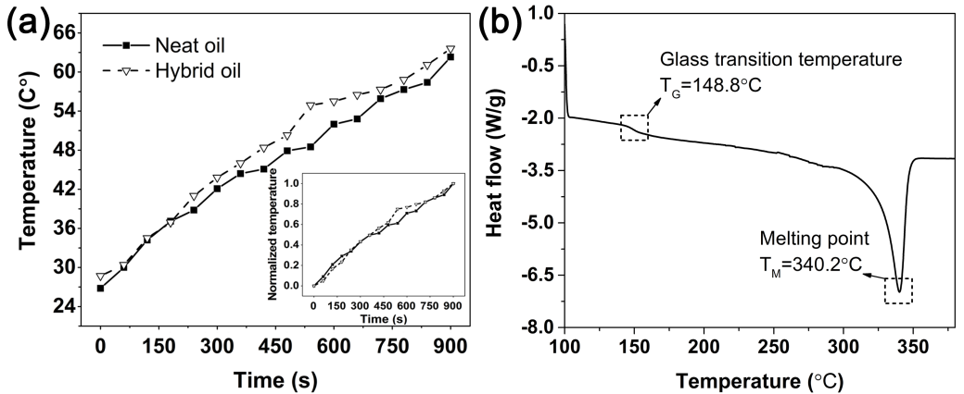
Fig. 7 (a) Temperature variation of PEEK disk with test time and (b) DSC of PEEK specimen.
To further investigate the mechanism and explain the influence of the carbon spheres as lubricant additives for the tribological improvement of PEEK, the wear surfaces of PEEK disks were observed by SEM. As shown in Fig. 8, the ripple-like patterns vertical to sliding direction are observed on wear surfaces under both neat and hybrid oil lubrication. Such wear surface features indicate the occurrence of the boundary or mixed lubrication regimes [9]. The morphologies of ripple-like patterns are caused by the plastic deformation of the PEEK surface. Then, the wear debris and the material transfer occur due to relative motion. That is to say, the adhesive wear is the major mechanism here. In contrast to neat oil lubrication (Fig. 8b), carbon spheres and more ripple-like patterns can be observed on the wear surface of hybrid oil lubrication (Fig. 8d). The carbon spheres remain in good spherical morphologies after the friction test, indicated by red arrows. The different microstructures of wear surfaces can be attributed to the presence of carbon spheres between the wear surfaces of friction pairs. When the wear surfaces are in contact, the carbon spheres and lubricating oil could form a thin lubricating film and take a synergistic effect to bear the normal pressure and reduce the wear. The results demonstrate that the carbon spheres play an important role under lubricated condition and could be beneficial for the reduction of friction and wear.
Fig. 8 SEM images of wear surfaces of PEEK under neat oil lubrication (a, b) and under hybrid oil lubrication (c, d).
The 3D surface topography of PEEK specimen before friction test and a schematic of friction process under hybrid oil lubrication are shown in Fig. 9. The initial average surface roughness (R_{a}) of the PEEK specimen is 459.5 nm measured by optical surface profiler. The 3D surface topography of PEEK specimen indicates that the microsurface is fairly rough and full of asperities (Fig. 9a). In fact, the real contact between friction surfaces is the interaction of these asperities, which is an important factor to impede the surfaces sliding of friction pairs on the microscale. When this system is loaded, the asperities will diminish with the deformation of the contact surfaces. This deformation can bring about a topography of the ripple-like patterns (Fig. 8). Meanwhile, when the distance of contact surfaces reduces as the test goes on, the mixture of carbon spheres and lubricating oil can fill in the gap and form a protective boundary film to bear the normal pressure and reduce the friction force (Fig. 9b). In addition, considering the spherical morphology of the carbon spheres, they can act as the third body to result in a rolling movement, further promoting the lubricating performance [31]. This is evidenced by the observation of the presence of the carbon spheres after the friction test, see Fig. 8d.

Fig. 9 (a) 3D surface topography of PEEK specimen before friction test and (b) schematic of friction process under hybrid oil lubrication.

4. Conclusions
Carbon spheres as lubricant additives have an effective improvement for the tribological performance of PEEK. Carbon spheres prepared by hydrothermal carbonization method possess abundant functional groups on the surface, which leads to the strong interactions between carbon spheres and lubricating oil, ensuring the good dispersibility of carbon spheres in lubricating oil. Tribological tests manifest an evident reduction in coefficient of friction (23.5-33.2%) and wear rate (24.1%) under hybrid oil lubrication compared with neat oil lubrication. The notable promotion for tribological performance could be explained by a good blend of hybrid oil and a spherical morphology of the carbon spheres. When the contact surfaces of frication pairs slide against each other, the uniform mixture of carbon spheres and lubricating oil can fill in the gap of irregularities and form a protective boundary film to bear the normal load and reduce the friction force. In addition, carbon spheres possess a spherical morphology can result in rolling movement to promote the lubricating performance in the friction process.

Acknowledgments
This work was supported by NSFC (11572080, 51775541, 11772086, 51811530309), NSFC of Liaoning Province (2015020198), Fundamental Research Funds for the Central Universities (DUT18ZD302, DUT17ZD229).

Conflict of Interest
The authors declared that they have no conflicts of interest to this work.

References
[1] Mu L, Feng X, Zhu J, Wang H, Sun Q, Shi Y, Lu X (2010) Comparative study of tribological properties of different fibers reinforced PTFE/PEEK composites at elevated temperatures. Tribol T 53(2):189-194
[2] Khun NW, Liu E (2012) Tribological behavior of polyurethane immersed in acidic solution. Tribol T 55(4):401-408
[3] Wang J, Yan F, Xue Q (2009) Tribological behavior of PTFE sliding against steel in sea water. Wear 267(9-10):1634-1641
[4] Lu ZP, Friedrich K (1995) On sliding friction and wear of PEEK and its composites. Wear 181:624-631
[5] Kalin M, Zalaznik M, Novak S (2015) Wear and friction behaviour of poly-ether-ether-ketone (PEEK) filled with graphene, WS₂ and CNT nanoparticles. Wear 332:855-862
[6] Tang Q, Chen J, Liu L (2010) Tribological behaviours of carbon fibre reinforced PEEK sliding on silicon nitride lubricated with water. Wear 269(7-8):541-546
[7] Wang Z, Gao D (2014) Friction and wear properties of stainless steel sliding against polyetheretherketone and carbon-fiber-reinforced polyetheretherketone under natural seawater lubrication. Mater Design 53:881-887
[8] Wu J, Lu X, Feng X, Shi Y (2016) Halogen-free ionic liquids as excellent lubricants for PEEK-stainless steel contacts at elevated temperatures. Tribol Int 104:1-9
[9] Zhang G, Wetzel B, Wang Q (2015) Tribological behavior of PEEK-based materials under mixed and boundary lubrication conditions. Tribol Int 88:153-161
[10] Jones DP, Leach DC, Moore DR (1985) Mechanical properties of poly (ether-ether-ketone) for engineering applications. Polymer 26(9):1385-1393
[11] Stolarski TA (1992) Tribology of polyetheretherketone. Wear 158(1-2):71-78
[12] Greco AC, Erck R, Ajayi O, Fenske G (2011) Effect of reinforcement morphology on high-speed sliding friction and wear of PEEK polymers. Wear 271(9-10):2222-2229
[13] Zhang G, Schlarb AK (2009) Correlation of the tribological behaviors with the mechanical properties of poly-ether-ether-ketones (PEEKs) with different molecular weights and their fiber filled composites. Wear 266(1-2):337-344
[14] Choi Y, Lee C, Hwang Y, Park M, Lee J, Choi C, Jung M (2009) Tribological behavior of copper nanoparticles as additives in oil. Curr Appl Phys 9(2):e124-e127
[15] Yamamoto Y, Takashima T (2002) Friction and wear of water lubricated PEEK and PPS sliding contacts. Wear 253(7-8):820-826
[16] Loy XZK, Sinha SK (2012) Lubrication of polyether ether ketone (PEEK) surface by liquid ultrathin films for high wear durability. Wear 296(1-2): 681-692
[17] Zheng M, Liu Y, Jiang K, Xiao Y, Yuan D (2010) Alcohol-assisted hydrothermal carbonization to fabricate spheroidal carbons with a tunable shape and aspect ratio. Carbon 48(4):1224-1233
[18] Sheng C (2007) Char structure characterised by Raman spectroscopy and its correlations with combustion reactivity. Fuel 86(15):2316-2324
[19] Schwan J, Ulrich S, Batori V, Ehrhardt H, Silva SRP (1996) Raman spectroscopy on amorphous carbon films. J Appl Phys 80(1):440-447
[20] Ferrari AC, Robertson J (2001) Origin of the 1150-cm⁻¹ Raman mode in nanocrystalline diamond. Phys Rev B 63(12):121405
[21] Pelletier MJ (1999) Analytical applications of Raman spectroscopy. Blackwell Science, Oxford
[22] Dardan E, Afrand M, Isfahani AHM (2016) Effect of suspending hybrid nano-additives on rheological behavior of engine oil and pumping power. Appl Therm Eng 109:524-534
[23] Sevilla M, Fuertes AB (2009) Chemical and structural properties of carbonaceous products obtained by hydrothermal carbonization of saccharides. Chem-Eur J 15(16):4195-4203
[24] Araujo-Andrade C, Ruiz F, Martínez-Mendoza JR, Terrones H (2005) Infrared and Raman spectra, conformational stability, ab initio calculations of structure, and vibrational assignment of α and β glucose. J Mol Struct-Theochem 714(2):143-146
[25] Movasaghi Z, Rehman S, ur Rehman I (2008) Fourier transform infrared (FTIR) spectroscopy of biological tissues. Appl Spectrosc Rev 43(2):134-179
[26] Cheng G, Dong L, Kamboj L, Khosla T, Wang X, Zhang Z, Guo L, Pesika N, Ding J (2017) Hydrothermal synthesis of monodisperse hard carbon spheres and their water-based lubrication. Tribol Lett 65(4):141
[27] Banyay M, Sarkar M, Gräslund A (2003) A library of IR bands of nucleic acids in solution. Biophys Chem 104(2):477-488
[28] Li M, Li W, Liu S (2012) Control of the morphology and chemical properties of carbon spheres prepared from glucose by a hydrothermal method. J Mater Res 27(8):1117-1123
[29] Zhang K, Jin L, Cao Q (2016) Evaluation of modified used engine oil acting as a dispersant for concentrated coal–water slurry. Fuel 175:202-209
[30] Zhang G, Yu H, Zhang C, Liao H, Coddet C (2008) Temperature dependence of the tribological mechanisms of amorphous PEEK (polyetheretherketone) under dry sliding conditions. Acta Mater 56(10):2182-2190
[31] Alazemi AA, Etacheri V, Dysart AD, Stacke L-E, Pol VG, Sadeghi F (2015) Ultrasmooth submicrometer carbon spheres as lubricant additives for friction and wear reduction. ACS Appl Mater Inter 7(9):5514-5521

Corresponding author. Tel: +86 411 84706353. E-mail: wei.zhang@dlut.edu.cn (Wei Zhang)

