Resistance to amorphisation in Ca_{1-x}La_{2x/3}TiO₃ perovskites – a bulk ion-irradiation study.
Sebastian M Lawson¹, Neil C Hyatt¹, Karl R Whittle^{1,2}, Amy S Gandy¹
¹Immobilisation Science Laboratory, Department of Materials Science and Engineering, University of Sheffield, Sheffield, S1 3JD, United Kingdom
²School of Engineering, University of Liverpool, Liverpool, L69 3GH, United Kingdom

Abstract
The changes induced from 1 MeV Kr⁺ and 5 MeV Au⁺ ion irradiation at room temperature have been utilised to determine the impact of cation vacancies on the radiation damage response on bulk Ca_{1-x}La_{2x/3}TiO₃ perovskite structured ceramics. Perovskite systems have long been considered as candidate waste forms for the disposition of actinide wastes and doping with multi-valent elements such as Pu may lead to cation deficiency. Based on GAXRD and TEM analysis, two regions of resistance/susceptibility to amorphisation have been confirmed with reference to CaTiO₃. Increased resistance to amorphisation has been observed for 0.1 ≤ x ≤ 0.4, with an increased susceptibility to amorphisation for x ≥ 0.5. It is proposed that these processes are induced by enhanced recovery from radiation damage for 0.1 ≤ x ≤ 0.4, and reduced tolerance for disorder/increased A-O bond covalency for x ≥ 0.5. Lattice parameter analysis of the x = 0 and 0.5 samples showed a saturation in radiation damage induced volume swelling at 4.7 ± 0.1 % and 1.8 ± 0.1 %, respectively, while the saturation limit for the b parameter was lower than the respective a and c orthorhombic parameters. In the x = 0.2 and 0.4 samples, amorphisation was not observed, however the b parameter was found to swell to a lesser extent than the a and c parameters. Swelling was not observed for the ion irradiated x ≥ 0.6 samples.

1. Introduction
A-site cation deficiency in perovskites has been studied widely and exploited to produce perovskites suitable across a range of applications. These include anodes for solid oxide fuel cells [1,2], memory storage [3] and dielectric resonators [4], while perovskite was a constituent of the SYNROC study for the disposition of high-level nuclear waste [5–7]. The potential to use perovskites as an actinide baring ceramic phase has been extensively investigated [7–16], and is a potential secondary Pu host phase in ceramics for immobilisation in the UK stockpile [17]. Perovskites take the general chemical formula ABO₃, and it has been proposed that doping the perovskite A-site with multi-valent uranium and plutonium ions leads to A-site cation deficiency through charge compensation [18]. Characterisation of the effects of A-site deficiency is a key factor in understanding the long-term material properties of doped perovskites in a nuclear waste form disposal environment.
Perovskites have previously shown intriguing behaviour under irradiation, including phase transitions prior to amorphisation in CaTiO₃ [12,16,19] and SrTiO₃ [20]. Recently, studies have focused on understanding radiation damage recovery mechanisms in A-site deficient perovskites. Smith et al. [21] first reported the critical temperature of amorphisation, T_{c}, in the Sr_{1-x}La_{2x/3}TiO₃ system using in-situ ion irradiation within a TEM. Above T_{c}, damage annealing rates exceed induced damage rates, preventing amorphisation in crystalline materials. Within the 0.1 ≤ x ≤ 0.3 regime, a reduction in T_{c} was reported relative to the T_{c} for SrTiO₃, whereas T_{c} was found to increase with increasing La content from x ≥ 0.45. The authors proposed a possible mechanism for this phenomena, with increased A-site vacancy defect mobility induced by La doping leading to the reductions in T_{c}. They further proposed that as these phenomena were only observed in the Pm-3m cubic structure, whereby the distorted octahedral networks of the I4/mcm and Cmmm phases produced by stoichiometry of x ≥ 0.45 hindered defect migration and inhibit damage recovery. More recently, Whittle et al. [22] conducted equivalent in-situ experiments in the counterpart Ca_{1-x}La_{2x/3}TiO₃ system, again observing a decrease in T_{c}, relative to CaTiO₃, in the range 0.1 ≤ x ≤ 0.3. However, in this instance decreases in T_{c} were observed within the orthorhombic Pbnm phase with highly distorted octahedral tilting present, providing further evidence that A-site vacancies play a key role in the decreased values of T_{c}. This was further linked to the ability of the samples in the 0.1 ≤ x ≤ 0.3 regime to accommodate disorder compared to those for x ≥ 0.5. In this study we have investigated further the response of Ca_{1-x}La_{2x/3}TiO₃ to heavy ion irradiation, used as an analogue for alpha-recoil nuclei, in bulk samples in order for more detailed structural analysis to be carried out.
Structural characterisation of the Ca_{1-x}La_{2x/3}TiO₃ system has previously been reported. Phase transitions in the Ca_{1-x}La_{2x/3}TiO₃ solid-solution were reported by Vashook et al. [1,2] using synchrotron X-ray diffraction (XRD) and later refined by Zhang et al. [23] using neutron diffraction. Structures are reported as Pbnm (a⁻a⁻c⁺, using Glazer notation [24]) for 0 ≤ x ≤ 0.5; Ibmm (a⁻a⁻c⁰) for x = 0.6; I4/mcm (a⁰a⁰c⁻) for 0.7 ≤ x ≤ 0.8; and Cmmm (a⁻b⁰c⁰) for 0.8 ≤ x ≤ 0.96. These structures are graphically represented in Figure 1. Furthermore, short-range A-site vacancy and cation ordering is reported in the x = 0.7 and 0.8 samples by Zhang et al. [23], with long-range ordering reported in the x = 0.9 sample. This was confirmed by Danaie et al. [25], observing long-range cation/vacancy ordering in the x = 0.9 sample using high-resolution scanning transmission electron microscopy. Ordering of this nature occurs as alternating layers of cation deficient and cation rich A-site planes, and has been previously observed in the sister Sr_{1-x}La_{2x/3}TiO₃ system for x ≥ 0.7 [26] and the A-site deficient La_{1/3}NbO₃ and La_{1/3}TaO₃ compounds [27].
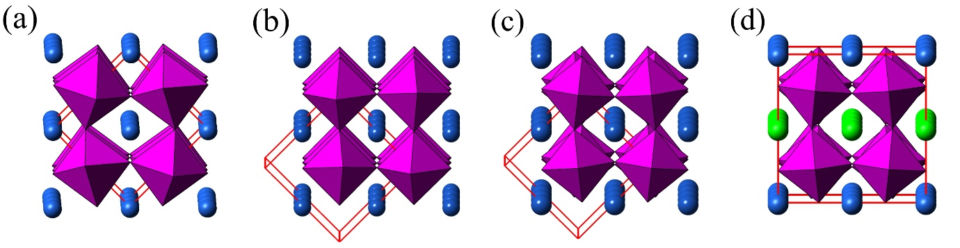
Figure 1. Structures of the Ca_{1-x}La_{2x/3}TiO₃ system with unit cells outlined, as reported by Zhang et al. [21]. A-site Ca/La are represented in blue, with TiO₆ octahedra shown in purple. Green atoms are used to donate A-site vacancy ordering. (a) x = 0 Pbnm (b) x = 0.6 Ibmm (c) x = 0.7 I4/mcm (d) x = 0 .9 Cmmm
The work by Smith et al. [21] and Whittle et al. [22] demonstrates that damage recovery in these systems is not simply due to crystal structure, and that vacancy content may play an integral role. These studies were carried out at variable temperatures (< 900 K) on thin, typically ~100 nm, electron transparent samples in-situ in a TEM. Thus whilst both dynamical and thermal annealing were investigated, the damage recovery process may not be fully representative of the bulk due to the proportionally high surface area acting as a sink for defects. In this study we have investigated the impact of vacancies on damage recovery in bulk Ca_{1-x}La_{2x/3}TiO₃ samples, and observed irradiation induced volume swelling prior to amorphisation following room temperature Kr⁺ and Au⁺ ion irradiations. Cross-sectional transmission electron microscopy (XTEM), including electron diffraction pattern analysis, and glancing-angle X-ray diffraction (GAXRD) have been used to elucidate the behaviour of A-site deficient perovskites under heavy ion irradiation.

2. Experimental Methods

2.1 Sample Synthesis
Pellets of the Ca_{1-x}La_{2x/3}TiO₃ system (x = 0, 0.1…0.9) were prepared by solid-state synthesis. Stoichiometric amounts of La₂O₃ (Alfa Aesar 99.99 %), dried at 1073 K for 24 hours, TiO₂ (Sigma-Aldrich 99.9 %) and CaCO₃ (Alfa Aesar 99.9 %), both dried at 453 K for 24 hours, were weighed then milled with isopropanol in a planetary ball-mill for 5 minutes. Dried powders were sieved, pressed and heated at 1573 K in air for 48 hours. A final step of grinding, sieving and pressing was undertaken before sintering at 1673 K in air, achieving sample densities of > 95 %th. For characterisation and ion irradiation, samples were ground with silicon carbide grinding papers and polished to a 0.25 µm finish with diamond suspension (MatPrep).

2.2 Ion Irradiations
Irradiations with 1 MeV Kr⁺ ions, to a fluence of 1 x 10¹⁵ ions cm⁻², were undertaken at the Surrey Ion Beam Centre (University of Surrey, Guildford, UK), and irradiations with 5 MeV Au⁺ ions, to a fluence of 5 x 10¹⁴ ions cm⁻², were undertaken at the Australian National University (Canberra, Australia). In both cases, irradiations were conducted at room temperature with the ion beam angle of incidence normal to the sample surface. Estimations of the ion irradiation induced damage and electronic-nuclear stopping powers were calculated using SRIM [28], with ‘Detailed Calculation with Full Damage Cascades’ option (SRIM 2008) was operated with 99,999 ions run for all calculations. Due to the wide range of displacement energies reported for O, Ca, La and Ti, displacement energies were set to 50 eV for all elements to give an estimation of the damage induced [29]. While this is not ideal, no experimental values are available and as with other groups we have used this flat value as a best compromise. We concede dpa values could change if accurate displacement energies could be determined and implemented, as is described by Thomas et al. [30] for the SrTiO₃ system. The densities inputted into the SRIM calculations were determined in pristine samples using the Archimedes method. SRIM damage depth profiles for the x = 0 and x = 0.9 samples irradiated with the 1 MeV Kr⁺ and 5 MeV Au⁺ conditions are presented in Figures 2a and 2b, respectively. For the 1 MeV Kr⁺ ion irradiations, the peak damage, estimated using results from SRIM calculations, was 1.38 ± 0.04 displacements per atom (dpa) across the full Ca_{1-x}La_{2x/3}TiO₃ compositional range, with the peak damage depth between 300 and 310 nm across the system, and the full damage region extending from the surface to about 600 nm. Nuclear stopping was determined to be dominant for Kr⁺ ion irradiations, with the electronic-nuclear stopping ratio remaining between 0.76 and 0.8 across the system. For the 5 MeV Au⁺ ion irradiations, estimated peak damage was 1.43 ± 0.05 dpa across the entire compositional range. Peak damage depths were found to be between 600 and 640 nm, with the full damage region extending from the surface to about 1000 nm. In 5 MeV Au+ ion irradiations, electronic stopping was determined to be more prevalent, with the electronic-nuclear stopping ratio remaining between 1.18 and 1.22 across the system.
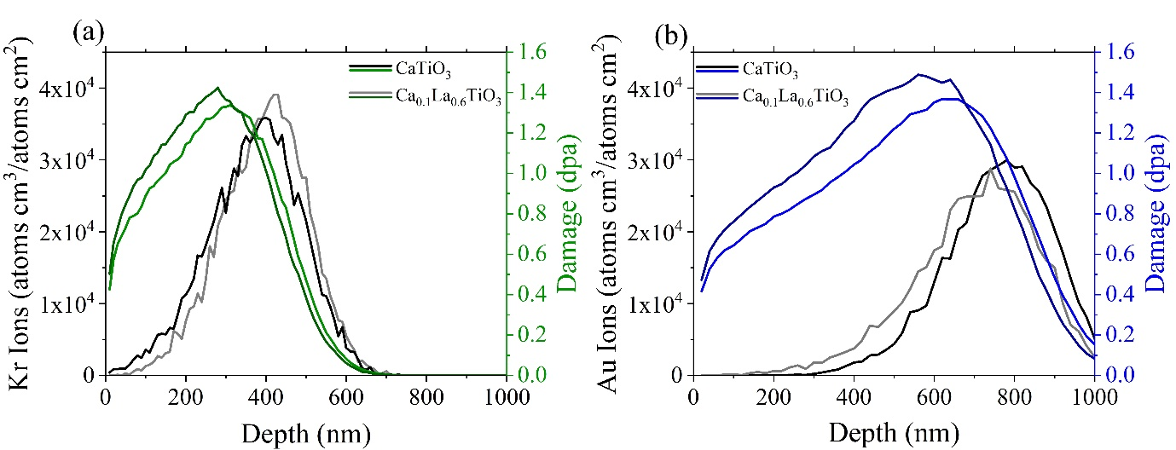
Figure 2. Estimated displacement damage-depth profiles calculated using SRIM for
Ca_{1-x}La_{2x/3}TiO₃ samples x = 0 and x = 0.9 irradiated with (a) 1 MeV Kr⁺ to a fluence of
1 x 10¹⁵ ions cm⁻² and (b) 5 MeV Au⁺ to a fluence of 5 x 10¹⁴ ions cm⁻².

2.3 X-ray Diffraction
X-ray diffraction (XRD) was undertaken on the pristine Ca_{1-x}La_{2x/3}TiO₃ samples using a PANalytical X’pert3 diffractometer with Cu K_{α} radiation (λ = 1.5418 Å) in reflection. Data were collected between 10 ° and 100 ° with a step size of 0.02 ° and a step time of 1 s, with X-rays generated at 45 kV, 40 mA. Data were calibrated using an external NIST 640e line position standard. Phase indexing was undertaken by observing the appearance and loss of reflections indicative of in-phase, anti-phase and mixed-phase octahedral tilting [23,31]. Indexing was made with regard to the aristotype perovskites structure, donated by a subscript p in (hlk)_{p} miller indices notation.

2.4 Scanning Electron Microscopy
Grain size analysis and compositional homogeneity were determined using a Hitachi TM3030 operating with a 15 kV acceleration voltage. Pellets were mounted on aluminium stubs with 12 mm adhesive carbon tabs (Agar). EDS mapping was undertaken using a 10 kV acceleration voltage and a Quantax70 spectrometer with a 154 eV resolution silicon drift detector. Imaging and element mapping were undertaken at 2500x magnification. Grain size analysis was conducted by measuring the area of > 100 grains using the ImageJ draw [32] and measure functions to produce a distribution, and an average reported.

2.5 Transmission Electron Microscopy
Cross-sectional TEM (XTEM) was used to characterise ion irradiation induced damage of selected Ca_{1-x}La_{2x/3}TiO₃. Samples were prepared by conventional grinding and polishing using SiC and diamond suspension, following by final thinning to electron transparency using Ar⁺ milling with a Gatan PIPS II. The final thinning energy of the beam was 0.5 keV at 4 ° from the sample surface. XTEM imaging and electron diffraction pattern analysis was performed using either a FEI Tecnai T20 or JEOL 3010 TEM, both operating at 200 keV. Images and diffraction patterns were captured using a CCD camera. Electron diffraction patterns were taken from both implanted regions and regions that were unaltered by ion irradiation, allowing direct comparison between damage and undamaged areas within the same sample.

2.6 Glancing-angle X-ray Diffraction
Glancing-angle XRD (GAXRD) was carried out using the PANalytical X’pert3 in a parallel beam geometry configuration with Cu K_{α} radiation (λ = 1.5418 Å). Data were collected between 20 ° and 60 ° with a step size of 0.04 ° and a time step of 16 s, with X-rays generated with 45 kV, 40mA. To give a representation of the system as a whole, including varying La contents and phase transitions, Kr⁺ and Au⁺ ion implanted samples of compositions x = 0, 0.2, 0.4, 0.5, 0.6, 0.7 and 0.9 were examined using GAXRD. The 5 MeV Au⁺ implanted x = 0.4 sample was omitted due to an experimental error during irradiation that led to an unknown final irradiation fluence. Ion implanted pellets were placed within a circular cavity machined into a silicon zero background holder to ensure the response detected was only from the ion implanted sample surface. Changes in sample density and X-ray attenuation lengths were induced by La doping and ion irradiation induced amorphisation, leading to variations in X-ray penetration depths in the samples studied. To account for this, patterns were obtained using three incident X-ray angles, Ω, of 0.5 °, 1.0 ° and 1.5 ° to probe a range of depths. X-ray penetration depths, τ, were calculated using linear attenuation theory, given by equation (1),
$\text{Ω} \text{=} {\text{sin}}^{\text{-1}}\left({\text{τ}}/{\text{3μ}}\right)$, (1)
where µ is the linear attenuation coefficient, provided Ω is not below the critical angle, Ω_{c} of the incident sample, given by equation (2),
${\text{Ω}}_{\text{c}}\text{=(1.6 × }{\text{10}}^{\text{-3}}\text{)}{\text{ρ}}^{\text{1/2}}\text{λ}$. (2)
For all samples characterised, the condition Ω > Ω_{c} always applied when Ω ≥ 0.5 °. The linear attenuation coefficient is defined as the length of material travelled through for the X-ray intensity to drop 1/e of the initial (≈ 67 %). The factor of 3µ provides ≈ 99 % attenuation, giving the total range over which X-rays penetrate. Calculated X-ray penetration depths for the examined samples are presented in Table 1.
Table 1. X-ray penetration depths for
Ca_{1-x}La_{2x/3}TiO₃ samples as calculated using equation (1) for the three incident angles.
x | X-ray Penetration Depth, τ (± 10 nm)
 | Ω = 0.5° | 1.0° | 1.5°
0 | 450 | 900 | 1350
0.2 | 420 | 840 | 1260
0.4 | 360 | 720 | 1080
0.5 | 310 | 620 | 930
0.6 | 300 | 600 | 900
0.7 | 280 | 560 | 840
0.9 | 250 | 500 | 750
Amorphous fractions were calculated using the Ω = 0.5 ° patterns by fitting pseudo-Voigt peaks to the amorphous diffuse scattering component and (101)_{p} crystalline reflection, and taking a ratio of the amorphous area to the total fitted area, an example of which is presented in Figure 3. A single peak fit was used for the (101)_{p} reflection as it was not possible to differentiate between the K_{α} contributions to the patterns. This method has been previously used to quantify XRD data by various groups [33–35]. These calculations give a semi-quantitative representation of the induced damage. It should be noted that as X-ray penetration depths are not constant and GAXRD analysis considers a volume of material rather than a specific depth, these values did not give a precise representation of the irradiated region as a whole. For this reason, we termed this analysis as semi-quantitative and this point is further expanded on in section 3.2. Errors quoted are the standard calculated errors from the area fitting process. Lattice parameters of the damaged samples were calculated using a Le Bail refinement and the Bruker TOPAS software, with errors quoted as calculated.
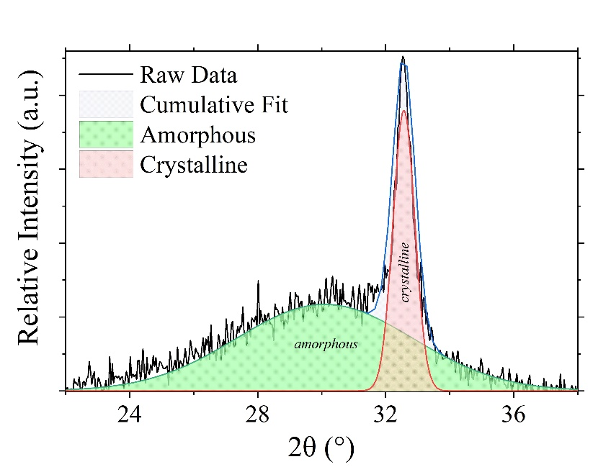
Figure 3. Example of the pseudo-Voigt peak fitting employed to produce amorphous fractions. The crystalline contribution is donated with a c in red and the amorphous contribution with an a in green. The pattern presented is for the x = 0.5 sample irradiated with the 5 MeV Au⁺ condition.

3. Results and Discussion

3.1 Pristine Characterisation
After synthesis, grain size quantification was undertaken using SEM and compositional homogeneity checked with EDS. Micrographs of the x = 0, 0.2, 0.4, 0.5, 0.6, 0.7 and 0.9 samples, those from which ion irradiation studies were undertaken, are presented in supplementary Figure 1. The grain sizes observed varied within each sample, with x = 0 comprising grains of 5 – 30 μm, the x = 0.2 and 0.4 samples from 10 – 30 μm, and for x ≥ 0.5 grains were < 50 μm. While grain sizes varied, this did show an increase in maximum grain size with lanthanum content, likely due to the increased diffusion induced by increased A-site vacancy content. EDS maps showed the samples to be homogeneous, with only Ca, La, Ti and O present across each grain and no evidence of secondary phases or unreacted reagents.
Pristine XRD patterns of the Ca_{1-x}La_{2x/3}TiO₃ system are presented in supplementary Figure 2, with all reflections indexed with regard to the aristotype perovskite structure. Our analysis is in agreement with that by Zhang et al. [23], with the phase transitions reported as Pbnm (a⁻a⁻c⁺) for 0 ≤ x ≤ 0.5, Ibmm (a⁻a⁻c⁰) for x = 0.6, I4/mcm (a⁰a⁰c⁻) for 0.7 ≤ x ≤ 0.8 and Cmmm (a⁰b⁰c⁻) for x = 0.9. Further discussion of these observations are available in the supplementary information.
Zone axis [111] electron diffraction patterns for the x = 0, 0.2, 0.5 and 0.6 samples are presented in Figure 4a, 4b, 4c and 4d, respectively. Zone axis [110] and [111] electron diffraction patterns for the x = 0.7 and 0.9 samples are presented in Figures 4e, 4f, 4g and 4h, respectively. Aristotype perovskite reflections are indexed with miller indices notation, with reflections originating from in-phase tilting and anti-phase tilting identified with a pink square or green circle, respectively, following the rules reported by Woodward and Reaney [31]. Following their observations, ½(eoo) reflections indicate in-phase tilting and ½(ooo) reflections indicate anti-phase tilting, using miller indices notation (e = even, o = odd). The x = 0, 0.2 and 0.5 samples were all found to exhibit ½(eoo) tilt reflections in [111] zone axis patterns, confirming the presence of in-phase tilting and the Pbnm (a⁻a⁻c⁺) structure. The transition from Pbnm (a⁻a⁻c⁺) to Ibmm (a⁻a⁻c⁰) was observed through the loss of such in-phase ½(eoo) tilt reflections in Figure 4d for the x = 0.6 [111] pattern.
Reflections indicative of long-range ordering are observable in the x = 0.7 and 0.9 [110] zone axis electron diffraction patterns presented in Figures 4e and 4f, respectively. Anti-phase tilting reflections were observed for both samples, indicated by the ½(ooo) reflections denoted by green circles. Additional ½(oee) were observed in the [110] patterns for each sample, as indicated by right-pointing purple arrows, and ½(ooe) reflections were observed in the same pattern for the x = 0.9 sample, as denoted by left-pointing red arrows. No evidence of in-phase tilting was observed for these samples in [111] zone axis patterns (Figures 4g and 4h), so these reflections could not be attributed to mixed-phase tilting. Such additional ½(oee) reflections were previously allocated to cation/vacancy ordering in the Sr_{1-x}La_{2x/3}TiO₃ x = 0.7 and 0.9 samples [36], and considering previous observations of cation/vacancy ordering in Ca_{1-x}La_{2x/3}TiO₃ x = 0.7 and 0.9 samples [23] [25], the ½(oee) reflections were similarly attributed to ordering or antiparallel cation displacement. The presence of ½(ooe) reflections in x = 0.9 samples were similarly credited, with the presence of a layered structure of ordered A-site vacancies observed by Lu et al. [36] to provide double diffraction routes for such reflections.
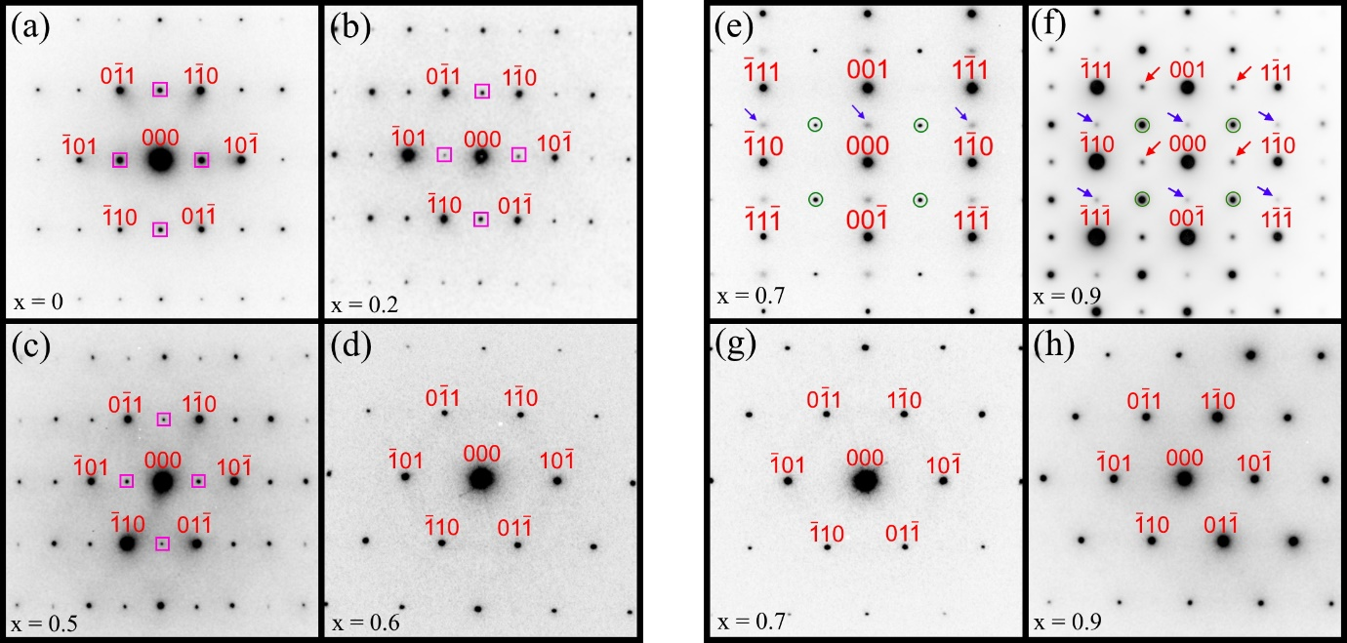
Figure 4. [111] zone axis electron diffraction patterns for Ca_{1-x}La_{2x/3}TiO₃ samples (a) x = 0, (b) x = 0.2, (c) x = 0.5 and (d) x = 0.6. [110] zone axis patterns for Ca_{1-x}La_{2x/3}TiO₃ samples (e) x = 0.7 and (f) x = 0.9 and [111] patterns for (g) x = 0.7 and (h) x = 0.9. Aristotype perovskite reflections are labelled, with additional ½(eoo) reflections indicated with pink squares. Aristotype perovskite reflections are labelled, with additional ½(eoo) reflections indicated with pink squares and ½(ooo) indicated with green circles. In (e) and (f), ½(eoo) reflections are identified with right-pointing purple arrows and ½(eeo) with left-pointing red arrows.

3.2 Post-ion irradiation Characterisation
Bright-field TEM (BFTEM) micrographs of the x = 0, 0.2 and 0.9 samples irradiated with 1 MeV Kr⁺ ions are presented in Figures 5a, 5c and 5e, respectively. Calculated SRIM profiles for each sample are superimposed, with selective area electron diffraction patterns denoted by white circles for location and an i or ii identifier. The sample surface is indicated by the black/white dashed line and labelled as such. Corresponding GAXRD patterns are presented in Figures 5b, 5d and 5f for the x = 0, 0.2 and 0.9 samples, respectively. For the x = 0 sample, lighter regions were observed near the peak of the SRIM profile and were attributed to amorphous or highly damaged material. Dark regions of contrast between the surface and 450 nm from the surface were attributed to regions of crystallinity and confirmed by the electron diffraction pattern taken at point i in Figure 5a, comprising crystalline reflections and a diffuse ring indicative of damaged material. Figure 6 shows a magnified XTEM image of these “crystallites”, with Moiré fringes observed where crystallites of similar interatomic spacing overlap, confirming the crystalline nature of these regions. Regions of dark contrast between 450 nm and 600 nm were attributed to interstitial-type defect clusters. The maximum damage and range predicted by SRIM was in agreement with the observed results, i.e. 600 nm and peak 310 nm, as confirmed by electron diffraction patterns taken from points i and ii in Figure 5a. Very faint ½(ooo)
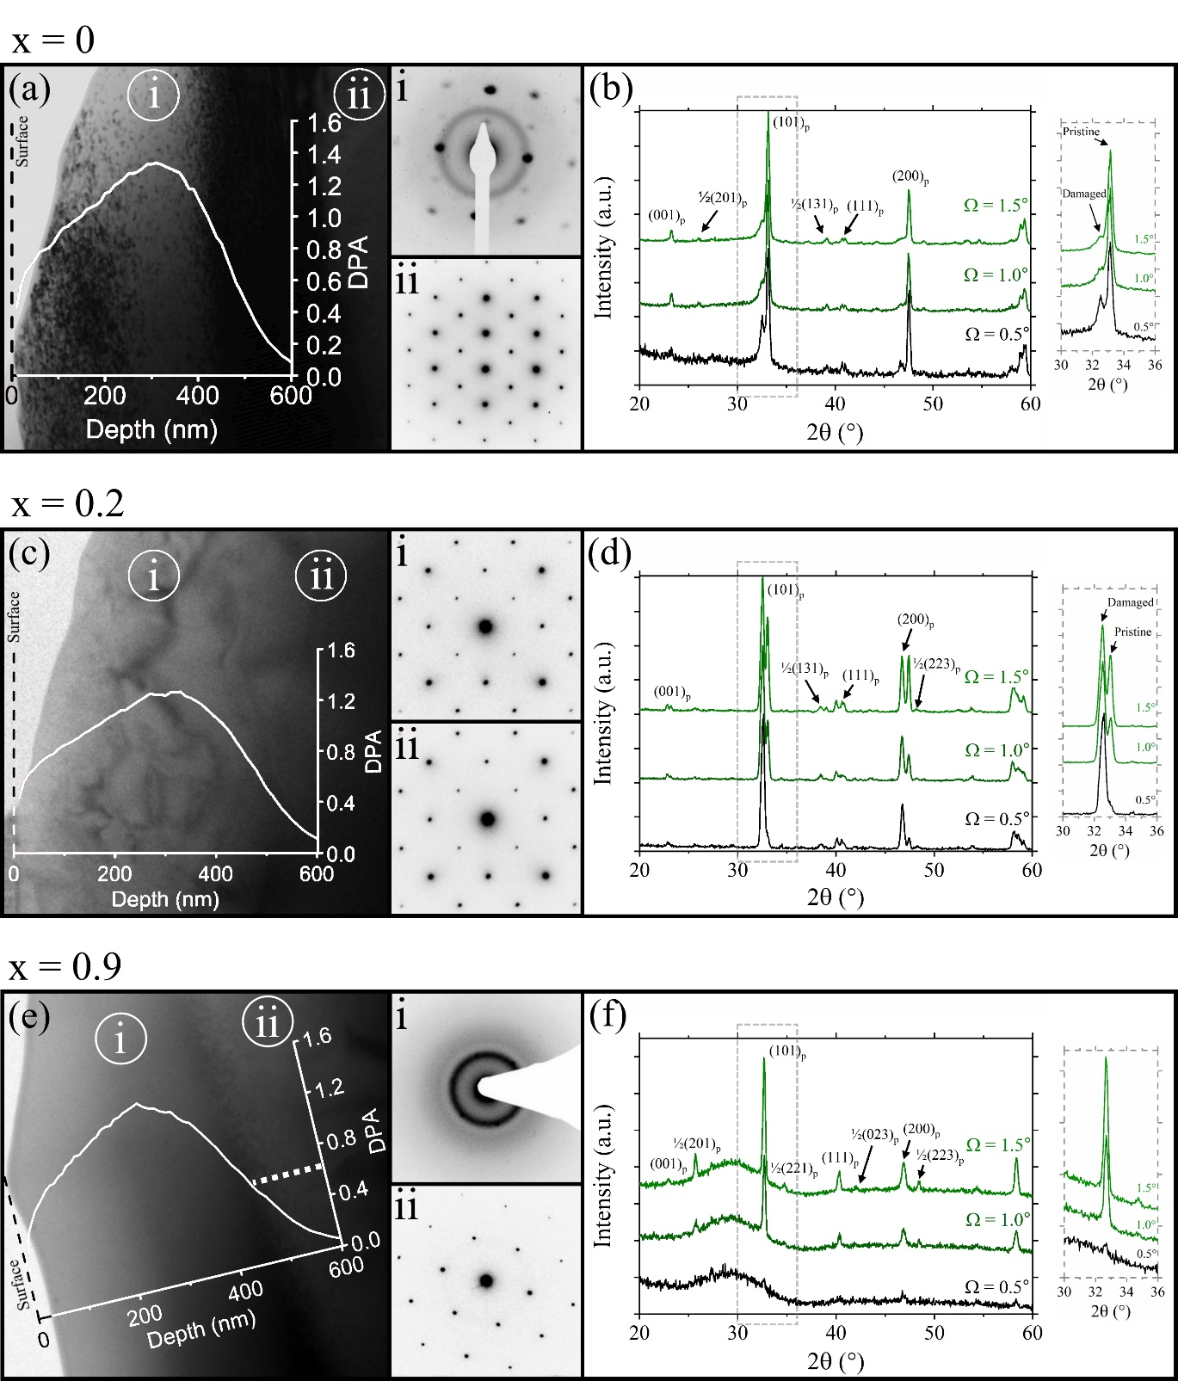
Figure 5. BFTEM micrographs of 1 MeV Kr⁺ ion irradiated Ca_{1-x}La_{2x/3}TiO₃ (a) x = 0, (c) x = 0.2 and (e) x = 0.9 samples with associated SAEDPs taken from the circles labelled i or ii, with SAEDPs labelled as such. SRIM profiles for each sample are overlaid on the BFTEM micrographs. Corresponding GAXRD patterns are presented for 1 MeV Kr⁺ ion irradiated (b) x = 0, (d) x = 0.2 and (f) x = 0.9 samples for incident X-ray angles of Ω = 0.5°, 1.0° and 1.5°. Plot colours represent changes in incident X-ray angle, with light green for Ω = 0.5°, dark green for 1.0° and black for 1.5°, with each further labelled accordingly. Magnifications of the 30° < 2θ < 36° region are shown for each corresponding GAXRD pattern, as identified by the grey dashed boxes in the full GAXRD patterns. Reflections from pristine material and those corresponding to damage, volume swollen material are labelled in these magnifications.
Reflections were identified in the [110] ZAEDP taken at point i in Figure 5a, suggesting no cubic transition was observed at this fluence. Such a transition has been previously observed, suggesting that an increased fluence was required to induce this transition [12,16,19]. The partially damaged nature of the x = 0 sample at 1.34 dpa is in agreement with amorphisation values reported by Meldrum et al. [11] (1.8 dpa) and Smith et al. [16] (2.2 dpa) calculated using in-situ methods, however disagreement was found with the bulk 2 MeV Kr⁺ ion irradiation study reported by Davoisne et al. [12] (4 dpa). This is discussed further in the next paragraph.
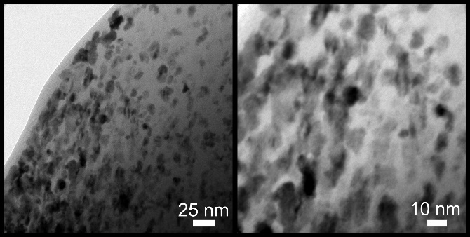
Figure 6. BFTEM micrographs of the x = 0 sample. Areas of dark mottled contrast show regions of nano-crystalline material amongst highly damaged light contrast regions. Moiré fringes are visible, confirming the crystalline nature of these regions.
No crystallite formation was observed for the x = 0.2 sample (figure 5c). The electron diffraction pattern taken from the peak damage depth by SRIM at point i in Figure 5b showed
no evidence of induced damage, with only crystalline reflections present. This was the case across the SRIM profile. As with the x = 0 sample, the Pbnm structure was maintained, as evidenced by the ½(ooe) reflections in the [001] ZAEDP taken at point i. These findings were in agreement with the GAXRD patterns observed for the x = 0.2 sample ion irradiated with the 1 MeV Kr⁺ condition, representing an increase in resistance to amorphisation when compared to the x = 0 sample. This may also have provided an explanation for the discrepancy with Davoisne et al. [12] whose sample was of the form (Ca_{0.9}Nd_{0.1})(Ti_{0.9}Al_{0.1})TiO₃. B-site doping with Al was employed to compensate for A-site Nd doping, however it is likely that a level of A-site deficiency was unintentionally induced, and it is possible that A-site deficiency is responsible for the increased amorphisation fluence within this study.
A BFTEM micrograph of the x = 0.9 sample is presented in Figure 5e. In this instance, the light contrast from the sample surface to a depth ≈ 450 nm was indicative of amorphisation, confirmed by the diffuse electron diffraction pattern taken from point i in Figure 5e. The amorphisation fluence for the x = 0.9 sample was estimated as 0.61 ± 0.2 dpa using the SRIM pattern superimposed on the BFTEM micrograph. At 450 nm, regions of mottled contrast were observed and attributed to interstitial-type end of track defects.
In each instance, the corresponding GAXRD patterns agreed with the BFTEM micrographs. In all cases, as Ω increases the pristine response was greater as X-rays penetrated further past the irradiated surface. This is evidenced by the magnifications presented of the (101)_{p} peaks, with the pristine and additional ‘damaged’ reflections indicated. Considering the Ω = 0.5° pattern taken from the 1 MeV Kr⁺ irradiated x = 0 sample (Figure 5b), reflections were observed in the pristine CaTiO₃ positions, with additional reflections shifted to higher d-spacing. These reflections were attributed to volume expansion of the unit-cell lattice. Small amounts of diffuse scattering were also observed, in agreement with the diffuse rings observed in the corresponding SAEDP (Figure 5a at point i). The appearance of both pristine and volume expanded reflections is due to the 450 nm X-ray penetration depth for the x = 0 sample, penetrating past the peak damage depth at 310 nm and probing regions with a reduced dpa. A highly-crystalline response was observed for the x = 0.2 sample at all Ω angles, presented in Figure 5d. This was in agreement with SAEDP analysis. For Ω = 0.5°, reflections were shifted to a higher d-spacings, with a slight shoulder peak in the (101)_{p} reflection indexed to a pristine response. At Ω = 0.5° for the x = 0.9 sample (Figure 5f), the pattern was dominated by diffuse scattering with small amounts of residual crystallinity present. At Ω = 1.0°, a significant crystalline response is observed, corresponding to an X-ray penetration depth of 500 nm. This was surprising, as SAEDP analysis showed the sample was amorphous to a depth of ≈ 450 nm. Two explanations could explain this behaviour. Either the A-site vacancy content within the sample altered the X-ray penetration depth calculated using linear attenuation theory, or the amorphisation induced by ion irradiation increased X-ray penetration depth, possibly due to reduced density. By comparison with BFTEM analysis, it appears the X-ray penetration depth for the irradiated x = 0.9 sample is similar to the x = 0 sample.
GAXRD patterns for the x = 0, 0.2, 0.4, 0.5, 0.6, 0.7 and 0.9 samples irradiated with 1 MeV Kr⁺ and 5 MeV Au⁺ with an incident X-ray angle of Ω = 0.5° are presented in Figure 7. Patterns from 1 MeV Kr⁺ irradiated samples are presented in green and 5 MeV Au⁺ irradiated in blue. The 5 MeV Au⁺ irradiated x = 0.4 sample was not presented due to an experimental error during irradiation. A key difference across the two conditions was the increased amorphous fraction for the 5 MeV Au⁺ condition when compared to the 1 MeV Kr⁺ condition. This may result from the increased electronic stopping contribution for the 5 MeV Au⁺ condition for all samples, and 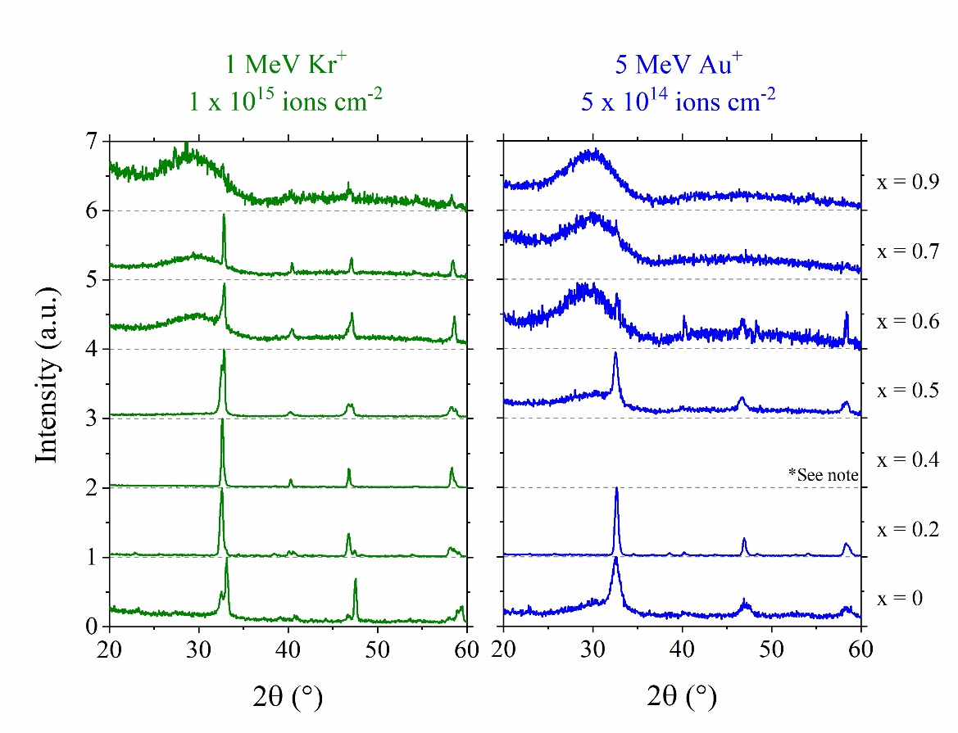
Figure 7. GAXRD patterns with Ω = 0.5° of 1 MeV Kr⁺ and 5 MeV Au⁺ ion irradiated Ca_{1-x}La_{2x/3}TiO₃ samples as labelled. 1 MeV Kr⁺ irradiated samples are presented in green and 5 MeV Au⁺ irradiated samples in blue. *Note: the 5 MeV Au⁺ irradiated x = 0.4 sample is note presented due to an experimental error during irradiation leading to an undecipherable fluence.
the previously reported underestimation of damage induction predicted by the SRIM code for ions irradiating compounds with light atoms such as Ti or Ca under electronic stopping conditions [37,38]. Pristine reflections were observed for the 1 MeV Kr⁺ samples, with the reasoning for this already discussed. The increased penetration depth of 5 MeV Au⁺ ions leads to an extended damage region, and pristine reflections for these samples are not observed at Ω = 0.5°. Considering the previous description of GAXRD patterns taken from the 1 MeV Kr⁺ irradiated x = 0, 0.2 and 0.9 samples, Ω = 0.5° patterns were used to give the best representation of the irradiated surface. The diffuse scattering present was used to give an estimation of the level of damage induced in each sample. Amorphous fractions calculated by through pseudo-Voigt peak analysis are presented in Figure 8. Under both conditions, the smallest amorphous fraction, and by association the most resistant to amorphisation, can be classified with x as 0.2 = 0.4 > 0 > 0.5 > 0.6 > 0.7 > 0.9. This behaviour lends itself to direct comparison to the work
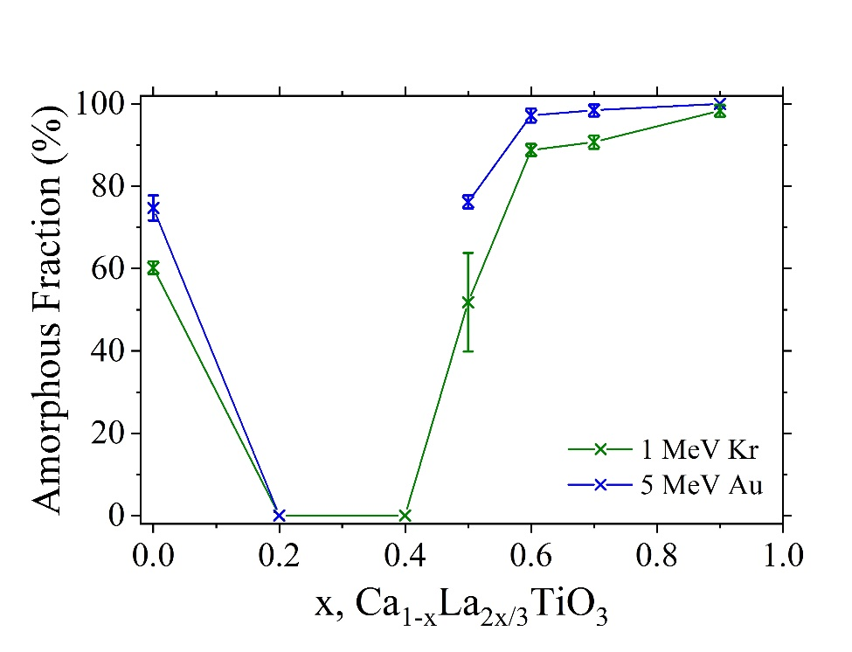
Figure 8. Semi-quantitative amorphous fractions for the Ca_{1-x}La_{2x/3}TiO₃ system irradiated with 1 MeV Kr⁺ (green) and 5 MeV Au⁺ (blue).
of Smith et al. [21] (Sr_{1-x}La_{2x/3}TiO₃) and Whittle et al. [22] (Ca_{1-x}La_{2x/3}TiO₃). Within these systems, measurements of the T_{c} amorphisation showed a reduction in the 0.1 ≤ x ≤ 0.4 regions observed to produce a reduced amorphous fraction in this study when, compared with CaTiO₃. Furthermore, this agreed with critical fluences reported by Whittle et al. at ≈ 300 K, albeit the x = 0.3 sample could not be amorphised at this temperature. Within these systems, T_{c} was found to increase at x = 0.5-0.55, and again this was in agreement with a rise in the amorphous fraction calculated for the x = 0.5 sample. From these findings, it is evident that the mechanisms for increased resistance to amorphisation for 0.1 ≤ x ≤ 0.4 and decreased resistance for 0.5 ≤ x ≤ 0.9 are present under both irradiation conditions. This is the first observation of such effects in a bulk system, rather than through in-situ techniques, and under both nuclear and electronic stopping conditions. Resistance to amorphisation is observed within the highly distorted octahedral networks of the Pbnm phase, as opposed to the lesser distorted Pm-3m region of the Sr_{1-x}La_{2x/3}TiO₃. The x = 0.5 sample, in which such resistance is reduced, also maintains this symmetry, suggesting these effects are unrelated to octahedral tilting or crystal structure. We would agree in this regard that the induction of A-site vacancies is therefore the most likely cause of the increased resistance to amorphisation observed and the reduced barriers to migration for lattice defects. Whittle et al. [22] further argue reduced tolerance for disorder leads to the reduction in amorphisation fluences for x ≥ 0.5, drawing comparisons with fluorite-type structures that exhibit similar behaviour. The example of Y₂TiO₅ versus Y₂Ti₂O₇ is given, in which Y₂TiO₅ more readily recovers from damage due to its increased ability to accommodate disorder through Y locating on both the A and B-sites and readily accommodating anion vacancies. A-site cation/vacancy ordering was observed in the x = 0.7 and 0.9 samples through electron diffraction, and we would agree this likely leads to such marked decreases in the resistance to amorphisation observed, as the structure is less able to tolerate the induction of vacancy defects in a disordered manner. However, a full high-resolution TEM/STEM study of the x = 0.5 and 0.6 structures will likely aid in understanding of this behaviour when considering the system as a whole.
We would offer another possible explanation of this behaviour based on the simulations of Trachenko et al. [14]. Within their work on the amorphisation of CaTiO₃, they formulated the hypothesis “a complex material is amorphisable by radiation damage if its chemistry allows it to form a covalent network”, and explain this process through the increased resistance with Zr content in the Gd₂Zr_{x}Ti_{2-x}O₇ solid-solution. The increased covalency of the Ti-O bond as compared to Zr-O more readily produces an amorphous covalent network under ion irradiation, limiting recovery processes within the crystalline network. This theory has been further strengthened through the Compton profile measurements of Bhamu et al. [39], which have shown that Sr-O bonding in SrTiO₃ is more ionic than Ca-O in CaTiO₃, which computes the covalent network theory through the reported amorphisation doses at 20 K of SrTiO₃ (0.93 dpa) and CaTiO₃ (0.75 dpa) [11]. It is therefore possible that for 0.1 ≤ x ≤ 0.4 within our system of interest, increased A-site recovery or another explanation such as a mass dependence/displacement energy increase is responsible. For x ≥ 0.5, it is possible that the La-O bond leads to a more readily produced covalent network, reducing the resistance to amorphisation within the system. However, without understanding the true nature of the bonding between the constituent elements of the Ca_{1-x}La_{2x/3}TiO₃ system as a whole, this theory cannot be truly tested and remains, as such, a hypothesis. Study of zirconate perovskites systems, namely the Ba_{1-x}La_{2x/3}ZrO₃ system, would offer more clarity in this area, and experiments are currently being undertaken in this regard.
Table 2. Calculated lattice parameters for the x = 0, 0.2 and x = 0.4 samples after 1 MeV Kr⁺ and 5 MeV Au⁺ implantation, with pristine values presented for comparison.
 | Pristine | 1 MeV Kr⁺ | 5 MeV Au⁺
Dose |  | 1 x 10¹⁵  ions cm⁻² | 5 x 10¹⁴  ions cm⁻²
x = 0
Volume Expansion (%) | - | 4.81 (5) | 4.78 (7)
a (Å) | 3.8043 (2) | 3.863 (5) | 3.861 (3)
b (Å) | 3.8469 (2) | 3.892 (6) | 3.891 (5)
c (Å) | 3.81835 (3) | 3.904 (3) | 3.903 (4)
x = 0.2
Volume Expansion (%) | - | 2.11 (8) | 1.72 (6)
a (Å) | 3.8251 (4) | 3.846 (5) | 3.841 (7)
b (Å) | 3.8497 (3) | 3.859 (7) | 3.856 (9)
c (Å) | 3.8326 (5) | 3.884 (5) | 3.876 (4)
x = 0.4
Volume Expansion (%) | - | 1.90 (3) | -
a (Å) | 3.8445 (1) | 3.874 (6) | -
b (Å) | 3.8573 (2) | 3.864 (3) | -
c (Å) | 3.8513 (5) | 3.879 (5) | -
x = 0.5
Volume Expansion (%) | - | 1.71 (9) | 1.85 (5)
a (Å) | 3.8526 (6) | 3.873 (6) | 3.881 (4)
b (Å) | 3.8573 (3) | 3.863 (5) | 3.862 (7)
c (Å) | 3.8513 (3) | 3.891 (3) | 3.890 (3)
Volume expansion of the unit cell was observed within the x = 0, 0.2, 0.4 and 0.5 samples under both irradiation conditions, but not for the x = 0.6, 0.7 and 0.9 samples. This is either due to the highly damaged nature of these samples preventing observation of volume swelling, or the inability for these samples to undergo detectable volume swelling prior to amorphisation. Table 2 details the lattice parameter and volume expansion calculated using the Ω = 0.5° GAXRD patterns. Only d-spacing shifted reflections were used for this analysis. Volume swelling in the x = 0 sample remained within error across both conditions at 4.8 ± 0.1 %, and similarly for the x = 0.5 sample at 1.8 ± 0.1 %. Considering the increased diffuse
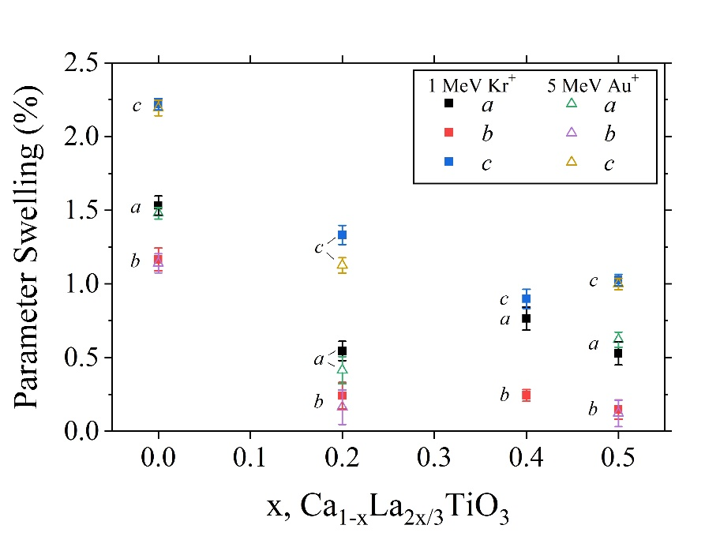
Figure 9. Percentage change from pristine measurements in a, b and c lattice parameters due to 1 MeV Kr⁺ and 5 MeV Au⁺ irradiations for the x = 0, 0.2, 0.4 and 0.5 samples.
scattering present in the 5 MeV Au⁺ irradiated GAXRD patterns, these values provided evidence of a saturation of volume expansion prior to amorphisation of these samples. If this was not the case, volume swelling would be theoretically higher under the 5 MeV Au⁺ condition. This finding agreed with Ball et al. [40], who reported a saturation value of 3.8% for CaTiO₃ using neutron irradiation. The use of neutron irradiation was the likely source of discrepancy between our value and that reported by Ball et al. [40]. No such saturation was observed for the highly crystalline x = 0.2 sample, with volume expansion values of 2.11 ± 0.08 % and 1.72 ± 0.06 % for the 1 MeV Kr⁺ and 5 MeV Au⁺ conditions, respectively. If a saturation point in this sample exists, it would likely require a higher induced dpa. Ball et al. [40] further noted the anisotropic nature of the lattice expansion observed. The b orthorhombic lattice parameter was observed to expand to a lesser extent to the a and c parameters for the x = 0, 0.2, 0.4 and 0.5 samples across both irradiation conditions. These values are plotted graphically in Figure 9, with a consistent trend of c > a > b for parameter swelling. For example, the b parameter of the x = 0 sample expanded by 1.2 ± 0.1 % across both conditions, with the a and c parameters increasing by 1.5 ± 0.1 % and 2.2 ± 0.1 %, respectively. Lattice parameter analysis has shown the pseudo-cubicity of the system increases with La content for x ≤ 0.5 [23] and our own analysis shows the b parameter increases by 0.0148 ± 0.0005 Å from x = 0 to 0.5, while increases for the a and c parameter are observed of 0.0683 ± 0.0004 Å and 0.0659 ± 0.0003 Å. This is teamed with a reduction in the in-phase TiO₆ octahedral tilt angle until no in-phase tilting is observed for x ≥ 0.6. Considering the observations of a cubic phase transition prior amorphisation in CaTiO₃ [12,16,19], we postulate a similar mechanism drives the a and c parameters to pseudo-cubicity and reduced in-phase tilting prior to amorphisation, leading to the reduced lattice expansion observed in the b parameter.

5. Conclusions
A region of enhanced radiation damage tolerance has been observed for 0 < x < 0.5 bulk 1 MeV Kr⁺ and 5 MeV Au⁺ ion irradiated Ca_{1-x}La_{2x/3}TiO₃ ceramics. This the first observation of such effects in a bulk system, and is present across both nuclear and electronic stopping regimes. Both mechanisms appear unrelated to structural phase-transitions, with both enhanced and reduced tolerance observed within the Pbnm structure. This offers confirmation that such effects are likely due to increased A-site cation vacancy mobility onset by intrinsic vacancy induction through La doping. Saturation of radiation damage induced lattice expansion was observed for the x = 0 and x = 0.5, reaching maximum expansions of 4.8 ± 0.1 % and 1.8 ± 0.1 %, respectively. Insufficient damage was induced, or recovery was rapid, to prevent such confirmation of saturation in x = 0.2 and 0.4 samples, while no lattice expansion was observed for highly damaged x ≥ 0.6 samples. The orthorhombic b lattice parameter was found to saturate at a reduced expansion when compared with the a and c parameters, possibly due to increasingly pseudo-cubic nature of the samples with irradiation.

Acknowledgements
The authors would like to acknowledge Engineering and Physical Sciences Research Council (EPSRC) for funding under grant numbers EP/L005581/2, EP/K03684X/1 and EP/G037140/1. SML acknowledges funding from the EPSRC funded Nuclear FiRST Doctoral Training Centre. The authors would like to further acknowledge Prof Steve E. Donnelley and Dr Graeme Greaves of the University of Huddersfield for advice and access to microscopy facilities, and Helmholtz-Zentrum Dresden-Rossendorf (Dresden, Germany) and the Australian National University (Canberra, Australia) for access to irradiation facilities.

References
[1] V. Vashook, L. Vasylechko, M. Knapp, H. Ullmann, U. Guth, Lanthanum doped calcium titanates: synthesis, crystal structure, thermal expansion and transport properties, J. Alloys Compd. 354 (2003) 13–23. doi:10.1016/S0925-8388(02)01345-2.
[2] V. Vashook, L. Vasylechko, N. Trofimenko, M. Kuznecov, P. Otchik, J. Zosel, U. Guth, A-site deficient perovskite-type compounds in the ternary CaTiO3-LaCrO3-La2/3TiO3 system, J. Alloys Compd. 419 (2006) 271–280. doi:10.1016/j.jallcom.2005.09.063.
[3] E. Salje, H. Zhang, Domain boundary engineering, Phase Transitions. 82 (2009) 452–469. doi:10.1080/01411590902936138.
[4] I.-S. Kim, W.-H. Jung, Y. Inaguma, T. Nakamure, M. Itoh, Dielectric Properties of A-Site Deficient Peroskite-Type Lanthanum-Calcium-Titanium Oxide Solid Solution System, Mater. Res. Bull. 30 (1995) 307–316. doi:10.1016/0025-5408(94)00142-1.
[5] K. Reeve, J. Woolfrey, Accelerated irradiation testing of Synroc using fast neutrons - First results on barium hollandite, perovskite and synroc B, J. Austrialian Ceram. Soc. 16 (1980).
[6] S. Myhra, D.K. Pham, R.S.C. Smart, T.P. S, Dissolution Mechanisms of the Perovskite and Hollandite Phases in the SYNROC Assemblage, MRS Proc. 176 (1990) 249–254. doi:10.1557/PROC-176-249.
[7] A.E. Ringwood, V.M. Oversby, S.E. Kesson, W. Sinclair, N. Ware, W. Hibberson, A. Major, Immobilization of high-level nuclear reactor wastes in SYNROC: A current appraisal, Nucl. Chem. Waste Manag. 2 (1981) 287–305. doi:10.1016/0191-815X(81)90055-3.
[8] A. Jostons, S.E. Kesson, The Synroc strategy for HLW management, Mineral. Mag. 58A (1993) 458–459. doi:10.1180/minmag.1994.58a.1.238.
[9] H. Mitamura, S. Matsumoto, T. Tsuboi, E.R. Vance, B.D. Begg, K.P. Hart, Alpha-decay Damage of Cm-Doped Perovskite, MRS Proc. 353 (1995) 1405–1412. doi:10.1557/PROC-353-1405.
[10] T.J. White, H. Mitamura, T. Tsuboi, Rietveld Analysis of Phase Separation in Annealed and Leach Tested Cm-Doped Perovskite, MRS Proc. 353 (1995) 871–878. doi:10.1557/PROC-353-871.
[11] A. Meldrum, L.A. Boatner, W.J. Weber, R.C. Ewing, Amorphization and recrystallization of the ABO3 oxides, J. Nucl. Mater. 300 (2002) 242–254. doi:10.1016/S0022-3115(01)00733-4.
[12] C. Davoisne, M.C. Stennett, N.C. Hyatt, N. Peng, C. Jeynes, W.E. Lee, Krypton irradiation damage in Nd-doped zirconolite and perovskite, J. Nucl. Mater. 415 (2011) 67–73. doi:10.1016/j.jnucmat.2011.05.043.
[13] M.J. Hambley, S. Dumbill, E.R. Maddrell, S.C. R, Characterisation of 20 Year Old Pu 238 -Doped Synroc C, MRS Proc. 1107 (2008). doi:10.1557/PROC-1107-373.
[14] K. Trachenko, M. Pruneda, E. Artacho, M. Dove, Radiation damage effects in the perovskite CaTiO3 and resistance of materials to amorphization, Phys. Rev. B. 70 (2004) 134112. doi:10.1103/PhysRevB.70.134112.
[15] G.R. Lumpkin, Alpha-decay damage and aqueous durability of actinide host phases in natural systems, J. Nucl. Mater. 289 (2001) 136–166. doi:10.1016/S0022-3115(00)00693-0.
[16] K.L. Smith, N.J. Zaluzec, G.R. Lumpkin, In situ studies of ion irradiated zirconolite, pyrochlore and perovskite, J. Nucl. Mater. 250 (1997) 36–52. doi:10.1016/S0022-3115(97)00237-7.
[17] N.C. Hyatt, Plutonium management policy in the United Kingdom: The need for a dual track strategy, Energy Policy. 101 (2017) 303–309. doi:10.1016/j.enpol.2016.08.033.
[18] E.R. Vance, J. V Hanna, J.H. Hadley, Cation vacancies in perovskites doped with La and Gd, Adv. Appl. Ceram. 111 (2012) 94–98. doi:10.1179/1743676111Y.0000000037.
[19] W. Sinclair, A.E. Ringwood, Alpha-recoil damage in natural zirconoite and perovskite, Geochem. J. 15 (1981) 229–243.
[20] C. Sabathier, J. Chaumont, S. Rouzière, A. Traverse, Characterisation of Ti and Sr atomic environments in SrTiO3 before and after ion beam irradiation by X-ray absorption spectroscopy, Nucl. Instr. Meth. Phys. Res. B. 234 (2005) 509–519. doi:10.1016/j.nimb.2005.02.017.
[21] K.L. Smith, G.R. Lumpkin, M.G. Blackford, M. Colella, N.J. Zaluzec, In situ radiation damage studies of La(x)Sr(1-3x∕2)TiO(3) perovskites, J. Appl. Phys. 103 (2008) 083531. doi:10.1063/1.2901183.
[22] K.R. Whittle, M. de los Reyes, R.D. Aughterson, M.G. Blackford, K.L. Smith, P. Baldo, E.P. Ryan, N.J. Zaluzec, G.R. Lumpkin, In-situ Irradiation of Ca(1-x)La(2/3x)TiO3 Defect Perovskites: the Role of Vacancies in Recovery, Materialia. 3 (2018) 186–191. doi:10.1016/j.mtla.2018.08.016.
[23] Z. Zhang, G.R. Lumpkin, C.J. Howard, K.S. Knight, K.R. Whittle, K. Osaka, Structures and phase diagram for the system CaTiO₃-La_{2/3}TiO₃, J. Solid State Chem. 180 (2007) 1083–1092. doi:10.1016/j.jssc.2007.01.005.
[24] A.M. Glazer, The classification of tilted octahedra in perovskites, Acta Crystallogr. Sect. B. 28 (1972) 3384–3392. doi:10.1107/S0567740872007976.
[25] M. Danaie, D. Kepaptsoglou, Q.M. Ramasse, C. Ophus, K.R. Whittle, S.M. Lawson, S. Pedrazzini, N.P. Young, P.A.J. Bagot, P.D. Edmondson, Characterization of Ordering in A-Site Deficient Perovskite Ca 1– x La 2 x /3 TiO 3 Using STEM/EELS, Inorg. Chem. 55 (2016) 9937–9948. doi:10.1021/acs.inorgchem.6b02087.
[26] C.J. Howard, G.R. Lumpkin, R.I. Smith, Z. Zhang, Crystal structures and phase transition in the system SrTiO3–La2/3TiO3, J. Solid State Chem. 177 (2004) 2726–2732. doi:10.1016/j.jssc.2004.04.018.
[27] G. King, P.M. Woodward, Cation ordering in perovskites, J. Mater. Chem. 20 (2010) 5785–5796. doi:10.1039/b926757c.
[28] J.F. Ziegler, M.D. Ziegler, J.P. Biersack, SRIM - The stopping and range of ions in matter (2010), Nucl. Instruments Methods Phys. Res. Sect. B Beam Interact. with Mater. Atoms. 268 (2010) 1818–1823. doi:10.1016/j.nimb.2010.02.091.
[29] R.C. Ewing, W.J. Weber, J. Lian, Nuclear waste disposal - pyrochlore (A2B2O7): Nuclear waste form for the immobilization of plutonium and “minor” actinides, J. Appl. Phys. 95 (2004) 5949–5971. doi:10.1063/1.1707213.
[30] B.S. Thomas, N. a. Marks, B.D. Begg, Defects and threshold displacement energies in SrTiO3 perovskite using atomistic computer simulations, Nucl. Instruments Methods Phys. Res. Sect. B Beam Interact. with Mater. Atoms. 254 (2007) 211–218. doi:10.1016/j.nimb.2006.11.069.
[31] D.I. Woodward, I.M. Reaney, Electron diffraction of tilted perovskites, Acta Crystallogr. Sect. B Struct. Sci. 61 (2005) 387–399. doi:10.1107/S0108768105015521.
[32] C.A. Schneider, W.S. Rasband, K.W. Eliceiri, NIH Image to ImageJ: 25 years of image analysis., Nat. Methods. 9 (2012) 671–5. doi:10.1038/nmeth.2089.
[33] M. Lang, F. Zhang, W. Li, D. Severin, M. Bender, S. Klaumünzer, C. Trautmann, R.C. Ewing, Swift heavy ion-induced amorphization of CaZrO 3 perovskite, Nucl. Instruments Methods Phys. Res. Sect. B Beam Interact. with Mater. Atoms. 286 (2012) 271–276. doi:10.1016/j.nimb.2011.12.028.
[34] D.Y. Yang, C.P. Xu, E.G. Fu, J. Wen, C.G. Liu, K.Q. Zhang, Y.Q. Wang, Y.H. Li, Structure and radiation effect of Er-stuffed pyrochlore Er2(Ti2-xErx)O7-x/2 (x=0–0.667), Nucl. Inst. Methods Phys. Res. B. 357 (2015) 69–74. doi:10.1016/j.nimb.2015.04.058.
[35] S. Park, M. Lang, C.L. Tracy, J. Zhang, F. Zhang, C. Trautmann, M.D. Rodriguez, P. Kluth, R.C. Ewing, Response of Gd2Ti2O7 and La2Ti2O7 to swift-heavy ion irradiation and annealing, Acta Mater. 93 (2015) 1–11. doi:10.1016/j.actamat.2015.04.010.
[36] Z. Lu, H. Zhang, W. Lei, D.C. Sinclair, I.M. Reaney, High-Figure-of-Merit Thermoelectric La-Doped A-Site-Deficient SrTiO3 Ceramics, Chem. Mater. 28 (2016) 925–935. doi:10.1021/acs.chemmater.5b04616.
[37] K. Jin, Y. Zhang, Z. Zhu, D.A. Grove, H. Xue, J. Xue, W.J. Weber, Electronic stopping powers for heavy ions in SiC and SiO2, J. Appl. Phys. 115 (2014). doi:10.1063/1.4861642.
[38] Y. Zhang, I.T. Bae, K. Sun, C. Wang, M. Ishimaru, Z. Zhu, W. Jiang, W.J. Weber, Damage profile and ion distribution of slow heavy ions in compounds, J. Appl. Phys. 105 (2009). doi:10.1063/1.3118582.
[39] K.C. Bhamu, A. Dashora, G. Arora, B.L. Ahuja, Nature of bonding in CaTiO 3 and SrTiO 3: A Compton scattering study, Radiat. Phys. Chem. 81 (2012) 728–734. doi:10.1016/j.radphyschem.2012.04.010.
[40] C.J. Ball, R.G. Blake, D.J. Cassidy, J.L. Woolfrey, Neutron irradiations effects in perovskite (CaTiO3), J. Nucl. Mater. 151 (1988) 151–161. doi:10.1016/0022-3115(88)90067-0.

