Postglacial succession of caddisfly (Trichoptera) assemblages in a central European montane lake

Daniel Vondrák, Nick B. Schafstall, Pavel Chvojka, Richard C. Chiverrell, Niina Kuosmanen, Jolana Tátosová and Jennifer L. Clear

# Abstract

The Bohemian Forest lakes, situated along the Czech-German-Austrian border, were strongly affected by atmospheric acidification between the 1950s and the late 1980s. The subsequent chemical recovery of the lake water should precede and enable a biological recovery, including changes in caddisfly (Insecta: Trichoptera) assemblages. Nevertheless, local pre-acidification data and detailed knowledge of the lake district history are missing, making evaluation of lake recovery difficult. We performed high-resolution analysis of caddisfly remains in a 2.2 m long sediment profile from Prášilské Lake covering the complete history of the lake-catchment evolution. Caddisfly larvae are good indicators of environmental conditions and their subfossil remains are well preserved in unconsolidated waterlaid sediments. A total of 10 caddisfly morpho-taxa were found providing a record from 11,400 cal. yr. BP to the present. With the exception of Athripsodes aterrimus, all identified species are currently present in the Bohemian Forest glacial lakes or their inflow streams but not all of them are documented in Prášilské Lake. The caddisfly fauna consisted of acid-resistant, acid-tolerant and eurytopic species since the Early Holocene. Based on our results, the acid, dystrophic state of Prášilské Lake has been occurring since the lake formation. We conclude that the first signs of natural acidification appeared not later than during the Holocene onset in the Bohemian Forest region. Furthermore, we did not detect any abrupt changes in the species composition connected to the period of anthropogenic acidification during the twentieth century. This study provides for the first time a record of postglacial succession of caddisfly assemblages in a central European mountain lake.

# Keywords

Natural acidification Holocene Palaeolimnology Macrozoobenthos Lake sediment Erosion events Bohemian Forest

# Introduction

During the last decades, many freshwater bodies across the Northern Hemisphere have experienced anthropogenic acidification (e.g. Mylona 1996; Clair et al. 2007; Jia and Gao 2017). This process, caused by high inputs of acidic or acidifying compounds to the atmosphere and their subsequent transport, also resulted in chemical changes in groundwater and soil (Norton et al. 2013), as well as substantial changes in terrestrial and aquatic ecosystems, including reduction of biodiversity and local species extinctions (e.g. Beamish 1976; Fott et al. 1994; Bobbink et al. 1998). In geologically sensitive regions, the negative effect of decreased pH is usually associated with acidification-induced oligotrophication, low phosphorus availability, lack of food resources for secondary producers, and ionic aluminium toxicity (Vrba et al. 2015; Stuchlík et al. 2017). However, levels of acidification stress and acidification recovery rate are always site-specific, depending on the ability of an ecosystem to neutralize the flux of acidity (Stuchlík et al. 2017). In addition to the acidification caused by atmospheric pollution, the process of natural acidification and phosphorus depletion plays a crucial role in longer time scales (Kuneš et al. 2011; Boyle et al. 2013). pH history reconstructions from many Northern Hemisphere lakes show more alkaline conditions after the last local deglaciation (e.g. Engstrom et al. 2000). In the low- and mid-altitude temperate regions with bedrock formed from metamorphic and crystalline rocks, the first signs of acidification begun to manifest since the Early Holocene (Birks et al. 2000; Norton et al. 2011). According to the mineral-depletion hypothesis (Salisbury 1922; Boyle 2007), this shift can be explained by leaching of the calcium phosphate mineral apatite from granitic till soils or windblown material (loess) during the postglacial period(s). For alternative acidifying mechanisms, such as direct climate impacts and successional vegetation cover changes, only a lesser importance is assumed (Boyle et al. 2013).

Among organisms sensitive to acidification in water environment, several groups have an advantage of good preservation in waterlogged anoxic environments, allowing tracking of acidification history using fossil assemblages. Especially diatom (Bacillariophyta) and cladoceran (Crustacea: Branchiopoda) remains are widely used for pH reconstructions and gained importance in the field of palaeoecology (e.g. Smol 2008). Also, insect remains are often abundant and well-preserved in Quaternary lacustrine and fluvial sediments, but their bioindication potential has been little used in acidification-focused studies (Elias 2010). Especially caddisflies (Insecta: Trichoptera) can provide a potentially important proxy, as their recent ecology and pH preferences are, compared to the other water invertebrates, relatively well known (Williams 1988; Fjellheim and Raddum 1990; Braukmann and Biss 2004; Graf et al. 2008; Schartau et al. 2008). Besides studies related to recovery from anthropogenic acidification (e.g. Larsen et al. 1996; Langheinrich et al. 2002; Ross et al. 2008), current caddisfly assemblages are also used for bioindication of water quality and hydromorphological degradation (Hering et al. 2004; Savić et al. 2013), bottom substrate (Beisel et al. 1998), macrophyte presence (Buczyńska et al. 2017), and recovery from environmental stress (Bradt et al. 1999). Williams (1988) acknowledged their value in palaeoecological studies, as subfossil Trichoptera are abundant in limnic and fluvial sediments. Subfossil caddis larvae remains consist especially of chitinous head sclerites, thoracic sclerites, and disarticulated leg segments (Williams 1988; Elias 2010). Caddisfly cases or retreats can be also preserved in the sediments but usually in low numbers (Williams 1988). For identification, froclypeal apotome (frotoclypeus), one of the head sclerites, is the most valuable. Caddisfly frontoclypeal apotomes differ based on shapes and textures, including differences in colour pattern, muscle scar pattern and setal distribution (Elias 2010; Waringer and Graf 2011). Although the presence of caddisfly larvae remains was occasionally reported from Quaternary sediments (e.g. Elias and Wilkinson 1983; Solem et al. 1997), few comprehensive palaeoecological studies using caddisflies have been conducted in Europe. The first quantitative study based on well-dated record was published by Solem and Birks (2000) showing climate-related Late Glacial and Early Holocene caddisfly succession in Lake Kråkenes, Norway. Later, one Danish and several English studies on riverine deposits resulted in detailed reconstructions of the flow environment of former river channels and the adoption of subfossil caddisfly larvae remains in paleo-flow reconstructions (Wiberg-Larsen et al. 2001; Greenwood et al. 2003, 2006; Ponel et al. 2007; Howard et al. 2009). These studies demonstrate that subfossil Trichoptera larvae are still an underused valuable palaeoecological tool and can be applied in studies in other regions as well. Moreover, no study has yet utilized caddisfly remains to reconstruct the history of natural or anthropogenic acidity.

Among lake districts affected by strong anthropogenic acidification, the Bohemian Forest, a Czech Republic-Germany-Austria border area with geologically sensitive bedrock (mica-schist, gneiss, granite), has been intensively studied during the last decades (Vrba et al. 2015 and references therein). Three glacial lakes on the German side (Großer Arbersee, Kleiner Arbersee, Rachelsee) and five lakes on the Czech side (Černé Lake, Čertovo Lake, Laka Lake, Plešné Lake, Prášilské Lake) are distributed over the Bohemian Forest (Fig. 1) and protected within the Šumava National Park, the Šumava Landscape Protected Area, and the Bayerischer Wald National Park. Their atmospheric acidification started presumably in the 1950s and peaked in the late 1970s and first half of the 1980s, when surface water pH decreased below 5 (Fott et al. 1994). Moreover, the total aluminium concentrations at the most affected localities were ~1 mg.l−1 and elevated terrestrial export of toxic ionic aluminium and lake water oligotrophication resulted in drastic changes in biota (e.g. Fott et al. 1994; Vrba et al. 2000; Soldán et al. 2012). Despite a decline in sulphur and nitrogen deposition and rapid improvement in water chemistry of all lakes in the last 30 years, biological recovery has been relatively slow (Vrba et al. 2016). There is also a long, albeit fragmented, history of macrozoobenthos research in the Bohemian Forest lakes (Soldán et al. 2012) and the first mention of caddisfly larvae from Černé Lake can be found in Frič (1872). The recovering lakes are a subject of regular monitoring since 1984, including aquatic insect larvae sampling (e.g. Ungermanová et al. 2014; Vrba et al. 2016). Currently, a total of 46 species of Trichoptera is known from these lakes and their inflow streams and outlets (Soldán et al. 2012). Although the signs of biological recovery (re-appearance of indigenous species, decline in eurytopic and acid-tolerant species, or colonisation of vagile species) are obvious in the lake biota, including macrozoobenthos (Vrba et al. 2016), the long-term history of the lakes and their pre-acidification states are almost unknown. Thus, these gaps in knowledge make it difficult to interpret the currently observed changes in invertebrate assemblages. In this study, we reconstruct a postglacial caddisfly succession in one of the Bohemian Forest lakes – Prášilské Lake – using their subfossil remains. Here we aim: (i) to demonstrate the pre-acidification/preindustrial caddisfly species composition and its comparison with the species composition of the currently recovering lake; and (ii) to assess potential signs of natural acidification during the lake evolution.

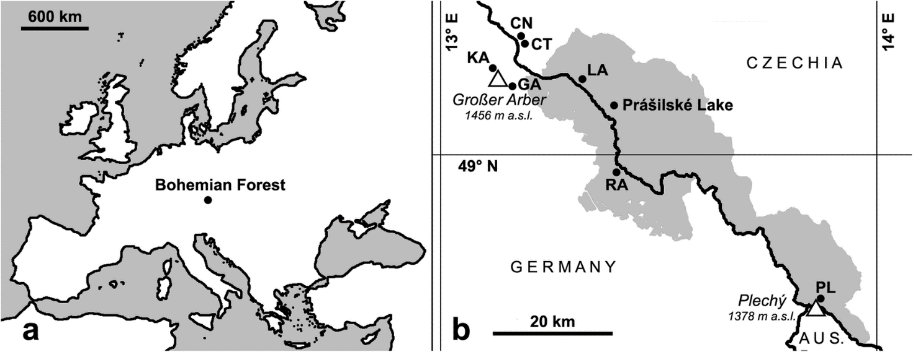

Fig. 1 Location of the Bohemian Forest in Europe (a). Location of the study site (Prášilské Lake) within the Bohemian Forest lake district (b). Area of Šumava National Park, Czechia, and Bayerischer Wald National Park, Germany, is shown in grey. Depicted are the tallest mountains of the two national parks, as well as all eight glacial lakes. LA – Laka Lake, CT – Čertovo Lake, CN – Černé Lake, KA – Kleiner Arbersee, GA – Großer Arbersee, RA – Rachelsee, PL – Plešné Lake

# Material and methods

## Study site

Prášilské Lake (49.075° N, 13.400° E) is a moraine-dammed glacial lake in the Bohemian Forest (Šumava NP), Czech Republic, and is situated at an altitude of 1079 m a.s.l. (Fig. 1). The total surface area is 4.2 ha and the basin comprises a steep littoral zone that deepens rapidly to a maximum depth of 17 m. At the nearest meteorological station Churáňov (49.068°N, 13.615°E, 1122 m a.s.l.), the mean annual rainfall is 1090 mm, the mean January temperature − 4.1 °C, the mean July temperature 12.9 °C, and the number of frost days is 165 (during the climatic period 1961–1990). Currently, three mountain streams drain a lake catchment of 65 ha that is dominated by Norway spruce (Picea abies) forest (Šobr and Janský 2016). According to published literature (Vrba et al. 2000; Soldán et al. 2012 and references therein), Prášilské Lake used to be a humic brown-water lake with more or less neutral pH before the onset of anthropogenic acidification. Heavy atmospheric pollution, resulting in acidification of the lake, occurred between 1950 and 1980 and the current pH is approximately 5.0–5.3 pH (Vrba et al. 2000; Soldán et al. 2012). The low water pH levels in this lake may explain the poor composition of the littoral vegetation, which consists of Carex rostrata and two species of Sphagnum (Soldán et al. 2012). Compared to other Bohemian Forest lakes, Prašilské Lake contains only moderate concentrations of dissolved aluminium (Kopáček et al. 1999). This may be the reason why two sensitive crustacean species (Daphnia longispina (O. F. Müller, 1776) and Cyclops abyssorum G. O. Sars, 1863) have survived in this lake to present, while they became extinct in all other sites (with exception of Großer Arbersee) during the peak of anthropogenic acidification and accompanied rise of ionic forms of aluminium (Kohout and Fott 2006; Kopáček et al. 2009). There is no documented evidence of any fish population in the lake since at least the mid-nineteenth century when the lake was first studied, and it has been speculated that the site is too difficult to reach by fish (Vrba et al. 2000). Prášilské Lake has been subject of long-term ecological studies on the recovery of acidified Bohemian Forest lakes (e.g. Fott et al. 1994; Ungermanová et al. 2014; Vrba et al. 2016).

## Sediment record and age-depth modelling

In August 2015, a 2.19 m sediment profile (1480–1699 cm below lake water surface) was collected in three 1.5 m long overlapping cores (PRA15–1-2, PRA15–2-1 and PRA15–2-2) using a Russian peat corer of 0.075 × 1.5 m chamber and using a floating platform in the central part of the lake basin (49.0752925° N, 13.4000039° E). A gravity corer (Boyle 1995) was used to recover unconsolidated deposits including the sediment-water interface. The retrieved gravity core (PRA15-GC-2) was 0.43 m long and 0.1 m in diameter. For sedimentological interpretation and correlation of the cores, the whole profile including its overlapping parts was scanned with micro X-Ray Fluorescence (Olympus Delta Professional μXRF) and line-scan photographed at high-resolution (15 μm) under uniform lighting using the University of Liverpool Geotek Multi-Sensor Core Logger (MSCL). For obtaining chronological control, the cores were dated using Accelerator Mass Spectrometry (AMS) 14C dating, 210Pb and 137Cs radioisotope dating, and a Bayesian age-depth modelling routine ‘BACON’ (see Carter et al. 2018a for additional details). The ages are reported in calibrated years before present (cal. yr. BP; calibration sensu Reimer et al. 2013), where ‘present’ refers to 1950 AD. In this study, we also present the rubidium (Rb) concentrations measured by μXRF, which is interpreted as a proxy record for detrital sediment supply recording changes in erosion and transport of allochthonous inorganic matter from the catchment to the lake.

## Sediment subsampling and caddisfly analysis

The long cores from Prášilské Lake were used for a multi-proxy study (see Carter et al. 2018a, 2018b) and sub-sampled in 0.5 cm resolution, while core PRA15-GC-2 was subsampled in 1 cm resolution. During the subsampling, several thin (2–0.1 cm) grey and dark brown units containing various plant and animal macro-remains were identified. These erosional layers were targeted and the adjacent samples above and below were selected for analysis of the caddisfly remains. Finally, most of the samples from non-overlapping parts of the long cores and the gravity core were analysed. A total of 318 sediment samples with wet volume of 1.5–5 mL for the long cores and 5–20 mL for the gravity core were processed. The samples were sieved over 100 μm mesh size to retain all macro-fossils. Caddisfly larvae remains were picked using a stereoscopic microscope at 15x magnification, dehydrated in 90% ethanol, and mounted in Euparal to prepare permanent slides. To avoid an overestimation of individuals, we focused only on frontoclypeal apotomes. Frontoclypei were identified using a reference collection of Trichoptera larvae from Bohemian Forest lakes and streams, and the identification key by Waringer and Graf (2011). Conventional identification keys to caddisfly larvae are only partially useful since they use combination of many characters located on different parts of the body. Therefore, the direct comparison with recent identified larvae was essential. Where identification to species level was not possible, morphotypes were established for the frontoclypei. Ecological characteristics of the individual caddisfly species based on Wallace et al. (1990), Braukmann and Biss (2004), Graf et al. (2008), Schartau et al. (2008), and personal observations were used to derive ecological properties of the identified taxa. According to the latest agreements on the subdivision of the Holocene epoch (Walker et al. 2012) and sediment lithology, we divided our stratigraphic record into 4 zones - the Early Holocene (11,400–8300 cal. yr. BP), a multiple-erosion event (8300–7600 cal. yr. BP), the Middle Holocene (7600–4200 cal. yr. BP) and the Late Holocene (4200 cal. yr. BP – present). The multiple-erosion event represents a site-specific transitional unit covering the proposed Early–Middle Holocene Boundary at 8200 cal. yr. BP (Walker et al. 2012).

# Results

## Chronology and lithology

The age-depth model (Table 1, Fig. 2) dates the oldest sediments of Prášilské Lake to 11,400 cal. yr. BP. The whole profile consists of a brown organic gyttja, except for the basal 0.09 m of sandy sediment at the base of PRA15–2-2. In addition, the long cores were characterized by the presence of thin grey and dark brown units contrasting strongly with the lighter brown colour of the gyttja. Most of these unites contained increased concentrations of inorganic material and plant and insect macro-remains. Because of very low thickness (˂ 2 mm) of some units, we used the Rb curve to track these event laminations interpreted as erosion layers instead of their visual description (Figs. 2 and 3).

| **Depth (cm)** | **Core code** | **Laboratory code** | **14C age (a BP)** | **Calibrated age (cal. a BP, 2σ range)** | **Mean calibrated age (cal. a BP)** | **Material dated** |
| --- | --- | --- | --- | --- | --- | --- |
| 1500.5–1501 | Pra-15-2-1 | Poz-84783 | 590 ± 30 | 494–711 | 602 | Bulk |
| 1539–1539.5 | Pra-15-2-1 | Poz-81580 | 2,545 ± 30 | 2,422–2782 | 2,631 | *Picea* needle |
| 1628.5–1629 | Pra-15-2-1 | Poz-87722 | 7,055 ± 40 | 7,763–8317 | 8,009 | *Picea* needle |
| 1571.5–1572 | Pra-15-2-2 | Poz-81582 | 4,040 ± 35 | 4,223–4812 | 4,506 | *Picea* needles |
| 1599.5–1600 | Pra-15-2-2 | Poz-81583 | 5,700 ± 40 | 6,198–6677 | 6,469 | *Picea* needle |
| 1628.5–1629 | Pra-15-2-2 | Poz-80182 | 7,550 ± 40 | 7,763–8317 | 8,009 | *Picea* needles |
| 1637–1637.5 | Pra-15-2-2 | Poz-87724 | 7,460 ± 40a | 8,209–8497 | 8,371 | *Picea* needles |
| 1651–1651.5 | Pra-15-2-2 | Poz-84781 | 8,210 ± 50 | 8,852–9449 | 9,191 | *Picea* needle |
| 1669.5–1670 | Pra-15-2-2 | Poz-81780 | 9,330 ± 60 | 10,027–10,749 | 10,441 | *Picea* bud scales, *Betula* leaf and seed |
| 1690–1690.5 | Pra-15-2-2 | Poz-80183 | 9,620 ± 60 | 10,877–11,367 | 11,147 | *Picea* seed |

a Date excluded by Bacon model

Table 1 Results of AMS radiocarbon dating

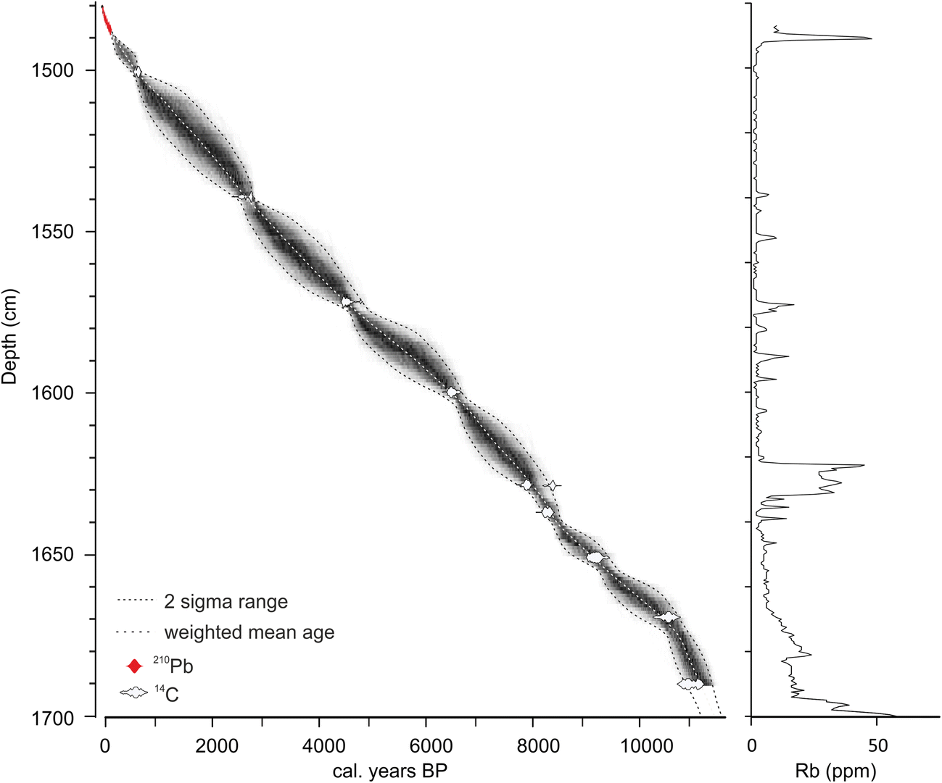

Fig. 2 Bayesian age-depth model and rubidium (Rb) concentrations for Prášilské Lake sediment profile (core drives PRA15-GC-2, PRA15–1-2, PRA15–2-1, and PRA15–2-2)

Thin erosional units (bands) occurred in an irregular interval at depths of 16.46, 16.38, 16.05, 15.94, 15.87, 15.79, 15.73, 15.39, and 15.03 m. Only two of them, 15.87 and 15.72, had a thickness over 0.01 m. Moreover, the largest band of bright brown/greyish erosional sediment was found between 16.215–16.355 m. It contained abundant macro-remains, only the uppermost 8 mm (16.215–16.223 cm) was clayey and poor in remnants (> 100 μm) of subfossil organisms. Radiocarbon dates below and above this distinctive 0.14 m thick unit show a relatively long deposition time from 8300 to 7600 cal. yr. BP. Besides increased inorganic content in the erosional units, the Rb curve demonstrates gradually decreasing values (from 60 to 10 ppm) during the transition from sandy to more organic sediment in the basal part of the profile and a peak (50 ppm) in the uppermost part of PRA15–2-2 (Figs. 2 and 3).

## Trichoptera record

Altogether, 58 individuals from 10 taxa were found in the profile (Figs. 3 and 4). An overview of the species occurring in Prášilské Lake and its inflow streams during the last century (1918/1919–2015) along with the taxa identified from the lake sediment samples is summarized in Table 2. In some cases, trichopteran frontoclypei could not be identified to species level and were named according to the taxa to which the remnants were likely to belong. Therefore, we established 4 morphotypes. Two distinct taxa of the genus Limnephilus were recognized – L. rhombicus-type (frontoclypeus pale with a dark brown longitudinal band broadened anteriorly) and L. coenosus-type (frontoclypeus uniformly dark brown without a pale area in the posterior angle). A phryganeid morphotype Agrypnia – Phryganea includes Agrypnia spp. and Phryganea spp., and a psychomyiid morphotype Lype – Tinodes could be represented by species with an almost concolorous frontoclypeus (e.g. Lype phaeopa and Tinodes waeneri) (Fig. 4). In addition, we documented presence of 6 species from 5 families: Athripsodes aterrimus (Leptoceridae), Cyrnus trimaculatus and Holocentropus dubius (Polycentropodidae), Molanna nigra (Molannidae), Oligotricha striata (Phryganeidae), and Philopotamus ludificatus (Philopotamidae).

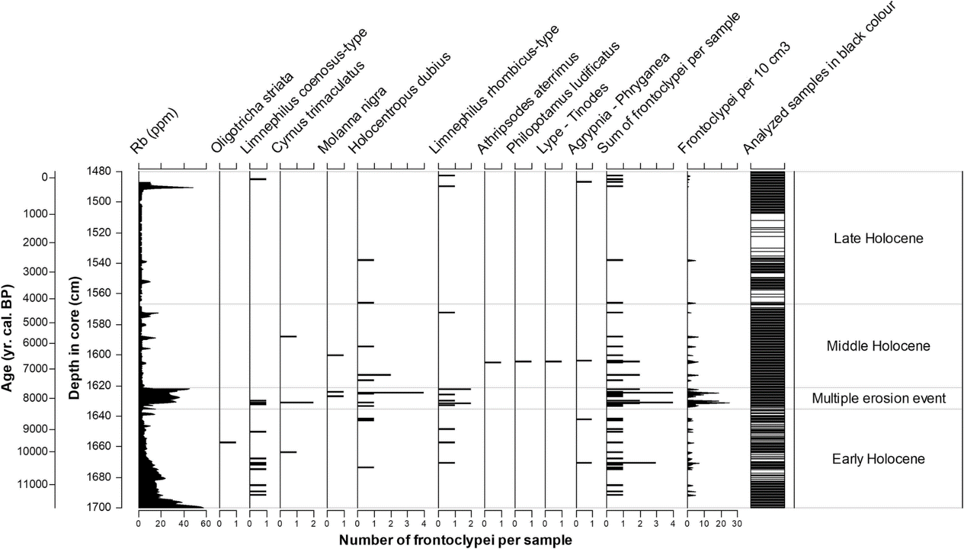

Fig. 3 Changes in caddisfly assemblages in Prášilské Lake through time. The core runs from the top of the sediment at 1480 cm water depth to the sandy substrate at 1699 cm. Increases in rubidium (Rb) demonstrate periods of erosional activity in the lake catchment. The four zones were added according to the division of the Holocene epoch (Walker et al. 2012), with an additional zone represented by a multiple erosion event between the depth of 1634.5 cm and 1621.5 cm (8300–7600 cal. yr. BP)



Modern data (1918/1919–2015) were compiled by Soldán et al. (2012) and supplemented by 2 additional species (a) observed by J. Petruželová (pers. comm.)

Table 2 Occurrences of caddisfly larvae (+) documented in Prášilské Lake during the Early Holocene (11,400–8300 cal. yr. BP), the multiple erosion event (MEE, 8300–7600 cal. yr. BP), the Middle Holocene (7600–4200 cal. yr. BP), and the Late Holocene (4200 cal. yr. BP – recent)

Ecological evaluation of the caddisfly assemblages is presented in Table 3. Individual taxa include species widely distributed in lentic waters (Agrypnia – Phryganea, Holocentropus dubius, Limnephilus coenosus-type, Molanna nigra, Oligotricha striata), as well as in both lentic and lotic waters (Athripsodes aterrimus, Cyrnus trimaculatus, Limnephilus rhombicus-type, and Lype – Tinodes). Only Philopotamus ludificatus is a characteristic inhabitant of streams. Among these taxa, almost all basic functional-feeding groups are represented, although passive filter feeders, shredders, and predators are predominant. Most of the documented taxa use a wide range of food items. Similarly, the substrate preferences are diverse, ranging from species which preferably occur in fine mud or sand to species which depend on stable substrates like stones and water macrophytes. On the other hand, a categorization to pH sensitivity groups is more uniform showing presence of acid-resistant, acid-tolerant, and pH indifferent caddisflies. The only exception is the single finding of pH sensitive Philopotamus ludificatus, an inhabitant of non-acidified streams (the specimen probably originates from any of the lake inflow streams).

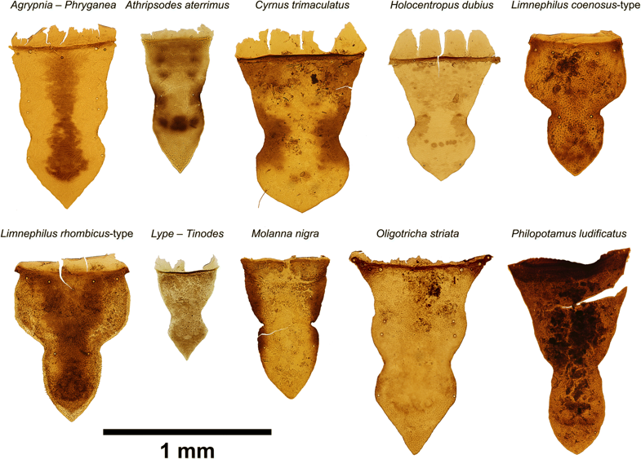

Fig. 4 Frontoclypeal apotomes of all caddisfly taxa found in this study

|  |  |  |  |  |  |
| --- | --- | --- | --- | --- | --- |
| **Taxon** | **Functional feeding group** | **Habitat** | **Substrate** | **Sensitivity to acid water** | **References** |
| *Agrypnia – Phryganea* | gat, pre, shr | L | alg, mph, pel, pom, woo | – | Graf et al. (2008) |
| *Athripsodes aterrimus* (Stephens, 1836) | gat, pre, shr | L, S | mph, pel, psa | IN | Fjellheim and Raddum (1990); Graf et al. (2008); Schartau et al. (2008) |
| *Cyrnus trimaculatus* (Curtis, 1834) | pff, pre | L, S | mal, mil, mph | IN | Fjellheim and Raddum (1990); Graf et al. (2008) |
| *Holocentropus dubius* (Rambur, 1842) | pff, pre | L | mph | IN | Fjellheim and Raddum (1990); Graf et al. (2008); Schartau et al. (2008) |
| a*Limnephilus coenosus* Curtis, 1834 | gra, pre, shr | L | pel, mph, pom, psa | AR | Zamora-Muñoz and Svensson (1996); Krno et al. (2006); Graf et al. (2008) |
| a*Limnephilus rhombicus* (Linnaeus, 1758) | gra, pre, shr | L, S | pel, mph, pom, psa | AR | Fjellheim and Raddum (1990); Braukmann and Biss (2004); Graf et al. (2008) |
| a*Lype phaeopa* (Stephens, 1836) | gra, xyl | L, S | woo | AS? | Graf et al. (2008) |
| *Molanna nigra* (Zetterstedt, 1840) | gat, pre | L | pel, psa | IN? | Graf et al. (2008); Soldán et al. (2012) |
| *Oligotricha striata* (Linnaeus, 1758) | gat, pre, shr | L | mal, mph, pel, pom, psa | AT | Wallace et al. (1990); Braukmann and Biss (2004); Graf et al. (2008) |
| *Philopotamus ludificatus* McLachlan, 1878 | pff | S | mal, mil | AS | Braukmann and Biss (2004); Graf et al. (2008) |
| a*Tinodes waeneri* (Linnaeus, 1758) | gat, gra, pff, pre | L, S | mal, mil | IN | Fjellheim and Raddum (1990); Graf et al. (2008); Ings et al. (2017) |

Functional feeding groups: gat – gatherer/collector, gra – grazer and scraper, pff – passive filter feeder, pre – predator, shr – shredder, xyl – xylophage

Substrate preference: alg – algae, mal – stones and bedrock, mil – coarse gravel (2–20 cm), mph – macrophytes and mosses, pel – mud, pom – coarse and fine particulate organic matter, psa – sand, woo – woody debris. Habitat: L – lake (littoral and/or sublittoral zone), S – stream

Sensitivity to acidification: AR – acid resistant (pH ˂ 5.5), AS – moderately acid sensitive (pH around 6.5–7.0), AT – acid tolerant (pH 6.5–5.5 and sometimes bellow), IN – indifferent (occurrence across wide range of pH including values ˂ 5.5)

Table 3 Caddisfly taxa and morpho-taxa documented in the sediment record from Prášilské Lake and their feeding strategies and habitat, substrate and pH preferences. For the morpho-taxa which most likely belong to a particular species (a), we present ecological characteristics of a such species

To evaluate changes in caddisfly species composition in time, 4 zones based on the climatological subdivision of the Holocene and sediment lithology were established (Fig. 3). The first zone (1699–1631 cm; 11,400–8300 cal. yr. BP; Early Holocene) covers the development of the lake shortly after its formation and initially contains remains of Limnephilus coenosus-type after which Holocentropus dubius, Limnephilus rhombicus-type, Agrypnia – Phryganea, Cyrnus trimaculatus, and Oligotricha striata occurred. The second zone (1634.5–1621.5 cm; 8300–7600 cal. yr. BP; multiple erosion event) covers the large erosion band accompanied by peaks in Rb concentration. This zone contains the highest numbers and volumetric abundances of Trichoptera remains (up to 27 frontoclypei per 10 cm3). The assemblage consists of relatively abundant Limnephilus rhombicus-type and Holocentropus dubius, and less abundant Cyrnus trimaculatus, Limnephilus coenosus-type, and Molanna nigra. In the third zone (1621.5–1567 cm; 7600–4200 cal. yr. BP; Middle Holocene), we found frontoclypeal apotomes of Holocentropus dubius, and single evidence of Athripsodes aterrimus, Agrypnia – Phryganea, Cyrnus trimaculatus, Limnephilus rhombicus-type, Molanna nigra, Philopotamus ludificatus, and Lype – Tinodes. The last zone (1567–1480 cm; 4200 cal. yr. BP – present; Late Holocene) is characterized by a very low volumetric abundance of caddisfly remains (0–5 frontoclypei per 10 cm3). Only two specimens of Holocentropus dubius were documented between the depths 1621.5 cm and 1483.5 cm. The top part of this zone (1483.5–1480 cm; 1960–2015 AD) contains Agrypnia – Phryganea, Limnephilus coenosus-type, and Limnephilus rhombicus-type. The most abundant taxa in the whole profile were Holocentropus dubius (31%), Limnephilus coenosus-type (24%), and L. rhombicus-type (24%). The remaining taxa were less represented (˂7%) (Fig. 3).

# Discussion

The subfossil Trichoptera larvae assemblages from Prášilské Lake include most of the species which were found in the lake during the irregular environmental monitoring since 1918/1919 (Soldán et al. 2012 and references therein; see Table 2). Only Chaetopteryx villosa and Plectrocnemia conspersa, common species in streams, rivers and small upland lakes (Wallace et al. 1990; Andersen and Tysse 2008), currently inhabiting all Bohemian Forest lakes and/or their inflow streams (Soldán et al. 2012), were not found in our samples. We also have not found any evidence of Limnephilus centralis and Limnephilus lunatus, two species recorded in the first half of the twentieth century (Šámal 1920; Novák 1996). Both morphotypes of the genus Limnephilus presented in this study, L. coenosus-type and L. rhombicus-type, may include more species with the same frontoclypeal colour pattern because the identification of living larvae to species level is based on a combination of different morphological characters including characters on soft body parts (Waringer and Graf 2011). However, since the species L. rhombicus and L. coenosus are much more common in the Bohemian Forest lakes (Soldán et al. 2012), it is highly likely that the remains identified as L. rhombicus-type and L. coenosus-type, respectively, correspond with these two species. Similarly, Agrypnia varia and Phryganea bipunctata were not found with certainty, but we assume that these species are included within the Agrypnia – Phryganea morphotype. Nevertheless, for these identifications, it has to be taken into regard that they might concern species which are rare or absent in the recent Bohemian Forest lakes. On the other hand, several taxa, which were not reported from Prášilské Lake at present, were found in the sedimentary archive – Athripsodes aterrimus, Cyrnus trimaculatus, Lype – Tinodes morphotype, and Philopotamus ludificatus. In the latter case, however, it is worth mentioning that the species is known from the lake inflow streams. It cannot be ruled out that in the past a small portion of the caddisfly remains could be transported from these inflow streams to the lake and deposited in the sediments. Nevertheless, the majority of frontoclypeal sclerites cannot have been transported far from the larval habitat. We assume this because of low discharge of the recent inflows and very small proportion of stream Diptera remains found in the same sediment samples (D. Vondrák, unpublished data). The caddisfly stratigraphic record (Fig. 3) should not be interpreted to represent complete species composition or precise concentration of individuals through time. Due to the low number of remains/individuals in the lake sediment we are not able to assess detailed changes in volumetric or relative abundances. Our results are of a qualitative nature. Therefore, we focus on interpreting the ecological preferences of the individual indicator species.

Ecological characteristics of individual species found in the sediment record are summarized in Table 3. Holocentropus dubius, a polycentropodid species and the most dominant taxon in our sediment samples, generally occurs in the littoral zone with macrovegetation (Graf et al. 2008) and is also known from dystrophic (peaty) mountain lakes (Chvojka 1992). Despite its frequent occurrence in Prášilské Lake in the past, it has not been recorded there during the recent monitoring (1918/1919–2015) until its first observation in 2007 (J. Petruželová, pers. comm). In the Bohemian Forest lakes, stable populations of H. dubius are only known from Laka Lake and Großer Arbersee (Soldán et al. 2012; Ungermanová et al. 2014), two sites with well-developed littoral macrovegetation (Fig. 1). The other dominant taxa (˂20%) in the sedimentary record are the two morphotypes of genus Limnephilus – L. coenosus-type and L. rhombicus-type. L. rhombicus is a eurytopic species known from a variety of standing and slow-flowing waters including acidic peaty waters (Wallace et al. 1990). It is widely distributed in the Bohemian Forest (K. Novák, unpublished data) and it was recorded from all glacial lakes with the exception of Rachelsee (Soldán et al. 2012). L. coenosus is a common species in pools on peat bogs (Waringer and Graf 2011) and in small, strongly acidified lakes (Krno et al. 2006). It is also well established in the Bohemian Forest, above all in peat bogs (Novák 1996). The phryganeid taxon Agrypnia – Phryganea could include not only Agrypnia varia and Phryganea bipunctata, but also A. obsoleta (McLachlan, 1865) and P. grandis Linnaeus, 1758 since all species are known from the glacial lakes in this area (Novák 1996; Soldán et al. 2012). Agrypnia varia and P. bipunctata occupy the same ecological niche – littoral zone with macrophytes. Oligotricha striata is a common species in pools, especially with acidic peaty water (Wallace 1991). This species is known from all present Bohemian Forest lakes, except of Černé and Čertovo lakes (Fig. 1), and also from peatbog pools in the region (Novák 1996; Soldán et al. 2012). The larvae of Molanna nigra prefer a psammopelal habitat (sand or clay) of mid-montane and lowland lakes (Graf et al. 2008). Molanna nigra is a species with boreo-montane distribution and is known from northern Europe (Graf et al. 2008) and also from Siberia (Ivanov 2011). In central Europe, it has isolated populations in the Bohemian Forest glacial lakes at altitudes up to 1079 m (recently known only from Prášilské Lake, Čertovo Lake, and Großer Arbersee; Fig. 1) (Soldán et al. 2012). Our records show the species to be present in Prášilské Lake since at least 8000 cal. yr. BP, i.e. around the complex multiple erosion episode. Cyrnus trimaculatus is a widely distributed species in flowing as well as in stagnant waters with macrophytes and stony substrate (Graf et al. 2008). It was recorded in historical records from Černé Lake and Großer Arbersee (Klapálek 1903), but more recent records are missing. Larvae of Philopotamus ludificatus prefer the epirhithral zone of mountain and submountain streams (Graf et al. 2008). The species is also known from streams in the Bohemian Forest including inflow streams of Prášilské Lake and Laka Lake (Novák 1996; Soldán et al. 2012). Athripsodes aterrimus occurs in lakes and pools as well as slow flowing rivers among water plants and on psammopelal habitats (Wallace et al. 1990; Graf et al. 2008). This widely distributed European species occurs also in small pools in the Bohemian Forest at altitudes of ca. 1000 m a.s.l. (P. Chvojka, unpublished data), but it was not found in any of the glacial lakes recently (Soldán et al. 2012). The Lype – Tinodes morphotype includes species with an almost concolorous frontoclypeus, e.g. L. phaeopa and T. waeneri. Both species occur in stagnant and slow flowing waters primarily in lower altitudes. Larvae of L. phaeopa live on logs and woody debris while T. waeneri prefers stony substrata (Graf et al. 2008). None of the species of Psychomyiidae were recorded from the Bohemian Forest lakes during recent investigations (Soldán et al. 2012), only L. phaeopa was found in Großer Arbersee in historical records (Klapálek 1903).

As pH fluctuates annually, seasonally and even daily, the occurring caddisflies are good indicators of the longer-term acidity status of water bodies (Graf et al. 2008). Most of the taxa we identified occur in waters with low pH – only Philopotamus ludificatus is moderately sensitive to acidic conditions (Braukmann and Biss 2004; Schartau et al. 2008) – and display a wide range of feeding strategies (Table 3). Some of the species are eurytopic and/or their substrate preferences are ambiguous. In addition, the littoral zone of Prášilské Lake at present is a diverse mosaic of microhabitats and has probably taken this similar form since formation of the lake. Therefore, it is not possible to reconstruct the pattern of changes in the littoral zone substrate through time from our limited caddisfly record. Nevertheless, all dominant taxa found in the sediment core (Holocentropus dubius, Limnephilus spp., Agrypnia – Phryganea) inhabit dystrophic water bodies with Sphagnum spp. (Graf et al. 2008).

The Early-Holocene caddisfly assemblages (Fig. 3) indicate that the littoral zone of Prášilské lake was partially overgrown by aquatic vegetation (including Sphagnum spp.), in combination with muddy and/or sandy substrate. A very similar modern Trichoptera taxocoenoses were found in Laka Lake and Großer Arbersee in this region (Soldán et al. 2012), and at Nižné Rakytovské Lake, a small, dystrophic montane lake (1320 m a.s.l.) further afield in the High Tatra Mts. (Chvojka 1992). Changes between organic and minerogenic sedimentary units usually reflect the alternating stability of catchment hillslopes. During the second phase of the lake evolution (Fig. 3), a series of erosion events occurred between 8300 and 7600 cal. yr. BP. This increased transport of allochthonous material documented by the sharp rise in Rb content, may also be reflected in a removal of water insect remains from the shallow to deeper parts of the lake basin. As a result, the highest concentration of frontoclypeal sclerites was recorded in this stratigraphic zone. Molanna nigra indicate the presence of muddy and sandy substrate but a distinct peak of phytophilous taxa (H. dubius, L. coenosus-type, L. rhombicus-type) suggest a high amount of available plant debris during the same period. This combination of substrates is also in agreement with the ecology of Cyrnus trimaculatus (Table 3). The timing of this zone roughly coincides with the establishment of Norway spruce as the most dominant forest canopy taxa in the lake catchment (Carter et al. 2018a), highest biomass burning (Carter et al. 2018b), and the so-called 8.2 ka cooling event (e.g. Tinner and Lotter 2001). However, the series of erosion events in our record lasted around 600 years, while global environmental responses to this climatic event are thought to have lasted no longer than 160 years (Thomas et al. 2007), thus these erosion events cannot be readily linked to the 8.2 ka cooling. In the Middle Holocene, the Trichoptera assemblages were more diverse (8 taxa recorded) and suggest a continuous presence of a more varied littoral zone consisting of macrophytes, mud, sand or gravel. During the Late Holocene, the caddisfly remains were almost absent in the profile implying less favourable conditions for the larvae. The sporadic presence of only one species, Holocentropus dubius, was documented until the twentieth century when Agrypnia – Phryganea and both Limnephilus morphotypes reappeared again in the record. A low population density could be the cause that the remains did not reach the coring site in the central part of the lake basin in detectable concentrations. However, the period of caddisfly decline begun at the end of the Middle Holocene and approximately coincides with a local European beech (Fagus sylvatica) expansion into the Norway spruce dominated forest and a dramatic decrease in biomass burning circa 6500–500 cal. yr. BP (Carter et al. 2018b). Related changes in leaf litter characteristics (Albers et al. 2004) might have supported near-bottom oxygen depletion. Unfortunately, this lack of subfossil remains therefore does not allow the reconstruction of the pre-acidification trichopteran fauna. It can only be assumed that H. dubius was likely to be represented as one of the dominant species. The small increase in number of species and volumetric abundance in the sediment record during the last century (the uppermost part of the Late Holocene zone; Fig. 3) is probably not related to atmospheric acidification and can be explained by other factors. Historical records show that strong gales during the period 1868–1870 and subsequent active logging destroyed large parts of the forest and increased erosion in the immediate vicinity of Prášilské Lake (Čada et al. 2016). Moreover, the single outflow of the lake was dammed in 1883, raising the lake water level by 2.5 m (Švambera 1914). Both events could have changed the representation of bottom substrate types, oxygen concentration near the bottom or certain hydrological conditions (e.g. water residence time, mixing regime). The pioneer investigations by Šámal (1920) and Novák (1996) document presence of C. villosa, M. nigra, O. striata and members of genus Limnephilus between 1910s and 1950s. For the same period, we found an evidence of Agrypnia – Phryganea and both Limnephilus morphotypes. This is practically the same assemblage as recorded later in the recovering lake (Soldán et al. 2012).

The subfossil Trichoptera assemblages suggest that Prášilské Lake has been a dystrophic, moderately acid lake from its early development and throughout the Holocene. The species composition shows many similarities to the modern-day ones of Laka and Großer Arbersee lakes (see Soldán et al. 2012). Therefore, the process of natural acidification affected lake water chemistry shortly after the lake formation near the Younger Dryas – Holocene boundary. This is consistent with the timing of Early Holocene lake acidification observed at Kråkenes Lake in Norway (Solem and Birks 2000; Boyle et al. 2013). In the case of Prášilské Lake, however, we are not able to confirm significantly different Late-glacial assemblages. An unexpected absence of a Late-glacial sedimentary record at the study site was confirmed by repeated drilling. This suggests that the onset of lacustrine sedimentation in Prášilské Lake is younger than in other Bohemian Forest lakes. Namely for Černé Lake (Michler 2001), Großer Arbersee (Michler 2000), Plešné Lake (Pražáková et al. 2006), Rachelsee (Carter et al. 2018a) and two former lakes (Vočadlová et al. 2015; Kletetschka et al. 2018) the presence of several meters thick Late-glacial sediments is well documented. This asynchrony between timing of local deglaciation (Mentlík et al. 2013) and sedimentation onset in Prášilské Lake may result from a lag time necessary to seal a permeable moraine. Nevertheless, the anticipated Early Holocene onset of natural acidification is supported by evidence from a closely located site, Plešné Lake (Fig. 1), presented by Pražáková et al. (2006) and Kopáček et al. (2009). Their results imply a forest soil development and a subsequent rise in soil organic acids’ input to the lake water following the Holocene climatic warming. Both processes are interpreted as key factors leading to dissolved (organically-bound) aluminium increase, pH decrease, oligotrophication, and change in zooplankton species composition. Therefore, we assume that the Early Holocene climatic shift and subsequent changes in vegetation cover triggered natural acidification in the Bohemian Forest region. A future investigation of Late-glacial and Early Holocene sedimentary records might provide further insights into natural acidification history of central European mountain ranges with metamorphic and crystalline bedrock.

# Conclusions

Here we present, to our knowledge, the first continuous post-glacial records of subfossil caddisfly succession in a mountain lake in central Europe. The results demonstrate signs of natural acidity in the Bohemian Forest region since the Late Pleistocene-Holocene transition. The Prášilské Lake record is characterized by resident caddisfly fauna dominated by species tolerant to low pH (Holocentropus dubius, Limnephilus coenosus, L. rhombicus). Based on our results and the scarce observations from the first half of the twentieth century, we conclude that no evidence of a dramatic change in original caddisfly taxocoenoses as a result of the strong anthropogenic acidification was found. The suggested naturally acidic state of the humic lake ameliorated the negative effect of changes in water chemistry on macrozoobenthos community. Our results can be used as a baseline for assessment of biological recovery level of the study lake in future conservation policies and management. Sediments of glacial lakes represent crucial natural archives of local post-glacial environmental history that should be intensively studied. Despite its potential, caddisflies have received less attention from Quaternary palaeoecologists than many other microfossil groups. Our study underlines the importance of caddisfly remains as one of the valuable biological proxies in palaeolimnological research.

# Acknowledgments

We thank Alexander Klink for his help with caddisfly remains identification, Jana Petruželová for her comments on recent caddisfly fauna of the Bohemian Forest lakes, Petr Kuneš for allowing us to study the sediment profile, and colleagues for assistance during fieldwork. This study was supported by the Internal Grant Agency of the Faculty of Forestry and Wood Sciences of the Czech University of Life Sciences Prague (IGA grant 21/17), the Czech Grant Foundation (project no. 16-23183Y – PEDECO; project no. 16-06915S – EUROPIA), and the Ministry of Culture of the Czech Republic (DKRVO 2018/12, National Museum, 00023272).

# Funding

This study was funded by the Czech Grant Foundation (project no. 16-23183Y and project no. 16-06915S), the Ministry of Culture of the Czech Republic (DKRVO 2018/12, National Museum, 00023272), and the Internal Grant Agency of the Faculty of Forestry and Wood Sciences of the Czech University of Life Sciences Prague (IGA grant 21/17).

# References

Albers D, Migge S, Schaefer M, Scheu S (2004) Decomposition of beech leaves (Fagus sylvatica) and spruce needles (Picea abies) in pure and mixed stands of beech and spruce. Soil Biol Biochem 36:155–164. https://doi.org/10.1016/j.soilbio.2003.09.002

Andersen T, Tysse Å (2008) Life cycle of Chaetopteryx villosa (Fabricius, 1798) (Trichoptera: Limnephilidae) in a lowland- and a mountain-stream in western Norway. Aquat Insects 6(4):217–231. https://doi.org/10.1080/01650428409361187

Beamish RJ (1976) Acidification of lakes in Canada by acid precipitation and the resulting effects on fishes. Water Air Soil Pollut 6:501–514. https://doi.org/10.1007/BF00182888

Beisel J-N, Usseglio-Polatera P, Thomas S, Moreteau J-C (1998) Stream community structure in relation to spatial variation: the influence of mesohabitat characteristics. Hydrobiologia 389:73–88. https://doi.org/10.1023/A:1003519429979

Birks HH, Battarbee RW, Birks HJB (2000) The development of the aquatic ecosystem at Kråkenes Lake, western Norway, during the late-glacial and early-Holocene – a synthesis. J Paleolimnol 23:91–114. https://doi.org/10.1023/A:1008079725596

Bobbink R, Hornung M, Roelofs JGM (1998) The effects of air-borne nitrogen pollutants on species diversity in natural and semi-natural European vegetation. J Ecol 86:717–738. https://doi.org/10.1046/j.1365-2745.1998.8650717.x

Boyle JF (1995) A simple closure mechanism for a compact, large-diameter, gravity corer. J Paleolimnol 13(1):85–87. https://doi.org/10.1007/BF00678113

Boyle JF (2007) Loss of apatite caused irreversible early-Holocene lake acidification. Holocene 17(4):543–547. https://doi.org/10.1177/0959683607077046

Boyle JF, Chiverrell RC, Plater A, Thrasher I, Bradshaw E, Birks H, Birks J (2013) Soil mineral depletion drives early Holocene lake acidification. Geology 41:415–418. https://doi.org/10.1130/G33907.1

Bradt P, Urban M, Goodman N, Bissell S, Spiegel I (1999) Stability and resilience in benthic macroinvertebrate assemblages - impact of physical disturbance over twenty-five years. Hydrobiologia 403:123–133. https://doi.org/10.1023/A:1003711928980

Braukmann U, Biss R (2004) Conceptual study – an improved method to assess acidification in German streams by using benthic macroinvertebrates. Limnologica 34:433–450. https://doi.org/10.1016/S0075-9511(04)80011-2

Buczyńska E, Czachorowski S, Buczyński P, Pakulnicka J, Stępień E, Szlauer-Łukaszewska A, Stryjecki R, Zawal A (2017) Environmental heterogeneity at different scales: key factors affecting caddisfly larvae assemblages in standing waters within a lowland river catchment. J Limnol 76(2):305–325. https://doi.org/10.4081/jlimnol.2016.1535

Čada V, Morrissey RC, Michalová Z, Bače R, Janda P, Svoboda M (2016) Frequent severe natural disturbances and non-equilibrium landscape dynamics shaped the mountain spruce forest in Central Europe. For Ecol Manag 363:169–178. https://doi.org/10.1016/j.foreco.2015.12.023

Carter VA, Chiverrell RC, Clear JL, Kuosmanen N, Moravcová A, Svoboda M, Svobodová- Svitavská H, van Leeuwen JFN, van der Knaap WO, Kuneš P (2018a) Quantitative palynology informing conservation ecology in the bohemian/Bavarian forest of Central Europe. Front Plant Sci 8:2268. https://doi.org/10.3389/fpls.2017.02268

Carter VA, Moravcová A, Chiverrell RC, Clear JL, Finsinger W, Dreslerová D, Halsall K, Kuneš P (2018b) Holocene-scale fire dynamics of central European temperate spruce–beech forests. Quat Sci Rev 191:15–30. https://doi.org/10.1016/j.quascirev.2018.05.001

Chvojka P (1992) Chrostíci (Trichoptera, Insecta) Tatranského národního parku [Caddisflies (Trichoptera, Insecta) of the Tatra National Park]. Zborník prác o Tatranskom národnom parku 32:165–195. [in Czech, English summary]

Clair TA, Dennis IF, Scruton DA, Gillis M (2007) Freshwater acidification research in Atlantic Canada: a review of results and predictions for the future. Environ Rev 15:153–167. https://doi.org/10.1139/A07-004

Elias SA (2010) Advances in quaternary entomology. Elsevier, Amsterdam. https://doi.org/10.1016/S1571-0866(09)01225-1

Elias SA, Wilkinson B (1983) Lateglacial insect fossil assemblages from Lobsigensee (Swiss Palteau). Studies in the Late Quaternary of Lobsigensee 3. Rev Paléobiol 2(2):189–204

Engstrom DR, Fritz SC, Almendinger JE, Juggins S (2000) Chemical and biological trends during lake evolution in recently deglaciated terrain. Nature 408:161–166. https://doi.org/10.1038/35041500

Fjellheim A, Raddum GG (1990) Acid precipitation: biological monitoring of streams and lakes. Sci Total Environ 96:57–66. https://doi.org/10.1016/0048-9697(90)90006-G

Fott J, Pražáková M, Stuchlík E, Stuchlíková Z (1994) Acidification of lakes in Šumava (Bohemia) and in the high Tatra Mountains (Slovakia). Hydrobiologia 274:37–47. https://doi.org/10.1007/BF00014625

Frič A (1872) Über die Fauna der Böhmerwaldseen. Sitzungsberichte der königlichen böhmischen Gesellschaft der Wissenschaften in Prag 1872(2):3–12 [in German]

Graf W, Murphy J, Dahl J, Zamora-Muñoz C, López-Rodríguez MJ (2008) Distribution and ecological preferences of European freshwater organisms. Volume 1. Trichoptera. Pensoft Publishers, Sofia and Moscow

Greenwood MT, Agnew MD, Wood PJ (2003) The use of caddisfly fauna (Insecta: Trichoptera) to characterise the Late-Glacial River Trent, England. J Quaternary Sci 18:645–661. https://doi.org/10.1002/jqs.786

Greenwood MT, Wood PJ, Monk WA (2006) The use of fossil caddisfly assemblages in the reconstruction of flow environments from floodplain paleochannels of the river Trent, England. J Paleolimnol 35:747–761. https://doi.org/10.1007/s10933-005-5162-6

Hering D, Meier C, Rawer-Jost C, Feld CK, Biss R, Zenker A, Sundermann A, Lohse S, Böhmer J (2004) Assessing streams in Germany with benthic invertebrates: selection of candidate metrics. Limnologica 34:398–415. https://doi.org/10.1016/S0075-9511(04)80009-4

Howard LC, Wood PJ, Greenwood MT, Rendell HM (2009) Reconstructing riverine paleo-flow regimes using subfossil insects (Coleoptera and Trichoptera): the application of the LIFE methodology to paleochannel sediments. J Paleolimnol 42:453–466. https://doi.org/10.1007/s10933-008-9298-z

Ings NL, Grey J, King L, McGowan S, Hildrew AG (2017) Modification of littoral algal assemblages by gardening caddisfly larvae. Freshw Biol 62:507–518. https://doi.org/10.1111/fwb.12881

Ivanov VD (2011) Caddisflies of Russia: Fauna and biodiversity. Zoosymposia 5:171–209. https://doi.org/10.1134/S001387381201006X

Jia J, Gao Y (2017) Acid deposition and assessment of its critical load for the environmental health of waterbodies in a subtropical watershed, China. J Hydrol 555:155–168. https://doi.org/10.1016/j.jhydrol.2017.10.017

Klapálek F (1903) Zpráva o výzkumu českých Neuropteroid v r. 1902 [A report on the research of Bohemian Neuropteroids in the year 1902]. Věstník České Akademie Císaře Františka Josefa pro Vědy, Slovesnost a Umění 12:257–264. [in Czech]

Kletetschka G, Vondrák D, Hrubá J, Procházka V, Nábělek L, Svitavská-Svobodová H, Bobek P, Hořická Z, Kadlec J, Takáč M, Stuchlík E (2018) Cosmic-impact event in Lake sediments from Central Europe postdates the Laacher see eruption and Marks onset of the younger Dryas. J Geol 126(6):561–575. https://doi.org/10.1086/699869

Kohout L, Fott J (2006) Restoration of zooplankton in a small acidified mountain Lake (Plešné lake, Bohemian Forest) by reintroduction of key species. Biologia 61(Suppl. 20):S477–S483. https://doi.org/10.2478/s11756-007-0065-9

Kopáček J, Hejzlar J, Porcal P, Nedoma J (1999) Chemistry of Prášilské Lake and its tributaries during the 1998 summer temperature stratification. Silva Gabreta 3:33–48

Kopáček J, Hejzlar J, Kaňa J, Norton SA, Porcal P, Turek J (2009) Trends in aluminium export from a mountainous area to surface waters, from deglaciation to the recent: effects of vegetation and soil development, atmospheric acidification, and nitrogen-saturation. J Inorg Biochem 103:1439–1448. https://doi.org/10.1016/j.jinorgbio.2009.07.019

Krno I, Šporka F, Galas J, Hamerlík L, Zaťovičová Z, Bitušík P (2006) Littoral benthic macro- invertebrates of mountain lakes in the Tatra Mountains (Slovakia, Poland). Biologia 61(Suppl. 18):S147–S166. https://doi.org/10.2478/s11756-006-0127-4

Kuneš P, Odgaard BV, Gaillard M-J (2011) Soil phosphorus as a control of productivity and openness in temperate interglacial forest ecosystems. J Biogeogr 38:2150–2164. https://doi.org/10.1111/j.1365-2699.2011.02557.x

Langheinrich U, Böhme D, Wegener U, Lüderitz V (2002) Streams in the Harz National Parks (Germany) - a hydrochemical and hydrobiological evaluation. Limnologica 32:309–321. https://doi.org/10.1016/S0075-9511(02)80022-6

Larsen J, Birks HJB, Raddum GG, Fjellheim A (1996) Quantitative relationships of invertebrates to pH in Norwegian river systems. Hydrobiologia 328:57–74. https://doi.org/10.1007/BF00016900

Mentlík P, Engel Z, Braucher R, Léanni L, Team A (2013) Chronology of the late Weichselian glaciation in the Bohemian Forest in Central Europe. Quat Sci Rev 65:120–128. https://doi.org/10.1016/j.quascirev.2013.01.020

Michler G (2000) Untersuchungen an Sedimentkernen aus dem Großen Arbersee. Der Bayerische Wald 14(2):3–16 [in German]

Michler G (2001) Untersuchungen an Sedimentkernen aus dem Schwarzen See (Cerne jezero) und Teufelssee (Certovov jezero) im Böhmerwald (Tschechien). Der Bayerische Wald 15(2):20–31 [in German]

Mylona S (1996) Sulphur dioxide emissions in Europe 1880-1991 and their effect on sulphur concentrations and depositions. Tellus B 48:662–689. https://doi.org/10.1034/j.1600-0889.1996.t01-2-00005.x

Norton SA, Perry RH, Saros JE, Jacobson GL Jr, Fernandez IJ, Kopáček J, Wilson TA, SanClemens MD (2011) The controls on phosphorus availability in a Boreal lake ecosystem since deglaciation. J Paleolimnol 46:107–122. https://doi.org/10.1007/s10933-011-9526-9

Norton SA, Kopáček J, Fernandez IJ (2013) Acid rain – acidification and recovery. In: Turekian KK, Holland HD (eds) Treatise on Geochemistry, 2nd edn, vol. 11: Environmental Geochemistry, Elsevier, Oxford, pp 379–414. https://doi.org/10.1016/B978-0-08-095975-7.00910-4

Novák K (1996) Fauna Trichopter Šumavy. Die Trichopterenfauna im Böhmerwald [Fauna of Trichoptera of the Bohemian Forest]. Sborník Jihočeského muzea v Českých Budějovicích, Přírodní vědy 36:51–61. [in Czech, German summary]

Ponel P, Gandouin E, Coope GR, Andrieu-Ponel V, Guiter F, Van Vliet-Lanoe B, Franquet E, Brocandel M, Brulhet J (2007) Insect evidence for environmental and climate changes from younger Dryas to sub- Boreal in a river floodplain at St-Momelin (St-Omer basin, northern France), Coleoptera and Trichoptera. Palaeogeogr Palaeoclimatol Palaeoecol 245:483–504. https://doi.org/10.1002/jqs.634

Pražáková M, Veselý J, Fott J, Majer V, Kopáček J (2006) The long-term succession of cladoceran fauna and palaeoclimate forcing: a 14,600–year record from Plešné Lake, the Bohemian Forest. Biologia 61(Suppl. 20):S387–S399. https://doi.org/10.2478/s11756-007-0072-x

Reimer PJ, Bard E, Bayliss A et al (2013) IntCal13 and Marine13 radiocarbon age calibration curves 0-50,000 years cal. BP. Radiocarbon 55:1869–1887. https://doi.org/10.2458/azu_js_rc.55.16947

Ross RM, Long ES, Dropkin DS (2008) Response of macroinvertebrate communities to remediation-simulating conditions in Pennsylvania streams influenced by acid mine drainage. Environ Monit Assess 145:323–338. https://doi.org/10.1007/s10661-007-0042-3

Salisbury EJ (1922) Stratification and hydrogen-ion concentration of the soil in relation to leaching and plant succession with special reference to woodlands. J Ecol 9(2):220–240. https://doi.org/10.1177/0959683607077046

Šámal J (1920) Příspěvek k plecopterologickému a trichopterologickému výzkumu šumavských vod [A contribution to the plecopterological and trichopterological research in Šumava mountains waters]. Časopis Národního Musea, Řada Přírodovědná 94:114–116 [in Czech]

Savić A, Randelović V, Ðorđević M, Karadžić B, Ðokić M, Krpo-Ćetković J (2013) The influence of environmental factors on the structure of caddisfly (Trichoptera) assemblage in the Nišava River (Central Balkan Peninsula). Knowl Manag Aquat Ecosyst 409:03. https://doi.org/10.1051/kmae/2013051

Schartau AK, Moe J, Sandin L, McFarland B, Raddum G (2008) Macroinvertebrate indicators of lake acidification: analysis of monitoring data from UK, Norway and Sweden. Aquat Ecol 42:293–305. https://doi.org/10.1007/s10452-008-9186-7

Smol JP (2008) Pollution of lakes and rivers: a paleoenvironmental perspective. Blackwell Publishing, Oxford

Šobr M, Janský B (2016) The morphometric parameters of glacial lakes in the Bohemian Forest. Silva Gabreta 22:31–61

Soldán T, Bojková J, Vrba J, Bitušík P, Chvojka P, Papáček M, Peltanová J, Sychra J, Tátosová J (2012) Aquatic insects of the Bohemian Forest glacial lakes: diversity, long-term changes, and influence of acidification. Silva Gabreta 18(3):123–283

Solem JO, Birks HH (2000) Late-glacial and early-Holocene Trichoptera (Insecta) from Kråkenes Lake, western Norway. J Paleolimnol 23(1):49–56. https://doi.org/10.1023/A:1008064831048

Solem JO, Solem T, Aagaard K, Hanssen O (1997) Colonization and evolution of lakes on the central Norwegian coast following deglaciation and land uplift 9500 to 7800 years B.P. J Paleolimnol 18:269–228. https://doi.org/10.1023/A:1007934825272

Stuchlík E, Bitušík P, Hardekopf D, Hořická Z, Kahounová M, Tátosová J, Vondrák D, Dočkalová K (2017) Complexity in the biological recovery of Tatra mountain lakes from acidification. Water Air Soil Pollut 228:184. https://doi.org/10.1007/s11270-017-3362-0

Švambera V (1914) Šumavská jezera III. Prášilské jezero. Rozpravy České akademie císaře Františka Josefa Class II 23(16):1–28 [in Czech]

Thomas ER, Wolff EW, Mulvaney R, Steffensen JP, Johnsen SJ, Arrowsmith C, White JWC, Vaughn B, Popp T (2007) The 8.2 ka event from Greenland ice cores. Quat Sci Rev 26(1–2):70–81. https://doi.org/10.1016/j.quascirev.2006.07.017

Tinner W, Lotter AF (2001) Central European vegetation response to abrupt climate change at 8.2 ka. Geology 29(6):551–554. https://doi.org/10.1130/0091-7613(2001)029<0551:CEVRTA>2.0.CO;2

Ungermanová L, Kolaříková K, Stuchlík E, Senoo T, Horecký J, Kopáček J, Chvojka P, Tátosová J, Bitušík P, Fjellheim A (2014) Littoral macroinvertebrates of acidified lakes in the Bohemian Forest. Biologia 69(9):1190–1201. https://doi.org/10.2478/s11756-014-0420-6

Vočadlová K, Petr L, Žáčková P, Křížek M, Křížová L, Hutchinson SM, Šobr M (2015) The Lateglacial and Holocene in Central Europe: a multi-proxy environmental record from the Bohemian Forest, Czech Republic. Boreas 44:769–784. https://doi.org/10.1111/bor.12126

Vrba J, Kopáček J, Fott J (2000) Long-term limnological research of the Bohemian Forest lakes and their recent status. Silva Gabreta 4:7–28

Vrba J, Kopáček J, Tahovská K, Šantrůčková H (2015) Long-term ecological research of glacial lakes in the Bohemian Forest and their catchments. Silva Gabreta 21(1):53–71

Vrba J, Bojková J, Chvojka P, Fott J, Kopáček J, Macek M, Nedbalová L, Papáček M, Rádková V, Sacherová V, Soldán T, Šorf M (2016) Constraints on the biological recovery of the Bohemian Forest lakes from acid stress. Freshw Biol 61:376–395. https://doi.org/10.1111/fwb.12714

Walker MJC, Berkelhammer M, Björk S, Cwynar LC, Fisher DA, Long AJ, Lowe JJ, Newnham RM, Rasmussen SO, Weiss H (2012) Formal subdivision of the Holocene series/epoch: a discussion paper by a working group of INTIMATE (Integration of ice-core, marine and terrestrial records) and the subcommission on quaternary stratigraphy (International Commission on Stratigraphy). J Quat Sci 27(7):649–659. https://doi.org/10.1002/jqs.2565

Wallace ID (1991) A review of the Trichoptera of Great Britain. Research and Survey in Nature Conservation 32:1–59

Wallace ID, Wallace B, Philipson GN (1990) A key to the case-bearing caddis larvae of Britain and Ireland. Freshwater Biological Association, Ambleside

Waringer J, Graf W (2011) Atlas der mitteleuropäischen Köcherfliegenlarven/atlas of central European Trichoptera larvae. Erik Mauch Verlag, Dinkelscherben

Wiberg-Larsen P, Bennike O, Jensen JB, Lemke W (2001) Trichoptera remains from early Holocene river deposits in the Great Belt, Denmark. Boreas 30:299–306. https://doi.org/10.1111/j.1502-3885.2001.tb01049.x

Williams N (1988) The use of caddisflies (Trichoptera) in palaeoecology. Palaeogeogr Palaeoclimatol Palaeoecol 61(1–4):493–500. https://doi.org/10.1016/0031-0182(88)90069-7

Zamora-Muñoz C, Svensson BW (1996) Survival of caddis larvae in relation to their case material in a group of temporary and permanent pools. Freshw Biol 36:23–31. https://doi.org/10.1046/j.1365-2427.1996.00057.x