Using the shape of the basicranial portion of the temporal bone to distinguish between relatively closely-related human populations

L. Timbrell¹, K.A. Plomp²

¹ Leverhulme Centre for Human Evolutionary Studies, Department of Archaeology, University of Cambridge
² Department of Archaeology, Classics and Egyptology, University of Liverpool.

Corresponding author: k.a.plomp@liverpool.ac.uk

ABSTRACT

Cranial morphology is routinely used in archaeology to identify population affinity in human skeletal remains and the shape of the basicranial portion of the temporal bone, in particular, has been shown to have a strong phylogenetic signal. Because the morphology of this section of the temporal bone has been found to have one of the strongest phylogenetic signals in the crania, it can be effectively used to distinguish between populations on a large, often global, scale. However, its applicability to the analysis of relatively closely-related groups remains largely unexplored. The retention of population signatures in the shape of this small portion of the temporal bone is particularly useful for archaeology as often its fragility makes analysis of the full cranium unlikely. In addition, if the shape of the basicranial portion of the temporal bone can identify differences between relatively closely-related populations with similar accuracy as it does for more distantly-related populations, this would significantly aid analyses of population history on a local scale. To test this, we initiated a study that used three-dimensional geometric morphometrics to investigate the shape variation of the temporal bone of two British archaeological populations that were separated both temporally and geographically. The results of a MANOVA found statistically significant shape differences between the two populations and a DFA found that the shape of the temporal bone can correctly classify 84.7% of individuals into their respective population. Therefore, the findings of this study suggest that the shape of the temporal bone can accurately identify differences between two relatively closely-related populations. Future research needs to focus on examining larger samples from a greater number of populations to determine whether this pattern is widespread.

Keywords: Human variation, cranial shape, shape analyses, relatedness, identification, Poundbury, Portmahomack

INTRODUCTION

Identifying population affinity in human skeletal remains is an important endeavour in both bioarchaeology and forensic anthropology, as it can shed light on population history, human migrations, and human dispersals (Howells, 1989; Roseman, 2004; Relethford, 2004; Harvati & Weaver, 2006a,b; Gunz et al., 2009; Spradley & Jantz, 2016). In recent years there have been major advances in DNA methodology that have facilitated research into the ancestral background of human skeletons from different populations (Patterson et al., 2012; Mathieson & McVean, 2014; Novembre & Peter, 2016). However, not only are these methods expensive and sometimes difficult to perform on aDNA due to its fragility (Hoss et al., 1996), but most DNA databases are based on the genetic makeup of modern population groups (e.g. International HapMap Consortium, 2003; The 1000 Genomes Project Consortium, 2012), limiting their ability to identify ancestry in archaeological remains (Morozova et al., 2016). Alternatively, cranial shape has been suggested to have significant concordance with phylogenetic distances, making the analyses of morphological differences between populations a relatively cost-effective alternative for investigating the ancestral background of skeletal material (Roseman, 2004; Reyes-Centeno et al., 2017).

Many studies have so far used either traditional linear metrics or geometric morphometrics to investigate the relationship between cranial shape variation and population affinity in a large number of modern and archaeological populations (Howells, 1973; Hennesy & Stringer, 2002; Viðarsdóttir et al., 2002; Roseman, 2004; Harvati & Weaver, 2006a,b; Perez et al., 2007; Perez & Monteiro, 2009; Smith et al., 2013). Traditional metrics have largely been replaced in analyses of morphological shape, as the data consists of lengths, angles and widths, providing little information about the overall geometry of the crania (Slice, 2007). Population-specific cranial shape traits are established very early in ontogeny and these traits are accentuated throughout development (Viðarsdóttir et al., 2002: Smith et al., 2013), however the extent to which these indicators are expressed varies according to the cranial area. Many cranial elements are developmentally flexible and vulnerable to epigenetic interactions with the environment (Harvati & Weaver, 2006a). For example, the facial skeleton has been found to be considerably reflective of climatic variables (Roseman, 2004; Hubbe et al., 2009), especially in areas linked to the nasal aperture which varies dramatically according to humidity, latitude, and temperature (Carey & Steegmann,1981; Franciscus & Long, 1991). Diet, through mastication of various foods, has also been found to influence cranial shape by exerting mechanical strain on the cranium (Collard & Wood, 2007; von Cramon-Taubadel, 2009). However, the shape of the cranial vault, including the temporal bone, has been found to be largely unaffected by such environmental factors, generally correlating with phylogenetics through morphological signatures of population history (Olson, 1981; Wood & Lieberman, 2001; von Cramon Taubadel 2009, 2011).

The conservation of population affiliation in the morphology of the cranial vault when compared with other cranial areas, has also been confirmed through a number of geometric morphometric studies (Howells, 1989; Roseman, 2004; Harvati & Weaver, 2006b; Smith et al., 2013). For example, Harvati and Weaver (2006a) found that both the temporal bone and other bones of the cranial vault were indicative of population affinity in ten recent human populations. To further explore this finding, Harvati and Weaver (2006b) added three more sample populations (13 groups) and investigated the relationship between the anatomical shape of three cranial areas (face, neurocranium and basicranial portion of the temporal bone) with neutral genetic distances and climatic variables. Their findings were similar to previous studies (Carey & Steegmann,1981; Franciscus & Long, 1991), that indicated that whilst the shape of the facial skeleton mostly reflects climatic variables, the temporal bone and neurocranium significantly correlate with neutral genetic distances (Harvati & Weaver, 2006b). In their sample, the temporal bone was shown to be more conservative of population signatures than the shape of the complete cranium (Harvati & Weaver, 2006b). In particular, they found that the cranial vault was more effective for identifying relationships in populations that have diverged relatively recently whilst the temporal bone is indicative of considerably earlier divergences in prehistory between sub-Saharan African and non-sub-Saharan African populations.

Although the findings of these studies support the use of cranial shape variation to determine population affinity, there are a few limitations to these previous works that may be important for using it in archaeological research. First, Harvati and Weaver (2006a,b) found that temporal and vault shape can distinguish between distantly related populations; for example, one population from sub-Saharan Africa and one from Northern Europe. And although important, their findings do not provide information about whether the shape of the cranial vault or temporal bone can be used to distinguish relatively closely related populations, such as two British populations that are separated by geography or time. Second, the use of other bones of the cranial vault to distinguish populations (Harvati and Weaver 2006; von Cramon Taubadel 2009, 2011) may have limited application to archaeological contexts, as the parietals, frontals, and occipital can be fragile and often fragmented, precluding analysis of the full cranium. Traditional metrics have found to be very effective at determining between closely related populations. For example, Ousley et al. (2009) found that Northern and Southern Japanese individuals from Howells (1973) cranial dataset could be identified to 89% accuracy, however analyses such as this include measurements taken of the full cranium, which is often not possible in archaeological situations. If a smaller section of the cranium, such as the basicranial element of the temporal bone, is found to be effective at distinguishing between closely related populations, this would be more useful for archaeology and forensic anthropology.

With these issues in mind, we initiated a study that aimed to test whether the shape of the temporal bone reflects intergroup variation between relatively closely related populations. To accomplish this, we used 3D geometric morphometrics to investigate the shape variation of the temporal bone of adult individuals from two archaeological sites, Portmahomack, an Early Medieval monastery from Scotland, and Poundbury, a Romano British site from London. The populations are both British in origin and thus relatively low amounts of shape difference are expected compared to the worldwide populations in Harvati and Weaver (2016), since population groups that share common ancestry or inhabit a similar environment should have similar morphologies (Roseman, 2004). We have selected basicranial landmarks for analyses based on those of Harvati and Weaver (2006b) in order to attempt to accurately identify morphological variation that reflects inter-group differences between phylogenetically similar archaeological populations. We hypothesize that the shape of the temporal bone will be able to distinguish between the two populations and if supported, these findings will be of importance for both archaeological research and forensic anthropology.

MATERIALS AND METHODS

The sample consisted of a total of 38 adult individuals from two English archaeological populations, with 19 individuals being from Portmahomack in Scotland and 19 being from and Poundbury in Dorchester. The material from both sites date to the first millennia AD, the individuals from Portmahomack dating to between 550-800 AD and those from Poundbury to the fourth century AD. Each cranium was selected for analysis based on the overall good preservation of the basicranial portion of the temporal bone. We chose to include only adult male individuals to avoid morphological variation associated with sexual dimorphism. Three-dimensional scans of each crania were created using photogrammetry, which involved the construction of 3D images from 2D photographs (Evin et al. 2016) The scans were created using Agisoft Photoscan© (Agisoft, 2018).

Thirteen homologous anatomical points were selected as landmarks based on those used in Harvati and Weaver (2006b) (Figure 1) and captured on each crania using Landmark Editor© (Wiley 2006). Four individuals did not exhibit an intact mastoid process (1 from Portmahomack and 3 from Poundbury) and were therefore omitted from the main analyses. A secondary analysis was conducted with the inclusion of these specimens without the landmark located on the mastoid process to test the strength of identifying populations without it. For clarity, the analyses on the dataset that included all 13 landmarks will be called Analysis 1 and those performed on the dataset that included only 12 landmarks will be called Analysis 2. A single author (LT) digitized each individual to eliminate inter-observer error. Intra-observer error of landmark digitization was tested through repeat measurements (O’Higgins & Jones, 1998). To assess measurement error, we digitized a single cranium 6 times. The largest Procrustes distance between the repeated observations was compared to the smallest Procrustes distance between the non-repeated observations. The distance between the repeated observations was two times smaller than that between the non-repeated observations (Neubauer et al., 2009), thus we determined that intra-observer error would be unlikely to result in misclassifying individuals into populations.

Once the raw landmark data were acquired, the data were subjected to generalised Procrustes analysis (GPA), which removed rotational, translational, and scaling variation in the landmark configurations (Webster & Sheets, 2010; Slice, 2007; Klingenberg, 2016).The superimposed data were then analysed using principal components analysis (PCA) to assess the morphological variance between the two populations (Bookstein, 1991). In order to reduce noise present in higher components, only the PCs that accounted for 5% or more of the total shape variance were retained for analyses (Zelditch et al., 2005; Balyac & Frieb 2005). Next, we performed discriminant function analysis (DFA) with leave-one-out cross validation to evaluate how accurately the individuals can be assigned to their population based on shape variables (Klingenberg, 2016; White & Ruttenberg, 2007). And lastly, MANOVAs were run to determine the statistical significance of the shape differences between the populations. The GPA, PCA and DFA were performed in MorphoJ© (Klingenberg, 2016) and the MANOVAs were carried out in SPSS 16.0 (SPSS Inc, 2016).

To test for allometry (shape differences deriving from variation in size), a regression of log centroid size against the Procrustes coordinates was performed in MorphoJ© (Klingenberg, 2016). The regression found only 5.62% of the total variation in the shape data was able to be predicted by differences in size, therefore cranial shape is determined to have a strong underlying genetic component in the sample, as opposed being primarily the result of allometric consequences.

Table 1. Anatomical points of the landmarks based on those chosen by Harvati & Weaver (2006).
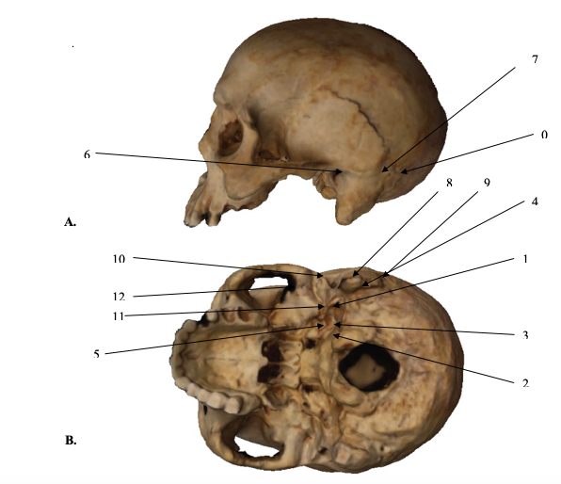
1
2
3
4
5
6
7
8
9
10
11
12
13
Landmark number | Anatomical point
1 | Asterion
2 | Base of styloid process
3 | Most medial point of the jugular fossa
4 | Most lateral point of the jugular fossa
5 | Proximal origin of the juxtamastoid crest
6 | Carotid canal
7 | Auriculare
8 | Parietal notch
9 | Tip of mastoid process
10 | Distal point on the juxtamastoid crest
11 | Deepest point of lateral margin of the articular eminence
12 | Most inferior point on the the entoglenoid process
13 | Suture between the temporal and zygomatic bones on the inferior aspect of the zygomatic process

Figure 1. Landmarks used in the analysis based on Harvati & Weaver (2006). A) Lateral view of the cranium. B) Inferior view of the cranium

RESULTS

Analysis 1
Seven PCs, accounting for 5% or more of the total shape variation, described a total of 77.6% of the shape variance. The cross-validated DFA found a mean accuracy rate of 84.7% of correctly classifying individuals into their population groups (Poundbury = 75% accuracy, Portmahomack = 94.4%), based on the seven retained PCs. This suggests that Portmahomack individuals are more homogenous than Poundbury individuals. The results of the MANOVA found that the differences in temporal shape between two populations was statistically significant (λ 0.116, F=28.424, p<0.0001).

Figure 2 depicts the PCA scatter-plot when PC1, which accounts for 19.2% of the total shape variation, is plotted against PC2, which accounts for 15.5%. Overall, Poundbury individuals score negatively on PC1and PC2, while Portmahomack individuals score more positively. The wireframes illustrate that the main shape difference between the populations is the relative location of the asterion and projection of the mastoid process. In particular, when compared to individuals from Portmahomack, Poundbury individuals tend to exhibit relatively taller, medially translated mastoid processes, more dorsally and superiorly located asterions, and relatively longer and narrower petrous pyramids.

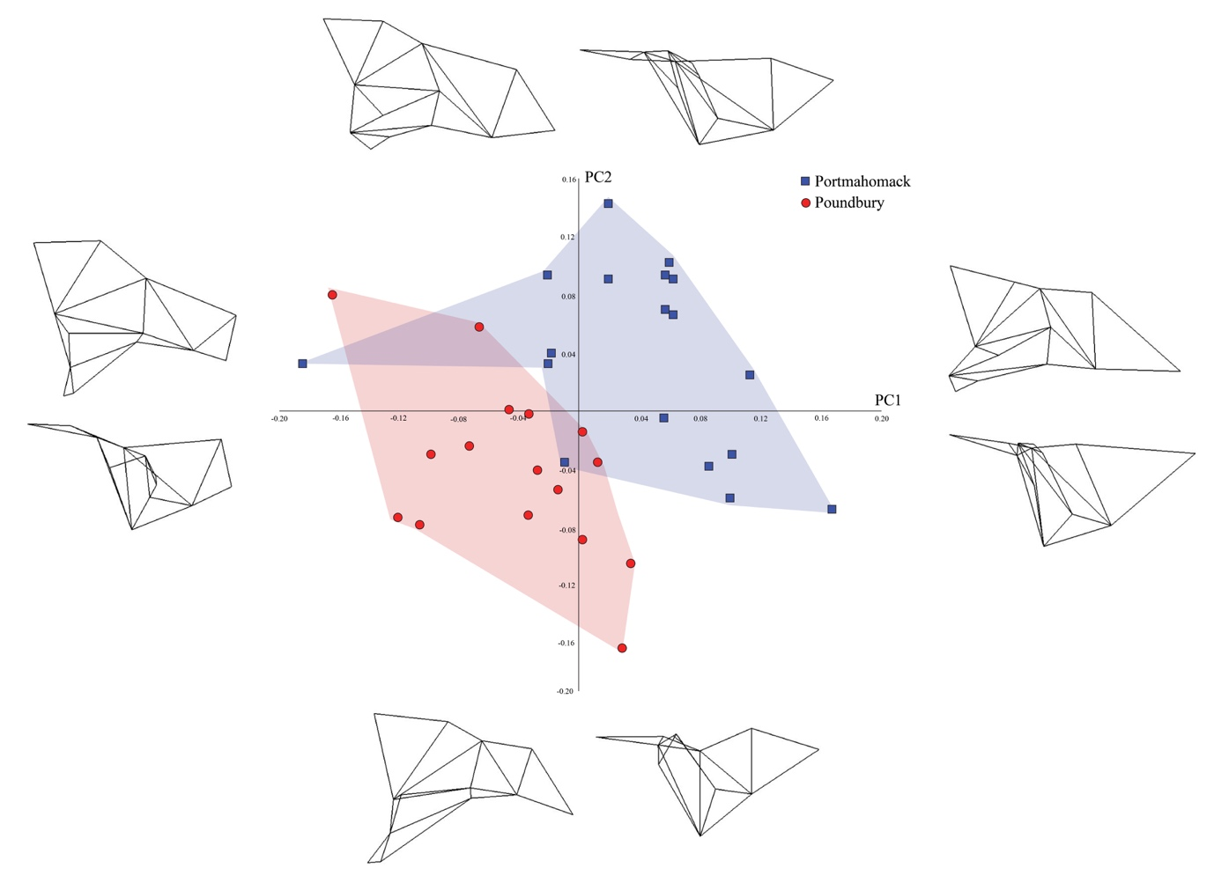
8
8
8
1
1
1
1
13
13
13
13
11
11
11
11
10
10
10
10
1
1
1
1
9
9
9
9
8

Figure 2. A PCA scatter plot highlighting the shape differences between Portmahomack and Poundbury along PC1 and PC2. This chart accounts for 19.2% of the total variation in the sample. Wireframes at the end of each PC axis demonstrate the visible shape differences with the top image representing an inferior view of the basicranium and the bottom image representing a lateral view.

Analysis 2
For the analysis on only 12 landmarks, the first seven PCs were found to account for 5% or more of the total shape variance, for a combined total of 78.1%. The DFA found that individuals can be correctly classified to population with a mean accuracy of 65.7% (Poundbury = 57.8% accuracy, Portmahomack = 73.6%). The classification bias revealed in Analysis 1 is mirrored in Analysis 2, with Poundbury individuals showing more heterogeneity than Portmahomack. The MANOVA found that the differences between the populations was statistically significant (λ 0.336, F=8.462, p<0.0001). Figure 3 illustrates the shape differences accounted for on PC1 and PC2 through wireframe deformations. The main shape differences between the two populations are similar to those identified in Figure 2, but without the differences associated with the mastoid process. Additionally, Poundbury individuals tend to have more inferiorly located styloid processes and juxtamastoid crests than those from Portmahomack.

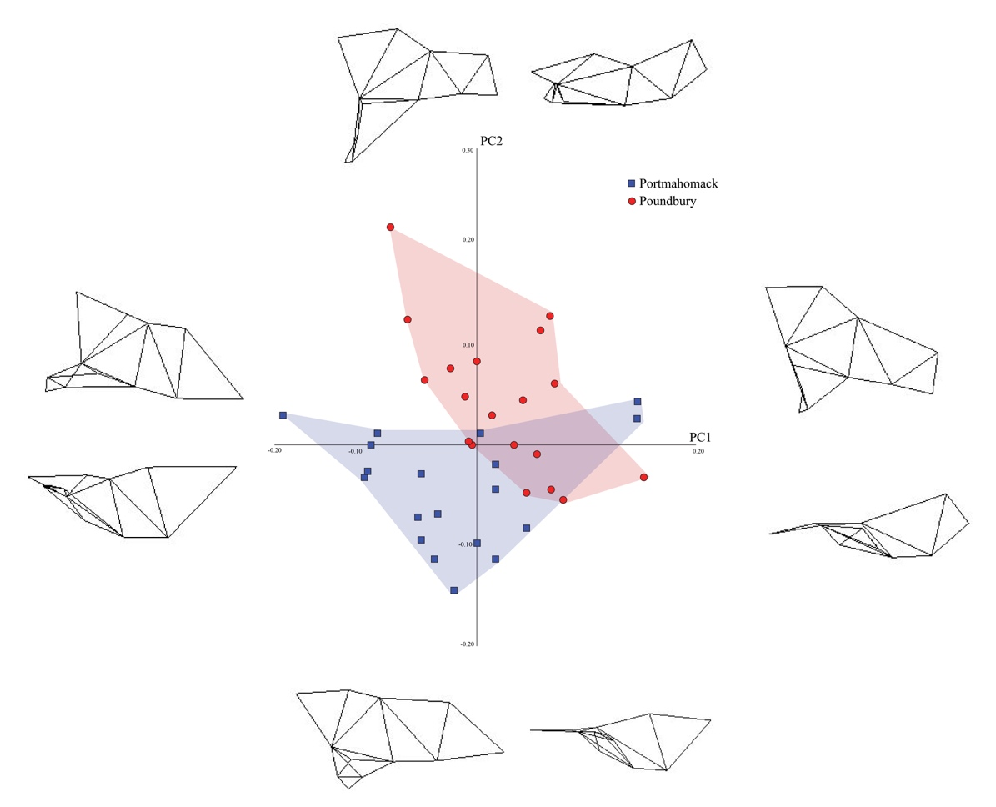
1
1
1
1
1
1
1
1
11
11
11
11
13
13
13
10
10
10
10
13
8
8
8
8
Figure 3. PC1 (x axis) and PC2 (y axis) charts the shape variance for both populations. Red circles represent Poundbury and blue circles represent Portmahomack. This chart accounts for 36.368% of the total variance. Wireframes at the end of each PC axis demonstrate the visible shape differences with the top image representing an inferior view of the basicranium and the bottom image representing a lateral view.

DISCUSSION AND CONCLUSIONS

This study aimed to test whether the shape of the basicranial portion of the temporal bone can accurately distinguish between the crania of relatively closely-related human populations. The results of our first analysis indicate that the shape of the basicranium was indeed effective in distinguishing between individuals from Portmahomack and Poundbury, as the MANOVA found statistically significant differences between the populations. Additionally, we found that the shape of the temporal bone can accurately determine population affiliation, with 84.7% of individuals being correctly classified into population based on a cross-validated DFA. Therefore, our study not only supports the findings of Harvati and Weaver (2006b), but it also indicates that the shape of the temporal bone may be able to accurately identify population-level differences between relatively closely-related populations.

In addition, the results of Analysis 2 are also important, as they indicate that even when the temporal bone is damaged and the mastoid process is missing, the differences between the populations are statistically significant. However, a lower 65.7% rate of correctly classifying individuals into their population group was recorded for Analysis 2. This suggests that damaged or corroded crania have the potential to produce results that distinguish between closely-related populations with a lower level of accuracy. Since the accuracy did change from Analysis 1 to Analysis 2, the findings suggest that the height of the mastoid process is particularly useful for identifying population differences and should be included in landmark configurations when possible. This result might also suggest that the shape of the temporal bone is less differentiated, and it is the inclusion of the mastoid process into the landmark configuration that is significantly influencing the results. Preservation biases and limitations in the archaeological record usually render missing landmarks unavoidable; however, if the mastoid process is well-preserved then it should be included in order to improve the accuracy of identifying population differences with the temporal bone, as suggested by the results of Analysis 2.

The findings have significance for both archaeological and forensic research, as they indicate that a small portion of the cranium, the temporal bone, can be used to accurately determine population affinity. Therefore, the shape of the temporal bone may be particularly useful in this regard and could become part of a standardized method for future archaeological and anthropological research aiming to identify morphological differences between population groups, if a large open-access database of crania is made available. Considering that only a relatively small fragment of the crania can be used to produce this landmark configuration for GM analyses, these findings are particularly useful in archaeological or forensic situations.

Whilst temporal bone shape was found to be an accurate method of distinguishing morphological differences between populations, there are limitations to what these results can reveal for archaeological research. First, the sample size in this study was small and included only two populations, and therefore the results may not be representative, as small sample sizes are more likely to produce classification errors (Raudys & Jain, 1991). In this sense, the small sample size may reflect a trend produced by morphological biases in the specimens as opposed to reflecting a trend present in the whole population. The results of this project however could provide the foundation for larger studies which should incorporate more individuals from multiple populations. In addition to this, future research could look at both sexes (as the current study only examined males) to test the effect of sexual dimorphism on the accuracy of this study. Further studies may also want to build upon this project by testing the effect of individual landmarks on the accuracy of population group determination. This paper looked specifically at the temporal bone and found that the mastoid process slightly affected the accuracy of the results due to preservation biases. It might therefore be of interest to see whether any other of Harvati and Weaver’s (2006b) landmarks have a similar effect. It may be useful to archaeologists and forensic anthropologists to find the minimum number of landmarks that can be used to identify population differences in the temporal bone, as differences in preservation in skeletal remains may produce slight partiality between samples. In addition, whilst this study found evidence to suggest that the temporal bone can be used to accurately distinguish between more closely-related populations than those that have diverged deep in prehistory, there is currently no independent genetic data that confirms how closely related the groups in the study are. Further research should look at replicating the results on genetically known closely-related populations. Overall, despite these limitations, the results of this project support the use of basicranial shape to identify population differences between relatively closely-related populations

Acknowledgments:

We thank the editor and two anonymous reviewers for their valuable insights and suggestions on an earlier version of this paper. We would also like to thank the Tarbat Discovery Centre, Martin Carver, and the National Museum of Natural History for access to collections. Data collection for this project was funded by Marie Skłodowska-Curie Actions (SAR10359).

REFERENCES:

AgiSoft PhotoScan Professional (Version 1.4.3) (Software). (2018). Retrieved from http://www.agisoft.com/downloads/installer/

Baylac, M. and Frieβ, M. (2005). Fourier descriptors, Procrustes superimposition, and data dimensionality: an example of cranial shape analysis in modern human populations. In: Slice D. (Ed), Modern Morphometrics in Physical Anthropology, Part 1 Theory and Methods. Kluwer, New York, pp. 145-165.

Bookstein, F. l. (1991). Morphometric Tools for Landmark Data: Geometry and Biology. Cambridge: Cambridge University Press

Cardini, A., Nagorsen, D., O’Higgins, P., Polly. P.D., Thorington, R.W. and Tongiori, P. (2009). Detecting biological distinctiveness using geometric morphometrics: an example case from the Vancouver Island Marmot. Ethology, Ecology & Evolution 21:209-223

Carey, J.W. and Steegmann, A.T. (1981). Human nasal protrusion, latitude and climate. American Journal of Physical Anthropology. 56(3):313-9

Collard, M. & Wood, B. (2007). Hominin homiology: an assessment of the impact of phenotypic plasticity on phylogenetic analyses of humans and their fossil relatives. Journal of Human Evolution 52:573-584

Evin, A., Souten, T., Hulme-Beaman, H., Ameen, C., Allen, R., Viacava, P., Larson, G., Cucchi, T. and Dobney, K. (2016) The use of close-range photogrammetry in zooarchaoelogy: creating accurate 3D models of wolf crania to study dog domestication. Journal of Archaeological Science: Reports. 9(1):87-93

Franciscus, R. G. & Long, J. C. (1991). Variation in human nasal height and breadth. American Journal of Physical Anthropology. 85:419-427

Gunz, P., Bookstein, F.L, Mitteroecker, P., Stadlmayr, A., Seidler, H. and Weber, G.W. (2009). Early modern human diversity suggests subdivided population structure and a complex out-of-Africa scenario. Proceedings of the National Academy of Sciences of the United States of America. 106(15):6094-6098

Harvati K. & Weaver, T.D. (2006a). Reliability of cranial morphology in reconstructing Neanderthal phylogeny. In: Harvarti, K. Harrison, T. (eds.) Neanderthals Revisited: New Approaches and Perspectives. Dordrecht: Springe

Harvati, K. & Weaver, T.D. (2006b). Human cranial anatomy and the differential preservation of population history and climate signatures. The Anatomical Record 288(12):1225-1233
Hennessy, R.J. & Stringer, C.B. (2002). Geometric morphometric study of the regional variation of modern human craniofacial form. American Journal of Physical Anthropology 117(1):37-48

Hoss, M., Jaruga, P, Dizdaroglu, T.H. and Paabo., S. (1996). DNA damage and DNA sequence retrieval from ancient tissues. Nucleic Acids Research. 24(1):1304-1307

Howells, W.W. (1973). Cranial variation in man. A study by multivariates analysis of patterns of difference among recent human populations. Cambridge: Harvard University Press

Howells WW. 1989. Skull Shapes and the Map. Cambridge, MA: Peabody Museum of Archaeology and Ethnology, Harvard University

Hubbe, M., Hanihara, T. and Harvati, K. (2009). Climate signatures in the morphological differentiation of worldwide modern human populations. The Anatomical Record (Hoboken). 292:1720-1733

Humphries, A.L. and Ross, A.H. (2011). Craniofacial sexual dimorphism in two Portuguese skeletal samples. Anthropologie. 49(1):13-20

International HapMap Consortium. (2003). The International HapMap Project. Nature. 426(1):789-794

Klingenberg, C.P. (2016). Size, shape and form: concepts of allometry in geometric morphometrics. Development Genes and Evolution 226:113-137

Legendre, P. & Legendre, L. (1998). Numerical ecology: developments in environmental modelling 20. Amsterdam: Elsevier Publishing

Mathieson, I. and McVean, G. (2014). Demography and the age of rare variants. PLoS Genetics. 10(8):1-11

Morozova, I. et al. (2016). Toward high-resolution population genomics using archaeological samples. DNA Res. 23(3):295-310

Noback, M. L. & Harvati, K. (2015). The contribution of subsistence to global human cranial variation. Journal of Human Evolution 80:34-50

Novembre, J. and Peter, B.M. (2016). Recent advances in the study of fine-scale population structure in humans. Current Opinion in Genetics and Development. 41(1):98-105

O’Higgins, P. & Jones, N. (1998). Facial growth in Cercocebus torquatus: an application of three- dimensional geometric morphometric techniques to the study of morphological variation. Journal of Anatomy 193:251-272.

Olson, T.R. (1981). Basicranial morphology of the extant hominoids and Pliocene hominids: the new material from the Hadar Formation, Ethiopia and its significance in early human evolution and taxonomy. In: Stringer, C. B. (ed.), Aspects of human evolution. London: Taylor and Francis

Patterson, N.J., Moorjani, P., Luo, Y., Mallick, S., Rohland, N., Zhan, Y., Genschoreck, T., Webster, T., and Reich, D. (2012). Ancient admixture in human history. Genetics. 192(3):1065-1093

Perez, S.I. & Monteiro, L.R. (2009). Nonrandom factors in modern human morphological diversification: a study of craniofacial variation in southern South American peoples. Evolution 63(4):978–993

Perez, S.I., Bernal, V. and Gonzalez, P.N. (2007). Morphological differentiation of aboriginal human populations from Tierra del Fuego (Patagonia): implications for South American peopling. American Journal of Physical Anthropology 133(4):1067-1079

Raudys, S.J. and Jain, A.K. (1991). Small sample size effects in statistical pattern recognition: recommendations for practitioners. IEEE Transactions on Pattern Analysis and Machine Intelligence. 13(3):252-264

Relethford, J.H. (2004). Boas and beyond: migration and craniometric variation. American Journal of Human Biology 16(4):379–386

Reyes-Centeno, H. et al. (2017). Genomic validation of the differential preservation of population history in modern human cranial anatomy. American Journal of Physical Anthropology. 162(1):170-179

Rogers, T.L. (2005). Determining the sex of human remains through cranial morphology. Journal of Forensic Science 50(3):493-500

Roseman, C.C. (2004). Detection of inter-regionally diversifying natural selection on modern human cranial form by using matched molecular and morphometric data.
Proceedings of the National Academy of Sciences in the United States of America.101(35):12824-12829

Slice, D.E. (2007). Geometric morphometrics. Annual Review of Anthropology 36:261-281

Smith, H.F., Ritzman, T., Otarola-Castillo, E. and Terhune, C.E. (2013). A 3D geometric morphometric study of intraspecific variation in the ontogeny of the temporal bone in modern Homo sapiens. Journal of Human Evolution 65(5):479-489

Spradley, M.K. & Jantz, R.L. (2016). Ancestry estimation in forensic anthropology: geometric morphometric versus standard and nonstandard interlandmark distances. Journal of Forensic Science 61(4):892-897

SPSS Inc. (2016). SPSS Base 8.0 for Windows User’s Guide. Chicago: SPSS Inc.

The 1000 Genomes Consortium. (2012). An integrated map of genetic variation from 1,092 human genomes. Nature. 491(1):56-65
Viðarsdóttir, U.S., O’Higgins, P., and Stringer, C. (2002).A geometric morphometric study of regional differences in the ontogeny of the modern human facial skeleton. Journal of Anatomy 201(3):211-229

von Cramon-Taubadel, N. (2009). Revisiting the Homiology Hypothesis: The impact of phenotypic plasticity on the reconstruction of human population history from craniometric data. Journal of Human Evolution 57(2):179-90

von Cramon-Taubadel, N. (2014). The microevolution of modern human cranial variation: implications for hominin and primate evolution. Annals of Human Biology 41(4):323-13

Webster, M. & Sheets, D.H. (2010). A practical introduction to landmark-based geometric morphometrics. Quantitative Methods in Paleobiology 16:163-188

White, J.W., & Ruttenberg, B.I. (2007). Discriminant function analysis in marine ecology: some oversights and their solutions. Marine Ecology Progress 329:301-305

Wiley. (2006). Landmark Editor Version 3.6: Institute for Data Analysis and Visualization

Wood, B. & Lieberman, D.E. (2001). Craniodental variation in Paranthropus Boisei: a developmental and functional perspective. American Journal of Physical Anthropology. 116:13-25
Zelditch, M.L., Swiderski, D.L., Sheets, H.D. and Fink, W.L. (2004). Geometric morphometrics for biologists: a primer. London: Elsevier Academic Press.

