Effects of dapagliflozin on development and progression of kidney disease in patients with type 2 diabetes: Analysis from DECLARE-TIMI 58 trial

Ofri Mosenzon¹, Stephen D. Wiviott², Avivit Cahn¹, Aliza Rozenberg¹, Ilan Yanuv¹, Erica L. Goodrich², Sabina A. Murphy², Hiddo J.L. Heerspink³, Thomas A. Zelniker², Jamie P. Dwyer⁴, Deepak L. Bhatt², Lawrence A. Leiter⁵, Darren K. McGuire⁶, John P.H. Wilding⁷, Eri T. Kato⁸, Ingrid A. M. Gause- Nilsson⁹, Martin Fredriksson⁹, Peter A. Johansson⁹, Anna Maria Langkilde⁹, Marc S. Sabatine², Itamar Raz¹

¹ Hadassah Hebrew University Hospital, Jerusalem, Israel
² TIMI study Group, Brigham and Women's Hospital, Boston MA USA
³ University Medical Center Groningen, Groningen, Netherlands
⁴ Vanderbilt University Medical Center, Nashville TN USA
⁵ Li Ka Shing Knowledge Institute, St. Michael's Hospital, University of Toronto, Toronto, ON Canada
⁶ University of Texas Southwestern Medical Center, Dallas, Texas USA
⁷ University of Liverpool, Liverpool UK
⁸ Kyoto University Graduate School of Medicine, Kyoto Japan
⁹ AstraZeneca, Molndal Sweden

Word Counts:
Abstract: 305
Manuscript total word count: 3,904

Research in context:

Evidence before this study:

Prior trials have shown that the sodium-glucose co-transporter-2 inhibitors (SGLT2i) empagliflozin and canagliflozin slowed the progression of nephropathy in patients with type 2 diabetes. However, most of the patients in these trials had established atherosclerotic cardiovascular disease (ASCVD) and/or high prevalence of mild to moderate chronic kidney disease.

Added value of this study:

This analysis is the first to show the effects of the SGLT2i dapagliflozin on clinically important renal outcomes and on change in eGFR in a large and broad cohort of patients with type 2 diabetes with or without previous ASCVD and most of whom had normal or only mildly reduced renal function. Thereby, we are able to demonstrate the effect of a SGLT2i on early prevention of chronic kidney disease in patients with type 2 diabetes.

Implications of all the available evidence:

On the basis of available evidence, SGLT2i are expected to reduce the risk of both progression and development of nephropathy in patients with type 2 diabetes, regardless of prevalence of ASCVD, or baseline renal dysfunction. The effect of SGLT2i on nephropathy is being examined in dedicated studies of renal outcome, both in patients with and without type 2 diabetes, however these trials focus on populations of patients with nephropathy at baseline and therefore should be seen as complementary.

Abstract:

Background
Sodium glucose co-transporter 2 inhibitors (SGLT2i) have shown beneficial effects on renal outcomes primarily in patients with established atherosclerotic cardiovascular disease (ASCVD). We report renal outcomes of treatment with dapagliflozin vs. placebo in the DECLARE-TIMI 58 trial which included patients with type 2 diabetes (T2D) primarily with preserved renal function and without ASCVD.

Methods
DECLARE-TIMI 58 enrolled patients with creatinine clearance of ≥60 ml/min, randomized to treatment with dapagliflozin 10 mg/day vs. placebo. The pre-specified primary composite renal outcome (PCRO) was: sustained 40% eGFR decline to < 60 ml/min/1.73m², end-stage renal disease (ESRD) (defined as dialysis ≥90 days, kidney transplantation, confirmed sustained eGFR <15ml/min/1.73 m²), or death from renal or cardiovascular causes; the same outcome without cardiovascular death was the secondary composite renal outcome (SCRO).

Results
Out of 17,160 subjects randomized, 8,162 (47.6%) had eGFR >90, 7,732 (45.1%) had eGFR 60-<90 and 1,265 (7.4%) had eGFR <60 ml/min/1.73m², median follow-up was 4.2 yrs.
PCRO occurred in 370 (4.3%) vs. 480 (5.6%) in dapagliflozin and placebo arms, respectively [HR 0.76 (0.67, 0.87) p<0.001]. SCRO occurred in 127 (1.5%) vs. 238 (2.8%) in dapagliflozin and placebo arms, [HR 0.53 (0.43 to 0.66) p<0.001]. These differences included a 46% reduction in sustained 40% eGFR decline to < 60 ml/min/1.73m²: 120 (1.4%) vs. 221 (2.6%) in dapagliflozin and placebo arms [HR 0.54 (0.43, 0.67) p<0.001]. Although rare, there were lower rates of ESRD and renal death: 11 (0.1%) vs. 27 (0.3%) in dapagliflozin and placebo arms [HR 0.41 (0.20, 0.82) p=0.012]. Acute kidney injury was less common in dapagliflozin (1.5%) vs. placebo arm (2.0%) (p=0.002).

Conclusion
Dapagliflozin appeared to prevent and reduce progression of kidney disease compared to placebo. This was demonstrated in a large and broad population of patients with T2D, most of them without ASCVD and with preserved renal function.

Funded by AstraZeneca; DECLARE–TIMI 58 ClinicalTrials.gov number, NCT01730534.

Introduction:
For many years the cornerstone of treatment of diabetic kidney disease (DKD) consisted of angiotensin converting enzyme inhibitors (ACEi) or angiotensin receptor blockers (ARB)^{1,2} in combination with optimal blood pressure and glucose control³⁻⁵. Early identification and appropriate interventions are more effective to prevent adverse renal outcomes than late intervention³. Despite treatment with ACEI/ARB, the residual risk for both adverse renal and cardiovascular outcomes amongst patients with T2D compared to their non-diabetic age and sex matched counterparts is high^{4,5} and diabetes is still the leading cause for ESRD in most parts of the world^{6,7}. Novel treatments are therefore desired to address the unmet need of both prevention and halting the progression of chronic kidney disease (CKD) amongst patients with T2D.
Sodium glucose co-transporter inhibitors (SGLT2i) are a newer class of drug that have been shown to decrease the rate of renal function decline in patients with type 2 diabetes and cardiovascular disease. In the EMPA-REG outcome trial⁸ treatment with the SGLT2i empagliflozin reduced the risk of the primary composite renal outcome by 39%. This reduction was demonstrated in a high-risk population of patients who all had previous atherosclerotic cardiovascular disease (ASCVD) and high prevalence of chronic kidney disease (baseline median eGFR= 74.1 ml/minute/1.73 m² with 25% with eGFR 30-60 ml/minute/1.73 m2 and 40% with microalbuminuria or macroalbuminuria at baseline⁹).
In the Canagliflozin Cardiovascular Assessment Study (CANVAS) program^{10–12}, the SGLT2i canagliflozin improved renal outcomes in a population of patients with predominantly ASCVD¹² Most recently, the Canagliflozin and Renal Events in Diabetes with Established Nephropathy Clinical Evaluation (CREDENCE) trial randomized patients with type 2 diabetes and albuminuric chronic kidney disease (eGFR 30 to <90 ml/minute/1.73 m² and UACR >300 to 5000 mg/g) to canagliflozin vs. placebo¹³. The primary composite outcome of: end-stage renal disease (ESRD) (dialysis, transplantation, or a sustained estimated GFR of <15 ml/minute/1.73 m²), doubling of the serum creatinine level, or death from renal or cardiovascular causes was reduced by 30% with canagliflozin treatment¹³.
The Dapagliflozin Effect on Cardiovascular Events (DECLARE)-TIMI 58 trial showed that the SGLT2i dapagliflozin decreased one of the dual primary composite outcomes, that of CV death or hospitalization for heart failure (HF), and was non-inferior for the other: major adverse cardiovascular outcome (MACE). This was demonstrated in patients with T2D and either established ASCVD (40.6%) or multiple risk factors (MRF) for CV disease (59.4%)¹⁴.
Herein we report the findings of the predefined renal outcomes in the DECLARE-TIMI 58 trial, and provide new insights into the role of SGLT2i in the treatment of patients with T2D with and without known ASCVD and relatively normal renal function.

METHODS

Study Design, trial population, intervention and CV outcomes:
DECLARE TIMI-58 trial design, baseline characteristics and main results were previously reported^{14–16}. Briefly, the trial enrolled patients with T2D and either established ASCVD (age ≥ 40 and either ischemic heart disease, cerebrovascular disease or peripheral arterial disease), or MRF for ASCVD ( age ≥ 55 years for men or ≥ 60 years for women plus at least one of the following risk factors: dyslipidemia, hypertension or current tobacco use). Enrollment criteria included patients with HbA1c 6.5-12% and creatinine clearance (estimated by Cockcroft-Gault equation¹⁷) above 60 ml/min. Patients were randomly assigned in a double-blinded fashion to dapagliflozin 10 mg once daily or matching placebo, on top of standard-of-care therapy for T2D, CV diseases, and risk factors. Randomization was stratified by CV risk category (established ASCVD vs MRF for ASCVD) and baseline hematuria status (due to regulatory requirement to investigate the risk for bladder cancer). The trial's dual primary efficacy endpoints (changed during the trial in agreement with regulatory agencies and before unblinding) were: MACE (the composite of CV death, MI or ischemic stroke) and the composite of CV death or HF hospitalizations. The two secondary outcomes were (changed during the trial in agreement with regulatory agencies and before unblinding) the primary composite renal outcome (specified below) and all cause death. Since the trial met only one of its dual primary outcomes for superiority (CV death/HF hospitalization) all other analyses of additional outcomes should be considered hypothesis-generating.

Renal data collection and Predefined Renal Outcomes
Laboratory tests including both serum creatinine and urinary albumin to creatinine ratio (UACR) were collected and measured by Covance central laboratories services at screening, baseline, 6 and 12 months and once a year therafter. Serum creatinine and UACR were also measured at the end of treatment visit for patients who permanently discontinued study drug and at the end of trial visit for patients who did not have earlier end of treatment visit.
According to protocol, unscheduled creatinine testing was done, either centrally or locally, when any of the following occurred based on central or local lab results: doubling of serum creatinine from baseline; serum creatinine >6.0 mg/dL (530 µmol/L); a decrease in eGFR of ≥30% from baseline to eGFR <60 ml/min/1.73m²; and/or an eGFR value of <15 ml/min/1.73m². In these instances, a new central laboratory measurement of serum creatinine was obtained at the earliest possible time (within 4 days whenever possible) and another central laboratory measurement of serum creatinine was obtained after at least four weeks. If the creatinine clearance (CrCl, based on Cockroft-Gault) fell below 45 ml/min, the patient was scheduled for a re-test within 4 days whenever possible. If at any time the patient´s CrCl (based on Cockroft-Gault) fell below 30 ml/min calculated at the central laboratory and confirmed at a repeated central laboratory measurement, the patient was discontinued from the investigational product (IP). The baseline value of each safety laboratory test was defined as the last assessment on or before the date of randomization and change from this baseline was calculated. Time to onset of the outcomes was calculated according to the first of the two subsequent laboratory assessments.
The primary composite renal outcome was previously reported¹⁴ and defined as: time to first event of composite of sustained confirmed decrease of eGFR by at least 40 % (calculated by Chronic Kidney Disease Epidemiology Collaboration equation (CKD-EPI) and defined as confirmed on two tests at the central laboratory at least 4 weeks apart)¹⁸ to eGFR<60 ml/min/1.73 m², and/or end-stage renal disease (ESRD) (defined as either dialysis for 90 days or more, kidney transplantation or sustained (defined as two tests at the central laboratory at least 4 weeks apart) eGFR of <15 ml/min/1.73 m²), and/or CV or renal death. The secondary composite renal outcome was the same as the primary composite renal outcome without CV death and was also previously reported¹⁴. The primary composite renal outcome represents the renal outcome with it's main competing event - CV death, while the secondary composite renal outcome is the renal specific outcome. The components of the primary and secondary composite renal outcomes were prespecified exploratory endpoints. All analyses and all subgroups presented in this manuscript were predefined in the statistical analysis plan (SAP) or in the academic SAP of the DECLARE-TIMI 58 trial, and only the primary and secondary outcomes in the entire trial population were previously presented¹⁴.
Renal adverse events were predefined adverse events (AE) of special interest and were therefore collected throughout the trial. AEs of special interest in this study fell into the following categories: suspect neoplasm (benign, malignant or unspecified), hepatic events, major hypoglycemic events, fractures, renal events, symptoms of volume depletion, hypersensitivity reactions [serious or led to discontinuation of investigational product (IP)], urinary tract infections (serious or led to discontinuation of IP) and genital infections (serious or led to discontinuation of IP). CV and renal death were adjudicated by an independent CEC. Renal adverse events were based on predefined preferred term lists and were coded using MedDRA version 21.0. Renal adverse events were collected in the safety analysis set (defined as: all patients who received at least 1 dose of randomized dapagliflozin or placebo and who have data observed at any time after first randomized dose till the end of the study) and on treatment: if they occurred after the first dose of the study drug to the earlier of 30 days (for serious adverse event) or 7 days (for non-serious adverse event) after the last dose of the study drug or the closing visit. Acute kidney injury (AKI) was one of the preferred MedDRA terms used, AKI cases were not adjudicated.

Statistical Analysis
In this analysis patients are presented based on their baseline eGFR categories according to CKD-EPI formulation classified into eGFR>90 mL/min/1.73m², 60-<90 mL/min/1.73m² and <60 mL/min/1.73m². Baseline characteristics were reported as absolute numbers and percentages for categorical variables and as mean and standard deviation (SD) for continuous variables. They were compared using the chi-square test for categorical and Kruskal-Wallis test for continuous variables.
Analyses were performed according to the intention-to-treat principle with the use of adjudicated events. Safety analysis, including renal adverse events (including acute kidney injury), were performed in the safety analysis set. Kaplan-Meier (KM) method was used to estimate cumulative incidence curves for the primary and secondary composite renal outcomes and selected components. Event rates are reported as n/N. Hazard ratios (HR) and 95% confidence intervals were calculated using the Cox proportional hazard model for the primary and secondary composite renal outcomes and their components for the entire population as well as by pre-specified subgroups according to the patients' demographics, medical history, background medications and baseline measurements with corresponding interaction p-values presented. Treatment effect models included the stratification factors of baseline ASCVD category (established ASCVD or multiple risk factors for ASCVD) and the presence or absence of hematuria at baseline. The change in eGFR was calculated using a mixed model for repeated measures, presenting least square mean estimators and 95% CI by treatment arms, for the entire trial population by eGFR categories at baseline: eGFR>90 mL/min/1.73m², eGFR 60-<90 mL/min/1.73m² and eGFR<60 mL/min/1.73m².
No adjustment for multiplicity was performed. The statistical programs used for the analysis were SAS version 9.3 (SAS Institute Inc., Cary, North Carolina) and Stata version 14.2 (StataCorp, College Station, Texas).

Results:
Of the 17,160 participants at baseline, 8,162 (47.6%) had eGFR>=90 mL/min/1.73m², 7,732 (45.1%) subjects had eGFR 60-<90 mL/min/1.73m² and 1,265 (7.4%) subjects had eGFR<60 mL/min/1.73m² (eGFR was missing for one patient) reflecting the enrollment criteria. Due to the difference between creatinine clearance (estimated by Cockcroft-Gault equation¹⁷) and eGFR calculations (estimated by CKD-EPI##), and due to fact that inclusion criteria were applied at the screening visit while baseline eGFR was from the randomization visit, there were 1,265 participants who entered the trial with eGFR<60 mL/min/1.73m². Mean (SD) eGFR of the entire trial population was 85.2 (15.9) mL/min/1.73m²; 98.3 (6.5) in the >=90 mL/min/1.73m² subgroup, 77.0 (8.5) in the 60-<90 mL/min/1.73m² subgroup and 51.4 (7.2) mL/min/1.73m² in the <60 mL/min/1.73m² subgroup. (Table 1).
At baseline there were 11,644 (69%) patients with normo-albuminuria (UACR <30 mg/g), 4,030 (24%) with microalbuminuria (UACR ≥30 to ≤300 mg/g); and 1,169 (7%) with macroalbuminuria (UACR >300 mg/g).
Patients’ characteristics were compared according to baseline eGFR categories (Table 1) and according to treatment arms in the different eGFR categories (Table S1). Participants with lower eGFR were older, with longer diabetes duration and higher BMI. Patients in the lower eGFR categories had higher prevalence of previous ASCVD, history of heart failure and cardiovascular risk factors (such as HTN and hyperlipidemia). Consistently, the use of different CV medications, including anti-coagulants, anti-platelets, beta-blockers, calcium channel blockers, statins, diuretics and mineralocorticoid antagonists was more common in the lower eGFR categories. ACEi/ARB use ranged from 78.8% in the eGFR>90 mL/min/1.73m² group to 86.7% in the eGFR<60 mL/min/1.73m² group. The distribution of glucose lowering agents amongst the different eGFR sub-groups was more diverse with less use of metformin and sulphonylurea in the lower eGFR subgroups, and more frequent use of insulin. Patients in the lower eGFR subgroups had lower HbA1c and LDL cholesterol at baseline. As expected, patients with lower eGFR had also higher albuminuria rates.
The primary composite renal outcome (Figure 1) was 24% lower in patients treated with dapagliflozin compared to placebo (HR=0.76 95% CI 0.67-0.87, p<0.001) (Figure 2A). A sensitivity analysis using a decrease in eGFR of ≥40% to eGFR <60 mL/min/1.73m² performed 90 days instead of 4 weeks after the first test (according to chronic kidney disease definition) demonstrated a significant reduction in the primary composite outcome with dapagliflozin vs placebo (HR=0.76 95% CI 0.66-0.88, p<0.001). An additional sensitivity analysis done using a one-time decrease in eGFR of ≥40% to eGFR <60 mL/min/1.73m² without requirement of confirmation by repeated testing also demonstrated a significant reduction in the primary composite outcome with dapagliflozin vs placebo (HR=0.77 95% CI 0.70-0.85, p<0.001). Both of these sensitivity analyses yielded similar results to the pre-specified secondary composite renal outcome.
The secondary composite renal outcome, which is the renal specific outcome after exclusion of CV death, was 47% lower in the dapagliflozin arm (HR=0.53, 95% CI 0.43-0.66, p<0.001) (Figure 2B). This improvement included a 46% reduction in the risk of sustained confirmed decrease in eGFR of ≥40% to eGFR <60 mL/min/1.73m² (HR=0.54, 95% CI 0.43-0.67 p<0.001), with 120 (1.4%) vs. 221 (2.6%) events (Figure 2C). Additionally, the number of the rare but the clinically important combined events of ESRD or renal death was 11 vs. 27 events (HR 0.41. 95% CI 0.20-0.82, p=0.012) in the dapagliflozin vs. placebo arm, respectively.
We analysed the primary (Figure S1 A-D) and secondary (Figure 3) composite renal outcomes according to pre-specified subgroups by patient's demographics, medical history, background medication and baseline laboratory measurements. There was no statistically significant interaction between most subgroups and the positive effect of dapagliflozin on both composite renal outcomes. Specifically, there was no difference between the ASCVD strata vs. the multiple risk factors for CVD strata, both for the primary composite renal outcome (p value for interaction=0.719), and for the secondary composite renal outcome (p value for interaction=0.668) (Figures S1 B and 3). The exception was an interaction between treatment arms and UACR categories on the primary composite renal outcome but not the secondary composite renal outcome. There was also an interaction between treatment arms and diuretic use on the secondary composite renal outcome (p value for interaction=0.002), though benefit was observed with and without diuretics, the positive effect of dapagliflozin appeared to be greater in patients not taking diuretics at baseline.
We compared the adjusted mean change in eGFR over time in the two treatment arms for the overall population and by eGFR subgroups (Figure 4 A-D). In the entire population and in all eGFR subgroups the mean decrease in eGFR in the dapagliflozin arm was equal to the decrease in the placebo arm by year two; and was smaller than at the placebo arm at year 4.
There were fewer patients with events reported as acute kidney injury in the dapagliflozin group compared with the placebo group: 125 and 175, respectively (HR 0.69, 95% CI 0.55-0.87, p=0.002), of which 67 and 101 were reported as serious adverse events.
Discussion:
In the DECLARE-TIMI 58 trial, patients randomized to dapagliflozin had considerable improvement in clinically significant renal outcomes. This includes a 24% and 47% decrease in the risk for the primary and secondary composite renal outcomes respectively (time to first event of sustained decrease of eGFR by ≥40 % to eGFR<60 ml/min/1.73 m², and/or ESRD, and/or renal death with or without CV death). They also showed marked improvement in the components of sustained decrease of eGFR by ≥40 % and ESRD. ESRD was a rare event in the DECLARE-TIMI 58 trial, as expected in a population with high baseline eGFR, yet the incidence was significantly reduced by dapagliflozin. These benefits occurred in a large and broad population of patients with T2D irrespective of the presence of ASCVD. Almost half of the patients (47.6%) had preserved renal function at baseline (eGFR>=90 mL/min/1.73m²) and only 7.4% had moderate renal impairment (eGFR<60 mL/min/1.73m²), suggesting that the protective effect of dapagliflozin is not limited to patients with renal impairment. Collectively, these data underscore the value of early identification and treatment with SGLT2i to delay the risk of chronic kidney disease in patients with type 2 diabetes.
Comparing the renal results of the DECLARE-TIMI 58 trial to the renal outcomes in the EMPA REG^{8,9} trial and the CANVAS^{10–12} program, a few important differences are observed: the population included in DECLARE-TIMI 58 is healthier with less ASCVD (only 40.6% vs. 100% and 65.6% in DECLARE-TIMI 58 vs. EMPA-REG and CANVAS, respectively) and had better renal function at baseline (mean eGFR= 85.2 ml/min/1.73 m² vs. 74.1 ml/min/1.73 m² and 76.5 ml/min/1.73 m² in the DECLARE-TIMI 58 vs. EMPA-REG and CANVAS, respectively). The duration of follow-up was longer (median follow-up of 4.2 years vs. 3.1 years and 2.4 years; in the DECLARE-TIMI 58 vs. EMPA-REG and CANVAS, respectively). The primary and secondary composite renal outcomes included outcomes which were based only on sustained change in eGFR and clinical endpoints and not on “softer” endpoints of changes in albuminuria. The fact that all eGFR changes had to be sustained (2 consecutive tests >4 weeks apart) add to the robustness of this analysis. The more recently published CREDENCE trial¹³ is the first trial completed, among other ongoing trials with different SGLT2 inhibitors, in which the primary outcome is renal, and not cardiovascular. The CREDENCE and other ongoing trials in this area will help to define the position of SGLT2i in the pharmacological management of DKD and possibly other nephropathies. However, the participants in these trials are patients with prevalent nephropathy- in the CREDENCE trial, only patients with albuminuric CKD were included. The DECLARE-TIMI 58 population, in contrast, is able to demonstrate the effect of dapagliflozin on renal outcomes in a population that is primarily without reduction in eGFR and/or with normo-albuminuria, and therefore with much lower risk for adverse renal outcomes. This may have important implications for the early prevention of DKD.
The fact that almost all subgroups analysed had similar renal benefits from treatment with dapagliflozin further emphasizes the consistency of this effect. However, since subgroup analyses were done without correction for multiplicity of statistical testing, these results should be considered with caution. In the primary outcome analysis, there was an indication for an even stronger improvement in renal outcome in the subgroup of patients with micro and macro-albuminuria at baseline compared to the subpopulation with normo-albuminuria. This finding was not observed in the secondary renal outcome that did not include CV death.
The mechanisms underlying the beneficial effects of SGLT2i on renal outcomes are not known, but may include hemodynamic, metabolic and possibly other mechanisms that are beyond the scope of the current manuscript^{23–27}. The secondary composite renal outcome seems to further improve in the subgroup of patients not treated with any diuretics (p value for interaction=0.002). This may be just a chance finding or may be associated with the renal protective mechanism of SGLT2i.
The use of ACEi/ARB in the DECLARE-TIMI 58 trial was extensive (81.3%). Background ACEi/ARB use did not attenuate the positive renal effect of dapagliflozin (p value for interaction=0.161). The positive renal effect of dapagliflozin when combined with ACEi/ARB further supports the hemodynamic theory of the renal effect of SGLT2i: reduction in intra-glomerular pressure driven both by vasoconstriction of the afferent arteriole with SGLT2i and vasodilation of the afferent arteriole with ACEi/ARB ^{23–27}.
Six months after randomization the average decrease in eGFR in the dapagliflozin arm was larger than in the placebo arm. Thereafter, the slope of the reduction in eGFR in the dapagliflozin arm was slower than the placebo arm. The average change in eGFR equalized at two years, leading to a higher eGFR in the dapagliflozin arm at four years. This finding can be explained by the difference between the acute vs. the chronic effect of SGLT2i on renal function (associated with their hemodynamic effect^{23–27}). The population of patients in the DECLARE-TIMI 58 trial had considerably better-preserved renal function and therefore the rate of deterioration in both treatment arms was slower and it took longer to demonstrate the benefit of dapagliflozin on eGFR, compared to previous CVOTs. The frequency of testing of renal function throughout the trial (baseline, six months, 12 months and yearly after) limits our ability to accurately estimate the exact timing of changes in eGFR.
The difference between treatment arms in eGFR is small (Figure 4), and probably does not fully explain the larger difference in the primary and secondary composite renal outcomes (Figure 1), and specifically the difference in the eGFR decrease >=40% to sustained eGFR <60 mL/min per 1.73m² (Figure 2C), which seems to differ by treatment arm after two years. This discrepancy, however, is not unique to the DECLARE-TIMI 58 trial. In the CREDENCE trial, the between-group difference in the rate of eGFR decline was 1.52 ml/min/1.73 m² per year (95% CI, 1.11 to 1.93), yet the difference in the primary composite outcome was already present after a year of follow-up¹³. When looking into differences in eGFR between treatment arms, it is also important to consider the group size, wherein the smallest group of patients with eGFR<60 ml/min/1.73 m² might not be truly representative (Figure 4D).
The FDA has previously, based on post marketing reports, published a warning regarding the risk of AKI in patients using SGLT2i²⁸. However, in this trial there was a 31% decrease in the risk of AKI. No increase in AKI was demonstrated in the CANVAS program¹⁰ and in observational retrospective cohorts^{29,30}, and a decrease in AKI was observed in the EMPA REG OUTCOME trial⁸ and in CREDENCE¹³.
A limitation of the current analysis is the fact that the renal outcome was the secondary outcome in the trial and since one of the dual primary outcomes did not demonstrate superiority, all other outcomes must be considered as hypothesis generating. However, the extent and the robustness of the renal findings in all CVOTs as well as in retrospective cohorts^{29,30} strongly support the conclusion that SGLT2i are potent reno-protective drugs. Moreover, the information added by the DECLARE-TIMI 58 trial is the place of dapagliflozin in early intervention for prevention of CKD.
Another limitation of the current analysis includes the fact that creatinine and spot urine UACR were only done at screening, baseline, 6 months, 12 months, and once a year thereafter, unless specific criteria (detailed in the methods section) required in an earlier repeated test were met, and therefore more subtle changes in renal function might have been missed. AKI was not adjudicated in this trial, unlike in the CANVAS program⁹⁻¹² and the CREDENCE trial¹³. However, cases of AKI were specifically ascertained at each visit as adverse events of special interest (AESI) and a decrease in eGFR from baseline by more than 30% was flagged by the central laboratory as requiring a repeated measurement. Lastly, the choice to use only confirmed sustained outcomes and not any one time change in eGFR (like in the previous SGLT2i CVOTs) might have caused some reduction in the numbers of events, however this actually adds to the robustness of our findings and helps differentiate between AKI which might be transient and permanent changes in renal function.
In conclusion, in the DECLARE-TIMI 58 trial dapagliflozin demonstrated substantial reduction in the risk of clinically significant renal deterioration in a large and broad population of patients with T2D. These results underscore the value of SGLT2i as an important component of both prevention and treatment of chronic kidney disease amongst patients with T2D.

Author Contributions
OM-literature search, figures, study design, data collection, data analysis, data interpretation, writing. SDW-literature search, figures, study design, data collection, data analysis, data interpretation, writing. AC-data interpretation, data analysis, writing. AR-figures, data analysis, data interpretation, writing. IY-figures, data analysis, data interpretation, writing. ELG-figures, data analysis. SAM-figures, data analysis. HJLH-data interpretation, writing. TAZ-data interpretation, writing. JPD-study design, writing. DLB-data analysis, data interpretation, writing. LAL- data analysis, data interpretation, writing. DKM- data analysis, data interpretation, writing. JPHW-data analysis, data interpretation, writing. ETK- study design, data collection, data analysis, data interpretation, writing. IAMG-N-literature search, figures, study design, data collection, data analysis, data interpretation, writing. MF - data analysis. PAJ-data analysis. AML- literature search, figures, study design, data collection, data analysis, data interpretation, writing. MSS-literature search, figures, study design, data collection, data analysis, data interpretation, writing. IR -literature search, figures, study design, data collection, data analysis, data interpretation, writing.

Declaration of Interests
OM: reports grants and personal fees from AstraZeneca, grants and personal fees from Bristol-Myers Squibb, during the conduct of the study; grants and personal fees from NovoNordisk, personal fees from Eli Lilly, personal fees from sanofi, personal fees from Merck Sharp & Dohme, personal fees from Boehringer Ingelheim, personal fees from Jansen and Jansen, personal fees from Novartis, outside the submitted work. SDW: reports grants from AstraZeneca, grants from Bristol Myers Squibb, during the conduct of the study; grants from AMGEN, grants and personal fees from Arena, grants and personal fees from Daiichi Sankyo, grants and personal fees from Eisai, grants and personal fees from Eli Lilly, grants and personal fees from Janssen, grants, personal fees and other from Merck, grants from Sanofi Aventis, personal fees from Aegerion, personal fees from Allergan, personal fees from Angelmed, personal fees from Boehringer Ingelheim, personal fees from Boston Clinical Research Institute, personal fees from Icon Clinical, personal fees from Lexicon, personal fees from St Jude Medical, personal fees from Xoma, personal fees from Servier, personal fees from AstraZeneca, personal fees from Bristol Myers Squibb, outside the submitted work. AC: reports personal fees from Novonordisk, personal fees from Elli Lilly, personal fees from Sanofi, grants and personal fees from AstraZeneca, personal fees from Boehringer Ingelheim, personal fees from Merck Sharp & Dohme, personal fees from Glucome, outside the submitted work. AR and IY: report no conflict of interests. ELG: reports no conflict of interests. SAM: reports research grant support through Brigham and Women’s Hospital from Abbott Laboratories, Amgen, AstraZeneca, Critical Diagnostics, Daiichi-Sankyo, Eisai, Genzyme, Gilead, GlaxoSmithKline, Intarcia, Janssen Research and Development, the Medicines Company, MedImmune, Merck,, Novartis, Poxel, Pfizer, Roche Diagnostics, and Takeda. HJLH: reports consulting for
AbbVie, Astellas, AstraZeneca, Boehringer Ingelheim, Fresenius, Gilead, Janssen, Merck, Mitsubishi Tanabe and Mundi Pharma and has a policy that all honoraria are paid to his employer.TAZ: reports a research grant from Deutsche Forschungsgemeinschaft (ZE 1109/1-1), and grants to his institution from Astra Zeneca, grants from Bristol-Myers Squibb, during the conduct of the study. JPD: reports research support from AstraZeneca and Sanofi. DLB: reports the following: Advisory Board: Cardax, Elsevier Practice Update Cardiology, Medscape Cardiology, PhaseBio, Regado Biosciences; Board of Directors: Boston VA Research Institute, Society of Cardiovascular Patient Care, TobeSoft; Chair: American Heart Association Quality Oversight Committee; Data Monitoring Committees: Baim Institute for Clinical Research (formerly Harvard Clinical Research Institute, for the PORTICO trial, funded by St. Jude Medical, now Abbott), Cleveland Clinic (including for the ExCEED trial, funded by Edwards), Duke Clinical Research Institute, Mayo Clinic, Mount Sinai School of Medicine (for the ENVISAGE trial, funded by Daiichi Sankyo), Population Health Research Institute; Honoraria: American College of Cardiology (Senior Associate Editor, Clinical Trials and News, ACC.org; Vice-Chair, ACC Accreditation Committee), Baim Institute for Clinical Research (formerly Harvard Clinical Research Institute; RE-DUAL PCI clinical trial steering committee funded by Boehringer Ingelheim), Belvoir Publications (Editor in Chief, Harvard Heart Letter), Duke Clinical Research Institute (clinical trial steering committees), HMP Global (Editor in Chief, Journal of Invasive Cardiology), Journal of the American College of Cardiology (Guest Editor; Associate Editor), Medtelligence/ReachMD (CME steering committees), Population Health Research Institute (for the COMPASS operations committee, publications committee, steering committee, and USA national co-leader, funded by Bayer), Slack Publications (Chief Medical Editor, Cardiology Today’s Intervention), Society of Cardiovascular Patient Care (Secretary/Treasurer), WebMD (CME steering committees); Other: Clinical Cardiology (Deputy Editor), NCDR-ACTION Registry Steering Committee (Chair), VA CART Research and Publications Committee (Chair); Research Funding: Abbott, Amarin, Amgen, AstraZeneca (including for the DECLARE-TIMI 58 Executive Committee), Bayer, Boehringer Ingelheim, Bristol-Myers Squibb, Chiesi, Eisai, Ethicon, Forest Laboratories, Idorsia, Ironwood, Ischemix, Lilly, Medtronic, PhaseBio, Pfizer, Regeneron, Roche, Sanofi Aventis, Synaptic, The Medicines Company; Royalties: Elsevier (Editor, Cardiovascular Intervention: A Companion to Braunwald’s Heart Disease); Site Co-Investigator: Biotronik, Boston Scientific, St. Jude Medical (now Abbott), Svelte; Trustee: American College of Cardiology; Unfunded Research: FlowCo, Fractyl, Merck, Novo Nordisk, PLx Pharma, Takeda. LAL: reports grants and personal fees from AstraZeneca, during the conduct of the study; grants and personal fees from AstraZeneca, grants and personal fees from Boehringer Ingelheim, grants and personal fees from Eli Lilly, grants and personal fees from Janssen, grants and personal fees from Merck, grants and personal fees from Novo Nordisk, grants and personal fees from Sanofi, personal fees from Servier, grants from GSK, outside the submitted work. DKM: reports personal fees from AstraZeneca, during the conduct of the study; personal fees from Boehringer Ingelheim, personal fees from Janssen Research and Development LLC, personal fees from Sanofi US, personal fees from Merck Sharp and Dohme Corp., personal fees from Lilly USA, personal fees from Novo Nordisk, personal fees from GlaxoSmithKline, personal fees from AstraZeneca, personal fees from Lexicon, personal fees from Eisai Inc., personal fees from Esperion, personal fees from Metavant, personal fees from Pfizer, personal fees from Applied Therapeutics, outside the submitted work. JPHW: reports personal fees and other from Brigham and Women's Hospital, during the conduct of the study; grants, personal fees and consultancy fees (paid to his institution) from AstraZeneca, personal fees and consultancy fees (paid to his institution) from Boehringer Ingelheim, personal fees and consultancy fees (paid to his institution) from Lilly, grants, personal fees and consultancy fees (paid to his institution) from Novo Nordisk, personal fees and consultancy fees (paid to his institution) from Janssen, personal fees and consultancy fees (paid to his institution) from Napp, personal fees and consultancy fees (paid to his institution) Mundipharma, personal fees, consultancy fees (paid to his institution) from Sanofi, grants, personal fees and consultancy fees (paid to his institution) from Takeda, consultancy fees (paid to his institution) from Wilmington Healthcare, outside the submitted work. ETK: reports personal fees from Daiichi Sankyo, grants and personal fees from Ono Pharmaceutical, personal fees from AstraZeneca, personal fees from Bristol-Myers Squibb, and personal fees from Tanabe-Mitsubishi Pharma, outside the submitted work. IAMG-N, MF, PAJ and AML are employees of AstraZeneca. MSS: reports research grant support through Brigham and Women’s Hospital from Abbott Laboratories; Amgen; AstraZeneca; Bayer; Daiichi-Sankyo; Eisai; Gilead; GlaxoSmithKline; Intarcia; Janssen Research and Development; Medicines Company; MedImmune; Merck; Novartis; Poxel; Pfizer; Quark Pharmaceuticals; Roche Diagnostics; Takeda, and consulting fee for Alnylam; Amgen; AstraZeneca; Bristol-Myers Squibb; CVS Caremark; Dyrnamix; Esperion; IFM Therapeutics; Intarcia; Ionis; Janssen Research and Development; Medicines Company; MedImmune; Merck; MyoKardia; Novartis. IR: reports personal fees from AstraZeneca, personal fees from Bristol-Myers Squibb, during the conduct of the study; personal fees from Boehringer Ingelheim, personal fees from Concenter BioPharma/Silkim Ltd, personal fees from Eli Lilly and Company, personal fees from Merck Sharp & Dohme Limited, personal fees from Novo Nordisk, Inc, personal fees from Orgenesis, personal fees from Pfizer, personal fees from Sanofi, personal fees from SmartZyme Innovation Ltd, personal fees from Panaxia, personal fees from FuturRx Ltd, personal fees from Insuline Medical, personal fees from Medial EarlySign Ltd, personal fees from CameraEyes, personal fees from Exscopia, personal fees from Dermal Biomics Inc, personal fees from Johnson & Johnson, personal fees from Novartis Pharma AG, personal fees from Teva, personal fees from Glucome Ltd, personal fees from DarioHealth, outside the submitted work.

References
1 Roscioni SS, Heerspink HJL, de Zeeuw D. The effect of RAAS blockade on the progression of diabetic nephropathy. Nat Rev Nephrol 2014; 10: 77–87.
2 Molitch ME, Adler AI, Flyvbjerg A, et al. Diabetic kidney disease: a clinical update from Kidney Disease: Improving Global Outcomes. Kidney Int 2015; 87: 20–30.
3 Schievink B, Kröpelin T, Mulder S, et al. Early renin-angiotensin system intervention is more beneficial than late intervention in delaying end-stage renal disease in patients with type 2 diabetes. Diabetes, Obes Metab 2016; 18: 64–71.
4 de Boer IH, Rue TC, Hall YN, Heagerty PJ, Weiss NS, Himmelfarb J. Temporal Trends in the Prevalence of Diabetic Kidney Disease in the United States. JAMA 2011; 305: 2532.
5 Afkarian M, Sachs MC, Kestenbaum B, et al. Kidney Disease and Increased Mortality Risk in Type 2 Diabetes. J Am Soc Nephrol 2013; 24: 302–8.
6 Liyanage T, Ninomiya T, Jha V, et al. Worldwide access to treatment for end-stage kidney disease: a systematic review. Lancet 2015; 385: 1975–82.
7 United States Renal Data System. 2016 USRDS annual data report: Epidemiology of kidney disease in the United States. National Institutes of Health, National Institute of Diabetes and Digestive and Kidney Diseases, Bethesda, MD, 2016. 2016.
8 Wanner C, Inzucchi SE, Lachin JM, et al. Empagliflozin and Progression of Kidney Disease in Type 2 Diabetes. N Engl J Med 2016; 375: 323–34.
9 Cherney DZI, Zinman B, Inzucchi SE, et al. Effects of empagliflozin on the urinary albumin-to-creatinine ratio in patients with type 2 diabetes and established cardiovascular disease: an exploratory analysis from the EMPA-REG OUTCOME randomised, placebo-controlled trial. lancet Diabetes Endocrinol 2017; 5: 610–21.
10 Neal B, Perkovic V, Mahaffey KW, et al. Canagliflozin and Cardiovascular and Renal Events in Type 2 Diabetes. N Engl J Med 2017; 377: 644–57.
11 Perkovic V, de Zeeuw D, Mahaffey KW, et al. Canagliflozin and renal outcomes in type 2 diabetes: results from the CANVAS Program randomised clinical trials. Lancet Diabetes Endocrinol 2018; 6: 691–704.
12 Neuen BL, Ohkuma T, Neal B, et al. Cardiovascular and Renal Outcomes With Canagliflozin According to Baseline Kidney Function. Circulation 2018; 138: 1537–50.
13 Perkovic V, Jardine MJ, Neal B, et al. Canagliflozin and Renal Outcomes in Type 2 Diabetes and Nephropathy. N Engl J Med 2019; NEJMoa1811744.
14 Wiviott SD, Raz I, Bonaca MP, et al. Dapagliflozin and Cardiovascular Outcomes in Type 2 Diabetes. N Engl J Med 2019; 380: 347–57.
15 Wiviott SD, Raz I, Bonaca MP, et al. The design and rationale for the Dapagliflozin Effect on Cardiovascular Events (DECLARE)–TIMI 58 Trial. Am Heart J 2018; 200. DOI:10.1016/j.ahj.2018.01.012.
16 Raz I, Mosenzon O, Bonaca MP, et al. DECLARE-TIMI 58: Participants’ baseline characteristics. Diabetes, Obes Metab 2018; 20: 1102–10.
17 Schwandt A, Denkinger M, Fasching P, et al. Comparison of MDRD, CKD-EPI, and Cockcroft-Gault equation in relation to measured glomerular filtration rate among a large cohort with diabetes. J Diabetes Complications 2017; 31: 1376–83.
18 Levey AS, Stevens LA, Schmid CH, et al. A new equation to estimate glomerular filtration rate. Ann Intern Med 2009; 150: 604–12.
19 Ninomiya T, Perkovic V, de Galan BE, et al. Albuminuria and Kidney Function Independently Predict Cardiovascular and Renal Outcomes in Diabetes. J Am Soc Nephrol 2009; 20: 1813–21.
20 Gerstein HC, Mann JF, Yi Q, et al. Albuminuria and risk of cardiovascular events, death, and heart failure in diabetic and nondiabetic individuals. JAMA 2001; 286: 421–6.
21 Hollenberg NK. Urinary albumin excretion predicts cardiovascular and non-cardiovascular mortality in general population. Curr Hypertens Rep 2003; 5: 356–7.
22 Scirica BM, Mosenzon O, Bhatt DL, et al. Cardiovascular Outcomes According to Urinary Albumin and Kidney Disease in Patients With Type 2 Diabetes at High Cardiovascular Risk. JAMA Cardiol 2018; 3: 155.
23 Heerspink HJL, Kosiborod M, Inzucchi SE, Cherney DZI. Renoprotective effects of sodium-glucose cotransporter-2 inhibitors. Kidney Int 2018; 94: 26–39.
24 de Albuquerque Rocha N, Neeland IJ, McCullough PA, Toto RD, McGuire DK. Effects of sodium glucose co-transporter 2 inhibitors on the kidney. Diabetes Vasc Dis Res 2018; 15: 375–86.
25 DeFronzo RA, Norton L, Abdul-Ghani M. Renal, metabolic and cardiovascular considerations of SGLT2 inhibition. Nat Rev Nephrol 2017; 13: 11–26.
26 Heerspink HJL, Perkins BA, Fitchett DH, Husain M, Cherney DZI. Sodium Glucose Cotransporter 2 Inhibitors in the Treatment of Diabetes Mellitus. Circulation 2016; 134: 752–72.
27 Fioretto P, Zambon A, Rossato M, Busetto L, Vettor R. SGLT2 Inhibitors and the Diabetic Kidney. Diabetes Care 2016; 39: S165–71.
28 Research C for DE and. Drug Safety and Availability - FDA Drug Safety Communication: FDA strengthens kidney warnings for diabetes medicines canagliflozin (Invokana, Invokamet) and dapagliflozin (Farxiga, Xigduo XR). https://www.fda.gov/drugs/drugsafety/ucm505860.htm (accessed April 1, 2019).
29 Fadini GP, Solini A, Manca ML, et al. Effectiveness of dapagliflozin versus comparators on renal endpoints in the real world: A multicentre retrospective study. Diabetes, Obes Metab 2019; 21: 252–60.
30 Cahn A, Melzer-Cohen C, Pollack R, Chodick G, Shalev V. Acute renal outcomes with sodium-glucose co-transporter-2 inhibitors: Real-world data analysis. Diabetes, Obes Metab 2019; 21: 340–8.

Tables and Figures:
Table 1- Baseline characteristics according to eGFR categories at baseline
 | eGFR* >90 mL/min/1.73m²  (N=8162) | eGFR* 60-<90 mL/min/1.73m²  (N=7731) | eGFR* <60 mL/min/1.73m²  (N=1265) | P value**
Male- n (%) | 5057 (62) | 4866 (62.9) | 814 (64.3) | 0.178
Age- mean ±SD | 61.2 ±6.1 | 66.2 ±6.5 | 67.3 ±6.6 | <0.001
Age >= 75 years- n (%) | 95 (1.2) | 818 (10.6) | 183 (14.5) | <0.001
BMI- mean ±SD | 31.6 ±6.1 | 32.1 ±5.9 | 34.5 ±6.0 | <0.001
Caucasian- n(%) | 1088 (86) | 6313 (81.6) | 6251 (76.6) | <0.001
Medical History:
Duration of Type 2 Diabetes- mean ±SD | 10.9 ±7.2 | 12.5 ±8.0 | 14.5 ±8.9 | <0.001
Established atherosclerotic cardiovascular disease- n (%) | 3193 (39.1) | 3138 (40.6) | 643 (50.8) | <0.001
History of CHF- n (%) | 688 (8.4) | 809 (10.5) | 227 (17.9) | <0.001
History of Dyslipidemia - n (%) | 6370 (78) | 6327 (81.8) | 1098 (86.8) | <0.001
History of HTN- n (%) | 7133 (87.4) | 7088 (91.7) | 1205 (95.3) | <0.001
Background medication:
CV medications:
Antiplatelet use- n (%) | 4813 (59) | 4790 (62) | 884 (69.9) | <0.001
ACEi/ARB use- n (%) | 6434 (78.8) | 6418 (83) | 1097 (86.7) | <0.001
Beta-blocker use- n (%) | 3978 (48.7) | 4235 (54.8) | 816 (64.5) | <0.001
Statin or Ezetimibe use- n (%) | 5934 (72.7) | 5903 (76.3) | 1031 (81.5) | <0.001
Diuretic use- n (%) | 2752 (33.7) | 3442 (44.5) | 773 (61.1) | <0.001
Mineralocorticoid receptor antagonist (MRA) use- n (%) | 262 (3.2) | 386 (5) | 114 (9) | <0.001
Glucose lowering agents:
Metformin use – n (%) | 6961 (85.3) | 6263 (81) | 843 (66.6) | <0.001
Insulin use – n (%) | 3018 (37) | 3284 (42.5) | 711 (56.2) | <0.001
Sulfonylurea use- n (%) | 3671 (45) | 3205 (41.5) | 445 (35.2) | <0.001
DPP4 inhibitor use- n (%) | 1366 (16.7) | 1331 (17.2) | 191 (15.1) | 0.167
GLP1 Agonists use – n (%) | 347 (4.3) | 331 (4.3) | 72 (5.7) | 0.058
Laboratory and Clinical Measurements:
Hemoglobin A1c (%)- mean ±SD | 8.5 ±1.2 | 8.1 ±1.1 | 8.2 ±1.2 | <0.001
eGFR by CKD-EPI (mL/min/1.73 m^2)- mean ±SD | 98.3 ±6.5 | 77.0 ±8.5 | 51.4 ±7.2 | <0.001
UACR group- n (%)
<30 mg/g | 5691 (70.9) | 5267 (69.5) | 686 (55.6) | <0.001
30 to 300 mg/g | 1887 (23.5) | 1761 (23.2) | 381 (30.9)
> 300 mg/g | 448 (5.6) | 554 (7.3) | 167 (13.5)
Systolic BP (mmHg)- mean ±SD | 134.9 ±15.0 | 135.3 ±15.6 | 133.5 ±16.6 | 0.001
Diastolic BP (mmHg)- mean ±SD | 78.9 ±8.8 | 77.5 ±9.2 | 75.3 ±9.4 | <0.001
LDL-C (mg/dL)- mean ±SD | 90.3 ±35.9 | 85.4 ±34.5 | 83.5 ±36.4 | <0.001
HDL-C (mg/dL)- mean ±SD | 47.4 ±13.1 | 47.4 ±13.0 | 44.2 ±12.0 | <0.001
Triglycerides (mg/dL)- mean ±SD | 179.4 ±141.8 | 173.9 ±121.7 | 197.4 ±155.3 | <0.001
*. eGFR calculated using CKD-EPI formula.
**. P-values for continuous variables were calculated using Kruskal-Wallis test and for categorical variables using Chi-square test.
#. History of Dyslipidemia within last 12 months
##. History of HTN- vitals or therapy

Figure 1. Primary and secondary composite renal outcomes and their components
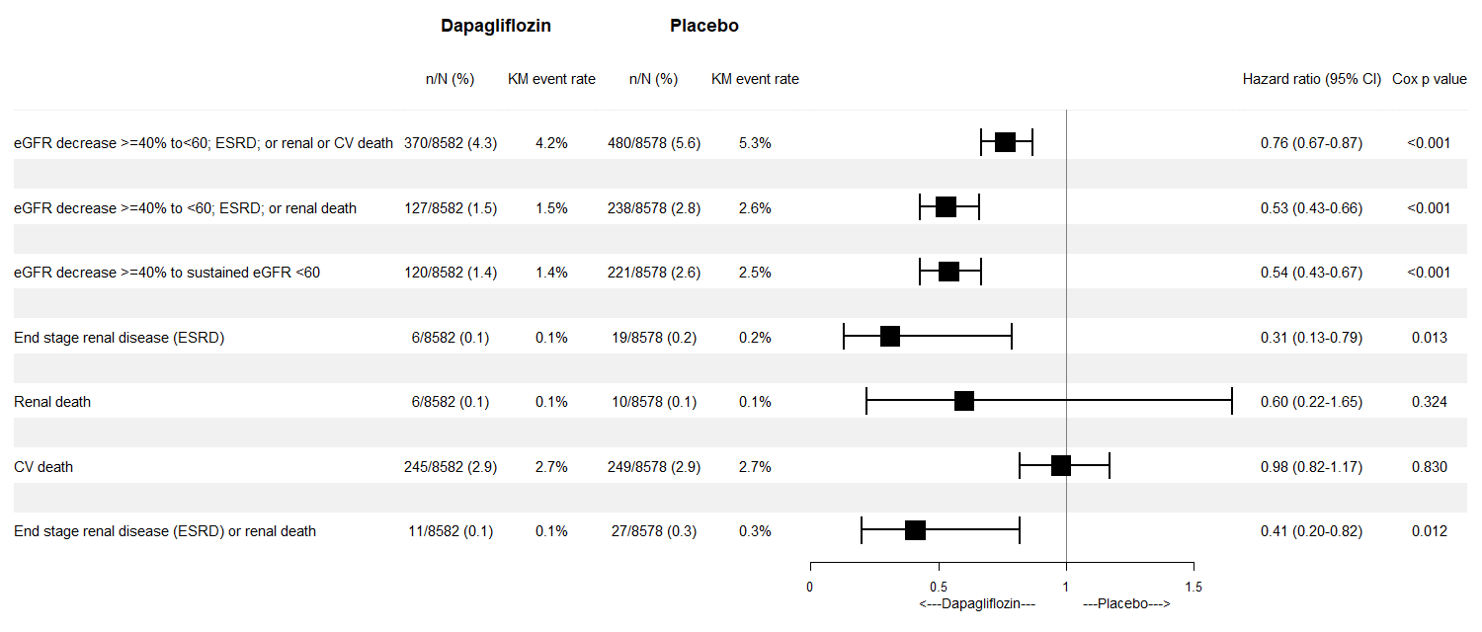

Figure 2. Kaplan-Meier curves for main renal outcomes: A. eGFR decrease >=40% to<60 mL/min per 1.73m²; ESRD; or renal or CV death. B. eGFR decrease >=40% to<60 mL/min per 1.73m²; ESRD; or renal death. C. eGFR decrease >=40% to sustained eGFR <60 mL/min per 1.73m²
HR=0.76 (0.67, 0.87)
P-Value<0.001
HR=0.53 (0.43, 0.66)
P-Value<0.001

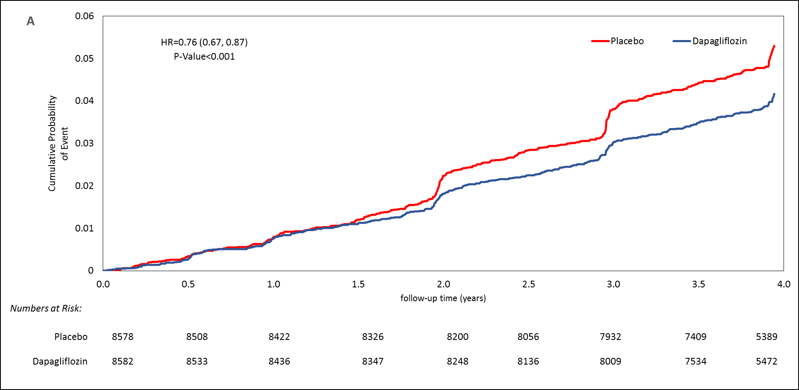
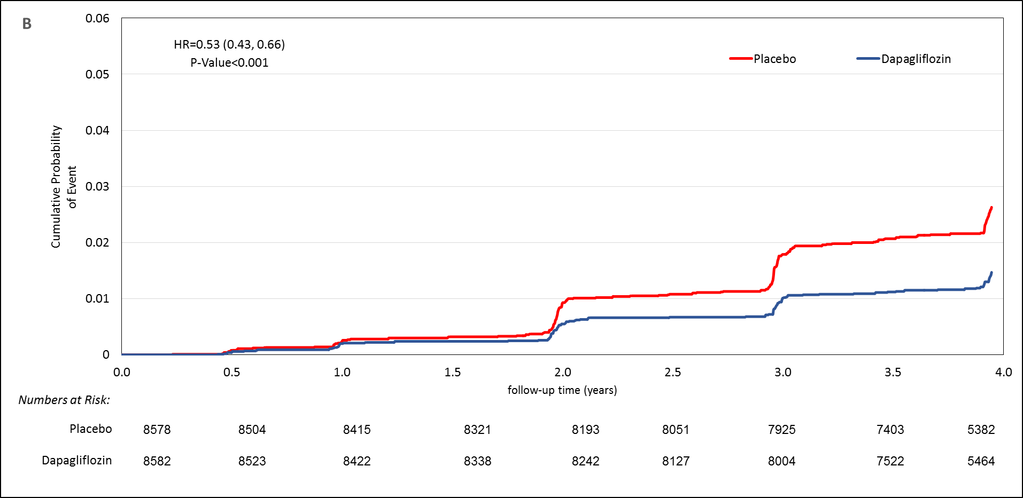

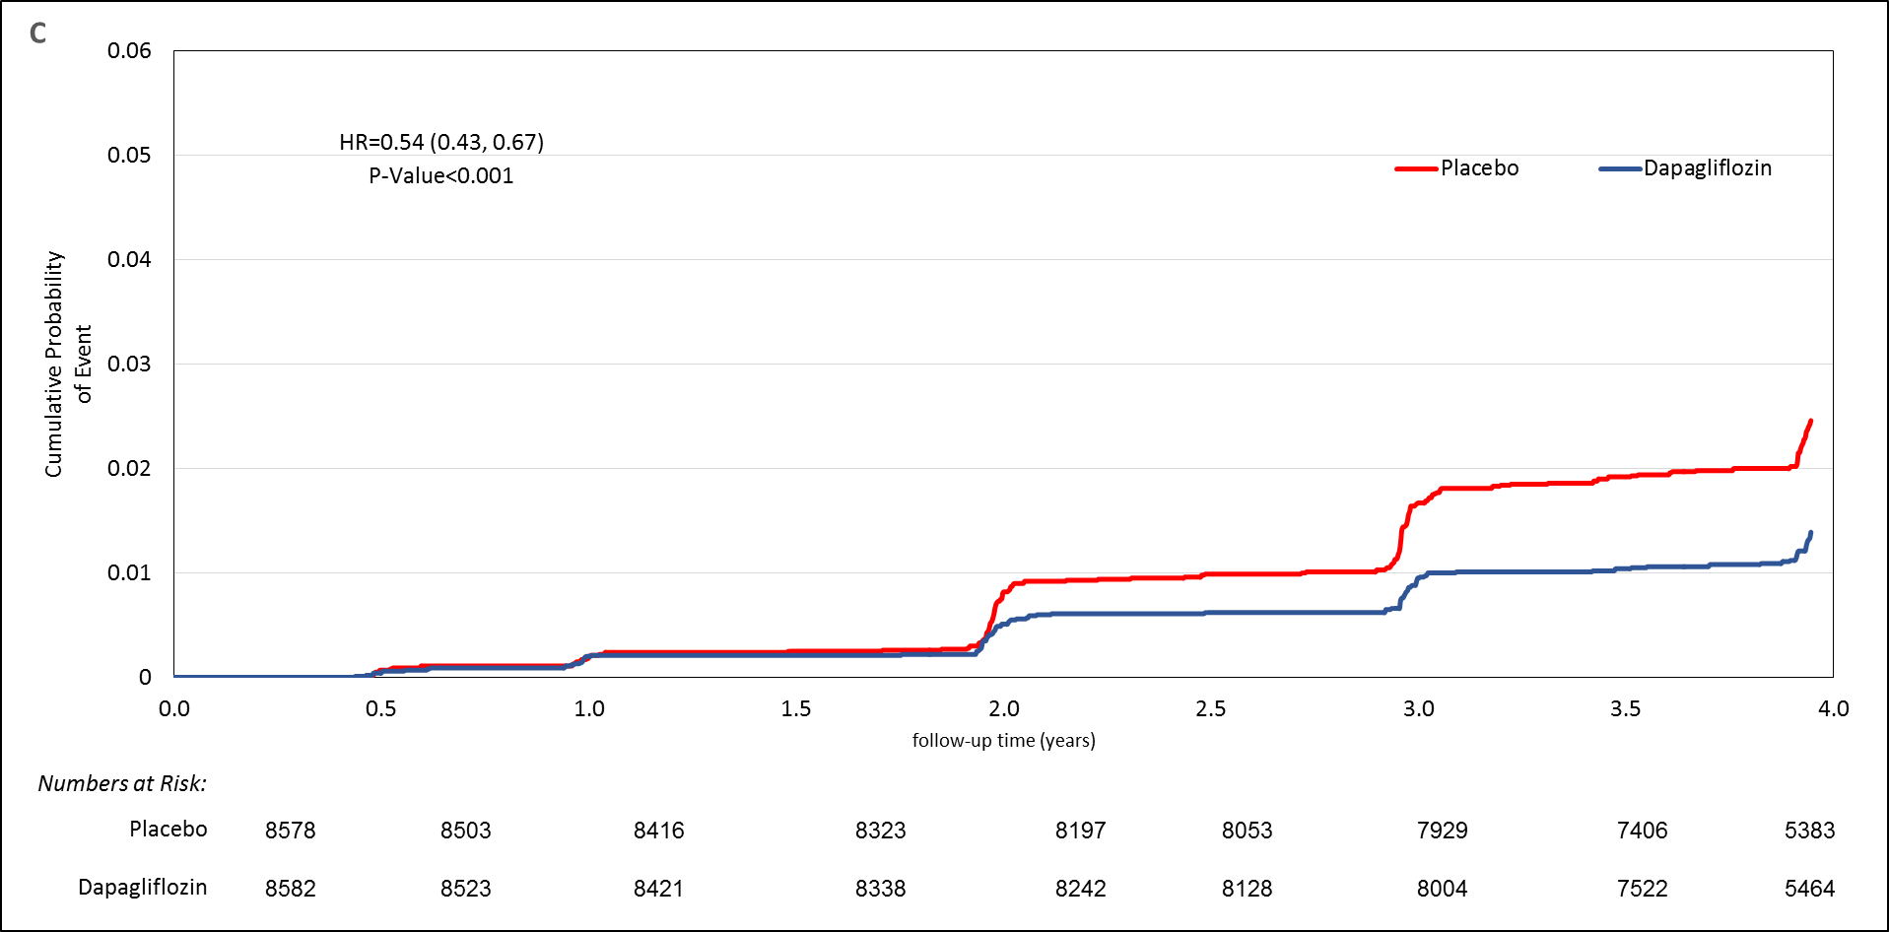

Figure 3. Risk comparison by treatment allocation and subgroups of interest, for the combined Secondary: eGFR decrease >=40% to <60 ml/min/1.73 m²; ESRD; or renal death
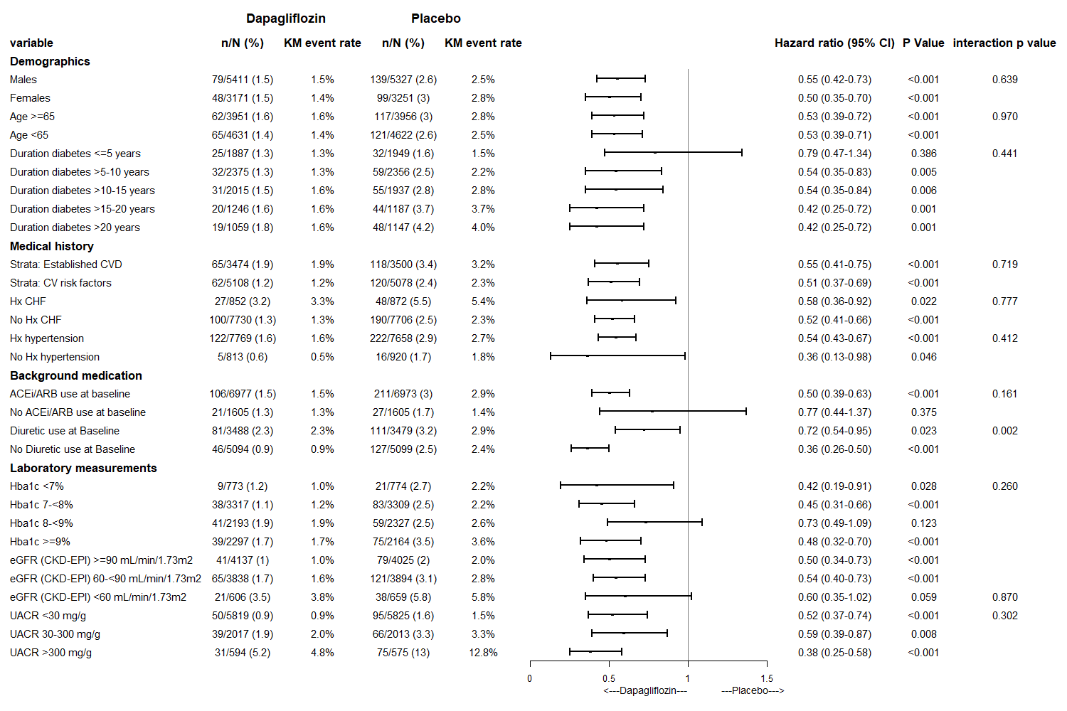

Figure 4. Line graph for eGFR plotting model adjusted mean and CI 95% from repeated measures model, by eGFR categories at baseline. A. Overall Population B. eGFR>=90 mL/min/1.73m² C. eGFR 60-<90 mL/min/1.73m² D. eGFR<60 mL/min/1.73m²

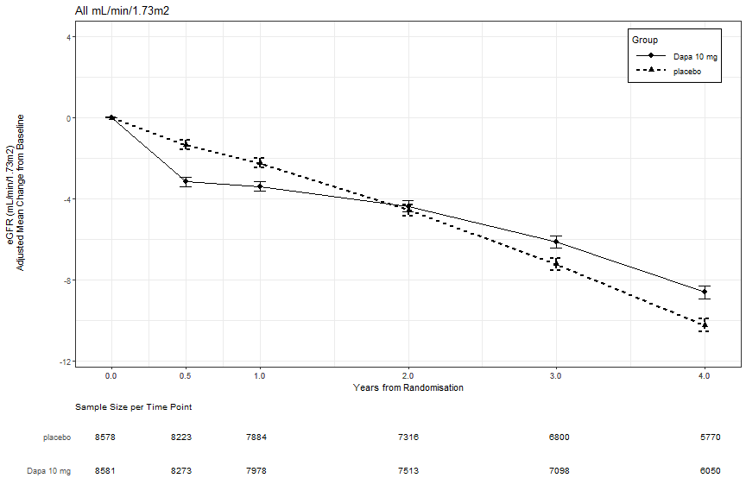
**
**
**
**
A
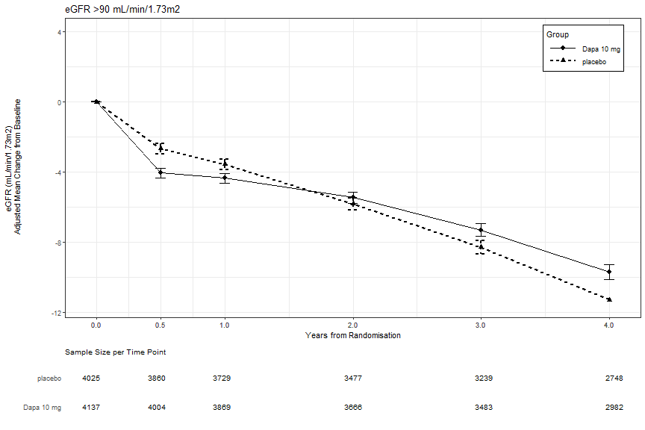
**
**
**
**
B

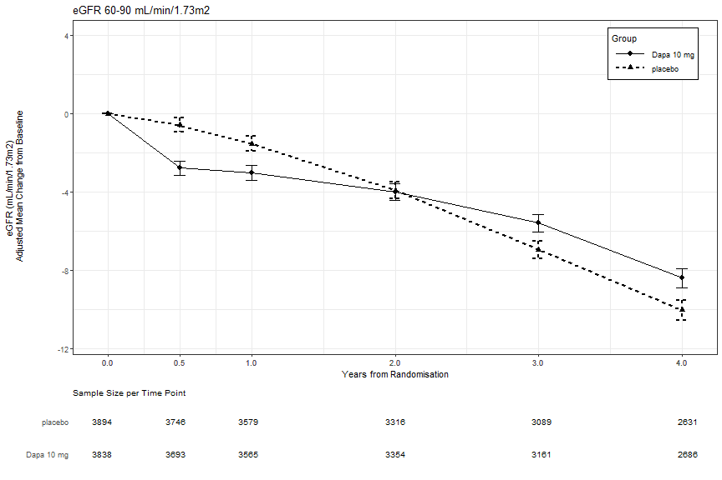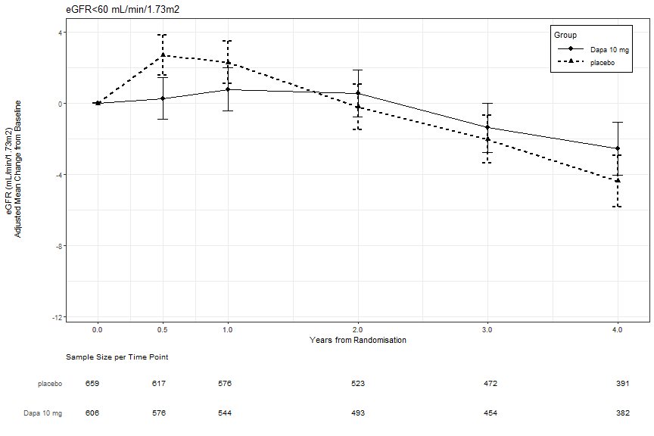
**
**
**
*
D
**
**
C
*. P<0.05, **. P<0.001
eGFR Means were adjusted for the stratification variables of prevalent atherosclerotic cardiovascular disease and hematuria.
APPENDIX- Tables and Figures for DECLARE- renal manuscript
Table S1- Baseline characteristics according to eGFR categories at baseline, by treatment allocation
 | eGFR* >90 mL/min/1.73m² |  | eGFR* 60-<90 mL/min/1.73m² |  | eGFR* <60 mL/min/1.73m²
 | Dapagliflozin (N=4137) | Placebo (N=4025) | Dapagliflozin (N=3838) | Placebo (N=3894) | Dapagliflozin (N=606) | Placebo (N=659)
Male- n (%) | 2623 (63.4) | 2434 (60.5) | 2402 (62.6) | 2464 (63.3) | 385 (63.5) | 429 (65.1)
Age (years)- mean± SD | 61.3± 6.1 | 61.2± 6.1 | 66.2± 6.6 | 66.3± 6.4 | 67.5± 6.2 | 67.1± 6.9
Age >= 75 years- n (%) | 50 (1.2) | 45 (1.1) | 398 (10.4) | 420 (10.8) | 90 (14.9) | 93 (14.1)
BMI (kg/m2)- mean± SD | 31.6± 6.0 | 31.6± 6.1 | 32.1± 5.9 | 32.1± 5.9 | 34.6± 5.7 | 34.5± 6.3
Caucasian - n (%) | 522 (86.1) | 566 (85.9) | 3124 (81.4) | 3189 (81.9) | 3196 (77.3) | 3055 (75.9)
Medical History:
Duration of diabetes at randomization (years)- mean± SD | 11.0± 7.1 | 10.8± 7.3 | 12.5± 7.9 | 12.6± 8.2 | 14.3± 9 | 14.7± 8.8
Established atherosclerotic cardiovascular disease- n (%) | 1636 (39.5) | 1557 (38.7) | 1557 (40.6) | 1581 (40.6) | 281 (46.4) | 362 (54.9)
History of CHF- n (%) | 338 (8.2) | 350 (8.7) | 413 (10.8) | 396 (10.2) | 101 (16.7) | 126 (19.1)
History of Dyslipidemia# - n (%) | 3223 (77.9) | 3147 (78.2) | 3142 (81.9) | 3185 (81.8) | 519 (85.6) | 579 (87.9)
History of HTN## -n (%) | 3629 (87.7) | 3504 (87.1) | 3560 (92.8) | 3528 (90.6) | 579 (95.5) | 626 (95)
Background Medication:
CV Medications:
Antiplatelet use at baseline- n (%) | 2429 (58.7) | 2384 (59.2) | 2402 (62.6) | 2388 (61.3) | 414 (68.3) | 470 (71.3)
ACEi/ARB use at baseline- n (%) | 3238 (78.3) | 3196 (79.4) | 3209 (83.6) | 3209 (82.4) | 529 (87.3) | 568 (86.2)
Beta-blocker use at baseline- n (%) | 2014 (48.7) | 1964 (48.8) | 2104 (54.8) | 2131 (54.7) | 379 (62.5) | 437 (66.3)
Statin or Ezetimibe use at baseline- n (%) | 2998 (72.5) | 2936 (72.9) | 2944 (76.7) | 2959 (76) | 490 (80.9) | 541 (82.1)
Diuretic use at baseline- n (%) | 1405 (34) | 1347 (33.5) | 1705 (44.4) | 1737 (44.6) | 378 (62.4) | 395 (59.9)
Mineralocorticoid receptor antagonist (MRA) use at baseline- n (%) | 130 (3.1) | 132 (3.3) | 189 (4.9) | 197 (5.1) | 48 (7.9) | 66 (10)
GLA Medications:
Metformin use at baseline- n (%) | 3526 (85.2) | 3435 (85.3) | 3096 (80.7) | 3167 (81.3) | 397 (65.5) | 446 (67.7)
Insulin use at baseline- n (%) | 1557 (37.6) | 1461 (36.3) | 1660 (43.3) | 1624 (41.7) | 350 (57.8) | 361 (54.8)
Sulfonylurea use at baseline- n (%) | 1834 (44.3) | 1837 (45.6) | 1571 (40.9) | 1634 (42) | 209 (34.5) | 236 (35.8)
DPP4 inhibitor use at baseline- n (%) | 687 (16.6) | 679 (16.9) | 651 (17) | 680 (17.5) | 80 (13.2) | 111 (16.8)
GLP1 Agonists use at baseline- n (%) | 185 (4.5) | 162 (4) | 170 (4.4) | 161 (4.1) | 42 (6.9) | 30 (4.6)
Laboratory and Clinical Measurements:
Hemoglobin A1c (%)- mean± SD | 8.5± 1.3 | 8.4± 1.2 | 8.1± 1.2 | 8.1± 1.1 | 8.2± 1.2 | 8.3± 1.2
eGFR by CKD-EPI (mL/min/1.73 m^2) | 98.2± 6.5 | 98.4± 6.5 | 77.0± 8.4 | 77.0± 8.5 | 51.1± 7.7 | 51.6± 6.8
UACR group- n (%)
<30 mg/g | 2864 (70.4) | 2827 (71.4) | 2621 (69.5) | 2646 (69.4) | 334 (56.7) | 352 (54.6)
30 to 300 mg/g | 968 (23.8) | 919 (23.2) | 873 (23.2) | 888 (23.3) | 175 (29.7) | 206 (31.9)
> 300 mg/g | 237 (5.8) | 211 (5.3) | 277 (7.3) | 277 (7.3) | 80 (13.6) | 87 (13.5)
Systolic BP (mmHg)- mean± SD | 135.1± 15.1 | 134.7± 15.0 | 135.4± 15.4 | 135.2± 15.8 | 133.9± 16.4 | 133.2± 16.7
Diastolic BP (mmHg)- mean± SD | 78.9± 8.7 | 78.8± 8.9 | 77.5± 9.2 | 77.5± 9.2 | 75.4± 9.3 | 75.3± 9.6
LDL-C (mg/dL)- mean± SD | 89.9± 35.6 | 90.7± 36.2 | 85.4± 34.3 | 85.3± 34.7 | 83.8± 36.4 | 83.2± 36.5
HDL-C (mg/dL)- mean± SD | 47.3± 13.1 | 47.5± 13.1 | 47.5± 12.9 | 47.3± 13.1 | 43.9± 11.1 | 44.5± 12.8
Triglycerides (mg/dL)- mean± SD | 181.5± 147.7 | 177.1± 135.3 | 172.0± 118.8 | 175.8± 124.6 | 196.3± 154.7 | 198.5± 156.0
*. eGFR calculated using CKD-EPI formula.
#. History of Dyslipidemia within last 12 months
##. History of HTN- vitals or therapy

Figure S1. Risk Comparison by treatment allocation and subgroups of interest, for the combined Primary Renal Outcome: eGFR decrease >=40% to<60; ESRD; or renal or CV death
A- Demographics, B- Medical history, C- Background medication, D- Laboratory Measurements

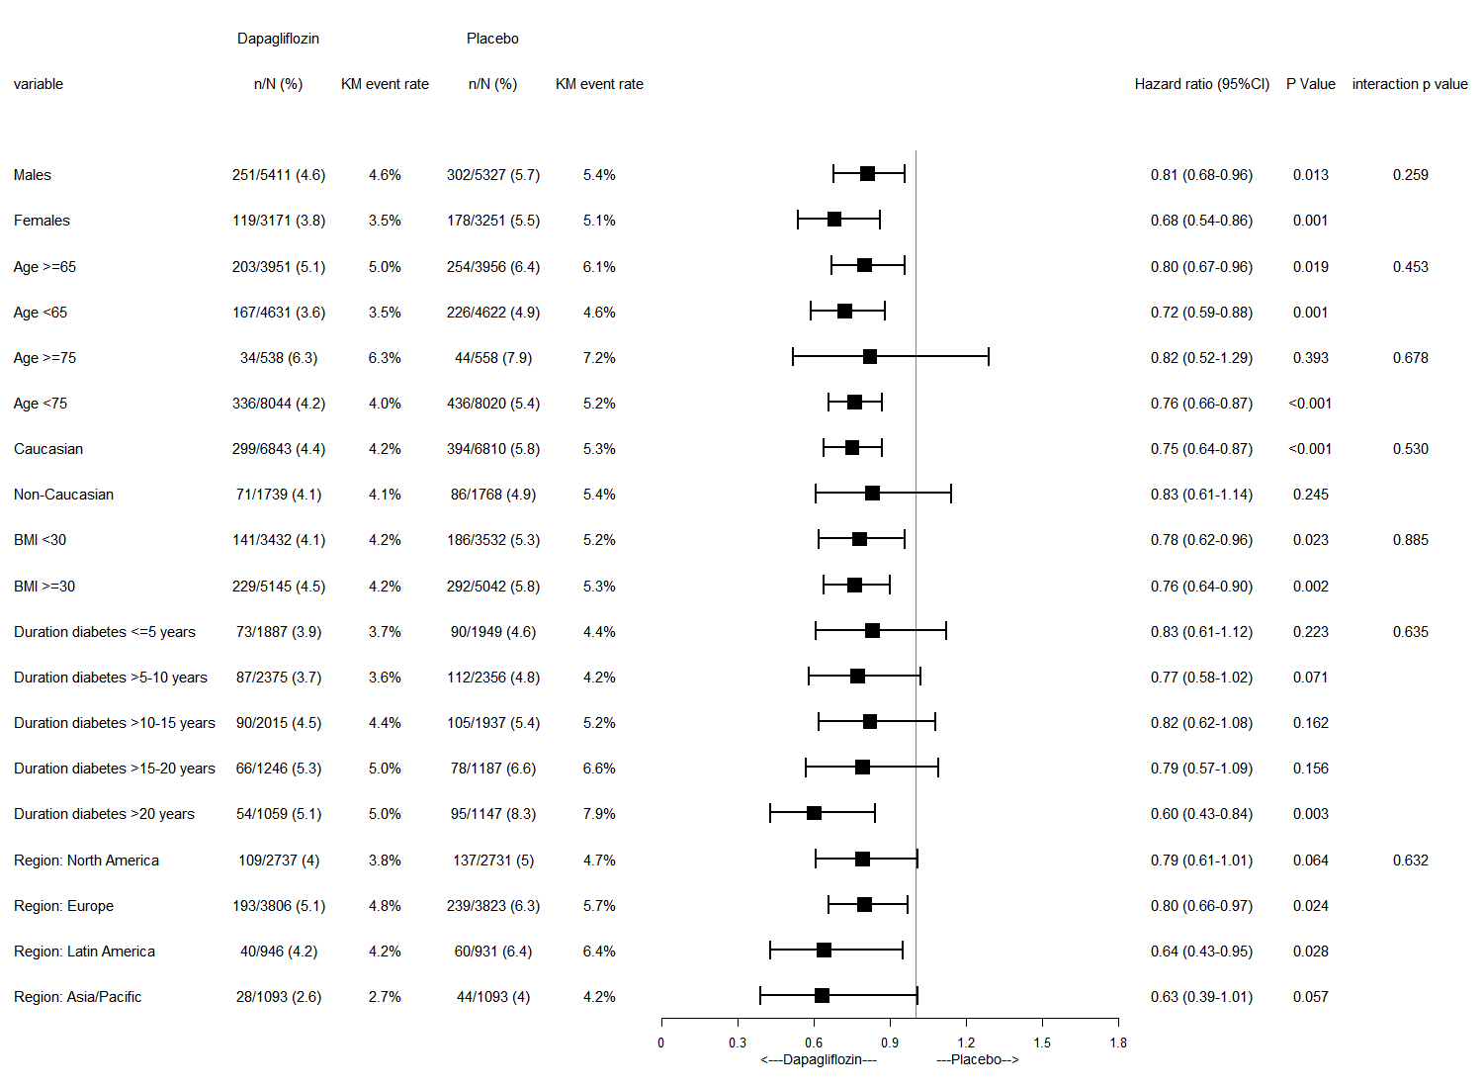
A
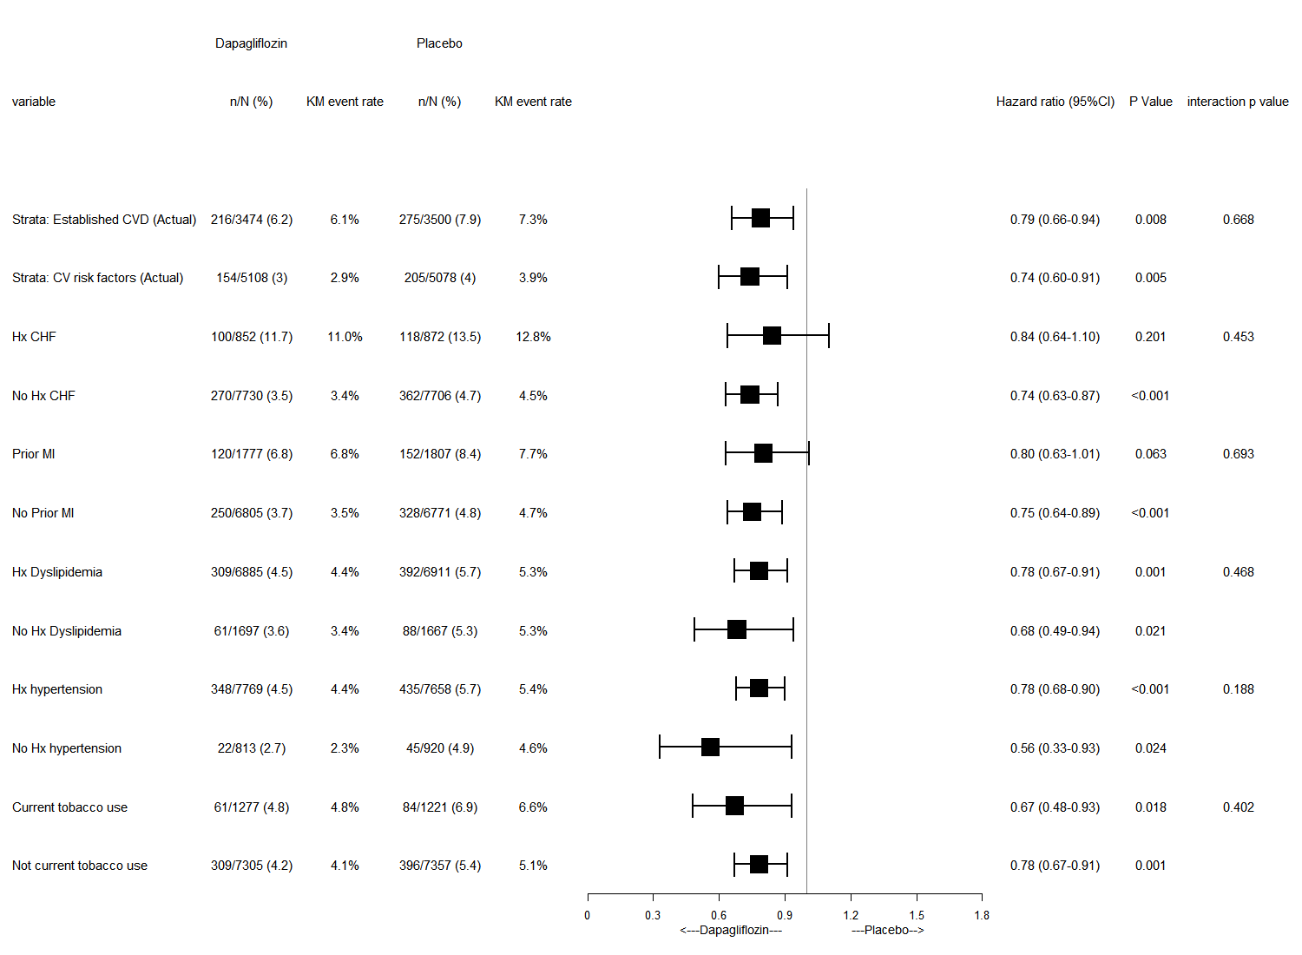
B
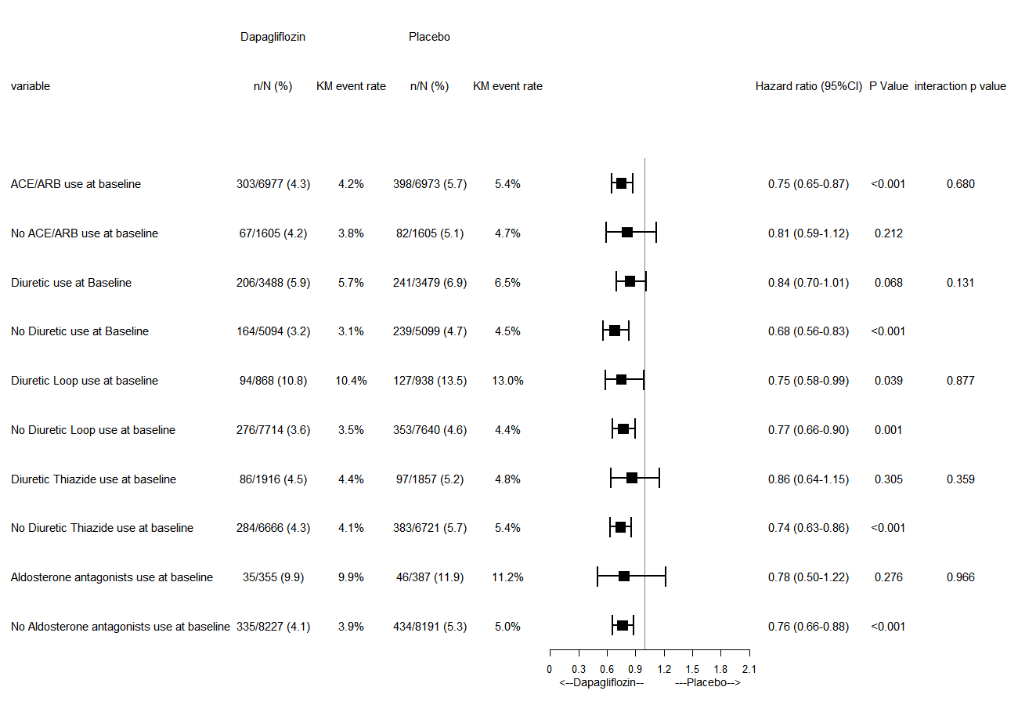
C
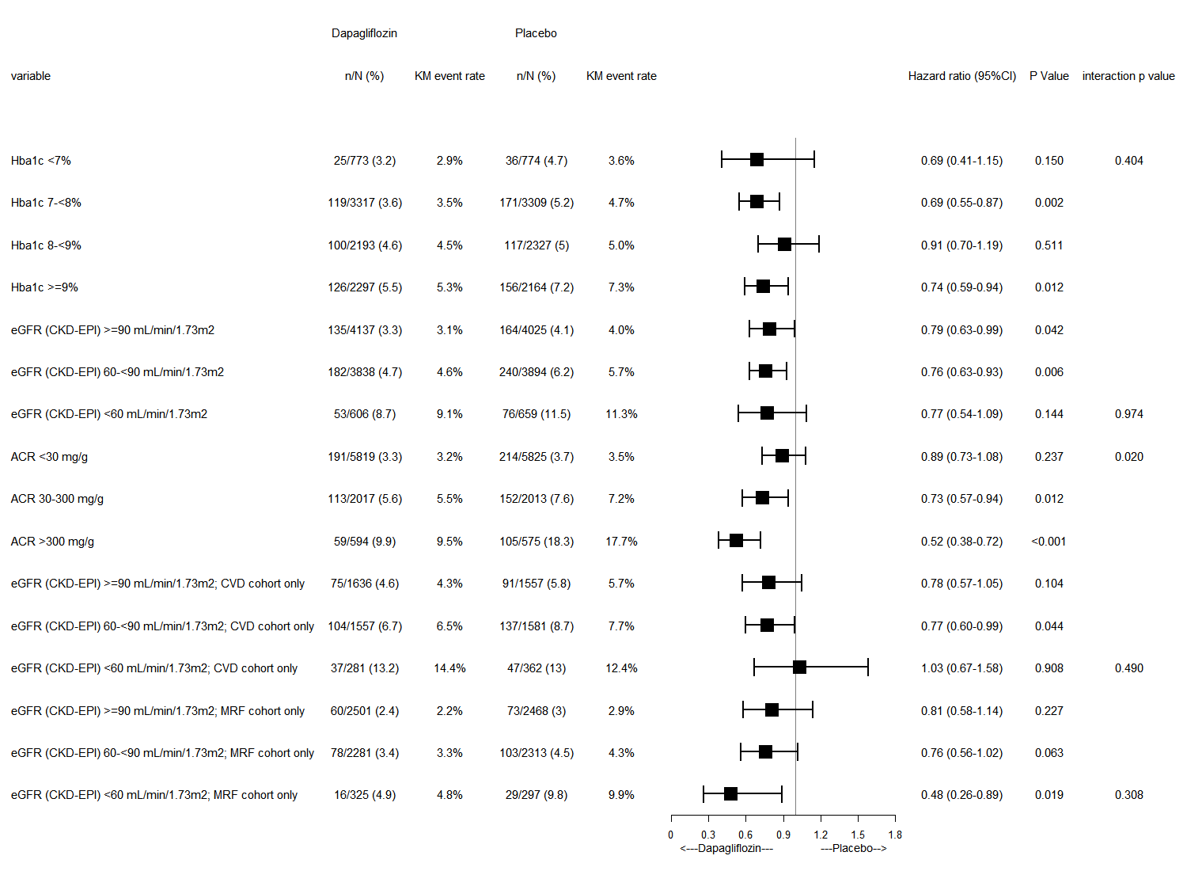
D

