Atomic layer deposited α-Ga₂O₃ solar-blind photodetectors
J. Moloney,^{1†} O. Tesh,^{1†} M. Singh,² J.W. Roberts,³ J.C. Jarman,¹ L.C. Lee,¹ T.N. Huq,¹ J. Brister,¹ S. Karboyan,² M. Kuball,² P.R. Chalker,³ R.A. Oliver,¹ and F.C-P. Massabuau^{1*}
¹ Department of Materials Science and Metallurgy, University of Cambridge, 27 Charles Babbage Road, Cambridge CB3 0FS, UK
² School of Physics, HH Wills Physics Laboratory, University of Bristol, Tyndall Avenue, Bristol BS8 1TL, UK
³ School of Engineering, The University of Liverpool, Brownlow Hill, Liverpool L69 3GH, UK
† These authors contributed equally to the work.
* Email: fm350@cam.ac.uk

Abstract
Low temperature atomic layer deposition was used to deposit α-Ga₂O₃ films, which were subsequently annealed at various temperatures and atmospheres. The α-Ga₂O₃ phase is stable up to 400 ºC, which is also the temperature that yields the most intense and sharpest reflection by X-ray diffraction. The suitability of the materials for solar-blind photodetector applications has been demonstrated with the best responsivity achieved being 1.2 A/W under 240 nm illumination and 10 V bias, for the sample annealed at 400 ºC in argon. It is worth noting however that the device performance strongly depends on the annealing conditions, with the device annealed in forming gas behaving poorly. Given that the tested devices have similar microstructure, the discrepancies in device performance are attributed to hydrogen impurities.

Introduction
Gallium oxide (Ga₂O₃) is currently viewed as one of the most promising wide band gap semiconductors for future power electronics and ultraviolet (UV) optoelectronics applications [1]. Currently, there are six reported Ga₂O₃ polymorphs, namely α, β, γ, δ, ε, and κ [2,3] – the κ phase being an ordered variant of the ε phase [4]. The monoclinic β phase is the only thermodynamically stable phase and has therefore been the focus of most research effort [1]. The rhombohedral α phase (corundum) is metastable and is therefore less studied, despite being the most promising polymorph for band gap engineering in the UV since it is isostructural with other group-III sesquioxide semiconductors (α-In₂O₃ and α-Al₂O₃) [5].
In the past, α-Ga2O3 has been stabilized under high pressures (several GPa) and high temperatures (1000 °C) [6, 7]. More recently, stabilisation of this phase under less extreme conditions has been achieved, using mist chemical vapor deposition (CVD) at ca. 450 °C [5, 8], metalorganic vapor phase deposition (MOCVD) at 600 °C [9], halide vapor phase epitaxy (HVPE) at 650 °C [10] and 550 °C [11], molecular beam epitaxy (MBE) at 800 °C–850 °C [12], or RF magnetron sputtering at >600 °C [13]. Using atomic layer deposition (ALD), most studies have reported the deposition of amorphous Ga2O3 films [14–20]. However, it has been recently demonstrated that α-Ga2O3 could also be synthesized using plasma-enhanced ALD at temperatures as low as 250 °C [21]. To date, the body of work on this material has focused on growth aspects, and only a limited number of studies have reported the application of the grown materials in devices. In particular, for solar-blind UV detection applications (detection wavelength <280 nm) relatively few reports using α-Ga2O3 appear in the literature [12, 22, 23].
In an earlier paper, it was showed that ca. 130 nm thick films of α-Ga2O3 could be deposited by low temperature ALD on c-plane sapphire [21]. The films consisted predominantly of α phase columns. However, inclusions of the ε phase, as well as amorphous material, were also found. In the present study, it is shown that the quality of similarly grown films can be improved using post-deposition thermal annealing and the suitability of the resulting materials for solar-blind UV photodetector applications is demonstrated. A 3 orders of magnitude improvement of the device responsivity between the as-grown sample and the sample annealed in argon or oxygen at 400 °C is reported, with the best device exhibiting a responsivity of ca. 1.2 A W−1 under 10 V bias and 240 nm illumination.
Methods
Deposition of Ga2O3 was achieved using alternating pulses of triethylgallium (TEGa) and O2 plasma in an Oxford Instruments Plasma-OpAL ALD system. A c-plane sapphire substrate, with a miscut of 0.25 ± 0.10° towards $\left(11\overline{2}0\right)$, was employed. The substrate temperature was set at 250 °C, reactor wall temperatures were 150 °C, the TEGa bubbler was kept at ~25 °C and the delivery lines from the TEGa bubbler to the deposition chamber were set at 50 °C. The base pressure in the chamber (with no process gases flowing) was ca. 10 mTorr. During the deposition processes the chamber pressure varied between ca. 80 mTorr (during the plasma steps) and 160 mTorr (during the TEGa dose). Each ALD cycle consisted of one 0.1 s pulse of TEGa with 100 sccm of Ar carrier gas, a 5 s purge using 100 sccm Ar through the TEGa line, a 5 s 300 W O2 plasma exposure using 20 sccm O2, and finally a 5 s purge using 100 sccm Ar. These conditions of temperature, plasma power and O2 flow were found to be optimal for the growth of Ga2O3 in the α phase [24]. 2730 cycles were performed, resulting in a nominal film thickness of ca. 130 nm.
The samples were annealed after growth to improve the crystalline quality of the Ga2O3 films. Samples were placed on a flat bottom alumina boat and loaded into a clean quartz tube inside a small horizontal annealing furnace (Carbolite). The furnace temperature ramp rate was set to 10 °C min−1 using a Eurotherm temperature controller. The samples were annealed for 1 h at various temperatures and atmospheres and were cooled down to room temperature before unloading. For the temperature series, the samples were annealed in air for 1 h under 1000 mbar pressure, and temperatures of 300, 350, 400, 450, 500, 600 and 700 °C. For the ambient series, the samples were annealed for 1 h under 1000 mbar pressure at 400 °C, and in atmospheres of argon, air, oxygen and forming gas (3% H2, 97% N2).
X-ray diffraction (XRD) was employed to investigate the phase and crystalline quality of the samples, as well as the strain state of the films. An X'pert MRD diffractometer, in open detector configuration (and using a 1° slit), was used to record symmetric 2θ − ω scans of the samples. The intensity of each spectrum has been normalized relative to the sapphire $0006$ peak to avoid effects from illuminated area and variation in intensity of the x-ray source. A Panalytical Empyrean diffractometer with PIXcel detector was used to record reciprocal space maps (RSMs) of the symmetric $0006$ and asymmetric $10\overline{1}10$ reflections (data not shown here).
Atomic force microscopy (AFM) was performed in peak force tapping mode using a Bruker Dimension Icon microscope. The peak force tapping yields a greater lateral resolution than other AFM techniques (e.g. intermittent-contact mode) due to the smaller tip radius (Bruker ScanAsyst-Air), which was nominally 2 nm.
Transmission electron microscopy (TEM) was used to observe the structure of the films in cross-section. High angle annular dark field scanning TEM (HAADF-STEM) was carried out in an FEI Tecnai Osiris operated at 200 kV.
Following cleaning in acetone and isopropyl alcohol, metal contacts were defined using UV lithography and thermal evaporation. Shipley s1813 positive photoresist was developed with MF-319, an aqueous developer containing dilute tetramethylammonium hydroxide (TMAH), after a short post-exposure treatment with chlorobenzene to produce the undercut profile required for the metal lift-off process. It was observed that the Ga₂O₃ film is slowly etched by the developer solution, and so care was taken to restrict the development time to the minimum required to clear the exposed areas. After resist processing, a 10 nm Ti adhesion layer and 80 nm Au were evaporated by resistive thermal evaporation from tungsten boats, and the patterns were lifted off in acetone. The devices were made of two interdigitated electrodes. The illuminated area of the devices is 0.425 mm².
The electrical properties of the devices were tested using a Keithley Source Measure Unit coupled with a probe station. To measure the optical response, a Xe lamp was used, which was spectrally filtered by a prism monochromator and controlled using LabView software. The optical fibre source was fixed at a distance of 2 cm from the device. To calibrate the setup, power output was measured at the same distance from the fibre and same wavelength used during the experiment. At 240 nm the input power density was 0.46 W m⁻². Dark current I–V curves were measured for all devices to ensure minimum current flow, followed by response measured at fixed 240 nm illumination (lamp ON time of 20 s and OFF time of 40 s has been fixed throughout the experiment).
Results and discussion
- The impact of annealing at varying temperature
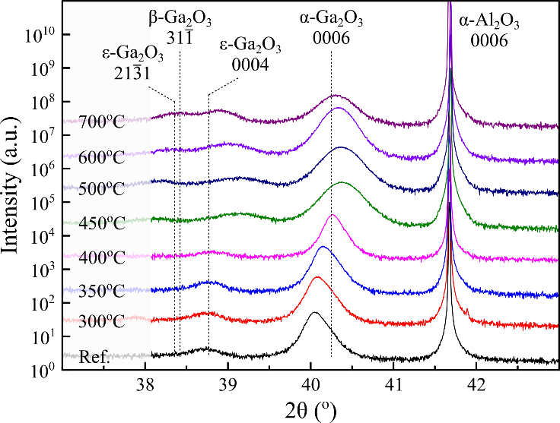
Figure 1 – Symmetric 2θ-ω scan for the samples annealed in air at various temperatures. The position of the reflections for the α, β and ϵ phases are obtained using the lattice parameters from Ref. [18], [19] and [4] respectively.
Figure 1 shows the symmetric 2θ − ω scan of the samples annealed in ambient air and at various temperatures. The $0006$ reflection from the sapphire (α-Al₂O₃) substrate is clearly visible at 2θ = 41.68°. To facilitate interpretation, each spectrum has been normalized relative to the substrate peak. All the XRD diffractograms exhibit a $0006$ reflection for α-Ga₂O₃ near 2θ = 40.25° (the expected value for a relaxed film, using the lattice parameter from Marezio et al [25]). The peak shifts slightly depending on the annealing temperature—the origin of this shift will be discussed later. It can be seen from figure 1 that the α phase is stable up to 400 °C. At this temperature, the $0006$ reflection is the most intense and sharpest, which can be interpreted as an increase in crystalline quality of the film and/or an increase in crystallite size. Compared to the reference as-grown sample, annealing at 400 °C increases the $0006$ peak intensity by a factor of 2–4.
For annealing temperatures above 450 °C, the α phase is still present in the film but the peak significantly broadens, and its intensity decreases, which is indicative of a poorer crystalline quality, smaller volume fraction of α phase and/or smaller crystallite size. Lee et al reported that α-Ga₂O₃ grown by mist-CVD was stable up to 550 °C, beyond which temperature the material gradually transformed to β phase [27]—the present results are consistent with that study. It has been shown that doping the film with Al can be an effective approach to improve the stability of the α phase beyond 400 °C [28]. That is, however, beyond the scope of this work.
Additional peaks can be observed at lower 2θ values throughout the set of samples. In the reference sample, the peak at 2θ ~ 38.7º has previously been attributed to inclusions in the ϵ phase forming at the tip of the α-Ga₂O₃ columns [21]. A similar peak is observed in all the samples and it is also noted that this peak undergoes the same shift as the α-Ga₂O₃ $0006$ peak. For higher temperature anneals, an additional peak can be observed at lower 2θ value (at 2θ ~ 38.4º), which could be attributed to either ϵ-Ga₂O₃ $21\overline{3}1$ or β-Ga₂O₃ $31\overline{1}$ reflections – definitive identification is not possible. This peak gradually appears as the α-Ga₂O₃ $0006$ reflection weakens, supporting the idea that the α-phase decomposes to a thermodynamically more favourable phase, that is, ϵ or β [29].
The shift of the peaks towards higher 2θ angles with increasing annealing temperature could be attributed to several factors, such as change of strain in the film upon annealing, or interdiffusion of Ga with Al from the substrate (which has been reported by other studies despite the acknowledged chemical stability of sapphire [30–32]). From measurements of the a and c lattice parameters using RSM in the XRD, it is observed that the lattice parameters are inversely correlated, i.e. an increase in the c parameter is associated with a decreasing a parameter. Consequently, the volume of the unit cell remains relatively constant (all values are within a 1% relative range) throughout the set of samples. This is a strong indication that the peak shift is strain-induced rather than composition-induced. Indeed, if the film was being contaminated with Al by interdiffusion from the substrate, we would expect (i) a decrease of the unit cell volume associated with the peak shift, and (ii) a continuous shift of the peak towards higher angles as the annealing temperature increases (instead, the peak stops shifting for temperatures above 450 °C).
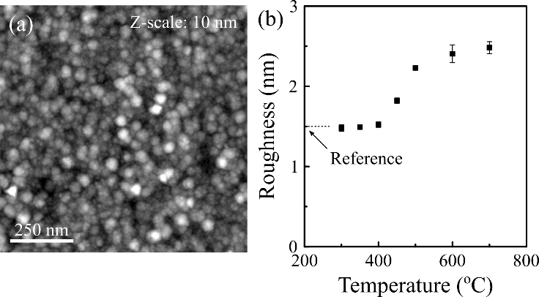
Figure 2 – (a) Typical AFM topography image of the samples (here the sample annealed at 400 ºC). (b) RMS roughess of the samples annealed in air at various temperatures. The roughness was obtained from 1 μm x 1 μm AFM images.
The topography of all the samples has been investigated using AFM. All the samples exhibited a similar morphology, as shown in figure 2(a). It is noted however that the annealing temperature effects the height range of the sample, but not visibly the lateral dimensions of the features. The evolution of the root mean square (RMS) roughness over a 1 µm × 1 µm area with annealing temperature is shown in figure 2(b). In particular, a roughening of the surface for temperatures above 400 °C is observed, which correlates with the decrease of the α phase peak in the XRD diffractograms (figure 1). A power spectral density analysis of the AFM data provides further insights on the mechanisms dominating the topography. Following the approach described in [33, 34], the dominant smoothing (plastic flow, evaporation/recondensation, bulk diffusion, or surface diffusion) and roughening (stochastic or non-stochastic) mechanisms in films during growth, annealing or etching could be determined. It was found that the dominant smoothing mechanism in all the samples is by surface diffusion (the power law gradient ranges between 3.9 and 4.4) while roughening tends to be stochastic. This may imply that upon annealing, material is lost from random positions across the surface (stochastic roughening) while surface migration of atoms occurs to smoothen the topography. The overall increase in roughness with annealing temperature indicates that, whilst smoothing and roughening processes are competing to results in the observed topography, the (stochastic) roughening tend to dominate during annealing.
- The impact of annealing under different atmospheres
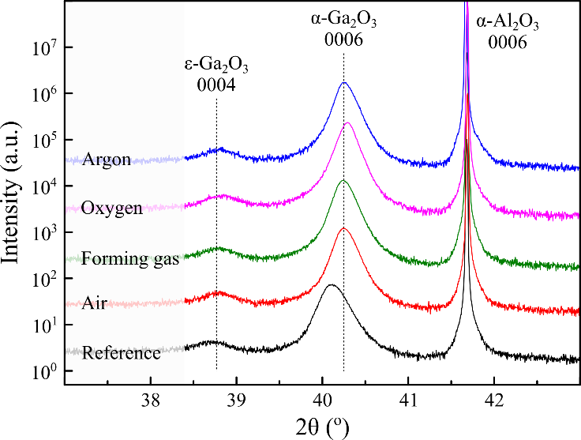
Figure 3 – Symmetric 2θ-ω scan for the samples annealed at 400 ºC in various atmospheres. The position of the reflections for the α and ϵ phases are obtained using the lattice parameters from Ref. [25] and [4] respectively.
It was established earlier that 400 °C was the optimal annealing temperature in air—leading to the sharpest and most intense α-Ga₂O₃ reflection. Figure 3 presents the XRD diffractograms of the samples annealed at 400 °C under different atmospheres—i.e. air, argon, oxygen, and forming gas (3% H₂, 97% N₂). Firstly, all these annealed samples show a sharper and more intense α-Ga₂O₃ $0006$ reflection compared to the reference sample (the scans are normalized to the substrate reflection): the samples annealed in air, argon and forming gas exhibit approximately a 2-fold increase in peak intensity relative to the as-grown sample, while the sample annealed under oxygen shows a 3-fold improvement. It is also noted that the peaks all shift to the same value in 2θ indicating that all the films have the same strain state irrespective of the ambient employed. The topography of the samples grown under different anneals was also analysed using AFM (data not shown). All the data obtained were similar to the image presented in figure 2(b), with a roughness of ca. 1.3 nm for all the samples. It is concluded that, as far as the AFM and XRD data are concerned, the annealing temperature has a much greater impact on the film structural properties than the annealing atmosphere.
- Solar-blind photodetector devices
Metal-Semiconductor-Metal (MSM) photodetectors were subsequently fabricated from the reference as-grown sample and the samples annealed at 400 ºC under different atmospheres. The devices’ main characteristics are listed in Table 1, together with those from similar MSM device structures from the literature.
Sample | Responsivity (A/W) at 240 nm | Dark current (pA) | (I_{photo}-I_{dark})/I_{dark}
Reference | 0.0003 | 0.2 | ~450
Air | 0.5 | 3 | ~35000
Forming gas | 0.014 | 19 | ~150
Oxygen | 1.05 | 8 | ~25000
Argon | 1.2 | 163 | ~1500
Guo et al. [12] | 0.007 (10V; 254 nm) | 1020 | 30-68
Lee et al. [15] | 0.76 (20V; 253 nm) | 0.5 | ~10⁴
Table 1 – Summary of device performances: responsivity at 240 nm illumination and 10 V bias; dark current recorded at 10 V bias; photo-to-dark current contrast.
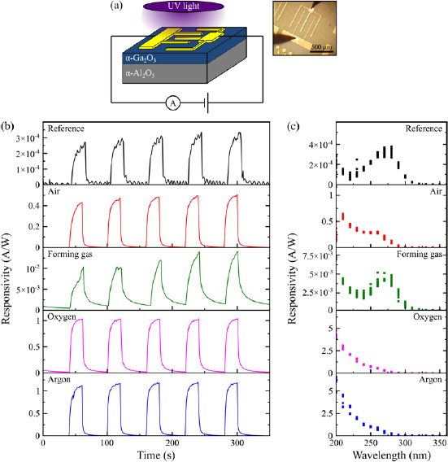
Figure 4 – (a) Schematic of the device set up. (b) Responsivity of the devices tested under illumination of 240 nm (power density 0.46 W.m⁻²) and 10 V bias. The light source was turned ON for 20 s and OFF for 40 s. In the inset, optical image of a device under bias. (c) Spectral response of the devices illuminated under wavelength from 200 to 360 nm and 10 V bias.
The optical response of the devices recorded under 240 nm UV illumination and 10 V bias, is shown in Figure 4(b). A clear increase in photocurrent can be observed when the devices are illuminated under 240 nm – i.e. near the optical bandgap of α-Ga₂O₃ [5,9,17,24]. The dark current varies between samples, but overall remains fairly low – of the order of a few pA. The photo-to-dark current contrast varies between samples from ca. 1.5 × 10² to up to ca. 3.5 × 10⁴ depending on the annealing conditions, which demonstrates a good photoconductive behaviour. It is noted however that the devices are relatively slow in response. The rise and decay times in all the devices are of the order of several seconds. This is clearly a point that needs to be addressed in future devices.
The responsivity of the as-grown sample is rather low, at 0.3 mA W⁻¹, but increases significantly by about three orders of magnitudes upon annealing. For anneals in argon and oxygen, we report responsivity at 240 nm illumination and 10 V bias of 1.2 and 1.05 A W⁻¹, respectively, which to our knowledge, is the best performance reported for α-Ga₂O₃ MSM photodetectors so far (note that direct comparison is difficult, as the other reported results used different illumination and/or bias conditions). To put these results into a broader context, photodetectors made from Ga₂O₃ phases that have received more research effort exhibit responsivities such as 45.11 A W⁻¹ (under 253 nm and 20 V conditions) for amorphous Ga₂O₃ [35], and 96.13 A W⁻¹ (under 250 nm and 5 V conditions) for β-Ga₂O₃ [36].
The spectral response of the devices, shown in Figure 4(c), demonstrates the suitability of all our devices to detect radiations in the solar-blind region. The responsivity is very low in the long wavelength side (i.e. for sub-bandgap excitation). A peak in response can be seen for all samples for approximately 260-280 nm illumination (this peak is more or less pronounced between the samples) and corresponds to transitions across the bandgap of α-Ga₂O₃. It is worth noting that this corresponds to a slightly lower transition than the expected bandgap [5,9,17,24], which may imply the presence of shallow states near the band edges. The short wavelength response links to near surface photoconduction, which appears to be enhanced in the case of anneals in argon and oxygen compared to the other samples.
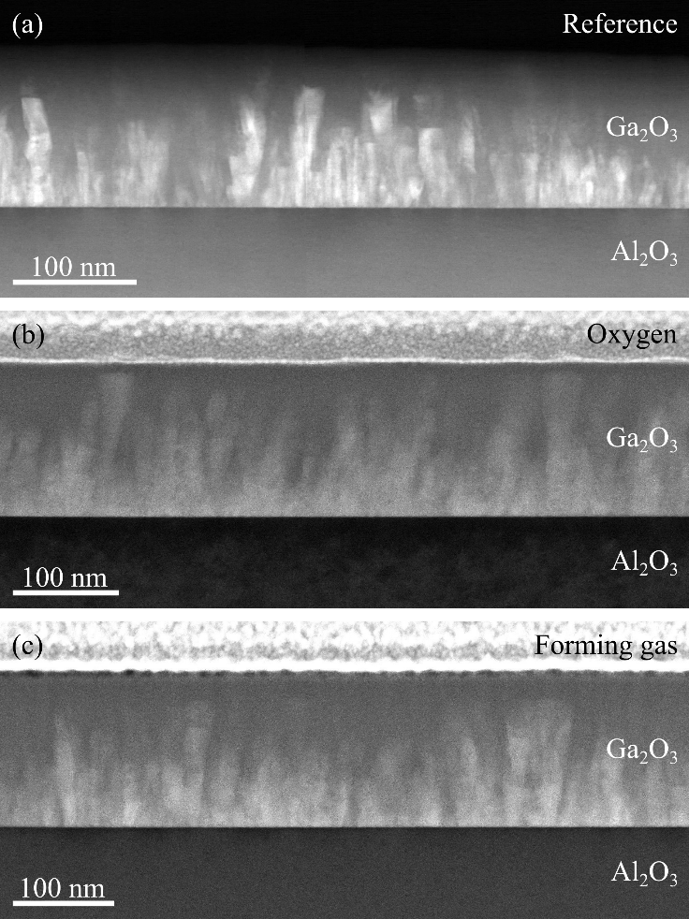
Figure 5 – HAADF-STEM images of (a) the as-deposited sample, (b) the sample annealed in oxygen at 400 ºC, and (c) the sample annealed in forming gas at 400 ºC.
Finally, we point out that the sample annealed in forming gas behaves surprisingly poorly compared to the other annealed samples. The responsivity of this device is about 2 orders of magnitude below the other annealed samples and the rise and decay times are significantly longer (the photocurrent does not reach saturation within the 20 s illumination window) (Figure 4(b)). Figure 4(c) also shows that this sample has almost no photoresponse for short wavelength illumination. To better understand the origin of this variation, TEM imaging of the as-grown sample, of the sample annealed in oxygen, and of the forming gas annealed sample was conducted. As illustrated in Figure 5, all three samples are nearly identical; they exhibit a columnar structure of α-Ga₂O₃ separated by amorphous Ga₂O₃ [21] and the columns have visually similar width and height. It appears that all the annealed samples exhibit a columnar structure (from TEM observations); a comparable α phase volume fraction or crystallite size (from XRD 2θ-ω scans); and similar strain state (from XRD RSMs). The reason for the lower responsivity of the device annealed in forming gas device does not appear to derive from the microstructure of the film. Given that only the sample annealed in forming gas – from a sample set that includes air, oxygen, argon and forming gas atmosphere – behaves poorly, we tentatively attribute this to hydrogen impurities in the film. This is a reasonable suggestion given that the extremely long rise and decay time of the forming gas device imply the presence of trap states in the film (This comment could also be made for the reference sample although it is impossible to hold a specific point defect responsible in that case). In β-Ga₂O₃, hydrogen has been predicted to act as a shallow donor [38] and hydrogen termination at the sample surface has been linked to electron accumulation and downwards band bending at the surface [39,40]. However, the behaviour of hydrogen could differ significantly depending on the oxide material under consideration [41], and a proper study of the impact of hydrogen in specifically α-Ga₂O₃ materials would be necessary.
Conclusion
In conclusion, α-Ga₂O₃ has been deposited by low-temperature ALD and the film quality has been improved using post-deposition anneals at temperatures up to 400 °C and various atmospheres. The α-Ga₂O₃ films are stable up to 400 °C, which is also the temperature that yields the most intense and sharpest XRD reflection. The suitability of the materials for solar-blind photodetector applications has been demonstrated with best responsivity of 1.2 A W⁻¹ under 240 nm illumination and 10 V bias reported for the sample annealed at 400 °C in an argon atmosphere. It is finally noted that better control over impurities in the materials could lead to further improvements in device performance.
Acknowledgements
This project is funded by the Engineering and Physical Sciences Research Council (EPSRC Grants No. EP/P00945X/1, EP/M010589/1 and EP/K014471/1). T N H acknowledges funding from the EPSRC Centre for Doctoral Training in Graphene Technology (Grant No. EP/L016087/1).
Manuscript and datasets for the figures can be found at https://www.repository.cam.ac.uk/handle/1810/296062 and https://doi.org/10.17863/CAM.42970.
References
[1] S.J. Pearton, J. Yang, P.H. Cary IV, F. Ren J. Kim, M.J. Tadjer, and M.A. Mastro, Appl. Phys. Rev. 5, 011301 (2018)
[2] R. Roy, V.G. Hill, and E.F. Osborn, J. Am. Chem. Soc. 75, 719 (1952)
[3] H.Y. Playford, A.C. Hannon, E.R. Barney, and R.I. Walton, Chem. Eur. J. 19, 2803 (2013)
[4] I. Cora, F. Mezzadri, F. Boschi, M. Bosi, M. Caplovicova, G. Calestani, I. Dodony, B. Pecz, and R. Fornari, CrystEngComm 19, 1509 (2017)
[5] S. Fujita, and K. Kaneko, J. Cryst. Growth 401, 588 (2014)
[6] J.P. Remeika, and M. Marezio, Appl. Phys. Lett. 8, 87 (1966)
[7] D. Machon, P.F. McMillan, B. Xu, and J. Dong, Phys. Rev. B 73, 094125 (2006)
[8] D. Sinohara, and S. Fujita, Jap. J. Appl. Phys. 47, 7311 (2008)
[9] H. Sun, K.-H. Li, C.G. Torres Castanedo, S. Okur, G.S. Tompa, T. Salagaj, S. Lopatin, A. Genovese, and X. Li, Cryst. Growth Des. 18, 2370 (2018)
[10] Y. Yao, S. Okur, L.A.M. Lyle, C.S. Tompa, T. Salagaj, N. Sbrockey, R.F. Davis, and L.M. Porter, Mater. Res. Lett. 6, 268 (2018)
[11] J.H. Leach, K. Udwary, J. Rumsey, G. Dodson, H. Splawn, and K.R. Evans, APL Mater. 7, 022504 (2018)
[12] D.Y. Guo, X.L. Zhao, Y.S. Zhi, W. Cui, Y.Q. Huang, Y.H. An, P.G. Li, Z.P. Wu, and W.H. Tang, Mat. Lett. 164, 364 (2016)
[13] H. Akazawa, Vacuum 123, 8 (2016)
[14] Comstock D J and Elam J W 2012 Chem. Mater. 24 4011
[15] Shih H Y, Chu F C, Das A, Lee C Y, Chen M J and Lin R M 2016 Nanoscale Res. Lett. 11 235
[16] Donmez I, Ozgit-Akgun C and Biyikli N 2013 J. Vac. Sci. Technol. A 31 01A110
[17] Choi D W, Chung K B and Park J S 2013 Thin Solid Films 546 31
[18] Dezelah C L, Niinisto J, Arstila K, Niinisto L and Winter C H 2006 Chem. Mater. 18 471
[19] O’Donoghue R, Rechmann J, Aghaee M, Rogalla D and Beck H W 2017 Dalton Trans. 46 16551
[20] Li X, Lu H-L, Ma H-P, Yang J-G, Chen J-X, Huang W, Guo Q, Feng J-J and Zhang D W 2019 Curr. Appl. Phys. 19 72
[21] Roberts J W, Jarman J C, Johnstone D N, Midgley P A, Chalker P R, Oliver R A and Massabuau F C P 2018 J. Cryst. Growth 487 23
[22] Lee S H, Lee K M, Kim Y B, Moon Y J, Kim S B, Bae D, Kim T J, Kim Y D, Kim S K and Lee S W 2019 J. Alloys and Compounds 780 400
[23] Chen X et al 2017 ACS Appl. Mater. Interfaces 9 36997
[24] Roberts J W, Chalker P R, Ding B, Oliver R A, Gibbon J T, Jones L, Dhanak V R, Phillips L J, Major J and Massabuau F C-P 2019 Low temperature growth and optical properties of α-Ga2O3 deposited on sapphire by plasma enhanced atomic layer deposition (arXiv:1908.06914)
[25] Marezio M and Remeika J P 1966 J. Chem. Phys. 46 1862
[26] Ahman J, Svensson G and Albertsson J 1996 Acta Cryst. C 52 1336
[27] Lee S D, Akaiwa K and Fujita S 2013 Phys. Status Solidi c 10 1592
[28] Lee S D, Ito Y, Kaneko K and Fujita S 2015 Japan. J. Appl. Phys. 54 030301
[29] Yoshioka S, Hayashi H, Kuwabara A, Oba F, Matsunaga K and Tanaka I 2007 J. Phys.: Condens. Matter 19 346211
[30] Rogers D J, Bove P, Arrateig X, Sandana V E, Teherani F H, Razeghi M, McClintock R, Frisch E and Harel S 2018 Proc. SPIE 10533 105331P
[31] Rogers D J et al 2008 Phys. Status Solidi c 5 3084
[32] Goyal A, Yadav B S, Thakur O P and Kapoor A K 2014 Structural and optical characterization of β-Ga2O3 thin films grown by pulsed laser deposition Physics of Semiconductor Devices. Environmental Science and Engineering ed V Jain and A Verma (Cham: Springer)
[33] Koleske D D, Coltrin M E, Cross K C, Mitchell C C and Alleman A A 2004 J. Cryst. Growth 273 86
[34] Oliver R A, Sumner J, Kappers M J and Humphreys C J 2009 J. Appl. Phys. 106 054319
[35] Lee S H, Kim S B, Moon Y-J, Kim S M, Jung H J, Seo M S, Lee K M, Kim S-K and Lee S W 2017 ACS Photonics 4 2937
[36] Arora K, Goel N, Kumar M and Kumar M 2018 ACS Photonics 5 2391
[37] Sze S M 1985 Semiconductor Devices—Physics and Technology (New York: Wiley)
[38] Varley J B, Weber J R, Janotti A and Van de Walle C G 2010 Appl. Phys. Lett. 97 142106
[39] Swallow J E N, Varley J B, Jones L A H, Gibbon J T, Piper L F J, Dhanak V R and Veal T D 2019 APL Mater. 7 022528
[40] Polyakov A Y et al 2019 Appl. Phys. Lett. 115 032101
[41] Stavola M, Bekisli F, Yin W, Smithe K, Beall Fowler W and Boatner L A 2014 J. Appl. Phys. 115 012001

