Supplementary file 3. Chi Square results
6. What type of premises is/are your equine(s) kept on?
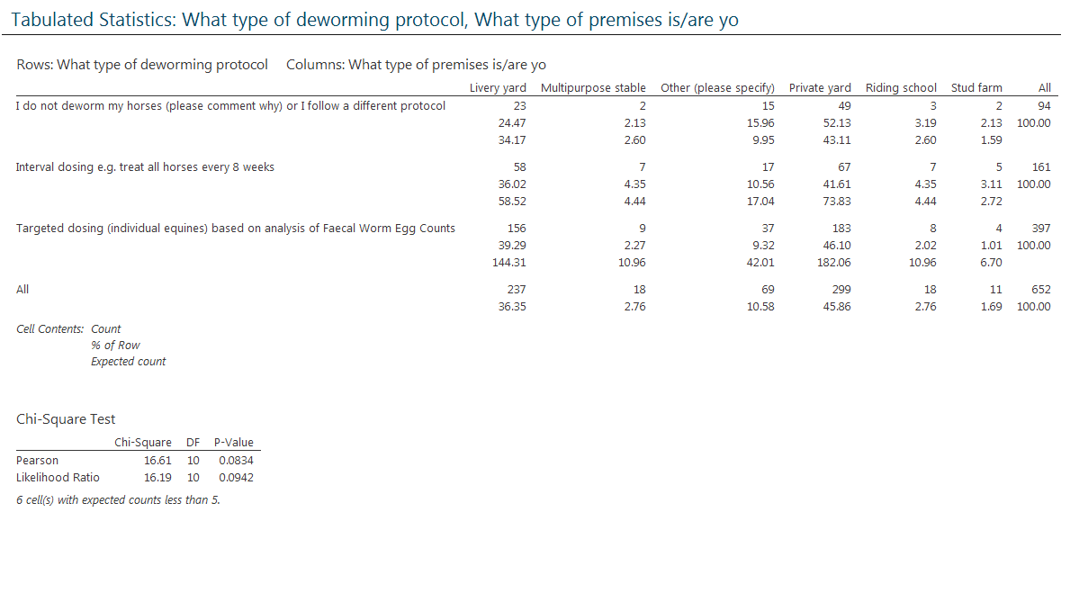
No significant difference. Most kept on a livery yard.

7. Do you think any of the equines at your premises have been affected by worm-related disease in the last 12 months?
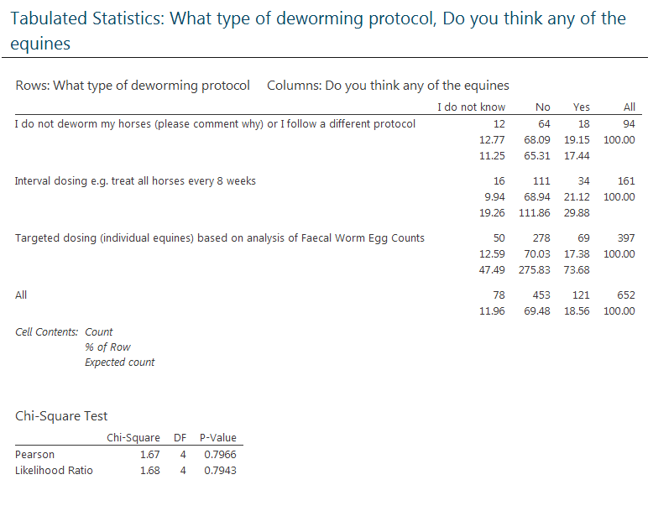
No significant difference. Most say no.

9. Was a veterinary diagnosis made?
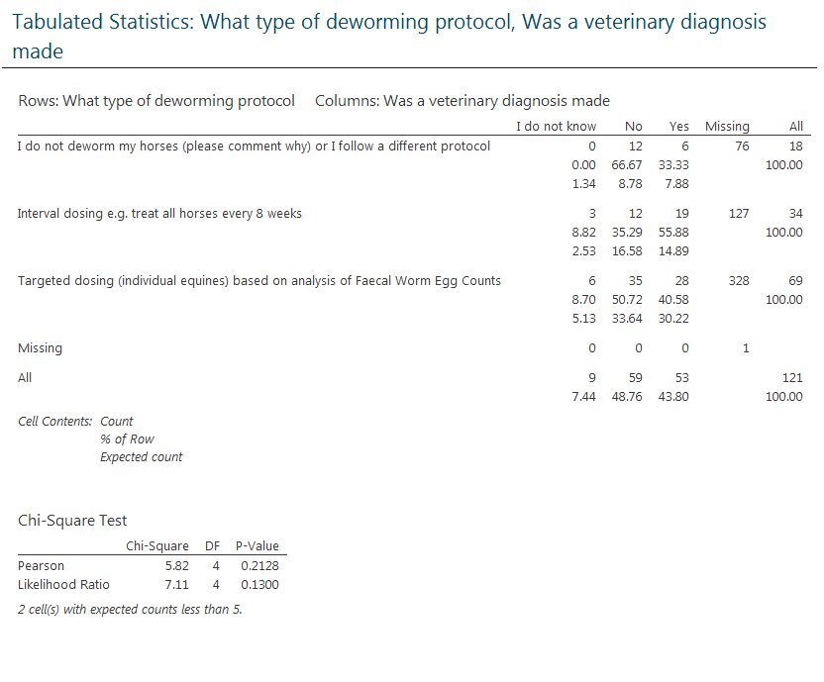
No significant difference.
Analysis by ‘Interval’ vs. ‘Targeted.
15. In your opinion, what hurdles are there to the application of Faecal Worm Egg Count-directed dosing protocols? (please tick one option)
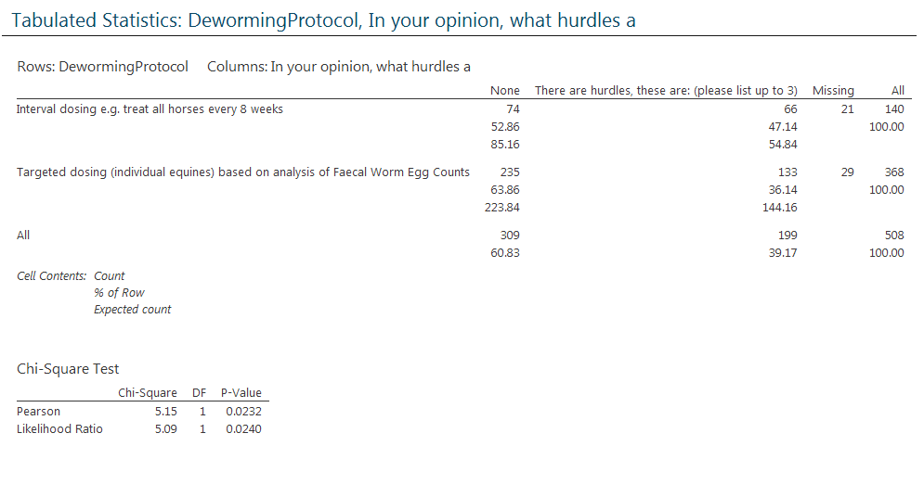
No significant differences. More say no hurdles.

17. In your opinion, which one is the most important worm type to target in a deworming programme?
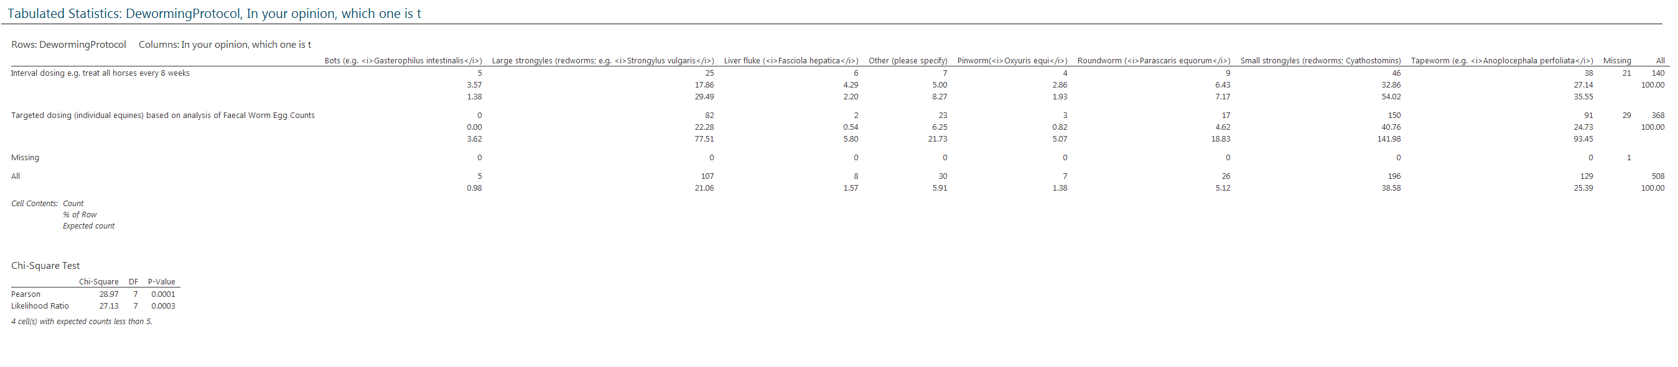

18. How satisfied are you with the level of knowledge that you have about equine parasites and parasitic diseases on a scale of 1 - 5? (1 being the least satisfied and 5 being the most satisfied)
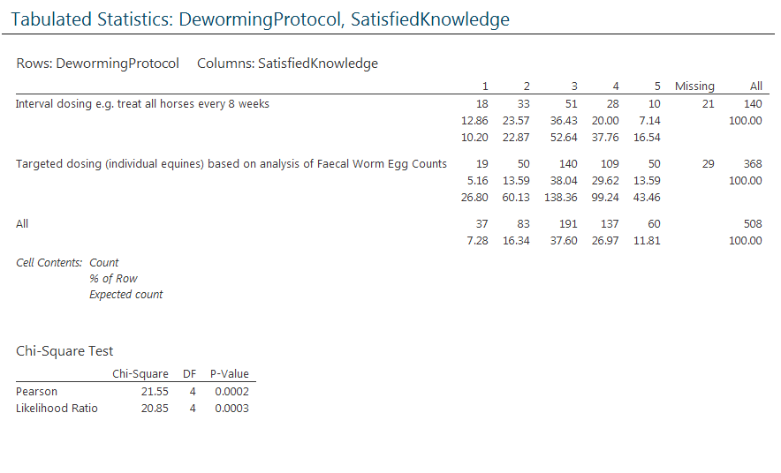
Those using targeted dosing were significantly more satisfied.

19. Would you find impartial, free and accessible parasite control guidelines useful?
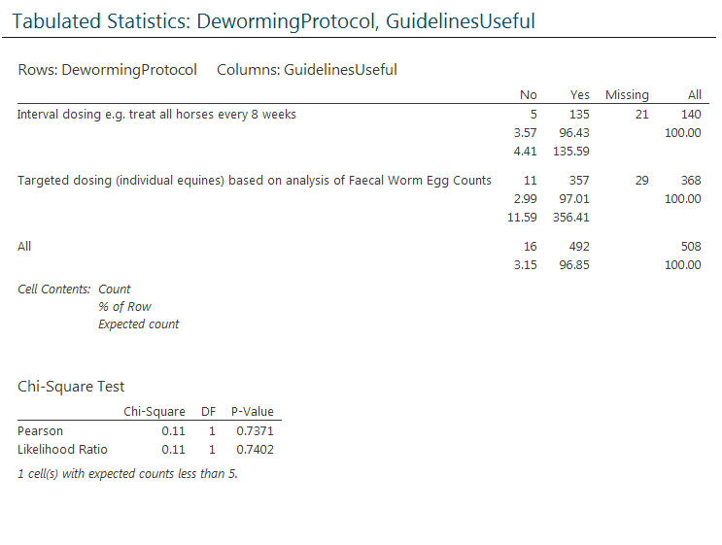
No significant differences.

21. How often do you access the internet?
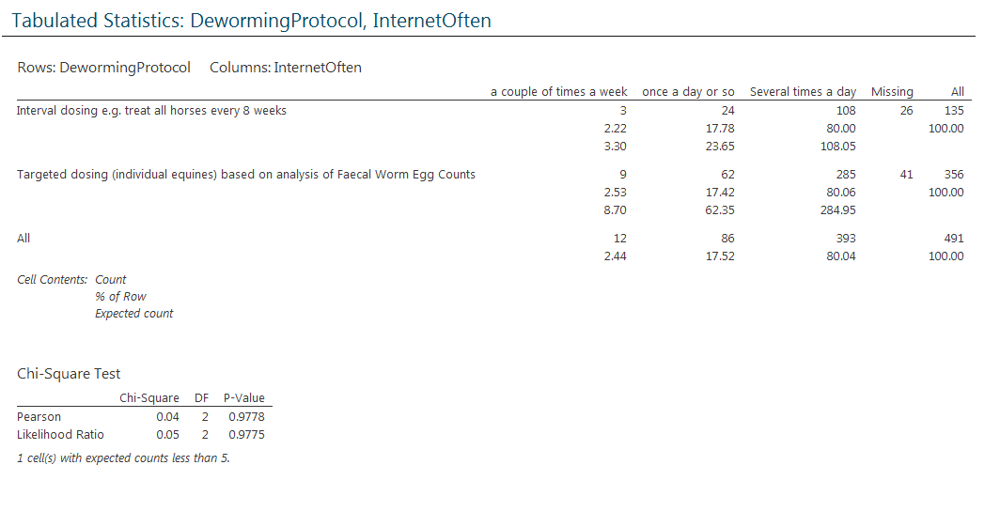
No significant difference. Most several times a day.

22. In your opinion, which deworming protocol do you think costs more financially? (please tick one option)
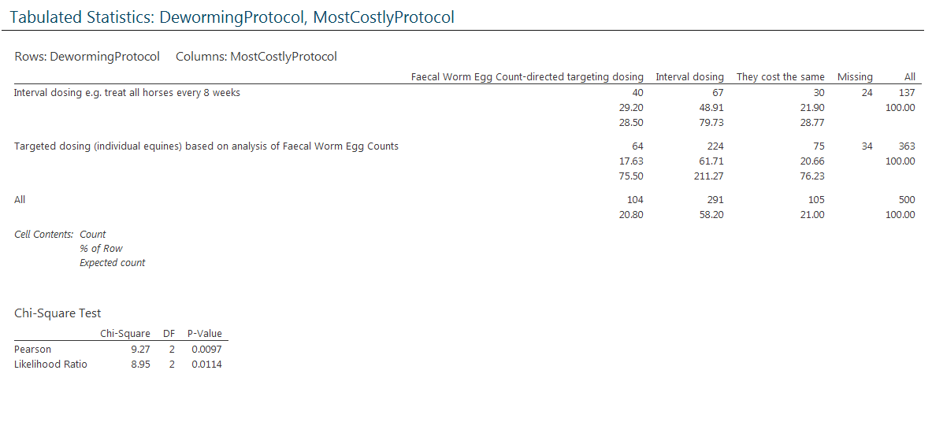
No significant difference. Most perceive interval to be most costly.

23. Who administers the dewormer(anthelmintic) to your horses or the horses in your care? (please tick one option)
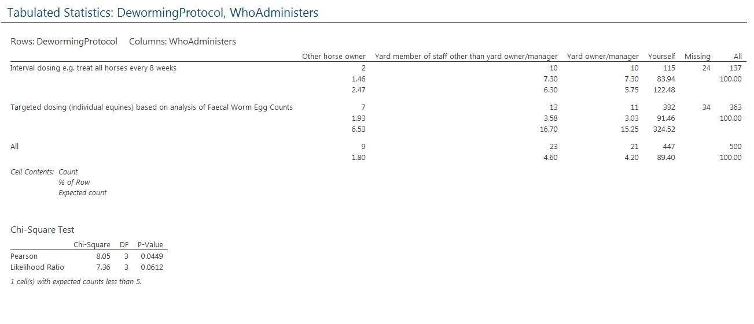
No significant difference. Most do it themselves.

24. How is it determined what dose of dewormer (anthelmintic) is administered to each horse? (please tick one option)
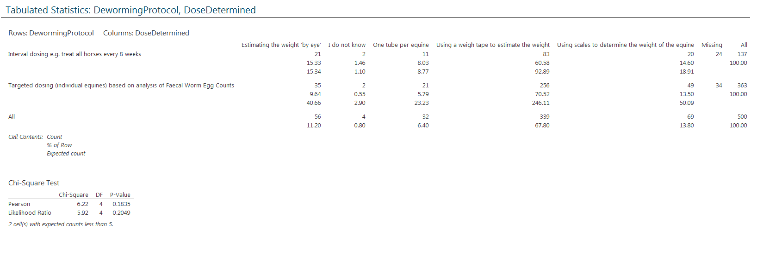
No significant difference. Mostly using a weigh tape.

25. How concerned are you about worm resistance to dewormers on a scale of 1 - 5 (1 being the least concerned and 5 being the most concerned)?
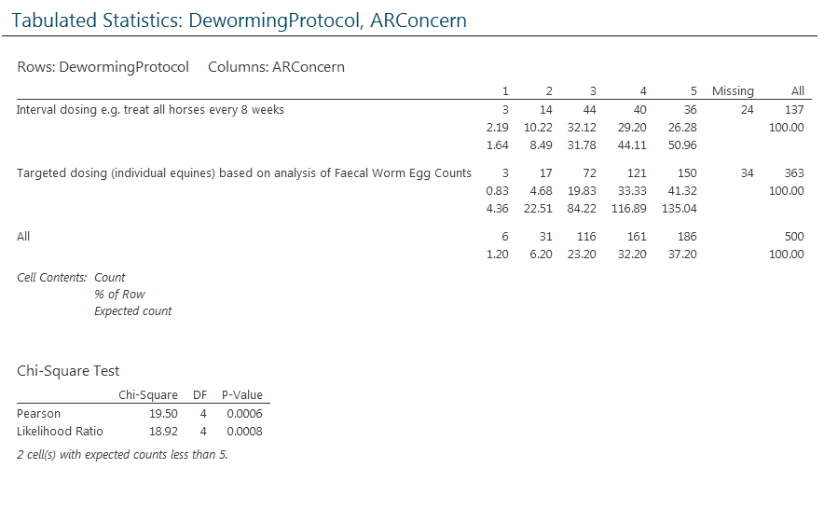
Those using targeted dosing are significantly more concerned about AR.

26. Are you aware of any resistance to wormers at your premises? (please ticko ne option)
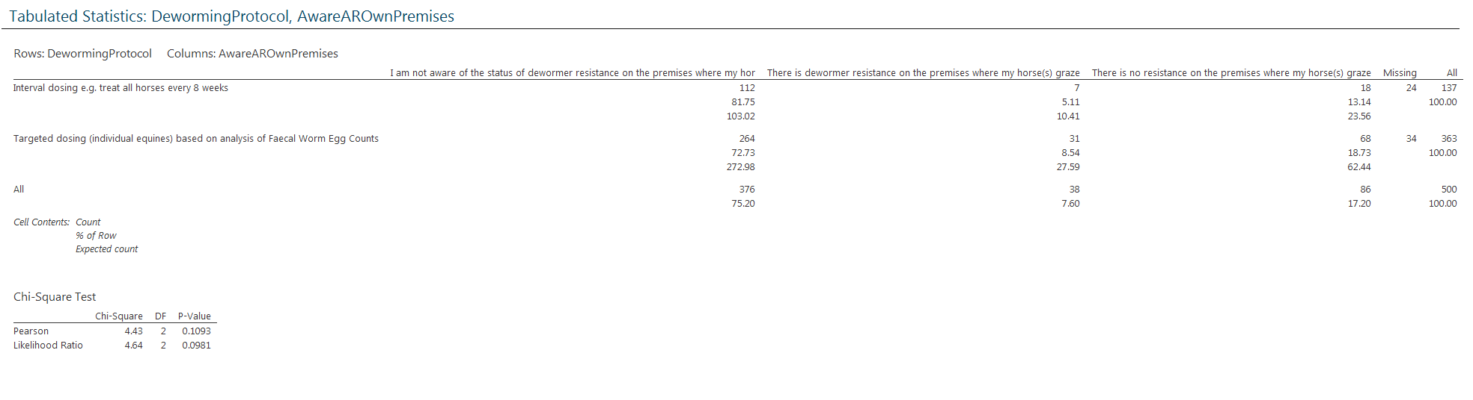
No significant difference. Most not aware of AR on own premises.

27. How was the presence or lack of resistance identified? (please tick one option)
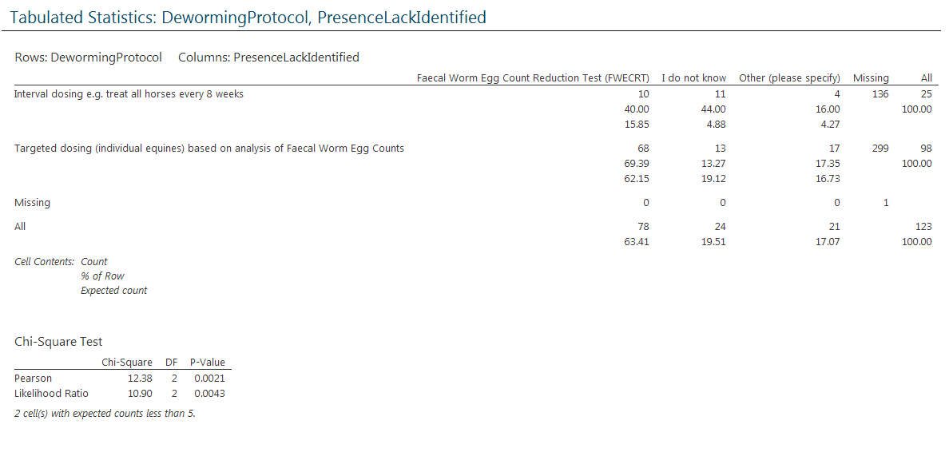
No significant difference. Most FEC.

30. Do you specifically treat for tapeworms? (please tick one option)
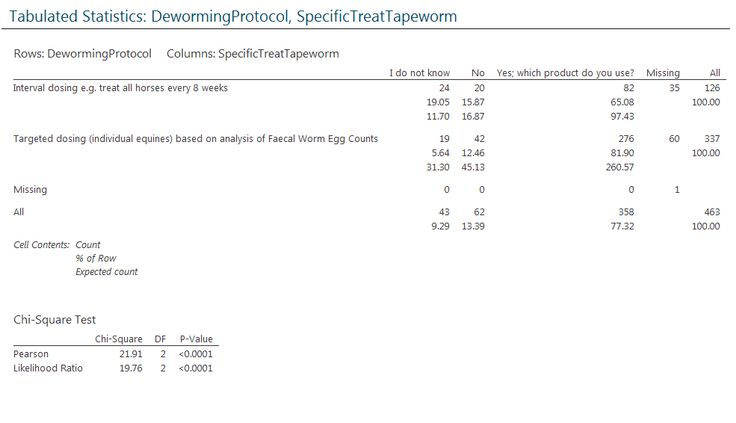
Targeted more likely to specifically treat for tapeworm.

31. Do you specifically treat for encysted cyathostomin larvae (i.e. small redworm encysted larvae)? (please tick one option)
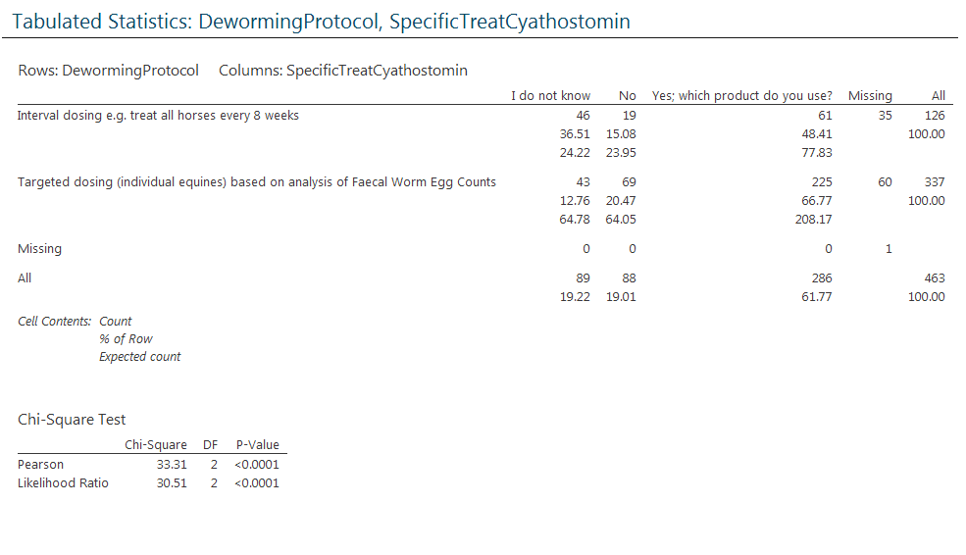
Targeted are significantly more likely to specifically target encysted cyathostomin larvae.

32. When choosing a dewormer (anthelmintic) product, what most influences your decision? (please tick one option)
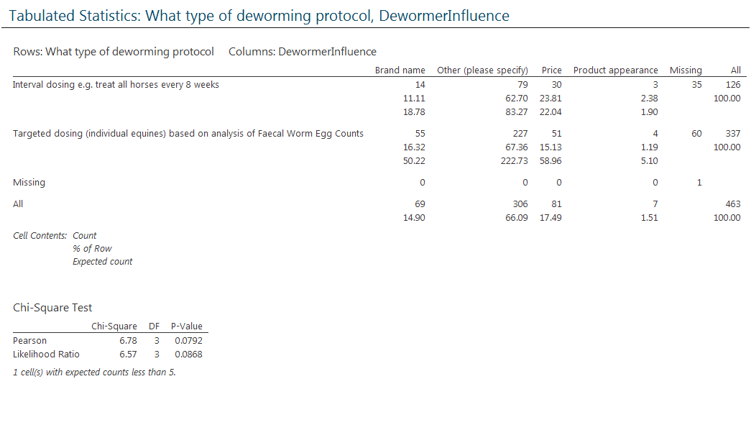
No significant difference. Most say other.

33. Where do you most seek advice when choosing a dewormer (anthelmintic)? (please tick one option)
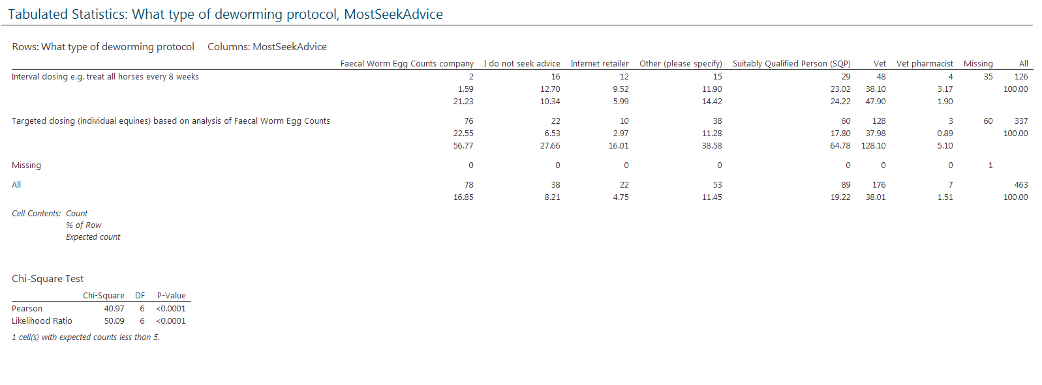
Targeted more likely to seek advice from FEC companies than interval.

34. Where do you purchase dewormer (anthelmintic) products from? (please tick one option)
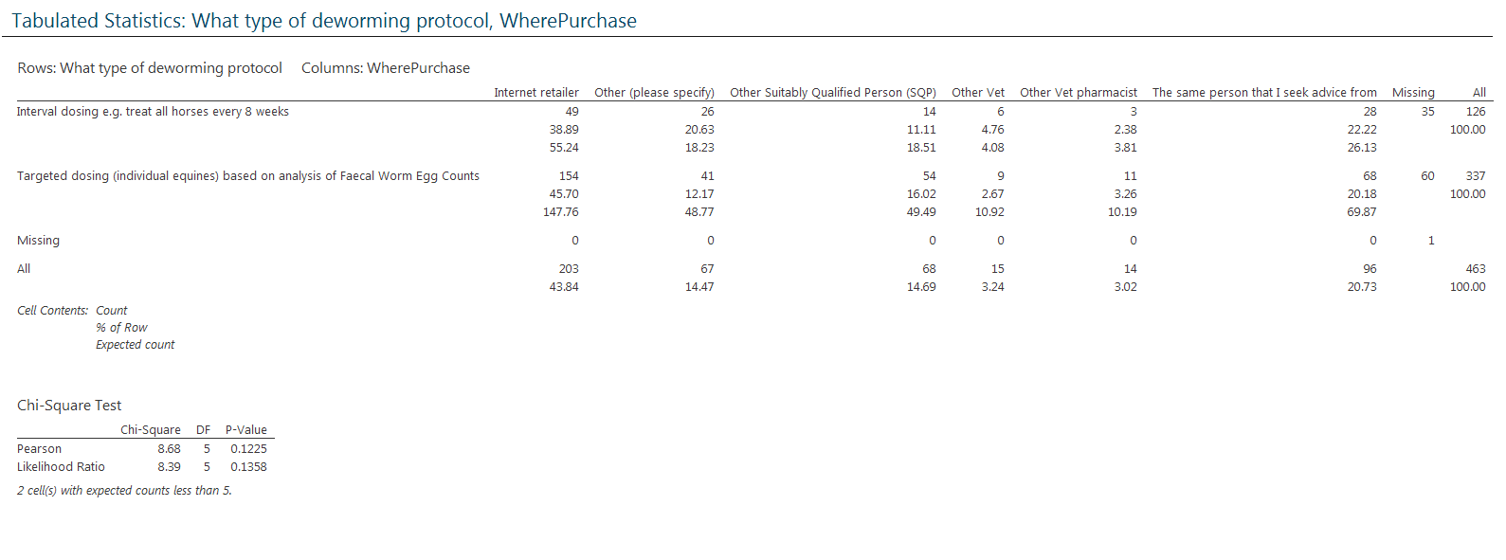
No significant difference. Most purchase online.

35. Please rate the following statements...
“I believe that wormers are bad for my horse and want to minimise their use as far as possible”
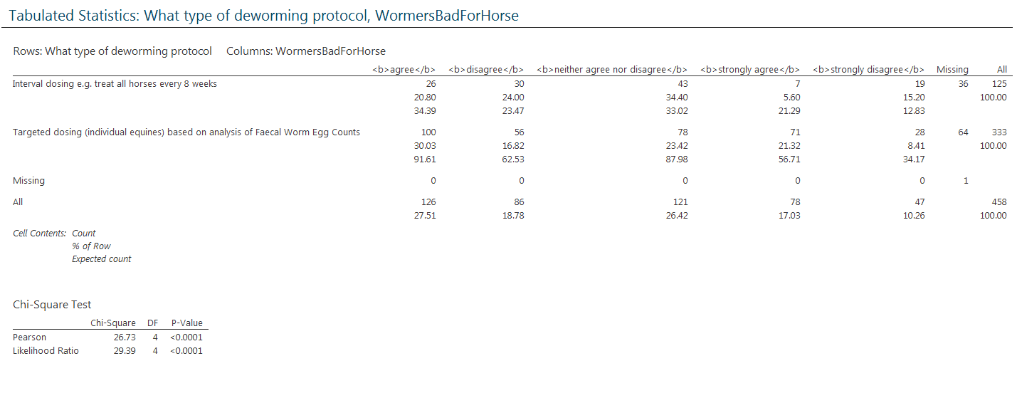
Targeted are more likely to agree.

“Drug companies want me to buy as much wormer as possible and I do not wish to be exploited commercially”
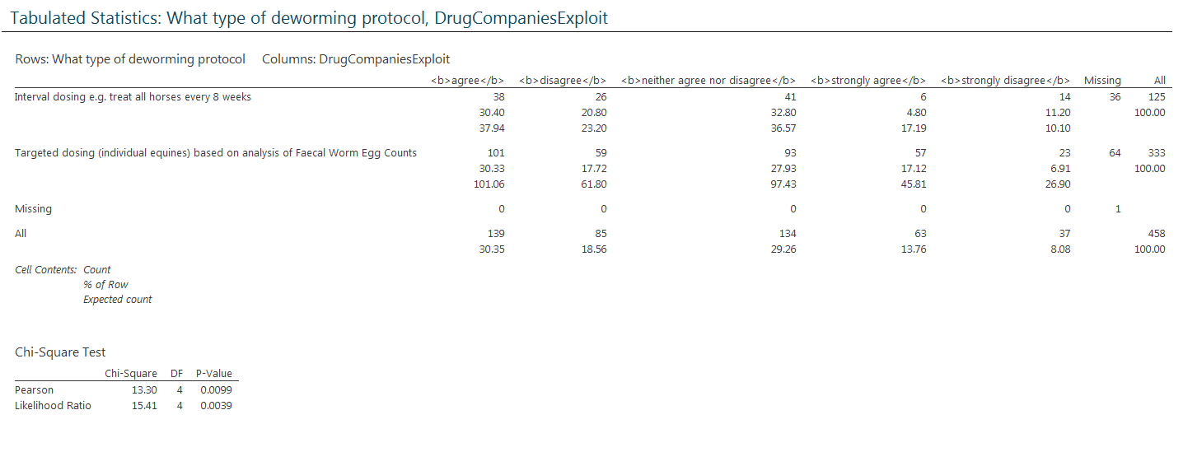
No significant difference. Most agree.

“Herbal medicines are safer than conventional medicines and better for the environment too”
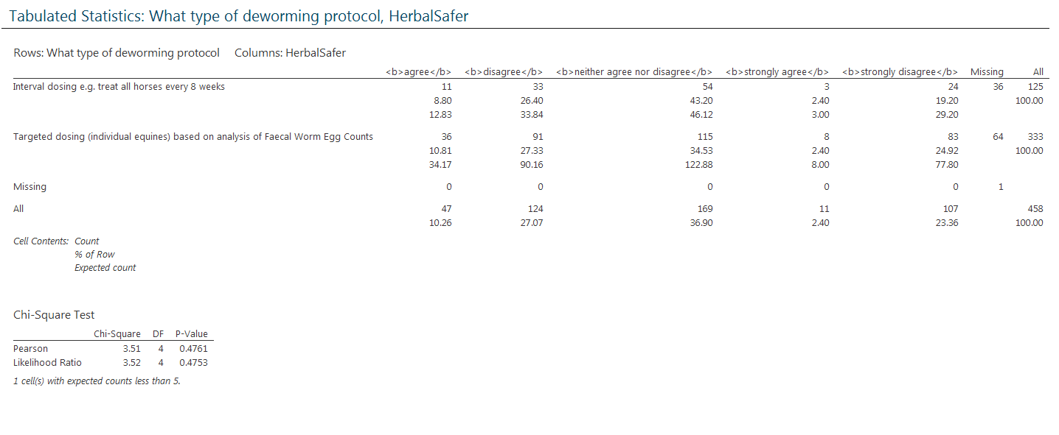
No significant difference. Most disagree.

“Worms are something our horses have to live with and are not always bad for them”
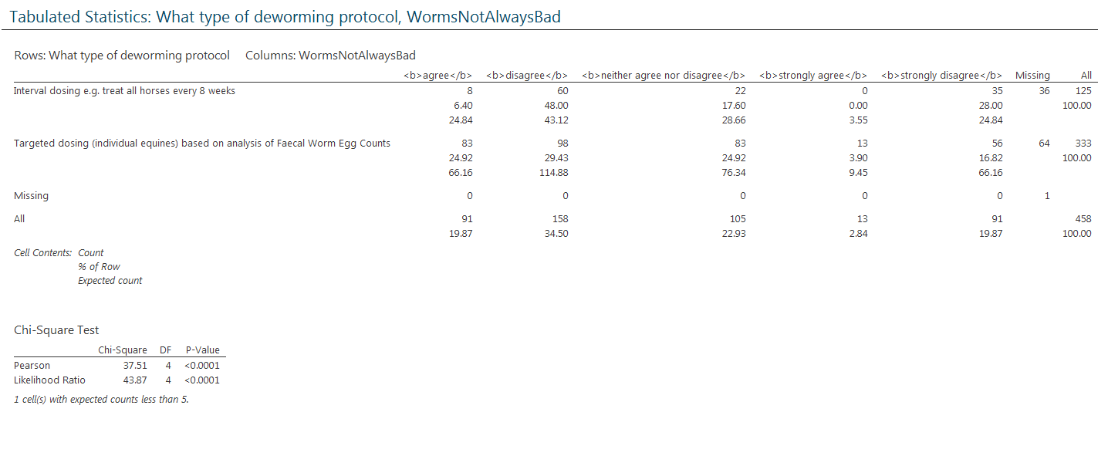
Interval more likely to disagree.

“Worms can cause severe illness in horses and we should seek to eliminate them”
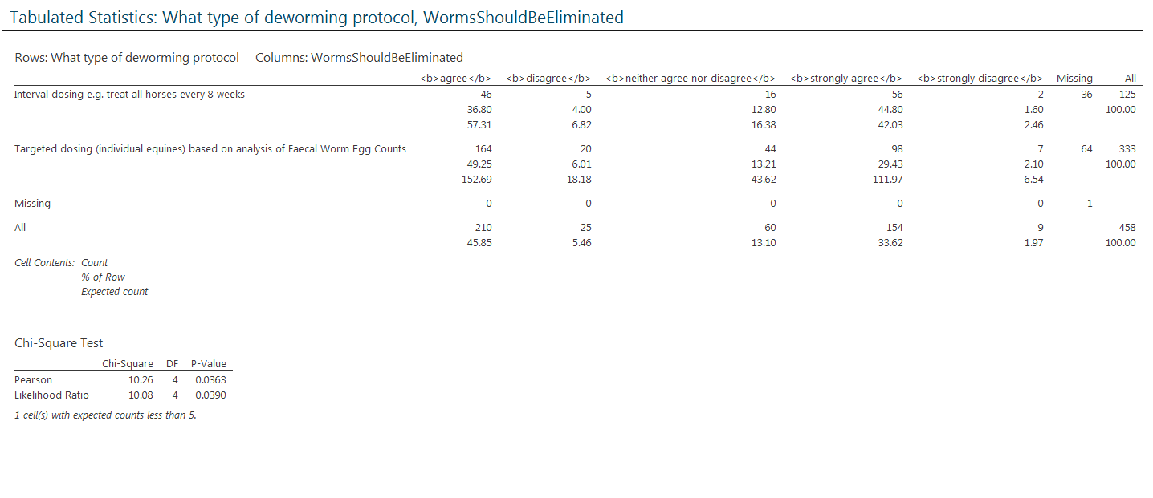
No significant difference. Most agree.

“I am aware of the emergence of wormer resistance in horses and this concerns me”
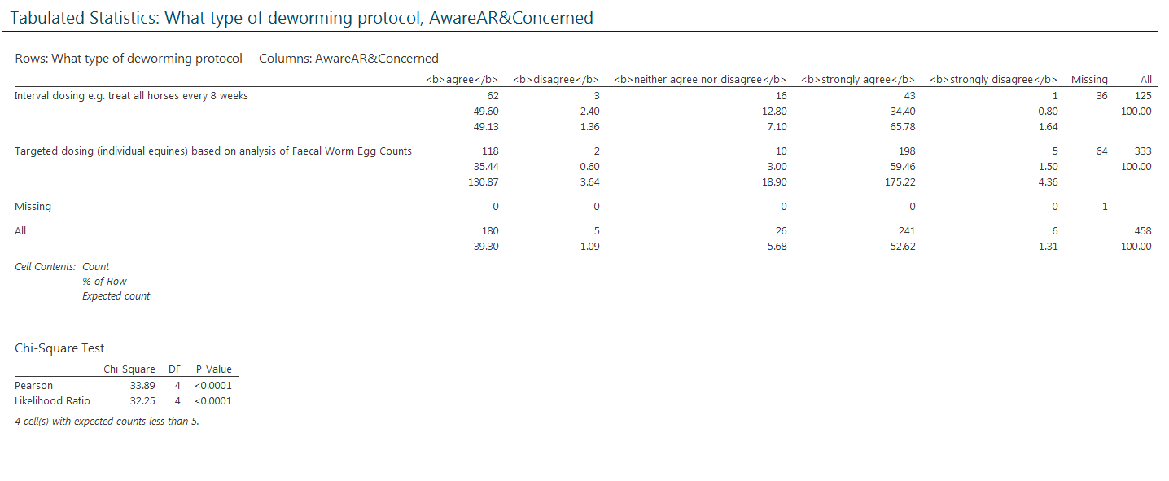
Targeted more likely to agree.

36. Are Faecal Worm Egg Counts performed on samples from horses at your premises? (please tick one option)
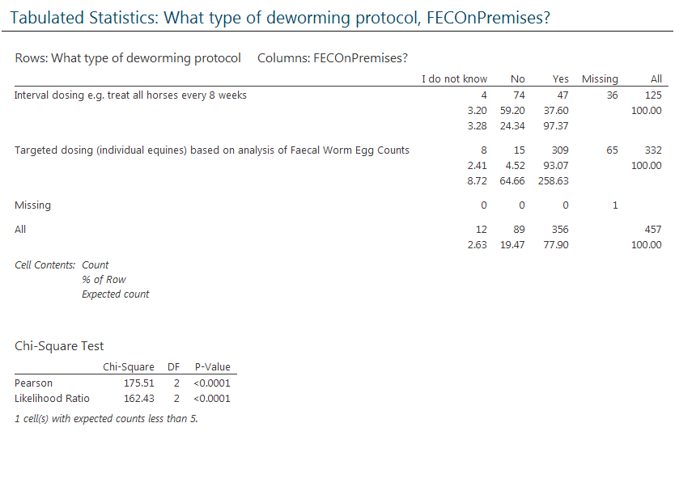
Targeted do FEC more.

37. Who performs the Faecal Worm Egg Counts? (please tick one option)
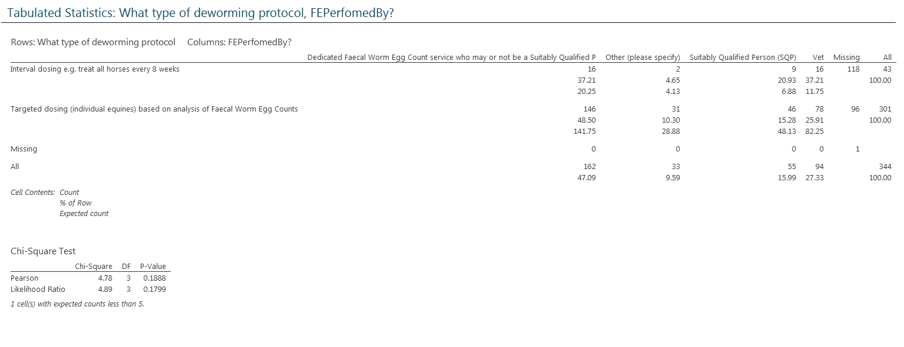
No significant difference.

38. In your opinion, is the person who performs the Faecal Worm Egg Counts qualified enough? (please tick one option)
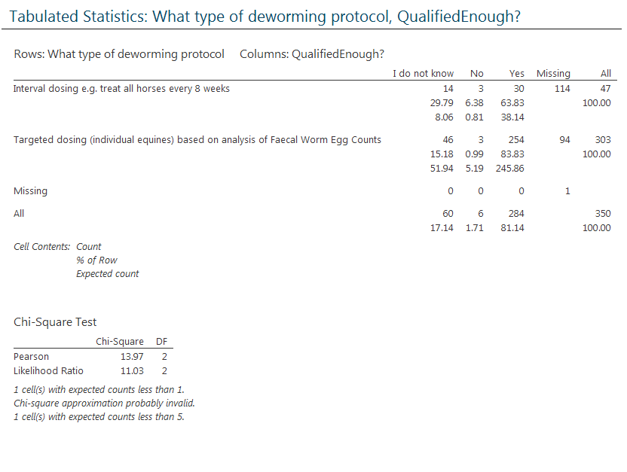
Most say yes.

39. Specific evidence of their expertise is... (please tick one option)
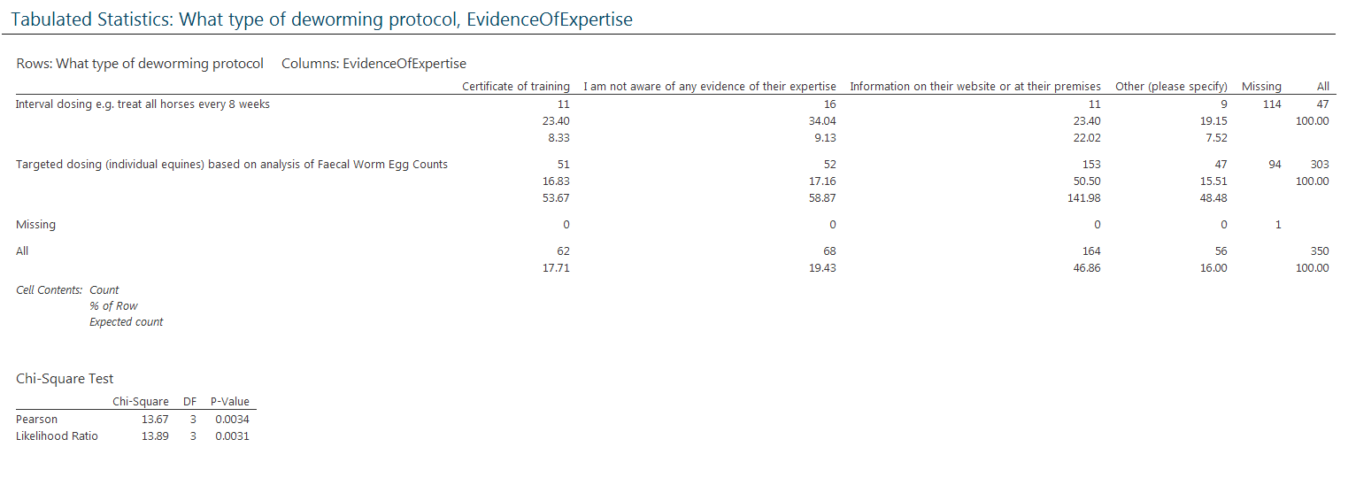
No significant difference.

41. Please rate the following statements regarding Faecal Worm Egg Counts (FWECs)...
“Not enough advice on what to do arrives with FWEC for them to be useful to me”
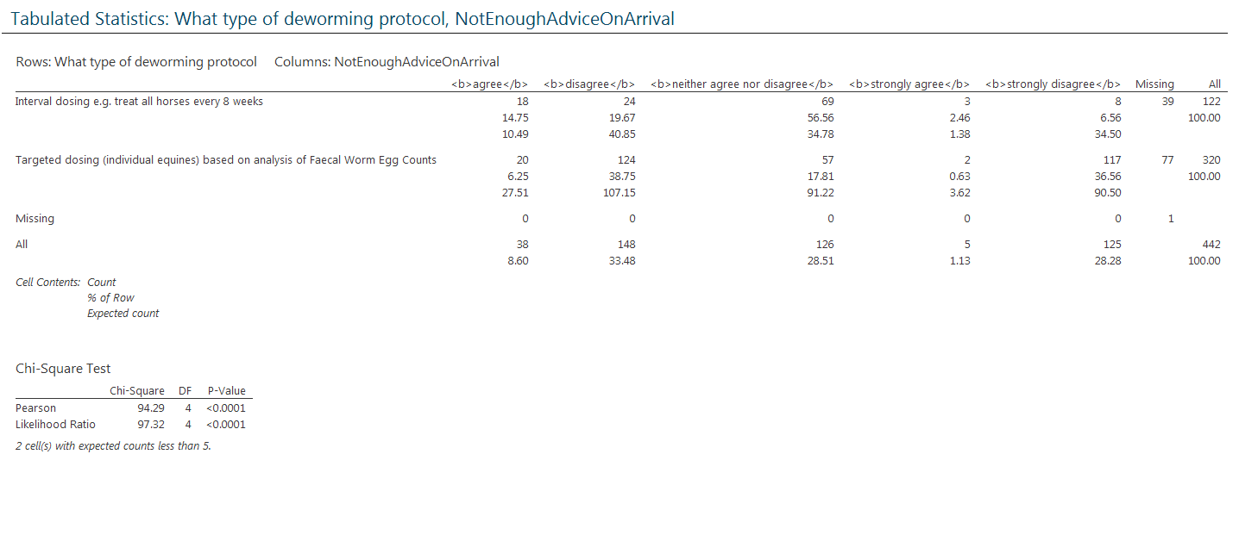
Targeted more likely to disagree while interval more likely to remain neutral.

“FWEC are too expensive and provide no advantage over administering wormer regardless of results”
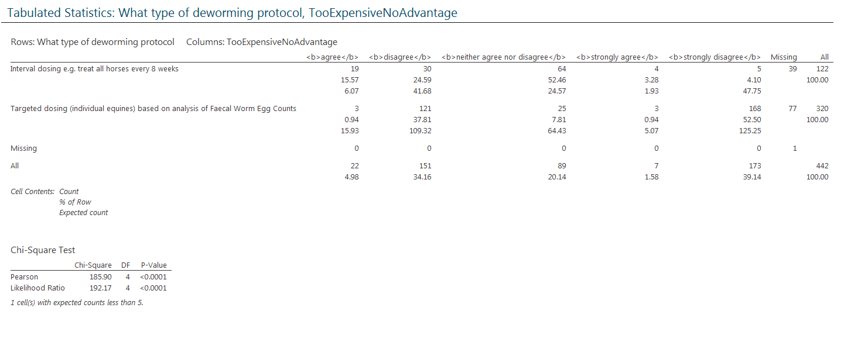
Targeted more likely to disagree.

“Knowing how many eggs are being shed by horses helps me to manage grazing so that horses do not encounter heavily contaminated pastures”
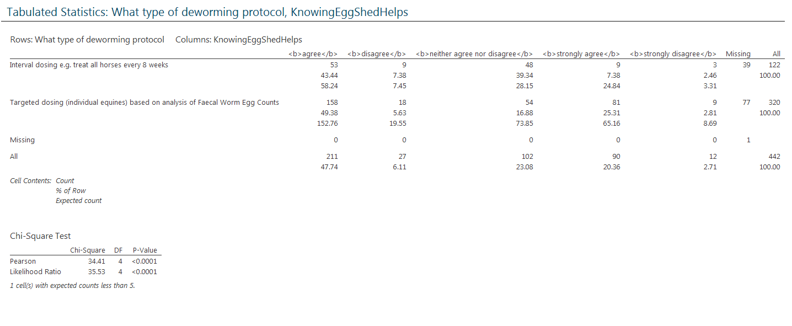
Targeted more likely to agree.

“If FWEC were quicker and cheaper I would use them more”
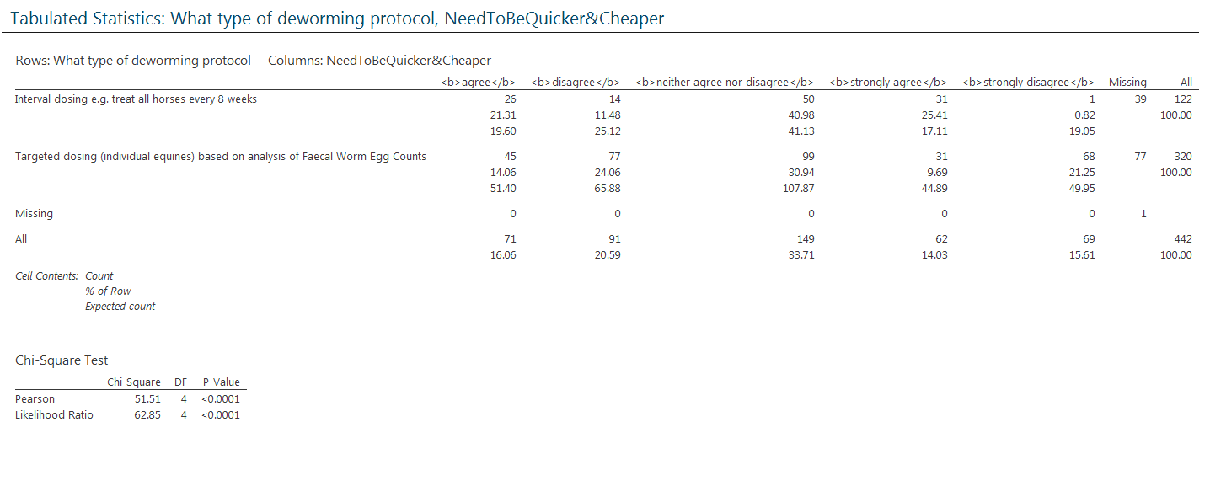
Interval more likely to agree.

42. Do you deworm foals at your premises? (please tick one option)
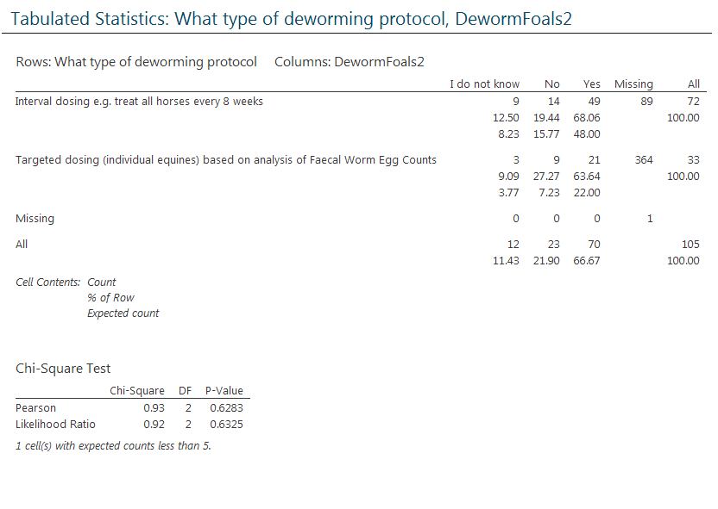
No significant difference. Most deworm foals.

43. How does the deworming of foals compare to that of adult equines at your premises? (please tick one option)
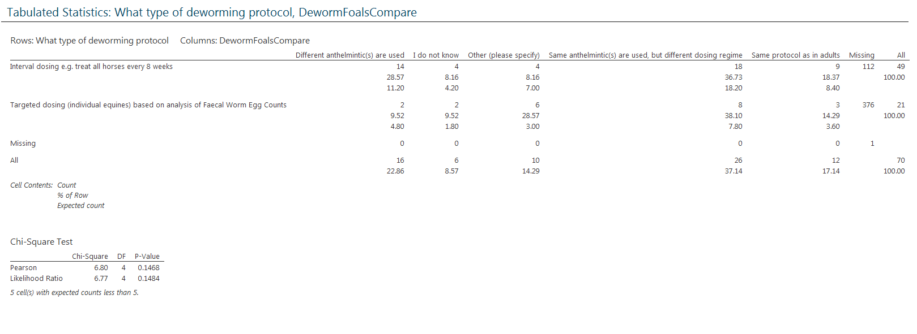
No significant difference. Both use same drugs but different regime.

45. Are new arrivals dewormed before mixing with other horses? (please tick one option)
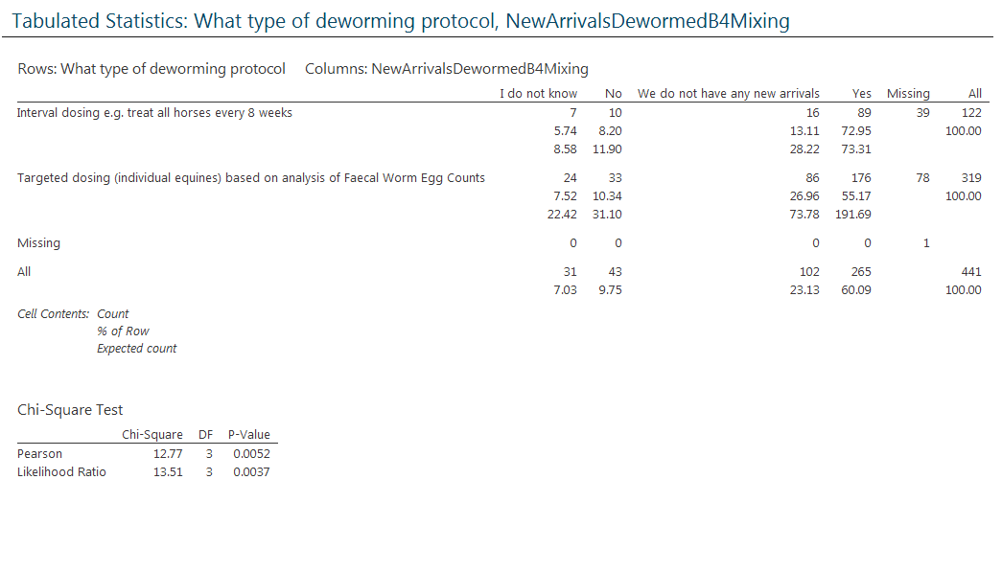
No significant difference. Most deworm before mixing.

47. Are new arrivals withheld from pasture before mixing with other horses?
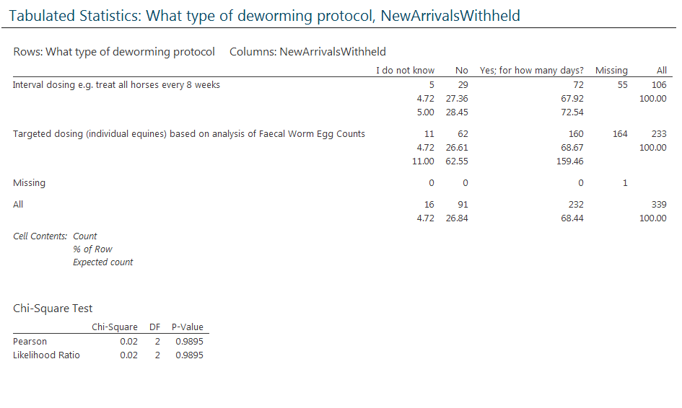
No significant difference. Most say yes.

49. Are pastures on your establishment...
“Rotated between groups of equines?”
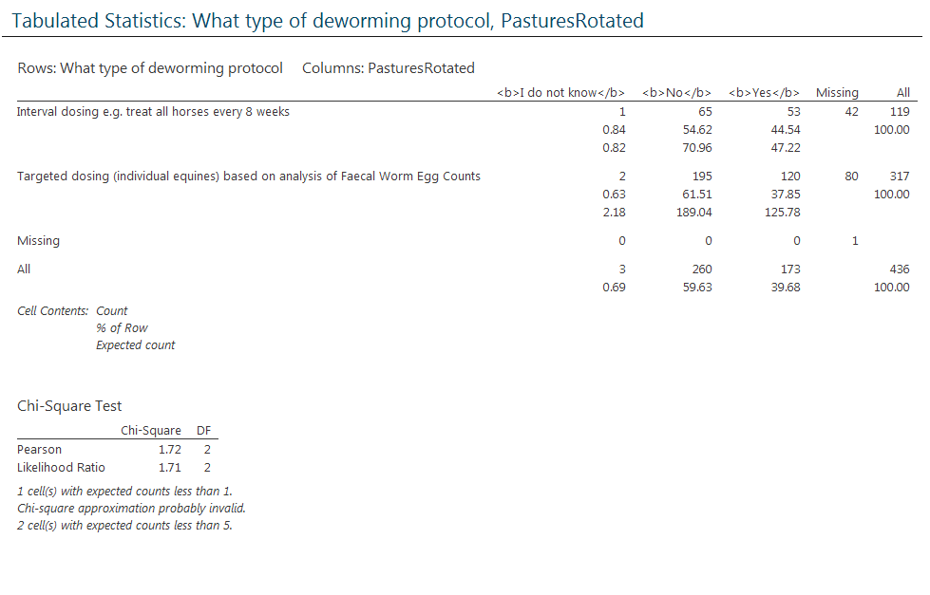

“Rested from grazing?”
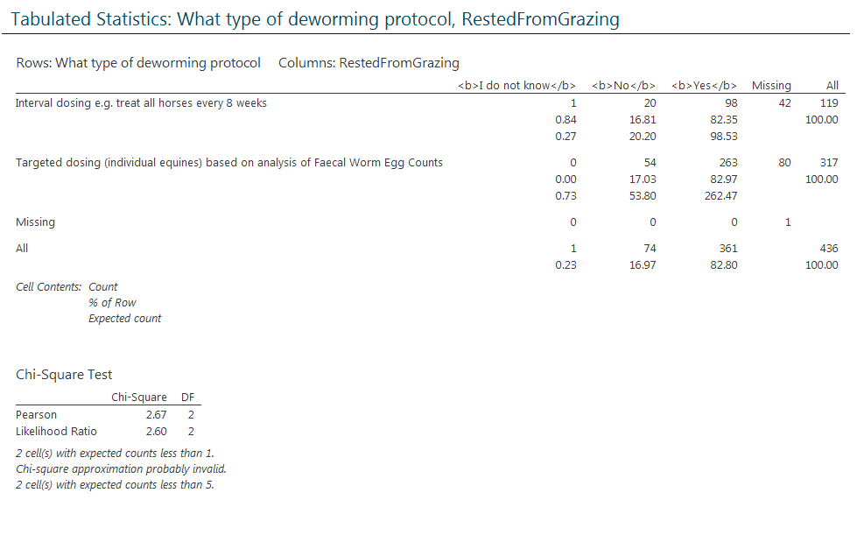
No significant difference. Most say yes.

“Harrowed &/or clipped?”
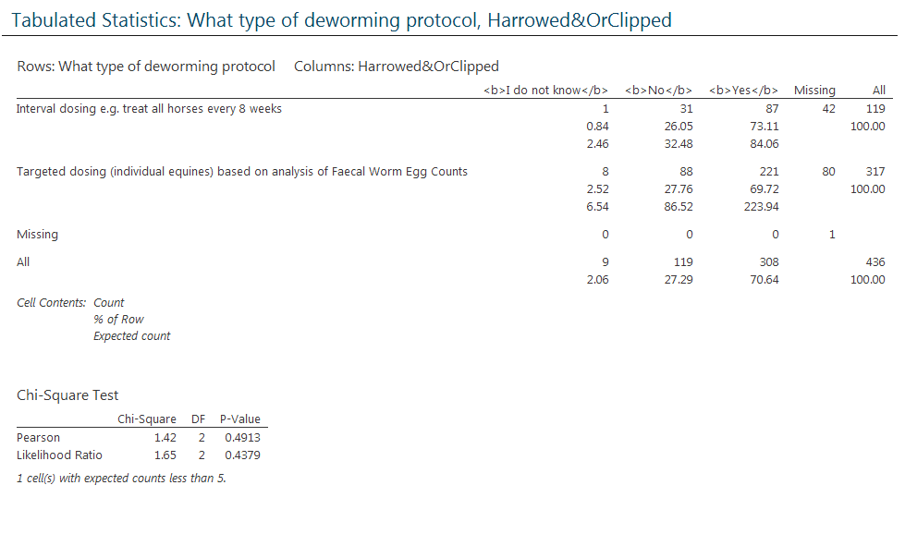
No significant difference. Most say yes.

“Grazed by cattle/sheep?”
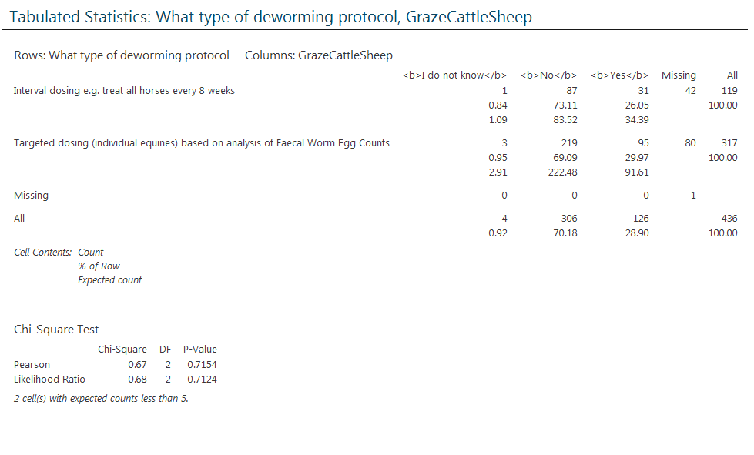No significant difference. Most say no.

52. Are droppings removed from pasture?
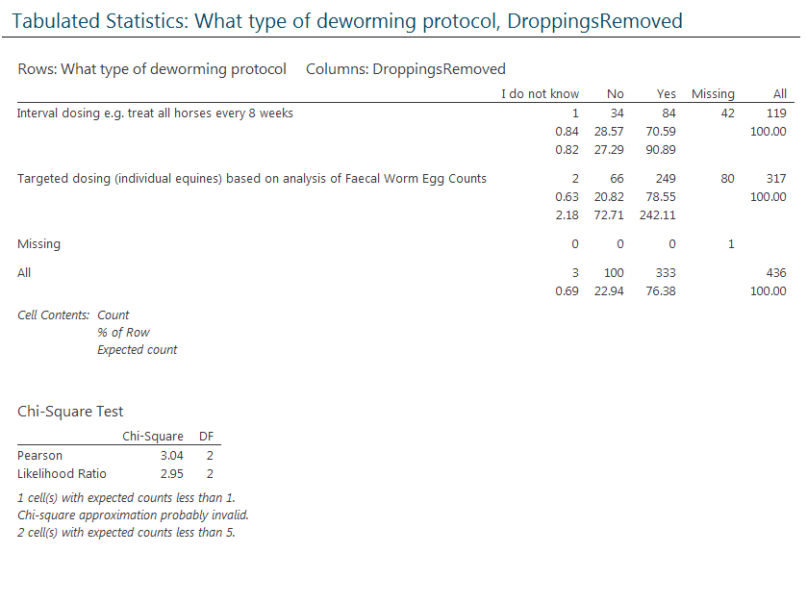
No significant difference. Most say yes.

53. How frequently are droppings removed from pasture?
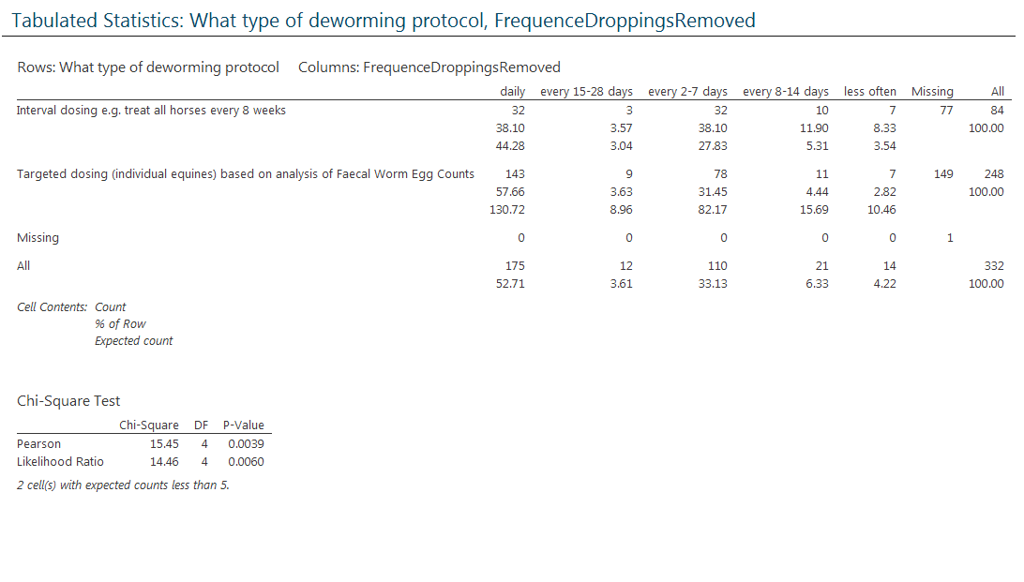
No significant difference.

55. For how long has this been done?
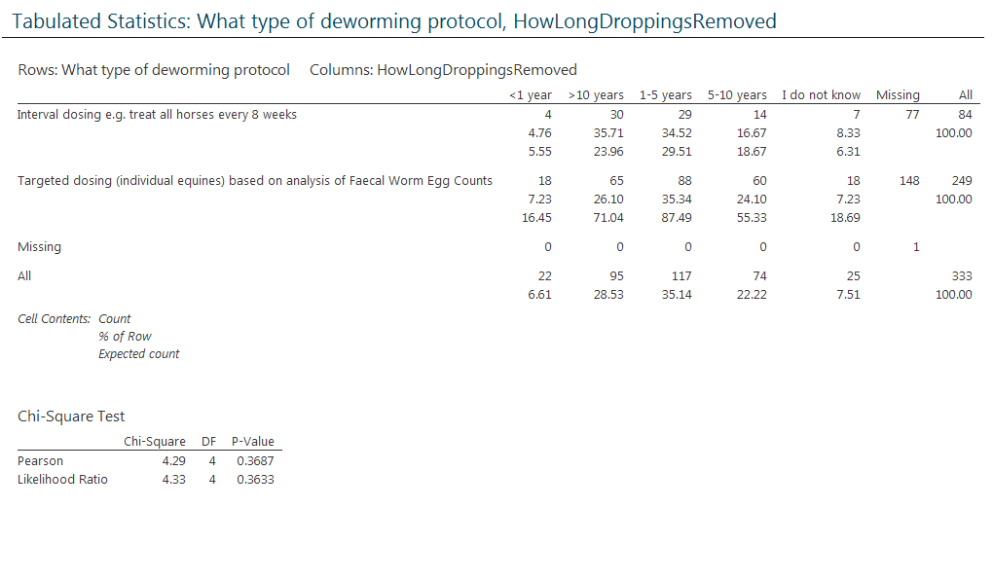
No significant difference.

45. Are new arrivals dewormed before mixing with other horses?
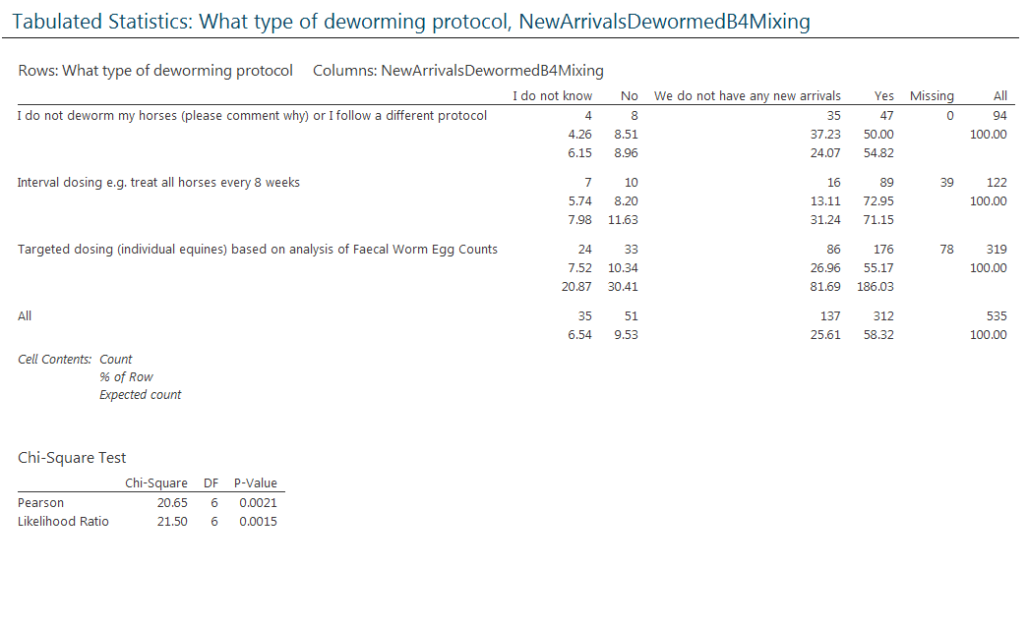
No significant difference. Most say yes or no new arrivals.

47. Are new arrivals withheld from pasture before mixing with other horses?
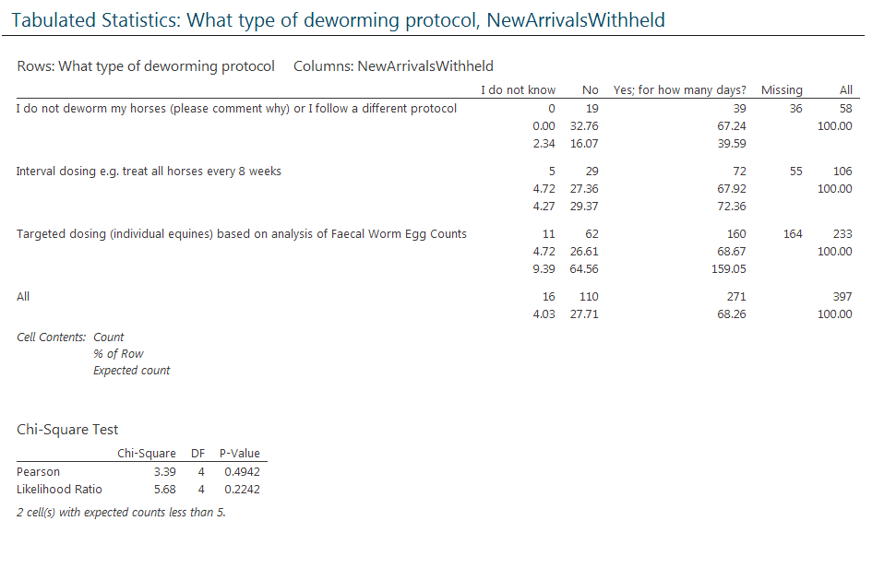
No significant difference. Most say yes.

49. Are pastures on your establishment...
“Rotated between groups of equines?”
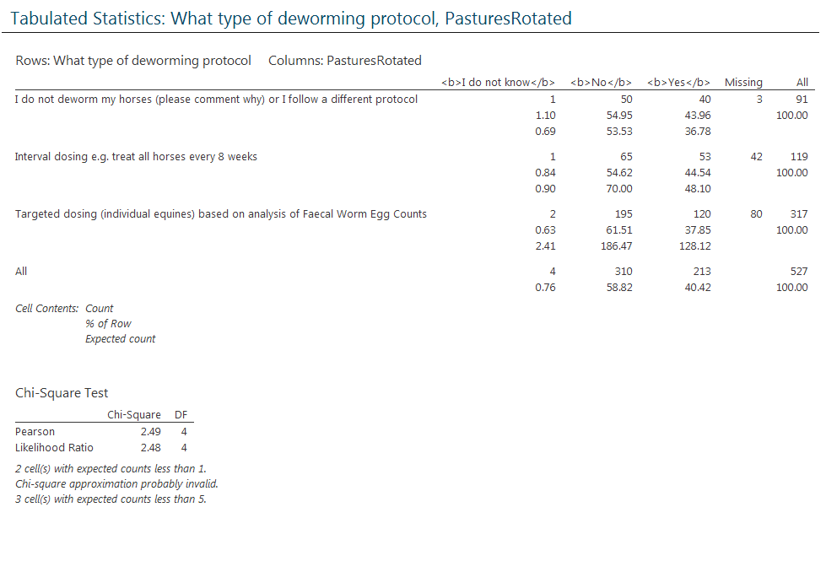
No significant difference. Most say no.

“Rested from grazing?”
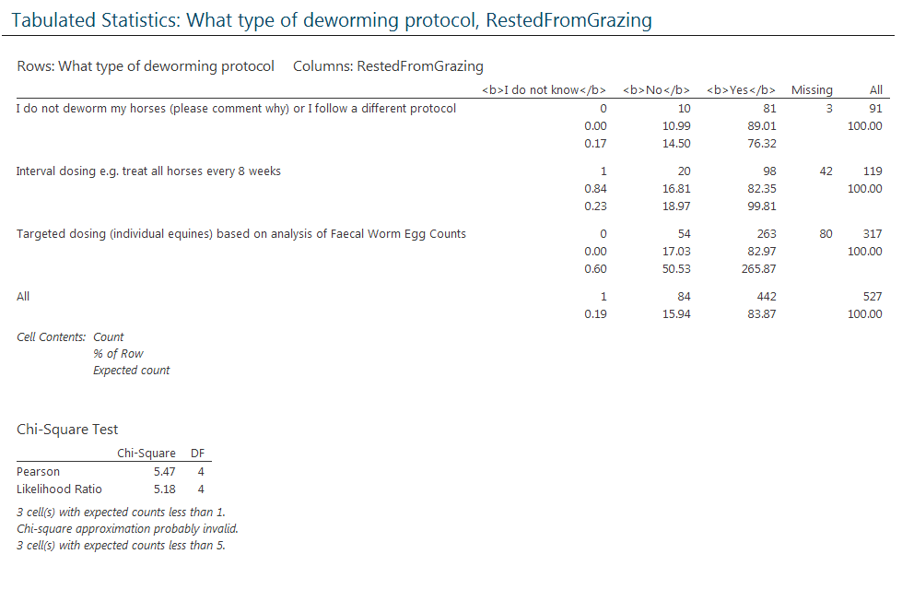
No significant difference. Most say yes.

“Harrowed &/or clipped?”
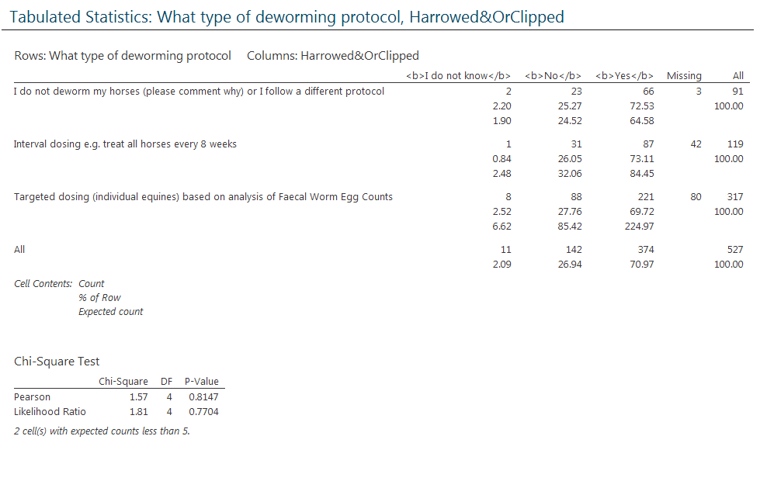
No significant difference. Most say yes.

“Grazed by cattle/sheep?”
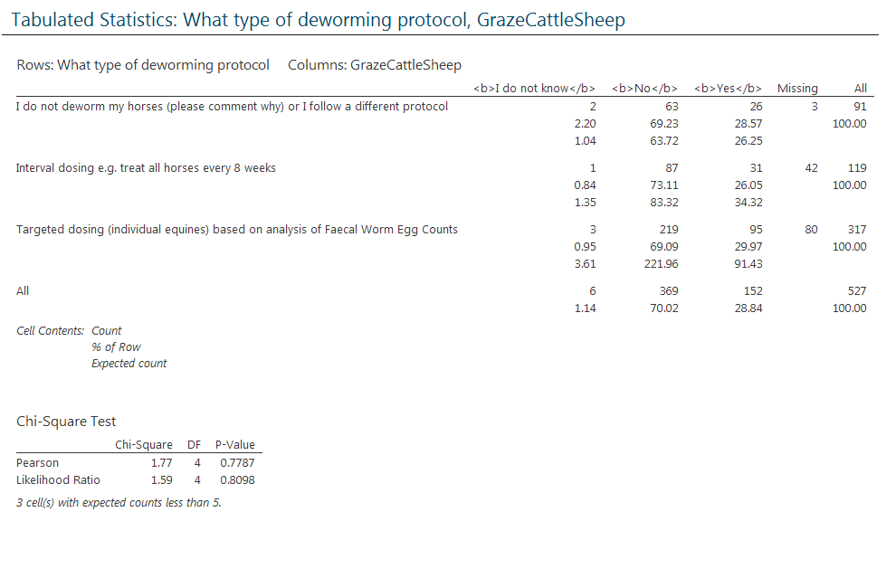
No significant difference. Most say no.

“52. Are droppings removed from pasture?”
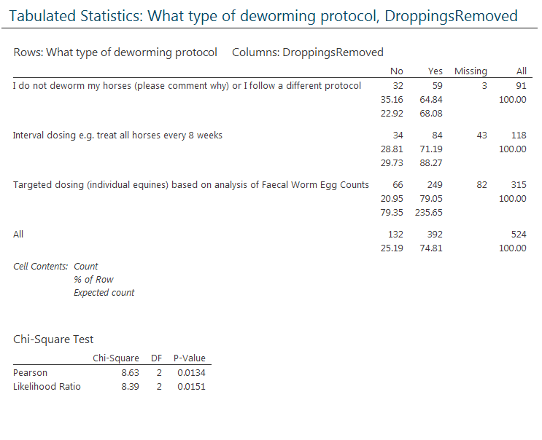
No significant difference. Most say yes.

53. How frequently are droppings removed from pasture?
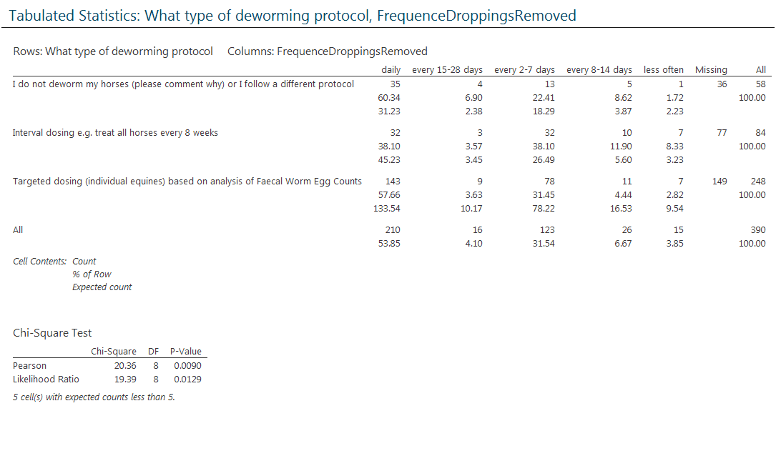
No significant difference.

55. For how long has this been done?
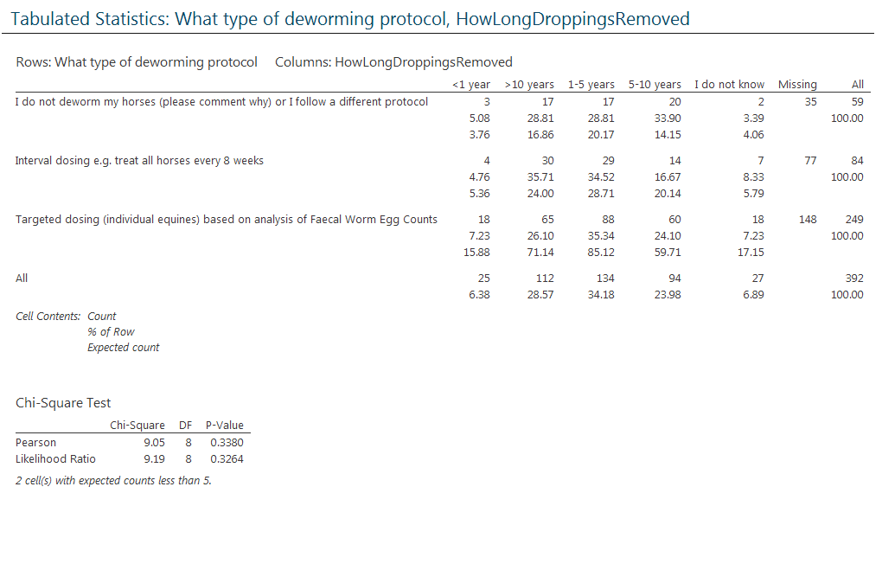
No significant difference.

