THE NATIONAL INSTITUTE FOR HEALTH RESEARCH (NIHR) GLOBAL HEALTH RESEARCH GROUP ON ATRIAL FIBRILLATION MANAGEMENT

Gregory Y. H. Lip, Yutao Guo, Paulo Lotufo, Rajendra Surenthirakumaran, Lindsey Humphreys, G. Neil Thomas, on behalf of the NIHR Global Reach AF Investigators*
(United Kingdom, Sri Lanka, China and Brazil)

Correspondence:
Prof Gregory Y. H. Lip
Liverpool Centre for Cardiovascular Science, University of Liverpool and Liverpool Heart & Chest Hospital, Liverpool, UK.
gregory.lip@liverpool.ac.uk

Atrial fibrillation (AF) is the most common heart rhythm disorder globally and is associated with a high risk of death, disability, ill health and poor life quality. The main causes high blood pressure, and diabetes are common in low- and middle-income countries (LMICs), as is AF under-treatment, leading to missed opportunities in preventing fatal or disabling strokes and cardiovascular disease.

Many patients, particularly in LMICs, are undiagnosed and not receiving life-saving treatment. Warfarin, the most common stroke prevention option, needs careful monitoring, but clinical services in many LMICs are patchy which can lead to treatment-initiation failures, insufficient monitoring/follow-up. In LMICs, newer treatments are too expensive for the majority of patients and this is compounded by patient care rarely being delivered in a joined-up or integrated manner.

We have successfully led changes in AF management locally, nationally and internationally, in diverse healthcare systems by promoting AF detection, stroke risk assessment and enabling clinicians to manage AF in an integrated/holistic manner [see Figure 1, adapted from Arnar et al (1)].

We are working with disadvantaged populations in China, Brazil, and Sri Lanka. These countries have different populations, risk profiles with distinct healthcare systems and needs, and even within each setting there remains considerable variation. Their AF research is limited and patient identification and management suboptimal. By co-developing/adapting known effective methods to increase awareness of AF and its complications and implement evidence-based treatments the project will contribute to improving both management pathways and most importantly lives.
The principle is to develop and adapt feasible, locally-adapted, evidence-based, sustainable pharmacological and behavioural approaches for integrated AF management to improve care and outcomes.

This approach would be focused on the ABC pathway (2):
A: ‘Avoid stroke with Anticoagulation’
B: ‘Better symptom management’ with patient centred and symptom directed approachs to rate or rhythm control.
C: ‘Cardiovascular and comorbidity risk reduction’ with attention to risk factors for the progression of AF and its complications, as well as lifestyle changes. Patient values and preferences would be addressed, as well as the psychological morbidity associated with AF and its complications.

The aim is to build long-term, sustainable collaborations to increase AF education/awareness amongst key stakeholders including patients, families, healthcare providers and commissioners and co-develop research capacity. This will be achieved through co-developed, culturally-adapted, community-based approaches. The program will deliver locally-focused evidence-based research to develop patient pathways to facilitate models of best care to meet patient needs, reduce healthcare inequalities and improve well-being and health outcomes in ways that could be introduced in other developing countries in future.

In addition, we intend to empower patients through development of culturally-adapted, community-based approaches to increase education/awareness for patients, families and health care professionals. We believe an informed and educated population is a critical mediator to improving healthcare both on an individual and system level. This would align with the evidence-based local models of best care for policy makers to improve well-being of AF patients. Finally, we intend to build a sustainable research platform for long-term future collaborations.

This 3-year funded NIHR programme has identified clinical partners in the three LMICs working in AF management who are keen to expand their knowledge in research to bring about changes that will benefit their patients and influence future methods of care. We have been working with our partners/patients to identify their training needs, formulate research questions with local stakeholders to assess need and plan effective and ‘value for money’ projects.

ACKNOWLEDGEMENTS
* NIHR Global AF Reach Investigators (alphabetical): Ajini Arasalingam, Isabela Bensenor, Peter Brocklehurst, Kar Keung Cheng, Mei Feng, Alessandra Goulart, Sheila Greenfield, Yutao Guo, Mahesan Guruparan, Gustavo Gusso, Wang Hao, Lindsey Humphreys, Balachandran Kumarendran, Kate Jolly, Sue Jowett, Paulus Kirchhof, Emma Lancashire, Deirdre Lane, Dan Lasserson, Xuewen Li, Gregory Y H Lip (Co-PI), Trudie Lobban, Paulo Lotufo, Semira Manseki-Holland, David Moore, Krishnarajah Nirantharakumar, Rodrigo Olmos, Alena Shantsila, Isabelle Szmigin, Kumaran Subaschandren, Rajendra Surenthirakumaran, G Neil Thomas (Co-PI)

REFERENCES
- Arnar D, Mairesse G, Boriani G, et al. Management of asymptomatic arrhythmias: a European Heart Rhythm Association (EHRA) consensus document, endorsed by the Heart Failure Association (HFA), Heart Rhythm Society (HRS), Asia Pacific Heart Rhythm Society (APHRS), Cardiac Arrhythmia Society of Southern Africa (CASSA), and Latin America Heart Rhythm Society (LAHRS). Europace 2019; doi:10.1093/europace/euz046
- Lip GYH. The ABC pathway: an integrated approach to improve AF management. Nat Rev Cardiol. 14(11):627-628;2017.

Figure 1.
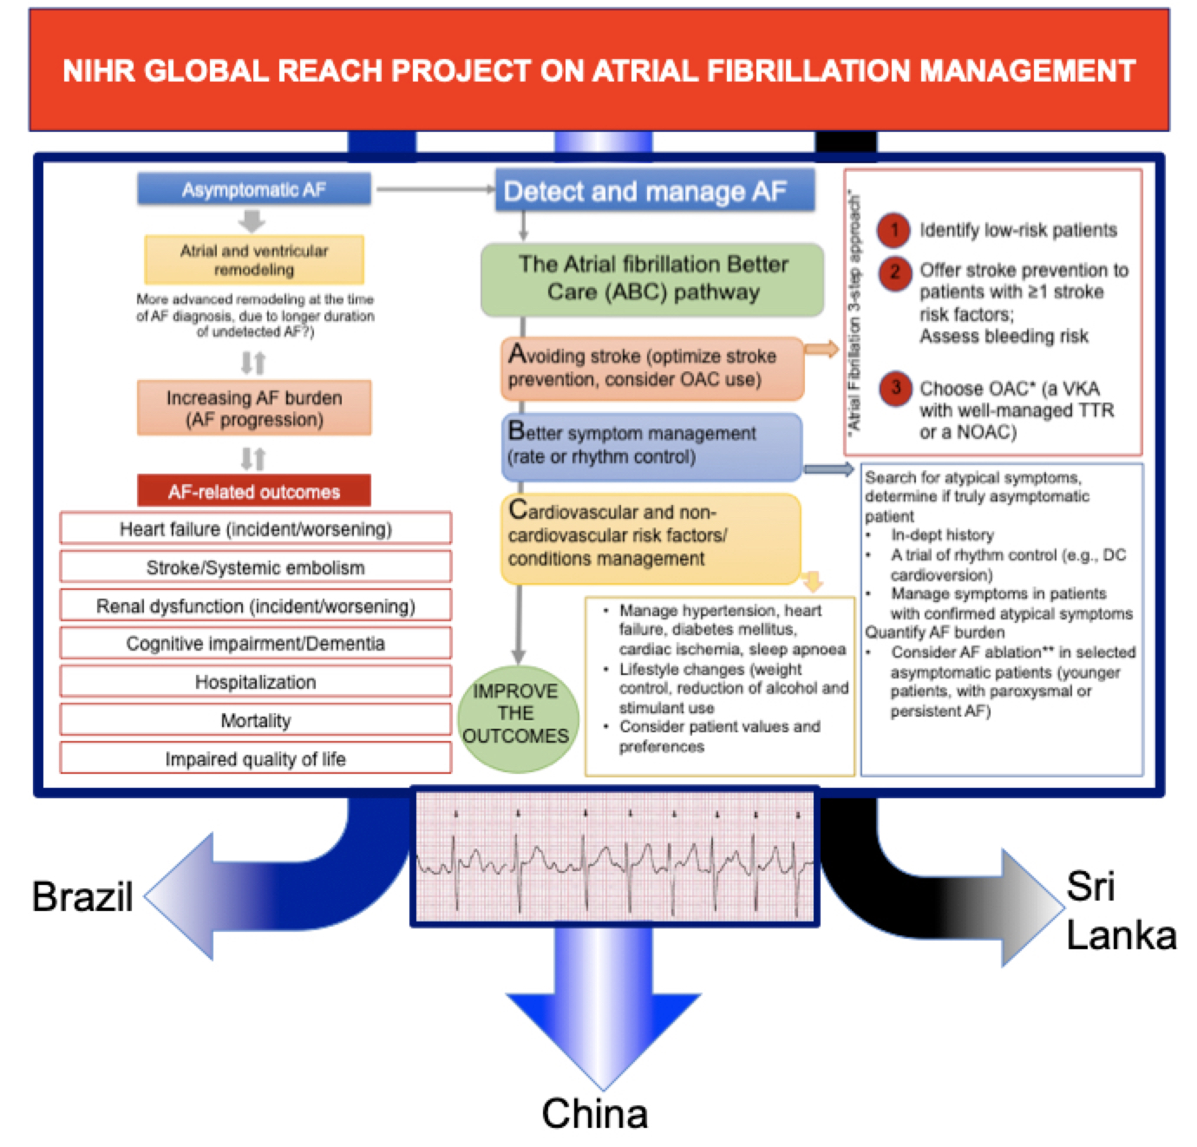

Photo CAPTIONS

DSC03184[4]
Global Health Research Group on AF Management inaugural meeting at the Chancellor’s Court, University of Birmingham

IMG_8917
Attending a community health centre to discuss care pathways, Taoyuan, Shanxi province, China

IMG_8918[4]
Patients discussing their perspectives and care pathways at a stakeholder and investigator meeting, Taoyuan, Shanxi province, China

Greg Lip presentation in MAFA II Steering committee meeting_SCR_RET

