The influence of hypoxia on the prostate cancer proteome

James A. Ross^{1,a}, Johannes P.C. Vissers^{2,a}, Jyoti Nanda³, Grant D. Stewart⁴, Holger Husi⁵, Fouad K. Habib³, Dean E. Hammond^{6,Δ,}*, Lee A. Gethings^{2,7}*

Short title: The influence of hypoxia on the prostate cancer proteome

1 Tissue Injury and Repair Group, University of Edinburgh, Edinburgh, United Kingdom
2 Waters Corporation, Wilmslow, United Kingdom
3 Prostate Research Group, University of Edinburgh, United Kingdom/ Tissue Injury and Repair Group, University of Edinburgh, Edinburgh, United Kingdom
4 Department of Surgery, University of Cambridge, Cambridge, United Kingdom
5 Institute of Cardiovascular & Medical Sciences, University of Glasgow, Glasgow, United Kingdom
6 Department of Cellular and Molecular Physiology, University of Liverpool, Liverpool, United Kingdom
7 Manchester Institute of Biotechnology, Division of Infection, Immunity and Respiratory Medicine, Faculty of Biology, Medicine and Health, University of Manchester, Manchester, United Kingdom

ª James A. Ross^{1,a}, Johannes P.C. Vissers contributed equally to this work
* Corresponding authors:
d.e.hammond@liverpool.ac.uk
lee_gethings@waters.com

Keywords
prostate cancer, liquid chromatography, mass spectrometry, ion mobility, proteomics, label-free quantitation, hypoxia, nitric oxide donors.
Abstract
Prostate cancer accounts for around 15% of male deaths in Western Europe and is the second cause of cancer death in men after lung cancer. Mounting evidence suggests that prostate cancer deposits exist within a hypoxic environment and this contributes to radio-resistance thus hampering one of the major therapies for this cancer. Recent reports have shown that nitric oxide (NO) donating non-steroidal anti-inflammatory drugs (NSAIDs) reduced tumour hypoxia as well as maintaining a radio-sensitising/therapeutic effect on prostate cancer cells. The aim of this study was to evaluate the impact of hypoxia on the proteome of the prostate and to establish whether NO-NSAID treatment reverted the protein profiles back to their normoxic status. To this end an established hormone insensitive prostate cancer cell line, PC-3, was cultured under hypoxic and normoxic conditions before and following exposure to NO-NSAID in combination with selected other common prostate cancer treatment types. The extracted proteins were analysed by ion mobility-assisted data independent acquisition mass spectrometry, combined with multivariate statistical analyses, to measure hypoxia-induced alterations in the proteome of these cells. The analyses demonstrated that under hypoxic conditions there were well defined, significantly regulated/differentially expressed proteins primarily involved with structural and binding processes including, for example, TUBB4A, CIRP and PLOD1. Additionally, the exposure of hypoxic cells to NSAID and NO-NSAID agents, resulted in some of these proteins being differentially expressed; for example, both PCNA and HNRNPA1L were down-regulated, corresponding with disruption in the nucleocytoplasmic shuttling process.

Introduction
Solid tumours, including prostate cancer, exist under fluctuating oxygen tension and are exposed to both acute and chronic hypoxia. The presence of hypoxia in the tumour environment contributes to tumorigenicity through positive effects on angiogenesis, energy production, genetic instability, inhibition of apoptosis and upregulation of growth factors leading to a pro-survival phenotype (1,2). Hypoxia is a complicating factor in the microenvironment of most solid tumours where it contributes to chemo-resistance and radio-resistance (3,4). This phenomenon complicates common treatments for prostate cancer such as brachytherapy or external beam radiotherapy. Therefore, mechanisms for modulating the hypoxia response in prostate cancer would potentially improve the outcome of chemotherapy and radiotherapy treatment in this disease.
The cellular response to hypoxia is largely governed by the basic helix-loop-helix (bHLH) transcription factor hypoxia-inducible factor (HIF) (5). Prototypical HIF is a heterodimer consisting of HIF-1α and HIF-1β, the aryl hydrocarbon nuclear translocator (ARNT) (5,6). HIF-1β can also form heterodimers with two other α- subunits, HIF-2α (EPAS) and HIF-3α, in a tissue restricted manner (7). Control of the hypoxia response through HIF-1α is affected at multiple levels (8).
Independently, nitric oxide (NO) and non-steroidal anti-inflammatory drugs (NSAIDs) have both been shown to behave as radio-sensitising agents (9,10). We and others have demonstrated that nitric oxide-donating non-steroidal anti-inflammatory drugs (NO-NSAIDs) prevent the development of malignancy and are powerful agents against established cancer deposits in vitro and in vivo (11–14). The NO group on these drugs confers a protective effect on the gastric mucosa by increasing mucous secretion and mucosal blood supply, helping to protect against the most serious side effect of NSAIDs such as gastric erosion (15). Thus, NO-NSAIDs combine the anti-proliferative effects of NSAIDs with the gastric protection and potential tumoricidal effects of NO (16). We have previously demonstrated that the NO-NSAID NO-Sulindac inhibits the hypoxia response in prostate cancer cells; an effect at least partially due to a reduction of Akt phosphorylation and subsequent inhibition of HIF-1α nuclear translocation (14). Further studies demonstrated that NO-Sulindac treatment also increased single and double strand DNA damage, independently of irradiation, as well as reducing the repair rate of these lesions in cancer (17). Notably, there were no tangible effects reported for prostate stromal cells in vitro, under both normoxic and hypoxic conditions (17).
Given the multiplicity of potential mechanisms for HIF-1α inhibition and the resultant alterations in protein expression, we undertook a proteomic study to examine global changes in protein expression in both normoxic and hypoxic PC-3 prostate cancer cells. The potential use of tissue or fluid proteomic biomarkers in clinical tests and for diagnostics was recently highlighted by Tanase et al. (18). Here, using ion mobility-assisted data independent acquisition ((U)(H)DMS^{E}) mass spectrometry, combined with multivariate statistical analyses, we assessed hypoxia-induced alterations in the proteome of prostate cancer cells. This work provides novel insights into the proteome of PC-3 cells under normoxic and hypoxic conditions. It also provides a platform for further work on the role of NSAIDs, and potentially, NO-donating drugs as candidates for neoadjuvant therapy to modulate the hypoxic response of tumour cells and improve outcome in the radiotherapeutic treatment of prostate cancer.

Materials and methods
Cell culture
PC-3 cells, obtained from the European Collection of Cell Cultures, Salisbury, UK, were cultured in RPMI 1640 media supplemented with 10% foetal calf serum, 2 mM L-glutamine, penicillin 100 iu/ml, streptomycin 100 μg/ml (all from Invitrogen, Paisley, UK). On day 0, cells were seeded at 2x10⁶ cells/25 cm² flask and left overnight in a 37ºC incubator, 5% CO₂. Next day (day 1) 0.05% DMSO (Sigma-Aldrich, Gillingham, UK), 25 µM of NCX1102 (NO-Sulindac; donated by NicOx SA (Sophia Antipolis, France)), and 25 µM of Sulindac (NicOx) were prepared in DMSO and added to the corresponding flasks. Flasks were placed in normoxic (21% O₂, 37°C, 5% CO₂) or hypoxic (0.2% O₂, 37°C, 95% CO₂ and 5% N₂) conditions in a PROOX 110 oxygen controller (BioSpherix Ltd., Redfield, NY) for 48 hrs.
Protein digestion
20 µg of each sample was dissolved in 0.1% (w/v) RapiGest (Waters Corporation, Milford, USA) in 50 mM ammonium bicarbonate (Sigma Aldrich, St. Louis, MO) and heated at 80 ºC for 45 min. The samples were reduced in the presence of 5 mM dithiothreitol (Sigma Aldrich) at 60 ºC for 30 min and alkylated in the presence of 10 mM iodoacetamide (Sigma Aldrich) at ambient temperature in the dark for another 30 min. Proteolytic digestion was initiated by adding sequencing grade TMPK-treated trypsin (Promega, Madison, MI) at a 1:50 (w/w) ratio and incubation conducted for 4 h at 37ºC. A further aliquot of trypsin was added at a 1:50 (w/w) ratio and followed by incubation overnight at 37ºC. TFA was added to a final concentration of 0.5% (v/v), to hydrolyse the RapiGest, and the solutions incubated at 37°C for 20 min before being vortexed and centrifuged for 30 min at 18,000 g.
LC-MS configuration
One-dimensional nanoscale LC separation of tryptic peptides was performed with an ACQUITY M Class system (Waters Corporation), equipped with a Symmetry C18 5 µm, 2 cm x 180 µm precolumn and an HSS T3 C18 1.7 µm, 15 cm x 75 µm analytical RP column (Waters Corporation). Samples were transferred with aqueous 0.1% (v/v) formic acid to the precolumn at a flow rate of 15 µL/min for 2 min. Mobile phase A was water containing 0.1% (v/v) formic acid, whilst mobile phase B was acetonitrile containing 0.1% (v/v) formic acid. Peptides were eluted from the precolumn and separated with a gradient of 3-40% mobile phase B over 60 min at a flow rate of 400 nL/min. The analytical column temperature was maintained at 35ºC. Lock mass solution was delivered by the auxiliary pump of the LC system at 1 µL/min to the reference sprayer of the source of the mass spectrometer.
Mass spectrometric analysis was performed using a Synapt G2 mass spectrometer (Waters Corporation, Wilmslow, United Kingdom). For all measurements, the mass spectrometer was operated in v-mode with nominal resolution of 25,000 FWHM. All analyses were performed in positive mode ESI. The ion source block temperature and capillary voltage were set to 100ºC and 2.8 kV, respectively. The time-of-flight analyser of the mass spectrometer was externally calibrated with a NaCsI mixture from m/z 50 to 1990. The data were post-acquisition lock mass-corrected using the doubly charged monoisotopic ion of [Glu1]-Fibrinopeptide B. The reference sprayer was sampled with a frequency of 60 s. Accurate mass LC-MS data were collected in HDMS^{E} mode of acquisition (19,20). The spectral acquisition time in each mode was 0.5 s with a 0.02 s interscan delay. In low energy MS mode, data were collected at constant trap and transfer collision energy of 6 eV (per unit charge). In the elevated energy mode, the trap collision energy was ramped from 19 eV to 45 eV (per unit charge) in 0.5 s. One cycle of low and elevated energy data was acquired every 1 s. Data were acquired in random order and a QC sample injected every tenth injection. Label-free data independent acquisition, including ion mobility separation, to increase specificity of the experiment, as applied here, is an emerging LC-MS method applied for the quantitation of (sub) proteomes, and recently applied, in an alternative form, for the analysis of prostate cancer samples (21).
Data processing and database searching
ProteinLynx GlobalSERVER version 3.0.2 (Waters Corporation) was used to process all data acquired. Protein identifications were obtained by the reviewed entries of a H. Sapiens UniProt database (20,161 reviewed entries, release 2016_10). In order to detect and monitor protein and peptide identification error rates, decoy database strategies were utilised as previously described (22). Peptide and fragment ion tolerances were determined automatically, one missed cleavage site was allowed, as well as fixed modification carbamidomethylation of cysteine and variable modification oxidation of methionine. ISOQuant was applied for the co-detection based quantitative analysis of data derived from multiple LC-MS runs (http://www.isoquant.net).
Informatics and statistical analysis
The results data matrix, that is, normalised total abundance values based on the estimation of the amount of the proteins present within the samples (23), was imported into EZinfo (Umetrics, Umeå, Sweden) for multivariate statistical analysis, using Principal Component Analysis (PCA) followed by orthogonal projection to latent structures discriminant analysis (OPLS-DA) to identify group differences based on covariance and correlation. Pareto scaling was used in which each variable was centred and multiplied by 1/√Sk, where Sk is the standard deviation of the variable. Identification of variable protein perturbations was achieved by examination of the OPLS-DA loadings distributions where variables with high covariance and correlation where selected for further investigation. The resultant data were visualized using R v3.3.2, ggplot2 v2.2.1, STRING (24) and Reactome (25). Gene ontology annotation was conducted with DAVID Bioinformatics Resources 6.8 (26).
Disease-based network analysis
The cBio Cancer Genomics Portal (27) (http://www.cbioportal.org/) was used to overlap mRNA expression profiles of major cancer types (clinical data) from all published Cancer Genome Atlas (TCGA) and Prostate Cancer data-sets, with the experimental protein-level data. Data from female-only cancers (Cervical, Ovarian) was excluded. Only cancers in which changes in the significantly-changing differentially-expressed proteins are evident in > 5% of cases were considered to simplify the network(s). The significantly-changing differentially-expressed protein list(s) were also submitted to the Reactome FI plugin (28) via Cytoscape v3.5.0 (29) to predict functional interaction networks, and the resultant data integrated with the protein expression data, also in Cytoscape. Gene network searches were conducted with GeneNetwork v2 (30,31) using the GTEXv5 Human Prostate RefSeq data set.
Data availability
The mass spectrometry proteomics data described in this manuscript have been deposited to the ProteomeXchange Consortium (32) via the PRoteomics IDEntifications (PRIDE) partner repository with the dataset identifier PXD009047.

Results
Experimental design
The prime objective of the present study was to identify the differentially expressed proteins in PC-3 cell lines following the induction of hypoxia and to determine whether the differentially regulated proteins were restored to their initial concentrations following treatment of the hypoxic cells with NSAID or NO-NSAID. Earlier studies (14) had demonstrated that NO-NSAIDs, unlike NSAIDs, were effective agents in suppressing the hypoxic response in prostate cancer cells. Potential candidate proteins identified in these preliminary studies will be earmarked as potential biomarkers for further investigations and will also offer an insight into the mechanism by which the NO-NSAIDs drug treatments might inhibit the hypoxic process in the prostate. The workflow for the experiments carried out, which affords both discovery and hypothesis driven analysis strategies, is summarized in Figure 1.
Quantitative precision and profiling label-free LC-MS proteomic data
PC-3 prostate cancer cells were grown under normoxic and hypoxic conditions in the presence and absence of Sulindac or NO-Sulindac and optionally exposed to radiation. Three plates of PC-3 cells (biological replicates) were each divided into three aliquots for parallel processing (technical replications), through all sample preparation steps and LC-MS proteomics, as described in the Methods section. In total, from 117 LC-MS runs, 1,122 protein groups were identified and quantified in at least two replicates with a protein and peptide false discovery rate of 1%, representing a total of 1,378 proteins. A semi-quantitative overview of the identified proteins and protein homology (protein groups) is provided in Supplementary Tables 1A and 1B, respectively. As part of the experiment, study pool quality control (QC) samples, comprising equal amount aliquots of each sample, were interspersed every tenth LC-MS experiment, thus providing a precision estimation method of the applied ion mobility assisted label-free LC-MS approach. As shown in Supplementary Figure 1, with the average amount in ppm values distributed over 8 bins, the median abundance estimation of the coefficient of variation was well below 10%, which affords the detection of minor changes in concentration. In terms of overall label-free quantification, the protein abundance profiles were very similar with only a very small number of proteins demonstrating subtle but significant changes. However, given the very high precision of the label-free LC-MS data and results, statistically significant protein abundance changes were readily detected for several proteins.
The results shown in Figure 2 provide a treatment-associated functional profile of the data, summarising the overall STRINGdb protein-protein interaction network (Figure 2A), the most significantly-enriched Reactome pathway(s) (Figure 2B), as well as the frequency of gene ontology annotations specifically of the biological processes and molecular functions (Figure 2C), for the differentially-expressed part of the PC-3 proteome detected by label-free LC-MS. As shown in Figure 2B and Supplementary Figure 2, showing the complete Reactome pathway, high relative detection coverage was observed for proteins associated with the immune system, cell cycle regulation and developmental biology. This observation is not unsurprising given the close interactions between these pathways. The proteins detected that illustrated quantitative change under hypoxic conditions are accentuated in panels (Figure 2A) and (Figure 2C), suggesting a specific hypoxia response is underway at the particular time-points examined. The results from the hypoxia vs. normoxia, hypoxia vs. Sulindac and hypoxia vs NO-Sulindac hypothesis-driven comparisons are discussed and contrasted in the Discussion section. As previously mentioned, the additional binary hypothesis-driven comparisons revealed only a few additional regulated proteins. Moreover, since the observed changes were substantially smaller and less significant, they were not included in the primary analysis and discussion.
Discovery-driven data and results analysis
The normalised protein concentration data of the complete data set, following co-detection based quantitative analysis of data derived from multiple LC-MS runs, were subjected to unsupervised principle components analysis (PCA). The resulting scores distribution shown in Supplementary Figure 3 demonstrates that hypoxia and normoxia are the most discriminating PC-3 cell factors with respect to inducing protein abundance changes as a function of treatment type, which is in agreement with the work of Ihling et al. (33), who noted acidosis-induced changes in the proteome of the prostate cancer-derived tumour cell line AT-1.
Next, the full data set was partitioned into two distinct subsets based on the result of the primary PCA experiment, and the two subsets re-analysed again by means of unsupervised PCA. This second level of analysis revealed that under hypoxic conditions (0.2% O₂, 37°C, 95% CO₂ and 5% N₂), treatment with NO-Sulindac also induced significant changes in the concentrations of a number of proteins as illustrated by the inset in Supplementary Figure 3. The analyses process was continued until no further discriminatory factors were detected. The outcome of the analyses is graphically summarised in Supplementary Figure 4, which demonstrates the relative changes in protein concentrations following the different treatments.
Following these initial discriminative multivariate analysis experiments, independent orthogonal projections to latent structures discriminant analysis (OPLS-DA) and Student’s t-test analyses of the data subsets were used to identify the most discriminating proteins, which are summarised in Supplementary Table 1. Both statistical tests had to be passed, using comparison-specific criteria, before a quantitative protein result was reported. This provided complementary and guiding information to the hypothesis-driven analyses of the data because of the reoccurrence of certain proteins and proteins classes in certain treatments or combinations of treatments. Since some of the factors comprise of one or more treatment type, interpretation of these results can be challenging. However, the results of this exploratory data analysis experiments strengthen the selection of the primary hypothesis-driven analysis experiments.
Hypothesis-driven data and results analysis
Following the exploratory analysis outlined above, several hypothesis-driven data analysis experiments were conducted to investigate the contribution of individual treatment parameters in a more univariate manner. The cases included the following three binary comparisons, i) ‘hypoxia’ vs. ‘normoxia’, ii) ‘hypoxia + radiation’ vs. ‘hypoxia’, and iii) ‘hypoxia + radiation’ vs. ‘normoxia + radiation’. The selection of these particular treatment types and their combinations were prompted by parallel genomic studies showing changes in gene expression in response to hypoxia and following Sulindac or NO-Sulindac treatment (34). As for the discovery analysis experiments, only the significantly-changing proteins, passing both OPLS-DA and Student’s T-test discriminant analysis were accepted and are summarised in Table 1 and Supplementary Table 2. Note the reoccurrence of a number of detected proteins by means of the previous results driven analysis of the LC-MS data. Example descriptive statistics and relative abundance profiles for the comparative analysis hypoxia vs. normoxia are shown in Figure 3. Although binary in comparison, OPLS-DA acknowledges the multi-variate aspect of the data, as is the case for the combined treatment samples, and therefore affords selectivity and sensitivity towards detecting subtle changes in protein abundances. Additional Student’s T-test analyses of the data were applied as a second level of curation, thereby, although arguably smaller in number, providing a more robust list of key PC-3 protein regulators as a function of treatment type. The regulated proteins that passed both statistical tests are labelled by their accession number in the significance vs. fold-change volcano plot (T-Test) (left) and covariance vs. correlation s-plot (OPLS-DA) (right) distributions shown in the two top panels of Figure 3. A graphical univariate summary of the individual quantitative results of these proteins is shown in Figure 3 as well, demonstrating the distribution and significance of the data in box-plot format. The same data analysis logic and routines were applied for the three remaining comparisons and the results summarised in Supplementary Table 3. As anticipated, a lower number of quantitatively-regulated proteins were identified from these experiments as they represent lower level discriminating tests as identified during the discovery-driven analysis of the data.
Since there is little quantitative prostate cancer proteomics data currently available in the literature, we looked for evidence of our significantly-altered proteins in other publicly-available omics datasets for comparison. The nine differentially-expressed proteins were submitted to cBioPortal to obtain their mRNA expression data across several major cancer types. Figure 4 displays this data in the form of a network, where grey nodes represent the proteins (red borders – up-regulated in hypoxia; blue borders – down-regulated). Green and yellow nodes represent cancer types in which these proteins’ mRNA expression has been shown to be altered in either TCGA datasets (green) or other large-scale prostate cancer datasets (yellow); the size of the nodes is proportional to the frequency of alteration of all 9 proteins in that particular type of cancer, and the thickness of the lines/edges connecting a protein to a particular cancer type indicative of the frequency to which that protein has been shown to be overexpressed in that particular cancer type. Clearly, the significantly changed proteins under hypoxic conditions (TUBB4A, MYL6B, RBM3, KRT7, COL6A1, KRT81, PLOD1, AKAP9 and REXO2) are also commonly altered in multiple other cancer types, as shown by the number of connections (edges) between each cancer node (green/yellow) and the protein nodes (grey) (see Figure legend for more detail).

Discussion
Hypoxia represents a constant feature of solid tumours and adaptation of cancer cells to their hypoxic microenvironment is a vital step in disease progression (1,2). Indeed, the increased risk of malignancy in prostate cancer has been associated with the presence of large hypoxic areas; these have been shown to correlate with increased tumour invasiveness, metastasis and resistance to chemotherapy in hormone refractive prostate cancer (4). Additionally, hypoxia causes radio resistance in prostate cancer hindering the optimal treatment of these tumours by radiotherapy (35,36).
There has, so far, been no systematic proteomic evaluation of prostate cells under hypoxic conditions and no attempts to identify specific proteins associated with the hypoxic response in the PC-3 prostate cancer cell line. Furthermore, we have recently demonstrated that NO-Sulindac inhibits the hypoxia response in these cells and behaves as a radio-sensitizing agent (14). Whether this process is linked to a reversal in the proteome of the hypoxic cells to a normoxic profile remains to be established. Here, using ion mobility-assisted data independent acquisition mass spectrometry combined with multivariate statistical analyses, the impact of hypoxia-induced alterations on the proteome of prostate cancer cells was assessed. We also attempted to identify any proteins associated with the inhibition of the hypoxia response following treatment with the nitric oxide donating non-steroidal anti-inflammatory drugs.
Proteomic evaluation of prostate cells under hypoxic conditions
The analyses uncovered several candidates which were significantly altered by hypoxia alone, including TUBB4A, MYL6B, RBM3, KRT7, COL6A1, KRT81, PLOD1, AKAP9 and REXO2. The TUBB4A gene provides instructions for making beta-tubulin (βIVa-tubulin). This protein is part of the tubulin family of proteins that form and organise microtubules which are rigid, hollow fibers that make up the cell cytoskeleton. There are no previous reports of TUBB4A expression being influenced by hypoxia in prostate cancer cells although the down-regulation of βIVa-tubulin in lung cancer cells increases their sensitivity to tubulin-binding agents (37). Myosin light chain 6B (MYL6B) is a hexameric ATPase cellular motor protein composed of two heavy chains, two non-phosphorylatable light chains, and two phosphorylatable regulatory light chains. This gene encodes a myosin alkali light chain expressed in both slow-twitch skeletal muscle and in non-muscle tissue. Again, there are no described links between myosin light chain expression in prostate cancer and hypoxia, but hypoxia has been shown to promote myosin heavy chain expression in a HIF1-α dependent manner in a cardiomyocyte model (38).
Cold-inducible RNA-binding protein (CIRP) and RNA-binding motif protein 3 (RBM3) are two evolutionarily conserved RNA-binding proteins which are transcriptionally upregulated in response to low temperature. In addition, oxygen-regulated expression of RBM3 and CIRP, by a HIF-1-independent mechanism, has previously been shown in leukaemic cells (39). RBM3 expression appears to confer resistance to serum withdrawal, endoplasmic reticulum stress, or other harsh conditions, suggesting RBM3 is a survival gene, which would fit with its increased expression in a hypoxic environment in the present study. The increased expression of CIRP has also been implicated in the adaption of cells to novel environmental conditions by stabilizing specific mRNAs and facilitating their translation (40). CIRP expression not only protects cells in mild hypothermic conditions, but also protects cells from ultraviolet radiation and hypoxia-induced senescence. Clearly the hypoxia-induced expression of these two proteins help protect PC-3 prostate cells in an oxygen-reduced environment.
KRT7 or keratin, type II cytoskeletal 7, also known as cytokeratin-7, keratin-7 or sarcolectin, is a protein that, in humans, is encoded by the KRT7 gene. Keratin 7 is specifically expressed in the epithelia lining the cavities of the internal organs, glandular ducts and blood vessels. In placental hypoxia, an increased expression of KRT7 has been shown (41) in a guinea pig model. The significance of increased expression of KRT7 in hypoxic prostate cells is unknown but the increase in expression on exposure to a hypoxic environment is confirmed. The PLOD1 gene encodes the enzyme lysyl hydroxylase 1 which hydroxylates lysine to hydroxylysine. Hydroxylysine is essential for collagen molecules to form stable cross-link interactions. PLOD1 has recently been identified as part of a signature set of genes associated with adverse patient outcomes in a study examining the expression of oxygen-sensing genes in 25 types of cancer (42).
AKAP9 (A-kinase anchoring protein 9) was also significantly altered in expression in hypoxic PC-3 cells. The A-kinase anchor proteins (AKAPs) are a group of structurally diverse proteins which have the common function of binding to the regulatory subunit of protein kinase A (PKA) and confining the holoenzyme to discrete locations within the cell. Alternate splicing of the AKAP gene results in at least two isoforms that localize to the centrosome and the Golgi apparatus, and interact with numerous signaling proteins from multiple signal transduction pathways. Other members of this family such as AKAP121 have been shown to influence cellular function during hypoxia (43) but this is the first indication that AKAP9 is influenced by hypoxia in prostate cancer cells.
Finally, in this study, RNA exonuclease 2 (REXO2) was increased in hypoxic conditions compared with normoxic. The REXO2 gene encodes a 3'-to-5' exonuclease specific for small single-stranded RNA and DNA oligomers. It has a possible role in DNA repair and in RNA processing and degradation. It is highly expressed in prostate tissue (https://www.ncbi.nlm.nih.gov/gene/25996#gene-expression, https://www.proteinatlas.org/ENSG00000076043-REXO2/pathology). A role for the REXO2 protein in hypoxic prostate cancer cells is not known. However, the increased expression of this protein and the others described here may provide valuable insights into the response of prostate cancer cells in the hypoxic environment.

Proteome patterns of hypoxic prostate cells treated with NSAID or NO-NSAID
Our earlier genomic studies following the combined hypoxic treatment of PC-3 cells and NO-Sulindac inhibition demonstrated significant changes in gene expression (32) but whether these were replicated or complemented by their protein profiles had not been investigated. In the present study we extended our network analysis to include genes of which the mRNA expression was changed following treatment with NO-NSAID under hypoxic conditions. These patterns were confirmed in more than one study and with a likelihood to demonstrate changeable proteins with the onset of hypoxia (14,34). They include PHD1 (EGLN2), PHD2 (EGLN1), VHL, FOXA2, IGFPP3, CITED2, SIAH1, FLT1, GLUT4 (SLC2A4), CA9, TGFb3, BNIP3, GLUT1 (SLC2A1), LOX5 and FOXO3. The gene network analysis of the differentially expressed proteins and genes in prostate cancer tissue is graphically summarised in Figure 5, showing central roles for the VHL gene and AKAP9 protein; both are either directly or indirectly connected to the majority of the genes and proteins considered for network analysis as well as to each other. In addition, the proteins COL6A1 and PLOD1 are exclusively linked to each other and also have a strong connection with the VHL gene. Other strong protein interactors included MYL6B and REXO2. The proteins specifically altered within the PC-3 proteome because of drug treatment under hypoxic conditions, as detected using hypothesis-driven analysis and passing both OPLS-DA and Student’s T-test discriminant analysis, are summarized in Table 2, Figure 6 and Supplementary Figure 5 & 6.
HNRNPA1L (RA1L2) and PCNA were shown to be down-regulated. HNRNPA1L has been implicated as a biomarker of not only prostate cancer but other cancers (44), with multiple roles in, among others, binding and transportation, including the transfer of spliced mRNA from the nucleus. Guil et al. previously showed the effects of environmental stress factors on HNRNPA1L. Under stress conditions, like hypoxia, the binding of HNRNPA1L to poly(A) mRNA is increased, leading to its accumulation within the cytoplasm rather than its transfer back to the nucleus (45). Furthermore, the administration of small molecule drugs to PC-3 cells has shown to result in similar effects (46). Upon binding to form the drug-protein complex, HNRNPA1L becomes even more segregated and is subsequently transported into stress granules, ultimately leading to apopotosis. In this study, the combination of hypoxia and NO-Sulindac could be hypothesized to accumulate HNRNPA1L within the cytoplasm, whilst NO-Sulindac then hinders the return of HNRNPA1L back to the nucleus.
To confirm if the results presented in Tables 1 and 2 can solely be attributed to the studied treatment type, comparing proteome level changes under normoxia with hypoxia conditions and affirming the hypothesis that drug-treatment reverses the proteomic changes associated with hypoxia, respectively, the normalised abundances of the proteins of interest are expressed for the protein of interest for the four sample conditions of, i.e. ‘normoxia’, ‘hypoxia’, ‘hypoxia + Sulindac’, and ‘hypoxia + NO-Sulindac’. The former result is presented in Supplementary Figure 4, demonstrating that the presence/absence of oxygen was indeed the most discriminating fact; however, for three of the proteins, namely TUBB4A, COL6A1 and KRT7, similar quantitative changes can be observed in terms of direction (up- or down-regulation), but the degree of quantitative change is much smaller compared to just PC-3 cell growth under hypoxic conditions and not sufficient in terms of magnitude to allow for discrimination when studied and analyzed under univariate/binary conditions. The results shown in Figure 7 summarize the two other cases, contrasting hypoxia with the two drug treatments under hypoxic conditions. In the instance of Sulindac treatment, all seven reported proteins illustrate exclusive and complete reversal of the change induced by the hypoxic environment. Interestingly, for the NO-Sulindac quantitatively identified proteins, the direction of change was contrary to the expected direction, given earlier observations on the influence of NO-Sulindac on gene changes in hypoxic conditions (14,17). In the present study, Sulindac had a significant effect in returning the majority of the normalised abundances of discriminating proteins to a normoxic state compared with hypoxia.
In summary, this work contributes further insights into the impact of hypoxia on the prostate cancer cell proteome and also complements the work of Tonry and colleagues (47) who investigated the impact of hypoxia on a hormone-dependent prostate cancer cell line (LNCaP), employing proteomic analysis to identify potential protein biomarkers of prostate cancer progression. The present study emphasises a potential role for both NSAIDs and NO-NSAIDs in negating the protective effect of hypoxia on prostate cancer cells and thereby rendering these cells more susceptible to radiotherapy.

Acknowledgments: Craig Dorschel is kindly acknowledged for his assistance with collecting the LC-MS data. FKH and JAR are also grateful to the Prostate Cancer Charity and Ralph Shackman Trust for their support.
Author contributions: All the authors have accepted responsibility for the entire content of this submitted manuscript and approved submission.
Research funding: None declared.
Employment or leadership: None declared.
Honorarium: None declared.
Competing interests: The funding organization(s) played no role in the study design; in the collection, analysis, and interpretation of data; in the writing of the report; or in the decision to submit the report for publication.

References
1. Bertout JA, Patel SA, Simon MC. The impact of O2 availability on human cancer. Nature Reviews Cancer. 2008.
2. Semenza GL. Hypoxia-inducible factors: Mediators of cancer progression and targets for cancer therapy. Trends in Pharmacological Sciences. 2012.
3. Stewart GD, Ross JA, McLaren DB, Parker CC, Habib FK, Riddick ACP. The relevance of a hypoxic tumour microenvironment in prostate cancer. BJU International. 2010.
4. Ranasinghe WKB, Xiao L, Kovac S, Chang M, Michiels C, Bolton D, et al. The Role of Hypoxia-Inducible Factor 1α in Determining the Properties of Castrate-Resistant Prostate Cancers. PLoS One. 2013;
5. Semenza GL. HIF-1: mediator of physiological and pathophysiological responses to hypoxia. J Appl Physiol. 2017;
6. Keith B, Johnson RS, Simon MC. HIF1α and HIF2α: sibling rivalry in hypoxic tumour growth and progression. Nat Rev Cancer [Internet]. 2011 Dec 15;12(1):9–22. Available from: https://www.ncbi.nlm.nih.gov/pubmed/22169972
7. Pasanen A, Heikkilä M, Rautavuoma K, Hirsilä M, Kivirikko KI, Myllyharju J. Hypoxia-inducible factor (HIF)-3α is subject to extensive alternative splicing in human tissues and cancer cells and is regulated by HIF-1 but not HIF-2. Int J Biochem Cell Biol. 2010;
8. Shin DH, Li SH, Chun YS, Huang LE, Kim MS, Park JW. CITED2 mediates the paradoxical responses of HIF-1α to proteasome inhibition. Oncogene. 2008;
9. Dewey DL. Effect of oxygen and nitric oxide on the radiosensitivity of human cells in tissue culture. Nature. 1960;
10. Furuta Y, Hunter N, Barkley T, Hall E, Milas L. Increase in Radioresponse of Murine Tumors by Treatment with Indomethacin. Cancer Res. 1988;
11. Williams JL, Kashfi K, Ouyang N, Del Soldato P, Kopelovich L, Rigas B. NO-donating aspirin inhibits intestinal carcinogenesis in Min (APC Min/+) mice. Biochem Biophys Res Commun. 2004;
12. Royle JS, Ross JA, Ansell I, Bollina P, Tulloch DN, Habib FK. Nitric oxide donating nonsteroidal anti-inflammatory drugs induce apoptosis in human prostate cancer cell systems and human prostatic stroma via caspase-3. J Urol. 2004;
13. Tesei A, Ulivi P, Fabbri F, Rosetti M, Leonetti C, Scarsella M, et al. In vitro and in vivo evaluation of NCX 4040 cytotoxic activity in human colon cancer cell lines. J Transl Med. 2005;
14. Stewart GD, Nanda J, Brown DJG, Riddick ACP, Ross JA, Habib FK. NO-sulindac inhibits the hypoxia response of PC-3 prostate cancer cells via the Akt signalling pathway. Int J Cancer. 2009;
15. Fiorucci S, Santucci L, Gresele P, Faccino RM, Del Soldato P, Morelli A. Gastrointestinal safety of NO-aspirin (NCX-4016) in healthy human volunteers: A proof of concept endoscopic study. Gastroenterology. 2003;
16. Umansky V, Schirrmacher V. Nitric oxide-induced apoptosis in tumor cells. Advances in Cancer Research. 2001.
17. Stewart GD, Nanda J, Katz E, Bowman KJ, Christie JG, Brown DJG, et al. DNA strand breaks and hypoxia response inhibition mediate the radiosensitisation effect of nitric oxide donors on prostate cancer under varying oxygen conditions. Biochem Pharmacol. 2011;
18. Tanase CP, Codrici E, Popescu ID, Mihai S, Enciu A-M, Necula LG, et al. Prostate cancer proteomics: Current trends and future perspectives for biomarker discovery. Oncotarget [Internet]. 2017 Mar 14;8(11):18497–512. Available from: https://www.ncbi.nlm.nih.gov/pubmed/28061466
19. Rodriguez-Suarez E, Hughes C, Gethings L, Giles K, Wildgoose J, Stapels M, et al. An Ion Mobility Assisted Data Independent LC-MS Strategy for the Analysis of Complex Biological Samples [Internet]. Current Analytical Chemistry 2013 p. 199–211. Available from: https://www.ingentaconnect.com/content/ben/cac/2013/00000009/00000002/art00006
20. Distler U, Kuharev JJ, Navarro P, Levin Y, Schild HH, Tenzer S. Drift time-specific collision energies enable deep-coverage data-independent acquisition proteomics. Nat Meth [Internet]. 2014 Feb 15;11(2):167–70. Available from: https://doi.org/10.1038/nmeth.2767
21. Keam SP, Gulati T, Gamell C, Caramia F, Huang C, Schittenhelm RB, et al. Exploring the oncoproteomic response of human prostate cancer to therapeutic radiation using data-independent acquisition (DIA) mass spectrometry. Prostate. 2018;
22. Li G-ZZ, Vissers JPCC, Silva JC, Golick D, Gorenstein M V., Geromanos SJ. Database searching and accounting of multiplexed precursor and product ion spectra from the data independent analysis of simple and complex peptide mixtures. Proteomics [Internet]. 2009 Mar 1;9(6):1696–719. Available from: http://dx.doi.org/10.1002/pmic.200800564
23. Li G-Z, Geromanos SJ, Silva JC, Gorenstein M V., Vissers JPC. Absolute Quantification of Proteins by LCMSE: A Virtue of Parallel ms Acquisition . Mol Cell Proteomics. 2006;
24. Jeanquartier F, Jean-Quartier C, Holzinger A. Integrated web visualizations for protein-protein interaction databases. BMC Bioinformatics. 2015;
25. Fabregat A, Jupe S, Matthews L, Sidiropoulos K, Gillespie M, Garapati P, et al. The Reactome Pathway Knowledgebase. Nucleic Acids Res. 2018;
26. Huang DW, Sherman BT, Lempicki RA. Bioinformatics enrichment tools: Paths toward the comprehensive functional analysis of large gene lists. Nucleic Acids Res. 2009;
27. Cerami E, Gao J, Dogrusoz U, Gross BE, Sumer SO, Aksoy BA, et al. The cBio cancer genomics portal: an open platform for exploring multidimensional cancer genomics data. Cancer Discov [Internet]. 2012 May;2(5):401–4. Available from: https://www.ncbi.nlm.nih.gov/pubmed/22588877
28. Wu G, Dawson E, Duong A, Haw R, Stein L. ReactomeFIViz: a Cytoscape app for pathway and network-based data analysis. F1000Research [Internet]. 2014 Sep 12;3:146. Available from: https://www.ncbi.nlm.nih.gov/pubmed/25309732
29. Shannon P, Markiel A, Ozier O, Baliga NS, Wang JT, Ramage D, et al. Cytoscape: a software environment for integrated models of biomolecular interaction networks. Genome Res [Internet]. 2003 Nov;13(11):2498–504. Available from: https://www.ncbi.nlm.nih.gov/pubmed/14597658
30. Mulligan MK, Mozhui K, Prins P, Williams RW. Genenetwork: A toolbox for systems genetics. In: Methods in Molecular Biology. 2017.
31. Zachary S, Danny A, Karl W. B, Arthur C, Nicholas F, Harm N, et al. GeneNetwork: framework for web-based genetics. J Open Source Softw. 2016;1(2):1–3.
32. Vizcaíno JA, Deutsch EW, Wang R, Csordas A, Reisinger F, Ríos D, et al. ProteomeXchange provides globally coordinated proteomics data submission and dissemination. Nat Biotechnol [Internet]. 2014 Mar;32(3):223–6. Available from: https://www.ncbi.nlm.nih.gov/pubmed/24727771
33. Ihling A, Ihling CH, Sinz A, Gekle M. Acidosis-induced changes in proteome patterns of the prostate cancer-derived tumor cell line AT-1. J Proteome Res. 2015;
34. Gallagher IJ, Stewart GD, Nanda J, Riddick AC, Habib FK, Ross JA. Global Changes in Gene Expression in Normoxic and Hypoxic Prostate Cancer and the influence of NO-Sulindac. 2019;
35. Dai Y, Bae K, Siemann DW. Impact of hypoxia on the metastatic potential of human prostate cancer Cells. Int J Radiat Oncol Biol Phys. 2011;
36. Movsas B, Chapman JD, Hanlon AL, Horwitz EM, Greenberg RE, Stobbe C, et al. Hypoxic prostate/muscle PO2 ratio predicts for biochemical failure in patients with prostate cancer: Preliminary findings. Urology. 2002;
37. Tamura D, Arao T, Nagai T, Kaneda H, Aomatsu K, Fujita Y, et al. Slug increases sensitivity to tubulin-binding agents via the downregulation of βIII and βIVa-tubulin in lung cancer cells. Cancer Med. 2013;
38. Binó L, Procházková J, Radaszkiewicz KA, Kučera J, Kudová J, Pacherník J, et al. Hypoxia favors myosin heavy chain beta gene expression in an Hif-1alpha-dependent manner. Oncotarget. 2017;
39. Wellmann S, Bührer C, Moderegger E, Zelmer A, Kirschner R, Koehne P, et al. Oxygen-regulated expression of the RNA-binding proteins RBM3 and CIRP by a HIF-1-independent mechanism. J Cell Sci. 2004;
40. Liao Y, Tong L, Tang L, Wu S. The role of cold-inducible RNA binding protein in cell stress response. Int J Cancer [Internet]. 2017 Dec 1;141(11):2164–73. Available from: https://doi.org/10.1002/ijc.30833
41. Thompson LP, Pence L, Pinkas G, Song H, Telugu BP. Placental Hypoxia During Early Pregnancy Causes Maternal Hypertension and Placental Insufficiency in the Hypoxic Guinea Pig Model. Biol Reprod. 2016;
42. Chang WH, Forde D, Lai AG. Dual prognostic role of 2-oxoglutarate-dependent oxygenases in ten cancer types: Implications for cell cycle regulation and cell adhesion maintenance. Cancer Commun. 2019;
43. Carlucci A, Adornetto A, Scorziello A, Viggiano D, Foca M, Cuomo O, et al. Proteolysis of AKAP121 regulates mitochondrial activity during cellular hypoxia and brain ischaemia. EMBO J. 2008;
44. Ma YL, Peng JY, Zhang P, Huang L, Liu WJ, Shen TY, et al. Heterogeneous nuclear ribonucleoprotein A1 is identified as a potential biomarker for colorectal cancer based on differential proteomics technology. J Proteome Res. 2009;
45. Guil S, Long JC, Caceres JF. hnRNP A1 Relocalization to the Stress Granules Reflects a Role in the Stress Response. Mol Cell Biol. 2006;
46. Ko CC, Chen YJ, Chen CT, Liu YC, Cheng FC, Hsu KC, et al. Chemical proteomics identifies heterogeneous nuclear ribonucleoprotein (hnRNP) A1 as the molecular target of quercetin in its anti-cancer effects in PC-3 cells. J Biol Chem. 2014;
47. Tonry C, Armstrong J, Pennington S. Probing the prostate tumour microenvironment II: Impact of hypoxia on a cell model of prostate cancer progression. Oncotarget. 2017;

Table 1. Multivariate analysis results summary discriminating proteins of the hypothesis driven analysis of the data independent analysis ‘hypoxia’ vs. ‘normoxia’ LC-MS PC-3 data.

Accession  number | Description | Gene name | Entry name | # Peptides | Sequence  coverage (%) | log₂ fold change | p*
‘hypoxia’ vs. ‘normoxia’
P04350  P14649  P98179  P08729  P12109  Q14533  Q02809  Q99996  Q9Y3B8 | Tubulin beta-4A chain  Myosin light chain 6B  Putative RNA-binding protein 3  Keratin, type II cytoskeletal 7  Collagen alpha-1(VI) chain  Keratin, type II cuticular Hb1  Procollagen-lysine,2-oxoglutarate 5-dioxygenase 1  A-kinase anchor protein 9  Oligoribonuclease, mitochondrial | TUBB4A  MYL6B  RBM3  KRT7  COL6A1  KRT81  PLOD1  AKAP9  REXO2 | TBB4A_HUMAN  MYL6B_HUMAN  RBM3_HUMAN  K2C7_HUMAN  CO6A1_HUMAN  KRT81_HUMAN  PLOD1_HUMAN  AKAP9_HUMAN  ORN_HUMAN | 19  3  3  16  12  8  4  2  2 | 57.7  15.4  38.2  38.0  21.7  14.1  8.9  0.5  6.8 | 0.95  1.14  1.00  -0.89  0.76  0.63  0.70  0.86  0.70 | 8.93E-05  3.57E-04  6.25E-04  5.36E-04  2.23E-04  8.48E-04  6.70E-04  9.38E-04  4.46E-04

* Benjamini and Hochberg corrected.

Table 2. Multivariate analysis results summary discriminating proteins of the hypothesis driven analysis of the data independent analysis LC-MS ‘hypoxia’ vs. ‘hypoxia + NO-Sulindac’ and hypoxia’ vs. ‘hypoxia + Sulindac’ PC-3 data.

accession  number | description | gene name | entry name | # peptides | sequence  coverage (%) | log₂ fold change | p*
.
‘hypoxia’’ vs. ‘hypoxia + NO-Sulindac’
Q32P51  P12004 | Heterogeneous nuclear ribonucleoprotein A1-like 2  Proliferating cell nuclear antigen | HNRNPA1L2  PNCA | RA1L2_HUMAN  PCNA_HUMAN | 8  9 | 29.7  37.9 | -0.58  -0.71 | 4.46E-05  7.59E-05
‘hypoxia’’ vs. ‘hypoxia + Sulindac’
P68431  Q16352  O60361  P12429  P27482  P09493  Q58FF3 | Histone H3.1  Alpha-internexin  Putative nucleoside diphosphate kinase  Annexin A3  Calmodulin-like protein 3  Tropomyosin alpha-1 chain  Putative endoplasmin-like protein | HIST1H3A  INA  NME2P1  ANXA3  CALML3  TPM1  HSP90B2P | H31_HUMAN  AINX_HUMAN  NDK8_HUMAN  ANXA3_HUMAN  CALL3_HUMAN  TPM1_HUMAN  ENPLL_HUMAN | 7  7  9  10  3  7  7 | 47.8  16.0  73.0  31.0  18.8  28.2  14.8 | 0.98  0.89  -0.88  -0.78  -1.08  -0.82  -0.94 | 4.46E-05  2.51E-05  8.93E-05  2.68E-04  1.03E-03  8.04E-04  1.21E-03

* Benjamini and Hochberg corrected.

Figure 1. Experimental design of the study.
PC-3 cells grown under normoxic and hypoxic conditions and treated/exposed to various treatment types (drug and radiation), including three biological replicates each. Following protein extraction and digestion, and label free ion mobility assisted data independent acquisition LC-MS, detailed multi- and univariate statistical analysis of the data was carried out.

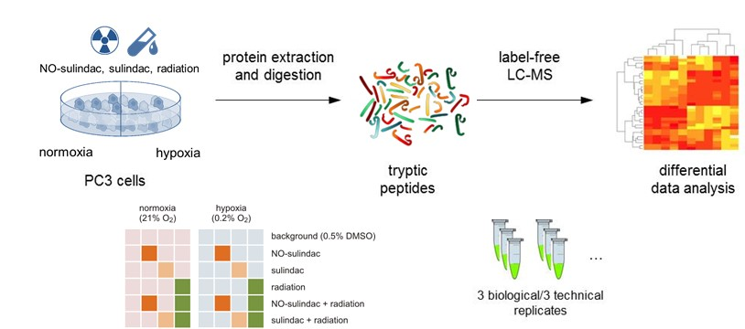

Figure 2. Network (A), pathway (B) and gene ontology annotation (C) profiling of the quantitatively significantly regulated proteins identified through discovery and hypothesis driven analyses of the data independent LC-MS data and results.
(A) Yellow/red = quantitative ‘hypoxia vs. normoxia’ detections’; (B) yellow = detected pathway components/processes and grey = undetected pathway components/processes; (C) yellow = quantitative ‘hypoxia vs. normoxia’ detections (changes induced by solely hypoxia treatment) and grey = significantly changed proteins as a result of radiation, drug-treatment under either hypoxic or normoxic conditions.

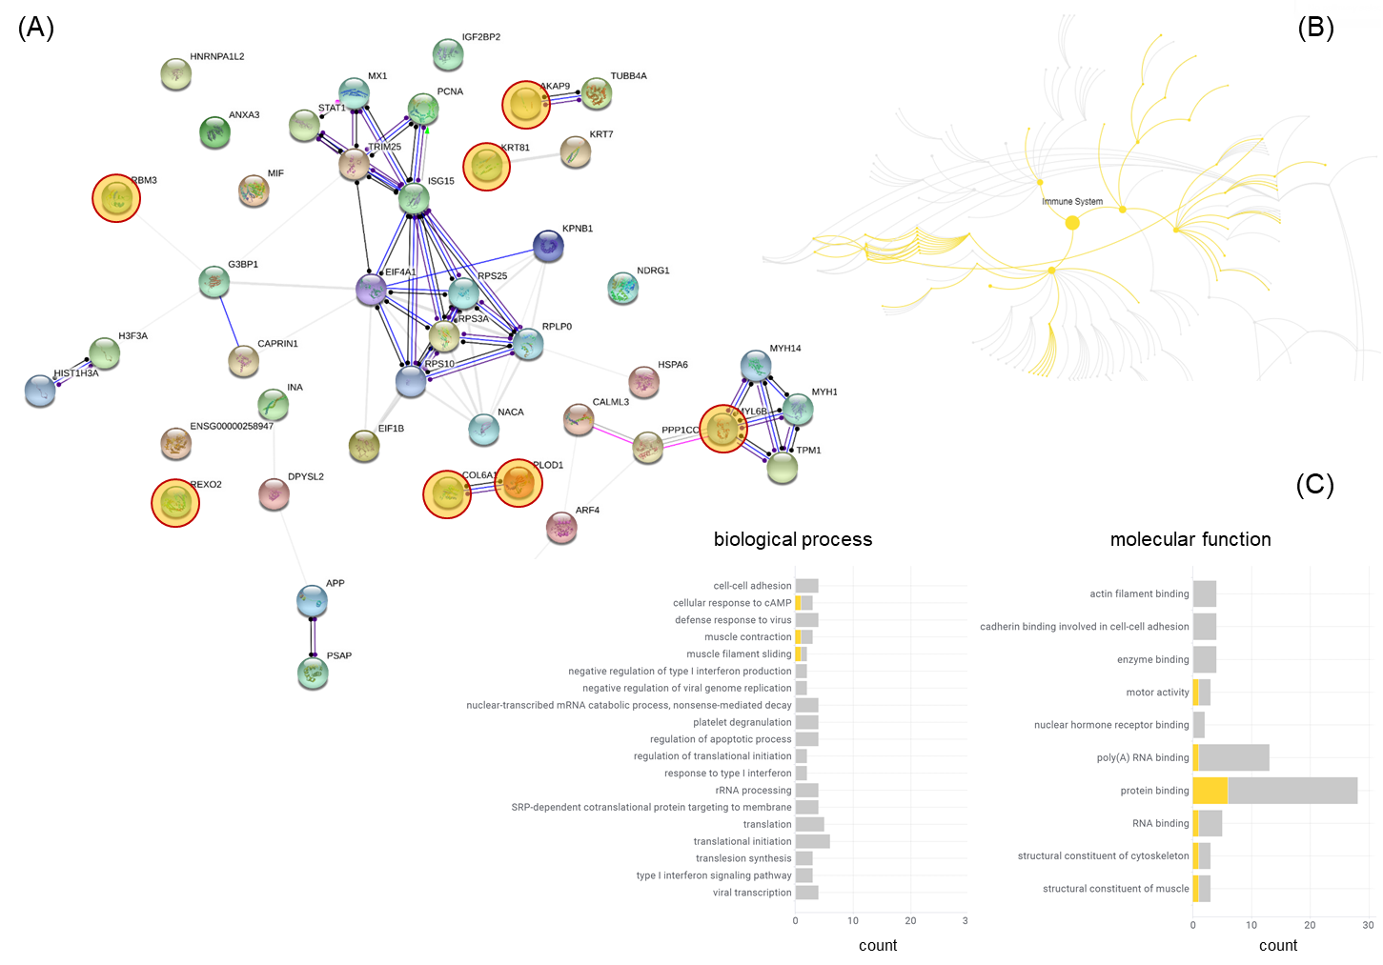
Figure 3. Statistical analysis (A) and normalised abundances (parts-per-million) (B) discriminating proteins exposed to ‘hypoxic’ vs. ‘normoxic’ conditions. n, shown inset, represents the number of identified peptides and, p, the Benjamini and Hochberg corrected probability value.

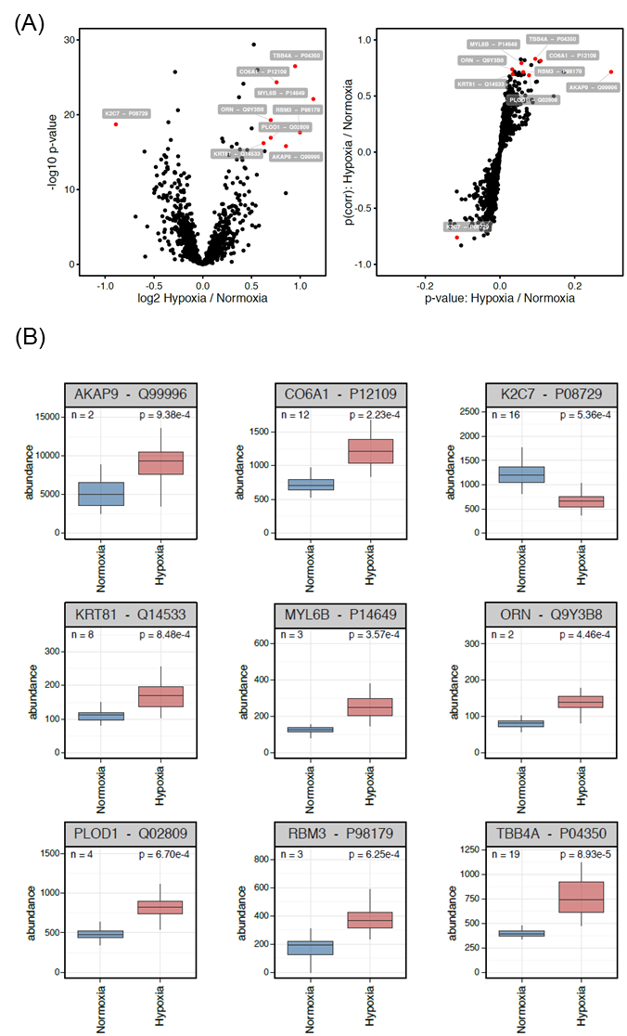

Figure 4. mRNA expression (cBio Cancer Genomics Portal) in major cancer types of the proteins (grey nodes) identified through analysis of the proteomic data/results summarised in Table 1.
Red bordered = proteins up-regulated in hypoxia; blue bordered = down-regulated proteins; green = cancer types in which protein mRNA expression has been shown to be altered in TCGA datasets, or, yellow, other large-scale prostate cancer datasets; node size = frequency. AML = acute myeloid leukemia; ccRCC = Clear cell renal cell carcinoma; chRCC = renal cell carcinoma; pRCC = Papillary renal cell carcinoma; DLBC = Diffuse large B-cell lymphoma; HNSC= head and neck squamous cell carcinoma; Lung (SC) = Squamous cell lung cancer; Lung (A) = Lung Adenocarcinoma; NEPC = Neuroendocrine prostate cancer; PCPG = Pheochromocytoma and Paraganglioma; Uveal Mel = Uveal Melanoma; Prostate (Hutch) = Prostate Cancer dataset of Fred Hutchinson Cancer Research Center; Prostate (SU2C) = Stand Up To Cancer-Prostate Cancer dataset; Prostate (TCGA-Prov) = Provisional TCGA Prostate Adenocarcinoma dataset.

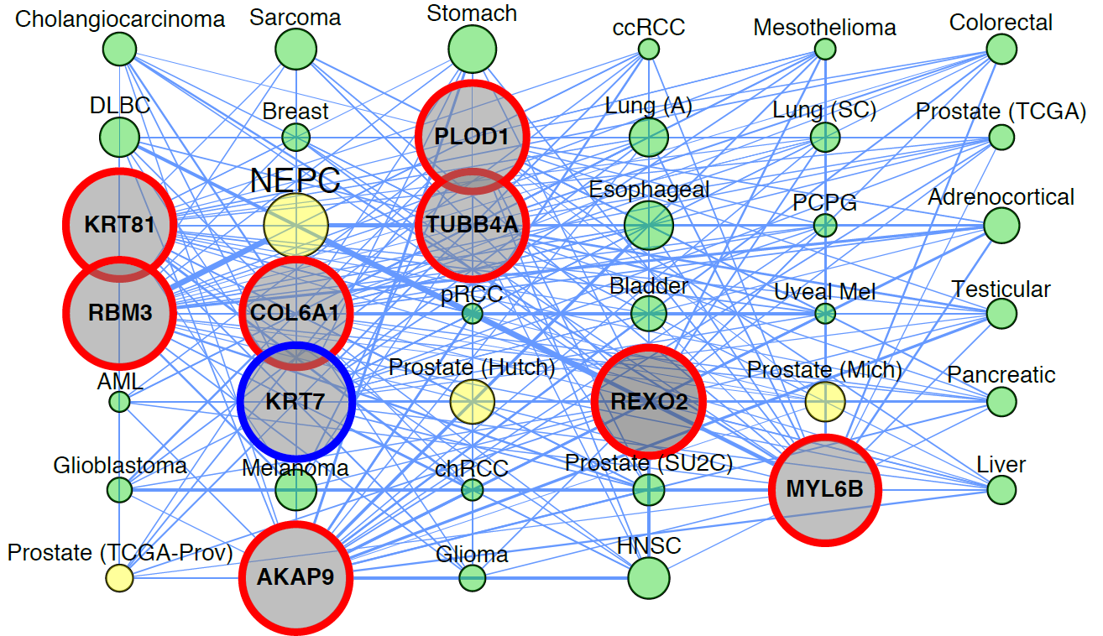

Figure 5. Gene network analysis of the quantified proteins in prostate cancer tissue.
Blue (icon/character) = genes of which the mRNA expression has been changed following treatment with NO-NSAID under hypoxic conditions (14,34); red (icon/character) = significantly changed proteins under hypoxic growth conditions identified and quantified by ion mobility assisted DIA LC-MS. Icon = network connected gene/protein; character = singleton, non-networked gene/protein. Line thickness = network connectivity (line colour = display purposes only). Node text is provided left and right of the network in addition to text next to the nodes.
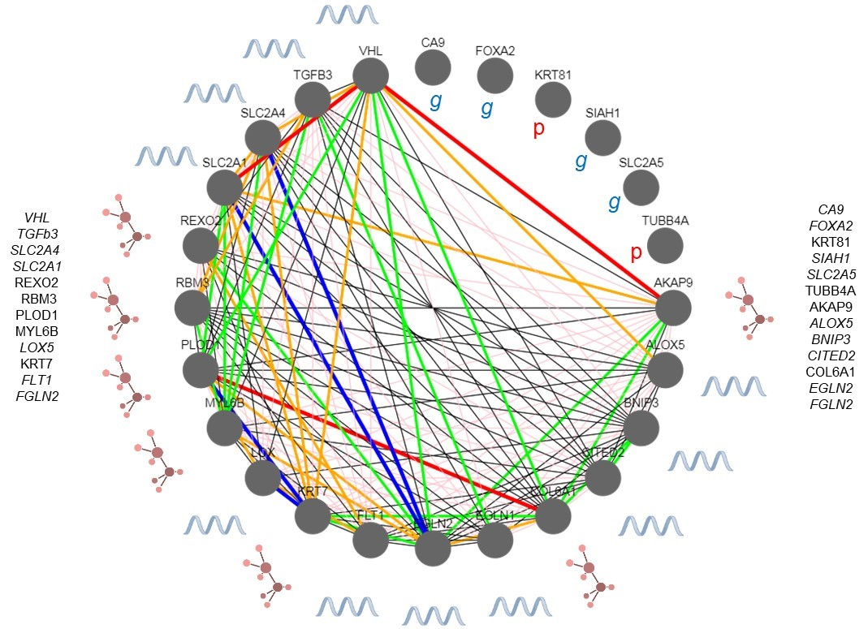
Figure 6. Statistical analysis (A) and normalised abundances (parts-per-million) (B) discriminating proteins exposed to ‘hypoxia’’ vs. ‘hypoxia + NO-Sulindac’ conditions. n, shown inset, represents the number of identified peptides and, p, the Benjamini and Hochberg corrected probability value. RA1L2 = HNRNPA1L2.

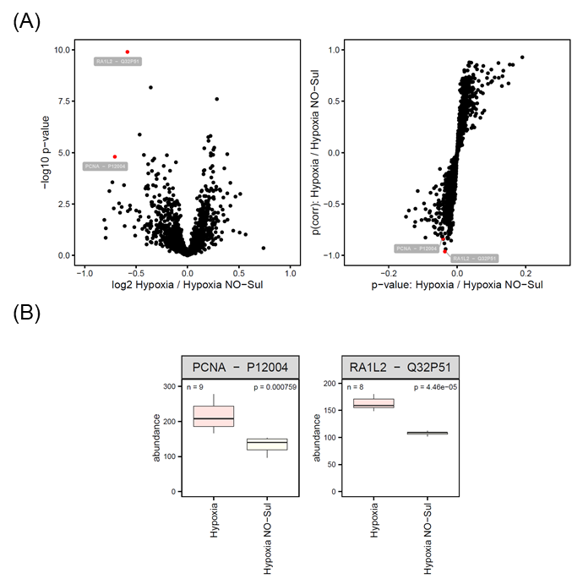

Figure 7. Normalised abundances (parts-per-million) of the discriminating proteins quantitively identified by univariate/derived hypothesis driven ‘hypoxic vs. ‘hypoxia + Sulindac’ and ‘hypoxic vs. ‘hypoxia + NO-Sulindac’ analyses (Table 2) under ‘normoxic’, ‘hypoxic’, ‘hypoxic + Sulindac’, and ‘hypoxic + NO-Sulindac’ conditions.
Blue = quantified proteins originating from ‘hypoxic vs. ‘hypoxia + NO-Sulindac analysis’; orange/brown = quantified proteins originating from ‘hypoxic vs. ‘hypoxia + Sulindac’ analysis.

