Title: Droughts decouple African savanna grazers from their preferred forage with consequences for grassland productivity.

Jason E Donaldson^{1, 2} jedonaldson6@gmail.com
Catherine L Parr^{1, 3, 4} Kate.Parr@liverpool.ac.uk
E Happy Mangena⁵ mangenahappy@gmail.com
Sally Archibald¹ Sally.Archibald@wits.ac.za
¹School of Animal Plant and Environmental Sciences, University of the Witwatersrand, Private Bag 3, Wits 2050, South Africa
²Department of Biology, Wake Forest University, 049 Winston Hall, Winston-Salem NC 27109, USA
³School of Environmental Sciences, University of Liverpool, Liverpool, L69 3GP, UK
⁴Department of Zoology & Entomology, University of Pretoria, Pretoria 0002, South Africa
⁵Scientific Services, Kruger National Park, Private Bag X402, Skukuza 1350, South Africa
Corresponding author: Jason Ernest Donaldson
Email: jedonaldson6@gmail.com
Tel: (071) 581 1257
Fax: (011) 717 6494
Running Title: Drought effects on African grazing systems

Manuscript highlights
- Drought decouples established feedbacks between grazers, fire and grass communities
- The collapse of feedbacks negatively affects system productivity when rain returns
- Area burned during droughts is a major driver of post-drought ecosystem function

Abstract
Grazing lawn and flammable-tussock grass communities are contrasting resource pools for mammalian grazers in terms of forage quantity and quality. Drought events fundamentally alter forage availability within these communities, and therefore should alter herbivore use with repercussions for the recovery and functioning of ecosystems after drought. During and after an intense El Niño drought (2014-17) in Kruger National Park, South Africa, we addressed two questions: (1) How does herbivore use of different grass types change during a drought and (2) how do these changes affect grass productivity post-drought? We monitored grazer use of three different grass communities (lawn, tussock and burned-tussock) at a landscape scale and measured primary productivity monthly during and post-drought. For the first drought year grazer numbers were highest on grazing lawn communities. This pattern continued into the second dry growing season, until herbivores finally left the study area. Both lawns and tussock grasslands recovered rapidly after the first good rainfall (productivity >150 g.m⁻² per month). However, grazers did not return to feed on the same patches they had frequented pre-drought resulting in grazing lawn grasses self-shading and senescing. Longer droughts have the potential to decouple grazers and grazing lawns with negative impacts on lawn productivity and persistence that could drive the loss of lawns in savanna landscapes and impact mesoherbivore populations. It is clear from our results that grazer effects need to be incorporated into drought frameworks to understand the consequences of droughts for grassland function.
Keywords: African savannas, drought, fire ecology, grazer ecology, grazing, grazing lawns, productivity

Introduction
Predictive climate models suggest that the effects and frequency of El Niño Southern Oscillation (ENSO) events will increase in southern Africa with the continued increase of atmospheric CO₂ (Gizaw and Gan 2017). The onset of ENSO in southern Africa is associated with drought events across eastern areas (Ratnam and others 2014). This zone is dominated by the savanna and grassland biomes (Mucina and Rutherford 2006) and supports most of southern Africa’s domestic and wild ungulate populations. Droughts are a periodic feature of these savanna ecosystems, but under current management regimes wild ungulate populations are often kept within hard boundaries and there are limited options for ungulate migration. Thus, during drought events, management decisions in individual reserves can have lasting impacts on grass communities and herbivore populations (Walker and others 1987).
Free ranging ungulate populations in African savannas vary their use of different grass communities throughout the year with selectivity dependant on their seasonal requirements (Mc Naughton 1990). Tall tussock-grasslands and grazing lawns represent spatially and temporally distinct resources throughout the year (Yoganand and Owen-Smith 2014). Tall tussock-grasslands represent low-quality, but high-quantity food reserves and are characterised by grass species that grow vertically from long-living tussocks that build up moribund material (Simpson and others 2016). In normal years these systems are never fully used by grazing animals due to the poor quality of old growth grasses and high risk of predation due to low visibility (Anderson and others 2010; Yoganand and Owen-Smith 2014). Dead grass biomass is left unconsumed and fires are common (Bond and Keeley 2005). After fire, for a short period of time, these systems represent a high quality food resource and grazers increase their use of tussock grasslands (three-six months –Tomor and Owen-Smith 2002). Grazer use of tussock grass areas also increases in the late-dry season and during drought events when moribund material is often the only available high quantity resource (Walker and others 1987; Macandza and others 2004).
By contrast, it has been suggested that grazing lawns co-evolved with certain ungulate grazers and require constant high grazing pressure during the growing season to maintain a competitive advantage over light-competitive tussock grass species (Mc Naughton 1984). Lawn communities consist of prostate growing species that capture space through stoloniferous or rhizomatous growth and generally have higher nutrient content than tussock grasses (see Hempson et al. 2015 for review). Lawns are preferred and selected for by several grazer species (Kleynhans and others 2010) during the wet season when fresh growth is readily available (Bonnet and others 2010) and represent an important resource to breeding animals (Owen-Smith and Ogutu 2013).
Lawn and tussock grass communities are also thought to differ in terms of above ground productivity with lawns often considered far less productive than tussock grasslands due to their low standing biomass (Tainton 1999). Most experiments on community level productivity in African savannas have focused on the effects of fire and grazing on either tussock grasses (Fay and others 2003; Knapp and others 2012) or grazing lawns (Mc Naughton 1985; Bonnet and others 2010). However, comparative experiments in east Africa found higher productivity of grazing lawns occurring on the high nutrient soils of abandoned cattle bomas than surrounding tussock grass communities (Augustine and others 2003), and there is evidence that heavy grazing can increase the NPP of grasslands (Mc Naughton 1979). In addition, although tall-grass areas are valued as “reserve forage”, there is limited understanding of the comparative productivity and thus herbivore available resources of these two communities in African savannas during and immediately after drought events. Yahdjian and Sala (2006) found that post-drought productivity of South American grasslands was largely the result of vegetation structure, with lower productivity in grasslands with lower basal cover. Lawn and tussock communities are by definition structurally different due to dissimilarities in grazing pressure with differences compounded during drought conditions (O’Connor 1995). Thus, we would expect differences both in their productivity during drought events and a productivity lag time immediately after drought events.
Van der Plas et al. (2013) carried out drought experiments on individual plants from lawn and tussock grass communities and showed they had distinct methods for coping with drought conditions. They suggested that lawn grass species are better suited than tussock grass species to recolonise areas once a drought has broken due to their ability to laterally spread (van der Plas and others 2013), with O’Connor (1991) showing that species can rapidly recolonise bare ground after drought dieback if they are capable of rhizomatous or stoloniferous growth compared with those that need to reseed. Pulsed grass productivity linked to large rainfall events in grazing lawns in South Africa support the idea that grazing lawns are well suited to quickly respond to water availability (Bonnet and others 2010), but are likely to offer little to no fresh forage during a drought event. Further, simulated grazing experiments by Anderson and others (2013) show that while tussock and lawn grasses both upregulate photosynthesis in response to defoliation, tussock grasses increase stomatal conductance to enable higher photosynthetic rates and have lower water use efficiency than lawn grasses. Thus, we predict that grazing lawns will cope better with the combined effects of low water availability and increased defoliation pressure experienced during drought events than tussock grasslands. Here we experimentally test the feedbacks between grass community productivity and their use by free-roaming ungulate grazers during and after a major ENSO related drought event. In doing so we address two questions focusing on savanna grazer movements and grass productivity during the southern-African El Niño drought of 2014-16: (1) How does herbivore grazing behaviour and use of different grass types change during a drought and (2) how does the timing of herbivore use affect grass productivity and subsequent grass recovery?

Methods

Study site
Kruger National Park (KNP, S 24° 23' 35.17", E 31° 46' 41.13") in South Africa contains the full suite of native mammal species and occupies approximately 19 485 km². Animals are free to move throughout the park and into numerous adjacent private reserves, and the Limpopo National Park in Mozambique where shared fences have been removed to increase natural movement. Fences that limit movement out of these protected areas do exist at their extremes with the most notable being the western boundary fence, which when erected stopped the historical western migration (Whyte and Joubert 1988). The Satara Land System is characterized by clayey basalt soils (Venter and others 2003), supporting extensive C₄ grass plains in a Sclerocarya birrea-Acacia nigrescens tree savanna (Gertenbach 1983). This area is currently dominated by tussock grass C₄ species Bothriochloa radicans, Digitaria eriantha, Panicum coloratum, and Themeda triandra (Knapp and others 2012) that burn on average every 3 - 4 years. Interspersed within these tussock grass communities are the heavily grazed short-grass lawn patches that make up a very small proportion (<2%) of the broader landscape (Cromsigt and te Beest 2014) with grass species including, in order of abundance, Urochloa mosambicensis, Tragus berteronianus, Eragrostis cilianensis, Chloris virgata, and Brachiaria eruciformis.
A complete suite of indigenous herbivores occurs in relatively large abundances within the Satara Land System; however, for this study we focus on the four major grazer species (African buffalo (Syncerus caffer), impala (Aepyceros melampus), blue wildebeest (Connochaetes taurinus) and plains zebra (Equus quagga)) due to low dung counts for the remaining species. Zebras are non-ruminant grazers with their diet consisting of 92% C₄ grasses (Codron and others 2007). Buffalo, impala and wildebeest are all ruminants with studies in KNP showing that 88, 60 and 90% of their diets are made up of C₄ grasses, respectively (Codron and others 2007).

Rainfall
The growing season for grasses occurs during the austral summer (November-April), during which 78% of the mean annual rainfall of 502 mm year⁻¹ falls (Venter and others 2003). Grasses are dormant during the dry, frost-free winters (May-October). The last major drought event occurred during the early 1990s after which rainfall has been consistently high up until the 2014 – 2015 season when rainfall was well below the long-term mean, with rains failing again over the 2015 – 2016 season before above average rainfall fell in 2016 – 2017 (Figure 1). Satara had the most severe proportional decrease in rainfall over these two seasons within KNP and represented a rare opportunity to assess the effects of drought on a well-studied grazing system.
Monthly rainfall data were recorded from the Satara Rest Camp and Singita Lebombo staff village weather stations.

Grazer use of grass types
We addressed the question of temporal use of lawn, tussock and burned grass communities during and after the drought by assessing herbivore presence on the three different communities from the onset of the growing season in 2015/2016 to the end of the growing season in 2016/2017. Data on grazer presence and use was collected via dung counts and bite prevalence on 5 ha plots. For each of the three grass communities (lawn, tussock and burned) we selected three replicate plots within a 70 km² area of the Satara landscape. We defined lawns as areas where >80% grass was below 5 cm and dominated by Urochloa mosambicensis and Tragus berteroneanus. Tussock grass areas were selected where grass height was over 30 cm and dominated by Themeda triandra and Bothriochloa radicans with fires excluded for three years. Finally, burned grass communities represented tussock grass communities that were burned at the end of the dry season in October 2015.
Sampling took place in four 50 x 50 m subplots within each larger 5 ha plot. Within each subplot we sampled two parallel 50 m transects 25 m apart. Grazing pressure was recorded at the end of the growing season (May) and at the end of the dormant season (October) by observing bite presence or absence on the grass tussock closest to each 2-m point along the 50 m transects. This gave a cumulative measure of grazing pressure per season. Grazer presence was measured by recording all dung (species and abundance) including dry dung encountered in 4-m-wide belts along transect lines. Dung sampling was done on a strict monthly basis for the studies entirety with only two months in 2016 (February and May) excluded from the dataset when time constraints meant dung was not accurately identified to species level but was crushed in these months as in all usual sampling months to avoid recounting. Dung transects have been used previously to estimate large herbivore habitat usage within African savannas and have repeatedly performed better than both direct observations and other indirect measurements (Cromsigt and others 2009; Burkepile and others 2013; Hema and others 2017), giving relatively reliable measures of relative abundance across similar habitats (Sensenig and others 2010; Hema and others 2017). Despite this, decomposition rates on different substrates and dung removal rates by dung beetles represent two inherent issues with using dung counts to assess large mammal abundance in savannas.

Grass productivity
We measured monthly grass and forb productivity, end of season standing biomass and biomass removal by grazers over the two growing seasons (2015/2016 and 2016/2017) on matched lawn, tussock and burned grass plots located in the field. Five lawn grass patches (>100 m²) were located that were surrounded by tussock grass communities. All patches were within 50 m of an area that had been burned in October of 2015 to allow for comparisons with the grass productivity and use of burnt-tussock grass communities by grazers during and after the drought. Methods from Mc Naughton, Milchunas and Frank (1996) with improvements made by Knapp et al. (2012) for estimating annual net primary productivity (ANPP) in grazed communities were adjusted to suit an assessment of monthly net primary productivity (MNPP) in different grass communities. We erected a single 1 m² permanent exclosure (PE) and four smaller 2500 cm² mobile exclosures (ME) with paired “exposed” plots (PPs) on each of the five grazing lawns and their respective matched tussock and burned patches resulting in 15 PEs, 60 MEs and 60 PPs. Mobile exclosures were initially placed at the four cardinal points of the respective PEs but were moved 1 m in a clockwise direction during sampling when all the above ground biomass within a 625 cm² quadrat was harvested both in the MEs and the PPs. Sampling occurred at monthly time intervals to avoid over harvesting resulting in productivity overestimates (Knapp and others 2012) and we included both positive and negative differences between ME’s and matched grazed plots when calculating net grass productivity (Biondini and others 1998). The harvested biomass was separated into forbs and grasses with grass material separated further into dead and live (green) material before being weighed after being oven dried at 60°C to a constant weight. Monthly net primary productivity in g.m⁻² was estimated as the sum of the differences between green biomass from PPs at the beginning of a time interval (i.e. beginning of a sampling month) and the biomass in the MEs at the end of a time interval (i.e. end of a sampling month). Positive values for a month indicate continued productivity, while negative net productivity values suggest grass productivity has slowed and the grass is curing. To account for the accumulation of previous growth in tussock grasslands only differences in the dry weight of live material was summed (Briggs and Knapp 1995). Sampling of MEs and PPs occurred over all months of the growing season and only stopped once grasses had cured during the dry season at which point standing grass biomass was collected from the PEs by harvesting four 625 cm² quadrats from the four corners of the exclosures. This material was then dried to estimate ANPP in the absence of grazing (Knapp and others 2012).
Finally, we looked at the death of individual tussocks on the three communities by counting and measuring the diameter of live and dead grass tussocks within 625 cm² quadrats under MEs and PPs at the end of the growing season in May 2017.

Data analysis
We modelled grazer dung events per month for all four grazer species (wildebeest, zebra, impala, and buffalo) combined (as a proxy for grazer abundance) using a generalized linear mixed effect model (GLMM) with a Poisson distribution to assess the changes in the density of grazers during four different seasons over the two-year study period on all three grass community types (Crawley 2012). Dormant (May, June, July, August and September) and growing (November, December, January, February, March and April) season, distance to water, and grass community (lawn, tussock and burned) represented fixed effects with plot and subplot acting as nested random effects to control for repeated measures along transects of each subplot every month. To get a more detailed assessment of the specific species responses we ran GLMMs with Poisson distributions for monthly dung events of each species on the three different treatments (lawn, tussock and burned) resulting in a total of 12 models (Table 1). In every model, species dung density represented the response variable with month representing the fixed effect and plot and subplot the nested random effects.
To understand how grazer presence affected grazing pressure we modelled the bite intensity for all grass communities using GLMMs with binomial distributions. Bite intensity represented the response variables and year, distance to water, and grass community (lawn, tussock and burned) acted as fixed effects. Plot and subplot represented the nested random effects (Table 1).
We ran statistical models on dry grass biomass data to assess how grass productivity changed through the growing season in different communities. We assessed grass biomass accumulation using a linear mixed model (LMM) with the restricted maximum likelihood method. Grass community, month and forb biomass represented fixed effects, with patch acting as the random effect. A separate LMM was run to look at differences in tussock cover in the three grass communities, with grass community the only fixed effect and patch the random effect. To determine differences in seasonal above ground productivity of grass communities when grazed compared to when grazers were excluded we averaged the cumulative monthly grass productivity (grazed) for the 2016/2017 growing season and the end of season standing biomass within PE’s (no grazing) of each plot and ran an LMM with grass community and grazing (presence/absence) as interacting fixed effects and patch the random effect (Table 1). To account for biomass present in tussock grassland PE’s at the beginning of the 2016/2017 season from the previous season’s growth we subtracted the dry biomass measured at the start of that 2016/2017 season from the final standing biomass measures.
All LMMs and GLMMs were processed using R statistical software (Version 3.3.1.; R Core Team, 2016) and the lme4 package (Bates and others 2015). Following the suggestions of Zuur et al. (2009), we used a top-down approach to model selection with an ANOVA to remove effects that resulted in models that did not differ (p < 0.05) significantly from the full model. We looked for obvious deviations from homoscedasticity and overdispersion in our models by plotting residuals against fitted values and visually assessing plots. To verify normality of the residuals of selected models, we used the Shapiro-Wilks test and assessed histograms and QQ-plots visually (Zuur and others 2009). We ensured that sampling points were not spatially auto-correlated by using the georR package (Ribeiro and Diggle 2016) to calculate semivariograms for raw data and using the residuals from all selected models (Zuur and others 2009). Semivariograms showed that variation in direct measures of grass biomass, dung counts and bites, did not increase with increasing distance between plots, indicating no serious autocorrelation issues were present (see Appendix S1 in Supporting Information).

Results

Grazer use of grass types
Grazer numbers were highest on grazing lawns at the beginning of the drought with dung events per month most abundant on lawns (mean = 45.01, SE = 12.16) followed by tussock grasslands (mean = 19.75, SE = 5.88) and burned tussock grasslands (mean = 5.76, SE = 1.02). This pattern continued into the following 2015/2016 growing season (Figure 2), but herbivores left the study area when rains failed that season for the second year in a row. In the 2016/2017 dormant season herbivores used lawns less (Effect Size (ES) = −41.67, SE = 6.8) and in the following two seasons dung events per month became very rare (mean = 7.24, SE = 1.24) (Figure 2). Grazers did not use burnt areas heavily during the 2016 dormant season (mean = 5.76, SE = 1.02), but briefly increased their use in the 2015/2016 growing season (ES = 3.57, SE = 1.21) before leaving in the 2016 dry season (ES = −3.09, SE = 0.87) (Figure 2). In contrast, grazers used tussock grasslands consistently during the four seasons of data collection and tussock grasslands had the highest grazer dung abundance (mean = 10.52, SE = 1.90) in the 2016/2017 dormant season (Figure 2). Rainfall returned during the 2016/2017 growing season, but dung events continued to decline (ES = −2.68, SE = 0.57) on all grass community types (Figure 2).
Wildebeest, impala and zebra accounted for 93% of the total dung events recorded and drove the observed patterns in grazer use across grass communities. Thus, GLMMs for these three species showed similar trends to the full grazer model and dung counts severely declined on grazing lawns in June 2016 (wildebeest ES = -18.22, SE = 2.12; impala ES = −7.32, SE = 1.39, zebra ES -1.32, SE = 0.47) (Figure S2). After the rainfall event in March 2016, all species increased on lawns (wildebeest ES = 6.35, SE = 1.92; impala ES = 8.18, SE = 1.20; zebra ES = 0.77, SE = 0.36; buffalo ES = 2.26, SE = 1.24) and burned grasslands (wildebeest ES = 7.02, SE = 3.70; impala ES = 3.11, SE = 1.18; zebra ES = 2.07, SE = 1.53) in April that year, although buffalo dung remained absent on burned plots.
High grazer numbers on grazing lawns meant lawns had the highest bite pressure throughout the study except for the 2016 dormant season (Figure 2). During the 2016 dormant season, bites per transect decreased on lawns (ES = −0.56, SE = 0.034) but remained high on burned grass areas after increasing following fires (mean = 0.08, SE = 0.02) during the 2015/2016 wet season (Figure 2). Tussock grasslands (mean = 0.43, SE = 0.05) experienced consistently low grazing pressure throughout the entire study excluding 2017 (ES = −0.34, SE = 0.06) when grazer pressure decreased across all communities (ES = −0.57, SE = 0.05).

Established grass tussock cover
Established grass tussocks were absent from lawns (which were dominated by non-tussock species) and the LMM showed that after the drought, tussock cover was lower on burnt (mean = 891 cm², SE = 195.4) than tussock grass (mean = 2699 cm², SE = 255.7) communities (Table 2) due to high tussock mortality on burned areas.

Grass productivity
During the 2015/2016 growing season productivity was extremely restricted. Only a single rainfall event in late March 2015, was large enough to stimulate grass growth, and grass communities showed differential response to this (Figure 2): tussock grass plots had the smallest response (mean = 4.25 g.m⁻², SE = 2.51) while burned tussock plots had the greatest growth (mean = 46.42 g.m⁻², SE = 6.67). Persistent rains finally arrived late in December 2016 when the landscape had received almost no rain for eight months. In January and February 2017 all grass communities responded equally to rainfall (LMM, ES = 171.23 g.m⁻², SE = 98.08). However, by March productivity declined on both the lawn grasses (ES = −273.78 g.m⁻², SE = 169.92) and burned tussock grasses (ES = −214.20 g.m⁻², SE = 117.73) - the former probably due to self-shading and senescence, and the latter due to limited reserves. In contrast, unburned tussock grasses continued to grow vertically and maintained productivity while rainfall persisted (mean = 46.42 g.m⁻², SE = 6.67). All communities stopped growing and began to cure by May when rainfall was only 11.5 mm. Forb biomass had little impact on LMM performance (F = 0.18, p = 0.67) and was dropped as a fixed effect.
At the conclusion of the 2016/2017 growing season productivity in the exclosure plots was similar across treatments (Figure 4) i.e. in the absence of grazing all grasslands had similar productivity in the year immediately post drought. Grazing had a strong negative influence on burned tussock grassland productivity (ES = -247.18 g.m⁻², SE = 99.62) and grazed-burnt plots produced only 38% of that produced in the absence of grazing (Figure 4). In contrast, grazing had no significant effect on grazing lawn (ES = -109.01 g.m⁻², SE = 140.89) or tussock grassland productivity (Figure 4).

Discussion
In response to our first question regarding grazer selection of different grass communities during drought, we found that grazers used different grass communities inconsistently both in terms of timing and intensity. This variation was driven by erratic rainfall, changing nutritional stress, perceived predation risk and large-scale variation in drought severity. The inconsistency in the timing of grazer presence and grazing intensity on the three different grass communities during the drought that culminated in grazers migrating away from our study sites in 2016 highlights a fundamental flaw in using agricultural systems or artificial clippings to understand drought effects in systems with mobile herbivores. In agricultural grazing systems (where migration is restricted) and simulated experiments the grazing pressure is determined artificially and not dictated by the preference of grazers for different resources (O’Connor 1995; Koerner and Collins 2014). Our work shows clearly that this fails to account for actual grazer decisions on where and when to feed during drought events. Importantly, in line with our second question, we found that the timing of grazer use of different grass communities during drought dictated the patterns of grassland productivity into the season following the drought.
Grazing lawns
We found that grazers varied their use of grazing lawns during different stages of the drought and that their decisions during and after the drought had unexpected effects on lawn productivity. Grazers used grazing lawns heavily during the early phases of the drought, an observation that confirms previous studies in African savannas (Augustine 2004; Owen-Smith and Traill 2017), but they left the study system completely in the second full season of drought and did not return with rainfall. Although there were no tussock grasses in the lawn-grass plots, these plots showed equivalent productivity to tussock grasslands immediately when rainfall arrived – not all from seed. This implies that non-tussock perennial grasses have mechanisms for persisting through drought. However, grazing lawns in the absence of high grazing pressure senesced in March 2017 despite good rainfall (Figure 3) and did not experience rainfall productivity pulses nor grazing facilitation (Figure 4) found in previous studies (Mc Naughton 1979, 1985; Frank and others 2002; Augustine and others 2003; Bonnet and others 2010). Rather, they more closely resemble grazing lawns in east Africa that self-shade and senesce when grazers are not present (Augustine and McNaughton 2006). Another possibility is that high grazer densities on lawns during drought drove mortality of perennial grasses and invasion by annual grasses in a manner observed in tussock grasslands during a previous drought (O’Connor 1995). This could potentially explain the low grass productivity after initially good growth, but fails to explain why there was no difference between grazed and ungrazed lawns.
Regardless of the overriding driver, it is clear that the lack of grazing pressure on a lawn system for an entire high rainfall growing season indicates a decoupling of grazer-grazing lawn dynamics. Grazing lawn formation and maintenance within mesic savanna landscapes is reliant on the establishment and continuation of positive feedbacks between grazers and grasses (Mc Naughton and others 1997; Archibald and others 2005; Cromsigt and Olff 2008; Waldram and others 2008; Anderson and others 2010; Arnold and others 2014). Within a single season, we observed a build-up of standing biomass on lawns that would reduce visibility for smaller grazers. This is likely to increase perceived predation risk and reduce the likelihood that lawns will be revisited the following season (Anderson and others 2010; Kleynhans and others 2010). Further, the build-up of potential fuel loads during a low use season will increase the likelihood that lawns burn the following dry-season. Large fires spread grazers over broad areas of the landscape, decrease grazing pressure on lawn patches and represent a pathway for the breakdown of grazing lawns (Archibald and Bond 2004; Archibald and others 2005). Thus, in an unexpected way the interaction between rainfall and grazer decisions during this drought could result in a loss of grazing lawns locally.
Tussock grasslands
We found no evidence to support our prediction that differences in the physiological responses of tussock grasses to drought stress and grazing result in the low productivity (under compensation) of tussock grasslands after drought. Rather tussock grasslands retained high tussock cover (Table 2) and had high productivity through the growing season when rainfall returned even with grazing. However, this changed substantially once tussock grasslands were burnt and grazed with the grazer response to burnt grasslands (pyric-herbivory) impacting grassland function considerably. If burnt before a drought, tussock grasslands suffered substantial tussock mortality, and tussocks also reduced in average size. As the drought experienced was equivalent, this mortality can be attributed to grazing during a drought, when stored reserves were limited because they had been used to resprout in the minor rainfall events during the first season of drought.
Our data corroborate that grazer numbers and grazing intensity increased on both lawns and burned areas as grazers responded to the fresh growth available in the middle of a drought year (March 2016). The same trend was not true of tussock grasslands that did not respond to the rainfall event and produced little new foliage with no observed increase in herbivore use. Consequently, grazing pressure on burned and lawn grass areas was intense at this time, and contrasts with tussock grasses (low graze pressure throughout the entire study with highest grazing pressure during a period of dormancy). In the absence of intense grazing pressure, African savanna tussock grasses are largely unaffected by drought and recover productivity and maintain ground cover when rainfall returns (O’Connor 1994, 1995; Koerner and Collins 2014). Tussock grasslands in our study had high tussock cover and remained productive when rainfall returned, and when burnt and protected from grazing, experienced a productivity stimulation in line with previous studies (Buis and others 2009). However, when burnt and exposed to grazing, tussock grasslands experienced intense grazing at a sensitive time. This resulted in substantially lower tussock cover that constrained productivity (Yahdjian and Sala 2006) when rainfall returned. This switch of burnt grasslands from the highest productivity when ungrazed to the lowest productivity when grazed was the strongest effect of grazing and drought that we observed. This is important as the impact of fire on grassland productivity within grazed savanna systems and rangelands is generally positive (Mc Naughton 1985; Singh 1993) or at least compensatory (Buis and others 2009; Knapp and others 2012; Koerner and Collins 2014). Fire is often used as a management tool in grasslands to manipulate herbivore populations (Tainton 1999; Fuhlendorf and Engle 2001), but our results show that this can result in substantial reductions in productivity (~60%) if these fires coincide with extended drought events. Thus, special attention should be paid to the spatial extent of burns during droughts (Fuhlendorf and others 2009).
Our dung deposition results indicate that grazers used tussock grasslands in a low and consistent manner during the drought, but we found increased grazing intensity (bites per transect) during the second season of drought. This appears contradictory, but may be explained by the predator avoidance behaviour of small bodied grazers. Wildebeest and impala drove the patterns of grazer use in this study; both these species are wary of tussock grasslands due to the increased risk of predation (Yoganand and Owen-Smith 2014) and lower nutritional value (Anderson and others 2010). Despite this, during the second season of drought the necessity for food forced them to feed in tussock grasslands (high bite intensity). Our results suggest that to balance this risk/nutrition trade-off wildebeest and impala used bare-lawns, with no nutritional benefit, at night for protection (high dung counts) and moved into the tussock grasslands in the day to feed (high bite intensity). This behaviour has been documented for both wildebeest (Owen-Smith and Traill 2017) and impala (Augustine 2004) during periods of low forage availability and highlights the necessity of both grass communities to mesoherbivores in savanna landscapes that experience periodic drought.
Conclusion
Over- or undercompensation of grass productivity in response to defoliation by grazers has received substantial interest in the grazing literature with studies finding grazing drove overcompensation (Mc Naughton 1979, 1985; Frank and others 2002), compensation (Knapp and others 2012), under compensation (Koerner and Collins 2014) or a range of responses (Augustine and McNaughton 2006) within different systems. The inconsistency across studies is due in part to rainfall, soil conditions and the grass communities being grazed (Mc Naughton 1985; Augustine and McNaughton 2006), but here we have shown that predicting the response of grassland productivity to drought and grazing cannot be done without understanding grazer decisions. Our results represent a single unique set of drought conditions that drove the local patterns of productivity observed during drought recovery. However, there is enough theory available from our work and previous studies to formulate hypotheses about how grazers use the landscape during drought and how these decisions impact long-term grassland function (Figure 5). If this theory can be tested at larger landscape scales it will allow grazer impacts during droughts to be incorporated into drought frameworks in a manner that benefits managers of free roaming grassland systems. To this end, we found that when grazers are present, they severely reduce burnt grassland productivity after drought. Further, if grazers migrate in response to drought, the established feedbacks that maintain grazing lawns can break down and may result in the local loss of lawns with potential cascading effects to grassland diversity (Hempson and others 2015). If these findings represent larger scale processes then they will help land managers to understand potential drought impacts. Considering that drought in the absence of grazing had little effect on grassland productivity it is clear that grazer effects during drought cannot be ignored. Thus, work on droughts requires an understanding of grazer driven processes at broader spatial scales and temporal scales that incorporates their impacts on long-term processes such as grass species turnover. Studies of this spatial and temporal scale that focus on periodic droughts are recognizably difficult to reproduce, yet are essential for understanding ecosystem response to extreme weather (Smith 2011). This is true not only within African savannas, but in all grasslands where fires burn regularly in the presence of mammal herbivores and within the numerous systems globally where mammal-maintained grazing lawns form important ecosystem features.
Acknowledgements
We thank Khensani Mkhonto for collecting data in the field. We are grateful to SANParks and Working on Fire for their continued support, particularly Navashni Govender and Tercia Strydom. This work was funded by the USAID/NAS program ‘Partnerships for Enhanced Engagement in Research’ (Sub-Grant 2000004946, Cycle 3) and the Andrew Mellon Foundation. JED was funded by the National Research Foundation Freestanding, Innovation and Scarce Skills Development Fund.
References
Anderson TM, Hopcraft JGC, Eby SL, Ritchie M, Grace JB, Olff H. 2010. Landscape-scale analyses suggest both nutrient and antipredator advantages to Serengeti herbivore hotspots. Ecology 91:1519–29. http://www.ncbi.nlm.nih.gov/pubmed/20503883
Archibald S, Bond WJ. 2004. Grazer movements: Spatial and temporal responses to burning in a tall-grass African savanna. Int J Wildl Fire 13:377–85.
Archibald S, Bond WJ, Stock WD, Fairbanks DHK. 2005. Shaping the landscape: Fire-grazer interactions in an african savanna. Ecol Appl 15:96–109.
Arnold SG, Anderson TM, Holdo RM. 2014. Edaphic, nutritive, and species assemblage differences between hotspots and matrix vegetation: two African case studies. Biotropica 46:387–94.
Augustine DJ. 2004. Influence of cattle management on habitat selection by impala on central Kenyan rangeland. J Wildl Manage 68:916–23.
Augustine DJ, McNaughton SJ. 2006. Interactive effects of ungulate herbivores, soil fertility, and variable rainfall on ecosystem processes in a semi-arid savanna. Ecosystems 9:1242–56.
Augustine DJ, McNaughton SJ, Frank DA. 2003. Feedbacks between soil nutrients and large herbivores in a managed savanna ecosystem. Ecol Appl 13:1325–37.
Bates D, Mächler M, Bolker BM, Walker SC. 2015. Fitting linear mixed-effects models using lme4. J Stat Softw 325:883–5. http://www.sciencemag.org/cgi/doi/10.1126/science.1176170
Biondini ME, Patton BD, Nyren PE. 1998. Grazing intensity and ecosystem processes in northern-mixed grass prairie, USA. Ecol Appl 8:469–79.
Bond WJ, Keeley JE. 2005. Fire as a global ‘herbivore’: the ecology and evolution of flammable ecosystems. Trends Ecol Evol 20:387–94. http://www.ncbi.nlm.nih.gov/pubmed/16701401. Last accessed 15/06/2011
Bonnet O, Fritz H, Gignoux J, Meuret M. 2010. Challenges of foraging on a high-quality but unpredictable food source: the dynamics of grass production and consumption in savanna grazing lawns. J Ecol 98:908–16. http://doi.wiley.com/10.1111/j.1365-2745.2010.01663.x. Last accessed 24/02/2012
Briggs JM, Knapp AK. 1995. Interannual variability in primary production in tallgrass prairie: climate, soil moisture, topographic, and fire as determinants of aboveground biomass. Am J Bot 82:1064–9.
Buis GM, Blair JM, Burkepile DE, Burns CE, Chamberlain AJ, Chapman PL, Collins SL, Fynn RWS, Govender N, Kirkman KP, Smith MD, Knapp AK. 2009. Controls of aboveground net primary production in mesic savanna grasslands: An inter-hemispheric comparison. Ecosystems 12:982–95.
Burkepile DE, Burns CE, Tambling CJ, Amendola E, Buis GM, Govender N, Nelson V, Thompson DI, Zinn AD, Smith MD. 2013. Habitat selection by large herbivores in a southern African savanna: the relative roles of bottom-up and top-down forces. Ecosphere 4:1–19.
Burkepile DE, Thompson DI, Fynn RWS, Koerner SE, Eby SL, Govender N, Hagenah N, Lemoine NP, Matchett KJ, Wilcox KR, Collins SL, Kirkman KP, Knapp AK, Smith MD. 2016. Fire frequency drives habitat selection by a diverse herbivore guild impacting top–down control of plant communities in an African savanna. Oikos 125:1636–46.
Codron D, Codron J, Lee-Thorp JA, Sponheimer M, de Ruiter D, Sealy J, Grant R, Fourie N. 2007. Diets of savanna ungulates from stable carbon isotope composition of faeces. J Zool 273:21–9. http://doi.wiley.com/10.1111/j.1469-7998.2007.00292.x. Last accessed 28/06/2011
Crawley MJ. 2012. The R Book. (Crawley MJ, editor.). West Sussex: John Wiley and Sons
Cromsigt JPGM, te Beest M. 2014. Restoration of a megaherbivore: Landscape-level impacts of white rhinoceros in Kruger National Park, South Africa. J Ecol 102:566–75.
Cromsigt JPGM, Olff H. 2008. Dynamics of grazing lawn formation: An experimental test of the role of scale-dependent processes. Oikos 117:1444–52.
Cromsigt JPGM, Rensburg SJ, Etienne RS, Olff H. 2009. Monitoring large herbivore diversity at different scales: comparing direct and indirect methods. Biodivers Conserv 18:1219–31. http://www.springerlink.com/index/10.1007/s10531-008-9506-1. Last accessed 28/08/2011
Fay PA, Carlisle JD, Knapp AK, Blair JM, Collins SL. 2003. Productivity responses to altered rainfall patterns in a C4 -dominated grassland. Oecologia 137:245–51.
Frank DA, Kuns MM, Guido DR. 2002. Consumer control of grassland plant production. Ecology 83:602–6.
Fuhlendorf SD, Engle DM. 2001. Restoring Heterogeneity on Rangelands: Ecosystem Management Based on Evolutionary Grazing Patterns. Bioscience 51:625.
Fuhlendorf SD, Engle DM, Kerby J, Hamilton R. 2009. Pyric herbivory: Rewilding landscapes through the recoupling of fire and grazing. Conserv Biol 23:588–98.
Gertenbach WPD. 1983. Landscapes of the Kruger National Park. Koedoe 26:9–121.
Gizaw MS, Gan TY. 2017. Impact of climate change and El Niño episodes on droughts in sub‑Saharan Africa. Clim Dyn 49:665–82.
Hema EM, Di Vittorio M, Barnes RF, Guenda W, Luiselli L. 2017. Detection of interannual population trends in seven herbivores from West African savannah: a comparison between dung counts and direct counts of individuals. Afr J Ecol 55:609–17.
Hempson GP, Archibald S, Bond WJ, Ellis RP, Grant CC, Kruger FJ, Kruger LM, Moxley C, Owen-Smith N, Peel MJS, Smit IPJ, Vickers KJ. 2015. Ecology of grazing lawns in Africa. Biol Rev 90:979–94. http://rstb.royalsocietypublishing.org/lookup/doi/10.1098/rstb.2015.0309
Kleynhans EJ, Jolles AE, Bos MRE, Olff H. 2010. Resource partitioning along multiple niche dimensions in differently sized African grazers. Oikos 120:591–600.
Knapp AK, Hoover DL, Blair JM, Buis GM, Burkepile DE, Chamberlain A, Collins SL, Fynn RWS, Kirkman KP, Smith MD, Blake D, Govender N, O’Neal P, Schreck T, Zinn A. 2012. A test of two mechanisms proposed to optimize grassland aboveground primary productivity in response to grazing. J Plant Ecol 5:357–65.
Koerner SE, Collins SL. 2014. Interactive effects of grazing, drought, and fire on grassland plant communities in North America and South Africa. Ecology 95:98–109.
Macandza VA, Owen-Smith N, Cross PC. 2004. Forage selection by African buffalo in the late dry season in two landscapes. South African J Wildl Res 34:113–21.
Mc Naughton SJ. 1979. Grazing as an optimization process : Grass-ungulate relationships in the Serengeti. Am Nat 113:691–703.
Mc Naughton SJ. 1984. Grazing lawns: animals in herds, plant form, and coevolution. Am Nat 124:863–86. http://www.jstor.org/stable/2461305 .
Mc Naughton SJ. 1985. Ecology of a grazing ecosystem: the Serengeti. Ecol Monogr 55:259–94. http://www.jstor.org/stable/1942578 .
Mc Naughton SJ. 1990. Mineral nutrition and seasonal movements of African migratory ungulates. Nature 345:613–5.
Mc Naughton SJ, Banyikwa FF, Mc Naughton MM. 1997. Promotion of the cycling of diet-enhancing nutrients by African grazers. Science (80- ) 278:1798–800.
Mc Naughton SJ, Milchunas DG, Frank DA. 1996. How can net primary productivity be measured in grazing ecosystems? Ecology 77:974–7.
Mucina L, Rutherford MC. 2006. The vegetation of South Africa, Lesotho and Swaziland. (Mucina L, Rutherford MC, editors.). Pretoria: South African National Biodiversity Institute
O’Connor TG. 1991. Patch Colonization in A Savanna Grassland. J Veg Sci 2:245–54.
O’Connor TG. 1994. Composition and population responses of an African savanna grassland to rainfall and grazing. J Appl Ecol 31:155–71.
O’Connor TG. 1995. Transformation of a savanna grassland by drought and grazing. African J Forage Sci 12:53–60.
Owen-Smith N, Ogutu JO. 2013. Controls over reproductive phenology among ungulates : allometry and tropical-temperate contrasts. Ecography (Cop) 36:256–63.
Owen-Smith N, Traill LW. 2017. Space use patterns of a large mammalian herbivore distinguished by activity state: fear versus food? J Zool 303:281–90.
van der Plas F, Zeinstra P, Veldhuis M, Fokkema R, Howison R, Olff H. 2013. Responses of savanna lawn and bunch grasses to water limitation. Plant Ecol 214:1157–68.
Ratnam J V., Behera SK, Masumoto Y, Yamagata T. 2014. Remote effects of El Nino and Modoki events on the austral summer precipitation of southern Africa. Am Meteorol Soc 27:3802–16.
Ribeiro PJ, Diggle PJ. 2016. Package ‘geoR’.
Sensenig RL, Demment MW, Laca EA. 2010. Allometric scaling predicts preferences for burned patches in a guild of East African grazers. Ecology 91:2898–907.
Simpson KJ, Ripley BS, Christin PA, Belcher CM, Lehmann CER, Thomas GH, Osborne CP. 2016. Determinants of flammability in savanna grass species. J Ecol 104:138–48.
Singh RS. 1993. Effect of winter fire on primary productivity and nutrient concentration of a dry tropical savanna. Vegetatio 106:63–71.
Smith MD. 2011. An ecological perspective on extreme climatic events: A synthetic definition and framework to guide future research. J Ecol 99:656–63.
Tainton NM. 1999. Veld Management in South Africa. Pietermaritzberg: Natal University Press
Tomor BM, Owen-Smith N. 2002. Comparative use of grass regrowth following burns by four ungulate species in the Nylsvley Nature Reserve, South Africa. Afr J Ecol 40:201–4.
Venter FJ, Scholes RJ, Eckhardt HC. 2003. The abiotic template and its associated vegetation pattern. In: Du Toit JT, Rogers KH, Biggs HC, editors. The Kruger Experience: Ecology and Management of Savanna Heterogeneity. Washington: Island Press. pp 83–129.
Waldram MS, Bond WJ, Stock WD. 2008. Ecological Engineering by a Mega-Grazer : White Rhino Impacts on a South African Savanna. Ecosystems 11:101–12.
Walker BH, Emslie RH, Owen-Smith N, Scholes RJ. 1987. To cull or not to cull: Lessons from a Southern African drought. J Appl Ecol 24:381–401.
Whyte IJ, Joubert SCJ. 1988. Blue wildebeest population trends in the Kruger National Park and the effects of fencing. South African J Wildl Res 18:78–87.
Yahdjian L, Sala OE. 2006. Vegetation structure constrains primary production response to water availability in the Patagonian steppe. Ecology 87:952–62.
Yoganand K, Owen-Smith N. 2014. Restricted habitat use by an African savanna herbivore through the seasonal cycle: Key resources concept expanded. Ecography (Cop) 37:969–82.
Zuur AF, Ieno EN, Walker NJ, Saveliev AA, Smith GM. 2009. Mixed Effects Models and Extensions in Ecology with R. New York

Table 1. Linear mixed models and generalized linear mixed models used to assess the relationships between herbivore utilization of grass communities. In cases where no fixed effects showed any relationship to the response variable, null models were selected, and more complex models are only shown to indicate effects tested
Table 2. Overview of structural differences between grass communities after the drought (mean with standard deviation in brackets). Area covered by grass tussocks and end of season standing biomass was sampled within 625 cm² sampling plots on the three different grass communities in February and June 2017 respectively (n = 5)
Table 1.
Selected models | df | F | P
Grazer utilization
Dung density ~ Season * Grass community (1|plot|subplot) | 8 | 171.3 | <0.0001
Lawn treatment wildebeest dung ~ Month (1|plot|subplot) | 20 | 1518.8 | <0.0001
Tussock treatment | 20 | 50.92 | <0.0001
Burned treatment | 20 | 709.15 | <0.0001
Lawn treatment zebra dung ~ Month (1|plot|subplot) | 20 | 274.8 | <0.0001
Tussock treatment | 20 | 36.19 | <0.001
Burned treatment | 20 | 143.2 | <0.0001
Lawn treatment impala dung ~ Month (1|plot|subplot) | 20 | 552.3 | <0.0001
Tussock treatment | 20 | 73.14 | <0.0001
Burned treatment | 20 | 201.75 | <0.0001
Lawn treatment buffalo dung ~ Month (1|plot|subplot) | 20 | 144.87 | <0.0001
Tussock treatment | 20 | 24.81 | <0.0001
Burned treatment | NA
Bites per subplot ~ Season * Grass community (1|plot|subplot) | 10 | 917.9 | <0.0001
Grass productivity
Grass productivity ~ Month * Treatment (1|Site) | 12 | 102.5 | <0.0001
Log (Seasonal productivity) ~ Grass community * Grazing | 2 | 5.8 | <0.01
Tussock area ~ Treatment (1|Site) | 1 | 4.1 | = 0.043

Community | Total tussock cover (cm²) | Live tussock cover (cm²) | Dead tussock cover (cm²) | End of season standing grass biomass (g.m⁻²) | End of season standing forb biomass (g.m⁻²)
Lawn | 0 (0) | 0 (0) | 0 (0) | 400 (234.2) | 22 (10.9)
Tussock | 2699 (571.8) | 1589 (537.8) | 1110 (362.3) | 753 (197.5) | 38 (30.1)
Burned | 891 (437.9) | 106 (63.7) | 784 (456.2) | 282 (81.9) | 82 (18.7)
Table 2.

Figure 1. Wet season rainfall from the South African National Parks’ (SANParks) Satara weather station over the past 17 years. The 2014-2016 and 1991 drought years (black shading) falling over 200 mm below the 502 mm long term average (hatched line).
Figure 2. Dung deposition (mean ± SE) (a) and proportional available grass bitten (mean ± SE) (b) found in the three grass communities (lawn, tussock and burned) over the entire study period. Dormant season data represents data collected in June, July and August and growing season data was collected in December, January and February. Data were sampled on lawn (light grey), tussock (hatched line) and burned-tussock grass communities (black) with fires burnt in the 2015 late-dry season.
Figure 3. Monthly net primary production (mean ± SE) found in the three grass communities (lawn, tussock and burned) over the entire study period. Data were sampled on lawn (light grey), tussock (hatched line) and burned-tussock grass communities (black) with fires burnt in the 2015 late-dry season. Rainfall (hatched shading) was collected at the Satara Rest Camp weather station. Positive net primary production values for a month indicate continued productivity, while negative values suggest grass growth has stopped and the grass is curing.
Figure 4. Effects of grazing (open vs. exclosure) on the post-drought seasonal above ground productivity (mean ± SE) of three different grass communities. Lower case letters represent significant differences (P<0.05) between grass communities and grazing treatments.
Figure 5. Conceptual framework for grazer effects on grassland function during and after drought. Grey arrows are hypothesized.

Figure 1.
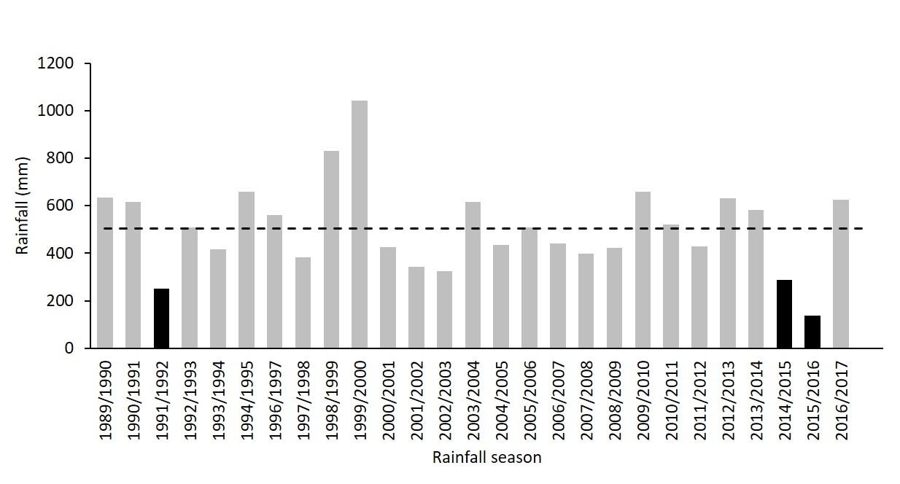
Figure 2.
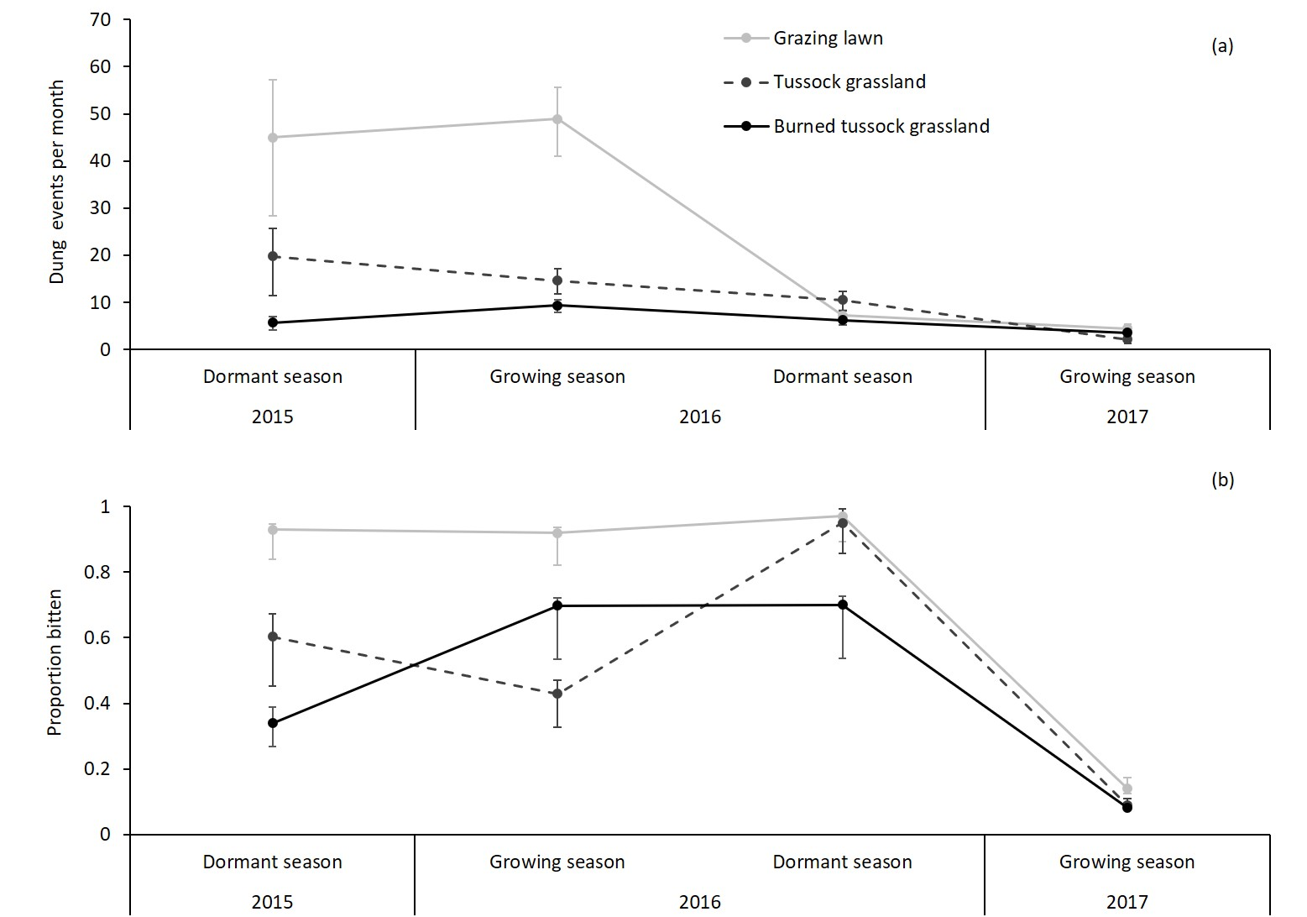
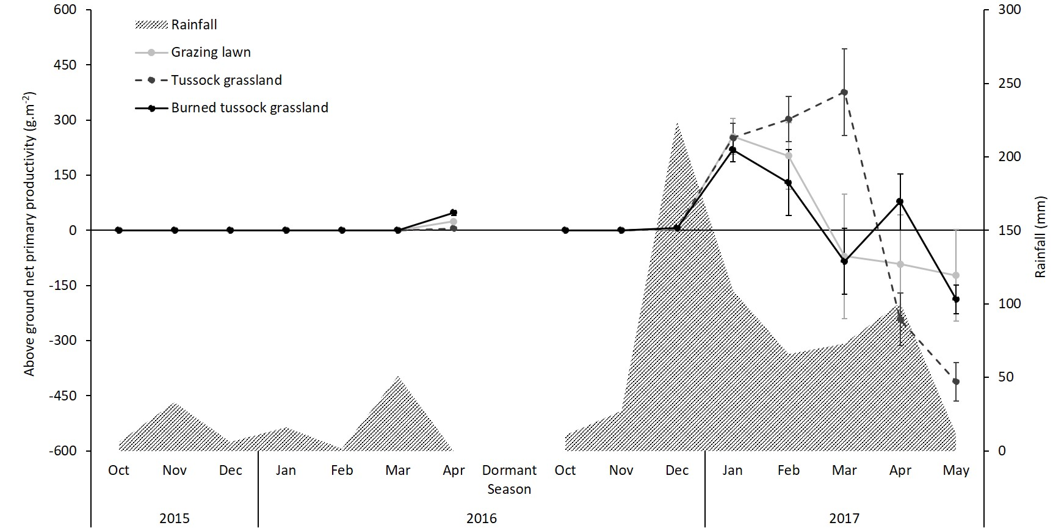
Figure 3.

Figure 4.
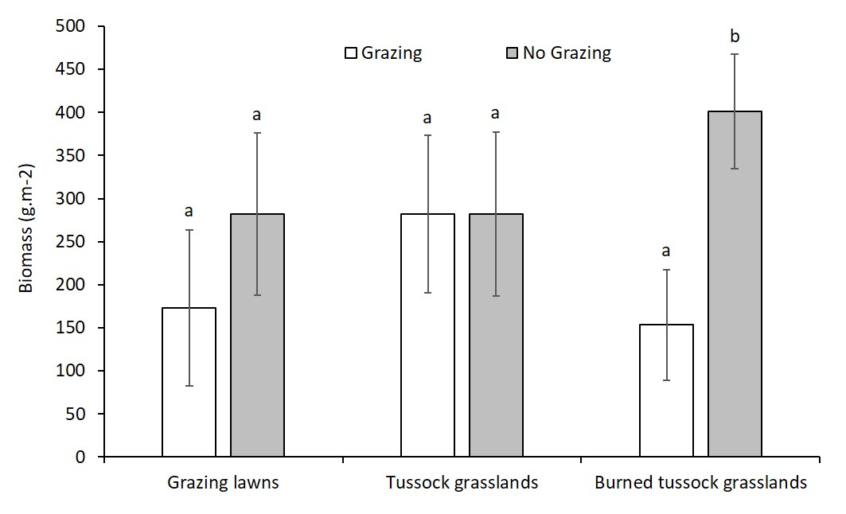
Figure 5.
