**ACCIDENTAL TOURISTS? A COGNITIVE EXPLORATION OF SERENDIPITOUS INTERNATIONALIZATION**

**Abstract**

A substantial body of work views initial foreign market entries (FMEs) as intentional and deliberately planned by proactive entrepreneurs. However, research suggests that FMEs may also occur serendipitously. We take an international opportunity recognition (IOR) perspective and focus on the cognitive underpinnings of serendipitous internationalization processes associated with six ventures. We highlight differences in entrepreneurs’ causal logics and cognitive attributes that, in the process of updating causal logics, create oscillations between serendipitous and subsequent planned FMEs, and explain when and why an effectuation logic is more likely to be employed. We extend research on IOR by elaborating a dynamic interaction between planned and unplanned cognition that provides new insights on how cognitive processes facilitate opportunity recognition

**Keywords**: international opportunity recognition; international entrepreneurship; serendipity; effectuation; cognition

**Introduction**

The identification and exploitation of opportunities for international exchange is a phenomenon is a foundational, but poorly understood facet of international entrepreneurship (IE). IE research often implicitly assumes that FMEs are preceded by a series of proactive, rational and deliberately managed strategic decisions with respect to market selection, entry mode, timing, that are made on the basis of objective, systematically gathered information and firm-performance-maximizing objectives (e.g., Oviatt and McDougall, 1994; 2005; Young et al., 1989).

However, research also notes the often unplanned, seemingly accidental, or serendipitous nature of internationalization, particularly initial FMEs (e.g., Crick and Spence, 2005; Ellis, 2000; Meyer and Skak, 2002), the lack of a systematic or strategic approach in market selection processes (e.g., Kalinic, Sarasvathy, & Forza, 2014), and inconsistencies between decision-makers’ attitudes toward firm internationalization and actual internationalization behavior (Ibeh, 2003; Baum, Schwens, and Kabst, 2014). Recent research investigating the outcome of internationalization processes initiated by first-time internationalizers shows that internationalization may be more successful when it is improvised and opportunistic rather than carefully planned and scripted (Bingham, 2009; Kuemmerle, 2005). Yet, our understanding of unplanned and in particular serendipitous FMEs is limited. Consistent with prior research (Dew, 2009; Hohenthal et al., 2003), we use the term serendipitous to denote FMEs that occur as the result of an opportunity recognition process that is sparked through a chance event in which the entrepreneur (or their management team) has *no preexisting intent to internationalize*, but, once internationalization occurs, retrospectively qualifies the act as *positive.*

IOR has been equated with the initiation of international sales (Di Gregorio et al.,; 2008) and has been examined from a variety of perspectives, such as social networks (Coviello and Munro, 1997; Coviello, 2006; Ellis, 2011), industry, resources, and capabilities views (Oviatt and McDougall, 2005; Chandra et al., 2009). Like the broader research on opportunity recognition (e.g. Shane and Venkataraman, 2000; Shepherd et al, 2007), there is an implicit understanding that IOR is a *cognitive* process. However, most normative IE theorizing (e.g. Oviatt and McDougall, 1994, 2005) and subsequent empirical research (e.g. Acedo and Florin, 2006; Acedo and Jones, 2007) assumes that internationalization is preceded by a proactive, planned, or intentional search for opportunities, and has focused on capturing cognitive attributes (e.g., tolerance for ambiguity, risk perception) that support such a process. The issue of serendipitous FMEs, however, remains largely unexplored. Further, this stream of research has mostly taken a cross-sectional approach utilizing surveys aimed at capturing individual traits and has not explored in detail the evolution of the cognitive processes involved in FMEs over time.

Preliminary research on serendipitous internationalization suggests that a focus on individual decision makers and their information-processing capabilities is especially relevant for serendipitous FMEs . For example, Meyer and Skak (2002) argue that serendipitous FMEs in Central and Eastern Europe (CEE) can only be explained by managers’ opportunity recognition abilities, and more specifically their interpretations of the local economic environment. However, research on serendipitous FMEs is in its infancy, and the exact nature of the cognitive processes involved in initial serendipitous FMEs is unclear, as is our understanding of the evolution of these processes over time as entrepreneurs enter new markets. Understanding such processes not only provide a more complete perspective on FMEs, including FMEs that are typically relegated to the category of “happy accidents” or “luck”, but also on IOR as it unfolds over time. Our guiding question is, *what are the cognitive determinants of serendipitous FME’s?*

To explore this question, we integrate three emerging research streams. First, we draw on the cognitive process perspective on opportunity recognition (Bhave, 1994; Shane and Venkataraman, 2000; Shepherd et al., 2007; Wood et al,, 2012). Second, we incorporate research on managerial cognition, particularly research on the role of mental models in information processing (Calori et al., 1994; Kiss and Barr, 2015; Nadkarni and Narayanan, 2007). Finally we integrate research on effectual logic (Prashantham et al., 2019; Sarasvathy, 2001; Sarasvathy et al., 2014). We supplement our theoretical analysis of the literature with illustrative data drawn from ongoing research on FMEs by six ventures from three emerging economies (Bulgaria, India, and Romania). From this we develop a set of theoretically and empirically grounded propositions that can serve as the basis of further research.

Our study makes several contributions. First, we contribute to the IOR literature (Ellis, 2011; Mainela et al., 2014; Reuber et al., 2018; Zahra et al., 2005) by theoretically elaborating the cognitive processes that support serendipitous FMEs, an important yet often overlooked mode of accessing international markets, and their evolution over time. We highlight the role of different causal logics employed at different stages in the IOR process as well as cognitive attributes, such as cognitive complexity, that allow international entrepreneurs to oscillate between serendipitous and planned FMEs. Thus, we focus attention on cognitive approaches to IOR and echo calls in the literature (Manolova et al., 2002) to move beyond social networks, industry, and capabilities views that tend to dominate this stream of research.

Second, we push forward the growing stream of research on the role of an effectuation logic in IE (Kalinic et al., 2014; Prashantham et al., 2019; Sarasvathy, 2001; Sarasvathy et al., 2014) by highlighting when and why effectuation logic is more likely to be employed. Third, by elaborating on a cognitive model associated with a relatively less explored side of opportunity recognition (i.e. serendipitous discoveries) we push forward research on opportunity recognition in general, and in particular the cognitive process perspective on opportunity recognition (e.g., Shepherd et al., 2007; Wood et al., 2012). Finally, we answer calls for research that employs qualitative methodologies to explore cognitions associated with opportunity recognition (Suddaby et al., 2015) and utilizes different country contexts (e.g., Kiss et al., 2012; Bruton et al., 2013) to advance research on this topic.

**Theoretical background**

Opportunity recognition as a theoretical lens is fundamental to entrepreneurship theory. Scholars have increasingly recognized internationalization as an entrepreneurial act (e.g., Ellis, 2011; Mainela, Puhakka, & Servais, 2014; Oviatt & McDougall, 2005). In order to understand entrepreneurial action (i.e. efforts by *individuals* to identify, develop and/or pursue ideas for the introduction of products, services or business models into specific markets, including international markets), entrepreneurship must be analyzed from a *process* perspective (e.g., Bhave, 1994; Davidsson, 2003; Groen, 2005; Shane & Venkataraman; 2000) with a focus on how opportunities are identified and exploited.

Although a variety of explanations and theoretical perspectives have been advanced on the nature (source) and exploitation of opportunities, two perspectives have been particularly influential: the creation and the discovery perspectives. Creation scholars view opportunities as rooted in individuals’ subjective realities and arising from their creative and imaginative actions (e.g., Alvarez & Barney, 2007), while discovery scholars view them as objective artifacts that are discovered by alert individuals (e.g., Kirzner, 1973; 1997; Shane & Venkataraman, 2000). Without discounting the prominent role of individual interpretive processes in opportunity recognition (Gregoire et al., 2010) regardless of the subjective or objective nature of opportunities, we focus our attention primarily on the discovery perspective because of its strong conceptual linkages to the process (serendipitous FME) we are interested in investigating.

Research conducted by discovery scholars focuses, primarily, on the objective nature of opportunities, seen as situations in which new goods, services, raw materials, and organizing methods can be introduced to better serve consumer needs in markets. Discovery scholars also examine the subjective nature of opportunity recognition and exploitation processes stemming from individuals’ prior knowledge and individual level differences, such as risk perception or self-efficacy (e.g., Shane & Venkatarman, 2000; Shane, 2000; 2012). When reflecting on the process of opportunity recognition, discovery scholars signal important distinctions between *systematic search* for available opportunities and *actual discovery*. Systematic search implies that individuals know the outcomes for which they are searching (e.g., underserved market needs) and make cost-effective informational investments (i.e., they search when the benefit of the information to be obtained outweighs the cost of obtaining it) (Fiet, 1996, 2002; Stigler, 1961). In contrast, actual discovery entails *surprise* and the realization that information received by chance may have value attached to it (Kirzner, 1997).

The discovery perspective serves as a space for the concept of *serendipity* (Dew, 2009; Hohenthal et al., 2003). The idea that individuals often discover something that in retrospect turns out to be valuable without deliberately searching for it (i.e., serendipity) is central to scientific progress. Historians often identify serendipity, or happy accidents, as important to the evolution of science, given the regularity with which they leads to important discoveries (Kantorovich & Ne`eman, 1989; Myers, 2007). However, despite its widely acknowledged importance, serendipity and its cognitive underpinnings has received little attention beyond observations that it plays a role in the discovery of new or underserved markets, including international markets (Crick and Spence, 2005; Merrilees et al., 1998) and that individuals’ information interpretation and reasoning abilities are important in this process (Dew, 2009; Hohenthal et al., 2003; Meyer and Skak, 2002). Taken together these arguments suggest the need to take a closer look at the extant research taking a cognitive perspective on opportunity recognition.

*The cognitive process perspective on opportunity recognition*

The cognitive process perspective on opportunity recognition views opportunity recognition as a sequence comprised of both subjective and objective dimensions at each stage (Grégoire et al., 2010; McMullen and Shepherd, 2006; Wood et al., 2012). In certain cases (e.g. repeat or serial entrepreneurs) this process maintains similar elements over time (Westhead et al., 2005). The objective dimension reflects the context in which individuals operate, whereas the subjective dimension reflects the interpretations that individuals make of that context.

At the *identification stage* individuals interpret changes or information signals generated through either internal development of new knowledge or changes in the behavior of relevant actors in the firm’s task and general environments. Attention allocation and interpretation processes have a heightened importance at this stage. Shane and Venkataraman (2000) suggest that individuals possess different stocks of information (i.e., mental schemas) that influence their ability to recognize new information and therefore to recognize an opportunity. However, it is unclear, what aspects related to mental schemas influence initial opportunity identification processes, particularly those that do not involve systematic search.

Work on managerial cognition suggests that structural differences in individuals’ existing mental models (i.e., how information is organized in schemas), particularly in their causal logic, contribute to opportunity recognition. Causal logic refersto how managers view the relationship between their firm and its environment (Fahey and Narayanan, 1989). A *deterministic causal logic* assumes that managers (entrepreneurs) are more likely to focus their attention on signals received from the firm’s external environment, which they view as the main driver of their actions) while a *proactive causal logic* assumes that managers (entrepreneurs) rely more on internally developed knowledge and view their actions as influencing the environment (Fahey and Narayanan, 1989; Nadkarni and Barr, 2008).

As individuals move toward *evaluating* and forming decisions about *exploiting* opportunities, different cognitive processes may become relevant, such as rule-based processing (e.g., rules about market demand, resources and capabilities, the wealth-generating potential of opportunities) and perceptions of feasibility or desirability (e.g., Ardichivili, Cardozo, & Ray, 2003; Choi & Shepherd, 2004; Sarasvathy, 2001, 2014; Shane & Venkataraman, 2000). Some authors suggest that decision processes at the evaluation and exploitation stages tend to be highly systematic and organized, with individuals drawing clear causal links between the opportunity identified, its expected value, and courses of action needed to exploit it profitably (e.g., Kirzner, 1997) thus implying a logic of causation (Sarasvathy, 2001; 2014). A logic of causation takes a particular end goal (e.g., internationalization) as a given and focuses on choosing among means to achieve that particular goal (Sarasvathy, 2001).

In contrast, *effectual logic* does not begin with a clear goal in mind. An effectual logic takes a set of means as given and focuses on choosing among many possible end goals using that particular set of means (Sarasvathy, 2001). An entrepreneur employing this logic would look to the resources they currently control as a means of achieving any number of alternative future outcomes. According to this way of thinking evaluating and exploiting opportunities are akin to a discovery process, the end result of which is unknown at the outset (Duening, Shepherd, & Czaplewski, 2012; Kirzner, 1997). Effectual logic implies that attributions of expected value are highly influenced by individuals’ risk perceptions, optimism or levels of self-efficacy and actions undertaken or imagined toward opportunity exploitation lack predictive value (Dew, 2009; Sarasvathy, 2001, 2014). Individuals employing an effectual logic tend to avoid prediction-based strategies and employ heuristics that embody five principles: 1) they take a means-based approach and focus on their abilities (i.e. bird-in-hand approach), 2) they focus on what they can afford to lose rather than on prediction of possible gains (i.e. affordable loss), 3) they rely on partnerships (i.e. crazy quilt) to expand their existing resources, 4) they treat surprises as opportunities and harness serendipity and unintended discovery to leverage emergent possibilities (i.e. turn “lemons to lemonade”), and 5) they aim to shape, with others, their environments (i.e. pilot-in-the-plane) rather than adapt to them (Sarasvasthy et al., 2014). Effectuation theory may be particularly well-suited to understanding opportunity evaluation and exploitation in international contexts because such contexts inject additional uncertainty into a firm’s environment as reflected in more diverse and dynamic sociocultural, economic, political and institutional contingencies (Sarasvasthy et al., 2014; Schweizer, Vahlne, & Johanson, 2010) and individuals may be more likely to rely on effectual heuristics when they encounter potential opportunities.

Finally, research that examines *opportunity recognition over time* (e.g., by serial or portfolio entrepreneurs) also provides contrasting perspectives. Some authors suggest that the success associated with an initial venture coupled with high levels of expertise prompts entrepreneurs to employ similar modes of recognition in subsequent endeavors (Robson et al., 2012; Westhead et al., 2005), thereby suggesting a lack of flexibilityin updating mental models (Scott, 1962). However, managerial cognition research suggests managers update their understandings (i.e., mental models) and the modes in which they identify and interpret environmental signals particularly when previous actions taken to exploit similar events are perceived to have clear links to firm performance (Barr, 1998). *Cognitive complexity (*i.e. thebreadth and diversity of knowledge embedded in the mental model) has been linked to managers’ superior information processing capabilities, improved understanding of strategic issues from a variety of perspectives, and openness to strategy reformulation (Bartunek et al., 1983; Nadkarni and Narayanan, 2007).

In summary, prior work provides diverse arguments about the cognitive mechanisms associated with serendipitous opportunity recognition that may also apply to serendipitous IOR, and provides limited insights into how these mechanisms change over time. We attempt to elucidate these issues through our study set in the context of internationalizing firms which explores both initial and subsequent FMEs.

**Methods**

We aim to identify and interpret elements of the IOR process. Because the type of IOR process we seek to understand is poorly understood in the literature our study is a *theory elaboration* effort(Lee, 1999; Suddaby, 2006). We adopt a multiple case study research design because it is a research strategy that allows us to engage in deep investigations of dynamic and complex processes (Eisenhardt, 1989). The case study design for theory building and elaboration has been widely used in the internationalization literature (cf., Welch et al., 2011, Chetty et al., 2014). Further, we adopt a longitudinal case design (Chetty et al., 2014, Chetty, 1996) due to our interest in understanding a complex process that unfolds over time.

We employed a theoretical sampling approach and focused was on identifying firms that exemplify the unique phenomenon under consideration (Cope, 2005, ;Eisenhardt, 1989; Eisenhardt & Graebner, 2007). Consistent with preliminary research on serendipitous FMEs (e.g., Meyer and Skak, 2002) we conjectured that the dynamic institutional conditions that characterize emerging countries enhance the likelihood of entrepreneurs engaging in serendipitous FMEs, so that we focused on identifying cases from three emerging countries (Bulgaria, India, and Romania) that we were familiar with. In keeping with research on IOR and the cognitive process approach adopted, the focus was on privately founded firms where the lead entrepreneur was still present, the firm had internationalized within ten years of inception (Coviello & Jones, 2004; Kiss et al., 2013), and was engaged in multiple FMEs. Our aim to understand the phenomenon in a systematic way made us agnostic to the firm’s current age and industry as initial sampling criteria (Ghauri, 2004; Kalinic et al. 2014).

We identified firms that met our theoretical sampling criteria through a snowball sampling technique initiated by information provided by local Chambers of Commerce and personal referrals. Our selection process generated 13 firms from Bulgaria, India, and Romania. The selection of 13 cases is consistent with a saturation threshold logic (Eisenhardt, 1989; Eisenhardt & Graebner, 2008) in which the patterns that started to emerge from the initial cases were reemerging in subsequent cases despite differences in firm industry, age, and country. Therefore, we decided to limit the overall sample to 13 cases.

*Data collection*

Our principal means of data collection was semi-structured interviews with each firm’s lead-entrepreneur in 2013. We followed guidelines on rigorous qualitative research methods (Glaser, 1965; Lincoln and Guba, 1985) and supplemented our interview data with information from firm web sites, e-mails, participant observation (e.g., participation in an annual shareholder meeting, office visits during order fulfillment, and factory visits), phone conversations, and follow-up inquires to confirm the firm’s internationalization trajectory (i.e., FME dates and locations). We conducted follow-up interviews in 2014 approximately one year after the initial data-collection process, to inquire about additional FMEs. In conducting interviews, we allowed sufficient time for our discussions; the duration of the initial interviews ranged from approximately 60 to 90 minutes, with follow-up interviews ranging from 20 to 45 minutes. Overall, this approach ensured the *credibility* (internal validity) of the data collected and allowed exploration of IOR at different points in time (Goulding, 1992).

Consistent with our theory elaboration approach, interviews were considered an appropriate method of obtaining data because they have “the potential to generate rich and detailed accounts of the individual’s experience” (Goulding, 2002, p. 59). Additionally, face-to-face interviews allowed informants to share their “subjective experiences and attitudes” (Perakyla & Ruusuvuori, 2011, p. 529; Patton, 1990), which was critical to our study and consistent with the theoretical perspective employed (Suddaby et al., 2015). Prior to the meetings, the informants were told only about the general topic of the study (internationalization). During the interviews, they were prompted to answer open-ended questions about the circumstances in which initial and subsequent FMEs occurred.

We used the language of ‘what, who, where, why, when, and how’ to guide the interview protocol (Coviello, 2006; Pettigrew, Woodman, & Cameron, 2001), established a “back-in-time” cognitive frame for our initial interviews, and limited our interventions to the maximum extent possible. We further advised the informants that neither they nor their companies’ identities would be divulged either in the transcribed data or in the results of our research, thereby encouraging candor and further reducing the potential for biased responses. This approach ensured data *reliability* (Shah and Corley, 2006). For the Bulgarian and Romanian informants, the interview protocol was translated, and interviews were conducted in the informant’s native language. The interviews were recorded, transcribed and translated into English following standard back-translation procedures. Taken together, these techniques ensured that both researcher biases (e.g., imposing our own view of the internationalization process during data collection) and informant biases (e.g., recall bias and misrepresentation) were minimized (Bingham & Davis, 2012; Calori et al., 1994; Eden et al., 1992).

*Analysis*

We reviewed the literature and developed a broad coding scheme upon which all authors agreed. We used a three-stage coding process: we first coded cases based on whether initial FME was serendipitous or planned, focusing on key words such as “planning”, “strategic”, “intent”, “want” and “desire,” in statements made by entrepreneurs when prompted to speak about initial internationalization. Cases where entrepreneurs indicated they 1) had no initial internationalization intent, and 2) this act was retrospectively viewed as beneficial for the company, were coded as serendipitous. Conversely, cases were coded as planned when initial intent to internationalize was mentioned. Six cases were coded as serendipitous and were the primary focus of theory development. Following Miles and Huberman (1994) opposite (i.e. planned) cases were used as comparators to confirm/disconfirm the elaborated theory.

The case profiles are summarized in Table. Figure 1 provides information on the firms’ internationalization trajectories. Information on firm year of internationalization is presented on the X-axis while information related to countries entered is provided (as distance from home country) on the Y-axis. The three letter acronyms are the country abbreviations used by the United Nations. The legend of the graph lists the firms’ abbreviated names, founding, and initial FME years.

Table 1 and Figure 1

We next classified the *nature* of the environmental signals or changes surrounding initial opportunity identification and indicated whether changes arose from development of new knowledge by individuals, in the entrepreneur’s interpersonal networks (e.g., a happenstance new connection), the firm’s task environment (e.g., actions by competitors or customers), or the general environment (e.g., market liberalization and global economic downturns) (Dew, 2009; Wood et al., 2012). We then focused on identifying statements relevant to the subsequent stages of IOR (i.e., evaluation and exploitation). In the final stage, we coded subsequent FMEs as either serendipitous or planned.

Given the anticipated importance of entrepreneurs’ mental models at the opportunity identification stage, we implemented the *causal mapping approach* (Axelrod, 1976) because it generates visually interpretable cognitive maps and alows explorations of their structural attributes, such as the overall complexity of the map or the type of causal logic that it reflects. Causal mapping, is a form of content analysis that focuses on causal assertions within documents (e.g., interview transcripts, letters to shareholders etc.) (Eden, 1992; Huff, 1990; Nelson et al., 2000). To minimize the impact of researcher biases on causal map analyses, we used coders with similar skills, computed inter-coder reliability, and controlled for the length of the interviews in our analyses. Building on the idea that mental models are cognitive structures that represent organized knowledge about a given concept or circumstance (such as the firm, its resources, and its environment) and contain both attributes of the concept and the relationships among the attributes (e.g., Daft and Weick, 1984; Fiske and Taylor, 1991), we manually identifiedstatements that depicted causal relationships among *firm actions*, *firm resources*, *firm performance*, and the *environmen*t ;(e.g.,) these four broad categories are most relevant when focusing on the mental models of strategic decision-makers (Calori et al., 1994; Kiss and Barr, 2015; Nadkarni and Barr, 2008). First, two raters (an author and a graduate MBA student blind to the study’s purpose) independently identified these statements. (agreement was88.3%, κ = 0.812). Next, the same coders separated causal statements into causes and effects (98.8% agreement, κ = 0.932) and generated raw “environmental,” “firm action,” “resources,” and “performance” concepts.This process generated 101 raw concepts. In the third step, we developed broad conceptual categories representing the environment, firm action, resources, and performance (Kiss and Barr, 2015; Nadkarni and Barr, 2008). In the final step, we asked two blind coders—experts who were familiar with management terminology—to validate the categorization of raw concepts into broad categories (86.2% agreement, κ = 0.824). To categorize concepts for which agreement was not 100%, we utilized the majority rule. The resulting categorization scheme was similar to schemes previously developed in the literature (e.g., Kiss and Barr, 2015), andfurther validated our approach. Sample partial and full causal maps developed through causal mapping are included in Appendix A. The partial maps (Figure A1) provide information about the number and directionality of environment-actions links and was used to determine the type of causal logic employed. The full maps include all links (Figure A2) and were used to determine entrepreneurs’ overall level of cognitive complexity. The information derived from the maps is summarized in Table 2.

**Findings**

The process we uncovered and the associated propositions are summarized in Figure 2.

Figure 2

Our analyses suggest that precipitating circumstances (i.e. changes and information signals) associated with the identification stage of serendipitous FMEs range from chance encounters that result in new interpersonal connections to unexpected actions by known actors in the firm’s task environment (e.g., an existing customer that makes an internationalization proposition) to broader shocks or changes in the general environment that present unforeseen opportunities for internationalization. For example, the entrepreneur of R-Steel had no intent to pursue business opportunities abroad because he was more concerned with attracting attention from potentially large domestic clients. He is still puzzled about how a large French firm was able to contact him only a few months into the firm’s existence: “*So after I started, as I told you I started in January 2005, in September 2005 they found us, I don’t know how, probably through the Chamber of Commerce and Industry.”* B-Pack received visits from prospective customers in neighboring countries as the global financial crisis was unfolding: “*I am almost sure that I am not mixing the year... ‘98 in the end, which means in the beginning of ‘99… we had interested customers visiting us from neighboring countries, Serbia, Macedonia. Kosovo was still part of Serbia, so we started selling polyethylene film to Kosovo as well*.” Similarly, B-Sport received a visit from an Austrian firm that “*was not selected by some special criteria. [The Austrian partner] came to us and wanted us to work together.*” I-Appliance found its products in high demand after rising manufacturing prices forced a large Swedish company to look elsewhere for components: “*Manufacturing in Sweden was not attractive... [Costs] were going up there, so not that attractive. So ultimately, they closed their cylinder factories. They had to buy cylinders from us. That’s how our entry into the export market in a good way happened*.”

Our analysis further revealed that the informants identified interpersonal connections as the predominant means by which they identified international opportunities (four of the six serendipitous cases). For example, R-Furniture’s entrepreneur first met his German partner while visiting his sister in Germany; the two became friends and later developed a business relationship that led to the firm’s first sale in Germany. Similarly, one of I-Acad’s entrepreneurs learned about internationalization opportunities through a chance connection with an American professor, and R-Steel and B-Sport’s entrepreneurs struck deals with “complete strangers” (i.e., prospective partners from France and Austria looking for cheaper options for sourcing some of their input materials).

Overall, our cases provide evidence of entrepreneurs’ attention to “external” environmental signalsoccurring in the firm’s relational (i.e. networks), task, and general environments instead of internal goals or motivation to solve specific issues (e.g., the procurement of specific resources) or problems (e.g., poor firm performance) at this stage in IOR. We found that entrepreneurs notice *both* signals related to their prior knowledge and experience (Shane and Venkataraman, 2000) and unfamiliar signals that “stand out” against the general background. Signals related to prior knowledge and experience originate from existing network partners while unfamiliar signals are related to political crises, economic downturn or originate from happenstance encounters (Shepherd et al., 2007; Styles, 2006).

Taken together these insights suggest that entrepreneurs with a *deterministic* causal logic who believe that the environment influences their actions and are therefore more attuned to changes occurring in their environments are more likely to be involved in serendipitous FMEs.The causal mapping performed on the six cases support these assertions as each of the entrepreneurs associated with these cases initially employed a deterministic causal logic. Figure A.1 in the appendix graphically illustrates this point for R-Steel and B-Sport while Table 2 (second and third columns) lists the number of deterministic and proactive links for each serendipitous entrepreneur during initial opportunity identification. We note that in each case there is a higher number of environment →organizational action links, indicative of a deterministic causal logic than organizational action →environment links, indicative of a proactive causal logic.

Table 2

We suggest that:

*Proposition 1) Entrepreneurs are likely to employ a deterministic causal logic in the opportunity identification stage of serendipitous FMEs.*

At the evaluation and *exploitation* of opportunities stages of serendipitous FMEs entrepreneurs relied on rules regarding market demand, resources, and opportunity wealth-generating potential to assess the viability (attractiveness) of international opportunities and engage in the exploitation of those opportunities (Wood et al., 2012; Wood and Williams, 2014). However, the manner in which entrepreneurs applied these rules indicated a relatively unstructured approach, with entrepreneurs making attributions of expected value and use of resources based on various personal attributes such as risk perceptions, optimism, and levels of self-efficacy along with imagining and/or devising actions that lacked predictive value suggestive of an effectual logic (Sarasvathy, 2001, 2014). Further, in each case we found evidence that multiple key effectuation principles (e.g., affordable loss, pilot-in-the-plane , lemonade, and crazy quilt) mentioned in the literature were at play at this stage (Table 3).

Table 3

For example, B-Pack’s entrepreneur emphasizes that, “*Until this so-called global crisis came, the Bulgarian market was probably near 80%. The crisis forced us, thank God, to look for new markets and countries.” “We had the necessary equipment and capabilities to do it… because it is not easy.” “The equipment is expensive. Our last investment was nearly 15 million BGN. So, to start doing this during a crisis is just absurd.*” He then focused on “affordable” losses: “*We focused on these countries because they are close to us, shipping costs are negligible, there is no language barrier, no need for a qualified management team that offers production.”* Once again, this entrepreneur again demonstrated an aversion to planning—and implicitly, causation—when asked about the organization of existing and near-future export operations: “*In the next five years, whoever and whatever anyone is saying, he/she is either going to be dreaming or complaining, or he/she would be a shaman.*”

B-Sport’s entrepreneur emphasizes that the organization of export activities, in light of new EU standards, “…*had to happen, and it didn’t matter for us what we had to do*.” R-Furniture’s entrepreneur’s more general perspective on the company’s founding process and subsequent internationalization suggests that “making lemonade out of lemons” is an integral part of embracing and exploiting the unexpected: *“It was an opportunity, and generally very much I... at least the decisions I made or the decisions about what happened with R-Furniture, because I made decisions as I went on, they were made, let’s say, as opportunities showed up. Because we were at such small level, you couldn’t, how should I say, you couldn’t make decisions so that you can say that in a year I’ll do this. I mean it was very little predictability for what would come next. Especially the way the market was.”* We suggest that:

*Proposition 2) Entrepreneurs are likely to employ an effectual logic in the opportunity exploitation stage of serendipitous FMEs.*

Analysis of the opportunity identification processes associated with subsequent FMEs revealed that in four (R-Steel, B_Pack, I_Acad, and I_Appliance) of the six serendipitous cases, a shift toward more purposeful approaches occurred. The entrepreneurs’ pattern of attention allocation shifted toward a heightened importance of internally driven sources of change (i.e., development of new knowledge by individuals) for opportunity identification. Furthermore, signals received from the task and general environments were interpreted as cues for actions that shape the environment instead of reacting to it suggesting a shift toward proactive causal logic.

For example, after some unexpected initial orders and the use of an exclusive partner for ten years, I-Appliance is now actively and directly pursuing partners abroad. B-Pack was able to leverage the experience and knowledge acquired from its initial customers to subsequent international pursuits. Its entrepreneur highlights, “*Alongside our customers, we got an idea and because of the new information, we expanded our production capacity, began to participate in fairs and made a decent range of customers from the countries of former Yugoslavia.”* Although R-Steel was international from its inception in 2005, almost ten years into the firm’s existence, its entrepreneur decided to pursue international opportunities more purposefully and aggressively: “*I intend to buy a house at the border of France and Germany this year [2014] and spend two weeks each month in that area to closely monitor business opportunities. I found that something gets lost when communicating via electronic means with the French and they do better with oral communication. I want to be there and personally develop these relationships. I want to focus more on the European market, and the two countries I mentioned in particular*.” I-Appliance’s entrepreneur highlights, “*We’re now identifying these fairs through the Indian associations… and we get good customers,*” and *“we have someone in Europe now who’s promoting us*.”

To further investigate this idea we relied on the causal mapping procedure. Column four of Table 2 reveals a higher number of organizational actions →environment links compared to the number of environment →organizational actions (third column) for the four cases (R_Steel, B_Pack, I_Appliance, and I_Acad), in which the shift occurred. Figure A.1 illustrates this point for a case (R-Steel) in which the shift from deterministic toward a proactive causal logic occurred and one (B-Sport) in which this shift did not occur. We suggest that:

*Proposition 3a) Entrepreneurs are likely to employ a proactive causal logic during the opportunity identification stage of planned FMEs.*

When trying to find an explanation for these updates, we turned our attention to the data and found that perceived *success* (e.g., higher sales and acquisition of new market share or customers)associated with the exploitation of international opportunities initially identified through serendipity leads, in some cases to an update to the causal logic used in subsequent opportunity identification. For example, R-Steel’s entrepreneur views the firm’s entry into the French and German markets, *“the economic vortex of Europe,”* as *“something that took us very far”* and now is *“all up to us.”* B-Pack’s entrepreneur emphasizes that success in the Serbian market translated into *“expanded production capacity”* and the active pursuit of additional markets, whereas I-Acad’s entrepreneur states that the *“markets we already have (i.e., the U.S. and the E.U.) are so lucrative...”* and that” once *they are saturated we will start looking at the other end (i.e., Australia and other countries in Asia)*.” I-Appliance’s entrepreneur highlights that Yemen and Saudi Arabia (from which the firm’s first unsolicited orders were received in 1996) have been *“big markets for us”* but to anticipate industry trends, *“we are now looking at focusing within Europe, small companies with small requirements.”*

Taken together this evidence suggests that entrepreneurs were engaged in a process of experiential learning in which the lessons learned at each successful entry were important enough to lead to a more substantial shift in their overall understanding (i.e. mental model) . We suggest that:

*Proposition 3b) Perceived success associated with the exploitation of international opportunities initially identified through serendipity is associated with updates in entrepreneurs’ causal logic and thus a shift from deterministic to proactive causal logic in subsequent opportunity identification.*

There was significant variation in the amount of time that it took the entrepreneurs to update their causal logic or to shift and alternate between the two logics. In the cases of I-Acad and B-Pack, this update occurred relatively quickly, whereas in the cases of R-Steel and I-Appliance, such updates occurred at around the 10-year mark. In contrast, in the cases of R-Furniture and B-Sport, updates did not occur (Table 2). We compared the statements made by the entrepreneurs of companies whose shifts in logic occurred quickly and the statements made by the entrepreneurs of companies whose updates occurred slowly, or did not occur. For example, R-Steel’s, R-Furniture’s and B-Sport’s entrepreneurs repeatedly emphasized an exclusive focus on their initial foreign partners for international exchanges. This reliance persists even though none of the firms are contractually precluded from pursuing other international partners and market conditions have substantially changed since their initial internationalization. B-Sport’s entrepreneur rigidly maintains, *“I’m telling you again, that was determined only by the partners with whom he worked at the time. We do not care about which country, which partner, the name does not apply to us*.” In contrast, B-Pack’s entrepreneur was open to exploring a variety of options to internationalize soon after the firm’s initial serendipitous entry into the Yugoslavian market: “*Alongside our customers, we got an idea and because of the new information, we expanded our production capacity, began to participate in fairs and made a decent range of customers from the countries of former Yugoslavia*.” We concluded that these statements are indicative of certain degree of flexibility and adaptability in the cases were updates occurred and of cognitive entrenchment , or rigidity in the cases where updates occurred more slowly or did not occur.

We engaged in additional causal-map analyses to further support these preliminary insights. First, visual comparisons of the full causal maps derived suggested that differences in the maps’ overall degree of complexity (i.e., the number of concepts and connections among those concepts) might provide some insight into this issue. For example, the I-Acad entrepreneur’s full causal map exhibited a greater degree of complexity than the B-Sport entrepreneur’s full causal map (Figure A.2 and A.3 in the Appendix). The additional structural analyses performed on the full causal maps summarized in Table 2 revealed that entrepreneurs who quickly shifted toward a proactive causal logic exhibited maps with greater degrees of complexity than the entrepreneurs who either did not shift toward a proactive causal logic or who shifted more slowly.

Mental model complexity has been linked to managers’ openness to strategy reformulation their use of dynamic learning processes when looking for alternative ways to position their firms and therefore their ability to update their mental models and or employ alternative mental models (Bartunek et al., 1983). We suggest that:

*Proposition 4) Entrepreneurs with higher levels of cognitive complexity who perceive serendipitous FME opportunities to be successfully exploited will update their causal logic more quickly.*

Unlike the unstructured manner in which entrepreneurs applied the rules about market demand, resources, and opportunity for wealth-generating potential during the evaluation and exploitation decisions associated with serendipitous FMEs, the evaluation and exploitation of purposefully identified international opportunities consisted of more structured, systematic, and rational decision-making processes. Entrepreneurs drew clear causal links among the opportunities identified, their expected value, and necessary courses of actions, including resource allocation, to profitably exploit those opportunities (Fiet, 1996; Kirzner, 1997) (Table 4).

Table 4

For example, R-Steel’s entrepreneur is now independently operating in the French market and has very clear expectations about that market’s growth potential, allocating significant funds for French marketing and advertising. I-Appliance’s entrepreneur made several investments in upgrading manufacturing facilities and adjusting the company’s product offerings to appeal to European customers: “*So the first thing that we are doing is to upgrade our facilities here, which would appeal to the European customer in terms of how we have it… We are investing in the European market… we developed 0.34-L bottles to appeal to them*.” Both B-Pack and I-Acad’s entrepreneurs have recently applied for various grants and subsidies for their current international operations because they have specific financial expectations of these applications. B-Pack’s entrepreneur emphasizes, “*The project is for approximately 3 million and 300-400 thousand Levs. If we manage, from the European funds we will receive a 2 million Lev refund, which is a serious amount."* To further confirm these findings we also examined evidence provided in our contrasting cases (Miles and Huberman, 1984) and found that the entrepreneurs associated with these cases apply rule-based processing in a consistent and systematic manner throughout their international trajectories.

Taken together, this evidence confirms that entrepreneurs are likely to employ a logic of causation, which implies that entrepreneurs are more systematic and organized in their decision making processes and are able to draw clear causal links between the international opportunity identified, its expected returns, and actions needed to exploit it profitably at this stage (Sarasvathy, 2001; Sarasvathy et al., 2014). We suggest that:

*Proposition 5) Entrepreneurs are likely to employ a logic of causation in the opportunity exploitation stage of planned FMEs.*

**Discussion and implications**

We undertook this study to gain an understanding of initial serendipitous FMEs and their impact on the subsequent evolution of a firm’s international trajectory. We found that at the opportunity identification stage of serendipitous FMEs structural differences in entrepreneurs’ mental models, particularly their causal logics, help explain why entrepreneurs associated with initial serendipitous FMEs focus their attention on external information signals and identify them as opportunities for international actions. Entrepreneurs associated with serendipitous FMEs employ a deterministic causal logic, which orients their attention to signals received from familiar and unfamiliar external sources ranging from network partners to economic crises. Thus, our findings provide more clarity into how international entrepreneurs that do not have a preexisting motivation or intention to internationalize are still able to identify initial internationalization opportunities.

We also found that the evaluation and successful exploitation of opportunities associated with initial serendipitous FMEs does not depend on a systematic and structured process of matching firm-level capabilities with identified opportunities and accurately anticipating their financial value but instead stem from reasoning processes that consider and enact existing contingencies (e.g., resource limitations). More specifically, we found that entrepreneurs rely on a logic of effectuation, taking a means-based approach and focusing on their locally developed abilities to navigate the business system, manage their affordable losses, and rely on their exiting partners to successfully expand their resource profiles and exploit these opportunities. Thus, our analyses provide clarity on the stage in the IOR process associated with serendipitous FMEs when an effectual logic is likely to be employed.

By taking a longitudinal perspective and exploring the firms’ subsequent internationalization trajectory we also focused on why entrepreneurs continue to be involved in serendipitous FMEs or, in contrast, switch to planned FMEs. The extent to which entrepreneurs who initially pursue serendipitous FMEs engage in similar entries over time is strongly dependent on whether they update their causal logic and rely on internally developed knowledge to identify subsequent international opportunities. The perceived success associated with the exploitation of serendipitous FMEs prompts this update; however, the speed at which this update occurs is strongly influenced by the overall level of complexity exhibited in a entrepreneur’s mental model.

Taken together, these findings extend research on IOR (Chandra et al., 2009; Di Gregorio et al., 2008; Ellis, 2011; Manolova et al ., 2002; Oviatt and McDougall, 2005; Reuber et al., 2018). First, whereas much research in IE has focused on exogenous country, firm, and industry characteristics to explain differences in FMEs and firm internationalization trajectories (Cerrato & Fernhaber, 2018), our study extends such work by suggesting that differences in *how individuals interpret these characteristics and act upon* them are an important but often theoretically overlooked aspect in IE. We suggest that a focus on the individuals engaged in IOR, and in particular a shift in attention from a trait-based approach toward mental model attributes and/or the reasoning processes employed at different stages in the opportunity recognition process can provide new insights into FMEs, in particular initial serendipitous FMEs. Such an approach provides a finer-grained perspective on FMEs because it distinguishes theoretically between FMEs that are strategic or planned and those that are serendipitous, and helps explain how FME processes vary in terms of timing, country choices, and internationalization trajectories when other explanations fall short.

Further, by taking a longitudinal approach and studying both initial and subsequent FMEs our study addresses limitations identified in field reviews (Mainela et al., 2014) where studies have overwhelmingly focused on initial FMEs using cross-sectional approaches. Our approach enabled us to identify cognitive complexity as an important attribute to consider, particularly in research that explores longitudinal processes of IOR and serial international entrepreneurship. Cognitive complexity explains the extent to which entrepreneurs engage in *similar* modes of IOR over time and the ease with which they *transition* between serendipitous and planned FMEs.

Second, our findings contribute to research on effectuation in IE (Kalinic et al., 2014; Sarasvathy, 2001; Sarasvathy et al., 2014; Prashantham et al., 2019). Entrepreneurs who initially lack intent to internationalize employ an effectual logic as they decide to exploit serendipitous international opportunities, whereas entrepreneurs who systematically pursue international opportunities are more likely to rely on a logic of causation. This suggests that entrepreneurs employ different decision processes (effectual vs. causal) and causal logics (proactive vs. deterministic) depending on the nature of the international opportunity (serendipitous vs. planned) and the stage of FME (identification vs. exploitation). By illuminating some of the contingencies that determine when different decision processes and causal logics are more/less likely to be used, we provide more precision to the growing stream of work on effectuation in IE.

Third, we further unpack the black box of cognition associated with opportunity recognition. Our findings related to the deterministic causal logic employed by some entrepreneurs at the initial opportunity identification stage raise the interesting possibility that actual discoveries may not be the result of “flashes of superior insight,” superior cognitive abilities or a separate alertness schema (e.g., Gaglio and Katz, 2001); instead, they might be the result of differences in how knowledge is structured in entrepreneurs’ mental models. We suggest that a focus on measures and methods devised to capture mental model attributes might improve our understanding of opportunity identification processes and help advance our theorizing beyond the problematic issue of capturing alertness (cf. Gaglio and Katz, 2001). Further, we answer calls (e.g., Wood et al., 2012to provide a more nuanced understanding of the connection between the cognitive processes and attributes relevant at various stages of the opportunity recognition process. The finding that entrepreneurs who initially lack intent or motivation to internationalize employ an effectual logic as they decide to exploit international opportunities, whereas entrepreneurs who systematically pursue international opportunities are more likely to rely on a logic of causation, provides more precision to research on rule-based processing (e.g., Wood and Williams, 2014) Furthermore, our study provides preliminary empirical validation for the notion that effectuation and serendipity are intertwined (Dew, 2009) and highlights the importance of separating opportunity identification and exploitation to better understand how effectuation logic is relevant to serendipitous discoveries.,We also suggest that cognitive complexity is an important attribute to consider in research that explores serial and portfolio entrepreneurship because it helps explain the extent to which entrepreneurs engage in similar modes of opportunity recognition over time and the ease with which they transition between systematic search and actual discovery.

Finally, we answer calls (e.g., Bruton et al., 2013; Kiss et al., 2012; MSuddaby et al., 2015) to employ theory and methods that facilitate explorations of the cognitive processes associated with opportunity recognition in a wider range of country contexts and increase the relevance of research on this topic.Our work also has implications for practicing or aspiring entrepreneurs, policy makers, and entrepreneurship educators. Much normative research (cf. Dew, 2009) implies that entrepreneurs should make carefully considered, cost-effective investments in information that signal the value of opportunities whereas research on spontaneous recognition suggests that opportunities can and will be discovered without active search (Shane, 2000). We suggest that both approaches are viable depending on the nature of the opportunity and stage of FME. Entrepreneurs need to find the right balance between attending to and dismissing unexpected contingencies. While the business planning approaches advocated in many entrepreneurship programs certainly have value, our work suggests that entrepreneurs should acknowledge and, where possible, leverage serendipity. Moreover, when business-planning approaches are adopted by policy makers, educators and investors (e.g., the requirement of a formal business plan as a precondition for financing or acceptance into a business incubator), those approaches should be used flexibly such that unanticipated contingencies may be exploited.

A final important takeaway is that entrepreneurs who do not purposefully plan FMEs may still reap benefits similar to those enjoyed by entrepreneurs who do. However, as entrepreneurs’ views of the world change over time, and as environmental conditions change, it becomes important to develop and invest in cognitive capabilities (such as complexity) that allow quick adaptation to emergent conditions.

**Contextual boundaries, limitations, and future research**

Several contextual boundaries and limitations associated with our study may warrant future research. First, the study’s external validity is limited to the context of internationalizing firms, particularly those that internationalized relatively early in their existence. However, FMEs and opportunity recognition processes are also relevant for mature or diversified firms. The extent to which serendipitous FMEs occur in these settings, and the role that is played by managerial cognition in these process of international opportunity recognition, is an important empirical question.

Second, the nature of our research question prompted us to select a sample of cases from emerging economies. Although this approach allowed us to address criticism related to theory building from developed country samples, it is not without limitations. Future comparative research that addresses this issue in other national contexts will provide for further refinement and testing of our theorizing.

Third, and related to the second point, the findings of our study are based on data collected between 2014 and 2015 through interviews with lead entrepreneurs of ventures from three emerging economies. Although most of our initial questions were related to the firms’ initial internationalization processes, and thus the country’s current institutional and technological setting was less relevant it is possible that subsequent internationalization processes and the phenomena described in the second part of the model might have been affected (precipitated) by rapid technological advancements that allow information to circulate faster. Future research may want to tease out these issues by validating our model with more recent data.

Fourth, recent research suggests that the breadth and depth of firm internalization trajectories can be traded off to minimize risks and have implications for firm performance (Cerrato & Fernhaber, 2018). The trajectories observed in Figure 1 suggest that Indian entrepreneurs are more adept at pursuing geographically distant opportunities focusing on internationalization breadth while European entrepreneurs are regionally committed and suggest the need for additional work and methods (e.g. verbal protocols) that investigate cognitive processes involved in opportunity evaluation in cross-country settings to understand these differences and their implications.

Fifth, the methodology employed has both strengths and weaknesses. Interview-based case studies allowed us to focus on a phenomenon that is retrospective in nature (i.e., serendipitous FMEs) and hard to capture through real-time methodologies given its unpredictability, and to employ causal mapping to capture structural properties associated with mental models. However, this approach did not allow us to capture other cognitive processes (e.g., processes of association) that are relevant at various stages of opportunity recognition. Future research employing ethnographic or experimental methods might help address this issue.

Finally, our study builds on a large body of research on opportunity recognition that takes an individual level perspective on opportunity recognition,. However top management team level processes such as transactive memory systems and prior shared experience leads to shared cognitions (e.g., Bruneel, Clarysse, and Autio, 2018) and may shape IOR. Future research taking a TMT perspective and a longitudinal approach could reveal new insights into this process.

**Conclusion**

Our study calls into question key assumptions on the nature of initial and subsequent international opportunity recognition processes and sheds new light on serendipitous FMEs. By taking a cognitive process perspective we found key differences in entrepreneurs’ causal logics depending on the nature (serendipitous or planned) of FMEsand identified a key cognitive attribute, cognitive complexity, that allows for causal logic updates and therefore oscillations between serendipitous and planned FMEs. We also show that effectuation logic is more likely to be employed in the exploitation stage of serendipitous FMEs. We extends research IOR and highlight connections to the broader research on opportunity recognition. and hope that this study, and the questions raised herein, will spur additional research on the nature of opportunity recognition in a wider range of contexts.

**References**

Acedo FJ and Florin J (2006) An entrepreneurial cognition perspective on the internationalization of SMEs. *Journal of International Entrepreneurship* 4(1): 49-67.

Acedo FJ and Jones MV (2007) Speed of internationalization and entrepreneurial cognition: Insights and a comparison between international new ventures, exporters and domestic firms. *Journal of World Business* 42(3): 236-252.

Ardichvili A, Cardozo R and Ray S (2003) A theory of entrepreneurial opportunity identification and development. *Journal of Business Venturing* 18(1): 105−123.

Axelrod R (1976) *Structure of Decision: The Causal Maps of Political Elites*. Princeton, NJ: Princeton University Press.

Barr PS (1998) Adapting to unfamiliar environmental events: A look at the evolution of interpretation and its role in strategic change. *Organization Science* 9(6): 644−669.

Bhave, MP (1994) A process model of entrepreneurial venture creation. *Journal of Business Venturing* 9(3), 223−242.

Bingham CB (2009) Oscillating improvisation: How entrepreneurial firms create success in foreign market entries over time. *Strategic Entrepreneurship Journal* 3(4): 321−345.

Calori R, Johnson G and Sarnin P (1994) CEOs' cognitive maps and the scope of the organization. *Strategic Management Journal* 15(6): 437−457.

Cavusgil ST and Godiwalla YM (1982) Decision-making for international marketing: A comparative review. *Management Decision* 20(4): 47−54.

Chandra Y, Styles C and Wilkinson I (2009) The recognition of first time international entrepreneurial opportunities: Evidence from firms in knowledge-based industries. *International Marketing Review* 26(1): 30-61.

Choi YR and Shepherd DA (2004) Entrepreneurs’ decisions to exploit opportunities. *Journal of Management* 30(3): 377−395.

Coviello NE (2006) The network dynamics of international new ventures. *Journal of International Business Studies* 37(5): 713−731.

Coviello NE and Munro H (1997) Network relationships and the internationalisation process of small software firms. *International Business Review* 6(4): 361-386.

Crick D and Spence M (2005) The internationalisation of 'high performing' UK high-tech SMEs: A study of planned and unplanned strategies. *International Business Review* 14(2): 167−185.

Davidsson P (2003) The domain of entrepreneurship research: some suggestions. In: Katz JA and Shepherd DA (eds) *Cognitive Approaches to Entrepreneurship Research (Advances in Entrepreneurship, Firm Emergence and Growth, Volume 6)* Bingley, UK:Emerald Group Publishing Limited, pp.315 – 372.

Dew N (2009) Serendipity in entrepreneurship. *Organization Studies* 30(7): 735−753.

Di Gregorio D, Musteen M and Thomas DE (2008) International new ventures: The cross-border nexus of individuals and opportunities. *Journal of World Business* 43(2): 186-196.

Eisenhardt, K. M. (1989). Building theories from case study research. *Academy of Management Review,* 14(4),: 532−550.

Ellis PD (2000) Social ties and foreign market entry. *Journal of International Business Studies* 31(3): 443−469.

Ellis PD (2011) Social ties and international entrepreneurship: Opportunities and constraints affecting firm internationalization. *Journal of International Business Studies* 42(1): 99−127.

Fahey L and Narayanan VK (1989) Linking changes in revealed causal maps and environmental change: An empirical study. *Journal of Management Studies* 26(4): 361−378.

Fiet JO (1996) The informational basis of entrepreneurial discovery. *Small Business Economics* 8(6): 419−430.

Glaser BG (1965) The constant comparative method of qualitative analysis. *Social problems*, 12(4): 436-445.

Goulding C (2002) *Grounded Theory: A Practical Guide for Management, Business and Market Researchers.* Thousand Oaks, USA: Sage Publications

Grégoire DA, Barr PS and Shepherd DA (2010) Cognitive processes of opportunity recognition: The role of structural alignment. *Organization Science* 21(2): 413−431.

Hohenthal J, Johanson J and Johanson M (2003) Market discovery and the international expansion of the firm. *International Business Review* 12(6) 659−672.

Johanson J, and Vahlne JE (1977) The internationalization process of the firm—A model of knowledge development and increasing foreign market commitments. *Journal of International Business Studies* 8(1): 23-32.

Kalinic I, Sarasvathy SD and Forza C (2014) ‘Expect the unexpected’: Implications of effectual logic on the internationalization process. *International Business Review* 23(3), 635-647.

Kantorovich A and Ne'eman Y (1989) Serendipity as a source of evolutionary progress in science. *Studies in History and Philosophy of Science Part A* 20(4), 505−529.

Kirzner IM (1997) Entrepreneurial discovery and the competitive market process: An Austrian approach. *Journal of Economic Literature* 35(1), 60−85.

Kiss AN and Barr PS (2015) New venture strategic adaptation: The interplay of belief structures and industry context. *Strategic Management Journal* 36(8), 1245−1263.

Kiss AN, Danis WM and Cavusgil ST (2012) International entrepreneurship research in emerging economies: A critical review and research agenda. *Journal of Business Venturing* 27(2), 266−290.

Kiss AN, Williams DW and Houghton SM (2013) Risk bias and the link between motivation and new venture post-entry international growth. *International Business Review* 22(6), 1068−1078.

Kuemmerle W (2005) The entrepreneur’s path to global expansion. *Sloan Management Review* 46(2), 411−432.

Lee TW (1999) *Using Qualitative Methods to Organize Research*. Newbury Park: Sage Publications.

Lincoln YS and Guba EG (1985) *Naturalistic Inquiry*. New York: Sage Publications.

Mainela T, Puhakka V and Servais P (2014) The concept of international opportunity in international entrepreneurship: A review and a research agenda. *International Journal of Management Review* 16(1), 105−129.

Manolova TS, Brush CG, Edelman LF and Greene PG (2002) Internationalization of small firms: Personal factors revisited. *International Small Business Journal* 20(1), 9-31.

McMullen JS and Shepherd DA( 2006) Entrepreneurial action and the role of uncertainty in the theory of the entrepreneur. *Academy of Management Review* 31(1), 132−152.

Merrilees B, Miller D and Tiessen J (1998) Serendipity, leverage, and the process of entrepreneurial internationalization. *Small Enterprise Research* 6(2), 3−11.

Meyer K and Skak A (2002) Networks, serendipity and SME entry into Eastern Europe. *European Management Journal* 20(2), 179−188.

Miles MB and Huberman AM (1994) *Qualitative Data Analysis: An Expanded Sourcebook*, 2nd edition. Thousand Oaks, USA: Sage Publications.

Nadkarni S and Narayanan VK (2007) Strategic schemas, strategic flexibility, and firm performance: The moderating role of industry clockspeed. *Strategic Management Journal* 28(3), 243−270.

Nadkarni S and Barr PS (2008) Environmental context, managerial cognition, and strategic action: An integrated view. *Strategic Management Journal* 29(13), 1395−1427.

Oviatt BM and McDougall PP (1994) Toward a theory of international new ventures. *Journal of International Business Studies* 25(1), 45-64.

Oviatt BM and McDougall PP (2005) Defining international entrepreneurship and modeling the speed of internationalization. *Entrepreneurship: Theory and Practice* 29(5), 537−553.

Reuber AR, Knight GA, Liesch PW and Zhou L (2018) International entrepreneurship: The pursuit of entrepreneurial opportunities across national borders. *Journal of International Business Studies* 49(4), 395-406.

Root FR (1994) *Entry Strategies for International Markets*. San Francisco, CA: Jossey-Bass.

Sarasvathy SD (2001) Causation and effectuation: Toward a theoretical shift from economic inevitability to entrepreneurial contingency. *Academy of Management Review* 26(2), 243−263.

Sarasvathy SD (2014) The whole deal: Models, metaphors and mechanisms in entrepreneurial cognition. In: Mitchell JR, Mitchell RK and Randolph-Seng B (eds), *Handbook of entrepreneurial cognition.* Northampton, MA: Edward Elgar Publishing, pp. 448−70.

Sarasvathy SD, Kumar K, York JG and Bhagavatula S (2014) An effectual approach to international entrepreneurship: Overlaps, challenges, and provocative possibilities. *Entrepreneurship Theory and Practice* 38(1), 71−93.

Scott WA (1962) Cognitive complexity and cognitive flexibility. *Sociometry* 25(4), 405–414.

Shane S (2000) Prior knowledge and the discovery of entrepreneurial opportunities. *Organization Science* 11(4), 448−469.

Shane S and Venkataraman S (2000) The promise of entrepreneurship as a field of research. *Academy of Management Review* 25(1), 217−226.

Shepherd DA, McMullen JS and Jennings PD (2007) The formation of opportunity beliefs: Overcoming ignorance and reducing doubt. *Strategic Entrepreneurship Journal* 1(1-2),

Smallbone D, Welter F and Ateljevic J (2014) Entrepreneurship in emerging market economies: Contemporary issues and perspectives. *International Small Business Journal* 32(2), pp.113-116.

Stake RE (1995) *The art of case study research*. Thousand Oaks, CA: Sage Publications.

Stigler GJ (1961) The economics of information. *Journal of Political Economy* 69(3), 213−225.

Styles E (2006) *The Psychology of Attention.* East Sussex, UK: Psychology Press.

Suddaby R (2006) From the editors: What grounded theory is not. *Academy of Management Journal* 49(4), 633−642.

Suddaby R, Bruton GD and Si SX (2015) Entrepreneurship through a qualitative lens: Insights on the construction and/or discovery of entrepreneurial opportunity. *Journal of Business Venturing* 30(1), 1-10.

Westhead P, Ucbasaran D and Wright M (2005) Decisions, actions, and performance: Do novice, serial, and portfolio entrepreneurs differ? *Journal of Small Business Management* 43(4), 393−417.

Wood MS and Williams DW (2014) Opportunity evaluation as rule‐based decision making. *Journal of Management Studies* 51(4), 573−602.

Wood MS, Williams DW and Grégoire DA (2012) The road to riches? A model of the cognitive processes and inflection points underpinning entreprenurial action’. In: Corbett A and Katz J (eds), *Entrepreneurial Action: Advances in Entrepreneurship, Firm Emergence and Growth.* Bingley, UK: Emerald Group Publishing, pp. 207−252

Young S, Hamill J, Wheeler C and Davies JR (1989) *International Market Entry and Development: Strategies and Management*. Hemel Hempstead, UK: Harvester Wheatsheaf.

Zahra SA, Korri JS and Yu J (2005) Cognition and international entrepreneurship: Implications for research on international opportunity recognition and exploitation. *International Business Review* 14(2), 129-146.

**Figure 1**

**Firm trajectories (S-serendipitous entry, P–planned entry)**

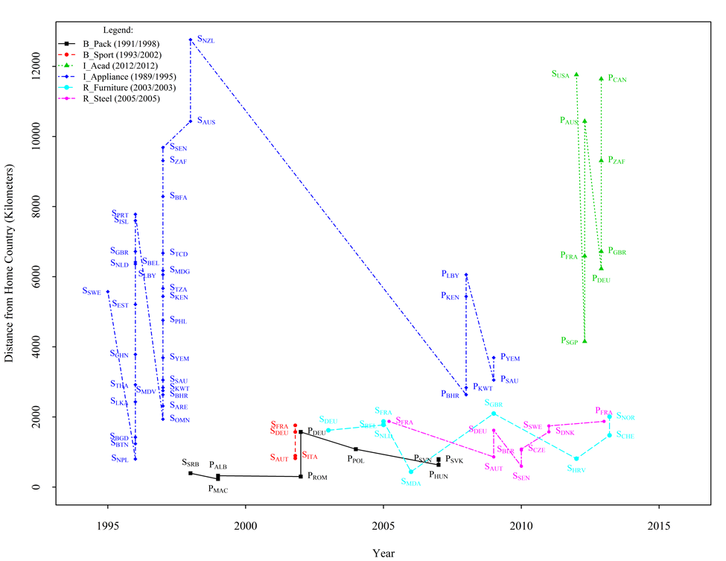



**Figure 2**

**A cognitive process perspective on serendipitous internationalization**



**Table 1**

**Case profiles**



**Table 2**

**Causal logic change in revealed partial causal maps and level of complexity in revealed full causal maps**



|  |  |
| --- | --- |
| **Table 3**  **Illustrative quotations for effectuation logic** |  |



**Table 4**

**Illustrative quotations for causation logic**



**Figure A.1**

**Example of partial causal maps that illustrate causal logics employed at the opportunity identification stage (D- Deterministic Links; P-Proactive Links)**

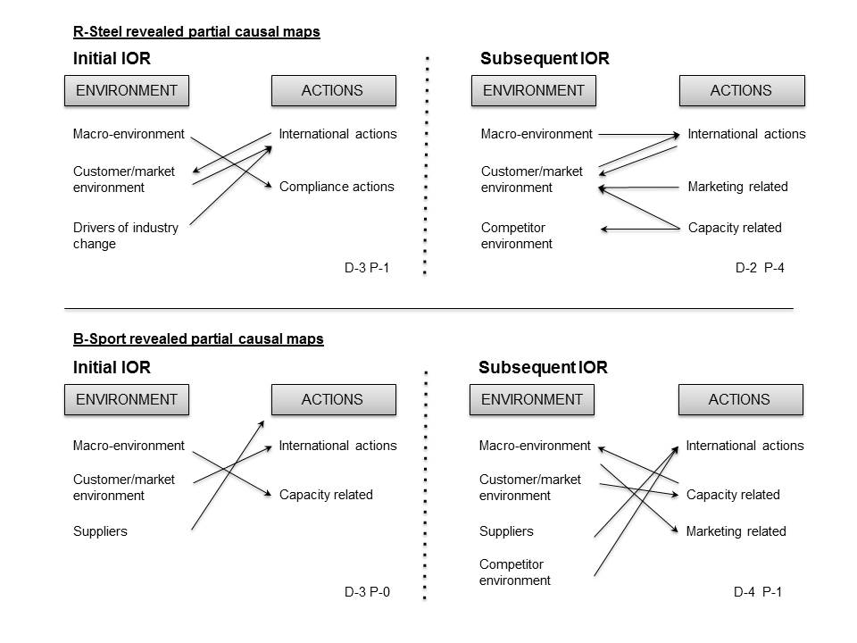

**APPENDIX**

**Figure A.2**

**Full causal map for I_Acad**

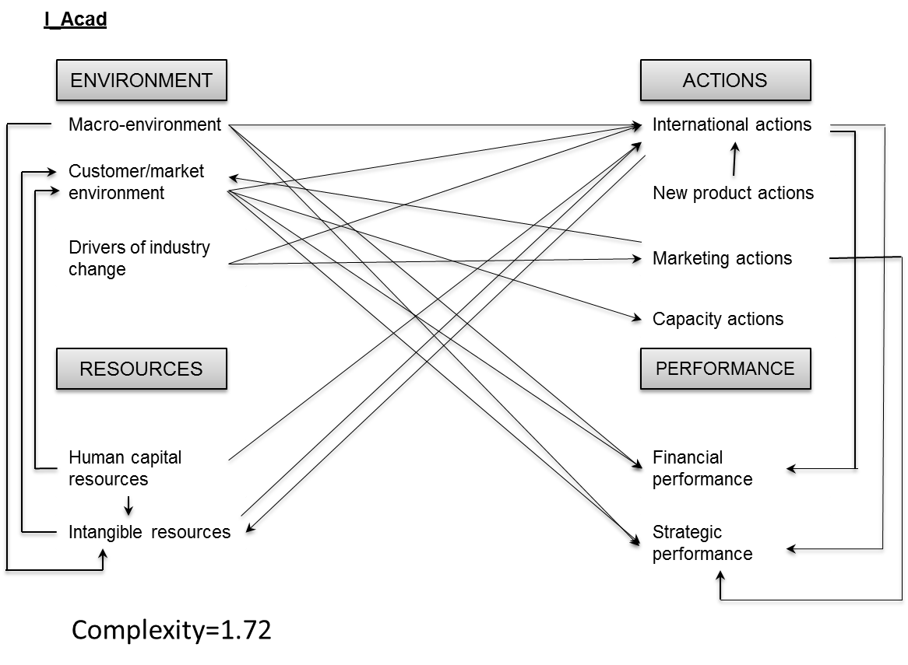

**Figure A.3**

**Full causal map for B_Sport**

