**Bayesian identification of bolted-joint parameters using measured PSD**

Y. Zhang1, Y. Zhao1, [1]a), Y. Lu1, H. Ouyang1, 2

*1 State Key Laboratory of Structural Analysis for Industrial Equipment, Department of Engineering Mechanics, International Center for Computational Mechanics, Dalian*

*University of Technology, Dalian 116023, PR China*

*2 School of Engineering, University of Liverpool, The Quadrangle, Liverpool L69 3GH, United Kingdom*

**Abstract**

A Bayesian method for the optimal estimation of parameters that characterize a bolted joint based on measured power spectral density (PSD) is proposed in this paper. Due to uncertainties such as measurement noise and modelling errors, it is difficult to identify joint parameters of a bolted structure accurately with incomplete measured response data. In this paper, using the Bayesian probability framework to describe the uncertainty of the joint parameters, and using the power spectrum of the structural response of the single-point/multi-point excitation as measurements, the conditional probability density function of the joint parameters is established. Then the Bayesian maximum posterior estimation is performed by an optimization method. Two simplified bolted-joint models are built in the numerical examples. Firstly, the feasibility of the proposed method in the undamped model is proved. Then, taking advantage of multi-point excitation, the identification accuracy of the proposed method in the damped model is improved. The numerical results show that the proposed method can accurately identify the stiffness and damping characteristics of joint parameters with good robustness to noise. Finally, the joint parameters of the finite element model for an aero engine casing are identified by the proposed method with satisfactory accuracy.

**Keyword**: bolted joint; uncertainty; power spectrum; Bayesian inference; optimal estimator; aero engine casing.

**1 Introduction**

Bolting, welding, and riveting are common ways of joining structural components to form structures in various structures and machines such as airplanes, automobiles and machine tools. Bolted joints of jointed structures, though often modelled as rigid connections, possess finite stiffness and certain damping, which have a significant impact on the overall dynamical behaviour and therefore cannot be ignored during the design phase. Although the finite element method is a universal methodology for analysing all kinds of structures, it does not yield very good results when directly applied to jointed structures, because of poor modelling of joints, including inaccurate joint parameters. A general and feasible solution is to correct the parameters of an established mathematical model of the joints based on vibration test data to achieve an accurate prediction of the dynamical behaviour of jointed or assembled structures.

The free vibration characteristics (frequencies and modes) essentially determine the dynamic response of the structure to external excitation. Identifying characteristics of a jointed structure by means of modal analysis is a straightforward method. Li[1] constructed a reduced order characteristic polynomial (ROCP) using the measured eigenfrequency data. Because each test frequency was a root of the ROCP, the joint parameters could be identified by a set of nonlinear equations. This method only required frequency measurement data, without mode matching, which greatly saved resources in data analysis. However, using determinants of a reduced matrix would lead to fairly big errors when the order of the reduced matrix could not be low. Ingole and Chatterjee[2] modelled a joint as a translational and a rotational spring and constructed the frequency domain equations of the jointed structure by a substructure synthesis. Their study showed effective identification of joint stiffness using only the first few natural frequencies. Adel et al.[3, 4] proposed the concept of Joint Affected Region (JAR) for bolted joint interfaces in a hybrid aluminium/composite structure and used measured modal data to identify the JAR parameters by means of a genetic algorithm.

The joint parameter identification method based on modal analysis requires higher order eigenfrequency data, which is currently not easy to acquire due to the limitations of instrumentation and modal analysis methods, especially for complex structures. On the other hand, joint parameter identification based on frequency response functions (FRFs) has drawn much attention due to its ease in implementation, and many researchers have used and developed this method. Yang and Park[5] proposed a method of identifying joint parameters using subset frequency response function measurements. Ren and Beards[6] developed a joint parameter identification method based on FRFs, which were insensitive to measurement errors, by using mathematical models to describe the mechanical properties of joint structures. Wang et al.[7] proposed a method of four basic formulas for identifying dynamic joint properties with partially measured FRFs. Due to the estimation of unmeasured FRFs in the identification procedure, the identification accuracy and robustness can be improved significantly. Tol and Ozguven[8] proposed an experimental identification method for joints based on FRF decoupling and an optimization algorithm, and validated their method with experimental data of the bolted joints.

The model parameters of each substructure in an assembled structure can be accurately obtained, so that a substructure-based model reduction method is well suited to the joint parameter identification problem. Yang et al.[9] used a substructural synthesis method and frequency response functions to derive the identification equations and to identify the joint parameters including the rotational stiffness. $\check{C}$ eli $\check{c}$ and Bolte $\check{z}$ ar[10] presented a method for establishing a theoretical model of a joint which considered translational and rotational degrees of freedom.

Noise is an inevitable problem in actual measurement, which significantly affects the accuracy and robustness of the identification results. Some studies indicate that even errors at quite a low level (i.e., 5% of FRFs[6,11]) will have a considerable adverse effect on the parameter identification results. The accuracy of identification can be greatly improved if all available information can be used reasonably. Aiming at the noise problem, Wang and Chuang[12] proposed a new method to identify joint parameters with an error function to select the best data of measured FRFs, and discussed the scenario where non-Gaussian noise is involved.

The mathematical model of bolted joints has always been a key issue in the study of dynamics of assembled structures. $\check{C}$ eli $\check{c}$ and Bolte $\check{z}$ ar[10] modelled the bolt as a set of translation and rotational springs. Mehrpouya et al.[13] considered the bolt as an oscillator, which included a lumped mass, damping and stiffness elements, and investigated the dynamic properties of the joint with inverse receptance coupling (IRC) method. The studies mentioned above generally focus on 2D joint models, which are not adequate for complex industrial machines and structures. To achieve good predictability, Mehrpouya et al[14]. proposed a linear joint model with 6 DOFs at each node to include the effects of translational and rotational FRFs, and presented a joint identification technique using the IRC method suitable for 3D structures. For special types of jointed structures, such as oil film lubrication system in rotating machines, the identification of jointed properties is studied and an effective method is developed[15].

The purpose of dynamic identification of jointed structures is to obtain optimal characteristic parameters of the mathematical model of joints which agree with the actual dynamic behaviour. It has certain common features with model updating (Mottershead et al.[16]; Esfandiari et al.[17], damage detection (Fang and Perera[18], Liberatore and Carman[19], Gao et al.[20]), modal identification (Brincker et al[21]., sensor placement (Stephan[22]; Kim and Park[23]) and so on, which all belong to the category of dynamic inverse analysis. Many research results on identification of joint parameters have been published. However, research in which the following factors are simultaneously considered is rare.

(I) Identification of joint parameters using random vibration test data. In fact, in addition to modal properties and FRFs, it is always valuable to identify the bolted-joint parameters from the statistical characteristics of the response. There have been some studies on the identification of structural damage based on the power spectral density tests (Yang et al[24]; Liberatore and Carman[19]; Fang and Perera[18]), and modal property identification based on on-line monitoringdataof huge buildings without artificial excitation (Beck and Au[25, 26]). To the authors’ knowledge, there has not been any published research on the identification of joint parameters of assembled structures based on random vibration test data, even though some similar research has been done on damage detection[24, 27].

(II) Consideration of the uncertainty of the jointed system. The dynamical test data of assembled structures usually contain significant uncertainties. Regardless of the influence of noise, the uncertainty of joints is still a significant source of uncertainty in the test results (Ibrahim and Pettit[28]; Hanss et al[29]). Previous studies were generally about the influence of measurement noise on the accuracy and robustness of the identification method, which did not consider the uncertainty of the joints themselves. In the related research on the effect of uncertain parameters on identification parameters, A point estimation method based on maximum entropy principle is proposed, which effectively handles a double-loop procedure with uncertainty propagation and inverse calculation, and greatly improves the solving efficiency ( Liu et al [30]). In some cases, it is easier to implement multi-point stochastic excitation, which makes it possible to generate vibration spectrums and further reveal some local features of vibration (Joshi and Ramakrishna[31]; Noda and Ishibashi[32]; Fuellekrug et al[33].).

The authors believe that introducing the multi-input-multi-output (MIMO) random vibration theory into joint parameter identification of assembled structures is an attractive approach. The Bayesian inference method also provides a feasible solution for the optimal estimation of uncertain joint parameters (Yuen and Katafygiotis[35-36]). In this paper, a Bayesian method based on power spectrum is proposed for joint parameter identification of a bolt-jointed structure. In section 2, the FRFs of an assembled structure are derived, and the frequency domain solution of the multi-input random vibration problem is solved by the pseudo excitation method (PEM). In section 3, taking the joint parameters as uncertain parameters, combined with the Bayesian method, the posterior probability function of the joint parameters is determined, and the objective function is constructed to find the optimal estimation of the joint parameters to achieve an improved model. In section 4, the feasibility and main features of the proposed method are discussed separately using two different types of theoretical models. Then the proposed method combined with general finite element software Ansys is applied to the parameter identification of fixing bolts of an aero engine casing. Section 5 provides a brief summary of the work in this paper.

**2 Pseudo excitation method for MIMO random vibration of Bolt-jointed structures**



1. (b)

Fig.1 Three systems in joint identification; (a) substructure in the uncoupled state, (b) substructure in the coupled state

2.1 FRF of assembled structures with bolted joints

As shown in Fig. 1, an assembled structure consists of two substructures connected by *n* bolted joints, which are modelled as linear springs $k_{i}$ and dampings $c_{i}$. A and D represent the internal degrees of freedom (DOFs) in each substructure respectively, excluding the joint DOFs. Meanwhile, B and C represent the DOFs of the joint region in each substructure respectively. From the above, the equation of motion for substructures 1 and 2 in the frequency domain can be derived:

|  |  |  |
| --- | --- | --- |
|  | $$\left\{\begin{matrix}x_{A}^{1} \\ x_{B}^{1}\end{matrix}\right\}=\left[\begin{matrix}H_{AA}^{1} & H_{AB}^{1} \\ H_{BA}^{1} & H_{BB}^{1}\end{matrix}\right]\left\{\begin{matrix}f_{A}^{1} \\ f_{B}^{1}+f_{j}^{1}\end{matrix}\right\},$$ $$\left\{\begin{matrix}x_{C}^{2} \\ x_{D}^{2}\end{matrix}\right\}=\left[\begin{matrix}H_{CC}^{2} & H_{CD}^{2} \\ H_{DC}^{2} & H_{DD}^{2}\end{matrix}\right]\left\{\begin{matrix}f_{C}^{2}+f_{j}^{2} \\ f_{D}^{2}\end{matrix}\right\}$$ | (1) |

where $x_{A}^{1},x_{B}^{1},x_{C}^{2},x_{D}^{2}$ are displacement vectors, and $f_{A}^{1},f_{B}^{1},f_{C}^{2},f_{D}^{2}$ are excitation vectors applied to the corresponding DOFs. $f_{j}^{1}$ and $f_{j}^{2}$ are internal forces between the substructures and bolts at location B and C respectively with the following relationship

|  |  |  |
| --- | --- | --- |
|  | $$f_{j}^{1}=-f_{j}^{2},$$ | (2) |

then the difference between displacement vector $x_{C}^{2}$ and $x_{B}^{1}$ can be expressed as

|  |  |  |
| --- | --- | --- |
|  | $$x_{C}^{2}-x_{B}^{1}={H_{j}∙f}_{j}^{1},$$ $$H_{j}={\left[\begin{matrix}k_{1}+iωc_{1} & 0 & 0 & ⋯ & 0 \\ 0 & k_{2}+iωc_{2} & 0 & ⋯ & 0 \\ 0 & ⋮ & ⋱ & ⋮ & ⋮ \\ ⋮ & ⋮ & ⋮ & ⋱ & ⋮ \\ 0 & 0 & 0 & ⋯ & k_{n}+iωc_{n}\end{matrix}\right]}^{-1},$$ | (3) |

where $k_{1},k_{2}, ⋯,k_{n}$ and $c_{1},c_{2}, ⋯,c_{n}$ represent the stiffness and damping coefficients of bolts respectively.

Accordingly, the dynamic equation of the assembled structure can be expressed as

|  |
| --- |
| $$\left\{\begin{matrix}x_{A}^{1} \\ x_{B}^{1} \\ x_{C}^{2} \\ x_{D}^{2}\end{matrix}\right\}=\left[\begin{matrix}H_{AA} & H_{AB} & H_{AC} & H_{AD} \\ H_{BA} & H_{BB} & H_{BC} & H_{BD} \\ H_{CA} & H_{CB} & H_{CC} & H_{CD} \\ H_{DA} & H_{DB} & H_{DC} & H_{DD}\end{matrix}\right]\left\{\begin{matrix}f_{A}^{1} \\ f_{B}^{1} \\ f_{C}^{2} \\ f_{D}^{2}\end{matrix}\right\}$$ $$=\left[\begin{matrix}H_{AA}^{1}-H_{AB}^{1}G^{-1}H_{BA}^{1} & H_{AB}^{1}-H_{AB}^{1}G^{-1}H_{BB}^{1} & H_{AB}^{1}G^{-1}H_{CC}^{2} & H_{AB}^{1}G^{-1}H_{CD}^{2} \\ H_{BA}^{1}-H_{BB}^{1}G^{-1}H_{BA}^{1} & H_{BB}^{1}-H_{BB}^{1}G^{-1}H_{BB}^{1} & H_{BB}^{1}G^{-1}H_{CC}^{2} & H_{BB}^{1}G^{-1}H_{CD}^{2} \\ H_{CC}^{2}G^{-1}H_{BA}^{1} & H_{CC}^{2}G^{-1}H_{BB}^{1} & H_{CC}^{2}-H_{CC}^{2}G^{-1}H_{CC}^{2} & H_{CD}^{2}-H_{CC}^{2}G^{-1}H_{CD}^{2} \\ H_{DC}^{2}G^{-1}H_{BA}^{1} & H_{DC}^{2}G^{-1}H_{BB}^{1} & H_{DC}^{2}-H_{DC}^{2}G^{-1}H_{CC}^{2} & H_{DD}^{2}-H_{DC}^{2}G^{-1}H_{CD}^{2}\end{matrix}\right]\left\{\begin{matrix}f_{A}^{1} \\ f_{B}^{1} \\ f_{C}^{2} \\ f_{D}^{2}\end{matrix}\right\},$$ |

(4)

where ${G=H}_{AA}^{1}+H_{BB}^{1}+H_{j}$.

2.2 MIMO random vibration based on pseudo excitation method

Considering the dynamic response of the bolt-jointed structure under random excitation, Eq. (4) can be rewritten into the following form

|  |  |  |
| --- | --- | --- |
|  | $$x\left(ω,θ\right)=H\left(ω,θ\right)f\left(ω\right),$$ | (5) |

where $H$ is the FRF matrix of the assembled structure described by Eq. (4), $θ$ is a vector of joint parameters (such as $k_{i}, i=1, 2, ⋯, n$). $f\left(ω\right)$’s power spectral matrix $S_{ff}\left(ω\right)$ is known as

|  |  |  |
| --- | --- | --- |
|  | $$S_{ff}\left(iω\right)=\left[\begin{matrix}S_{11}\left(iω\right) & S_{12}\left(iω\right) & ⋯ & S_{1m}\left(iω\right) \\ S_{21}\left(iω\right) & S_{22}\left(iω\right) & ⋯ & S_{2m}\left(iω\right) \\ ⋮ & ⋮ & ⋮ & ⋮ \\ S_{m1}\left(iω\right) & S_{m2}\left(iω\right) & ⋯ & S_{mm}\left(iω\right)\end{matrix}\right].$$ | (6) |

which is necessarily the Hermitian matrix and can be decomposed as

|  |  |  |
| --- | --- | --- |
|  | $$S_{ff}\left(iω\right)=\sum_{j=1}^{m}{λ_{j}ψ_{j}}ψ_{j}^{H},$$ | (7) |

where superscript H denotes the Hermitain transpose, $λ_{j}$ and $ψ_{j}$ are the eigen pairs of $S_{ff}\left(ω\right)$, which satisfy the following expression:

|  |  |  |
| --- | --- | --- |
|  | $$S_{ff}ψ_{j}=λ_{j}ψ_{j}, (j=1,2,⋯,r)$$ | (8) |
|  | $$ψ_{j}^{H}ψ_{j}=δ_{ij}=\left\{\begin{matrix}1 & \left(i=j\right) \\ 0 & \left(i≠j\right)\end{matrix}\right.$$ | (9) |

where $r$ is the rank of $S_{ff}$ with $r≤m$.

According to the pseudo excitation method, the following pseudo excitation using each order of eigenpairs in Eq. (8) should be applied:

|  |  |  |
| --- | --- | --- |
|  | $${\tilde{f}}_{j}=ψ_{j}^{*}\sqrt{λ_{j}}e^{iωt},$$ | (10) |

then substituting Eq. (10) into Eq. (5), the structure’s pseudo response under pseudo excitation can be easily derived as:

|  |  |  |
| --- | --- | --- |
|  | $${\tilde{x}}_{j}\left(ω,θ\right)=H\left(ω,θ\right)ψ_{j}^{*}\sqrt{λ_{j}}e^{iωt},$$ | (11) |

and the PSD function of response can be obtained using the pseudo response:

|  |  |  |
| --- | --- | --- |
|  | $$S_{xx}\left(ω,θ\right)=\sum_{j=1}^{r}{{\tilde{x}}_{j}^{*}}{\tilde{x}}_{j}^{T}.$$ | (12) |

In general, $ψ_{j}$ is a complex vector and $λ_{j}$ is a non-negative real number. Eq. (12) indicates that $S_{xx}\left(ω,θ\right)$ is a random matrix due to the presence of the uncertain system parameter vector $θ$, which makes the response of any DOF (such as the PSD of a displacement) a stochastic variable too.

3. Bayesian method for the identification of joint parameters using measured PSD

Parameter identification of a jointed structure is usually a deterministic identification problem, but some investigations suggest that the characteristics of a jointed structure have significant uncertainty[27]. Even for the noise-free response signal in ideal acquisition, there is an influence of epistemic and aleatoric uncertainty, which points to the need of parameter identification of such uncertain jointed structures. In the theory of probability and statistics, the Bayesian probabilistic framework provides an effective solution for estimation of uncertain parameters. In this investigation, assuming that the uncertainty of joint parameters can be treated as random variables and taking the power spectrum response to MIMO random vibration as an observation, the Bayesian method is used for optimal estimation of the uncertain joint parameters.

3.1 Probability density function of measured response PSD

In consideration of measurement errors, the measured response of any DOF can be given by:

|  |  |  |
| --- | --- | --- |
|  | $$y\left(ω_{k}\right)=\tilde{x}\left(ω_{k},θ\right)+ε,$$ | (13) |

where $\tilde{x}\left(ω_{k},θ\right)$ is the theoretical response of the structure described in Section 2, and $ε$ represents the measurement error and is modelled as $ε$ = $\tilde{x}\left(ω_{k},θ\right)∙\sqrt{Δ}∙ε_{noise}$, in which $ε_{noise}$ is a zero-mean white noise process, and $Δ$ is the noise level.

So, the measured response PSD can be calculated:

|  |  |  |
| --- | --- | --- |
|  | $${S_{yy}\left(ω_{k}\right)=S}_{xx}\left(ω_{k},θ\right)+S_{ϵ}\left(ω_{k}\right),$$ | (14) |

To use Bayesian inference, the conditional PDF of measured response PSD under condition $θ$ must be calculated and used as a likelihood function. The measured time domain data is Gaussian with zero mean, then response in frequency domain obtained by the Fourier transform satisfies complex Gaussian distribution. According to references[32,37], for long data, response PSD $S_{yy}\left(ω_{k}\right)$ have a 2-DOF $χ^{2}$ distribution asymptotically., and the PDF of measured response PSD can be approximated as:

|  |  |  |
| --- | --- | --- |
|  |  | (15) |

where the mean value of measured response PSD $E\left[S_{yy}\left(ω_{k}\right) | θ\right]$ is expressed as:

|  |  |  |
| --- | --- | --- |
|  |  | (16) |

and $E\left[∙\right]$ denotes the mathematical expectation.

In the frequency range of the PSD analysis, $S_{yy}\left(ω_{k}\right)$ and $S_{yy}\left(ω_{k^{'}}\right)$ are uncorrelated when $ω_{k}≠ω_{k^{'}}(k,k^{'}ϵK)$. According to Yaglom’s study[38], uncorrelated $χ^{2}$-distributed random variables are independent. Hence, defining the power spectrum set $S_{K}$ as:

|  |  |  |
| --- | --- | --- |
|  |  | (17) |

where $K$ denotes the frequency index. The joint PDF of $S_{K}$ can be obtained from the Eq. (10):

|  |  |  |
| --- | --- | --- |
|  |  | (18) |

where $E\left[S_{yy}\left(ω_{k}\right) | θ\right]$ can be computed using Eq. (16).

3.2 Bayesian identification method based on measured PSD

The bolted joint parameter **θ** is a vector of independent random variables that follow the same type (Gaussian) of probabilistic distributions, which can be described by a probability distribution called prior probability distribution. According to Bayesian inference, the posteriori probability distribution of bolted joint parameters can be derived by the measured response data and prior data. The Bayesian formula for single-channel and multiple-channel measurements are introduced below.

3.2.1 The Bayesian formula for single-channel and multiple frequency points measurements

Assuming that the prior probability distribution of bolt parameter $θ$ is $p\left(θ\right)$. The joint PDF of a random variable $S_{yy}\left(ω_{k}\right)$ and parameter $θ$ can be derived by multiplication formula:

|  |  |  |
| --- | --- | --- |
|  |  | (19) |

where $p\left(S_{yy}\left(ω_{k}\right) | θ\right)$ is the conditional PDF of $S_{yy}\left(ω_{k}\right)$ under condition $θ$. The marginal PDF is computed by integrating $h\left(S_{yy}\left(ω_{k}\right);θ\right)$ over the parameter space of .

|  |  |  |
| --- | --- | --- |
|  |  | (20) |

Assuming that the probability property of $S_{yy}\left(ω_{k}\right)$ is already known, then the joint PDF of $S_{yy}\left(ω_{k}\right)$ and $θ$ can be expressed as:

|  |  |  |
| --- | --- | --- |
|  |  | (21) |

where $p\left(θ | S_{yy}\left(ω_{k}\right)\right)$ denotes the conditional PDF under the condition $S_{yy}\left(ω_{k}\right)$.

Obviously, the following can be obtained from Eq. (19) and Eq. (21):

|  |  |  |
| --- | --- | --- |
|  |  | (22) |

Further, the posteriori PDF of parameter $θ$ can be derived using Eq. (20):

|  |  |  |
| --- | --- | --- |
|  |  | (23) |

where $α_{1}$ is a normalization constant uncorrelated to parameter $θ$.

The posterior PDF of parameter $θ$ in the case of multiple frequency points can be computed from Eq. (23) and Eq. (18):

|  |  |  |
| --- | --- | --- |
|  |  | (24) |

where $p\left(S_{K} | θ\right)$ is the likelihood function in Bayesian estimation.

Generally, there are three ways for optimal estimation of bolt parameter $θ$ based on the posterior PDF $p\left(θ | S_{K}\right)$. First, the Maximum A Posterior (MAP) estimation takes the maximum value of the posterior PDF as a point estimate; Second, the posterior median estimation takes medians as a point estimate; Last, the expectation estimation takes expectation as a point estimate. Different estimation methods are chosen according to the item of interest. In Bayesian identification, MAP is the most common point estimate method. For the MPV of bolt parameter $θ$, the objective function can be constructed from Eq. (24):

|  |  |  |
| --- | --- | --- |
|  |  | (25) |

and the optimal estimator $θ^{*}$ can be obtained by minimizing the objective function $J\left(θ\right)$.

In global identification problems, the posterior PDF can be approximated by Gaussian PDF centered at the MPV and with a covariance matrix. The quality of Gaussian approximation to the posterior PDF is depends on how close the second order Taylor series about $θ^{*}$ is to $J\left(θ\right)$, which is closely related to the data size. Practically, the MPV and posterior variance are more valuable than the quality of Gaussian approximation[37]. In this paper, the size of data is large enough to approximate the posterior PDF by a Gaussian distribution. If the posterior PDF does not satisfy the Gaussian distribution, Markov Chain Monte Carlo sample from the posterior PDF can be used for evaluating the uncertainty[39].’

3.2.2 The Bayesian formula for multiple-channel and multiple frequency point measurements

If the measured data contains PSD information of $N_{s}$ channels, $S_{K}^{\left(1\right)}，S_{K}^{\left(2\right)}，⋯S_{K}^{\left(N_{s}\right)}$, the posterior PDF $p\left(θ | S_{K}^{\left(1\right)}，S_{K}^{\left(2\right)}，⋯S_{K}^{\left(N_{s}\right)}\right)$ can be computed from Eq. (18) and Eq. (23):

|  |  |  |
| --- | --- | --- |
|  |  | (26) |

By analogy to Eq. (25), the objective function for multiple-channel and multiple frequency points measurements can be calculated as follows:

|  |  |
| --- | --- |
|  | (27) |

where ${\overline{S}}_{yy}\left(ω_{k}\right)$ denotes the nominal mean value of the power spectrum response of different channels at the same frequency:

|  |  |  |
| --- | --- | --- |
|  | $${\overline{S}}_{yy}\left(ω_{k}\right)=\frac{1}{N_{s}}\sum_{s=1}^{N_{s}}{S_{yy}^{\left(s\right)}\left(ω_{k}\right)}.$$ | (28) |

**4 Numerical examples**

In section 4, three numerical examples are analysed. The first example considers a cantilever beam with one end bolted to a rigid support, which is modelled as a linear spring and a torsional spring. The focus of study is on the influence of noise level, selected frequency band and the number of frequency points on Bayesian identification method. The second example is about an assembled structure with two parallel cantilever beams jointed by three bolts. In this example, each bolted joint is modelled as a linear spring and a damper. The advantage of Bayesian identification method using multi-point excitation is verified by comparing identification errors in results using multi-point and single-point excitation in a certain range of frequency. The third example resembles an aero engine casing and further demonstrates the effectiveness of the method prosed in this paper.

4.1 Numerical example 1

As shown in Fig. 2, the cantilever beam is bolted at one end and free at the other end. The bolt is modelled as a linear spring with stiffness $k_{1}=9×{10}^{4}{Nm}^{-1}$ together with a torsional spring with stiffness $k_{2}=1.2×{10}^{4}Nm {rad}^{-1}$. The main properties of the beam are as follows: Young’s modulus $E=207 GPa$, Poisson’s ratio $v=0.3$, length of beam $L=1m$, cross-sectional area $A=2×{10}^{-4}m^{2}$ and moment of area $I=3×{10}^{-9}m^{4}$ and damping coefficient $ξ=0.03$. The excitation imposed at the end of beam is a white noise excitation with PSD $S_{F}={10}^{3}{ N}^{2}s$



Fig.2 A cantilever beam bolted at one end



Fig. 3 ‘Measured’ displacement PSD of the measured point

4.1.1 Optimal estimator

In order to fully illustrate the information on the measured data, the prior distribution is assumed to be a uniform distribution. Using Eq. (13) with $Δ=0.15$, the ‘measured’ displacement PSD of the ‘measured point’ with 15% noise level is generated at first. Fig 3 presents ‘measured’ displacement PSD in the frequency range of 0~60 Hz where 1200 frequency points are regularly distributed.

Tab. 1 shows the result of an actual parameter $θ$, its optimal estimate $θ^{*}$, the standard deviation $σ$, the coefficient of variation (COV), the normalized distance (ND) and the mean value bias using the Bayesian identification mentioned above. ND is define using Eq. (29):

|  |  |  |
| --- | --- | --- |
|  |  | (29) |

Tab.1 Estimation results with the full data in the frequency range of [0,60] Hz

|  |  |  |  |  |  |  |
| --- | --- | --- | --- | --- | --- | --- |
| Parameter | Actual parameter $θ$ | Optimal estimator $θ^{*}$ | standard deviation $σ$ | COV | ND | Mean value bias (%) |
| $$k_{1}$$ | 90000 | 90021.63 | 753.93 | 0.008 | 0.029 | 0.02 |
| $$k_{2}$$ | 12000 | 12052.21 | 628.05 | 0.052 | 0.083 | 0.44 |

4.1.2 Influence of selected frequency band

In this section, the influence of the frequency range adopted on the precision of the estimation results is analysed. Hence, first the ‘measured’ PSD as given in Fig. 3 is divided into 3 sub-intervals, i.e., Case 1: $f_{1} ϵ \left(0 20\right) Hz$, Case 2: $f_{2} ϵ \left(20 40\right) Hz$ and Case 3: $f_{3} ϵ \left(40 60\right) Hz$. Three cases, where the estimation processes are carried out using the above 3 sub-intervals respectively are considered. The estimation results are reported in Table 2.

Tab. 2 shows the optimal bolt parameters obtained from different frequency bands. Optimal results from Case 1 is closest to the actual parameters with the smallest standard deviation of $k_{2}$. The ND and error of each case indicate that Case 1 has the best identification accuracy, followed by Case 3 and the least accurate one is Case 2.

The ‘measured’ PSD of Case 1 and Case 3 contain the first-order and second-order response peaks respectively, so their identification results are more accurate than Case 2, and the variance is smaller. This also proves that the bolt’s structural features included in the ‘measured’ data of Case 2 are not significant and are susceptible to uncertain factors such as noise. In other words, this part of the information is not conducive to the identification of bolt features. When identifying local structural characteristics, Bayesian based methods require measurements obtained in a specific frequency range. .

Tab. 2 Identification results of different Cases

|  |  |  |  |  |  |  |
| --- | --- | --- | --- | --- | --- | --- |
|  | Case 1 | | Case 2 | | Case 3 | |
| Parameter | $$k_{1}$$ | $$k_{2}$$ | $$k_{1}$$ | $$k_{2}$$ | $$k_{1}$$ | $$k_{2}$$ |
| Actual parameter $θ$ | 90000.00 | 12000.00 | 90000.00 | 12000.00 | 90000.00 | 12000.00 |
| Optimal estimator $θ^{*}$ | 90060.99 | 12240.19 | 89832.62 | 10283.54 | 89849.35 | 12235.97 |
| standard deviation $σ$ | 2235.75 | 720.37 | 1668.46 | 7622.7 | 911.79 | 1253.08 |
| COV | 0.025 | 0.059 | 0.019 | 0.741 | 0.01 | 0.102 |
| ND | 0.027 | 0.333 | 0.100 | 0.225 | 0.165 | 0.188 |
| Mean value bias (%) | 0.07 | 2.00 | 0.19 | 14.30 | 0.17 | 1.97 |
| Total bias (%) | 2.07 | | 14.49 | | 2.14 | |

4.1.3 Influence of the number of frequency points

This section discusses the influence of the number of frequency points used in identification. The selected frequency band is 0-60Hz, the noise level is 15%, and the minimum number of frequency points is 100 and the maximum is 1600. The error bar chart of identification results is shown in Fig. 4, in which the hollow circles represent MPV and the dotted line the target values. It can be seen clearly from Fig. 4 that, as the number of frequency points increases, the variances of the parameters significantly decrease, and the trend of decrease becomes less and less until steady, but they do not vanish. The MPV fluctuates around the target value because of the uncertainty, which is always within the $±$ one standard deviation error bar.



Fig. 4 Identification results for the different numbers of frequency points

4.1.4 Influence of noise level

The presence of noise is inevitable in the measurement process, and the noise level of ‘measured’ data often determines the accuracy of identification results, thus noise robustness of any identification method is very important. In this section the ‘measured’ PSD is generated in frequency band of 0-60Hz, with 400 frequency points which are enough for accurate identification results, when the noise level is from 1% ($∆=0.01$) to 20% ($∆=0.2$). Fig. 5 shows identification results at different noise levels. Apparently, the noise level has no significant impact on the variance of the identification results. At low noise levels of less than 5% ($∆=0.05$), the MPVs are closer to the target values, especially for $k_{2}$. At high uncertainty levels, the identification method can still get MPVs near the target values, because the number of identified parameters is small and the identified structure is simple, which suggests weak local characteristics of the parameters.



Fig. 5 Identification results for different Noise levels （%）

4.2 Numerical example 2

The bolted joint studied in example 1 is modelled by only springs. However, a bolted joint provides both stiffness and damping, and thus these characteristics of a bolt-jointed structure must be considered simultaneously in practice. A composite structure consisting of two parallel cantilever beams connected by three bolted joints shown in Fig. 6 is considered in this example. Each bolt is modelled as a linear spring together with a viscous damper. The bolted joint parameters are as follows: $k_{1}=1×{10}^{6} N/m$, $k_{2}=2×{10}^{6} N/m$, $k_{3}=1.5×{10}^{6} N/m$, $d_{1}=100 N s/m$, $d_{2}=200 N s/m$, $d_{3}=150 N s/m$. In the FEM model, each cantilever beam as a substructure is discretized into 20 elements with 40 DOFs.

It is generally known that the frequency bands for identifying stiffness and for damping at good accuracy are different, especially when there is a wide disparity in their orders of magnitude. In such conditions, the ‘measured’ frequency band is required to be wide, which presents a challenge to measurement technology. To overcome such a practical problem, a multi-point excitation method is believed to be an effective technique. Hence, in the following simulations, two different excitation methods are considered. In the first excitation method, only single point excitation $F_{1}$ is applied. While in the second excitation method, $F_{1}$ and $F_{2}$ are applied simultaneously. They are white noise with time lag $τ=0.02 s$, as shown in Fig. 6.

Fig. 7 shows the ‘measured’ PSDs under single-point and multi-point excitations with 5% noise level, respectively. The following simulations are carried out on two different frequent sections, i.e., band A and band B. Band A covers the range of 300-1100 Hz which contains 2000 uniformly distributed measured points. As for band B, which is a subsection of band A, only 500 measured points in a small frequency range, i.e., 700-900 Hz, is selected. Neither band A nor band B contains information about response peaks which has been demonstrated to be rich in structural information. In traditional senses, band A is actually not an ideal measurement range, and band B is even worse. The simulation results obtained by two different excitation methods acting in band A and band B are exhibited in Fig. 8 and Fig. 9, respectively.

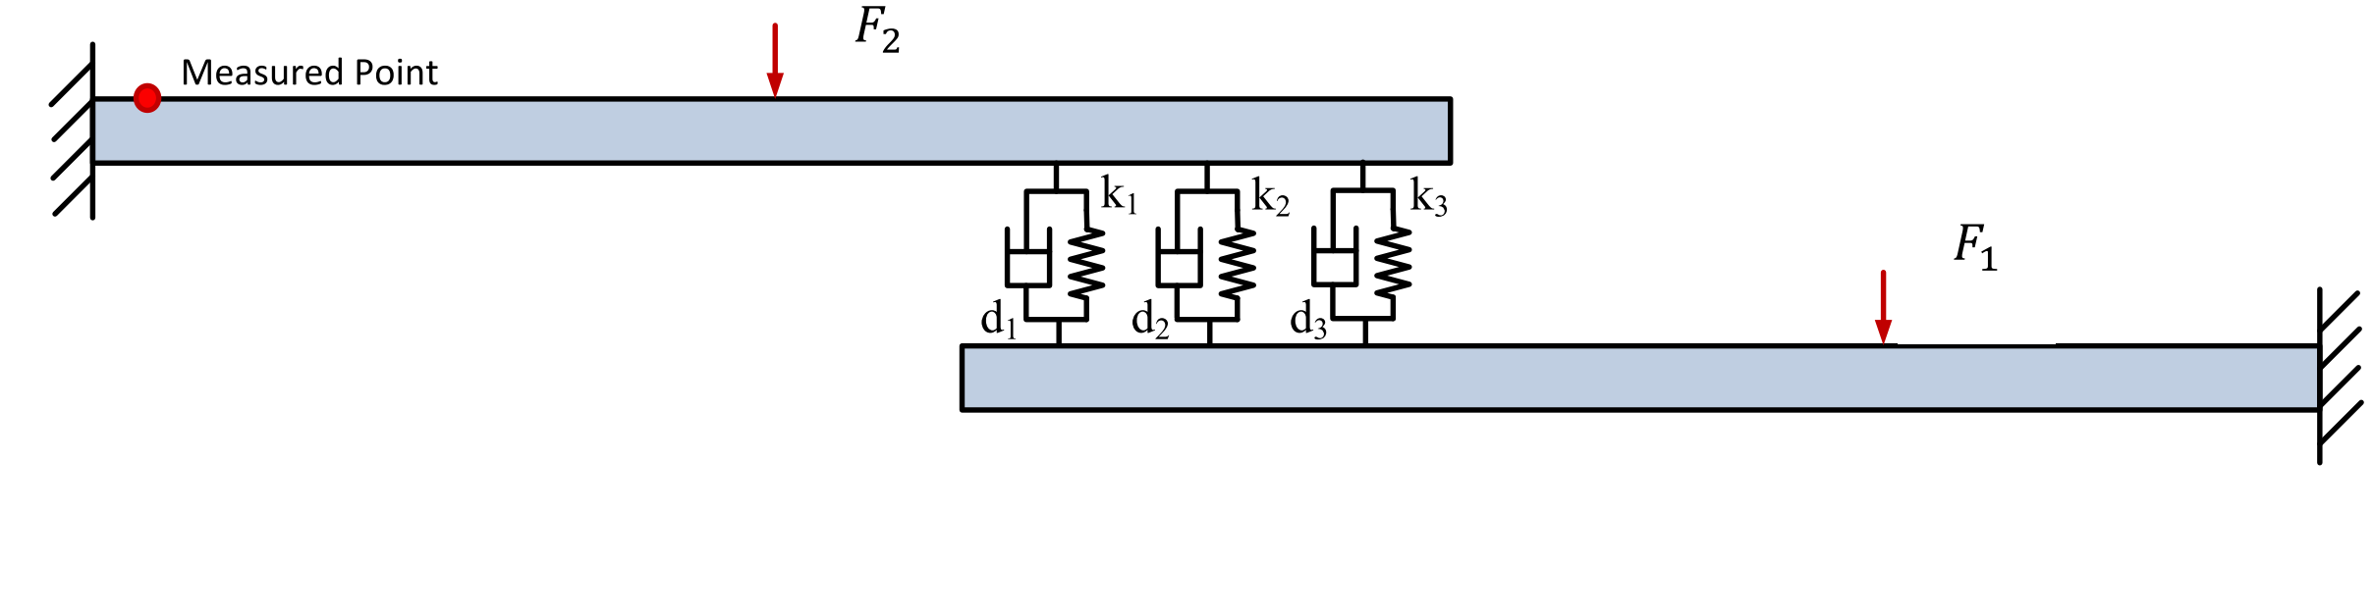

Fig. 6 The assemble structure with bolted joints each modelled as a spring and a damper

Fig. 7 Comparison with ‘measured’ PSD under single-point Excitation and multi-point Excitation

As can be seen from Fig. 8, satisfactory identification results can be obtained using band A since this wide frequency range contains relatively abundant structural information. In contrast, when using band B, deviation of the MPV from the target value is quite large, and the variance also is greater than that for band A. The above phenomenon is mainly due to the following two reasons: (a) band B is too narrow to contain enough structural information; (b) the bolt-jointed structure in numerical example 2 has both stiffness and damping parameters. As already pointed out previously in this paper, it is known that it is more difficult to identify a stiffness parameter than a damping parameter in high frequency band like band B.

Fig. 9 gives a posterior probability distribution of bolted joint parameters using measured data in band A and band B under a multi-point excitation. Whether for the MPV or the variance, the identification results obtained in band A and band B do not differ much. However, it is worth noting that band A response peaks contains 2000 measured data points, while band B contains only 500 measured data points. Therefore the advantages of band B in computational efficiency is obvious.

Since the noise level in the two simulations are small, i.e. 5%, it can be expected that the MPV would not deviate much from the target, as has been confirmed in Example 1. Hence, the results obtained under single-point excitation and multi-point excitation are worth to be compared. When the results of the single-point excitation (the red line in Fig. 8) with the results of the multi-point excitation (the red line in Fig. 9) in band B are compared, the identification accuracy under the multi-point excitation is obviously higher than that under the single-point excitation. In addition, from the blue line in Fig. 8 and the red line in Fig. 9, it can be found that the MPV under the multi-point excitation is closer to the target value, which indicates that 500 ‘measured’ data points in band B under the multi-point excitation contains more local structural information than 2000 ‘measured’ data points in band A under the single-point excitation. The above finding can be explained as follows:

The response PSD under coherent excitations with time lag ($τ$) contains many periodic response peaks whose period depends on $τ$. Though such excitation response peaks are at small amplitudes, they store abundant structural information than the PSD under single excitation and are less sensitive to noise.

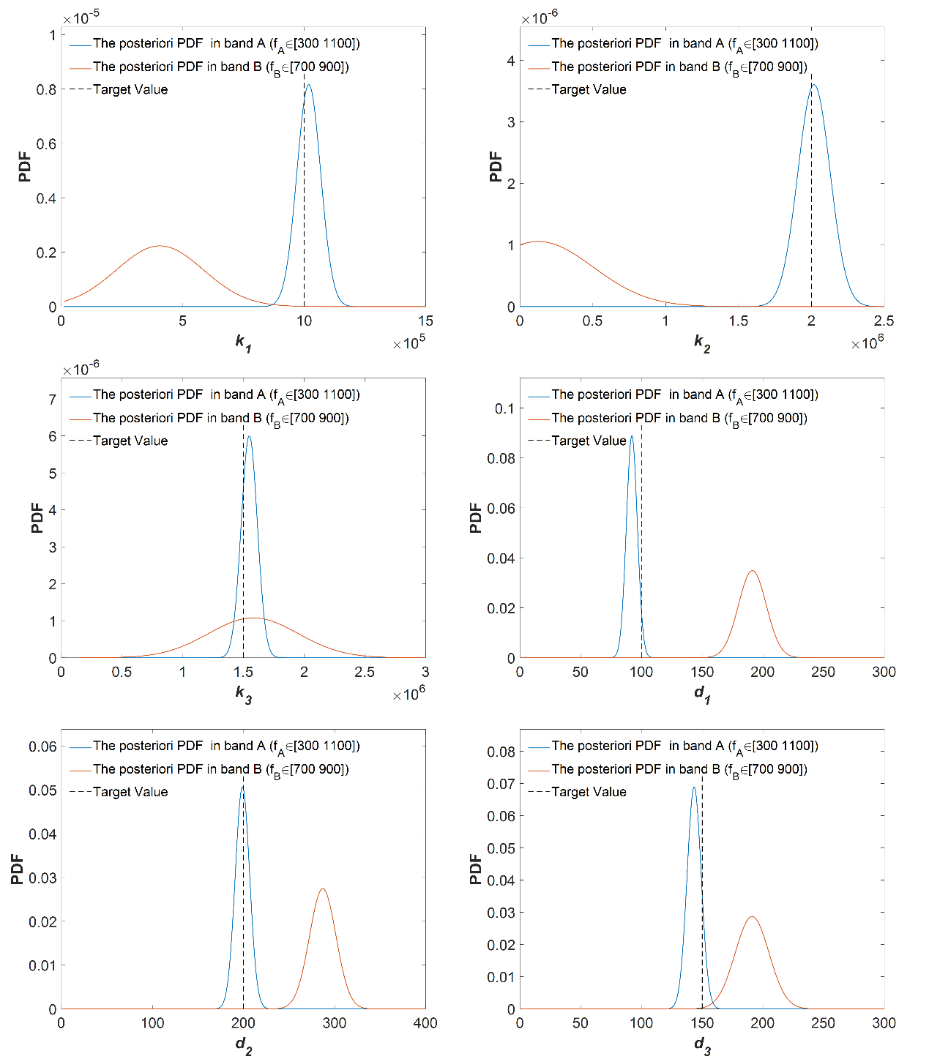

Fig. 8 Comparison of the posteriori PDF under single-point excitation

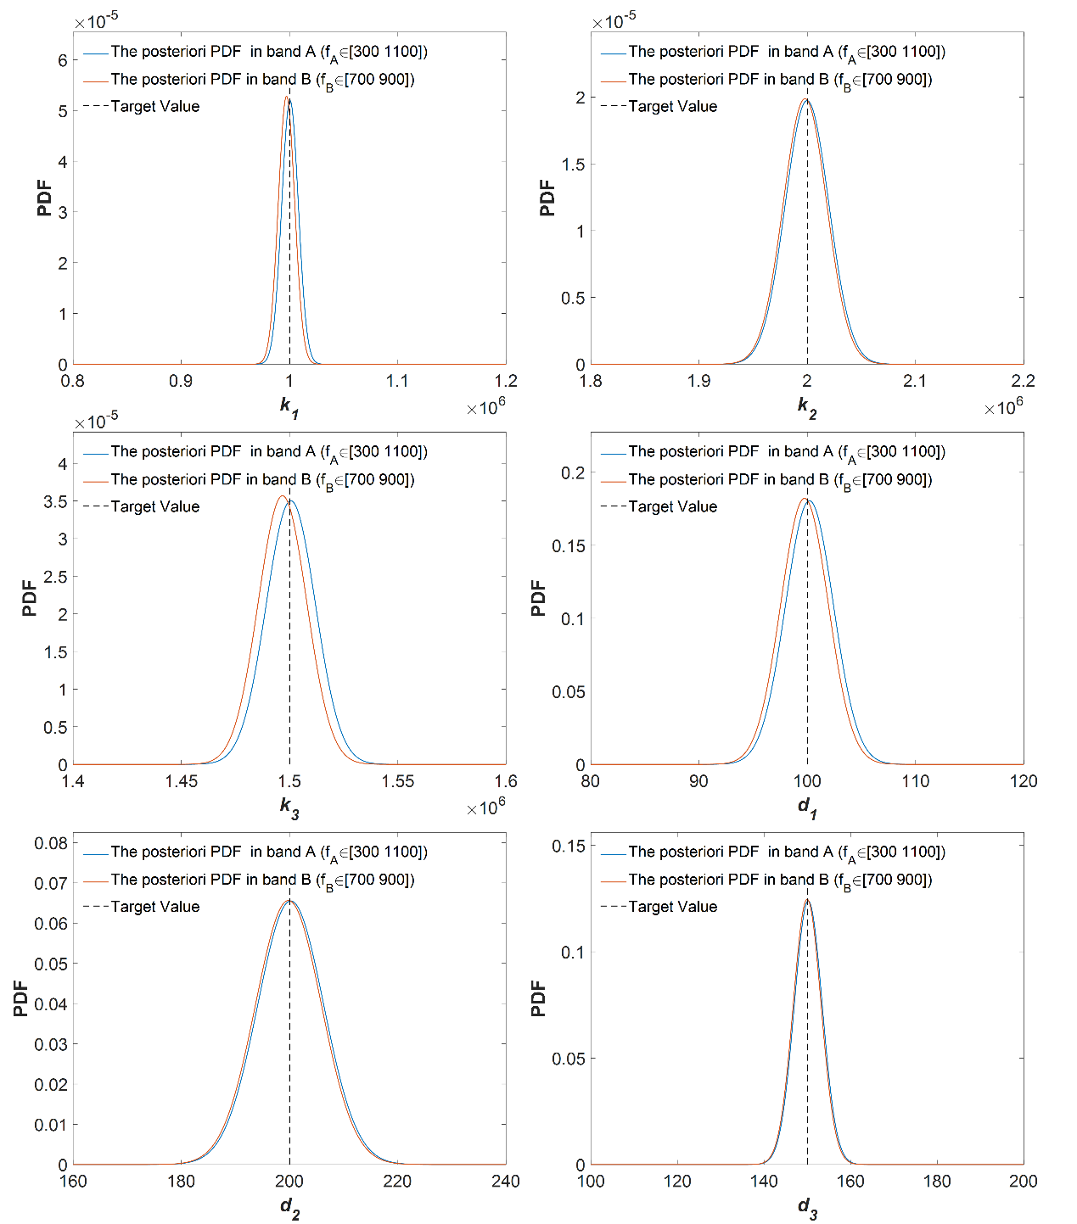

Fig. 9 Comprison of the posteriori PDF under multi-point Excitation

4.3 Numerical example 3

Bolt-joined cylindrical shells are widely utilized in various structures, such as submarines, aerospace structures, vehicles and pressure vessels. Fig. 10(a) shows the mechanical model of a bolted cylindrical shell as an aero engine casing. Each bolt is modelled by three perpendicular linear springs and one torsional spring. The left end of the model is fastened to a fixed support by 16 bolts, and the other end is free. $x, θ and z$ represent the axial, circumferential and radial directions respectively. The shell thickness $h=0.008 m$, the length of shell $L=1.25 m$, the mean radius of shell $R=0.25 m$; the mass density, Poisson’s ratio and Young’s modulus of the shell material are $ρ=7800 kg/m^{3}$， $μ=0.3$ and $E=210 GPa$ respectively.

The following dimensionless parameters of each bolt $k_{u}^{*}=\frac{k_{u}(1-μ^{2})R}{EhL}$, $k_{w}^{*}=\frac{k_{w}(1-μ^{2})R}{EhL}$, $k_{v}^{*}=\frac{k_{v}(1-μ^{2})R}{EhL}$, $k_{θ}^{*}=\frac{k_{θ}(1-μ^{2})}{EhLR}$ are introduced. The locations of the observation points are shown in Fig. 11. A white noise excitation is applied at position 34 in the radial direction at the free end, as shown in Fig. 11. The actual bolted joint parameters are $k_{u}^{*}=k_{w}^{*}=k_{v}^{*}=k_{θ}^{*}=1$

Tab. 14 lists the identification results of the bolted joint parameters of the aero engine casing. It can be seen that the difference in identification results at different observation points is negligible. Although the number of joint parameters in this example is not very high due to the computational workload, the applicability of the identification method can be demonstrated. By improving the computational efficiency, real industrial structures can be dealt with.

In order to further study the influence of MPE position on the identification results, two cases under MPE are examined. The excitation positions and the observation positions of each case are shown in Fig. 12, and the noise level of the ‘measured’ PSD is 15%. The identified parameters of Case A and Case B are 0.9998 and 1.0014 respectively, which are very close to the actual value of 1. Fig. 13 and Fig. 14 show the comparisons between ‘measured’ PSDs and updated PSDs in Case A and Case B respectively. It can be observed that the ‘measured’ PSD in Case A has more fluctuations than in Case B, which is advantageous to the identification accuracy improvement in Case A. Excitation positions in Case A can give full play to the superiority of MPE, which makes the identification results in Case A more accurate.

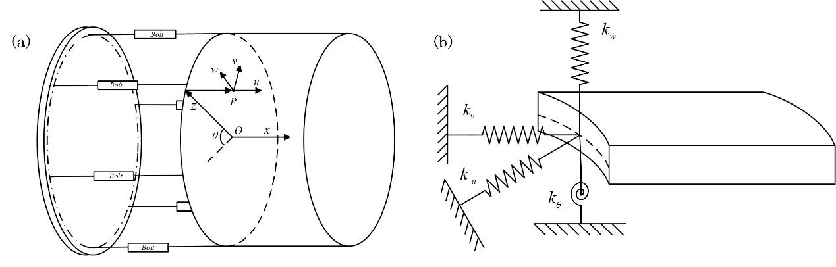

Fig. 10 The aero engine casing structure: (a) mechanical model of bolted jointed cylindrical shell;

(b)Bolt-joint model of three linear springs and one torsional spring

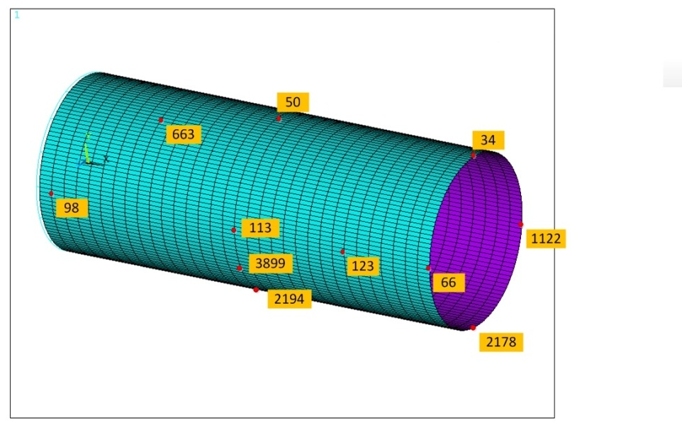

Fig.11 Excitation and observation positions of the finite element model of the aero engine casing

Tab. 14 Identification results of the different observation positions

|  |  |  |  |  |
| --- | --- | --- | --- | --- |
| Node ID | Node Location | | | Estimation  (Actual parameter is 1) |
| X (m) | Y (m) | Z (m) |
| 98 | 0.039 | 0 | 0.250 | 1.0346 |
| 1123 | 0.039 | 0 | -0.250 | 1.0325 |
| 663 | 0.313 | 0 | 0.159 | 1.0015 |
| 113 | 0.625 | 0 | 0.250 | 1.0237 |
| 1138 | 0.625 | 0 | -0.250 | 1.0237 |
| 50 | 0.625 | 0.250 | 0 | 1.0128 |
| 2194 | 0.625 | -0.250 | 0 | 1.0116 |
| 123 | 1.016 | 0 | 0.250 | 1.0237 |
| 66 | 1.250 | 0 | 0.250 | 1.0238 |
| 1122 | 1.250 | 0 | -0.250 | 1.0238 |
| 34 | 1.250 | 0.250 | 0 | 1.0128 |
| 2178 | 1.250 | -0.250 | 0 | 1.0116 |

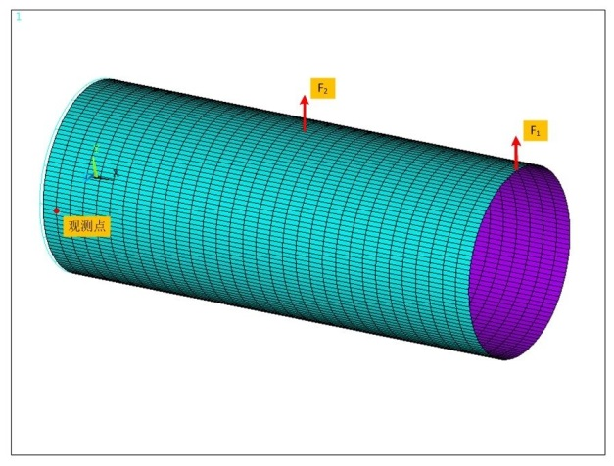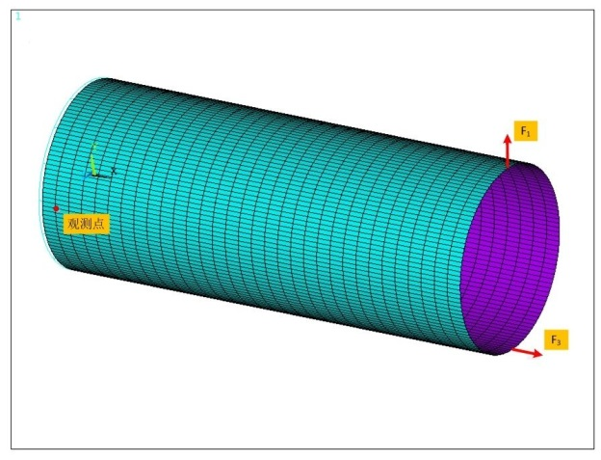

Fig.12 The aero engine casing under multi-point excitations

1. Case A; (b) Case B

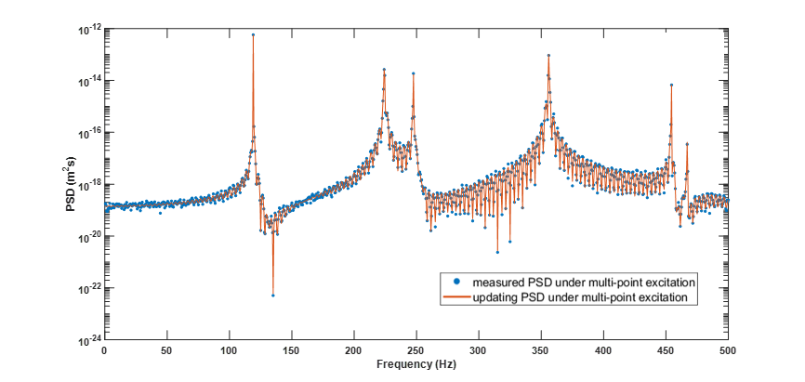

Fig.13 Comparison with ‘measured’ PSD and updated PSD in Case A

(Estimator $k^{*}=0.9998$)

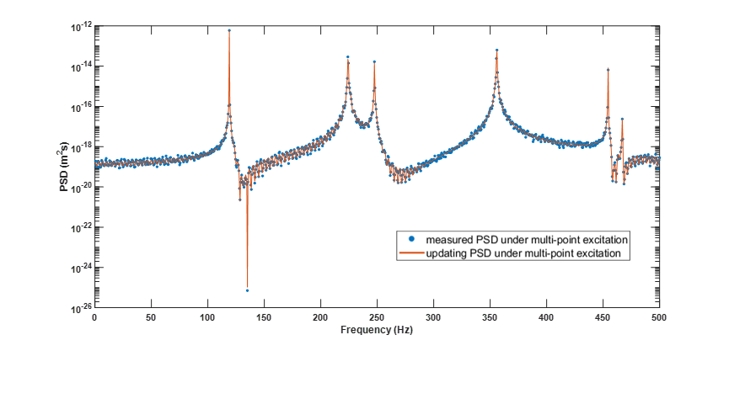

Fig.14 Comparison with ‘measured’ PSD and Updated PSD in Case B

(Estimator $k^{*}=1.0014$)

5 Conclusions

In this paper, a Bayesian identification method is proposed for the identification of bolted joint parameters of assembled structures, based on simulated random response PSD to overcome the limitations of using FRF data or modal data. In addition, the pseudo excitation method is combined to accelerate the spectral analysis of the Bayesian identification method.

The Bayesian identification method under a single-point excitation has low requirements for identification frequency range and the number of frequency points when identifying only the stiffness parameters of a bolted joint, and the identification results have a high accuracy and are noise resistant. However, when an assembled structure contains both stiffness and damping parameters, especially when the damping are quite high, single-input-multiple-output methods have low identification accuracy, and even fail to converge in many iteration steps.

The structural response under multi-points excitation is found to be able to reveal the local and subtle properties of a jointed structure, which is suitable for joint parameter identification. This paper demonstrates the advantages of the multi-input Bayesian identification method for bolt-jointed structures with damping parameters. The simulation results lead to the following conclusions:

1. The response under a multi-point excitation contains many periodic response peaks that are present in high frequency band and store abundant structural information.
2. The ‘measured’ response data caused by a multi-point excitation improve identification accuracy by up to 100%
3. Compared with a single-point excitation, a multi-point excitation can reduce the requirement width of frequency band and number of ‘test’ samples by 75%.

**Acknowledgements**

The authors are grateful for the support under grants from the National Science Foundation of China (11772084 and 11672052) and the National Basic Research Program of China (2014CB046803).

**Reference**

1. Li W L. A new method for structural model updating and joint stiffness identification. *Mech Syst Sig Process* 2002; 16(1): 155-167.

2. Ingole S B, Chatterjee A. Joint Stiffness Identification: a Three-Parameter Joint Model of Cantilever Beam. *Int J Acoust Vibr* 2017; 22(1).

3. Shokrollahi S, Ahmadian H, A New Approach for Finite Element Model Updating of Bolted Joints and Comparison with Interface Layer Method. *Mech Eng* *J* 2016;16: 35-42.

4. Adel F, Shokrollahi S, Jamal-Omidi M, et al. A model updating method for hybrid composite/aluminum bolted joints using modal test data. *J Sound Vib* 2017;396: 172-185.

5. Yang K T, Y Park Y. Joint structural parameter identification using a subset of frequency response function measurements. *Mech Syst Sig Process*. 1993; 7 (6):509-530.

6. Ren Y, Beards C F. Identification of joint properties of a structure using frf data. *J Sound Vib* 1995;186(4): 567-587.

7. Wang M, Wang D, Zheng G. Joint dynamic properties identification with partially measured frequency response function. *Mech Syst Sig Process*. 2012;27: 499-512.

8. Tol Ş,zg $\ddot{u}$ ven H N. Dynamic characterization of bolted joints using FRF decoupling and optimization. *Mech Syst Sig Process*. 2015; 54-55: 124-138.

9. Yang T, Fan S, Lin C. Joint stiffness identification using FRF measurements. *Comput Struct* 2003; 81(28-29): 2549-2556.

10. Čelič D, Boltežar M. Identification of the dynamic properties of joints using frequency–response functions. *J Sound Vib* 2008;317(1-2): 158-174.

11. Wang JH, Lion CM, Experimental Identification of Mechanical Joint Parameters. *J Vib Acoust* 1991; 113 (1): 28-36.

12. Wang J H, Chuang S C. Reducing errors in the identification of structural joint parameters using error functions. *J Sound Vib* 2004; 273(1-2): 295-316.

13. Mehrpouya M, Graham E, Park S S. FRF based joint dynamics modeling and identification. *Mech Syst Sig Process*. 2013; 39(1-2): 265-279.

14. Mehrpouya M, Sanati M, Park S S. Identification of joint dynamics in 3D structures through the inverse receptance coupling method. *Int J Mech Sci* 2016; 105: 135-145.

15. Li K, Liu J, Xu H, et al. Identification of oil-film coefficients for a rotor-journal bearing system based on equivalent load reconstruction. *Tribol Int*, 2016; 104:285-293.

16. Mottershead J E, Link M, Friswell M I. The sensitivity method in finite element model updating: A tutorial. *Mech Syst Sig Process*. 2011; 25(7): 2275-2296.

17. Esfandiari A, Bakhtiari-Nejad F, Rahai A, et al. Structural model updating using frequency response function and quasi-linear sensitivity equation. *J Sound Vib* 2009; 326(3-5): 557-573.

18. Fang S, Perera R. Power mode shapes for early damage detection in linear structures. *J Sound Vib* 2009; 324(1-2): 40-56.

19. Liberatore S, Carman G P. Power spectral density analysis for damage identification and location. *J Sound Vib* 2004; 274(3-5): 761-776.

20. Gao H, Guo X, Ouyang H, et al. Crack Identification of Cantilever Plates Based on a Kriging Surrogate Model. *J Vib Acoust* 2013; 135(5): 51012.

21. Brincker R, Zhang L, Andersen P. Modal identification of output-only systems using frequency domain decomposition. *Smart Mater Struct* 2001; 10(3): 441-445.

22. Stephan C. Sensor placement for modal identification. *Mech Syst Sig Process*. 2012; 27: 461-470.

23. Kim H B, Park Y S. Sensor placement guide for structural joint stiffness model improvement . *Mech Syst Sig Process*. 1997; 11(5): 651-672.

24. Yang Z, Wang L, Wang H, et al. Damage detection in composite structures using vibration response under stochastic excitation. *J Sound Vib* 2009; 325(4-5): 755-768.

25. Beck J L, Au S, Vanik M W. Monitoring Structural Health Using a Probabilistic Measure. *Computer-Aided Civil and Infrastructure Engineering*. 2001; 16(1): 1-11.

26. Au S, Fast Bayesian ambient modal identification in the frequency domain, Part II: Posterior uncertainty. *Mech Syst Sig Process*. 2012; 26: 76-90.

27. Zheng Z D, Lu Z R, Chen W H, et al. Structural damage identification based on power spectral density sensitivity analysis of dynamic responses. *Comput Struct* 2015; 146: 176-184.

28. Ibrahim R A, Pettit C L. Uncertainties and dynamic problems of bolted joints and other fasteners. *J Sound Vib* 2005; 279(3-5): 857-936.

29. Hanss M, Oexl S, Gaul L. Identification of a bolted-joint model with fuzzy parameters loaded normal to the contact interface. *Mech Res Commun* 2002; 29(2): 177-187.

30. Liu J, Hu Y, Xu C, et al. Probability assessments of identified parameters for stochastic structures using point estimation method. *Reliab Eng Syst Safe*; 2016, 156:51-58.

31. Joshi A, Ramkrishna D, Mujumdar PM, et al. Evolution of vibration testing strategy using multi-point excitation. Proceedings of the 49th AIAA/ASME/ASCE/AHS/ASC Structures, Structural Dynamics, and Material Conference, Schaumburg, IL, USA, 2008 1-1.

32. Noda S, Ishibashi F, Ide K. Vibration response analysis of induction motor stator core: vibration response of distributed excitation and multi-point excitation. *JSME Int J*, Ser C 1995; 38 (3): 420-426.

33. Füllekrug U, Boeswald M, Goege D, et al. Measurement of FRFs and modal identification in case of correlated multi-point excitation. Shock Vib 2008; 15(3, 4): 435-445.

34. Yuen K, Bayesian methods for structural dynamics and civil engineering. John Wiley & Sons, 2010.

35. Yuen K, Katafygiotis L S. Bayesian time–domain approach for modal updating using ambient data. *Probab Eng Mech* 2001; 16(3): 219-231.

36. Yuen K, Katafygiotis L S. Bayesian Modal Updating using Complete Input and Incomplete Response Noisy Measurements. *J Eng Mech* 2002; 128(3): 340-350.

37. Au S, Insights on the Bayesian spectral density method for operational modal analysis. *Mech Syst Sig Process*. 2015; 66-67.

38. Yaglom A M . Correlation theory of stationary and related random functions. Springer Berl 1987; 1 , 2.

39. Behmanesh I, Moaveni B, Lombaert G, et al. Hierarchical Bayesian model updating for structural identification. *Mech Syst Sig Process*. 2015; 64-65:360-376.

1. a) Zhao Yan. Email: [yzhao@dlut.edu.cn](mailto:404247432@qq.com).