Potential threats facing a globally important population of the magnificent frigatebird Fregata magnificens

Zaluski, S. ¹, Soanes, L.M. ^{2,3*}, Bright, J.A. ⁴, George, A. ⁵, Jodice, P.G.R. ⁶, Meyer, K. ⁷, Woodfield- Pascoe N. ⁸ & Green, J.A²
¹Jost Van Dykes Preservation Society, Jost Van Dyke, British Virgin Islands; ²School of Environmental Sciences, University of Liverpool, UK/current address: ³Life Sciences, University of Roehampton, UK; ⁴ Royal Society for the Protection of Birds, The Lodge, Bedfordshire, UK; ⁵Conservation & Fisheries Department, British Virgin Islands Government, Road Town, Tortola; ⁶U.S. Geological Survey, South Carolina Cooperative Fish and Wildlife Research Unit, Clemson University, Clemson, South Carolina, USA; ⁷Avian Research and Conservation Institute, 411 N.E 7th Street, Gainesville, FL 32601; ⁸National Parks Trust of the Virgin Islands, Road Town, Tortola, British Virgin Islands.
* Corresponding author: louise.soanes@roehampton.ac.uk
This draft manuscript is distributed solely for purposes of scientific peer review. Its content is deliberative and predecisional, so it must not be disclosed or released by reviewers. Because the manuscript has not yet been approved for publication by the U.S. Geological Survey (USGS), it does not represent any official USGS finding or policy.

Acknowledgements
We would like to thank boat captains Lavern (Mix-up) Peterkin, Adam Turbe, Gilbert (Prophet) Smart and NPTVI marine staff, and our field volunteers Israel Bahadoor, Rosina Norris-Gumbs, Clive Smith, Colen Corea, Adrianna Callwood, Giovanni Hughes and Tashim Fleming for their assistance with fieldwork. Thanks also to the National Parks Trust of the Virgin Islands for granting permission to conduct fieldwork on the National Park of Great Tobago and for supplying MPA shapefiles and the Government of BVI for supplying fishing license information. Funding for this project was provided by Darwin Plus under the project “Using seabirds for Caribbean marine planning”, BirdsCaribbean and by the U.S Geological Survey South Carolina Cooperative Fish and Wildlife Research Unit, in kind support was also provided by the Avian Research and Conservation Institute. Any use of trade, firm, or product names is for descriptive purposes only and does not imply endorsement by the U.S. Government.

Abstract
Tracking of seabirds has been used to identify foraging hotspots, migratory routes and to assess at-sea threats facing populations. One such threat is the potential negative interaction between seabirds and fisheries through incidental by-catch. In 2012, 60 magnificent frigatebirds Fregata magnificens were found dead, entangled in fishing line, at the globally important breeding site in the British Virgin Islands (BVI). To assess the potential relationship between foraging behaviour and fishing activity, data loggers were deployed on breeding magnificent frigatebirds to record foraging movements. In addition, a survey of local fishers was conducted to assess the scale of incidental by-catch. We recorded 28 complete foraging trips from GPS and GPS-GSM loggers, and 1758 PTT locations. Birds travelled up to 3.3-1067 km from their breeding colony and entered the waters of 10 neighbouring territories. A high percentage of fishers (93% n=28) reported catching at least one seabird annually, of which the most common were magnificent frigatebirds and brown boobies Sula leucogaster. There are estimated to be at least 1112 vessels in the recreational and artisanal fishing fleets of BVI and its neighbouring islands. Thus, this substantial fishery may have potentially profound effects on seabird populations in the region.

Keywords: Seabird by-catch, entanglement, mono-filament fishing line
Word count: 5706

Introduction.
Globally, seabirds are declining faster than any other avian group and face a range of threats, including alien invasive species at their breeding colonies, pollution, incidental mortality in fisheries etc. (Croxall et al. 2012). Fisheries represent a widespread threat via both competition, e.g., the large-scale harvesting of important prey species in Northern Europe, which is thought to have substantially reduced prey supplies for many seabirds and caused widespread breeding failure (Furness 2003; Frederiksen et al. 2004; Daunt et al. 2008), or incidental mortality (bycatch) of seabirds in fishing nets, lines or in collisions with trawl cables (Furness 2003 Sullivan et al 2006; Watkins et al 2008; Zydelis et al 2013). Anderson et al. (2011) estimated that longline fisheries (mainly industrial) caused approximately 320,000 seabird mortalities each year. Certain seabird species appear to be more at risk of bycatch than others, including those that dive to capture their prey, and the more generalist or near shore foragers (Gauthier, Milot & Weimerskirch 2010; Jodice et al. 2011; Bodey et al. 2014). Relatively small-scale, recreational/sports fisheries (defined as fishing for pleasure or competition) or artisanal fisheries (defined as small-scale fisheries for subsistence or local, small markets, generally using traditional fishing techniques and small boats) can also result in significant seabird by-catch (Jahncke, Goya & Guillen 2001; Laneri et al. 2010). Monitoring bycatch of seabirds from such local or small scale operations can be very difficult due to the diffuse and intermittent nature of fishing activities, and lack of independent observers or registering of vessel movements or operations; however, it appears that the impact on local populations of seabirds could be substantial (Salas et al. 2007 Sullivan et al 2006; Watkins et al 2008; Zydelis et al 2013).
As a region, the Caribbean and Bahamas support 25 breeding species of seabirds across 26 island nations. The region does not have substantial large-scale fishing fleets (e.g. longline or trawler fleets) but does support many local recreational and artisanal fishers most of which are minimally regulated or monitored. The interaction between seabirds and these fishing activities is poorly understood but there is evidence that birds may be negatively affected. For example, during several visits to the colony of magnificent frigatebirds (Fregata magnificens) on the island of Great Tobago, British Virgin Islands (BVI) in 2012, 60 birds were found dead, entangled with monofilament fishing line (Zaluski pers. comm). BVI hosts only small-scale, local artisanal fisheries, which predominately use fish pots rather than hook and line methods. However, BVI also attracts sports fishers (fishing for competition) from mainland USA, the United States Virgin Islands (USVI) and Puerto Rico, these fishing vessels do use monofilament line to target large game fish species such as mahi mahi Coryphaena hippurus, yellow fin tuna Thunnus albacares, marlin Makaira nigricans and wahoo Acanthocybium solandri. In addition, the islands support the second largest charter yacht fleet in the world, with a reported 154,000 sailing and motor boat tourists visiting the islands every year (Turner 2014). Approximately 3000 recreational fishing licenses are issued monthly to tourists every year, thus BVI supports a substantial fishing fleet relative to the small resident population of the islands (28,000 inhabitants).
Magnificent frigatebirds are generalist foragers, feeding predominantly on flying fish (Exocoetidae) and squid (Ommastrephidae) and are frequently reported to kleptoparasitise other seabirds (Le Corre & Jouventin et al. 1997). Interactions between frigatebirds and fishing vessels have also previously been reported (Barbieri 2010; Traversi & Vooren 2010; Carniel & Krul 2012; Wickliffe & Jodice 2010). It appears that a decline in the globally important breeding population of frigatebirds has occurred at the BVI colony, from 3000 pairs reported in 1995 to 925 pairs in 2014 (Zaluski et al. 2018). Although the reasons underlying that decline are unclear, observations of mortality due to entanglement in fishing line, when combined with the rate of decline, suggest that an investigation of the overlap between frigatebirds and fishing activity is warranted. In this study, we use data from GPS, GPS-GSM and GPS-PTT tags to investigate the movements of magnificent frigatebirds nesting on Great Tobago, BVI. These data are combined with analyses of answers provided by fishers to questionnaires, in an effort to investigate the risk that fishing activity in the BVI and its neighbouring territories may pose to magnificent frigatebirds from BVI. Specifically, our objectives were to (1) determine foraging ranges of breeding frigatebirds, (2) assess recreational fishing activity in the region via surveys of fishers, and (3) examine overlap of foraging ranges with recreational fishing activity to assess spatial risk to frigatebirds.
Methods.
Study Species and Study Area
The magnificent frigatebird colony on Great Tobago, BVI (18.45˚N, 64.80˚E), is one of only four colonies in the North-eastern Caribbean, and the only breeding colony within the Virgin Islands, and supports approximately 900 breeding pairs. The colony is the second largest within the Lesser Antilles and Virgin Islands.
Tracking data
Tracking was conducted on birds breeding on the island of Great Tobago, using three different approaches. IgotU 600 Global Positioning Satellite loggers (GPS) loggers (Mobile Action, Taiwan) were attached to 34 breeding magnificent frigatebirds during the January 2014 and January 2015 breeding seasons, and set to record a position every 70 secs, at this recording frequency. Four GPS-GSM (Global System for Mobile Communication) loggers with solar panels (British Trust for Ornithology, UK) set to record a position every hour, were attached to breeding individuals on 23 February 2015. Loggers were attached to the four central tail feathers using waterproof Tesa tape (Wilson et al. 1997). These devices weighed approximately 20-25 g when packaged, representing between 2-3% of bird body weight. In addition, three GPS-PTT (Platform Transmitter Terminal) tags (North Star, Virginia, USA), weighing 22 g were attached to three breeding birds on 14 April 2014. These GPS-PTT tags were set to record a GPS location every four hours for eight hours then switch to a 52 hour “off” cycle. Tags were attached using a leg hoop harness. Logger deployment or retrieval took less than 15 minutes per bird. We attempted to recapture birds with GPS loggers 5 days - 3 weeks after logger deployment (once batteries would have been exhausted). Loggers were only attached to adults which had chicks at the time of tracking to reduce the risk of nest desertion, and birds were only caught at night to reduce the risk of nest predation by conspecifics. Birds were caught at the nest using a net or by hand. Before attaching the data logger we held the bird loosely for a few seconds to allow it to regurgitate any prey to reduce the risk of the bird choking while it was restrained.
For each foraging trip away from the colony, we determined the total and maximum distance (km), and the trip duration recorded from the GPS and GPS-GSM loggers, using ArcMap 10.0 (ESRI Computing, Vienna). However, the GPS-GSM loggers occasionally did not record a fix for several hours at a time, making it difficult to distinguish the start and end of each foraging trip. As such, when analysing the GPS-GSM data, we only defined complete foraging trips if there was no more than a two-hour gap between fixes. Analysis of GPS-PTT loggers was restricted to the main periods of breeding (October-March in each year), but again the infrequent fixes resulting from the power-saving duty-cycling of these loggers made it difficult to accurately distinguish individual foraging trips. Therefore, we do not attempt to interpolate positions to separate trips but instead report the maximum distance recorded from the colony for each bird during the breeding season for the birds fitted with the GPS-PTT.
We used the marine IBA script developed by BirdLife International (Lascelles et al. 2016) in R statistical software (R Statistical Core Team 2014) to perform kernel density analysis on all complete foraging trips (from the GPS and GPS-GSM loggers). Core foraging areas were defined as areas where 50% of the time spent on each foraging trip was located using h-ref as a smoothing factor (Calenge 2017). A map overlaying core foraging areas of each trip was created in ArcMap 10.0.
The breeding season movements of all tracked birds were overlaid in ArcMap 10.0 with shapefiles representing the Exclusive Economic Zone (EEZ) (downloaded from www.marineregions.org), and the spatial extents of existing and proposed marine protected areas around the BVI (created and supplied by National Parks Trust of the Virgin Islands) and USVI (Pittman et al. 2014).
In addition to the tracking data, a 14-point bespoke questionnaire (Appendix 1) designed to ascertain the extent to which different types of fishers encountered seabirds whilst fishing in local waters (defined as the BVI EEZ). Four fishing sectors were identified; (1) small-scale artisanal fishers operating from BVI (2) sports fishers (3) charter boat operators, and (4) visiting tourists on board yachts. Fishers were targeted in the local community, sport fishers were questioned at fishing tournaments (e.g. at the Marlin Angling Festival, St Thomas), charter boat operators were visited at their shops, and tourists were questioned when landing on the island of Jost Van Dyke, BVI (18.45˚N, 64.73˚E). Surveys were conducted on an ad hoc basis between 2013-2014.
Results
Tracking data
Of 34 GPS loggers deployed over two breeding seasons, we successfully retrieved four, these provided 6-8 days of data each; the remainder were not recovered due primarily to the skittish behaviour of the frigatebirds at the colony. The four GPS–GSM data loggers transmitted data for 2-122 days. Two of the three satellite tags provided data throughout the 2014/15 breeding season (10 October 2014 - 06 April 2015 for bird 9, and 23 September 2014 - 24 March 2015 for bird 10) the third tag stopped transmitting 61 days after deployment and shortly after deployment of the tag the bird left the colony so breeding season foraging movements were not recorded as such, data from this bird was not included in further analysis.
Twenty-eight complete foraging trips were recorded from the GPS and GSM-GPS loggers, and 1758 positions were recorded by the GPS-PTT loggers. All four birds deployed with GPS tags still had chicks at the time of tag retrieval. We were unable to check the nest contents of the birds deployed with GPS-GSM tags of GPS-PTT tags due to financial and logistical difficulties accessing the field site. However it appears as through bird number eight lost her chick during the GPS-GSM logger deployment period given this individual’s long absence (35 days) away from the colony before returning, The mean maximum distance travelled from the colony during the breeding period for all GPS and GPS-GSM tracked birds (with the exception of bird eight) was 68.8 km (± 61.1) km, with a maximum distance travelled from the colony of 941 km. Trip duration ranged from 20 minutes to 25 hours, and total trip distance ranged from 7.5 - 3010 km (Table 1). Magnificent frigatebirds were recorded in 10 EEZs (Figure 1). The core foraging areas of the birds tracked with GPS and GPS-GSM loggers occurred predominately within the EEZs of the BVI (48%), the USVI (16%) and Puerto Rico (35%) (Figure 2a). Twenty-nine percent, 10% and 28% of locations of the birds tracked using GPS-PTTs were within the EEZs of BVI, USVI and Puerto Rico, respectively. These birds were also recorded in the territories of Anguilla, Dominican Republic, Haiti, Guadeloupe, Antigua & Barbuda, Montserrat, Saint Kitts & Nevis and Saint. Eustatius (Table 3).
Insert figure 1 and Figure 2 near here
Core foraging areas of tracked birds overlapped with marine protected areas in the waters of both BVI and USVI. These areas included the proposed marine parks of Green Cay; The Caves and Indians; the parks surrounding Peter Island, Jost Van Dyke and the Tobago Islands in BVI, and the existing Virgin Islands National Park (St John) and Virgin Islands Coral Reef monument of USVI (Figure 2b).
Questionnaire data
Ninety-three percent of 28 fishers from BVI that completed the questionnaire reported bycatch of seabirds with hook and line rods during their career/experience of fishing in BVI/USVI/Puerto Rican waters; 72% reported incidental catch of at least one seabird per year, and one participant reported capture of 30 seabirds in a single day of fishing (Table 1). Species most frequently reported as bycatch included the magnificent frigatebird and brown booby (Figure 3). A combination of lures and live bait (predominately ballyhoo, Hemiramphus brasiliensis) were the most reported bait choices, and most fishers reported the use of J-fishing hooks (25%) or a combination of J and circular hooks (43%). All types of fisher reported incidentally catching seabirds. Of the 25 fishermen that reported incidental by-catch, 72% reported attempting to free a hooked bird when possible (e.g. pulling the bird to the boat, wrapping or covering the birds head, and attempting to remove hooks). However, two fishers reported that they were more likely to cut the line, or that the bird was already dead before they could attempt a rescue (Table 1).
Insert Figure 3 near here
Discussion
Locations were obtained for the tracked birds in this study for a total of 475 days. The maximum foraging range from the breeding colony (1067 km) and the range in foraging trip duration recorded during this study are comparable to previous studies on this species or closely-related species (De Monte et al. 2012; Gilmour, Schreiber & Dearborn 2012). Frigatebirds in this study foraged in the EEZ of 10 neighbouring islands/territories, with core foraging areas occurring primarily within the waters of BVI, USVI and Puerto Rico. Such cross-territorial use of waters can pose a challenge for conservationists, given the difficulties in developing policy, standardising data collection protocols, and implementing conservation measures across international borders (Jodice & Suryan 2010, Soanes et al. 2014). Our results also highlight that magnificent frigatebirds breeding in BVI use both existing and proposed marine protected areas in the Virgin Islands.
Our sample of fishers questioned for this study was limited, particularly the sample of commercial fishermen as the majority of local commercial fishers primarily deploy fish pots rather than use hook and line; therefore, our questionnaire was not relevant to this sector. However, of the 28 fishers that used hook and line, 13 reported catching at least 1-2 birds per year in BVI/USVI/Puerto Rican waters. This equates to a total of 13-26 birds caught per year by this very small percentage of fishers sampled, with a further seven participants reporting that they caught at least three birds per year (equating to a further 21 birds per year). Actual numbers are likely to be even higher, as some participants reported the incidental accidental capture of more than 3 and up to 25 per year, and one fisher reporting the capture of 30 birds in one day on a charter fishing vessel (where several lines were set at the same time). There are ca. 59 sport and commercial fishing licenses issued per year in the BVI, and another 36000 recreational licenses issued to tourists at BVI annually. Our tracking data demonstrate, however, that waters of Puerto Rico and the USVI are also frequented by frigatebirds. The USVI issue approximately 383 commercial fishing licenses annually, with an unknown, but likely substantial number of recreational and unlicensed fishermen (Pittman et al. 2014), and in Puerto Rico, 670 fishing vessels were licensed in 2008, with hook and line being the most common type of fishery accounting for 49% of all landings (Matos-Caraballo et al. 2008). Although our questionnaire sample is limited in size and geographic scope, additional investigation of bycatch rates is warranted when considering the size of the combined fishing fleet of these three neighbouring territories. Our data suggest that a more thorough examination of fisher experiences and frigatebird mortality events in the region may be warranted, and the levels of by-catch from different sectors of the fishing community should be further investigated. Surveys of the nearest breeding colony of magnificent frigatebirds in Anguilla (167 km away from Great Tobago) report only one bird entangled in fishing line between 2012 and 2015 (Soanes et al. pers. comm). The Anguillian government reports licensing 105 artisanal small-scale fishers per year, with 41 of these registered as pot/cage fishers, and 59 registered to fish with methods that have a risk of incidental accidental by-catch of seabirds such as hook and lines, long-lines and gill nets. Despite having a larger commercial fishing fleet than BVI, Anguilla supports a relatively small recreational fishing fleet (8 or fewer boats registered per year), and unlike BVI, Anguilla supports a very small charter yacht tourism industry, and has no marinas suitable to support this sector of tourism (Gumbs 2008). This suggests that by-catch by sports fishers and the charter yacht industry may be the biggest threat facing BVIs frigatebirds.
Seabird bycatch is a global problem, prevalent in many types of fishery, but is particularly reported from the large scale industrial long-line fisheries (Weimerskirch, Brothers & Jouventin 1997; Inchausti & Weimerskirch 2001, Oppel et al. 2018). Bugoni et al. (2008) report that most studies in Brazil and elsewhere focus on such large-scale fisheries, whilst small-scale or artisanal fisheries are often neglected. The authors highlight the potential impacts of such fisheries on seabirds and sea turtles. For example, a small fishing town, composed of 497 vessels up to 14 m long, that use a range of artisanal hook-and-line gears and techniques has no regulation or management by the Brazilian government despite frequent reports of seabird and turtle by-catch. Similarly, Jahnke et al. (2001) estimated that a small scale longline fishery in Peru incidentally caught one to two waved albatross Phoebastria irrorata and Chatham Island albatross Thalassarche eremita per 1000 hooks set, equivalent to 2,370-5,610 birds each year, which represents 5 - 13% of the pooled global populations of these species.
Globally, small scale artisanal and recreational fisheries generally have a limited capability (due to finances and availability of technology) to establish regulations and to implement mitigation measures to prevent fisheries by-catch. However, while technological mitigation in small-scale fisheries may be a challenge (Mangel et al. 2018, Field et al. 2019), education of fishers can be effective (BirdLife International and ACAP 2014). Examples from around the world suggest that public awareness that encourages the implementation of bycatch mitigation measures such as streamer (or tori) lines, night setting, improved line-weighting and the use of fresh rather than frozen bait, has helped to reduce seabird bycatch and bait loss, thus benefiting fishermen and promoting seabird conservation (Melvin et al. 2013, Cortes et al. 2017). For example, Moreno et al. (2006) recommended that seabird bycatch from a local artisanal long-line fishery in northern Chile could be reduced by increasing fishing line weight, which not only improves setting performance but also ensures lines sink faster and hence reduces opportunities for seabirds to retrieve baits from below the surface. Practices used in large-scale fisheries may also be applied if they are also proven to be cost-effective for small-scale fishers.
Locally based non-governmental organisations (NGOs) and the BVI Government have implemented a campaign to educate fishers on both by-catch mitigation and the proper procedure to follow in the event that a seabird is hooked on a fishing line. Posters and fliers are posted at marinas and distributed to charter boat operators which describe what to do if a bird is hooked and safe handling during hook removal. Plans are currently being developed to expand seabird conservation efforts beyond the current reactive education and outreach program. Our results underline the need to develop a proactive bycatch mitigation program in consultation with local fishers and charter boat operators that will trial and implement strategies to reduce seabird bycatch that can be applied to small scale commercial and recreational fishing boats in the region.

References
Anderson ORJ, Small CJ, Croxall JP, Dunn EK, Sullivan BJ, Yates O, Black, A. 2011. Global seabird bycatch in longline fisheries. Endangered Species Research, 14: 91-106.
Barbieri E. 2010. Seasonal abundance of Magnificent Frigatebird, Fregata magnificens during the year 2006 at Ilha Comprida (Sao Paulo, Brazil), and its relation to the number of shrimp fishing boats. Revista Brasileira De Ornitologia, 18:164-168.
BirdLife International & ACAP. 2015. Bycatch mitigation fact sheets. http://www.birdlife.org/worldwide/seabird-bycatch-mitigation-factsheets. Cambridge UK
Bodey TW, Jessopp MJ, Votier SC, Gerritsen HD, Cleasby IR, Hamer KC, Patrick SC, Wakefield ED. Bearhop S. 2014. Seabird movement reveals the ecological footprint of fishing vessels. Current Biology, 24:514-R515.
Bugoni L, Neves TS, Leite NO, Carvalho D, Sales G, Furness RW, Stein CE, Peppes FV, Giffoni BB, Monteiro DS. 2008. Potential bycatch of seabirds and turtles in hook-and-line fisheries of the Itaipava Fleet, Brazil. Fisheries Research, 90:217-224.
Carniel VL, Krul R. 2012. Utilisation of discards from small-scale fisheries by seabirds in coastal waters of Parana State, Brazil. Seabird, 25:29-38.
Calenge C. 2007. Exploring habitat selection by wildlife with adehabitat. Journal of Statistical Software 22, 1-19
Cortés V, Arcos JM, González-Solís J. 2017. Seabirds and demersal longliners in the northwestern Mediterranean: factors driving their interactions and bycatch rates. Marine Ecological Progress Series. 565:1-16.
Croxall JP, Butchart SHM., Lascelles B, Stattersfield AJ, Sullivan B, Symes A, Taylor P. 2012. Seabird conservation status, threats and priority actions: a global assessment. Bird Conservation International, 22: 1-34.
Daunt F, Wanless S, Greenstreet SPR., Jensen H, Hamer KC, Harris MP. 2008. The impact of the sandeel fishery closure on seabird food consumption, distribution, and productivity in the northwestern North Sea. Canadian Journal of Fisheries and Aquatic Sciences, 65:362-381.
De Monte S, Cotte C, d'Ovidio F, Levy M, Le Corre M., Weimerskirch H. 2012. Frigatebird behaviour at the ocean-atmosphere interface: integrating animal behaviour with multi-satellite data. Journal of the Royal Society Interface, 9:3351-3358.
Dietrich KS, Parrish JK, Melvin EF. 2009. Understanding and addressing seabird bycatch in Alaska demersal longline fisheries. Biological Conservation, 142: 2642-2656.
Frederiksen M, Wanless S, Harris MP, Rothery P, Wilson LJ 2004. The role of industrial fisheries and oceanographic change in the decline of North Sea black-legged kittiwakes. Journal of Applied Ecology, 41, 1129-1139.
Field R, Crawford R, Enever R, Linkowski T, Martin G, Morkunas J, Morkune R, Rouxel Y, Oppel S. (2019) High contrast panels and lights do not reduce bird bycatch in Baltic Sea gillnet fisheries. Global Ecology and Conservation. 18: e00602.
Furness RW. 2003. Impacts of fisheries on seabird communities. Scientia Marina, 67: 33-45.
Gauthier G, Milot E, Weimerskirch H. 2010. Small-scale dispersal and survival in a long-lived seabird, the wandering albatross. Journal of Animal Ecology, 79:879-887.
Gilmour ME, Schreiber EA, Dearborn DC. 2012. Satellite telemetry of Great Frigatebirds rearing chicks on Tern island, North Central Pacific Ocean. Marine Ornithology, 40:17-23.
Gumbs J. 2011. A Brief description of Anguilla’s fishing industry and recommendations for action in prepration for its development. Report to Department of Fisheries & Marine Resources, Anguilla.
Inchausti P, Weimerskirch H. 2001. Risks of decline and extinction of the endangered Amsterdam albatross and the projected impact of long-line fisheries. Biological Conservation, 100:377-386.
Jahncke J, Goya E, Guillen A. 2001. Seabird by-catch in small-scale longline fisheries in northern Peru. Waterbirds, 24:137-141.
Jodice PGR, Wickliffe LS., Sachs EB. 2011 Seabird use of discards from a nearshore shrimp fishery in the South Atlantic Bight, USA. Marine Biology. 158(10): 2289-2298.
Jodice PGR, Suryan RM. 2010. The transboundary nature of seabird ecology (Chapter 8). Landscape-scale Conservation Planning. Edited by Trombulak, S.C. & R. F. Baldwin. Springer-Verlag, New York, N.Y. S.C.
Lascelles BP, Taylor P, Miller B, Dias MP, Oppel O, Torres, Hedd A, le Corre M, Phillips RA, Scott S, Weimerskirch H, Small C. 2016. Applying global criteria to tracking data to define important areas for marine conservation. Diversity and Distributions, 22(4):433-431.
Laneri K, Louzao M, Martinez-Abrain A, Arcos JM, Belda EJ, Guallart J, Sanchez A, Gimenez M, Maestre R, Oro D. 2010. Trawling regime influences longline seabird bycatch in the Mediterranean: new insights from a small-scale fishery. Marine Ecology Progress Series, 420: 241-599.
Li Y, Browder JA, Jiao Y. 2012. Hook effects on seabird bycatch in the United States Atlantic Pelagic Longline Fishery. Bulletin of Marine Science, 88:559-569.
Le Corre M, Jouventin P. 1997. Kleptoparasitism in Tropical Seabirds: Vulnerability and Avoidance Responses of a Host Species, the Red-Footed Booby. The Condor, 99 (1):162-168.
Mangel J, Wang J, Alfaro-Shigueto J, Pingo S, Jimenez A, Carvalho F, Swimmer Y, Godley B . 2018. Illuminating gillnets to save seabirds and the potential for multi-taxa bycatch mitigation. Royal Society Open Science, 5: 180254.
Matos-Caraballo D, Agar J. 2008. Census of Active Commercial Fishermen in Puerto Rico. Marine Fisheries Review, 73(1):13-27.
Moreno CA, Arata JA, Rubilar P, Hucke-Gaete R, Robertson G. 2006. Artisanal longline fisheries in Southern Chile: Lessons to be learned to avoid incidental seabird mortality. Biological Conservation, 127, 27-36.
Oppel S, Bolton M, Carneiro APB, Dias M, Green J, Masello J, Phillips R, Owen E, Quilldeldt P, Beard A, Betrand S, Blacjburn J, Boersma D, Borges A, Broderick A, Catry P, Cleasby I, Clingham E, et al .2018. Spatial scales of marine conservation management for breeding seabirds. Mar. Pol. 98:37-46.
Pittman SJ, Bauer L, Hile SD, Jeffrey CFG, Davenport E, Caldow C. 2014. Marine protected Areas of the U.S. Virgin Islands: Ecological Performance Report. NOAA Technical Memorandum NOS NCCOS 187. Silver Spring, MD.
R Statistical Core Team. (2012) R: A Language and Environment for Statistical Computing. R Foundation for Statistical Computing, Vienna, Austria.
Salas S, Chuenpagdee R, Seijo JC, Charles A. 2007. Challenges in the assessment and management of small-scale fisheries in Latin America and the Caribbean. Fisheries research 87 (1): 5–16.
Soanes L, Bright J, Millett J, Muhkida F, Green J. 2014. Foraging areas of Brown Boobies Sula Leucogaster in Anguilla, Lesser Antilles: Preliminary identification of at-sea distribution using a time-in area approach. Bird Conservation International, 25(01):1-10.
Sullivan BJ, Reid TA, Bugoni L, 2006b. Seabird mortality on factory trawlers in the Falkland Islands and beyond. Biological Conservation 131: 495-504.
Thiers L, Louzao M, Ridoux V, Le Corre M, Jaquemet S, Weimerskirch H. 2014. Combining Methods to Describe Important Marine Habitats for Top Predators: Application to Identify Biological Hotspots in Tropical Waters. Plos One, 9.
Traversi GS, Vooren CM. 2010. Interactions between seabirds and the trawl fishery in coastal waters of southern Brazil in summer. Revista Brasileira De Ornitologia, 18:183-193.
Turner R.. 2014. Travel & tourism economic impact 2014: British Virgin Islands. Report by World Travel & Tourism Council, London, UK.
Watkins BP, Petersen SL, Ryan PG. 2008. Interactions between seabirds and deep-water hake trawl gear: an assessment of impacts in South African waters. Animal Conservation 11: 247-254.
Weimerskirch H, Brothers N, Jouventin P. 1997. Population dynamics of wandering albatross Diomedea exulans and Amsterdam albatross D-amsterdamensis in the Indian Ocean and their relationships with long-line fisheries: Conservation implications. Biological Conservation, 79: 257-270.
Weimerskirch H, Le Corre M, Jaquemet S, Potier M, Marsac F. 2004. Foraging strategy of a top predator in tropical waters: great frigatebirds in the Mozambique Channel. Marine Ecology Progress Series, 275, 297-308.
Wickliffe LC, Jodice PGR. 2010. Seabird attendance at shrimp trawlers in nearshore waters of South Carolina. Marine Ornithology 38:31–39.
Zaluski S, George A, Petrvic C, Pierce J, Woodfield-Pascoe N, Soanes LM. 2018. Seabird surveys of globally important populations in the British Virgin Islands. Journal of Caribbean Ornithology. 31.
Žydelis R, Small C, French G. 2013. The incidental catch of seabirds in gillnet fisheries: a global review. Biological Conservation 162: 76-88.

Tables and Figures
Table 1. Average foraging trip characteristics (± st.dev) of magnificent frigatebirds tracked from the breeding colony at Great Tobago, British Virgin Islands.
ID | Sex | Number of complete trips recorded | Maximum foraging range (km) | Average total trip distance (km) | Average trip duration (h.m) | Logger type | Logger deployment period | Year
1 | Female | 6 | 64.5 (± 33.3) | 284 (± 147.7) | 15.01 (± 3.21) | IgotU | 8 days | 2014
2 | Male | 4 | 111.3 (± 45.5) | 370.6 (± 318.4) | 30.9 (± 30.4) | IgotU | 6 days | 2014
3 | Female | 4 | 34.6 (± 6.3) | 146 (± 171.6) | 10.5 (± 8.79) | IgotU | 7 days | 2015
4 | Female | 8 | 39.6 (± 42.3) | 186.1 (± 190.6) | 10:46 (± 10.44) | IgotU | 6 days | 2015
5 | Female | 0 | 165 | n/a | n/a | GPS-GSM | 5 days | 2015
6 | Male | 3 | 197.5 (± 21.3) | 691.2 (± 325.8) | 103.0 (± 62.2) | GPS-GSM | 20 days | 2015
7 | Female | 2 | 637.5 (± 429.2) | 2039 (± 1383) | 497.6 (± 512.6) | GPS-GSM | 47 days | 2015
8 | Male | 1 | 25 | 72 | 11.00 | GPS-GSM | 2 days | 2015
9 | Male | n/a | 960 | n/a | n/a | PTT tag | 182 days | 2014/15
10 | Male | n/a | 1067 | n/a | n/a | PTT tag | 183 days | 2014/15

Table 2. Results of a survey conducted to assess issues associated with seabird by-catch in British Virgin Islands. The survey was distributed to fishers at various locations in British Virgin Islands (number of fishers questioned = 28. Fishers could report more than one species when asked what seabirds they have incidentally caught)

 | % of sample |  | % of sample
Type of fisher questioned |  | What type of gear do you use?
Charter fishing boat operator | 57 | Rod and line | 86
Sports fishing boat | 18 | Fly fishing | 8
Personal/recreational | 18 | Rod & line plus trawling | 3
Artisanal/commercial | 7 | Rod & line plus fly fishing | 3
How often do you fish? |  | Nationality of fishers
1-4 times per year | 25 | BVI | 22
1-2 times per month | 11 | USVI | 21
1-2 days per week | 28 | Puerto Rico | 43
3-7 days per week | 36 | US (mainland) | 14
What type of hook do you use? |  | What type of bait do you use?
Fly | 7 | Fly | 7
J hook | 25 | Lure | 21
C hook | 14 | Lure & live bait | 54
Combination of J & C hook | 43 | Lure & dead bait | 4
Combination of treble & C hook | 11 | Live bait & dead bate | 14
How often do you catch a bird? |  | What species do you catch? (n=26)
Never | 7 | Tern species | 14
Rarely (< than one every 5 years) | 21 | Brown booby | 29
Occasionally (1-2 a year) | 47 | Brown pelican | 11
Frequently (3-25 a year) | 25 | Magnificent frigatebirds | 32
 |  | Laughing gull | 7
 |  | Other, (e.g. heron species) | 7

Table 3. Relative importance of different Exclusive Economic Zones to foraging magnificent frigate birds breeding in the British Virgin Islands.
Territory | Size of EEZ (km²) | % of frigatebird core foraging areas that occur in EEZ | % of satellite tag positions that occur in EEZ | Approximate number of fishing licenses issued annually
BVI | 90,935 | 48 | 29 | 59 commercial, 3000 monthly recreational*
USVI | 39,536 | 16 | 10 | 383**
Puerto Rico | 204,132 | 35 | 28 | 670***
Other neighbouring territories | - | 0 | 18 | n/a
Outside of territorial waters | - | 0 | 15 | n/a
Data supplied by *BVI Government (pers.comm 2015), **Pittman et al. 2014, *** Matos-Caraballo et al. 2008
.
Figure 1. Tracks of magnificent frigatebirds tagged with GPS loggers (n = 4 birds), (black line), GPS-GSM loggers (n = 4 birds), (grey line), and GPS-PTT loggers (n = 2 birds), (grey circles) overlaid on Exclusive Economic Zones. White star indicates the Great Tobago breeding colony, British Virgin Islands.
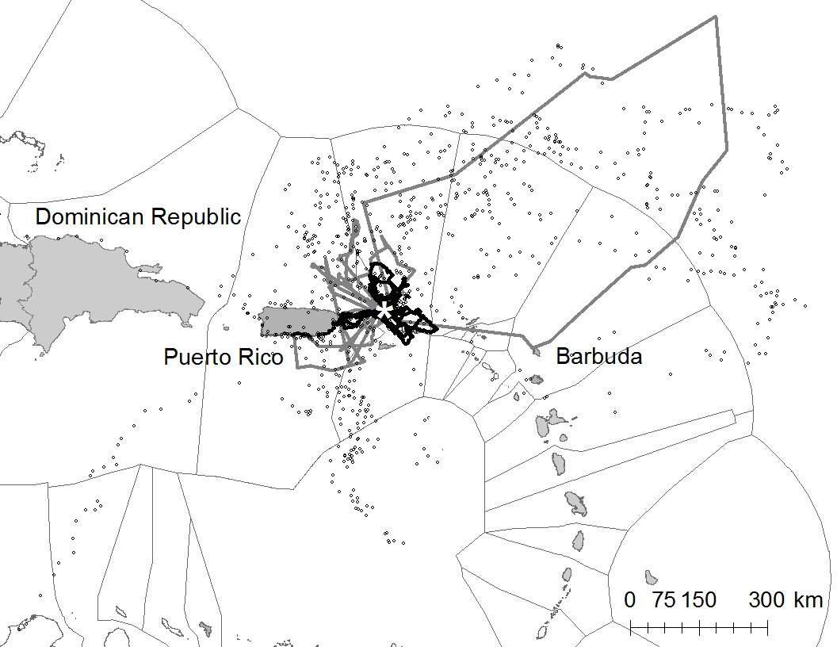
Figure 2. (a) Percentage area overlap of the core foraging areas of all foraging trips of magnificent frigatebirds tracked from the breeding colony on Great Tobago, British Virgin Islands, overlaid with Exclusive Economic Zones of British Virgin Islands (BVI) US Virgin Islands (USVI) and neighbouring islands (white star marks the breeding colony). (B) Percentage area overlap of core foraging areas overlaid with marine protected areas (existing and proposed in BVI and USVI (black lines).
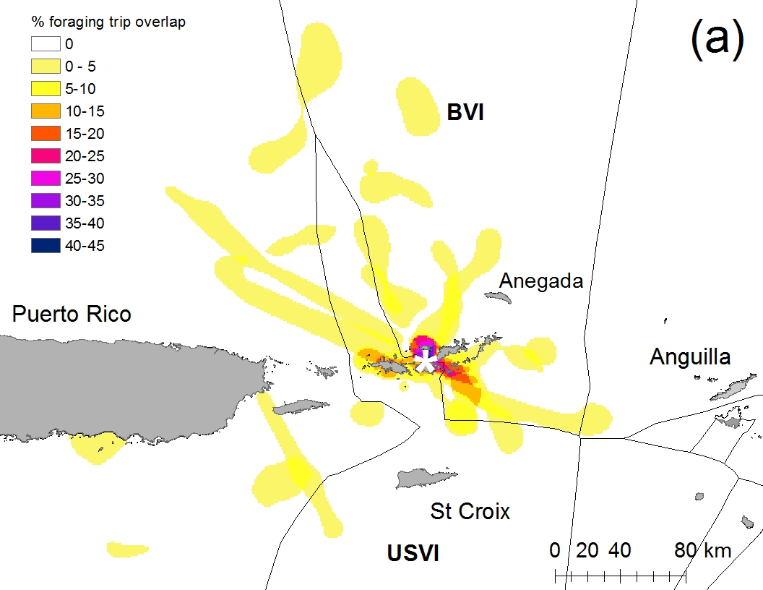
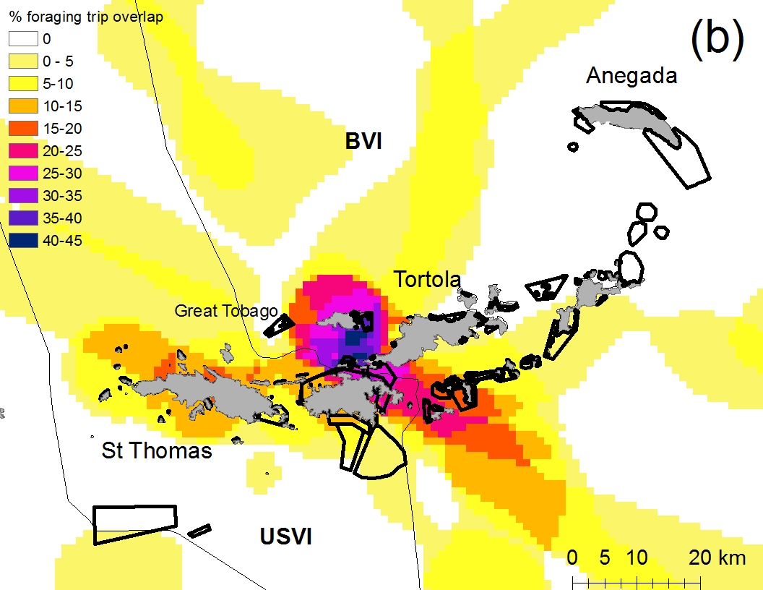
Figure 3: Bird species most frequently reported as by-catch by 26 fishers who reported incidentally catching a seabird whilst fishing, surveyed at various locations throughout the British Virgin Islands. (fishers were asked to identify those species that they had caught in the last 3 years, identified using an ID guide).

