Modular design via multiple anion chemistry of the high mobility van der Waals semiconductor Bi₄O₄SeCl₂
Quinn D. Gibson¹, Troy D. Manning¹, Marco Zanella¹, Tianqi Zhao², Philip J. Murgatroyd³, Craig M. Robertson¹, Leanne A.H. Jones³, Fiona McBride¹, Rasmita Raval¹, Furio Cora², Ben Slater², John B. Claridge¹, Vin R. Dhanak³, Matthew S. Dyer¹, Jonathan Alaria³ & Matthew J. Rosseinsky^{1*}
¹University of Liverpool, Department of Chemistry, Crown St, Liverpool L69 7ZD
²University College London, Department of Chemistry, 20 Gordon St, Kings Cross, London WC1H 0AJ
³University of Liverpool, Department of Physics, Oxford St, Liverpool L69 7ZE
Supporting Information Placeholder
ABSTRACT: Making new van der Waals materials with electronic or magnetic functionality is a chemical design challenge for the development of two-dimensional nanoelectronic and energy conversion devices. We present the synthesis and properties of the van der Waals material Bi₄O₄SeCl₂, which is a 1:1 superlattice of the structural units present in the van der Waals insulator BiOCl and the three-dimensionally connected semiconductor Bi₂O₂Se. The presence of three anions gives the new structure both the bridging selenide anion sites that connect pairs of Bi₂O₂ layers in Bi₂O₂Se and the terminal chloride sites that produce the van der Waals gap in BiOCl. This retains the electronic properties of Bi₂O₂Se, while reducing the dimensionality of the bonding network connecting the Bi₂O₂Se units to allow exfoliation of Bi₄O₄SeCl₂ to 1.4 nm height. The superlattice structure is stabilised by the configurational entropy of anion disorder across the terminal and bridging sites. The reduction in connective dimensionality with retention of electronic functionality stems from the expanded anion compositional diversity.
Introduction
Layered materials are built from the stacking of extended two-dimensional units and can be classified according to the dimensionality of the bonding in the resulting structure¹. Van der Waals materials such as the semimetal graphene, semiconducting transition metal dichalcogenides², and magnetic RuCl₃³ and Fe₃GeTe₂⁴ have two-dimensional networks of strong bonds within the layers and much weaker van der Waals interactions in the third dimension between the layers. Heteroanionic systems offer a distinct path to new materials and properties tuning⁵⁻⁶ and have been recently put forward as a general design principle to new materials and properties tuning via affecting coordination environments and dimensionality⁵⁻⁶. There are multiple anion van der Waals materials, such as BiOCl, which has cationic anti-fluorite Bi₂O₂²⁺ layers bound on either side to terminal Cl⁻ anion layers in the sequence Bi₂O₂-Cl-Cl-Bi₂O₂, forming a van der Waals gap between successive chloride layers: the material can be described as layered Bi₂O₂Cl₂ slabs because there is no network of bonding interactions in the third dimension (Fig. 1a). The van der Waals gaps allow ready exfoliation to or deposition as layers of thicknesses at or approaching those of a single unit cell. This is generally useful in the fabrication of functional heterostructures and devices, spanning electronics to energy materials⁷⁻⁸. For example, high mobility two-dimensional semiconductors such as modified graphene and phosphorene have been studied intensively in nanoelectronics as field effect transistors⁹⁻¹⁰, and the library of known two-dimensional materials has been extensively explored for potential photocatalysts¹¹.
There are however many more layered materials where the stacked two-dimensional structural units are connected by networks of bonding interactions in the third dimension which are not interrupted by a van der Waals gap^{1, 12}. Ionic layered materials are a subset of these three dimensionally connected layered materials, as bonds that connect them along the third dimension are ionic in nature (LiFeAs would be an example of this, with layers of (FeAs)⁻ bonded along the c-axis to layers of Li⁺)¹³. The semiconductor Bi₂O₂Se is also an example of such three-dimensionally connected layered materials. Here the Bi₂O₂-Se-Bi₂O₂ layer sequence features the Bi₂O₂²⁺ layer found in BiOCl but now bridged by Se²⁻ anions bound equally to each adjacent cationic layer, forming non-van der Waals cohesive interactions in the third dimension (Fig. 1b). The electronic properties of Bi₂O₂Se are however highly anisotropic due to the minimal mixing of the Bi₂O₂ states that form the conduction band minimum with the 4p_{z} states of the bridging Se. The resulting high and anisotropic electronic mobility, which is still present in ultrathin films, has placed Bi₂O₂Se under intense study as a nanoelectronic material¹⁴⁻¹⁶.
Chloride and selenide thus act as terminal and bridging ligands respectively to oxide-based Bi₂O₂²⁺ layers in two-dimensionally bonded BiOCl and three-dimensionally connected Bi₂O₂Se. By combining bridging and terminal anion chemistries in a multiple anion material, superlattices in the quaternary Bi-O-Se-Cl phase field can be designed that exhibit both the electronic structure defined by the bridging anion and the van der Waals gap afforded by the terminal anion. The resulting reduction in connective dimensionality would generate a new van der Waals material with high electronic mobility that would be a candidate material for study as a new air stable 2D semiconductor.
Results and Discussion
Reaction of BiOCl, Bi, Bi₂O₃ and Se in evacuated ampoules at elevated temperatures affords phase-pure powders and single crystals of Bi₄O₄SeCl_{2,} which contains all three anions – this composition had been previously identified in a gas-phase reactivity study as forming a phase, without reported crystal structure or properties.¹⁷ The refined structural parameters from a crystal grown at 800 ˚C are given in Supplementary Tables 1-6 and the structure shown in Fig. 1c. Bi₄O₄SeCl₂ adopts a layered structure based on the anti-fluorite Bi₂O₂²⁺ layers (denoted A in Fig. 1) characteristic of both van der Waals BiOCl (AC₂ layer sequence, where C is a Cl⁻ layer) and layered Bi₂O₂Se (AB layer sequence, where B is an Se²⁻ layer). The structure of Bi₄O₄SeCl₂ can be considered as an A₂BC₂ 1:1 superlattice of AB and AC₂ slabs present in the parent compounds Bi₂O₂Se and BiOCl, respectively, resulting in a Bi₂O₂-Se-Bi₂O₂-Cl-Cl-Bi₂O₂ layer sequence. The introduction of the two successive Cl⁻ (C) layers produces the van der Waals gap in Bi₄O₄SeCl₂. In this construction, the B and C slabs are not defined by the anion present, but rather the bridging and terminal nature of the slab, respectively.
The environment of the Bi₂O₂²⁺ unit is asymmetric, in contrast to both parent structures, as on one side there is the single bridging anion Se²⁻ layer present in Bi₂O₂Se that connects to a neighbouring Bi₂O₂²⁺ layer, whereas on the other there are two successive layers of terminally bound chloride anions characteristic of BiOCl. This creates the symmetrical cleavage plane in Bi₄O₄SeCl₂ (Fig. 1c), which separates the two halves of the unit cell without breaking bonds. Bi₂O₂Se, by contrast, does not have such a plane, as its layered structural units share bridging atoms producing a three-dimensional network of bonds. The bridging Se in Bi₄O₄SeCl₂ still connects two neighbouring Bi₂O₂²⁺ cationic layers, but the van der Waals gap prevents further extension of bonding interactions along c. The structure can then be represented as charge-neutral Bi₄O₄SeCl₂ slabs of thickness 1.40 nm (Fig. 2a), stacked by van der Waals forces in the c direction.
There is significant anion mixing across the bridging and terminal sites, such that the composition of the bridging layer is Se_{0.52(2)}Cl_{0.42(2)} and that of the terminal bilayer is Cl_{1.516(26)}Se_{0.484(26)} respectively. The layers will be referred to as the Se(Cl) layer and (Cl(Se))₂ layers in what follows. The two alternating anion layers produce two different square antiprismatic Bi environments on either side of the Bi₂O₂²⁺ unit; while both Bi sites are coordinated to four oxide and four non-oxide anions, due to the different nature of the Se(Cl) and (Cl(Se))₂ layers the bond lengths at the two sites are markedly different (Fig. 2b). The 2.360(6) Å Bi(2)-O bond is elongated compared to Bi(1)-O (2.272(5) Å), while the 3.041(2) Å Bi(2)-Cl(Se) bond is significantly shorter than the Bi(1)-Se(Cl) bond (3.3085(5) Å) – the four elongated Bi(2)-O bonds correspond to four shorter bonds between Bi(2) and the terminal anion site. These variations reflect the asymmetrical bonding at the cation and anion sites – the terminal Cl(Se) anion site only makes four bonds to Bi(2) and is repelled from the neighbouring Cl(Se) site in the adjacent anion layer, both effects shortening the bond compared to Bi(1)-Se(Cl) where the bridging anion bonds equally to eight Bi(1) cations on either side. This difference in anion coordination environment is fundamentally linked to the presence or absence of the van der Waals gap. The difference in bond length is more associated with the different anion coordination environment than ionic radii, and is consistent with the bond lengths in the parent materials BiOCl (Bi-Cl = 3.059(9) Å) and Bi₂O₂Se (Bi-Se = 3.272(17) Å). This Bi-Se bond length in Bi₂O₂Se and the Bi(1)-Se(Cl) bond length in Bi₄O₄SeCl₂ are 0.24 Å longer than the longest Bi-Se bond in Bi₂Se₃¹⁸, indicating that this bond is relatively weak and ionic. Electronic structure calculations presented later in Figure 4 show that covalent bonding interactions do exist between these ions. Bi₂O₂Se can then be considered to have three dimensional connectivity arising from both ionic and covalent interactions, in contrast to BiOCl, where the van der Waals gap between the two successive Cl layers prevents three dimensional connectivity. The fundamental difference in connectivity is further explored in the Supplementary Information (Supplementary Tables 13-14, Supplementary Figure 9), where Density Functional Theory demonstrates the direct bonding nature of the Bi-Se-Bi interface, and the dispersive interaction (van der Waals bonding) nature of the Bi-Cl-Cl-Bi interface. This difference in connectivity has a significant impact on the exfoliation energy, as explored in Figure 7.
Each of the three anion sites in Bi₄O₄SeCl₂ has a unique bonding environment (Fig. 2b). The oxygen in all of the compounds discussed is tetrahedrally coordinated to Bi; the parent materials have the same Bi-O bond lengths, within error, of 2.3165(13) Å and 2.312(17) Å for BiOCl and Bi₂O₂Se respectively, which is a value in between the two Bi-O bond lengths observed in Bi₄O₄SeCl₂. The asymmetry of the two sides of the Bi₂O₂ unit in Bi₄O₄SeCl₂ thus changes the oxygen environment compared to the parent structures. Due to the retention of the site chemistries and atomic positions seen in the structural units of Bi₂O₂Se and BiOCl, Bi₄O₄SeCl₂ can be described as a 1:1 superlattice of these structural units, with Se/Cl mixing allowed on the distinct structural sites within the material, with assignment of the B and C structural units as shown in Figure 1.

Figure 1. Building the van der Waals material Bi₄O₄SeCl₂ from parent structural units
A comparison of the crystal structures of a, BiOCl (a two-dimensionally bonded layered material held together along c by van der Waals interactions), b, Bi₂O₂Se (a three dimensionally bonded material held together along c by direct bonding interactions) and c, Bi₄O₄SeCl₂ (a superlattice material). Dashed lines show the van der Waals gaps present in BiOCl and Bi₄O₄SeCl₂, which correspond to symmetrical cleavage planes not present in Bi₂O₂Se. The A, B and C blocks represent the common structural units in the three materials, and constitute the AC₂ and AB sequence parent materials that combine to create a new A₂BC₂ structure.
Figure 2. Multiple anion bonding environments form a composite charge-neutral slab in Bi₄O₄SeCl₂
a, A representation of the crystal structure of Bi₄O₄SeCl₂, showing the Bi coordination polyhedra, which highlights the charge-neutral Bi₄O₄SeCl₂ van der Waals slabs b, Coordination environments for the two cation and three anion sites in Bi₄O₄SeCl₂ c, Raman spectra of single crystal flakes of BiOCl, Bi₂O₂Se and Bi₄O₄SeCl₂. Both the incident and measured beam were normal to the crystal surface. Some relevant peaks are denoted by the wavenumber of their maximum intensity.
The Raman spectrum (Fig. 2c) of large platelike (~5mm x 5mm) single crystals grown by chemical vapour transport (Supporting Information) of Bi₄O₄SeCl₂ exhibits features seen in the Raman spectra of single crystals of both the parent materials Bi₂O₂Se and BiOCl, and is consistent with the presence of the same total set of bonding interactions, together with some extra features, likely due to the new Bi-Se and Bi-Cl bonds present from the Se/Cl disorder. Previous Raman studies of Bi₂O₂Se have shown broad peaks starting from 59 cm⁻¹ along with a sharp peak at 159.2 cm⁻¹, which was assigned to an interlayer breathing mode¹⁹, which is not observed in this case due to the beam being perpendicular to the single crystal surface.
The formation of Bi₄O₄SeCl₂ from the parent materials was considered by calculation of the free energy of reaction (1) over the temperature range 0 ≤ T/˚C ≤ 1000, where the entropy change is assumed to be purely due to configurational entropy.
- Bi₂O₂Se + 2 BiOCl → Bi₄O₄SeCl₂
Here Bi₄O₄SeCl₂ is described in terms of the component structural units (Bi₂O₂Se_{1-x}Cl_{x})(Bi₂O₂Cl_{2-x}Se_{x}) where the mixing parameter x describes the level of Se/Cl disorder. x = 0 corresponds to perfect order and the refined experimental structure corresponds to x = 0.48(2). Supercells were constructed from disordered structures as described in the Supplementary Information, with a representative structure shown for x = 3/8 in Fig. 3a.
Within these approximations, reaction (1) is not spontaneous at perfect anion site order (x = 0, ΔG = + 0.46 meV/atom). The Cl/Se anion site substitutional disorder increases the enthalpy of the product, but this is offset by the increase in configurational entropy leading to a negative ΔG for a wide range of x (Fig. 3b). At T = 800 ˚C, the minimum of ΔG, where the reaction would come to equilibrium, occurs at x = 0.21 and the zero crossing occurs at x = 0.43, past which the formation of the phase is not thermodynamically favoured compared to the parent compounds (Fig. 3c). This equilibrium value of 0.21 is lower than the experimental value of 0.48(2), assigned to overestimation of the enthalpy due to the finite supercells used for the calculation.
Because the enthalpy of the defect formation is very small (on the order 10 meV/atom), the configurational entropy can become a significant stabilizing effect to allow the reaction to proceed. The anion mixing will produce partial charges on each layer, with the resulting charge distribution in each van der Waals slab of (Cl_{1-x/2}Se_{x/2})^{x/2-}(Bi₂O₂)(Se_{1-x}Cl_{x})^{x+}(Bi₂O₂) (Cl_{1-x/2}Se_{x/2})^{x/2-}, where the layer charge quoted is the difference in charge from the perfectly anion-ordered case. The Cl/Se disorder only generates a quadrupolar charge distribution in each van der Waals slab, and the monotonic increase in ΔH as a function of x rules out the electrostatic interaction as being the stabilizing effect for superlattice formation. The stabilising entropy arises not from solid solution mixing on sites within a known structure, as in the high entropy alloys and oxides²⁰⁻²¹, but through the creation of two distinct anion sites between the Bi₂O₂²⁺ layers by the superlattice formation. This creates an “entropy-stabilized superlattice” through cross-substitution between the sites in the component blocks. While it is possible that other stabilizing interactions are missed by the choice of the supercell, at this level of theory it is clear that the configurational entropy of mixing plays a significant role in stabilizing the formation of the phase.
This modular approach to building a layered structure is related to recently reported homologous series²²⁻²³, and especially to the family of Sillén-Aurivilius phases, a large materials family which contain Bi₂O₂Se-like Bi₂O₂Cl charged blocks along with perovskite-like metal oxide layers in order to charge balance, and have been explored as ferroelectric and photocatalytic materials ²⁴⁻²⁵. , Bi₄O₄SeCl₂ represents a different and complementary approach to generating new structures that combines two otherwise charge neutral slabs, and three different types of anion environment with a single cation. Here two modules have been put together via an entropy stabilization effect, yielding a three anion material with one cation, formed from two layered parent materials, and the first reported structure in the Bi-Se-O-Cl field, where Se,O,Cl are all anions.
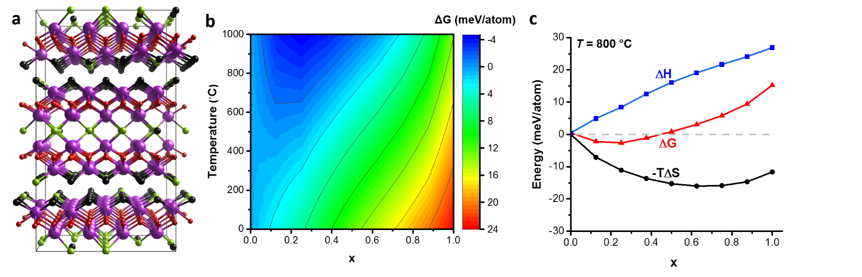
Figure 3. Stabilization of the superlattice phase Bi₄O₄SeCl₂ via configurational entropy from anion mixing
a, A representative optimized superstructure of Bi₄O₄SeCl_{2,} for a level of anion site occupancy disorder corresponding to x = 3/8, showing the distribution of Se/Cl defects. Other optimized superstructures are shown in Supplementary Fig. 6. Bi-Se and Bi-Cl bonds are not drawn to allow for easier visualization of the Se/Cl distribution. b, ΔG for reaction (1) versus T and the anion site occupancy disorder parameter x, indicating regions at which formation is spontaneous. At any given T, the minimum in ΔG corresponds to the expected equilibrium value for x. At x = 0 the value for ΔG is slightly positive for all T. This map was constructed by interpolating between the discrete calculated points at intervals of 1/8 for x. c, A plot of ΔH, -TΔS and ΔG for reaction (1) Bi₂O₂Se + 2BiOCl → Bi₄O₄SeCl₂ as a function of x at 800 ˚C.
The layer sequence in Bi₄O₄SeCl₂ places a large band gap BiOCl unit on either side of the Bi₂O₂Se layer. The electronic band structure of Bi₄O₄SeCl₂ has both conduction and valence bands derived from the Bi₂O₂Se layer, consistent with the calculated band positions in the parent materials (Fig. 4). The states of the more electronegative Cl lie below those of Se in the valence band. The lowest lying unoccupied states are derived from the Bi(1) site bound to the bridging Se anion, because at high symmetry k-points such as the bottom of the conduction band at Γ, the Se p states cannot, by symmetry, form bonding or anti-bonding states with both sets of equivalent Bi(1) sites that lie on either side. Therefore the states at the conduction band minimum are Bi(1)-Se non-bonding, and composed purely of Bi 6p-derived Bi(1)-O antibonding states from the Bi₂O₂²⁺ slab. This symmetry constraint does not apply to the terminal Cl site, which has Bi(2) only on one side and therefore can form bonding/antibonding interactions at all k-points, leading to an antibonding interaction at Γ, placing the Bi(2)-O states interacting with Cl at higher energy than the Bi(1)-O states, which are forbidden by symmetry from interacting with Se and thus less antibonding. While the conduction band minimum is mainly formed of Bi 6p and O states, the level of mixing with the Se/Cl anion p states as determined by symmetry is what leads to a small (< 1 eV) shift in energy of these Bi 6p – O states. A full symmetry analysis of the relevant orbitals is shown in Supplementary Table 8. It is notable however, that bonding interactions are allowed at other k-points and, especially in bands more than 2eV above E_{F}, significant Bi 6p – Se 4p mixing is observed in the electronic structure, indicating covalent interactions between these ions. This is further confirmed by noting that these bands are heavily affected by the Se/Cl disorder (Supplementary Figure 7).
This picture is confirmed by projection of the orbitals from the two Bi sites onto the bands (Supplementary Fig. 8), showing that the highest occupied and lowest unoccupied states are dominated by Bi(1). The distinct terminal and bridging anion chemistries result in two lowest unoccupied bands which have not only different energies but different dispersions because of the different bonding modes at the Bi(1) and Bi(2) sites. Bi(1)-Se bonding and antibonding interactions do form at lower symmetry k-points and thus are still important for the cohesive interactions. Bi₄O₄SeCl₂ is experimentally determined to be an n-type semiconductor (Fig. 5), so the properties of the conduction band control charge transport.
Because the conduction band dispersion at and near the minimum is dominated by in-plane interactions between Bi(1) 6p states, it is highly two-dimensional, to an even greater extent than Bi₂O₂Se because the terminal Cl more strongly attenuate the Bi-Bi interactions along c. This band narrowing results in an increase in the computed (HSE06) gap from 1.00 eV (indirect, near IR) in Bi₂O₂Se to 1.25 eV (indirect, visible) in Bi₄O₄SeCl₂, both considerably smaller than in BiOCl (3.41 eV) where the bands are separated by the Bi-Cl bonding.
That both the valence band maximum and conduction band minimum in Bi₄O₄SeCl₂ derive from the Bi₂O₂Se slab is reflected in the effective masses. The in-plane electron effective masses are 0.20(1) m_{e}, 0.17(1) m_{e} and 0.41(1) m_{e} for Bi₄O₄SeCl₂, Bi₂O₂Se and BiOCl, respectively, with out-of-plane electron effective masses of 0.65(1) m_{e}, 0.44(1) m_{e} and 0.69(1) m_{e}. Therefore conduction band of Bi₄O₄SeCl₂ thus behaves like that of Bi₂O₂Se in-plane and that of BiOCl out-of-plane. Similarly to the electron states, the hole states of Bi₄O₄SeCl₂ in-plane are like those in Bi₂O₂Se, but are heavier out-of-plane (Supplementary Tables 11-12). The hole states for BiOCl fundamentally differ from either Bi₄O₄SeCl₂ and Bi₂O₂Se as they originate from mixed O and Cl orbitals.
Electronic structure calculations of an anion site-disordered supercell with x = 3/8 show that the disorder significantly smears out the valence band manifold while the conduction band is almost unchanged (Supplementary Fig. 7). The conduction band minimum is only weakly affected by the Se/Cl disorder, as the bridging anion is nonbonding at those k-points and the resulting wavefunctions are derived from Bi(1)-O orbitals. Thus, even in the presence of anion site disorder, Bi₄O₄SeCl₂ should retain the in-plane electron transport features of Bi₂O₂Se with enhanced anisotropy arising from the reduced bonding dimensionality associated with the van der Waals gap introduced by the BiOCl layer.
Figure 4. Electronic structure of Bi₄O₄SeCl₂: relationship to BiOCl and Bi₂O₂Se
Electronic band structures (top) and Density of States plots (bottom) for a, Bi₂O₂Se, b, BiOCl and c, Bi₄O₄SeCl₂ at the SCAN + SOC + vdW level of theory. The colours correspond to the atomic orbitals that contribute to the states at that point.
XPS measurements were performed on Bi₄O₄SeCl₂ to experimentally determine the density of states (Fig. 5a). To compare the experimental data with the calculated DOS, orbital dependent photoionization cross sections²⁶ and a Gaussian instrumental correction were applied to the calculations (Supplementary Information). These data show good agreement, with some discrepancies which may arise from the Se/Cl disorder as discussed earlier. The material is n-type and the gap from the valence band to conduction band edge is measured as 1.2 eV.
The experimental optical band gaps were measured on powders of Bi₄O₄SeCl₂ and the parent materials Bi₂O₂Se and BiOCl by diffuse reflectance spectroscopy (Fig. 5b). Comparison of the Kubelka-Munk transform of the reflectivity shows that the indirect gap of Bi₄O₄SeCl₂ is moved to higher energy of 1.15(5) eV from the 0.87(5) eV of Bi₂O₂Se. The gap of BiOCl is much larger (3.30(5) eV), consistent with the electronic structure calculations. The gap values, and the 0.25 eV increase from Bi₂O₂Se to the Bi₄O₄SeCl₂ superlattice, are close to the predictions of the HSE06 hybrid functional. Fitting the direct gap leads to a larger gap of 1.35(5) eV, indicating that the smaller gap is the indirect one, consistent with the electronic structure calculations. The measured gap was confirmed by transmission measurements on large single crystals of Bi₄O₄SeCl₂ (Fig. 5b), which also gave an indirect gap of 1.15 eV, consistent with the XPS and reflectivity results.

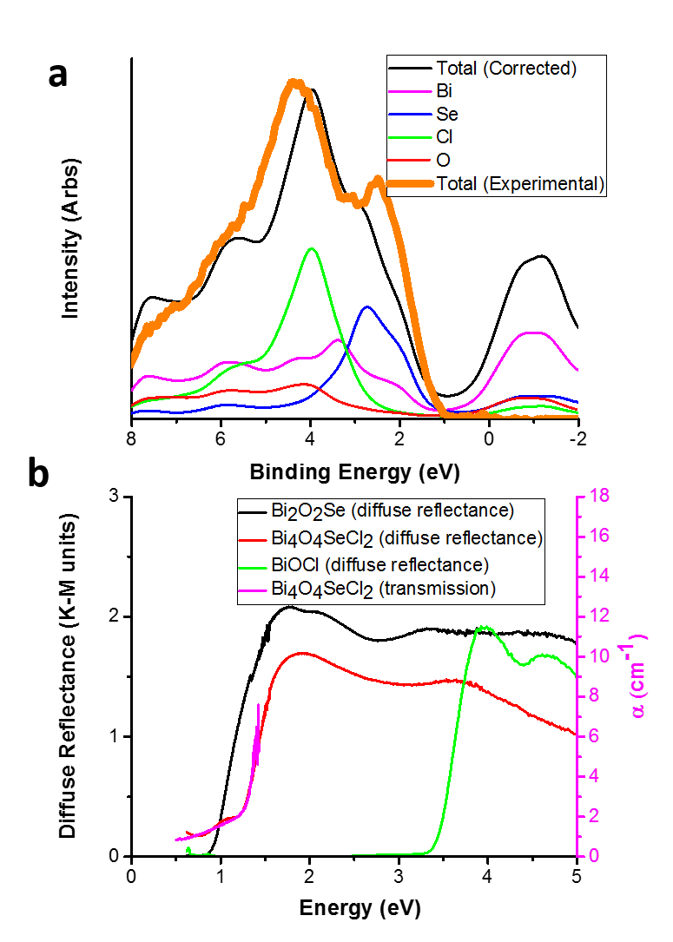
Figure 5. Experimental characterization of electronic structure of Bi₄O₄SeCl₂
a. Valence band XPS of Bi₄O₄SeCl₂, compared with the calculated density of states (total and atomic), as corrected with orbital-dependent cross sections and instrumental broadening factors. b. Diffuse reflectance of powdered Bi₄O₄SeCl₂ (red), Bi₂O₂Se (black), and BiOCl (green), and absorbance of a Bi₄O₄SeCl₂ single crystal (magenta), as calculated from the transmission.
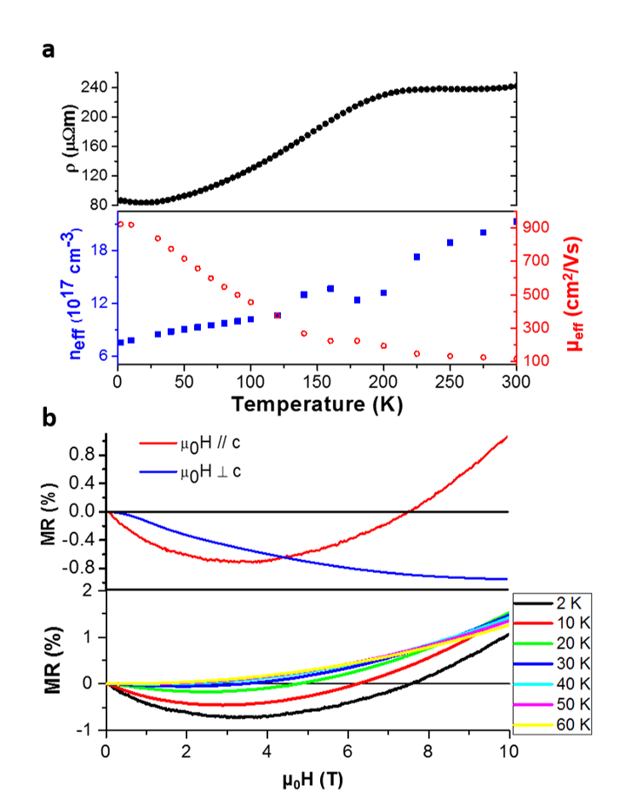
Figure 6. Electronic properties of single crystal Bi₄O₄SeCl₂
a. Resistivity (black dots), carrier concentration (blue squares) and mobility (red circles) as a function of temperature measured on a Bi₄O₄SeCl₂ single crystal. All measurements were performed with the current in the ab plane of the crystal b. Top: Magnetoresistance measured at 2 K with the magnetic field parallel (red line) and perpendicular (blue line) to the c axis. The current is in the ab plane of the crystal. Bottom: Magnetoresistance as a function of applied field (along c) at various temperatures, showing the emergence of classical parabolic behaviour at 60K. The response at lower temperatures results from quantum mechanical weak localisation effects.
The electronic transport properties measured on a single crystal of Bi₄O₄SeCl₂ are shown in Fig. 6a-dn The temperature dependence of the resistivity (top panel of Fig. 6a) is typical of a degenerate semiconductor which is mobility- rather than carrier concentration-controlled (bottom panel of Fig. 6a) and decreases with temperature down to 10 K. The effective carrier concentration at 300 K is 2.1(2) × 10¹⁸ cm⁻³ and decreases slightly as the temperature is decreased, as expected for a degenerate semiconductor. The Hall mobility measured at 300 K is 117 (1) cm²/Vs which is comparable to the field effect mobility (140 cm²/Vs) measured in a similar band gap two-dimensional (1.34 eV) material WSe₂²⁷, as well as the Hall mobility of ultrathin devices of the parent material Bi₂O₂Se (~ 100 cm²/Vs)¹⁶: the Hall mobility of Bi₄O₄SeCl₂ reaches 920(1) cm²/Vs at 2 K. The high in-plane room temperature mobility is consistent with the electronic structure calculations, and suggests Bi₄O₄SeCl₂ as a viable candidate for two-dimensional semiconductor applications.
Below 10 K the resistivity starts increasing as the temperature decreases, which is a signature of weak localisation. This is confirmed with a combination of positive non-saturating quadratic magnetoresistance dominating at high field due to free carriers in an open orbit and a negative contribution at low field due to the weak localisation effect (Fig. 6b). The negative contribution disappears above 60 K, confirming a quantum origin and ruling out ionised impurity magnetoresistance. It is worth noting that a more negative magnetoresistance is observed when the field is applied parallel to the ab plane, and hence parallel to the anion disordered Se/Cl plane, suggesting that the origin of the weak localisation is the chemical site disorder of Se and Cl, rather than impurities and dislocations. This is consistent with the wavefunctions at the conduction band minimum being Bi 6p states that are non-bonding with the bridging anion, and thus only slightly affected by the anion site occupancy disorder which stabilises the material thermodynamically. Because this is a weak effect that only manifests as quantum interference, above 60K the conduction electrons are essentially blind to this disorder due to protection by symmetry.
Because of the van der Waals gap in the crystal structure, the potential of Bi₄O₄SeCl₂ as a van der Waals material that undergoes exfoliation was explored by total energy calculations. Here the unit cell is elongated and the structure is allowed to relax; the energy, which includes a van der Waals contribution, will increase towards a plateau as the layers are separated (Fig. 6a). The energy to separate two layers of Bi₂O₂Se is 0.5 eV/surface atom (0.53 J/m²), while for Bi₄O₄SeCl₂ (and BiOCl) it is 0.2 eV/surface atom (0.21 J/m²), indicating that it is significantly easier to separate layers of Bi₄O₄SeCl₂. Including the effect of disorder only slightly increases the calculated exfoliation energy by 0.02J/m² (Supplementary Fig. 14). The same calculation for BiOCl shows an almost identical exfoliation behaviour to that of Bi₄O₄SeCl₂, indicating that the exfoliation behaviour is indeed controlled by the van der Waals gap interface, which is structurally the same in both materials.
Consistent with this, the calculations were strongly affected by removing the van der Waals component of the energy in the Bi₄O₄SeCl₂ and BiOCl cases, but not in the case of Bi₂O₂Se, where changes in the non-dispersion interactions are dominant upon separation of the layers. The relaxed structures at high separation show that Bi₂O₂Se reconstructs at the Se interface, with half of the Se atoms going to the top layer and the other half going to the bottom layer, consistent with the surface termination measured by Chen et al²⁸. Because of the breaking of the bonds, the resulting Bi₂O₂Se layer undergoes significant reconstruction when the structure is relaxed (Supplementary Figs. 12-13). As such, creating the superlattice allows for a combination of the mechanical exfoliation properties of BiOCl with the electronic properties of Bi₂O₂Se.
The energy to separate two layers for Bi₄O₄SeCl₂ of ~ 0.2 J/m² is consistent with that calculated for other exfoliatable van der Waals materials, such as CrOCl, and lower than that calculated for graphite (0.21 J/ m² and 0.3 J/ m², respectively)²⁹. This value is not expected to be precise, as the binding energy of the layer varies significantly depending on the functional used³⁰. However, it does indicate a much reduced layer binding energy for Bi₄O₄SeCl₂ compared to Bi₂O₂Se.
Electronic structure calculations performed on an idealized two-dimensional slab of Bi₄O₄SeCl₂ (Supplementary Fig. 20) show that the conduction and valence bands arise from the same states as in the bulk, with similar features and dispersions, with a 0.87 eV indirect band gap, as calculated by SCAN+SOC (compared to 0.79 eV for the bulk material) and an electron effective mass of 0.22(1)m_{e}. Therefore a two-dimensional slab (corresponding to half a unit cell along c in Fig. 1c) should retain high mobility semiconductor properties. As such, electronic measurements on exfoliated Bi₄O₄SeCl₂ would be of considerable future interest.
Large single crystals were affixed to Scotch tape, and exfoliated by repeated removal of the tape until the crystals were semi-transparent. At this point, the crystals were transferred onto a Si substrate. The resulting exfoliated crystals were measured by atomic force microscopy (AFM). Fig. 6b shows a height map of an exfoliated crystal, along with a line cut showing the flake to be one layer thick, where one layer is a half a unit cell (Fig. 1c), or approximately 1.4nm in height; this represents the distance between two van der Waals gaps and therefore the thinnest charge-neutral unit that can be expected to exfoliate. This layer thickness was confirmed by the height of the step edges in AFM measurements on thicker flakes (Supplementary Fig. 16). The Raman spectrum of the exfoliated material (Fig. 7c) retains features at the same frequencies as the bulk, confirming that the material has remained intact. Small shifts in intensity and position of Raman peaks are expected when going from a bulk material to a monolayer, as observed for MoS₂³¹. The presence of Bi and Se in the flakes was also confirmed by EDX and XPS mapping (Supplementary Fig. 18). Electron diffraction on the tape-exfoliated material (Fig. 8) shows a square lattice with an interatomic distance of 2.5(1) Å, which is slightly smaller than but consistent with the Bi-Bi distances as projected down the (0,0,1) axis (Supplementary Fig. 17).

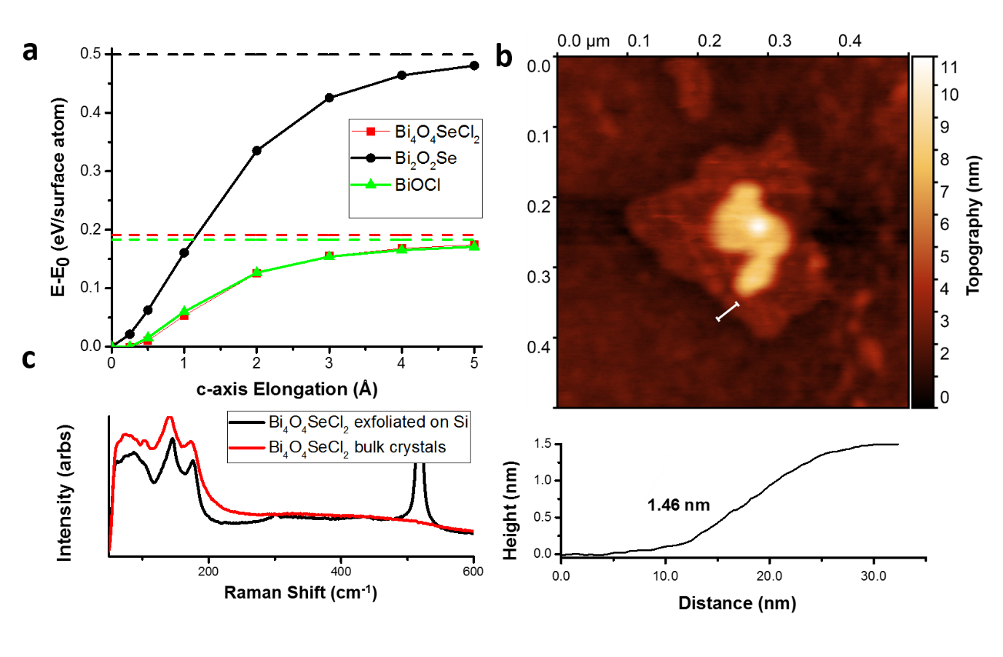
Figure 7. (a) Energy versus c-axis elongation for Bi₄O₄SeCl₂ compared with Bi₂O₂Se and BiOCl, showing the inter-layer binding strength. (b) AFM image of a monolayer flake of Bi₄O₄SeCl₂ with the height profile corresponding to the line cut. . (c) A comparison of the Raman spectrum of the bulk crystals (red) and tape exfoliated multilayer flakes (blue) on native oxide Si, both taken with a 532 nm laser. The intense peak near 500 nm is background from the substrate.
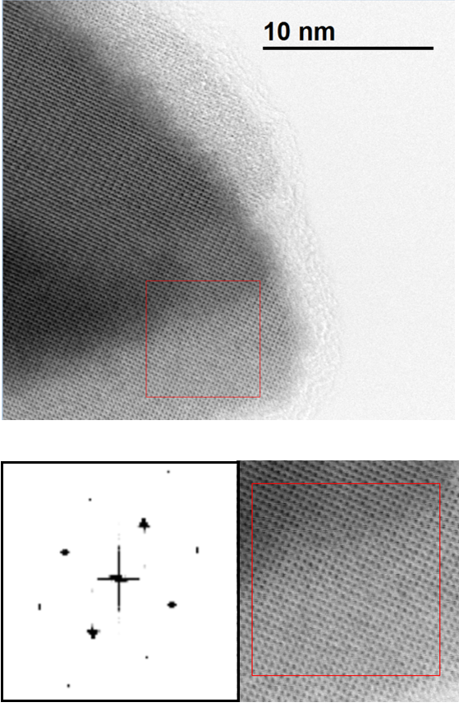
Figure 8. TEM image (top) and Fast Fourier Transform with an enlarged view of the area (bottom) of a tape exfoliated crystal of Bi₄O₄SeCl₂, showing a retention of the square lattice down the (0,0,1) direction, and a lattice spacing consistent with the Bi-Bi distances in the crystal structure projected down the (0,0,1) axis
Conclusions
Reduction in the bonding dimensionality of three dimensionally-connected layered structures is a chemical route to new families of van der Waals materials. Here we have shown this by the modular design concept of introducing a van der Waals gap into a material by making an entropy stabilized superlattice with a different, van der Waals, containing module which does not interfere with the electronic properties. We demonstrate that this can be achieved by enhancing anion chemical diversity and thus the number of bond types present in the stacking sequence. Bridging selenide anions connect the Bi₂O₂²⁺ slabs in structurally layered Bi₂O₂Se, forming a network of interlayer bonds in the third dimension. Introduction of chloride as a third anion interrupts this network and reduces the bonding dimensionality, affording the van der Waals high mobility semiconductor Bi₄O₄SeCl₂. The terminally bonded chlorides in Bi₄O₄SeCl₂ replace half of the selenides in Bi₂O₂Se (Fig. 1). While the selenide and chloride anions mix producing an entropy driven stabilizing effect, the structural units present Bi₂O₂Se and BiOCl. This retains the electronic structure and properties of the parent defined by the bridging anion layers, and introduces a van der Waals gap between adjacent chloride layers to allow exfoliation of Bi₄O₄SeCl₂ to 1.4 nm thick sheets, half the height of the crystallographic unit cell. This inserted van der Waals gap is thermodynamically stabilized by occupancy disorder across the two chemically distinct sites, generating the entropy-stabilized superlattice phase Bi₄O₄SeCl₂. Bi₄O₄SeCl₂ is therefore a good candidate material for study as a new air-stable 2D semiconductor.
Experimental
The Bi₄O₄SeCl₂ composition can be prepared as a single phase powder. Bi₄O₄SeCl₂ was synthesized from a stoichiometric mixture of BiOCl, Bi, Bi₂O₃ and Se powder sealed in an evacuated quartz ampoule and heated at 800 ˚C for 12 hours, followed by regrinding and a second identical heating step. Small single crystals were isolated from the powder for X-ray diffraction measurements, affording a cell of a = 3.8995(8) Å, c = 26.968(5) Å in space group I4/mmm which allowed complete indexing and Pawley refinement (Supplementary Fig.1) of the bulk powder pattern to confirm phase purity. WDX measurements, using BiOCl and Bi₂O₂Se as standards, revealed a composition of Bi_{3.9(3)}O_{4.0(3)}SeCl_{1.9(2)}, which is within error of the expected nominal composition Bi₄O₄SeCl₂. Multiple crystallites of the sample were measured, showing a narrow compositional range (Supplementary Fig. 2). The material showed no sign of degradation on standing in laboratory air for one week, submerged in water for 24 hours or when exposed to simulated solar radiation for 24 hours. The growth of single crystals is described in the Supplementary Information section.
The stability of (Bi₂O₂Cl_{2-x}Se_{x})(Bi₂O₂Se_{1-x}Cl_{x}) as compared to its building blocks was calculated by dividing the chemical reaction into two steps, i.e., separating
(1) Bi₂O₂Se + 2 BiOCl = Bi₂O₂Cl_{2-x}Se_{x}Bi₂O₂Se_{1-x}Cl_{x}
into
(2) Bi₂O₂Se + 2 BiOCl = Bi₄O₄Cl₂Se
+
(3) Bi₄O₄Cl₂Se = Bi₂O₂Cl_{2-x}Se_{x}Bi₂O₂Se_{1-x}Cl_{x}
The enthalpy changes of steps 2 and 3 were used to calculate the total energy change with VASP³². The enthalpy change for step 2 was calculated to be +0.46meV/atom. The cut-off energy of plane wave basis set was set to 550 eV. The van der Waals interaction was included with the optB86b-vdW functional³³. In order to consider the positional randomness of Cl and Se atoms in Bi₂O₂Cl_{2-x}Se_{x}∙Bi₂O₂Se_{1-x}Cl_{x}, 4 × 4 × 1 supercells with 352 atoms were built based on the optimized structure of perfect Bi₄O₄Cl₂Se. Eight random configurations, wherein random Cl and Se atoms in each layer were chosen as defect sites with a random number generating Python algorithm (with the constraint that each layer has the same overall defect concentration), were built for Bi₂O₂Cl_{2-x}Se_{x}∙Bi₂O₂Se_{1-x}Cl_{x} with x ranging from 0 to 1. Bi₄O₄Cl₂Se, Bi₂O₂Se, and BiOCl unit cells were optimized with Monkhost-Pack k mesh of 7 × 7 × 1, 9 × 9 × 4, and 9 × 9 × 5 respectively. Supercells were optimized with  point-only calculations. As there are 4 Cl atomic layers and 2 Se atomic layers in the unit cell, the configurational entropy was calculated as
ΔS = {-4N_{Cl}k_{B}[x_{Se}ln(x_{Se}) + (1 - x_{Se}) ln(1 - x_{Se})] – 2N_{Se}k_{B}[x_{Cl}ln(x_{Cl}) + (1 - x_{Cl}) ln(1 - x_{Cl})]}
where N_{Cl} is the number of Cl sites in the Cl atomic layer, N_{Se} is the number of Se sites in Se atomic layer, N_{total} is the total number of atoms in the supercell, and x_{Cl} = 2 x_{Se} = x.
All calculations were performed using periodic, plane-wave based, density functional theory as implemented in VASP³². Core electrons were treated using the projector augmented wave approach³⁴. Structural optimization was performed using the meta-GGA functional SCAN+rVV10³⁵ which includes non-local correlation to better describe van der Waals interactions. Improved values of the band gaps were obtained using single-point calculations with the HSE06 hybrid functional³⁶ with spin-orbit coupling (HSE06+SOC) on reduced k-point grids (Supplementary Table 7) and a plane-wave cut-off energy of 400 eV. Full computational details can be found in the Supplementary Information.
Diffuse reflectance measurements were taken on powdered samples of BiOCl, Bi₂O₂Se and Bi₄O₄SeCl₂ using a Cary 5000 UV-Vis-NIR Spectrometer. Transmission experiments were performed on Scotch tape-cleaved samples, such that the crystals were sufficiently thin, on a Bruker Vertex 70V Fourier transform infrared spectrometer, using a Mid infrared source, KBr beamsplitter, and deuterated L-alanine doped triglycene (DLaTGS) pyroelectric detector. X-ray photoelectron spectroscopy measurements were conducted using a monochromatic Al-kα SPECS (hν = 1486.7 eV) X-ray source operated at 250W. Full details can be found in the Supplementary Information.
The magneto-transport properties were measured on a single crystal using the van der Pauw method. Four indium contacts were soldered on the edge of the crystal with the current and voltage lead configured for measuring both the longitudinal and transverse magnetoresistance between -10 T to 10 T using the ETO option of the MPMS Dynacool system with an AC excitation of 3 mA. The antisymmetric part of the transverse magnetoresistance was used to extract the Hall resistance and the symmetric part of the longitudinal magnetoresistance was used to extract the conventional magnetoresistance.
Bi₄O₄Cl₂Se was exfoliated using the well-established ‘Scotch tape’ method.³⁷ Crystals of the material were placed onto a strip of Scotch tape and a new strip of Scotch tape was pressed onto the crystals and removed. This process was repeated on each subsequent new piece of Scotch tape until the material was difficult to see by eye, approximately 8 times. The final piece of Scotch tape containing thin flakes of material was pressed firmly onto a fragment of native oxide Si wafer ranging from 1-2 cm x 1-2 cm, and cleaned by sonication in propan-2-ol and dried in a stream of nitrogen. The Scotch tape was slowly removed from the surface of the Si to transfer the material. An optical microscope inspection confirmed the transfer of larger flakes of material. AFM was used to determine the thickness of the flakes.
AFM measurements were performed using an Agilent 5600LS Atomic Force Microscope using tapping mode and Keysight Technologies PicoView control software v1.20.3. Image processing was performed using Gwyddion SPM visualisation and analysis software v2.39.
Raman spectroscopy was performed on a Renishaw InViaTM Qontor® confocal Raman microscope using a 532 nm excitation source and 100 x objective lens. Raman mapping images of the Scotch tape exfoliated flakes on Si wafers were obtained at 1 m intervals with 1000 accumulations per pixel for a large area scan and 2000 accumulations for a smaller area scan. Data was processed using Renishaw WiRE software.

ASSOCIATED CONTENT
Supporting Information
Crystallographic Information File
Supplementary Information Document
1. Synthesis, Phase Purity and Composition
2. Crystal Structure Solution
3. Raman Spectroscopy
4. Disorder and Entropy Stabilization
5. Electronic Structure
6. Optical Measurements
7. Exfoliation

AUTHOR INFORMATION
Corresponding Author
* m.j.rosseinsky@liverpool.ac.uk
The manuscript was written through contributions of all authors. / All authors have given approval to the final version of the manuscript.
Funding Sources
The authors acknowledge support from the EPSRC (EP/N004884). Access to the national HPC resource, Archer, was provided through the EPSRC programme grant (EP/N004884) and other HPC resources were provided by the University of Liverpool. R.R and F.McB thank the BBSRC (BB/R012415/1) and Innovate UK (TS/P013716/1Z) for support.
Data Availability
The data as presented in this paper is freely available at http://datacat.liverpool.ac.uk/id/eprint/901.

References
1. McKinney, R. W.; Gorai, P.; Manna, S.; Toberer, E.; Stevanović, V., Ionic vs. van der Waals layered materials: identification and comparison of elastic anisotropy. J. Mat. Chem. A 2018, 6 (32), 15828-15838.
2. Manzeli, S.; Ovchinnikov, D.; Pasquier, D.; Yazyev, O. V.; Kis, A., 2D transition metal dichalcogenides. Nat. Rev. Mat. 2017, 2 (8), 17033.
3. Ziatdinov, M.; Banerjee, A.; Maksov, A.; Berlijn, T.; Zhou, W.; Cao, H.; Yan, J.-Q.; Bridges, C. A.; Mandrus, D.; Nagler, S. E., Atomic-scale observation of structural and electronic orders in the layered compound α-RuCl₃. Nature Communications 2016, 7, 13774.
4. Chen, B.; Yang, J.; Wang, H.; Imai, M.; Ohta, H.; Michioka, C.; Yoshimura, K.; Fang, M., Magnetic properties of layered itinerant electron ferromagnet Fe₃GeTe₂. J. Phys. Soc. Japan 2013, 82 (12), 124711.
5. Harada, J. K.; Charles, N.; Poeppelmeier, K. R.; Rondinelli, J. M., Materials Design: Heteroanionic Materials by Design: Progress Toward Targeted Properties (Adv. Mater. 19/2019). Adv. Mat. 2019, 31 (19), 1970134.
6. Kageyama, H.; Hayashi, K.; Maeda, K.; Attfield, J. P.; Hiroi, Z.; Rondinelli, J. M.; Poeppelmeier, K. R., Expanding frontiers in materials chemistry and physics with multiple anions. Nature Communications 2018, 9 (1), 772.
7. Novoselov, K.; Mishchenko, A.; Carvalho, A.; Neto, A. C., 2D materials and van der Waals heterostructures. Science 2016, 353 (6298), aac9439.
8. Mas-Balleste, R.; Gomez-Navarro, C.; Gomez-Herrero, J.; Zamora, F., 2D materials: to graphene and beyond. Nanoscale 2011, 3 (1), 20-30.
9. Schwierz, F., Graphene transistors. Nature Nanotechnology 2010, 5 (7), 487.
10. Liu, H.; Du, Y.; Deng, Y.; Peide, D. Y., Semiconducting black phosphorus: synthesis, transport properties and electronic applications. Chem. Soc. Rev. 2015, 44 (9), 2732-2743.
11. Singh, A. K.; Mathew, K.; Zhuang, H. L.; Hennig, R. G., Computational screening of 2D materials for photocatalysis. J. Phys. Chem. Lett. 2015, 6 (6), 1087-1098.
12. Larsen, P. M.; Pandey, M.; Strange, M.; Jacobsen, K. W., Definition of a scoring parameter to identify low-dimensional materials components. Phys. Rev. Mat. 2019, 3 (3), 034003.
13. Juza, R.; Langer, K., Ternäre Phosphide und Arsenide des Lithiums mit Eisen, Kobalt oder Chrom im Cu₂Sb‐Typ. Zeitschrift für Anorganische und Allgemeine Chemie 1968, 361 (1‐2), 58-73.
14. Fu, Q.; Zhu, C.; Zhao, X.; Wang, X.; Chaturvedi, A.; Zhu, C.; Wang, X.; Zeng, Q.; Zhou, J.; Liu, F., Ultrasensitive 2D Bi₂O₂Se phototransistors on silicon substrates. Adv. Mat.2019, 31 (1), 1804945.
15. Wu, J.; Liu, Y.; Tan, Z.; Tan, C.; Yin, J.; Li, T.; Tu, T.; Peng, H., Chemical Patterning of High‐Mobility Semiconducting 2D Bi₂O₂Se Crystals for Integrated Optoelectronic Devices. Adv. Mat. 2017, 29 (44), 1704060.
16. Wu, J.; Yuan, H.; Meng, M.; Chen, C.; Sun, Y.; Chen, Z.; Dang, W.; Tan, C.; Liu, Y.; Yin, J., High electron mobility and quantum oscillations in non-encapsulated ultrathin semiconducting Bi₂O₂Se. Nature Nanotechnology 2017, 12 (6), 530.
17. Schmidt, P.; Oppermann, H.; Söger, N.; Binnewies, M.; Rykov, A.; Znamenkov, K.; Kuznetzov, A.; Popovkin, B., Gasphasengleichgewichte quaternärer Bismut‐Selen‐Oxidchloride. Zeitschrift für Anorganische und Allgemeine Chemie 2000, 626 (12), 2515-2524.
18. Nakajima, S., The crystal structure of Bi₂Te_{3− x}Se_{x}. J. Phys. Chem. Sol. 1963, 24 (3), 479-485.
19. Pereira, A. L.; Santamaría-Pérez, D.; Ruiz-Fuertes, J.; Manjón, F.; Cuenca-Gotor, V.; Vilaplana, R.; Gomis, O.; Popescu, C.; Muñoz, A.; Rodríguez-Hernández, P., Experimental and theoretical Study of Bi₂O₂Se under compression. J. Phys. Chem. C 2018, 122 (16), 8853-8867.
20. Yang, X.; Zhang, Y., Prediction of high-entropy stabilized solid-solution in multi-component alloys. Mat. Chem. Phys. 2012, 132 (2-3), 233-238.
21. Rost, C. M.; Sachet, E.; Borman, T.; Moballegh, A.; Dickey, E. C.; Hou, D.; Jones, J. L.; Curtarolo, S.; Maria, J.-P., Entropy-stabilized oxides. Nature Communications 2015, 6, 8485.
22. Gibson, Q. D.; Dyer, M. S.; Robertson, C.; Delacotte, C.; Manning, T. D.; Pitcher, M. J.; Daniels, L. M.; Zanella, M.; Alaria, J.; Claridge, J. B., Bi_{2+2 n}O_{2+2n}Cu_{2−δ}Se_{2+n–δ}X_{δ} (X= Cl, Br): A Three-Anion Homologous Series. Inorg. Chem. 2018, 57 (20), 12489-12500.
23. Kabbour, H.; Cario, L., Ae₂Sb₂X₄F₂ (Ae= Sr, Ba): New Members of the Homologous Series Ae₂M_{1+n}X_{3+n}F₂ Designed from Rock Salt and Fluorite 2D Building Blocks. Inorg. Chem. 2006, 45 (6), 2713-2717.
24. Kusainova, A. M.; Lightfoot, P.; Zhou, W.; Stefanovich, S. Y.; Mosunov, A. V.; Dolgikh, V. A., Ferroelectric properties and crystal structure of the layered intergrowth phase Bi₃Pb₂Nb₂O₁₁Cl. Chem. Mat. 2001, 13 (12), 4731-4737.
25. Fujito, H.; Kunioku, H.; Kato, D.; Suzuki, H.; Higashi, M.; Kageyama, H.; Abe, R., Layered perovskite oxychloride Bi₄NbO₈Cl: a stable visible light responsive photocatalyst for water splitting. J. Am. Chem. Soc. 2016, 138 (7), 2082-2085.
26. Scofield, J. H. Theoretical photoionization cross sections from 1 to 1500 keV; California Univ., Livermore. Lawrence Livermore Lab.: 1973.
27. Fang, H.; Chuang, S.; Chang, T. C.; Takei, K.; Takahashi, T.; Javey, A., High-performance single layered WSe₂ p-FETs with chemically doped contacts. Nano Lett. 2012, 12 (7), 3788-3792.
28. Chen, C.; Wang, M.; Wu, J.; Fu, H.; Yang, H.; Tian, Z.; Tu, T.; Peng, H.; Sun, Y.; Xu, X., Electronic structures and unusually robust bandgap in an ultrahigh-mobility layered oxide semiconductor, Bi₂O₂Se. Science Adv. 2018, 4 (9), eaat8355.
29. Miao, N.; Xu, B.; Zhu, L.; Zhou, J.; Sun, Z., 2D intrinsic ferromagnets from Van der Waals antiferromagnets. J. Am. Chem. Soc. 2018, 140 (7), 2417-2420.
30. Björkman, T.; Gulans, A.; Krasheninnikov, A. V.; Nieminen, R. M., van der Waals bonding in layered compounds from advanced density-functional first-principles calculations. Phys. Rev. Lett. 2012, 108 (23), 235502.
31. Li, H.; Zhang, Q.; Yap, C. C. R.; Tay, B. K.; Edwin, T. H. T.; Olivier, A.; Baillargeat, D., From bulk to monolayer MoS₂: evolution of Raman scattering. Advanced Functional Materials 2012, 22 (7), 1385-1390.
32. Kresse, G.; Furthmüller, J., Software VASP, vienna (1999). Phys. Rev. B 1996, 54 (11), 169.
33. Klimeš, J.; Bowler, D. R.; Michaelides, A., Van der Waals density functionals applied to solids. Phys. Rev. B. 2011, 83 (19), 195131.
34. Kresse, G.; Joubert, D., From ultrasoft pseudopotentials to the projector augmented-wave method. Phys. Rev. B. 1999, 59 (3), 1758.
35. Peng, H.; Yang, Z.-H.; Perdew, J. P.; Sun, J., Versatile van der Waals density functional based on a meta-generalized gradient approximation. Phys. Rev. X 2016, 6 (4), 041005.
36. Krukau, A. V.; Vydrov, O. A.; Izmaylov, A. F.; Scuseria, G. E., Influence of the exchange screening parameter on the performance of screened hybrid functionals. J. Chem. Phys. 2006, 125 (22), 224106.
37. Yi, M.; Shen, Z., A review on mechanical exfoliation for the scalable production of graphene. J. Mat. Chem. A 2015, 3 (22), 11700-11715.

For Table of Contents Only

