Efficacy and safety of dapagliflozin in the elderly -
analysis from the DECLARE TIMI-58 study

Running title: Efficacy and safety of dapagliflozin in the elderly

Avivit Cahn, MD ¹, Ofri Mosenzon, MD, MSc ¹, Stephen D. Wiviott MD ², Aliza Rozenberg, MA¹, Ilan Yanuv MSc ¹, Erica L. Goodrich MS², Sabina A. Murphy, MPH ², Deepak L. Bhatt, MD, MPH ², Lawrence A. Leiter, MD ³, Darren K. McGuire, MD, MHSc ⁴, John P.H. Wilding, MD ⁵, Ingrid A. M. Gause- Nilsson, MD, PhD ⁶, Martin Fredriksson, MD ⁶, Peter A. Johansson, MSc ⁶, Anna Maria Langkilde, MD, PhD⁶, Marc S. Sabatine, MD, MPH ², Itamar Raz, MD¹

¹ Hadassah Hebrew University Hospital, Jerusalem, Israel
² TIMI Study Group, Division of Cardiovascular Medicine, Brigham and Women's Hospital and Harvard Medical School, Boston, MA USA
³ Li Ka Shing Knowledge Institute, St. Michael’s Hospital, University of Toronto, Toronto, Canada
⁴ University of Texas Southwestern Medical Center, Dallas, Texas USA
⁵ Institute of Ageing and Chronic Disease, University of Liverpool, Liverpool, UK
⁶ AstraZeneca, Molndal Sweden

Corresponding author:
Dr. Avivit Cahn
Diabetes Unit, Endocrinology and Metabolism Unit
Hadassah Hebrew University Hospital, PO Box 12000
Jerusalem, Israel 91120
Tel: 97226776498
Fax: 97226437940
Email: avivit@hadassah.org.il

Word Counts: 3110
Tables: 0
Figures: 4
Abstract
Objective: Data regarding effects of sodium-glucose-cotransporter-2 inhibitors in the elderly (age≥65) and very elderly (age≥75) are limited.
Methods: DECLARE-TIMI-58 assessed cardiac and renal outcomes of dapagliflozin vs. placebo in patients with type 2 diabetes. Efficacy and safety outcomes were studied within age sub-groups for treatment effect and age-based treatment interaction.
Results: Of the 17,160 patients, 9253 were <65 years of age, 6811 ≥65-<75 years and 1096 ≥75 years. Dapagliflozin reduced the composite of cardiovascular death or hospitalization for heart failure consistently with HR(95%CI) of 0.88(0.72,1.07), 0.77(0.63,0.94), and 0.94(0.65,1.36) in age groups <65, ≥65-<75 and ≥75 respectively (interaction p-value 0.5277). Overall, dapagliflozin did not significantly decrease rates of major adverse cardiovascular events with HR(95%CI) of 0.93(0.81,1.08), 0.97(0.83,1.13), and 0.84(0.61,1.15) in age groups <65, ≥65-<75 and ≥75 respectively (interaction p-value 0.7352). The relative risk reduction for the secondary prespecified cardiorenal composite outcome ranged from 18-28% in the different age groups with no heterogeneity. Major hypoglycemia was less frequent with dapagliflozin vs. placebo with HR(95%CI) 0.97(0.58,1.64), 0.50(0.29,0.84), 0.68(0.29,1.57) in age groups <65, ≥65-<75 and ≥75 respectively (interaction p-value 0.2107). Safety outcomes including fractures, volume depletion, cancer, urinary tract infections and amputations were balanced with dapagliflozin vs. placebo, and acute kidney injury was reduced, all regardless of age. Genital infections that were serious or led to discontinuation of study drug and diabetic ketoacidosis were uncommon, yet more frequent with dapagliflozin vs. placebo, without heterogeneity (interaction p-values 0.1058 and 0.8433 respectively).
Conclusions: Overall efficacy and safety of dapagliflozin are consistent regardless of age.

Type 2 Diabetes Mellitus (T2DM) is a prevalent disorder in the elderly with approximately one quarter of people age >65 with diabetes, and an expected increase in rates of diabetes in the upcoming years (1). Diabetes care in the elderly is challenging due to high rates of concomitant comorbidities, functional disability, frailty, cognitive impairment and polypharmacy. Complexity of treatment, side effects, and drug interactions are important considerations when choosing the appropriate glucose lowering pharmacotherapy for older patients with diabetes (1,2). However, data regarding the efficacy and safety of glucose lowering agents is often lacking, particularly in the very elderly, age ≥75. The US Food and Drug Administration as well as the European Medicines Agency recommended collecting comprehensive data especially in very elderly patients with diabetes to enable appropriate assessment of their drug responses (2,3).
Sodium glucose cotransporter (SGLT) 2 inhibitors have been available for the treatment of diabetes since 2012. Multiple clinical benefits beyond glucose lowering have been established with this drug class. These include reduced hospitalizations for heart failure, renal protection and improvements in weight and blood pressure​. (4-8). Furthermore, the drugs are taken orally, at any time of the day and have no known significant drug interactions (8). Considering their multiple favorable effects, minimal incremental risk for hypoglycemia and simplicity of administration, they appear to be an attractive therapeutic option for older adults addressing the many comorbidities more prevalent in this population. Nevertheless, there has been some hesitance in clinical practice prescribing these agents to the elderly, mostly due to insufficient long-term safety data (1). Older patients are more prone to the development of fractures and acute kidney injury, and safety alerts regarding these potential risks with some SGLT2 inhibitors have been issued (9). Moreover, due to the limited therapeutic experience in patients age 75 years and older, initiation of SGLT2 inhibitor therapy at this age has so far not been recommended by some authorities (10).
The Dapagliflozin Effect on Cardiovascular Events (DECLARE) – TIMI-58 study is a cardiovascular outcome study which ascertained the CV and renal effects of dapagliflozin on a large patient population both with and without established cardiovascular disease, including a large cohort of elderly and very elderly patients (4). In the present analysis we studied the efficacy and safety of dapagliflozin stratified by age.

Research Design and Methods
Study overview
In the DECLARE - TIMI 58 trial, a total of 17,160 patients, including 7907 age ≥ 65 and 1096 age ≥ 75, with T2DM and established atherosclerotic cardiovascular disease (ASCVD) or risk factors, 41% and 59% respectively, were randomly assigned to receive dapagliflozin or placebo and followed for a median period of 4.2 years. The study enrolled patients at least 40 years old, with HbA1c of 6.5% -12.0% and creatinine clearance >60 mL/min. Patients who remained eligible after a 4-8 weeks placebo run-in period were randomized in a 1:1 double-blind fashion to dapagliflozin 10 mg daily or matched placebo. The design, baseline characteristics and principal results of this study have been published (4, 11, 12).

Assessment of outcomes
The dual primary composite efficacy endpoints were cardiovascular death or hospitalization for heart failure (CVD/HHF) and major adverse cardiovascular events (MACE; the composite of CV death, MI or ischemic stroke). A secondary prespecified cardiorenal composite outcome was sustained decrease of 40% or more in estimated GFR (eGFR) to less than 60 ml/min/1.73m², new end-stage renal disease (ESRD), or death from renal or CV causes. A renal-specific composite outcome included 40% decrease in eGFR to <60 ml/min/1.73 m², ESRD or death from renal cause.
Safety endpoints were assessed in all patients who received at least one dose of study drug. For amputations, fractures and malignancies – all outcomes from that time until the end of trial. The remaining safety outcomes were assessed on-treatment, which included all events that occurred after the first dose of study drug to the earlier of 30 (for serious AE) or 7 (for non-serious AE) days after last dose of study drug or closing visit. Major hypoglycemia was defined as symptomatic events requiring external assistance due to severe impairment of consciousness with prompt recovery after glucose or glucagon administration. Urinary tract and genital infections collected were only those which were either serious or led to discontinuation of study drug.

Statistical analysis
Pre-specified age groups were <65, ≥65 and <75, ≥75. Data presented in the main paper is for three age groups <65, ≥65- <75 and ≥75 to enable description of data from all age subgroups including 65-<75 which comprised 39.7% of the study population. Efficacy and safety data limited to the pre-specified age groups are included in the supplementary material.
Baseline characteristics are reported as frequencies and percentages for categorical variables and as median and IQR for continuous variables. Incidence rates and Log-Rank test for trend p-values in efficacy and safety endpoints are reported for the three age groups.
Analyses were performed on an intention-to-treat basis. Hazard ratios (HRs) and 95% confidence intervals (CIs) were determined from Cox regression models with stratification factor (ASCVD or multiple CV risk factors and hematuria status) as strata in models comparing treatment in age groups.
Mixed models for repeated measures in HbA1c, weight, systolic blood pressure and diastolic blood pressure were analyzed to produce least-squares mean estimates and 95% CIs in each treatment and age group. Attainment of glycemic and weight targets was compared between groups using logistic regression models. P-values for the covariate of interest were adjusted for baseline HbA1c or weight accordingly.
There was no statistical adjustment for multiple comparisons.
All analyses were performed using SAS software, version 9.4 (SAS Institute Inc., Cary, NC, USA) and Stata version 14.2 (College Station, Tx, USA).

Results
Baseline characteristics
The study included 9253 patients age <65, 6811 patients age ≥65-<75 and 1096 patients age ≥75 years, their baseline characteristics are shown in supplementary table 1. Chronic kidney disease (CKD) and history of heart failure were more prevalent with increasing age as was use of ACE inhibitors or ARB, diuretics, loop diuretics and antiplatelet therapy.

Efficacy
Overall incidence rates of the dual primary composite efficacy endpoints and of their individual components were higher with increasing age. Incidence rates of CVD/HHF were 10.9, 14.8 and 26.7 (p <0.0001) and those of MACE were 20.9, 24.7 and 37.4 cases per 1000 person years in age groups <65, ≥65-<75 and ≥75 respectively (p<0.0001).
Dapagliflozin reduced the composite CVD/HHF consistently with HR (95%CI) of 0.88 (0.72,1.07), 0.77 (0.63,0.94), and 0.94 (0.65,1.36) in age groups <65, ≥65-<75 and ≥75 respectively (interaction p-value 0.5277). The HR (95%CI) for dapagliflozin for major adverse cardiovascular events were 0.93 (0.81,1.08), 0.97 (0.83,1.13), and 0.84 (0.61,1.15) in age groups <65, ≥65-<75 and ≥75 respectively (interaction p-value 0.7352). Rates of HHF were reduced with dapagliflozin with HR (95% CI) of 0.88 (0.68, 1.15), 0.60 (0.46, 0.79) and 0.81 (0.50, 1.30) respectively in age groups <65, ≥65-<75 and ≥75 (interaction p-value 0.1402). The other components of the primary endpoints as well as all-cause mortality were unchanged, with effects consistent across all age groups (figure 1).
The cardiorenal secondary composite outcome (sustained decrease of 40% or more in eGFR to less than 60 ml/min/1.73m², new ESRD, or death from renal or CV causes) was reduced with dapagliflozin vs. placebo with HR (95% CI) 0.72 (0.59, 0.88), 0.80 (0.65, 0.98) and 0.82 (0.52, 1.29) in age groups <65, ≥65-<75 and ≥75 respectively (interaction p-value 0.7299). Similar results were observed for the renal-specific composite outcome (figure 1).
Efficacy endpoints by dichotomous age groups showed similar results with no age-based treatment interactions (supplementary figure 1).

Metabolic outcomes
Changes in HbA1c, weight and blood pressure by age subgroups and treatment allocation are shown in figure 2. Baseline HbA1c in the elderly and very elderly was lower compared to the younger population (median (IQR) levels 8.2 (7.5, 9.3), 7.9 (7.3, 8.7) and 7.8 (7.2, 8.5) in age groups <65, ≥65-<75 and ≥75 respectively (p-trend<0.0001)). Nevertheless, significant and similar declines in HbA1c with dapagliflozin vs. placebo were observed for all age groups (figure 2). At 1 year, least-squares mean difference (95% CI) between the treatment groups was -0.58 (-0.63, -0.53), -0.46 (-0.51, -0.41) and -0.51
(-0.63, -0.40) in age groups <65, ≥65-<75 and ≥75 respectively (all p<0.0001). At 1, 2 and 3 years, patients allocated to dapagliflozin vs. placebo, at all age sub-groups, were statistically more likely to attain a HbA1c of <7.0% (excluding age ≥75 at year 3) or <8.0% or to reduce their HbA1c by ≥0.5%
(figure 3). The effect was somewhat attenuated at year 4, particularly in the very elderly.
Dapagliflozin yielded greater reduction in weight versus placebo, and this was maintained in all age groups during the entire study period (all p<0.0001) (figure 2). Patients allocated to dapagliflozin vs. placebo were more likely to attain a 5% weight loss at all age groups which was sustained throughout the study (figure 3). In the fourth year, a 5% weight reduction was observed in 37.0% vs. 23.2%, 40.5% vs. 24.6%, and 52.9% vs. 31.2% with dapagliflozin vs. placebo in age groups <65, ≥65-<75 and ≥75 respectively (all p<0.0001).

Safety
Serious adverse events (SAE’s) in the overall study population were more common in the elderly and very elderly compared to the younger patients with incidence rates of 107.3, 131.2 and 191.1 cases per 1000 person years in age groups <65, ≥65-<75 and ≥75 respectively (p<0.0001). The incidence of SAE’s was lower with dapagliflozin vs. placebo overall in the trial, and this pattern was consistent regardless of age with HR (95% CI) of 0.93 (0.86, 1.00), 0.88 (0.81, 0.95) and 1.02 (0.85, 1.21) in age groups <65, ≥65-<75 and ≥75 respectively, with no age based treatment interaction (interaction p value 0.2667) (figure 4). Moreover, no heterogeneity across age groups was observed for any of the outcomes assessed, although the number of events in the very elderly was often quite small yielding wide confidence intervals in this age category.
Major hypoglycemia events increased with increasing age in the overall study population with incidence rates of 1.7, 2.6 and 6.5 cases per 1000 person years in age groups <65, ≥65-<75 and ≥75 respectively (p<0.0001). Major hypoglycemia was less frequent with dapagliflozin vs. placebo, with the effect more predominantly observed in age group of ≥65 vs. <65 (HR (95% CI) 0.53 (0.34, 0.83) vs. 0.97 (0.58, 1.64) respectively, interaction p value 0.0896). Overall fractures were more common in the elderly and very elderly with incidence rates of 11.2, 15.8 and 17.4 cases per 1000 person years in age groups <65, ≥65-<75 and ≥75 respectively (p<0.0001), yet events were balanced between the dapagliflozin and placebo groups at all age subgroups studied, with no heterogeneity. Events of volume depletion in the general study population increased with increasing age with incidence rates of 5.6, 7.8 and 14.9 cases per 1000 person years in age groups <65, ≥65-<75 and ≥75 respectively (p<0.0001). Similarly, acute kidney injury (AKI) was reported overall at higher rates with increasing age, with incidence rates of 4.2, 5.4 and 9.3 cases per 1000 person years in age groups <65, ≥65-<75 and ≥75 respectively (p=0.0001). Volume depletion events were balanced between the dapagliflozin and placebo groups, and AKI events were overall reduced with dapagliflozin vs. placebo, with no age-based treatment interaction. Amputations rate did not differ by age (p=0.3201) and was balanced between dapagliflozin and placebo with no age-based treatment interaction. Diabetic ketoacidosis was rare, but more events were observed with dapagliflozin vs. placebo, consistently across age groups. Genital infections that were serious (two events in each arm) or led to discontinuation of study drug, were more common with dapagliflozin vs. placebo with no heterogeneity. There was no statistically significant increase in urinary tract infections (serious or leading to drug discontinuation) with dapagliflozin vs. placebo in the overall population or in any of the age groups. Overall malignancies were balanced between treatment arms across all age groups (figure 4).
Safety endpoints by dichotomous age groups revealed consistent results with no age-based treatment interaction for any of the outcomes (supplementary figure 2).

Conclusions
In this manuscript, we present analyses of data from the DECLARE TIMI-58 study that establish the beneficial CV and renal effects of dapagliflozin in a robust number of elderly and very elderly participants. The overall pattern of efficacy and safety of dapagliflozin was consistent regardless of age.
Care of older patients with diabetes represents an ongoing challenge. Rates of HHF, CVD and MI are increased in those age ≥65 and are markedly increased in patients with age ≥75. The robust reduction in HHF observed with dapagliflozin, is thus of great clinical significance, particularly when viewed in light of the fact that many of these patients were already treated with standard of care including ACE inhibitors, ARBs, beta-blockers, and diuretics. Although fewer events of MACE where observed in patients treated with dapagliflozin, it did not result in a significant reduction in the incidence of MACE. The study met its primary safety non-inferiority endpoint for MACE across all studied age groups.
SAE’s, though generally more frequent in older vs. younger individuals were not increased in the elderly or the very elderly with dapagliflozin vs. placebo, and there was no age-based treatment interaction for any of the safety outcomes assessed. Several adverse outcomes are of particular concern in older patients with diabetes. Events of volume depletion increase with increasing age and there is greater concern related to possible adverse consequences of volume depletion in older patients including falls, and kidney injury. In that respect, the observed reduction in HHF and renal benefit with dapagliflozin with no excess risk of volume depletion and reduced rate of AKI is reassuring. Older adults are at higher risk of hypoglycemia from both insulin and sulfonylurea treatment as a result of insulin deficiency, progressive renal insufficiency and higher rates of cognitive deficits which may cause difficulty in disease management i.e. glucose monitoring and adjustment of insulin dosing (1). Hypoglycemia should be particularly avoided in older patients due to their greater risk of other major adverse outcomes secondary to hypoglycemia such as falls or fractures (1). Patients randomized to dapagliflozin vs. placebo in addition to standard of care attained superior glycemic control with lower rates of hypoglycemia, irrespective of age, highlighting the benefit of the drug.
The greater morbidity of the elderly and very elderly population in our study, as reflected by higher rates of baseline HF and CKD, strengthen the clinical impact of our results which demonstrate consistent efficacy and safety of dapagliflozin extending across all age groups. The paradigm of diabetes treatment has shifted from a glucose focused approach to the pursuit of a therapeutic regimen that will yield a reduction in morbidity and mortality. This is particularly true in the elderly whose life expectancy is shorter and for whom event rates are higher (13).
Treatment goals for T2DM in the elderly should be individualized, thus, in healthy patients with good functional status, few comorbidities and intact cognitive function goals may be similar to those of younger adults. However, in patients with intermediate remaining life expectancy targets should be less stringent as part of individualized care and a target HbA1c <8.0% may be acceptable (13). Dapagliflozin enabled more patients to attain a clinically significant HbA1c reduction, whether striving for the standard or less stringent target.
Weight loss is generally not a treatment goal in the very elderly population, nevertheless, in our analysis we observed sustained weight loss across all age groups. This did not appear to lead to any untoward effects in the elderly during the timeframe of the study. SGLT 2 inhibitors have been shown to reduce adipose tissue mass while maintaining lean body mass (14), changes which are probably beneficial at all ages.
Few studies have been published to date on the use of SGLT 2 inhibitors in the elderly. A randomized double blind, age-stratified trial of dapagliflozin vs. placebo demonstrated a beneficial effect of dapagliflozin on glucose, weight and blood pressure across in all age groups studied, with no outstanding safety issues in the elderly or very elderly, although not many very elderly patients were included (15). Post-marketing reports from Japan reported no age-related safety issues with tofogliflozin, ipragliflozin and canagliflozin, yet these studies are limited by the lack of comparator and dependence upon physician reporting of adverse events (16-18).
The efficacy and safety of other glucose lowering agents in the elderly has been studied. DPP-4 inhibitors showed no CV benefit in any age group studied, and safety outcomes of DPP-4 inhibitors were shown to be similar in older vs. younger patients (19, 20). GLP-1 receptor agonists have also shown efficacy and safety in the elderly which is comparable to that of younger patients, and post-hoc analysis of the LEADER trial proposed greater benefit in the elderly (21). Our study is the first to substantiate the efficacy and safety of an SGLT2 inhibitor in the elderly and very elderly and may pave the way for relaxing the warning placed on this drug in the geriatric population – although individualization of therapy is pivotal, particularly in this vulnerable population.
Some limitations of our study should be noted. Creatinine clearance <60 ml/min was an exclusion criterion in the study, and this may have led to exclusion of the frailer elderly patients which are more prone to volume depletion, AKI, fractures and other adverse outcomes. Moreover, there were no assessments of cognitive function, functional capacity or frailty at baseline or at any time during the study. As a randomized trial, one would expect these unmeasured features would be balanced between groups. Additionally, the very elderly subgroup consisted of a small subset (6.4%) of the total population of 17160, and the number of events were small, yet, it still accounted for 1096 participants. Finally, analyses of metabolic outcomes are post-hoc and should be considered exploratory.
In conclusion, our study establishes the CV and renal benefits of dapagliflozin in the elderly and very elderly. The overall efficacy and safety of dapagliflozin was consistent regardless of age, thus this drug may be considered a valuable glucose lowering agent regardless of age.

Acknowledgments
Author contribution
AC, SDW, IAMG-N, MF, AML, MSS, and IR contributed to the study design. AC, SDW, IAMG-N, AML, MSS, and IR did the literature search. AC, SDW, AR, IY, ELG, SAM, IAMG-N, AML, MSS, and IR designed the figures. AC, SDW, IAMG-N, MF, AML, MSS, and IR contributed to data collection and AC, OM, SDW, AR, IY, ELG, SAM, DLB, LAL, DKM, JPHW, IAMG-N, MF, PAJ, AML, MSS, and IR contributed to data analysis. AC, OM, SDW, AR, IY, HJLH, TAZ, DLB, LAL, DKM, JPHW, ETK, IAMG-N, MF, AML, MSS, and IR contributed to data interpretation. AC, OM, SDW, AR, IY, ELG, SAM, DLB, LAL, DKM, JPHW, IAMG-N, MF, PAJ, AML, MSS, and IR contributed to the writing of the report and approved the final submitted version. AC, IR, SDW, ELG, SAM and SDW are the guarantors of this work and, as such, had full access to all the data in the study and take responsibility for the integrity of the data and the accuracy of the data analysis.
Funding
The sponsor of the DECLARE - TIMI 58 study was initially AstraZeneca and Bristol-Myers Squibb and AstraZeneca later became the sole sponsor of the study. The DECLARE–TIMI 58 trial was a collaboration between the funder and two academic research organizations (TIMI Study Group and Hadassah Medical Organization). The funder was involved in the study design, data collection, data analysis, interpretation, and writing of this report. IAMG-N, MF, PAJ, AML are employed by the study funder. Data analyses were done by the academic TIMI Study Group, which has access to the complete study database, allowing independent analyses of the results; any discrepancies were resolved by discussion. The DECLARE–TIMI 58 publication committee made the decision to submit for publication.
Conflicts of interest
AC reports grants and personal fees from AstraZeneca and Novo Nordisk and personal fees fromAbbott, Eli Lilly, Sanofi, Boehringer Ingelheim, Merck Sharp & Dohme, Medial Early-Sign and GlucoMe. OM reports grants and personal fees from AstraZeneca, Bristol-Myers Squibb, and Novo Nordisk and personal fees from Eli Lilly, Sanofi, Merck Sharp & Dohme, Boehringer Ingelheim, Johnson & Johnson, and Novartis. SDW reports grants from AstraZeneca, Bristol-Myers Squibb, Sanofi Aventis, and Amgen; grants and personal fees from Arena, Daiichi Sankyo, Eisai, Eli Lilly, and Janssen; grants and consulting fees from Merck (additionally his spouse is employed by Merck); and personal fees from Aegerion, Allergan, AngelMed, Boehringer Ingelheim, Boston Clinical Research Institute, Icon Clinical, Lexicon, St Jude Medical, Xoma, Servier, AstraZeneca, and Bristol-Myers Squibb. ELG and SAM report research grant support through Brigham and Women’s Hospital from Abbott Laboratories, Amgen, AstraZeneca, Critical Diagnostics, Daiichi-Sankyo, Eisai, Genzyme, Gilead, GlaxoSmithKline, Intarcia, Janssen Research and Development, The Medicines Company, MedImmune, Merck, Novartis, Poxel, Pfizer, Roche Diagnostics, and Takeda. DLB discloses the following relationshis - Advisory Board: Cardax, Cereno Scientific, Elsevier Practice Update Cardiology, Medscape Cardiology, PhaseBio, Regado Biosciences; Board of Directors: Boston VA Research Institute, Society of Cardiovascular Patient Care, TobeSoft; Chair: American Heart Association Quality Oversight Committee; Data Monitoring Committees: Baim Institute for Clinical Research (formerly Harvard Clinical Research Institute, for the PORTICO trial, funded by St. Jude Medical, now Abbott), Cleveland Clinic (including for the ExCEED trial, funded by Edwards), Duke Clinical Research Institute, Mayo Clinic, Mount Sinai School of Medicine (for the ENVISAGE trial, funded by Daiichi Sankyo), Population Health Research Institute; Honoraria: American College of Cardiology (Senior Associate Editor, Clinical Trials and News, ACC.org; Vice-Chair, ACC Accreditation Committee), Baim Institute for Clinical Research (formerly Harvard Clinical Research Institute; RE-DUAL PCI clinical trial steering committee funded by Boehringer Ingelheim; AEGIS-II executive committee funded by CSL Behring), Belvoir Publications (Editor in Chief, Harvard Heart Letter), Duke Clinical Research Institute (clinical trial steering committees), HMP Global (Editor in Chief, Journal of Invasive Cardiology), Journal of the American College of Cardiology (Guest Editor; Associate Editor), Medtelligence/ReachMD (CME steering committees), Population Health Research Institute (for the COMPASS operations committee, publications committee, steering committee, and USA national co-leader, funded by Bayer), Slack Publications (Chief Medical Editor, Cardiology Today’s Intervention), Society of Cardiovascular Patient Care (Secretary/Treasurer), WebMD (CME steering committees); Other: Clinical Cardiology (Deputy Editor), NCDR-ACTION Registry Steering Committee (Chair), VA CART Research and Publications Committee (Chair); Research Funding: Abbott, Amarin, Amgen, AstraZeneca, Bayer, Boehringer Ingelheim, Bristol-Myers Squibb, Chiesi, CSL Behring, Eisai, Ethicon, Ferring Pharmaceuticals, Forest Laboratories, Idorsia, Ironwood, Ischemix, Lilly, Medtronic, PhaseBio, Pfizer, Regeneron, Roche, Sanofi Aventis, Synaptic, The Medicines Company; Royalties: Elsevier (Editor, Cardiovascular Intervention: A Companion to Braunwald’s Heart Disease); Site Co-Investigator: Biotronik, Boston Scientific, St. Jude Medical (now Abbott), Svelte; Trustee: American College of Cardiology; Unfunded Research: FlowCo, Fractyl, Merck, Novo Nordisk, PLx Pharma, Takeda. LAL reports grants and personal fees from AstraZeneca, Boehringer Ingelheim, Eli Lilly, Janssen, Novo Nordisk, and Sanofi; personal fees from Merck and Servier; and grants from GlaxoSmithKline. DKM discloses the following relationships: personal fees for clinical trial leadership from GlaxoSmithKline, Janssen, Lexicon AstraZeneca, Sanofi Aventis, Boehringer Ingelheim, Merck & Co, Pfizer, Novo Nordisk, Eisai Inc., Esperion, Lilly USA; and personal fees for consultancy from AstraZeneca, Lilly USA, Boehringer Ingelheim, Merck & Co, Novo Nordisk, Metavant, Applied Therapeutics, Sanofi Aventis, Afimmune. JPHW, outside the submitted work, has grants, personal fees for lectures and consultancy fees (paid to his institution) from AstraZeneca and Novo Nordisk; personal fees for lectures and consultancy fees (paid to his institution) from Boehringer Ingelheim, Janssen, Lilly, Mundipharma, Napp, Sanofi and Takeda; and consultancy fees (paid to his institution) from Wilmington Healthcare. MSS reports research grant support through Brigham and Women’s Hospital from Abbott Laboratories, Amgen, AstraZeneca, Bayer, Daiichi-Sankyo, Eisai, Gilead, GlaxoSmithKline, Intarcia, Janssen Research and Development, The Medicines Company, MedImmune, Merck, Novartis, Poxel, Pfizer, Quark, Roche Diagnostics, and Takeda and consulting fees from Alnylam, Amgen, AstraZeneca, Bristol-Myers Squibb, CVS Caremark, Dyrnamix, Esperion, IFM Therapeutics, Intarcia, Ionis, Janssen Research and Development, The Medicines Company, MedImmune, Merck, MyoKardia, and Novartis. IR reports personal fees from AstraZeneca, Bristol-Myers Squibb, Boehringer Ingelheim, Concenter BioPharma and Silkim, Eli Lilly, Merck Sharp & Dohme, Novo Nordisk, Orgenesis, Pfizer, Sanofi, SmartZyme Innovation, Panaxia, FuturRx, Insuline Medical, Medial EarlySign, CameraEyes, Exscopia, Dermal Biomics, Johnson & Johnson, Novartis, Teva, GlucoMe, and DarioHealth. IAMG-N, MF, PAJ and AML are employees of AstraZeneca. AR and IY declare no competing interests.

References
- American Diabetes Association. Older Adults: Standards of Medical Care in Diabetes-2019. Diabetes Care. 2019;42(Suppl 1):S139-S147
- U.S. Department of Health and Human Services; U.S. Food and Drug Administration; Center for Drug Evaluation and Research; Center for Biologics Evaluation and Research. Guidance for industry. E7 studies in support of special populations: geriatrics - questions and answers. 2012. Accessed at www.fda.gov/downloads/Drugs/GuidanceComplianceRegulatoryInformation/Guidances/UCM189544.pdf.
- Committee for Human Medicinal Products. Adequacy of guidance on the elderly regarding medicinal products for human use. European Medicines Agency. 2006. Accessed at www.ema.europa.eu/docs/en_GB/document_library/Scientific_guideline/2010/01/WC500049541.pdf
- Wiviott SD, Raz I, Bonaca MP, et al. Dapagliflozin and Cardiovascular Outcomes in Type 2 Diabetes. N Engl J Med 2019;380:347-57.
- Zinman B, Wanner C, Lachin JM, et al. Empagliflozin, Cardiovascular Outcomes, and Mortality in Type 2 Diabetes. N Engl J Med 2015;373:2117-28
- Wanner C, Inzucchi SE, Lachin JM, et al. Empagliflozin and Progression of Kidney Disease in Type 2 Diabetes. N Engl J Med 2016;375:323-34
- Neal B, Perkovic V, Mahaffey KW, et al. Canagliflozin and Cardiovascular and Renal Events in Type 2 Diabetes. N Engl J Med 2017;377:644-57
- Scheen AJ. Pharmacodynamics, efficacy and safety of sodium-glucose co-transporter type 2 (SGLT2) inhibitors for the treatment of type 2 diabetes mellitus. Drugs 2015;75:33-59.
- FDA drug safety communications. https://www.fda.gov/drugs/drug-safety-and-availability/fda-drug-safety-communication-fda-revises-label-diabetes-drug-canagliflozin-invokana-invokamet; https://www.fda.gov/drugs/drug-safety-and-availability/fda-drug-safety-communication-fda-strengthens-kidney-warnings-diabetes-medicines-canagliflozin. Last accessed July 10, 2019.
- Summary of product characteristics. Available at: https://www.ema.europa.eu/en/documents/product-information/forxiga-epar-product-information_en.pdf. Last accessed July 10, 2019.
- Wiviott SD, Raz I, Bonaca MP, et al. The design and rationale for the Dapagliflozin Effect on Cardiovascular Events (DECLARE)-TIMI 58 Trial. Am Heart J 2018;200:83-9.
- Raz I, Mosenzon O, Bonaca MP, et al. DECLARE-TIMI 58: Participants' baseline characteristics. Diabetes Obes Metab 2018;20:1102-10.
- American Diabetes Association. 6. Glycemic Targets: Standards of Medical Care in Diabetes-2019. Diabetes Care. 2019;42(Suppl 1):S61-S70
- Schork A, Saynisch J, Vosseler A, et al. Effect of SGLT2 inhibitors on body composition, fluid status and renin-angiotensin-aldosterone system in type 2 diabetes: a prospective study using bioimpedance spectroscopy. Cardiovasc Diabetol 2019;18:46-58.
- Leiter LA, Cefalu WT, de Bruin TW, Gause-Nilsson I, Sugg J, Parikh SJ. Dapagliflozin added to usual care in individuals with type 2 diabetes mellitus with preexisting cardiovascular disease: a 24-week, multicenter, randomized, double-blind, placebo-controlled study with a 28-week extension. J Am Geriatr Soc 2014;62:1252-62
- Yokote K, Terauchi Y, Nakamura I, Sugamori H. Real-world evidence for the safety of ipragliflozin in elderly Japanese patients with type 2 diabetes mellitus (STELLA-ELDER): final results of a post-marketing surveillance study. Expert Opin Pharmacother 2016;17:1995-2003.
- Goda M, Yamakura T, Sasaki K, Tajima T, Ueno M. Safety and efficacy of canagliflozin in elderly patients with type 2 diabetes mellitus: a 1-year post-marketing surveillance in Japan. Curr Med Res Opin 2018;34:319-27.
- Utsunomiya K, Shimmoto N, Senda M, et al. Safety and effectiveness of tofogliflozin in elderly Japanese patients with type 2 diabetes mellitus: A post-marketing study (J-STEP/EL Study). J Diabetes Investig 2017;8:766-75.
- Leiter LA, Teoh H, Braunwald E et al. Efficacy and safety of saxagliptin in older participants in the SAVOR-TIMI 53 trial. Diabetes Care 2015;38:1145-53
- Bethel MA, Engel SS, Green JB, et al. Assessing the Safety of Sitagliptin in Older Participants in the Trial Evaluating Cardiovascular Outcomes with Sitagliptin (TECOS). Diabetes Care. 2017;40:494-501.
- Gilbert MP, Bain SC, Franek E, et al. Effect of Liraglutide on Cardiovascular Outcomes in Elderly Patients: A Post Hoc Analysis of a Randomized Controlled Trial. Ann Intern Med. 2019;170:423-6.

Figure legends
Figure 1 – Efficacy outcomes by age groups
Legend: CVD – Cardiovascular disease; HHF – Hospitalization for heart failure; MACE – Major adverse cardiovascular events
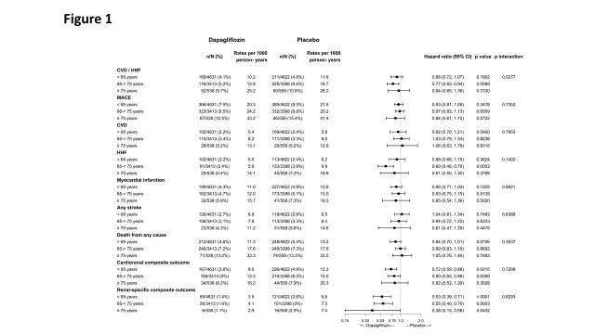

Figure 2 – Changes in metabolic parameters over time
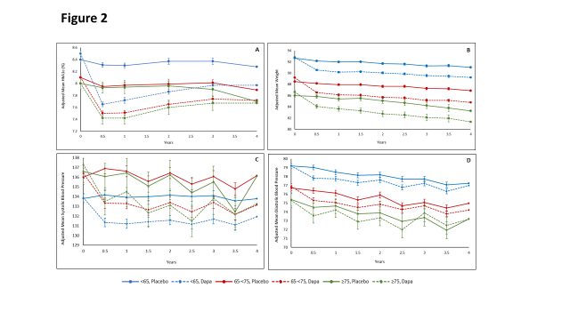
Legend: Change in HbA1c (A), Weight (B), Systolic blood pressure (C) and Diastolic blood pressure (D) with dapagliflozin vs. placebo according to age group

Figure 3 – Attainment of HbA1c and weight targets
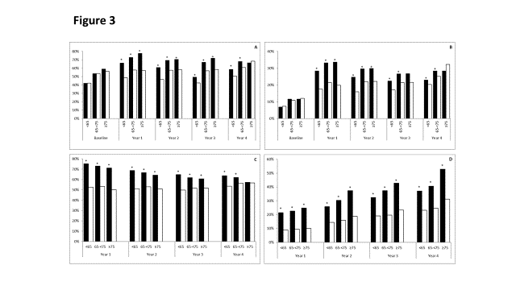
Legend: Percentage of patients attaining HbA1c <8 (A) or HbA1c <7 (B) reducing HbA1c by >0.5% (C) or reducing weight by >5% (D) with dapagliflozin vs. placebo by age group. Dapagliflozin – black bars, Placebo – white bars. * p<0.0001, + p<0.05

Figure 4 – Safety outcomes by age groups
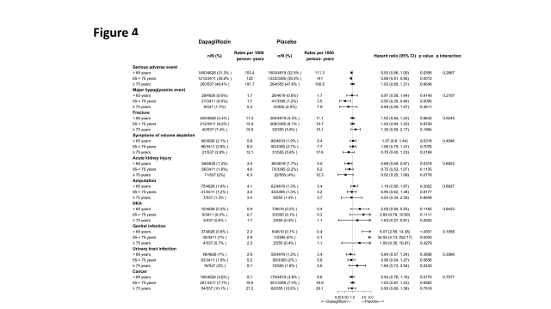
Legend: DKA – Diabetic ketoacidosis

Supplementary Table 1 – Baseline characteristics of overall population by age groups

Characteristic | Age < 65 | Age ≥65-<75 | Age ≥75 | P-Trend
 | (N = 9253) | (N = 6811) | (N = 1096)
Age, Median (IQR) | 60.0 (57.0, 62.0) | 68.0 (66.0, 70.0) | 77.0 (75.0, 79.0)
Male Sex, N (%) | 6203 (67.0) | 3873 (56.9) | 662 (60.4) | <.0001
White, N (%) | 7052 (76.2) | 5639 (82.8) | 962 (87.8) | <.0001
Black, N (%) | 351 (3.8) | 222 (3.3) | 30 (2.7) | 0.0203
Asian, N (%) | 1493 (16.1) | 727 (10.7) | 83 (7.6) | <.0001
Other Race, N (%) | 357 (3.9) | 223 (3.3) | 21 (1.9) | 0.0007
BMI, Median (IQR) | 31.6/9249 (28.0, 35.9) | 31.1/6807 (27.8, 35.0) | 30.2/1095 (27.4, 33.9) | <.0001
Established ASCVD N (%) | 3973 (42.9) | 2519 (37.0) | 482 (44.0) | <.0001
History of HF, N (%) | 886 (9.6) | 682 (10.0) | 156 (14.2) | 0.0002
eGFR, Median (IQR) | 94.0/9252 (81.0, 100.0) | 84.0 (70.0, 92.0) | 75.0 (64.0, 84.0) | <.0001
eGFR < 60, N (%) | 403/9252 (4.4) | 679 (10.0) | 183 (16.7) | <.0001
eGFR >=60-<90, N (%) | 3091/9252 (33.4) | 3823 (56.1) | 818 (74.6) | <.0001
eGFR >=90, N (%) | 5758/9252 (62.2) | 2309 (33.9) | 95 (8.7) | <.0001
Duration of diabetes (years), Median (IQR) | 10.0/9251 (5.0, 15.0) | 12.0 (7.0, 18.0) | 14.0 (8.0, 20.0) | <.0001
UACR <30, N (%) | 6312/9097 (69.4) | 4638/6675 (69.5) | 694/1071 (64.8) | 0.0592
UACR >=30-<=300, N (%) | 2134/9097 (23.5) | 1592/6675 (23.9) | 304/1071 (28.4) | 0.0078
UACR >300, N (%) | 651/9097 (7.2) | 445/6675 (6.7) | 73/1071 (6.8) | 0.3007
HbA1c, Median (IQR) | 8.2/9251 (7.5, 9.3) | 7.9/6809 (7.3, 8.7) | 7.8/1094 (7.2, 8.5) | <.0001
Metformin, N (%) | 7702 (83.2) | 5572 (81.8) | 794 (72.4) | <.0001
SU, N (%) | 3962 (42.8) | 2882 (42.3) | 478 (43.6) | 0.9301
Insulin, N (%) | 3779 (40.8) | 2805 (41.2) | 429 (39.1) | 0.6789
DPP4i, N (%) | 1527 (16.5) | 1190 (17.5) | 171 (15.6) | 0.5765
Statin, N (%) | 6772 (73.2) | 5164 (75.8) | 823 (75.1) | 0.001
ACE Inhibitor/ARB, N (%) | 7404 (80.0) | 5629 (82.6) | 917 (83.7) | <.0001
Any diuretics, N (%) | 3453 (37.3) | 3000 (44.0) | 514 (46.9) | <.0001
Diuretics - loops, N (%) | 832 (9.0) | 791 (11.6) | 183 (16.7) | <.0001
Antiplatelet Therapy, N (%) | 5605 (60.6) | 4171 (61.2) | 711 (64.9) | 0.0203
Beta Blockers, N (%) | 4854 (52.5) | 3570 (52.4) | 606 (55.3) | 0.2689

ACE – angiotensin converting enzyme; ARB = angiotensin receptor blockers; eGFR – estimated glomerular filtration rate (calculated using the CKD-EPI formula; DPP4i – Dipeptidyl peptidase-4 inhibitors. Medications listed are those taken at baseline.

Supplementary figure 1 – Efficacy of dapagliflozin by prespecified age categories
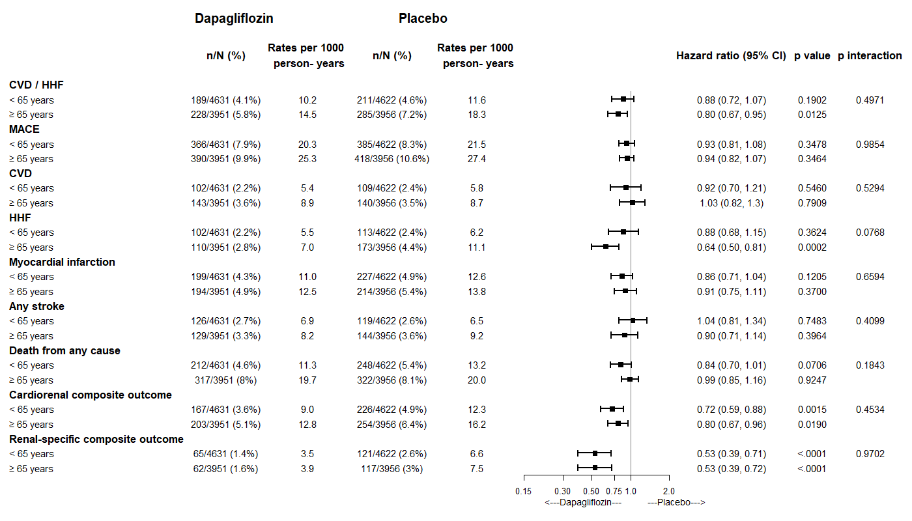

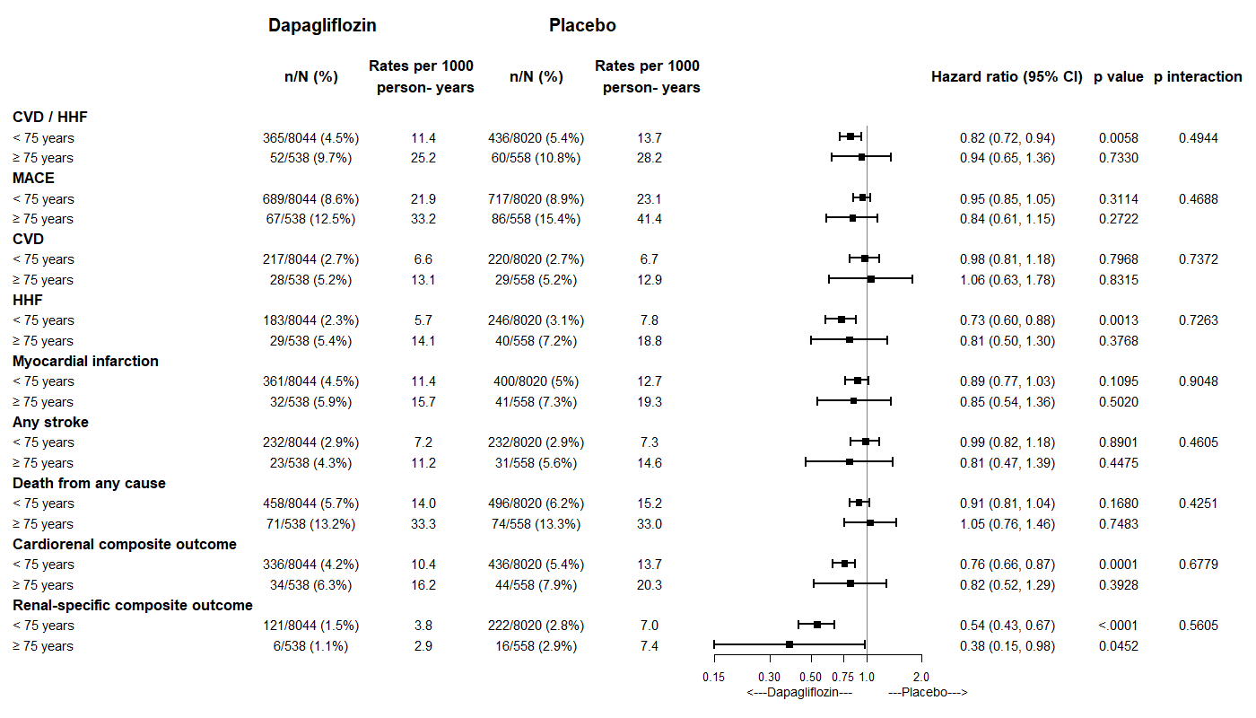

Supplementary figure 2 – Safety of dapagliflozin by prespecified age categories
