The Shaping of Selection:
Internal Migration, Scale and Changing Immigrant Geographies

Keywords: Secondary/Internal Migration, Spatial Integration, Selection, Earnings, Concentration, Generations

Abstract
The internal migration and settlement patterns of immigrants have long been of interest in assessing immigrant outcomes. I use the 1940, 1970, and 2000 IPUMS to analyze the changing relationships between secondary migration, immigrant concentration, and earnings outcomes. The endogenous switching models employed explicitly relate the sorting of individual and metro characteristics to secondary migration through selection. Investigating how these relationships change over time and between generations, as well as the differing relevance of overall mobility and inter-county migration, contributes to theoretical perspectives on spatial assimilation and secondary migration. Results show that immigrant concentration is positively associated with wage outcomes for movers, although remaining in immigrant concentrations can have negative effects. Effects are more significant for those undertaking larger-scale moves, and more consistent over time. Women and less-educated individuals who move have reduced wage disadvantages relative to men and more-educated individuals. These findings suggest that it may be useful to think about migration as a strategy through which immigrants respond to vulnerability, and that the advantages or disadvantages of immigrant context are related to migration selection. The addition of city characteristics experienced by a previous immigrant generation in situ suggests that the salience of immigrant geography emerges over time, as metros with high immigrant wages and educational levels continue to attract immigrants and their offspring decades later.

Introduction
In the United States, spatial mobility has often been deemed necessary for or indicative of social mobility, especially for immigrants and their offspring. The human capital perspectives that underlie this thinking also suggest this process is selective, in that that those who will benefit from mobility will undertake it, whilst those who will not benefit stay home. For immigrants and their children (in the US these are together termed the foreign-stock population), spatial assimilation perspectives suggest that moves away from initial immigrant concentration signal integration. Thus mobility and dispersal are connected with immigrant progress, especially the progress of immigrants’ American-reared offspring, for whom the stakes of remaining in concentrated immigrant settlements are seen as quite high. These stakes are often thought to be particularly high for the offspring of post-1965 immigrants, who have faced more difficult and contexts of reception as ethnic minorities, and who came of age in a post-manufacturing economy. However, the mechanisms are difficult to disentangle. I thus ask the following research questions:

- How is internal migration related to the earnings of immigrants and their adult children?
- What are the relationships between internal migration and metro characteristics, especially immigrant concentration, in shaping earnings outcomes?
- How have these relationships changed or remained consistent between older and newer immigrant generations?

Following 1990s changes to immigrant settlement patterns, researchers examined the impacts of new destinations on immigrants’ socioeconomic fortunes. In so doing, these scholars extended spatial assimilation arguments broadly, evaluating outcomes at the inter-metropolitan or inter-state level. Hall does this most explicitly, testing a ‘regional variant of the spatial assimilation model’ with longitudinal data and finding that immigrants’ earnings and employment benefit from inter-state moves, especially if they move to states with smaller immigrant populations, and especially if they have more advantageous personal characteristics (2009). Goodwin-White finds that immigrants improve wage outcomes through internal migration although those in new destination states are negatively selected (2012). These contribute to earlier research (discussed below) on immigrant mobility or residence beyond the neighborhood level, as well as to studies of migration selection. Connecting these ideas is critical to better understanding of the relationships between immigrant geography and economic integration.
The current research makes several contributions to this effort. I explicitly link immigrant concentration, internal migration, and wages for two generations of immigrants and their offspring. With simultaneously estimated wage equations for movers and stayers, I query the role of internal migration in translating individual and place characteristics differently for movers and stayers. This contributes to rethinking the ways that migration and concentration relate to immigrants’ economic outcomes. Secondly, I disaggregate models for 1) overall mobility and 2) inter-metropolitan migration, realizing that larger-scale moves may respond to concentration differently, and that local moves also indicate retention within a metropolitan area. Finally, with two time periods and two generations at each scale, I identify continuities in how migration and concentration matter, as well as emerging patterns that shift with population compositions. Thus, the current study attempts to extend spatial accounts of immigrant progress by analyzing the selectivity of internal migration, and the importance of scale.

Theoretical Background
Secondary migration, spatial assimilation, and scale
The study of secondary migration in the United States has often focused on its relationship with spatial assimilation. (Secondary migration refers to the internal mobility of immigrants in the US, acknowledging previous international migration. Similar to the term ‘ongoing migration’, more widely employed in Europe, it emphasizes migration as an adjustment to conditions experienced in the host society.) In this formulation, immigrants undertake internal migration as their experience with the host society increases, and with diminishing needs for the site-specific resources originally provided by concentrated immigrant communities (Logan, Alba, McNulty, and Fisher 1996; Fong and Wilkes 1999, Logan and Alba 1993, Alba, Logan, and Stults, 2002). However, migration scholars have also noted evidence of persistent settlement or re-concentration of long-resident immigrant and second generation groups, especially at state or regional levels (Lieberson and Waters 1989, Newbold 1999, Alba and Nee 2003). A related literature suggests the post-1965 immigrants and their children may not demonstrate patterns of assimilation, and especially of spatial assimilation, due to the magnitude of US racial and ethnic segregation and the non-European origins of these newer immigrants (Portes and Zhou 1993, Rumbaut and Portes 2001).
Traditional spatial assimilation approaches evaluate mobility and residence at a local level, commensurate with ideas of residential attainment via suburbanization (Massey 1985, Alba and Nee 1997, Alba, Logan, and Stults 2002, Urban 2009), and many look at segregation levels over time rather than mobility per se. Related research assesses secondary migration between counties or metropolitan areas or states, in line with a broader migration literature on how human capital is translated across labor markets (Kritz and Nogle 1994, Gurak and Kritz 2000, Ellis and Goodwin-White 2006, Crowley, Lichter and Qian 2006, Hall 2009). These authors are also concerned with immigrant progress over time and across generations, and often measure this in relation to migration from or toward traditional cities or states of immigration, noting the importance of concentration rather more generally. The studies mentioned in the introduction fit in this latter literature in locating concentration beyond the neighborhood, as well as in finding selection effects that connect migration and destination to economic outcomes.
Some scholars have mixed the scales whereby immigrant concentration and secondary migration matter, whether in theoretical discussion or models. Alba and Nee interlace regional, state, and metro-level concentrations with those at the neighborhood level in an expansive discussion of spatial assimilation, arguing that movement away from concentrated settlement “…tends to be associated with a ratcheting forward of assimilation – borne out generally by European groups also plausible for new groups in which case new concentrations will be more diverse” (1997). South, Crowder and Chavez (2005) report that more-skilled Latino immigrants tend to move into less-poor neighborhoods with more white residents, but that Latinos overall are much less likely to move to white neighborhoods when they live in metro areas with large Latino populations. The findings that suggest assimilation or integration at one scale may thus be confounded at another. In pointing to the significance of metro-scale context, many of these authors join other calls to study cities as integration-conditioning contexts of immigration shaped by distinctive and historic ethnic compositions, labor markets, and patterns of discrimination (Gurak and Kritz 2000, Ellis and Almgren 2009, Musterd and Ostendorf 2009).
Thus, debates over immigrant geography have focused on the ways in which immigrant settlement intensifies or diminishes over time and across generations, and recognized the meaningful contexts of immigrant locations. Post-1990 changes in the patterns of immigrant destinations, whether from primary or secondary (subsequent) migration, ensured that these debates would increasingly occur beyond the neighborhood. As immigrants and their descendants began to repopulate decades-old immigrant concentrations and establish new ones well outside of border states and major immigrant cities (Suro and Singer 2002, Singer 2004), researchers looked to the determinants of new flows and counterflows (Fernandez, Howard, and Amastae 2007, Lichter and Johnson 2009, Kritz, Gurak, and Lee 2011, Ellis, Wright, and Townley 2014), and to consequences of new locations for immigrants and the second generation (Zuniga and Hernandez-Leon 2005, Kandel and Parrado 2005, Crowley et al 2006, Stamps and Bohon 2006, Donato et al 2008, Goodwin-White 2012, Kritz, Gurak, and Lee 2013, Turner 2014). Although the new destinations literature has not always concerned itself specifically with spatial assimilation, it shares an emphasis on documenting and evaluating the dispersion of immigrant groups away from traditional locations of immigrant concentration, especially beyond at metropolitan or state scales.
A related body of work has long sought to understand how places themselves transmit advantages and disadvantages to immigrants, especially over time as population compositions change. Following a classical human capital approach to modeling internal migration, these researchers have emphasized the barriers and obstacles that immigrants face across generations, and how migration may ameliorate or exacerbate these (Borjas 1992, 1995; Borjas, Bronars, and Trejo 1992, Feliciano 2005, Greenman 2011). Interestingly, the place-level ‘controls’ used in modeling migration have received little substantive attention in the immigrant integration literature, where measures of ethnic or immigrant concentration are the primary theoretical concern. The major exception is manufacturing employment, often employed as a control for labor market size or job opportunities in internal migration models. A substantive literature suggests that increasingly service-heavy labor markets provide few opportunities for the social mobility and integration earlier European arrivals and their descendants once experienced via manufacturing jobs (Perlmann 2005, Waldinger 2007).
Research from outside the US has often employed spatial assimilation ideas as well, although these enquiries have been more nuanced, reflecting generally lower levels of segregation and different histories of racialized settlement (as well as greater political controversies over the topic). This diversity has been used to test the equation of spatial concentration with failures of integration, or simply to complicate the theory (Fong and Wilkes 1999, Musterd 2003, Bolt, Özüekren and Phillips 2010, Koopmans 2010, Murdie and Ghosh 2010). Finding evidence of spatial assimilation for immigrants arriving in Toronto 1980, but mixed results for more recent groups, Murdie and Ghosh’s intensive survey of a Bangladeshi community argues for a more immigrant-subjective notion of integration than declining concentration (2010). For the Netherlands, a more straightforward relationship is often in evidence. Koopmans finds that the most segregated immigrant groups are those with the lowest labor force involvement (2000). Others find persistently high levels of segregation for Turks and Morroccans regardless of income or education (Van Ham and Feijten 2008, Bolt and Van Kempen 2010), although Turkish Berliners educated alongside Germans are more likely to desire mixed neighborhoods, especially as they mature and raise children (Özüekren and Ergoz-Karahan 2010). Like many US studies, Musterd et al (2008) find that residential concentration benefits immigrants to Sweden initially, but not over time. The authors’ suggestion to focus on social support, education, and labor market accessibility are a response to a European context in which failures of integration are increasingly diagnosed and concentration stigmatized, but they echo US literature from the previous paragraph in emphasizing socio-economic contexts of cities.
Like much of the US literature, these studies examine neighborhood concentrations and segregation within cities, rather than secondary migration across metro areas (although Bolt and Van Kempen 2010 look at mobility between concentrated and non-concentrated neighborhoods). However, the critical nature of this research makes it useful for framing the current paper. First, its authors remind us that segregation is driven by majority group avoidance of ethnic minority neighborhoods (Musterd 2003, Brama 2006, Phillips 2006, Bolt et al 2008, van Ham and Feijten 2008, Koopmans 2010), a finding that makes it difficult to judge concentration as signaling something about immigrants alone. Secondly, they demonstrate that concentrations shift over time (Musterd and Ostendorf 2009), lending urgency to US work that suggests dispersal might be more about responses to changing social and economic structures or circumstances than assimilation/integration (Kritz and Nogle 1994, Goodwin-White 2015). Finally, as Phillips argues in a special issue of Journal of Ethnic and Migration Studies, much of this research points out how short we fall of “understanding the mechanisms linking concentration to integration” (2010).
In the current paper, I turn to perhaps the most critical mechanism through consideration of secondary migration and selection. Although integration is a contested and expansive concept, one that increasingly looks to social and cultural dimensions rather than economic ones, I have chosen here to look at earnings as one simple economic outcome. This is common in the US secondary migration literature, which connects internal migration of immigrants and natives alike as a way of investigating how different locations relate to earnings and different levels of human capital. I have also chosen to look at immigrants overall, although experiences of different nationalities undoubtedly differ. I have made these choices to direct attention to the contextual contours of the theoretical debate undergirding discussions of immigrant geographies and concentration – across all cities and all groups and over time. Compositional and spatial changes in immigrant populations are part of the story of how and why concentration matters for immigrants. How are concentration and secondary migration related to the economic outcomes of immigrants and the second generation? How has this relationship changed over time?

Migration, selection, concentration
Connecting migration and immigrant concentration with outcomes (at whatever scale) is complicated by selectivity and endogeneity, and the direction of these relationships is confusingly varied. Although ethnic neighborhoods and concentrations of earlier immigrants provide employment opportunities and valuable networks (Model 1988, Waldinger and Lichter 2003, Jargowsky 2009), remaining in immigrant concentrations over time is often seen to signal a barrier to further progress or as a sign that integration has been thwarted. Concentration is thought to especially limit the progress of immigrants with less-advantageous personal characteristics, including limited education or labor force skills or non-Western origin (King, Thomson, Fielding, and Warnes 2006). Bauer, Epstein, and Gang find that Mexican immigrants without English skills are more likely to choose concentrated locations within the US (2005), a finding that replicates Nogle’s 1997 discovery that less-educated and less-fluent immigrants are more likely to choose California over other states, and a host of similar studies (Bartel 1989, Espinosa and Massey 1997, Liaw and Frey 1998). Evidencing the same negative selection pattern (consistent with spatial assimilation) in reverse, Zhang found that Mexican migrants with higher levels of human capital tended to move to less-concentrated, less-poor, higher-income destinations (2006).
Yet concentration also likely has more positive effects for those immigrants with the most advantageous personal characteristics. Querying “When are ghettos bad?” Cutler, Glaeser, and Vigdor explain that the disadvantages of ethnic concentration derive largely from negative selection into them, such that the positive average treatment effect of concentration is concealed (2007). Zavodny reported that state-level concentrations attract legal permanent residents, over and above other factors (1999). Some positive effects of concentration are found to extend to the children of immigrants in the form of established employment and residential niches, especially for later labor market experience (Borjas 1999, King et al 2006, Thomson and Crul 2007). Although much research (including the current paper) seeks to elucidate broad-brush theoretical connections between immigrant concentration and mobility, disaggregated case studies also evidence selection by national origin or ethnicity. Immigrant concentration improves educational outcomes of the children of Asian immigrants, even as this positive effect does not extend to the children of Mexican immigrants (Portes and Hao 2004). This particular finding is in line with numerous reports that Mexicans and their children may face challenges to integration and face delayed assimilation whether as a result of or signaled by concentrated residential patterns that persist across generations (Bean and Stevens 2003, Brown 2007, Jargowsky 2009).
Although scholars have expanded spatial assimilation ideas beyond the neighborhood scale and documented the varying effects of concentration for different immigrants, there has been little work integrating scale and selection to query the relationships between internal migration, concentration, and economic outcomes. The current paper seeks to explicitly test these relationships through counterfactual estimation of earnings outcomes for movers and stayers, related individual and place characteristics, across two generations and time periods. The first period immediately follows the 1965 shift in immigrant origins, and the second is notable for seeing the maturation of the post-65 second generation as well as a 1990s shift in immigrant destinations within the US. Both of these time periods are relevant for how immigrant geographies are theorized.

Framing place characteristics and hypotheses for the current study

This paper is an attempt to narrow a small gap in the literature by examining how immigrants’ wage outcomes are shaped through internal migration and metro-level immigrant context, querying a presumed integration mechanism of dispersal acquired from expanded-scale spatial assimilation theory. The critical place characteristics are thus metro-level 1) immigrant concentration and 2) Mexican concentration, the latter due to the size of this group and the literature documenting its particular disadvantages, especially with regard to concentrated settlement. For each metro, I also include the average levels of immigrant education and wages (relative to non-immigrants) from a previous immigrant generation, in an attempt to assess the effects of immigrant context over generations. In this, I have partially followed similar approaches by Vigdor, who identified similar metro-level covariates relating the aggregated characteristics of members of the Great Migration to the socioeconomic outcomes of a subsequent generation in the same metro area (2002). I argue that these place characteristics affect wages selectively through secondary migration patterns that respond to and reflect the differences between US metropolitan areas – differences whose constitution is historic as well as contemporary.
I expect several key relationships to emerge from the models. First, consistent with human capital and spatial assimilation theories, those who move should experience augmented earnings relative to non-movers, across generations and cohorts, and this relationship should intensify for moves that cross county or state boundaries. Second, consistent with spatial assimilation ideas, immigrant concentration at current residence or destination should diminish earnings, especially over time and especially for the second generation. Mindful of the attention given in the literature to the particularly difficult experiences of Mexicans and their descendants, I expect Mexican concentration to have additional negative effects on earnings for all immigrants. These hypotheses are bi-directional, and beset with endogeneity, as is most often the case in similar literature. Those individuals who move may be those who would be most likely to garner higher wages, and those who choose concentrations may be more disadvantaged. The theoretical importance of concentrations is undiminished by this bi-directionality. However, the results of the selection models help to interpret these relationships.
I expect that immigrant concentration (and to a lesser extent Mexican concentration) will attract immigrants, especially recent arrivals, but not attract the second generation between 1995 and 2000. However, I have few expectations about the previous period given that the main source countries of immigrants to the US changed markedly from 1965. Older immigrant concentrations might not provide social support to new source-country immigrants between 1965 and 1970, and the 1965 adult second generation include descendants of older European arrivals as well as co-ethnics of newer immigrants. Because concentration may have some positive effects for the most recent immigrants, I include these individuals in supplementary model iterations to isolate this effect and to clarify how immigrant locations (whether attained through immigration or secondary migration) matter for outcomes.
Although concentration is used as a continuous metro-level variable in the models that follow, a summary of the top concentrations is useful for reference. Table 1 details the top twenty metro areas in terms of the proportion of the population that is 1) foreign-born and 2) Mexican-born for 1940, 1970, and 2000. Immigrant settlement patterns have changed considerably over time, and in line with the overall westward shift of US population. 1940s immigrant concentrations all have declining shares by 1970, and there is a general shift away from Northeastern and Midwestern metros where European immigrants and their descendants first resided toward Florida and California. By 2000, all of the Northeastern and Midwestern metros except New York have dropped off the list, new Western concentrations (especially in California and Texas) have been added, and the top 20 concentrations have increased immigrant shares. Mexican concentrations are much smaller in 1940 and 1970, although El Paso and San Antonio are large early on and there are also concentrations in California, Texas, and Arizona. By 2000, it becomes clear from the very large Mexican concentrations in these Western border states that the shift in immigrant origins has affected the overall geography of immigrant concentration. Were the list to extend beyond the top 20, the array of post-90s new destinations would become more evident than the few Washington and Connecticut metros that make these lists.

Data and Models

Using the integrated Public Use Microdata Samples (IPUMS-USA), I extract 1970 and 2000 samples of immigrant and second generation individuals (restricted to those aged 24-54 who worked for wages in the previous year and were resident in a metropolitan area). In 2000, I use the 1.5 generation (those born abroad but who arrived in the US before they were ten years of age) as a proxy for the second generation. This customary delineation is necessary because the decadal census did not enquire about parental birthplace after 1990. The samples are further divided into 1) those who undertook (or did not) a move in the previous five years (overall mobility) and 2) those who undertook (or did not) a more significant move at least changing counties (migration). Each case is then divided into sets including and excluding recent immigrants (those who were abroad 5 years ago). The differences are interesting as theories of immigrant concentration have oscillated between internal migration accounts of labor market outcomes and integration-based queries into the retaining effects of more local (neighborhood-level) immigrant concentration. Interesting differences in the covariate relationships are contingent upon scale of move, and overlap in the samples shows this whilst maintaining adequate 1970s sample sizes.
Individual-level variables include the dependent variable of logged wages, a continuous age variable, gender, and binary variables indicating 1) having less than a high school diploma or 2) at least a 4-year university degree (the omitted reference category is thus a completed high school education). Key metropolitan-level variables as discussed above include proportion of the population born outside of the US and proportion Mexican-born. I add customary control covariates (labor force size and proportion of manufacturing jobs), noting that the latter is also of theoretical interest in terms of the economic opportunities offered immigrants and their offspring and how these have changed over time. Table 2 displays descriptive statistics for key variables, as well as a breakdown of mobility/migration rates by the 1970 and 2000 samples (all immigrants, non-recent immigrants, and the second/1.5 generation).
I then estimate a series of endogenous switching regression models for wages on these individual and place covariates, such that logged wages are simultaneously estimated for movers and stayers. All models are population-weighted with robust standard errors. Following Lokshin and Sajaia (2005), the wage equations for movers and stayers are:
ln w_{mi} =X_{i}β_{m}+ε_{mi ,} and
ln w_{ni} =X_{i}β_{n} +ε_{ni}
and the probit selection equation determining migration is:
I*_{i} =δ(lnw_{mi} –lnw_{ni} )+Z_{i}γ +u_{i}.
I*_{i} is a latent variable that determines whether or not an individual undertakes migration, w_{mi/}w_{ni} is the wage of the individual who did/did not undertake migration, Zi is a vector of covariates influencing the decision to migrate or not, Xi are vectors of individual and metro-level characteristics, β_{m,} β_{n,} and γ are parameter vectors, and e_{mi}, e_{ni}, and u_{i} are error terms. The selection parameter captures the selection in migration via a latent variable that relates unexplained variance in wages to unexplained variance in migration behavior.
The selection equations also include instruments: covariates absent from the wage equations assumed to underlie migration but not necessarily wages. Mathematically, some of these covariates should be significant to avoid multicollinearity and provide grounds for the reasonable estimation of selection effects. Here, as discussed in the previous section, I have instrumented for the characteristics of immigrant metros 30 years previously, including 1) the concentration and labor force measures, 2) average levels of immigrant education, and 3) an immigrant/native wage ratio. While these historic place characteristics may continue to affect immigrants’ location choices and settlement patterns, they are probably not directly related to wages of contemporary immigrants in situ. In the event of their significance over current metro-level characteristics, they signal the persistence of metro-level immigrant context, and the selectivity of immigrants’ location choices over time and generation.
The value of the switching regressions approach is that it avoids the problem of observing 2 truncated distributions wherein we only observe wages and their determinants for 1) those who actually move and 2) those who actually stay, rather than population-level structural effects. Through simultaneous estimation of the mover and stayer equations, it allows for the interpretation of counterfactuals, and for the identification of selection effects that explain how and why the choice to move may be associated with wage outcomes. The language of choice and selection throughout refers to whether individuals moved or stayed as evidenced by location, but does not indicate knowledge or judgement of the constraints or options behind individual decisions. Indeed, the results suggest locational constraints are critically important for both movers and stayers.
There are several key insights. First, the wage models show how individual and place characteristics affect earnings differently for movers and stayers over the previous five-year period (1965-1970 or 1995-2000, respectively). Second, the relationship of these characteristics to mobility over the preceding five-year period can be seen in the migration/mobility models. Finally, the rho coefficients ($ρ_{1}, ρ_{2})$ are correlation coefficients of the error terms of the 1st and 2nd stage equations and thus indicate the presence and direction of migration selectivity in determining wage outcomes.

Results
Table 3 provides a concise summary of the key relationships, distilled from the full results reported for 1970 (Table 4) and 2000 (Table 5). Although I concentrate on the models of larger-scale migration that exclude recent immigrants, there are insights to be gained from comparing how place characteristics and individual selection depend on recency of immigration and the scale of movement. These differences help illustrate the role immigrant concentration plays through secondary migration, and contribute to inter-scalar thinking on economic integration.

Wages
Moving narrows gender wage gaps, particularly for those migrating beyond county lines (from a -.80 relative disadvantage to a -.54 one in for non-recent immigrants in 1970, and more for the second generation). The disadvantage of lacking a high school diploma is highest for recent immigrants, but longer-settled immigrants and members of the second generation reduced this disadvantage through internal migration. The positive returns to a university degree are higher for those who do not move. Since higher-educated individuals seem to fare better without migration and less-educated individuals and women fare better if they move, it appears that migration is about avoiding vulnerability. Although gender gaps diminish and educational gaps increase markedly between 1970 and 2000, the relationships between wages, individual characteristics, and the role of internal migration are remarkably consistent.
Considering metro-level immigrant characteristics (here, at destination for movers or residence for stayers) sharpens this analysis. In 1970, immigrant concentration diminishes wages for immigrants, especially recent ones, but the second generation who has moved experiences concentration positively. By 2000, immigrant concentration is consistently related to higher wages for movers and lower wages for stayers. This is true regardless of generation, but effects increase with scale of move. This finding complicates assessments of the valence of immigrant concentration on wages -- a relationship that appears positive for those who have recently moved toward more concentrated metros but negative for those who have remained in concentrated metros. Immigrants who choose more concentrated immigrant metros have better wages. Further, even in the earlier period when immigrant concentration worked to the detriment of immigrants’ wages, it could improve conditions for the second generation.
For immigrants, Mexican concentration evinces a similar pattern, whereby its generally negative effects on wages are undone for migrants (in 1970) and reversed for migrants (in 2000). Immigrants choosing Mexican concentrations fare relatively better, and the negative effect accrues to those remaining in them (this is shored up by positive effects for recent immigrants in both 1970 and 2000). For the second generation, Mexican concentration has positive wage effects in 1970 but negative effects in 2000 (although the effect turns positive for those who migrate). For models including local mobility, however, Mexican concentration shows strong negative effects across both time periods. Local moves could indicate mobile foreign stock populations, or their retention in local low-wage immigrant labor markets.
Thus, the importance of immigrant concentration for wage outcomes is tied up in the selection of internal migration and scale, as well as in differences in how concentration matters across immigrant generations and cohorts. Although manufacturing employment is intended as a control variable, it is useful to see how it also evidences selective migration patterns. It generally improves wages in both time periods, especially for those who have migrated toward it. However, by 2000 there were some negative wage effects for members of the 1.5 generation who had remained in places where manufacturing was relatively high. This points to the changing relevance of place characteristics across generations: manufacturing jobs are not as beneficial to 2000’s 2nd generation as to 1970’s 2nd generation, as most of the literature suggests. Further, population compositions matter for interpretation. Mexican concentration’s effect on the 2nd generation was positive in 1970, when the immigrant population was less Mexican and most of the second generation were not of Mexican descent. However, its negative effects are clear 30 years later, when increasing numbers of Mexican immigrants and their descendants constituted border metro areas and labor markets, and the foreign-stock population overall.

Migration
More explicit evidence of the role of migration is apparent in the selection models in the bottom half of Tables 4-5. Since individual characteristics work as expected (men and more educated people are more mobile, and mobility declines with age), I will focus on place characteristics. Immigrant concentration deterred everyone except new immigrants between 1965 and 1970. The increased strength of this relationship by 1995/2000 probably has much to do with the new array of immigrant destinations and thus the overall dilution of the concentration variable. Although Mexican concentration also deters long-distance movers in both time periods, it attracted local immigrant and 1.5 generation movers in 2000. Foreign-stock concentrations might be cementing within counties even as new destinations draw migrants from traditional locations. Manufacturing metros did not attract movers with the exception of new 1965-70 immigrants. The differences between models including or excluding recent immigrants suggests that much of 1) the negative effects of concentration and 2) the impact of manufacturing employment come from the magnitude of new immigration in the years immediately following the immigration reforms of 1965.
Compositional effects aside, the main point of the selection equations is the additional variables added from the wage models. Theoretically, these instruments capture the ongoing significance of the context faced by a previous generation’s immigrants in the same metro. 1940’s limited Mexican concentrations attracted new 1965-70 immigrants, although 1940’s immigrant concentrations had mixed effects. This is not surprising in that that immigrant concentrations reflected earlier European arrivals just as new immigrants were overwhelmingly non-European. The patterns are clearer by 2000, when 1970’s immigrant concentration deters migrants but 1970’s Mexican concentration attracts migrants. This shows the decline in early East Coast immigrant concentrations that were still sizeable in 1970 but not by 2000, as well as the westward shift in US population from 1970. More intriguingly, metros that had historically high levels of immigrant education over decades attracted and retained immigrants and their offspring in both periods. Metros with historically high immigrant wages (relative to natives) attracted the second generation between 1965 and 1970, and retained immigrants and their offspring between 1995 and 2000. The relationships evidenced point to the ongoing contribution of immigrant metros and labor markets to driving internal migration and, via selection, wage outcomes.

Selection
The significant rho coefficients indicate that individuals who moved earned more than a random person with the same characteristics, while stayers generally fared worse. Expected wages for migrants (non-local moves) are higher than those for stayers, although those for overall mobility are lower than those of stayers in 2000. Table 6 shows this clearly with average predicted wages for movers and stayers, as well as predicted counterfactual wages for movers (had they stayed) and stayers (had they moved). The white columns include recent immigrants amongst movers and are thus less useful here, as we would expect the most recent immigrants to evidence negative selection.
Again, scale matters for interpretation. There were scant differences between movers and stayers in the overall mobility models. Migrants, on the other hand, fared better than stayers in all cases, and would have fared better still had they not moved. Stayers, however, would have fared better had they moved—at any scale and every model: better than they did staying, better than expected, and better than those who actually moved. Had stayers moved beyond their metro area, they would have had the highest average wages of all. The counterfactuals imply that both groups exhibit behavior that disadvantages them, relatively, probably indicating constraints on immigrants’ locations and location choice.

Summary: consistency and change in spatial integration 1970-2000
The amelioration of wage disadvantages to women and less-educated individuals in both periods demonstrates the continuous role of internal migration in avoiding relative labor market vulnerabilities, especially for the second generation. The benefits of remaining in place for university-educated immigrants, and especially for their descendants, contrasts with a broader literature that premises migration as necessary to recoup high human capital investments. This echoes earlier reports that college-educated immigrants are unlikely to leave locations where immigrant or co-national concentrations are high, or to go to places where there are small foreign-born populations (Ellis and Goodwin-White 2006, Kritz, Gurak, and Lee 2011). Selection effects of moving for immigrants and the second generation seem to be about evading wage penalties, and not with capitalizing on a university degree.
The evolution of contextual characteristics for movers and stayers is more interesting theoretically. As expected, concentration hindered immigrants in 1970, probably due to discrimination toward or competition amongst recent immigrants, and probably because 1970s concentrations were also constituted by older immigrant groups as much as co-ethnics of more recent immigrants. Second generation movers benefitted from immigrant concentration, as suggested by King et al 2006. By 2000, it is clear that immigrant concentration is related to increased wages for movers, but not for longer-settled residents. In contrast, Mexican concentration is associated with reduced wages, suggesting labor markets where wages are low and immigrant labor market segmentation high. However, a much-expanded array of Mexican concentrations in 2000 has some positive wage effects for immigrant movers. Again, there is evidence that migration provides some relative benefits, and that the selection into migration connects concentration with economic outcomes.
Shifting immigrant populations and historical immigrant contexts are a missing piece of explaining the relationship between wages and locations a generation later. For the most part, metros with earlier manufacturing employment, highly educated immigrant populations, and relatively high immigrant wages continue to attract immigrants and their offspring for decades, even as the significance of immigrant concentration waxes and wanes. These historical context variables explain the selection of secondary migration over time, in that immigrants and the second generation continued to move to places where a previous generation had established themselves and fared relatively well.

Conclusions

The research presented in this paper questions the constitution of the relationships between immigrant concentration, secondary migration, and economic outcomes, employing models that allow for the simultaneous estimation of how individual and place characteristics matter differently for movers and stayers. Inclusion of local and cross-metro moves means that movement toward or within immigrant concentrations can be interpreted at different scales. The models are both overly complex with regard to theoretical comparison and overly simplified with regard to individual covariates. They do not disaggregate immigrants by national origin in favor of addressing overarching theoretical issues around immigrant integration and the role of secondary migration and concentration. Future comparative research on how specific national origin groups experienced locations, especially with regard to immigrant contexts and secondary migration, is critical. Although there are limitations of publically-available data, the confidential historical IPUMS provide greater opportunities for more granular investigations. However, the counterfactual analysis of this paper provides evidence for the mechanism of migration selection that links concentration and other immigrant metro contexts to economic outcomes.
The first hypothesis that migration benefits wages for immigrants and their descendants is only partially born out, in that labor market vulnerabilities seem ameliorated through secondary migration. Mobility appears to provide relative advantages compared with those who do not move. That said, there are evident advantages to remaining in place for the university-educated immigrant and second generation. These patterns hold especially for larger-scale, inter-metropolitan moves.
The second hypothesis that immigrant concentration should be associated with reduced earnings, especially over time and generations, is also only mildly supported. Much of the negative effect of concentration – whether immigrant or Mexican – is for very recent immigrants or those who have remained in place rather than moving. Concentrations have positive wage effects for the second generation overall and for immigrants who choose them. This is the most striking finding from these models in that it challenges the framing of spatial assimilation arguments without examination of the selection of secondary migration. Moving toward concentration is associated with positive outcomes via selection.
The third hypothesis that immigrant concentration should attract immigrants but not the second generation is also only partially supported. 1970 immigrant concentration attracts recent immigrants and deters the second generation as expected, but in 2000 concentration deters everyone. However, Mexican concentration attracts overall mobility from settled immigrants and the 1.5 generation. The selection parameters relating concentration to movement demonstrate that discussions of concentration and dispersion often miss a latent effect whereby immigrants and their descendants may be cementing concentrations within metropolitan areas, even as new metro-level concentrations may disperse previous settlement.
Finally, the place characteristics of a previous generation, especially in terms of immigrant educational and relative wage profiles, continue to drive secondary migration 30 years later. Taken together, these findings suggest a more substantial role for the consideration not only of immigrant geographies and how they matter for outcomes, but of how their ongoing and historical constitution evolves through secondary migration’s selective sorting of individuals and places. Otherwise, our understanding of secondary migration for immigrant outcomes remains firmly ensconced between competing accounts of dispersion as locational attainment and more classically-framed human capital models of migration, and considerable analytical territory is ceded.

References

Alba, R. D., Logan, J. R., & Stults, B. J. (2000). The changing neighborhood contexts of the immigrant metropolis. Social Forces, 79(2), 587–621.

Alba, R.D., & Nee, V. (1997). Rethinking Assimilation Theory for a New Era of Immigration. International Migration Review, 31(4), 826-874.

Alba, R.D., & Nee, V. (2003). Remaking the American Mainstream: Assimilation and Contemporary Immigration. Cambridge, MA: Harvard University Press.

Bartel, A. (1989). Where Do the New US Immigrants Live? Journal of Labor Economics, 7(4), 371-391.

Bauer, T. K., Epstein, G.S., & Gang, I.N. (2005). Enclaves, Languages, and the Location Choice of Migrants. Journal of Population Economics, 18(4), 649–662.

Bean, F.D. & Stevens, G. (2003). America's Newcomers and the Dynamics of Diversity. New York: Russell Sage Foundation.

Bolt, G., Özüekren, A.S. & Phillips, D. (2010) Linking Integration
and Residential Segregation. Journal of Ethnic and Migration Studies, 36(2), 169-186.

Bolt, G. & van Kempen, R. (2010). Ethnic Segregation and Residential
Mobility: Relocations of Minority Ethnic Groups in the Netherlands. Journal of Ethnic and Migration Studies, 36(2), 333-354.

Borjas, G. J. (1992). Ethnic capital and intergenerational mobility. The Quarterly Journal of Economics, 107, 123-150.

Borjas, G. J. (1995). Ethnicity, neighborhoods, and ethnic capital. American Economic Review, 85, 365-390.

Borjas, G.J., Bronars, S.G., & Trejo, S.J. (1992). Self-selection and Internal Migration in the United States. Journal of Urban Economics, 32(2), 159-185.

Bråmå, Åsa. 2006. ‘White Flight’? The Production and Reproduction of Immigrant Concentration Areas in Swedish Cities, 1990–2000. Urban Studies, 43(7), 1127–1146.

Brown, S. K. (2007). Delayed Spatial Assimilation: Multigenerational
Incorporation of the Mexican-Origin Population in Los Angeles. City and Community, 6(3), 193-209.

Crowley, M., Lichter, D. T., & Qian, Z. (2006). Beyond Gateway Cities: Economic Restructuring and Poverty Among Mexican Immigrant Families and Children. Family Relations, 55, 345–360.

Cutler, D.M., Glaeser, E.L. & Vigdor, J.L. (2008). When Are Ghettos Bad? Lessons from Immigrant Segregation in the United States. Journal of Urban Economics, 63(3), 759-774.

Donato, K. M., Tolbert, C., Nucci, A., & Kawano, Y. (2008). Changing Faces, Changing Places: The Emergence of New, Nonmetropolitan Immigrant Gateways. In Massey, D.S. (Ed.), New Faces in New Places: The Changing Geography of American Immigration (pp. 75–98). New York: Russell Sage Foundation.

Ellis, M. & Almgren, G. (2009) Local Contexts of Immigrant and
Second-Generation Integration in the United States, Journal of Ethnic and Migration Studies,
35(7), 1059-1076.

Ellis, M. & Goodwin-White, J. (2006). 1.5 Generation Internal Migration in the U.S.: Dispersion from States of Immigration? International Migration Review, 40, 899–926.
Ellis, M., Wright, R., & Townley, M. (2014). The Allure of New Immigrant Destinations and the Great Recession in the United States. International Migration Review, 48(1), 3-33.
Espinosa, K. E., & Massey, D.S. (1997). Determinants of English Proficiency among Mexican Migrants to the United States. International Migration Review, 31(1), 28–50.

Feliciano, C. (2005). Does Selective Migration Matter? Explaining Ethnic Disparities in Educational Attainment among Immigrants’ Children. International Migration Review, 39, 841–871.

Fernández, L., Howard, C., & Amastae, J. (2007). Education, race/ethnicity and out-migration from a border city. Population Research and Policy Review, 26, 103–124.

Fong, E., and Wilkes, R. (1999). The Spatial Assimilation Model Reexamined: An Assessment by Canadian Data. International Migration Review 33(3), 594-620.

Goodwin-White, J. (2012). Emerging U.S. Immigrant Geographies: Racial Wages and Migration Selectivity’ Social Science Quarterly, 93, 779–798.

Greenman, E. (2011). Assimilation Choices Among Immigrant Families: Does School Context Matter? International Migration Review, 45, 29–67.

Hall, M. (2009). Interstate migration, spatial assimilation, and the incorporation of US immigrants. Population, Space and Place, 15, 57–77.

Jargowsky, P. (2009). Immigrants and Neighbourhoods of Concentrated Poverty: Assimilation or Stagnation? Journal of Ethnic and Migration Studies, 35(7),1129-1151.

Kandel, W., & Parrado, E. A. (2009). Restructuring of the US meat processing industry and new Hispanic migrant destinations. Population and Development Review, 31, 447–471.

King, R., Thomson, M., Fielding, T., & Warnes, T. (2006). Time, Generations, and Gender in Migration and Settlement. Chapter 9 (pp 233-267) in Pennix, R., Berger, M., & Kraal,K. (eds) The Dynamics of International Migration and Settlement in Europe. Amsterdam University Press: Amsterdam.

Koopmans, R. (2010) Trade-Offs between Equality and Difference:
Immigrant Integration, Multiculturalism and the Welfare State in Cross-National Perspective. Journal of Ethnic and Migration Studies, 36(1), 1-26.

Kritz, M. & Gurak, D. (2000). The Interstate Migration of U.S. Immigrants: Individual and Contextual Determinants. Social Forces, 78(3), 1017-1039.

Kritz, M. M., Gurak, D. T., & Lee, M. (2011). Will They Stay? Foreign-born Out-migration from New U.S. Destinations. Population Research and Policy Review, 30, 537-67.

Kritz, M. M., Gurak, D. T., & Lee, M. (2013). Foreign-born out-migration from new destinations: Onward or back to the enclave? Social Science Research, 42(2), 527-546.

Kritz, M. and Nogle, J. (1994). Nativity Concentration and Internal Migration among the Foreign-Born, Demography 31(3), 509-24.

Liaw, K. & Frey, W. H. (1998). Destination Choices of the 1985-90 Young Adult Immigrants to the United States: Importance of Race, Educational Attainment, and Labour Market Forces. International Journal of Population Geography, 4(1), 49-61.

Lichter, D. T., & Johnson, K. M. (2009). Immigrant Gateways and Hispanic Migration to New Destinations. International Migration Review, 43, 496–518.

Lieberson, S. & Waters, M. (1987). The Location of Ethnic and Racial Groups in the
United States. Sociological Forum, 2(4), 780-810.

Logan, J. R., Alba, R. D., McNulty, T., & Fisher, B. (1996). Making a place in the metropolis: Locational attainment in cities and suburbs. Demography, 33(4), 443–453.

Lokshin, M. & Sajaia, Z. (2004). Maximum likelihood estimation of endogenous switching regression models. The Stata Journal, 4(3), 282–289.

Massey, D. (1985). Ethnic Residential Segregation: A Theoretical and Empirical Synthesis. Sociology and Social Research, 69(3), 315–350.

Model, S. (1988) Mode of job entry and the ethnic-composition of firms: early 18th-century migrants to New York City. Sociological Forum, 3(1), 110-127.

Murdie, R. & Ghosh, S. (2010) Does Spatial Concentration Always Mean a Lack of Integration? Exploring Ethnic Concentration and Integration in Toronto. Journal of Ethnic and Migration Studies. 36(2), 293-311

Musterd, S. (2003) Segregation and integration: A contested relationship. Journal of Ethnic and Migration Studies, 29(4), 623-641.

Musterd, S., Andersson, R., Galster, G. & Kauppinen, T. (2008) ‘Are immigrants’ earnings influenced by the characteristics of their neighbours?’. Environment and Planning A, 40(4),785-805.

Musterd, S. & Ostendorf, W. (2009) Residential Segregation and Integration in the Netherlands. Journal of Ethnic and Migration Studies, 35(9), 1515-1532.

Newbold, K.B. 1999. Internal Migration of the Foreign-Born: Population Concentration or Dispersion. Journal of Population Economics 20(3), 259-76.

Nogle, J. M. (1997). Internal Migration Patterns for US Foreign Born. International Journal of Population Geography 3, 1–13.

Özüekren, S. & Ergoz-Karahan, E. (2010) Housing Experiences of Turkish
(Im)migrants in Berlin and Istanbul: Internal Differentiation and Segregation. Journal of Ethnic and Migration Studies, 36(2), 355-372.

Phillips, D. (2010) Minority Ethnic Segregation, Integration and Citizenship: A European Perspective. Journal of Ethnic and Migration Studies, 36(2), 209-225.

Portes, A. & Hao, L. (2004). The schooling of children of immigrants: Contextual effects on the educational attainment of the second generation. PNAS 101(33), 11920-11927.

Rumbaut, R. G., & Portes, A. (2001). Ethnicities: children of immigrants in America. Berkeley; New York: University of California Press ; Russell Sage Foundation.

Portes, A., & Zhou, M. (1993). The New Second Generation: Segmented Assimilation and Its Variants. Annals of the American Academy of Political and Social Science, 530, 74-96.

Ruggles, S., Alexander, J. T., Genadek, K., Goeken, R., Schroeder, M. B. & Sobek, M. (2010). Integrated Public Use Microdata Series: Version 5.0 [Machine-readable database]. Minneapolis: University of Minnesota.

Singer, R. (2004). The rise of new immigrant gateways. Washington, DC: Brookings Institution.

South, SJ; Crowder, K. & Chavez, E. (2005). Geographic Mobility and Spatial Assimilation among U.S. Latino Immigrants. International Migration Review, 30(3), 577-607.

Stamps, K. & Bohon, S. A. (2006). Educational Attainment in New and Established Latino Metropolitan Destinations. Social Science Quarterly, 87, 1225–1240.

Suro, R. & Singer, A. (2002). Latino growth in metropolitan America: Changing patterns, new locations. Washington, DC: Brookings Institution Center on Urban and Metropolitan Policy (in collaboration with the Pew Hispanic Center).

Thomson, M. & Crul, M. (2007). The Second Generation in Europe and the United States: How is the Transatlantic Debate Relevant for Further Research on the European Second Generation? Journal of Ethnic and Migration Studies, 33(7), 1025-1041.

Turner, R. N. (2014). Occupational Stratification of Hispanics, Whites, and Blacks in Southern Rural Destinations: A Quantitative Analysis. Population Research and Policy Review, 33, 537-67.

Urban, S. (2009). Is the Neighbourhood Effect an Economic or an Immigrant Issue? A Study of the Importance of the Childhood Neighbourhood for Future Integration into the Labour Market. Urban Studies, 46, 583 –603.

van Ham, M. & Feijten, P. (2008). Who Wants to Leave the Neighbourhood? The Effect of Being Different from the Neighbourhood Population on Wishes to Move. Environment and Planning A, 40(5), 1151-70.

Vigdor JL. 2002. Locations, outcomes, and selective migration. Review of Economics and Statistics, 84, 751–755.

Waldinger, R. “Did Manufacturing Matter? The experience of yesterday's second generation: a reassessment,” International Migration Review 41(1), 3-39.

Waldinger, R. and Lichter, M. (2003) How the Other Half Works: Immigration and the Social Organization of Labor. Berkeley, CA: University of California Press.

Zavody, M. 1999. Determinants of Recent Immigrants’ Location Choices. International Migration Review, 33(4), 1014-1030.

Zúñiga, V. & Hernández-León, R. (Eds.) (2005). New Destinations: Mexican Immigration in the United States. New York: Russell Sage Foundation.

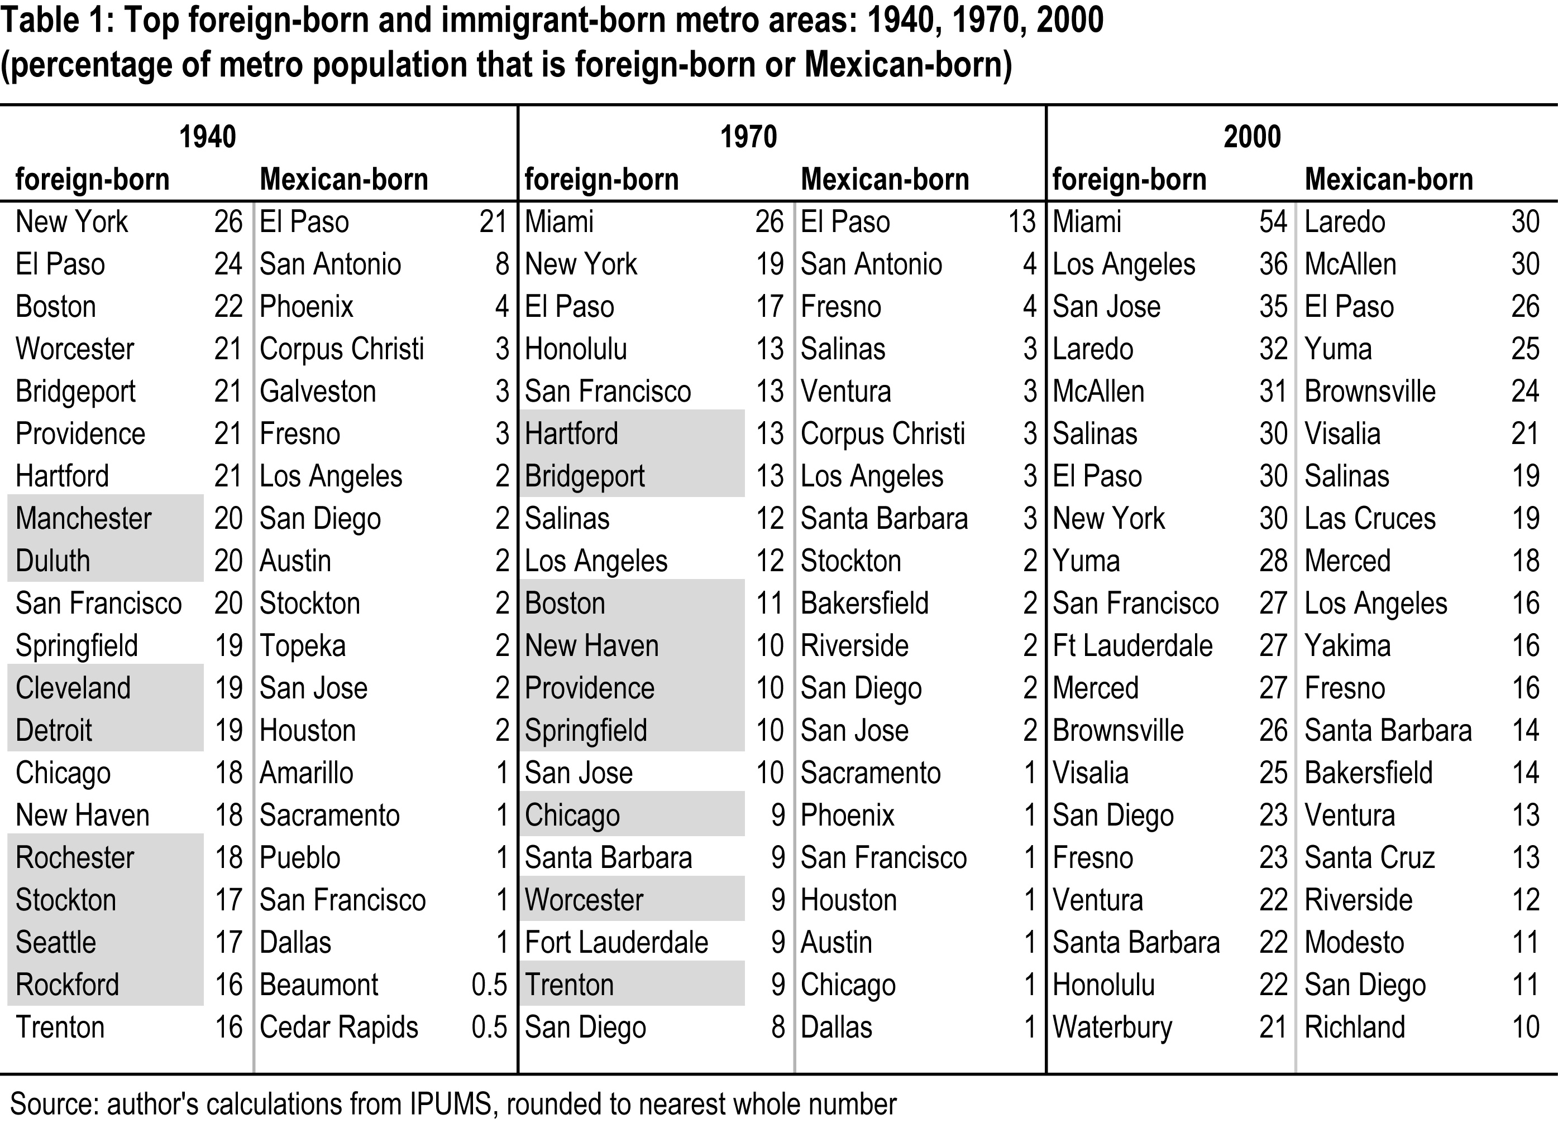

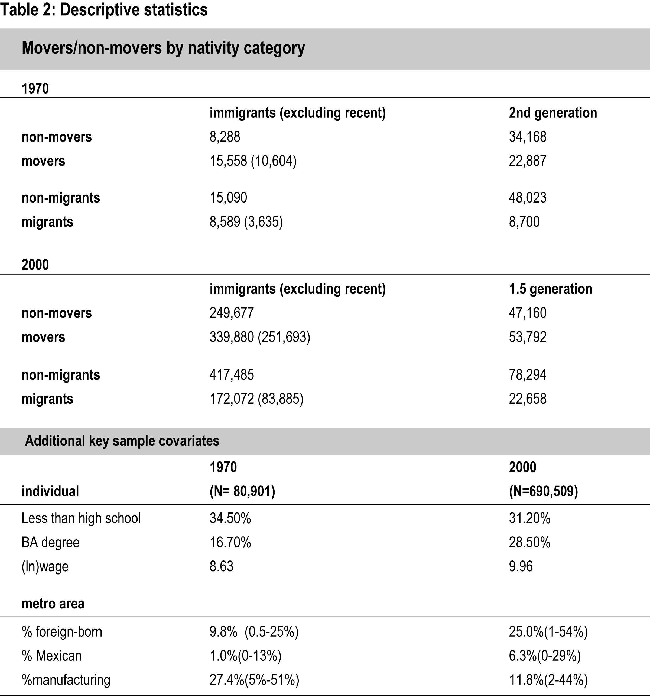

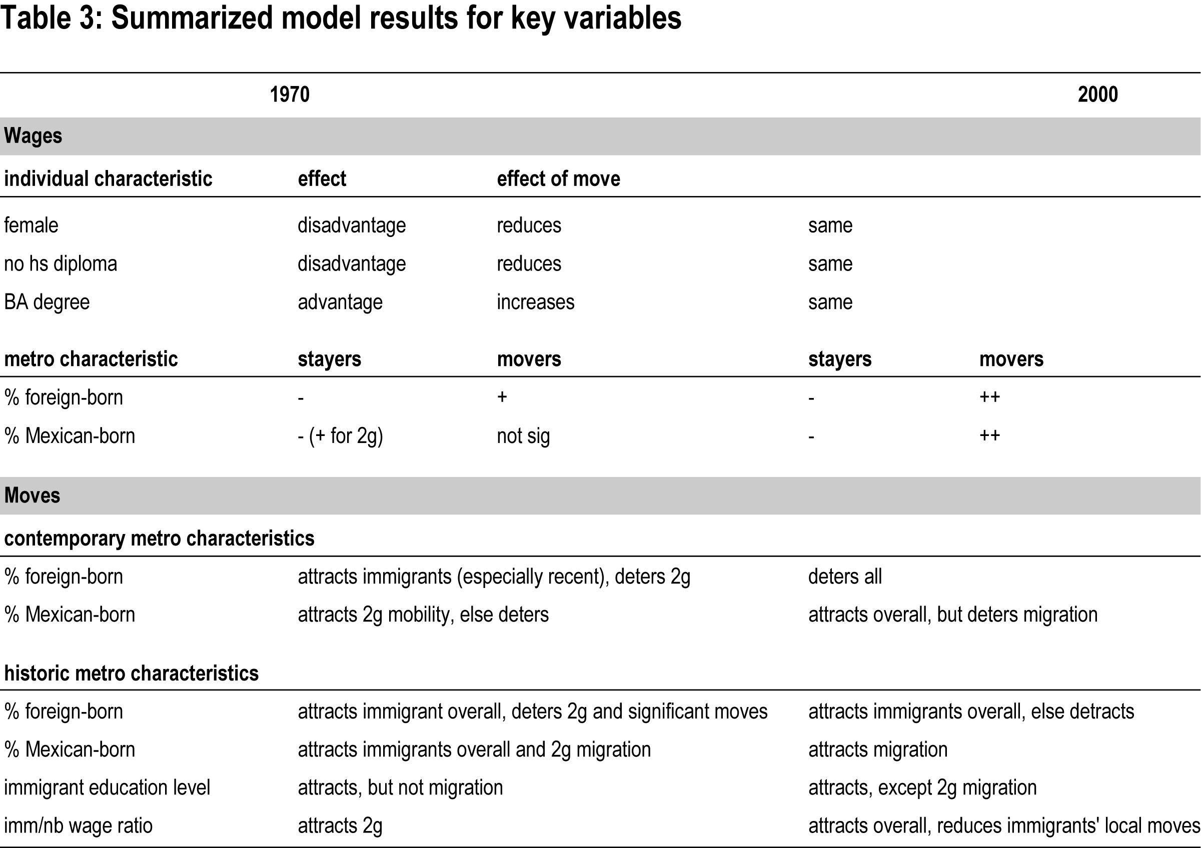

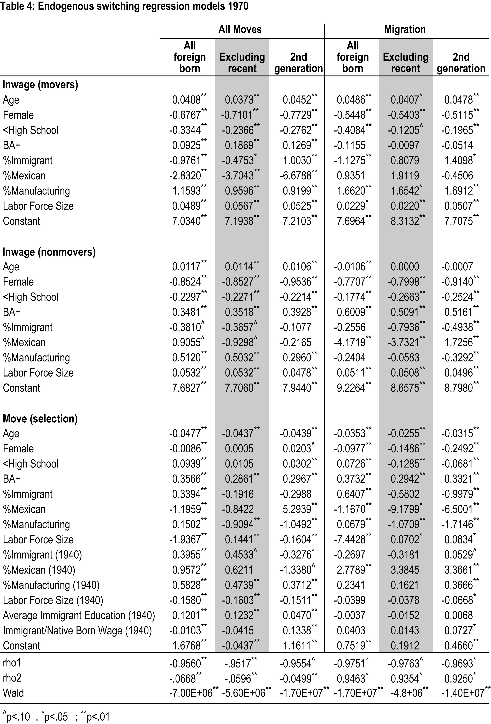

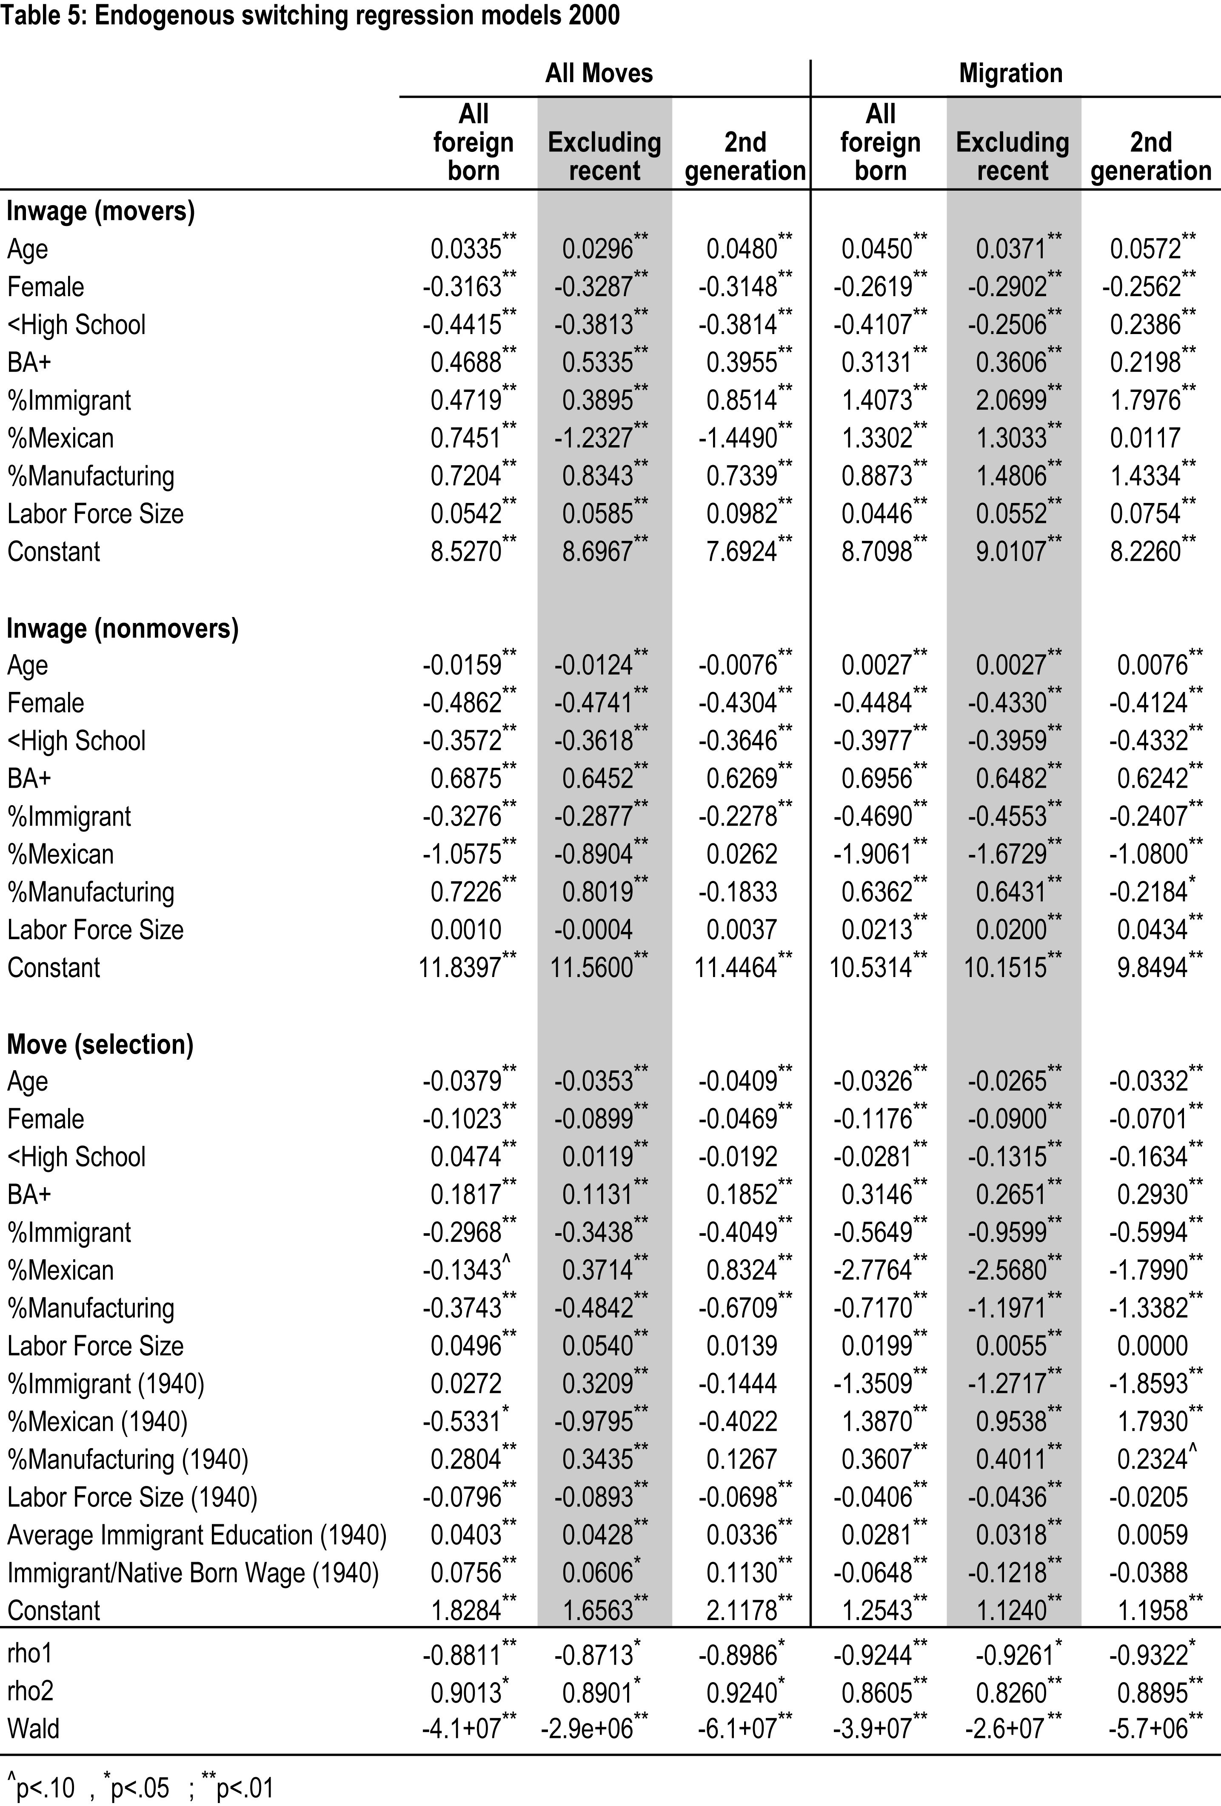

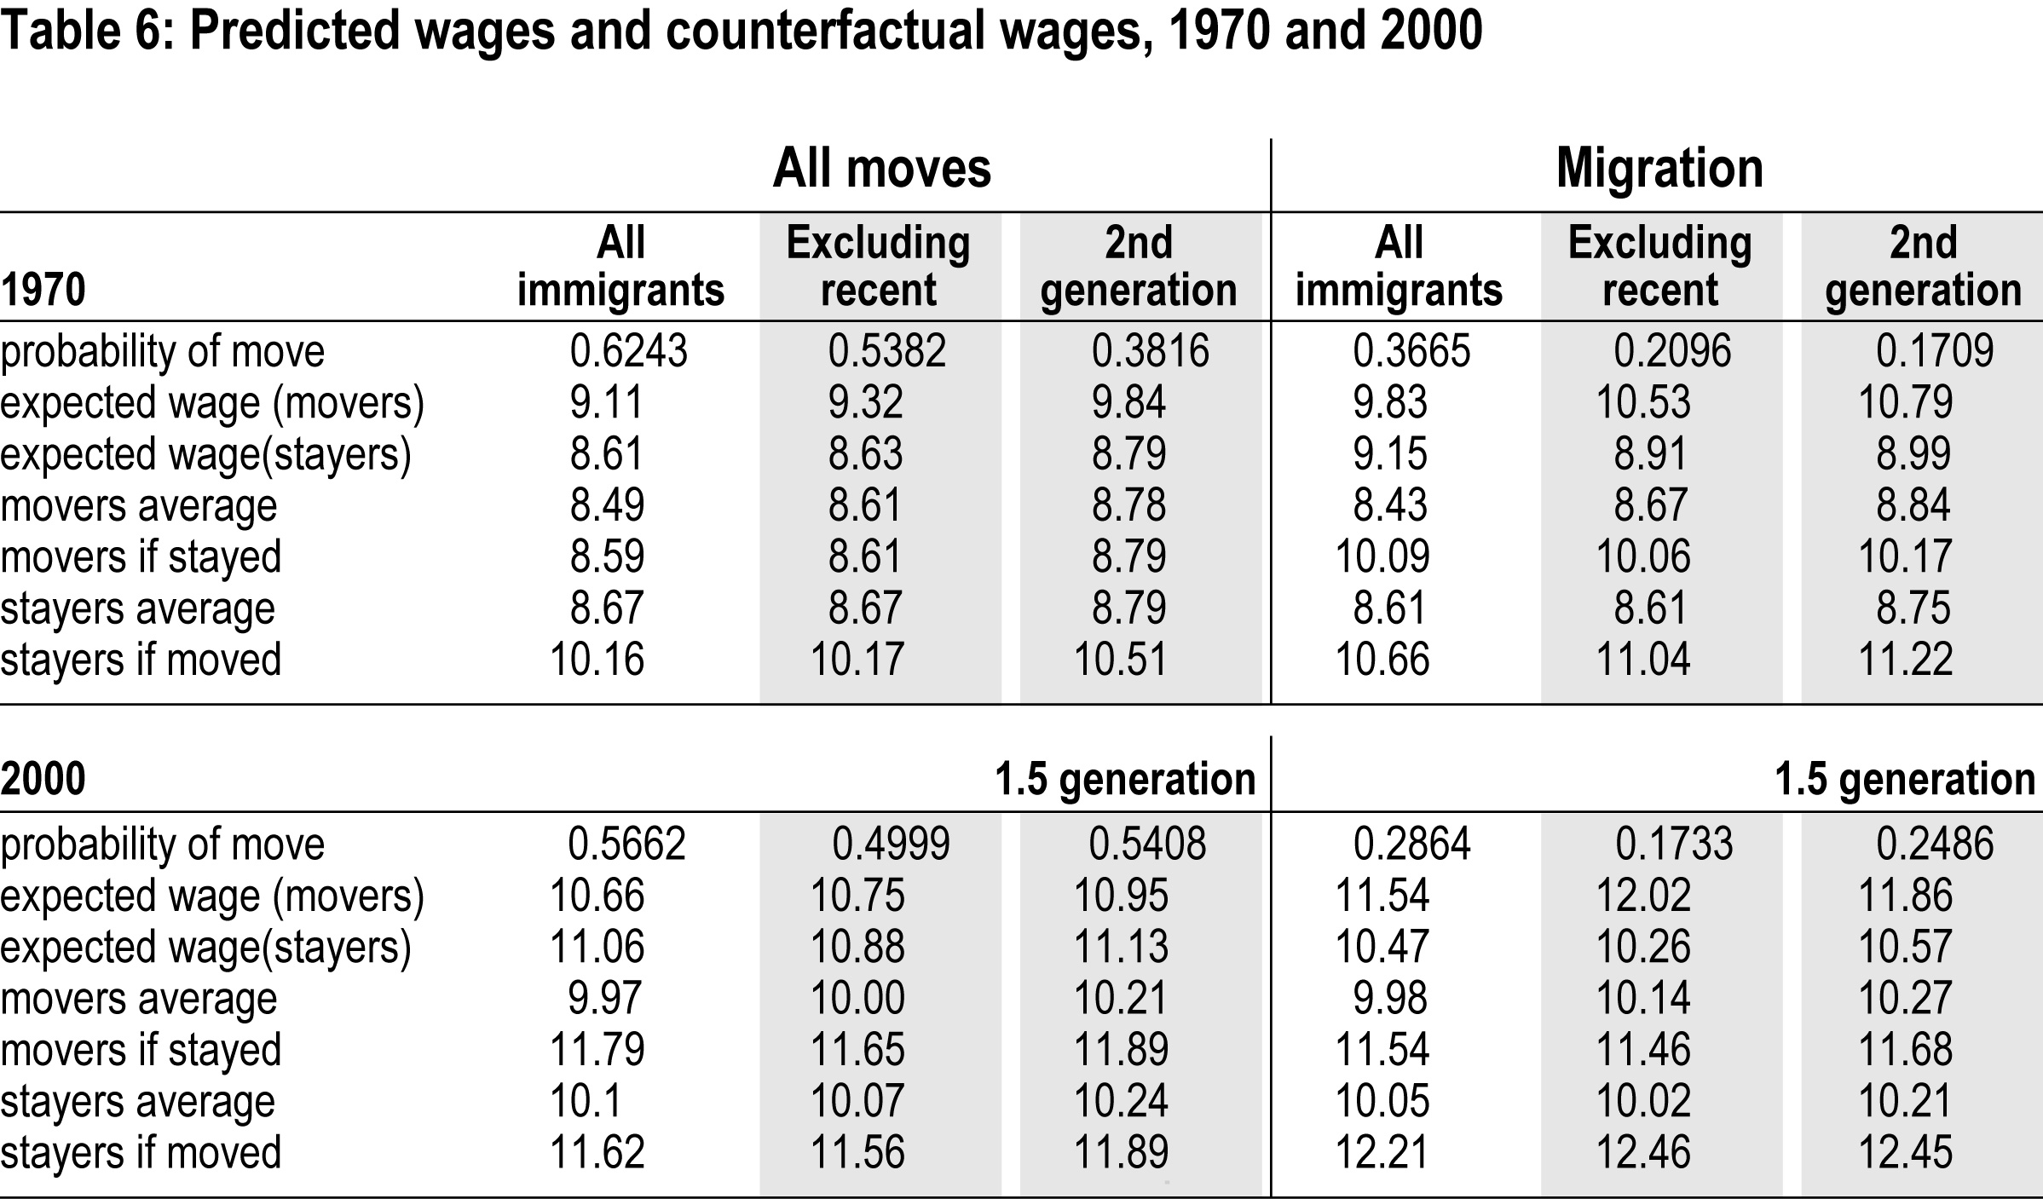

This variable proved more significant than and collinear with overall metro-level population.
The sample sizes vary with scale of move because there were different numbers of missing/irreconcilable data on the two census questions used to determine scale of move, and also because the 1.5 generation who had been abroad 5 years ago were excluded in order to make them comparable with 1970’s true 2nd generation.
These are estimated using Stata’s movestay (Lokshin and Sajaia, 2005).
The nonsignificant results for larger-scale migrants are likely due to small 1970s sample sizes for college-educated immigrant migrants.
. Since we do not have pre-migration information, I mean that immigrants move toward more concentrated metros in the array of metro areas they could choose (not necessarily a more concentrated metro than the one in which they previously resided).
These are mostly significant as required for model specification, although low levels for 1970s movers overall probably reflect low sample sizes.
If this seems slightly counterintuitive, it is because rho2 is the correlation coefficient between errors in the selection (move) equation and the wage equation for stayers. However, there is some evidence of positive selection for stayers in 2000, relative to local mobility.
There are some positive effects for 1970’s second generation, although there are few sizeable Mexican concentrations in 1970 and much of this second generation would not have been of Mexican parentage. They may have benefitted from growing metros with large Mexican populations but I cannot test this specifically here.

