Optimal CSR and Pricing Decisions with Risk-averse Providers in a Competitive Shipping System

Wei Zheng, Hua-Fei Huang, Dong-Ping Song and Bo Li, *Senior* Member, IEEE

*Abstract*—Logistics shipping is one of the critical activities in business operation. Facing fierce competition and high uncertainty of demands, shipping service providers often take risk-averse behavior when making decisions. In addition, due to the great impact on environment and society, some logistics shipping companies start engaging in corporate social responsibility (CSR). This paper investigates the competition of two risk-averse shipping service providers with one of them committing CSR effort. The conditional-value-at-risk is used to gauge the risk attitude of two players. The aim is to determine the optimal CSR effort and pricing decisions for two players under uncertain demand. The problem is formulated as a Stackelberg game model and the optimal decisions are obtained analytically. The effects of key factors such as risk attitude, competitive intensity, cost coefficient of CSR effort on the economic outcomes and social outcomes are analyzed in great detail. Results show that it is possible that one player’s CSR effort could benefit both players to achieve a win-win situation. On the other hand, it is also possible that adopting CSR activities may reduce the total social welfare of the system in some situations. Our paper is among the first to tackle the optimal decision problem for competing logistics shipping providers considering CSR commitment and risk-averse behavior simultaneously. Findings in this study can offer managerial insights for logistics shipping companies and government into decision making and policy making.

*Index Terms*—CSR effort, Game theory, Logistics shipping system, Pricing, Risk-averse behavior

# INTRODUCTION

## Background

L

[Citation: Zheng, W., Huang, H.F., Song, D.P. and Li, B. (2019). Optimal CSR and Pricing Decisions with Risk-averse Providers in a Competitive Shipping System, IEEE Transactions on Systems, Man, and Cybernetics: Systems, accepted on 25/11/2019]

OGISTICS shipping concerns the movement of cargos from one place to another. It plays a huge role in today’s economy. According to the report from Al Masah Capital, an investment and market analysis agency[1], the market scale of global logistics could increase from 8.1 trillion US dollars in 2015 to 15.5 trillion US dollars in 2024. On the one hand, the increasing market size of freight volumes creates plenty of development opportunity for logistics service providers. On the other hand, owing to the individualized needs and quick response from consumers, the competition among logistics service providers is becoming more and more intense. In addition, logistics shipping providers have to face high degree of demand uncertainty because nowadays consumers can shop at anytime and anywhere with the aid of omni-channel modes and many large suppliers can offer in-house delivery services. Therefore, the logistics shipping sector is characterized with fierce competition and highly uncertain demand.

The challenges faced by logistics shipping companies are further complicated by other dimensions of activities, e.g. Corporate Social Responsibility (CSR). CSR can be regarded as a kind of voluntary self-regulating business model, which attempts to integrate social and environmental factors into a firm’s business decision-making (see [23]). The importance of CSR for enterprises is accelerated by the government and publics’ increasing concern on the social and environmental issues (see [37]). In the logistics shipping sector, social and environmental issues have started attracting attention (see [33, 35]). For example, CEVA, one of the major logistics shipping companies in the world, stated in their 2014 sustainability report that they have committed a lot investment and effort as part of their CSR program including investment in Lombardy to support economic development in the region, rolling out US$20 million fleet investment program in the UK to equip with telematics that can improve the behavior of the drivers in terms of safety, emission and efficiency (see [5]). SF, one of the largest logistics express companies in China, built the supreme honor award “Best SFer” in 2012 to encourage his members to pursue social responsibility and recently invested several rural primary schools to help dropout children.

However, performing CSR activities will incur additional cost, such as implementing new technologies, deploying more environment-friendly vehicle, using more expensive fuel types or replacing old equipment. On the other hand, scholars have stated that CSR effort can raise company’s image and bring economic benefits by attracting more demands. For example, Choi et al [9] pointed out that CSR effort could enhance consumer loyalty directly and indirectly. Shin et al [34] stated that CSR activities might improve customer satisfaction and retention. More importantly, the contradicting effect of CSR activities further interact with demand uncertainty and competition. For example, high demand uncertainty may discourage logistics companies’ motivation to commit CSR effort because the positive effect of CSR activities become uncertain as well. In the competition environment, the positive effect of CSR activities may be diminished by the rival firm's low price strategy. Therefore, whether to commit CSR and how much CSR effort should be committed should be carefully determined in the uncertain and competition environment.

Due to low service differentiation, competition among logistics providers is mainly based on pricing especially in the spot market, in which the price and demand-supply relationship are depending on each other dynamically on daily/weekly basis (see [18]). As a result of the fierce competition and the higher uncertainty, the logistics companies have to face high-risk and tend to take risk-averse attitude. For example, the logistics shipping companies, CEVA, explicitly stated that “CEVA is rather risk-averse” in service pricing decision because shippers’ tendering processes became ever-more fierce and price driven (see [20]). In the broad supply chain context, risk-averse behavior in the decision-making has been extensively studied (see [4, 47]). However, to the best of our knowledge, there has been no research considering the mixed decisions of service pricing and CSR effort strategy for risk-averse providers in a competitive logistics shipping market. This paper aims to fill the above research gap by investigating a logistics system consisting of two risk-averse shipping service providers (a major provider as provider 1 and a secondary provider as provider 2), who compete against each other in the spot market with uncertain demand.

Note that although CSR has attracted more and more attentions in the logistics industry, only 53 percent of logistics service providers mentioned the sustainability in their website, furthermore, only 13 percent of providers published their CSR reports annually (see [28]). This means that many companies have no social responsibility awareness, especially the small firms, who are limited by the capital and are hard to survival in the market[2]. To represent the different awareness of CSR in the logistics industry, we assume the major firm, i.e. Provider 1, is CSR conscious, whereas Provider 2 is not. Under this assumption, we can analyze the impact of different CSR awareness on their decisions and profits. This assumption also reflects the phenomenon that major companies often have more financial capacity and motivation to take the CSR initiative than smaller ones. We will address the following questions:

(i) When both players have risk-averse behaviors, how do two players make optimal pricing decisions in the benchmark case (i.e. no CSR effort) and in the CSR effort case? And how much CSR effort should be committed?

(ii) How do some critical parameters, e.g. the risk-averse indicators, the competitive intensity, influence two players’ decisions and profits?

(iii) What are the effects of the players’ risk-averse indicators and the CSR effort on the social welfare of the entire system (including providers’ profits, consumer surplus, externality benefit)?

## Contributions and Organization

The main procedures and methods to answer these questions are as follows: firstly, we consider two cases corresponding to no CSR effort and committing CSR effort respectively. The conditional-value-at-risk (CVaR) measure is adopted to gauge the risk attitude of two shipping service providers. In the benchmark case (i.e. no CSR effort), the optimal pricing decisions of two providers are obtained by solving the simultaneous game. In the CSR effort case, assuming that provider 1’s CSR commitment is a long-term strategic decision, a Stackelberg game is presented to model the CSR commitment decision and two providers’ pricing decisions. Utilizing the backward induction method, the optimal equilibrium solution is obtained analytically. Secondly, we analyze and compare these two cases in great detail, e.g. the impacts of key parameters such as the risk-averse indicators, the market sharing parameter and the competition intensity on the optimal decisions. Thirdly, we investigate the effects of the provider 1’s CSR effort and two providers’ risk-averse indicators on their profits and the system’s social welfare through numerical experiments.

This paper makes the following contributions. Theoretically, this study is among the first to tackle the optimal pricing decision problem for competing logistics shipping providers considering CSR commitment and risk-averse behavior simultaneously. We find that in some conditions one provider may enjoy benefits from its competitor’s CSR effort. We also conclude that the CSR activities should be adopted carefully in a fierce pricing competition market, because the CSR effort may lead to worse-off in such situations. Moreover, it is shown that the CSR effort may be harmful to the social welfare under some conditions. Practically, our study reveals the conditions under which whether the competing players should adopt the CSR effort, and how risk-averse behaviors and CSR effort influence the decisions of two players. The results can not only help logistics shipping companies make pricing and CSR effort decisions, but also offer useful insights for government and publics to make policies and regulations to enhance the social welfare of the entire system.

The rest of the paper is organized as follows: In section 2, we give a review of the relevant literature. In section 3, the problem and notation are described. Then, the benchmark model (without CSR effort) and the CSR model (adopting CSR activities) are formulated and solved respectively. In section 4, the comparison and analysis are conducted analytically. In section 5, profits are evaluated through numerical experiments. Finally, section 6 draws the conclusions and indicates further research directions.

# Literature Review

The relevant literature may be categorized into two research streams: the risk-averse behavior with demand uncertainty, and the CSR activities in logistics shipping industry.

## Risk Behavior under Uncertainty

Demands uncertainty (see [29]) and fierce competition (see [17]) often lead to risk behavior of service providers in the logistics shipping industry. Generally speaking, risk-neutral decision-makers aim to maximize the expected profit, but risk-averse managers can tolerate certain expectations of profit reduction to avoid high impact of risk (see [20]). In other sectors such as finance, risk measurement tools have been widely used to gauge the risk attitude of agents. For example, Jullien et al. [14] considered the risk-averse agents under moral hazard in insurance market. Bruno et al. [4] developed a multistage stochastic programming approach for project investment planning by considering firms’ risk attitude. In the supply chain field, many researchers have taken into account the players’ risk behavior. Chiu et al. [8] proposed a price-rebate-return contract to minimize the risk and coordinate the whole supply chain. Chan et al. [6] sought the optimal inventory decisions of retailers considering the environment tax, decision makers’ risk preferences as well as the consumer return.

However, up to now, relatively few studies have utilized the risk measurement tools to represent decision-makers’ risk preferences in the logistics shipping industry. Existing literature on the risk attitude of service providers mainly focus on cost optimization or network design. For example, Xiao et al. [40] applied the prospect theory to present an adaptive navigation approach for risk-averse travelers. Kang et al. [15] introduced an approach to help shippers achieve an optimal route for a hazmat shipment by using value-at-risk (VaR) method. They found that route choice depended on the risk attitude. Soleimani et al. [36] presented a risk-averse two-stage stochastic programming approach to design a capital-saving reverse supply chain network. They applied conditional value-at-risk (CVaR) method to measure the risk in the reverse supply chain. All the above studies did not consider the pricing decisions. There are two papers (Yin et al. [43] and Lee et al. [19]) that have investigated the optimal pricing decisions in the shipping market with uncertain demand; however, both of them neglected the risk preference of decision makers. To the best of our knowledge, there is only one published study that examined the pricing strategies in a competitive shipping market consisting of risk-averse carriers [47]. However, they did not consider the CSR effort, which is one of the emerging phenomena and is closely related to decision-makers’ risk preference.

There are three risk measures commonly used in the literature, i.e. Mean-Variance [25], Value-at-Risk (VaR) [2] and Conditional Value-at-Risk (CVaR) [31]. Mean-Variance is proposed to measure risk attitude of decision-makers based on the concept of variance (see [25]). However, it is a symmetrical measurement that treats desirable outcomes (e.g. profit) in the same way as undesirable outcomes (e.g. loss) [18]. This implies that it cannot measure the downside risk separately. As a result, it is not appropriate when decision-makers are more concerned with undesirable outcomes. On the other hand, VaR and CVaR allow decision-makers to focus more on the possible loss. VaR can be defined as a threshold such that the probability that the profit below this value is  (see [2]), where  can be seen as the confidence level. Nevertheless, the limitation of VaR is that the tail end of the distribution of outcomes cannot be assessed. In addition, VaR is difficult to analyze when the outcomes are not ‘‘normally’’ distributed. CVaR method can overcome the shortcomings of VaR (see [31]). Thus, we choose CVaR to measure the risk attitude in this paper. CVaR is able to measure the average profit falling below the -quantile level, and ignore the contribution of profit above the specified quantile. Its ability to measure the downside risk and the tail loss simultaneously makes it more suitable for risk-averse players. Nevertheless, it should be pointed out that despite being a theoretically sound measure, CVaR may be not easy to understand by practitioners, as compared to Mean-Variance or VaR.

## CSR Activities in Logistics Shipping Systems

Though the effects of CSR activities on enterprises have attracted widespread attentions, the relationship between the CSR effort and the firm performance is under-studied (see [34, 35]). This section will give the review on CSR activities in logistics shipping industry and supply chain management.

Recent stricter regulations on environmental pollution in logistics shipping industry (e.g. Sulphur emission regulation, Energy efficiency design index) have made the service providers recognize that they need pay more attention on CSR activities within their business strategies (see [38]). However, Sampson et al. [33] also pointed out that CSR activities were still not efficiently adopted by shipping companies. In fact, researches on CSR effort and green behavior mostly focused on optimization issues in the shipping network aspect, such as path optimization, port location and network optimization with low-carbon emission or CSR activity constraints (see [38]).

Fewer studies considered the effects of CSR effort on firm performance. Shin and Thai [34] analyzed the impact of perceived CSR on customer satisfaction, relationship maintenance and customer loyalty in the shipping industry. They concluded that CSR activities was an important marketing tool and its values could affect customers’ perception significantly. Shin et al. [35] continued this topic and found that CSR activities had a significant effect on customer satisfaction, word of mouth intention and the whole demands. Adland et al. [1] investigated the impacts of the Emission Control Area (ECA) on vessel speeds through analyzing a dataset and their result suggested that emission control area (ECA) did not affect vessel speeds. Yuen et al. [45] examined the financial synergistic interactions between CSR and service quality. They found that CSR could complement service quality and generate additional financial contribution to shipping firms by improving customer satisfaction. Yuen et al. [46] surveyed 276 shippers in Singapore and demonstrated that the shippers who had strong beliefs on CSR activities would derive greater satisfaction and exhibit stronger behavioral intentions to encourage the shipping service providers’ involvement in CSR activities.

The above studies about CSR activities in logistics shipping field focus on the impacts of CSR investment, but ignore the competition among firms, the decision-making behavior and the impacts of a firm’s decision on its rival, or on government and society, which are important issues in supply chain management. For example, Albuquerque et al. [10] combined two decision methods to evaluate the environmental impacts and business indicators in green supply chains and provided one case to verify the proposed hybrid method. Arya et al. [3] discussed the influence of the supplier’ CSR activities on their own and downstream agents in a two-level supply chain. They identified that the subsidies for CSR effort could not only win the societal goals, but also had an incentive to increase retailing prices. Panda et al. [26] studied the impacts of CSR activities on players’ decision-making in a manufacturer-distributor-retailer supply chain and compared the impacts of social responsibility behavior on consumer surplus and social welfare. They found that the profit of the manufacturer might be negative when he did more CSR practice. Li et al. [21] constructed a game model in the dual-channel green supply chain and compared the decisions and profits between the single-channel and dual-channel green supply chain. Ma et al. [24] analyzed the effect of CSR on the growth of enterprises’ demands in a supply chain. The result showed that the supplier' CSR effort might have an opposite effect on two agents and it was not always good for retailers.

TABLE I

Positioning of This Paper

|  |  |  |  |  |  |  |
| --- | --- | --- | --- | --- | --- | --- |
|  | SM | UD | Comp. | RA | CSR | GT |
| [15,40] | √ |  |  | √ |  |  |
| [36] |  |  |  | √ |  |  |
| [1,33,34,35,45,46] | √ |  |  |  | √ |  |
| [3,24,26,32] |  |  |  |  | √ | √ |
| [21] |  |  | √ |  | √ | √ |
| [44] | √ |  |  |  | √ |  |
| [47] | √ | √ | √ | √ |  | √ |
| [6,8] |  | √ |  | √ |  | √ |
| [43] | √ | √ | √ |  |  | √ |
| [19] | √ | √ |  |  |  | √ |
| This paper | √ | √ | √ | √ | √ | √ |

Specially, considering CSR or decision-makers’ behavior in shipping industry, Yliskylä et al. [44] concluded that the CSR effort could benefit environment and social impacts in the shipping industry. Further they discussed the effects of self-regulation behavior on the CSR effort in the shipping industry. Through verifying the impacts of CSR effort on firm risk and value, Rui et al. [32] regarded CSR effort as an investment for the differentiated product to realize the firms’ higher profits.

In summary, the literature positioning of this paper is showed in Table I by comparing shipping market (SM), uncertain demand (UD), competition (Comp.), risk-averse (RA), CSR and game theory (GT). It can be found that most existing studies have not considered the risk preference behavior generated from the uncertainty of demands. In addition, although some studies on logistics shipping sector addressed the pricing decisions in uncertain demand situations (i.e. Yin et al. [43]; Lee et al. [19]), they did not consider the competition context, which is one of the main factors that contribute uncertainty and influence pricing decisions in shipping market. On the other hand, the researches involving CSR in shipping field usually focus on cost optimization in a non-competitive context, and ignore the decision-maker’s risk behavior and its impact on the decisions with game theory, which is an important phenomenon in supply chain management. Thus, we will fill the research gap by introducing the competition, the risk-attitudes, the CSR effort, and the pricing-decisions in the context of logistics shipping industry.

# The Model and Solutions

Consider a competitive system with two logistics providers: provider 1 and provider 2. The two-player assumption is mainly based on the following reasons: Firstly, the two-player problem is analytically tractable, whereas multiple-player problems appear to be intractable and difficult to obtain the managerial insights. Secondly, the setting of two providers can reasonably represent the important characteristics in the market such as competition and heterogeneity. Thirdly, two-player game is fundamental and can shed light on multi-player games. This is also in line with the principles of economics, i.e. simple model is preferable to illustrate a complicated phenomenon ([39]). In fact, the two-player setting is quite common in the literature. For example, two-player competitive transportation systems have been investigated in many researches (see [42,47,49]). Nevertheless, we have to admit that multiple-player setting is more realistic and deserves further research.

We assume that the two providers have sufficient service capacity to meet customer demands and they both have risk-averse behaviors in their decision making. This assumption may be justified by the fact that the logistics shipping industry has been facing severe overcapacity and intense competition since the global economic crisis in 2008.

In logistics shipping industry, there exist two common pricing strategies: the long-term contracted service price (that is fixed) and the spot prices (that are decision variables depending on the demand in spot market). For example, in container shipping sector, the long-term shipping contracts are often signed on yearly basis, i.e. up to one year before the actual shipping date. On the other hand, in the spot market, the shipping price could be negotiated at a couple of weeks before the actual shipping date. However, due to overcapacity and intense competition, the long-term contract price nowadays may not have the advantage over the spot market price [19]. Thus, shippers may prefer to book shipping services in the spot market and can even break the long-term contracts in order to take advantage of the low price in the spot market.

## Model Establishment

In our model, provider 1 is a major provider, which is more conscious with social responsibility, while provider 2 is a relatively small provider (e.g. freight forwarders or small logistics companies), who is less concerned with environment or social welfare. Both provider 1 and provider 2 will make pricing decisions for the similar shipping services that they provide. Moreover, provider 1 will also decide his CSR effort. Notation and parameters used in developing our model are defined in Table II.

To facilitate the comparison, we build a benchmark model first without considering CSR effort. After that, we will build the CSR model in which provider 1 will commit CSR effort. As the CSR effort decision is a strategic decision, it is usually made well in advance of the pricing decisions. For example, many major shipping companies including Maersk often publish their sustainability goals and strategies in their websites on annual basis. However, their pricing decisions are often made on weekly or even daily basis. As a result, a two-stage Stackelberg game is appropriate to model the competition between two players. The sequence of the events in the two-stage Stackelberg game is: provider 1 makes its CSR decision in the first stage; then in stage 2 two providers make their pricing decisions simultaneously.

We use the conditional value at risk (CVaR) to model the risk-averse attitude of two providers. CVaR measures the expected profit falling below the  quantile level. Rockafellar and Uryasev [31] proposed the following equivalent form of the CVaR definition to simplify the computation:



Where  is the profit function, and  represents the risk-averse indicator. More specifically, when , it represents the risk-neutral case, and the CVaR is equal to the expected profit. When , the part of profit below v is amplified. So the measure of CVaR value is less than the expected profit. Our problem is to maximize  for i = 1, 2.

TABLE II

Notations and Parameters

|  |  |
| --- | --- |
|  | , where  represents provider 1 and  represents provider 2. |
|  | the forecasted market demand, which is a random variable with the probability density function and the cumulative distribution function ,  respectively. |
|  | the fraction of the forecasted market demand occupied by provider 1, then  represents the forecasted market demand to be met by provider 2, where *θ*∈(0, 1). |
|  | the long-term contracted service price per unit as a benchmark. |
|  | the service price per unit for provider , which is a decision variable, . |
|  | the competitive intensity of the price for providers. |
|  | The service cost per unit for provider , . |
|  | the random demand for provider , . |
|  | the profit of provider , . |
|  | the risk-averse indicator of providers, where . |
|  | the CSR efforts of provider 1. |
|  | the CSR sensitivity for provider 1. |
|  | the CSR sensitivity for provider 2. |
|  | the cost coefficient of CSR efforts. |
| *F* | the fixed cost of CSR activities. |
| *k* | correspond to two scenarios: the benchmark model in which no players commit CSR effort, and the CSR model in which provider 1 invests in CSR, and provider 2 doesn’t. |

## Solutions under the Benchmark Case

In the benchmark model, both providers do not commit CSR effort. The demand for logistics shipping services is uncertain and price-dependent. It is assumed that demand depends linearly on each provider’s own price and its rival’s price:

 (1)

The similar linear demand models have been widely adopted in supply chain literature (see [24,42,49]). In the demand function,  are the service prices of the two providers in the spot market.  is defined as the long-term contract price which is signed in advance; thus we set  as an exogenous parameter. In addition,  can also be considered as an average price in a period of time which can represent the customer's expected price, i.e., reference price. By this setting, we are able to model the situation that many shippers tend to break the long-term contract and turn to the spot market when the price in spot market is lower than the contract price. In addition, when  is set to zero, the demand function can be reduced as a normal demand function in supply chain literature. The parameter *θ* is introduced to represent market shares of two providers, which can be regarded as customer’s preference, or the degree of customer loyalty to the providers (see [11,22]). Because the major provider may have a massive service network and a small provider focuses on specific shipping demands, the preference of customers is likely different. This preference is often not so susceptible to its price. For example, in the mobile phone retail market, though the price of iPhone is higher than Nokia, the volume of sales of iPhone is higher than Nokia in 2015 (SinoMarket Research[3]). There is also some literature adopting this setting such as Feng et al. [11], Liu et al. [22]. In addition, when *θ*=0.5, the degrees of customer loyalty to the providers become the same.

Furthermore, some constraints should be satisfied, i.e.,, ,  and , , . Note that if , then the profit of the provider would be negative, which makes the provider exit from the market. We do not consider such trivial case.

The profits of two providers can be given as:

 (2)

Then we need to analyze the CVaR of two providers as the objective functions. The providers’  utilities are:

 (3)

Because two providers make pricing decisions simultaneously, we can obtain the optimal equilibrium solution  under the Nash game. Specially, we assume that the two providers have the same product cost, i.e., = *c*, then

,

.

*Proof:* Let , ,. Then, , and



Note thatand .

So  is concave. We define . Thus,  reaches its maximum at . Then,



It follows,



The Nash equilibrium solution can be obtained by solving the first order differential equations. We have





Where , It follows that  is concave in , then the equilibrium can be reached at:

,

.

This completes the proof. ■

## Solutions under the CSR effort case

This section considers the CSR effort case, i.e. provider 1 will commit CSR effort. We formulate the problem into a two-stage Stackelberg game. In the first stage, provider 1 makes a decision on the CSR effort amount , by which the provider can boost its own demand and snatch part of its rival’s demands. Suppose that the cost of the CSR effort is increasing and convex, defined as: , where  can be regarded as the cost coefficient (see [24,34]). In the second stage, after observing the outcome of the provider 1’s CSR effort, two providers make their pricing decisions  and  simultaneously. Finally, after observing the CSR effort and the pricing decisions, the consumers make their purchase decisions to realize the demands.

Similar to the benchmark model, we assume that the realized demand for one provider’s demand depends linearly on its own price, its rival’s price and the CSR effort as shown in (4) and (5) (see [34,35]). Moreover, as provider 1 increases the CSR effort, its own demand will increase by  units, while its rival’s demand will decrease by  units.

 (4)

 (5)

The parameters  and  can be regarded as the impact of the CSR effort on the demands of two providers respectively. Specifically,  is the positive effect on its own demands, and  is the negative effect on its rival’s demands. These positive and negative effects may be explained by the following facts. Provider 1’s CSR effort can improve the company’s image and acts as a positive propaganda to consumers, e.g., advertisements. It is likely to attract more demands from the market ([9]). In addition, some consumers who are CSR conscious and have previously ordered the shipping service from the rival provider may switch their purchase to the provider with more CSR. It is worth mentioning that the similar effects caused by advertising activities have been assumed in [16] and [27].

It is reasonable to assume . To simplify the narrative, we define  where *τ* is a positive number. In this way, the effect of provider 1’s CSR effort on its own demands is divided into two parts, the increased demands from the market (i.e. the expansion effect) and the increased demands snatched from its rival (i.e. the plunder effect).

The profits of two providers are given by:

 (6)

 (7)

Consider the risk-averse attitudes of two providers, the providers’ utilities are:

 (8)

 (9)

The two-stage Stackelberg game can be solved analytically using the backward induction method. The optimal equilibrium solution  in the CSR effort case is given below subject to , where :

,

.

.

Where , and . When , the equilibrium does not exist.

*Proof:* Similar to the benchmark case, , the providers’ is given by:

,

.

By using the backward induction method to solve the Stackelberg game model, we can get the response functions of two providers’ prices to the CSR effort:

,

.

Note that . We substitute the above response functions to the objective function of provider 1, and can obtain the optimal CSR effort decision of provider 1 in stage 1. This completes the proof. ■

From the above optimal equilibrium solution, we can observe that given the CSR effort of provider 1, the optimal pricing decisions of two providers are symmetric relative to several key parameters, e.g. the risk-averse indicator *η*, the competitive intensity *γ*.

Further, we define the price difference between provider 1 and provider 2 as , and, . It would be interesting to examine how the price difference responds to the changes of key parameters such as the risk attitude, the market share, the CSR effort and the competitive intensity. We have the results as follows.

*Proposition 1:* In the CSR effort case, when , the difference of the optimal prices between provider 1 and provider 2 has the following properties:, , , .

The proofs of this proposition and the remaining propositions can be referred to [48]. When provider 1 commits relatively high CSR effort, i.e., , provider 1’s optimal price will be higher than provider 2’s optimal price. Proposition 1 reveals the further results in the situations when provider 1 commits relatively high CSR effort. Firstly, when provider 1 and provider 2 have very different risk attitudes or a larger difference between market shares, they tend to differentiate their pricing decisions. Physically, provider 1 is a major company, compared with provider 2, he may tend to be much more risk-neural than provider 2 and may have a larger market share; as a result, he will choose a higher price than provider 2. Secondly, as the CSR effort of provider 1 increases, which implies that provider 1 will have the higher cost, then he will give a higher price; it follows that the price difference between provider 1 and provider 2 is increasing. That is, the CSR effort is equivalent to increasing the service differentiation of two providers. Thirdly, with the competitive intensity between provider 1 and provider 2 increasing, provider 1 may choose a lower price to capture the consumers, then the price difference will be reduced.

# Comparison and Analysis

In this section, we will discuss some properties of the analytical solutions with the emphasis on the sensitivities of the providers’ optimal decisions to the key parameters. In order to compare two cases, we assume all discussions are limited in the condition of .

## The effects of CSR effort and its sensitivity to parameters

First, we consider provider 1’s CSR effort decision. Comparing the equilibrium solutions between the benchmark case and the CSR effort case, we have

, .

From the above, we can find that in the CSR effort case, the optimal prices of two providers can be expressed as the optimal prices in the benchmark case plus a linear function of . Clearly, as the CSR effort increases, provider 1’s price  is increasing. That is, the cost of the CSR effort will be reflected in suppler 1’s own price. On the other hand, the effect of the CSR effort on his rival’s price  will depend on the relationship between two parameters and .

In fact, from the demand functions (Eq. (4) and Eq. (5)), we can see that  represents the extra positive impact (i.e. on top of the amount ) of the CSR effort on provider 1’s own demand to be generated from the potential market, which can be interpreted as the expansion effect; whereas  represents the negative impact of the CSR effort on provider 2’ demand (or provider 1’s additional demands snatched from its rival’s demand), which can be interpreted as the plunder effect. We have the results in proposition 2 as follows.

*Proposition 2:* Comparing the equilibrium solutions between the benchmark case and the CSR effort case, and concerning with provider 1’s CSR effort, there exist

1. Free-ride effect: when , provider 2 can enjoy a free-ride higher price from the CSR effort of provider 1.
2. Snatching effect: when , CSR efforts of provider 1 has a negative impact on provider 2’s pricing decision.

Where .

From Proposition 2 (i), we can observe that when the expansion effect of the CSR effort is high, (i.e.), that is, provider 1’s CSR effort is able to attract much more consumers from other logistics service markets, then the CSR effort also brings a positive impact on provider 2’s price. It means provider 1 can set a higher price to gain more profits because of his boosting more demands; accordingly, provider 2 can also increase its price by following provider 1. The profits gained from increasing price can offset the negative impact from the plunder effect. Hence, setting a higher price is profitable to provider 2 in this situation. As a result, Provider 2 can enjoy a free-ride higher price from the CSR effort of provider 1.

In Proposition 2(ii), the expansion effect is low or the plunder effect is high enough to satisfy the condition . In this situation, provider 2 has to set a lower price to avoid too much loss of consumers. As a result, the CSR effort of provider 1 has a negative impact on provider 2’s price. From the expression , we can find that as the price competitive intensity  increases,  and *T*(*ρ*) are decreasing. The implication is that as the price competition becomes fiercer in the market, it is more likely the free-ride effect of the CSR effort will occur.

Now we perform sensitivity analysis of the optimal CSR effort to some key parameters.

*Proposition 3:* In the CSR effort case, we have the following properties with respect to provider 1’ optimal CSR effort, , , , .

The results of Proposition 3 indicate that when the service cost or the long-term contract price increases, provider 1 should pay less effort to perform CSR activities. Furthermore, both the expansion effect and the plunder effect have positive effects on the CSR effort. These results are relatively intuitive. Note that higher service cost and contracted price will lead to a higher cost of performing CSR effort, then this will make provider 1 commit less CSR effort. Moreover, higher expansion effect or higher plunder effect can bring about more demands for provider 1, which encourages provider 1 to commit more CSR effort.

## The effects of market characteristics on pricing decisions

This sub-section examines the sensitivity analysis of the optimal pricing decisions to some key parameters.

*Proposition 4:*In the CSR effort case, there exist four threshold values, ,, ,, that are able to characterize the sensitivity of the optimal prices to the service cost and the long-term contract price,

1. For provider 1,

if , then ; if , then .

if , then .

1. For provider 2,

When ,

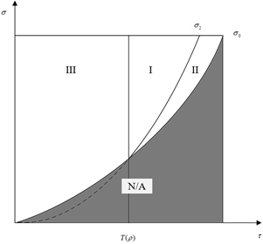 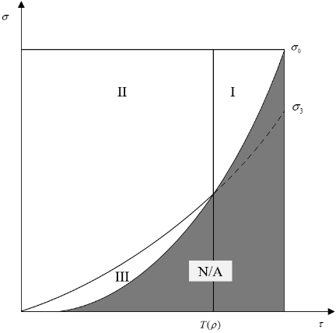

|  |  |
| --- | --- |
| (a) the service cost | (b) the long-term contract price |

Fig. 1 The impacts of  and  on the optimal price of provider 2

if , then ; if , then . if , then .

When ,

if , then ; if , then; if , then .

Where , , , .

From Proposition 4, it can be seen that the impacts of the service cost and the long-term contract price on the optimal prices of two providers are not monotone increasing any more, which is different from the benchmark case. Proposition 4(i) indicates that the impact of the service cost on provider 1’s optimal price can be characterized by the cost coefficient  of the CSR effort. When  is relatively high, provider 1 is unwillingness to commit the CSR effort and tends to increase the price with *c* increasing. This is obvious because the service cost and the CSR effort cost are increasing simultaneously, provider 1 cannot stand the pressure for high expenditure. However, when  is low, the provider tends to adopt a higher CSR effort. CSR becomes a more important factor affecting the price than the cost, since the decrease of marginal profits caused by *c* will lead to the decrease of CSR effort. Then the price in the spot market decreases, too. In addition, the influence of the long-term contract price on provider 1’s optimal price is intuitive, that is, the CSR effort is decreasing and the price is increasing in .

With regard to the impact of the service cost and the long-term contract price on provider 2’s price, the results are more complicated. In order to explain more clearly, we introduce Fig.1. First, from Proposition 4(ii) and Fig.1(a), we have:

1. In the region I and II, the expansion effect  is relatively high. But in region I, the price of provider 2 is increasing in *c*. So, the CSR cost is unaffordable, and provider 1 prefers to neglect the CSR effort. In the region II, the CSR cost is affordable, which generates a large influence on two providers’ prices. In this situation, the expansion effect is far more than the plunder effect, so provider 2 can enjoy a free-ride from provider 1’s CSR effort. However, with the service cost *c* increasing, provider 1 will commit less CSR effort, then provider 2 will decrease its price at the same time.
2. In the region III, because the CSR cost is affordable, the indirect influence of the CSR effort exceeds the direct impact of the service cost (i.e., the price is increasing as the service cost increases). At the same time, the plunder effect is relatively high, thus the CSR effort has a negative effect on the provider 2’s price.

In terms of the long-term contract price, from Proposition 4(ii) and Fig.1(b), we can similarly discuss and give the implications as follows:

1. In the region I(), provider 2 enjoys a free-ride with provider 1’s CSR effort. Similar to provider 1, provider 2’s price is increasing in the contract price.
2. In the region II and III, the expansion effect  is relatively small. The plunder effect plays a vital role, so the competition in the market will be much fierce. If the CSR effort cost is high enough, which falls in the region II, the CSR effort is neglected by provider 1. The result is similar to that in the benchmark case. If the CSR effort cost is relatively low, which falls in the region III. As the long-term contract price increases, the CSR effort of provider 1 is increasing; then provider 2’s price is decreasing at the same time.

*Proposition 5:* In the CSR effort case, the sensitivity of the optimal prices to the expansion effect and the plunder effect has the following properties,

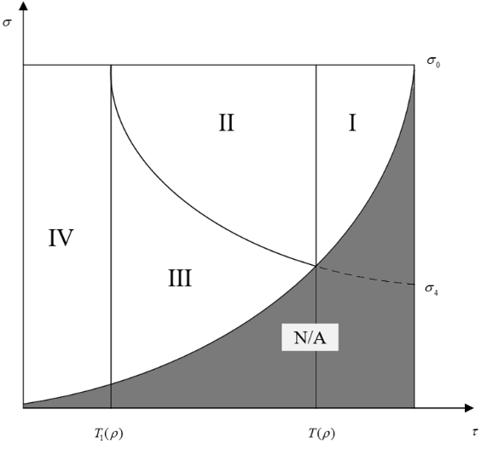 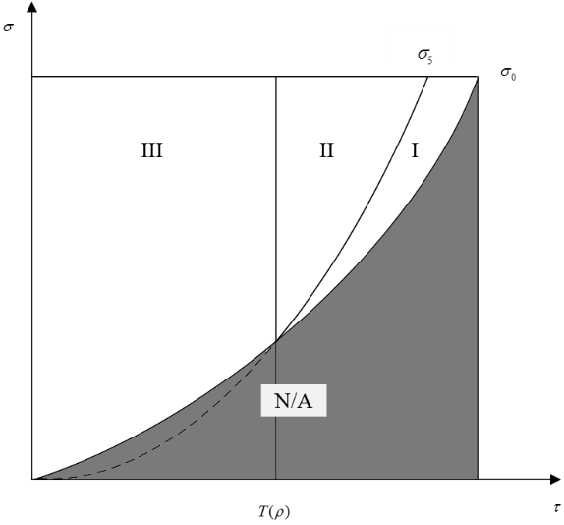

|  |  |
| --- | --- |
| (a) the effect of expansion effect | (b) the effect of plunder effect |

Fig. 2 The effects of expansion and plunder effect on provider 2’s optimal price

1. For provider 1, , ;
2. For provider 2,

(i) If , ;

If  and , then ;

If  and , then ;

If , ;

(ii) If  and , then ;

If  and , then ;

If , .

where , ,

,.

From Proposition 5(i), the expansion effect and the plunder effect both generate positive effects on the pricing decision of provider 1. It is understandable that the two impacts can benefit provider 1 through attracting more demands.

However, Proposition 5(ii) shows that their effects on provider 2 are mixed and need to be discussed furthermore. As shown in Fig.2(a), when  in region I, provider 2 can be benefited from the CSR effort of provider 1 by improving its price to obtain more marginal profits. However, when , provider 2 will be worse off from provider 1’s CSR effort. When the CSR cost is high enough, in region II, provider 1 prefers to ignore the CSR activity. That is, the CSR effort has an insignificant effect on providers’ decisions. In this situation, provider 2 doesn’t care about the negligible loss of demand, so it can follow provider 1 to improve its price and get more marginal profits. In region III, that is, the cost of the CSR effort is affordable, provider 1 will adopt CSR effort actively. As the expansion effect increases, provider 1 will increase the CSR effort; provider 2 need decrease its price to make up the losing demands. Finally, when  shown in region IV, that is, the expansion effect is fairly small, provider 2 can’t enjoy any benefits from the CSR effort; then it will have a negative effect on provider 2’s price.

Similarly, as showed in Fig.2(b), when the condition  is satisfied, provider 2 can enjoy a free-ride; when the cost of the CSR effort is affordable, in region I,  has a positive effect. However, when the cost of provider 1’s CSR effort increase further, it has an opposite effect, as shown in region II. Obviously, when the expansion effect is small (), provider 2 will always decrease its price to make up its losing demands in  as region III.

## Effects of risk behavior and demand uncertainty on optimal decisions

In this section, we analyze the effects of the risk-averse indicators and the degree of demand uncertainty on the optimal decisions of two providers.

*Proposition 6:* In the CSR effort case, concerning with two players’ risk-averse indicators, we have

1. , , , .
2. When, , ;

When,

if , ; otherwise, ;

if , ; otherwise, .

Where .

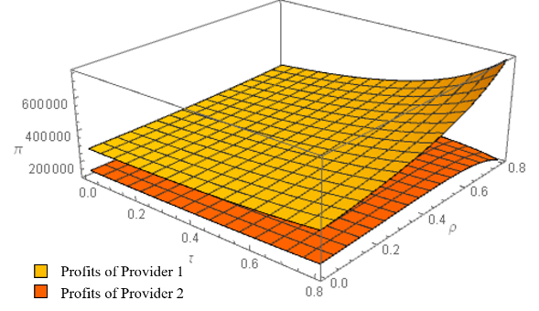 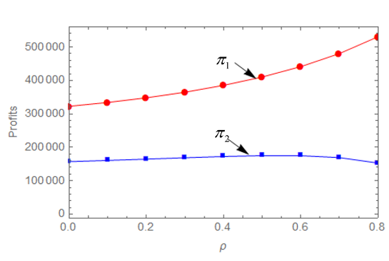

|  |  |
| --- | --- |
| (a) Effects of  and on two providers’ profits | (b) Details of plunder effect |

Fig.3 Effects of and on two providers’ profits

From proposition 6, we can find that for provider 1, when he or provider 2 is more risk-averse (i.e. takes smaller risk-averse indicator), he always feels pessimistic to the demand; then he reduces his price in order to attract more customers to make up the uncertainty in demand. Meanwhile, he also reduces his CSR effort to avoid the CSR costs. However, as for provider 2, when , it means that he can enjoy a free-ride from provider 1, so the effect of the risk attitude is similar to provider 1. When, the competition in the market is fierce; if , then the cost of the CSR effort is so high that provider 1 will neglect the CSR effort, that is, the effect of the risk attitude is similar to the benchmark case. If the CSR cost is low enough, then the decision of provider 2 is contrary to provider 1; consequently, as the risk-averse indicator of provider 1 increases, provider 2’s price is decreasing.

To facilitate the analysis of the impact of the demand uncertainty, we assume the stochastic demand  follows a uniform distribution, , then

*Proposition 7:* The increasing of the uncertainty in the market has the similar effect on the optimal decisions to that of the decreasing of the risk-averse indicator.

# Profits Analysis and Social Welfare

In our model, the expressions of the optimal profits of two providers and the social welfare of the market are very complicated and difficult to analyze, so we turn to numerical methods to further examine the impacts of the CSR effort and other parameters on the profits and the social welfare. Specifically, we first examine the impacts of several parameters that are associated with the CSR effort on the profits of two providers. Then, we evaluate how the profit differences between the CSR effort case and the benchmark case for two players may be affected by the changes of key system parameters. This can shed light on whether provider 1’ CSR effort is beneficial to the players, in what circumstances, and to what extent. Finally, we examine how the social welfare may be affected by the CSR effort and some system parameters.

We assume that the random demand follows a uniform distribution with *D* = 1500 and . In addition, we set that ,  or 0.5,  The above parameter settings are mainly based on Zheng et al. [18], Lee et al. [21] and Chen et al. [7]. In addition, we assume that there are two asymmetric providers with general risk-averse preference in the competitive market, which can basically represent the research problem that we like to analyze.

## Impacts of the CSR effort on two players’ profits

In this section, we focus on three parameters that are associated with the CSR effort, i.e. the expansion effect τ, the plunder effect ρ, and the CSR cost coefficient σ. Fig. 3 shows how the parametersτ and ρ influence the profits of two providers. From Fig. 3, we can find that  and  both have a positive effect on provider 1’s profit. In that sense, the higher  and  means that provider 1 has a higher ability to capture the demand. As long as the cost of the CSR effort is not too expensive, provider 1 can benefit from the CSR effort. However, the effects of these two coefficients on provider 2 are not monotonous and correlative. As shown in the Fig.3a, the coefficient  has a positive effect on provider 2’s profit. As for , the profit of provider 2 increases first and then decreases in (see Fig. 3b). When is small enough, provider 1 can only snatch a small amount of demand from provider 2. In that situation, the free-ride effect from the CSR effort is larger than the plunder effect, then provider 2 can still enjoy the increase of profits. Nevertheless, when  is relatively high, the plunder effect will exceed the free-ride effect, then as  increases further, provider 2 will lose more demands; as a result his profit will decrease.

Next, we analyze the effects of the cost coefficient  of the CSR effort on the providers’ profits. As showed in Fig.4, the cost coefficient  of the CSR effort has a negative effect on provider 1’s profit. This is understandable because as the cost increases, provider 1 tends to reduce his CSR effort. It is shown that the slope of descending is slowed down quickly and then gradually. That is, as the cost coefficient of the CSR effort increases, the CSR effort is decreasing to zero; then  will have no influence on the profits of provider 1 anymore. Furthermore, the effect of  on provider 2’s profit has a different tendency. When  is small, then the plunder effect is less than the free-ride effect. As  increases, provider 1 will reduce its CSR effort, and the free-ride effect will decrease; then the profit of provider 2 will decrease at the same time. When  is larger, then the free-ride effect becomes less than the plunder effect; so the profit of provider 2’s may increase in slower paces.

Next, we analyze the effects of the cost coefficient  of the CSR effort on the providers’ profits. As showed in Fig.4, the cost coefficient  of the CSR effort has a negative effect on provider 1’s profit. This is understandable because as the cost increases, provider 1 tends to reduce his CSR effort. It is shown that the slope of descending is slowed down quickly and then gradually. That is, as the cost coefficient of the CSR effort increases, the CSR effort is decreasing to zero; then  will have no influence on the profits of provider 1 anymore. Furthermore, the effect of  on provider 2’s profit has a different tendency. When  is small, then the plunder effect is less than the free-ride effect. As  increases, provider 1 will reduce its CSR effort, and the free-ride effect will decrease; then the profit of provider 2 will decrease at the same time. When  is larger, then the free-ride effect becomes less than the plunder effect; so the profit of provider 2’s may increase in slower paces.

## Sensitivity of the profit differences between CSR effort case and benchmark case

In this section, we evaluate the impacts of several key system parameters on the profit difference between two cases, adopting the CSR and no CSR effort.

First, we present the effects of the market share parameter on the profit difference to identify when provider 1 should adopt the CSR effort. As shown in Fig. 5(a), when the market share of provider 1 is small, adopting the CSR effort may hurt its profits. That is, the profit difference in two cases is negative (). As  increases, the price difference is reaching zero, which means that adopting the CSR effort can help provider 1 gain more profits. As for provider 2, an optimal market share or a worst market share can be observed. When the plunder effect is lower (), he has an optimal market share. That is, a higher market share can’t help him enjoy a free-ride from provider 1 fully. Similarly, we can understand why provider 2 has a worst market share point when the plunder effect is large(). The above findings reveal that the CSR effort is more suitable for a major company (having a high market share), which is in line with the reality that many major companies in the logistics industry have indeed adopted a range of CSR activities. For example, UPS, one of the world’s largest logistics firms, has initiated the Sustainable Logistics Solutions and attempts to achieve service quality and sustainability simultaneously[4]. It should be noted that the CSR activities are almost voluntary; thus, many small and medium firms may not have enough capability to commit such CSR effort.

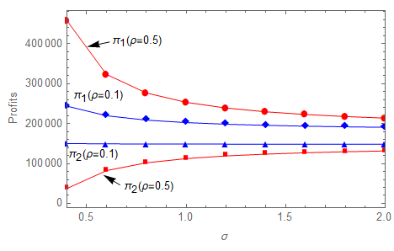

Fig.4 Effects of the cost coefficient  of the CSR effort on two players’ profits

Next, we illustrate the effect of the price competitive intensity on the profit differences between two cases in Fig. 5(b). As the price competitive intensity increases, the profit difference for provider 1 between two cases (the CSR effort case and the benchmark case) is decreasing quite rapidly from positive to negative, which shows that the benefit of the CSR effort to provider 1 is diminishing quickly. On the other hand, the impact of the price competitive intensity on the price difference between two cases for provider 2 is on the opposite. That is, as the competitive intensity increases, the price difference is increasing from negative to positive.

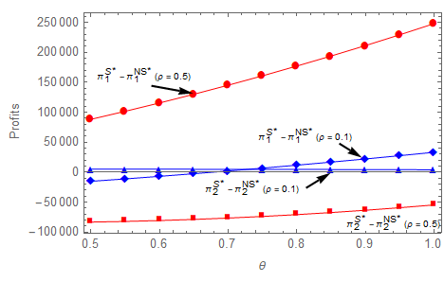 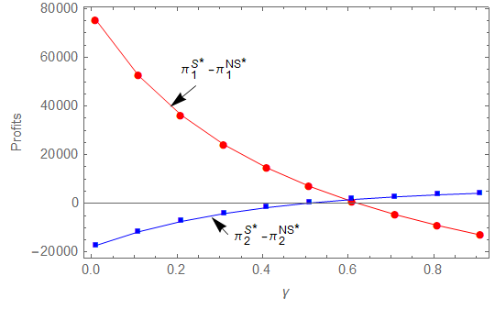

|  |  |
| --- | --- |
| (a) Market shares | (b) Price competitive intensity |

Fig.5 Effects of market share and price competitive intensity on the profit difference

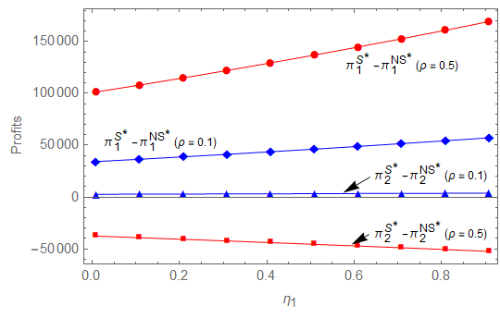 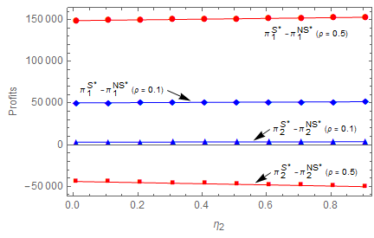

|  |  |
| --- | --- |
| (a) Provider 1’s risk attitude | (b) Provider 2’s risk attitude |

Fig.6 Effects of risk attitude on the profits

An interesting observation from Fig. 5(b) is that there exists an interval of the competitive intensity values, in which the impacts of the CSR effort on the profits of both providers are positive, i.e. the price differences between two cases are positive for both players. Moreover, when the competitive intensity exceeds a certain level, provider 1’s CSR effort would have a negative impact on its own profit but positive impact on its competitor’s profit. This phenomenon may be explained as follows. When the price competition in the market is fierce, customers are particularly sensitive to the price of the services. By adopting the CSR activities, although provider 1 can snatch and attract some customer demands, it is bound to raise service prices due to the CSR cost. The customer loss caused by the price increasing may offset the demand that provider 1 has attracted through the adoption of the CSR effort. Thus, the CSR effort leads negative impact on provider 1’ profit. On the other hand, provider 2 can raise his price in response to provider’s price increasing. This would contribute to provider 2’s profit and offset the lost demand robbed by provider 1. As a result, the CSR effort leads to a positive impact on provider 2’ profit. The above findings show that the level of the price competitive intensity has a significant impact on the profits of two providers. In particular, it is possible that provider 1’s CSR effort could benefit both players to achieve a win-win situation when the price competitive intensity lies in a certain middle range.

Finally, Fig.6 displays the effects of the players’ risk attitudes on their profit differences between the CSR effort case and the benchmark case. From Fig. 6(a), it can be noticed that as provider 1 becomes more risk-neutral (i.e. *η*1 increases), the CSR effort will benefit provider 1 to a greater extent as indicted by two monotone increasing curves corresponding to *ρ* = 0.1 and *ρ* = 0.5. When the plunder effect parameter  is larger (e.g. 0.5), the effect of player 1’s risk attitude on its profit difference becomes more significant. However, the effect of provider 1’s risk attitude on the profit difference between two cases for provider 2 is mixed and depending on *ρ*. For example, when *ρ* = 0.1, the effect is positive; when *ρ* =0.5, the effect is negative. From Fig. 6(b), we can observe the similar patterns to that in Fig. 6(a). However, the curves appear to be flatter, which implies that the impacts of provider 2’s risk attitude on the profit differences are less significant than provider 1’s risk attitude.

## Effects of System Parameters on the Social Welfare

Social welfare is one of the most commonly used criterion to measure the output of the CSR effort. Social welfare not only includes the economic performance but also concerns the quality of life that includes the performance indicators such as the quality of the environment (air, soil, water), and the availability of essential social services. This is in line with the goal of CSR activities. Thus, many studies on CSR effort have adopted the social welfare as the tool to measure the effectiveness of CSR effort (e.g. [12,13]).

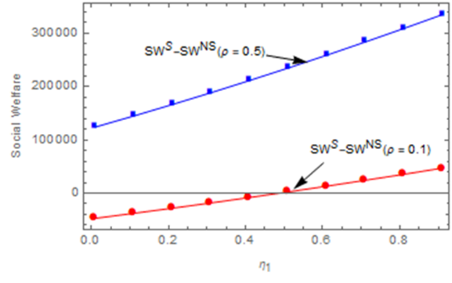 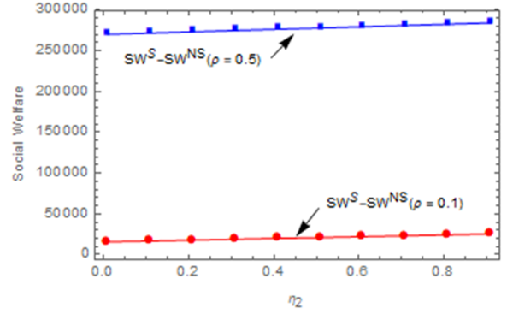

|  |  |
| --- | --- |
| (a) Effect of Provider 1’s risk attitude | (b) Effect of Provider 2’s risk attitude |

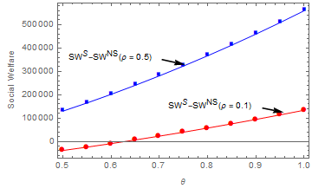 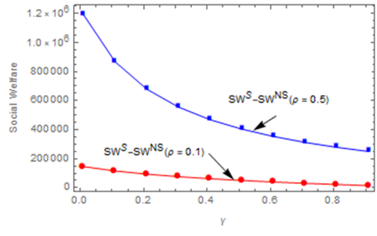

(c) Effects of market share (d) Effect of the competitive intensity

Fig.7 Effects of key factors on social welfare

In our model, the social welfare consists of three parts:

*Social Welfare = Providers’ Profit + Consumer Surplus +Externality Benefit*

Then each part is explained as:

1) *Providers’ profit* is defined as the sum of two players’ profits, , where:

,  (10)

2) *Consumer surplus* is to measure the consumer’s benefit in society and can be expressed by the area under the demand curve above the market price according to Economics (see [39]). The consumer surplus *CS(p)* of the logistics shipping service can be calculated as follows (see [30]):

,  (11)  (12)

3) *Externality benefit* can be expressed as a favorable indirect impact of a product or a service generated from the process of production, transportation, service imposed on the society. In our model, the externality benefit generated from the CSR effort of provider 1 can be calculated as:



The CSR effort  can be seen as the effectiveness of the CSR effort related to the demand, for example, the benefit from using cleaner energy (see [30,41]).

The expected *Social Welfare* is the sum of three components:



For the general adoptability, the parameter  and  are introduced to represent the weights of the corresponding components of the social welfare. When , three components are of the same importance. Now, we can analyze the differences of social welfares in two cases (the CSR effort case and the benchmark case) by numerical experiments. We focus on the impacts of the parameters such as the cost of the CSR effort, the market share, the risk attitude and the competitive intensity on the social welfare.

Fig. 7(a), (b) and (c) show that, with the increase of provider 1’s market share and the risk-averse indicators of two providers, there is an increasing gain generated from the CSR effort compared to the benchmark case in terms of the social welfare. However, with the increase of the competitive intensity in the market, Fig. 7(d) show that the effect of the CSR effort is decreasing. Furthermore, when the plunder effect parameter ρ increases, the growth rate of the social welfare gain is also increasing. The reason may be that the increase of the plunder effect can increase the degree of market concentration, then the total profits in the market increase. It is worth noting that when the market size of provider 1 is relatively small (e.g. less than 60%), the CSR effort could lead to a lower social welfare than the benchmark case when . Therefore, it is possible that adopting CSR activities may reduce the total social welfare of the entire system. The implication is that the government and non-profit organizations should not simply encourage the logistics shipping companies to adopt the CSR effort without considering the market conditions and companies’ characteristics.

# Conclusion

In this paper we consider corporate social responsibility (CSR) effort and pricing decisions for two competing shipping providers. Facing uncertain demand and fierce competition, both service providers are risk-averse. The condition value-at-risk (CVaR) is used to measure the players’ risk attitudes. We formulate the problem into a Stackelberg game model and solve the problem analytically. Through this, we have filled a research gap by combining CSR effort, competition and risk attitude of decision makers in logistics shipping systems.

Corresponding to three research questions, the findings are summarized as follows. Firstly, when both players are risk-averse, we have obtained the optimal equilibrium solutions to the players' pricing decisions in both the benchmark case and the CSR effort case. More specifically, we find that when the major provider commits CSR effort, he will increase his service price; but its impact on provider 2’s pricing decision will depend on the combination of two other parameters, i.e., the expansion effect and the plunder effect, as shown in Proposition 2. For example, provider 2 may enjoy a free-ride high price from the CSR effort of provider 1 in certain circumstances.

Secondly, the impacts of the risk-averse indicators and the competitive intensity on two players' decisions and profits are characterized and illustrated in Proposition 1, Proposition 6, and numerical experiments. Specifically, if either player is less risk-averse, provider 1 would tend to commit more CSR effort and set up higher price. The impact of risk-averse indicators on provider 2's price decision is more complicated but can be characterized into three categories determined by a set of inequalities of the system parameters. In the CSR effort case, the difference between provider 1’s and provider 2’s prices is decreasing as the competitive intensity increases. Moreover, the impacts of the long-term contract price and the service cost parameter on two players’ pricing decisions and provider 1’s CSR effort are also characterized analytically. It should be noted that under the different conditions of expansion effect and plunder effect, nearly all parameters (i.e., competitive intensity, market scale, risk preference, etc.) can generate opposite effect on the pricing decisions of two providers. In addition, the major provider (with larger market scale) prefers to operate the CSR activities. However, the CSR activities should be adopted carefully in a very fierce competition market, because in this situation, the CSR activity may result in more loss.

Thirdly, we answer the third question by some numerical experiments. We find that in some conditions, the CSR effort may be harmful to the social welfare. Numerical results show that as the players' risk-averse indicators increase (i.e. they become less risk-averse), the social welfare of the entire system gained from adopting the CSR effort is increasing. Moreover, as the cost coefficient of the CSR effort or the market competitive intensity increases, the social welfare gained from adopting the CSR effort is decreasing. An interesting finding is that it is possible that provider 1’s CSR effort could benefit both players to achieve a win-win situation; on the other hand, it is also possible that adopting CSR activities may reduce the total social welfare of the system in some situations. Therefore, this study offers managerial insights for logistics shipping firms and government into decision making and policy making by taking into account the CSR effort and the risk-averse behaviors.

However, there are some limitations in our work. First, our model considers two logistics service providers offering a similar shipping service. In practice, each company may provide multiple types of shipping services to compete with other providers. Second, our stochastic demand function is a linear function. Third, our model does not consider the role of government and non-profit organization, which may add another stage in the game models. Further research can be done by relaxing these limitations.

# References

1. Adland, R., Fonnes, G., Jia, H., Lampe, O. D., & Strandenes, S. P., “The impact of regional environmental regulations on empirical vessel speeds,” *Transportation Research Part D: Transport and Environment*, vol. 53, pp. 37-49, Jun. 2017.
2. Artzner, P., Delbaen, F., Eber, J.M. & Heath, D., “Thinking coherently,” *Risk*, vol. 10, pp. 68-71, 1997.
3. Arya, A., & Mittendorf, B., “Supply chain consequences of subsidies for corporate social responsibility,” *Production and Operations Management*, vol. 24, no. 8, pp. 1346-1357, Aug. 2015.
4. Bruno, S., Ahmed, S., Shapiro, A., & Street, A., “Risk neutral and risk averse approaches to multistage renewable investment planning under uncertainty,” *European Journal of Operational Research*, vol. 250, no. 3, pp. 979-989, Mar. 2016
5. CEVA (2015). CEVA’s 2014 Environment, Social Responsibility and Governance report: Sustainable Excellence. *CEVA Logistics*, Apr. 2015.
6. Chan, H. L., Choi, T.M., Cai, Y. J., and Shen, B., “Environmental taxes in newsvendor supply chains: A mean-downside-risk analysis,” *IEEE Transactions on Systems, Man, and Cybernetics: Systems*, to be published, doi: 10.1109/TSMC.2018.2870881
7. Chen, R., Dong, J. X., & Lee, C. Y., “Pricing and competition in a shipping market with waste shipments and empty container repositioning,” *Transportation Research Part B: Methodological*, vol. 85, no. 3, pp. 32-55, Mar. 2016.
8. Chiu, C.H., Chan, H.L., Choi, T.M., “Risk minimizing price-rebate-return contracts in supply chains with ordering and pricing decisions: a multimethodological analysis.” *IEEE Transactions on Engineering Management*, to be published, doi: 10.1109/TEM.2018.2882843.
9. Choi, B., & La, S., “The impact of corporate social responsibility (CSR) and customer trust on the restoration of loyalty after service failure and recovery,” *Journal of Services Marketing*, vol. 27, no. 3, pp. 223-233, Mar. 2013.
10. de Albuquerque, G. A., Maciel, P., Lima, R. M. F., & Magnani, F., “Strategic and tactical evaluation of conflicting environment and business goals in green supply chains,” *IEEE Transactions on Systems, Man, and Cybernetics: Systems*, vol. 43, no. 5, pp. 1013-1027, May. 2013.
11. Feng, Y., Guo, Z., & Chiang, W. Y. K., “Optimal digital content distribution strategy in the presence of the consumer-to-consumer channel,” *Journal of Management Information Systems*, vol. 25, no. 4, pp. 241-270, Apr. 2009.
12. Hong, I. H., Lee, Y. T., and Chang, P. Y., “Socially optimal and fund-balanced advanced recycling fees and subsidies in a competitive forward and reverse supply chain,” *Resources, Conservation and Recycling*, vol.82, pp.75–85. Jan. 2014.
13. Jacobs, B. W., Subramanian, R. “Sharing responsibility for product recovery across the supply chain,” *Production and Operations Management*, vol.21, no.1, pp.85-100, Jan. 2012.
14. Jullien, B., Salanie, B., & Salanie, F., “Screening risk-averse agents under moral hazard: single-crossing and the CARA case,” *Economic Theory*, vol. 30, no. 1, pp. 151-169, Jan. 2007.
15. Kang, Y., Batta, R., & Kwon, C., “Value-at-risk model for hazardous material transportation,” *Annals of Operations Research*, vol. 222, no. 1, 361-387, Jan. 2014.
16. Karray, S., “Cooperative promotions in the distribution channel,” *Omega*, vol. 51, no. 3, pp. 49-58, Mar. 2015.
17. Lam, J. S. L., & Wong, H. N., “Analyzing business models of liner shipping companies,” *International Journal of Shipping and Transport Logistics*, vol. 10, no. 2, pp. 237-256, Feb. 2018.
18. Lee, C.Y. & Song, D.P., “Ocean container transport in global supply chains: Overview and research opportunities,” *Transportation Research Part B: Methodological*, vol. 95, no.1, pp. 442-474, Jan. 2017.
19. Lee, C.Y., Tang, C.S., Yin, R. and An, J., “Fractional price matching policies arising from the ocean freight service industry,” *Production and operations management*, vol. 24, no.7, pp.1118-1134, July. 2015.
20. Lennane, A. (2013). Shippers’ growing appetite for tenders adds to market volatility, say forwarders. The Loadstar, 17th, May, 2013.
21. Li, B., Zhu, M., Jiang, Y., & Li, Z., “Pricing policies of a competitive dual-channel green supply chain,” *Journal of Cleaner Production*, vol. 112, pp. 2029-2042, Jan. 2016.
22. Liu, M., Cao, E., & Salifou, C. K., “Pricing strategies of a dual-channel supply chain with risk aversion,” *Transportation Research Part E: Logistics and Transportation Review*, vol. 90, pp. 108-120, Jun. 2016.
23. Lund-Thomsen, P., “Towards a critical framework on corporate social and environmental responsibility in the south: the case of Pakistan,” *Development*, vol. 47, no. 3, pp. 106-113, Mar. 2004.
24. Ma, P., Shang, J., & Wang, H., “Enhancing corporate social responsibility: Contract design under information asymmetry,” *Omega*, vol. 67, pp. 19-30, Mar. 2017.
25. Markowitz, H., “Portfolio selection: efficient diversification of investment,” *Investment under Uncertainty*, 1959.
26. Panda, S., Modak, N. M., Basu, M., & Goyal, S. K., “Channel coordination and profit distribution in a social responsible three-layer supply chain,” *International Journal of Production Economics*, vol. 168, pp. 224-233, Oct. 2015.
27. Pei, Z., & Yan, R., “National advertising, dual-channel coordination and firm performance,” *Journal of Retailing and Consumer Services*, vol. 20, no. 2, pp. 218-224, Feb. 2013.
28. Piecyk, M. I., & Björklund, M., “Logistics service providers and corporate social responsibility: sustainability reporting in the logistics industry,” *International Journal of Physical Distribution & Logistics Management*, vol. 45, no. 5, pp. 459-485, May. 2015.
29. Rau, P., & Spinler, S., “Investment into container shipping capacity: A real options approach in oligopolistic competition,” *Transportation Research Part E: Logistics and Transportation Review*, vol. 93, no. 9, pp. 130-147, Sep. 2016.
30. Raz, G., & Ovchinnikov, A., “Coordinating pricing and supply of public interest goods using government rebates and subsidies,” *IEEE Transactions on Engineering Management*, vol. 62, no. 1, pp. 65-79, Jan. 2015.
31. Rockafellar, R. T., & Uryasev, S., “Optimization of conditional value-at-risk,” *Journal of Risk*, vol. 2, pp. 21-42, Sep. 2000.
32. Rui, A., Yrjö, K., Chendi, Z., “Corporate social responsibility and firm risk: theory and empirical evidence,” *Management Science*, to be published, doi: 10.1287/mnsc.2018.3043.
33. Sampson, H., & Ellis, N., “Elusive corporate social responsibility (CSR) in global shipping,” *Journal of Global Responsibility*, vol. 6, no. 1, pp. 80-98, Jan. 2015.
34. Shin, Y., & Thai, V. V., “The impact of corporate social responsibility on customer satisfaction, relationship maintenance and loyalty in the shipping industry,” *Corporate Social Responsibility and Environmental Management*, vol. 22, no. 6, pp. 381-392, Jun. 2016.
35. Shin, Y., Thai, V. V., Grewal, D., & Kim, Y., “Do corporate sustainable management activities improve customer satisfaction, word of mouth intention and repurchase intention? Empirical evidence from the shipping industry,” *The International Journal of Logistics Management*, vol. 28, no. 2, pp. 555-570, Feb. 2019.
36. Soleimani, H., & Govindan, K., “Reverse logistics network design and planning utilizing conditional value at risk,” *European Journal of Operational Research*, vol. 237, no. 2, pp. 487-497, Feb. 2014.
37. Steurer, R., Langer, M. E., Konrad, A., & Martinuzzi, A., “Corporations, stakeholders and sustainable development I: a theoretical exploration of business–society relations” *Journal of Business Ethics*, vol. 61, no. 3, pp. 263-281, Mar. 2005.
38. Tzannatos, E., & Stournaras, L., “EEDI analysis of Ro-Pax and passenger ships in Greece,” *Maritime Policy & Management*, vol. 42, no. 4, pp. 305-316, Apr. 2015.
39. Varian, H. R., “Intermediate microeconomics: a modern approach: Ninth International Student Edition,” *WW Norton & Company*, 2014.
40. Xiao, L., & Lo, H. K., “Adaptive vehicle routing for risk-averse travelers,” *Transportation Research Part C: Emerging Technologies*, vol. 36, pp. 460-479, Jun. 2013.
41. Xie, G., “Modeling decision processes of a green supply chain with regulation on energy saving level,” *Computers & Operations Research*, vol. 54, pp. 266-273, Feb. 2015.
42. Xu, L., Govindan, K., Bu, X., & Yin, Y., “Pricing and balancing of the sea–cargo service chain with empty equipment repositioning,” *Computers & Operations Research*, vol. 54, pp. 286-294, 2015.
43. Yin, M., Kim, K.H., “Quantity discount pricing for container transportation services by shipping lines,” *Computers & Industrial Engineering*, vol. 63, no. 1, pp. 313–322, Jan. 2012.
44. Yliskylä-Peuralahti, J., & Gritsenko, D., “Binding rules or voluntary actions? A conceptual framework for CSR in shipping,” *WMU Journal of Maritime Affairs*, vol. 13, no. 2, pp. 251-268, Feb. 2014.
45. Yuen, K. F., & Thai, V. V., “Corporate social responsibility and service quality provision in shipping firms: financial synergies or trade-offs?,” *Maritime Policy & Management*, vol. 44, no. 1, pp. 131-146, Jan. 2017.
46. Yuen, K. F., Thai, V. V., & Wong, Y. D., “An investigation of shippers’ satisfaction and behaviour towards corporate social responsibility in maritime transport,” *Transportation Research Part A: Policy and Practice*, vol. 116, pp. 275-289, Oct. 2018.
47. Zheng, W., Li, B., & Song, D. P., “Effects of risk-aversion on competing shipping lines’ pricing strategies with uncertain demands,” *Transportation Research Part B: Methodological*, vol. 104, no. 10, pp. 337-356, Oct. 2017.
48. Zheng, W., Li, B., Huang, H. F. and Song, D. P., (2019) Optimal CSR and Pricing Decisions with Risk-averse Providers in a Competitive Shipping System, Technical report, Tianjin University.
49. Zhou, W. H., & Lee, C. Y., “Pricing and competition in a transportation market with empty equipment repositioning,” *Transportation Research Part B: Methodological*, vol. 43, no. 6, pp. 677-691, Jun. 2009.

**Wei Zheng** obtained his BSc and MSc at Tianjin University. He is currently a PhD student in Tianjin University. He has had papers published in journals such as *Transportation Research Part B*. His research interests include supply chain management, transportation management and operational management.

**Bo Li** received the BSc and MSc at Nankai University and PhD at Tianjin University. She is currently a professor at Tianjin University. She has had papers published in *Transportation Research Part B/E, International Journal of Production Economics, International Journal of Electronic Commerce, International Journal Production Research.* Her research interests include supply chain management, Operational management, supply chain financial.

**H.F. Huang** obtained his BSc and MSc at Military Transportation University in Tianjin. He is currently a PhD student in Tianjin University. His research area includes supply chain management, operation management under low carbon environment.

**Dong-Ping Song** (M’06–SM’08) obtained his BSc and MSc at Nankai University and PhD at Zhejiang University and Newcastle University. He is currently a Chair of Supply Chain Management at the University of Liverpool. He has had papers published in journals including *IEEE Tran. on Automatic Control, SIAM Journal on Control & Optimization, European Journal of Operational Research, Transportation Research Part B/E/D*. He is an Associate Editor for *Transportation Research Part E* and *International Journal of Shipping and Transport Logistics*. His research interests include transport and logistics, supply chain management, emissions and sustainability.

1. Readers can refer to https:// www.almasahcapital.com
2. Readers can refer to https://www.eurofound.europa.eu/publications/article
3. Readers can refer to http://www.sino-report.com/
4. Readers can refer to https://sustainability.ups.com/committed-to-more/sustainability-solutions/