Architecture, Time, and Cultural Politics
Paul Jones, University of Liverpool

Abstract
Architecture is inextricably entangled with time. Illustrating this point, the article explores two moments of architectural production centred on London in the mid-nineteenth century: the 'Battle of the Styles', a struggle over the social meaning of historicist architectural design and the suitability of different revivalist styles for state-funded public buildings; and the proto-modernist Crystal Palace, which housed the Great Exhibition of 1851. While ostensibly involving different cultural orientations to pasts-presents-futures, both cases reflect ways political claims making can involve the mobilisation of temporalized architectural forms. A general contention is that architecture is a culturally- experimental space through which nation-states and architects seek to orientate otherwise abstracted notions of temporality. While there is no straightforward or singular correspondence between temporality and architectural sites, the built environment is pushed and pulled by states' politicized claims regarding time and temporality. Architecture always involves the materialisation of particular and partial visions of the world as is, as was, and as could be; temporal registers in the built environment see the stabilisation of some ways of being and the displacement of others. The political basis of such can be illuminated sociologically.

Introduction
Social scientific analyses of time have added much to our understanding of this fundamental category of collective human experience (Zerubavel, 1982, 1996, 2003; Adam, 1990; Edensor, 2006; Lorenz and Bevernage, 2013 Bastian, 2014). For its part, sociological research in this field typically eschews metaphysical analysis in favour of the situated study of the locally-rational sense-making that underpins the production of collectively-meaningful time, with Jconsensus regarding such reliant in part on objects for its legibility (Stewart, 2015). Importantly, this research has shown it is not just clocks and other explicitly temporal technologies that allow time to become resonant; cultural artefacts such as currency, educational curricula, flags, music, and pageantry help symbolise and narrate political belongings vis-à-vis temporality.

Here I argue that - due to its material and symbolic affordances - architecture is one site in which political institutions attempt to make understandings of time meaningful to a variety of publics. With some notable exceptions (Jones, 2011, 2016 for surveys), sociologists have on the whole been slow to address architecture in general; in particular the fascinating question of the entanglement between the built environment and the cultural politics of time remains to be directly interrogated. My approach to the study of architecture sets out to disrupt the ready contextual familiarity of the built environment, denaturalising the sets of spatial assumptions that lead to its commission and realisation, and to highlight buildings’ relation to a particular type of social order (this is distinct to architectural historians’ approach, which is more ‘internal’, inasmuch as it can begin and end with formalistic properties of designed style). Against this backdrop, this article draws perspectives from studies of time into an analysis of state-commissioned architectures. The overarching aim is to explore some of the ways in which the built environment has been mobilised by the UK state relative to time; focusing on the 19th century, in a period when experiment characterised architectural design, I take two different ‘controversies’ as a way in to this study (Yaneva, 2014).

The paper is in four main parts. Section One briefly introduces some sociological analyses of time. The work of Eviatar Zerubavel (1982, 1996, 2003), amongst others, is used to address two key questions, concerning: i) the requirement for cultural objects to materialise time’s otherwise abstract nature; and ii) the divisive character of socially-sanctioned time, which is political inasmuch as it adds momentum to some practices and removes it from others. In Section Two the relation between time and architecture is considered. In this section, the temporal nature of architectural meanings - and the practices they imply - are discussed alongside some important sociologies of architecture (from Bonta, 1979 and Molnár, 2006 amongst others), which in turn imply the significance of time for understanding the built environment, its meaning and use. The remainder of the paper focuses on two instances of governmental commission of very different – but related - architectural-temporal expressions.

Section Three addresses the 'Battle of the Styles', a series of mid-19th century disagreements in UK architecture and politics concerning the most appropriate form for landmark, state-funded public buildings. In this context, Gothic and Neo-classicism - two revivalist architectural styles – were positioned by their protagonists (drawn primarily from architecture, design, and politics) as materialisations of competing historicist civilisational values (Lee and Beck, 1954; Kornwolf, 1974; Iggers, 1995). Reflecting governmental appetite to exploit architecture’s socially-meaningful nature - and the relative weakness of the emergent architectural profession’s interpretative authority - the Battle of the Styles drew historicist architecture squarely into governmental representation. The suggestion is that through the commission of these historicist buildings, the state and their architects sought not just to materialise, but to actively create, cultural pasts; these were part of wider sets of political discourses that were used to explore – and gain authority over - the political present.

Section Four addresses the case of the Crystal Palace, a temporary iron and glass structure that housed the 1851 ‘Great Exhibition’. The Crystal Palace was also a political-cultural experiment, but with radically-advanced engineering construction techniques and modernist aesthetics. The Crystal Palace illustrates how in the context of ‘megaevents’ the work of architects is implicated and imbricated relative to the articulation and cultural embedding of state-commissioned futures. The extensive use of glass and other ‘new’ materials and techniques on the Crystal Palace went with the grain of an exhibition curated explicitly to create invidious comparators between industrial-capitalist futures and the colonised, devalued pasts and ways of being of others.

Centrally then, the paper concerns the mobilisation of architecture by states relative to narratives of time. While both case studies emerge from the mid-19th century UK context, these were buildings that their designers and politicians situated very differently relative to pasts and futures; this historicist and modernist architecture is reflective of the considerable appetite of the UK state to codify the time dimensions of their political programmes through architecture. Although the cases assessed appear as opposed temporal registers – one historicist, one modernist - they were coterminous political experiments with architecture and time. The two cases are not chosen as direct comparators, so much as complementary examples that allow sociological theories of time to be deployed. Drawing on academic retellings of the period/controversy - and a few first-hand contemporaneous accounts - the paper seeks to reconstitute these ‘battle lines’ to emphasize their temporal dimension. The argument here is suggestive of the Battle of Styles concerning the state’s place in time, as much as architectural style (its seeming focus). One key aim of the paper is to draw out the controversies that centre on architecture with respect to time; an overarching argument is that state-commissioned architecture is a cultural terrain on which governments and architects experiment with cultures of time.

Section One: Sociological Study of Time
As 'the category of time neither inheres in nature nor does it exist as an a priori category of the mind' (Stewart, 2015: 152), the ways in which it is made ‘real’ and culturally resonant has been of much interest to sociologists (Durkheim [1915] 2008; Merton and Sorokin, 1937; Zerubavel, 1982, 1996, 2003; Adam, 1990). Certainly, studying how shared assumptions about time provide a context for social life, how they are made legible – and dissented from - through symbols and technologies, opens up a number of beguiling possibilities for analysis.

For example, clocks and associated time-keeping - more accurately time-making - technologies have been interrogated, as has their incorporation into industrialised work (Thompson, 1967). The highly gendered social relations that industrialised time regimes gave rise to are also the object of much critical analysis (Adam, 1990; Bastian, 2014; Browne, 2014), and remind us that time is always an 'irreducibly social' (Adam, 1990: 89) category. In other words, the social reality of time is contingent on the cultural articulation of shared-but-partial meaning regarding collective rhythms of experience; it is ‘[intersubjective] experience... created through social interaction' (Nowotny, 1994: 425), and it is this that forms the basis of sociological study.

Emile Durkheim’s pathbreaking The Elementary Forms of Religious Life positioned time as a fundamental category of collective human experience, without which social life is impossible. A social fact, 'time common to the group' (Durkheim [1915] 2008: 12) has an external character that constrains practice and conceptions of reality to some empirically-open extent. From this perspective, if time is to be the object of effective socialisation, it requires embedding in socially-resonant form recognisable to group members. In addition to the clocks, sundials, sand timers, pendulums, and other technologies used to mark/make time, ostensibly non-temporal artefacts are also crucial in making pasts-presents-futures meaningful to this end (Zerubavel, 1982; Adam, 1990; Stewart, 2015). Such objects help to externalise implicit and/or amorphous social realities with respect to space and time, making both categories tangible and reminding members of human societies both of their mortality and their reliance on the group (Durkheim, [1915] 2008; Miller, 2000).

In line with Durkheim's broader theory ([1915] 2008), it is the structurally-similar experience of participating regularly and rhythmically in communal rites and rituals over many generations that creates a sense of normalised, taken-for-granted time regimes (Merton and Sorokin, 1937; Nisbet, 1975; Julkunen, 1977; Miller, 2000); as time emerges from - and shapes - social life, it can only be understood relative to the practices that give/borrow meaning to/from it. In short, time is an inherently relational category that helps situate otherwise disconnected events and rituals (Miller, 2000). By approaching time-making as a practical endeavour that is symbolised in outwardly different but structurally-similar ways, Durkheim and his followers make it clear that judgements concerning objects and time are inextricably linked to other social categorisation practices (Julkunen, 1977; Miller, 2000).

Precisely because of this relation to other hierarchical sets of value judgements concerning social categories, time is not a 'boundless canvas' against which any claims at all can become resonant; it is not a 'plastic' resource 'infinitely susceptible to the whims of contemporary interest and the distortions of contemporary ideology' (Appadurai, 1981: 201). As a cultural construction bound up with the distribution of other resources, the normalizing of time is then a highly political issue. Implicitly and occasionally explicitly critiquing Durkheim’s approach, a number of thinkers exploring temporality have suggested that – far from the consensual category growing from shared assumptions concerning social interaction - the creation and embedding of time is a site of socio-cultural conflict, which benefits some groups and marginalises others (for example, Thompson, 1967; Zerubavel, 1982, 1996; Adam, 1990; Bastian, 2014). Against this backdrop, the emergence of modern states’ ‘time maps’ (Zerubavel, 2003) involves the addition of momentum to some memories and temporal visions and away from others. As Zerubavel argues, time is a socially-structured form that in turn structures ways of thinking and being; not only does the temporal provide a formal feature of the ways in which we collectively remember (2003: 7), it also allows otherwise disparate events and social formations to be arranged and ranked.

If we are to approach time as an uneven, divisive category with a close relationship to material artefacts, then critical sociological analysis can concern itself with the forms these objects take, how they help make legible certain (partial) temporal assumptions concerning social order and their relation to elite social visions. I now turn to architecture, which I suggest is a space in which questions concerning the cultural politics of state time are extremely pertinent, if to date understudied. Sociological analysis of such must necessarily deal with the temporal dimension of politics, and the ways in which states situate themselves within differing registers of time, narrating social pasts-presents-futures as they do.

Section Two: Architecture and Time
It was suggested above that, as an abstracted element of collective human experience, time requires materialisation for its stabilisation and legibility. Architecture is an excellent technology to deploy to this end: not only do buildings satisfy dual requirements of symbolising social orders while sheltering their institutions (Gieryn 2002; Whyte, 2006), they are also publicly-visible sites bound up with everyday experiences on the one hand, and spectacular events on the other. Due to these affordances, architecture is frequently commissioned by states seeking to articulate sets of cultural-temporal claims, to add meaning and status to the social activity the built environment encloses (Whyte, 2006). A number of theoretical and empirical challenges for the sociologist emerge from this context, all of which involve denaturalisizing the ostensible stabilities that lead to the commission, design, and use of certain types of buildings for certain types of things.

This approach is in evidence in Juan Pablo Bonta's analysis (1979) of the changing reception of the Ludwig Mies van der Rohe-designed German Pavilion at the 1929 Barcelona EXPO. Bonta draws out the changing, but at-that-moment stable, nature of prominent critics' architectural judgements of this now celebrated, but then overlooked, structure. Revealing the ‘collective plagiarism’ within critics’ pronouncements on this building’s meaning and value, for Bonta it is the emergence and dissemination of an 'architectural orthodoxy’ - an aesthetic consensus amongst a cultural elite – that explains why the collectivised judgements concerning value ‘originate and disappear with time’ (1979: 16-22). There is an arbitrary, as distinct from random, foundation to these critics’ judgements: if they are to be considered valid by architectural publics they need to be 'in time' and to connect with wider sets of aesthetic consecrations of their day. Through his inquiry, Bonta shows that judgements about architecture’s aesthetic value is bound up with the cultural zeitgeist, sets of assumptions concerning beauty and value in the built environment; architecture is a field conscious of its own history, with the ‘trained bodies’ (Stevens, 1998) of architects socialised into learning relational values regarding buildings, styles, and architects.

Further illustrating the contingency of architectural value relative to time, Virag Molnár has studied the controversy surrounding the use of Tulips – a historic folk decoration – on otherwise-minimalist Hungarian modernist buildings in the post-war period (2005). A series of contests centred on the adornment of buildings that had tulip motifs; these were symbols that ran counter to other definitions of international modernism's aesthetic of future-orientation. Accordingly, in the Hungarian post-war context the use of tulip decorations became a touchstone for wider questions concerning national cultural pasts and futures. As Molnár’s study shows, interpretative struggle over architecture’s meaning does not take place in a cultural vacuum, but overwrites other forms of social division and controversy, including concerning the ways in which pasts-presents-futures are to be articulated culturally and the place of a given society in history. In this case, the tulip was a locally-important architectural symbol, with meaningful associations with pasts.

Bonta (1979) and Molnár (2006) give us critiques of architectural conventions of meaning and judgement, focusing on the practices of critics and designers respectively; a strong conclusion from their work is that architectural style should not be essentialised, or equated with a stable meaning (also see Steets, 2016). Rather, the creation of meanings of style, materials, the value of certain architects, and what should be done or not in their buildings are the basis of controversy, which can fruitfully be studied sociologically (Yaneva, 2014). In contested contexts in which architecture is implicated, apolitical statements concerning the built environment are analytically inadequate; studying architectural controversies sociologically involves less taking sides in the sets of cultural assumptions that they presume, but denaturalising such. The tendency to ‘fold in’ authors’ aesthetic preferences is typical in architectural criticism (Panofsky, 2005; Porter, 2011a), but sociological accounts must not so much pick sides in architectural controversies, so much as illuminate the implication of the built environment in projects of social ordering political representations of institutions, and the stabilisation of certain practices and not others.

Theoretically then, it is the ‘essential arbitrariness of [architectural] symbols that allows them to be the object of struggles, in which groups try to convince others to value their capital more than that of their rivals’ (Stevens, 1998: 69). This arbitrariness, which I take to mean that judgements could be different, extends to questions concerning the ‘timing’ of values, meanings, and uses. The very presence of buildings gives the illusion of stability (a point made more broadly by Gieryn, 2002; Whyte, 2006), including regarding the reality of time. In addition to the meaning of architecture there is the extent to which it is involved in the actual shaping of practice. This is particularly evident when we think of the gendering of sites within buildings, or the disabling character of elements of the designed environment; assumptions regarding social order seep in to architectural design, taking on material form as a result, and then can in turn materially reinforce inequalities and divisions. Just as states commission architecture, they de facto create the material and symbolic conditions that emphasize some ways of being and not others, delivering the sites that are experienced as hostile by some groups of people and not to others. The monumental public buildings commissioned by states overwrite and compound other sets of social boundaries; as the paper goes on to argue, time is one such divisive element, with assumptions concerning pasts-presents-futures underpinning the commission and design of certain types of buildings and not others.

Architecture’s affordance to embed otherwise abstracted projects within socially-meaningful form has long meant leading architects - whose practice is ‘client-dependent’ inasmuch as commissions are typically required to realise it (Larson, 1996; Stevens, 1998; Jones, 2009) – are commissioned by governments seeking to symbolise change or continuity (Vale, 1992). Time remains an understudied plane in studies of these issues within what is still an emerging sociology of architecture. Although many of the sociological studies of architecture drawn upon here have a significantly temporal dimension, the analysis of time tends to be implied rather than explicit (for instance in Bonta, 1979; King, 1980; Molnar, 2006).In what follows I develop lines of inquiry from sociological studies of time so as to interrogate the cultural politics of major state-funded buildings; the result in an increased theorisation of the crucial temporal dimension in architectural politics.

The two cases that are interrogated in the following sections have been chosen purposefully. Despite being the result of commissions by the same government, at the same time, they point in very different directions with respect to time. Drawing from both sociologies of time and sociologies of architecture, I demonstrate that these buildings were part of a cultural context in which people gained understanding of the past and the future. A potential of critical sociological research is to pull buildings out of the sets of temporal assumptions that characterise their commission, design, interpretation, and use. This is a challenging task of course, but one that the application of theories from sociologies of time can help us achieve. Just as with time in fact, the ready familiarisation we enjoy with the built environment can mean that it becomes part of a ‘time map’ (Zerubavel, 2003) that remains a crucial – but unspoken – part of the ways in which governments commission and mobilise symbols of pasts-presents-futures.

Section Three: The Politics of Architectural Pasts
In the mid-19th century in the UK, cultural claims concerning the Victorian state’s place in time, and how to best symbolise it, became the basis of interpretive struggles regarding the meaning of state-commissioned architecture. In general, significant expansion of UK state activity in this period was accompanied by its monumentalisation in the built environment, with government enthusiastically commissioning architecture to serve both as part of an ‘invention’ (Hobsbawm and Ranger, 1983: 4) and a ‘flagging’ (Billig, 1995) of the cultural nation. As was argued above, the achievement of temporal continuity is a political one (Zerubavel, 1982: 3-5; Adam, 1990), that implicates all manner of objects and artefacts.

The quest for an ‘appropriate’ architectural style in which to situate the expanding UK government’s functions set up a cultural-political ‘Battle of the Styles’ that involved entrenched disagreement concerning the meaning – including temporal meaning - of state-funded buildings. In the Battle of the Styles, two revivalist architectural styles - neo-gothic and neo-classicism - gave protagonists a material basis to support political claims concerning ‘socially appropriate narrative forms for recounting the past’ (Zerubavel, 2003: 5). It is important to note that they were both historicist styles, albeit drawing from different geo-political lineages and traditions of design; both Gothic and neo-classicism ‘corroborate[d] the world view of the dominant class, by carving in stone their interpretation of their historical and cultural identity’ (Heynen, 1999: 375).

As a starting point, controversies in architecture are useful from the point of view of sociological analysis as they compel protagonists to articulate their position explicitly (and relative to that of the opponent) (Yaneva, 2014). Classicism - associated by its advocates as representing symmetry, geometric form, clean lines, and Enlightenment rationality (Crinson, 1996) - was stylistically at odds with Gothic, whose arches, ribbed vaults, and buttresses are redolent of ecclesiastical architecture and castles:

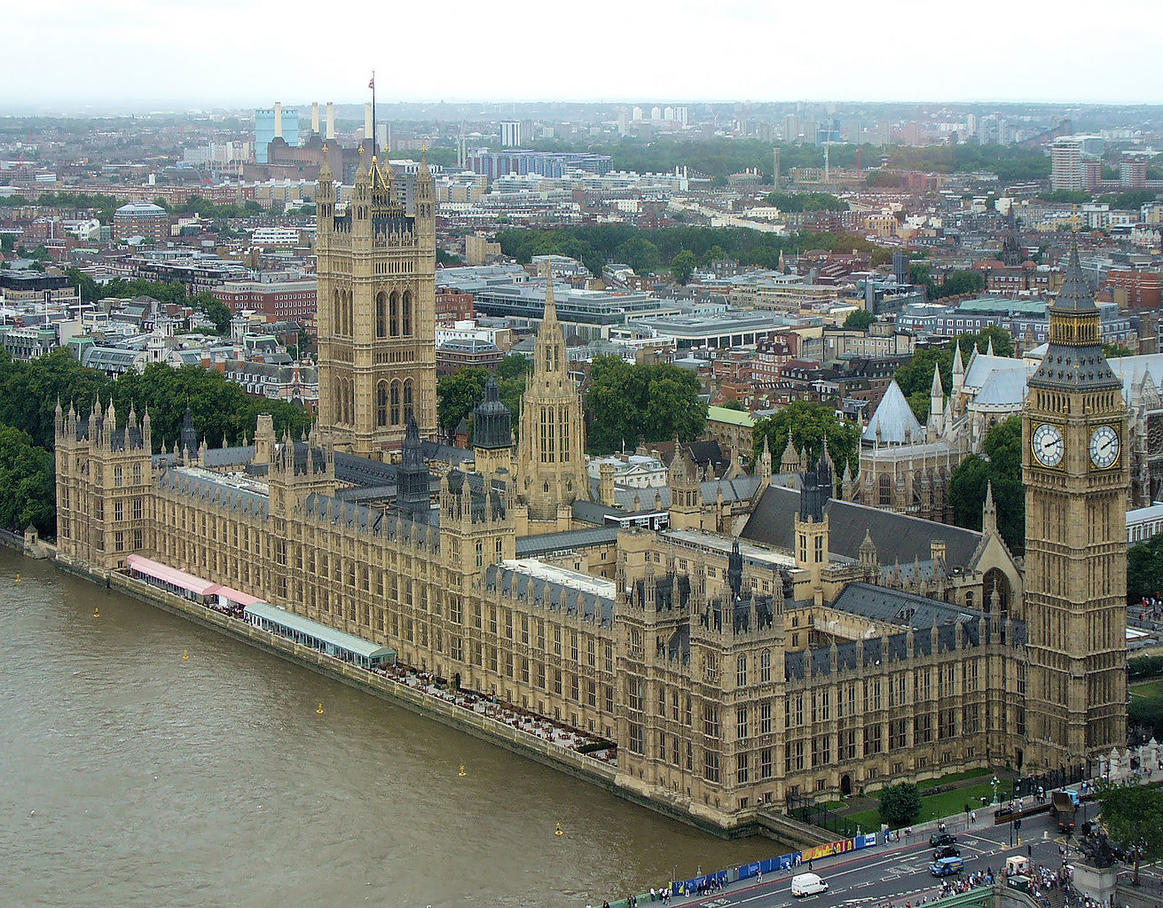

Image 1.1 – The Palace of Westminster (‘Houses of Commons’), London. An example of mid-19th century UK ‘English’ Gothic. Image courtesy of
Wikipedia Commons; available for reproduction on a Creative Commons License https://commons.m.wikimedia.org/wiki/Palace_of_Westminster#/media/File%3AWestminster_Palace_2.jpg

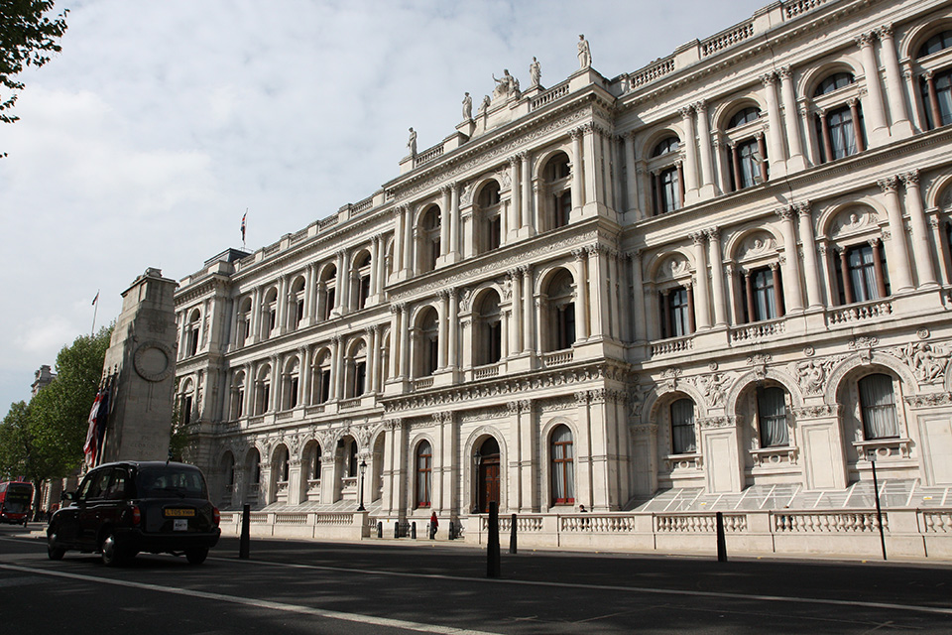

Image 1.2 – Foreign and Commonwealth Office, London. An example of mid-19th century, UK translation of neo-classicism. Image courtesy of Wikipedia Commons; available for reproduction on a Creative Commons License https://commons.m.wikimedia.org/wiki/File:Foreign_%26_Commonwealth_Office_(15352849624).jpg

These, and other key buildings in the Battle (such as Marble Arch, the Albert Memorial, and St Pancras Station [all London]), are saturated in semiotic assumptions and aesthetic sensibilities of their time, even as their architects and commissioners were deploying them to stand in for others. In other words, the 19th century architectural present was active in shaping pasts, replete with all manner of cultural-political assumptions of that day. The active creation of historic architectural styles involved the design and construction of buildings that – far from being ‘authentic’ – were highly stylised vis-a-vis Victorian cultural-aesthetic assumptions (and that accordingly bore all manner of amplified elements, oversights in terms of historic building techniques – see Crinson, 1996). These general arguments are explored and substantiated with respect to the cases under consideration in what follows.

So, while neither building in the images above looks like a radical avant-garde in the contemporary context, somewhat paradoxically for both neo-Gothics and neo-classicists ‘their’ style was a materialisation of a past that their contemporaneous society was a continuation of. Just as the Victorian social form was a culmination of civilisation, democracy, colonial power, and economic development, architecture helped to situate that society as the apogee of history, ‘as a continuation of the past’ (Zerubavel, 2003: 37). Accordingly, architectural pasts were one way for the commissioning UK state to emphasise lineage and, paradoxically, the modernity of their present (Lee and Beck, 1954; Crinson, 1996). Cultural artefacts – including architectural - are curated to assist in metaphorically ‘inflating’ some periods and backgrounding others (Zerubavel, 2003: 25-35): in the Battle of the Styles it was partial versions of ancient social orders that were being emphasised. Both styles of building are reasonably common to those familiar with major UK cities, but when first designed – despite appearing mediaeval – constituted a ‘new style’, unfamiliar to the contemporaneous gaze. There is a paradox here, which Zerubavel’s work (especially 2003) highlights theoretically, and with reference to other examples: the celebration of pasts is a cultural-political project, but symbols of the past are sites of contemporary production, reworking, and reinvention.

From the perspective of the Battle’s protagonists then, both styles were representations of different civilisational meanings, moralities, and ways of life. Gothic, drawn from medieval cathedral architecture, and neo-classicism, primarily associated with ‘European’ (Roman) heritage, became a way that national cultural differentiation was materialised and could be made meaningful (Crinson, 1996: 38). Somewhat ironically, given the mediaeval myths of its origin that gained traction (Kornwolf, 1975), for its supporters Gothic was 'the fresh young Turk of a style that was supposed to sweep away the Classical dead wood and revive the architectural face of Britain' (Porter, 2011: 11). Put bluntly, it was a new take on an old style. On the opposing side of the ‘Battle’, for its advocates, neoclassicism hinted at a stripped-down rationalism, a proportionate approach to building and public life that foreshadowed later modernisms.

Furthermore, although Gothic and neoclassicism were both represented as quintessentially ‘British’ by their respective advocates (Porter, 2011b), they actually were reinterpretations of styles associated with prior European civilisations (of ancient Rome, Greece in the case of neo-classicism, and European colonial powers such as Germany and France in the case of Gothic). Allusions to historic empires or regimes elsewhere were not coincidental; transit of Gothic and Neo-classical styles through time and space involved translation of knowledge garnered on the so-called Grand Tour (Chaney, 1998), that is classed travel around European cities and sites of architectural significance, undertaken by an elite group of young classically-educated ‘Gentleman Architects’ (Cohen, 2001; Naddeo, 2005). The European high cultural discourses emanating from the Grand Tour did suggest/represent massively broad sweeps of time, and were attractive to states wanting to situate themselves as civilisationally-significant institutions, and to ‘stretch’ time to situate themselves as part of civilisational lineages (Zerubavel, 2003: 59). Despite the superficially formalistic/aesthetic similarity of buildings from radically different sociology-historic peridots, emphasis on cultural continuities is often bound up with political desires to create linkages and lineages between particular parts of the world, particular times, and their attendant social arrangements.

While the knowledge made geographically and historically mobile by the tour was key for architectural periodisation and canonisation, the interpretative ‘rules’ of the professionalising architectural field were still nascent (Brain, 2009). Reflective of this messy situation, ‘The Tour’ did not result in cultural agreement concerning the social values of architecture: disagreement concerning the meaning of styles proliferated (Chaney, 1998). While knowledge of styles distant in time and space allowed British architects to consolidate the semiotic and aesthetic parameters of their field of operation - and to distinguish their expertise from related building professionals (Stevens, 1998) - cultural disagreement was revealing of the then still-fragile semiotic authority of the architectural profession. So, the ‘correct’ [sic] readings of style were part and parcel of architecture’s project of professionalisation, but in the period under consideration were still significantly in flux (Brain, 2009).

As no unquestionable canonical authority – of the type studied by Bonta (1979) – existed in architecture, partiality and differing interpretations of styles abounded. Formalistically-speaking, both Battle of the Styles styles were hotchpotches drawn from a variety of vernaculars, and included otherwise-disparate elements of historic architecture (Kornwolff, 1975; Crinson, 1996; Porter, 2011a). Despite the outwardly culturally-assured positions of Battle of the Style advocates (Porter, 2011b), both 19th-century revivals involved the partial translation of historical styles, oxymoronically expressing of the active nature of translation (Kornwolff, 1975; Iggers, 1995). In 19th-century architecture Controversy concerning translational error [sic] abounded; the sources reviewed here – which help build my argument – are reflective of the differing positions staked out by protagonists in the Battle of the Styles (Ruskin [1842] 1992; Panofski, 2005). The variant positions in this architectural controversy are analytically significant in and of themselves (Yaneva, 2014), but the sources – including later reconstructions (for example Kornwolff, 1975; Crinson, 1996; Porter 2011a, b) – can also be understood as part of a representative cultural politics surrounding the built environment and its temporal meaning.

The architect Augustus Pugin - a particularly vocal supporter of Gothic architecture, which he thought a pure and true form, and co-designer of the UK ‘Houses of Parliament’ - described the popular form of Gothic as incorrect, a translation of prior misreadings and misinterpretations (Crinson, 1996). Decimus Burton, architect of many major neoclassical houses and prominent supporter of urban development in that style, made similar observations about the technical errors associated with partial interpretations of historic buildings (Ruskin, [1849] 1992). In a reflection of the relatively callow nature of architectural authority, the Battle was plural in terms of the backgrounds of those intervening. In the absence of a codified professional status for architects – relative to others working in the built environment such as masons, engineers, greenhouse designers, critics, etc – the plurality of interlocutors is worthy of note. Rather, politically and economically dominant men/the factions they spoke for intervened in architectural semiotics and aesthetics. The positions of these figures is revealing of the general arguments suggested above.

The then Prime Minister, Lord Palmerston, was a central protagonist in the Battle of the Styles who ‘loathed Gothic... thought it was dark and gloomy; he associated it with medieval superstition' (Porter, 2011: 12). Palmerston saw Gothic styling on state buildings, such as the House of Commons, as 'wholly unsuited … [though] admirably suited for a monastic building, a monastery, or Jesuit college, it was not suited, either internally or externally, for the purpose to which it had now been proposed to apply' (Parl. Debs (series 3) vol. 155, col. 931; 4 Aug. 1859). Politicians such as Palmerston voicing strong opinions about architectural semiotics is further reflective of the emergent status of architects who themselves were less definitively authorial regarding architecture’s meaning than their profession would subsequently become. The critic John Ruskin, a champion of Gothic architecture due to the astounding technical skill of the craftspeople carving stone, making stained glass, and the other elaborate features characteristic of the style, was also a critic of standards that he felt fell short of the required artistry on Gothic (Ruskin, [1849] 1992). In his definitive guide to the style, the critic Erwin Panofsky also suggested that ‘there exists between Gothic architecture and Scholasticism a palpable and hardly accidental occupancy’ (2005: 12).

So, this ‘battle over the social legacy of the past’ (Zerabuvel, 1996: 283), was characterised not so much by disinterested, objective positions regarding architecture but political ones bound up with claims pertaining to pasts-presents-futures. Even when the architectural canon was uncertain, it provided a space for struggle between political elites concerning their legitimacy, contingent at that point on the authority borrowed from the cultural past (Therborn, 2002).In fact, there is an oxymoron here: the relative fragility of architectural knowledge concerning historic architectural styles saw them as a cultural battleground of which differing projections could be cast in stone. Accordingly, the stability of architectural meaning was not in evidence in the Battle, so much as its malleability and interpretative shifts. Of course, this is not to suggest time – or architectural meaning - as completely malleable (see Appadurai’s 1981 critique), but rather that there was an affinity between political aims and historicist architectural oeuvres, even as the cultural basis for the latter was unsure. Capturing the centrality of time to social life requires us to think sociologically concerning the ways in which it is made tangible (Zerubavel, 2003).

As well as rarefied debates concerning architectural interpretation, MPs wanted to avoid the politically-unfavourable impression of largesse with respect to buildings paid for by the public purse but with an elite political and social function. Whether or not buildings such as the Foreign Office should exist at all, as well as what they should be for or what they meant, were issues folded into the Battle (Porter, 2011). Despite being referred to as a 'Palace of Administration' by some, it was the literal collapse of the previous Foreign and Commonwealth Office that saw urgency for the commission of the new one (Porter, 2011: 10). It was motivations both pragmatic and cultural that led to the Victorian state generating architectural competitions so prolifically (Roraburgh, 1973). Still, the commissioning of buildings to house government function created opportunity for newly-professionalising architects keen to express their cultural capacity for the ‘construction’ of meaningful form. As well as illustrating architecture’s ‘dual function’ of symbolism and utilitarian shelter for activity (Whyte, 2006), competitions were often the sites of major controversies in the Battle of the Styles; for example, the 1834 design competition for the ‘Houses of Parliament’ – which required rebuilding after major fire damage - specified a ‘medieval’ style, widely interpreted by architects and politicians to mean Gothic (Kornwolf, 1975; Crinson, 1996). The competition had over 240 entries; a so-called 'pamphlet war' between protagonists accompanied this and other design competitions (Porter, 2011: 12).

Importantly, the buildings resulting from the Battle of the Styles provided somewhere to meet, ‘do’ the formal elements of political administration. Much of this ‘practical’ politics involved with the administration of colonised societies elsewhere in the world. However, the architectural historian Bernard Porter forwards the view that the architecture that emerged from the Battle of the Styles ‘was relatively empire-free’ (2010: 182); he sees the lack of ‘evidence’ in contemporaneous documentation as key, and places much credence on what is explicitly said or written concerning architecture by culturally authoritative sources. But if one problem, as identified by Porter, is finding Empire everywhere, in all of the cultural expressions of a colonial society, then finding it nowhere is an equal and opposite problem. Porter’s position (2010, 2011a, 2011b) claims a stake in the battle, contingent on an interpretative authority that posits an essentialised meaning of buildings, so missing both the dynamic basis of architecture’s production and use, not to mention the cultural politics of time more broadly. Again, sociological analysis may seek to disrupt the central claim of the battle, that is that architectural styles are essentially embedded with moral value, rather than taking sides in it. Porter’s reconstruction of the Battle is written from the perspective – scholarly and precise though it is – of one who has a particular stake in the controversy, rather than an analytical perspective that reflects on the ways in which architectural controversies are animated by social ones, and vice versa (Yaneva, 2014).

Furthermore, sociological analysis of the Battle of the Styles is revealing of at least two key things relative to architecture and time: i) as the architectural field was nascent, the social meaning of the built environment was open to a variety of interpretations. Precisely because knowledge of styles distinct in time and space was fragile, and architects’ professional authority uncertain, government commissioners had input regarding buildings’ meaning and value; and ii) time matters vis-a-vis the creation of meaning in the built environment, which always rests on architecture’s ‘dual function’ of symbolism and utilitarian shelter for activity (Whyte, 2006). It is now to a very different architectural manifestation of state time that the paper now turns.

Section Four: The Crystal Palace and the Politics of an Architectural Future
Coterminous with the historicist ‘Battle of the Styles’, in the mid-19th century UK the then government also commissioned radically-modernist works of architecture. In a way similar to the exploratory terrain of the past, the future is a fruitful timeframe within which states position themselves (Vale, 1992; Bozdoǧan; 2001). Modernism always involves projection forward, creating a cultural ‘plot line that helps us string together [futures]’ (Zerubavel, 2003: 13); the narration of a bright future inherently involves the creation of beginnings, endings, and other devices that serve to add momentum to such periodisations and claims (Zerubavel, 1996). Such anticipated futures are politically authored, and de facto entail contrasts with pasts and presents. To return to aforementioned sociological studies of time, these modernist forms are never universalist expressions; they favour some ways of being and not others.

The Great Exhibition 1851 was ‘megaevent’ (Roche, 2000) - a spectacular cultural display by the state - associated with industrial time via the curation of objects, technologies, and architecture. Megaevents do not so much mark the passing of time, but are active sites of its construction, with the generation of periodisation via ‘cultural genres specific to modernity’ (Roche, 2003: 100) adding frisson to the present, making it seem more ‘now’, by contrasting fictionalised pasts and possible futures. As with the historicist buildings assessed above, in this context architecture is one way that time – future time - is given a social reality. Despite over six million visiting the Exhibition (Greenhalgh, 1998; Roche, 2000; Addis, 2006), exclusions and partial incorporations associated with class, gender, ethnicity and other forms of social division abounded. The Crystal Palace, which housed The Great Exhibition, involved intervention both in the phenomenological sense of affecting individuals’ time-consciousness and in the sense of broader social structures involving the state, the nation, and the Empire.

The exhibition was organised under the auspices of the Royal Society for the Encouragement of Arts, Manufactures and Commerce (the ‘Royal Society for the Arts’). The full title of the event was ‘The Great Exhibition of the Works of Industry of All Nations’, with the official exhibition guidebook suggesting that ‘to make the rounds of this palace means literally to circle the earth. All peoples come together here’ (cited in Crinson 1996: 68). The event had strong political backing: in addition to Prince Albert as Honorary President, its patrons included the future Prime Minister William Gladstone as a member of the organising commission.

The Great Exhibition was an event ‘during which people and things entered the new, global time–space of capital’ (Andermann, 2009: 334). Whereas Walter Benjamin remarked that this amounted to a ‘pilgrimage to the fetish [c]ommodity... a ritual worship’ of capitalism (cited in Roche, 2000: 47), Albert suggested that the central aims of the exhibition should be aspirational display and competition (‘products of all quarters of the globe are placed at our disposal, and we have only to choose which is the best and cheapest for our purposes’). Both positions can of course be true. The aim of converting the entire world to capitalism via globalising free trade bore the imprint of Victorian colonialism, as did the incorporation of colonised societies into commodity exchange (Greenhalgh, 1998; Roche, 2000; Celik, 2010). The building was crucial to this aim, not just as a backdrop but as actually adding momentum to the force of the objects displayed therein (Jones and MacLeod, 2016).

The temporary architectural structures housing megaevents are one way that their out-of-the-ordinariness is symbolised and materialised; key buildings tend to be characterised by radical experimentation with materials and forms. As with The Crystal Palace, the architectural-temporal experimentation at major sporting events such as Olympic Games, World Cups, Expos, and World’s Fairs is part of a governmental ‘performance complex’ (Roche, 2000), typically radically modernist in form. The Crystal Palace was a breach with contemporaneous architectural styles – such as Gothic and neo-classical - and building materials, such as stone (that led to the proliferation of dark, ‘heavy’ spaces) underpinned development of a glass and steel structure whose radical aesthetic captured the exhibition’s motif of ‘newness’:
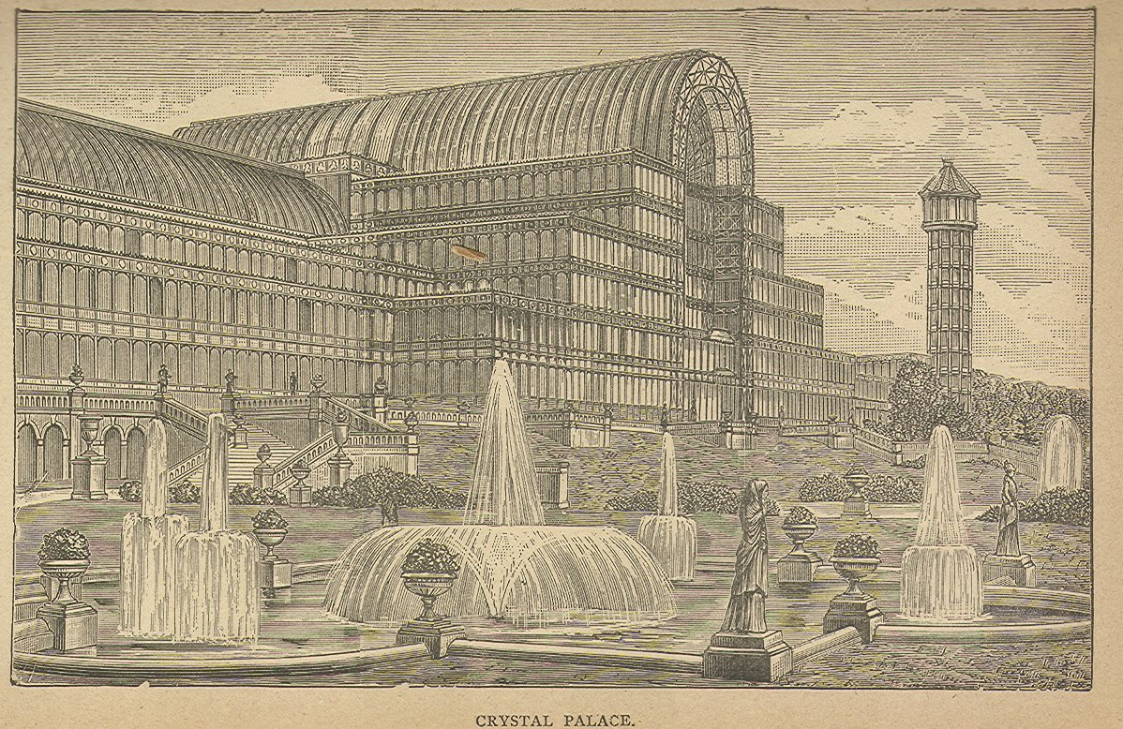
Image 1.3. Etching of the Crystal Palace, London. Image courtesy of Wikipedia Commons; available for reproduction on a Creative Commons License https://commons.m.wikimedia.org/wiki/Crystal_Palace#/media/File%3ACrystalPalaceEngraving.jpg

A number of features of The Crystal Palace were highly innovative, at least in combination; to create such as huge internal space, the architect drew together elements common on mills, railway sheds, dockyard structures, and greenhouses (perhaps further reflective of the uncertain status of the architectural profession, Joseph Paxton was in fact a gardener rather than an architect per se) (Addis, 2006: 14-15). Ingenious drainage/guttering, the structural stability of iron frames and glass curtain walls, and prefabricated sections assembled on site had emerged in the technological firmament of the industrial revolution and were used in docks, warehouses, and factories, and blurred the boundaries between architecture and function-driven engineering. Without overstating the subsequent influence that this construction technique had in ‘opening the way in Europe to the Modern Movement and, in the USA, to the growth of high-rise building’ (Addis, 2006: 3; also see Larson, 1993; Heynen, 1998), such pioneering construction on what was one of the world’s first rigid-jointed iron frames subsequently became commonplace on architecture the world over.

Thanks to such radically-advanced construction, The Crystal Palace was constructed extremely rapidly, with the whole build taking under 200 days (Addis, 2006: 3), significantly in comparison to the decades-long design and build of heavy stone buildings such as the Palace of Westminster. Accordingly, when judged as a contribution to the history of architecture, the Crystal Palace was a marvel. In 1851 it was one of the largest buildings ever constructed that opened a massive internal space sufficient to house three mature elm trees and 70,000 square metres for display (Addis, 2006: 3-7).Architectural materials are one key way of signalling time-as-social reality. The novelty of the extensive use of glass on such a large building brought with it associations of modernity, in addition to the technical affordance of enclosing a huge volume of space by removing internal supports. The mystic and representational qualities of glass have been observed elsewhere (Haag Bletter, 1981; Ersoy, 2007); the functional drivers of the design aside, such historical, fictive associations of glass were ever-present in the discourses of Paxton (Addis, 2007). Not only did his design make use of glass’ out-of-the-ordinariness and stark contrast with the heavy, dark stone of other major buildings, the relational meaning of the extensive use of glass on a building in 1851 and 1951 is also not unbroken (pun intended) despite the formalistic similarity of the material (Fierro, 2003). Contemporaneous accounts suggest that being in and around this building form was experienced highly affectively, both in terms of buildings’ users and in adding relationally to the display of objects (Jones and MacLeod, 2016). In the case of the Crystal Palace the building gave context for the display of very large materials, creating a futuristic cultural context for display and viewing objects.

Exoticised consumption was a prominent feature of the exhibition hall, with the predomination of spectacular artefacts and ‘theatrical’ symbols of national identity that put ‘ephemera and dramatization to the fore’ (Heynen 1999b: 378). Edward Said revealed how the construction of a generalised category of ‘others’ underpinned the self-understanding of western colonial states (1980). The artefacts and objects displayed at the exhibition sustained a hierarchical vision of national cultures and ‘races’. The cultural essentialism that saw artefacts classified and exhibited by nation, in line with the vision of prominent cultural reformer and high-profile patron of the exhibition Henry Cole (Crinson 1996: 54). Attendant hierarchies were designed to reflect positively on the British nation’s culture and industry. The creation of a mythical indigenous ethnic ‘other’ - replete with atavistic ways and objects - that could be contrasted with such was constructed (Said, 1980; Roche, 2000). If some of the 100, 000 or so objects displayed were associated with traditional ways of being, others were so new as to be unseen by most. Viewing such in a structure that blurred inside and outside, that was experienced as out-of-the-ordinary, and that allowed spectacular spatial scales, compounded the affect.

However, despite, or perhaps because of, its out-of-keeping aesthetic, The Crystal Palace was not universally-admired. The influential architectural critic Nicolaus Pevsner called the building ‘[A]bominable... wrong from any point of view... unpleasantly realistic... incongruous... monstrous... [revealing] failure, coarseness, barbarism, atrocities, vulgarity, [and] insensibility’ (cited in Kornwolf 1975: 39). The contemporaneous press dubbed the Exhibition a ‘Chamber of Horrors’; according to unverified reports, the arts and crafts designer William Morris was ‘violently ill after becoming overwhelmed by the excess of the event’.

The architecture of the Crystal Palace went with the grain of a project that stressed the future, in part by providing the perfect context for ‘showcasing’ invidious comparators drawn from the past/elsewhere (Said, 1980). As such, the Crystal Palace building is difficult to decouple from the project it enclosed or the context from which it emerged (Porter, 2011a, 2011b; Steets, 2016). This points to the social basis of architecture: it is always collectively-produced, long after the architect has left the stage. While flatly positioning the Great Exhibition, and its constituent architecture, as a cultural expression of colonial, industrial-capitalist ideology illustrates the point concerning the empirically non-present made by Porter (2011a, 2011b), the entanglements between this event, its building, and a broader political programme cannot be overlooked. Architecture is always and everywhere political, inasmuch as it is implicated in, and emerges from, particular sets of social arrangements, distributions of resources, and visions of how the world is, was, and could be.

Conclusion
Because it simultaneously symbolises and stabilises forms of social life (Gieryn, 2002; Whyte, 2006), architecture is one highly material way that social activity can be situated vis-à-vis cultural pasts and futures (Vale, 1992). As a constitutive part of the ‘unmistakably social maplike structures in which history is typically organised in our minds’ (Zerubavel, 2003: 1) architecture’s distinctive combination of providing shelter in addition to cultural meaning have proved very attractive to states. In this paper I have argued that exploring affinities between political programmes and the form and function of the major architectural projects is rich in sociological potential. If on one hand sociologists should not reduce architecture a priori to political ideology made cultural, then on the other it is incontrovertible that the built environment is a component of ideological projects, which always have a temporal character.

In the context of The Battle of the Styles, the commission of architects engaged with 19th-century nation-building projects involved an active creation of a cultural past, to lend the nation-state the appearance of a historic and continuous institution and to house a rapidly-expanding colonial administration. The appropriate form in which to do this was the basis of much controversy between architects and politicians of the day. The evidence marshalled by this or that side involved interpretation of drawings and other representations of buildings from the ancient world, which had been garnered from The Grand Tour. So, ‘the battle’ was over the meaning of architectural form, while at the same time entangled in all manner of cultural politics concerning how best to represent the aspirations of a cultural and political elite for that particular nation at that particular point. Variations in interpretation illustrate how architectural meaning ‘can be dissociated from what architecture actually is’ (Bonta, 1979), and in that context flourished without the limiting authority of professional canonical authoritative judgement.

The tendency for political institutions to align themselves with radical modernist cultural form is clearly observable in the architecture of megaevents (Roche, 2000, 2003), and is politically expedient in certain - but not all - contexts (Appadurai, 1981; Vale, 1992; Bhabha, 1994; Bozdoǧan, 2001). The Crystal Palace was both architecturally and politically experimental, providing the context for projections of the future to be articulated alongside artefacts and practices associated with the past and elsewhere. The exhibition’s architecture, as did the objects in and around such, saw the celebration of the new, creating a distinctive, out-of-the-ordinary site for display and commodification. While drawing on ostensibly opposing temporal repertoires, both historicist styles and proto-modernist ones reflected the state aim of capturing the cultural legitimation of particular political relationships to time (Appadurai, 1981).

Lines of inquiry from sociologically-inflected studies of time illuminate something relevant and hitherto absent from sociologies of architecture, namely the extent to which the built environment shapes and is shaped by practices associated with social categories of pasts-presents-futures. Disrupting linear narratives about the built environment that posit Y following neatly from X, the literature on time leads us to analyse architecture as a space of temporal experiment. It is by studying how architectural ‘objects have histories and trajectories which when plotted over time take stable but relatively unpredictable courses’ (Stewart, 2015: 148), sociologists can reveal how states - whose buildings reflect the self-representation of the elite rather than of the whole society (Vale, 1992) - attempt to make their political activity culturally resonant through the built environment. When researching architecture sociologically, analysis of how it is bound up with political makings of 'social time' (Durkheim, [1915] 2008) is crucial.

References
Adam, B (1990) Time and Social Theory. Cambridge: Polity Press.
Addis, B (2006) The Crystal Palace and its Place in Structural History. International Journal
of Space Structures 21(1): 3-19.
Appadurai, A (1981) The Past as Scarce Resource. Man 16(2): 201-19.
Bastian, M (2014) Time and Community: A Scoping Study. Time & Society 23(2): 137-66.
Bhabha, H (1994) The Location of Culture. London: Routledge.
Bozdoǧan, S (2001) Modernism and Nation Building: Turkish Architectural Culture in the
Early Republic. Seattle and London: University of Washington Press.
Bonta, J-P (1979) Architecture and its Interpretation. London: Lund Humphries.
Browne, M (2014) Feminism, Time and Non-Linear History: A Polytemporal Approach. New
York: Palgrave Macmillan.
Celik, Z (2010) Displaying the Orient: Architecture of Islam at Nineteenth Century World's
Fairs. Berkeley, CA: University of California Press.
Chaney, E (1998) The Evolution of the Grand Tour: Anglo-Italian Cultural Relations Since
the Renaissance. London: Taylor & Francis.
Cohen, M (2001) The Grand Tour. Language, National Identity and Masculinity. Changing
English: Studies in Culture and Education 8(2): 129-41.
Crinson, M (1996) Empire Building: Orientalism and Victorian Architecture. London:
Routledge.
Delitz, H (2017) Architectural Modes of Collective Existence: Architectural Sociology as a
Comparative Social Theory. Cultural Sociology 12(1): 37-57.
Durkheim, E ([1915] 2008) The Elementary Forms of the Religious Life. Oxford: Oxford
University Press.
Edensor, T (2006) Reconsidering National Temporalities: Institutional Times, Everyday
Routines, Serial Spaces and Synchronicities European Journal of Social Theory 9(4):
525-45.
Elchardus, M (1988) The Rediscovery of Chronos: The New Role of Time in Sociological
Theory International Sociology 3: 35-59.
Ersoy, U (2007) The fictive quality of glass. Architectural Review Quarterly 11(3-4):
237-44.
Fierro, A (2003) The Glass State: The Technology of the Spectacle, Paris 1981-1998.
Cambridge, Mass.: MIT Press.
Gieryn, T F (2002) What Buildings Do. Theory and Society, 31: 35–74.
Greenhalgh, P (1988) Ephemeral Vistas: The Expositions Universelles, Great Exhibitions and
World’s Fairs, 1851–1939. Manchester: Manchester University Press.
Greenhouse, C J (2014) A Moment's Notice: Time Politics Across Cultures. London: Cornell
University Press.
Haag Bletter, R (1981) The Interpretation of the Glass Dream - Expressionist
Architecture and the History of the Crystal Metaphor. Journal of the Society of
Architectural Historians 40(1): 20-43.
Hobsbawm, E (1983) Mass-Producing Traditions: Europe, 1870–1914. In E Hobsbawm and T
Ranger (eds.) The Invention of Tradition. Cambridge: Cambridge University Press.
Iggers, G G (1995) Historicism: The History and Meaning of the Term. Journal of the
History of Ideas 56(1): 129-52.
Jones, P (2009) Putting Architecture in its Social Place: A Cultural Political Economy of
Architecture. Urban Studies 46(12): 2519-36.
Jones, P (2011) The Sociology of Architecture: Constructing Identities. Liverpool: Liverpool
University Press.
Jones, P (2016) ‘(Cultural) Sociologies of Architecture?’. In Inglis, D. and Almila, A-M. (eds.)
The Sage Handbook of Cultural Sociology. 465-80.
Jones, P and MacLeod, S (2016) Museum Architecture Matters. Museum & Society 14(1): 207-
19.
King, A D (1980) Introduction’. In King, A. D. (ed.) Buildings and Society: Essays on the
Social Development of the Built Environment. London: Routledge, Kegan & Paul.
Kornwolf, J D (1975) High Victorian Gothic; or, the Dilemma of Style in Modern
Architecture. Journal of the Society of Architectural Historians, 34(1): 37–47.
Larson, M (1993) Behind the Postmodern Façade: Architectural Change in the Late Twentieth
Century. California: University of California Press,
Lee, D E and Beck, R N (1954) The Meaning of “Historicism”. The American Historical
Review 59(3): 568-77.
McKeon, R (1974) Time and Temporality. Philosophy East and West 24(2): 123-8.
Merton, R and Sorokin, P (1937) Social Time: A Methodological and Functional Analysis.
American Journal of Sociology 42(5): 615-29.
Miller, W W (2000) Durkheimian Time. Time & Society 9(1): 5-20.
Misztal, B A (2003) Theories of Social Remembering. Milton Keynes: Open University Press.
Molnár, V (2005) Cultural Politics and Modernist Architecture: The Tulip Debate in Postwar
Hungary. American Sociological Review 70(1): 111-35.
Naddeo, B A (2005) Cultural Capitals and Cosmopolitanism in Eighteenth Century Italy:
The Historiography and Italy on the Grand Tour. Journal of Modern Italian Studies
10(2): 183-99.
Nowotny, H ([1994] 2005) Time: The Modern and Postmodern Experience. Cambridge: Polity
Press.
Panofsky, E (2005) Gothic Architecture and Scholasticism. Pennsylvania: Archabbey
Publications.
Porter, B (2010) Architecture and Empire: The Case of the “Battle of the Styles”, 1855-61.
British Scholar II(2): 181-96.
Porter, B (2011a) Twilight of the Goths. History Today 61(7): 10-7.
Porter, B (2011b) The Battle of the Styles: Society, Culture, and the Design of a New Foreign
Office, 1855-1861. London: Continuum.
Powell, C (1993) Present Concern with Future Time: The Evidence of Building Permanence and Mutability. Time & Society 2(1): 51-60.
Roche, M (2003) Mega-events, Time and Modernity: On Time Structures in Global Society.
Time & Society 12(1): 99-126.
Roraburgh, W (1973) Politics and the Architectural Competition for the Houses of
Parliament, 1834-1837. Victorian Studies 17(2): 155-75.
Ruskin, J (1992 [1849]) The Lamp of Memory. In M. Wheeler and N. Whiteley (eds.) The
Lamp of Memory: Ruskin, Tradition and Architecture. Manchester: Manchester
University Press.
Steets, S (2016) Taking Berger and Luckmann into the Realm of Materiality: Architecture as
Social Construction. Cultural Sociology 10(1): 93-108.
Stevens, G (1998) The Favored Circle: The Social Basis of Architectural Distinction.
Cambridge, MA: MIT Press.
Stewart, S (2015) Aesthetics and Time: Sustained and Distracted Modes of Engagement.
Cultural Sociology 9(2): 147-161.
Therborn, G (2002) Monumental Europe: The National Years. On the Iconography of
European Capital Cities. Housing, Theory and Society 19: 26–47.
Thompson, E P (1967) Time, Work Discipline, and Industrial Capitalism. Past & Present
38: 56-97.
Vale, L J (1992) Architecture, Power and National Identity. Yale: Yale University Press.
Whyte, W (2006) How Do Buildings Mean? Some Issues of Interpretation in the
History of Architecture. History & Theory 45: 153-77.
Yaneva, A (2014) Mapping Controversies in Architecture. Farnham, UK: Ashgate.
Zerubavel, E (1982) The Standardisation of Time: A Sociological Perspective.
American Journal of Sociology 88(1): 1-23.
Zerubavel, E (1996) Social Memories: Steps to a Sociology of the Past. Qualitative
Sociology 19(3): 283-99.
Zerubavel, E (2003) Time Maps: Collective Memory and the Social Shape of the
Past. London: university of Chicago Press.

Despite often being used synonymously, time and temporality have distinct meanings. Whereas temporality implies abstract questions concerning perceptions of existence, time is perhaps closer to a sociological understanding of socially-embedded structures of chronology and rhythms of sense-making (McKeon, 1974). The formulation ‘time and temporality’ is designed to point to this broadened usage.
Studies have addressed power and temporality, for example '[h]ow clock time came to dominate industrial societies [and] converge in describing the evolution of one dominant (the western) concept of time' (Nowotny, 1994: 426). Architecture was also implicated in time-disciplining institutions such as prisons, schools, hospitals, army barracks, courts (King, 1980 for a survey).
It would be an architect’s fallacy to understand buildings as the primary way in which people understand time. This error is compounded by the tendency to focus exclusively on elite constructions of time at the cost of everyday practices (Edensor, 2006).
Architecture is a practice as well as a built form. The emergence of the architectural profession in this context bore significant relationship to temporality; the historical demography of architects is suggestive of a normalised, yet temporally-specific, cultural hierarchy (Stevens, 1998).
There was a simulation of a Turkish Court, replete with silks, hookahs, coffee sets, and Turkish Delight (all for sale); a Tunisian Court complete with an attendant with whom to haggle over the prices of carpets, guns and ostrich feathers; and Jones’ Alhambra-inspired coloured silks and swags (Crinson 1996: 35-62).
Another reflection of the uncertain rules of the architectural field is that all of the original 245 competition entries for the Crystal Palace were considered unsuitable (Addis, 2006: 3); the language of modernism did not exist, and there was no stylistic referent for glass and iron buildings of this type.

