Evaluating the effectiveness of a large multi-use MPA in protecting key biodiversity areas for marine predators

Running title
Key Biodiversity Areas and Fisheries

Abstract
Aim: Marine protected areas can serve to regulate harvesting and conserve biodiversity. Within large multi-use MPAs it is often unclear to what degree critical sites of biodiversity are afforded protection against commercial activities. Addressing this issue is a prerequisite if we are to appropriately assess sites against conservation targets. We evaluated whether the management regime of a large MPA conserved sites (Key Biodiversity Areas, KBAs) supporting the global persistence of top marine predators.
Location: Southwest Atlantic Ocean
Method: We collated population and tracking data (1418 tracks) from 14 marine predator species (Procellariiformes, Sphenisciformes, Pinnipedia) that breed at South Georgia and the South Sandwich Islands, and identified hotspots for their conservation under the recently developed KBA framework. We then evaluated the spatiotemporal overlap of these sites and the different management regimes of krill, demersal longline, and pelagic trawl fisheries operating within a large MPA, which was created with the intention to protect marine predator species.
Results: We identified 12 new global marine KBAs that are important for this community of top predators, both within and beyond the focal MPA. Only three species consistently used marine areas at a time when a potentially higher-risk fishery was allowed to operate in that area, while other interactions between fisheries and our target species were mostly precluded by MPA management plans.
Main conclusions: We show that current fishery management measures within the MPA contribute to protecting top predators considered in this study, and that resource harvesting within the MPA does not pose a major threat – under current climate conditions. Unregulated fisheries beyond the MPA, however, pose a likely threat to identified KBAs. Our approach demonstrates the utility of the KBA guidelines and multi-species tracking data to assess the contributing role of well-designed MPAs in achieving local and internationally agreed conservation targets.

Key words
animal tracking, fisheries, important bird and biodiversity area, key biodiversity area, marine protected area, pinnipeds, seabirds

1. Introduction
For the conservation of marine species and ecosystems, particularly for those where harvesting of living resources is pursued, it is imperative to ensure both sustainable production and adequate long-term protection are appropriately maintained (Margules & Pressey, 2000). In the marine realm, both the UN Convention on Biological Diversity (CBD) Decision X/2 and the Sustainable Development Goals (SDGs) highlight the need for sustainable use of marine resources (Aichi Target 6 and SDG 14) (CBD, 2010; UN General Assembly, 2015). Additionally, the CBD has set a global conservation target of 10% of coastal and marine areas to be protected through effective management (encompassed in Aichi Target 11) (CBD, 2010). The generally accepted route to achieving these outcomes is through robust fisheries management and, more recently, in combination with the designation of marine protected areas (MPAs) (Edgar et al., 2014). However, while there has been increased emphasis on the establishment of MPAs (Lubchenco & Grorud-Colvert, 2015), their location and effectiveness has been questioned (Gill et al., 2017; UNEP-WCMC and IUCN, 2016; Zupan et al., 2018). Robust fisheries management will always be a necessity, and capacity shortfall often limits protected area efficacy of both small and large MPAs (Gill et al., 2017; O’Leary et al., 2018). There are also concerns regarding whether MPAs can ensure the long-term persistence of species, and whether they cover the most important sites for biodiversity (Barr & Possingham, 2013; Klein et al., 2015).
A suite of criteria now exist for identifying important sites for marine biodiversity (Dunn et al., 2014; Lyons, 2019); a critical requirement for both MPA delineation and assessment (Ehler & Douvere, 2009; Smith et al., 2019). Of these, the overarching framework for identifying critical sites for species is that of Key Biodiversity Areas (KBAs) (Eken et al., 2004). KBAs are sites important for the global persistence of biodiversity, identified as containing a significant proportion of a species’ global population or ecosystem extent; the criteria include thresholds for threatened and geographically restricted species or ecosystems, and congregations of species during key life stages (IUCN, 2016). These global criteria are applicable to all macro-organisms, and KBA identification follows a standardized and quantitative set of guidelines that have recently been released (IUCN, 2016; KBA Standards and Appeals Committee, 2019). Coupled with these recently established guidelines, the proliferation and enhanced resolution of animal tracking data has now made it feasible to identify marine biodiversity hotspots, along with associated abundance estimates of species within these hotspots (Dias, Carneiro, et al., 2018; Lascelles et al., 2016; Soanes et al., 2016). The marine conservation community can therefore apply these standardized protocols to identify sites of high biodiversity value and assess whether they are sufficiently represented within the boundaries of established MPAs or whether further areas need to be afforded legislative protection.
We applied the new KBA criteria (KBA Standards and Appeals Committee, 2019) to identify sites critical to the persistence of biodiversity for a suite of marine top predators (12 seabird species, 2 mammal species) which breed at South Georgia and the South Sandwich Islands (SGSSI). Because KBAs can only be designated based on the current known presence of biodiversity, we selected taxa which are widely regarded as indicators of the broader biodiversity and state of the ecosystem (Boersma, 2008; Furness & Camphuysen, 1997; Moore, 2008), and for which sufficient data exist. We then addressed the extent to which there is spatiotemporal overlap between these sites and key fisheries, to assess whether the key objectives of the MPA could be potentially met. We focused particularly on two objectives of the MPA, namely to ‘better protect important biodiversity’ and to ‘protect foraging areas used by spatially constrained krill-eating predators’. Assessing whether these objectives are being met will enhance the ability of the Government of SGSSI to implement adaptive management regimes within the MPA, and will facilitate understanding about the broader factors that may play a role in driving species population trends.
Our approach focuses on evaluating whether established conservation investment is delivering desired protection, and is the first utilising the new KBA guidelines (KBA Standards and Appeals Committee, 2019) for identifying critical biodiversity sites at-sea for marine top predators. This approach is readily applicable for use by practitioners requiring the identification of KBA sites elsewhere.

2. Methods

2.1 Study area
South Georgia and the South Sandwich Islands lie within the Antarctic Circumpolar Current, south of the Polar Front (Figure 1), and are a hotspot of marine biodiversity (Rogers, Yesson, & Gravestock, 2016; Trathan et al., 2014). Their position means they are subject to strong seasonal variations in light, temperature and sea ice, which leads to strong seasonality in primary production and the abundance of Antarctic krill (Euphausia superba), a key prey item for many predators that breed at the islands (Barlow et al., 2002; J. P. Croxall, Prince, & Reid, 1997). Specifically, the islands support key populations of seabirds and pinnipeds (Hart & Convey, 2018; Lynch et al., 2016; Trathan, Daunt, & Murphy, 1996). At South Georgia, top predators breed primarily along the north coast and in the northwest of the islands, where breeding habitat is favourable (Appendix 2, Trathan et al., 1996). Furthermore, the seascape northwest of the islands hosts a region of high primary productivity which supports local krill stocks (Rogers et al., 2016).
The islands are surrounded by a large sustainable-use MPA (SGSSI MPA, 1.07 million km²) which was designated in 2012, and includes the entire exclusive economic zone (EEZ) (Trathan et al., 2014). The primary objective of the MPA (IUCN Category VI) is to ensure the protection and conservation of the region’s rich biodiversity, through a number of measures that reduce the risk of biodiversity loss, whilst also allowing for sustainable fisheries operations and ecotourism (GSGSSI, 2013; Rogers et al., 2016; Trathan et al., 2014). Impetus for the MPA came from the desire to conserve species and habitats in the face of climate variability and change, and previously high levels of illegal, unregulated and unreported fishing (IUU), and incidental mortality (bycatch) (GSGSSI, 2017; Trathan et al., 2014).

2.2 Data considered for KBA identification
We collated data on IUCN Red List threat status (IUCN, 2018), breeding site locations, population sizes, and at-sea locations (derived from tracking data) sampled using global positioning systems (GPS) and platform terminal transmitters (PTT), for 14 species of higher predators (Table 1) which breed at approximately 815 sites across SGSSI (Appendix 1, Sheet: ‘Pops_data_sources’ & Appendix 2, section ‘Species overview’). We used the most recent population estimates available for each breeding site, based on published information (Table 1) and our own databases (British Antarctic Survey, unpublished data). Population sizes refer to the number of breeding pairs and adult females for seabirds and seals, respectively; estimates which are based on the standardised census techniques for each taxon.
In total, 1418 tracks, comprising 2351 trips, were compiled from the BirdLife International Seabird Tracking Database (www.seabirdtracking.org) and other stakeholders, representing 12 different species (Table 2). Tracking data came from species rich sites with high abundance of biodiversity. Sites included a primary site in the north-west of South Georgia, Bird Island, and six other regions on the northern coastline of South Georgia. Two key sites to the west and south of South Georgia would benefit from future sampling efforts, but the southwest coast of South Georgia provides generally poor breeding habitat for many of the species considered in this study (Appendix 2, Figure S1). Tracking data spanned the 1990/91 austral summer to the 2015 austral winter (Appendix 1, Sheet: Tracking_data_sources). No species have been tracked from the South Sandwich Islands.
Data were analysed at the level of homogeneous units, which account for specific stages in the annual cycle of an organism where distribution may be more or less constrained during a given stage, location or age of the organism. Specifically, we refer to these homogeneous units as ‘data-groups’, where each data-group represents a species, from a particular breeding site and during a specific breeding stage, and accounts for age or sex differences where necessary (e.g. Figure 2). Initially, 69 data-groups were distinguished from the collated tracking data (Appendix 2, Figure S2). Each of these data-groups were assessed in a step-wise fashion to determine whether at-sea distribution data were suitable for attempts to identify representative core-area use sites (step 1, e.g. sufficient sample size), then whether these sites were representative of the sampled population (step 2), and finally if these sites would be regarded as manageable units as per the KBA guidelines (step 3). The final at-sea sites, identified through the approaches outlined below, were assessed to determine if they met the global KBA criteria (See Appendix 2 for further details and Table S1 for details pertaining to each data-group).

2.3 Delineating KBAs
Delineating KBAs for marine predators at sea requires the identification of representative core areas used by a threshold number of individuals from a population. These areas were then assessed against two of the five sets of KBA criteria (IUCN, 2016; Lascelles et al., 2016): presence of significant numbers of globally threatened species subject to conservation status (KBA criterion A), or demographic aggregations (>1% of the species population is present, regardless of the conservation status) during key stages of their life cycles (KBA criterion D) (Appendix 2).
We used recently established methods which have been derived for seabird species to identify representative at-sea areas used by a threshold number of individuals based on, i) tracking data (Lascelles et al. 2016; Dias et al. 2017, 2018a, Heraah et al. 2019), and ii) foraging radii (Soanes et al., 2016) and species distribution models (Dias, Warwick-Evans, et al., 2018).
The above methods were originally developed for the identification of marine Important Bird and Biodiversity Areas (mIBAs) (Lascelles et al., 2016). However, the key outcome from these methods is a spatial polygon representative of the sampled population in which one can assign the proportion of individuals compared to the global population (the method used to determine the number of individuals should be consistent between the global and site levels as per the KBA guidelines), and the IUCN Red List threat status of the species. Thus, these methods are directly suited to the identification of sites (spatial polygons) which can be assessed against the KBA criteria. Furthermore, IBA identification and conservation has played a major role in shaping the design and implementation of the new KBA programme, as the previously identified marine and terrestrial IBAs form a core part of the KBA network (Waliczky et al., 2018).

2.3.1. Tracking data
The primary method used to identify marine KBA sites utilised the raw tracking data (Dias, Carneiro, et al., 2018; Dias, Warwick-Evans, et al., 2018; Lascelles et al., 2016) (Figure 2). Tracks from GPS and PTT devices were filtered following standard protocols to remove outlying locations based on speed thresholds and ARGOS location classes (Freitas, 2012; Sumner, 2016), remove points on land, and regularise sampling intervals across all data-groups (Calenge, 2006). Additionally, data-groups were removed when the sample size was insufficient or sampling intervals too sparse (Appendix 2: Further details).
Following the methods detailed in Lascelles et al. (2016), we identified representative core areas used by individuals from a population based on tracking data by performing a kernel density analysis (Figure 2 i, ii, Appendix 2). Kernel density analysis calculates the density of locations by fitting a bivariate normal function with a pre-defined radius (smoothing parameter, h) around each location, and summing up the values to create a smooth density surface. The kernel utilisation distribution (UD) is the isopleth that contains a certain percentage of the density distribution (Calenge, 2006). The smoothing parameter (h) and utilisation distribution (UD) were set specific to each data-group according to the species foraging ecology (Appendix 2). We then quantified the representativeness of the tracking data for each data-group (i.e. how well the sample of data is deemed to represent the sampled population) (Figure 2 iii), and quantified the number of overlapping core foraging ranges across all tracked individuals from each breeding population in each 0.1 x 0.1° grid cell (chosen according to the scale of the SGSSI MPA). Finally, we identified the sites used by ≥10%, ≥12.5% or ≥20% of the tracked individuals, depending on whether representativeness values of >90%, 80-90% or 70-80%, respectively, were achieved by a given data-group (Lascelles et al., 2016) (Figure iv, v). Abundance estimates within the at-sea sites (based on breeding site population numbers) were modified by a correction factor of 0.9, 0.75, or 0.5, respectively, to give a conservative estimate of the number of individuals using the site; depending on the representativeness (See Lascelles et al. 2016 supplementary material). Where representativeness was <70% for a data-group, the tracking data were deemed inadequate to describe the space-use of the population (Appendix 2, Table S1).
To enhance practicability of management zones, the identified spatial polygons were aggregated to minimise the boundary-to-area ratio via a custom R script utilising the smoothr package (Strimas-Mackey, 2018). Specifically, any isolated polygon or hole within a larger polygon, which was smaller than 5% of the total area identified was removed or filled, respectively. For the remaining polygons, the great circle distance between centroids was calculated. Using this distance matrix, a hierarchical cluster analysis was implemented to identify which polygons could be grouped specified by a threshold distance of 5% of the maximum distance between polygons. The final boundaries of sites identified for each data-group were delimited by a minimum convex polygon (Figure 2, vi).

2.3.2 Foraging radii and species distribution models
Where tracking data were unavailable for species, the alternate methods of using foraging radii and previously developed species distribution models for near-shore foraging species were used (See Appendix 2, ‘KBA sites per data-group’, for further details of methods specific to sites identified for each data-group). The foraging radius approach was applied to breeding sites holding >1% of the global population of a species. This method consists of defining a radius around the colony based on the mean-maximum foraging distance achieved by the species (derived from tracking data collected elsewhere) (Soanes et al., 2016). This approach was applied for Gentoo Penguins (17 km radius (Ratcliffe, Adlard, Stowasser, & Mcgill, 2018; Tanton, Reid, Croxall, & Trathan, 2004)) at South Georgia, and for Chinstrap Penguins (60 km radius (Ratcliffe & Trathan, 2011)) at the South Sandwich Islands. We also used the foraging radius approach for Antarctic Fur Seals (150 km radius (Boyd, 1999), but bound this site by an established species distribution model (Boyd, Staniland, & Martin, 2002)) and further understanding of the species foraging ecology (Lunn, Boyd, Barton, & Croxall, 1993).
A recent Chinstrap Penguin tracking study, a near-shore foraging species during the breeding period, at the South Orkney Islands showed a high degree of overlap between the areas identified as important using tracking data and those predicted from species distribution models (Dias, Warwick-Evans, et al., 2018; Warwick-Evans et al., 2018). Therefore, for Macaroni Penguins which also forage in the near-shore environment during the brood-guard and crèche periods, we used the final boundaries of South Georgia island-wide predicted distribution models for Macaroni Penguins during these different periods (Scheffer, Ratcliffe, Dias, Bost, & Trathan, 2015). As these projected distributions reflect the likely distribution for this species across the whole of South Georgia as oppose to the site-based tracking data approach, we based abundance estimates for these data-groups on the island-wide population estimates for species during the breeding period.

2.4 Final KBA boundaries
Key Biodiversity Area sites identified for unique data-groups (KBA element layers) might overlap in space. However, the finalised KBAs submitted to the KBA Secretariat for ratification cannot consist of multiple overlapping layers, and must be delineated as manageable units (IUCN 2016). Therefore, all individual overlapping data-group layers were first merged to encompass their entire area. To fulfil the objective of creating manageable units, two zones were delineated around South Georgia and the KBA polygon was split accordingly: Zone 1 (Inner EEZ Zone): a 160 km buffer from the South Georgia main island, defined by a radius which would encompass the near-shore foraging species range. Zone 2 (Outer EEZ Zone): the remaining zone between the Inner EEZ Zone buffer and SGSSI EEZ boundary. Finally, where KBAs fell beyond the jurisdiction of their respective territories, final boundaries were clipped to the limits of the relevant EEZs.

2.5 Fisheries in identified KBAs
Three fisheries (details outlined in Table 3) operate within the SGSSI MPA: the demersal longline fishery for Patagonian (Dissostichus eleginoides) and Antarctic Toothfish (Dissostichus mawsoni), and the pelagic trawl fisheries for Mackerel Icefish (Champsocephalus gunnari) and Antarctic Krill (GSGSSI, 2013; Rogers et al., 2016; Trathan et al., 2014).
We evaluated the role of the MPA in conserving globally important sites of biodiversity by assessing the overlap between the identified KBAs and the operational areas of the main fisheries within the MPA. This analysis was carried out for each data-group separately to account for variation in foraging distributions. Due to differences in diets and foraging behaviours of predators, overlap with the krill fishery was only assessed for krill-dependent species and overlap with demersal longline and pelagic trawl fisheries only for species which have historically been recorded as bycatch (Table 3). We first assessed temporal overlap for data-groups which met the KBA criteria during the operating periods of the fisheries. Then, when temporal overlap was possible, we assessed spatial overlap as the proportion of the KBA layer which intersected with potential fishing grounds within the SGSSI MPA.

3. Results

3.1 KBA identification
Representative core areas at sea which met the global KBA criteria were identified for 19 data-groups, featuring 9 species (1 seal, 8 seabird species) of the 69 data-groups assessed (Table 4 and Appendix 2 (‘KBA sites per data-group’)). After accounting for jurisdictional boundaries, this resulted in the delimitation of 12 new global KBAs (Figure 3), which were within the EEZs of SGSSI, Falkland Islands and Argentina, and within the high seas and around the Antarctic Peninsula. The KBAs within the SGSSI MPA were concentrated in the north-west of the MPA, where a majority of tracking studies have been conducted, and numerous species breed (Appendix 2, Figure S1).

3.2 Potential interactions with fisheries in KBAs
For four species, comprising five of the 19 data-groups, there was temporal overlap with the KBA site and the respective fisheries operating period (Table 4). For four of these data-groups there was also the opportunity for direct interaction with a fishery through spatial overlap (Figure 4). For the remaining 5 species and 14 of 19 data-groups, the relevant fishery would be closed during the period for which we identified KBAs (Appendix 2, ‘Temporal overlap of KBA sites with fisheries operating periods’).

3.2.1 Krill fishery
Six species were recognised as krill-dependent predators (Table 3). For the four species which had representative sites at sea that met the KBA criteria, all except one were delimited entirely within the MPA (Table 4). Two of nine data-groups had the potential for temporal interaction with the krill fishery, as for all other data-groups their use of the MPA was during the fishery closure period (Appendix 2). These data-groups were 1) adult Macaroni Penguins from Fairy Point and Goldcrest Point which utilise three core-areas in the north west of the MPA during the post-moult period (May-August), and 2) adult Gentoo Penguins around the entirety of South Georgia during the non-breeding period (May-September) (Figure 4(i), 4(ii)). For both species, 100% of the KBAs fell within the MPA. However, only the KBA of Macaroni Penguins has the potential for spatial overlap with the krill fishery as 88.8% of this KBA is beyond the 30 km no-take zone (Table 4). By contrast, the South Georgia island-wide KBA identified for Gentoo Penguins, based on a 17 km foraging radius, lies entirely within the pelagic no-take zone.

3.2.2 Demersal longline fishery
Of the six species recognised to be at risk of bycatch in the demersal longline fishery (Table 3), four had representative sites at sea that met the KBA criteria. For these four species, two of nine data-groups, both for the Wandering Albatrosses, had KBAs where a potential for interaction with the demersal longline fishery would be possible (Table 4). These data-groups were adult Wandering Albatrosses during the 1) brood-guard period (April) and 2) post-guard period (April-August), where 82.0% and 98.1% of the KBAs fell within the MPA, respectively (Figure 4(iii), 4(iv)). During both periods, KBAs were situated in the region where the longline fishery is legally allowed to operate (waters between 700-2250 m deep). However, areas of these KBA sites are also off limits to demersal longline fisheries because they fall within the 30 km no-take zone, the no bottom fishing zones (0-700 m depth) and two of the main benthic closed areas (Figure 1). Therefore, for both Wandering Albatross data-groups, the proportion of the KBAs for which there is potential for interaction with fisheries within the MPA, is 23.5% and 27.8% for the brood-guard and post-guard period, respectively (Table 4).

3.2.3 Pelagic trawl fishery
For two species, Black-browed Albatrosses and White-chinned Petrels, we recognised the potential for negative interactions with the pelagic trawl fishery (Table 3). A single data-group for White-chinned petrels during the breeding period (January & February), met the global KBA criteria. This KBA site is entirely within the MPA and 90% of the site is open to the pelagic trawl fishery, after accounting for the 30 km no-take zone (Figure 1, Figure 4(v)).

4. Discussion
Using a collation of contemporary tracking data and knowledge of species breeding populations, we identified the first marine KBAs both within and beyond the borders of the South Georgia and South Sandwich Islands large MPA. This distribution of KBAs reflects the contrasting foraging strategies of top predators assessed in this study (Appendix 2, Figure S2). Critically, the primary objective of the MPA is to protect marine biodiversity, habitats and critical ecosystem function (Trathan et al., 2014). Therefore, considering that for only five data-groups there was the possibility of spatiotemporal overlap with a unique KBA site and relevant fishery within the MPA, the current conservation measures (Table 3) in the context of interaction with fisheries appear to be achieving the desired goals for the 14 top predators considered in this study. Coupled with the seasonal closures of the krill and demersal longline fisheries throughout the entire MPA, protection of these marine predators at sea is also promoted by regulations on gear used and fishing practices (Table 3). These mitigation measures facilitate the achievement of objective I of the MPA; protection for all species considered in this study (J. Croxall, Prince, & Reid, 2004; GSGSSI, 2013, 2017). For krill-eating Macaroni Penguins, there is potential for spatial overlap with the krill fishery during the post-moult period (May-August), however the estimated krill stock taken by both this species and the krill fishery is negligible. As such, direct competition during this period is likely to be low under the current krill harvesting levels (Ratcliffe et al., 2015). It seems likely, therefore, that the foraging areas of the six krill-eating predators (Table 3) are well-protected; contributing to objective V of the MPA, the protection of localised areas of ecological importance (Trathan et al., 2014). For these reasons, the conservation measures implemented within the SGSSI MPA should be recognised as positive practice for similar MPAs.
MPAs have been designated recently within the EEZs of other archipelagos which are key breeding sites for similar suites of marine top predators; Prince Edward Islands (2013), Crozet and Kerguelen archipelagos (2006, revised in 2016), Amsterdam Island (2006, revised 2017), Heard & McDonald Islands (1997, revised in 2002) and Macquarie Island (1997, revised in 2012) (Marine Conservation Institute, 2019). Many of these MPAs do not encompass the entirety of the EEZs, as is the case of the SGSSI MPA. However, retrospective analyses of tracking data from top predators at the Prince Edwards Islands (Reisinger et al., 2018), Amsterdam Island (Delord et al., 2014; Heerah et al., 2019) and Heard Island (Patterson et al., 2016) have shown that these MPAs prevent interactions with fisheries which operate within their respective EEZs. Conservation measures in many of these areas, beyond seasonal closures, require seabird bycatch mitigation measures to be used within the fisheries which are similar to those in the SGSSI MPA, all of which have greatly reduced seabird bycatch rates. Concerns which still remain for many of these species, however, are the effects of distant-water pelagic longline fisheries and IUU fishing, mostly in waters beyond the jurisdiction of MPAs (Clay et al., 2019; Michael et al., 2017; Österblom & Bodin, 2012). This threat is believed to be a key driver in continued declines of some albatross and petrel populations, including those at SGSSI (Table 1) (Krüger et al., 2018; Pardo et al., 2017; Poncet et al., 2017). Therefore, efforts must still be made across fisheries management organisations to implement and enforce best-practice bycatch mitigation both within areas beyond national jurisdiction and the EEZs of other coastal states (Carneiro et al., in press; Clay et al., 2019; Melanie, White, Smith, Crain, & Beck, 2010).
While the links between both local and distant-water fisheries and marine top predator population declines have been well-established, of growing concern is the impact of climate change on predator populations and their prey (Atkinson et al., 2019; Krüger et al., 2018; Pardo et al., 2017). Of particular importance for SGSSI is the impact of climate change on the distribution of Antarctic krill, an important prey item for numerous top predators which breed at the islands (Boyd, 1999; J. P. Croxall et al., 1997; Forcada & Hoffman, 2014). Recent evidence suggests that over a 90-year period, krill distribution has shifted southward by approximately 440 km, likely as a result of warming seas and a reduction in sea-ice cover (Atkinson et al., 2019). The shifting distribution of krill may in turn influence the breeding success of top predators as these species are constrained in foraging duration and distance when rearing offspring (Lunn et al., 1993; Weimerskirch, 2007). Therefore, just as for predators which breed in high northern latitudes (Divoky, Douglas, & Stenhouse, 2016; Macias-Fauria & Post, 2018), there is a critical need for continued monitoring efforts to assess the effects of shifting prey distributions (due to climate change) on predator populations. Spatially explicit analyses of krill consumption by predators would be particularly informative, especially in understanding if recovery of marine mammals or changes in other predator species distributions have occurred in particular areas as a result of changing krill distributions. Identifying KBAs at sea may serve as a key baseline with which to compare spatial distribution of sites identified in future.
Because South Georgia is a comparatively well-studied archipelago (Hart & Convey, 2018; Lynch et al., 2016; Rogers et al., 2016; Trathan et al., 2014, 1996), prior conservation successes for some albatross and petrel species have been possible (John P Croxall, 2008; Hays et al., 2019). However, to enhance the identification of at-sea KBAs for marine top predators that inhabit remote sites in future, several limitations of this study which apply to marine predator datasets globally (e.g. incomplete population estimates and representativeness of tracking data) will need to be overcome. Although the population counts and tracking data were not available for the same time periods, it is unlikely that the KBAs would have changed substantially if we used more contemporaneous population estimates. This is because many of the sites identified for each data-group were from declining populations of globally threatened species (Table 1, Table 4) where the proportion of mature individuals need only exceed ≥0.1% or ≥0.2% of the global population for Critically Endangered or Endangered, and Vulnerable species, respectively (KBA criteria A1c, A1d). Furthermore, for species which sites met KBA criteria D1a (aggregations of >1% of the global population), the primary breeding site for many of these species (Gentoo Penguin, King Penguin, Chinstrap Penguin, Antarctic Fur Seal) is at SGSSI (Borboroglu & Boersma, 2013; Boyd et al., 2002; Lynch et al., 2016).
Improved knowledge of the spatio-temporal distribution of top predators during all major life-history stages is crucial for a holistic understanding of population-level habitat use and overlap with threats (Carneiro et al., in press.; Clay et al., 2019; Reisinger et al., 2018). For the species breeding at South Georgia, many have been tracked throughout key life-history stages. However, there are still critical gaps in our knowledge of dispersal patterns and survival rates of juveniles and immatures which cannot be inferred from existing tracking data (Oppel et al., 2018). Additionally, for some species, the at-sea distribution of major colonies at South Georgia and all colonies at the South Sandwich Islands remains to be investigated (Appendix 2, Figure S1, and ‘Future research’). Despite these knowledge gaps, the network of KBA sites is probably well justified for the species considered in this study, particularly near-shore foraging species – penguins and Antarctic Fur Seals – as they account for their most plausible island-wide breeding ranges. During the non-breeding period when all species considered in this study (excl. Gentoo Penguins) are wide-ranging (Appendix 2, Figure S2) and site-based conservation approaches such as protection or management of KBAs are less effective, likely conservation solutions will be the mitigation of the broad threats marine predators face across the oceans (Clay et al., 2019; Halpern et al., 2015). Future effort should also be directed towards recovering populations of previously over-exploited cetaceans (Zerbini et al., 2019).
In a more localised context, environmental management plans should also consider the fact that sites meeting the global KBA criteria are those sites which “contribute significantly to the global persistence of biodiversity” (IUCN, 2016). This presents caveats to the KBA approach that may either promote or mask the conservation requirements of species at a regional scale. For example, if a species is locally abundant but globally rare (such as the Antarctic fur seal) higher priority might be given to the conservation of a species in systematic conservation planning procedures (Smith et al., 2019). In contrast, species which are globally abundant but experiencing local population declines may not yield sites which meet global KBA criteria (such as the South Georgia Black-browed Albatross population which is considered locally vulnerable (Poncet et al., 2017)). Thus, context-specific decisions must be made as to how and when the utility of KBAs can be used to achieve local, national and global goals, and when additional data sources or approaches will be required to achieve conservation goals at varying spatiotemporal scales (Smith et al., 2019).
In recognition of the globally threatened species and species with significant proportions of their respective global populations that breed at SGSSI, our study informed policy and management processes at a local level through the utility of the new global KBA initiative. . Ensuring both the conservation of species and sustainable harvesting of biological resources is a critical factor for the continued success of the MPA, as revenue generated from fisheries is often key to supporting the ongoing monitoring and management of MPAs (Melanie et al., 2010). Furthermore, the objectively defined sites identified in this study play a critical role toward meeting the 2020 Aichi Biodiversity Targets and the 2030 Agenda for the Sustainable Development, as the coverage of KBAs by protected areas is already an indicator of these global goals (UN General Assembly, 2015). Beyond the borders of the SGSSI MPA, where KBAs were also identified, global conservation efforts must focus on the enforcement of bycatch mitigation measures, as their benefits have been clearly demonstrated within the MPA (Hays et al., 2019; Phillips et al., 2016). Precedence to address the effects of competition for resources, particularly with a growing interest in mesopelagic fisheries (St John et al., 2016), and the future resilience of systems to climate change will also be critical to consider. Ultimately, recognising sites through the new KBA framework now provides a harmonised approach to identify sites critical to biodiversity across all taxa (IUCN, 2016; KBA Standards and Appeals Committee, 2019). Therefore, we encourage practitioners to adopt this framework both for the development of future projects investigating species distributions and for the retrospective analysis of animal tracking data.

5. References
Atkinson, A., Hill, S. L., Pakhomov, E. A., Siegel, V., Reiss, C. S., Loeb, V. J., … Sailley, S. F. (2019). Krill (Euphausia superba) distribution contracts southward during rapid regional warming. Nature Climate Change. https://doi.org/10.1038/s41558-018-0370-z
Barlow, K. E., Boyd, I. L., Croxall, J. P., Reid, K., Staniland, I. J., & Brierly, A. S. (2002). Are penguins and seals in competition for Antarctic krill at South Georgia? Marine Biology, 140, 205–213. https://doi.org/10.1007/s00227-001-0691-7
Barr, L., & Possingham, H. P. (2013). Are outcomes matching policy commitments in Australian marine conservation planning? Marine Policy, 42, 39–48.
Boersma, P. D. (2008). Penguins as Marine Sentinels. BioScience, 58(7), 597–607. https://doi.org/10.1641/B580707
Borboroglu, P. G., & Boersma, P. D. (2013). Penguins: Natural History and Conservation. Seattle: University of Washington Press.
Boyd, I. L. (1999). Foraging and provisioning in Antarctic fur seals: interannual variability in time-energy budgets. Behavioral Ecology, 10(2), 198–208. https://doi.org/10.1093/beheco/10.2.198
Boyd, I. L., Staniland, I. J., & Martin, A. R. (2002). Distribution of foraging by female Antarctic fur seals. Marine Ecology Progress Series, 242, 285–294. https://doi.org/10.3354/meps242285
Calenge, C. (2006). The package adehabitat for the R software: a tool for the analysis of space and habitat use by animals. Ecological Modelling, 197, 516–519.
Carneiro, A. P. B., Pearmain, E. J., Oppel, S., Clay, T. A., Phillips, R. A., Bonnet-Lebrun, A.-S., … Dias, M. P. (in press.). A framework for mapping the distribution of Southern Ocean seabirds across life-history stages, by integrating tracking, demography and phenology. Journal of Applied Ecology.
CBD. (2010). Aichi Biodiversity Targets. https://www.cbd.int/sp/targets/ (Accessed 12 Jan 2019).
Clay, T. A., Small, C., Tuck, G. N., Pardo, D., Carneiro, A. P. B., Wood, A. G., … Phillips, R. A. (2019). A comprehensive large‐scale assessment of fisheries bycatch risk to threatened seabird populations. Journal of Applied Ecology, 0, 1–12. https://doi.org/10.1111/1365-2664.13407
Croxall, J. P. (2008). The role of science and advocacy in the conservation of Southern Ocean albatrosses at sea. Bird Conservation International, 18, 13–29. https://doi.org/10.1017/S0959270908000300
Croxall, J. P., Prince, P. A., & Reid, K. (1997). Dietary segregation of krill-eating South Georgia seabirds. Journal of Zoology, 242(3), 531–556. https://doi.org/10.1111/j.1469-7998.1997.tb03854.x
Croxall, J., Prince, P., & Reid, K. (2004). Management of Southern Ocean fisheries: global forces and future sustainability. Antarctic Science, 16(4), 569–584. https://doi.org/10.1017/S0954102004002330
Delord, K., Barbraud, C., Bost, C. A., Deceuninck, B., Lefebvre, T., Lutz, R., … Weimerskirch, H. (2014). Areas of importance for seabirds tracked from French southern territories, and recommendations for conservation. Marine Policy, 48, 1–13. https://doi.org/10.1016/j.marpol.2014.02.019
Dias, M. P., Carneiro, A. P. B., Warwick-evans, V., Harris, C., Lorenz, K., Lascelles, B., … Trathan, P. N. (2018). Identification of marine Important Bird and Biodiversity Areas for penguins around the South Shetland Islands and South Orkeny Islands. Ecology and Evolution, 8, 10520–10529. https://doi.org/10.1002/ece3.4519
Dias, M. P., Warwick-Evans, V., Carneiro, A. P. B., Harris, C., Lascelles, B. G., Clewlow, H. L., … Trathan, P. N. (2018). Using habitat models to identify marine important bird and biodiversity areas for Chinstrap Penguins Pygoscelis antarcticus in the South Orkney Islands. Polar Biology, 1–9. https://doi.org/10.1007/s00300-018-2404-4
Divoky, G. J., Douglas, D. C., & Stenhouse, I. J. (2016). Arctic sea ice a major determinant in Mandt ’s black guillemot movement and distribution during non-breeding season. Biology Letters, 12, 20160275.
Dunn, D. C., Ardron, J., Bax, N., Bernal, P., Cleary, J., Cresswell, I., … Halpin, P. N. (2014). The Convention on Biological Diversity’s Ecologically or Biologically Significant Areas: Origins, development, and current status. Marine Policy, 49, 137–145. https://doi.org/10.1016/j.marpol.2013.12.002
Edgar, G. J., Stuart-Smith, R. D., Willis, T. J., Kininmonth, S., Baker, S. C., Banks, S., … Thomson, R. J. (2014). Global conservation outcomes depend on marine protected areas with five key features. Nature, 506(7487), 216–220. https://doi.org/10.1038/nature13022
Ehler, C., & Douvere, F. (2009). Marine spatial planning. A Step-by-Step Approach toward ecosystem-based management. Intergovernmental Oceanographic Commission and Man and the Biosphere Programme. IOC Manual and Guides No. 53, ICAM Dossier No. 6. Paris: UNESCO. 2009 (English).
Eken, G., Bennun, L., Brooks, T. M., Darwall, W., Fishpool, L. D. C., Foster, M., … Tordoff, A. (2004). Key Biodiversity Areas as Site Conservation Targets. BioScience, 54(12), 1110–1118.
Forcada, J., & Hoffman, J. I. (2014). Climate change selects for heterozygosity in a declining fur seal population. Nature, 511(7510), 462–465. https://doi.org/10.1038/nature13542
Freitas, C. (2012). argosfilter: Argos locations filter. R Package Version 0.63.
Furness, R. W., & Camphuysen, K. C. J. (1997). Seabirds as monitors of the marine environment. ICES Journal of Marine Science, 54, 726–737.
Gill, D. A., Mascia, M. B., Ahmadia, G. N., Glew, L., Lester, S. E., Barnes, M., … Fox, H. E. (2017). Capacity shortfalls hinder the performance of marine protected areas globally. Nature, 543(7647), 665–669. https://doi.org/10.1038/nature21708
GSGSSI. (2013). South Georgia and the South Sandwich Islands Marine Protected Area Management Plan, Version 2.0: 31/08/2013.
GSGSSI. (2017). South Georgia & the South Sandwich Islands Implementation Plan for the Agreement on the Conservation of Albatrosses and Petrels (ACAP) 2016-2020. Government of South Georgia & the South Sandwich Islands, Stanley, Falkland Islands.
Halpern, B. S., Frazier, M., Potapenko, J., Casey, K. S., Koenig, K., Longo, C., … Walbridge, S. (2015). Spatial and temporal changes in cumulative human impacts on the world’s ocean. Nature Communications, 6(7615), 1–7. https://doi.org/10.1038/ncomms8615
Hart, T., & Convey, P. (2018). The South Sandwich Islands – a community of meta-populations across all trophic levels. Biodiversity. https://doi.org/10.1080/14888386.2018.1464952
Hays, G. C., Bailey, H., Bograd, S. J., Bowen, W. D., Campagna, C., Carmichael, R. H., … Sequeira, A. M. M. (2019). Translating Marine Animal Tracking Data into Conservation Policy and Management. Trends in Ecology and Evolution, 34(5), 459–473. https://doi.org/10.1016/j.tree.2019.01.009
Heerah, K., Dias, M. P., Delord, K., Oppel, S., Barbraud, C., Weimerskirch, H., & Bost, C. A. (2019). Important areas and conservation sites for a community of globally threatened marine predators of the Southern Indian Ocean. Biological Conservation, 234, 192–201. https://doi.org/10.1016/j.biocon.2019.03.037
IUCN. (2016). A Global Standard for the Identification of Key Biodiversity Areas, Version 1.0. Gland, Switzerland.
IUCN. (2018). IUCN 2018. The IUCN Red List of Threatened Species. Version 2018-1. <http://www.iucnredlist.org>. Downloaded on 05 July 2018.
KBA Standards and Appeals Committee. (2019). Guidelines for using a Global Standard for the Identification of Key Biodiversity Areas. Version 1.0. Prepared by the KBA Standards and Appeals Committee of the IUCN Species Survival Commission and IUCN World Commission on Protected Areas. Gland, Switzerl.
Klein, C. J., Brown, C. J., Halpern, B. S., Segan, D. B., Mcgowan, J., Beger, M., & Watson, J. E. M. (2015). Shortfalls in the global protected area network at representing marine biodiversity. Scientific Reports, 5, 17539. https://doi.org/10.1038/srep17539
Krüger, L., Ramos, J. A., Xavier, J. C., Grémillet, D., González-solís, J., Petry, M. V., … Paiva, V. H. (2018). Projected distributions of Southern Ocean albatrosses, petrels and fisheries as a consequence of climatic change. Ecography, 41, 195–208. https://doi.org/10.1111/ecog.02590
Lascelles, B. G., Taylor, P. R., Miller, M. G. R., Dias, M. P., Oppel, S., Torres, L., … Small, C. (2016). Applying global criteria to tracking data to define important areas for marine conservation. Diversity and Distributions, 22(4), 422–431. https://doi.org/10.1111/ddi.12411
Lubchenco, J., & Grorud-Colvert, K. (2015). Making waves: The science and politics of ocean protection. Science, 350(6259), 382–383.
Lunn, N., Boyd, I., Barton, T., & Croxall, J. (1993). Factors Affecting the Growth Rate and Mass at Weaning of Antarctic Fur Seals at Bird Island, South Georgia. Journal of Mammalogy, 74(4), 908–919.
Lynch, H. J., White, R., Naveen, R., Black, A., Meixler, M. S., & Fagan, W. F. (2016). In stark contrast to widespread declines along the Scotia Arc, a survey of the South Sandwich Islands finds a robust seabird community. Polar Biology, 39(9), 1615–1625. https://doi.org/10.1007/s00300-015-1886-6
Lyons, Y. (2019). Identifying Sensitive Marine Areas in the High Seas : a Review of the Scientific Criteria Adopted under International Law. In R. Beckman, M. McCreath, A. Roach, & Z. Sun (Eds.), High Seas Governance: Gaps and Challenges (pp. 57–125). Netherlands: Brill | Nijhoff. https://doi.org/10.1163/9789004373303
Macias-Fauria, M., & Post, E. (2018). Effects of sea ice on Arctic biota: an emerging crisis discipline. Biology Letters, 14, 20170702.
Margules, C., & Pressey, R. (2000). A framework for systematic conservation planning. Nature, 405, 243–253. https://doi.org/10.1038/35012251
Marine Conservation Institute, . (2019). MPAtlas [On-line]. Seattle, WA. Available at: www.mpatlas.org [Accessed 02/03/2019].
Melanie, I., White, A., Smith, S., Crain, C., & Beck, M. (2010). Moving forward toward networks and broader spatial management. In C. Toropova, I. Meliane, D. Laffoley, E. Matthews, & M. Spalding (Eds.), Global ocean protection: Present status and future possibilities (pp. 69–82). Cambridge: UNEP-WCMC.
Michael, P. E., Thomson, R., Barbraud, C., Delord, K., De Grissac, S., Hobday, A. J., … Wilcox, C. (2017). Illegal fishing bycatch overshadows climate as a driver of albatross population decline. Marine Ecology Progress Series, 579, 185–199.
Moore, S. (2008). Marine mammals as ecosystem sentinels. Journal of Mammalogy, 89(3), 534–540.
O’Leary, B. C., Ban, N. C., Fernandez, M., Friedlander, A. M., García-Borboroglu, P., Golbuu, Y., … Roberts, C. M. (2018). Addressing Criticisms of Large-Scale Marine Protected Areas. BioScience, 68(5), 359–370. https://doi.org/10.1093/biosci/biy021
Oppel, S., Bolton, M., Carneiro, A. P. B., Dias, M. P., Green, J. A., Masello, J. F., … Croxall, J. (2018). Spatial scales of marine conservation management for breeding seabirds. Marine Policy, 98, 37–46. https://doi.org/10.1016/j.marpol.2018.08.024
Österblom, H., & Bodin, Ö. (2012). Global Cooperation among Diverse Organizations to Reduce Illegal Fishing in the Southern Ocean. Conservation Biology, 26(4), 638–648. https://doi.org/10.1111/j.1523-1739.2012.01850.x
Pardo, D., Forcada, J., Wood, A. G., Tuck, G. N., Ireland, L., Pradel, R., … Phillips, R. A. (2017). Additive effects of climate and fisheries drive ongoing declines in multiple albatross species. Proceedings of the National Academy of Sciences, 50, E10829–E10837. https://doi.org/10.1073/pnas.1618819114
Patterson, T. A., Sharples, R. J., Raymond, B., Welsford, D. C., Andrews-Goff, V., Lea, M. A., … Hindell, M. (2016). Foraging distribution overlap and marine reserve usage amongst sub-Antarctic predators inferred from a multi-species satellite tagging experiment. Ecological Indicators, 70, 531–544. https://doi.org/10.1016/j.ecolind.2016.05.049
Phillips, R. A., Gales, R., Baker, G. B., Double, M. C., Favero, M., Quintana, F., … Wolfaardt, A. (2016). The conservation status and priorities for albatrosses and large petrels. Biological Conservation, 201, 169–183. https://doi.org/10.1016/j.biocon.2016.06.017
Poncet, S., Wolfaardt, A. C., Black, A., Browning, S., Lawton, K., Lee, J., … Phillips, R. A. (2017). Recent trends in numbers of wandering (Diomedea exulans), black-browed (Thalassarche melanophris) and grey-headed (T. chrysostoma) albatrosses breeding at South Georgia. Polar Biology, 40(7), 1347–1358. https://doi.org/10.1007/s00300-016-2057-0
Ratcliffe, N., Adlard, S., Stowasser, G., & Mcgill, R. (2018). Dietary divergence is associated with increased intra-specific competition in a marine predator. Scientific Reports, 8(April), 6827. https://doi.org/10.1038/s41598-018-25318-7
Ratcliffe, N., Hill, S. L., Staniland, I. J., Brown, R., Adlard, S., Horswill, C., & Trathan, P. N. (2015). Do krill fisheries compete with macaroni penguins? Spatial overlap in prey consumption and catches during winter. Diversity and Distributions, 21, 1339–1348. https://doi.org/10.1111/ddi.12366
Ratcliffe, N., & Trathan, P. N. (2011). A review of the diet and at-sea distribution of penguins breeding within the CCAMLR Convention Area. CCAMLR Science, 19, 75–114.
Reisinger, R. R., Raymond, B., Hindell, M. A., Bester, M. N., Crawford, R. J. M., Davies, D., … Pistorius, P. A. (2018). Habitat modelling of tracking data from multiple marine predators identifies important areas in the Southern Indian Ocean. Diversity and Distributions, 24, 535–550. https://doi.org/10.1111/ddi.12702
Rogers, A. D., Yesson, C., & Gravestock, P. (2016). A Biophysical and Economic Profile of South Georgia and the South Sandwich Islands as Potential Large-Scale Antarctic Protected Areas. Advances in Marine Biology (1st ed., Vol. 73). Elsevier Ltd. https://doi.org/10.1016/bs.amb.2015.06.001
Scheffer, A., Ratcliffe, N., Dias, M. P., Bost, C.-A., & Trathan, P. N. (2015). Identifying important marine areas for macaroni penguins (Eudyptes chrysolophus) in the UK and French Overseas Territories. Final report of the EU-BEST project 2012-6.
Smith, R. J., Bennun, L., Brooks, T. M., Butchart, S. H. M., Cuttelod, A., Di Marco, M., … Scaramuzza, C. A. d. M. (2019). Synergies between the key biodiversity area and systematic conservation planning approaches. Conservation Letters, 12(1), :e12625. https://doi.org/10.1111/conl.12625
Soanes, L. M., Bright, J. A., Angel, L. P., Arnould, J. P. Y., Bolton, M., Berlincourt, M., … Green, J. A. (2016). Defining marine important bird areas: Testing the foraging radius approach. Biological Conservation, 196, 69–79. https://doi.org/10.1016/j.biocon.2016.02.007
St John, M. A., Borja, A., Chust, G., Heath, M., Grigorov, I., Mariani, P., … Santos, R. S. (2016). A Dark Hole in Our Understanding of Marine Ecosystems and Their Services: Perspectives from the Mesopelagic Community. Frontiers in Marine Science, 3(31). https://doi.org/10.3389/fmars.2016.00031
Strimas-Mackey, M. (2018). smoothr: Smooth and Tidy Spatial Features. R package version 0.1.0. https://CRAN.R-project.org/package=smoothr.
Sumner, M. D. (2016). trip: Tools for the Analysis of Animal Track Data. R package version 1.5.0. https://CRAN.R-project.org/package=trip.
Tanton, J. L., Reid, K., Croxall, J. P., & Trathan, P. N. (2004). Winter distribution and behaviour of gentoo penguins Pygoscelis papua at South Georgia. Polar Biology, 27(5), 299–303. https://doi.org/10.1007/s00300-004-0592-6
Trathan, P. N., Collins, M. A., Grant, S. M., Belchier, M., Barnes, D. K. A., Brown, J., & Staniland, I. J. (2014). The South Georgia and the South Sandwich Islands MPA: Protecting A Biodiverse Oceanic Island Chain Situated in the Flow of the Antarctic Circumpolar Current. Advances in Marine Biology (Vol. 69). https://doi.org/10.1016/B978-0-12-800214-8.00002-5
Trathan, P. N., Daunt, F., & Murphy, E. J. (1996). South Georgia: an ecological atlas. Cambridge: British Antarctic Survey.
UN General Assembly. (2015). Transforming our world : the 2030 Agenda for Sustainable Development, 21 October 2015, A/RES/70/1, available at: https://www.refworld.org/docid/57b6e3e44.html [accessed 15 March 2019].
UNEP-WCMC and IUCN. (2016). Protected Planet Report 2016. UNEP-WCMC and IUCN: Cambridge UK and Gland, Switzerland.
Waliczky, Z., Fishpool, L., Butchart, S. H. M., Thomas, D., Heath, M., Donald, P., … Allison, T. (2018). Important Bird and Biodiversity Areas (IBAs): their impact on conservation policy, advocacy and action. Bird Conservation International. https://doi.org/10.1017/S0959270918000175
Warwick-Evans, V., Ratcliffe, N., Lowther, A. D., Manco, F., Ireland, L., Clewlow, H. L., & Trathan, P. N. (2018). Using habitat models for chinstrap penguins Pygoscelis antarctica to advise krill fisheries management during the penguin breeding season. Diversity and Distributions, (June), 1756–1771. https://doi.org/10.1111/ddi.12817
Weimerskirch, H. (2007). Are seabirds foraging for unpredictable resources? Deep Sea Research Part II: Topical Studies in Oceanography, 54(3–4), 211–223. https://doi.org/10.1016/j.dsr2.2006.11.013
Zerbini, A. N., Adams, G., Best, J., Clapham, P. J., Jackson, J. A., & Punt, A. E. (2019). Assessing the recovery of an Antarctic predator from historical exploitation. Royal Society Open Science, 6(10), 190368. https://doi.org/10.1098/rsos.190368
Zupan, M., Bulleri, F., Evans, J., Fraschetti, S., Guidetti, P., Garcia-Rubies, A., … Claudet, J. (2018). How good is your marine protected area at curbing threats? Biological Conservation, 221(August 2017), 237–245. https://doi.org/10.1016/j.biocon.2018.03.013

Data Accessibility
Tracking data used in this study are detailed in Appendix 1 (Sheet: Tracking_data_sources), where users may view the tracking dataset IDs and make appropriate requests for the data via the BirdLife International Seabird Tracking Database (www.seabirdtracking.org). South Georgia MPA spatial management layers are available via the South Georgia GIS data portal (https://www.sggis.gov.gs/). Population estimates and colony locations are available in Appendix 1. Key Biodiversity Area layers can be requested via: http://www.keybiodiversityareas.org/home

Table 1: Marine predators breeding at South Georgia (SG) and the South Sandwich Islands (SSI) (including, IUCN Red List threat status and population status), considered for identification of Key Biodiversity Areas. Breeding site types, * = breeding colonies; † = Bird Island breeding colony only; ‡ = breeding zones/regions; ║ = main haul-out regions; ╬ = specific haul-out beaches. ◊ = trend based on Bird Island colony only. Breeding site-specific population estimates available in Appendix I (Sheet: ‘Pops_data_sources’). References (alphabetic characters) listed in Appendix 3. Population sizes refer to the number of breeding pairs and adult females for seabirds and seals, respectively.
(sub)Order | Species | Code | Global  IUCN Status | Tracking data | Pop. Global | Pop. SG | Pop. SSI | Number of breeding locations | Breeding location census year | SG + SSI Pop. Trend
Procellariiformes | Black-browed Albatross  Thalassarche melanophris | BBA | LC | Y | 587953 ^{A} | 60563 ^{O} | Not recorded | 21* ^{AA} | 2014/15 | ↓
 | Grey-headed Albatross  Thalassarche chrysostoma | GHA | EN (A4) | Y | 75327 ^{B} | 27253 ^{O} | Not recorded | 9* ^{AB} | 2014/15 | ↓
 | Light-mantled Albatross  Phoebetria palpebrata | LMA | NT (A4) | Y | 20486 ^{C} | 5000 ^{C} | Not recorded | 1† ^{AC} | NA, 2017/18 | ?
 | Wandering Albatross  Diomedea exulans | WAA | VU (A4) | Y | 7908 ^{D} | 1278 ^{O} | Not recorded | 23* ^{AD} | 2014/15 | ↓
 | Northern Giant Petrel  Macronectes halli | NGP | LC | Y | 24690 ^{E} | 17200 ^{P} | Not recorded | 24‡ ^{AE} | NA, 2017/18 | ↑◊
 | Southern Giant Petrel  Macronectes giganteus | SGP | LC | Y | 53702 ^{F} | 8700 ^{P} | 1882 ^{X} | 26‡ ^{AF} | NA, 2010/11, 2017/18 | ↑◊
 | White-chinned Petrel  Procellaria aequinoctialis | WCP | VU (A4) | Y | 1030205 ^{G} | 773150 ^{Q} | Not recorded | 9‡ ^{AG} | 2005-2007 | ↓
Sphenisciformes | Adélie Penguin  Pygoscelis adeliae | ADP | LC | N | 3790000 ^{H} | Not recorded | 125000 ^{X} | 8* ^{AH} | 2010/11 | ?
 | Chinstrap Penguin  Pygoscelis antarcticus | CHP | LC | N | 2965800 ^{I} | 14770 ^{R} | 1290631 ^{X} | 27* ^{AI} | 1986/87, 2011/11 | ?
 | Gentoo Penguin  Pygoscelis papua | GEP | LC | Y | 387000 ^{J} | 115403 ^{S} | 1902 ^{X} | 227* ^{AJ} | 1988, 1990, 2010/11 | ?
 | King Penguin  Aptenodytes patagonicus | KIP | LC | Y | 1600000 ^{K} | 450000 ^{T} | 2 ^{X} | 42* ^{AK} | 1985, 2002, 2014-2017 | ↑
 | Macaroni Penguin  Eudyptes chrysolophus | MAP | VU (A2, A3, A4) | Y | 6300000 ^{L} | 1028617 ^{U} | 97000 ^{X} | 96* ^{AL} | 2002, 2010/11 | ↓
Pinnipedia | Antarctic Fur Seal  Arctocephalus gazella | AFS | LC | Y | 401009 ^{M} | 379207 ^{V} | 1752 ^{X} | 30║ ^{AM} | 1990, 1997, 2018 | ↓
 | Southern Elephant Seal  Mirounga leonina | SES | LC | Y | 210081 ^{N} | 113444 ^{W} | 100+ ^{Y} | 269╬ ^{AN} | 1995, 2007 | ?
Table 2: Tracking data considered for the identification of Key Biodiversity Areas within the South Georgia and the South Sandwich Islands MPA. For a more detailed breakdown of tracking data, see: Appendix I (Sheet: ‘Tracking_data_sources’) and Appendix 2 (Figure S2). * indicates those species for which global KBA sites were not delineated because either tracking data were not sufficiently representative, or assessed sites did not meet KBA criteria.
Species | Breeding site | Device | Age | Breeding stage | Tracks (n)
Black-browed Albatross* | Bird Island | GPS, PTT | Adult, Juvenile | incubation, brood-guard, post-guard, non-breeding | 508
Grey-headed Albatross | Bird Island | GPS, PTT | Adult, Juvenile | incubation, brood-guard, post-guard, migration, non-breeding | 374
Light-mantled Albatross* | Bird Island | GPS, PTT | Adult | incubation, brood-guard, post-guard | 62
Wandering Albatross | Bird Island | GPS, PTT | Adult, Juvenile | incubation, brood-guard, post-guard, migration, non-breeding | 428
Northern Giant Petrel | Bird Island | PTT | Adult | incubation, brood-guard, post-guard | 100
Southern Giant Petrel* | Bird Island | GPS, PTT | Adult | incubation, brood-guard, post-guard | 99
White-chinned Petrel | Bird Island | GPS, PTT | Adult, Juvenile | incubation, breeding, non-breeding | 51
Gentoo Penguin | Maiviken, Lower Natural Arch, Upper Natural Arch, Square Pond, Landing Beach | GPS, PTT | Adult | incubation, brood-guard, chick-rearing, crèche, non-breeding, unknown | 47
King Penguin | Hound Bay, Salisbury Plain, St. Andrews Bay | GPS, PTT | Adult, Juvenile | incubation, brood-guard, non-breeding, unknown | 80
Macaroni Penguin | Fairy Point, Goldcrest Point, Mac Cwm, Rookery Bay North, Rookery Bay South, Willis Island South | GPS, PTT | Adult | incubation, brood-guard, chick-rearing, crèche, non-breeding, pre-moult, fail (breeding season) | 398
Antarctic Fur Seal | Bird Island, Husvik (Stromness Bay) | PTT | Adult | breeding, post-breeding | 153
Southern Elephant Seal* | Stromness Bay, Hound Bay | PTT | Adult, Sub-adult | non-breeding, post-moult | 51

Table 3: Overview of key fisheries within the South Georgia and the South Sandwich Islands MPA (management regime as of December 2018), and species with potential for interaction.
 | Krill fishery | Demersal longline fishery | Pelagic trawl fishery
Target species | Antarctic krill | Patagonian toothfish  Antarctic toothfish | Mackerel Icefish
Open season | 1 May - 30 September^{A} | 16 April - 31 August (SG)  1 February - 30 November (SSI)^{A} | Year round  (stock dependent)
Gear | Pelagic trawls typically in upper 200m | Baited demersal longlines.  Only Spanish or autoline system permitted | Pelagic trawls typically over continental shelf.  Minimum mesh size, 90mm.
Restrictions | No take zone (30km SG, 50km SSI)  Ban on all bottom trawling | No take zone (30km SG, regulated by depth around SSI)  Fishing only at depths: 700-2250m*  *Excl. benthic closed areas | No take zone (30km SG, 50km SSI)  Ban on all bottom trawling
Bycatch mitigation | Escape panels (seals) | Night setting only  Line weighting  Streamer/Tori lines  Prohibition of offal discharge during setting  Vessel-specific marked hooks | During shooting operations:  - net cleaning  - weighted cod ends  - net binding  20 bird bycatch limit (Vessel ban for season after this)
Fishery observer coverage | 100% (since 2017) | 100% | 100%
Threat | Light induced seabird mortality  Warp strikes  Direct competition with krill fishery during predator breeding period | Incidental mortality in longline fisheries | Bird entanglement in larger mesh sizes  Warp strikes
Incidental mortality | Low | Low | Negligible
Species considered in this study with potential for interaction | Antarctic fur seals  Black-browed Albatrosses  White-chinned Petrels  Chinstrap Penguins  Gentoo Penguins  Macaroni Penguins | Black-browed Albatrosses  Grey-headed Albatrosses  Wandering Albatrosses  Northern Giant Petrels  Southern Giant Petrels  White-chinned Petrels | Black-browed Albatrosses  White-chinned Petrels
A: During season closures, both krill and demersal longline fisheries are not permitted to operate throughout the entire MPA (i.e. fisheries are not permitted to operate throughout the entire Exclusive Economic Zone)

Table 4: Nineteen data-groups which met the global Key Biodiversity Area (KBA) criteria following initial assessment of 69 data-groups (See Appendix 2 for spatial layers). KBA criteria A1 (globally threatened species) and D1a (congregations of >1% of global population). Method indicates approach used to identify KBA sites for marine predators at sea. T: tracking data, F: Foraging radius (radius in km), S: Species distribution model. Key fisheries: krill fishery (K), demersal longline fishery (L), and pelagic trawl fishery (P).
Species | % Global pop.  (min : max)^{A} | Colony | Breeding stage | Sex | Method for KBA identification | KBA criteria met | %of KBA in MPA | Fisheries of concern for negative interactions | Fisheries where temporal overlap is possible with KBA within MPA | % of KBA overlapping with fisheries area within MPA. ^{B}
Grey-headed Albatross | 0.495 : 1.156 | Bird Island | Brood-guard | M/F | T | A1a, A1c, D1a | 85.3 | L | - | n/a
 | 0.816 : 1.982 | Bird Island | Post-guard | M/F | T | A1a, A1c, D1a | 52.4 | L | - | n/a
Wandering Albatross | 1.113 : 4.603 | Bird Island | Incubation | M/F | T | A1b, A1d, D1a | 34.4 | L | - | n/a
 | 1.378 : 5.4 | Bird Island | Brood-guard | M/F | T | A1b, A1d, D1a | 82.0 | L | L | 23.5 (23.5)
 | 6.07 | Bird Island | Post-guard | M/F | T | A1b, A1d, D1a | 98.1 | L | L | 27.8 (27.8)
Northern Giant Petrel | 1.187 : 5.047 | Bird Island | Brood-guard | F | T | D1a | 100 | L | - | n/a
 | 5.253 | Bird Island | Brood-guard | M | T | D1a | 100 | L | - | n/a
 | 5.642 | Bird Island | Post-guard | M | T | D1a | 100 | L | - | n/a
White-chinned Petrel | 0.159 : 0.358 | Bird Island | Brood-guard | M/F | T | A1d | 100 | K, L, P | P | 88.9 (88.9)
Chinstrap Penguin | 1.58 : 41.67 | South Sandwich Islands | Breeding | M/F | F(60) | D1a | 100 | K | - | n/a
Gentoo Penguin | 29.43 | South Georgia | Breeding | M/F | F(17) | D1a | 100 | K | - | n/a
 | 29.43 | South Georgia | Winter | M/F | F(17) | D1a | 100 | K | K | 0 (0)
King Penguin | 1.05 | Hound Bay | Brood-guard | M/F | T | D1a | 100 | - | - | n/a
 | 1.395 | Salisbury Plain | Unknown chick status | M/F | T | D1a | 100 | - | - | n/a
Macaroni Penguin | 0.41 | Fairy Point & Goldcrest Point | Incubation | M/F | T | A1d | 83.0 | K | - | n/a
 | 16.34 | South Georgia | Brood-guard | M/F | S, T | A1b, A1d, D1a | 100 | K | - | n/a
 | 16.34 | South Georgia | Crèche | M/F | S, T | A1b, A1d, D1a | 100 | K | - | n/a
 | 0.094 – 0.281 | Fairy Point & Goldcrest Point | Post-moult | M/F | T | A1d | 100 | K | K | 88.8 (91.3)
Antarctic Fur Seal | 61.59 | South Georgia | Breeding | F | F(150), S | D1a | 100 | K | - | n/a
A: Where min and max values are given, this indicates that multiple core-area polygons were identified for a given data-group (as per the example in figure 2)
B: Value in () indicates % of KBA overlapping with area within MPA under previous management regime up until December 2018. n/a: not applicable

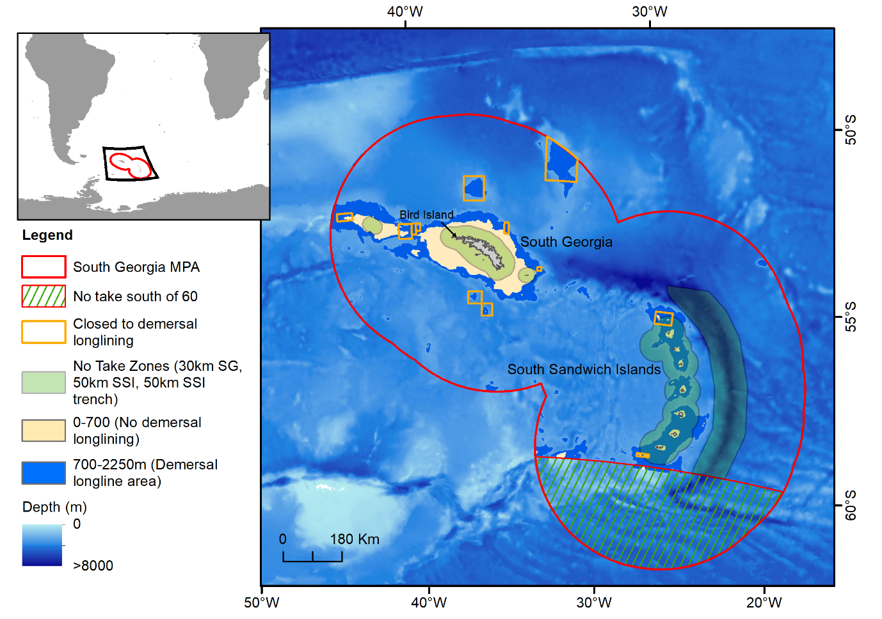
Figure 1: South Georgia (SG) and the South Sandwich Islands (SSI) MPA and associated fisheries management zones (as of December 2018).
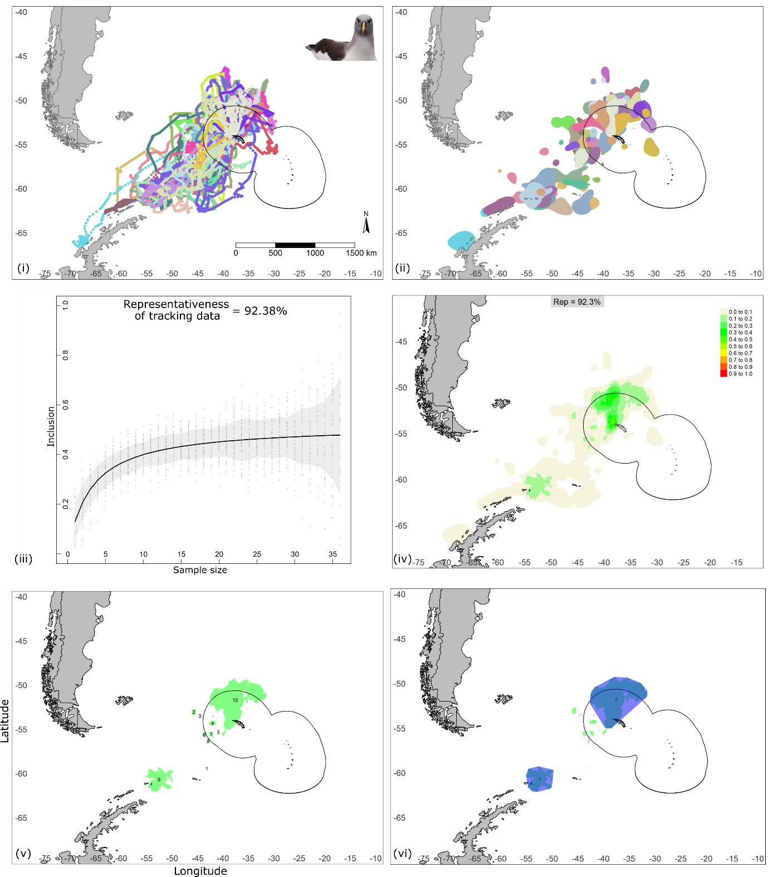
Figure 2: Overview of approach using tracking data to identify Key Biodiversity Areas at-sea (method adopted from the protocol to identify marine Important Bird and Biodiversity Areas (Lascelles et al., 2016)) shown for the example of the data-group, adult Grey-headed Albatrosses during post-guard from Bird Island, South Georgia (n_{individuals}=37, n_{tracks}=193): (i) interpolated tracks, (ii) core foraging areas of each individual bird, (iii) assessment for representativeness of tracking for sampled population, where data is simulated across sample sizes from 1 to n_{individuals} – 1, (iv) polygons where core foraging areas of at least 10% of tracked individuals overlap (selected according to representativeness value), (v) [green] core-area polygons with abundance estimates that meet KBA criteria, (vi) refined [blue] polygons with minimised boundary-to-area ratio suitable for management. Black boundary indicates South Georgia MPA.

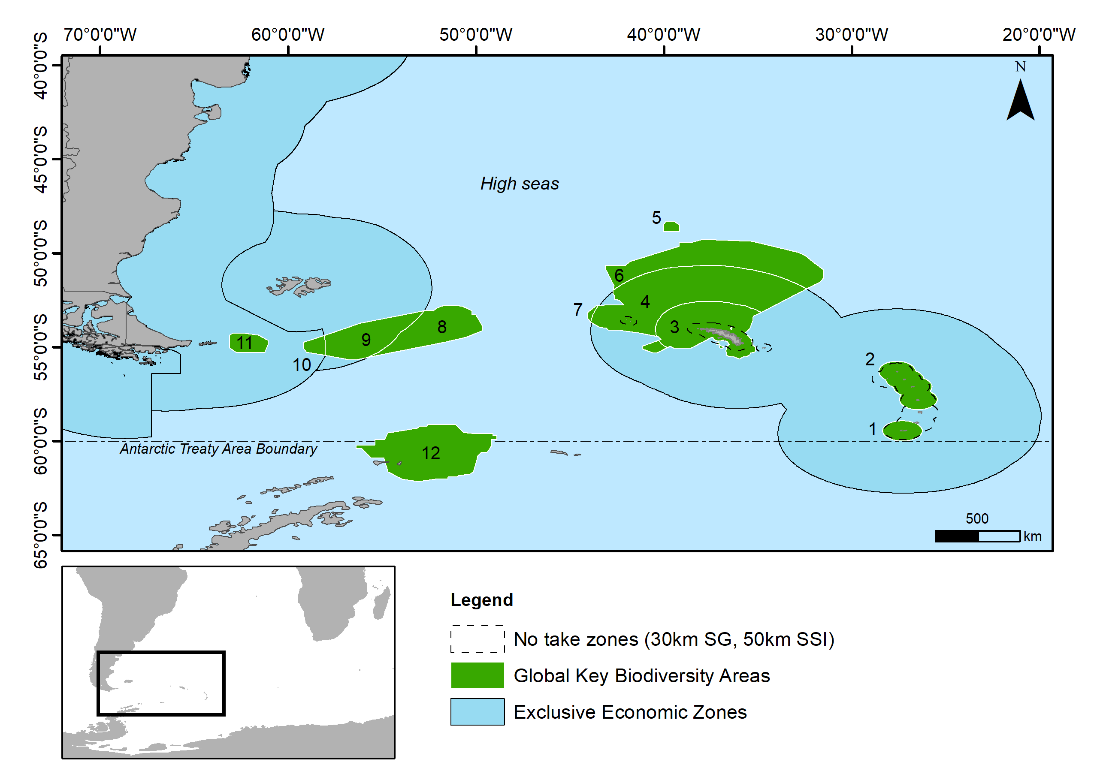
Figure 3: Twelve global KBA sites (white borders) identified for marine predators during the assessment of the South Georgia and South Sandwich Islands MPA and its role in conserving biodiversity. *A dispute exists between the Governments of Argentina and the United Kingdom of Great Britain and Northern Ireland concerning sovereignty over the Falkland Islands (Islas Malvinas), South Georgia and the South Sandwich Islands (Islas Georgias del Sur y Islas Sandwich del Sur) and the surrounding maritime areas. At the time of publication sites 10 and 11 are being amalgamated with new sites being identified throughout Argentinian waters.
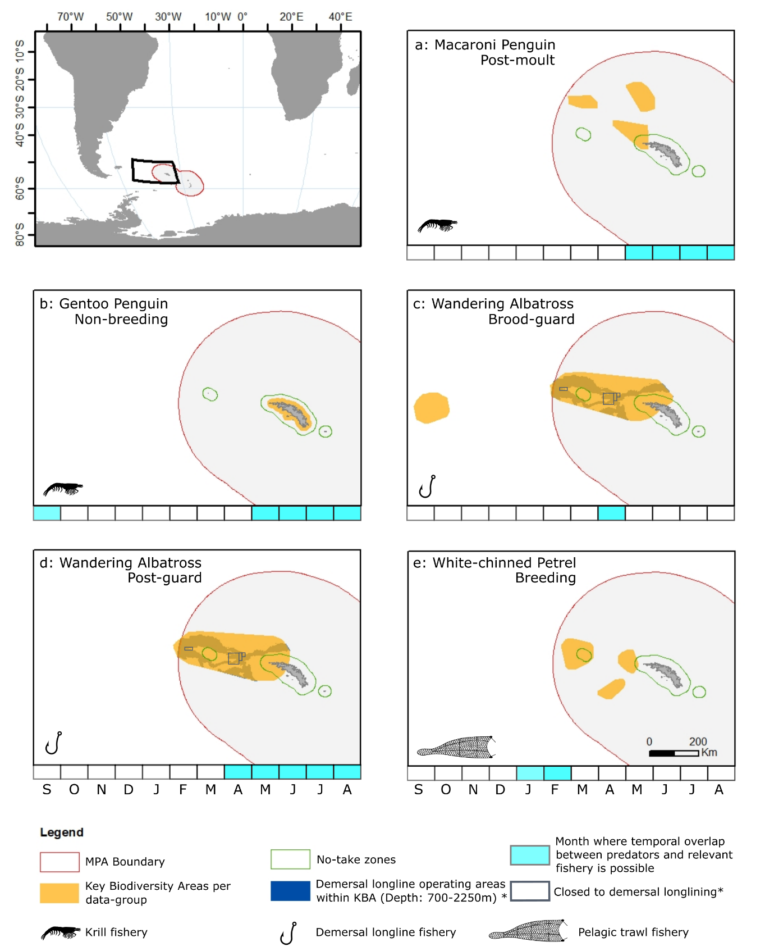
Figure 4: Key Biodiversity Areas (KBAs) for five of the 69 data-groups (unique life-history stages for a species) assessed, representing four species, which have the potential for interaction with a relevant fishery within the South Georgia and South Sandwich Islands MPA. For the remaining data-groups, tracking data used to delineate sites were either un-representative (see Methods) or temporal overlap with a relevant fishery was not possible. (see Results). Possible interaction with krill (a,b), demersal longline (c,d), and pelagic trawl (e) fisheries. * indicates map layers specific to demersal longline fisheries only (c,d).

