The building as a Deleuzoguattarian strata / machinic assemblage
What do we mean when we say that a building is an assemblage? To answer this question, we must first decide what we mean by ‘the assemblage’ and which areas of Deleuze and Guattari’s corpus we will use. In this paper I focus on one of two kinds of assemblage from A Thousand Plateaus: the machinic assemblage. Drawing on the third chapter of this core text, I show how and why this concept should be understood as complementary yet distinct from the often-neglected concept of the strata. I then illustrate these concepts through the architectural design process by discussing the creation of a physical and functional building, acts of (architectural) expression and as a contribution to one or more architectural languages. Using this insight, I argue that architecture provides us with a way to usefully illustrate and explore some of the complex and abstract concepts within Deleuze and Guattari’s philosophy.
Keywords: strata, assemblage; Deleuze and Guattari; architecture; building design
INTRODUCTION
What do we mean when we say that a building or a piece of architecture is an assemblage? One strategy for answering this question is to draw on a wide range of other studies within the spatial disciplines that use this concept to explore their respective fields of interest. In architecture and urban studies this might include the assemblage as a tool for analysing open plan classrooms or specific building projects, defining and critically engage with the city or as a synonym for the concept of ‘place’. In planning it might include studies that use the assemblage to explore issues of network governance and land-use. Expanding into geography literature, one may also consider how this concept has been used to analyse participatory development, harm-reduction drug policies, questions of race, geopolitics and to form an alternative to neoliberal ideology.
The problem with this strategy is that it is likely to create more rather than less confusion about that the assemblage is and what it does / might do. This confusion arises because these studies define the assemblage in very different ways. In response to this, Anderson and McFarlane have presented us with the idea of ‘assemblage thinking’. Assemblage thinking is founded on the principle that all such uses of the concept should be treated as equally valid regardless of their philosophical origins or uses. This is, they argue, because there is no single ‘correct’ way to deploy the term, nor does any theoretical tradition or style hold an exclusive right to it’. Expanding this principle further, they argue that such diversity should be encouraged within the literature to ensure the concept continues to expand and evolve in new and unpredictable ways.
But whilst they argue that the assemblage can only be defined as a relativist concept at the level of the individual case, they also posit that it can also be defined in more general terms by identifying commonalities across different cases. Using this principle they identify four common traits shared by many ‘assemblage thinkers’ within human geography: processes of assembling and disassembling; distributed agencies; emergence; and provisionally.
Looking outside of the spatial disciplines, the Deleuzoguattarian scholar, Ian Buchanan provides us with a very different reading of this literature. This reading challenges the idea that the assemblage should be defined and employed without linking it back to Deleuze and Guattari’s core texts or their philosophical project more broadly. Such ‘illusionary’ or ‘synthetic’ understandings of the assemblage, he adds, ‘continue to act as though the concept was invented by Deleuze and Guattari, but because it does not feel obligated to draw on their work in its actual operation or development’. As an alternative, Buchanan’s argument provides us with the foundations for a second strategy: one that combines a close reading of Deleuze and Guattari’s own use of the term (what he terms an ‘authentic’ approach) with the ‘real world’ processes of designing such buildings.
Within architectural theory, Gorny’s recent publication in this journal provides us with one of the most striking examples of this approach. In this study, Gorny offers one of the only attempts within the spatial disciplines to trace the Deleuzoguattarian assemblage to Hjelmselv’s theoretical framework. Not only does he use this to set out his own ‘authentic’ reading of the assemblage, he also draws on architecture to help illustrate and navigate this reading.
This second strategy to pursue an ‘authentic’ reading of Deleuze and Guattari’s core text does not, in itself, remove the risk of confusion identified above. This is because Deleuze and Guattari use concepts like the assemblage in different ways. Within A Thousand Plateaus alone one could argue that the descriptions of the machinic assemblage in the third chapter (Geology of Morals) does not neatly align with the use of the concept within the subsequent chapter (Postulates of Language). These variations become all the more significant if we extend this across Deleuze and Guattari’s broader corpus and across the work produced by them independently. Whilst one might form a clear distinction between Deleuze’s work prior to and after his engagement with Guattari and vice versa, even this simple distinction is problematic. Bogue suggests that it may be more appropriate to talk of several Deleuzes, several Guattaris and several Deleuze and Guattaris: an observation that is captured in the opening lines of A Thousand Plateaus.
With this in mind, it seems highly unlikely that one can find a clear and unified theory of the assemblage without favouring one of these variants over another or, as in the case of DeLanda’s proposals for a ‘neo-assemblage theory’, to combine concepts that have similar ontological features. To develop a strategy for developing an authentic reading of the Deleuzoguattarian I posit that one should identify the area of texts used to develop this reading and the path taken through and within this broader corpus. Rather than leading us to a unified theory of assemblages, this strategy acknowledges that many different understandings can be derived from a close reading of Deleuze and Guattari’s core texts.

With this in mind, this paper is focused of one of the chapters that form A Thousand Plateaus 10,000 B.C: The Geology of Morals (Who Does the Earth Think It Is?)’. As a result, this reading contains inevitable gaps. These include but are not limited to the development of Hjelmlev’s planar framework within Guattari’s own work; other uses of terms within this planar framework (content, expression, substance and form); the links made between such terms and other philosophical works within the lineage of this philosophy; further developments of the assemblage as implicitly or explicitly stated within other chapters of A Thousand Plateaus.

This paper also acknowledges that the use of diagrams to capture such concepts, and the subsequent illustration of these concepts through architectural design practice are not, therefore, intended as a definitive definition of the term or Deleuze and Guattari’s ontology more broadly. Rather, they act as an attempt to read Deleuze and Guattari’s philosophy through architecture.

THE DELEUZOGUATTARIAN STRATA/MACHINIC ASSEMBLAGE

Planes of content and expression

In the third chapter of A Thousand Plateaus, ‘10,000 B.C: The Geology of Morals (Who Does the Earth Think It Is?)’, Deleuze and Guattari identify the work of the linguist Louis Hjelmslev as a key influence in their philosophical project. In his seminal text Prolegomena to a Theory of Language Hjelmslev proposes an abstract, theoretical framework for analysing all languages. This analytical framework is composed of three planes: the plane of unformed matter (also termed, the ‘purport’), the plane of content and the plane of expression. According to Hjelmslev, a linguistic entity is created within a language when unformed matter transfers across the other two planes. In the first instance, unformed matter appears as substance on the plane of content where is it organised into a specific form. This first process defines a first articulation.
To develop further this must be articulated a second time on the plane of expression. As in the first articulation, this happens as a combination of form and substance. Form is used to organise the components of the emerging language in a more structured way before capturing these as a complex substance. This process of moving across planes is described by Hjelmslev as a process of ‘stratification’ (Hjelmslev, 1961) and captures the idea of ‘double articulation’ defined by André Martinet.

Figure 1: Hjelmslev’s structure of language
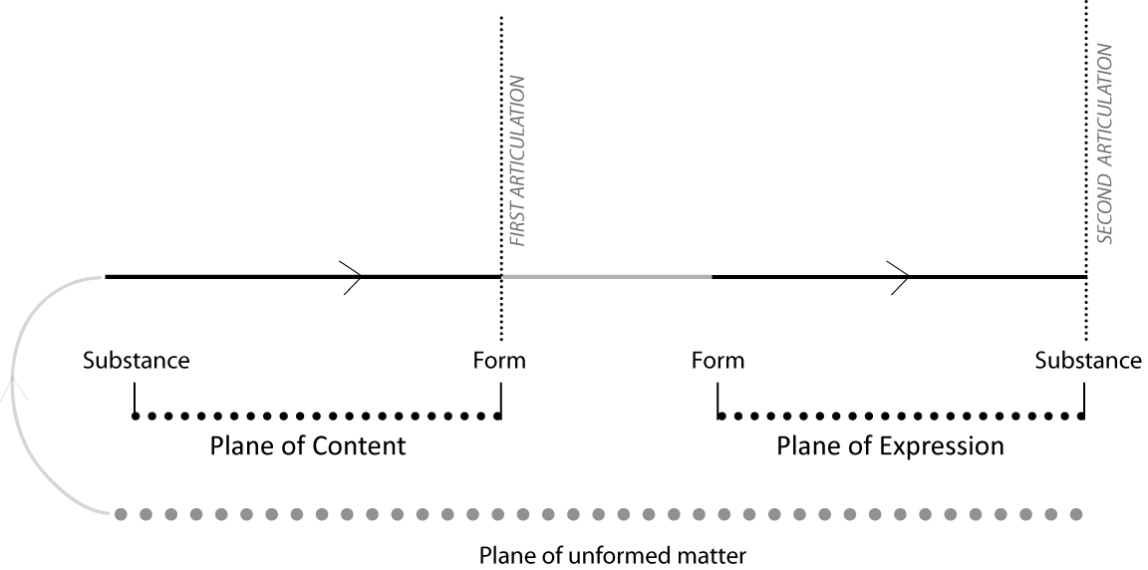
Source: Author

We can illustrate this process of stratification by simplifying an example used by Hjelmslev to explain the development of the utterance, ‘green’. Given that one is unable to perceive the unformed matter of the purport, the first conscious engagement we have with this process is when we identify a block of colour (substance) from all other substances. Then one loosely organises these substances to distinguish between reds, greens and blues (form). This first articulation provides us with a simple means of distinguishing and articulating major colours. But to develop this further, we must articulate these loosely defined colours in a more structured way. One does this by attributing each colour to a word that operates within a broader system of organisation (form) and then capturing these words as sounds (substance) through the utterance, ‘green’. For the purpose of this paper, this simple example shows how a linguistic entity moves across planes, and how these planes provide linguists like Hjelmslev with a structure from which to analyse the different stages of language development and mutation i.e its position within a ‘stratification’ process.

From language to ontology

One of the most radical and yet most neglected propositions within Deleuze and Guattari’s philosophical project is the idea that this composition is not only applicable to the formation and structuration of linguistic entities but is applicable to all things. In other words, this same conceptual structure can be used to analyse the formation of materials in the builder’s yard, the people that make and select these materials, the buildings in which they are embedded, the policy that determines how this is achieved and the written and architectural languages we use to discuss and make sense of such things. As Deleuze and Guattari note,
Hjelmslev was able to weave a net out of the notions of matter, content and expression, form and substance. …[but] Despite what Hjelmslev himself may have said, the net is not linguistic in scope or origin…[they] are general characteristics of strata.
To make this transition from language to ontology, Deleuze and Guattari present us with a number of connected propositions. Three of the most significant of these are summarized in the following text.
Firstly, they argue that the concepts developed by Hjelmslev are synonymous with concepts presented in their broader corpus. Thus, the plane of unformed matter is re-conceptualised as the plane of consistency; the concept of substance becomes territoriality; and the concept of form is re-conceptualised as code.
The problem is that this planar framework alone defines development in a relatively simple way because it focuses on the development of only one entity and treats this entity in relative isolation of other non-linguistic entities. To resolve this limitation, Deleuze and Guattari introduce us to the idea that the substances created through this process of stratification interact with substances produced in other planes. If these substances are to work together in some way, then one or both of these substances must create change in the other. If complex compounds (territorialities) are produced through stratification, they argue, then this adaptation occurs as an act of ‘deterritorialisation’ followed by an act of ‘re-territorialisation’. These processes occur in and across both planes, as formed matter is drawn into and interacts with the stratification process. These acts of de/reterritorialisation produce multiple layers that ‘pile on top of each other’ forming the ‘epistrata’.
As a further attempt to reconceptualize concepts from Hjelmslev’s work in linguistics, Deleuze and Guattari argue that it is the overarching framework that should be understood as a strata not the four components that form the two planes (substance and form on the plane of content; form and substance on the plane of expression).
Taken together these first two propositions form a general, conceptual diagram of the strata. Whilst this refines the planar framework set out by Hjelmslev it is not yet able to account for the formation of different kinds of entity. On this basis, the third proposition offered by Deleuze and Guattari allows them to make the leap from a general diagram of the strata, to a definition/s that can be used to analyse specific identities identified in the world around us. In doing so, this third proposition recognises that whilst physical, organic and linguistic entities develop according to the same planar structure, each entity moves across and through this structure in different ways. To account for these differences, Deleuze and Guattari provide us with three different variants of this diagram and crudely attribute to these to different ‘kinds’ of entity i.e. physical entities like a building, organic entities like the human architect; and the language one might use to discuss and give meaning to buildings and architecture.
These distinctions are crude because they are not intended as a simplistic typological distinction used to classify and separate different things, but to classify different processes that relate to the formation of different things. We can appreciate this distinction by briefly considering Deleuze and Guattari’s study of territorial birds in the 11th chapter of A Thousand Plateaus entitled, ‘1837: Of the Refrain’. In this chapter, Deleuze and Guattari use the diagram attributed to organic entities to discuss the way territorial birds produce physical nests. Whilst the birds may be organic, the entity developed in this example (the nest) is not. This shows that to analyse an assemblage one cannot simply select the variant that best suits the thing produced or study this thing in isolation. Rather, one must consider how such things are produced and how this process may or may not be understood using different strata types.
This point is particularly important for those of us interested in using Deleuze and Guattari’s conceptual framework to understand the design and development of a building. As the nesting bird suggests, it is not sufficient to limit our analysis to the developing building as a physical entity. We must also consider that this same building is designed by an organic entity (the architect) in a comparable way to the nesting bird but is also produced as part of a broader language of architecture. In other words, a building can be understood as a collection of all three kinds of strata.
The idea that strata do not develop and cannot be studied in isolation forms the basis of Deleuze and Guattari’s fourth proposition. This introduces us to the concept of the assemblage, or more precisely the ‘machinic assemblage’. The machinic assemblage, they note, has three roles in this conceptual framework:

A machinic assemblage is an interstratum insofar as it regulates the relations between strata, as well as the relations between contents and expressions on each stratum, in conformity with the preceding divisions... Finally, the machinic assemblage is a metastratum because it is also in touch with the plane of consistency and necessarily effectuates the abstract machine.

In simple terms, the above quotation shows that the machinic assemblage directs the process of moving across the planes within each strata type. And as such, the machinic assemblage accounts for the differences between the three variants of the strata as well as the ‘unity of composition’ within each. Deleuze and Guattari also use the concept to capture the strata’s relationship to an ‘exteriority’. This includes the relationship between the strata and the Plane of Consistency but also to other strata. These other strata may include other developments in the same strata type (such as two organic strata operating in parallel), as well connections across strata types: such as the connection between physical and organic strata (as presented in Of the Refrain). Unlike the arguments presented by the Deleuzoguattarian-inspired theorist, Manual DeLanda, this insight suggests that these concepts cannot be conflated. In other words, the concept of the strata is not simply a static, highly-coded and highly-territorialized assemblage. Rather it shows that these concepts are related and complementary, but they are distinct.
To fully appreciate Deleuze and Guattari strata/machinic assemblage framework in architectural terms, we must understand how the three variants of the strata and the machinic assemblage relate to the development process. With this in mind, the following section starts by ‘translating’ the three variants of the strata/machinic assemblage into an architectural setting.

THREE ARCHITECTURAL STRATA/ASSEMBLAGE DIAGRAMS

The most striking differences between the strata types and the machinic assemblages operating within them can be summarised in three ways. Firstly, they each sub-divide these planes differently affording more or less autonomy to different areas of these planes. Secondly, they each identify a different method for moving across the two planes (induction, transduction, translation). Thirdly, they each present different ways of drawing-in substances from an exterior (sub-strata in Deleuzoguattarian terms), resulting in different thresholds and impacts of the de/re-territorialisation process. Whilst the first of these differences relates to the structure of the planar framework, the second and third differences point to the roles played by the machinic assemblage in each of the strata types.
To understand these three strata/machinic assemblages and their relevance to the design and development of a building, the following text will explore each in turn. The first will be used to understand the formation of a building as a physical entity, the second will be used to understand the formation of a building as an organic entity and the third will be used to understand the formation of a building as a linguistic entity that operates as part of a broader collection of architectural languages.

Strata/machinic assemblage 1: The development of a building as a physical entity

Induction across planes

Deleuze and Guattari use the term ‘induction’ to describe the way in which a machinic assemblage regulates the transition from a plane of content to a plane of expression in the development of physical compounds. This inductive process, they suggest, represents a change in magnitude rather than a fundamental change in the code itself.
We can appreciate this concept by returning to the collection of (formed) materials in a builder’s yard and considering how they may be used in a roof design. Before this process commences, each material has a unique collection of tendencies and capacities that remain dormant as long as they sit within the yard. So, whilst slate has a capacity to withstand water penetration but a tendency to crack when placed under tension, these capacities and tendencies are not utilised.
When the designer commences the design of the roof, they initiate a stratification process. Slate tiles, structural timbers, tanalised battens, breather membranes and insulation are all selected as substances to help articulate the roof on the plane of content. This happens because the tendencies and capacities of these materials are aligned with a structuring code for the roof. In this instance this roof code identifies the need for materials that can shed water, withstand snow loading, achieve a certain level of ventilation and insulation, create a given impression and so forth. The result is a list of materials that are roughly positioned in an order that articulates a functional roof design.
This articulation forms a plane of content. But, like the identification of colours in Hjelmslev’s example, this first articulation does not provide us with sufficient information to fully appreciate what the roof will look like or how it will be put together. To do this we must form a second and more precise articulation of the roof, and thus shift from the plane of content to the plane of expression.
As an act of induction, Deleuze and Guattari tell us that this transition requires a change in the order of magnitude but not in the code itself. So rather than identifying a general need for ventilation and shedding of water, this code defines a dimension for the roof span; ventilation requirements as an airflow rate; a U-value for the thermal properties of the roof build-up; the level of water resistance and absorption; the anticipated imposed loading and so forth. This code is used to refine the substances selected, which may include a size and grading of the timber rafters; the size and thickness of the roof tiles; the thermal conductivity and the thickness of mineral wool insulation. This new code, therefore, results in a more refined and complex compound (substance), which architects may term, a ‘typical roof detail’.

De/reterritorialisation

But, of course, the design of a roof is not the only component of a building. Similar stratification processes will have been used to develop the walls, the floors and the windows. In the first instance, these components are stratified in relative isolation based on their own codes. We can imagine, for example, that the roof detail is articulated as an unvented ‘warm’ roof with the insulation over the structure, whilst the wall detail is articulated as a vented ‘cold’ cavity configuration with the insulation to the inner wall. When the architect tries to align these two details, they will probably find that they do not work together because they produce a ‘cold bridge’ formed from a break in the line of the insulation, and a risk of condensation and water penetration from a break in the weather membrane and the ventilation path. When this happens, the architect identifies a ‘clash’ that momentarily breaks up the coherence of these two complex substances (territorialities) or, as Deleuze and Guattari note the typical wall detail deterritorialises the typical roof detail.
As Deleuze and Guattari note, except for the most extreme instances of deterritorialisation, the act of deterritorialisation is quickly followed by an act of re-territorialisation; or what architects might term, a ‘re-design’. These re-designs lead the architect back to the plane of content by selecting new materials, or to the plane of expression by reconfiguring the code i.e. using different u-values, or different loading criteria. As above, this allows them to continue through the stratification process until they form a revised roof build-up, which may be further deterritorialised through its interaction with a revised wall build-up. These layers of design become epistrata ‘that pile atop each other’ during the design process (Figure 2).

Figure 2: Induction and de/reterritorialisation in the building as a physical entity
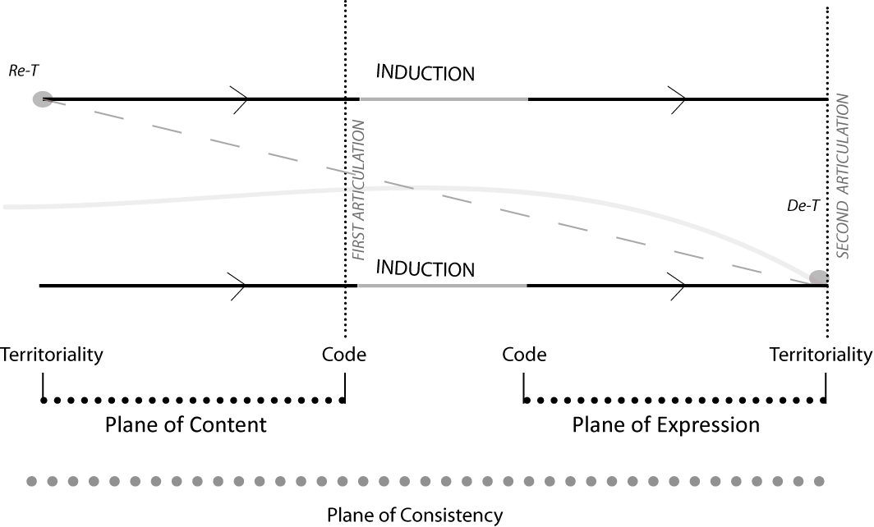
Source: Author

Strata / machinic assemblage 2: The development of a building as an organic entity

Transduction across planes
In Figure 2, physical entities were shown to be formed of two roughly equal planes, which allowed the machinic assemblage to regulate a simple inductive transition across these planes. Deleuze and Guattari’s proposals for the development of organic entities reveal several important changes to this structure (Figure 3). Firstly, they argue that to form an organic entity, the plane of expression must detach itself from the plane of content and become autonomous. Secondly, they suggest that this autonomy is achieved because the form (code) and substance (territoriality) of expression become indistinguishable:
In short, what is specific to the organic stratum is this alignment of expression, this exhaustion or detachment of a line of expression, this reduction of form and substance of expression to a unidimensional line, guaranteeing their reciprocal independence from content without having to account for orders of magnitude.
These two differences prevent a simple, inductive transition across the two planes. So, to make this transition possible, Deleuze and Guattari propose that the machinic assemblage must ‘transduce’ (or transcode) code from one plane to another. This process, they add, arises out of ‘surplus value’ within the code.

In the above example, I showed how the plane of content was formed by aligning the tendencies and capacities of building materials with the code of the roof. Timber’s capacity to span large distances without buckling; the slate’s capacity to repel water; and the capacity of mineral wool insulation to retain heat all played a valuable, functional role in the resulting roof design. In other words, these tendencies were ‘valuable to the roof code’ and this value can be understood as entirely functional.
But these materials also contained capacities and tendencies that were not utilised in this compound. Timber, for example, has the capacity to cantilever far beyond a support wall without losing its structural integrity. But this tendency remains dormant in the requirements and expectations of a roof for a specific building. As such, this capacity of structural timber can be understood as a ‘surplus value’ i.e. surplus to the functional requirements of the roof.
What we have, therefore, is a distinction between tendencies that are valuable because they serve a designated function, and surplus value that has no functional role. Whilst the process of induction is based on the former, the process of transduction is based on the latter.
The formation of an autonomous line of expression occurs when these surplus values undergo a change from a dormant function on the plane of content to an active, expressive quality on the plane of expression. As in the physical strata this is regulated by a machinic assemblage. In the case of the roof design, we can imagine that an architect identifies the timber rafters as an opportunity to create an architectural statement that expresses the eaves. The architect does this by extending the projection far beyond the supporting wall, producing an eaves that is much deeper than is required to serve its primary function i.e. to transport water away from the building envelope. This extra projection is entirely expressive. As Deleuze and Guattari note, such expressions form a new code particular to the plane of expression, that becomes indistinguishable from the material (timber) that facilitates such expressions. This expressive code then underpins other design decisions, thus creating an ‘aggregate of expressive qualities’. The architect may decide, for example, to emphasise the expressiveness of the deep eaves by integrating a gutter within the roof profile, to clad the soffit in a contrasting timber board and to integrate downlighters within this soffit.

De/reterritorialisation

It is highly unlikely that the deep eaves discussed above will be the only expressive statement used in the building design. Most, if not all buildings contain several such lines of expression. As these lines expand, one can image a point when these will confront each other. In the above example, we can imagine two architectural statements developing in parallel. As above, the first expresses a deep eaves and is supported by other design decisions. This results in a strong horizontal feature within the principal facade. But we can also imagine a second expression based on the use of tall narrow windows and vertical timber cladding intended to emphasise a strong vertical feature in the principal facade. From a design perspective, these two architectural statements are incompatible.
Using Deleuze and Guattari’s terms, this clash can be described as a point when the wall deterritorialises the expressiveness of the eaves. Given that this expressiveness was achieved by removing the distinction between the form (code) and substance (territory) of this plane, the impacts of such deterritorialisation are significant. As Deleuze and Guattari note, within this strata, the threshold for deterritorialisation may be higher but the effects are more pronounced
To resolve this clash, one of these features must be re-designed in full. If the decision is made to re-design the eaves detail instead of the wall design, then the architect must not only re-think the materials that form this eave but all the other design decisions that have been used to reinforce this as an expressive statement (Figure 3). As in the development of the roof in the physical strata, this new design becomes an ‘epistrata’ in the roof design.

Figure 3: Transcoding and de/reterritorialisation in the building as an organic entity
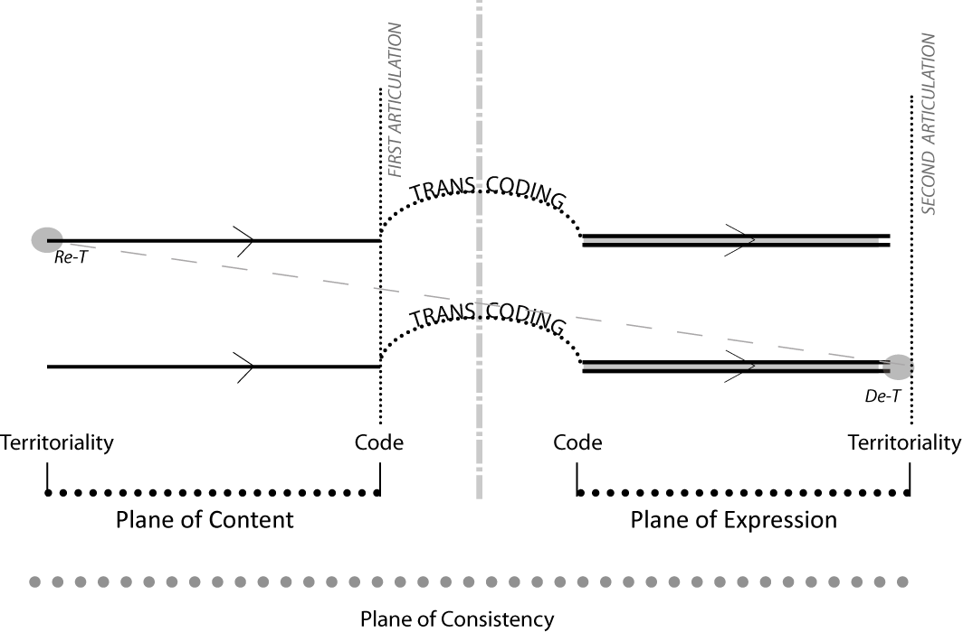
Source: Author

Strata/machinic assemblage 3: The development of a building as a linguistic entity

Translation across planes

In the third strata/machinic assemblage variant, Deleuze and Guattari sub-divide the planar framework further by dividing the plane of expression into its two components: form (code) and substance (territoriality) (Figure 4). This facilitates greater autonomy of expression, but this time, within the code of expression only. The autonomous role of the code of expression results in efforts to translate physical and expressive substances into an abstract organising structure i.e. language. The result, they argue is a ‘superlinearity’ of expression, or what they define elsewhere as acts of ‘overcoding’.
This act of ‘overcoding’ also helps to facilitate another important distinction. In the development of physical and organic entities, substances were selected to fulfil specific purposes. When the roof was designed as a physical entity, substances were selected on the basis of function. When the eave of this roof was designed as an organic entity, substances were selected on the basis of their capacity to form or complement an expressive statement. But in the linguistic composition, all substances are drawn into the strata regardless of their functional or expressive qualities. These include substances within physical compositions like building materials and roof details as well as expressive substances like deep eaves and vertical cladding. In doing so, the superlinear code of expression is used to organise and give meaning to all entities regardless of their physical and expressive status (Figure 4). And because this code is autonomous, this meaning can be transferred (or translated) from one building design to another. As Deleuze and Guattari note,
…This property of overcoding or superlinearity explains why, in language, not only is expression independent of content, but form of expression is independent of substance: translation is possible because the same form can pass from one substance to another, which is not the case for the genetic code, for example, between RNA and DNA chains.
We can appreciate these concepts of overcoding and translation by returning to the above example. As a language, building materials are overcoded through various performance specifications, and a typical roof design is overcoded in its relationship to industry guidance and best practice. These performance specifications and roof details are then translated from building to building when they become ‘best practice’ or ‘standard / typical details’.
The expressive statement of the extended eaves is also overcoded as part of a broader language in architectural style; perhaps linking it to the Arts-and-Crafts period, and thus as a counter-position to the kinds of architectural statements seen in modernist architecture. Similarly, this act of overcoding also facilitates translation across buildings when these statements become ‘design features’ used in other buildings.

De/reterritorialisation

As in the other two strata/machinic assemblage variants, we can identify an act of deterritorialisation when these linguistic entities clash with other languages developed through other expressive codes. Returning to the above examples, we can see how the language used to code different materials according to one set of traits may be deterritorialised by a language that overcodes these materials in a very different way. An obvious example of this can be seen in the language that overcoded asbestos according to its fire-retardant properties, which was later deterritorialised by a language that overcoded this material according to its toxicity. More recently, we have seen a clash between a collection of languages used to overcode materials according to a range of performance criteria, and a new language that overcodes these same materials according to their CO2 emissions, recyclability and capacity for natural degradation.
As in other strata/ machinic assemblages, each act of deterritorialisation is followed by an act of reterritorialisation that significantly transforms the language we use to discuss materials in the construction industry. In some instances, these reterritorialisations have resulted in a language that prohibits materials like asbestos and lead paint or places limitations on the use of paints with high toxicity levels, and high embedded CO2 values.
Similar acts of de/reterritorialisation can be seen in the expressive statements used in architectural design. Indeed, architectural history can be characterised as a sequence of efforts to deterritorialise the language/s of architecture. Some of these are equally underpinned by a conscious effort to reterritorialise this language using different codes of expression (Such as Baroque, Arts-and-Crafts) whilst others have been reterritorialised despite the movement’s underlying aims (Modernism, Deconstructivism).

Figure 4: Translation and de/reterritorialisation in the building as a linguistic entity
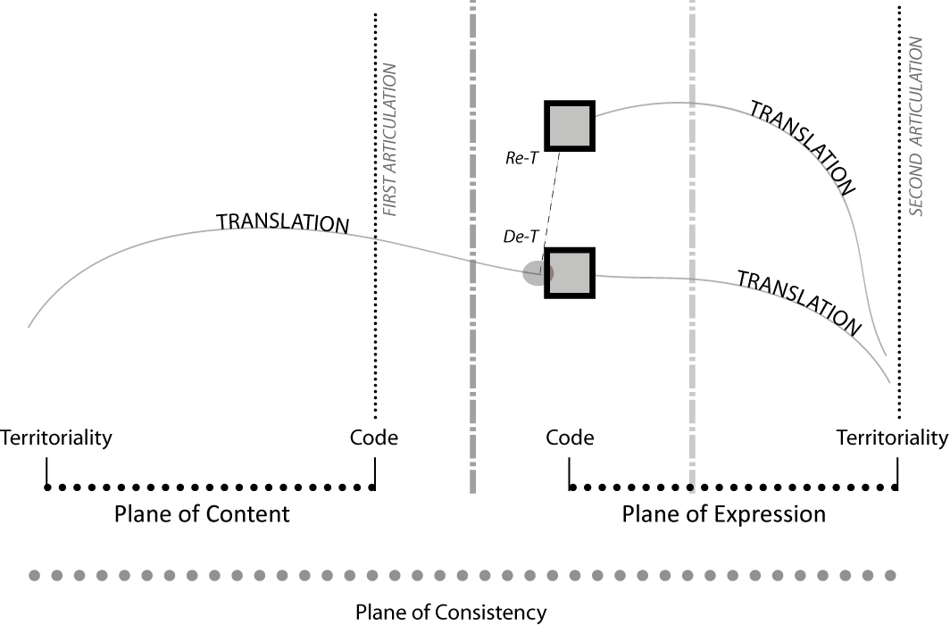Source: Author

Three connected strata/machinic assemblages

These examples provide a clear illustration of the three strata types and the role played by the machinic assemblage in each. But these illustrations only consider the way in which the machinic assemblage regulates strata of the same type rather than regulating the relationship between different strata. This point is all the more salient if we return to the example of the design process.

As anyone who has worked in professional practice knows, buildings do not develop as only one of the three strata types, neither do they develop in a progressive sequence from physical, to organic and then linguistic. A building may start as a physical strata, but then shift into a linguistic strata through the formation of an outline specification, then an organic strata through the introduction of an expressive statement, before returning to a physical strata through the introduction of a more refined design code, and shifting again to the linguistic strata through a more detailed specification and so forth. These transition across strata are complex and vary from building to building. And it is here that we can appreciate the importance of the machinic assemblage concept. Not only does it account for the regulation of development within a strata or between the interaction of strata of the same type, it also accounts for the constant shift between and across these types.

CONCLUSIONS

Three strata / machinic assemblages

In the introduction to this paper I asked the question, what do we mean when we say that a building is an assemblage? This question reflects a growing trend within the spatial disciplines to reconceptualize physical and non-physical entities as assemblages. The illustrations from the design process above show why such questions are misleading. The first, most obvious problem with identifying a building, a city or a policy as an assemblage is that it does not define which of the two kinds of assemblages we are referring to: the machinic assemblage or collective assemblages of enunciation. This distinction is important because these two forms of the assemblage serve different roles within Deleuze and Guattari’s core texts.
Looking at the machinic assemblage, the second problem is that it does not take account of the concept’s relationship with the strata. Of course, one may legitimately argue that it is impractical to include every Deleuzoguattarian concept in each and every study. But in this instance, by failing to consider the strata we are unable to account for the complementary yet distinct roles played by these two concepts. Using architecture to illustrate these concepts I have shown how a building can be conceptualised as a physical strata, organic strata and a linguistic strata, whilst the machinic assemblage provides us with some conceptual insight into the way these develop and how such strata interact with each other.
This observation leads onto a third issue regarding the relationship between assemblages and buildings (space, city, policy etc). Whilst one can identify a relatively clear definition of the strata and relate this to different aspects of the building (physical, organic and linguistic), the same cannot be said of the machinic assemblage. This is partly because the machinic assemblage has three different roles. But it also because the machinic assemblage fulfills these roles in different ways in each of the strata types. We can appreciate this second point by returning to the above illustrations, which provide insight into two of these roles: regulating the relationship between strata and regulating the relationship between content and expression.
The machinic assemblage in the building as physical strata regulates the shift from a simplistic code used to select and organize formed matter into a sketch design, to a more refined code used to refine the selection and organization of materials resulting in, what architects term a ‘technical’ or ‘detailed design’. In the building as organic strata, the machinic assemblage regulated the shift from a functional design to the introduction and development of an expressive ‘architectural’ statement. In the building as linguistic strata, the machinic assemblage directed the translation of functional design decisions and expressive statements into a broader architectural language, which included the building specification and the translation of the individual building into a broader architectural movement (such as modernism). Drawing these examples together, one might identify the machinic assemblage with several different ‘actors’ in the design process: the formalized design process itself, decisions made by the architect; the technician; the specification writer and the architectural theorist / historian.
This same diversity can be seen in the machinic assemblage’s role regulating the relationships between strata. The above illustrations mostly consider the relationship between two strata of the same type rather than of different types. But despite this limitation we can still identify the diverse ways in which the machinic assemblage fulfills this role through acts of de/reterritorialisation. In these strata such acts are derived from the tendencies and capacities of formed matter, expressive statements and the superlinearity of language/s.
Taken together, these examples show that one cannot associate the machinic assemblage with any one actor or entity. With this in mind, I would like to re-qualify the question used to introduce this paper. Rather than asking what is meant by a building as assemblage, perhaps we should ask what can we learn by thinking about architecture as strata/machinic assemblage.
For many, this requalified question and the above text may feel far more complicated than the simpler definitions of the assemblage often used in ‘assemblage thinking’ literature. Indeed, following on from DeLanda’s proposals for ‘assemblage theory’ most if not all of these studies either conflate the strata with the assemblage or ignore the former entirely. In anticipation of such comments, I would like to stress the point that Deleuze and Guattari develop these two concepts to fulfill different roles in a radical and ambitious agenda: not just to name the complexity that surrounds us or to show that such things have agency, but to provide us with a conceptual framework that allow us to analyse the development of everything.

Next steps…

This paper begins to show how architecture can be used to illustrate and explore some of the complex and abstract concepts within Deleuze and Guattari’s philosophy. This strategy is not new. It is employed by Deleuze and Guattari’s across much of their work. Within the third chapter alone, Deleuze and Guattari refer to a range of real-world illustrations including crystals, tortoises, ticks, the human hand and the Amazons. This paper demonstrates the advantages offered by using building design to add to this list. Unlike some of the examples identified by Deleuze and Guattari, it offers opportunities to explore all three strata types and machinic assemblage operating within and across these three strata. But one must not expect a perfect fit between Deleuze and Guattari’s philosophical concepts and these ‘real-world’ illustrations.
Moving beyond the limitations of this single paper, I would like to suggest that future research should consider the extent to which building design can provide us with greater insight into Deleuze and Guattari’s philosophy: can architecture can be used to illustrate and explore other chapters of A Thousand Plateaus? And across their broader corpus? Where do these illustrations align (and not)? How do these alignments help us piece together different fragments of their corpus?
But I would also like to suggest that future research should consider this relationship between Deleuzoguattarian philosophy and architecture as reciprocal. Building on the work of Deleuzoguattarian-inspired theorists such as Frichot and Smith such research should continue to ask whether Deleuze and Guattari’s concepts can be used to better understand and explore real world design practice. The difficulty we face as Deleuzoguattarian spatial theorists, it seems, is finding a way to link these two lines of enquiry together and to find ways to operate within and across them both.

Kim Dovey and Kenn Fisher, “Designing for Adaptation: The School as Socio-Spatial Assemblage,” The Journal of Architecture 19, no. 1 (January 2, 2014): 43–63,
Andrew Daly and Chris L. Smith, “Architecture, Cigarettes AND THE Dispositif,” Architectural Theory Review 16, no. 1 (April 2011): 22–37
Colin McFarlane, “The City as Assemblage: Dwelling and Urban Space,” Environment and Planning D: Society and Space 29, no. 4 (August 1, 2011): 649–71
Kim. Dovey, Becoming Places Urbanism, Architecture, Identity, Power (Routledge, 2009)
J Van Wazemael, “The Contribution of Assemblage Theory and Minor Politics for Democratic Network Governance,” Planning Theory 7, no. 2 (2008): 165–85.
Kim Dovey and Elek Pafka, “What Is Functional Mix? An Assemblage Approach,” Planning Theory & Practice 18, no. 2 (April 3, 2017): 249–67
Kevin Grove and Jonathan Pugh, “Assemblage Thinking and Participatory Development: Potentiality, Ethics, Biopolitics,” Geography Compass 9, no. 1 (2015)
Eugene McCann, “Veritable Inventions: Cities, Policies and Assemblage,” Area 43, no. 2 (June 1, 2011): 143–47
Arun Saldanha, “Assemblage, Materiality, Race, Capital,” Dialogues in Human Geography 2, no. 2 (July 10, 2012): 194–97
Jason Dittmer, “Geopolitical Assemblages and Complexity,” Progress in Human Geography 38, no. 3 (June 2, 2014): 385–401
Stephen J. Collier, “Neoliberalism as Big Leviathan, or … ? A Response to Wacquant and Hilgers,” Social Anthropology 20, no. 2 (May 1, 2012): 186–95; Stephen J. Collier and Aihwa Ong, “Global Assemblages Anthropological Problems,” in Global Assemblages (Oxford, UK: Blackwell Publishing Ltd, 2008), 3–21; Aihwa Ong, “Neoliberalism as a Mobile Technology,” Transactions of the Institute of British Geographers 32, no. 1 (January 1, 2007): 3–8; Aihwa Ong, “Ecologies of Expertise: Assembling Flows, Managing Citizenship,” in Global Assemblages (Oxford, UK: Blackwell Publishing Ltd, 2008), 337–53
Ben Anderson and Colin McFarlane, “Assemblage and Geography,” Area 43, no. 2 (June 1, 2011): 124,
Ibid., 125.
Ian Buchanan, “Assemblage Theory, or, the Future of an Illusion,” Deleuze Studies 11, no. 3 (August 25, 2017): 457–74
Ibid
Robert Alexander Gorny, “Reclaiming What Architecture Does: Toward an Ethology and Transformative Ethics of Material Arrangements,” Architectural Theory Review 22, no. 2 (May 4, 2018): 188–209
Catarina P. Nabais, Gilles Deleuze: philosophie et literature. Editions L'Harmattan (2013)
Ronald Bogue, ‘The Terrified Face and the Face Machine’ Conference paper presented at the 12th Annual Deleuze & Guattari Studies conference, 8-10 July 2019 at Royal Holloway,
Deleuze and Guattari, A Thousand Plateaus, 3.
Manuel DeLanda, Assemblage Theory Edinburgh, UK: Edinburgh University Press. (2016) This same strategy is employed across many other concepts in Manuel DeLanda’s previous work, Intensive Science and Virtual Philosophy London, UK: Continuum. (2002)
Manuel DeLanda, Assemblage Theory (2016)
See Graham Jones and Jon Roffe (Eds) Deleuze's Philosophical Lineage I Edinburgh, UK: Edinburgh University Press (2009); Graham Jones and Jon Roffe (Eds) Deleuze's Philosophical Lineage II Edinburgh, UK: Edinburgh University Press (2019)
L Hjelmslev, Prolegomena to a Theory of Language, ed. Winsconsin (University of Wisconsin Press, 1961).
A Martinet, Elements of General Linguistics, trans. E Palmer (London, UK: Faber & Faber, 1969).
Hjelmslev, Prolegomena to a Theory of Language; M Taverniers, “Hjelmslev’s Semiotic Model of Language: An Exegesis,” Semiotica, no. 171 (2008): 367–94.
Buchanan, “Assemblage Theory, or, the Future of an Illusion.”
Deleuze and Guattari, A Thousand Plateaus, 43.
Ibid., 41.
An argument used to underpin DeLanda’s reading of Deleuze and Guattari’s philosophy as ‘non-essentialist’ (2016).
Deleuze and Guattari argue that there are two assemblages used within A Thousand Plateaus: the machinic assemblage and the collective assemblage of enunciation. See Deleuze and Guattari, A Thousand Plateaus, 22.
Ibid., 73.
Ibid., 50.
Manuel DeLanda, Assemblage Theory. Edinburgh, UK: Edinburgh University Press (2016)
Note that for the purpose of legibility, Figure 2 shows only one instance of De/reterritorialisation. A more ‘complete’ diagram would include multiple acts positioned across both planes. This observation is equally applicable to all subsequent Figures in the paper.
Deleuze and Guattari, A Thousand Plateaus, 59.
Ibid., 60; 313.
Ibid., 315.
Ibid., 344.
Ibid., 60.
Ibid., 62.
Ibid., 62.
Given the limitations of this single paper publication I have not explored the third role of the machinic assemblage as the effectuation of the abstract machine. This is owing to the complexity of the concepts surrounding the Plane of Consistency and the abstract machines operating within this plane.
A more detailed illustration of relationships between different types of strata is captured in a forthcoming paper [Anonymised for peer review]
Helene Frichot, Creative Ecologies: Theorizing the Practice of Architecture. Edinburgh: Edinburgh University Press. (2018)
Chris Smith, Bare architecture: a schizoanalysis. London, UK: Bloomsbury Academic. (2017)

