Resubmitted to Phys. Rev. Materials on 11/11/2019

Magnetic Impurities as the Origin of the Variability in Spin Relaxation Rates
in Cu-based Spin Transport Devices

J. D. Watts*^{1,2}, L. O’Brien*³, J. S. Jeong², K. A. Mkhoyan², P. A. Crowell¹ and C. Leighton^{2,†}
¹ School of Physics and Astronomy, University of Minnesota, MN, USA
² Department of Chemical Engineering and Materials Science,
University of Minnesota, MN, USA
³ Department of Physics, University of Liverpool, UK

ABSTRACT: The Elliott-Yafet spin relaxation mechanism posits linear proportionality between spin and momentum lifetimes in low spin-orbit coupling non-magnetic metals, and is widely accepted in spintronics. Accurate experimental determination of the Elliott-Yafet proportionality constants ($β_{i}$) between the spin and momentum relaxation times for individual scattering sources is challenging, however. This is apparent from the literature on non-local spin transport in Cu, for example, where reported phonon ($β_{ph}$) and defect ($β_{def }$) Elliott-Yafet constants vary by an order of magnitude. In recent work we discovered that even part-per-million-level magnetic impurity concentrations can substantially influence spin relaxation in Cu, via a spin transport analog of the Kondo effect. To clarify whether this could explain the reported variability in $β_{i}$, here we report on a comprehensive study of spin transport in Cu-based lateral non-local spin valves, varying the ferromagnetic contact material, interface structure, Cu thickness, and post-fabrication annealing conditions, resulting in widely varied microstructures and magnetic impurity concentrations. Quantifying the effects of magnetic impurities on charge and spin transport we demonstrate the dramatic, even dominant, effect these can have on spin relaxation rates, and thus extracted $β_{i}$. Minimization of magnetic impurity effects is achieved via Al interlayer insertion or moderate annealing, restoring the expected temperature dependence for phonon-mediated spin relaxation, and enabling more reliable determination of $β_{i}$ for phonons (740 ± 200), and non-magnetic defects (240 ± 50). The latter contribution is shown to be dominated by grain boundaries in these polycrystalline Cu films. Cross-sectional transmission electron microscopy measurement of grain sizes in actual non-local spin valve devices then establishes a useful empirical relationship between average grain size and spin diffusion length. These measurements highlight the importance of magnetic impurities in metallic spin transport, explain the wide variability in reported $β_{ph}$ and $β_{def }$in Cu, and elucidate the relationship between metallic spin transport and microstructure.

*These authors contributed equally to this work.
†Corresponding author: leighton@umn.edu
SECTION: M6-A: Magnetic, ferroelectric, and multiferroic materials
PHYSH: Research areas: Magnetism, spintronics, spin injection, spin relaxation
Physical Systems: 3D systems, metals, elemental metals
Techniques: Transport techniques

I. INTRODUCTION
Efficient and controlled transport of spins in metals would enable numerous advances in spintronic devices, including in sensors, logic, and data storage devices. One specific example is the need for metal-based alternatives to magnetic tunnel junctions in hard disk drive read head sensors, which arises due to resistance scaling challenges at low dimensions ^{1–3}. The substantial effort to improve our understanding of the injection of spins from ferromagnetic (FM) to non-magnetically-ordered (“non-magnetic”, NM) metals, and their subsequent transport and relaxation, thus continues, particularly at nano- and meso-scopic scales^{4–22}. Among the many questions that remain open, the impact of specific scattering sources on spin relaxation in NM metals is prominent ^{11,21,23–25}. Even in heavily studied light metals with weak spin-orbit interaction (e.g., Al, Cu), the individual effects of interfaces, surfaces, grain boundaries, dislocations, and point defects (impurities, etc.) are far from understood ^{9,11,17–19,21,26–28}.
The prevailing theoretical picture for spin relaxation in light NM metals, widely accepted in spintronics, is the Elliott-Yafet (E-Y) mechanism, wherein conventional elastic scattering mediates spin mixing, controlled by the spin-orbit interaction strength^{29–31}. This was originally cast in terms of simple linear proportionality between the spin lifetime $τ_{s}$ and the momentum relaxation time $τ_{e}$, i.e., $τ_{s}=βτ_{e}$, where $β$ is sometimes referred to as an E-Y constant³². Following a probabilistic interpretation, spin relaxation thus occurs every $β$ momentum relaxation events on average (i.e., with probability $β^{-1}$ at each event), $β$ being proportional to the spin-orbit interaction strength. This original formulation did not, however, explicitly account for multiple possible sources of scattering, such as phonons, surfaces, grain boundaries, impurities, etc. To address this, a generalized E-Y relation was advanced ^{6,7,9–11,13–15,18–21}, essentially applying Matthiesen’s rule to spin transport. The total spin relaxation rate then becomes
$$\frac{1}{τ_{s}}=\sum_{i}{\frac{1}{τ_{s,i}}}=\sum_{i}{\frac{1}{β_{i}} \frac{1}{τ_{e,i}}} \left(1\right),$$
where the $1/τ_{s,i}$ are the individual spin relaxation rates due to scattering source i, the $1/{τ_{e,i}}$ are the corresponding individual momentum relaxation rates, and the $β_{i}$ are the E-Y constants for each source of scattering. Framed this way, the challenge of quantitative understanding of metallic spin relaxation reduces to determining the important $β_{i}$ in a given NM, for subsequent comparison with theory. Some successes have been achieved. Elemental NM metals such as Au, Cu, Ag, Na, and K, for example, were shown from conduction electron spin resonance (CESR) measurements to have the temperature(T)-dependent scaling of $1/τ_{s}$ with resistivity (ρ) expected from Eq. (1)³². More recently, the phonon value of $β$ ($β_{ph}$) in polyvalent Al was quantitatively understood in terms of “spin hot spots”, i.e., points on the Fermi surface where spin-orbit coupling becomes strong compared to inter-band energies^{33,34}. In general, however, quantitative experimental determination of even the most elementary $β_{i}$ in Eq. (1) has proven challenging. Historically, there has been a paucity of methods to accurately determine $τ_{s}$ for comparison to $τ_{e}$, particularly with some means to separate scattering sources such as phonons and T-independent defects. Historical literature data for $β$ are thus mostly restricted to $β_{ph}$ values from CESR on ultrapure NMs ^{30,32,35}. In Cu, for example, this has led to an accepted value for $β_{ph}$ of ∼1000, meaning that spin relaxation occurs every ∼1000 phonon scattering events on average ^{30,32}.
In principle, the lateral non-local spin valve (NLSV) provides a means to substantially advance the quantitative understanding of E-Y spin relaxation in metals, as it enables all-electrical generation and detection of diffusive pure spin currents^{4,5}. This allows for determination of $τ_{s}(T)$ in a device in which $(T)$, and thus $τ_{e}\left(T\right)$, can also be straightforwardly measured. Appropriate analysis then enables separation of T-dependent (phonon) scattering from T-independent (defect) scattering, thus determining $β_{ph}$ and $β_{def}$. Additional experiments carefully varying specific defect densities could then be used to deconvolute the effects of various defects (e.g., grain boundaries, surfaces, impurities, etc.) on $β_{def}$.
Briefly, the NLSV geometry places two FM nanowire contacts (a spin injector and a spin detector) a distance $d$ apart on an NM nanowire channel, as schematically shown in Fig. 1(a). Injection of a current $I$ from the injector FM into the NM wire results in accumulation of a non-equilibrium spin population in the NM. This spin population diffuses towards the detector FM where it is detected via the non-local potential difference ${ΔV}_{NL}$ that develops between the detector FM and the far end of the NM wire, which remains in equilibrium. This ${ΔV}_{NL}$ is measured by toggling the magnetizations of the injector and detector between parallel ($V_{P}$) and antiparallel ($V_{AP}$) states. The non-local spin resistance, or “spin signal” is then given by$ΔR_{NL}={ΔV}_{NL}/I$, providing a direct measure of the spin accumulation at the detector. T-dependent measurements of $ΔR_{NL}$ vs. $d$ then yield the NM spin diffusion length $λ_{N}(T)$ and thus $τ_{s}(T)$. This can be compared with $τ_{e}(T)$ determined from $ρ(T)$, enabling the determination of $β_{ph}$ (from the T-dependence) and $β_{def}$ (from the low $T$, residual values).
Although the above analysis appears relatively straightforward, examination of the literature on metallic NLSVs reveals remarkable variability in published $β_{ph}$ and $β_{def}$ values. Cu, Al, and Ag are the only NM metals that have been widely studied in NLSVs, Cu being the focus of most attention ^{10,11,13–15,18–20}. Even in this most heavily studied case, reported $β_{ph}$ values for Cu vary between 490 and 3570 ^{10,13–15,20}, i.e., almost an order-of-magnitude. Although this range encompasses the accepted CESR value of ∼1000 ^{30,32}, it is unclear what the origin of the large variability in NLSV-deduced $β_{ph}$ values is, and thus what level of agreement truly exists between CESR and NLSV measurements. The situation is similarly unsatisfactory for $β_{def}$. Reported values for Cu span from 215 to 2560 ^{10,11,13–15,18–20}, i.e., a factor of ∼12, with little understanding of how this should be apportioned among various possible defects. Some work has attempted to correlate $β_{def}$ with grain size, deducing a grain boundary $β$ ($β_{GB})$ of ∼1000 ¹¹, but other specific defect $β_{i}$ remain unknown. Moreover, given that the reported ranges for $β_{ph}$ and $β_{def}$ overlap, it is not clear if these values truly differ in Cu. Given these questions, it is imperative that some understanding be gained of the root cause of the wide variability in E-Y $β$ values from metallic NLSV studies.
A range of factors have been suggested to play a role in the variability of NLSV-deduced $β_{ph}$ and $β_{def}$ values in metals such as Cu, including strong and/or T-dependent surface spin relaxation ^{7,19,21,22}, variation in deposition conditions (generating variable distributions of defect types) ^{8,12}, and uncontrolled incorporation of large spin-orbit coupling impurities ³⁶. A quite different factor recently discovered to play a striking role in metallic spin transport is incorporation of magnetic impurities (MIs). Specifically, recent work from ourselves ^{28,37–39} and others ^{6,11,13,40} demonstrated that even very low concentrations of MIs (order parts-per-million (ppm)) can dramatically influence metallic spin transport through a manifestation of the Kondo effect. The first work on this effect noted that the widely-observed unexpected non-monotonicity in $ΔR_{NL}(T)$ in Cu-based NLSVs occurs due to a low T suppression of $ΔR_{NL}$ that is logarithmic in T, with characteristic temperature in good agreement with the known Kondo temperature ($T_{K}$) of the FM/Cu pairing ²⁸. The non-monotonicity in $ΔR_{NL}(T)$ was also found to vanish in NLSVs based on Al, a metal that is known to not support local moments on dilute 3d transition metal impurities, and thus not exhibit the Kondo effect ^{41–43}. Subsequent analyses demonstrated that the low T decrease in $ΔR_{NL}(T)$ occurs due to logarithmic suppression of the current spin polarization α ^{28,39}. This was explained in terms of depolarization of the injected spin current by Kondo scattering at MIs near the interface, generated by FM/NM interdiffusion. Annealing was shown to enhance this interdiffusion, leading to simultaneous observation of conventional transport and spin transport Kondo effects, and quantification of channel MI concentrations (in the 10-100 ppm range) ³⁷. Subsequent work also introduced MIs throughout the channel, rather than only at the FM/NM interface, resulting in similar Kondo effects not only in α(T), but directly in τ_{s}(T) and λ_{N}(T) ¹³. Accompanying theory was then developed, showing, remarkably, that although the process is not spin-orbit-mediated, Kondo spin relaxation at MIs can be cast in E-Y form, i.e., $τ_{s,K}=β_{K}τ_{e,K}$ (where the “K” subscript denotes Kondo), with $β_{K}$ = 3/2 ³⁹. This remarkably low effective E-Y β value (compare $β_{K}$ = 3/2 with $β_{ph}$ ≈ 1000 in Cu for example) was then validated experimentally ^{38,39}, confirming that spin relaxation at MIs is highly efficient compared to spin-orbit-mediated relaxation at NM defects. Spin transport is thus even more sensitive than charge transport to ppm-level MI concentrations. Given this demonstrated importance of MIs in Cu, it is natural to ask whether Kondo spin relaxation could play a role in the variability in $β_{ph}$ and $β_{def}$ in Cu-based NLSVs. This is the motivation for this work. Importantly, based on these recent experimental and theoretical developments, we are now armed with the capability to fully quantify the influence of MIs on both charge and spin transport.
With these goals in mind, we report here on a comprehensive study of spin transport in Cu-based NLSVs, varying the FM contact material, interface structure (either FM/Cu or FM/Al interlayer/Cu), Cu channel thickness, and post-fabrication annealing conditions, achieving widely varied microstructures, interdiffusion levels, and channel MI concentrations. Quantifying MI effects on charge and spin transport we demonstrate the significant, even dominant, effect these can have on spin relaxation. In the worst cases the expected T dependence of τ_{s} is in fact completely masked by Kondo scattering, rendering extraction of reliable $β_{i}$ impossible. Minimization of MI effects is achieved via Al interlayer insertion or moderate annealing, however, restoring the expected T dependence of ${}_{s}$ and enabling more reliable determination of $β_{ph}$ = 740 ± 200 and $β_{def }$= 240 ± 50. Grain boundaries are then shown to be the dominant contributor to $β_{def }$, cross-sectional transmission electron microscopy (TEM) measurement of grain sizes in actual NLSVs establishing a useful empirical relationship between average grain size and λ_{N} in Cu. These measurements and analyses highlight the importance of MIs in metallic spin transport, explain the wide variability in reported $β_{ph}$ and $β_{def }$in Cu-based NLSVs, and elucidate the relationship between metallic spin transport and microstructure.
II. EXPERIMENTAL METHODS
NLSVs were fabricated with Cu channels, using Fe, Co, and Ni₈₀Fe₂₀ (Py) as the FM contacts. Shadow masks defined by electron beam lithography on Si/Si-N substrates were used for multi-angle deposition of NLSVs, as in our prior work^{28,37–39,44}. Ultrahigh vacuum (∼10⁻¹⁰ Torr base pressure) electron beam evaporation was employed, with Cu source purity of 99.999% and FM purity of 99.95%. Deposition rates for Cu and the FMs were kept at 1.0 and 0.5 Ås⁻¹, respectively; the FM thickness ($t_{F}$) was held at 16 nm, while the Cu thickness ($t_{N}$) was varied between 25 and 400 nm. The widths of the FM injector, FM detector, and NM channel were fixed at 100, 150, and 200 nm, respectively, and the injector-detector separation ($d$) was varied between 150 and 2000 nm. As discussed below, some NLSVs also had a 6 nm Al interlayer (IL) between the FM and NM, and some devices (Fe/Cu) were annealed, post-fabrication, at temperatures $T_{A}$ up to 500 °C in vacuum (10⁻⁶ Torr) for 2 h. Unannealed devices reach 80 °C during processing, and are thus labelled as $T_{A}=$ 80 °C. Conventional cross-sectional TEM imaging was conducted using an aberration-corrected (probe-corrected) FEI Titan G2 60-300 scanning TEM (STEM), operated at 300 kV. Cross-sectional TEM specimens were prepared using a focused ion beam (FIB, FEI Helios NanoLab G4) using 30 kV Ga ions, followed by 1-5 kV ion milling to remove damaged layers on the specimen surfaces. An example TEM image from a Co/Cu NLSV, with $t_{N}=$50 nm, is shown in Fig 1(b), along with a corresponding energy-dispersive X-ray (EDX) spectroscopy composition map in Fig. 1(c) (color map: magenta, Co; green, Cu; cyan, Al). Examining Fig. 1(b,c), the 16 nm thick Co injector and conformal Cu channel are readily seen. NLSV electrical measurement methods have also been described in prior work²⁸. Briefly, 13 Hz AC excitation was employed, using typical currents of 316 μA. Measurements were made from 5 to 275 K, $R_{NL}$ being determined from in-plane magnetic field sweeps at each T.
III. RESULTS
III.A EXTRACTION OF SPIN DIFFUSION LENGTHS AND LIFETIMES
Two sets of NLSVs form the basis for the majority of this study: an Fe/Cu set with fixed $t_{N}$ = 200 nm and varied $T_{A}$ (80 to 500 °C) and a Co/Cu set with fixed $T_{A}=$ 300 °C and varied $t_{N}$ (25 to 200 nm). (An additional set of devices discussed in later sections is based on Py/Cu with $T_{A}=$ 80 °C and $t_{N}$ = 200 – 400 nm). Fig. 1(d) displays a typical measurement of $R_{NL}(H)$ for our devices, in this case a Co/Cu NLSV with $t_{N}=$ 50 nm, measured at $T=$5 K. Indicated in the figure is the spin accumulation signal, $ΔR_{NL}=R_{P}-R_{AP}$. Note, as is typical throughout the literature, a field-independent “background” (2.27 mΩ in this case) has been removed from the data of Fig. 1(d). Figs. 1(e,f) show illustrative $T=$ 5 K (semi-log) plots of $ΔR_{NL}$ vs. $d$ for the two primary sample sets. Considering Fig. 1(e), the expected simple exponential decay of $ΔR_{NL}\left(d\right)$ is evident at high d, directly reflecting the magnitude of $λ_{N}$, which apparently increases with $T_{A}$ and $t_{N}$ (Figs. 1(e) and 1(f), respectively). Also apparent in Fig. 1(e) are the typical low d deviations from simple exponential behaviour. These are characteristic of transparent (i.e., low resistance) FM/NM interfaces, occurring due to back-diffusion of injected spins into the FMs ⁴⁵. As illustrated by the solid fit lines, the full d dependence is well described by the 1-D magneto-electronic circuit theory solution for $ΔR_{NL}$in the NLSV geometry in the transparent interface limit ^{45,46}:
$$ΔR_{NL}\left(d,T\right)=4\frac{{α_{eff}}^{2}{R_{FM}}^{2}}{{\left(1-{α_{eff}}^{2}\right)}^{2}R_{N}} \frac{\exp\left(-d/{λ_{N}}\right)}{{\left[1+\frac{2R_{FM}}{\left(1-{α_{eff}}^{2}\right)R_{N}}\right]}^{2}-\exp\left(-{2d}/{λ_{N}}\right)} \left(2\right).$$
Here, $R_{N}=ρ_{N}λ_{N}/w_{N}t_{N}$ and $R_{F}=ρ_{F}λ_{F}/w_{N}w_{F}$ are the spin resistances in the NM and FM, $ρ_{N}$ and $ρ_{F}$ are the respective resistivities, $λ_{N}$ and $λ_{F}$ are the respective spin diffusion lengths, and $w_{N}$ and $w_{F}$ are the respective widths. As in our prior work^{28,37–39,44}, we employ an effective value of the current spin polarization, $α_{eff}$, to account for depolarization of the injected spin current by Kondo scattering at interdiffused FM/NM interfaces. In order to best constrain the fitting, resistivities were measured on the same NLSVs (or on nanowires with identical dimensions in the case of the FMs), all dimensions were measured for each device, and $λ_{F}$ was constrained to a T-independent value of 4 nm, derived from empirical scaling with $ρ_{F}$⁴⁷. This leaves only $λ_{N}$ and $α_{eff}$ as fitting parameters, the former being uniquely determined by the high d exponential behavior. Close inspection of Figs. 1(e,f) suggests complex T_{A} and t_{N} evolution of the slope and intercept, and thus $λ_{N}$ and $α_{eff}$, as discussed quantitatively below.
Fitting results for $λ_{N}(T)$ and $α_{eff}(T)$ are summarized in Fig. 2, for both the variable $T_{A}$ Fe/Cu NLSVs (left panel) and the variable $t_{N}$Co/Cu NLSVs (right panel). Also shown for comparison in Fig. 2 are $τ_{e}\left(T\right)$and $τ_{s}\left(T\right)$, for the same devices. $τ_{e}\left(T\right)$ is extracted from $ρ_{N}\left(T\right)$ measured on the exact same NLSVs, using $τ_{e}\left(T\right)=3/ρ_{N}\left(T\right)N(E_{F})e^{2}{v_{F}}^{2}$, i.e., standard Boltzmann transport⁴⁸, where $N(E_{F})$ denotes the density-of-states at the Fermi level and $v_{F}$ the Fermi velocity. $τ_{s}\left(T\right)$, on the other hand, is extracted from $λ_{N}(T)$ via the typical relations $τ_{s}={λ_{N}}^{2}/D$ and $D=v_{F}/\sqrt{3τ_{e}}$. Figs. 2(a,e) first show $τ_{e}\left(T\right)$, and its response to T_{A} and t_{N}, from which some simple deductions can be made. From Fig. 2(e), $τ_{e}$ can be seen to trend towards a weakly thickness-dependent value at high T, consistent with phonon scattering. In the low T limit, however, $τ_{e}$ increases monotonically with t_{N}, exceeding 100 fs at t_{N} = 200 nm. This reflects the typical finite size scaling of $ρ_{N}\left(T\right)$ in metals, which will be shown below to be dominated by increasing defect (grain boundary) scattering at low t_{N}. $τ_{e}$ is also monotonic with T at each t_{N} (i.e., $ρ_{N}\left(T\right)$ is monotonic), indicating that conventional charge transport Kondo effects are weak. (A minor low T downturn in $τ_{e}\left(T\right)$ is actually evidenced at 200 nm, consistent with our prior work on Co/Cu ³⁸ and statements in Section I). Moving to the T_{A} dependence, Fig. 2(a) shows similar overall $τ_{e}\left(T\right)$ for Fe/Cu, the increase with T_{A} at low T suggesting an unsurprising decrease in defect density. This holds only up to T_{A} = 450 °C, however, beyond which $τ_{e}$ drops significantly. Consistent with prior work on Fe/Cu, at T_{A} = 500 °C ³⁷ we then find a small maximum in $τ_{e}\left(T\right)$ at low T (i.e., a minimum in $ρ_{N}\left(T\right)$), which is evidence of the conventional Kondo effect. As will become more clear below, this is essentially the annealing temperature at which MIs diffuse so extensively throughout the channel that a significant conventional Kondo effect occurs in $ρ_{N}\left(T\right)$ ³⁷.
At first sight, and qualitatively, the trends in the extracted $λ_{N}(T)$ (Figs. 2(b,f)) appear broadly consistent with expectations based on $τ_{e}\left(T\right)$, i.e., with E-Y scaling. For most T_{A} and t_{N} values, $λ_{N}$ monotonically increases on cooling, apparently mirroring $τ_{e}\left(T\right)$. The low T value of $λ_{N}$ grows with increasing t_{N} (Fig. 2(f)), and with T_{A} from 80 to 300 °C (Fig. 2(b)), corresponding to the decreases in defect density deduced from $τ_{e}$. Spin diffusion lengths up to almost 1.5 μm are thus obtained. The situation is distinctly more complicated at $T_{A}≥$ 400 °C, however, where clear non-monotonicity emerges in $λ_{N}(T)$ (see for example the peak in $λ_{N}(T)$ at $T_{A}$ = 400 °C in Fig. 2(b)). This peak is notably similar to that seen in NLSVs based on low purity Cu ¹³, suggesting, in agreement with our own prior work on Fe/Cu ³⁷, that at these T_{A} substantial MI concentrations are present not only at the FM/NM interface (thus affecting $α_{eff}$), but also deep into the channel (thus affecting $λ_{N}$). At yet higher T_{A} the spin diffusion length undergoes a sharp drop, which will be further elucidated below. In general, broad comparison of Figs. 2(a,e) with Figs. 2(b,f) suggests qualitative agreement with the E-Y mechanism in that $λ_{N}$ appears to approximately scale with $τ_{e}$, at least until heavy MI contamination of the bulk of the Cu channel sets in.
Interestingly, the simple additional step of directly comparing $τ_{e}\left(T\right)$ with $τ_{s}\left(T\right)$ (Fig. 2c,g), rather than $λ_{N}(T)$, exposes obvious problems. These become apparent in Fig. 2(g), for example, where $τ_{s}$ in Co/Cu NLSVs is found to have remarkably weak T dependence, in most ranges of T and t_{N} actually increasing with increasing T, in obvious contrast with E-Y scaling expectations based on Fig. 2(e). Similar behaviour occurs at low T_{A} in the Fe/Cu NLSVs shown in Fig. 2(c), moderate annealing at around 200-300 °C being required to restore any T window within which $τ_{s}$ decreases on warming. Increasing T_{A} to 500 °C then induces a sharp drop in $τ_{s}$ to just a few ps, comparable to the low values seen in Fig. 2(g) for Co/Cu; this is clearly associated with the corresponding decreases in $λ_{N}$ (Fig. 2(b)) and $τ_{e}$ (Fig. 2(a)) at high $T_{A}$, occurring due to large MI concentrations accumulating throughout the channel. Before any further analysis, the fact that the spin lifetime in Cu is so different in the Fe/Cu and Co/Cu NLSVs shown in Figs. 2(c) and (g) strongly suggests an important role in spin relaxation for interdiffused MIs from the FM.
Figs. 2(d,h) show the final parameter extracted from the fits of the type shown in Fig. 1, i.e., $α_{eff}$. This is plotted as $α_{eff}(T)$ normalized to its maximum value, as: (i) this best illustrates the low T downturn due to Kondo suppression of injected polarization at interdiffused interfaces (as discussed in Section I); and (ii) the polarization is a property of the FM/NM interface more than the Cu channel (which is the focus here), meaning that the absolute $α_{eff}$ values are of lower interest. The reader may refer to prior work for typical absolute values of $α_{eff}$ ^{37,38}. The first feature of note in Figs. 2(d,h) is the aforementioned downturn in $α_{eff}$(T) at low T, which occurs in all cases. As T_{A} is increased in Fig. 2(d) this effect strengthens monotonically, to the point where ∼30% of the polarization is lost at low T. This reflects the increasing Fe/Cu interdiffusion with T_{A} (as studied quantitatively in our prior work ³⁷), leading to stronger suppression of α by Kondo scattering at interdiffused Fe impurities in the Cu near the interface. Also consistent with prior work, this suppression in polarization shifts dramatically upwards in T for Co/Cu NLSVs (Fig. 2(h)), due to the much larger $T_{K}$ for Co in Cu ($∼$500 K) compared to Fe in Cu (30 K) ^{41,49–52}. Due to the constant T_{A} in the Co/Cu NLSV set, and thus constant extent of interdiffusion, the $α_{eff}/α_{eff,max}(T)$ are rather similar in Fig 2(h).
III.B ANALYSIS OF SPIN RELAXATION RATES: IMPORTANCE OF MIs
Based on the above, the behaviour of $τ_{s}$ in these Cu-based NLSVs is clearly anomalous, actually increasing with T over a wide region of parameter space (Figs. 2(c,g)). This appears at qualitative odds with E-Y scaling ($τ_{e}$ monotonically decreases with T in Figs. 2(a,e)), even prior to the onset of extensive FM/NM interdiffusion at high T_{A}. To attempt to understand this we now consider the spin relaxation rate, $τ_{s}^{-1}$(T), applying Eq. (1) to decompose this rate into its dominant components. Fig. 3(a) shows $τ_{s}^{-1}$(T) for both Co/Cu and Fe/Cu NLSVs, at various t_{N} and T_{A}. For clarity of discussion the extensively interdiffused high $T_{A}$ samples (400, 450, and 500 °C) are first excluded here, but will be returned to below. Consistent of course with Figs. 2(d,g), the most striking feature of Fig. 3(a) is the observation of $τ_{s}^{-1}$ values that decrease on warming, in apparent contradiction to simple expectations based on increasing $τ_{e}^{-1}$(T). Devices such as the t_{N} = 25 nm Co/Cu NLSV in Fig. 3(a) thus appear to yield a spin scattering rate that decreases with increasing elastic scattering rate, i.e., an unphysical negative value of $β_{ph}$ in Eq. (1). As can be clearly seen in Fig. 3(a), however, the negative slope of $τ_{s}^{-1}$(T) in the 25-nm-thick Co/Cu case is gradually eliminated with increasing t_{N} and T_{A}, and on switching from Co to Fe, eventually inverting to positive (i.e., $β_{ph}$ > 0), at least at sufficiently high T. The anomalous decrease in $τ_{s}^{-1}$ on warming thus diminishes with decreasing overall spin relaxation rate (from top to bottom in Fig. 3(a)), achieved here through increased t_{N} and T_{A} (thus decreased defect density). Given the extensive evidence now gathered for the importance of MIs in metallic spin relaxation ^{11,13,27,28,37–40,53}, one emerging possibility to explain this behaviour is that these MIs produce T-dependent spin relaxation that masks the expected phonon contribution, even in the absence of a clear Kondo signature in $τ_{e}^{-1}$(T). Specific evolutions of the MI concentration with t_{N}, T_{A}, and the choice of FM, could then potentially explain all aspects of the behaviour in Fig. 3(a).
Including phonon, non-magnetic (T-independent) defect, and MI contributions, Eq. (1) becomes
$$\frac{1}{τ_{s}}=\frac{1}{β_{ph}}\frac{1}{τ_{e,ph}}+\frac{1}{β_{def}}\frac{1}{τ_{e,def}}+\frac{1}{β_{K}}\frac{1}{τ_{e,K}} \left(3\right),$$
where $τ_{e,ph}$, $τ_{e,def}$, and $τ_{e,K}$ are the momentum relaxation rates due to phonons, (T-independent) defects, and MIs. Critically, and as reviewed in Section I, it is now understood that Kondo spin relaxation at MIs follows $τ_{s,K}=β_{K}τ_{e,K}$ with $β_{K}$ = 3/2 ^{39,54}. The last term in Eq. (3) can thus be completely quantified, provided 1/$τ_{e,K}$ is quantified. We achieve this through use of the established Goldhaber-Gordon (G-G) phenomenological expression for the Kondo scattering rate ^{55,56}:
$$\frac{1}{τ_{e,K}}=\frac{1}{τ_{K,0}}{\left(\frac{{T_{K}^{'}}^{2}}{T^{2}+{T_{K}^{'}}^{2}}\right)}^{s} \left(4\right).$$
$τ_{K,0}$ here is the $τ_{e,K}$ value in the (T = 0) unitary scattering limit (extractable from $ρ_{N}\left(T\right)$), dependent on, amongst other quantities, the MI concentration, $T_{K}$, and $J$, the conduction electron-MI exchange interaction strength ⁵⁴. A modified Kondo temperature is introduced in Eq. (4), given by $T_{K}^{'}={T_{K}}/{\sqrt{2^{1/s}-1} }$, where s, the G-G exponent, is related to the magnitude of the MI spin ^{39,55}. $s=$ 0.22 is established for Fe in Cu (where the impurity spin, $S =$ 1/2), and is expected to decrease for Co, for which $S=$ 1 ^{38,52}. Due to the low equilibrium solubility of Co in Cu, however, which has prevented extensive studies of Kondo effects in bulk Cu_{1-x}Co_{x} alloys (they nevertheless occur in non-equilibrium thin film systems⁵⁷, such as the NLSVs studied here ³⁸), neither T_{K} nor s are well known for Co in Cu. We thus simply use $T_{K}=$ 500 K for Co/Cu (the approximate bulk value for Co impurities in Cu ^{49,50,52}), and leave $s$ as the only fit parameter in Eq. (4). $s =$ 0.11 is found to describe the data, at all $t_{N}$. For Fe/Cu, T_{K} and s are both well-known and are thus fixed at 30 K and 0.22, respectively ^{41,55}. Moving to the first and second terms in Eq. (3), in initial fits we simply set $β_{ph}=$ 1000 (the CESR literature value ^{30,32}), $τ_{e,ph}^{-1}$ and $τ_{e,def}^{-1}$ coming directly from the T-dependent and T → 0 values in Figs. 2(a,e). This leaves only $β_{def}$ and $1/τ_{K,0}$ as free parameters. Note here that while $T$-dependent MI spin relaxation is fully accounted for in $τ_{K}$, a classical $T$-independent term remains, contributing to $τ_{s,def}$.
Resulting fits to Eq. (3) are shown as solid lines in Fig. 3(a), providing very good quantitative descriptions of the data. Most strikingly, the T-dependent spin relaxation at MIs described by Eqs. (3) and (4) is seen to be capable of capturing not only low T decreases in $τ_{s}^{-1}$ on warming (e.g., in Fe/Cu, t_{N} = 200nm, T_{A} = 300 °C), but also the long high T tails in the upper curves in Fig. 3(a) (at higher overall spin relaxation rates). These logarithmic Kondo spin relaxation tails occur because of the very low value of $β_{K}$ (3/2) compared to other spin relaxation sources such as phonons ($β_{ph}$ ≈ 1000). This is most clearly visualized in Fig. 3(b), where each term in Eq. (3), due to phonons, T-independent defects, and T-dependent Kondo relaxation, is separately plotted for three illustrative devices: Fe/Cu, t_{N} = 200 nm, T_{A} = 300 °C (the lowest overall spin relaxation rate in Fig. 3(a); Fe/Cu, t_{N} = 200 nm, T_{A} = 80 °C (intermediate overall spin relaxation rate); and Co/Cu, t_{N} = 200 nm, T_{A} = 300 °C (just above the horizontal line dividing Co/Cu and Fe/Cu in Fig. 3(a)). The phonon contribution to $τ_{s}^{-1}$ is shown by the black solid line, increasing monotonically with T for all devices, the T-independent defect contribution by the device-dependent horizontal dashed lines, and the Kondo contribution, which decreases with T, by the colored solid lines. The key point is that because $β_{ph}≈1000 β_{K}$, the phonon contribution to $τ_{s}^{-1}$ only becomes comparable to the Kondo contribution at 100-1000 K, dependent on the specific defect and MI density. It is only above this that a regime of T-linear $τ_{s}^{-1}$ can be recovered, which is not reached in T < 300 K measurements for many samples in this work. The apparently simple expectation of a $τ_{s}^{-1}$ that increases linearly with T over a wide range is in fact only seen in the lowest defect and MI density devices in this study, the exemplar being the Fe/Cu, t_{N} = 200 nm, T_{A} = 300 °C device at the bottom of Fig. 3(a). In this device the phonon contribution overpowers Kondo relaxation at around 100 K (Fig. 3(b)), giving rise to the increase in $τ_{s}^{-1}$ with T seen in Fig. 3(a).
$1/τ_{s,K}\left(T=0\right)$ and $1/τ_{s,def}=1/β_{def}τ_{e,0}$, the T = 0 Kondo spin relaxation rate and the T-independent defect spin relaxation rate, are the two quantities extracted from the fits in Fig. 3(a), corresponding to the second and third terms in Eq. (3). (The first term is fixed by the assumed $β_{ph}=$ 1000 and the known τ_{e}(T)). These two contributions to $τ_{s}^{-1}$ are plotted vs. $T_{A}$ and $t_{N}$ in Figs. 4(a) and (b), respectively, the black points labelling the defect contribution to $τ_{s}^{-1}$, and the red points the T = 0 Kondo contribution. Note that an expanded data set is presented here, beyond what is shown in Fig. 3; added are the T_{A} ≥ 400 °C data in Fig. 4(a) and t_{N} > 200 nm Py/Cu data (T_{A} = 80 °C) in Fig. 4(b). The trends of course reflect the behaviour seen in Fig. 3(a), the main features being: (i) the significantly higher Kondo and defect relaxation rates in Co/Cu devices compared to Fe/Cu (by a factor of ∼10); (ii) the decrease in Kondo and defect relaxation rates with T_{A} up to ∼400 °C, before the rapid increase (Fig. 4(a)); and (iii) the increase in Kondo relaxation at t_{N} below ∼100 nm (Fig. 4(b)). The higher MI-mediated spin relaxation rate in Co/Cu devices compared to Fe/Cu ones (feature (i)) is readily explained by Eq. (4), due to the higher T_{K} (500 vs. 30 K) and J, which result in higher Kondo scattering rates. The substantial difference in overall spin lifetime between Figs. 2(c) and (g) is thus understood. The evolution of active Kondo impurity density with T_{A} and t_{N} is more complex, and strongly material and deposition method dependent, but has been studied in prior work ^{37,38}. Important observations in the context of Fig. 4(a) are the tendency for migration of MIs toward grain boundaries with moderate annealing and Cu grain growth, reducing their effective scattering rate and the extensive diffusion of Fe over mesoscopic distances into the Cu channel at the highest T_{A} ³⁷. With respect to Fig. 4(b), the most important prior observation is likely accumulation of MIs near the substrate/NM interface [detected via STEM/EDX (energy dispersive analysis of X-rays) imaging ^{37,38}, generating the increased Kondo spin relaxation rate at low t_{N}. The key result from analysis of $τ_{s}^{-1}(T)$ based on Eq. (3) is thus that Kondo relaxation at MIs quantitatively explains the puzzling behaviour of Figs. 2(c,g) and 3(a), the resulting trends in Kondo and defect scattering rates being relatively simple to rationalize. As a final comment on these data we note that the similar initial response to annealing in the Kondo and defect relaxation rates (Fig. 4(a)) is likely due to the aforementioned T-independent (non-Kondo) MI scattering.
III.C ACCURATE DETERMINATION OF $β_{ph}$ AND $β_{def}$
In the above analysis $β_{ph}$ was simply set at 1000, the approximate literature value from CESR measurements ^{30,32}. Devices in which Kondo spin relaxation is minimized, however, thus restoring the expected high T linear behaviour in $τ_{s}^{-1}(T)$, should enable accurate refinement of $β_{ph}$. This was approached in two ways: by moderate annealing of high t_{N} Fe/Cu NLSVs (i.e., using the lowest spin relaxation rate devices in Figs. 3(a) and 4(a)), and, following our prior work ²⁸, by inserting thin (6 nm) Al interlayers at the FM/Cu interface. The latter are effective as Al not only does not support local moments on dissolved 3d transition metal impurities (thus suppressing the Kondo effect), but also has a lower diffusivity for Fe and Co compared to Cu ⁵⁸. In Fig. 3(c) we thus show “E-Y plots”, i.e., $τ_{s}^{-1}$ vs. $τ_{e,ph}^{-1}$ (spin relaxation rate vs. momentum relaxation rate at phonons) for: Fe/Cu, t_{N} = 200 nm, $T_{A}=$ 300 °C; Co/Al/Cu, $t_{N}=$ 50 nm, $T_{A}=$ 80 °C; and Fe/Al/Cu, $t_{N}=$ 200 nm, $T_{A}=$ 80 °C. Similar behaviour is seen in all three cases, $τ_{s}^{-1}$ increasing linearly with $τ_{ph}^{-1}$ as T, the implicit variable in Fig. 3(c), is increased. This is of course nothing other than the behaviour expected from Eq. (3) when the third term is small, i.e., when Kondo relaxation at MIs is minimized. The slopes of the straight line fits in Fig. 3(c) then yield $β_{ph}$ values, the three devices shown giving 550, 670, and 990, averaging to $β_{ph}=$ 740 ± 200. Reassuringly, this is in reasonable agreement with both the CESR value from ultrahigh purity Cu (∼1000), as well as NLSV values (550 – 990) where two-step lithography¹¹ or deposition of FM and NM layers in separate chambers was employed⁵⁹, which could be expected to minimize MI concentrations. It can be readily visualized from Fig. 3(c) and Fig. 3(a) that Cu channels with even slightly higher MI concentration would yield weaker T dependence of $τ_{s}^{-1}$, lower slope in Fig. 3(c), and thus systematically higher $β_{ph}$ if MIs are not properly accounted for. Reported $β_{ph}$ values in Cu NLSVs indeed range up to 3570 ¹⁴.
$β_{def}$ values are similarly easily extracted from the “E-Y plots” in Fig. 3(c). The intercept with the $τ_{s}^{-1}$ axis occurs at $τ_{ph}^{-1}$ = 0 (i.e., T = 0), where the second term in Eq. (3) gives $β_{def}$, given the known τ_{e,def} (from ρ_{N}(T → 0)). This yields$β_{def}=$270, 289, and 209 from the three data sets shown in Fig. 3(c). With the inclusion of the $T_{A}=$ 200 and 400 °C data, these average to a “Kondo-minimized” $β_{def}$ = 240 ± 50. Following the discussion in Section I, it is then highly desirable to understand which specific defect type dominates this $β_{def}$, thus determining another of the $β_{i}$ in Eq. (1) for Cu, in addition to $β_{ph}$ and $β_{K}$. Before attempting this, it is illustrative to consider how our extracted value of $β_{def}$ would be affected by varying MI concentrations. Fig. 5(a) thus shows $τ_{s}^{-1}$(T = 5 K) vs. $τ_{e,def}^{-1}$, i.e., the T → 0 value of the momentum relaxation rate, on a log₁₀-log₁₀ plot, for all studied NLSVs, regardless of their MI spin relaxation rate. For comparison, Fig. 5(b) plots the same data as λ_{N}(T = 5 K) vs. ρ₀, the residual (T → 0) resistivity. In both panels the data points are color-coded, using red for Fe/Cu with variable T_{A}, green for Co/Cu with variable t_{N}, dark yellow for Py/Cu with variable t_{N}, and blue for FM/Al/Cu NLSVs. On such low T plots the first term in Eq. (3) is negligible, meaning that straight line fits (the dashed lines) simply yield the apparent $β_{def}$ ignoring Kondo scattering, i.e., ignoring the third term in Eq. (3). Three illustrative dashed lines are included in Figs. 5(a,b), corresponding to $β_{def}$ = 240 (our accurate, “Kondo-minimized” value), $β_{def}$ = 20 (approximately matching the Co/Cu data), and $β_{def}$ = 3/2 (the Kondo value); the latter is the limiting case, where all defect spin relaxation is due to Kondo scattering at MIs.
Clearly, the data points in Figs. 5(a,b) are remarkably widely scattered. At a given T = 0 momentum scattering rate the spin relaxation rate is seen to vary over about an order of magnitude, while the 5 K spin diffusion lengths span from <100 nm to well over 1000 nm. More meaningfully, the data essentially populate the region between the $β_{def}$ ≈ 240 and $β_{def}$ ≈ 20 dashed lines, i.e., between our accurate, “Kondo-minimized” value (240), and the approximate value for the Co/Cu device set (20). Close inspection confirms that the data close to the $β_{def}$ = 240 line are indeed from NLSVs in which MI effects are minimized, specifically IL devices (blue points) and moderate T_{A} Fe/Cu devices. At the other extreme, Co/Cu devices, which have the highest Kondo spin relaxation rates in this work (compare for example Figs. 4(a) and 4(b), or the top and bottom regions on Fig. 3(a)) essentially cluster around the $β_{def}$ = 20 line. This $β_{def}$ of 20 is in no way an accurate reflection of the properties of these polycrystalline Cu films, but instead a consequence of ignoring Kondo scattering at MIs in the analysis. Failure to properly understand and account for MI effects can thus have substantial impact on extracted $β_{def}$ values, leading to inaccurate and misleading conclusions, the fundamental reason being the very low $β_{K}$ at MIs. It should be noted that while this analysis provides a solid potential explanation for anomalously low $β_{def}$, there are several literature values that substantially exceed 240, by up to an order of magnitude^{14,18}. We emphasize that it is possible that our “Kondo-minimized” values would be even higher if MIs were entirely eradicated (which we do not claim here), and that the specific defect dominating $β_{def}$ (see Section III.D) may vary from study to study. As a final comment on our determined $β_{ph}$ and $β_{def}$ values of 740 ± 200 and 240 ± 50, we note that the two values are indeed significantly different, a conclusion that cannot be readily drawn from the widely distributed Cu NLSV literature values ($β_{ph}$ = 490-3570 ^{10,13–15,20} and $β_{def}$ = 215 to 2560 ^{10,11,13–15,18–20}).
III.D DETERMINATION OF THE DOMINANT DEFECT TYPE: GRAIN BOUNDARIES
Having highlighted the dramatic effects of Kondo scattering at MIs on spin relaxation in Cu, and having extracted reliable $β_{ph}$ and $β_{def}$ values in “Kondo-minimized” devices, we now turn to determining the dominant defect type contributing to $β_{def}$. To do this we examine the T_{A} and t_{N} dependence of the spin diffusion length $λ_{N}$ and elastic mean-free-path $λ_{mfp}=\sqrt{Dτ_{e}}=v_{F}τ_{e}/\sqrt{3}$, as plotted Fig. 6. Shown first in Figs. 6(a,b), for Fe/Cu NLSVs, are the responses of $λ_{N}$ and $λ_{mfp}$ to T_{A} at illustrative measurement temperatures of 5 and 100 K, i.e., in the T → 0 defect-dominated regime and at mildly elevated T. As already noted, moderate annealing at up to 300 °C induces substantial increases in $λ_{N}$, which are then lost as extensive FM/NM interdiffusion sets in at higher T_{A}. The increase in 5 K $λ_{N}$ from 80 to 300 °C annealing temperature in fact amounts to a factor of about 3 (from ∼350 to ∼1200 nm). As can be seen from Fig. 6(b), however, the corresponding increase in 5 K $λ_{mfp}$ is only a factor of ∼1.5, $λ_{mfp}(T_{A})$ (Fig. 6(b)) being generally weaker than $λ_{N}(T_{A})$ (Fig. 6(a)). This distinctly different response of $λ_{N}$ and $λ_{mfp}$ to annealing indicates that a single scattering mechanism does not dominate both charge and spin transport in the Cu channels studied here. It should also be noted that the significant increase in $λ_{N}$ with moderate annealing is preserved even at a measurement temperature of 100 K (Fig. 6(a)), where the Kondo scattering rate, $1/τ_{s,K}$, is significantly reduced compared to 5 K. Consistently, this observation indicates that some additional scattering mechanism, beyond MI effects, is needed to explain the observed trends in Cu $λ_{N}$.
The t_{N} dependences of the 5 K $λ_{N}$ and $λ_{mfp}$ in Co/Cu and Py/Cu NLSVs (Figs. 6(c,d), log₁₀-log₁₀ plots) provide a further clue as to the origin of this additional scattering source. Specifically, both quantities exhibit approximately linear t_{N} scaling over the substantial range from 25 to 400 nm, regardless of the specific FM material or annealing conditions. For $λ_{N}$ in Fig. 6(c), for example, the black and red dashed lines demonstrate linear t_{N} dependences for the 80 and 300 °C annealed device sets, respectively. Surface and/or interface spin relaxation is an obvious possibility to explain such t_{N}-linear scaling of the low T $λ_{N}$ (Fig. 6(c)), but is not easily reconciled with such a strong T_{A} dependence (Fig. 6(a)). Grain boundary scattering and subsequent spin relaxation is a second obvious possibility to explain t_{N}-linear scaling of the low T $λ_{mfp}$ and $λ_{N}$, due to the common increase in average grain size with thickness in polycrystalline films. In fact, given the very high purity (99.999%) Cu source material employed here, and the ultrahigh vacuum deposition conditions, grain boundaries in polycrystalline films would be expected to play a key, even dominant, role in defect scattering. The T_{A} response (Figs. 6(a,b)) is also qualitatively consistent with grain boundary scattering, as significant grain growth would be expected at these several hundred °C annealing temperatures.
Possible proportionality between the low T values of $λ_{mfp}$ and $λ_{N}$ and the average Cu grain size, $〈d_{G}〉$, was thus tested, with the assistance of TEM imaging. The latter was achieved via FIB-based preparation of cross-sectional TEM specimens from Co/Cu and Fe/Cu NLSVs, with the FIB cut along the long axis of the Cu nanowire channel. Cross-sectional bright-field conventional TEM (BF-CTEM) imaging was thus performed on the exact same devices used for spin and charge transport measurements. Illustrative examples are provided in Figs. 7(c-f), which show, respectively, cross-sectional BF-CTEM images of: Co/Al/Cu, t_{N} = 50 nm, T_{A} = 80 °C; Fe/Al/Cu, t_{N} = 200 nm, T_{A} = 80 °C; Fe/Cu, t_{N} = 200 nm, T_{A} = 200 °C; and Fe/Cu, t_{N} = 200 nm, T_{A} = 300 °C. Comparison between Figs. 7(c) and (d) thus illustrates the t_{N} dependence at fixed T_{A}, while comparison among Figs. 7(d-f) illustrates the T_{A} dependence at fixed t_{N}. Considering the images, the lower $t_{N}$ in Fig. 7(c) (note the different scale bar to Figs. 7(d-f)) enables clear identification of a Co nanowire contact under the Cu channel, visible to the right side of the image where the Cu appears rippled. Due to the high injector-detector separation here (2000 nm) the other FM contact is out of the field of view, which is ∼1500 nm wide. The overall microstructures are qualitatively typical for polycrystalline Cu films, the BF imaging enabling facile determination of the location of the grain boundaries. These are highlighted red in Figs. 7(c-f), providing the clear qualitative conclusion that $〈d_{G}〉$ indeed increases with t_{N} (compare Figs. 7(c,d)) and with T_{A} (Figs. 7(d-f)).
Quantitative analysis proceeded by manually tracing the grain boundaries (red lines in Figs. 7(c-f)) and then applying automated analysis of the grain areas, which were converted to equivalent circular grain diameters, d_{G}. The extracted d_{G} distribution (typically for 100 grains) was then fit to a standard log-normal probability (P(d_{G})) distribution:
$$P\left(d_{G}\right)=\frac{1}{d_{G}σ\sqrt{2π}}e^{-\frac{{\left[\ln\left(d_{G}-〈d_{G}〉\right)\right]}^{2}}{2σ^{2}}} \left(5\right),$$
where 𝜎 characterizes the distribution width. The resulting $〈d_{G}〉$ values are shown above the images in Figs. 7(c-f), increasing from 27 to 68 nm as t_{N} is increased from 50 to 200 nm, and from 68 to 153 nm as T_{A} is increased from 80 to 300 °C. A quantitative test of the hypothesized proportionality between the low T $λ_{mfp}$ and $λ_{N}$ and grain size is then provided in Figs. 7(a,b), which plot the 5 K $λ_{mfp}$ and $λ_{N}$ vs. $〈d_{G}〉$. A notable simple linear proportionality is found in both cases. The dashed line in Fig. 7(a) is in fact a linear fit through the origin, yielding $λ_{mfp}$(5 K) = 0.53$〈d_{G}〉$. The low T mean-free-path is thus not only proportional to $〈d_{G}〉$, but is in fact close to it in absolute magnitude, further supporting the conclusion that grain boundaries are a dominant T-independent scattering source. Moreover, the solid line through the origin in Fig. 7(b) is given by $λ_{N}(5 K)=\sqrt{β_{def}}λ_{mfp}$, i.e., the expectation from E-Y scaling. This is trivially derived from Eq. (3) by taking only the second term (the T-independent defect term), and using $λ_{N}=\sqrt{Dτ_{s}}$ and $λ_{mfp}=\sqrt{Dτ_{e}}$. The solid line in Fig. 7(b) is based on our previously determined $β_{def}$ = 240 and the $λ_{mfp}(〈d_{G}〉)$ in Fig. 7(a) and is seen to describe the $λ_{N}(〈d_{G}〉)$ data very well, quantitatively confirming the dominance of grain boundaries in non-magnetic-defect-induced spin relaxation in these Cu-based devices. The determined $β_{def}$ of 240 is thus definitively assigned to grain boundaries, meaning that three of the $β_{i}$ in Eq. (1) are now known for Cu:$β_{ph}$ = 740 ± 200, $β_{GB}$ = 240 ± 50, and $β_{K}$ = 3/2.
For completeness, we note that simple analysis of the t_{N} dependence of the residual resistivity, ρ₀, provides yet further evidence that grain boundaries are the dominant T-independent defect in these polycrystalline Cu films. This is illustrated in Fig. 8 where ρ₀ is plotted vs. 1/t_{N} for the T_{A} = 300 °C Co/Cu device set, testing the inverse thickness scaling frequently exhibited by metallic thin films. Linear behaviour of ρ₀ with 1/t_{N} is indeed found, the black solid line being a fit to a model that combines the well-known Mayadas-Schatzkes ⁶⁰ and Fuchs-Sondheimer ^{61,62} contributions from surface/interface and grain boundary scattering, respectively. This model is described in more detail in Appendix A. The key result, however, apparent from the dashed and dotted lines in Fig. 8, is the clear dominance of grain boundary scattering contributions over surface/interface scattering contributions. As described in the appendix, this conclusion is arrived at even assuming zero specularity of the surface scattering (the p = 0 label by the dotted line in Fig. 8), i.e., the worst-case surface/interface scattering. The channel thickness effects on charge and spin transport seen throughout this paper are thus dominated by the decreasing average grain size with decreasing thickness, rather than surface/interface scattering effects, consistent with the statements above.
Note that with the known $ρ_{0}$($1/{t_{N}}$) from Fig. 8 (for Co/Cu), and the known $β_{GB}$ = 240, the low T form of $λ_{N}\left(t_{N}\right)$ in the absence of Kondo spin relaxation can be predicted from E-Y scaling. A trivial derivation gives $λ_{N}\left(t_{N}\right)=\sqrt{3β_{GB}}/ρ_{0}\left(t_{N}\right)N(E_{F})e^{2}v_{F}$, which is plotted as the dashed magenta line in Fig. 6(b). Kondo spin relaxation at MIs is seen to result in a nearly one order of magnitude suppression of the low T $λ_{N}$ in the Co/Cu NLSV set. This occurs in devices in which $ρ_{N}(T)$ and $τ_{e}(T)$ are essentially monotonic, meaning that conventional charge transport Kondo effects are barely detectable. Again, the ultimate reason for this is the very low $β_{K}$ = 3/2, resulting in highly efficient Kondo spin relaxation at MIs in Cu.
As a final comment, we briefly consider the impact of MIs on spin transport in other technologically relevant materials, particularly semiconductors and 2D materials, e.g., graphene. A variety of magnetic impurities can play a role in spin transport in graphene, including vacancies or adatoms, such as hydrogen or fluorine. These are reviewed in Ref. ⁶³. As in the present case, the contribution of the impurity to the spin relaxation rate can become dominant at low T, as shown by McCreary et al. for the case of hydrogen impurities.⁶⁴ Fluctuating exchange fields from an adjacent magnetic layer can also induce spin relaxation.⁶⁵ In bulk semiconductor spin valves, less attention has been paid to magnetic impurities, in large part because they tend to form deep levels. This is distinct from the large body of work on magnetic semiconductors, but in that case the impurity concentration is substantial.
IV. SUMMARY
The influence of dilute magnetic impurities on spin relaxation in Cu-based non-local spin transport devices has been comprehensively studied, varying the ferromagnetic contact material, polycrystalline Cu channel thickness, and annealing temperature. A wide variety of microstructures and magnetic impurity concentrations and distributions result. Using recently developed theory for Kondo spin relaxation, the influence of magnetic impurities on charge and spin transport was then quantified, demonstrating their dramatic, often dominant, impact on spin relaxation rates. Temperature-dependent Kondo spin relaxation can even obscure the expected temperature dependence of phonon-limited spin lifetimes and diffusion lengths, rendering unfeasible the extraction of phonon and defect Elliott-Yafet constants. We propose this as a major contributing factor to the wide variation in Cu Elliott-Yafet parameters reported in the non-local spin transport literature. Magnetic impurity effects can be minimized, however, for example with the use of Al interlayers or moderate annealing, restoring expected temperature dependencies and enabling more accurate extraction of Elliott-Yafet constants. Elliott-Yafet β values in Cu of 740 ± 200, 240 ± 50, and 3/2 are thus now established for phonons, T-independent defects, and Kondo magnetic impurities, respectively. Through careful analyses of thickness and annealing temperature dependences of the low temperature mean-free-path and spin diffusion length, augmented with cross-sectional transmission electron microscopy, grain boundaries were then determined to be the dominant defects, establishing useful empirical relationships with grain size. These results highlight that part-per-million-level magnetic impurities can dominate spin relaxation rates in Kondo-active metals, even when the conventional charge transport Kondo effect is essentially undetectable.
ACKNOWLEDGMENTS: Work supported primarily by the National Science Foundation under Award Number DMR-1807124. Parts of this work were performed in the Characterization Facility, UMN, which receives partial support from NSF through the MSREC program. Other parts of this work were conducted in the Minnesota Nano Center, which is supported by the NSF through the National Nano Coordinated Infrastructure Network, Award Number NNCI-1542202. LO’B acknowledges support from the UK EPSRC, Grant No. EP/P005713/1.

REFERENCES
¹ M. Yamada, D. Sato, N. Yoshida, M. Sato, K. Meguro, and S. Ogawa, IEEE Trans. Magn. 49, 713 (2013).
² Y.K. Takahashi, S. Kasai, S. Hirayama, S. Mitani, and K. Hono, Appl. Phys. Lett. 100, 052405 (2012).
³ M. Takagishi, K. Yamada, H. Iwasaki, H.N. Fuke, and S. Hashimoto, IEEE Trans. Magn. 46, 2086 (2010).
⁴ M. Johnson and R.H. Silsbee, Phys. Rev. Lett. 55, 1790 (1985).
⁵ F.J. Jedema, A.T. Filip, and B.J. van Wees, Nature 410, 345 (2001).
⁶ G. Mihajlović, S.I. Erlingsson, K. Výborný, J.E. Pearson, S.D. Bader, and A. Hoffmann, Phys. Rev. B 84, 132407 (2011).
⁷ H. Idzuchi, Y. Fukuma, L. Wang, and Y. Otani, Appl. Phys. Lett. 101, 022415 (2012).
⁸ H. Zou and Y. Ji, Appl. Phys. Lett. 101, 082401 (2012).
⁹ S. Rakheja, Sou-Chi Chang, and A. Naeemi, IEEE Trans. Electron Devices 60, 3913 (2013).
¹⁰ E. Villamor, M. Isasa, L.E. Hueso, and F. Casanova, Phys. Rev. B 88, 184411 (2013).
¹¹ E. Villamor, M. Isasa, L.E. Hueso, and F. Casanova, Phys. Rev. B 87, 094417 (2013).
¹² S. Chen, H. Zou, C. Qin, and Y. Ji, Appl. Phys. Express 7, 113001 (2014).
¹³ J.T. Batley, M.C. Rosamond, M. Ali, E.H. Linfield, G. Burnell, and B.J. Hickey, Phys. Rev. B 92, 220420 (2015).
¹⁴ Y. Cai, Y. Luo, C. Zhou, C. Qin, S. Chen, Y. Wu, and Y. Ji, J. Phys. D. Appl. Phys. 49, 185003 (2016).
¹⁵ F. Jedema, M. Nijboer, A. Filip, and B. van Wees, Phys. Rev. B 67, 085319 (2003).
¹⁶ S.O. Valenzuela and M. Tinkham, Appl. Phys. Lett. 85, 5914 (2004).
¹⁷ Y. Ji, A. Hoffmann, J.S. Jiang, and S.D. Bader, Appl. Phys. Lett. 85, 6218 (2004).
¹⁸ S. Garzon, I. Žutić, and R. Webb, Phys. Rev. Lett. 94, 176601 (2005).
¹⁹ T. Kimura, T. Sato, and Y. Otani, Phys. Rev. Lett. 100, 066602 (2008).
²⁰ X.J. Wang, H. Zou, and Y. Ji, Phys. Rev. B 81, 104409 (2010).
²¹ G. Mihajlović, J.E. Pearson, S.D. Bader, and A. Hoffmann, Phys. Rev. Lett. 104, 237202 (2010).
²² M. Erekhinsky, A. Sharoni, F. Casanova, and I.K. Schuller, Appl. Phys. Lett. 96, 022513 (2010).
²³ N. Poli, M. Urech, V. Korenivski, and D.B. Haviland, J. Appl. Phys. 99, 08H701 (2006).
²⁴ A. Fert and P.M. Levy, Phys. Rev. Lett. 106, 157208 (2011).
²⁵ Y. Otani and T. Kimura, Philos. Trans. A. Math. Phys. Eng. Sci. 369, 3136 (2011).
²⁶ R. Godfrey and M. Johnson, Phys. Rev. Lett. 96, 136601 (2006).
²⁷ A. Fert and O. Jaoul, Phys. Rev. Lett. 28, 303 (1972).
²⁸ L. O’Brien, M.J. Erickson, D. Spivak, H. Ambaye, R.J. Goyette, V. Lauter, P.A. Crowell, and C. Leighton, Nat. Commun. 5, 3927 (2014).
²⁹ R.J. Elliott, Phys. Rev. 96, 266 (1954).
³⁰ F. Beuneu and P. Monod, Phys. Rev. B 18, 2422 (1978).
³¹ Y. Yafet, Solid State Phys. 14, 1 (1963).
³² P. Monod and F. Beuneu, Phys. Rev. B 19, 911 (1979).
³³ J. Fabian and S. Das Sarma, Phys. Rev. Lett. 81, 5624 (1998).
³⁴ J. Fabian and S. Das Sarma, Phys. Rev. Lett. 83, 1211 (1999).
³⁵ P. Monod and S. Schultz, J. Phys. 43, 393 (1982).
³⁶ C. Zhou, F. Kandaz, Y. Cai, C. Qin, M. Jia, Z. Yuan, Y. Wu, and Y. Ji, Phys. Rev. B 96, 094413 (2017).
³⁷ L. O’Brien, D. Spivak, J.S. Jeong, K.A. Mkhoyan, P.A. Crowell, and C. Leighton, Phys. Rev. B 93, 014413 (2016).
³⁸ J.D. Watts, J.S. Jeong, L. O’Brien, K.A. Mkhoyan, P.A. Crowell, and C. Leighton, Appl. Phys. Lett. 110, 222407 (2017).
³⁹ K.-W. Kim, L. O’Brien, P.A. Crowell, C. Leighton, and M.D. Stiles, Phys. Rev. B 95, 104404 (2017).
⁴⁰ K. Hamaya, T. Kurokawa, S. Oki, S. Yamada, T. Kanashima, and T. Taniyama, Phys. Rev. B 94, 140401 (2016).
⁴¹ J.A. Mydosh, Spin Glasses: An Experimental Introduction (Taylor & Francis, London, 1993).
⁴² G. Gruner and A. Zawadowski, Reports Prog. Phys. 37, 1497 (1974).
⁴³ J. Kondo, The Physics of Dilute Magnetic Alloys (Cambridge University Press, Cambridge, 2012).
⁴⁴ L. O’Brien, D. Spivak, N. Krueger, T.A. Peterson, M.J. Erickson, B. Bolon, C.C. Geppert, C. Leighton, and P.A. Crowell, Phys. Rev. B 94, 094431 (2016).
⁴⁵ S. Takahashi and S. Maekawa, Phys. Rev. B 67, 052409 (2003).
⁴⁶ T. Valet and A. Fert, Phys. Rev. B 48, 7099 (1993).
⁴⁷ J. Bass and W.P. Pratt, J. Phys. Condens. Matter 19, 183201 (2007).
⁴⁸ C. Kittel, Introduction to Solid State Physics, 6th ed. (Wiley, New York, 1986).
⁴⁹ W. Wei and G. Bergmann, Phys. Rev. B 37, 5990 (1988).
⁵⁰ N. Néel, J. Kröger, R. Berndt, T.O. Wehling, A.I. Lichtenstein, and M.I. Katsnelson, Phys. Rev. Lett. 101, 266803 (2008).
⁵¹ M.A. Blachly and N. Giordano, Phys. Rev. B 49, 6788 (1994).
⁵² B. Surer, M. Troyer, P. Werner, T.O. Wehling, A.M. Läuchli, A. Wilhelm, and A.I. Lichtenstein, Phys. Rev. B 85, 085114 (2012).
⁵³ A. Fert, A. Friederich, and A. Hamzic, J. Magn. Magn. Mater. 24, 231 (1981).
⁵⁴ J. Kondo, Prog. Theor. Phys. 32, 37 (1964).
⁵⁵ M. Grobis, I.G. Rau, R.M. Potok, and D. Goldhaber-Gordon, in Handb. Magn. Adv. Magn. Mater. (John Wiley & Sons, Ltd, Chichester, UK, 2006), p. 50.
⁵⁶ D. Goldhaber-Gordon, J. Göres, M. Kastner, H. Shtrikman, D. Mahalu, and U. Meirav, Phys. Rev. Lett. 81, 5225 (1998).
⁵⁷ J. Childress and C. Chien, Phys. Rev. B 43, 8089 (1991).
⁵⁸ G. Salje and M. Feller-Kniepmeier, J. Appl. Phys. 49, 229 (1978).
⁵⁹ Y. Fukuma, L. Wang, H. Idzuchi, S. Takahashi, S. Maekawa, and Y. Otani, Nat. Mater. 10, 527 (2011).
⁶⁰ A.F. Mayadas and M. Shatzkes, Phys. Rev. B 1, 1382 (1970).
⁶¹ K. Fuchs, Math. Proc. Cambridge Philos. Soc. 34, 100 (1938).
⁶² E.H. Sondheimer, Adv. Phys. 1, 1 (1952).
⁶³ W. Han, R.K. Kawakami, M. Gmitra, and J. Fabian, Nat. Nanotechnol. 9, 794 (2014).
⁶⁴ K.M. McCreary, A.G. Swartz, W. Han, J. Fabian, and R.K. Kawakami, Phys. Rev. Lett. 109, 186604 (2012).
⁶⁵ S. Singh, J. Katoch, T. Zhu, K.Y. Meng, T. Liu, J.T. Brangham, F. Yang, M.E. Flatté, and R.K. Kawakami, Phys. Rev. Lett. 118, (2017).
⁶⁶ T. Sun, B. Yao, A.P. Warren, K. Barmak, M.F. Toney, R.E. Peale, and K.R. Coffey, Phys. Rev. B 81, 155454 (2010).

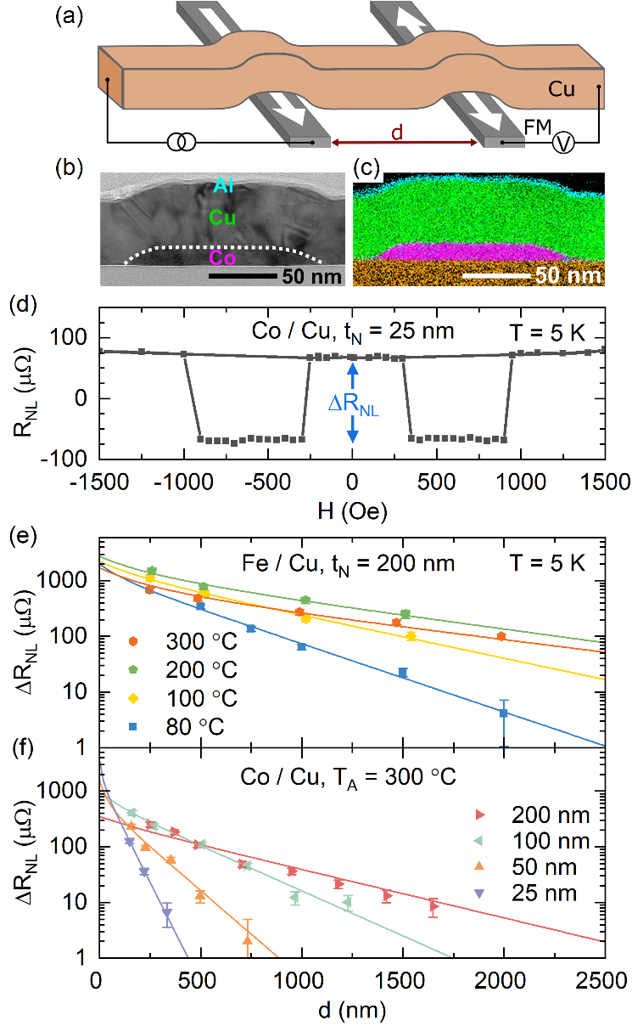
Fig. 1. (a) Schematic of the NLSV geometry for a FM/Cu device, showing the Cu channel, FM injector/detector, with separation $d$, and non-local measurement configuration. (b) Cross-sectional TEM image of a Co/Cu NLSV, showing the Co injector and Cu channel ($t_{N}=$ 50 nm). (c) Corresponding STEM/EDX chemical composition map (magenta, Co; cyan, Al; green, Cu). (d) Non-local resistance ($R_{NL}$) vs. $H$ for a $t_{N}=$ 25 nm Co/Cu NLSV at $T=$ 5 K; the spin accumulation signal ($ΔR_{NL}=R_{P}-R_{AP}$) is indicated. (e,f) ΔR_{NL} vs. d at temperature T = 5 K. Note the semi-log scale. Data are shown for: (e) Fe/Cu NLSVs with channel thickness t_{N} = 200 nm annealed at temperatures T_{A} between 80 and 300 °C; (f) Co/Cu NLSVs with T_{A} = 300 °C at t_{N} between 25 and 200 nm. Solid lines are fits to the model described in the text. Error bars are shown but in some cases are smaller than the data points.

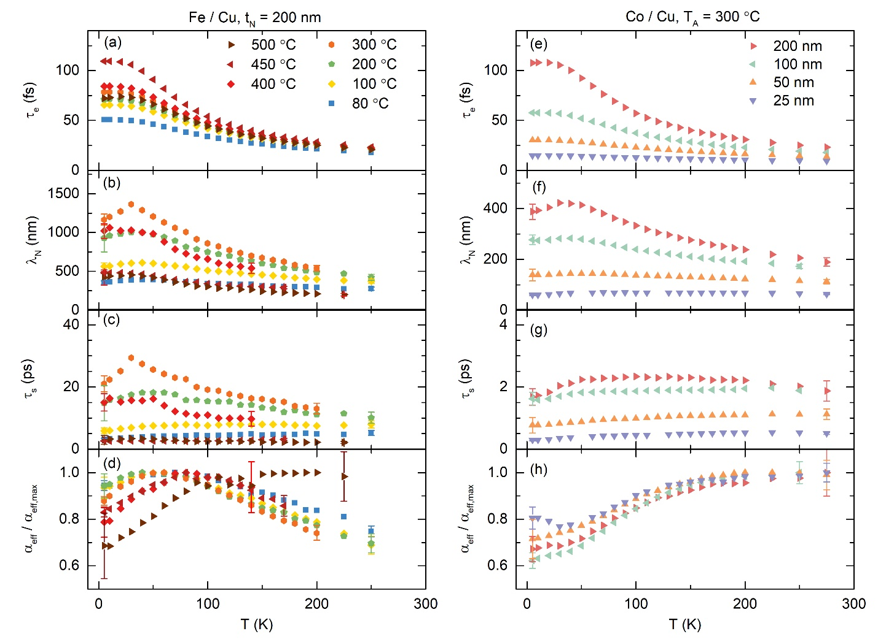
Fig. 2. Temperature (T) dependence of (a,e) the elastic scattering time ($τ_{e}$), (b,f) the spin diffusion length ($λ_{N}$), (c,g) the spin lifetime (τ_{s}), and (d,h) the effective spin polarization normalized to its maximum value (${}_{eff}/{}_{eff,max}$). Data are shown for Fe/Cu NLSVs (left) with fixed channel thickness t_{N} = 200 nm at various annealing temperatures T_{A} = 80 – 500 °C, and for Co/Cu NLSVs (right) at fixed T_{A} = 300 °C and t_{N} = 25 – 200 nm. Error bars are standard errors on extracted fit parameters and are shown only at the highest and lowest T for clarity.

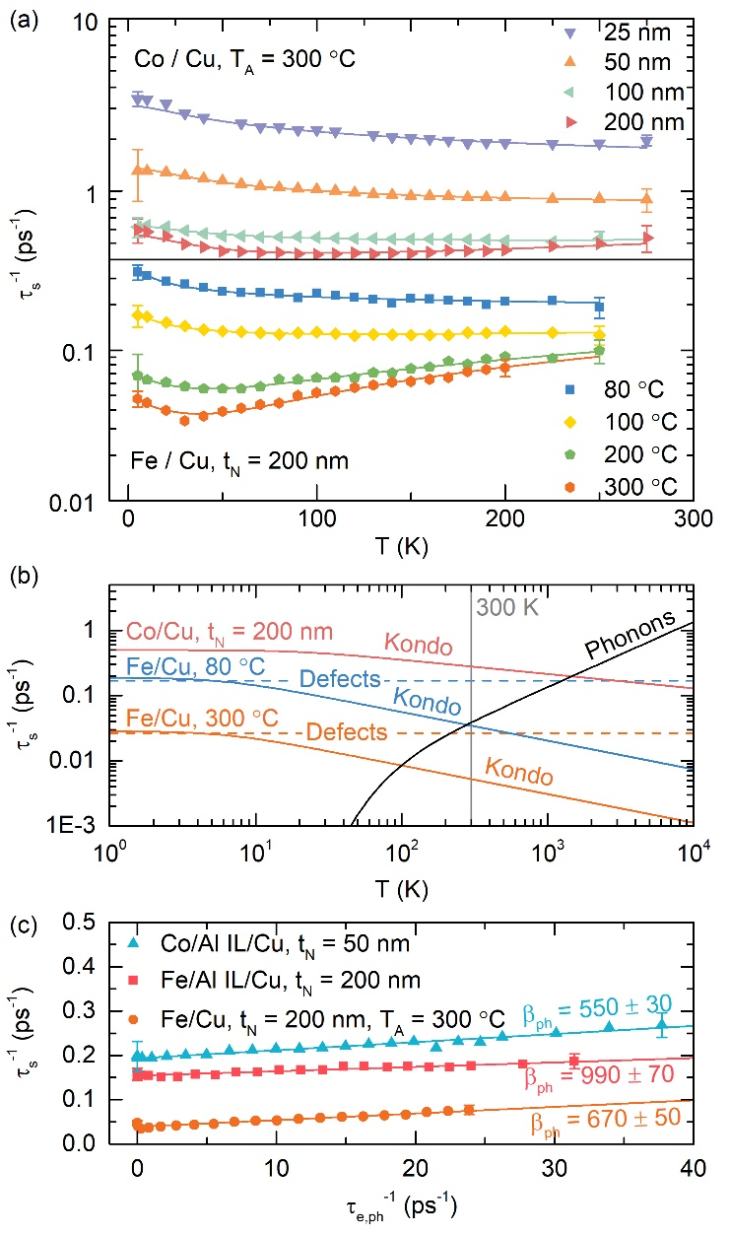
Fig. 3. (a) Temperature (T) dependence of the spin relaxation rate ($τ_{s}^{-1}$) for Co/Cu NLSVs (top) with channel thickness t_{N} = 25 – 200 nm and T_{A} = 300 °C, and Fe/Cu NLSVs (bottom) with t_{N} = 200 nm and T_{A} = 80 – 300 °C. Solid lines are fits to the model described in the text, accounting for spin relaxation due to phonons, magnetic impurities, and defects. (b) T dependence of the extracted contributions to $τ_{s}^{-1}$ in Fe/Cu with T_{A} = 80 and 300 °C, and Co/Cu with t_{N} = 200 nm and T_{A} = 300 °C. The contributions shown are due to Cu phonons (black line, Bloch–Grüneisen model using the average fitted Debye temperature θ_{D} = 300 K and the phonon Elliott-Yafet constant β_{ph} = 1000), Kondo magnetic impurities, and T-independent defects (dashed lines). (c) “Elliott-Yafet plot”, i.e., $τ_{s}^{-1}$ vs. $τ_{e,ph}^{-1}$, where $τ_{e,ph}^{-1}$ is the momentum relaxation rate due to phonons. Data are shown for Al interlayer (IL) NLSVs (Co/Al/Cu and Fe/Al/Cu), and a 300-°C-annealed Fe/Cu NLSV. The inverse slopes from the straight line fits give the β_{ph} values shown. Error bars are standard errors on fit parameters and are shown only at the highest and lowest T for clarity.

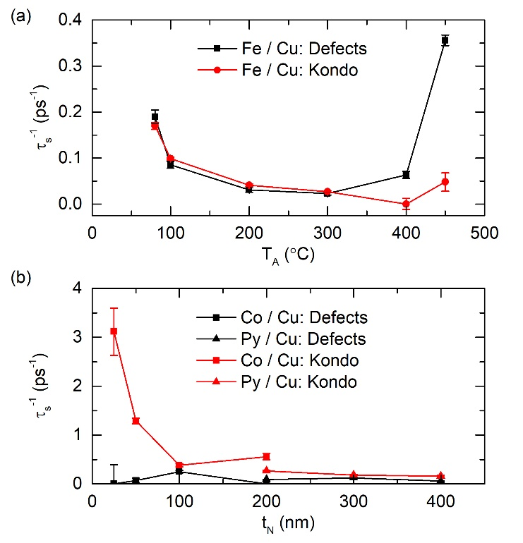
Fig. 4. Contributions to the spin relaxation rate ($τ_{s}^{-1}$) vs. (a) annealing temperature T_{A}, and (b) channel thickness t_{N}. The contributions shown are the T = 0 Kondo spin relaxation rate ($1/τ_{s,K,0}$, red points) and the T-independent defect spin relaxation rate ($1/τ_{s,def}$, black points). Results in (a) are for Fe/Cu NLSVs; (b) shows both Co/Cu and Py/Cu NLSVs. Error bars are standard errors on extracted fit parameters and in some cases are smaller than the points.

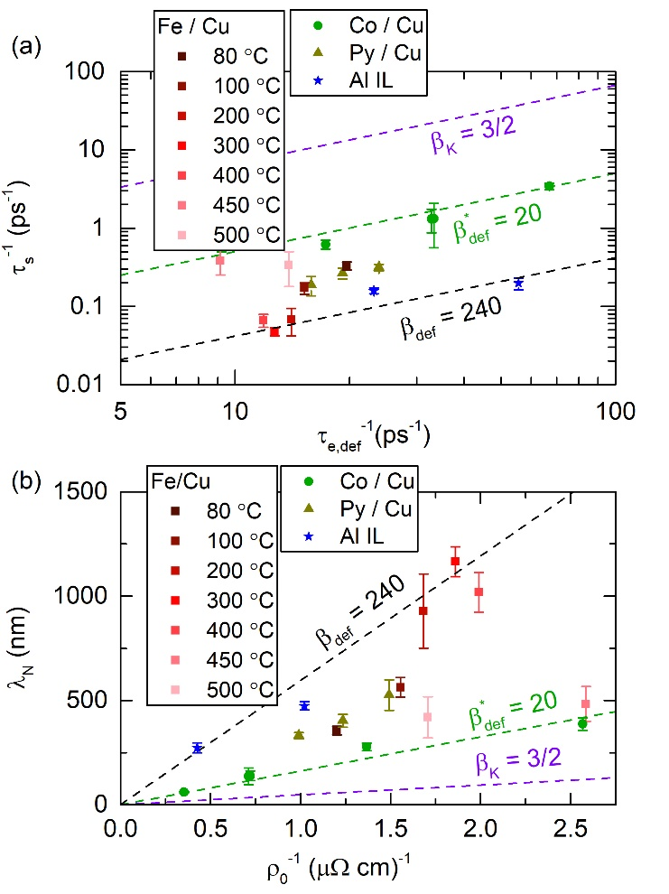
Fig. 5. (a) 5 K spin relaxation rate ($τ_{s}^{-1}$) vs. T = 0 momentum scattering rate ($τ_{e,def}^{-1}$) (log₁₀-log₁₀ scale) for Co/Cu, Py/Cu, Fe/Cu, and Al interlayer (IL) NLSVs. $T_{A}$ values are color coded. Both $T_{A}$ and $t_{N}$ are implicit variables. (b) Data from (a) plotted as 5 K spin diffusion length (λ_{N}) vs. residual (T = 0) resistivity ($ρ_{0}^{-1}$), on a linear scale. The dashed lines are for three values of the defect Elliott-Yafet constant: 3/2 (Kondo), 20 (the Co/Cu NLSV average) and 240 (the average in “Kondo-minimized” NLSVs). Error bars are standard errors on extracted fit parameters and in some cases are smaller than the data points.

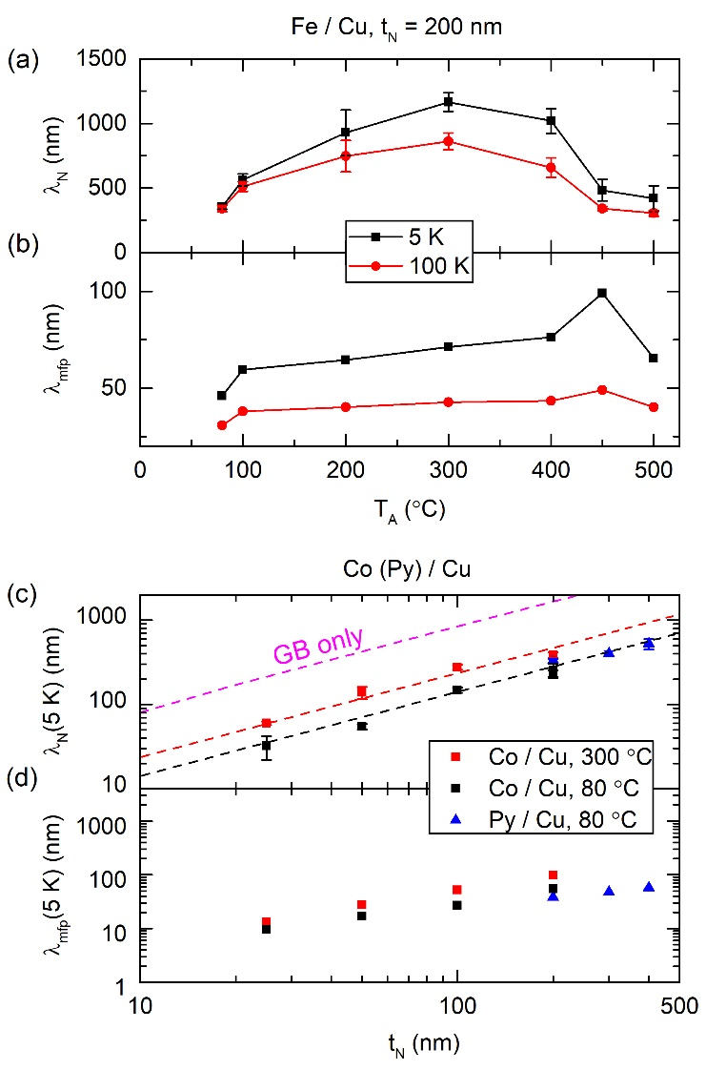
Fig. 6. Annealing temperature (T_{A}) dependence of (a) the spin diffusion length (λ_{N}), and (b) the mean-free-path (λ_{mfp}) in Fe/Cu NLSVs. Data are shown for both 5 and 100 K. Channel thickness (t_{N}) dependence at 5 K of (c) λ_{N} and (d) λ_{mfp} for Co/Cu and Py/Cu NLSVs (the T_{A} are shown), on a log₁₀-log₁₀ scale. In (c) the magenta dashed line shows the expected behavior in the absence of magnetic impurities, i.e., for T-independent defects (predominantly grain boundaries in this case) only, where $λ_{N}=\sqrt{β}λ_{mfp}$ with $β_{def}= β_{GB}$= 240. The red and black dashed lines are straight line guides to the eye for T_{A} = 300 and 80 °C. Note that for (b) and (d) we define $λ_{mfp}=\sqrt{Dτ_{e}}$, rather than $l_{mfp}=v_{F}τ_{e}$. Error bars are standard errors on extracted fit parameters and in some cases are smaller than the data points.

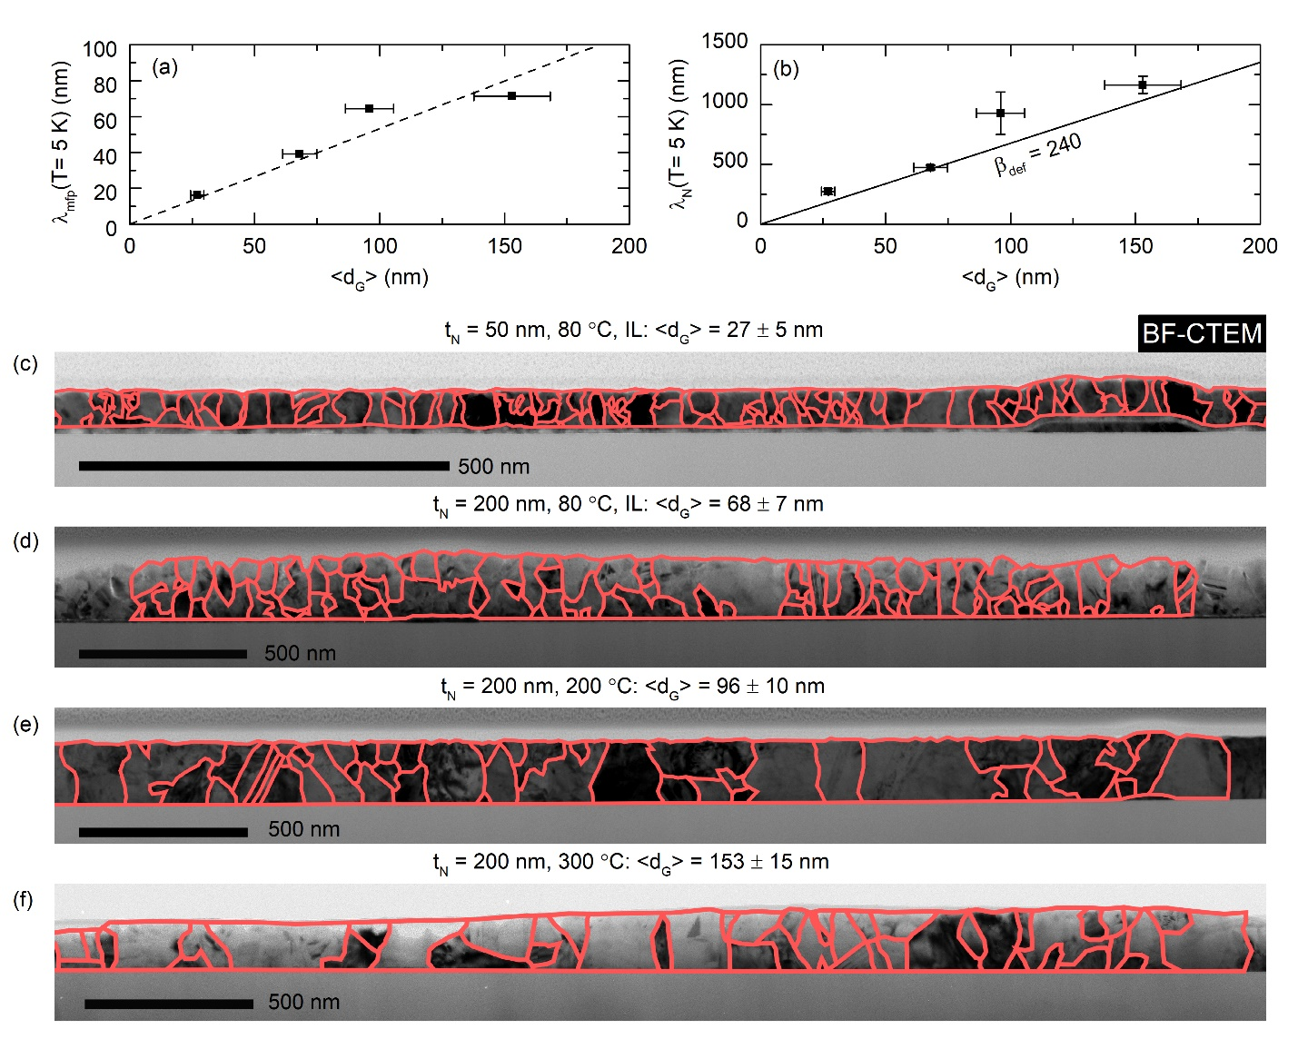
Fig. 7. Average grain size $〈d_{G}〉$ dependence of (a) the 5 K mean-free-path (λ_{mfp}) and (b) the 5 K spin diffusion length ($λ_{N}$) for Fe/Cu NLSVs. The dashed line in (a) is a straight line fit through the origin. The solid line in (b) is calculated from $λ_{N}=\sqrt{β_{def}}λ_{mfp}$, with $β_{def}=$ $β_{GB}$ = 240. Error bars correspond to one standard deviation of the grain size distribution. (c-f) Bright-field conventional transmission electron microscopy (BF-CTEM) images of Cu-based NLSVs. Grain outlines (red) and the resulting $〈d_{G}〉$ are shown for: (c) Co/Al/Cu with $t_{N}=$ 50 nm and $T_{A}=$ 80 °C, (d) Fe/Al/Cu with $t_{N}=$ 200 nm and $T_{A}=$ 80 °C, (e) Fe/Cu with $t_{N}=$ 200 nm and $T_{A}=$ 200 °C, and (f) Fe/Cu with $t_{N}=$ 200 nm and $T_{A}=$ 300 °C. Extracted $〈d_{G}〉$ are given above the images.

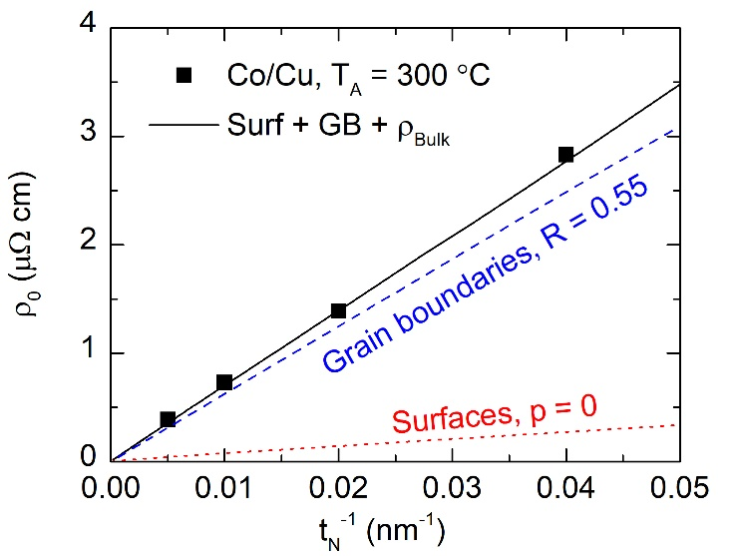
Fig. 8. Cu residual resistivity ($ρ_{0}$) vs. channel thickness ($t_{N}$) for Co/Cu NLSVs annealed at T_{A} = 300 °C. The solid line is a fit to the model described in the text based on Mayadas-Schatzke and Fuchs-Sondheimer descriptions of surface/interface and grain boundary effects (see Appendix A also). Scattering contributions from the surface (dotted line) and grain boundaries (dashed line) are shown, along with the respective fitting parameters $p$ and $R$ (defined in Appendix A).

Appendix A
T-independent defect scattering contributions due to grain boundaries and surfaces/interfaces were modelled assuming Matthiesen’s rule:
$$ρ_{N}=ρ_{bulk}+ρ_{surf}+ρ_{GB} \left(A1\right),$$
where $ρ_{bulk}$ is the resistivity in the absence of grain boundaries and surfaces (which we leave as a free parameter), $ρ_{surf}$ is the contribution to the resistivity due to surface/interface scattering, and $ρ_{GB}$ is the contribution to the resistivity due to grain boundary scattering. This is applied to the data of Fig. 8 to fit the t_{N} dependence of the residual resistivity, ρ₀. Following Mayadas and Schatzke, ⁶⁰ the surface contribution is given by
$$ρ_{surf}=ρ_{bulk} {\left[1-\frac{3}{2k} \left(1-p\right)\int_{1}^{∞}{\left(x^{-3}-x^{-5}\right)\frac{1-e^{-kx}}{1-pe^{-kx}}ⅆx}\right]}^{-1} \left(A2\right),$$
where $k=t_{N}/λ_{0}$, $p$ is the specularity of the surface scattering, and the bulk-limit mean-free-path $λ_{0}=\sqrt{3}/N(E_{F}{)e}^{2}v_{F}ρ_{bulk}$. Following Fuchs and Sondheimer,^{61,62} the grain boundary contribution is given by
$$ρ_{GB}=ρ_{bulk} {\left[1-\frac{3}{2}α_{G}+3{α_{G}}^{2}-3{α_{G}}^{3}\ln\left(1+{α_{G}}^{-1}\right)\right]}^{-1} (A3)$$
$$α_{G}=\frac{λ_{0}R}{d_{G}\left(1-R\right)} ,$$
where $R$ is the grain boundary scattering probability.
In Fig. 8 the solid line is a fit to Eq. (A1) assuming perfectly diffuse surfaces ($p =$ 0). This corresponds to the maximum possible surface contribution, leaving $R$ and $ρ_{bulk}$ as free parameters. The result from the solid line is $R=$ 0.55, in good agreement with previously reported values for Cu^{9,66}. The corresponding $ρ_{surf}$ (dotted line) and $ρ_{GB}$ (dashed line) are also shown in Fig. 8. Even assuming the maximum diffuse surface scattering contribution (i.e., $p =$ 0), we find that the scaling of $ρ_{0}$ with $1/t_{N}$ in these devices can only be accounted for with a dominant grain boundary scattering contribution, consistent with the other results in this paper.

