**Prevalence and outcome of bloodstream infections due to third-generation cephalosporin resistant Enterobacteriaceae in sub-Saharan Africa: a systematic review**

Rebecca Lester1,2, Patrick Musicha3,4, Nadja Van Ginneken5, Angela Dramowski6, David H Hamer7, Paul Garner1, Nicholas A Feasey1,2

1Liverpool School of Tropical Medicine, Liverpool, UK; 2Malawi-Liverpool-Wellcome Trust Clinical Research Programme, Blantyre, Malawi; 3Centre for Tropical Medicine and Global Health, Nuffield Department of Medicine, University of Oxford, UK; 4Mahidol-Oxford Tropical Medicine Research Unit, Mahidol University, Bangkok, Thailand; 5Department of Health Services Research, University of Liverpool, Liverpool, UK; 6Department of Paediatrics and Child Health, Stellenbosch University, Cape Town, South Africa; 7Departments of Global Health and Medicine, Boston University Schools of Public Health and Medicine, Boston, USA

**Corresponding author:** Dr Rebecca Lester, Liverpool School of Tropical Medicine, Pembroke Place, Liverpool, L3 5QA, UK. Telephone: +44 151 794 4220. Email: [Rebecca.Lester@lstmed.ac.uk](mailto:Rebecca.Lester@lstmed.ac.uk)

**Alternate corresponding author:** Dr Nicholas A Feasey, Liverpool School of Tropical Medicine, Pembroke Place, Liverpool, L3 5QA, UK. Telephone: +44 151 794 4220.

Email: [Nicholas.Feasey@lstmed.ac.uk](mailto:Nicholas.Feasey@lstmed.ac.uk)

**Running title:** Systematic review of 3GC-R BSI in sSA

**Keywords:** antimicrobial resistance, Africa south of the Sahara, bloodstream infection, Enterobacteriaceae

**Summary:** The prevalence of 3GC-R amongst amongst bloodstream Enterobacteriaceae in sSA is high, yet the mortality burden on patients is unknown.

**ABSTRACT**

**Background:** The prevalence of bacterial bloodstream infections in sub-Saharan Africa is high, and antimicrobial resistance is likely to increase mortality from these infections. Third-generation cephalosporin resistant (3GC-R) Enterobacteriaceae are of particular concern, given widespread reliance on ceftriaxone for management of sepsis in Africa.

**Methods:** We systematically reviewed studies reporting 3GC susceptibility testing of bloodstream Enterobacteriaceae. We searched MEDLINE, Embase and PubMed from January 1990, to December 2017, for primary data reporting either 3GC susceptibility testing of Enterobacteriaceae associated with BSI in sSA, and studies reporting mortality from 3GC-R BSI. Data were extracted directly from published reports and authors contacted for absolute numbers where percentages were reported. Outcomes were reported as median prevalence of 3GC resistance for each pathogen.

**Results:** We identified 38 articles, including six reporting mortality. Median prevalence of 3GC-R in *Escherichia coli* was 14.5% from 19 studies [IQR 10.3 to 36.0] and in *Klebsiella* was 49.0% from 26 studies [IQR 21.0 to 81.2]. 3GC-R amongst non-Typhoidal Salmonellae was 1.9% from 12 studies [IQR 0 to 6.1]. A pooled mortality estimate was prohibited by heterogeneity.

**Conclusions:** Levels of 3GC resistance amongst bloodstream Enterobacteriaceae in sSA are high, yet the mortality burden is unknown. The lack of clinical outcome data from drug resistant infections in Africa represents a major knowledge gap, and future work must link laboratory surveillance to clinical data, in order to understand the true burden of antimicrobial resistance.

**INTRODUCTION**

The emergence and spread of antimicrobial resistance (AMR) in bacteria is recognised as a global public health problem [1, 2]. Drug-resistant infections (DRI), caused by AMR bacteria, threaten human health worldwide, with the greatest mortality burden expected to occur in low and middle-income countries [3]. In settings where antibiotics and advanced diagnostics are available and affordable, DRIs can be treated with tailored regimens using second or third-line antibiotics; however these agents cost more and increase healthcare expenditure [4]. In sub-Saharan Africa (sSA), where bacterial bloodstream infection [5] is a major cause of morbidity and mortality [6], diagnostic facilities are scarce, and antibiotics such as carbapenems and semi-synthetic aminoglycosides (i.e. amikacin) are either unavailable or prohibitively expensive, the morbidity and mortality from DRIs is predicted to be high [3, 7].

In many sub-Saharan African hospitals, limited nursing capacity favours the use of broad spectrum antimicrobials with a once daily dosing regimen, and this has led to the widespread adoption of the third-generation cephalosporin (3GC), ceftriaxone, for the empirical management of hospitalised patients with suspected sepsis [8]. Extended-spectrum beta-lactamase producing Enterobacteriaceae (ESBL-E), resistant to penicillins and 3GC, represent a threat to the treatment of BSI in this setting, and have been identified as priority pathogens on which all national AMR programmes should focus their surveillance and reporting [3, 9].

Comprehensive AMR surveillance in sSA is limited by lack of quality assured diagnostic microbiology laboratories, but knowledge of the prevalence and spatio-temporal trends of 3GC-resistant (3GC-R) Enterobacteriaceae is critical to inform national and international antibiotic prescribing guidelines. Additionally, securing access to effective second and third-line antibiotics in Africa will not only require an understanding of the prevalence of 3GC-R, but also of the burden and impact of these pathogens on patients and healthcare systems [10]. We have therefore systematically reviewed published reports of 3GC susceptibility amongst key Enterobacteriaceae in sSA, including surveillance data and clinical cohorts. Robust clinical outcome data are needed to support the estimates and assumptions that the greatest global burden associated with AMR will occur in sSA[7] and we have therefore also reviewed studies which describe mortality from 3GC-R BSI. The aim of this systematic review was to determine the prevalence of 3GC-R amongst *Escherichia coli*, *Klebsiella* spp. and *Salmonella* BSI in sSA, and to provide an estimate of the associated mortality burden from these infections.

**METHODS**

**Search strategy and selection criteria**

We systematically reviewed articles published between 1st January 1990 and 31st December 2017, according to a pre-specified protocol, prepared in February 2017 (Supplementary Table 1) with no language restrictions, following PRISMA guidelines (Supplementary Material). We searched PubMed, Embase and Scopus according to a pre-defined strategy with search terms relating to BSI and susceptibility testing. A search string which included all sSA countries as defined by the United Nations list of 54 African Sovereign states, returned more articles than a string using ‘Africa’ alone. References cited in selected articles were reviewed for additional articles and authors were contacted to obtain original data, where percentages but not absolute numbers of resistant organisms were provided.

Studies were included if they tested *E. coli,* *Klebsiella* spp. or *Salmonella* spp., for 3GC resistance. Methods of confirmatory ESBL testing, such as double-disc synergy or PCR, were extracted from articles if they were reported, but we did not exclude studies that did not confirm ESBL status. We included surveillance data in addition to studies reporting clinical cohorts, but excluded case reports, case series, expert opinions and reviews. We excluded studies in which less than ten isolates were tested for resistance, to avoid biased estimation of prevalence.

**Data extraction**

Two authors (RL and PM) independently searched the literature and screened the abstracts of all retrieved records. Full-text of remaining English articles was reviewed by one author (RL) and of French language articles by another (NVG). Disputes about article inclusion were resolved through discussion with recourse to a third reviewer (NF) if required. Pre-defined variables were extracted from each article (Table 1). Variables included study design and setting, clinical data such as age and HIV prevalence of clinical cohorts, and information on laboratory methods including antimicrobial susceptibility testing method and guideline, and method of ESBL confirmation. Mortality data were extracted as they were reported in the articles, as case-fatality rates, odds ratios (OR) or risk ratios (RR).

**Data analysis**

Proportions of 3GC-R were calculated from numbers of isolates of *E. coli,* *Klebsiella* spp., nontyphoidal Salmonella (NTS) or *Salmonella* Typhi tested against a 3GC and the number of resistant strains. Forest plots were generated, illustrating proportion estimates for each study with 95% confidence intervals, calculated using the Wilson’s score method. The I2 statistic was calculated to quantify heterogeneity.

Our initial analysis plan aimed to calculate a pooled proportion of 3GC-R for each pathogen, using random-effects meta-analysis with sub-analysis by Africa region. However, high levels of heterogeneity amongst included studies precluded meaningful meta-analysis, and we therefore present median prevalence of 3GC-R for each pathogen, with corresponding inter-quartile range (IQR) to provide an assessment of the wide range in resistance prevalence. Medians were calculated for sSA and for each Africa Region as defined by the United Nations Statistics Division [11].

Heterogeneity of proportion estimates was explored using pre-defined subgroup analysis by Africa region and a post-hoc subgroup analysis by age-group of study population. Visual inspection of resulting forest plots was carried out and a test for subgroup differences applied where visual inspection suggested a likely difference in subgroup proportion estimates, and where more than two studies contributed to each subgroup. We additionally examined for trends in proportions estimates over time using visual inspection of forest plots ordered by year of publication, and a linear meta-regression model. Analyses were conducted using R-Studio version 3.3.2 (R Core Development Team 2015).

**Risk of bias assessment**

We modified the Critical Appraisal Skills Programme (CASP) checklist to design a risk of bias assessment to fit our research question, assessing risk of bias in patient recruitment and laboratory techniques used (Supplementary Table 2). The assessment was performed by both RL and PM, and any disagreements were resolved by consensus.

**RESULTS**

The online database search combined with reference review from key papers generated 1,320 articles and of these, 180 abstracts were selected for full-text review (Figure 1). Original data for one article were retrieved by direct communication with authors [12]. Thirty-eight articles met the inclusion criteria and were included in the systematic review, which synthesises 11,049 isolates. Of these, 19 articles reported proportions of 3GC resistance in *E. coli* and 27 in *Klebsiella* spp*.* Twelve studies reported proportions of 3CG resistance in NTS and three in *S*. Typhi.

Table 1 presents the characteristics of all included studies. Data were available from 12 countries across all four sSA regions (Figure 2) with the highest proportion of studies (10/38) from South Africa. All studies were observational. There were 29 studies which recruited cohorts of patients with confirmed or suspected BSI, 15 of which were prospective, 13 retrospective and one mixed. Three studies were cross-sectional reviews of isolates and three tested isolates collected as part of longitudinal multisite surveillance. There was one case-control study, designed to estimate mortality from 3GC-R BSI [13].

Median estimates of 3GC resistance in *E. coli, Klebsiella* spp. and Salmonellae for sSA are shown in Table 2, together with median estimates by Africa region, and forest plots of individual studies are shown in Figures 3-5. The median point estimate of 3GC-R in *E. coli* BSI from 19 studies, was 14.5% [IQR 10.3 to 36.0] (Table 2). Heterogeneity was high (*I2*=93%) (Figure 3) and not explained by prespecified subgroup analysis by Africa region (Supplementary Figure 1). Median point estimates of 3GC resistance in *Klebsiella* BSI were higher across all regions than for *E. coli* with an overall estimate of 50.0% [IQR 23.8 to 79.9] from 27 studies (Table 2, Figure 4). As with *E coli*, heterogeneity was high (*I*2=97%) and not explained by differences in Africa region (Supplementary Figure 1).

Third-generation cephalosporin resistance amongst nontyphoidal Salmonella(NTS)was low, at a median of 1.9% [IQR 0 to 6.1%] in isolates from 12 studies (Figure 5). The highest proportions of 3GC resistance in NTS came from eastern Africa (Kenya and Mozambique) but subgroup analysis by Africa region did not explain inter-study variability (Supplementary Figure 1). Four studies in this review carried out 3GC susceptibility testing on *S.* Typhi Isolates.[14-17] Of these, two studies from Kenya[14] and Tanzania[16] found 3GC resistance with prevalence of 6% (6/100) and 5.9% (1/17) respectively. These studies did not report confirmatory ESBL testing on cephalosporin resistant *S*. Typhi strains.

The earliest published reports of 3GC resistance in Gram negative BSI are from 2005.[18] Graphical exploration of forest plots ordered by year of publication (Figures 3-5), suggested a trend towards increased 3GC resistance over time for *Klebsiella* and NTSbut not for *E. coli*. Meta-regression by year of publication, supported a significant trend towards increased resistance over time for *Klebsiella* spp. (p<0.01) and NTS (p=0.02) and a trend approaching significance for *E. coli* (p=0.06).

Studies reporting mortality estimates from 3GC resistant BSI are shown in Table 3. Only 1 study, a paediatric case-control in Senegal, was designed to determine attributable mortality from 3GC-R resistance as a primary outcome, finding that 3GC-R BSI remained the only significant independent risk factor for death in multivariable logistic regression, (OR = 2.9, 95% CI: 1.8–7.3, p = 0.001) regardless of antibiotic treatment choice [13]. Six further studies [12, 19-23] provide mortality estimates for patients with 3GC resistant BSI, but were not designed to estimate attributable mortality from these infections. These studies were a mixture of retrospective and prospective designs, providing variably odds ratios, relative risks and case-fatality rates and incorporating different characteristics in multivariable models. It was therefore not possible to combine these into a single mortality estimate using meta-analysis. Where available, case-fatality rates from individual studies were high, ranging from 60-100%, with all but one study concluding 3GC resistant BSI to be a predictor of fatal outcome in patients.

Additional study population characteristics are shown in Table 1. There were 20 studies in paediatric populations, including five exclusively in neonates. Four studies recruited adults over 16 years of age, 13 recruited in all age groups and one study did not report age of participants from which blood cultures were obtained. Given that age categories were generally well reported and could explain differences between proportion estimates, we carried out post-hoc stratified analysis by age group (Appendix). Visual inspection of resulting forest plots suggested no difference in proportion estimates by age group for *E. coli* or *Klebsiella* spp. A higher proportion estimate for 3GC inNTS was seen in adults (Appendix), but there was only one study in this age group.

Results of the risk of bias assessment are shown in Figure 6. Bias in prevalence estimates was most likely introduced through selection of study participants. Many studies did not report criteria for blood culture sampling in the population recruited, and many were conducted in special populations such as neonatal ICUs. Most studies described blood culture methods well, but few reported external quality control in laboratory methods, resulting in a moderate risk of bias introduction across this domain for most studies.

Blood culture processing techniques varied. An automated system for blood culture incubation was used in 17 studies, whilst manual systems were used in nine. Three studies reported a mixture of manual and automated techniques, and nine did not report which methods were used. Antimicrobial susceptibility testing (AST) methods varied, but most laboratories used disc-diffusion (21/38). Four studies used Vitek-2 with the remainder using Etest, Microscan or a mixture of techniques. Three studies did not report which AST methods were used. Most studies (28/38) used CLSI breakpoint guidelines with the remainder using national or international guidelines as shown in Table 1. Twenty-one studies carried out ESBL confirmatory testing in 3GC resistant isolates. Of these, nine used double-disc synergy, with the remainder using broth dilution, PCR, or a mixture of methods.

The classification of isolates by source, for example whether community-acquired (CA) or hospital-acquired (HA), or urban versus rural is key to the interpretation of these data. Twenty-nine studies tested bloodstream isolates from patients presenting to public referral or private hospitals in urban settings, with eight recruiting from rural district hospitals and one from a mixed urban/rural setting [24][24]. HIV status of individuals who had blood culture sampling was recorded in only 10 studies, and one study was exclusively a cohort of HIV-infected individuals. Five studies investigated the difference in blood culture pathogens and prevalence of resistance between community acquired and hospital acquired or healthcare associated infection. Of these, four found a higher prevalence of 3GC-R in HA infections. Two studies were cohorts of patients with hospital acquired infection and one study included only patients with suspected community acquired BSI. Of the five neonatal studies, two differentiated early-onset from late-onset neonatal sepsis but did not report on differences in proportions of 3GC resistance between the two groups.

**DISCUSSION**

Our systematic review has synthesised over 11,000 blood culture isolates from patients in sSA, finding high levels of resistance to 3GC amongst the key Enterobacteriaceae *E. coli* and *Klebsiella* spp. and emerging resistance amongst Salmonellae. Ceftriaxone is one of the most widely used broad spectrum antibiotics in Africa, indicated in the empirical management of adult and paediatric patients at district, regional and tertiary level care facilities [25-27]. Limited access to carbapenems and aminoglycosides may make 3GC-R BSI untreatable in some settings [8]. The striking lack of mortality data we describe in this review is therefore a major barrier to a comprehensive understanding of the burden of AMR in this setting.

We found a high median prevalence of third-generation cephalosporin resistance in *E. coli* BSI, greater than estimates from high-income countries, which are typically less than 10% [28]. Interpreting the significance of proportion estimates in the absence of trend data is challenging and the latter will require long-term, high-quality surveillance. Some of the most comprehensive published trend data comes from Malawi, where 18 years of blood culture surveillance from patients presenting to a tertiary hospital, has shown a recent, rapid rise in 3GC-R amongst Enterobacteriaceae. Between 2003 and 2016, the proportion of 3GC-R *E coli* rose from 0.7% to 30.3%, with similar trends in other non-Salmonella Enterobacteriaceae[8]. The alarming trends described in Malawi highlight the urgent need for systematic AMR surveillance data from Africa that will inform both policy on access to antimicrobials and public health programmes aimed at reducing drug resistant infections.

Resistance amongst *Klebsiella* spp.was higher than for *E. coli* at 50.0%. *Klebsiella* spp.frequently acquire AMR genes, and are a common cause of BSI in vulnerable populations, often causing localised outbreaks in settings such as neonatal and paediatric intensive care units [29]. 3GC-R *Klebsiella* spp. are a particular challenge in neonatal infection as, in addition to the vulnerability of this age group to severe bacterial infection, many antimicrobials are either relatively contraindicated (i.e. chloramphenicol), or not locally available as intravenous agents (i.e. ciprofloxacin). In the single study from this review in which mortality from 3GC-R *Klebsiella* was recorded, all patients died and clearly, prospective studies investigating transmission dynamics of this nosocomial pathogen are required in order to support targeted interventions to reduce their development and spread [23].

Although resistance to first-line antimicrobials, such as ampicillin, chloramphenicol, and cotrimoxazole, is common among NTS in sSA [30], 3GC-R has remained low, but may represent an emerging problem (Figure 5) [31]. Our review found sporadic cases of ceftriaxone resistance amongst *S*. Typhi from 3 countries, but these studies did not carry out confirmatory testing for the presence of ESBL genes. Although not captured by our inclusion criteria, ESBL *S*. Typhi have been detected in sSA [32, 33]. In light of the recent outbreak of fluoroquinolone resistant (FQR) and ESBL producing *S*. Typhi in Pakistan, resulting from the acquisition of ESBL encoding plasmids by the H58 haplotype (genotype 4.3.1) known to be prevalent in Africa, this is concerning [34]. Surveillance of *S*. Typhi non-susceptibility in Africa will be essential, as emergence of drug resistant strains is associated with increase in transmissibility of typhoid and resurgence of disease [35].

We found marked heterogeneity amongst 3GC-R proportion estimates, which was not explained by differences in Africa region or age group of patients. Prevalence of resistance amongst key pathogens is likely to be influenced by a variety of clinical parameters including HIV status, healthcare attendance and prior antibiotic use, but these data were rarely reported and subgroup analysis by these factors was impossible. Detailed clinical and demographic parameters should be collected by studies which aim to understand the epidemiology of DRI and the drivers of transmission of AMR pathogens.

We aimed to provide an estimate of the mortality burden from 3GC-R BSI, but this was prohibited by the scarcity of outcome data and heterogeneity of study designs. DRIs are associated with adverse patient outcomes in high-income settings, including high mortality and increased length of hospital stay [36, 37]. In Africa, where the prevalence of bacterial sepsis is high [6], late presentation to secondary care is common, and the availability of alternative antimicrobials and advanced laboratory diagnostics is limited, the impact of AMR on patients is predictable, but currently unknown.

Potential sources of heterogeneity which we do not explore in this review, include the diversity of laboratory microbiological methods used, both for organism identification and for antimicrobial susceptibility testing. Most studies did not report whether or how they engaged with external quality assurance programmes, but we did not exclude these from the review, as they likely represent the vast majority of facilities in sSA. Confirmatory testing for ESBL production using phenotypic or molecular methods is recommended for any organisms showing reduced susceptibility to an indicator 3GC, but such confirmatory methods were employed in just under half the studies included in this review. However, resistance to 3GCs on primary screening tests is sufficient evidence to infer 3GC-R, therefore again, we did not exclude these studies from the analysis.

The limitations we highlight in this review, together with the high level of unexplained inter-study heterogeneity, prompt the need for standardisation of AMR research. In future, studies should be required to provide a clear account of the microbiological sampling criteria, study or surveillance sampling frame and laboratory methods used to generate resistance data. Studies should collect and report clinical metadata associated with the sample, including empiric antibiotic regimens, HIV status and the clinical setting, including level of the health system and intensity of care. There are increasing efforts in the AMR surveillance community to identify exactly what data are minimally acceptable and what data are ideal, to produce useful prevalence estimates that contribute to global repositories such as the World Health Organization’s Global Antimicrobial Resistance Surveillance System (GLASS)[38].

We have documented proportions of 3GC-R BSI from a large number of bloodstream isolates across sSA, expanding on previous reviews which have focussed on clinical syndromes [39], paediatric populations[40] or limited Africa regions [41]. Using inclusion criteria that capture surveillance studies in addition to clinical cohorts, we have, to our knowledge, captured the largest AMR dataset available from sSA, and therefore provide the most comprehensive summary of 3GC-BSI from the continent. In doing so, we demonstrate the lack of available clinical data and show that the burden of DRI on patients in Africa remains unknown. Low-income countries have multiple, competing priorities for limited healthcare resources and budgets, therefore clinicians, researchers and policy makers will need to demonstrate that AMR is a priority for patients in these settings. This information does not currently exist, and AMR prevalence studies from sSA, however comprehensive, will need to be accompanied by robust morbidity, mortality and economic outcome data, to allow for a true understanding of the burden of AMR on patients and health-systems.

**Contributors**

RL, PM and NAF conceived and designed the review. PG provided advice on methods. RL and PM applied the inclusion criteria. NVG reviewed the French language papers. RL analysed the data, prepared tables and figures and drafted the manuscript. RM NF, NVG, AD DH, PG, and NAF contributed to the interpretation of the data and commented on the manuscript. All the authors have read and approved the final manuscript.

**Acknowledgements**

**Financial support**

This work was supported by the Wellcome Trust (Clinical PhD Fellowship, University of Liverpool block award grant number [203919/Z/16/Z] (RL)).

**Potential conflicts of interest**

All authors: no reported conflicts.

**REFERENCES**

1. Collaborators GDaH. Global, regional, and national disability-adjusted life-years (DALYs) for 315 diseases and injuries and healthy life expectancy (HALE), 1990-2015: a systematic analysis for the Global Burden of Disease Study 2015. Lancet **2016**; 388(10053): 1603-58.

2. Laxminarayan R, Matsoso P, Pant S, et al. Access to effective antimicrobials: a worldwide challenge. Lancet **2016**; 387(10014): 168-75.

3. Essack SY, Desta AT, Abotsi RE, Agoba EE. Antimicrobial resistance in the WHO African region: current status and roadmap for action. J Public Health (Oxf) **2017**; 39(1): 8-13.

4. Cosgrove SE. The relationship between antimicrobial resistance and patient outcomes: mortality, length of hospital stay, and health care costs. Clin Infect Dis **2006**; 42 Suppl 2: S82-9.

5. Bantar C, Bavestrello L, Curcio D, et al. Acute community-acquired pneumonia in adults: Guidelines for initial antimicrobial therapy based on local evidence from a South American working group (ConsenSur). Journal of Chemotherapy **2002**; 14(SUPPL. 4): 1-22.

6. Reddy EA, Shaw AV, Crump JA. Community-acquired bloodstream infections in Africa: a systematic review and meta-analysis. Lancet Infect Dis **2010**; 10(6): 417-32.

7. O'Neill J. Review on Antimicrobial Resistance Antimicrobial Resistance: Tackling a crisis for the health and wealth of nations. London: Review on Antimicrobial Resistance; 2014. Available from: <https://amr-review.org/sites/default/files/AMR%20Review%20Paper%20-%20Tackling%20a%20crisis%20for%20the%20health%20and%20wealth%20of%20nations_1.pdfistant>.

8. Musicha P, Cornick JE, Bar-Zeev N, et al. Trends in antimicrobial resistance in bloodstream infection isolates at a large urban hospital in Malawi (1998-2016): a surveillance study. Lancet Infect Dis **2017**.

9. Tacconelli E, Carrara E, Savoldi A, et al. Discovery, research, and development of new antibiotics: the WHO priority list of antibiotic-resistant bacteria and tuberculosis. Lancet Infect Dis **2018**; 18(3): 318-27.

10. Ardal C, Outterson K, Hoffman SJ, et al. International cooperation to improve access to and sustain effectiveness of antimicrobials. Lancet **2016**; 387(10015): 296-307.

11. UNSD. Standard Country or Area Codes for Statistics Use. Available from: <https://unstats.un.org/unsd/methodology/m49/>. **1999**.

12. Dramowski A, Cotton MF, Rabie H, Whitelaw A. Trends in paediatric bloodstream infections at a South African referral hospital. BMC Pediatr **2015**; 15: 33.

13. Ndir A, Diop A, Faye PM, Cissé MF, Ndoye B, Astagneau P. Epidemiology and Burden of Bloodstream Infections Caused by Extended-Spectrum Beta-Lactamase Producing Enterobacteriaceae in a Pediatric Hospital in Senegal. PLoS One **2016**; 11(2): e0143729.

14. Mengo DM, Kariuki S, Muigai A, Revathi G. Trends in Salmonella enteric serovar Typhi in Nairobi, Kenya from 2004 to 2006. J Infect Dev Ctries **2010**; 4(6): 393-6.

15. Kalonji LM, Post A, Phoba MF, et al. Invasive Salmonella Infections at Multiple Surveillance Sites in the Democratic Republic of the Congo, 2011-2014. Clin Infect Dis **2015**; 61 Suppl 4: S346-53.

16. Mahende C, Ngasala B, Lusingu J, et al. Bloodstream bacterial infection among outpatient children with acute febrile illness in north-eastern Tanzania. BMC Res Notes **2015**; 8: 289.

17. Maltha J, Guiraud I, Kaboré B, et al. Frequency of severe malaria and invasive bacterial infections among children admitted to a rural hospital in Burkina Faso. PLoS One **2014**; 9(2): e89103.

18. Bejon P, Mwangi I, Ngetsa C, et al. Invasive Gram-negative bacilli are frequently resistant to standard antibiotics for children admitted to hospital in Kilifi, Kenya. J Antimicrob Chemother **2005**; 56(1): 232-5.

19. Blomberg B, Manji KP, Urassa WK, et al. Antimicrobial resistance predicts death in Tanzanian children with bloodstream infections: a prospective cohort study. BMC Infect Dis **2007**; 7: 43.

20. Seboxa T, Amogne W, Abebe W, et al. High Mortality from Blood Stream Infection in Addis Ababa, Ethiopia, Is Due to Antimicrobial Resistance. PLoS One **2015**; 10(12): e0144944.

21. Onken A, Said AK, Jørstad M, Jenum PA, Blomberg B. Prevalence and Antimicrobial Resistance of Microbes Causing Bloodstream Infections in Unguja, Zanzibar. PLoS One **2015**; 10(12): e0145632.

22. Eibach D, Belmar Campos C, Krumkamp R, et al. Extended spectrum beta-lactamase producing Enterobacteriaceae causing bloodstream infections in rural Ghana, 2007-2012. Int J Med Microbiol **2016**; 306(4): 249-54.

23. Buys H, Muloiwa R, Bamford C, Eley B. Klebsiella pneumoniae bloodstream infections at a South African children's hospital 2006-2011, a cross-sectional study. BMC Infect Dis **2016**; 16(1): 570.

24. Lunguya O, Lejon V, Phoba MF, et al. Antimicrobial resistance in invasive non-typhoid Salmonella from the Democratic Republic of the Congo: emergence of decreased fluoroquinolone susceptibility and extended-spectrum beta lactamases. PLoS Negl Trop Dis **2013**; 7(3): e2103.

25. WHO. Pocket book of hospital care for children: guidelines for the management of

common illnesses with limited resources - 2nd ed. World Health Organization, 2013.

<https://apps.who.int/iris/bitstream/handle/10665/81170/9789241548373_eng.pdf?sequence=1> (accessed July 6, 2019).

26. WHO. IMAI district clinician manual: hospital care for adolescents and adults: guidelines for the management of illnesses with limited-resources. World Health Organization, 2011. <https://apps.who.int/iris/bitstream/handle/10665/77751/9789241548281_Vol1_eng.pdf?sequence=1> (accessed July 6, 2019).

27. MoH, 2015. Malawi Standard Treatment Guidelines, Fifth Edition. <http://apps.who.int/medicinedocs/documents/s23103en/s23103en.pdf> (accessed July 6, 2019).

28. Bou-Antoun S, Davies J, Guy R, Johnson AP, Sheridan EA, Hope RJ. Descriptive epidemiology of Escherichia coli bacteraemia in England, April 2012 to March 2014. Euro Surveill **2016**; 21(35).

29. Haller S, Eller C, Hermes J, et al. What caused the outbreak of ESBL-producing Klebsiella pneumoniae in a neonatal intensive care unit, Germany 2009 to 2012? Reconstructing transmission with epidemiological analysis and whole-genome sequencing. BMJ Open **2015**; 5(5): e007397.

30. Feasey NA, Masesa C, Jassi C, et al. Three Epidemics of Invasive Multidrug-Resistant Salmonella Bloodstream Infection in Blantyre, Malawi, 1998-2014. Clin Infect Dis **2015**; 61 Suppl 4: S363-71.

31. Kariuki S, Okoro C, Kiiru J, et al. Ceftriaxone-resistant Salmonella enterica serotype typhimurium sequence type 313 from Kenyan patients is associated with the blaCTX-M-15 gene on a novel IncHI2 plasmid. Antimicrob Agents Chemother **2015**; 59(6): 3133-9.

32. Phoba MF, Barbe B, Lunguya O, et al. Salmonella enterica serovar Typhi Producing CTX-M-15 Extended Spectrum beta-Lactamase in the Democratic Republic of the Congo. Clin Infect Dis **2017**; 65(7): 1229-31.

33. Akinyemi KO, Iwalokun BA, Alafe OO, Mudashiru SA, Fakorede C. bla CTX-M-I group extended spectrum beta lactamase-producing Salmonella typhi from hospitalized patients in Lagos, Nigeria. Infect Drug Resist **2015**; 8: 99-106.

34. Klemm EJ, Shakoor S, Page AJ, et al. Emergence of an Extensively Drug-Resistant Salmonella enterica Serovar Typhi Clone Harboring a Promiscuous Plasmid Encoding Resistance to Fluoroquinolones and Third-Generation Cephalosporins. MBio **2018**; 9(1).

35. Pitzer VE, Feasey NA, Msefula C, et al. Mathematical Modeling to Assess the Drivers of the Recent Emergence of Typhoid Fever in Blantyre, Malawi. Clin Infect Dis **2015**; 61 Suppl 4: S251-8.

36. Cosgrove SE, Kaye KS, Eliopoulous GM, Carmeli Y. Health and economic outcomes of the emergence of third-generation cephalosporin resistance in Enterobacter species. Arch Intern Med **2002**; 162(2): 185-90.

37. de Kraker ME, Wolkewitz M, Davey PG, et al. Burden of antimicrobial resistance in European hospitals: excess mortality and length of hospital stay associated with bloodstream infections due to Escherichia coli resistant to third-generation cephalosporins. J Antimicrob Chemother **2011**; 66(2): 398-407.

38. Turner P, Fox-Lewis A, Shrestha P, et al. Microbiology Investigation Criteria for Reporting Objectively (MICRO): a framework for the reporting and interpretation of clinical microbiology data. BMC Med **2019**; 17(1): 70.

39. Leopold SJ, van Leth F, Tarekegn H, Schultsz C. Antimicrobial drug resistance among clinically relevant bacterial isolates in sub-Saharan Africa: a systematic review. J Antimicrob Chemother **2014**; 69(9): 2337-53.

40. Williams PCM, Isaacs D, Berkley JA. Antimicrobial resistance among children in sub-Saharan Africa. Lancet Infect Dis **2018**; 18(2): e33-e44.

41. Sonda T, Kumburu H, van Zwetselaar M, et al. Meta-analysis of proportion estimates of Extended-Spectrum-Beta-Lactamase-producing Enterobacteriaceae in East Africa hospitals. Antimicrob Resist Infect Control **2016**; 5: 18.

42. Acquah SE, Quaye L, Sagoe K, Ziem JB, Bromberger PI, Amponsem AA. Susceptibility of bacterial etiological agents to commonly-used antimicrobial agents in children with sepsis at the Tamale Teaching Hospital. BMC Infect Dis **2013**; 13: 89.

43. Apondi OE, Oduor OC, Gye BK, Kipkoech MK. High Prevalence of Multi-Drug Resistant Klebsiella Pneumoniae in a Tertiary Teaching Hospital in Western Kenya. Afr J Infect Dis **2016**; 10(2): 89-95.

44. Breurec S, Bouchiat C, Sire JM, et al. High third-generation cephalosporin resistant Enterobacteriaceae prevalence rate among neonatal infections in Dakar, Senegal. BMC Infect Dis **2016**; 16(1): 587.

45. Brink A, Moolman J, da Silva MC, Botha M, Forum NAS. Antimicrobial susceptibility profile of selected bacteraemic pathogens from private institutions in South Africa. S Afr Med J **2007**; 97(4): 273-9.

46. Dramowski A, Madide A, Bekker A. Neonatal nosocomial bloodstream infections at a referral hospital in a middle-income country: burden, pathogens, antimicrobial resistance and mortality. Paediatr Int Child Health **2015**; 35(3): 265-72.

47. Jaspan HB, Huang LC, Cotton MF, Whitelaw A, Myer L. Bacterial disease and antimicrobial susceptibility patterns in HIV-infected, hospitalized children: a retrospective cohort study. PLoS One **2008**; 3(9): e3260.

48. Kariuki S, Revathi G, Kariuki N, Kiiru J, Mwituria J, Hart CA. Characterisation of community acquired non-typhoidal Salmonella from bacteraemia and diarrhoeal infections in children admitted to hospital in Nairobi, Kenya. BMC Microbiol **2006**; 6: 101.

49. Kariuki S, Revathi G, Kiiru J, Lowe B, Berkley JA, Hart CA. Decreasing prevalence of antimicrobial resistance in non-typhoidal Salmonella isolated from children with bacteraemia in a rural district hospital, Kenya. Int J Antimicrob Agents **2006**; 28(3): 166-71.

50. Ko WC, Paterson DL, Sagnimeni AJ, et al. Community-acquired Klebsiella pneumoniae bacteremia: global differences in clinical patterns. Emerg Infect Dis **2002**; 8(2): 160-6.

51. Kohli R, Omuse G, Revathi G. Antibacterial susceptibility patterns of blood stream isolates in patients investigated at the Aga Khan University Hospital, Nairobi. East Afr Med J **2010**; 87(2): 74-80.

52. Labi AK, Obeng-Nkrumah N, Addison NO, Donkor ES. Salmonella blood stream infections in a tertiary care setting in Ghana. BMC Infect Dis **2014**; 14: 3857.

53. Lochan H, Pillay V, Bamford C, Nuttall J, Eley B. Bloodstream infections at a tertiary level paediatric hospital in South Africa. BMC Infect Dis **2017**; 17(1): 750.

54. Mhada TV, Fredrick F, Matee MI, Massawe A. Neonatal sepsis at Muhimbili National Hospital, Dar es Salaam, Tanzania; aetiology, antimicrobial sensitivity pattern and clinical outcome. BMC Public Health **2012**; 12: 904.

55. Morkel G, Bekker A, Marais BJ, Kirsten G, van Wyk J, Dramowski A. Bloodstream infections and antimicrobial resistance patterns in a South African neonatal intensive care unit. Paediatr Int Child Health **2014**; 34(2): 108-14.

56. Mshana SE, Kamugisha E, Mirambo M, Chakraborty T, Lyamuya EF. Prevalence of multiresistant gram-negative organisms in a tertiary hospital in Mwanza, Tanzania. BMC Res Notes **2009**; 2: 49.

57. Obeng-Nkrumah N, Twum-Danso K, Krogfelt KA, Newman MJ. High levels of extended-spectrum beta-lactamases in a major teaching hospital in Ghana: the need for regular monitoring and evaluation of antibiotic resistance. Am J Trop Med Hyg **2013**; 89(5): 960-4.

58. Obeng-Nkrumah N, Labi AK, Addison NO, Labi JE, Awuah-Mensah G. Trends in paediatric and adult bloodstream infections at a Ghanaian referral hospital: a retrospective study. Ann Clin Microbiol Antimicrob **2016**; 15(1): 49.

59. Ogunlesi TA, Ogunfowora OB, Osinupebi O, Olanrewaju DM. Changing trends in newborn sepsis in Sagamu, Nigeria: bacterial aetiology, risk factors and antibiotic susceptibility. J Paediatr Child Health **2011**; 47(1-2): 5-11.

60. Oneko M, Kariuki S, Muturi-Kioi V, et al. Emergence of Community-Acquired, Multidrug-Resistant Invasive Nontyphoidal Salmonella Disease in Rural Western Kenya, 2009-2013. Clin Infect Dis **2015**; 61 Suppl 4: S310-6.

61. Paterson DL, Ko WC, Von Gottberg A, et al. International prospective study of Klebsiella pneumoniae bacteremia: implications of extended-spectrum beta-lactamase production in nosocomial Infections. Ann Intern Med **2004**; 140(1): 26-32.

62. Perovic O, Singh-Moodley A, Duse A, et al. National sentinel site surveillance for antimicrobial resistance in Klebsiella pneumoniae isolates in South Africa, 2010 - 2012. S Afr Med J **2014**; 104(8): 563-8.

63. Preziosi M, Zimba TF, Lee K, et al. A prospective observational study of bacteraemia in adults admitted to an urban Mozambican hospital. S Afr Med J **2015**; 105(5): 370-4.

64. Sangare SA, Maiga AI, Guindo I, et al. Prevalence of ESBL-producing Enterobacteriaceae isolated from blood cultures in Mali. J Infect Dev Ctries **2016**; 10(10): 1059-64.

65. Wasihun AG, Wlekidan LN, Gebremariam SA, et al. Bacteriological profile and antimicrobial susceptibility patterns of blood culture isolates among febrile patients in Mekelle Hospital, Northern Ethiopia. Springerplus **2015**; 4: 314.

|  |  |  |  |  |  |  |  |  |  |  |  |  |
| --- | --- | --- | --- | --- | --- | --- | --- | --- | --- | --- | --- | --- |
| **Table 1.** Characteristics of included studies | | | | | | | | | | | | |
| **Author** | **Country**  **Year** | **Study type** | **Healthcare setting** | **Age category** | **HIV**  **n (%)** | **Blood culture**  **method**  **Organism identification** | **AST method**  **AST breakpoint**  **guideline** | **ESBL confirmatory test** | **External**  **laboratory**  **QC** | **Blood culture positivity in study population**  **n (%)** | **Prevalence of 3GC-R**  **n (%)** | **Other findings** |
| Acquah [42] | Ghana  2012 | Retrospective analysis of positive blood cultures | Urban referral hospital | Paediatric | NR | Manual  Manual | Disc diffusion  CLSI | NR | Yes | 86/331  (26.0) | *Klebsiella* spp.  1/12 (8.3) |  |
| Apondi [43] | Kenya  2016 | Retrospective analysis of *Klebsiella* isolates | Urban referral hospital | All ages | NR | Automated  NR | Disc diffusion  CLSI | NR | Yes | NR | *Klebsiella* spp. 68/78 (87.2) |  |
| Bejon [18] | Kenya  2005 | Retrospective analysis of Gram negative bacilli | Rural district hospital | Paediatric | NR | Manual (<1998) then automated  NR | Etest | NR | NR | NR | *E coli* 0/141 [1]  *Klebsiella* spp.4/63 (6.0)  NTS 0/296 [1] |  |
| Blomberg [19] | Tanzania  2007 | Prospective cohort of children with suspected systemic infection | Urban referral hospital | Paediatric (0-7 years) | (16.8) | Automated  Manual | Disc diffusion and Etest  CLSI | Etest, PCR | NR | 255/1828  (13.9) | *E coli* 9/37(24.3)  *Klebsiella* spp. 9/52 (17.0)  NTS 1/39 (2.6) | Significantly higher 3GC-R in HAI *E.coli* than CAI |
| Breurec [44] | Senegal  2016 | Prospective cohort of neonates with suspected systemic infection | Urban referral hospitals (three sites) | Paediatric (neonates) | NR | Manual  Manual | Disc diffusion  FSM | Double-disc synergy | NR | 77/226 (34.0) | *Klebsiella* spp. 33/39 (84.6) | Distinguish EOS from LOS but difference in 3GC-R NR |
| Brink [45] | South Africa  2007 | Prospective review of bacterial isolates | private urban hospitals (12 sites) | All ages | NR | NR | Mixture of disc diffusion and automated (Vitek 2)  CLSI | Mixture of Vitek 2 and double-disc synergy | Yes | NR | *E coli* 47/471(10.0)  *Klebsiella* spp. 293/636 (46.0) |  |
| Buys [23] | South Africa  *2016* | Retrospective review of *Klebsiella pneumoniae* isolates | Urban referral hospital | Paediatric | 82/410 (20.0) | Automated  Automated (Vitek 2) | Mixture of Vitek 2, disc diffusion and Etest  CLSI | Mixture of Vitek and double-disc synergy | NR | NR | *Klebsiella* spp. 339/410 (83.0) | Higher 3GC-R in HA than HAI or CAI  Reports trends but no definite pattern over time |
| Dramowski  [46] | South Africa  2015a | Retrospective cohort of hospital-acquired neonatal BSI | Urban referral hospital | Paediatric (neonates) | NR | Automated  Automated  (Vitek 2) | Vitek 2  CLSI | NR | Yes | 717/6251 (11.5) | *E coli* 7/58 (12.1)  *Klebsiella* spp.  172/235 (73.2) | All HAI |
| Dramowski  [12] | South Africa  2015b | Retrospective review of paediatric BSI | Urban referral | Paediatric (excluding neonates) | (13.4) | Automated  Automated  (Vitek 2) | Vitek 2  CLSI | NR | Yes | 935/17001  (5.5) | *E coli* 12/97 (12.4)  *Klebsiella* spp.  122/158 (77.2) | No significant difference in 3GC-R between HAI and CAI; no increase in 3GC-R over study period |
| Eibach [22] | Ghana  2016 | Prospective cohort of patients with fever/history of fever or suspected neonatal sepsis | Rural District Hospital | All | NR | Automated  Mixed (API with MALDI confirmation) | Vitek 2  EUCAST | Double-disc synergy and PCR | Yes | NR | *E coli* 5/50 (10)  *Klebsiella* spp. 34/41 (82.9)  NTS 0/215 | Possible lower 3GC-R in CAI, but no statistical analysis |
| Jaspan [47] | South Africa  2008 | Retrospective cohort of HIV infected children | Urban referral | Paediatric  (3months – 9 years) | (100) | NR  Manual | Disc diffusion +/- Etest  CLSI | NR | NR | NR | *Klebsiella* spp. 11/11(100) | All *Klebsiella* were HAI |
| Kalonji [15] | DRC  2010 | Multisite prospective surveillance of *Salmonella* BSI | Mixed urban referral and private | Paediatric  (excluding neonates) | NR | Manual  Manual | Disc diffusion  CLSI | Double disc synergy and PCR | Yes | 2353/14 110 (16.7) | NTS  49/776  (6.3)  S.Typhi 0/164 [1] |  |
| Kariuki [48] | Kenya  2006 | Prospective cohort of children with NTS in blood/CSF or stool | Urban referral and private hospital | Paediatric (4 weeks to 84 months) | NR | Manual  Manual | Disc diffusion and Etest  CLSI | Double-disc synergy | Yes | NA | NTS 0/198 [1] |  |
| Kariuki [48, 49] | Kenya  2006 | Cross-sectional review of NTS isolates over 12 years | Rural District Hospital | Children  (0-13) | NR | NR  Manual | Disc diffusion  CLSI | Double-disc synergy | Yes | NA | NTS 0/336 [1] | Trends reported, no change over time |
| Ko [50] | South Africa  2002 | Prospective cohort of patients with CA *K.pneumoniae* | Urban multisite | Adults  > 16 years | 7/40  (18) | NR  Automated (Vitek 2) | NR  NR | Broth dilution or double-disc synergy | NR | NA | *K.pneumoniae* 3/40 (7.5) | CAI only |
| Kohli [51] | Kenya  2012 | Retrospective analysis of positive blood cultures | Urban referral | All | 123/  1092 (11.3) | Automated  Manual | Disc diffusion  CLSI | NR | Yes | 1092/18750 (5.8) | *E coli* 10/69 (14.5)  *Klebsiella* spp.5/38 (13.1)  *NTS*  0/143 |  |
| Labi [52] | Ghana  2014 | Retrospective review of *Salmonella*  BC isolates | Urban referral | All | NR | Automated  Manual | Disc diffusion  CLSI | NR | Yes | 2768/23708  (11.7) | NTS 12/198 (12.2) |  |
| Lochan [53] | South Africa  2017 | Retrospective cohort of children with culture-confirmed BSI | Urban referral | Paediatric | 17/524 (13.4) | Automated  Automated (Vitek 2) | Vitek 2, disc- diffusion and Etest  CLSI | Vitek 2 or double-disc synergy | NR | 958/16,951  (5.7) | *E coli* (31/92)  (33.7)  *Klebsiella* spp.(68/88) | No obvious difference in 3GC-R between CAI,HAI and HCAI but no statistical analysis |
| Lunguya [24] | DRC  2013 | Prospective cohort of invasive NTS | Mixed multisite – full details not reported | All | NR | Manual  Manual with Vitek 2 confirmation | Vitek 2  CLSI | Vitek and double-disc synergy | Yes | 989/9364 (10.3) | NTS 3/233 (1.3) |  |
| Mahende [16] | Tanzania  2015 | Prospective cohort of children with fever or history of fever | Rural District Hospital | Paediatric  (2-59mnths) | NR | Automated  Manual | Disc diffusion  CLSI | NR | Yes | 26/808 (3.2) | S.Typhi 1/17 (5.9) |  |
| Maltha [17] | Burkina Faso  2014 | Prospective cohort  of children with fever or signs of severe illness | Rural district hospital and health centre | Paediatric  <15 years | 8/711 (1.1) | Automated  Manual | Disc diffusion  CLSI | Double-disc synergy | NR | 63/711  (8.9) | NTS 1/21(4.8)  S.Typhi 0/12 |  |
| Mengo [14] | Kenya  2010 | Cross sectional study of S.Typhi isolates | Urban referral and private | All | NR | NR | Disc diffusion  CLSI | NR | NR | NA | S.typhi 6/100 (6.0) |  |
| Mhada [54] | Tanzania  2012 | Prospective cohort of neonates with suspected sepsis | Urban referral hospital | Neonates | NR | Manual  Manual | Disc diffusion  CLSI | NR | NR | 5/330 (1.5) | *E coli* 2/14 (14.3)  *Klebsiella* spp.4/22 (18.2) | Differentiates  LOS and EOS but not by AMR patterns |
| Morkel [55] | South Africa  2014 | Retrospective cohort  of positive blood cultures on NICU | Urban referral hospital | Paediatric (Neonates) | HIV exposed 9/54 (16.6) | NR | NR | NR | NR | 58/503 (11.5%) | *Klebsiella* spp.10/17 (58.8) |  |
| Mshana [56] | Tanzania  2009 | Cross-sectional review of Gram- negative isolates from blood/urine/swabs | Urban referral hospital | NR | NR | NR | Disc  CLSI | Double disc synergy | Yes | NR | *Klebsiella* spp. 29/31 (93.5) |  |
| Musicha [8] | Malawi  2017 | Retrospective isolate surveillance  from patients admitted with suspicion of sepsis | Urban referral hospital | All | NR | Automated  Manual, confirmed with WGS | Disc  CLSI | Double disc synergy | Yes | 29,183/ 194,539  [1] | *E coli* 140/1311 (10.7)  *Klebsiella* spp. 260/542 (48.0) | Trends show increase in 3GC-R over time |
| Ndir [13] | Senegal  2016 | Case-control of patients with Enterobacteriaceae in blood | Urban referral | Paediatric | NR | NR  Manual | Disc  FSM | Double disc |  | 173/1800 (9.6) | *E coli* 7/12 (58.3)  *Klebsiella* spp.  *33/* 40 (82.5) | HAI only |
| Obeng-Nkrumah [57] | Ghana  2013 | Prospective cohort of patients with Enterobacteriaceae in BC  Culture criteria NR | Urban referral | All ages | NR | Automated  Manual | Disc Diffusion  CLSI | Double-disc | NR | NR | *E coli* 5/17  (29.4)  *Klebsiella* spp. 13/26 (50) |  |
| Obeng-Nkrumah [58] | Ghana  2016 | Retrospective analysis of children with BSI | Urban referral | Paediatric (excluding neonates) | NR | Automated  Manual | Disc  Diffusion  CLSI | NR | NR | 1451/15683 (9.3) | *E coli* 63/112 (56.2)  *Klebsiella* spp. 40/68 (58.8) |  |
| Ogunlesi [59] | Nigeria  2011 | Mixed prospective/  retrospective cohort of neonates with presumed or probable sepsis | Urban referral | Neonates | NR | Broth | Disc diffusion  CLSI | NR | Yes | 174/1050 (16.6) | *E coli* 6/16 (37.5)  *Klebsiella* spp. 12/33 (36.4) |  |
| Oneko [60] | Kenya  2015 | Prospective cohort of children with iNTS (nested cohort in RTS,S trial) | Rural district | Paediatric (6-12wks +5-17m) | 131/1696  (7.7) | Automated  Manual | Disc diffusion +broth microdilution  CLSI | NR | Yes | 134/1692 (7.9) | NTS 17/102 (16.7) |  |
| Onken [21] | Tanzania (Zanzibar)  2015 | Prospective cohort  of patients with suspected systemic infection | Urban referral | All ages | NR | Manual, confirmed with automated  Manual | Mixed disc diffusion, confirmed with Vitek 2  EUCAST | ESBL Etest, + PCR | Yes | 66/470 (14.0) | *E coli* 1/10 (10)  *Klebsiella* spp.5/11 (45.5) |  |
| Paterson [61] | South Africa  2004 | Prospective cohort of patients with *K.pneumoniae* BSI, Part of multi-country surveillance | Urban multisite | Adults > 16 years of age | NR | Mixed | NR | Broth dilution | NR | NR | *Klebsiella* spp. 28/76 (37.0) | HAI only  reports mortality data for 3GC-R but not split by country |
| Perovic [62] | South Africa  2014 | Multisite prospective surveillance of *K.pneumoniae isolates* | Academic urban centres (multisite) | All | NR | NR  Automated (Vitek 2) | MicroScan  CLSI/  EUCAST and or MicroScan guidelines | 14% confirmed with PCR from each region | NR | NR | *Klebsiella* spp. 1895/2774 (68.3) | Reports trends with increase over 3 years |
| Preziosi [63] | Mozambique  2015 | Prospective cohort of adults with fever | Urban referral hospital | Adults  >=18yrs | 652/841 (77.5) | Automated  Manual | Disc diffusion  CLSI | Double-disc synergy | NR | 63/841 (7.5) | *E coli* 1/14 (7.1)  NTS 4/10 (40.0) |  |
| Sangare [64] | Mali  2016 | Prospective cohort, patients with suspected systemic infection, referred from other health centres | Urban referral hospital | All | NR | Automated  Manual with Vitek /MALDI-Tof confirmation | Disc diffusion  EUCAST | Double disc | Yes | NR | *E coli* 8/34 (23.6)  Kleb 10/34 (29.4) | Referral patients only but not defined as HAI |
| Seboxa [20] | Ethiopia  2015 | Prospective cohort of adults with clinically suspected sepsis and retrospective study of BC positive for GNRs | Urban referral | All | 123/399 (30.1) | Automated (manual for retrospective cohort)  Manual | Disc diffusion  CLSI | NR | NR | 38/299 (12.7%) | *E coli* 8/16 (50)  *Klebsiella* spp 30/35 (85.7) |  |
| Wasihun [65] | Ethiopia  2015 | Prospective cohort of febrile outpatients  Febrile, no antibiotics for 2 weeks | Urban referral | All | NR | Manual  Standard biochemical | Disc diffusion  CLSI | NR | Yes | NR | *E coli* 9/16 (56.2)  S.Paratyphi 1/2(50) |  |
| Abbreviations: CAI, community-acquired infection; CLSI, Clinical and Laboratory Standards Institute; ESBL, Extended-spectrum beta-lactamase; EUCAST, European Committee on Antimicrobial Susceptibility Testing; EOS, early-onset sepsis; HAI, hospital-acquired infection; HCAI, healthcare-associated infection; MALDI, Matrix Assisted Laser Desorption/Ionisation Time of Flight; LOS, late-onset sepsis; NR, not reported; QC, quality control | | | | | | | | | | | | |

|  |  |  |  |  |  |
| --- | --- | --- | --- | --- | --- |
| **Table 2.**  Median prevalence of 3GC-R resistance in *E coli*, *Klebsiella* spp., and non-typhoidal *Salmonella* BSI, shown by Africa region. | | | | | |
| **Pathogen** | **Overall 3GC-R**  **Prevalence % [IQR]** | **Eastern**  **Prevalence % [IQR]** | **Middle**  **Prevalence % [IQR]** | **Western**  **Prevalence % [IQR]** | **Southern**  **Prevalence % [IQR]** |
| *E coli* | 14.5 [10.3 to 36.0]  19 studies | 14.3 [10.0 to 24.3]  9 studies | No data | 33.5 [25.0-51.6]  6 studies | 12.2 [11.5-17.9]  4 studies |
| *Klebsiella* spp. | 50.0 [23.8 to 79.9]  26 studies | 45.5 [17.3-85.7]  9 studies | No data | 58.3 [IQR 34.6-82.6]  8 studies | 63.6 [39.1-76.2]  10 studies |
| NTS | 1.9 [0 to 6.1]  12 studies | 0 [0-9.6]  7 studies | 1.3, 6.3  2 studies | 4.8 [2.4 – 5.4]  3 studies | No data |
| Abbreviations: IQR, inter-quartile range | | | | | |

|  |  |  |  |  |  |  |  |  |
| --- | --- | --- | --- | --- | --- | --- | --- | --- |
| **Table 3.**  Studies reporting mortality in patients with 3GC-R bloodstream infection | | | | | | | | |
| **Study** | **Study type** | **Population** | **Country** | **Total patients in study** | **Pathogens** | **Case- fatality ratea**  **n (%)** | **Adjusted mortality**  **estimate from 3GC-R BSI**  **(95%CI)** | **Author conclusions** |
| Blomberg [19]  2007 | Prospective cohort | Paediatric;  0-7 years  Urban referral hospital  Children with suspected systemic infection based on IMCI | Tanzania | 1,632 | Mixture of Enterobacteriaceae | 15/21  (71.0) | OR 12.87 (4.95 to 33.48)  Multivariable model adjusted for: age <1month, sex, HIV status, malaria, other underlying disease, polymicrobial blood culture | Inappropriate antimicrobial therapy due to 3GC-R resistance predicts fatal outcome |
| Dramowski [12]  2015 | Retrospective  cohort | Paediatric;  0-14 years  Urban referral hospital  Children with suspected sepsis or severe focal infection | South  Africa | 864 | Mixture of Enterobacteriaceae (mortality data available for *Klebsiella* spp.) | 21/122 (17.2) | Not reported by AMR type | AMR not associated with BSI mortality |
| Onken [21]  2015 | Prospective cohort | All ages;  no range reported  Urban referral hospital  Patients with fever (≥ 38.3°C in adults, ≥ 38.5°C in children) or hypothermia (<36.0°C), tachypnoea >20/min, tachycardia >90/min or suspected systemic bacterial infection | Zanzibar | 469 | Mixture of Enterobacteriaceae | 3/5  (60.0) | Not reported | No significantly higher case-fatality rate in 3GC-R compared to sensitive infections, but small numbers |
| Seboxa [20]  2015 | Prospective cohort | Adults;  13-98 years  Urban referral hospital  Patients with clinical suspicion of septicaemia and 2 of the 3 following criteria: axillary temperature ≥ 38.5°C or ≤ 36.5°C, pulse ≥ 90 beats / minute and frequency of respiration ≥ 20 /minute. | Ethiopia | 232 | Mixture of Enterobacteriaceae | 11/11 (100) | RR 9.00 (1.42 to 57.12)  No multivariable analysis | Inappropriate antimicrobial therapy due to 3GC-R predicts fatal outcome |
| Buys [23]  2016 | Retrospective cohort | Paediatric; (IQR  2-16 months)  Urban referral hospital  Electronic list of *Klebsiella* bloodstream isolates from hospital database | South Africa | 410 | *Klebsiella* spp. | Not reported | OR 1.09 (0.55 to 2.16)  Multivariable model adjusted for: age, gender, nutrition, HIV , ESBL, patient in PICU, patient needing to go to PICU, continuous IV infusion for >3 days before the BSI, Klebsiella BSI without source, chronic underlying medical condition excluding HIV, and skin erosions | Multi-drug resistant Klebsiella pneumoniae bloodstream infection is associated with high mortality in children |
| Eibach [22]  2016 | Prospective cohort | All ages; (1QR 1-18)  Rural primary healthcare centre  Patients with fever ≥38°C or history of fever within 24h after admission or neonates with suspected neonatal sepsis | Ghana | 7,172 | Mixture of Enterobacteriaceae | Not reported | Whole cohort:  OR 3.0 (1.2 to 7.3)  Neonates:  OR=0.6  (0.1–3.7)  No multivariable regression reported | 3GC-R BSI is associated with higher mortality than non  3GC-R , but this is highly dependent on age  No mortality difference from 3GC-R in neonates and higher overall mortality |
| Ndir [13]  2016 | Case-control | Paediatric;  0-17 years  Urban referral hospital  Cases - patients with a HA-BSI caused by Enterobacteriaceae  Controls - patients who did not experience an infection during the study period, randomly selected from the hospital database | Senegal | 173 | Mixture of Enterobacteriaceae | 46/50  (92.0) | OR 2.9 (1.8 to 7.3)  Multivariable model adjusted for: age <1month, prematurity, underlying comorbidities, admission diagnoses, invasive procedures, inappropriate antibiotics | 3GC-R BSI is associated with fatal outcome in HA-BSI |
| Abbreviations:IMCI, Integrated Management of Childhood Infection; IQR, interquartile range; PICU, paediatric intensive care unit  ain patients with BSI caused by 3GC-R Enterobacteriaceae | | | | | | | | |

**FIGURE LEGENDS**

**Figure 1.** Study selection

**Figure 2.** Geographical location of studies reporting proportions of third-generation

cephalosporin resistance amongst *E. coli, Klebsiella spp.* andnontyphoidal *Salmonella*. Numbers in country indicate the number of studies included in the review for each country.

**Figure 3.** Prevalence of third-generation cephalosporin resistance in 2585 *E. coli* bloodstream infection isolates from 19 studies.

**Figure 4.** Prevalence of third-generation cephalosporin resistance in 5604 *Klebsiella* spp. bloodstream infection isolates from 27 studies.

**Figure 5.** Prevalence of third-generation cephalosporin resistance in 2567 non-typhoidal *Salmonellae*  bloodstream infection isolates from 13 studies.

**Figure 6.** Results of risk of bias assessment. Domain 1: Are the characteristics of participants adequately described? Domain 2: Are the inclusion criteria explicit and appropriate? Domain 3: Are the criteria for blood culture sampling explicit? Domain 4: Are the blood culture methods precise and reported? Domain 5: Are the antimicrobial sensitivity testing methods precise and reported?

**FIGURES**

1320 articles identified through database screening

85 duplicates excluded

1239 identified for title and abstract screening

1059 articles excluded

180 identified for

full-text screening

143 excluded after full-text screening

6 no denominators

1 no absolute numbers

24 no 3GS testing

67 not blood cultures

20 not separated by specimen type

1 not separated by species

2 non-human samples

12 review articles

10 not sub-Saharan Africa

37 met eligibility criteria

1 additional study identified by contact with authors

38 included in systematic review and final analysis

**Figure 1**

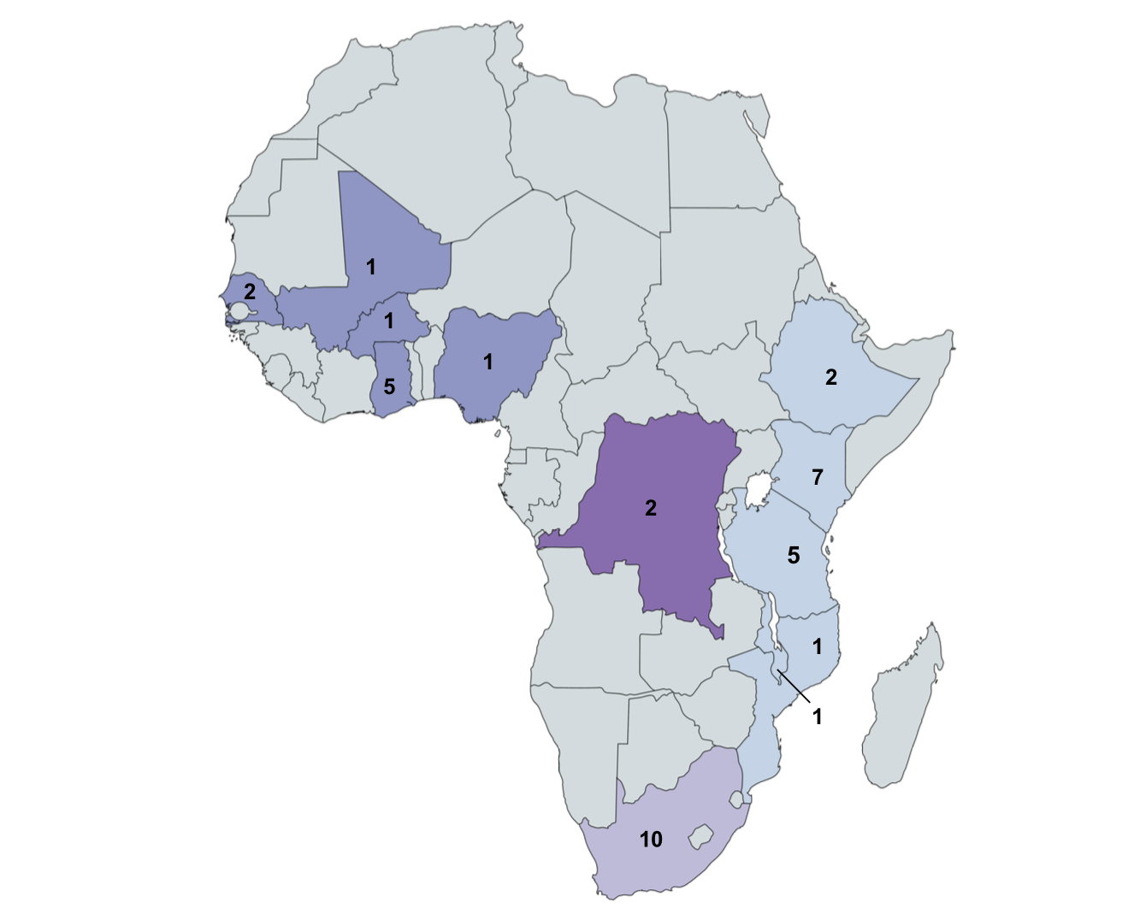

**middle Africa**

2 studies, 1 country

1173 isolates

**eastern Africa**

16 studies, 6 countries

3741 isolates

**western Africa**

10 studies, 5 countries

972 isolates

**xd**

**southern Africa**

10 studies, 1 country

5163 isolates

**Figure 2**

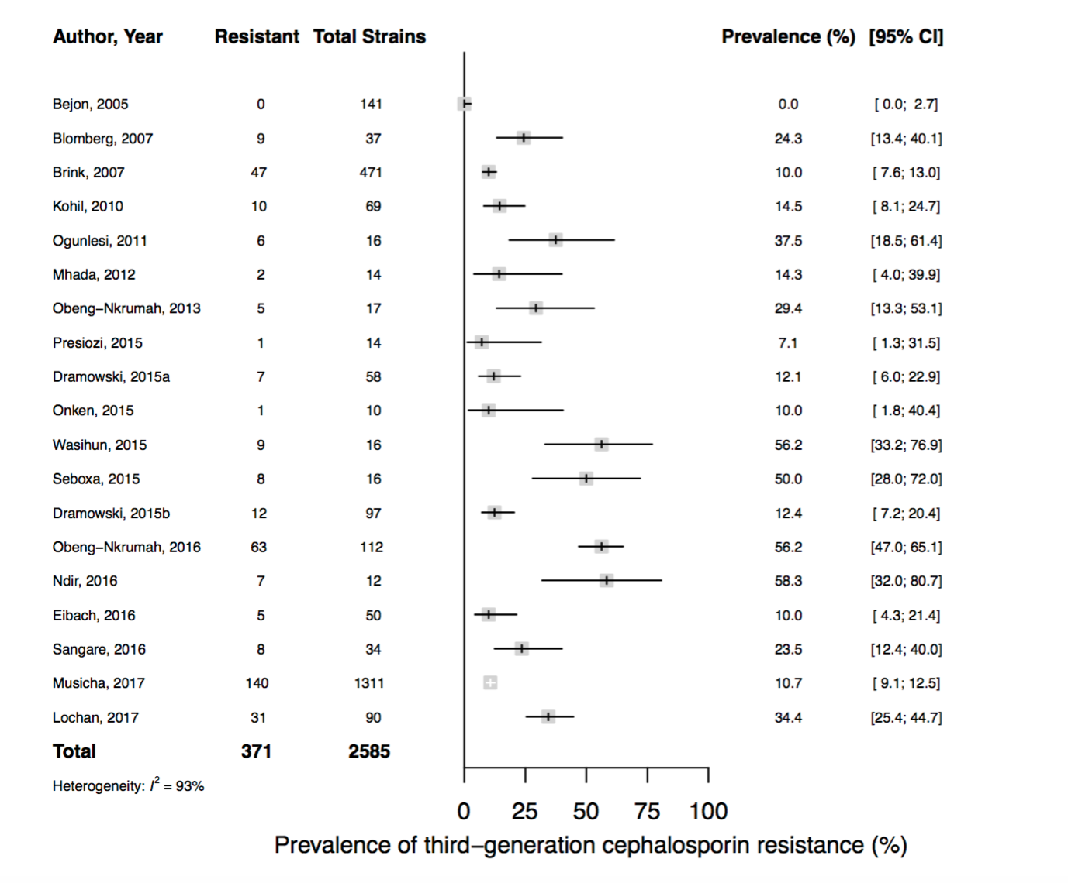

**Figure 3**



**Figure 4**



**Figure 5**

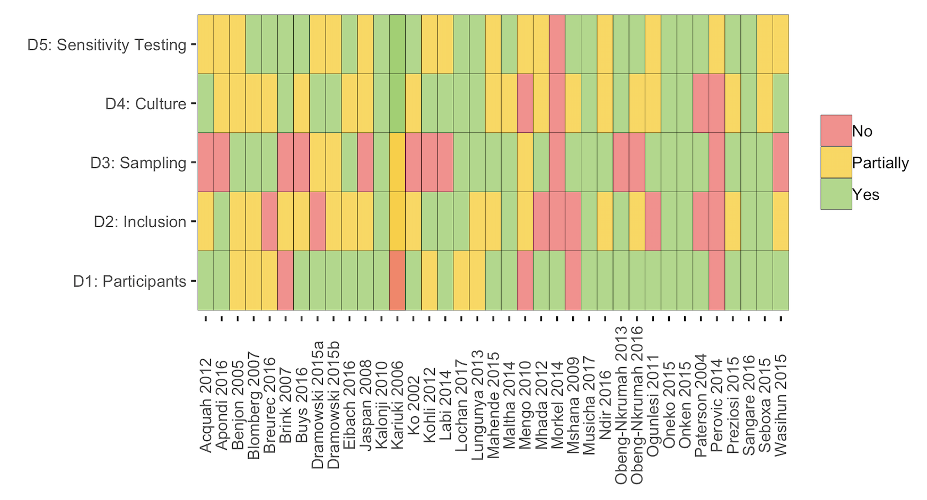

**Figure 6**