Social & Cultural Geography, 2020

Interacting with the Dead: Understanding the role and agency of spirits in assembling deathscapes

Terence Henga

aDepartment of Sociology, Social Policy and Criminology, University of Liverpool, Chatham Street, Liverpool, L69 7ZR, United Kingdom

(Received 2 Feburary 2018; accepted 18 December 2019)

When thinking about deathscapes and how they are assembled, current literature often points to the presence of material objects as ways in which individuals evoke the absence of the dead. These objects can be both performative and communicative, becoming a channel of communication. But the literature has so far mostly neglected the ability of spirits to ‘talk back’ to the living through objects and bodies, and in doing so influence and have effect on the latter’s actions. In this paper, I will investigate the ways in which spirits are seen to have agency in deathscapes. I propose the concept of material proxies of consociation, denoting objects/bodies which act as ways for spirits to not just communicate, but interact with the living. Using two visual ethnographic case studies, one of divining blocks and the other of a ritual exhumation, I will demonstrate that spirits can indeed be seen to be active and effective agents in the assembling of deathscapes. In doing so, this paper offers new ways of understanding three things – the role and importance of spirits in deathscapes, how the absent is made present, and how the spaces in which living and dead interact are constructed and shaped.

Keywords: Deathscapes, Assemblage, Bodies, Spirits, Agency, Visual Methods

Introduction

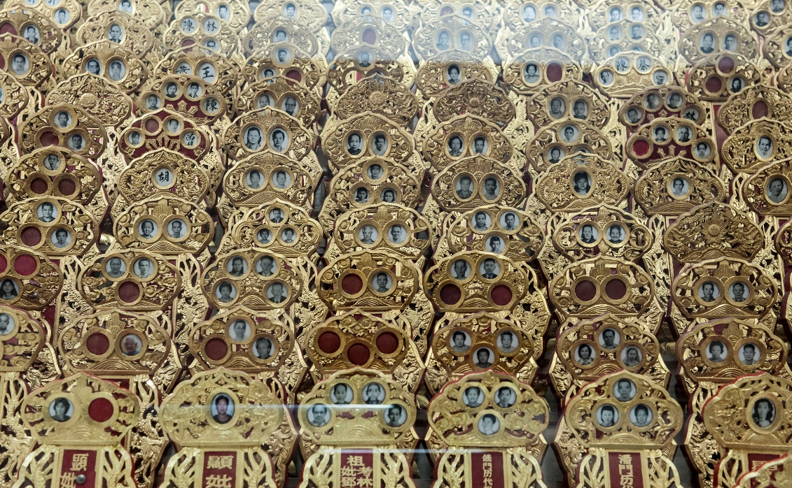

<< Figure 1 >> Ancestral Tablets in Guat Hoon Vegetarian Temple, containing fragments of active souls

In a special issue of this journal on the geographies of death, Stevenson, Kenten and Maddrell (2016) argue that despite death being a ubiquitous and physically inevitable conclusion to individuals, the study of it by geographers have continued to be numerically lacking in comparison to other everyday phenomenon. They note that “… geographers (are)… perhaps too reticent to engage with the actual embodied and visceral experiences of dying, death and associated boundaries, ruptures, ripples and vulnerabilities these create” (Stevenson et al 2016, p.158). Indeed, when examining the literature on the geographies of death, many articles make reference to similar, albeit significant studies and scholars (e.g. Kong 1999, 2012, Maddrell and Sidaway 2010, Maddrell 2009, 2013, Teather 2001). Stevenson et al (2016, p.158) also point out, with some notable exceptions (e.g. Evans et al 2015 and again, Kong 2012) that there also appears to be a trajectory in the geographies of death towards ‘Western’-centric cases of death and grieving, suggesting a much larger empirical and theoretical gap that needs to be filled with a more diverse body of work from around the world, addressing related themes such as “gender, class, ethnicity and intersectionality… sacred space and performances; emotion and affect.”
This article seeks to contribute to the diversity of issues related to the geographies of death and agency, where agency (as I will elaborate on later in this paper) is defined in the Latourian (1993) sense of the capacity to have effect and/or to influence the actions and interactions of individuals and events. In particular, I will consider the ways in which spirits have active, and not residual agency (Gell 1998, Harper 2010) as well as influence over the living through objects associated with them (corpses, graves, ritual artefacts), and how this agency contributes to the assembling of deathscapes (Hunter 2016, Porteaus 1987, Teather 2001) and more specifically, memorialscapes (Maddrell 2009, 2013, Maddrell and Sidaway 2010). Moreover, this study draws on fieldwork done in the context of Chinese Religion in Singapore, where power and punitive actions on the part of dead ancestors have long been well-established (Li 2011).
Deathscapes, as defined by Teather (2001, p. 185 as cited in Hunter, 2016, p. 248) are “the material expression in the landscape of practices relating to death”. Maddrell and Sidaway (2010, p.4-5) also use a similar definition, where deathscapes are “… both the places associated with the dead and for the dead, and how these are imbued with meanings and association.” Hallam and Hockey (2001), Hunter (2016), Maddrell and Sidaway (2010) and Kong (1999) all show in various ways that deathscapes are sites of place-making, of actions in which individuals actively do, make or act, often with material objects and features, actions that enable them to, amongst other things, grieve for the dead (Maddrell and Sidaway 2010), remember/care for the dead (Maddrell 2013) or (re)-introduce the dead into the social life of the living (Wojtkowiak and Venbrux 2010). However, deathscapes do not just deal with death, but also with memory and remembering loved ones (Hallam and Hockey 2001) – spaces in which active work involving the memory of lost loved ones are performed. In particular, Maddrell and Sidaway’s (2010) collection of essays on deathscapes examine these spaces from the perspective of memory work and the connections and relationships that the living have with the dead, draws upon the model of continuing bonds (see Klass 2006, Klass, Silverman and Nickman 2014) and the objects and spaces associated with such bones. Memorial benches (Wylie 2009), home shrines (Wojtkowiak and Venbrux 2010), columbaria (Kong 1999), roadside memorials (Clark and Franzmann 2006) all act as material objects that work towards assembling (Anderson and McFarlane 2011) deathscapes and memorialscapes.
One important concept linked to continuing bonds that helps frame this study is that of absence and presence, or how presence (of objects and other ‘things’) can make and accentuate the absence of individuals in deathscapes. This was drawn out succinctly by Maddrell (2013) in her paper on memorialscapes, continuing bonds and the absence-presence dichotomy. Maddrell argues for the materiality of absence, and how through artefacts and objects the absent can be signified (quoting Richardson 2001). Maddrell quotes Meyer and Woodthrope (2008), noting that absence can be physical, locatable and most importantly for this article, have agency – where having agency means that absence can and does have the capacity to have effect (Gell 1998).
The material objects that make absence present are often “things” – benches, house shrines, pebbles, vernacular monuments in everyday spaces (as noted in the previous paragraph). But with cemeteries and columbaria, one would also need to consider the dead individual to be part of this material and ethereal spectrum. Although there has been some work done with regard to the role of the dead in assembling deathscapes, more could be said from beyond simple physical-spiritual dichotomies, as well as Anglo-American perspectives. This paper thus seeks a deeper and more nuanced understanding of the roles and agency of the dead and spirits. It redefines and reconfigures the ways we enable the dead to communicate with us and have effect on us, focussing particularly on non-Western practices and perspectives, in this case Singaporean Chinese religion practitioners.

Bodies/Objects, Spirits and Agency
When considering dead individuals, most of the literature invariably and logically references artefacts related to the dead, particularly corpses and other associated objects (coffins, gravestones, memorials, etc). Corpses are seen as both as a site of identity (Foltyn 2008) and a way to remember (Hallam and Hockney 2001). But at the same time, spirits and spiritual spaces have also been seen as an important element in deathscapes (Francis et al 2005, Bartolini et al 2017a) – lingering post-death and existing in relationships with the living (Davies 2010). Less appears to be known about just how spirits, dead bodies, artefacts and the living interact to construct deathscapes. Using visual ethnographic methods and a case study of the largest Chinese cemetery outside of China, I will show how spirits and artefacts (including corpses) are a significant part of the ways in individuals perceive and interact with the dead and spaces of the dead. I will first consider how the dead and/or dead bodies have been viewed and discussed, before connecting this to spiritual forms.
The role of the dead and their bodies in the study of deathscapes is varied but not extensive, and when considered, are not always seen as active agents in the construction of the space they inhabit (with some exceptions, see Young and Light 2013). Williams (2004) argues that the dead do indeed have agency. Starting with an analysis of the archaeological study of death, corpses and burial, Williams points out that despite there being an increasing interest in issues of emotion, remembering and individual identity (citing Barrett 2000, Jones 2003 and Tarlow 1999 for example), much of mortuary archaeology’s concern regarding the dead body is about its construction through material culture, and not on the “materiality of the dead body” itself (Williams 2004, 264). Furthermore, the body is sometimes simply seen as osteological data, or at best as an object imbued with sociological and political meaning - a strategic resource for the living. Williams argues against this perspective, writing that “(t)he key lies in the frequently observed evidence, that, for many cultures, the social, symbolic and mnemonic significance of the dead body does not end with the extinguishing of vital signs” (Williams 2004, p265).
Williams points out that the dead can still influence the way their bodies are treated through various means, thus having the “potential for social action” (Williams 2004, p266). Such influence can manifest in several ways, for example through direct instructions given before their death, or by providing financial provision for their commemoration (through the building of tombs, graves and other memorials), or through the use of legal obligations in wills, amongst many others. Using Gell’s (1998) framework of agency in art and artefacts, Williams exposes the “social and mnemonic agency of the dead body” (Williams 2004, p263), showing that dead bodies are more than data, and that the dead are actively engaged in the way they are interacted with by the living, oftentimes through their bodies.
Despite this, the agency of the dead is still textured by the actions of the living – in other words, they are not always seen as capable of ‘acting’ on their own. At best, their influence from beyond the grave comes from prior instructions and actions taken before their death, and hence aspects of agency like intention, deliberateness and activity are still left wanting. Gell’s framework of the agency of artefacts, offers some way into addressing this. Gell (1998) considers agency to still be linked to human intentionality, but looks at material artefacts as extensions of the individual, gaining agency because of human intentionality. These artefacts become references to an expanded personhood, lingering after the death of an individual, hence, a secondary agency (Hockey et al 2010). Hockey et al (2010, p9) propose that like the belongings of an individual that gain agency (where agency is defined as the Latourian (1993) view of “the capacity to have effect”), the dead body (and other things associated with the dead, like tombs and possessions) then becomes like an artefact, extending personhood through human intentionality.
However, many of these studies do not consider the dead in spiritual form, and thus while the agency of the dead (i.e. non-living individuals) is actively discussed, the agency of spirits (‘living’ individuals in non-physical form) has not yet been given equal attention. To rectify this gap, I intend to offer a concept that encompasses the agency of spirits through material objects. To do this, my paper seeks to find its place in material, rather than surface geographies (Tolia-Kelly 2013), where materials are argued to be “live, agentic, and powerful” (Tolia-Kelly 2013, p154, paraphrasing Hethrington and Munro 1997). In other words, matter matters for the dead, their bodies, associated objects, and their spirits. But how does matter matter, and how agentic are the dead when we consider particular kinds of spirits, embodied practices and ritual artefacts? Some scholars have pointed towards the vibrancy (Bennett 2010) of matter, where objects have the potential to enchant and have affect (Burrell 2011, Ramsay 2009). But in thinking about the dead, we must also think of the whole individual - body and soul/spirit. In other words, how does spirit matter in material geographies?
Such questions can begin to be answered by looking beyond secondary agency to a mixed agency of the dead, where boundaries between tangible and intangible, corporeal and spiritual, primary and secondary agency are blurred. For amongst various groups, where death is not a biological end but a transitional phase where the dead still exist as individuals, spirits are seen to have agency. Returning to her work on memorialscapes, Maddrell (2013) notes that the spirits of the dead are often considered lively and agentic by the living – i.e. they are beings who can and still be communicated with for assistance or comfort, albeit in one-way direction. Francis et al’s (2005, p123) research into 21st century cemeteries in the United Kingdom showed how “many believe that the ‘spirit’ of the deceased is present at the gravesite and that contact and communication is still possible.” Davies (2010) also notes how other groups make use of space to accommodate non-corporeal agents, for example, the creation of “respectful sites” – spaces in which ancestral spirits are honoured, evidencing a continuing relationship between human and spirit. Other groups maintain a fearful relationship with their spirits, particularly those “believed to be misplaced or lost while journeying to the other world or malevolently inclined towards living kin because some ritual or respect has not been observed…” (Davies 2010, p211).
Spirits are thus a way to explain in part an active agency in the assemblage of a space that involves both materiality and non-materiality. As shown above, scholars have argued such a point in different ways, including Davies (2010), who frames spiritual space in the relationships between the living and the dead. In this paper, I intend to reconfigure some of these ideas by showing how individuals make use of the relationships between objects/bodies and non-physical spiritual forms as ways in which they assemble deathscapes. I will do this through two case studies, one of an active spirit residing in a material object, and the other of the grave and dead body or fragments of a body as home for the spirit. My research question is this, “How do we understand the role and agency of spirits in the assemblage of deathscapes?”. In order to answer this question, I will first further attend to the agency of the spirit in relation to materiality.

Spirit as Artefact, Spirit in Artefact: Material Proxies of Consociation
Rather than using examples from Anglo-American contexts, I will be drawing on research I have conducted on Chinese religion in Singapore. Chinese religion is defined here as a syncretic blend of Buddhism, Confucianism, Folklore and Taoism (DeBernardi 2012, Heng 2016a), although many adherents in my case studies often refer to themselves as “Taoists” – referencing many of the Taoist rites and beliefs that are included in the wider system of Chinese religionist practices, and that what is commonly practised in Singapore is Zhengyi Taoism (Tan 2018), which combines more animistic folk beliefs with Taoist principles. For the purpose of this paper however, when I refer to Chinese religion, I am referring to the system of beliefs reflected in the everyday life of some Chinese Singaporean individuals who espouse/practice such beliefs. In the 1960s, Chinese religion or Taoism was one of the main religions of the Chinese population in Singapore, but has now receded in favour of agnosticism, atheism and other religions, particularly Christianity (Chong and Hui 2013). Adherents to this system of beliefs practice a wide range of rituals throughout the year, with some considering what they do to be more cultural than religious. More prominent festivals include Qing Ming Jie (清明节 or Qing Ming Festival), a tomb-sweeping event similar to All-Souls day and the Hungry Ghost Festival (Teiser 1996) where individuals believe that ancestral spirits are allowed to roam the living world for one month (Heng 2014). In this paper, my focus is on spaces and mnemonic rites related to Qing Ming Jie.
While it is not in the purview of this paper to consider all aspects of belief and practices in Chinese religion, two selected cases before I present my empirical evidence are illuminating in the light of the literature on spiritual beings, deathscapes and materiality. When we think of objects having agency, or the capacity to have effect, one can certainly point to particular objects and individuals in Chinese religion that reflect this kind of embodiment, none more so than kim sin (金身) that have been ‘awoken’ or consecrated. Kim sin in Chinese Religion are typically physical representations (statues) of a deity in the Taoist, Buddhist or Folk Religion lore. Normally carved out of wood, kim sin that have been awoken (or ‘activated’) are seen as the body of a deity. To awaken or activate a kim sin is to invite the deity to not just inhabit, but to become the object. Kim sin are thus treated with intense care and respect, cannot be simply or easily disposed of, and are worshipped in their own right. An example of viewing the kim sin as a deity’s body can be seen in a 2017 BBC news article “Chinese deities flown on business class to Malaysia” (https://www.bbc.co.uk/news/world-asia-40490108), where kim sin (including those of Ma Zu, the Goddess of the Sea) have their own seat and boarding pass for their transportation from China to Singapore and Malaysia as part of an international tour. As a temple staff said in the same article, “This is the body of our divine goddess, a symbol of Chinese folk culture.” (ibid)
Such manifestations of spirits (of deities or more mundane, everyday individuals) are also apparent in Chinese religion spirit mediumship. Unlike Spiritualist (Bartolini, Mackian and Pile 2017c) mediums, who act as a conduit for “Spirit” (with a capital ‘S’) to communicate with the living, Chinese religion mediumship involves the literal embodiment of a deity’s spirit in a living individual – i.e. a form of possession (Debernardi 2006). When in a trance, these spirit mediums, also known as Tang-ki in Singapore, become the deity that they are channelling and in effect become the temporary locus around which sacred space is produced (Heng 2016a). The spirit medium loses their identity in this case, their soul moved to another object (a flag) that their assistant carries. Adherents engage with the medium as if engaging with a deity in their presence, offering food, treats (for Child deities) and other objects of consumption related to that particular deity’s preferences.
However, when dealing with deathscapes in Chinese religion, material and spiritual agency become a trickier concepts to reconcile. Although the spectrum of spiritual beings in Chinese religion deathscapes include deities, ancestral souls, ghosts and demons, the mnemonic rites I am analysing in this paper is focussed particularly on individuals’ relationships with ancestral souls (usually the personhood of one or two generations ago). In the case of these souls, rather than becoming an object (as is the case of embodied idols and mediums’ bodies), they tend to inhabit and reside in objects. Objects thus become a way for these spirits to be present, and to make their presence felt to the living. These objects are coherent, and do seem to make the spirit more tangible, but are not spirits in themselves. The consequences of this is that the spirit remains formless in a menagerie of forms.
How then do we focus on the ethereality and agency of spirits while still accepting the significance of objects (because, objects are significant in Chinese religion (Heng 2015))? In their study of Spiritualist churches, beliefs, histories and memories in Stoke-on-Trent, Bartolini, Mackian and Pile (2017c) point to how individuals communicate with Spirit through various means, including material objects and spaces, but do not ascribe the object with agency (i.e. agency remains with Spirit, not with object). Bartolini et al (2017b, p16-17) propose that “…matter is not personified (incarnate or reincarnated), not jaunted, and not vibrant on its own – and therefore cannot be understood through agency; rather, matter requires Spirit to have meaning… the material world takes on meaning through Spirit, but it is not Spirit itself.” For Bartolini et al, material objects are the conduits through which Spirit (and likely, spirits) communicate and interact with the living. Individuals in their study make use of objects in order to affirm their belief in the presence of Spirit and perform their spirituality. Bartolini et al’s proposition is useful, because it provides us with a different way of looking at materiality, divorced from the bifurcation between spiritual and physical. It means that many objects that might be interpreted as having agency are more proxies through which spirits/Spirit are communicating and socialising with the living.
Such acts of sociality imply that we need new concepts to explain how living and dead interact in the assemblage of deathscapes. I propose the term material proxies of consociation as a formal way of linking the agency of the spirit with the activeness of objects. The use of the word ‘proxy’ is not taken lightly – ‘proxy’ suggests more activity and engagement than ‘tool’, more integration than ‘symbol’ and certainly less passivity than ‘conduit’. I have also chosen to include the term ‘consociation’ rather than ‘communication’ to emphasise the very real outcomes and consequences to living individuals and the environment when these proxies come into play. The spirit in this case is not just talking to individuals, it is actively interacting with them. But like the individuals in Bartolini et al’s (2017b) study, these spiritual beings work through objects, but are not objects themselves (at least in the empirical evidence I am presenting here). I propose that such a concept helps us to better understand just how deathscapes are assembled. The ancestral soul may not be able to be assembled materially, but it surely can materially assemble.

Methodology: Chinese Religion in Singapore and Visual Ethnographic Case Studies
To evidence the use of such proxies, I will be using visual ethnographic case studies of mnemonic and mobility rites amongst practitioners of Chinese religion in Singapore, a small nation-state where the majority host population identify themselves as Chinese (Cohen 2008). My analysis will make use of a 3-year visual study conducted from 2012 to 2015 on the social and cultural life of Bukit Brown Cemetery and its associated deathscapes (for example, temples that individuals who visit Bukit Brown also frequent). Bukit Brown Cemetery is the largest Chinese cemetery outside of China, and one of the last remaining large, pre-Second World War cemeteries in Singapore, where many others have been cleared to make way for residential and commercial spaces. Located in the centre of Singapore, near the main water catchment reservoirs, Bukit Brown is a mix of nature, urban and spiritual spaces. Opened in 1992 but closed to new burials in 1973, the cemetery was re-designated as residential by the Singaporean state in the late 1990s, with a new road to be built straight through to alleviate commuter traffic from the north to the south. As such, almost 4,000 graves had to be exhumed – (which was commonplace in a hyper-modern nation-state like Singapore), but with an increased interest in heritage and remembrance, the state as a token gesture to conservationists and activists commissioned a documentation of the cemetery and its threatened graves (Heng and Hui 2015). I was part of this team that photographed and filmed various rituals that took place in and were connected to Bukit Brown Cemetery, and it is these photographs that I will be using to explain the agency of spiritual bodies.
Like other work I have done (Heng 2014, 2015, 2016), I will be taking a visual methods approach to creating, presenting and interpreting data, particularly through the medium of photography. My photographs are narrative and descriptive in their appearance but attempt to create an additional ethnographic and expressive layer that democratises the interpretation of the scene by the reader (Edwards 1992). Photographs in the social sciences have largely remained as illustrations – supplementing rather than complementing text (see Knowles and Sweetman 2004). The use of the term “visual methods” is also very wide-ranging and can mean vastly different things in different contexts. For instance, some scholarly texts on visual methods involve the reading and interpretation of images, rather than creating and using such images (Rose 2012, Spencer 2011, Walsh and Baker 2016), whilst others see visual methods as part of active fieldwork (Heng 2016b, Pink 2012), or using images already taken in fieldwork, for example in photo-elicitation interviews (Twine 2006). Regardless of approach, many scholars have argued for the efficacy of visual and sensory methods in the social sciences (Becker 1995, Harper 2012, Lomax 2018, Pauwels 2015), producing meaningful work that weaves photography into the fabric of social research (Greenblat 2004, Knowles and Harper 2009, Pauwels 2009).
In my photographic practice as a social researcher, I have spent 6 years photographing and observing both deathscapes and sacred spaces (Woods 2013), being both a witness and documenter of the embodied practices that work to assemble deathscapes. I have argued elsewhere (Heng 2018) that such an immersion has allowed me to create deeper narratives of absence by capturing “points of praxis” in my photographs – i.e. not just the static, assembled deathscape, but the deathscape in process of being assembled. This, of course, enriches the ethnographic narrative, but is also ethically more complicated, and required careful negotiation and collaboration with my informants. Suffice to say that as part of this research, consent was sought and granted from my informants, and all names have been anonymised. The photographs that have been chosen for this paper have also been composed in a way (Heng 2016b) that affords my informants an extra layer of anonymity.

Fragmented Souls and Spiritual Containers
My study of spiritual bodies begins with the annual journey of the Ang family, who travel to three different locations as part of their tomb-sweeping duties during Qing Ming Jie. HC (40s, M, Chinese), my contact, met me outside a petrol station before piling into a car – three adherents (HC himself and his two cousins – Wee Liang, 70s, M, Chinese and Wee Chin, 70s, M, Chinese) and two researchers. Despite my early memories of performing Qing Ming for my late paternal grandfather, my family has abstained from mnemonic rites during this time since our conversion to Christianity in the 1980s, choosing instead to remember my late father on his birthday and death anniversary. As such, much of what they were doing became new and odd – and many beliefs which seemed familiar were now re-treated as strange and ethnographic (Hammersly and Atkinson 2007).

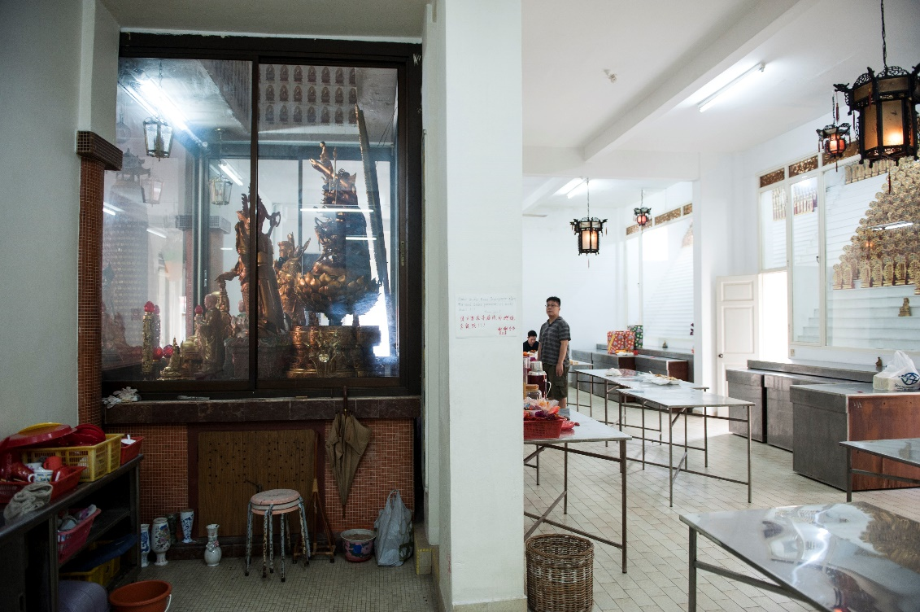

<< Figure 2>> Guat Hoon Vegetarian Temple in the east of Singapore. The hall for ancestral tablets is located in a room behind the main temple hall and deities

Our first stop was to a temple in the East of Singapore to visit the ancestral tablet of their grandfather, set in a suburban neighbourhood of terraced houses. The temple held no bodies, but instead was a sacred space for ancestral tablets, such tablets were said to hold an aspect of the soul. In a separate incident involving exhumation, a celebrant named Victor (M, 49, Chinese) explained how this worked according to his belief,
“If you really believe in Taoism, then the soul has different parts. When you die, 25% stays with the body, 25% goes to the ancestral tablet and 50% goes for reincarnation. That’s why we have to tell the spirit that we are moving the body, or else it won’t know where to go.”
The ancestral tablets were kept in a stepped glass cabinet, each of them having two to four oval slots for passport-sized photographs of dead ancestors, almost like a kind of family tree. In front of this glass cabinet were several tables in which individuals were allowed to set food offerings and offer incense sticks to the dead. HC and his relatives arrived where there was only one other person praying in the hall, and proceeded to arrange their food offerings – vegetarian noodles and packets of drinks. Once suitably arranged and prayers were said, we moved outside to a courtyard and chatted for a few minutes in order to give the soul time to ingest the food. HC and Wee Liang recounted the many visits they made to the temple, as well as the kinds of food their grandfather liked, and how people would nowadays buy rather than make food to offer.

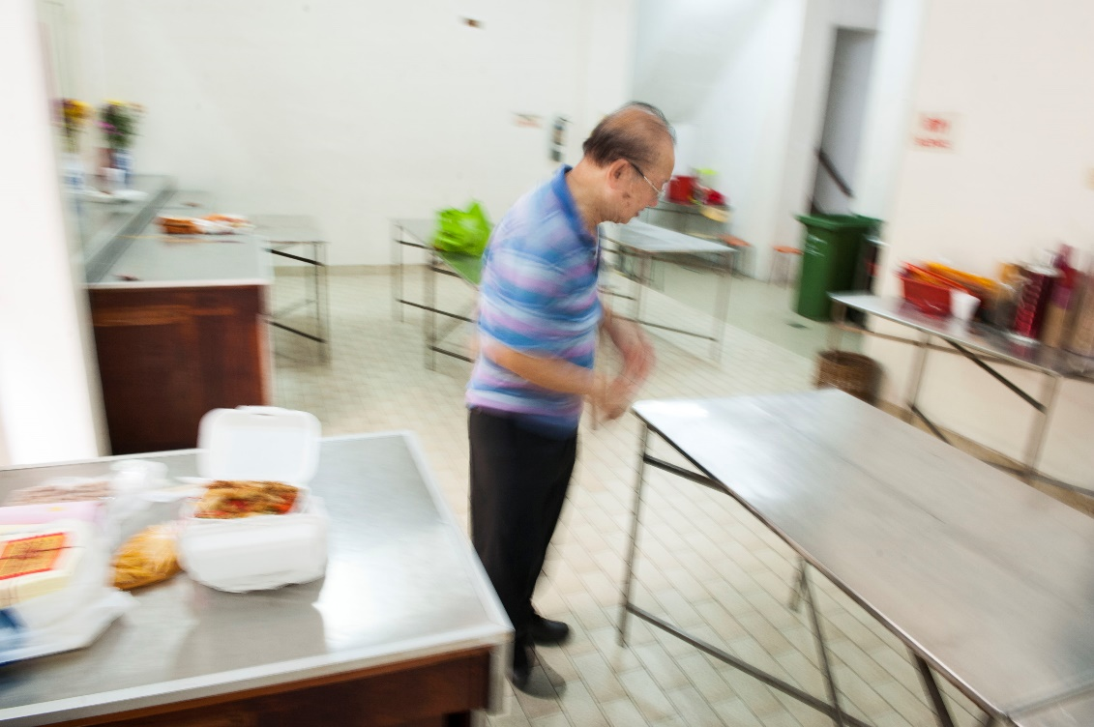

<<Figure 3>> Wee Chin setting up the food. Going early meant avoiding the rush of devotees on other days of Qing Ming Jie.

When a suitable time had passed, Wee Chin returned into the temple to “pua puay”. Puay (also known as Jiaobei (珓杯), or moon blocks) are divining stones – two crescent-shaped blocks of wood that determine if a spirit answers in the affirmative or negative to a request or question. It is used as a way to communicate with one’s ancestor, which in this case is to see if he has consumed his of the food and drink on offer. An adherent would say a prayer or question, then toss the two blocks of wood onto the floor. If they landed on opposing sides (one face down the other face up), it would indicate a “yes” (in the event that one did not have these blocks of wood, two coins would also suffice). Wee Chin tried multiple times but could not get a “yes”, and went back outside to give his grandfather more time. After another 10 minutes, and realising they had more places to go to in a short time, Wee Liang then decided to try, but no matter how many times he threw the blocks onto the ground, his grandfather had indicated that the food and drink was not consumed, and thus they had to wait.

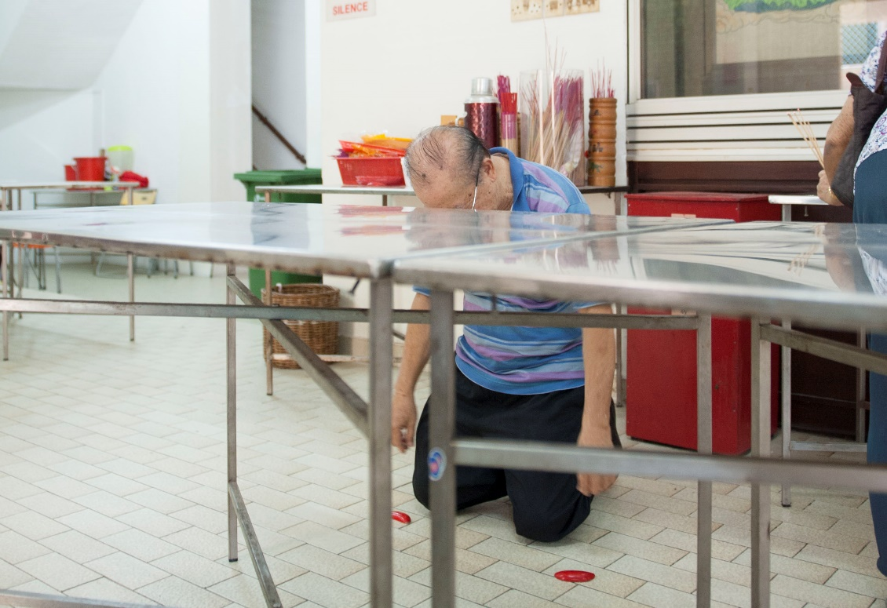

<<Figure 4>> With both divining stones falling face down, Wee Chin’s grandfather has indicated to the living that he has not eaten his fill yet.

At this point the lone other person in the room saw Wee Liang’s predicament. A sprightly elderly Chinese lady, she took a look at the food offerings, then admonished Wee Liang, and pointed out that the cutlery (chopsticks and spoon) were not laid out correctly in front of the offered food - how was his relative supposed to eat and be satiated if they could not pick up the food properly? She directed Wee Liang to position the cutlery in front of the packets of food, so that one would know that this cutlery was meant for this particular food. Wee Liang refused to believe her and tried again, and failed. Finally giving up, he rearranged the cutlery to the front, and threw the jiaobei onto the floor again. This time, the answer was “yes”, and Wee Liang looked even more incredulous. HC and Wee Chin walked into the room, and the elderly lady who had helped repeated her explanation of cutlery – the dead needed a way to eat, else they would not be satiated.

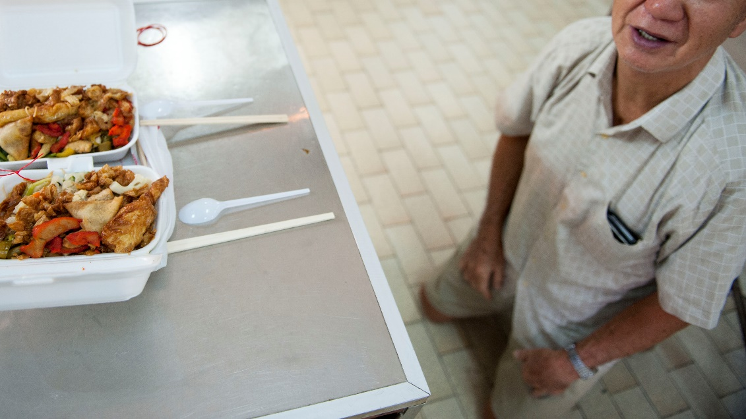

<<Figure 5>> Chopsticks and spoons placed ‘properly’, Wee Liang’s grandfather finally gets a chance to eat.

Such an incident is reflective of the practices of many other adherents, who see a corporeal and interactive element in their dealing with spirits. Spirits, especially those who were human, retain physical limitations, presence and preferences. The ancestral tablet is not just a representation of personhood, but is a container for the soul fragment who occupies physical space and has specific needs and wants, consociating via jiaobei and cutlery/offered food. In this instance the jiaobei becomes a material proxy for the presence of HC’s grandfather in an almost poltergeistic way - the spirit is actively and intentionally expressing desires through the object and consociating with the living. Thus, the use of jiaobei affirms Bartolini et al’s (2017b) assertion about the object itself not having agency, but acting as a proxy for the agency of the spirit/ soul fragment. The soul fragment itself appears to have something that is between secondary and primary agency (Hockey et al 2010). It is both human and non-human at the same time, having agency delegated to it (Latour 1993) but at the same time expressing its own preferences and desires, thereby creating social structures and assembling the social spaces around it. But rather than seeing and interacting with the soul fragment, individuals have instead established the ancestral tablet as another material proxy for consociation.
This case study also reveals the multiplicity of selves that Victor talked about. The dead individual is no longer a single person as when he or she was alive. Instead, he or she now takes on multiple forms at the same time in different places – becoming a turbulent and fluid mix of spirit and corpse. Shortly after we left the temple, HC and his cousins visited their grandfather’s grave to perform similar rituals, seeing their grandfather’s presence as both in the ancestral tablet as well as his bodily remains. The body in the grave remains as both a vessel for the spirit and person to be dealt with, a container which can be physical, symbolic (present even if the body has decomposed into earth) or both at the same time. In the next case study I will show how the body is treated in relation to the spirit as it is moved from one deathscape to another.

Moving Home

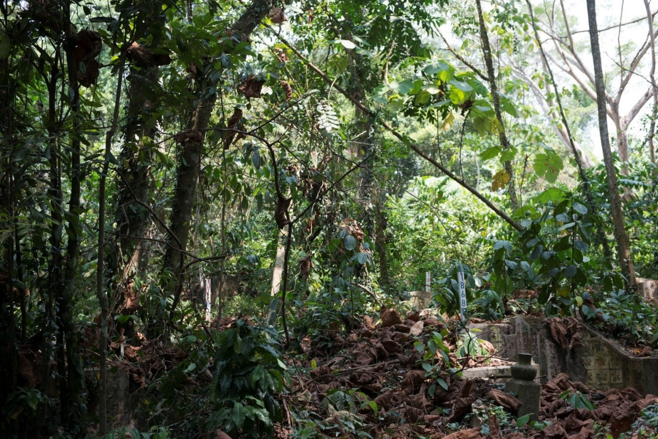

<<Figure 6>> A typical scene in Bukit Brown Cemetery – with a grave on the bottom right, its tombstone shorn off to indicate an exhumed status. Now covered in secondary rainforest, navigating through the cemetery, and exhuming graves in the middle of the night (as preferred in some Taoist beliefs) becomes a challenge for all involved.

In this section, I show how the exhumation process of a Chinese grave exhibits an active agency of the spirit through the residual body. Rather than being seen as simply a site for remembrance, Chinese tombs are often viewed as homes for the dead – the tomb itself is an assembled element, comprising of spirit, corpse and grave architecture. Despite the fragmentation, this multiplicity is seen as unproblematic for my informants, who treat separate parts as individual wholes. This case study takes place in Bukit Brown cemetery, where the Huang family (XJ, PT and their Singaporean cousin James) are taking part in an exhumation and re-internment ritual for their father. Unlike many other claimants to graves in Bukit Brown, the Huang family are based in China, and have come to Singapore to retrieve their father’s remains so that he may return ‘home’ and be buried with his wife. The deceased Mr Huang died in an accident at the age of 31 in 1943 during the Japanese occupation of Singapore in World War II.

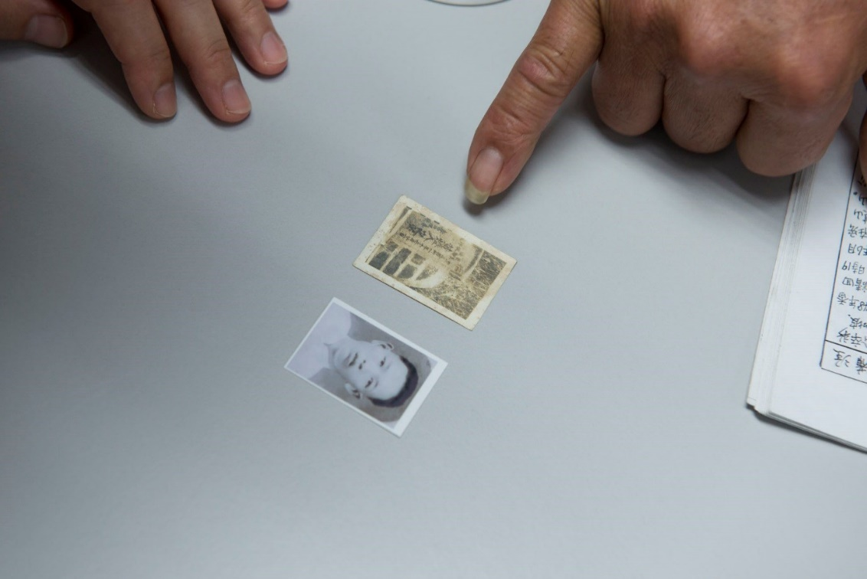

<<Figure 7>> XJ pointing to an old photograph of his father, and a small image of the tombstone in Bukit Brown Cemetery.

The rituals began when the family, gravediggers, government officials and researchers had arrived. Mr Chen, the Taoist priest and a regular exhumation celebrant, instructed the family to perform several rituals involving interaction with the spirit world, beginning with offerings made to the earth deity guarding this particular grave. Each Chinese grave has a small headstone perpendicular to the tombstone, and in Singapore this is usually inscribed with the words 后土 (hou tu), referencing the Goddess of the Earth (Theobald 2012), interpreted either as the wife/consort or female form of土地公 (tu di gong), also referred to as Tua Pek Gong, a minor but very popular deity in Singapore (Tan 2001). Such respects are needed to be paid before any earth is disturbed.
At the same time, the family set about placing offerings on the altar table for the late Mr Huang. This involved a whole cooked chicken, oranges and steamed cakes. In other exhumations I documented families would often choose food, drink and other items they felt the deceased might have enjoyed, including alcohol. Effigies of money meant to be spent in the netherworld are also offered and burnt. The Huang family, instructed by Mr Chen, then proceeded to offer prayers to the late Mr Huang, speaking directly to him and identifying themselves, whilst also stating their intention of moving his home back to China.

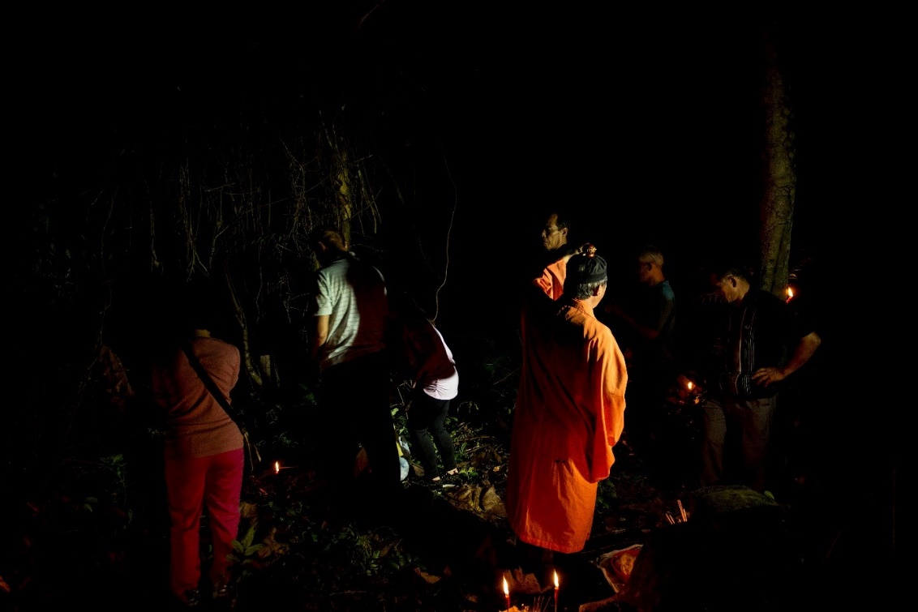

<<Figure 8>> Turning away to avoid ill fortune as the tomb is broken

When sufficient offerings and prayers were made, Mr Chen arranged the family members with incense sticks in a row in front of the grave and led prayers for and to the deceased. Most importantly, the priest’s chant involved informing the soul again that his or her home was to be moved from Bukit Brown Cemetery to another location. In other exhumations, this also involved giving the exact name of the place where the columbarium would be in Singapore. Such information is commonplace in Chinese exhumations and re-internments, and I am told by my informants that it is necessary because the soul needs to know where to go, lest he or she returns to an empty grave. As these prayers came to an end, XJ and his family were instructed to turn their backs to the grave, whilst the gravediggers, standing over the grave mound, struck the mound with their changkul (a kind of shovel) as a symbolic ‘breaking of the tomb’, while Mr Chen shouted “huat ah!” – a Hokkien phrase meaning “to prosper”. When broken, the gravediggers spent the next 3-4 hours manually removing concrete and earth to reach the coffin.
About the time the gravediggers felt they were near the coffin, judging by the colour of the earth they excavated, they erected a makeshift shelter over the dug grave using bamboo poles and a tarpaulin sheet, in the belief that the dead should not see heavenwards as they are taken out of the ground. Once secured, the gravediggers return to the pit they have made, using smaller and more precise tools to tease out bone fragments from the coffin. When all major bones or other items (these can include spectacles, coins, ritual effigies of cooking ware for the netherworld, clothing, jewellery and false teeth), the gravediggers will use their hands to comb through the dirt for the smallest of bone fragments.

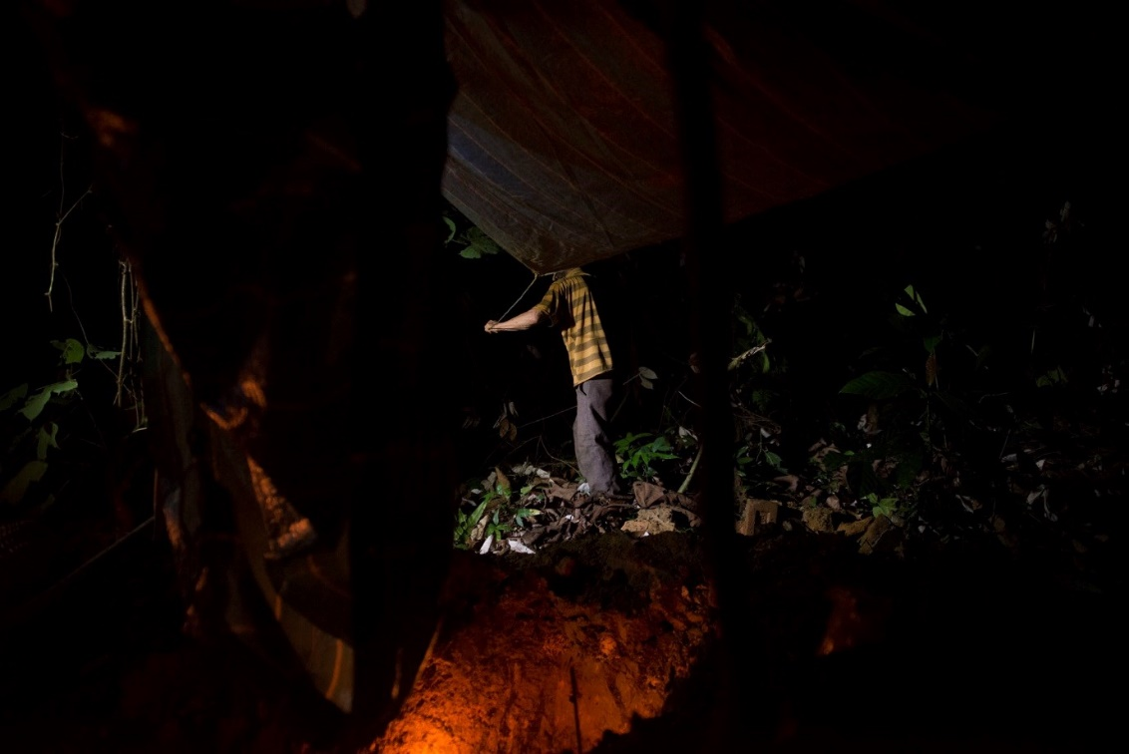

<<Figure 9>> Gravedigger Lim ties the tarpaulin sheet to any nearby trees to secure it. The sheet is erected regardless of time of day

In other exhumations, bones are first placed into a red plastic basin for sorting, before being ceremonially bathed in rice wine in a cleansing ritual, then placed in a white plastic bag. Here, gravedigger Lim placed Mr Huang’s remains directly into the bag and washed them there. The bag was then tied up with an elastic band, and a wooden/paper umbrella unfurled to protect and guide the spirit as its home departs for another location. Typically, the eldest son (or male descendent) of the deceased would carry this bag and umbrella, together with an incense stick, but in this case XJ passed the duty to Lim to bring his father’s remains to the government crematorium, before they would meet to retrieve the ashes the next day.
On the one hand, we can see here that the body has had agency delegated to it by the actions of the gravediggers and family, reminding us of the kind of corpse geographies articulated by Young and Light (2013). At the same time though, we also see an active consociation between the living and the dead through the actual/symbolic body. When considering the role of the spirit (and not just the wishes of the individual when alive), we see the capacity of the ethereal to shape circumstances, actions and structures, to have effect. Individuals speak to the spirit at its body and resting place to reassure and inform it of impending change – they treat the body with the greatest respect because of the spirit and the potential harm it might do if angered. This is not just an act of communication, but also of consociation and interaction – there are very real physical and tangible consequences in one’s relationship with the afterlife.

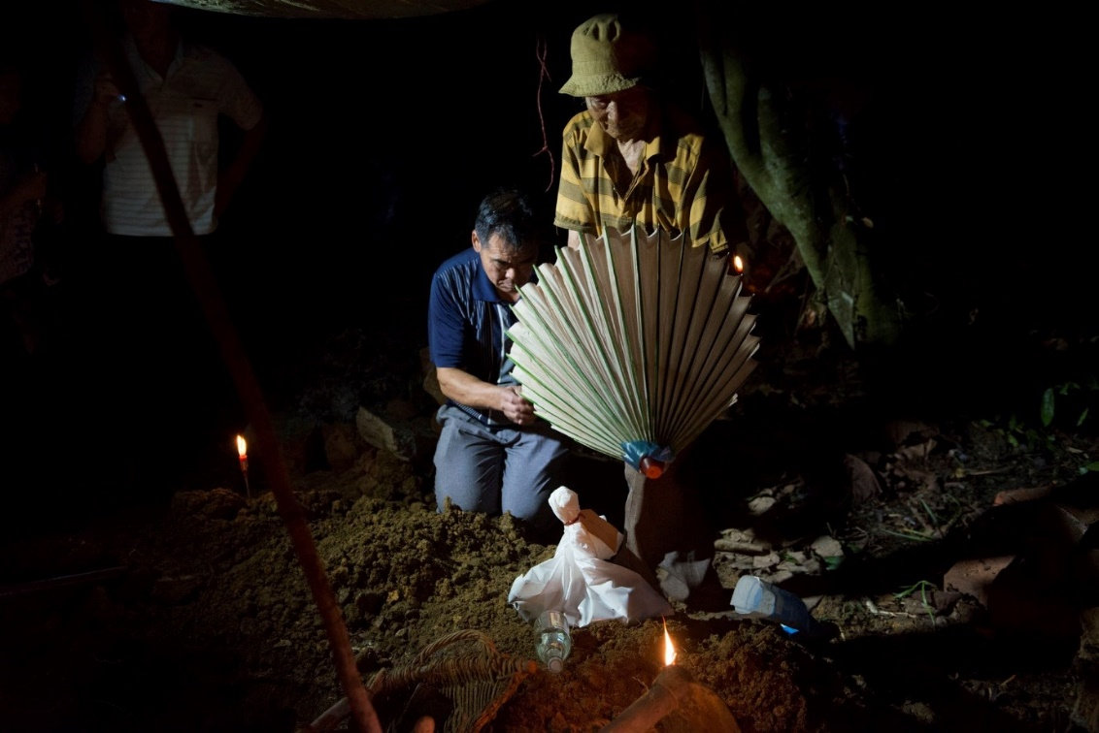

<<Figure 10>> Bones are retrieved, washed in rice wine (the bottle in the foreground), and tied up for transportation for cremation. Gravedigger Lim, with XJ in the background praying, unfolds the ceremonial umbrella meant to protect and guide the soul to its new home.

Discussion

“…some bodies have no body” (Bartolini at al 2017c, p181).

In this paper I made the argument for the importance of material objects such as artefacts and corpses as a key way of understanding the role of the spirit in assembling deathscapes, and in particular the agency of spirits in such assemblages. That we consider the material world important is not new, but how the material world affects the emotional and ritualistic work we do is still open to inquiry, especially when dealing with social and cultural variations The connection between material (proxies) and social (interaction) is key, because it is through the social we find the spiritual in the material. Certainly, we accept that individuals use objects to communicate with spirits and the spiritual world, but when we think not just about communication but interaction (i.e. consociation), where interaction has real and significant consequences to the lives of the living, we then can see the spirit as active agent, and object as proxy.
In constructing the spirit as agent through material proxy, capable of influencing through intention, the role of an ancestor in assembling deathscapes is one that involves fluidity and tension between primary and secondary agency, presence and absence, body/artefact and spirit. In these case studies, the spirit does not just communicate through artefacts, but consociates with the living and structures their actions – i.e. in the first case study no one could leave the temple until grandfather was satisfied. Certainly artefacts, the body and spirit have agency delegated to them by living individuals, but when accounting for the role of spirits, also appear to have agency delegated from the afterlife – revealing the ongoing and active relationships between living and dead. During Qing Ming Jie and in the exhumations in Bukit Brown Cemetery, we see the spirit manifest through material proxies of consociation – ancestral tablets, graves, corpses and more, and as we have seen from the narratives here, the ways in which individuals construct their encounters are many and myriad.
Taking this approach of spiritual agency and proxies by which they exercise this agency contributes to the existing deathscapes literature on absence and presence as well as the spaces in which absence-presence works. I will deal with each of these in turn. Firstly, as Maddrell’s case-study work (2009, 2013) has shown, individuals often make use of everyday spaces (and corresponding objects) to memorialise and remember their kin. Such markers of absence are said to have agency – they can evoke “emotional and affective responses” (Maddrell 2013, p511) and develop or perpetuate a sense of continuing bonds. Absence-presence, or the feeling of the absence of an individual through the presence of memorialscapes, “is expressed through a combination of representational spaces and material forms as well as embodied practices and emotional performances” (Maddrell 2013, p517). In other words, the materiality and embodiment of praxis, which is present, reveals absence and the emotions associated with absence.
Furthermore, individuals do actively interact and consider the absent dead “as alive” and agentic. Letters found on memorial benches show the living entreating the dead to strengthen and provide care for them (Maddrell 2013). However, this study differs in the kind of agency and level of interaction the living have with the dead. In the case of letters to the dead, communication with the lively dead is one-way, i.e. it is not interaction. Even when a voice is given to the dead, as Maddrell showed in inscriptions on benches, these were static voices ascribed by the living to the dead (or perhaps by the dead when alive). In other words, it was a kind of residual agency. The case studies here depicting material proxies of consociation show interaction in real-time – objects and bodies that actively impact the decisions and actions of the living. Such degrees of agency and interaction thus offers us a wider spectrum of understanding of the presence of deathscape objects and their role of evoking absent individuals. In this case, spirits talk back, resist, and threaten through objects and bodies.
Secondly, thinking about material proxies encourages us to develop more nuanced understandings of how absence-presence is textured by and located in the social spaces of interaction constructed between the living and the dead. Such social spaces are usefully explained in Maddrell’s (2016) mapping of spaces of bereavement and remembrance, in which Maddrell explores material, embodied-psychological and virtual spaces. Here, virtual spaces represent “non-material spaces of interaction, practices and performance” (Maddrell 2016, p178), while embodied-psychological spaces refer to those marked out on performative bodies as well as emotions evoked through dwelling in space. Framed in this way, material proxies of consociation reveal the intersections of material (body/object), embodied-psychological (emotional and other responses to acts of spirits, both perceived and anticipated) and virtual (imagined spaces of spiritual presence) spaces through the interactions between living individual, dead individual and body/object. Key to these interactions is the agency of spirit(s), for if my informants did not actively believe that there was a spiritual agent either influencing the way puay fell, or being able to enact wrathful vengeance for displacing a home, there would be no reaction, no emotion, no influence on praxis.
Seeing the spirit as agentic reorientates our way of articulating the presence of the absent. It suggests that we do not need to look solely at the material world for the presence of the absent, but also the active practices of the living interacting with the dead – performed in their embodied-psychological reactions and their virtual acts as they happen. Visual ethnographic methods are especially useful for this study of praxis and absence in deathscapes (Heng 2018), but so are other methods that successfully visualise and explore interaction, like participatory action research (O’Neill 2011), photovoice (Oh 2012, Ronzi et al 2019) and video participatory methods (Bates 2014).
How then do we understand interaction in this mixed personhood of body, artefact and spirit? Paradoxically, the case studies here suggest that there are limits to the way non-human actors ‘work’ when also taking into account the agency of the ethereal spirit (whether we classify a spirit as human or non-human is a task for another paper). When individuals believe that a spirit resides in and delegates agency to an object or its original host body, the object or body becomes proxy for the spirit, in very much the same way that the living body is often considered part of the human actor. This simultaneously expands and limits our use of the material world – on the one hand, it shifts agency back towards human-spirit intentionality. The material world becomes more of a conduit through which the effable and ineffable interface, and in this way, as mentioned previously, theories of assemblage may not always fully account for the agency of spirits (Bartolini et al 2017b). On the other hand, and this is where my argument moves away from Bartolini’s (2015) point that the agency/ vibrancy (Bennett 2010) of objects distracts us from their social constructions, the material world is still the primary methodological way for us to engage with the spiritual. Even if some objects are more social constructions than agents, it does not mean that the material world is immaterial to our analyses. Furthermore, while the specificities of these case studies as well as Bartolini et al’s (2017b, 2017c) study of Spirit propose that agency rests better with spirits than objects, other empirical evidence may suggest otherwise.

Conclusion and Areas for Further Study
In this paper I considered the importance and role of spirits acting through material objects, particularly corpses and artefacts related to the dead, in assembling deathscapes. Through two visual ethnographic case studies, I argued that it is possible to see the agency of spirits at work in the way individuals interact with objects and bodies associated with the dead. Rather than focussing on the agency that the living delegate to the material world, I propose that the spirits are also able to delegate agency to objects/bodies, thereby making these objects/bodies material proxies of consociation. It is through these objects/bodies that the dead interact with the living, thereby making their presence felt and their agency efficacious. Material proxies of consociation thus offer us new ways of understanding spaces of remembrance and how these spaces intersect through interaction. They widen the spectrum of the materiality of absence and presence, but at the same time constrain it by shifting agentic power to humans and spirits. In this way, my key contributions are twofold: one, I offer a new concept that introduces the importance of spirits in assembling deathscapes. I show that in the study of deathscapes, spirits need to be seen as having their own forms of praxis and their own ways of influencing outcomes, and that we can continue to do this through active and immersive studies of the body (both dead and alive) and the material world. Two, I show that such studies can reveal new ways of understanding how absence is made present, and that these studies can be effectively situated in non-Western contexts, where a diverse spectrum of beliefs and practices can open new pathways of conceptualising.
In proposing the concept of material proxies of consociation, this paper raises two final issues that warrant further study, one related to Chinese religion itself and the other policies on death and burial. With Chinese religion, understanding the agency of the ancestral spirit in relation to tablets and graves reveals the complicated and sometimes chaotic approaches adherents take to engage with the spiritual world. While we can see the agency of the ancestral spirit in how it resides and inhabits objects, and thus consociates with the living through these objects, other kinds of spirits within this system of beliefs render material proxies problematic. At the start of this paper and in other work (Heng 2016a), I highlighted how deities in particular embody both objects and bodies (of possessed spirit mediums) in order to engage with and consume the physical and social world. If the spirit does not simply reside in the object/body but is the object/body, even temporarily, then further research and conceptualisation is needed to understand the inter-agency of spirit as object or spirit as body.
The second issue relates to the increasing concerns of the state and storage and/or disposal of the dead (Kong 2012) and how this is connected to the needs of the living. Kong highlights how several nation-states, especially those with densely concentrated populations and limited access to land (Singapore, Hong Kong, Taiwan) face constant and escalating pressures on what to do with dead bodies. Kong examines different policies and practices that are taking effect, including sea burial, memorial gardens (converting remains to trees) and ash scattering. The Singapore state in particular has made cemeteries an almost endangered space, from mass exhumations for the purpose of land-use redevelopment (Chong and Chua 2014) to limiting the time one may stay buried before being exhumed for cremation (the current limit is 15 years). For now, the answer has been to compress individuals through cremation and columbaria – giving individuals the opportunity to maintain material proxies with the dead.
However, the state is also developing alternative methods of disposal that reduce pressure on land use, such as cordoning off a part of a beach for individuals to scatter ashes into the sea, or creating an inland ash-scattering garden within a columbarium. While such policies tend to be ecological and/or accepted in multiple cultures (Kawano 2010, Kellaher et al 2005, Rumble et al 2014, Sørensen 2009), resistance to such policies is not unheard of amongst Chinese individuals (in Singapore or otherwise – e.g. Debutts 2017, Heifetz 2017), who see scattering (and the absence of graves) as the destruction of a spirit’s home. Such resistance suggests that these individuals see the act as removing ways of interacting with the dead - creating spaces of finality and forgetting, rather than spaces of continuity and memory. For any policy to succeed, the state must first recognise the ongoing relationships the living have with the dead, and how they create and maintain these relationships. This paper has demonstrated that a key way of doing this is to first recognise the agency of spirits, and the materiality that is necessary for such agency to manifest. Future studies should consider in further detail the everyday spaces where spiritual agency is seen by the living to happen – these might include ancestral tablets in the home and online social media profiles. Such studies would significantly benefit the ways in which society (and the state) choose to deal with the dead.

Note
1. Email: t.heng@liverpool.ac.uk

References

Anderson, B., & McFarlane, C. (2011). Assemblage and geography. Area, 43(2), 124–127. https://doi.org/10.1111/j.1475-4762.2011.01004.x
Barrett, J. (2000). A Thesis on Agency. In M.-A. Dobres & J. E. Robb (Eds.), Agency in Archaeology (pp. 61–68). London: Routledge.
Bartolini, N. (2015). The politics of vibrant matter: Consistency, containment and the concrete of Mussolini’s bunker. Journal of Material Culture, 20(2), 191–210. https://doi.org/10.1177/1359183515577419
Bartolini, N., Chris, R., MacKian, S., & Pile, S. (2017a). The place of spirit. Progress in Human Geography, 41, 338–354.
Bartolini, N., MacKian, S., & Pile, S. (2017b). Spirit knows: materiality, memory and the recovery of Spiritualist places and practices in Stoke-on-Trent. Social & Cultural Geography, 1–24. https://doi.org/10.1080/14649365.2017.1419278
Bartolini, N., MacKian, S., & Pile, S. (2017c). Talking with the dead: Spirit mediumship, affect and embodiment in Stoke-on-Trent. Transactions of the Institute of British Geographers, 43(2), 170–183. https://doi.org/10.1111/tran.12207
Bates, C. (2014). Video Methods: Social Science Research in Motion. London: Routledge.
Becker, H. S. (1995). Visual sociology, documentary photography, and photojournalism: It’s (almost) all a matter of context. Visual Sociology, 10(1–2), 5–14. https://doi.org/10.1080/14725869508583745
Bennett, J. (2010). Vibrant matter : a political ecology of things. Duke University Press. Retrieved from https://books.google.co.uk/books/about/Vibrant_Matter.html?id=Vok4FxXvZioC&redir_esc=y
Burrell, K. (2011). Opportunity and uncertainty: young people’s narratives of ‘double transition’ in post-socialist Poland. Area, 43(4), 413–419. https://doi.org/10.1111/j.1475-4762.2011.01024.x
Chan, S. C. (2018). Heritagizing the Chaozhou Hungry Ghosts Festival in Hong Kong. In C. Maags & M. Svensson (Eds.), Chinese Heritage in the Making (pp. 146–167). Amsterdam: Amsterdam University Press.
Chong, T., & Hui, Y.-F. (2013). Different Under God: A Survey of Church-going Protestants. Singapore: Institute of South-East Asian Studies.
Chong, T., & Chua, A. L. (2014). The Multiple Spaces of Bukit Brown. In W. S. W. Lim (Ed.), Public Space in Urban Asia (pp. 26–55). Singapore: World Scientific Publishing.
Clark, J., & Franzmann, M. (2006). Hengity from Grief, Presence and Place in the Making of Roadside Memorials. Death Studies, 30(6), 579–599. https://doi.org/10.1080/07481180600742574
Cohen, R. (2008). Global diasporas : an introduction. Global diasporas. London: UCL Press.
Davies, D. J. (2010). Geographies of the Spirit World. In The Matter of Death (pp. 208–222). London: Palgrave Macmillan UK. https://doi.org/10.1057/9780230283060_14
DeBernardi, J. E. (2012). The Way that Lives in the Heart: Chinese Popular Religion and Spirit Mediums in Penang, Malaysia. NUS Press.
Debutts, M. (2017). Too many corpses to bury: China’s new campaign for cremation - SupChina. Retrieved October 19, 2019, from https://supchina.com/2017/03/30/too-many-corpses-bury-china/
Domanska, E. (2005). Toward the Archaeontology of the dead body. Rethinking History, 9(4), 389–413. https://doi.org/10.1080/13642520500307602
Edwards, E. (1992). Anthropology and photography, 1860-1920. New Haven: Yale University Press in association with the Royal Anthropological Institute, London.
Evans, R., Ribbens McCarthy, J., Kébé, F., Bowlby, S., & Wouango, J. (2017). Interpreting “grief” in Senegal: language, emotions and cross-cultural translation in a francophone African context. Mortality, 22(2), 118–135. https://doi.org/10.1080/13576275.2017.1291602
Foltyn, J. L. (2008). Dead famous and dead sexy: Popular culture, forensics, and the rise of the corpse. Mortality, 13(2), 153–173. https://doi.org/10.1080/13576270801954468
Francis, D., Kellaher, L. A., & Neophytou, G. (2005). The secret cemetery. Berg.
Gell, A. (1998). Art and agency : an anthropological theory. Oxford: Clarendon.
Greenblat, C. S. (2004). Alive with Alzheimer’s. University of Chicago Press.
Hallam, E., & Hockey, J. (2001). Death, Memory, and Material Culture. Berg. https://doi.org/10.1093/oxfordhb/9780199569069.013.0011
Hammersley, M., & Atkinson, P. (2007). Ethnography: Principles in Practice. Routledge. Retrieved from https://books.google.com/books?id=QLY0h-_hdysC&pgis=1
Harper, D. A. (2012). Visual Sociology. New York: Routledge.
Harper, S. (2010). The social agency of dead bodies. Mortality, 15(4), 308–322. https://doi.org/10.1080/13576275.2010.513163
Heifetz, J. (2017). Hong Kong Has No Space Left for the Dead. Retrieved October 19, 2019, from https://www.vice.com/en_us/article/xwaqm7/hong-kong-has-no-space-left-for-dead-people-china
Heng, T. (2014). Hungry ghosts in urban spaces: A visual study of aesthetic markers and material anchoring. Visual Communication, 13(2), 147–162. https://doi.org/10.1177/1470357213496520
Heng, T. (2015). An appropriation of ashes: transient aesthetic markers and spiritual place-making as performances of alternative ethnic identities. The Sociological Review, 63(1), 57–78. https://doi.org/10.1111/1467-954X.12235
Heng, T., & Hui, Y.-F. (2015). Diaspora after Death: A Visual Essay of Bukit Brown Cemetery in Singapore. ISA ESymposium, 5(3).
Heng, T. (2016a). Making “Unofficial” Sacred Space: Spirit Mediums and House Temples in Singapore. Geographical Review, 106(2), 215–234. https://doi.org/10.1111/j.1931-0846.2015.12156.x
Heng, T. (2016b). Visual Methods in the Field: Photography for the Social Sciences. London: Routledge. Retrieved from https://books.google.com/books?id=lIapjwEACAAJ&pgis=1
Heng, T. (2018). Photographing absence in deathscapes. Area. Early View Online. https://doi.org/10.1111/area.12514
Hetherington, K., & Munro, R. (1997). Ideas of Difference: Social Spaces and the Labour of Division. Retrieved from https://philpapers.org/rec/HETIOD
Hockey, J. L., Komaromy, C., & Woodthorpe, K. (2010). The matter of death : space, place and materiality. Palgrave Macmillan.
Jones, A. (2003). Technologies of Remembrance. Memory, Materiality and Identity in Early Bronze Age Scotland. In H. Williams (Ed.), Archaeologies of Remembrance - Death and Memory in Past Societies (pp. 65–88). New York: Kluwer/Plenum.
Kawano, S. (2010). Nature’s embrace : Japan’s aging urbanites and new death rites. University of Hawaiʻi Press.
Kellaher, L., Prendergast, D., & Hockey, J. (2005). In the shadow of the traditional grave. Mortality, 10(4), 237–250. https://doi.org/10.1080/13576270500321647
Klass, D. (2006). Continuing Conversation about Continuing Bonds. Death Studies, 30(9), 843–858. https://doi.org/10.1080/07481180600886959
Klass, D., Silverman, P. R., & Nickman, S. L. (2014). Continuing bonds : new understandings of grief. New York: Taylor & Francis.
Knowles, C., & Harper, D. A. (2009). Hong Kong : migrant lives, landscapes, and journeys. Chicago, Ill.: University of Chicago Press.
Knowles, C., & Sweetman, P. (2004). Picturing the social landscape : visual methods and the sociological imagination. London: Routledge.
Kong, L. (1999). Cemeteries and Columbaria, Memorials and Mausoleums: Narrative and Interpretation in the Study of Deathscapes in Geography. Australian Geographical Studies, 37(1), 1–10. https://doi.org/10.1111/1467-8470.00061
Kong, L. (2012). No Place, New Places: Death and its Rituals in Urban Asia. Urban Studies, 49(2), 415–433. https://doi.org/10.1177/0042098011402231
Latour, B. (1993). We have never been Modern. New York: Harvester Wheatsheaf.
Lomax, H. (2018). Participatory visual methods for understanding children’s lives in marginalized neighbourhoods. SAGE Research Methods Cases. doi:10.4135/9781526429001
Maddrell, A. (2009). Mapping changing shades of grief and consolation in the historic landscape of St Patrick’s Isle, Isle of Man. In M. Smith, J. Davidson, L. Cameron, & L. Bondi (Eds.), Emotion, Place and Culture, (pp. 35–56). Farnham: Ashgate.
Maddrell, A. (2013). Living with the deceased: absence, presence and absence-presence. Cultural Geographies, 20(4), 501–522. https://doi.org/10.1177/1474474013482806
Maddrell, A. (2016). Mapping grief. A conceptual framework for understanding the spatial dimensions of bereavement, mourning and remembrance. Social & Cultural Geography, 17(2), 166–188. https://doi.org/10.1080/14649365.2015.1075579
Maddrell, A., & Sidaway, J. D. (2010). Deathscapes : spaces for death, dying, mourning and remembrance. Ashgate.
Meyer, M., & Woodthorpe, K. (2008). The Material Presence of Absence: A Dialogue between Museums and Cemeteries. Sociological Research Online, 13(5), 1–9. https://doi.org/10.5153/sro.1780
O’Neill, M. (2011). Participatory methods and critical models: Arts, migration and diaspora. Crossings: Journal of Migration & Culture, 2(1), 13–37. https://doi.org/10.1386/cjmc.2.13_1
Oh, S.-A. (2012). Photofriend: creating visual ethnography with refugee children. Area, 44(3), 288–382. https://doi.org/10.1111/j.1475-4762.2012.01111.x
Pauwels, L. (2015). Reframing Visual Social Science. Cambridge: Cambridge University Press. https://doi.org/10.1017/CBO9781139017633
Pink, S. (2012). The Visual in Ethnography: Photography, Video, Cultures and Individuals. In J. Hughes (Ed.), SAGE Visual Methods (pp. 123–144). London: Sage.
Porteous, J. D. (1987). Deathscape: Malcolm Lowry’s Topophobic View of the City. The Canadian Geographer/Le Géographe Canadien, 31(1), 34–43. https://doi.org/10.1111/j.1541-0064.1987.tb01581.x
Ramsay, N. (2009). Taking-place: refracted enchantment and the habitual spaces of the tourist souvenir. Social & Cultural Geography, 10(2), 197–217. https://doi.org/10.1080/14649360802652111
Richardson, M. (2001). The Gift of Presence: Artifacts at Shrines, Memorials and Other Tragedies. In P. C. Adams, HoelscherS, & K. E. Till (Eds.), Texture of Place. Exploring Humanist Geographies (pp. 257–272). Minneapolis: University of Minnesota Press.
Ronzi, S., Puzzolo, E., Hyseni, L., Higgerson, J., Stanistreet, D., Hugo, Mb. N. B., … Pope, D. (2019). Using photovoice methods as a community-based participatory research tool to advance uptake of clean cooking and improve health: The LPG adoption in Cameroon evaluation studies. Social Science & Medicine, 228, 30–40. https://doi.org/10.1016/j.socscimed.2019.02.044
Rose, G. (2012). Visual methodologies : an introduction to the interpretation of visual materials (3rd ed.). London: SAGE.
Rumble, H., Troyer, J., Walter, T., & Woodthorpe, K. (2014). Disposal or dispersal? Environmentalism and final treatment of the British dead. Mortality, 19(3), 243–260. https://doi.org/10.1080/13576275.2014.920315
Sørensen, T. F. (2009). The presence of the dead. Journal of Social Archaeology, 9(1), 110–135. https://doi.org/10.1177/1469605308099373
Spencer, S. (2011). Visual Research Methods in the Social Sciences. New York: Routledge.
Stevenson, O., Kenten, C., & Maddrell, A. (2016). And now the end is near: enlivening and politizising the geographies of dying, death and mourning. Social & Cultural Geography, 17(2), 153–165. https://doi.org/10.1080/14649365.2016.1152396
Tan, K. Y. (2001). Chinese Customs: Ways of Worship. Singapore: Way Media.
Tan C.B. (2018) Chinese Religion in Malaysia. Leiden: Brill.
Tarlow, S. (1999). Bereavement and commemoration : an archaeology of mortality. Blackwell Publishers.
Teather, E. K. (2001). The case of the disorderly graves: Contemporary deathscapes in Guangzhou. Social & Cultural Geography, 2(2), 185–202. https://doi.org/10.1080/14649360120047805
Teiser, S. (1996). The Ghost Festival in Medieval China. New Jersey: Princeton University Press.
Theobald, U. (2012). Chinese Mythology - Hou Tu 后土. Retrieved January 3, 2017, from http://www.chinaknowledge.de/History/Myth/personshoutu.html
Tolia-Kelly, D. P. (2013). The geographies of cultural geography III. Progress in Human Geography, 37(1), 153–160. https://doi.org/10.1177/0309132512439154
Twine, F. W. (2006). Visual Ethnography and Racial Theory: Analysing family photograph albums as archives of interracial intimacies. Ethnic and Racial Studies, 29(3).
Walsh, M. J., & Baker, S. A. (2016). The selfie and the transformation of the public–private distinction. Information, Communication & Society, 1–19. https://doi.org/10.1080/1369118X.2016.1220969
Williams, H. (2004). Death Warmed up: The Agency of Bodies and Bones in Early Anglo-Saxon Cremation Rites. Journal of Material Culture, 9(3), 263–291. https://doi.org/10.1177/1359183504046894
Wojtkowiak, J., & Venbrux, E. (2010). Private spaces for the dead: Remembrance and continuing relationships at home memorials in the Netherlands. In A. Maddrell & J. D. Sidaway (Eds.), Deathscapes: Spaces for death, dying, mourning and remembrance (pp. 207–221). Farnham: Ashgate.
Woods, O. (2013). Converting houses into churches: the mobility, fission, and sacred networks of evangelical house churches in Sri Lanka. Environment and Planning D: Society and Space, 31(6), 1062–1075. https://doi.org/10.1068/d7912
Young, C., & Light, D. (2013). Corpses, dead body politics and agency in human geography: following the corpse of Dr Petru Groza. Transactions of the Institute of British Geographers, 38(1), 135–148. https://doi.org/10.1111/j.1475-5661.2012.00502.x

