Relationships Between Mitochondrial DNA Copy Number and Inflammatory Cytokines in Knee Osteoarthritis

Dong ZHAN^{1,2}, Aree TANAVALEE³, Saran TANTAVISUT³, Srihatach NGARMUKOS³,
Steven W. EDWARDS⁴, Sittisak HONSAWEK^{†‡2,3}
1Joint PhD Program in Biomedical Sciences and Biotechnology, Faculty of Medicine, Chulalongkorn University, Bangkok 10330, Thailand
2Department of Biochemistry, Osteoarthritis and Musculoskeleton Research Unit, Faculty of Medicine, King Chulalongkorn Memorial Hospital, Thai Red Cross Society, Chulalongkorn University, Bangkok 10330, Thailand
3Department of Orthopaedics, Vinai Parkpian Orthopaedic Research Center, Faculty of Medicine, King Chulalongkorn Memorial Hospital,
Thai Red Cross Society, Chulalongkorn University, Bangkok 10330, Thailand
4Institute of Integrative Biology, University of Liverpool, Liverpool, United Kingdom
†E-mail: sittisak.h@chula.ac.th
Abstract
Objective: To investigate mitochondrial DNA copy number (mtDNA_{CN}) and inflammatory cytokines in patients with primary osteoarthritis (OA) of the knee and healthy volunteers as well as analyze the relationships of mtDNA_{CN} and inflammatory cytokines.
Design: 204 patients with knee OA and 169 age-matched healthy volunteers were recruited and their peripheral blood was collected. The relative mtDNA_{CN} of leukocyte was assessed by real-time PCR and 10 inflammatory cytokines in their plasma were detected by multiplex immunoassay. Principle components analysis (PCA) was utilized to reveal underlying relationship of inflammatory cytokines and mtDNA_{CN}.
Results: Leukocyte mtDNA_{CN} of the OA group was significantly lower than the control group (0.502 ± 0.034 vs 1.068 ± 0.036, P < 0.0001 respectively). Leukocyte mtDNA_{CN} in the control group was negatively correlated with their age (r = -0.380, P < 0.0001), whereas mtDNA_{CN} in the OA group was positively correlated with their age (r = 0.198, P < 0.001). Two inflammatory cytokines, interleukin 4 and 6 (IL-4 and IL-6), were higher in the plasma of OA patients (4.072 and 437.826 pg/mL) than the control group (2.087 and 156.740 pg/mL, P < 0.01). IL-6 level was positively correlated with mtDNA_{CN} in the OA group (r = 0.547, P = 0.0014). PCA-transformed IL-5 becomes a major factor (coefficient 0.69) in dimensional 2 and was higher in the OA group (P < 0.001) as well as negatively correlated with mtDNA_{CN} (r = -0.577, P < 0.001).
Conclusion: IL-4 and IL-6 elevation in plasma and relative mtDNA_{CN} reduction might be effective biomarkers for primary OA of the knee. IL-5 is an underlying factor responsible for decreasing relative mtDNA_{CN} of leukocyte from the patients with knee OA.

Keywords: inflammatory cytokines, leukocytes, knee, mitochondrial DNA copy number, osteoarthritis
Introduction
Osteoarthritis (OA) is a typical degenerative articular disorder resulting in chronic joint pain and physical disability in the elderly. It has been characterized by fibrillation, sclerosis, osteophyte formation, and progressive destruction of the articular cartilage. The knee joint of human beings is a weight-bearing and structurally-complicated synovial joint with higher risk to be affected by OA. Multiple risk factors have been identified in the various stages of OA development such as gender, obesity, joint injury, senescence and genetic factors. However, the etiology and pathogenesis of OA remain poorly understood.
Mitochondria produce energy by synthesizing adenosine triphosphate (ATP) to drive normal cellular physiological functions. Mitochondrial DNA (mtDNA) does not contain introns and histones, so it mutates at a higher frequency than nuclear DNA.¹ A greater copy content of mtDNA is one of mechanism to repair dysfunctional mitochondrion.² It was demonstrated that the mtDNA defection expedited aging and shortened the lives of the mice.³ The mtDNA_{CN} was decreased with age in old adults after 5th decades, thus mtDNA biogenesis is important to maintain appropriate mtDNA_{CN} content for speeding down cellular aging.^{4,5} Approximately 15% of people older than 60 years old manifest symptoms and signs of OA of the knee.⁶ Aging and aging related alterations are strong risk factors for OA occurrence and progression.
A few inflammatory cytokines or chemokines are highly expressed in the circulation system of the elderly to preserve a low-grade systemic inflammatory condition.⁷⁻⁹ It has been shown that mitochondria and mtDNA content could influence low-grade systemic inflammation by various mechanisms. Rodex signal pathway, parkin and NF-κB are involved in the process to adjust mitochondrial biogenesis and functions.¹⁰ The systemic inflammation can be upgraded through weakening of the mitochondrial biogenesis of the macrophages.¹¹ Recently, mtDNA_{CN} of leukocytes was negatively correlated with high-sensitivity C-reactive protein (hs-CRP), white blood cell count, and interleukin-6 (IL-6) in the elderly.¹² Inflammatory cytokines with high expression do not only affect systemic and local condition of OA, but also are crucial in synthesizing cartilage and regulating the extracellular matrix.¹³⁻¹⁵
Both mtDNA content and knee OA are related to low-grade inflammatory reaction and aging progress, therefore it is necessary to investigate mtDNA_{CN} and its relationships with inflammatory mediators. The purpose of this study was to evaluate leukocyte mtDNA_{CN} and inflammatory cytokines in patients with knee OA and determine their correlations.

Methods
Study population
Our study was approved by the Institutional Review Board (IRB number 565/59) on Human Research of the Faculty of Medicine, Chulalongkorn University. The present study was conducted in compliance with the guidelines of the Declaration of Helsinki. All subjects gave written informed consent prior to their participation in this study.
204 patients with primary OA of the unilateral knee (age range 50 - 80 years) were recruited in the OA group. OA of one or both knees were identified by diagnostic criteria of the American College of Rheumatology. The participants who had other chronic inflammatory diseases, immunological abnormalities, prior knee trauma or knee surgery were excluded. 169 healthy volunteers (age range 50 - 80 years) without symptoms, signs and previous history of OA participated in the control group.
The severity of knee OA was categorized by Kellgren­Lawrence (KL) classification system based on radiographic examination.¹⁶ Every patient was included patient in the OA group was scored equal or greater than 2 by grade at least one of the knees. All patients were hospitalized at least one day before the knee arthroscopy or total knee replacement operation. The researchers were blinded to know which group the participant was in. Serial numbers were randomly selected for to labelling the biological samples from participants.
Sample preparation
A total of 5 ml of peripheral blood was drawn from each participant and transferred into coded tubes of sodium heparin (Greiner Bio-one, Chonburi, Thailand). Following this, genomic DNA was extracted using Illustra Blood Genomic Prep Mini Spin Kit (GE Healthcare, Buckinghamshire, UK). The quality and concentration of the extracted DNA was identified by using Nano Drop -1000 (NanoDrop Technologies, Wilmington, DE, USA). The genomic DNA was aliquoted and stored at −80°C until analysis. Among all participants, 12 healthy volunteers and 31 OA patients donated extra blood for multi-plex assay in plasma. Their anticoagulated blood was centrifuged at 1,000 × g for 15 min at 4°C to collect supernatant plasma. To obtain higher quality of plasma, the plasma was centrifuged again at 10,000 × g for 15 min at 4°C to remove platelets and precipitates. Eventually, the better-quality plasma was stored at −80°C until analysis.
Measurement of leukocyte’s mtDNA_{CN}
Relative mtDNA_{CN} was determined by using quantitative real-time polymerase chain reaction (PCR) as described previously.¹⁷ DNA samples were amplified in 10 μl reactions using a Step One Plus Real Time PCR system (Applied Biosystems, Foster City, CA, USA). The primer sequences for mitochondrial NADH dehydrogenase 1 (ND1) gene were as follows: ND1 F 5’-CCCTAAAACCCGCCACATCT-3’ and R 5’-GAGCGATGGTGAGAGCTAAGGT-3’. The primer sequences for nuclear human β-haemoglobin (HGB) gene were as follows: HGB F 5’-GTGCACCTGACTCCTGAGGAGA-3’ and R 5’-CCTTGATACCAACCTGCCCAG-3’. Both reactions contained 5 μl QPCR Green Master Mixes (2x) (Biotech Rabbit, Germany), 2 μl DNA template (1.56 ng/ml) and 0.2 μl forward and reverse primers (10 μM). The thermal cycling profile for both ND1 and HGB gene started with 95°C incubation for 30 s for 1 cycle, followed by 35 cycles of 94°C for 30 s, 58°C for 30 s and 72°C for 50 s. All amplification specificity was regulated by melt curve analysis. Threshold cycle (C_{T}) values were used to calculate the real time-PCR results. Unchanged DNA sample was used as reference which was placed in the same well position of the tray. Each sample mtDNA_{CN} was estimated by the comparative method by using fold induction 2^{-ΔΔCT} equation.¹⁸ The ΔC_{T} was determined by calculating the difference (ΔC_{T}) between the average C_{T} value of ND1 gene and that of HGB gene. The subtraction of the sample ΔC_{T} and reference ΔC_{T} gave us the ΔΔC_{T}.
Measurement of plasma inflammatory cytokines
The levels of 10 usually tested cytokines in plasma were examined by magnetic bead-based multiplex measurement on 96-well plates (Bio-Plex Precision Pro, Bio-Rad, Hercules, USA). These 10-type beads were coupled by 10 cytokines antibodies: Interleukin (IL)-1β, IL-2, IL-4, IL-5, IL-6, IL-10, IL-12p70, IL-13, Interferon (IFN)-γ and Tumor Necrosis Factor (TNF)-α. Briefly, 50 μl of the coupled beads was added into the experimental wells. After washing, 50 μl of standards, plasma of OA patients and healthy volunteers were transferred into each well with beads and incubated for 1 hr. Next, the detective antibodies were added and incubated for 30 min. The streptavidin-phycoerythrin (streptavidin-PE) of appropriate concentration was added into each well and incubated for 10 min. Finally, the assay buffer was added to resuspend beads. Bio Plex-200 array reader (Bio-Plex 200 Multiplex System, Bio-Rad, Hercules, USA) was used to measure cytokines level in suspension.
Statistical analysis
All qualitative and quantitative variables were analyzed with software R version 4.3.2 and GraphPad Prism (GraphPad Software Inc., La Jolla, CA). Quantitative data was presented as mean ± standard error of mean (SEM). Qualitative data was presented as frequencies. The normality of the quantitative data was identified by Shapiro-Wilk test and F test was used to check for homogeneity of the variance. Student’s t test and Welch’s test were utilized for unpaired normal data based on the variance equality. Variables not normally distributed were analyzed by Wilcoxon test. Qualitative data were determined by Pearson χ² test to examine the frequency. Linear correlations of two variables were analyzed by Pearson’s correlation for normal data and Spearman’s correlation for non-normal data.
To investigate the interaction of multiple cytokines with mtDNA_{CN,} and disease, all detectable cytokines were integrated into different dimensions/components by applying the principle components analysis (PCA) to reveal the potential progresses. The number of dimensions were collected from evidence of scree plot and Kaiser-Harris criterion for eigenvalues greater than one. None rotation method was used in PCA to display data feature. Interpretation of every dimension was supported on high absolute value of eigenvalue loading coefficients. The calculation of individual dimension score of each participant was based on detectable inflammatory cytokines. Differences between the control and OA groups in each dimension were analyzed with these scores. Subsequently, the correlations of standardized mtDNA_{CN} (mean=0, standard deviation (SD) = 1) and individual score of each dimension in different groups were analyzed by simple linear model. P < 0.05 was considered to be significantly different.
The logistic regression was used to inspect the relationship with demographic parameter. Three factors (age, gender, BMI) were attended in this analysis. Binary variable, sex, was set as 0 for male and 1 for female. Continue variables were not assigned to be any specific number.
Results
Clinical characteristics of the participants
Demographic data of this study is displayed in Table 1. The average age of the control group was lower than that of the OA group and no significant difference was found between them (P > 0.05). The ages of both groups marched each other group. 82.35% of OA patients were females and 65.68% of healthy volunteers were females. The OA group was composed of more females (P < 0.001). Compared to the control group, the mean of body mass index (BMI) was significantly greater in the OA group (P < 0.001). The severity of the condition in the healthy volunteers was 0. The OA severity was categorified according to KL grade was: 24.51% patients in KL Grade 2, 31.37% patients in KL Grade 3 and 44.12% patients in KL Grade 4.
Lower mtDNA_{CN} was positively correlated with age in patients with knee OA
As data is presented in Figure 1, the mtDNA_{CN} mean of the OA group was significantly lower than that of the control group (0.502 ± 0.034 v.s. 1.068 ± 0.036, P < 0.0001). After adjustment by age and gender, significant difference was still found (P < 0.0001). When samples of OA group were categorized by the OA severity, the differences between KL grade 2 or 3 or 4 and control group were significant also. But the mtDNA_{CN} difference among various KL grades of knee OA group was not found (P = 0.3277) in Figure 1. Further relationship analysis of age and mtDNA_{CN} is shown in Figure 2. In the control group, the mtDNA_{CN} was negatively correlated with the age of healthy participants (r = -0.380, P < 0.0001). Nevertheless, the mtDNA_{CN} was increased with the age in the OA group (r = 0.198, P = 0.0025). The relationships of age and mtDNA_{CN} were opposed linear correlations in different groups. Associations between mtDNA_{CN} and gender, BMI or KL grade presented no significant differences.
Inflammatory cytokines levels alteration in plasma
Plasma from 12 healthy volunteers and 31 OA patients were used to assess the inflammatory cytokines. Compared to the control group, the levels of two cytokines, IL-4 and IL-6, were significantly greater in the OA group (P = 0.003, P < 0.001, respectively) (Table 2). The levels of IL-1β, IL-2, IL-5, IL-10, IL-12p70, IL-13, and TNF-α were higher in the OA group but their differences were not significant. Plasma IFN-γ was undetectable in the control group. In the OA group, plasma IFN-γ was detected in 4 participants.
Correlation of the inflammatory cytokines and mtDNA_{CN}
Since paired 10 inflammatory cytokines level and mtDNA_{CN} were acquired from 43 participants, therefore, the matrix correlations analysis was applied to interpret their mutual relationships. The correlogram of the control group is shown in Figure 3A. Most of the inflammatory cytokines were positively correlated with other cytokines. Blue circles demonstrate that most of inflammatory cytokines were positively correlated with other cytokines (P < 0.05). But, mtDNA_{CN} was not associated with each cytokine studied. In the OA group (Figure 3B), only IL-6 was positively correlated with mtDNA_{CN} (r = 0.547, P = 0.0014). Blank squares represent undiscovered relationships between each cytokine and mtDNA_{CN}. The associations between IL-6 and other inflammatory cytokines were not significant, except for IL-1β which was positively correlated with IL-6 (r = 0.361, P = 0.0458) in the OA group. The other cytokines possess positive association by each other. The logistic regression model was successfully established, but no significant differences was found.
Principle components analysis (PCA)
Eigen values of the three dimensions were greater than 1; the first dimension was associated with the largest eigenvalue of 5.47, the second dimension was 1.11 and the third was 1.06, which are presented in the scree plot (Figure 4). The amount of variance calculated for 60.8%, 12.3% and 11.7% by these three dimensions for the 9 cytokine variables, so all three cumulative dimensions account for 84.5% of the variance in the height variables (Table 3).
All 9 detectable cytokines were positively correlated with the first dimension which suggested that the 9 variables worked together to produce the effects seen in OA. It was viewed that the first dimension correlated greatly with IL-13, TNF-α, IL-2, IL-10 and IL-1β whose coefficients were more than 0.90. Therefore, this dimension was a predominant measurement for these 5 cytokines. Although correlation coefficients of IL-4 and IL-12p70 were more than 0.5, they were not considered to be the main variables in the first dimension. As coefficient value was just 0.06 for IL-6, therefore this dimension could not be regarded as a measure of IL-6. Additionally, statistical differences were not found between OA and the control groups in the first dimension. Also, there were no significant correlations with standardized mtDNA_{CN} in both groups (Table 3).
Only when coefficients of IL-5 was increased to 0.69, beyond 0.5 in the secondary dimension, 4 cytokines (IL-5, IL-4, IL-12p70 and IL-6) were then positively correlated with this dimension, and the others were not (Table 3 and Figure 5A). The mean individual scores from the OA group was higher than that from the control group in the second dimension (0.283 ± 0.209 v.s. -0.545 ± 0.061, P < 0.001). The standardized mtDNA_{CN} was negatively correlated with the individual scores in the second dimension for the OA group (r = -0.577, P < 0.001), but there was no significant correlation for the control group.
In the third dimension, IL-6 became the only predominant factor with coefficient value of 0.94. In contrast, IL-5 was negatively correlated to this dimension with a coefficient value of 0.40 (Table 3 and Figure 5B). Other values were less than or equal to 0.11. When individual score of the control group was compared to the score of the OA group, the significance became higher with P < 0.0001. There was no significant correlation between the cytokines studied and the standardized mtDNA_{CN} for each group (Table 3).
Discussion
The sparse studies described mtDNA content from peripheral blood leukocytes (PBL) from patients with primary OA of the knee. Our study demonstrated that leukocytes’ mtDNA_{CN} was lower in OA patients compared to healthy participants. We also identified that mtDNA_{CN} was positively correlated with age in OA patients. Since inflammatory cytokines are meaningful in OA, hence, multiplex cytokines’ levels in OA of the knee was investigated. We found that IL-4 and IL-6 concentrations were significantly higher in OA patients. Moreover, IL-6 was significantly and positively correlated with mtDNA_{CN} in patients with OA of the knee. Furthermore, results from the PCA indicated that underlying dimensions of multiple cytokines and mtDNA_{CN} affected knee OA. The OA’s mtDNA_{CN} was higher and inversely correlated to dimension 2 of which IL-5 was the major factor. IL-5 was higher in patients with OA of the knee. In dimension 3, IL-6 was the major factor. IL-6 levels were higher in the OA group. These results may contribute to the biological characteristics of primary OA as well as cause chronic low-grade inflammation.
The mtDNA_{CN} can disrupt the gene expression, differentiation and migration of the normal cells.¹⁹ Mitochondria dysfunction of the peripheral leucocytes may be associated with OA development by increasing the reactive oxygen species (ROS) and apoptosis.^{20,21} Previous studies found that leukocytes’ mtDNA was lower in various diseases including metabolic syndrome, cancer as well as neurodegenerative diseases.²² Fang et al. reported that mtDNA_{CN} was higher in patients with OA of the knee compared to the controls. But the mtDNA_{CN} was not different among various subgroups of OA patients.²³ The explanation for these conflicting findings remain obscure. Age is an influential factor for mtDNA_{CN}. In a general population investigation, Knez et al. discovered that mtDNA content and age had a non-linear relationship; the mtDNA content of people older than 50 years decreased with their age.⁴ Our findings from the healthy volunteers showed that age was negatively correlated with relative mtDNA_{CN} which was consistent with that study. Because of this, we recruited healthy volunteers and knee OA patients who were 50 to 80. On the other hand, the distinct outcome may be due to the differences in the clinical setting, disease advancement, populations, ethnic groups, or assays used.
Inflammation has been recognized as a contributor to the symptoms and progression of OA, especially in cartilage and synovium.^{24,25} Cytokines and mediators of local inflammatory event involves circulating blood. Numerous studies reported that several inflammation related cytokines were higher in OA blood.^{13,26,27} Low-grade, systemic and chronic inflammation might be a pivotal sign or factor for initiating and/or developing the disorder.²⁸
IL-6 is a pro-inflammatory cytokine which decreases type II collagen and increases matrix metalloproteinases.^{14,29} Higher concentration of IL-6 was in plasma or sera of OA patients.^{13,30} In a 15-year follow-up study, researchers uncovered that IL-6 was consistently upregulated in patients with radiographic OA of the knee.³¹ On the contrary, lower IL-6 levels could decrease the development of OA by 7 folds.³² IL-6 is also recognized as a myokine which is enlarged when the skeletal muscle contracts during the aerobic exercise process up to 100 folds compared to the baseline level; IL-6 may be acutely secreted and have anti-inflammation effect.³³ Higher levels and long-term effect of IL-6 in the blood can maintain low-grade, chronic and systemic inflammation in OA patient instead of benefits of acute IL-6 production by myocytes.
As an anti-inflammatory cytokine, IL-4 regulates macrophage action to decrease inflammation, regulate lipid accretion and inhibit a few pro-inflammatory cytokines’ expressions and increase glucose tolerance.³⁴ Although IL-4 levels were higher in plasma of the OA group in this study and our previous report.¹³ The serum IL-4 concentration was lesser in OA model of a rat study.³⁵ This reverse result could was found from real cases of knee OA and animal model of OA and identical IL-4 epitope recognized by serum IL-4 receptor and antibodies of immunoassay. More importantly, blood IL-4 levels were changed with different stage of knee OA: IL-4 level of early knee OA (EOA) was higher than that of advanced knee OA (AOA).³⁶ We speculated that low-grade systemic inflammation of OA induced IL-4 release into circulating blood in EOA. However, increased IL-4 promoted soluble IL-4 receptor (IL-4R) increasing to keep balance of IL-4/IL-4R system.³⁷ The advantage of IL-4 effects can be blocked by increasing the levels of soluble IL-4 receptor which down-regulates IL-4 activity and quantity in AOA.
Type 2 helper T cells and mast cells express IL-5 to induce eosinophils activation, adhesion, chemotaxis and release of other inflammatory cytokines and chemokines.³⁸ Vangsness et al. reported that IL-5 of synovial fluid (SF) from the knee was higher in AOA patients according to International Cartilage Repair Society (ICRS) Classification.³⁹ In human genome at 5q31-33 region, six cytokine genes located and linked closely to be cytokine cluster: IL-4, IL-13, IL-5, IL-9, colony stimulating factor 2 (CSF2) and IL-3 genes.⁴⁰ Thus, IL-5 level variation could be influenced by IL-4 gene expression. In fact, this assumption was proved by a report about IL-5 production could be down-regulated in CD4⁺ T cells of IL-4 gene knock-out mice.⁴¹
Our study applied the PCA to identify patterns of complicated biological information.⁴² The mtDNA_{CN} was negatively correlated with CRP-related factors such as IL-6, fibrinogen, leukocytes count and Hs-CRP in the elderly.¹² Although our research did not find any correlation between leukocyte mtDNA_{CN} and plasma IL-6 level in healthy volunteers, IL-6 was positively correlated with mtDNA_{CN} in elderly patients with knee OA. The impact of IL-6 for mtDNA_{CN} probably was influenced by IL-5. According to the PCA of the dimension 3, the scoring coefficient of IL-5 was negative 0.40 whereas IL-6 was positive 0.94. When IL-5 became the largest positive coefficient (0.69) in dimension 2, it was negatively correlated with leukocytes mtDNA_{CN} in the OA group. Yousefi et al revealed that, after stimulation of eotaxin, lipopolysaccharide (LPS) or complement factor 5a (C5a), IL-5 pre-treated eosinophils were capable of releasing mtDNA into extracellular area resulting in intracellular mtDNA decline. Moreover, this process was dependent on reactive oxygen species method.⁴³
Even though the inclusion criteria confined participants’ age ranged from 50 to 80 years old, some limitations still are extant. The sampling of a single site cannot represent the general population. Systemic and local factors involved in pathological initiation and aggravation of knee OA may disturb our study. The mtDNA_{CN} of all participants from the control and OA group have been investigated, but most participates refused to donate extra peripheral blood to assess inflammatory cytokines levels in plasma. This descriptive study encourages us to research further in vitro to strengthen our finding and discover possible mechanism.
In conclusion, the mitochondrial degradation becomes worse in people older than 50 years. It is part of the aging process which can affect multiple organs and tissue degeneration. This process is more pronounced in patients with primary OA whose organism are in a condition of a low-grade, chronic and systemic inflammation. However, there are potential mechanisms that attempt to up-regulate mtDNA_{CN} which can prevent OA occurrence and development. Potential biomarkers for OA disease diagnosis and pathophysiology are high levels of IL-4 and IL-6. IL-5 could be an implicit cytokine to be responsible for leukocyte mtDNA_{CN} decline in primary OA of the knee.

Acknowledgements and Funding
This work was supported by the research scholarship from 90th Anniversary of Chulalongkorn University under the Ratchadapisek Sompotch fund, the Research Chair Grant from the National Science and Technology Development Agency, and Osteoarthritis and Musculoskeleton Research Unit. Dong Zhan was supported by 100th anniversary Chulalongkorn University Fund for Doctoral Scholarship, Overseas Research Experience Scholarship for Graduate Student and China Scholarship Council.
Declaration of Conflicting Interests
The authors declare no conflict of interest for this study and achievement.

References
1. Yu M. Generation, function and diagnostic value of mitochondrial DNA copy number alterations in human cancers. Life sciences. 2011;89(3):65-71.
2. Wallace DC. Mitochondrial DNA sequence variation in human evolution and disease. Proceedings of the National Academy of Sciences. 1994;91(19):8739-8746.
3. Trifunovic A, Wredenberg A, Falkenberg M, Spelbrink JN. Premature ageing in mice expressing defective mitochondrial DNA polymerase. Nature. 2004;429(6990):417.
4. Knez J, Winckelmans E, Plusquin M, Thijs L, Cauwenberghs N, Gu Y, Staessen JA, Nawrot TS, Kuznetsova T. Correlates of peripheral blood mitochondrial DNA content in a general population. American journal of epidemiology. 2015;183(2):138-146.
5. Gonzalez-Freire M, De Cabo R, Bernier M, Sollott SJ, Fabbri E, Navas P, Ferrucci L. Reconsidering the role of mitochondria in aging. Journals of Gerontology Series A: Biomedical Sciences and Medical Sciences. 2015;70(11):1334-1342.
6. Jordan JM, Helmick CG, Renner JB, Luta G, Dragomir AD, Woodard J, Fang F, Schwartz TA, Abbate LM, Callahan LF. Prevalence of knee symptoms and radiographic and symptomatic knee osteoarthritis in African Americans and Caucasians: the Johnston County Osteoarthritis Project. The Journal of rheumatology. 2007;34(1):172-180.
7. Schaap LA, Pluijm SM, Deeg DJ, Harris TB, Kritchevsky SB, Newman AB, Colbert LH, Pahor M, Rubin SM, Tylavsky FA. Higher inflammatory marker levels in older persons: associations with 5-year change in muscle mass and muscle strength. Journals of Gerontology Series A: Biomedical Sciences and Medical Sciences. 2009;64(11):1183-1189.
8. Hsu F-C, Kritchevsky SB, Liu Y, Kanaya A, Newman AB, Perry SE, Visser M, Pahor M, Harris TB, Nicklas BJ. Association between inflammatory components and physical function in the health, aging, and body composition study: a principal component analysis approach. Journals of Gerontology Series A: Biomedical Sciences and Medical Sciences. 2009;64(5):581-589.
9. López-Otín C, Blasco MA, Partridge L, Serrano M, Kroemer G. The hallmarks of aging. Cell. 2013;153(6):1194-1217.
10. Cherry AD, Piantadosi CA. Regulation of mitochondrial biogenesis and its intersection with inflammatory responses. Antioxidants & redox signaling. 2015;22(12):965-976.
11. Chawla A, Nguyen KD, Goh YS. Macrophage-mediated inflammation in metabolic disease. Nature reviews Immunology. 2011;11(11):738-749.
12. Wu I, Lin C-C, Liu C-S, Hsu C-C, Chen C-Y, Hsiung CA. Interrelations Between Mitochondrial DNA Copy Number and Inflammation in Older Adults. The journals of gerontology Series A, Biological sciences and medical sciences. 2017.
13. Mabey T, Honsawek S, Tanavalee A, Yuktanandana P, Wilairatana V, Poovorawan Y. Plasma and synovial fluid inflammatory cytokine profiles in primary knee osteoarthritis. Biomarkers. 2016;21(7):639-644.
14. Kapoor M, Martel-Pelletier J, Lajeunesse D, Pelletier J-P, Fahmi H. Role of proinflammatory cytokines in the pathophysiology of osteoarthritis. Nature Reviews Rheumatology. 2011;7(1):33-42.
15. van Meegeren ME, Roosendaal G, Jansen NW, Wenting MJ, van Wesel AC, van Roon JA, Lafeber FP. IL-4 alone and in combination with IL-10 protects against blood-induced cartilage damage. Osteoarthritis and Cartilage. 2012;20(7):764-772.
16. Kellgren J, Lawrence J. Radiological assessment of osteo-arthrosis. Annals of the rheumatic diseases. 1957;16(4):494.
17. Xing J, Chen M, Wood CG, Lin J, Spitz MR, Ma J, Amos CI, Shields PG, Benowitz NL, Gu J. Mitochondrial DNA content: its genetic heritability and association with renal cell carcinoma. Journal of the National Cancer Institute. 2008;100(15):1104-1112.
18. Livak KJ, Schmittgen TD. Analysis of relative gene expression data using real-time quantitative PCR and the 2− ΔΔCT method. methods. 2001;25(4):402-408.
19. Liu S-F, Kuo H-C, Tseng C-W, Huang H-T, Chen Y-C, Tseng C-C, Lin M-C. Leukocyte mitochondrial DNA copy number is associated with chronic obstructive pulmonary disease. PloS one. 2015;10(9):e0138716.
20. Yang Y, Bazhin AV, Werner J, Karakhanova S. Reactive oxygen species in the immune system. International reviews of immunology. 2013;32(3):249-270.
21. Meyer A, Zoll J, Charles AL, Charloux A, de Blay F, Diemunsch P, Sibilia J, Piquard F, Geny B. Skeletal muscle mitochondrial dysfunction during chronic obstructive pulmonary disease: central actor and therapeutic target. Experimental physiology. 2013;98(6):1063-1078.
22. Chomyn A, Attardi G. MtDNA mutations in aging and apoptosis. Biochemical and biophysical research communications. 2003;304(3):519-529.
23. Fang H, Liu X, Shen L, Li F, Liu Y, Chi H, Miao H, Lu J, Bai Y. Role of mtDNA haplogroups in the prevalence of knee osteoarthritis in a southern Chinese population. International journal of molecular sciences. 2014;15(2):2646-2659.
24. Smith MD, Triantafillou S, Parker A, Youssef PP, Coleman M. Synovial membrane inflammation and cytokine production in patients with early osteoarthritis. J Rheumatol. 1997;24(2):365-371.
25. Blanco FJ, Rego I, Ruiz-Romero C. The role of mitochondria in osteoarthritis. Nature Reviews Rheumatology. 2011;7(3):161-169.
26. Attur M, Statnikov A, Aliferis C, Li Z, Krasnokutsky S, Samuels J, Greenberg J, Patel J, Oh C, Lu Q. Inflammatory genomic and plasma biomarkers predict progression of symptomatic knee OA (SKOA). Osteoarthritis and Cartilage. 2012;20:S34-S35.
27. Berenbaum F. Osteoarthritis as an inflammatory disease (osteoarthritis is not osteoarthrosis!). Osteoarthritis and Cartilage. 2013;21(1):16-21.
28. Blanco FJ, Valdes AM, Rego-Perez I. Mitochondrial DNA variation and the pathogenesis of osteoarthritis phenotypes. Nat Rev Rheumatol. 2018;14(6):327-340.
29. Porée B, Kypriotou M, Chadjichristos C, Beauchef G, Renard E, Legendre F, Melin M, Gueret S, Hartmann D-J, Malléin-Gerin F. Interleukin-6 (IL-6) and/or soluble IL-6 receptor down-regulation of human type II collagen gene expression in articular chondrocytes requires a decrease of Sp1· Sp3 ratio and of the binding activity of both factors to the COL2A1 promoter. Journal of Biological Chemistry. 2008;283(8):4850-4865.
30. Kaneko S, Satoh T, Chiba J, Ju C, Inoue K, Kagawa J. Interleukin–6 and interleukin–8 levels in serum and synovial fluid of patients with osteoarthritis. Cytokines, cellular & molecular therapy. 2000;6(2):71-79.
31. Livshits G, Zhai G, Hart DJ, Kato BS, Wang H, Williams FM, Spector TD. Interleukin‐6 is a significant predictor of radiographic knee osteoarthritis: The Chingford study. Arthritis & Rheumatology. 2009;60(7):2037-2045.
32. Goekoop R, Kloppenburg M, Kroon H, Frölich M, Huizinga T, Westendorp R, Gussekloo J. Low innate production of interleukin-1β and interleukin-6 is associated with the absence of osteoarthritis in old age. Osteoarthritis and cartilage. 2010;18(7):942-947.
33. Pedersen BK, Febbraio MA. Muscle as an endocrine organ: focus on muscle-derived interleukin-6. Physiological reviews. 2008;88(4):1379-1406.
34. Chang Y, Ho K, Lu S, Huang C, Shiau M. Regulation of glucose/lipid metabolism and insulin sensitivity by interleukin-4. International journal of obesity. 2012;36(7):993-998.
35. Guo SY, Ding YJ, Li L, Zhang T, Zhang ZZ, Zhang ES. Correlation of CD(4)(+) CD(2)(5)(+) Foxp(3)(+) Treg with the recovery of joint function after total knee replacement in rats with osteoarthritis. Genet Mol Res. 2015;14(3):7290-7296.
36. Barker T, Rogers VE, Henriksen VT, Aguirre D, Trawick RH, Rasmussen GL, Momberger NG. Serum cytokines are increased and circulating micronutrients are not altered in subjects with early compared to advanced knee osteoarthritis. Cytokine. 2014;68(2):133-136.
37. Silvestri T, Pulsatelli L, Dolzani P, Facchini A, Meliconi R. Elevated serum levels of soluble interleukin-4 receptor in osteoarthritis. Osteoarthritis Cartilage. 2006;14(7):717-719.
38. Ashraf MI, Shahzad M, Shabbir A. Oxyresveratrol ameliorates allergic airway inflammation via attenuation of IL-4, IL-5, and IL-13 expression levels. Cytokine. 2015;76(2):375-381.
39. Vangsness CT, Jr., Burke WS, Narvy SJ, MacPhee RD, Fedenko AN. Human knee synovial fluid cytokines correlated with grade of knee osteoarthritis--a pilot study. Bull NYU Hosp Jt Dis. 2011;69(2):122-127.
40. Thomas N, Wilkinson J, Holgate S. The candidate region approach to the genetics of asthma and allergy. American journal of respiratory and critical care medicine. 1997;156(4):S144-S151.
41. Kopf M, Le Gros G, Bachmann M, Lamers MC, Bluethmann H, Köhler G. Disruption of the murine IL-4 gene blocks Th2 cytokine responses. Nature. 1993;362(6417):245-248.
42. Clark NR, Ma’ayan A. Introduction to statistical methods to analyze large data sets: Principal components analysis. Science signaling. 2011;4(190):tr3.
43. Yousefi S, Gold JA, Andina N, Lee JJ, Kelly AM, Kozlowski E, Schmid I, Straumann A, Reichenbach J, Gleich GJ, Simon HU. Catapult-like release of mitochondrial DNA by eosinophils contributes to antibacterial defense. Nat Med. 2008;14(9):949-953.

Figures
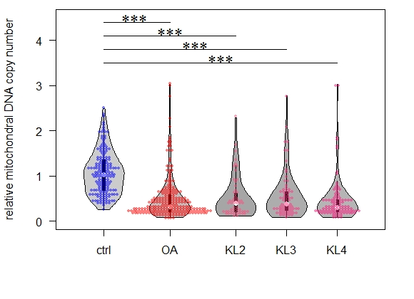
Figure 1. Relative mtDNA_{CN} of blood leukocytes in the control group, OA group and OA KL grade. Relative mtDNA_{CN} of blood leukocytes of the OA group was lower than control group (P < 0.0001); leukocyte mtDNA_{CN} of KL grade 2, 3 or 4 was lower than that of control group also (P < 0.0001, respectively). Two samples Wilcoxon test (also known as Mann-Whitney test) was used to estimate P value. Relative mtDNA_{CN} of blood leukocytes was not different among KL 2, 3 and 4 in OA group (P > 0.05). Kruskal-Wallis rank sum test was used to estimate P value. *** P < 0.001, * P < 0.05

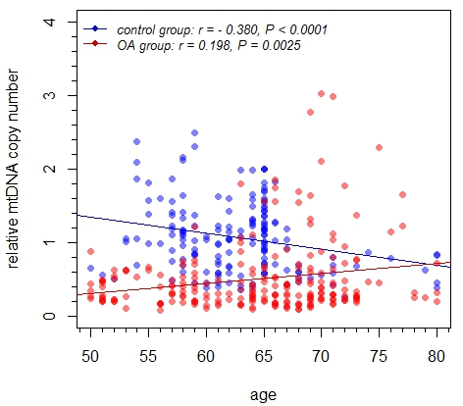
Figure 2. The correlation analysis for control group and OA group. The mtDNA_{CN} was negatively associated with age in control group (blue plots and regression line), but positive association was found in OA group (red plots and regression line). The linear correlation was estimated by Spearman method.

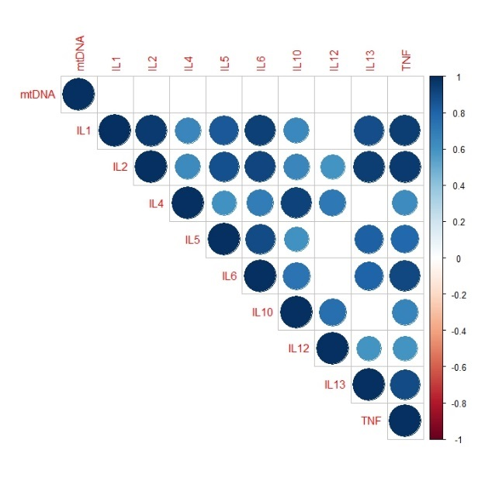  A | 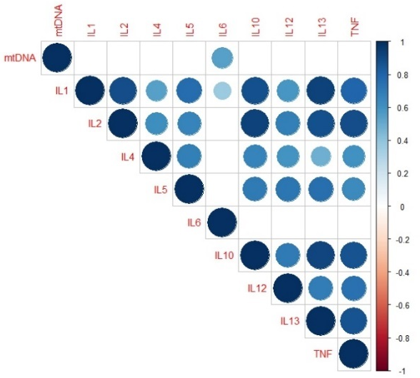  B
Figure 3. The correlational matrix of mtDNA_{CN} and 9 inflammatory cytokines (IL-1β, IL-2, IL-4, IL-5, IL-6, IL-10, IL-12p70, IL-13 and TNF-α). A gradient legend represented coefficient of correlation r value from +1 to -1 which were colored from dark blue to dark red. Appeared circles meant their correlation was significant (P < 0.05), oppositely, blank squares meant no significance (P > 0.05). All coefficients were computed by Spearman rho rank correlation for possible pairs of variables in matrix. The correlogram of control group shown in (A) and OA group in (B).

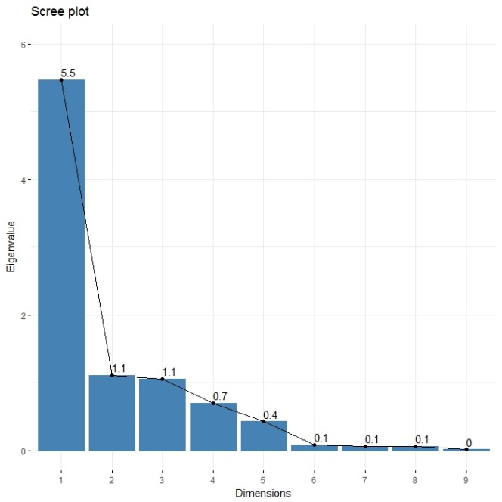
Figure 4. Scree plot of inflammatory cytokines. The eigenvalue of dimension 1, 2 and 3 were over than 1.

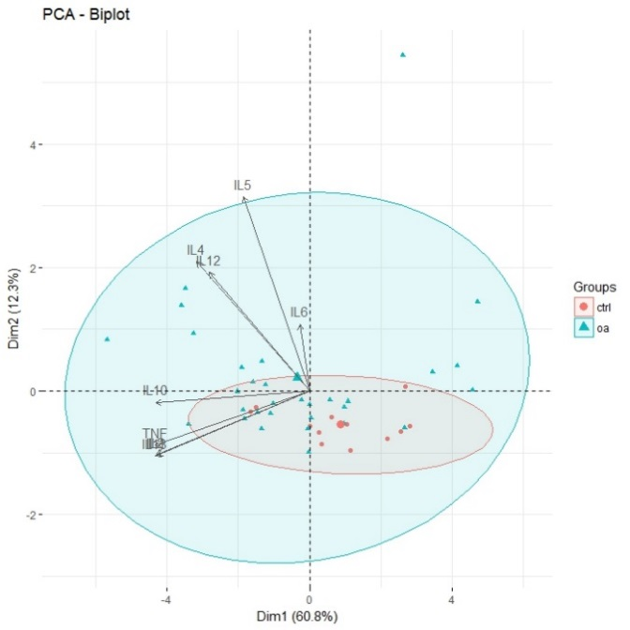  A | 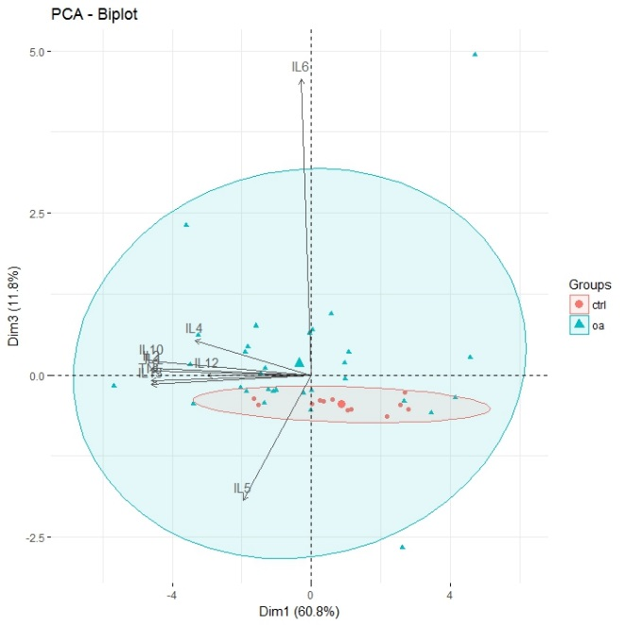  B
Figure 5. Biplots show cytokines coefficient with positive or negative effect in dimensional 1, 2 and 3. Participants component scores were plotted against each other and group-dependent clusters: the PCA biplot for dimensional 1 versus 2 in (A) and dimensional 1 versus 3 in (B).
Tables

Table 1. Basic characteristics of healthy controls and primary knee OA groups
 |  | Control group | OA group | P value
n |  | 169 | 204
Age (years) |  | 62.69 ± 0.42 | 63.70 ± 0.52 | 0.132
Female/Male (%) |  | 111 / 58 | 168 / 36 | < 0.001
BMI (kg/m²) |  | 25.12 ± 0.34 | 27.09 ± 0.26 | < 0.001
KL grading | 2 |  | 50
 | 3 |  | 64
 | 4 |  | 90

Table 2. Description of ten inflammatory cytokine and statistical analysis between control group and knee OA group.
Cytokine  (pg/mL) | Control group |  | OA group |  | 95 % CI |  | P value
IL-1β | 20.550±1.666 |  | 23.354±1.724 |  | -8.802, 3.195 |  | 0.351
IL-2 | 115.492±9.592 |  | 138.937±9.358 |  | -56.257, 9.367 |  | 0.157
IL-4 | 2.087±0.408 |  | 4.072±0.378 |  | -2.840, -0.530 |  | 0.003
IL-5 | 117.155±8.996 |  | 148.521±15.710 |  | -49.800, 4.820 |  | 0.088
IL-6 | 156.740±12.953 |  | 437.826±77.224 |  | -328.160, -73.660 |  | <0.001
IL-10 | 131.324±10.341 |  | 157.557±12.856 |  | -59.633, 7.167 |  | 0.120
IL-12p70 | 2.817±0.501 |  | 6.173±1.249 |  | -4.870, 0.240 |  | 0.155
IL-13 | 24.658±2.025 |  | 27.539±2.032 |  | -9.981, 4.217 |  | 0.417
IFN-γ | NA |  | 5.385±1.061 ª |  | NA |  | NA
TNF-α | 8.578±0.788 |  | 9.576±0.759 |  | -9.981, 4.217 |  | 0.454
a, just 4 knee OA patients IFN-γ were detectable

Table 3. The summary of principle component analysis in dimensional 1, 2 and 3
Dimension |  |  | 1 | 2 | 3
Eigen-value |  |  | 5.47 | 1.11 | 1.06
Explained Proportion |  |  | 60.8% | 12.3% | 11.7%
Scoring Coefficients | IL-1β |  | 0.93 | -0.23 | 0.01
 | IL-2 |  | 0.94 | -0.23 | 0.02
 | IL-4 |  | 0.69 | 0.46 | 0.11
 | IL-5 |  | 0.40 | 0.69 | -0.40
 | IL-6 |  | 0.06 | 0.24 | 0.94
 | IL-10 |  | 0.94 | -0.04 | 0.04
 | IL-12p70 |  | 0.62 | 0.42 | 0.00
 | IL-13 |  | 0.95 | -0.23 | -0.03
 | TNF-α |  | 0.95 | -0.19 | -0.02
Comparison in 3 major dimensions | Control group |  | 0.876±0.437 | -0.545±0.061 | -0.453±0.029
 | OA group |  | -0.339±0.454 | 0.283±0.209 | 0.175±0.210
 | P value |  | 0.128 | 0.0007 | < 0.0001
Correlation with standardized mtDNA_{CN} | Control group | r | 0.004 | 0.008 | -0.280
 |  | P value | 0.9893 | 0.9936 | 0.5272
 | OA group | r | -0.086 | -0.5767 | 0.1657
 |  | P value | 0.6439 | 0.0006843 | 0.373

Supplementary
Table S1 Logistic regression analysis of various factors for knee OA
factor | coefficient | OR | 95% CI | Wald χ² value | P value | assign
gender | -13.1989 | 7.2983×10⁻¹⁷ | 0~+∞ | -0.08 | 0.9364 | M=0, F=1
age | -0.1246 | 0.7872 | 0~+∞ | -0.01 | 0.9910 | —
bmi | 1.8872 | 0.0170 | 0~+∞ | 0.35 | 0.7273 | —
mtDNA_{CN} | -0.6751 | 0.1915 | 0~+∞ | 0.13 | 0.9005 | —
IL1 | 0.7042 | 5.7800 | 0~+∞ | 0.03 | 0.9757 | —
IL2 | -0.7252 | 0.1961 | 0~+∞ | -0.02 | 0.9850 | —
IL4 | 2.3774 | 0.0461 | 0~+∞ | 0.15 | 0.8826 | —
IL5 | -1.5147 | 0.0273 | 0~+∞ | -0.07 | 0.9460 | —
IL6 | 2.1920 | 0.0327 | 0~+∞ | 0.32 | 0.7520 | —
IL10 | 1.2924 | 0.3542 | 0~+∞ | 0.15 | 0.8840 | —
IL12 | 0.8229 | 9.3336 | 0~+∞ | 0.05 | 0.9574 | —
IL13 | 3.2434 | 0.0045 | 0~+∞ | 0.10 | 0.9235 | —
TNF | -4.5830 | 3.8350×10⁻⁶ | 0~+∞ | -0.25 | 0.8035 | —

Table S2 Logistic regression analysis adjust by gender for knee OA
factor | coefficient | OR | 95% CI | Wald χ² value | P value
mtDNA_{CN} | -0.3275 | 1.0790×10⁻¹⁷ | 0~+∞ | -1.70 | 0.0887
IL1 | 0.0317 | 1.3126×10¹² | 0~+∞ | 0.11 | 0.9132
IL2 | 0.1524 | 5.4054×10²⁷ | 0~+∞ | 0.40 | 0.6856
IL4 | 0.4025 | 1.5432×10⁶ | 0~+∞ | 1.46 | 0.1441
IL5 | -0.1480 | 1.2615×10⁻¹³ | 0~+∞ | -0.82 | 0.4129
IL6 | 0.3696 | 1.0530×10⁵⁵ | 0~+∞ | 1.88 | 0.0607
IL10 | -0.2772 | 1.0078×10⁵ | 0~+∞ | -0.93 | 0.3523
IL12 | -0.0650 | 8.5079×10¹⁵ | 0~+∞ | -0.29 | 0.7700
IL13 | 0.0558 | 2.4130×10⁻⁴ | 0~+∞ | 0.18 | 0.8574
TNF | 0.0372 | 1.7249×10⁻⁶⁰ | 0~+∞ | 1.13 | 0.2565

Table S3 Logistic regression analysis adjust by age for knee OA
factor | coefficient | OR | 95% CI | Wald χ² value | P value
mtDNA_{CN} | -0.1741 | 1.8268 | 0~+∞ | -1.28 | 0.2010
IL1 | 0.3062 | 3.6702×10¹³ | 0~+∞ | 0.83 | 0.4039
IL2 | 0.2630 | 0.0919 | 0~+∞ | 0.59 | 0.5548
IL4 | 0.3074 | 3.2890×10⁶ | 0~+∞ | 1.09 | 0.2777
IL5 | -0.2350 | 5.5506×10⁻¹⁰ | 0~+∞ | -0.99 | 0.3210
IL6 | 0.3353 | 1.4877×10¹³ | 0~+∞ | 1.78 | 0.0755
IL10 | -0.2245 | 1,5740×10⁻⁴ | 0~+∞ | -1.00 | 0.3194
IL12 | 0.0320 | 7.2553×10⁶ | 0~+∞ | 0.13 | 0.8967
IL13 | -0.3141 | 0.1142 | 0~+∞ | -0.78 | 0.4353
TNF | 0.0411 | 7,180 | 0~+∞ | 1.17 | 0.2416

Table S4 Logistic regression analysis adjust by BMI for knee OA

factor | coefficient | OR | 95% CI | Wald χ² value | P value
mtDNA_{CN} | -0.2492 | 0.0631 | 0~+∞ | -1.52 | 0.1276
IL1 | -0.2306 | 0.1225 | 0~+∞ | -0.56 | 0.5749
IL2 | -0.8372 | 1.5978×10⁻⁴ | 0~+∞ | -0.75 | 0.4544
IL4 | 0.5691 | 3.3800×10³ | 0~+∞ | 1.10 | 0.2725
IL5 | -0.3279 | 0.0540 | 0~+∞ | -1.02 | 0.3098
IL6 | 0.4477 | 0.0280 | 0~+∞ | 1.56 | 0.1185
IL10 | 0.2016 | 0.4642 | 0~+∞ | 0.49 | 0.6259
IL12 | -0.0285 | 0.7817 | 0~+∞ | -0.12 | 0.9039
IL13 | 0.891 | 3.8212×10⁶ | 0~+∞ | 0.83 | 0.4047
TNF | 0.0404 | 5.1331×10⁻⁶ | 0~+∞ | 1.11 | 0.2658

