Rivaroxaban vs. Dabigatran or warfarin in ‘real-world’ studies of stroke prevention in atrial fibrillation: Systematic review and meta-analysis

Ying Bai, PhD ^{a,b} , Hai Deng, PhD^{a,c}, Alena Shantsila, PhDª, Gregory Y H Lip, MD, FRCP ^{a,d}

ª University of Birmingham, Institute of Cardiovascular Sciences, City Hospital, Birmingham B18 7QH, United Kingdom;
^{b} Cardiovascular Center, Beijing Tongren Hospital, Capital Medical University, Beijing, China;
^{c} Guangdong Cardiovascular Institute, Guangdong General Hospital, Guangdong Academy of Medical Science, Guangzhou, China;
^{d}Aalborg Thrombosis Research Unit, Department of Clinical Medicine, Aalborg University, Aalborg, Denmark.

Corresponding author:

Professor GYH Lip
University of Birmingham Institute of Cardiovascular Sciences, City Hospital, Birmingham B18 7QH, United Kingdom
Tel: +44 121 507 5080; Fax: +44 121 507 5503; E-mail: g.y.h.lip@bham.ac.uk
Number of tables 2, Number of figures 4.

Key words atrial fibrillation; rivaroxaban; dabigatran; warfarin; real-world data

Abstract
Background and Purpose: This study was designed to evaluate the effectiveness and safety of rivaroxaban in real-world practice compared with dabigatran or with warfarin for stroke prevention in atrial fibrillation (AF) through meta-analyzing observational studies.
Methods 17 studies were included after searching in PubMed for studies reporting the comparative effectiveness and safety of rivaroxaban vs. dabigatran(n=3), rivaroxaban vs. warfarin(n=11) or both(n=3) for stroke prevention in AF.
Results: Overall, the risks of stroke/systematic thromboembolism (TE) with rivaroxaban were similar compared with dabigatran [Stroke/TE:(1.02, 0.91-1.13, I²=70.2%, N=5)], but were significantly reduced when compared to warfarin (0.75,0.64-0.85, I²=45.1%, N=9). Major bleeding risk was significantly higher with rivaroxaban than dabigatran (1.38, 1.27-1.49, I²=26.1%, N=5), but similar to warfarin (0.99, 0.91-1.07, I²=0.0%, N=6). Rivaroxaban was associated with increased all-cause mortality and gastrointestinal bleeding (GIB), but similar risk of acute myocardial infarction (AMI) and intracranial hemorrhage (ICH) compared with dabigatran. When compared with warfarin, rivaroxaban was associated with similar risk of any bleeding, mortality and AMI, but a higher risk of GIB and lower risk of ICH.
Conclusions: In this systematic review and meta-analysis, rivaroxaban was as effective as dabigatran, but was more effective than warfarin for the prevention of Stroke/TE in AF patients. Major bleeding risk was significantly higher with rivaroxaban than dabigatran, as was all-cause mortality and GIB. Rivaroxaban was comparable to warfarin for major bleeding, with an increased risk in GIB and decreased risk of ICH.
Introduction

The use of oral anticoagulants (OACs) such as the Vitamin K antagonists (VKA, eg. warfarin) in patients with atrial fibrillation (AF) results in a significant reduction in stroke, ischemic stroke (IS) and systematic thromboembolism (TE), as well as all-cause mortality, when compared to placebo or control.¹ However, warfarin has many limitations, including the necessity for regular anticoagulation monitoring, dietary and drug interactions, and the potential for serious bleeding if anticoagulation is poorly controlled, as reflected by a poor time in therapeutic range (TTR).²

The availability of the non-vitamin K antagonist oral anticoagulants (NOACs) have changed the landscape for stroke prevention in AF, and a meta-analysis of randomized clinical trials (RCTs) by Ruff et al ³ has shown that usual dose NOACs result in a significant reduction in stroke/TE and mortality with NOACs compared to warfarin, with a trend towards less major bleeding and significantly lower intracranial hemorrhage (ICH). However, RCTs have specific inclusion/exclusion criteria, set protocol-based follow-up and perhaps represent a highly selected and controlled scenario, but still represent the gold standard of testing the effectiveness and safety of an intervention. Based on RCT data, indirect comparisons have been published showing how the different NOACs may perform relative to each other ^{4, 5} but only a head-to-head RCT can definitively assess the relative efficacy and safety of one NOAC against another.

When a drug is licensed and used in everyday clinical practice, these drugs are then used in a broad patient population beyond the RCTs.⁶ Since the publication of the RCT data and regulatory approval of these drugs (rivaroxaban and dabigatran), numerous real world observational cohorts showing the comparative effectiveness and safety of the NOACs have been published.⁷⁻¹² Our objective was to perform a systematic review and meta-analysis of data on the effectiveness and safety of rivaroxaban in real-world practice compared with dabigatran or with warfarin for stroke prevention in AF.

Methods

We followed the preferred reporting items for systematic reviews and meta-analyses (PRISMA) and the reporting Meta-analyses of Observational Studies in Epidemiology (MOOSE) when performing this meta-analysis.^{13, 14}

Two independent reviewers (Y. B. and H. D.) conducted a search of Medline and the Cochrane Library using the following items “atrial fibrillation”, “AF”, “rivaroxaban”, “dabigatran”, “warfarin”, “real-world”, “observational studies” until 4 October, 2016, respectively. We also reviewed the lists of references in eligible studies and reviews. Disagreement was resolved by consensus.

To be included in the meta-analysis, the observational studies needed to fulfill the following criteria: (i) With OACs used for stroke prevention in patients with AF; (ii) Available quantitative data on clinical events; (iii) Adjusted hazard ratios (HRs) between rivaroxaban vs. dabigatran, or rivaroxaban vs. warfarin for stroke prevention in AF. The following studies were excluded:
- Animal based studies;
- Non-English based papers;
- Abstracts, editorials, case-reports, reviews and case series;
- Specific studies on AF patients undergoing ablation or cardioversion.
We recorded clinical events related to effectiveness outcomes as IS, TE, the combination of Stroke and TE (Stroke/TE), and acute myocardial infarction (AMI) of rivaroxaban in comparison with dabigatran or warfarin. Separate IS, hemorrhagic stroke, stroke or TE outcomes were used instead if no data on Stroke/TE was available in the original papers. Safety outcomes were major bleeding, any bleeding, ICH, gastrointestinal bleeding (GIB) or all-cause mortality. Definitions of these effectiveness and safety outcomes were extracted from the original papers. If available, other collected study characteristics included: authors, publication year, study country, period, cohort size, percentage of low-dose rivaroxaban, percentage of low-dose dabigatran, new-users or switchers of NOACs and estimated follow-up duration. Quality score for each study was assessed by the Newcastle-Ottawa scale.¹⁵

Statistical analysis
The analysis was conducted using STATA, version 12.0 (Stata Corp.). Event rate of various outcomes were evaluated using count of events/person-years of observation. Adjusted HRs with 95% confidence intervals (95% CI) was used to measure the effect sizes in our study. First we used a fixed model, and then a random effects model if there was heterogeneity according to I² index .¹⁶ Values of ≤25%, 25-50%, and ≥50% were defined as low, moderate and high degrees of heterogeneity, respectively. Begg’s correlation test and Egger’s regression test were used to assess publication bias.¹⁷⁻¹⁹ Sensitivity analyses were performed in dose-categorized comparisons of NOACs and ‘new user/switcher’ settings. P<0.05 was taken as statistically significant.

Results

A total of 1086 studies were initially identified (including 829 on-line and 257 from references). After screening titles and abstracts, we excluded 1007 papers and 79 remained for a detailed evaluation. Of these studies, 62 were excluded as they did not meet the inclusion criteria (6 were reviews and meta-analysis; 25 studies on OACs in specific AF populations, such as ablation or cardioversion were excluded due to their modest size and short period of follow-up (less than 30 days). Also, 12 papers lacked outcome data in AF patients. Comparison of separate data for rivaroxaban with warfarin could not be extracted from 2 papers; adjusted HRs between OACs comparisons were lacking in 16; and no separate AF data could be extracted from 1 paper with mixed disease states. Finally, 17 observational studies^{7-12, 20-31} were included in our analysis, with 3 comparing rivaroxaban vs. dabigatran⁹⁻¹¹, 11 comparing rivaroxaban vs. warfarin^{20-27, 29-31} and 3 evaluating both comparisons^{7, 8, 12}. Studies with new users and switchers are shown in Supplementary Table I. Quality scoring revealed moderate-to-high scores of the included studies. The selection process and baseline characteristics of included studies are summarized in Supplementary Figure I and Tables 1 and 2. Anticipated outcomes evaluated are summarized in Supplementary Table II. The endpoints in various comparison settings are shown in Supplementary Table III.

Comparisons between Rivaroxaban and Dabigatran
Rivaroxaban was associated with a similar risk of Stroke/TE compared with dabigatran,⁷⁻¹¹(HR: 1.02, 95% CI: 0.91-1.13, I²=70.2%, N=5) (Figure 1), with pooled rates for rivaroxaban being 0.3%/year vs. dabigatran 0.3%/year. No significant publication bias was seen among the included studies using Begg’s test (p=0.21) and Egger’s test (p=0.25). Subanalysis was performed through pooling 3 studies evaluating the IS risk between rivaroxaban and dabigatran⁹⁻¹¹, which was non-significantly different, (HR: 0.98, 95% CI: 0.88-1.08, I²=46.0%, p=0.12), (Supplementary Figure II), with pooled rates for rivaroxaban being 0.57%/year vs. dabigatran 0.54%/year. No significant publication bias was seen among the included studies using Begg’s test (p=0.46) and Egger’s test (p=0.08) .

The pooled rate of major bleeding was 1.45%/year for rivaroxaban and 0.55%/year for dabigatran. Major bleeding risk was significantly higher with rivaroxaban than dabigatran after pooling the five studies.^{7, 9-12} (HR: 1.38, 95% CI: 1.27-1.49, I²=26.1%, N=5) (Figure 2). No significant publication bias was seen among the included studies using Begg’s test (p=0.76) and Egger’s test (p=0.39).

Rivaroxaban was associated with increased risk in all-cause mortality⁷⁻¹⁰ (HR: 1.23, 95% CI: 1.12-1.33, I²=31.5%, N=4), any bleeding⁸⁻¹⁰ (HR:1.33, 95% CI:1.17-1.49, I²=74.8%, N=3) and GIB^{7, 9, 10} (HR: 1.33, 95% CI: 1.18-1.48, I²=58.3%, N=3), but similar risk of AMI^{7, 9} (HR: 0.81, 95% CI: 0.43-1.19, I²=0.0%,N=2) and ICH^{7, 9-11} (HR: 1.22, 95% CI: 0.85-1.59, I²=64.5%,N=4) when compared with dabigatran.

Comparisons between Rivaroxaban and Warfarin
The pooled annual rate of Stroke/SE was 2.57%/year for rivaroxaban and 2.86%/year for warfarin in AF patients. (HR: 0.75, 95% CI: 0.64-0.85, I²=45.1%, N=9).^{7, 8, 21, 22, 25, 26, 29-31} (Figure 3). Subgroup analysis was performed through meta-analyzing 6 observational studies evaluating IS risk between rivaroxaban and warfarin^{20, 22, 25, 26, 30, 31}, and rivaroxaban was associated with lower risk of IS (HR: 0.86, 95% CI: 0.75-0.97, I²=0.0%, N=6) (Supplementary Figure III). No publication bias was seen according to Begg’s test (IS: p=1.0; Stroke/SE: p=0.37) and Egger’s test (IS: p= 0.87; Stroke/SE: p=0.1).

The pooled rate of major bleeding was 3.70%/year for rivaroxaban and 3.73%/year for warfarin, based on meta-analysis of 6 studies (HR:0.99, 95% CI: 0.91-1.07, I²=0.0%, N= 6).^{7, 12, 24-26, 30} (Figure 4) No publication bias were seen in this study according to Begg’s test (p=0.26) and Egger’s test (p=0.22).

Rivaroxaban was associated with similar risk of any bleeding (HR:1.01, 95% CI: 0.94-1.08, I²=0.0%, N=5)^{8, 21, 24, 26, 29}, AMI (HR: 0.73, 95% CI: 0.30-1.15, I²=0.0%, N=2)^{7, 21} and all-cause mortality (HR: 1.04, 95% CI: 0.64-1.44, I²=92.7%, N=3) ^{7, 8, 26} compared with warfarin. The risk of ICH was significantly lower (HR: 0.54, 95% CI: 0.43-0.64, I²=63.6%, N=6)^{7, 22, 24-26, 30}, but risk of GIB was significantly higher (HR: 1.2, 95% CI: 1.07-1.33, I²=27.5%, N=5)^{7, 20, 24, 25, 30} with rivaroxaban compared to warfarin.

Sensitivity Analysis
The results were consistent among studies for both low-dose and high-dose rivaroxaban vs. dabigatran comparisons on the clinical outcomes, except for the endpoint of AMI, where studies did not report on low-dose rivaroxaban vs. dabigatran comparisons (Supplementary Figure IV).

The risk of Stroke/TE was similar (1.08, 0.95-1.21, I²=70.7%, N=4)⁷⁻¹⁰ when we conducted sensitivity analysis including studies with NOAC (Rivaroxaban vs. Dabigatran) new-users. When sensitivity analysis was performed for new-users of rivaroxaban vs. warfarin, there was general consistency with the summary comparisons. Although new users of rivaroxaban showed significant reductions in IS (HR 0.85, 0.72-0.97), Stroke/TE (0.78, 0.69-0.87) and ICH (-0.64,0.51-0.77). No significant difference in major bleeding, any bleeding, mortality and GIB was evident amongst new users (Supplementary Figure V, Table I and Table III).

For other endpoints, the results were broadly similar with the summary analysis except for an increased risk of mortality in low-dose rivaroxaban and similar risk of IS in high-dose rivaroxaban, when compared with warfarin (Supplementary Figure VI).
To minimize any confusion, we also show numbers needed to treat and numbers needed to harm were calculated for the absolute effectiveness and safety comparison.

Discussion

This systematic review and meta-analysis using real-world observational studies has the following principal findings: (i) When compared to dabigatran, rivaroxaban had similar risks of IS, Stroke/TE, AMI and ICH, but increased risks of major bleeding, any bleeding and GIB; (ii) When compared with warfarin, rivaroxaban was associated with lower risks of IS, Stroke/TE and ICH, with an increased risk of GIB, and similar risks of major bleeding, any bleeding and mortality; and (iii) New users of rivaroxaban had superiority to warfarin for the prevention of IS and Stroke/TE and a lower risk of ICH, but similar risk of GIB.

Our results are partially discordant from previous indirect comparisons of R vs. D for the risk of Stroke/TE and major bleeding in AF patients.^{4, 5} The large randomized trials³² ³³ differed in inclusion criteria based on stroke risk profile. Bias could easily be produced with unadjusted confounding, which was considered but unresolved in previous indirect comparison analyses. In contrast, our included ‘real-world’ studies have used adjusted HRs and compared subjects with broadly similar stroke risks taking rivaroxaban or dabigatran during the same time period within each study.

Different percentages of patients received low-dose NOACs in the published real-world studies (eg. for low-dose rivaroxaban and dabigatran: nearly 90% in Hernandez et al,¹⁰ and about 30% in Chan et al⁷). However, there were generally consistent results between low-dose and high-dose rivaroxaban vs. dabigatran in most clinical outcomes.

Our findings provide an estimate of the various anticipated outcomes of rivaroxaban when used in everyday clinical practice when compared to warfarin. Rivaroxaban was a non-inferior alternative to warfarin in IS, Stroke/TE prevention. While the results were similar to the summary data, low-dose and high-dose rivaroxban vs. warfarin data were limited when the sensitivity analysis was done. Our results also provide some insights regarding whether to switch patients from warfarin to NOACs. Rivaroxaban new-users showed superior effectiveness to warfarin for IS and Stroke/TE prevention, but switchers showed similar risks. The exact reason(s) are unknown, but could be partly explained by the assumption of poor compliance for OACs in those switched from warfarin, because usually AF patients would be transferred to take rivaroxaban for poor TTR of warfarin. Importantly, our study reflects real-world clinical practice, given that patients included in ROCKET-AF had a higher stroke risk profile.³³

In safety evaluations, both ROCKET-AF³³ and our analysis have shown patients treated with rivaroxaban have increased GIB risk and decreased ICH risk compared to warfarin. An ancillary analysis of ROCKET-AF has ascribed the higher GIB to a history of GIB or older age.³⁴ Our results could partially provide supportive evidence for this hypothesis, as new rivaroxaban users had a similar risk of GIB compared with warfarin users, with GIB risk evaluated using HRs adjusted for age and bleeding history, within the included studies.^{20, 24} ICH is the most feared complication for OACs and consistent with trial data, we show that rivaroxaban users had significantly less ICH compared to warfarin.

Limitations and Strengths
To our knowledge, this is the first meta-analysis of the head-to-head comparison among NOACs. There are several limitations inherent to the interpretation of these results. First, only studies in English were included for the analysis which increased the potential language bias. However, a tendency towards publication in English journals minimized this effect.³⁵ Second, high heterogeneity across studies in Stroke/TE should not be neglected, though a random-effects model was used for adjustment. Nonetheless, results were broadly similar even if sensitivity analysis (eg. new-users or different dose prescription) and subgroup analysis in IS, which decreased the heterogeneity, were performed. Third, different inclusion/exclusion criteria and follow-up periods in the included studies led to high heterogeneity, so it is necessary to cautiously interpret the noticeable differences in some event rates between the rivaroxaban vs. dabigatran cohort, and rivaroxaban vs. warfarin comparisons (eg. Stroke /TE rate 0.3%/year in the former vs. 2.8%/year in the latter; major bleeding was 1.45%/year in the former vs. 3.89%/year in the latter). To provide some perspective, we also show numbers needed to treat and numbers needed to harm for the absolute effectiveness and safety comparisons in Supplementary Table IV. Fourth, inherent limitations in the majority of meta-analysis, such as lack of access to raw data and the variety in definitions of outcomes in the included studies are unavoidable. However, we have enhanced the robustness of the analysis through extracting the effect sizes with adjusted HRs from the original studies. Indeed, low heterogeneity in the safety evaluations enhances the clinical applicability of our observations. No publication bias and the moderate-to-high quality scores according to Newcastle-Ottawa scale both increase the reliability of the pooled estimate. Finally, the analysis covers the whole population of AF patients and no separate outcome information could be extracted for some subgroups, eg. patients with TIA or prior stroke.
Conclusions
In this systematic review and meta-analysis, rivaroxaban was as effective as dabigatran for the prevention of IS and Stroke/TE, but was more effective than warfarin for stroke prevention in AF patients. Major bleeding risk was significantly higher with rivaroxaban than dabigatran, as was all-cause mortality and GIB. Rivaroxaban was comparable to warfarin for major bleeding, with an increased risk in GIB and decreased risk of ICH.
Hence, the risks and benefits of rivaroxaban use should be carefully accounted for, especially the individual’s risk of GIB. Based on the real-world evidence up to date, rivaroxaban was not superior to dabigatran for stroke prevention in AF patients, but had more bleeding risks.

Sources of Funding: None. This work was conducted independent of any industry collaboration or sponsorship.
Conflicts of Interest/Disclosures: GYHL has served as a consultant for Bayer/Janssen, BMS/Pfizer, Biotronik, Medtronic, Boehringer Ingelheim, Microlife and Daiichi-Sankyo. Speaker for Bayer, BMS/Pfizer, Medtronic, Boehringer Ingelheim, Microlife, Roche and Daiichi-Sankyo. Other authors: None declared
References
1. Hart RG, Pearce LA, Aguilar MI. Adjusted-dose warfarin versus aspirin for preventing stroke in patients with atrial fibrillation. Annals of internal medicine. 2007;147:590-592
2. Wan Y, Heneghan C, Perera R, Roberts N, Hollowell J, Glasziou P, et al. Anticoagulation control and prediction of adverse events in patients with atrial fibrillation: A systematic review. Circulation. Cardiovascular quality and outcomes. 2008;1:84-91
3. Ruff CT, Giugliano RP, Braunwald E, Hoffman EB, Deenadayalu N, Ezekowitz MD, et al. Comparison of the efficacy and safety of new oral anticoagulants with warfarin in patients with atrial fibrillation: A meta-analysis of randomised trials. Lancet. 2014;383:955-962
4. Skjoth F, Larsen TB, Rasmussen LH, Lip GY. Efficacy and safety of edoxaban in comparison with dabigatran, rivaroxaban and apixaban for stroke prevention in atrial fibrillation. An indirect comparison analysis. Thrombosis and haemostasis. 2014;111:981-988
5. Lip GY, Larsen TB, Skjoth F, Rasmussen LH. Indirect comparisons of new oral anticoagulant drugs for efficacy and safety when used for stroke prevention in atrial fibrillation. J Am Coll Cardiol. 2012;60:738-746
6. Freedman B, Potpara TS, Lip GY. Stroke prevention in atrial fibrillation. Lancet. 2016;388:806-817
7. Chan YH, Kuo CT, Yeh YH, Chang SH, Wu LS, Lee HF, et al. Thromboembolic, bleeding, and mortality risks of rivaroxaban and dabigatran in asians with nonvalvular atrial fibrillation. J Am Coll Cardiol. 2016;68:1389-1401
8. Gorst-Rasmussen A, Lip GY, Bjerregaard Larsen T. Rivaroxaban versus warfarin and dabigatran in atrial fibrillation: Comparative effectiveness and safety in danish routine care. Pharmacoepidemiol Drug Saf. 2016;25:1236-1244
9. Graham DJ, Reichman ME, Wernecke M, Hsueh YH, Izem R, Southworth MR, et al. Stroke, bleeding, and mortality risks in elderly medicare beneficiaries treated with dabigatran or rivaroxaban for nonvalvular atrial fibrillation. JAMA internal medicine. 2016;176:1662-1671
10. Hernandez I, Zhang Y. Comparing stroke and bleeding with rivaroxaban and dabigatran in atrial fibrillation: Analysis of the us medicare part d data. American journal of cardiovascular drugs : drugs, devices, and other interventions. 2017;17:37-47
11. Noseworthy P, Yao X, Sangaralingham LR, Abraham N, McBane R, Gersh B, et al. Direct comparison of dabigatran, rivaroxaban, and apixaban for effectiveness and safety in nonvalvular atrial fibrillation. Journal of the American College of Cardiology. 2016;67:692-692
12. Lip GY, Keshishian A, Kamble S, Pan X, Mardekian J, Horblyuk R, et al. Real-world comparison of major bleeding risk among non-valvular atrial fibrillation patients initiated on apixaban, dabigatran, rivaroxaban, or warfarin. A propensity score matched analysis. Thrombosis and haemostasis. 2016;116:975-986
13. Moher D, Liberati A, Tetzlaff J, Altman DG, Group P. Preferred reporting items for systematic reviews and meta-analyses: The prisma statement. Int J Surg. 2010;8:336-341
14. Stroup DF, Berlin JA, Morton SC, Olkin I, Williamson GD, Rennie D, et al. Meta-analysis of observational studies in epidemiology: A proposal for reporting. Meta-analysis of observational studies in epidemiology (moose) group. JAMA. 2000;283:2008-2012
15. Wells G, Shea B, O'Connell D, Peterson J, Welch V, Losos M, et al. The newcastle-ottawa scale (nos) for assessing the quality of nonrandomised studies in meta-analyses.
16. Higgins JP, Thompson SG, Deeks JJ, Altman DG. Measuring inconsistency in meta-analyses. BMJ. 2003;327:557-560
17. Begg CB, Mazumdar M. Operating characteristics of a rank correlation test for publication bias. Biometrics. 1994;50:1088-1101
18. Egger M, Davey Smith G, Schneider M, Minder C. Bias in meta-analysis detected by a simple, graphical test. BMJ. 1997;315:629-634
19. Chen Y, Ling L, Su G, Han M, Fan X, Xun P, et al. Effect of intermittent versus chronic calorie restriction on tumor incidence: A systematic review and meta-analysis of animal studies. Sci Rep. 2016;6:33739
20. Abraham NS, Singh S, Alexander GC, Heien H, Haas LR, Crown W, et al. Comparative risk of gastrointestinal bleeding with dabigatran, rivaroxaban, and warfarin: Population based cohort study. BMJ. 2015;350:h1857
21. Bouillon K, Bertrand M, Maura G, Blotiere PO, Ricordeau P, Zureik M. Risk of bleeding and arterial thromboembolism in patients with non-valvular atrial fibrillation either maintained on a vitamin k antagonist or switched to a non-vitamin k-antagonist oral anticoagulant: A retrospective, matched-cohort study. The Lancet. Haematology. 2015;2:e150-159
22. Coleman CI, Antz M, Bowrin K, Evers T, Simard EP, Bonnemeier H, et al. Real-world evidence of stroke prevention in patients with nonvalvular atrial fibrillation in the united states: The revisit-us study. Curr Med Res Opin. 2016:1-7
23. Coleman CI, Antz M, Ehlken B, Evers T. Real-life evidence of stroke prevention in patients with atrial fibrillation--the relief study. Int J Cardiol. 2016;203:882-884
24. Halvorsen S, Ghanima W, Tvete IF, Hoxmark C, Falck P, Solli O, et al. A nationwide registry study to compare bleeding rates in patients with atrial fibrillation being prescribed oral anticoagulants. Eur Heart J Cardiovasc Pharmacother.2017;3:28-36
25. Laliberte F, Cloutier M, Nelson WW, Coleman CI, Pilon D, Olson WH, et al. Real-world comparative effectiveness and safety of rivaroxaban and warfarin in nonvalvular atrial fibrillation patients. Curr Med Res Opin. 2014;30:1317-1325
26. Larsen TB, Skjoth F, Nielsen PB, Kjaeldgaard JN, Lip GY. Comparative effectiveness and safety of non-vitamin k antagonist oral anticoagulants and warfarin in patients with atrial fibrillation: Propensity weighted nationwide cohort study. BMJ. 2016;353:i3189
27. Lip GY, Pan X, Kamble S, Kawabata H, Mardekian J, Masseria C, et al. Major bleeding risk among non-valvular atrial fibrillation patients initiated on apixaban, dabigatran, rivaroxaban or warfarin: A "real-world" observational study in the united states. Int J Clin Pract. 2016;70:752-763
28. Mantha S, Ansell J. An indirect comparison of dabigatran, rivaroxaban and apixaban for atrial fibrillation. Thrombosis and haemostasis. 2012;108:476-484
29. Maura G, Blotiere PO, Bouillon K, Billionnet C, Ricordeau P, Alla F, et al. Comparison of the short-term risk of bleeding and arterial thromboembolic events in nonvalvular atrial fibrillation patients newly treated with dabigatran or rivaroxaban versus vitamin k antagonists: A french nationwide propensity-matched cohort study. Circulation. 2015;132:1252-1260
30. Yao X, Abraham NS, Sangaralingham LR, Bellolio MF, McBane RD, Shah ND, et al. Effectiveness and safety of dabigatran, rivaroxaban, and apixaban versus warfarin in nonvalvular atrial fibrillation. J Am Heart Assoc. 2016;5:e003725.
31. Staerk L, Fosbol EL, Lip GY, Lamberts M, Bonde AN, Torp-Pedersen C, et al. Ischaemic and haemorrhagic stroke associated with non-vitamin k antagonist oral anticoagulants and warfarin use in patients with atrial fibrillation: A nationwide cohort study. Eur Heart J. 2016:ehw496
32. Connolly SJ, Ezekowitz MD, Yusuf S, Eikelboom J, Oldgren J, Parekh A, et al. Dabigatran versus warfarin in patients with atrial fibrillation. N Engl J Med. 2009;361:1139-1151
33. Patel MR, Mahaffey KW, Garg J, Pan G, Singer DE, Hacke W, et al. Rivaroxaban versus warfarin in nonvalvular atrial fibrillation. N Engl J Med. 2011;365:883-891
34. Eikelboom J, Merli G. Bleeding with direct oral anticoagulants vs warfarin: Clinical experience. Am J Med. 2016;129:S33-S40
35. Sterne JAC, Egger M, Moher D, eds. Addressing reporting biases.In: Handbook for systematic reviews of interventions version 5.1.0 (updated march 2011), eds higgins jpt, green s. The cochrane collaboration, 2011 [online]. 2011. Available at http://handbook.cochrane.org/chapter_10/10_2_2_4_language_bias.htm. Accessed December 20, 2016.

Table 1 Baseline characteristics in Rivaroxaban versus Dabigatran studies
Author, year | Region | Enrolled Period | Cohort size | LD-R(%) | LD-D(%) | eFollow-up
Chan,2016⁷ | Taiwan | Feb-Dec, 2013 | 9,837 | 87 | 90 | 1 y
Hernandez,2016¹⁰ | US | Nov, 2011-Dec, 2013 | 17,507 | 30.7 | 24.8 | 1 y
Graham,2016⁹ | US | Nov, 2011-Jun, 2014 | 118,891 | 0 | 0 | 0.3 y
Lip,2016¹² | US | Jan, 2012-Dec, 2014 | 46,803 | 19.6 | 10.6 | 0.5 y
Noseworthy,2016¹¹ | US | Oct, 2010- Feb, 2015 | 31,574 | 23.1 | 9.9 | NA
Gorst-Rasmussen, 2016⁸ | Denmark | Feb, 2012-Jul, 2014 | 113,13 | 32.3 | 40.3 | 1.08 y

HD-D, high-dose dabigatran; HD-R: high-dose rivaroxaban; LD-D, low-dose dabigatran; LD-R, low-dose rivaroxaban;
eFollow-up, estimated follow-up; y, years ;NA, not available.

Table 2 Baseline Characteristics in Rivaroxaban versus Warfarin studies
Author, year | Study design | Region | Enrolled period | Cohort size | LD-R(%) | eFollow-up
Bouillon, 2015²¹ | RC | France | Jan 2011-Nov 2012 | 17,410 | NA | 0.8y
Coleman, 2016²² | RC | US | Jan 2012-Oct 2014 | 38,831 | 17.3 | NA
Lip, 2016²⁷ | RC | US | Jan-Dec 2013 | 29,338 | NA | 0.3y
Abraham, 2016²⁰ | RC | US | Nov 2010-Sep 2013 | 219,027 | NA | NA
Maura G, 2015²⁹ | RC | France | Jul-Nov 2012; | 32,807 | 38.5 | 0.2y
Coleman, 2015²³ | RC | Germany | Jan 2012-Oct 2013 | 5,108 | NA | 0.5y
Halvorsen, 2016²⁴ | registry | Norway | Jan 2013-Jun 2015 | 32,675 | 27 | 0.5y
Chan YH, 2016⁷ | RC | Taiwan | Feb 2013-Dec 2013 | 304,252 | 87 | 1 y
Larsen, 2016²⁶ | RC | Denmark | Aug 2011-Oct 2015 | 61 ,678 | 0 | 1.9 y
Yao X, 2016³⁰ | RC | US | Oct 2010-Jun 2015 | 125,243 | 21.5 | 0.6 y
Laliberte, 2014²⁵ | RC | US | May 2011-July 2012 | 30,479 | NA | 0.3y
Lip, 2016¹² | RC | US | Jan 2012-Dec 2014 | 33262 | NA | 0.5y
Gorst-Rasmussen,  2016⁸ | registry | Denmark | Feb 2012-Jul 2014 | 22,358 | 32.3 | 1.08y
Staerk,2016³¹ | registry | Denmark | 2011-2015 | 43,299 | NA | 0.6y
Data were presented as mean or median; RC, retrospective cohort; NA, not available;
LD-R, low-dose rivaroxaban; HD-R, high-dose rivaroxaban; eFollow-up, estimated follow-up; y, years.
Figure Legends

Figure 1 Rivaroxaban compared with Dabigatran in risk of Stroke/TE in AF patients.
IS, ischemic stroke; TE, thromboembolism; LD,low-dose; HD, high-dose; BD, both-dose; AF, atrial fibrillation.

Figure 2 Rivaroxaban compared with Dabigatran in risk of major bleeding in AF patients.
AF, atrial fibrillation; ECH, extracranial hemorrhage.

Figure 3 Rivaroxaban compared with Warfarin in risk of Stroke/TE in AF patients.
IS, ischemic stroke; TE, thromboembolism; AF, atrial fibrillation.

Figure 4 Rivaroxaban compared with Warfarin in risk of major bleeding in AF patients.
AF, atrial fibrillation.
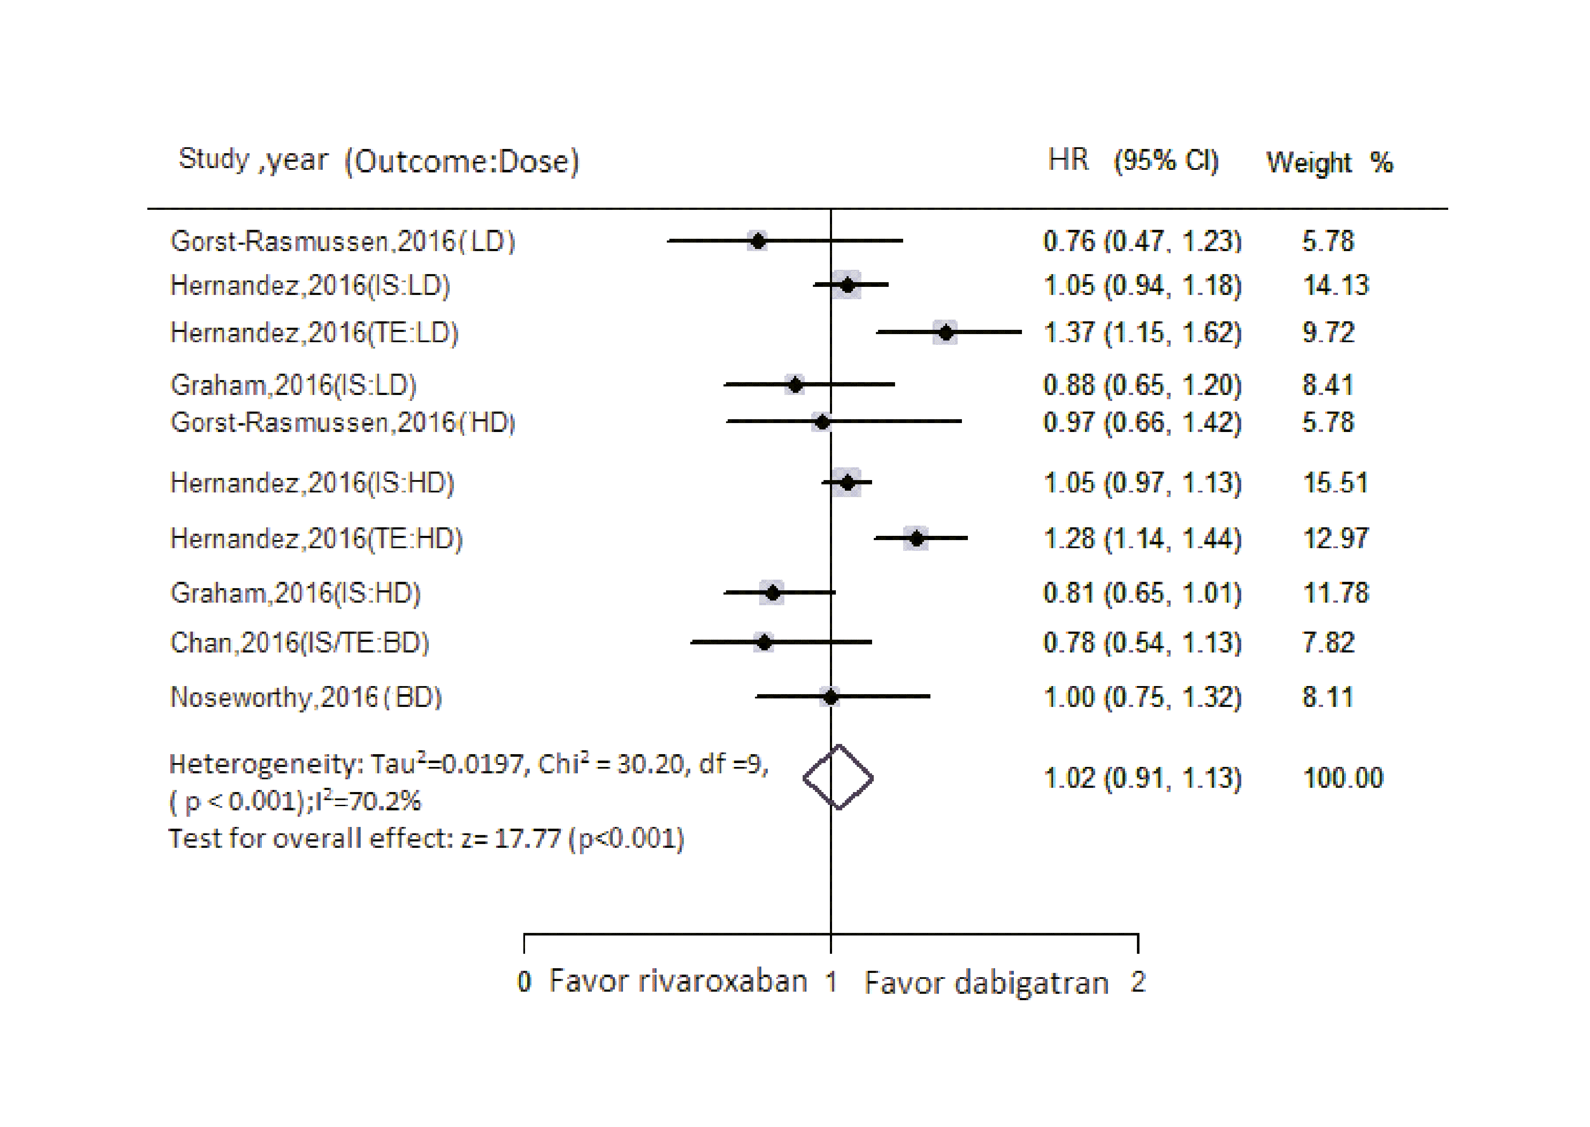
Figure 1.
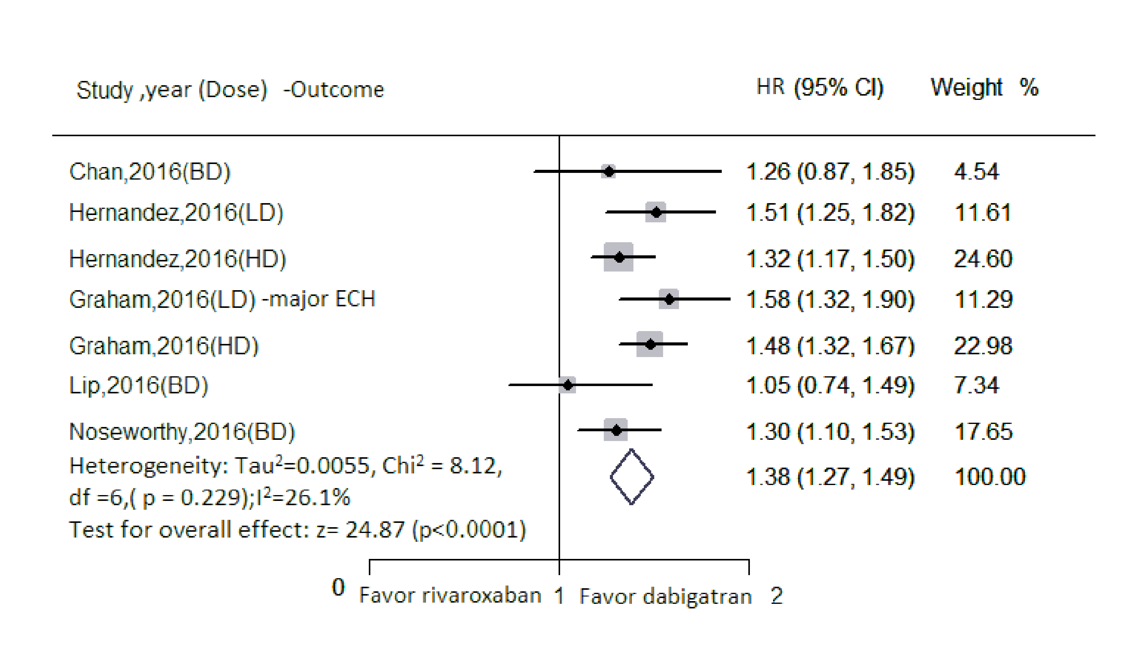
Figure 2.
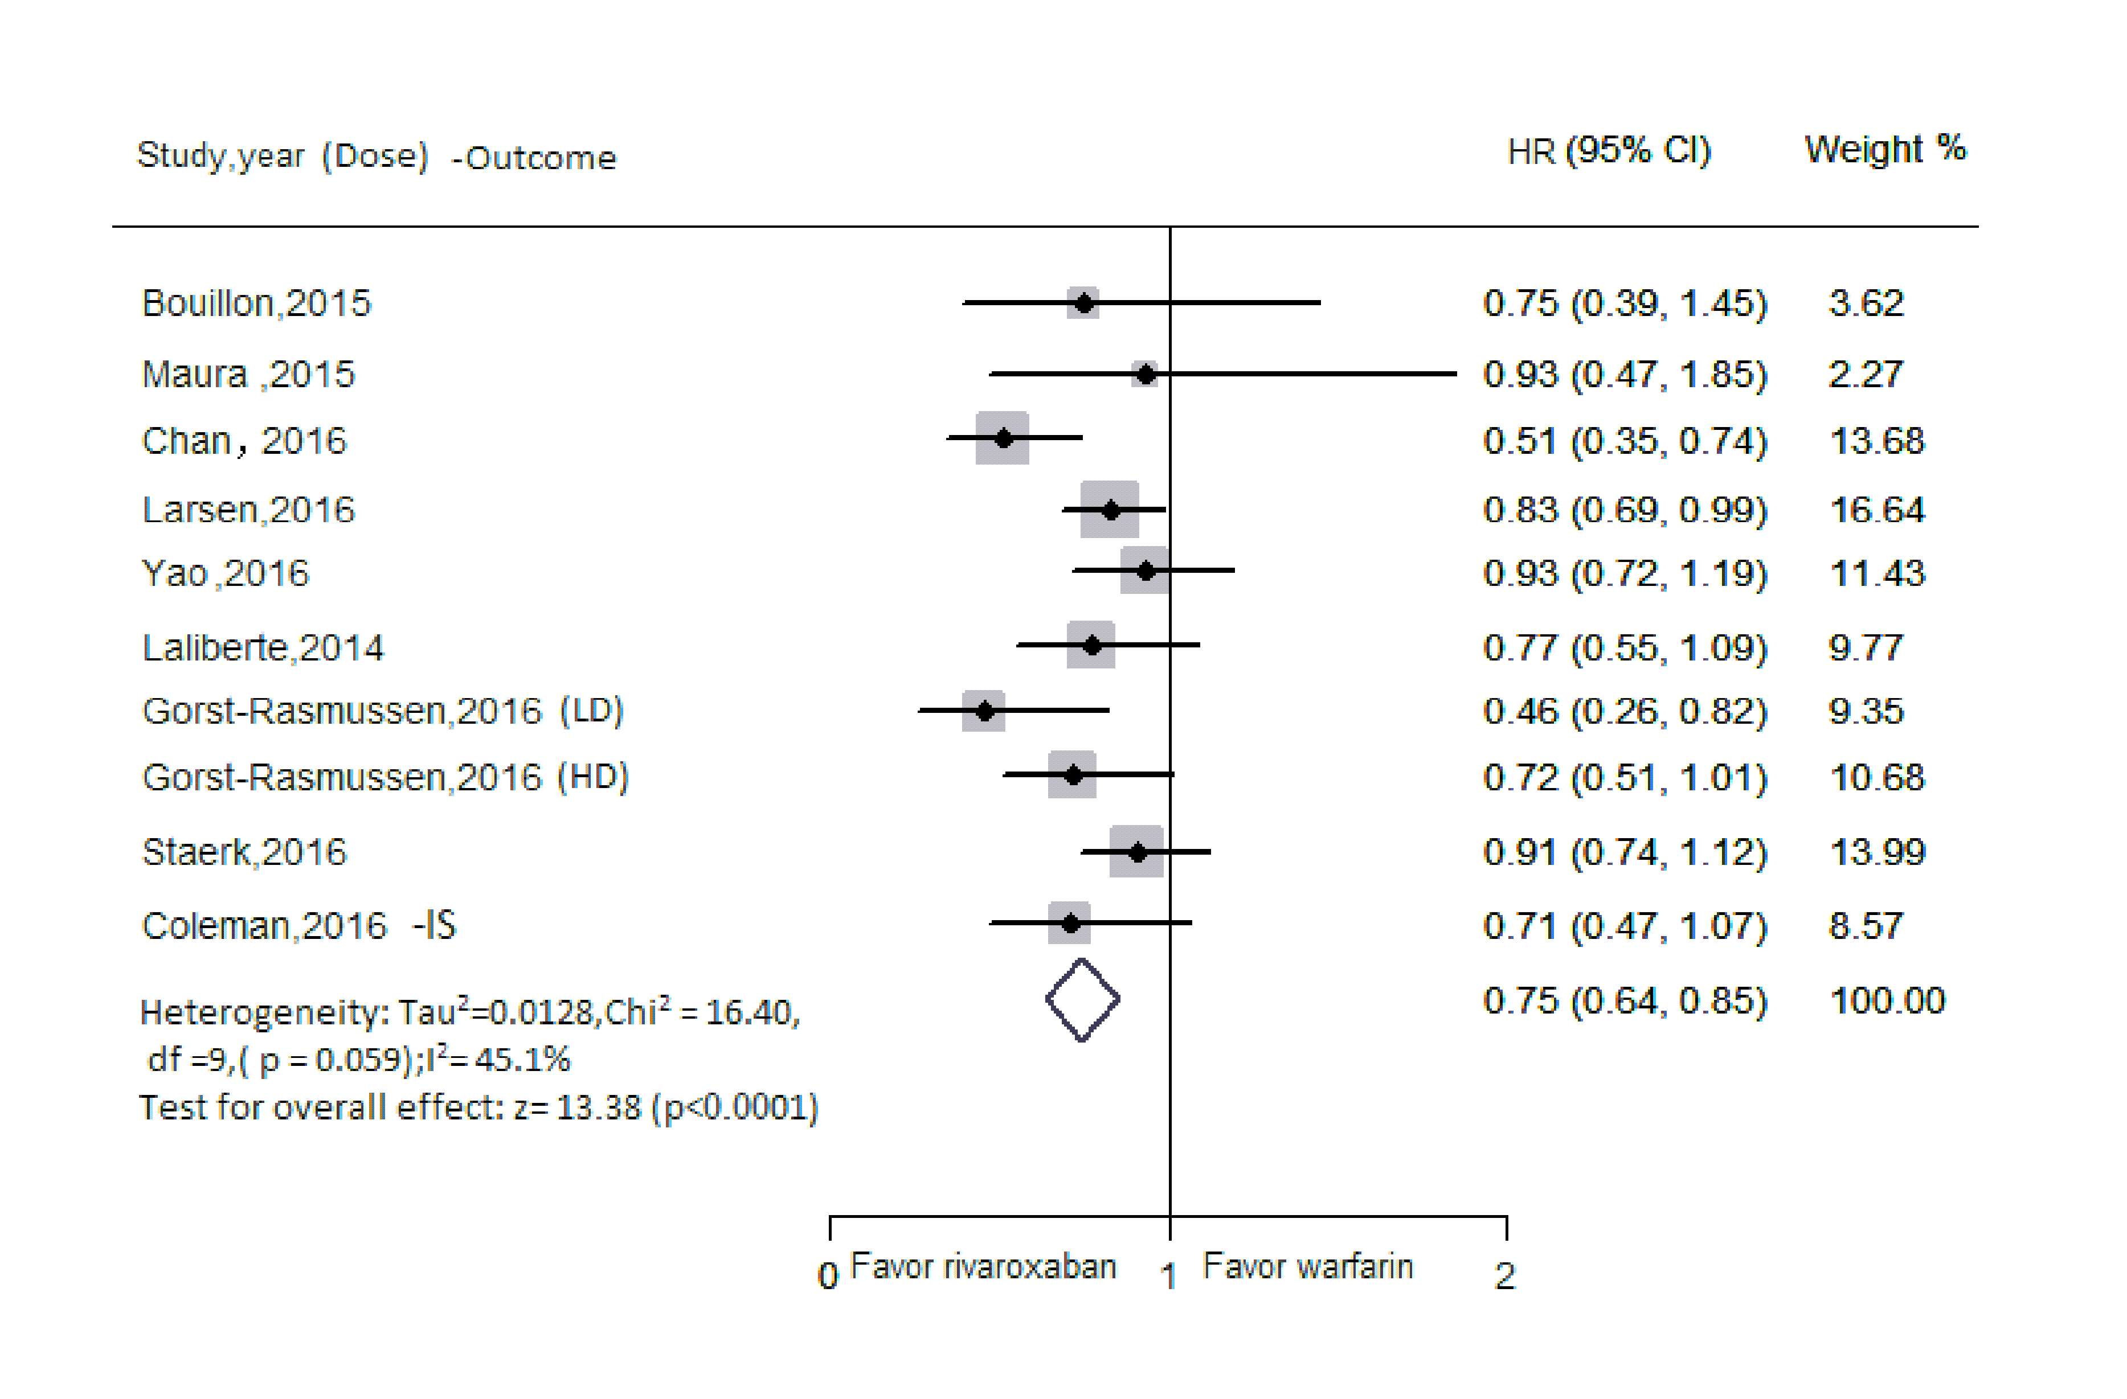
Figure 3.
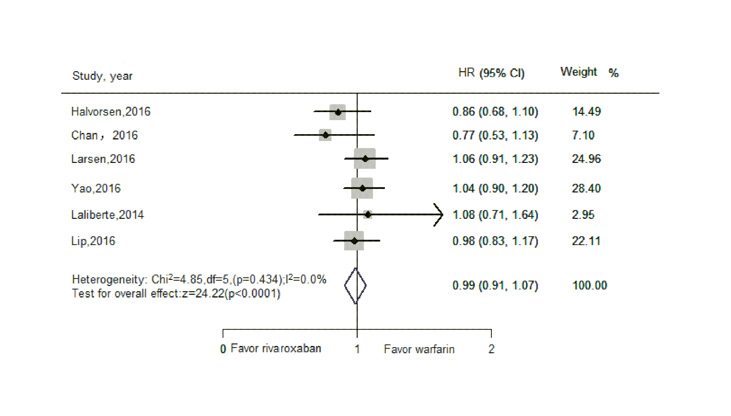
Figure 4.
ONLINE SUPPLEMENT
Rivaroxaban vs. Dabigatran or warfarin in ‘real-world’ studies of stroke prevention in atrial fibrillation: Systematic review and meta-analysis

Ying Bai, PhD , Hai Deng , Alena Shantsila, PhD, Gregory Y H Lip, MD, FRCP

Supplemental Tables Page 2
Supplemental Figures Page 6

SUPPLEMENTAL TABLES

Table I

New starters and Switchers in Rivaroxaban versus Warfarin studies

Author, year | New | Switch | Unclassified
Bouillon,2015¹ |  | +
Coleman,2016² | +
Lip,2016³ | +
Abraham,2016⁴ | +
Maura,2015⁵ | +
Coleman,2015⁶ | +
Halvorsen,2016⁷ | +
Chan,2016⁸ |  |  | +
Larsen,2016⁹ | +
Yao,2016¹⁰ | + | + | +
Laliberte,2014¹¹ |  |  | +
Lip,2016¹² | +
Gorst-Rasmussen,2016¹³ | +
Staerk,2016¹⁴ | +

Table II Various outcomes included in studies of Rivaroxaban versus Warfarin

Author,year | IS | Stroke/TE | major bleeding | any bleeding | AMI | ICB | GIB | All-cause mortality | Other clinical events
Bouillon,2015¹ |  | + |  | + | + |  |  |  | composite events
Coleman, 2016² | + |  |  |  |  | + |  |  | Combined IS and ICH
Lip,2016³ |  |  | +
Abrham,2016⁴ | + |  |  |  |  |  | +
Maura, 2015⁵ |  | + |  | + |  |  |  |  | IS/TE/death
 |  |  |  |  |  |  |  |  | Hospitalized for bleeding/death
Coleman, 2015⁶ |  |  |  |  |  |  |  |  | Composite end
Halvorsen, 2016⁷ |  |  | + | + |  | + | + |  | CRNM
Chan, 2016⁸ |  | + |  | + | + | + | + | +
Larsen, 2016⁹ | + | + | + | + |  | + |  | + | IS/TE/death
Yao X, 2016¹⁰ | + | + | + |  |  | + | + |  | hemorrhagic stroke
Laliberte, 2014¹¹ | + | + | + |  |  | + | + |  | hemorrhagic stroke
 |  |  |  |  |  |  |  |  | TE
 |  |  |  |  |  |  |  |  | VTE
 |  |  |  |  |  |  |  |  | DVT
 |  |  |  |  |  |  |  |  | PE with or without DVT
Lip, 2016¹² |  |  | +
Gorst-Rasmussen, 2016¹³ |  | + |  | + |  |  |  | + | net clinical benefit
Staerk,2016¹⁴ | + | + |  |  |  | +
IS, ischemic stroke; TE, thromboembolism; AMI, acute myocardial infarction; GIB, gastrointestinal bleeding; ICB, intracranial bleeding; CRNM, clinically relevant non-major bleeding; VTE, venous thromboembolism; DVT, deep venous thromboembolism; PE, pulmonary embolism.
Table III Endpoints in comparisons of rivaroxaban versus dabigatran or rivaroxaban versus warfarin

 | IS | Stroke/TE | Major bleeding | Any bleeding | Mortality | AMI | GIB | ICH
R vs. D | → | → | ↑ | ↑ | ↑ | → | ↑ | →
R vs. W | ↓ | ↓ | → | → | → | → | ↑ | ↓
R vs. D(LD) | → | → |  | ↑ | ↑
R vs. D(HD) | → | → | ↑ | ↑ | ↑ |  | ↑ | →
R vs. W(LD) |  | → |  | →
R vs. W(HD) |  | ↓ |  | →
R vs. W(New) | ↓ | ↓ | → | → | → |  | → | ↓
R vs. W(Switch) |  | → | ↑ | → |  | →

IS, ischemic stroke; TE, thromboembolism; AMI, acute myocardial infarction; GIB, gastrointestinal bleeding; ICH, intracranial hemorrhage;
R vs. D, rivaroxaban versus dabigatran; R vs. W, rivaroxaban versus warfarin; R vs. D(LD), low-dose rivaroxaban versus low-dose dabigatran;
R vs. D (HD), high-dose rivaroxaban versus high-dose dabigatran; R vs. W(LD), low-dose rivaroxaban versus warfarin; R vs. D (HD), high-dose rivaroxaban versus warfarin; R vs. W(New), rivaroxaban new-users versus warfarin; R vs. W(Switcher), rivaroxaban switcher versus warfarin;
→, similar risk; ↑, increased risk; ↓, decreased risk; blanket indicates not available; Other abbreviations see footnotes in Table II.

Table IV Number needed to treat or number needed to harm of rivaroxaban compared with dabigatran or warfarin on the risk of stroke/systematic thromboembolism and major bleeding

I-agent | C-agent | outcomes | No.of patients  in I-agent arm | No.of patients  in C-agent arm | IR of I-agent | IR of C-agent | NNT | NNH
Rivaroxaban | Dabigatran | Stroke/TE | 122,497 | 104,724 | 0.296(0.238-0.355) | 0.296(0.242-0.350) | +∞
 |  | Major bleeding | 137,893 | 100,477 | 1.452(1.304-1.600) | 0.550(0.469-0.632) |  | 111
Rivaroxaban | Warfarin | Stroke/TE | 58,769 | 157,118 | 2.569(1.817-3.321) | 2.856(1.968-3.744) | 348
 |  | Major bleeding | 55,555 | 98,366 | 3.705(2.770-4.640) | 3.733(2.970-4.495) |  | 3571

Stroke/TE, stoke and systematic thromboembolism; NNT, number needed to treat; NNH, number needed to harm; I-agent, interest-agent; C-agent; control-agent; IR, incidence rate; +∞, without upper limit.

SUPPLEMENTAL FIGURES

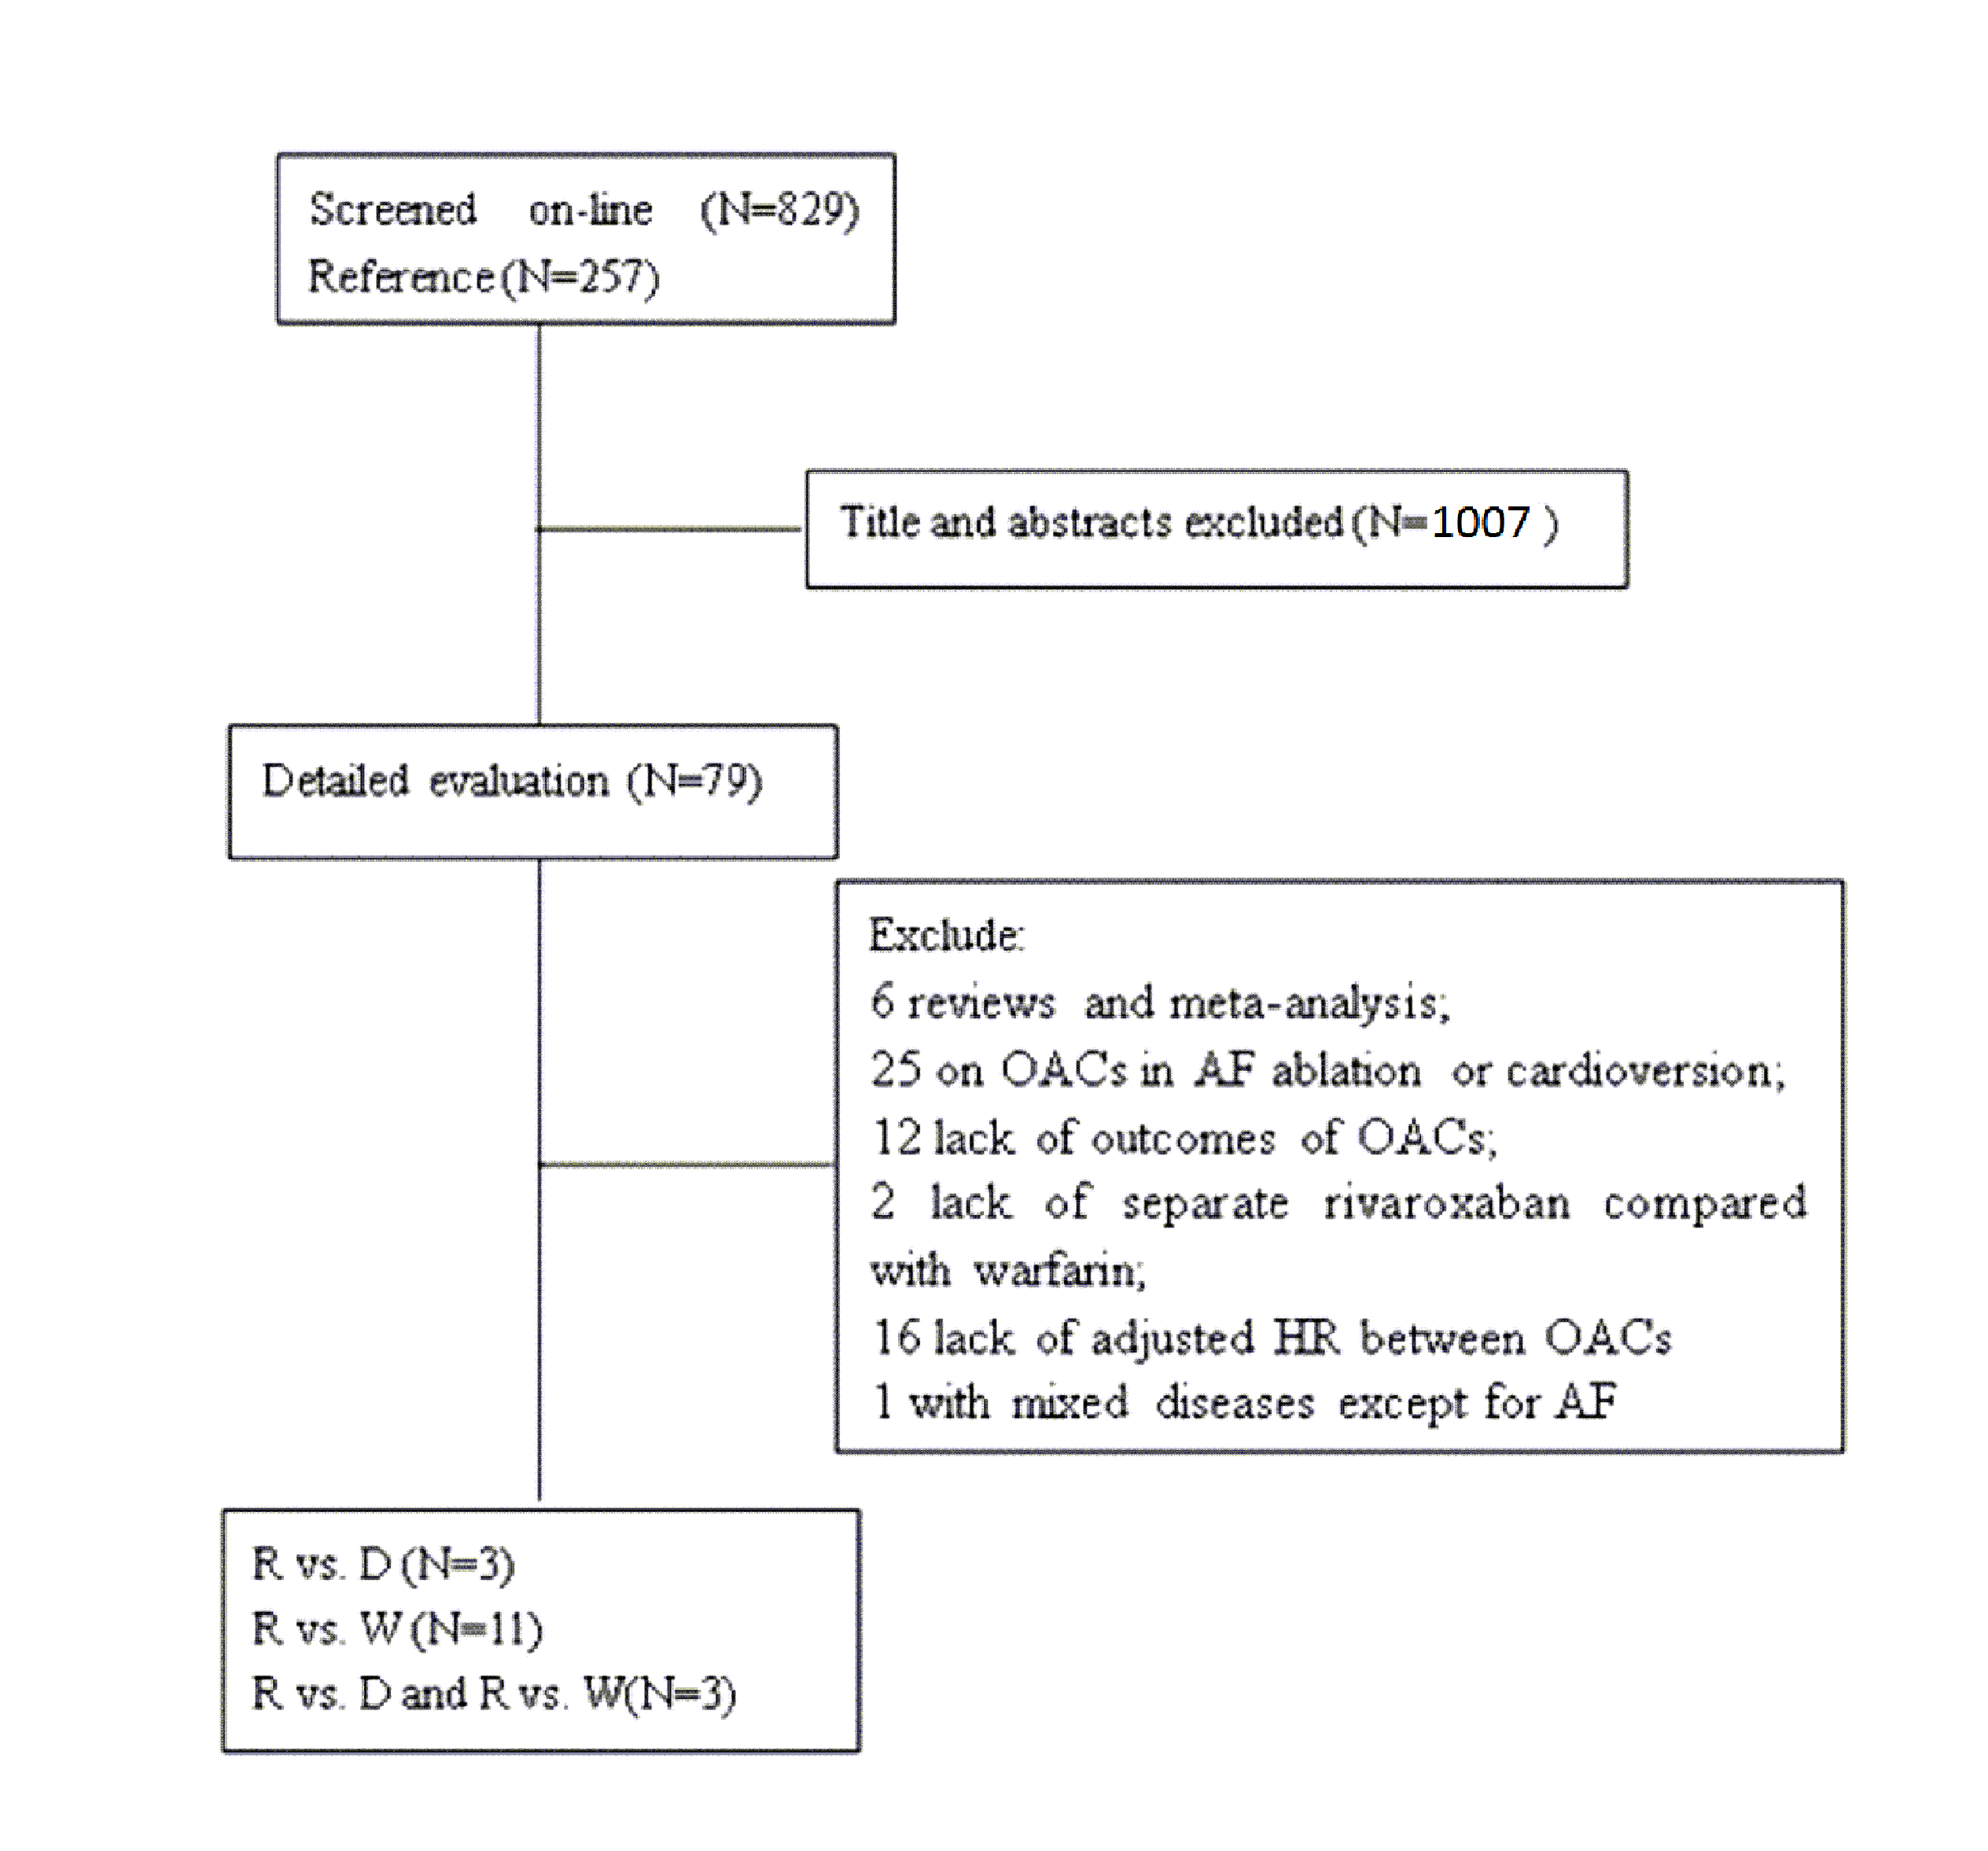

Figure I Study selection process.
OACs, oral anticoagulants; R vs. D, rivaroxaban versus dabigatran; R vs. W, rivaroxaban versus warfarin; AF, atrial fibrillation.

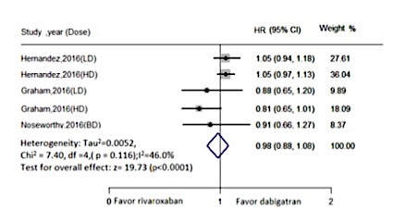
Figure II Rivaroxaban compared with Dabigatran for risk of IS in AF patients.
IS, ischemic stroke; LD, low-dose; HD, high-dose; BD, both-dose; AF, atrial fibrillation.

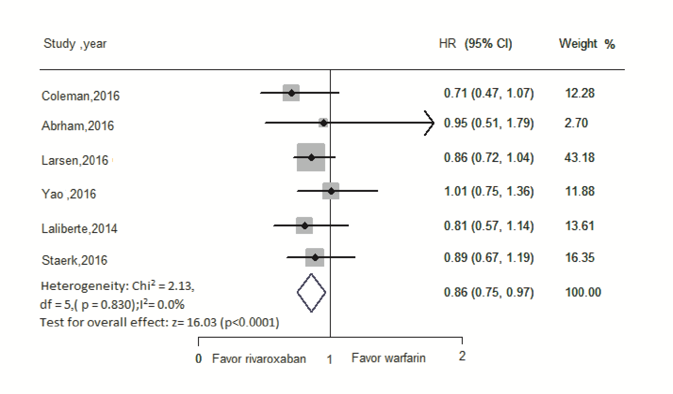
Figure III Rivaroxaban compared with Wafarin in risk of IS in AF patients.
IS, ischemic stroke; AF, atrial fibrillation.

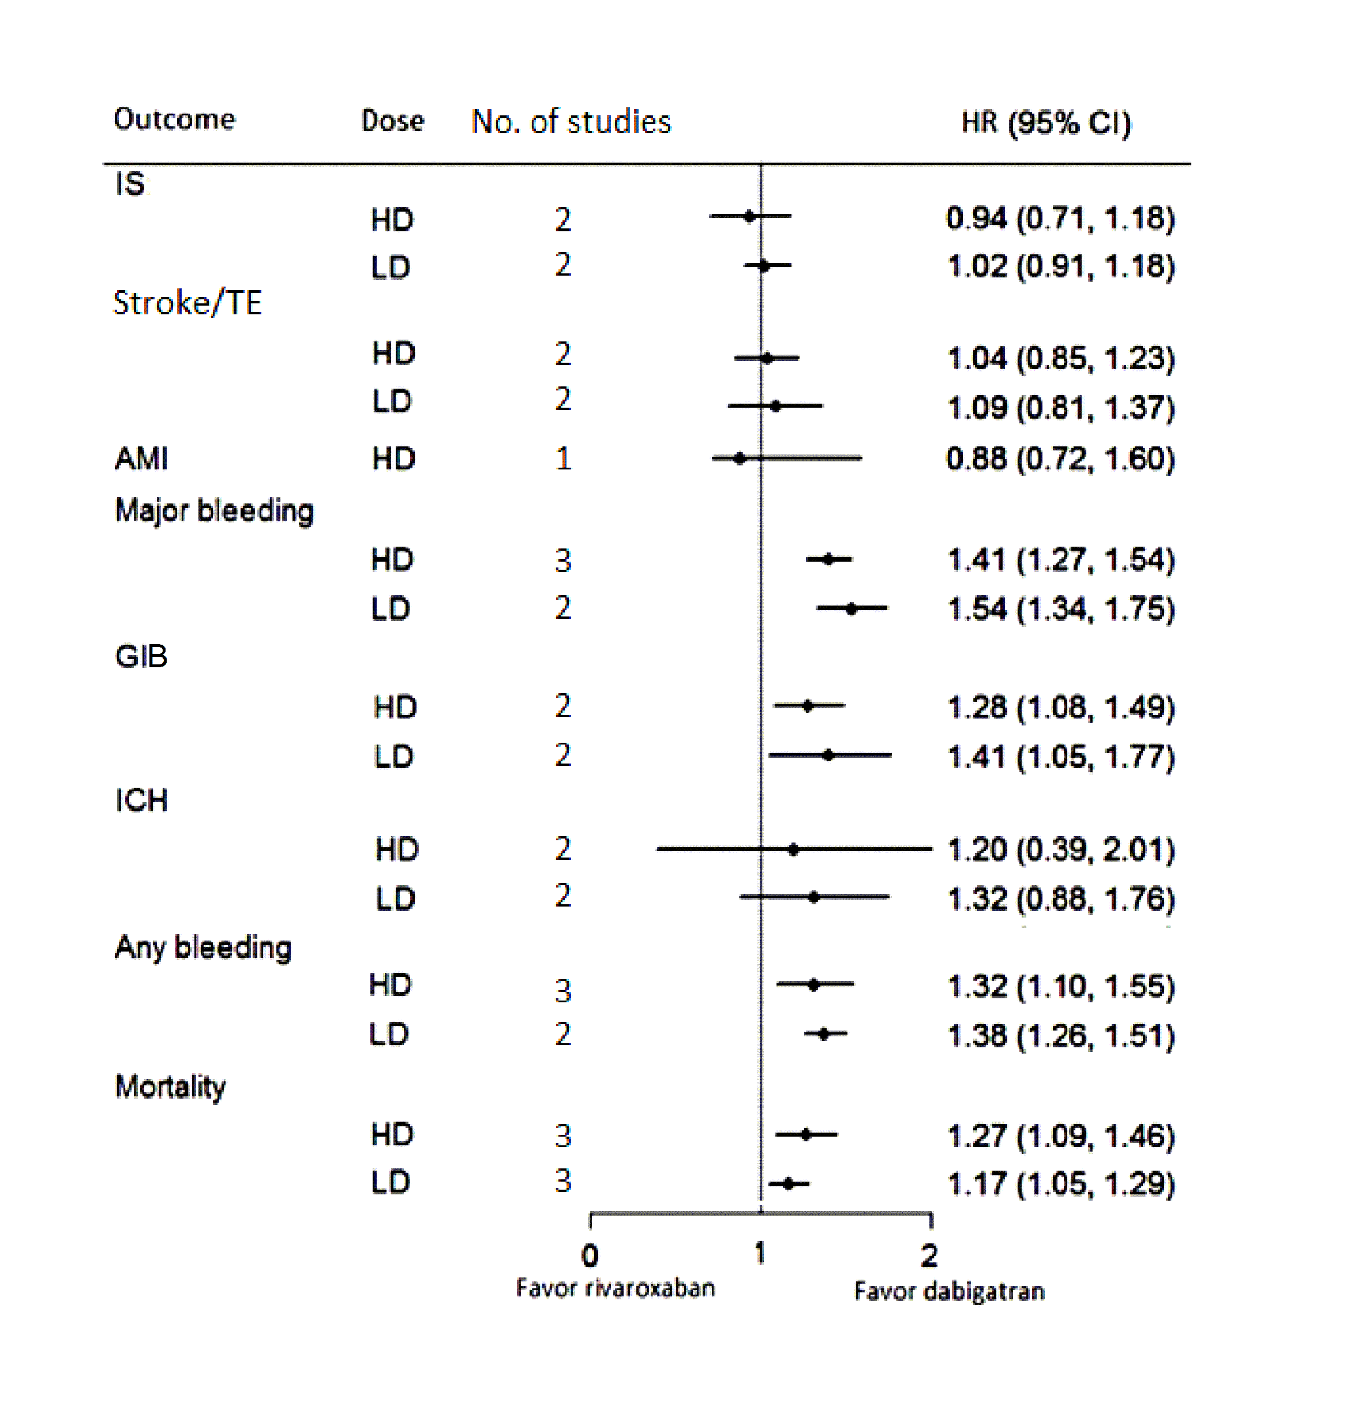
Figure IV Comparisons between HD- Rivaroxaban vs. HD- Dabigatran and LD-Rivaroxaban vs. LD-Dabigatran in various outcomes in AF patients.

IS, ischemic stroke; TE, thromboembolism; AMI, acute myocardial infarction; GIB, gastrointestinal bleeding; ICH, intracranial hemorrhage; LD, low-dose; HD, high-dose; HR, hazard ratio.

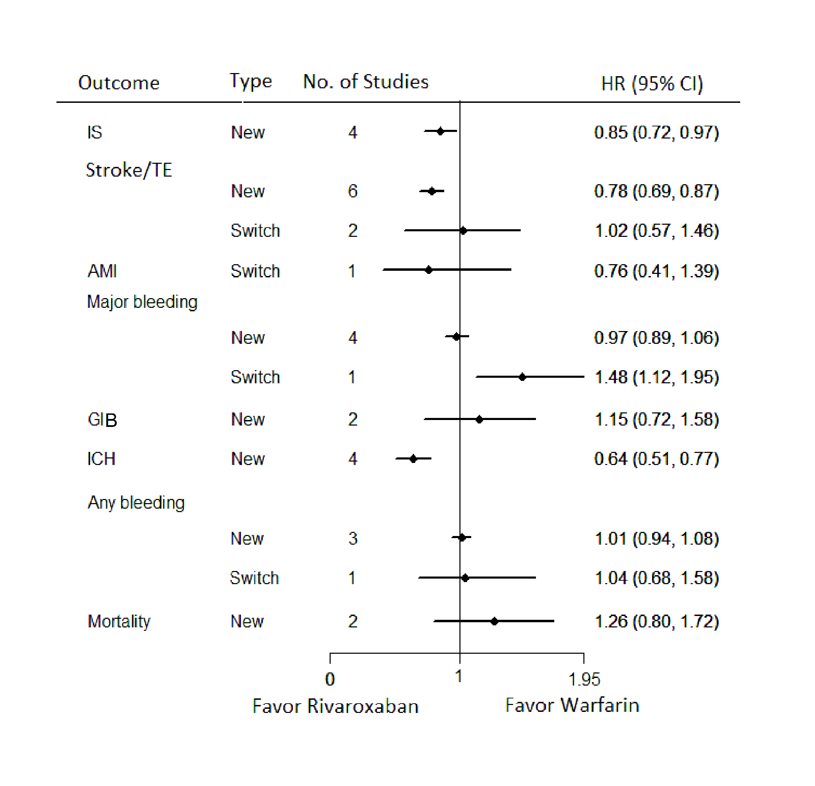
Figure V Rivaroxaban new users/switchers compared with warfarin in various outcomes in AF patients.

IS, ischemic stroke; TE, thromboembolism; AMI, acute myocardial infarction; GIB, gastrointestinal bleeding; ICH, intracranial hemorrhage; HR, hazard ratio.

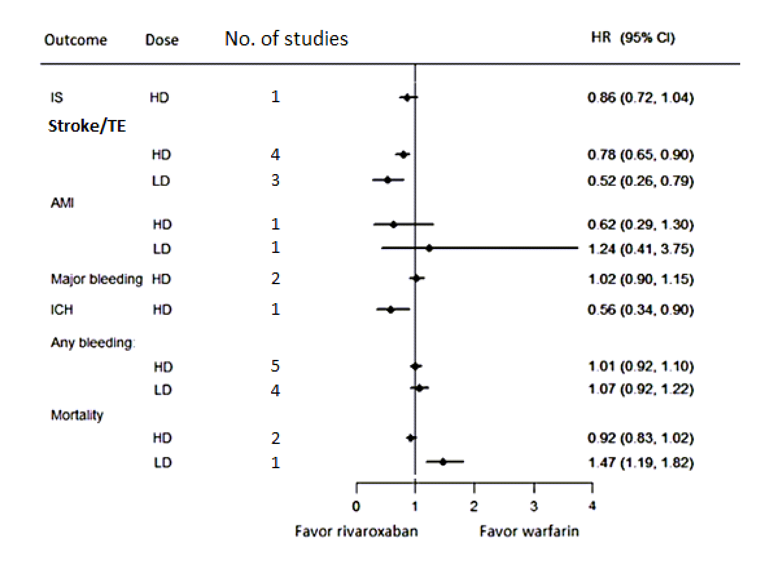
Figure VI Rivaroxaban at different doses compared with warfarin for various outcomes in AF patients.

IS, ischemic stroke; TE, thromboembolism; AMI, acute myocardial infarction; ICH, intracranial hemorrhage; HR, hazard ratio.
References

1. Bouillon K, Bertrand M, Maura G, Blotiere PO, Ricordeau P, Zureik M. Risk of bleeding and arterial thromboembolism in patients with non-valvular atrial fibrillation either maintained on a vitamin k antagonist or switched to a non-vitamin k-antagonist oral anticoagulant: A retrospective, matched-cohort study. The Lancet. Haematology. 2015;2:e150-159
2. Coleman CI, Antz M, Bowrin K, Evers T, Simard EP, Bonnemeier H, et al. Real-world evidence of stroke prevention in patients with nonvalvular atrial fibrillation in the united states: The revisit-us study. Curr Med Res Opin. 2016:1-7
3. Lip GY, Pan X, Kamble S, Kawabata H, Mardekian J, Masseria C, et al. Major bleeding risk among non-valvular atrial fibrillation patients initiated on apixaban, dabigatran, rivaroxaban or warfarin: A "real-world" observational study in the united states. Int J Clin Pract. 2016;70:752-763
4. Abraham NS, Singh S, Alexander GC, Heien H, Haas LR, Crown W, et al. Comparative risk of gastrointestinal bleeding with dabigatran, rivaroxaban, and warfarin: Population based cohort study. BMJ. 2015;350:h1857
5. Maura G, Blotiere PO, Bouillon K, Billionnet C, Ricordeau P, Alla F, et al. Comparison of the short-term risk of bleeding and arterial thromboembolic events in nonvalvular atrial fibrillation patients newly treated with dabigatran or rivaroxaban versus vitamin k antagonists: A french nationwide propensity-matched cohort study. Circulation. 2015;132:1252-1260
6. Coleman CI, Antz M, Ehlken B, Evers T. Real-life evidence of stroke prevention in patients with atrial fibrillation--the relief study. Int J Cardiol. 2016;203:882-884
7. Halvorsen S, Ghanima W, Tvete IF, Hoxmark C, Falck P, Solli O, et al. A nationwide registry study to compare bleeding rates in patients with atrial fibrillation being prescribed oral anticoagulants. Eur Heart J Cardiovasc Pharmacother.2017;3:28-36
8. Chan YH, Kuo CT, Yeh YH, Chang SH, Wu LS, Lee HF, et al. Thromboembolic, bleeding, and mortality risks of rivaroxaban and dabigatran in asians with nonvalvular atrial fibrillation. J Am Coll Cardiol. 2016;68:1389-1401
9. Larsen TB, Skjoth F, Nielsen PB, Kjaeldgaard JN, Lip GY. Comparative effectiveness and safety of non-vitamin k antagonist oral anticoagulants and warfarin in patients with atrial fibrillation: Propensity weighted nationwide cohort study. BMJ. 2016;353:i3189
10. Yao X, Abraham NS, Sangaralingham LR, Bellolio MF, McBane RD, Shah ND, et al. Effectiveness and safety of dabigatran, rivaroxaban, and apixaban versus warfarin in nonvalvular atrial fibrillation. J Am Heart Assoc. 2016;5:e003725.
11. Laliberte F, Cloutier M, Nelson WW, Coleman CI, Pilon D, Olson WH, et al. Real-world comparative effectiveness and safety of rivaroxaban and warfarin in nonvalvular atrial fibrillation patients. Curr Med Res Opin. 2014;30:1317-1325
12. Lip GY, Keshishian A, Kamble S, Pan X, Mardekian J, Horblyuk R, et al. Real-world comparison of major bleeding risk among non-valvular atrial fibrillation patients initiated on apixaban, dabigatran, rivaroxaban, or warfarin. A propensity score matched analysis. Thrombosis and haemostasis. 2016;116:975-986
13. Gorst-Rasmussen A, Lip GY, Bjerregaard Larsen T. Rivaroxaban versus warfarin and dabigatran in atrial fibrillation: Comparative effectiveness and safety in danish routine care. Pharmacoepidemiol Drug Saf. 2016;25:1236-1244
14. Staerk L, Fosbol EL, Lip GY, Lamberts M, Bonde AN, Torp-Pedersen C, et al. Ischaemic and haemorrhagic stroke associated with non-vitamin k antagonist oral anticoagulants and warfarin use in patients with atrial fibrillation: A nationwide cohort study. Eur Heart J. 2016:ehw496

