Medical Journal of Australia Manuscript submission template
Type of article  See Types of articles published by the MJA |  | Research
Title | Psychotropic medicine use before and after entering residential aged care in Australia: a national cohort study

Abstract
Articles requiring a descriptive 15-word introductory line are: Perspectives, Ethics and law, Reflection and History articles, and Editorials.
For these article types, please also supply a 100-word (maximum) abstract. Note this is not for publication but may be used in correspondence with reviewers for the a selection of articles see MJA Instructions for authors to identify these types of articles
Articles requiring 250-word structured abstracts are:
Research (original) (use the headings: Objectives, Design, Setting, Participants, Main outcome measures, Results, Conclusions and Trial registration [if applicable]);
Systematic reviews and Meta-analyses (use the headings: Objective, Study design, Data sources, , Data synthesis, Conclusions);
Guidelines etc: (use the headings: Introduction, Main recommendations and Changes in management as result of the guideline)
Articles requiring 250-word unstructured dot-point summary are: Narrative reviews
Abstract word count | 250

Objective: To examine psychotropic medicine use before and after entry to residential aged care.
Design: National retrospective cohort study.
Setting: All government-subsidised residential aged care facilities in Australia.
Participants: All concession card holders aged ≥65 years who accessed residential aged care for at least three months between 01/04/2008 and 30/06/2015 (n=322,120).
Main outcome measures: Dispensing of antipsychotics, benzodiazepines and antidepressants was examined at quarterly intervals one year before and after entering care.
Results: In the three months following entry into care, 21.3% (95% Confidence Interval (CI): 21.1-21.4%; n=68,483) of residents received at least one antipsychotic, 30.5% (95%CI: 30.4-30.7%; n=98,315) received at least one benzodiazepine and 37.9% (95%CI: 37.8-38.1%; n=122,224) of residents received at least one antidepressant. Among residents receiving these medicines in the first three months of care, 45.7%, 39.3% and 19.8% of residents had not received an antipsychotic, benzodiazepine or antidepressant in the year prior to entering care, respectively.
In the three months after entering care, compared to residents without dementia, antipsychotic use was 3.37 (95%CI: 3.31-3.43) times greater in residents with dementia. The use of benzodiazepines was not different, prevalence ratio 1.01 (95%CI: 0.99-1.02), while antidepressant use was slightly higher among residents with dementia, prevalence ratio 1.05 (95%CI: 1.04-1.07).
Conclusions: Use of psychotropic medicines among older Australians is high prior to entering residential care but increases markedly upon entry. Non-pharmacological, evidence-based strategies are important for community-dwelling individuals, and for people during the time of transitioning and whilst living in residential care to limit the use of psychotropic medicines.

Research articles only
Research articles: should include a Box that summarises the significance of your study in 100 words, using the following headings/content: “The known” [the starting point for your investigation], “The new” [your major novel finding] and “The implications” [the consequences of your finding].
Text word count | 99

The known
There is concern that psychotropic medicines are frequently prescribed in residential aged care, but the extent to which psychotropic use changes after entry to residential aged care is unknown.
The new
Use of psychotropic medicines among older Australians is high prior to entering care; however, prevalence of use increases markedly upon entry to residential care.
The implications
High rates of psychotropic prescribing in residential aged care should be addressed. Evidence-based interventions are available. Further research should determine if interventions which target psychotropic medicine use before and during transition to residential aged care could also reduce psychotropic use.

Text
Research reports should be written in IMRAD format (Introduction, Methods, Results and Discussion).
Lessons from practice should be written using headings “Clinical record” and “Discussion”.
Text word count | 2500

Introduction
Psychotropic medicines including antipsychotics, benzodiazepines and antidepressants are frequently prescribed to people in residential aged care facilities (RACFs), despite known associations with a high risk of adverse events.¹ ² Antipsychotics may be used for people with severe mental health conditions and risperidone is indicated for the treatment of severe and persistent psychotic symptoms in people with dementia. Antidepressants are used to treat depression and benzodiazepines may be used for conditions including sleep disturbance and anxiety. However, there have been growing concerns about the potential overuse of psychotropics as ‘chemical restraints’ in RACFs in Australia and internationally.³ There are differing interpretations of what is meant by ‘chemical restraint’, but it is often referred to as the use of medicines to influence a person’s behaviour.³ Psychotropic medicine use can however be appropriate if used in accordance with guidelines, at the lowest therapeutic dose and with adequate monitoring.

A recent national study of 150 Australian RACFs estimated antipsychotic use as 22%, benzodiazepine use as 22% and antidepressant use as 41%.¹ The time of entry to a RACF may be distressing for the individual due to exposure to unfamiliar surroundings, less contact with family members and adapting to a new lifestyle.⁴ People with and without dementia may experience agitation, depression and sleep disturbances in response to moving to a new environment and adjusting to the RACF.⁵ This may result in increased exposure to psychotropic medicines; however, it is unknown to what extent Australians entering RACFs are already treated with psychotropics and how use changes after entering RACFs.

Psychotropic use increased markedly in residents entering RACFs in Northern Ireland compared to people living in the community,⁶ but it is unknown if these findings reflect patterns in other countries. Understanding changes in the prevalence of use of psychotropic medicines is important to inform direction of educational resources and quality improvement interventions to limit psychotropics. There have been no previous national studies in Australia which have been able to examine how use of psychotropic medicines changes when individuals living in the community move to RACFs.

The objectives of this study were to: 1) examine the use of antipsychotics, benzodiazepines and antidepressants in the year before and after entering RACFs and 2) examine associations between dementia status and use of psychotropics.
Methods
Study design and data sources
A retrospective cohort study using the Registry Of Senior Australians (ROSA) was conducted.⁷ In Australia, older people can apply to access government-subsidised RACFs with 24-hour care and accommodation. Each person must have an aged care eligibility assessment, which includes information about the person related to their care needs.⁸ Upon entry to RACFs, the Aged Care Funding Instrument (ACFI) is used to assess the core care needs of individuals.⁹ In ROSA, de-identified data collected during aged care eligibility assessments for all older Australians were linked to information on the aged care services the person received, medicines dispensed via the Pharmaceutical Benefits Scheme (PBS) and Repatriation PBS, and mortality information from the National Death Index. Inclusion criteria and data linkage criteria are detailed in the supplementary material.

Psychotropic medicines
The World Health Organization Anatomical Therapeutic Classification (ATC) system codes were used to identify individuals dispensed antipsychotics (N05A*, excluding prochlorperazine and lithium), benzodiazepines (N05BA*, N05CD*, N05CF* or N03AE*) and/or antidepressants (N06A)* for the year before and after entering RACFs.¹⁰

Dementia ascertainment
Dementia was determined from aged care eligibility assessments, ACFI assessments (Supplementary Table 1), or if a resident was dispensed an acetylcholinesterase inhibitor (ATC codes N06DA02, N06DA03 or N06DA04) or memantine (N06DX01) in the six months prior to entering care, as these medications are only subsidised for symptoms of dementia.

Statistical analysis
Resident characteristics were summarised with frequencies and percentages for categorical variables and medians and inter-quartile ranges (IQR) for continuous variables. Generalized linear mixed models were applied to binary indicators for medicines use at quarterly intervals and postestimation of the models was employed to estimate prevalence of use of each psychotropic among all residents and stratified by dementia status. Models were adjusted for age, sex, location (state) and number of co-morbidities, as measured with the Rx-Risk-V, which is a validated co-morbidity measure applied to pharmaceutical claims data.¹¹ For estimating use of psychotropics after entry to care, we also adjusted for use of the psychotropic in the 3 months before entry. Equal quarters of 91 days were examined pre- and post-entry into residential care: 0-3 months (days 0-91), 3-6 months (days 92-182), 6-9 months (days 183-273), 9-12 months (days 274-364). We estimated medicines use among residents who were alive at each quarter. Poisson regression models adjusted for age, sex and number of co-morbidities were used to examine associations between dementia status at time of entry to residential care (yes/no) and psychotropic use in the first three months after entry to residential care. Statistical analyses were performed using Stata v.15.0 (Stata Corp LP, College Station, TX, USA).

Ethical Approval
Ethical approval was received from the University of South Australia ethics committee: ID 200489.
Results
Of the 322,120 residents who were included in this study, the median age was 85.0 years (IQR=80.0-89.0), 63.8% were female, 49.6% were identified as having a dementia diagnosis, 3.3% were identified as having schizophrenia or other psychoses (Table 1). In the first three months after entry to residential care, 60.8% (95%CI: 60.6-60.9%) of residents received at least one psychotropic medicine.

In the year before entering RACFs, antipsychotic use increased from 6.0% (95%CI: 5.9-6.1%) at 9-12 months before entering residential care to 12.3% (95%CI: 12.2-12.4%) in the three months before entering residential care. In the first three months after entering residential care, 21.3% (95%CI: 21.1-21.4%; n=68,483) of residents received at least one antipsychotic and prevalence remained relatively stable thereafter (Figure 1). The most common atypical antipsychotics dispensed in the three months after entering residential care were risperidone (61.5% of residents dispensed an antipsychotic), olanzapine (15.9%) and quetiapine (14.1%) and the most common typical antipsychotic dispensed was haloperidol (16.5%).

Benzodiazepine use also increased in the year before entering residential care, from 17.1% (95%CI: 17.0-17.3%) at 9-12 months before entering residential care to 19.7% (95%CI: 19.5-19.8%) at 0-3 months before entering. In the first three months after entering residential care, the prevalence of benzodiazepines increased to 30.5% (95%CI: 30.4-30.7%; n=98,315); this declined to 25.6% (95%CI: 25.5-25.7%) at 3-6 months after entering residential care and then remained relatively stable. The most common benzodiazepines dispensed in the three months after entering residential care were temazepam (62.2% of residents dispensed a benzodiazepine) and oxazepam (29.3%).

Dispensing of antidepressants increased steadily over the same period, from 27.0% (95%CI: 26.9-27.1%) at 9-12 months before entry to 31.4% (95%CI: 31.2-31.5%) at 0-3 months before entry. Dispensing of antidepressants increased to 37.9% (95%CI: 37.8-38.1%; n=122,224) in the three months after entering residential care; 51.8% of residents dispensed an antidepressant received selective serotonin reuptake inhibitor(s), 25.0% received mirtazapine and 15.6% received tricyclic antidepressant(s). At 9-12 months after entering RACFs dispensing of antidepressants had increased to 41.4% (95%CI: 41.2-41.5%).

Among residents receiving these medicines in the first three months of care, 45.7%, 39.3% and 19.8% of residents had not received an antipsychotic, benzodiazepine or antidepressant in the year prior to entering care, respectively.

In the first three months after entry to residential care, compared to residents without dementia, antipsychotic use was 3.37 (95%CI: 3.31-3.43) times greater in residents with dementia (32.9% (95%CI: 32.7-33.2) vs. 9.8% (95%CI: 9.7-9.9%). Prevalence of use of benzodiazepines was not different, prevalence ratio 1.01 (95%CI: 0.99-1.02), 30.3% (95%CI: 30.1-30.5%) vs. 30.1% (95%CI: 29.9-30.3%); while antidepressant use was slightly more common among residents with dementia, prevalence ratio 1.05 (95%CI: 1.04-1.07), 39.0% (95%CI: 38.8-39.2%) vs. 37.2% (95%CI: 36.9-37.4%).
Discussion
In this national study of all eligible older Australians who entered permanent RACFs over a seven-year period, the prevalence of use of psychotropics including antipsychotics, benzodiazepines and antidepressants increased substantially entering a RACF. Although use of psychotropics did increase in the year before entering RACFs, the use of psychotropics increased at a higher rate after entry. Exposure to psychotropics also remained high in the year following entry to RACFs.

The prevalence of antipsychotics in this study at 0-3 months after entering residential care was 21% which is comparable to a previous national study involving 150 RACFs across seven Australian states and territories which estimated use as 22%.¹ The previous study reported that 22% of residents received a benzodiazepine, whereas we report benzodiazepine use as 31% at 0-3 months post-entering residential care. High use of antidepressants was observed in this study and the previous study (38% and 41% respectively). Access to psychologists and psychological services is poor in Australian RACFs, despite evidence of effectiveness of psychological treatments in RACFs for reducing depression.¹² ¹³ More attention is needed to improve availability of alternative treatments for people with depression living in RACFs.

The finding in this study of an increase in psychotropic medicine use after entering RACFs is consistent with a previous study conducted in RACFs in Northern Ireland⁶ and two smaller studies, including a study in Melbourne, Australia involving residents of seven RACFs, and a study involving residents from one RACF in the United States.¹⁴ ¹⁵ Of particular concern is our finding that 20–46% of residents first received psychotropic medicines after entering RACFs. This is likely due to non-adherence to guidelines for psychotropic medicines. For example, for people with dementia risperidone is only indicated according to Australian clinical guidelines and PBS-subsidy criteria for mild to moderate behavioural symptoms in people with Alzheimer’s disease for up to 12 weeks.¹³ Previous estimates suggest only 10% of psychotropics prescribed in residential care for behavioural symptoms for people with dementia are appropriate.¹⁶ However, some psychotropic medicines are appropriate for residents and possibility of relapse should be considered when contemplating withdrawal of psychotropic(s). Interdisciplinary, person-centred interventions including adequate support, education and training of care staff have been shown to positively impact psychotropic prescribing rates in RACFs.¹ ¹⁷ Careful monitoring is required when deprescribing psychotropic medicines, as in a recent trial 22% of people whose antipsychotic medicines were deprescribed were subsequently represcribed a regular antipsychotic.¹⁷

Escalating behavioural symptoms among people with dementia is a common reason for admission to RACFs, and may contribute to increased psychotropic use during the transition to RACFs.¹⁸ It is possible that psychotropic use may help delay entry to residential care, but may also contribute to medicines-related harms that increase risk of entry to residential care.¹⁹ These complex relationships could be investigated in future studies.

Initiation of psychotropics upon entry to RACFs may be limited by supporting residents using non-pharmacological approaches for behavioural and psychological symptoms of dementia, stress and insomnia. Non-pharmacological approaches should be person-centred and a wide-range of activities tailored to the person’s preferences, skills and abilities are available.¹³ High prescribing rates of psychotropic medicines for people living in RACFs may be due to a ‘prescribing culture’ in some RACFs where there is an overreliance of psychotropic medicines as first-line therapy.²⁰ Sustained behaviour change is more likely when strategies such as non-pharmacological approaches for behavioural symptoms and staff training are prioritised across the entire organisation.

Given the high proportion of people who were receiving psychotropic medicines prior to entering residential care, there is a need to better support informal caregivers to provide non-pharmacological techniques. Multicomponent non-pharmacological interventions delivered by informal caregivers in the community have the potential to reduce both behavioural symptoms of dementia and caregiver distress without adverse events.²¹

In Australia, residential medication management reviews (RMMRs) are recommended for residents on entry to RACFs,²² and existing evidence suggests this RMMRs are valuable in identifying and resolving medicines-related problems and can reduce exposure to anticholinergic and sedative medicines.²³ Yet, it is unclear if RMMRs are always performed upon entry to RACFs and it is likely that few residents receive more than one RMMR during their stay in RACFs. Uptake of recommendations arising from RMMRs is variable and may be facilitated by interdisciplinary communication pre- and post-RMMR.²⁴ The value of RMMRs is also related to the prescribing culture of the RACF as the GP, managers and staff must value the RMMR to lead to changes in psychotropic prescribing.²⁰ The Quality Use of Medicines (QUM) program was introduced in Australia to improve practices relating to medicine use in RACFs. This program is designed to allow tailoring of services to an individual RACF and could include education and audit and feedback of psychotropic use.²² Reducing psychotropic prescribing in residential care at a national level is likely to be challenging and requires careful consideration; methods such as introducing requirements for reporting of antipsychotic prescribing patterns have been suggested, but measuring use of antipsychotics alone may not be an adequate proxy for quality of care.²⁵

In this study, in the three months after entering RACFs, compared to people without dementia, antipsychotic use was markedly higher for people with dementia, antidepressant use was also slightly higher, whereas benzodiazepine use was not different for those with and without dementia. This highlights the need for focus to reduce psychotropic medicine prescribing in RACFs for people with and without dementia.

Strengths and limitations
This is the first study to examine patterns of psychotropic dispensing before and after entering RACFs among all eligible Australians. The ROSA cohort captures all admissions to government-subsidised RACFs. Because of linkage of the cohort’s information to the National Death Index, and low likelihood of immigration/moving no loss to follow-up is expected. Several limitations should be noted. We did not have the indication for psychotropic use, dose prescribed or frequency of use; therefore, we could not further explore the appropriateness of use. We did not have information on medicines that were dispensed as private prescriptions and were not PBS-subsidised. The study used prescription claims data; therefore, we do not have information about prescriptions issued but not dispensed nor medicines that were dispensed but not administered including those prescribed ‘pro re nata’. A further limitation is that medicines which are supplied to hospital inpatients are not PBS-subsidised and only certain Australian hospitals are able to supply PBS-subsidised medicines on discharge. Therefore, supply of a psychotropic may appear 0-3 months post-entry for residents entering residential care immediately after a hospital stay where a psychotropic was commenced. We identified schizophrenia and other psychoses from the aged care assessments, but because these conditions are grouped together on the aged care assessment forms, we could not determine further information about these diagnoses. Furthermore, although dementia diagnosis was based on recording in aged care assessments and medicines indicated for use specifically for people with dementia, misclassification is possible as some individuals may be living with dementia that is not formally diagnosed or not recorded.

Conclusion
This nationally representative study showed that the use of psychotropics increases substantially after entering RACFs in Australia. Australian and international evidence suggests interdisciplinary interventions can significantly reduce psychotropic prescribing. Further research should study the underlying reasons for psychotropic prescribing and determine if interventions to reduce the use of psychotropics should also be targeted before and during the transition to RACFs. The prescribing culture and overreliance of psychotropic medicines in RACFs needs to be addressed. All staff in RACFs should be adequately educated and supported to reduce reliance on psychotropic medicines.

References
References should be in Vancouver style and should not appear as endnotes.
References to material on the Internet should include the organisation, the page title, the article title and the author (if there is one) as well as the URL and the month the page was visited (see examples here).

References
1. Westbury JL, Gee P, Ling T, et al. RedUSe: reducing antipsychotic and benzodiazepine prescribing in residential aged care facilities. Med J Aust 2018;208(9):398-403.
2. Westbury J, Gee P, Ling T, et al. More action needed: Psychotropic prescribing in Australian residential aged care. Aust N Z J Psychiatry 2018;53(2):136-47.
3. Royal Commission into Aged Care Quality and Safety. Restrictive Practices in Residential Aged Care in Australia, 2019. Available from: https://agedcare.royalcommission.gov.au/publications/Documents/background-paper-4.pdf accessed: 01/08/2019
4. Bradshaw SA, Playford ED, Riazi A. Living well in care homes: a systematic review of qualitative studies. Age Ageing 2012;41(4):429-40.
5. NHS England. Optimising treatment and care for people with behavioural and psychological symptoms of dementia, 2017. Available from: http://medicine.exeter.ac.uk/media/universityofexeter/medicalschool/pdfs/nhs-dementia-best-practice-guide.pdf accessed 01/08/2019
6. Maguire A, Hughes C, Cardwell C, et al. Psychotropic medications and the transition into care: a national data linkage study. J Am Geriatr Soc 2013;61(2):215-21.
7. Inacio MC, Bray SCE, Whitehead C, et al. Registry of Older South Australians (ROSA): framework and plan. BMJ Open 2019;9(6):e026319.
8. Australian Government Australian Institute of Health and Welfare. Aged Care Assessment Program Data Dictionary Version 1.0, 2002. Available from: https://www.aihw.gov.au/reports/aged-care/aged-care-assessment-program-data-dictionary-versi/contents/table-of-contents accessed 01/07/2019.
9. Australian Government Department of Health. Aged Care Funding Instrument (ACFI) User Guide, 2018. Available from: https://agedcare.health.gov.au/funding/aged-care-subsidies-and-supplements/residential-care-subsidy/basic-subsidy-amount-aged-care-funding-instrument/aged-care-funding-instrument-acfi-user-guide accessed 01/06/2019.
10. World Health Organisation. ATC/DDD Index, 2013. Available from: https://www.whocc.no/atc_ddd_index/ accessed 24/07/2019.
11. Pratt NL, Kerr M, Barratt JD, et al. The validity of the Rx-Risk Comorbidity Index using medicines mapped to the Anatomical Therapeutic Chemical (ATC) Classification System. BMJ Open 2018;8(4):e021122-e22.
12. Stargatt J, Bhar SS, Davison TE, et al. The Availability of Psychological Services for Aged Care Residents in Australia: A Survey of Facility Staff. Aust Psychol 2017;52(6):406-13.
13. Laver K, Cumming RG, Dyer SM, et al. Clinical practice guidelines for dementia in Australia. Med J Aust 2016;204(5):191-3.
14. O'Connor DW, Griffith J, McSweeney K. Changes to psychotropic medications in the six months after admission to nursing homes in Melbourne, Australia. Int Psychogeriatr 2010;22(7):1149-53.
15. Cohen-Mansfield J, Lipson S, Gruber-Baldini AL, et al. Longitudinal Prescribing Patterns of Psychotropic Drugs in Nursing Home Residents. Exp Clinical Psychopharm 1996;4(2):224-33.
16. van der Spek K, Gerritsen DL, Smalbrugge M, et al. Only 10% of the psychotropic drug use for neuropsychiatric symptoms in patients with dementia is fully appropriate. The PROPER I-study. International Psychogeriatr 2016;28(10):1589-95.
17. Brodaty H, Aerts L, Harrison F, et al. Antipsychotic Deprescription for Older Adults in Long-term Care: The HALT Study. J Am Med Dir Assoc 2018;19(7):592-600.e7.
18. Toot S, Swinson T, Devine M, et al. Causes of nursing home placement for older people with dementia: a systematic review and meta-analysis. International Psychogeriatr 2017;29(2):195-208.
19. Nerius M, Johnell K, Garcia-Ptacek S, et al. The Impact of Antipsychotic Drugs on Long-term Care, Nursing Home Admission, and Death in Dementia Patients. J Gerontol A Biol Sci Med Sci 2018;73(10):1396-402.
20. Sawan MJ, Jeon YH, Fois RJ, et al. A qualitative study exploring visible components of organizational culture: what influences the use of psychotropic medicines in nursing homes? International Psychogeriatr 2016;28(10):1725-35.
21. Brodaty H, Arasaratnam C. Meta-analysis of nonpharmacological interventions for neuropsychiatric symptoms of dementia. American J Psychiatry 2012;169(9):946-53.
22. Pharmaceutical Society of Australia. Guidelines for pharmacists providing Residential Medication Management Review and Quality Use of Medicines services, 2011. Available from: https://my.psa.org.au/servlet/fileField?entityId=ka17F000000cmjcQAA&field=PDF_File_Member_Content__Body__s accessed 01/08/2019.
23. Nishtala PS, Hilmer SN, McLachlan AJ, et al. Impact of Residential Medication Management Reviews on Drug Burden Index in Aged-Care Homes. Drugs Aging 2009;26(8):677-86.
24. Chen EYH, Wang KN, Sluggett JK, et al. Process, impact and outcomes of medication review in Australian residential aged care facilities: A systematic review. Australas J Ageing 2019; Suppl 2:9-25.
25. Maust DT, Kim HM, Chiang C, et al. Association of the Centers for Medicare & Medicaid Services' National Partnership to Improve Dementia Care With the Use of Antipsychotics and Other Psychotropics in Long-term Care in the United States From 2009 to 2014. JAMA Intern Med 2018;178(5):640-47.

Tables and Boxes
Tables and boxes should be provided as editable tables constructed using the tables function in your word processor, not as images or as PDFs. Table cells should not contain multiple items of data separated by hard returns.
Provide meaningful titles for each table/box.
Information in tables should be simplified as much as possible, keeping the number of columns to a minimum and the headings short.
Information in tables/boxes should not be duplicated in the text.
Tables should be designed to fit comfortably onto a Journal page.

Table 1. Resident characteristics and mortality among all residents and stratified by psychotropic medicines use in the first three months in residential aged care.
 | All residents | Residents dispensed medicine of interest in the first 3 months of care |  |  | No antipsychotic, benzodiazepine or antidepressant dispensed in the first 3 months of care
 |  | Antipsychotic(s) | Benzodiazepine(s) | Antidepressant(s)
Total, N (%) | 322,120 (100) | 68,483 (21.3) | 98,315 (30.5) | 122,224 (37.9) | 126,367 (39.2)
Age (years), Median (IQR) | 85.0 (80.0-89.0) | 83.0 (77.0-87.0) | 84.0 (79.0-89.0) | 83.0 (78.0-88.0) | 86.0 (81.0-90.0)
Female, n (%) | 205,582 (63.8) | 38,911 (56.8) | 63,348 (64.4) | 80,835 (66.1) | 80,571 (63.8)
State, n (%)
NSW | 108,518 (33.7) | 22,307 (32.6) | 26,257 (26.7) | 37,778 (30.9) | 47,488 (37.6)
Vic | 84,141 (26.1) | 18,720 (27.3) | 29,167 (29.7) | 32,394 (26.5) | 31,059 (24.6)
Qld | 58,419 (18.1) | 12,721 (18.6) | 19,703 (20.0) | 23,793 (19.5) | 21,121 (16.7)
SA | 30,934 (9.6) | 6,485 (9.5) | 11,545 (11.7) | 12,099 (9.9) | 11,170 (8.8)
WA | 26,979 (8.4) | 5,774 (8.4) | 7,961 (8.1) | 11,250 (9.2) | 10,097 (8.0)
Tas | 9,162 (2.8) | 1,801 (2.6) | 3,131 (3.2) | 3,572 (2.9) | 3,437 (2.7)
ACT | 3,230 (1.0) | 567 (0.8) | 451 (0.5) | 1,149 (0.9) | 1,558 (1.2)
NT | 737 (0.2) | 108 (0.2) | 100 (0.1) | 189 (0.2) | 437 (0.4)
Co-morbidity score, Median (IQR) | 5 (3-7) | 5 (3-7) | 6 (4-8) | 6 (4-8) | 4 (2-6)
Dementia, n (%) | 159,696 (49.6) | 52,423 (76.6) | 47,012 (47.8) | 59,058 (48.3) | 57,194 (45.3)
Schizophrenia and other psychoses, n (%) | 10,734 (3.3) | 7,7877 (11.5) | 3,579 (3.6) | 4,327 (3.5) | 1,433 (1.1)
Deaths
Died at 3-6 months after entering care, n (%) | 27,428 (8.5) | 7,159 (10.5) | 10,167 (10.3) | 10,739 (8.8) | 9,137 (7.2)
Died at 6-9 months after entering care, n (%) | 20,218 (6.3) | 4,799 (7.0) | 6,876 (7.0) | 7,512 (6.2) | 7,480 (5.9)
Died at 9-12 months after entering care, n (%) | 17,239 (5.4) | 4,118 (6.0) | 5,639 (5.7) | 6,522 (5.3) | 6,395 (5.1)
NSW=New South Wales, Vic=Victoria, Qld=Queensland, SA=South Australia, WA=Western Australia, Tas=Tasmania, ACT=Australian Capital Territory, NT=Northern Territory. IQR=Interquartile range.

Photographs, graphs and illustrations
Photographs and illustrations may be inserted into this document for the purposes of submitting your article. If we decide to proceed with your article, you will need to provide separate high-quality versions of your photos and illustrations in appropriate image file formats (JPG, TIF, EPS; see Instructions to authors) before your article can be accepted for publication.
Graphs: In a separate file, please supply the raw data for your graphs as a word or Excel file; all graphs will be re-drawn by our graphic artist so that they conform with MJA style.

Figure 1: Prevalence of psychotropic medicine use before and after entry to residential aged care.
*Data is from sheets 1,2 and 3 of excel file.
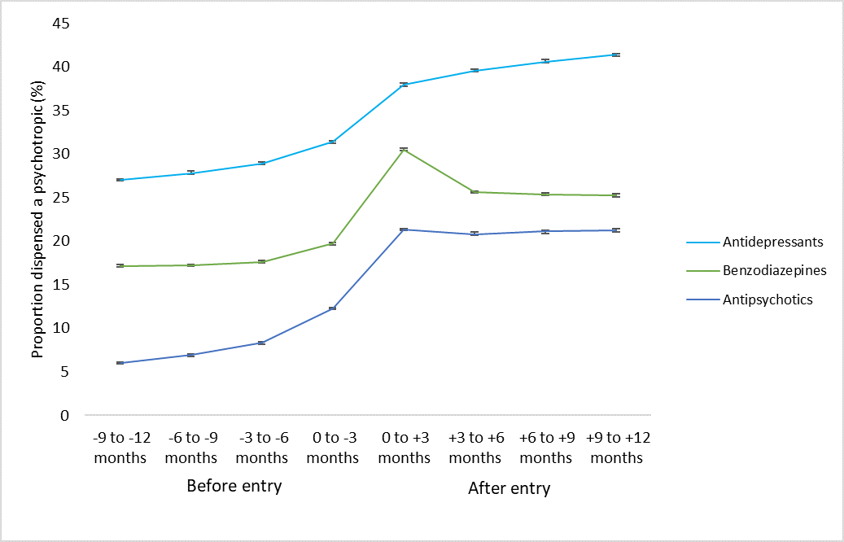

Supplementary figure 1: Prevalence of antipsychotic use before and after entry to residential aged care, by dementia status.
*Data is from sheet 4 of excel file.
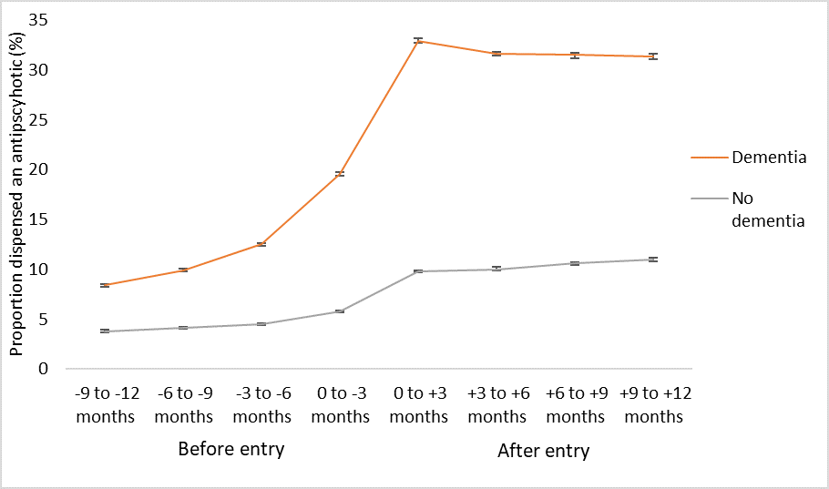
Supplementary figure 2: Prevalence of benzodiazepine use before and after entry to residential aged care, by dementia status.
*Data is from sheet 5 of excel file.
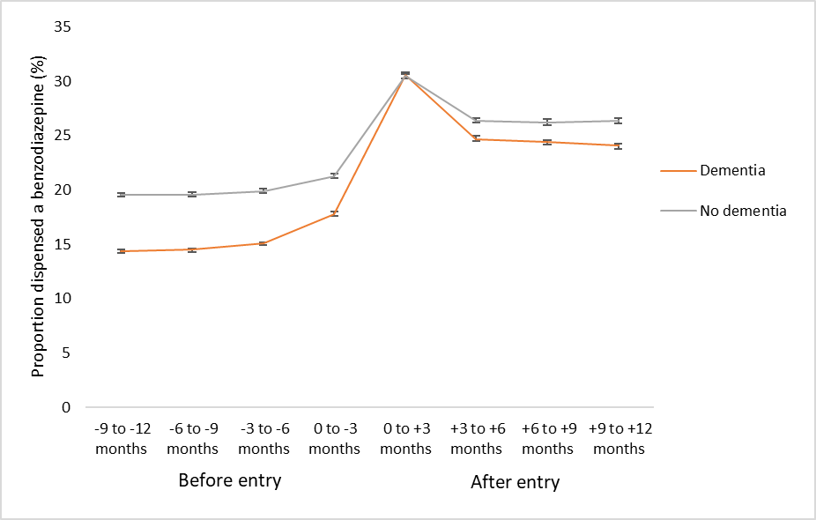

Supplementary figure 3: Prevalence of antidepressant use before and after entry to residential aged care, by dementia status.
*Data is from sheet 6 of excel file.
