**MICRORNA-184 IS INDUCED BY STORE-OPERATED CALCIUM ENTRY AND REGULATES EARLY KERATINOCYTE DIFFERENTIATION**

Adam Richardson1, Andrew K. Powell1, Darren W. Sexton1, Jason L. Parsons2, Nick J. Reynolds3, Kehinde Ross1

1School of Pharmacy and Biomolecular Sciences, Liverpool John Moores University

Liverpool, L3 3AF, UK.

2Cancer Research Centre, Department of Molecular and Clinical Cancer Medicine, University of Liverpool, Liverpool, L3 9TA, UK

3Dermatological Sciences, Institute of Cellular Medicine, Newcastle University, Newcastle upon Tyne, United Kingdom and Department of Dermatology, Royal Victoria Infirmary, Newcastle Hospitals NHS Foundation Trust, Newcastle upon Tyne, NE2 4HH, UK.

**Correspondence:**

Kehinde Ross

School of Pharmacy and Biomolecular Sciences

Liverpool John Moores University

Liverpool

L3 3AF

England

Tel: +44 151 231 2567

Fax: +44 151 231 2170

Email: [o.k.ross@ljmu.ac.uk](mailto:o.k.ross@ljmu.ac.uk)

**ORCID ID**: orcid.org/0000-0003-0252-1152

**Running Title:** SOCE-induced miR-184 regulates keratinocyte differentiation

**Data Availability Statement:** The data sets used and/or analyzed during the current study are available from the corresponding author on reasonable request**.**

**ABSTRACT**

Extracellular calcium (Ca2+) and store-operated Ca2+ entry (SOCE) govern homeostasis in the mammalian epidermis. Multiple microRNAs (miRNA) also regulate epidermal differentiation, and raised external Ca2+ modulates the expression of several such miRNAs in keratinocytes. However, little is known about the regulation of miR-184 in keratinocytes or the roles of miR-184 in keratinocyte differentiation. Here we report exogenous Ca2+ stimulates miR-184 expression in primary epidermal keratinocytes and that this occurs in a SOCE-dependent manner. Levels of miR-184 were raised by about 30-fold after exposure to 1.5 mM Ca2+ for 5 days. In contrast, neither phorbol ester nor 1, 25-dihydroxyvitamin D3 had any effect on miR-184 levels. Pharmacologic and genetic inhibitors of SOCE abrogated Ca2+-dependent miR-184 induction by 70% or more. Ectopic miR-184 inhibited keratinocyte proliferation and led to a 4-fold increase in the expression of involucrin, a marker of early keratinocyte differentiation. Exogenous miR-184 also triggered a 3-fold rise in levels of cyclin E and doubled the levels of γH2AX, a marker of DNA double strand breaks. The p21 cyclin-dependent kinase (CDK) inhibitor, which supports keratinocyte growth arrest, was also induced by miR-184. Together our findings point to a SOCE:miR-184 pathway that targets a cyclin E/DNA damage regulatory node to facilitate keratinocyte differentiation.

**ABBREVIATIONS**

**1, 25-(OH)2D3** 1, 25-dihydroxyvitamin D3

**CsA** cyclosporin A

**γH2AX** phosphorylated histone H2AX

**HPEK** human primary epidermal keratinocytes

**IVL** involucrin

**LNA** locked nucleic acid

**miRNA** microRNA

**NFAT** nuclear factor of activated T cells

**SOCE** store-operated calcium entry

**INTRODUCTION**

Epidermal stratification is maintained by controlled proliferation and terminal differentiation of keratinocytes (Eckhart et al., 2013). Extracellular calcium (Ca2+) induces involucrin (IVL) and several other cornified envelope proteins. Differentiating suprabasal keratinocytes express cell cycle proteins and cyclin E, which drives the G1/S phase transition, accumulates within suprabasal layers and promotes differentiation through mitotic failure and DNA damage (Freije et al., 2012; Zanet et al., 2010).

MicroRNAs (miRNAs) are short noncoding RNAs (18-25 nucleotides) that attenuate post-transcriptional gene output through translational inhibition and destabilization of mRNA transcripts, the latter sustaining the bulk of steady-state repression (Eichhorn et al., 2014; Huntzinger and Izaurralde, 2011). Several miRNAs have been implicated in epidermal differentiation including miR-203, miR-205 and miR-24 (reviewed (Riemondy et al., 2014), and multiple keratinocyte miRNAs were upregulated in response to high extracellular Ca2+ (Amelio et al., 2012; Hildebrand et al., 2011).

Store-operated Ca2+ entry (SOCE) through the STIM1:ORAI1 axis plays essential roles in keratinocyte and epidermal physiology (Numaga-Tomita and Putney, 2013; Ross et al., 2007; Vandenberghe et al., 2013). Depletion of luminal calcium (Ca2+) stores from the endoplasmic reticulum (ER) evokes clustering of STIM1 into aggregates that activate ORAI1, the predominant SOCE channel (Gudlur and Hogan, 2017). However, the impact of SOCE on miRNA expression has received little attention.

Recent studies detected miR-184 predominantly in the spinous layer of neonatal mouse epidermis, implicating miR-184 in epidermal differentiation (Nagosa et al., 2017). Modulation of miR-184 levels in mouse skin and human keratinocytes revealed that miR-184 represses keratinocyte proliferation and supports commitment to differentiation through the Notch axis. Although not listed among miRNAs upregulated by high Ca2+ in earlier work (Hildebrand et al., 2011), a 4-fold increase in miR-184 was observed in human keratinocytes exposed to high Ca2+ for 7 days (Nagosa et al., 2017).

We previously observed expression of miR-184 in reconstituted human epidermis (RHE) and in the HaCaT keratinocyte cell line (Roberts et al., 2013). Exposure of RHE to inflammatory cytokines interleukin-22 (IL-22) or oncostatin M (OSM) enhanced miR-184 expression, suggesting miR-184 levels respond to external signals (Roberts et al., 2013). Here, we show that extracellular Ca2+ induces miR-184 in human primary epidermal keratinocytes (HPEK) in a monolayer culture and SOCE inhibition impaired miR-184. Ectopic miR-184 promoted HPEK differentiation and this was associated with the elevation of cyclin E, DNA damage and induction of the p21 cyclin-dependent kinase inhibitor.

**MATERIALS AND METHODS**

**Reagents**

Oligonucleotides (miR-184 mimic, siORAI and respective controls) were purchased from GE Healthcare (Little Chalfont, UK). The locked nucleic acid (LNA) miR-184 inhibitor and a non-targeting control were from Exiqon (Vedbaek, Denmark). BTP2 (also known as YM58483 was from Abcam (Cambridge, UK), gadolinium(III) chloride (Gd3+) and differentiation reagents (1, 25-(OH)2D3/calcitriol and PMA) from Bio-Techne (Abingdon, UK).

**Keratinocyte Isolation, Culture and Differentiation**

Human progenitor epidermal keratinocytes (HPEK) were isolated from human foreskin (Liverpool John Moores University Research Ethics Committee approval number 16/PBS/008) or purchased from CellnTec (Bern, Switzerland). For isolation, tissues were washed with phosphate-buffered saline, trimmed of subcutaneous fat and digested with 20 mg/ml dispase (Sigma) at 4°C overnight with further digestion for 1 hour at room temperature. The epidermis was separated and incubated in 0.5% TrpLE (Thermofisher scientific, Cheshire, UK) for 5 min at 37°C, 5% CO2. Cells were centrifuged (1200 rpm for 5 min) and re-suspended in CnT-Prime media (CellnTec) supplemented with 1% penicillin/streptomycin/amphotericin B (PSA) and IsoBoost supplement CnT-ISO (CellnTec) to enhance isolation efficiency. Culture medium was changed every 2-3 days until cells reached 80% confluence with PSA exclusion from the medium after the first passage. Keratinocytes were sub-cultured using CnT-Accutase (CellnTec) and re-cultured at 4 x 103 cells per cm2. For differentiation, keratinocytes were at 3 x 105/well of a 6-well plate in CnT-Prime and allowed to reach confluence before adjusting the medium to 1.5 mM Ca2+ using CaCl2.

**Oligonucleotide Nucleofection**

Keratinocytes were sub-cultured and 5 x 105 cells resuspended in 100 µl nucleofection solution from the P3 Primary Cell 4D-Nucleofector kit (Lonza, Castleford, UK) and with 100 nM human miR-184 mimic (a synthetic double-stranded oligonucleotide mimicking endogenous miR-184), 100 nM of LNA miR-184 inhibitor or respective non-targeting negative control oligonucleotides. Cell suspensions were then transferred to nucleofection cuvettes and pulsed on the DS-138 programme of a 4D-Nucleofector. After incubation in pre-equilibrated CnT-Prime at room temperature for 10 min, the nucleofected cells were transferred to multi-well plates and incubated at 37°C, 5% CO2 with the media replacement the following day.

**Reverse Transcriptase Quantitative PCR (RT-qPCR)**

Total RNA was isolated from cells using the AllPrep DNA/RNA/miRNA Universal kit (Qiagen, Manchester, UK). RNA concentration was determined using a NanoDrop™ 2000c. Complementary DNA (cDNA) was synthesised from 400 ng of RNA using the miScript II RT kit (Qiagen) with HiFlex buffer. PCR amplifications were performed with Quantifast SYBR Green and QuantiTect miRNA/universal primers or RT2 ~~mRNA~~ primer assays from Qiagen (Supplementary Table 1). Thermocycling was performed on a Rotor-Gene® as follows: 95°C for 15 min, followed by 40 cycles of 94°C for 15 s, 55°C for 30 s and 70°C for 30 s. Relative expression of miRNA and mRNA were determined using the 2–ΔΔCT relative quantification method (Livak and Schmittgen, 2001).

**Western Blotting**

Cells were lysed in RIPA buffer containing protease and phosphatase inhibitors and 20 or 40 µg of total protein resolved on mini-PROTEAN 12% SDS/PAGE precast gels (Bio-Rad, Watford, UK). After transfer to polyvinylidene difluoride (PVDF) membranes, samples were incubated with primary antibodies: Involucrin (1:1000; Novus biologicals, Oxon, UK), Cyclin E (1:750; bio-Techne, Abingdon, UK), γH2AX (1:500; Millipore, Watford, UK), p21 (1:500; Bio-Rad, Oxfordshire, UK), GAPDH (1:5000, R&D systems) and β-actin (1:2000; Sigma) overnight at 4°C. Membranes were washed several times with Tris-buffered saline with 0.1% Tween-20 (TBST) and incubated with horseradish peroxidase (HRP) conjugated secondary antibodies for 1 h at room temperature. Membranes were washed before chemiluminescence detection using Clarity ECL reagents (Bio-Rad). ImageJ software was used to perform densitometry with target protein values normalised to the corresponding β-actin controls.

**Immunofluorescence staining for DNA double strand break foci**

Immunostaining was performed as previously reported (Nickson et al., 2017). Briefly, fixed and peameabilised cells were incubated with 2% BSA in PBS with 0.1 % Tween-20 (PBST) for 1 h at room temperature to block non-specific staining. Incubation with γH2AX (1:1000) antibody was performed overnight at 4°C in PBST with 2% BSA. After washing, coverslips were incubated with goat anti-mouse Alexa Fluor 647 for 1 h at room temperature in the dark. Samples were then washed with PBS and mounted on a microscope slide using Fluoroshield containing DAPI (Sigma-Aldrich, Gillingham, UK). Cells were examined using a Leica DMI6000B fluorescent microscope supported by Leica Application Suite (LAS) X software.

**Cell Viability**

Cells transfected with the miR-184 mimic or negative control were seeded at 2x104/well of a 96-well plate and maintained in CnT-Prime for 3 d. The MTT reagent 3-(4,5-Dimethylthiazol-2-yl)-2,5-diphenyltetrazolium bromide was added to each well at 5 mg/ml and incubated at 37°C, 5% CO2 for 4 h. Culture medium was removed, the 96-well plate air dried and 100 µl dimethyl sulfoxide added to each well. After shaking for 5 min to ensure solubilisation of formazan crystals, the absorbance of each well was read on a Clariostar plate reader (BMG Labtech, Aylesbury, UK) at OD 470 nm. All experiments were performed in triplicate and at least three times. For trypan blue viability tests, an aliquot of cells nucleofected with miR-184 mimic or negative control oligo was mixed 1:1 with 0.4% trypan blue before loading onto a haemocytometer. Dark blue cells were counted as non-viable cells and those with bright centres counted as live.

**Cell Cycle**

Nucleofected cells seeded at 3 x 105/well of a 6-well plate were grown for 2 d, detached using CnT-Accutase (CellnTec, Bern, Switzerland) washed twice with PBS and fixed in 70% ice cold ethanol for 24-72 h. Cells were then washed with PBS and propidium iodide (100 µg/ml) added for 30 min in the dark at room temperature. Cells were examined on a BD Accuri C6 flow cytometer (BD Biosciences, Wokingham, UK) with gates for forward scatter vs side scatter (FSC vs SSC) to exclude debris and FSC height vs FSC area (FSC-H vs FSC-A) to discriminate against doublets. Representative gating plots are presented in Fig. S5. Fluorescent values from 1 x 104 gated events were collected using the FL-2A parameter. Analysis was performed using FlowJo version 10.0 software and univariant Dean-Jett-Fox algorithm.

**Statistical Analysis**

Analysis of variance (ANOVA) was performed for the effects of SOCE inhibitors on miR-184 expression while the unpaired two‐tailed Student's *t*‐test was used for other indicated analyses. All statistical tests were performed with GraphPad Prism 5 (CA, USA) and results with p < 0.05 were considered significant.

**RESULTS**

**Calcium-dependent Induction of microRNA-184**

We examined the expression of miR-184 and genes of interest using reverse-transcriptase-qPCR (RT-qPCR) with primers and other reagents from Qiagen (Manchester, UK). In parallel HPEK cultures, relative miR-184 expression was almost 30-fold higher in HPEK treated with 1.5 mM Ca2+ for 5 days compared to cells in low (0.07 mM) Ca2+ media (Fig. 1A). Little miR-184 was detected in the cells under low Ca2+ conditions, suggesting that high Ca2+ triggers *de novo* miR-184 expression. In contrast, the active form of vitamin D, 1, 25-dihydroxyvitamin D3, (1, 25-(OH)2D3; Calcitriol) or phorbol 12-myristate 13-acetate (PMA) did not induce miR-184 even though they evoked *IVL* expression (data not shown). These observations suggest that induction of miR-184 by Ca2+ is associated with Ca2+-dependent pathways and not simply keratinocyte differentiation. Consistent with this, inhibition of SOCE with gadolinium (III) Gd3+, BTP2 and short-interfering RNA (siRNA) against ORAI1 reduced Ca2+-induced miR-184 expression by 70% or more (Fig. 1B). Furthermore, cyclosporin A (CsA) blocked Ca2+-dependent induction of miR-184 by 70% (Fig. 1B). As CsA inhibits the calcineurin-NFAT axis downstream of SOCE, the findings suggest elevation of miR-184 during Ca2+-mediated keratinocyte differentiation occurs downstream of ORAI1-dependent Ca2+ influx and NFAT activation. The siRNA suppressed ORAI1 levels by about 55%, whereas Gd3+ and BTP2 had little effect on ORAI1 expression (Fig. S1).

**MicroRNA-184 as an inducer of keratinocyte differentiation**

To uncover the effects of miR-184 on keratinocyte differentiation, IVL and cyclin E levels were examined in HPEK transfected with a miR-184 mimic (GE Healthcare, UK) or a locked nucleic acid (LNA) miR-184 inhibitor (Exiqon, Denmark). Modulation of miR-184 by the mimic or inhibitor was confirmed by RT-qPCR (Fig. S2). Both IVL and cyclin E were barely detectable in proliferating HPEK in low Ca2+ (Fig. 2A). However, ectopic miR-184 triggered a 3-fold elevation of IVL and cyclin E, respectively (Fig. 2A,B). Conversely, both IVL and cyclin E were detected in HPEK cultured under high Ca2+ conditions and the miR-184 inhibitor downregulated IVL and cyclin E by 60% and 90% respectively (Fig. 2 C,D).

**MicroRNA-184 induces keratinocyte DNA damage and growth arrest**

The above observations implicate miR-184 in the cyclin E pathway proposed by Gandarillas and colleagues whereby cyclin E hyperactivation causes DNA damage that signals for growth arrest and keratinocyte differentiation (Freije et al., 2012; Zanet et al., 2010). We thus investigated the effect of ectopic miR-184 on DNA damage. Levels of γH2AX, a biomarker of DNA double-strand breaks, were elevated almost 2-fold in HPEK transfected with miR-184 mimic compared to cells transfected with a control mimic (Fig. 3A,B). Conversely, in cells exposed to high Ca2+ for 5 days, the miR-184 inhibitor reduced γH2AX expression by 30% that observed in control samples (Fig. 3C,D). Furthermore, transfection with miR-184 mimic doubled the number of γH2AX foci visualised by fluorescence microscopy (Fig. 3E). Interestingly, the high Ca2+ treatment induced γH2AX foci but these were unaffected by the miR-184 inhibitor (Fig. 3F). Together, these observations suggest that miR-184 can mediate DNA damage in keratinocytes but is not essential for foci formation.

Finally, we investigated the effect of miR-184 on the p21 cyclin-dependent kinase inhibitor (CDKI), which was upregulated by cyclin E in HPEK (Freije et al., 2012). Exogenous miR-184 increased p21 expression 2-fold (Fig. 4A,B). Conversely, in HPEK maintained in high Ca2+ for 5 days, the miR-184 inhibitor halved levels of p21 (Fig. 4C,D). The miR-184 mimic also induced p21 at the transcript level, though the miR-184 inhibitor had little effect (Fig. S3). Our findings uncover a mechanism whereby SOCE triggers miR-184 during keratinocyte differentiation. In turn, miR-184 evokes DNA damage and p21 expression, the latter of which may explain the ability of miR-184 to inhibit HPEK proliferation and progression through G1 phase of the cell cycle (Figs. S4, S5).

**DISCUSSION**

Precise co-ordination of keratinocyte proliferation and differentiation is essential to epidermal homeostasis. Early work detected miR-184 in RHE but not monolayer cultures, suggesting that miR-184 may play a role in keratinocyte stratification (Roberts et al., 2013). Very recent work has described expression patterns of miR-184 in murine epidermis, reporting none in both basal and terminally differentiated compartments and high amounts in early differentiated layers (Nagosa et al., 2017). Our data in Fig. 1B specifically implicated SOCE in Ca2+-dependent induction of miR-184 during epidermal keratinocyte differentiation. Early work by Knott and colleagues has established the profile of miRNAs induced during cultivation under high Ca2+ conditions (Hildebrand et al., 2011). Although miR-184 did not feature in that dataset, it is likely that miR-184 is one of several miRNAs whose elevation in response to raised extracellular Ca2+ is SOCE-dependent. Our data also point to a role for the calciuneurin/NFAT pathway in driving miR-184 expression in differentiating HPEKs, though evidence of direct binding of NFAT to miR-184 promoter regions would be required to substantiate this finding.

Ectopic elevation of miR-184 levels induced IVL in proliferating HPEK, suggesting that miR-184 alone is sufficient to trigger a differentiation response in the absence of high Ca2+ or other differentiation agents. Further, the induction of IVL observed in differentiating HPEK was inhibited by blocking normal miR-184 activity. Consistent with this, recent work showed that inhibition of miR-184 during primary human keratinocyte differentiation reduced IVL expression (Nagosa et al., 2017).

Studies from the Gandarillas laboratory have demonstrated that p21 is induced during the onset of keratinocyte differentiation and is associated with cyclin E accumulation. Our data show that loading proliferating HPEK with miR-184 mimic results in upregulation of cyclin E. Given that cyclin E is a regulator of G1/S-phase transition, this may explain the ability of miR-184 to promote accumulation of G1-phase cells (Fig. S4,S5). Conversely, inhibition of physiological miR-184 during HPEK differentiation resulted in a drastic reduction of cyclin E (Fig. 2C). Previous work on murine epidermis showed that cyclin E accumulates in suprabasal layers supporting cellular enlargement through endoreplication (Zanet et al., 2010). Similarly, an *in vitro* study demonstrated that cyclin E accumulates in differentiating HPEK, where it induces mitotic failure, phosphorylation of γH2AX indicative of DNA damage and differentiation (Freije et al., 2012). Elevated levels of cyclin E downstream of miR-184 may trigger a similar differentiation response in proliferating HPEK given our evidence for miR-184-mediated DNA damage. However, there are likely to be other crucial molecules involved as the substantial loss of cyclin E in differentiating cells loaded with the miR-184 inhibitor was not reflected in altered γH2AX levels (compared Fig. 2C, 3F). Nevertheless, sustained miR-184-dependent accumulation of cyclin E may result in the induction of the DNA damage response pathway, leading to the upregulation of p21 and the expression of IVL to support differentiation.

Taken together, we have provided the first evidence linking miR-184 to keratinocyte differentiation through cyclin E, p21 and IVL. However, silencing of p21 did not appear to modulate the effects of miR-184 on IVL expression (data not shown), suggesting the growth arrest and differentiation axes of miR-184 function are not necessarily coupled. Furthermore, questions remain about the impact of cyclin E on miR-184-dependent DNA damage and how cyclin E is upregulated by miR-184 since no miR-184 binding sites were predicted in *CCNE1 or CCNE2* transcripts using TargetScan 7.1. Hence, the targets that convert miR-184 binding into a DNA damage signal remain to be defined. We propose that in addition to the Notch-dependent pathway (Nagosa et al., 2017), miR-184 couples SOCE to cyclin E and DNA damage to elevate p21 and IVL (Fig. 5) and further studies are warranted to establish other cells types in which a SOCE:miR-184 axis is associated with DNA damage.

CONFLICT OF INTEREST. The authors state no conflict of interest

DATA AVAILABILITY STATEMENT: The data sets used and/or analyzed during the current study are available from the corresponding author on reasonable request.

ACKNOWLEDGEMENTS: We thank Mr Abid Qazi, Mr Nadeem Haider, Dr Naseem Khan and Dr Mohammad Shafiq (Northern Circumcision Clinic, UK) for collecting skin samples (Liverpool John Moores University Research Ethics Committee approval number 16/PBS/008). We are grateful to Dr Eithne Costello (University of Liverpool, Liverpool, UK) for the gift of the cyclin E antibody. We thank Dr Katie Nickson and Dr Carlos Rubbi (both of the University of Liverpool, Liverpool, UK) for analysis and quantification of γH2AX foci staining. This study was funded by the British Skin Foundation (grant number 7006s). NJR's laboratory/research is supported by the NIHR-Newcastle Biomedical Research Centre and the Newcastle MRC/EPSRC Molecular Pathology Node.

**REFERENCES**

Amelio I, Lena AM, Viticchie G, Shalom-Feuerstein R, Terrinoni A, Dinsdale D, Russo G, Fortunato C, Bonanno E, Spagnoli LG, Aberdam D, Knight RA, Candi E, Melino G. 2012. miR-24 triggers epidermal differentiation by controlling actin adhesion and cell migration. J Cell Biol 199:347-363.

Eckhart L, Lippens S, Tschachler E, Declercq W. 2013. Cell death by cornification. Biochim Biophys Acta 1833:3471-3480.

Eichhorn SW, Guo H, McGeary SE, Rodriguez-Mias RA, Shin C, Baek D, Hsu SH, Ghoshal K, Villen J, Bartel DP. 2014. mRNA Destabilization Is the Dominant Effect of Mammalian MicroRNAs by the Time Substantial Repression Ensues. Mol Cell 56:104-115.

Freije A, Ceballos L, Coisy M, Barnes L, Rosa M, De Diego E, Blanchard JM, Gandarillas A. 2012. Cyclin E drives human keratinocyte growth into differentiation. Oncogene 31:5180-5192.

Gudlur A, Hogan PG. 2017. The STIM-Orai Pathway: Orai, the Pore-Forming Subunit of the CRAC Channel. Adv Exp Med Biol 993:39-57.

Hildebrand J, Rutze M, Walz N, Gallinat S, Wenck H, Deppert W, Grundhoff A, Knott A. 2011. A comprehensive analysis of microRNA expression during human keratinocyte differentiation in vitro and in vivo. J Invest Dermatol 131:20-29.

Huntzinger E, Izaurralde E. 2011. Gene silencing by microRNAs: contributions of translational repression and mRNA decay. Nat Rev Genet 12:99-110.

Livak KJ, Schmittgen TD. 2001. Analysis of relative gene expression data using real-time quantitative PCR and the 2(-Delta Delta C(T)) Method. Methods 25:402-408.

Nagosa S, Leesch F, Putin D, Bhattacharya S, Altshuler A, Serror L, Amitai-Lange A, Nasser W, Aberdam E, Rouleau M, Tattikota SG, Poy MN, Aberdam D, Shalom-Feuerstein R. 2017. microRNA-184 Induces a Commitment Switch to Epidermal Differentiation. Stem cell reports 9:1991-2004.

Nickson CM, Moori P, Carter RJ, Rubbi CP, Parsons JL. 2017. Misregulation of DNA damage repair pathways in HPV-positive head and neck squamous cell carcinoma contributes to cellular radiosensitivity. Oncotarget 8:29963-29975.

Numaga-Tomita T, Putney JW. 2013. Role of STIM1- and Orai1-mediated Ca2+ entry in Ca2+-induced epidermal keratinocyte differentiation. J Cell Sci 126:605-612.

Riemondy K, Hoefert JE, Yi R. 2014. Not miR-ly micromanagers: the functions and regulatory networks of microRNAs in mammalian skin. Wiley interdisciplinary reviews RNA 5:849-865.

Roberts JC, Warren RB, Griffiths CE, Ross K. 2013. Expression of microRNA-184 in keratinocytes represses argonaute 2. J Cell Physiol 228:2314-2323.

Ross K, Whitaker M, Reynolds NJ. 2007. Agonist-induced calcium entry correlates with STIM1 translocation. J Cell Physiol 211:569-576.

Vandenberghe M, Raphael M, Lehen'kyi V, Gordienko D, Hastie R, Oddos T, Rao A, Hogan PG, Skryma R, Prevarskaya N. 2013. ORAI1 calcium channel orchestrates skin homeostasis. Proc Natl Acad Sci U S A 110:E4839-4848.

Zanet J, Freije A, Ruiz M, Coulon V, Sanz JR, Chiesa J, Gandarillas A. 2010. A mitosis block links active cell cycle with human epidermal differentiation and results in endoreplication. PLoS One 5:e15701.

**M:\My Documents\Adam data\Original and revised FIGURES for miR-184 paper\JCP figures\FIGURE 1\FIGURE 1 JCP hi res - delete after upload.tif**

**Figure 1:** Induction of miR-184 during Ca2+-dependent HPEK differentiation. (A) HPEKs were grown to confluence and miR-184 expression analysed by RT-qPCR after treatment with high Ca2+ (1.5 mM) for 1 or 5 days (d) compared to cells maintained in 0.07 mM for 5 d. Data shown represent means +SEM from 3 independent experiments normalized to SNORD72; ***, p<0.001. (B) For evaluation of the role of SOCE, HPEKs were maintained in 1.5 mM Ca2+ for 5 d with or without 1 µM Gd3+, 1 µM BTP2, 100 nM ORAI1-targeting siRNA or 1 CsA µM as indicated. The Gd3+, BTP2 and CsA were added 1 h prior to Ca2+ switch and refreshed after day 2. Data represent means +SEM from 3 independent experiments normalized to SNORD72 and presented relative to control. ***, p<0.001.

**M:\My Documents\Adam data\Original and revised FIGURES for miR-184 paper\JCP figures\FIGURE 2\FIGURE 2 for JCP hi res.tif**

**Figure 2:** miR-184 induces IVL and cyclin E in HPEK. (A, C) Cells loaded with 100 nM miR-184 mimic, miRNA-184 inhibitor or control oligonucleotides by nucleofection were maintained in low Ca2+ (0.07 mM) or high Ca2+ (1.5 mM) media for 5 days (5 d) as indicated. (B,D) Densitometry levels (mean + SEM) relative to β-actin. Data were pooled from 3 independent experiments. ***, p<0.001; **, p<0.01.

**M:\My Documents\Adam data\Original and revised FIGURES for miR-184 paper\JCP figures\FIGURE 3 for JCP.tif**

**Figure 3:** miR-184 induces γH2AX in HPEK. (A, C) Cells loaded with 100 nM miR-184 mimic, miR-184 inhibitor or control oligonucleotides by nucleofection were maintained in low Ca2+ (0.07 mM) or high Ca2+ (1.5 mM) media for 5 days (5 d) as indicated. (B, D) Densitometry levels (mean + SEM) relative to β-actin. (E, F) Evaluation of γH2AX foci in cells loaded with 100 nM miR-184 mimic or miR-184 inhibitor for 5 d in low and high Ca2+, respectively. Relative number of foci/nucleus with standard errors from 3 independent experiments, 10 fields of view in each case. *Inset*: Overlaid immunofluorescent images of γH2AX and DAPI staining. Data were pooled from 3 independent experiments. ***, p<0.001; **, p<0.01.

**M:\My Documents\Adam data\Original and revised FIGURES for miR-184 paper\JCP figures\FIGURE 4\FIGURE 4 for JCP hi res.tif**

**Figure 4:** miR-184 induces p21 in HPEK. (A, C) Cells loaded with 100 nM miR-184 mimic, miRNA-184 inhibitor or respective control oligonucleotides by nucleofection were maintained in low Ca2+ (0.07 mM) or high Ca2+ (1.5 mM) media for 5 days as indicated. (B, D). Densitometry levels (mean + SEM) relative to β-actin. Data were pooled from 3 independent experiments. ***, p<0.001; *, p<0.05.

**M:\My Documents\Adam data\Original and revised FIGURES for miR-184 paper\JCP figures\FIGURE 5 for JCP.tif**

**Figure 5:** Schematic representation of the SOCE:miR-184 axis to keratinocyte differentiation.

SUPPLEMENTARY FILE

**MICRORNA-184 IS INDUCED BY STORE-OPERATED CALCIUM ENTRY AND REGULATES EARLY KERATINOCYTE DIFFERENTIATION**

Adam Richardson, Andrew K. Powell, Darren W. Sexton, Jason L. Parsons, Nick J. Reynolds, Kehinde Ross

**SUPPLEMENTARY FIGURE S1**

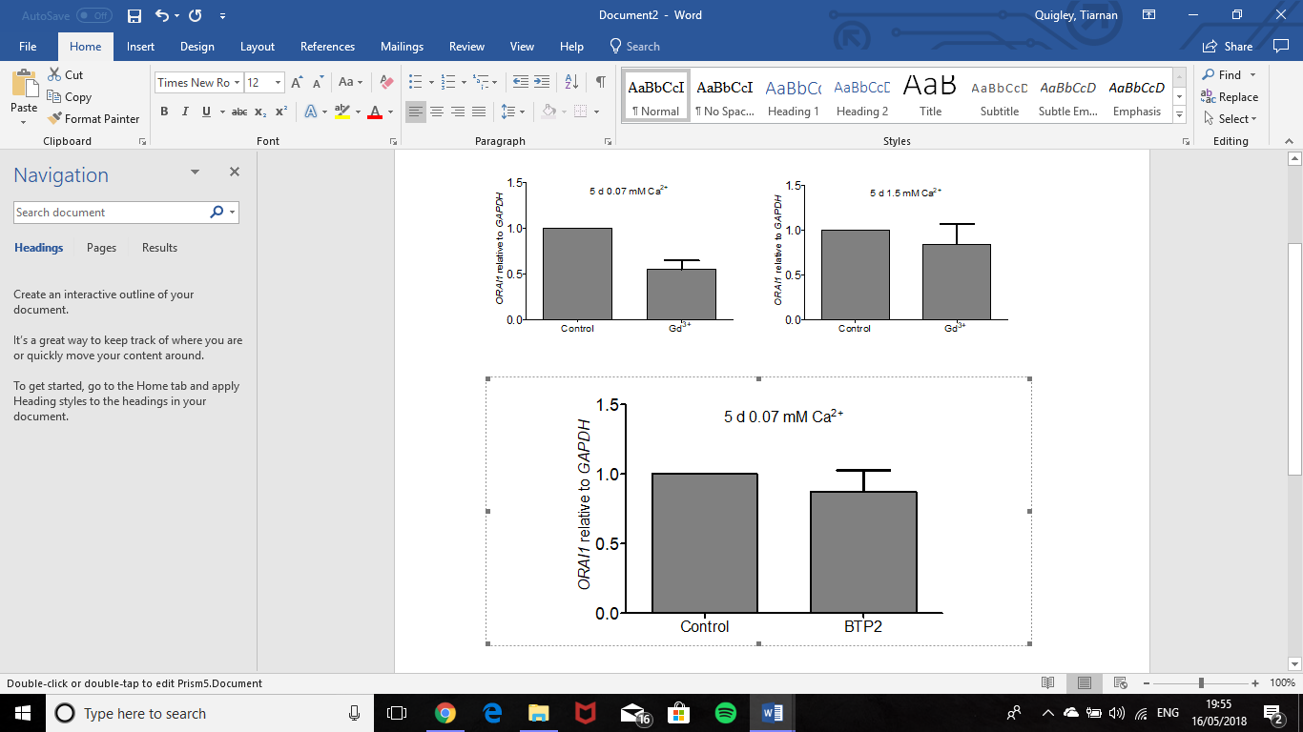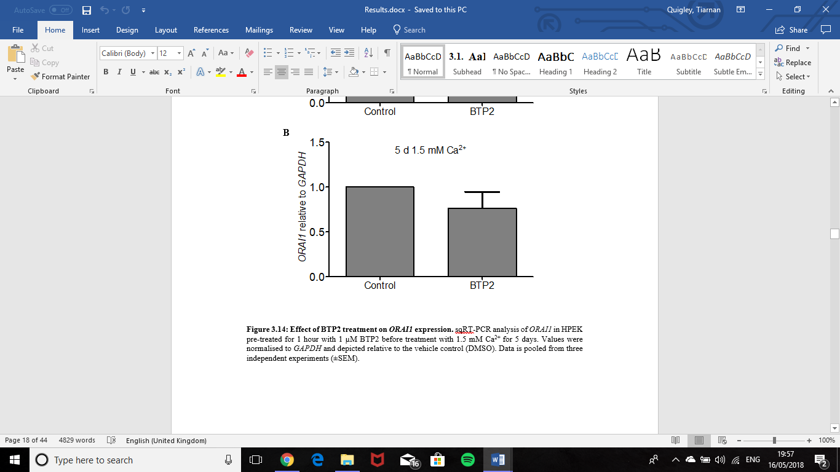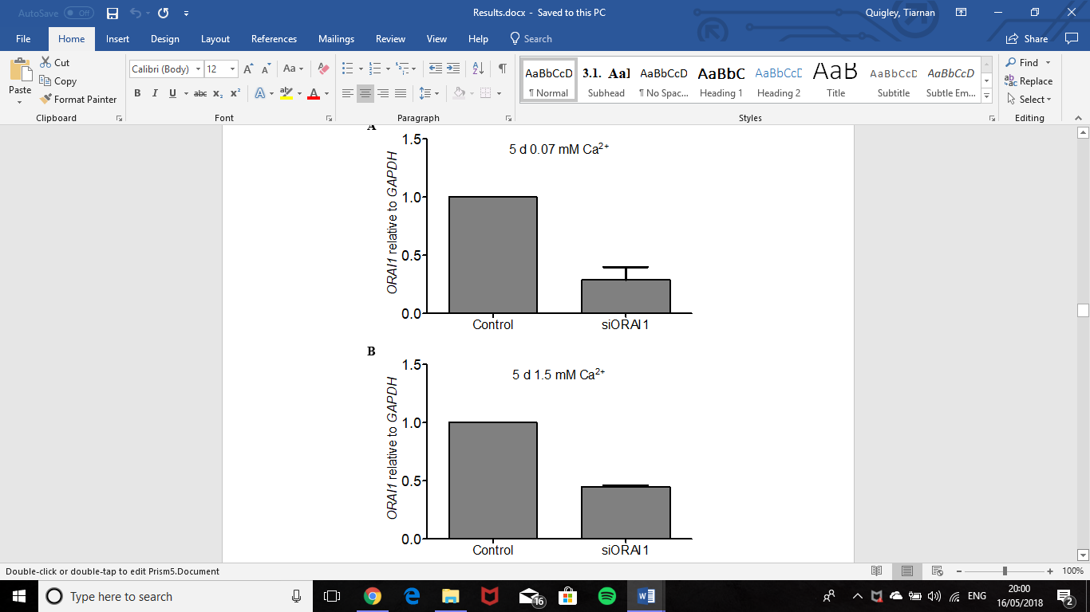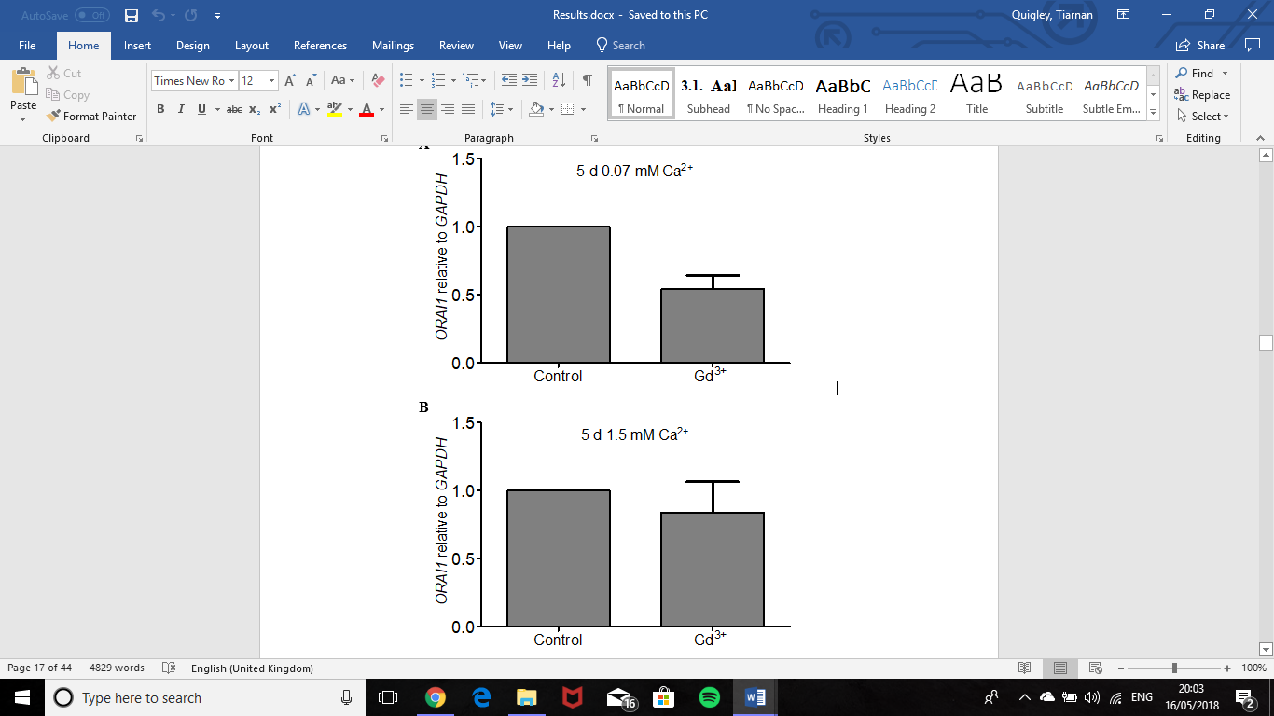

**B**

**A**

**C**

**D**

**E**

**F**

**Figure S1: Analysis of *ORAI1* expression following inhibition or knockdown.** HPEKs were maintained in either 0.07 mM or 1.5 mM Ca2+ for 5 d with or without (A,B) 1 µM Gd3+, (C,D) 1 µM BTP2, (E,F) 100 nM ORAI1-targeting siRNA. The Gd3+ and BTP2 were added 1 h prior to Ca2+ switch and refreshed after day 2. Data shown represent means +SEM from 3 independent experiments. Expression was normalized to *GAPDH.* Values are presented relative to untreated (A,B), DMSO-treated (C,D) or control siRNA (E,F).

**SUPPLEMENTARY FIGURE S2**

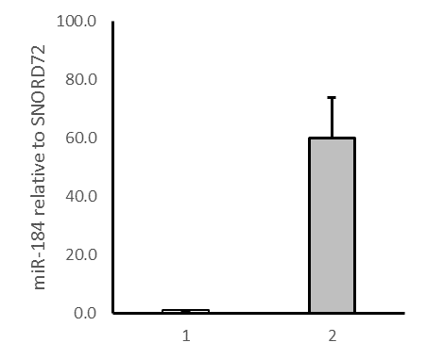

**A**

Control

miR-184 mimic

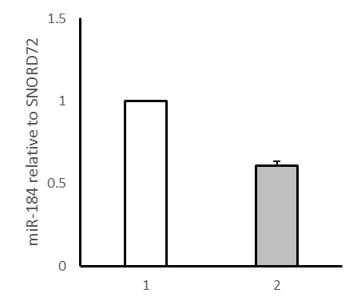

miR-184 inhibitor

Control

**B**

**Figure S2: miR-184levels following nucleofection with synthetic miR-184 mimic or miR-184 inhibitor.** HPEKs nucleofected with 100 nM of either miR-184 mimic (A) or miR-184 inhibitor (B) were maintained in 0.07 mM Ca2+ (A) or 1.5 mM Ca2+ (B) media for 5 d. Data shown represent means +SEM from 2 independent experiments. Expression was normalized to SNORD72*.* Values are presented relative to the relevant oligonucleotide control.

**SUPPLEMENTARY FIGURE S3**





**Figure S3**: Expression of p21 at the transcript level examined by RT-qPCR following modulation of miR-184 levels. Cells were loaded with 100 nM miR-184 mimic, miRNA-184 inhibitor or respective control oligonucleotides by nucleofection and maintained in low or high Ca2+ for 5 days as indicated. Data shown represent means +SEM from 3 independent experiments. Expression was normalized to *GAPDH.*

**SUPPLEMENTARY FIGURE S4**

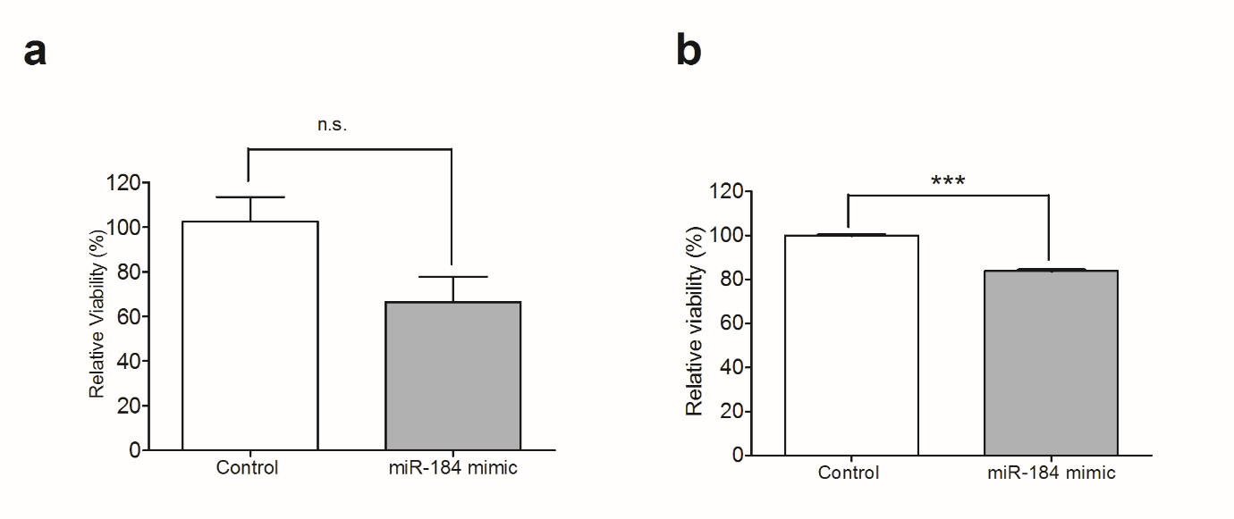

**A**

**B**

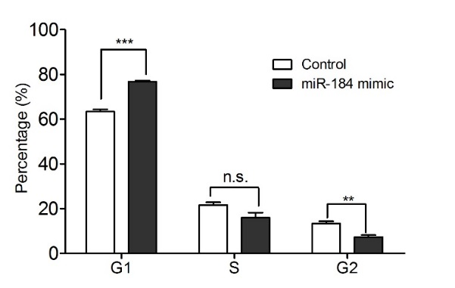

**C**

**Figure S4**: miR-184 reduces HPEK proliferation. HPEK were nucleofected with 100 nM of the miR-184 mimic or control oligonucleotide as indicated. The effect of miR-184 on HPEK viability determined with MTT (A) or trypan blue staining (B). Data shown are means +SEM of 3 independent experiments. (C) Cell cycle profiles were assessed using propidium iodide staining and flow cytometry. ***, p<0.001; **, p<0.01; n.s., not significant.

**SUPPLEMENTARY FIGURE S5**

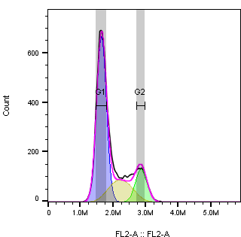

**B**

**A**

**D**



**C**



**Figure S5: Gating strategies used in flow cytometry analysis to detect differences in the cell cycle.** Cell cycle profiles from HPEK nucleofected with either control, miR-184 or miR-184 inhibitor was assessed using propidium iodide staining and flow cytometry. Identical gating strategies were used across samples with HPEK populations isolated and debris excluded using FSC vs SSC (A), discrimination of doublet cells using FSC-A vs FSC-H (B), fluorescent data collected using the FL-2A channel (C) and final analysis using the Dean-Jett-Fox model fitting algorithm on FlowJo software (D).

**SUPPLEMENTARY TABLE 1: Validated pre-designed primers used in RT-qPCR purchased from Qiagen or Thermo Fisher Primers.**

|  |  |
| --- | --- |
| **Name** | **Sequence** |
| miR-184 | MS00003640 purchased from Qiagen |
| SNORD72 | MS00033719 purchased from Qiagen |
| *GAPDH* | PPH00150F purchased from Qiagen |
| *CDKN1A (p21)* | Forward 5’-TCAGGCTTGGGCTTTCCACC-3’  Reverse 5’-CCATGCACTTGAATGTGTACCCAGA-3’  Both purchased from Thermo Fisher |
| *ORAI1* | Forward 5’-GAGCATGCAAAACAGCCCAGG-3’  Reverse 5’-GGCTCATCACCTCGGAGTAACTCT-3’  Both purchased from Thermo Fisher |